Corporate Social Responsibility and firm characteristics:
An econometric analysis

ERASMUS UNIVERSITY ROTTERDAM
Erasmus School of Economics
Department of Accounting & Finance

Student: Faniël Tzeggai
Student number: 325926
Supervisor: Dr. K.E.H. Maas

ACKNOWLEDGEMENTS
I would like to thank Dr. Karen Maas for acting as my supervisor in the writing of this thesis. Her assistance and comments has enabled me to improve the content. Her knowledge on this subject was very useful and I am grateful that she was willing to assist me in this endeavour.
Finally I would like to thank my parents for their support. This achievement also reflects upon them and I hope they will take pride in it.

ABSTRACT
This thesis examines the characteristics of firms implementing CSR measures against those that do not implement CSR measures. Listing on the Dow Jones Sustainability Index is used as a proxy for implementing CSR measures.

The outcome of the empirical analysis shows that there is a curvilinear relationship between firm size and probability of being listed on the DJSI. Initially a positive relationship can be found between firm size and the probability of a DJSI listing. After a certain point however, the probability does not increase anymore (North-America), or even declines to a point where it is more likely for very large firms to not be listed on the DJSI than it is to be listed (Europe).

Keywords:
Binary logit model, CSR, DJSI, marginal effects, odds ratios
Contents
LIST OF TABLES & GRAPHS 4
1 Introduction 5
1.1 Central research question 6
1.2 Research method 6
1.2.1 Literature analysis 6
1.2.2 Empirical research 7
2 Literature review 8
2.1 Defining CSR 8
2.2 Different types of CSR measurement 9
2.3 Reasons for engaging in CSR 11
2.4 CSR and financial performance 13
2.5 CSR and firm characteristics 15
2.6 Limitations of existing research 16
3 Research design 17
3.1 Introduction 17
3.2 Hypotheses 17
3.3 Data & sample selection 18
3.4 Research variables 19
3.5 Models 20
4 Methodology 21
4.1 Linear probability model 21
4.2 Binary logit model 22
4.3 Marginal effects for continuous variables 23
4.4 Marginal effects for dummy variables 24
4.5 Odds ratios 24
4.6 Diagnostics 25
5 Results 26
5.1 Introduction 26
5.2 Descriptive statistics and correlation coefficients 26
5.3 Model output and interpretation 28
6 Conclusion 39
6.1 Limitations and suggestions for further research 40
REFERENCES 41
APPENDIX 44

LIST OF TABLES & GRAPHS
Table 5.1: descriptive statistics of total assets 26
Table 5.2: correlation matrix 27
Table 5.3: EViews output of the Logistic regression for model 1 28
Table 5.4: marginal effects of model 1 29
Table 5.5: Expectation-Prediction-Evaluation output of model 1 30
Table 5.6: EViews output of the Logistic regression for model 2 33
Table 5.7: EViews output of the Logistic regression for model 3 34
Table 5.8: marginal effects of model 3 35
Table 5.9: Expectation-Prediction-Evaluation output of model 3 36

Graph 4.1: CDF of the logistic distribution 23
Graph 5.1: estimated odds ratio of North-American firms against firm size (total assets in billions USD) of model 1 31
Graph 5.2: estimated odds ratio of European firms against firm size (total assets in billions USD) of model 1 32
Graph 5.3: estimated odds ratio of North-American firms against firm size (total assets in billions USD) of model 3 37
Graph 5.4: estimated odds ratio of European firms against firm size (total assets in billions USD) of model 3 38

1 Introduction
This thesis for the master Accounting & Finance will analyze differences regarding integration of Corporate Social Responsibility in the strategy of firms. These will entail differences over regions and industry types as well as analyzing possible differences between small, medium and large firms.
In recent years an increase in attention for social and environmental issues could be witnessed. From the Brundtland Report where sustainability is defined as “development that meets the need of the present without compromising the ability of future generations to meet their own needs”, to the introduction of the Kyoto treaty on climate change, to increased media attention for these problems, social responsibility is seen as a relevant issue.
The corporate world cannot ignore this trend. Companies have an interest to be seen as socially responsible and acting within the accepted norms of a society that is growing more sceptical.
Studies have shown that there is an upward trend when it comes to firms disclosing information regarding their corporate social performance. A recent study by PricewaterhouseCoopers LLP found that the number of companies with CSR information on their website increased from 75% in 2009 to 81% in 2010.
Furthermore a 2010 report by the Sustainability Investment Research Analyst Network (SIRAN) shows that the number of Standard and Poors (S&P) firms producing sustainability reports with performance data has increased by one third.

1.1 Central research question
The main research question that this thesis will try to answer is:
- What are the region, sector and size characteristics of firms that are listed on the Dow Jones Sustainability Index versus those not listed on the DJSI?

1.2 Research method

1.2.1 Literature analysis
The method of research for this thesis will contain several parts. First there will be a literature review regarding existing research about the relationship between economic performance and corporate social responsibility. Furthermore literature will be reviewed showing varying ways of CSR measurements, reasons for implementing CSR measures and the firm characteristics of companies that engage in CSR. The limitations of current research will also be examined in order to get a better understanding where improvements can be made in empirical analysis.

1.2.2 Empirical research
The empirical part of this thesis will consist of a study analyzing the characteristics of firms that have implemented CSR measures. The variables region, sector type and firm size will be used to analyze to what extent CSR implementation differs among these variables. Data will be collected for 434 firms which are split into those that are listed on the DJSI and those not listed on the DJSI. Because this variable of interest can take on only two possible values (listed or unlisted), a binary logit model is used to analyze this data.
Since the estimated parameter values in a binary logit model are not equal to the marginal effects (change in predicted probability when one of the independent variables changes with one unit) the differences in implementation of CSR over these variables will be analyzed by calculating the mean marginal effects. Furthermore the odds ratios (relative preference of option 1 (listed at DJSI) as compared to option 0 (unlisted)) are informative, give us good insight into the differences over the independent variables and will therefore be analyzed. Finally the predictive quality of the models will be tested via diagnostic tests.
The remainder of this thesis is constructed as follows. The following section (chapter 2) contains the literature review. Chapter 3 contains the research design, where the hypotheses are formulated; the collecting of the data is clarified and finally the research variables and models are presented. Chapter 4 gives an extensive overview of the methodology used for the empirical study. Chapter 5 reports the results. Finally chapter 6 will conclude and give a short overview of the limitations in the empirical analysis of this thesis.

2 Literature review

2.1 Defining CSR
In order to enable us to measure the impact of Corporate Social Responsibility (CSR) on financial performance, it is critical to first examine what the definition of this term is.
According to the European Commission (2001) CSR is defined as “a concept whereby companies integrate social and environmental concerns in their business operations and in their interactions with stakeholders on a voluntary basis”. Although this is a rather broad definition, it divides CSR in a social and an environmental part, the underlying reason for this being that business operations of a firm have impact on a variety of issues.
McWilliams et al. (2001) define CSR as “actions that appear to further some social good, beyond the interest of the firm and that which is required by law”.
The Business for Social Responsibility is an organisation providing information, training and advisory to firms in order to make CSR an integral part of business operations and strategies. It defines CSR as “Business decision making linked to ethical values, compliance with legal requirements and respect for people, communities and the environment around the world” (Aaronson, 2003).
Kristoffersen et al. (2005) are critical of these types of definitions. They argue that these definitions of CSR indirectly imply that adhering to socially responsible practices is a non-commercial activity. The consequence of this is that people believing a firms only objective is to maximise profits, are pushed to oppose CSR. Friedman (1970) for instance stated “there is one and only one social responsibility of business-to use its resources and engage in activities designed to increase its profits so long as it stays within the rules of the game, which is to say, engages in open and free competition without deception or fraud”. Kristoffersen et al. conclude that a proper definition of CSR is one that does not interpret a firms responsibilities.

2.2 Different types of CSR measurement
While in the definition of the EC CSR is split into only two rather broad entities, many studies have used a more heterogeneous approach in analyzing the impact of CSR on financial performance. The Impact on issues such as employee relations, environment and community relations has been analyzed. Furthermore several studies have split these factors into more subdivisions so as to get a better understanding of the precise impact CSR has on financial performance.
A study by Brammer et al. (2005) uses data from the Ethical Investment Research Service (EIRIS), an organisation specialising in measurement of CSR performance by surveying firms and undertaking their own research. Three dimensions of social performance were used to analyze the extent of CSR practiced by a firm namely:
-Employee performance: six categories (health and safety, training and development, equal opportunities policies, equal opportunities systems, employee relations, systems for job creation and job security). On each of these six different employee indicators a firm can score between 0 and 3 points, yielding a total employee responsibility score out of 18;
-Environmental performance: three categories (policies, management systems, and reporting). On each of these three different environmental indicators a firm can score between 0 and 4 points, yielding a total environmental responsibility score out of 12;
-Community performance: measured as a single variable, graded between 0 and 3.
To arrive at a single aggregate measure, all three variables are normalized giving each of them scores between 0 and 3 and then summed to generate an overall score out of 9.
In a study by Tsoutsoura (2004) CSR is measured in two ways. First the Kinder Lydenberg Domini (KLD) rating data for companies in the S&P 500 is used. This method rates each company on multiple attributes considered relevant to Corporate Social Performance. A combination of surveys is used (financial statements, articles in the press, academic journals and government reports) in order to assess CSP along eleven dimensions. The absolute KLD scores are converted to scale, with 10 as a base.

The second measurement of CSR is the so-called Domini 400 Social Index which is based on the information from the KLD rating. This measure is used as a dummy variable in this study, with value 1 if a firm is included in the DSI 400 in a given year and 0 if it is not listed of that index.
Fortanier et al. (2007) use a binary logit variable to analyze the probabilities of firms with different characteristics to disclose CSP information. Three different (binary) dependent variables are used, since several studies have shown that disclosure of information may vary across different kinds of information. First the variable ‘report’ measures whether firms disclose information on their environmental activities at all. The second variable ‘data’ measures if the firms disclose extensive quantitative data on environmental performance. The third dependent variable ‘verify’, analyzes whether firms had their CSP verified externally by an independent auditor.
A meta-analysis by Wood (2010) concludes that most studies tend to focus on the impact CSP has on the firm itself (financial performance, innovation, reputation etc.), while studies examining the impact CSR measures have on stakeholders (consumers, employees, environment etc.) are conducted less often.
Wood also finds that multi-dimensional rating schemes (like the KLD measure mentioned above) are gaining in popularity, mainly because they are third-party assessments of CSP and don’t rely on firm self-reporting (which could be seen as biased).
Furthermore Wood observes that many studies have been conducted where CSP measures are related to the mode of corporate responsiveness (defensive, reactive, accommodative and proactive). Wood finds that assessing these action modes are not in favour as a CSP measure, given that such assessments are very subjective and are too monolithic to reflect the realities of corporate responsiveness. A firm can for example be defensive when it is faced with a situation where it has high liability exposure, reactive in situations which are not relevant to managers, accommodative in situations that can be seen as beneficial to the firm and proactive on issues of deep company concern that stands a chance of being shifted towards company benefit.

2.3 Reasons for engaging in CSR
Firms engaging in CSR may have a wide variety of reasons for doing so. While earlier on these initiatives may have been solely (or at least mainly) motivated by altruistic reasons, many studies have shown a gradual shift to CSR measures which also have the purpose of benefiting the firm itself (Seifert et al., 2003).
This shift results in CSR having dual objectives (altruistic and self-interest), which in first instance may seem contrary and impossible to reach similarly since there is a trade-off between social performance and profits (Husted & Salazar, 2006), however some argue that increased social awareness and performance can have a positive impact on a company’s financial performance.
The benefits of implementing CSR measures and disclosing information regarding CSR performance can be substantial, like a decrease in cost of capital. Botosan et al (2000) examine the relation between a firms expected cost of equity capital and disclosure (annual report, quarterly and other published report). To measure to what extent firms publish information, data is used from the Annual Reviews of Corporate Reporting which ranks firms based on the amount of information they disclose. The study shows that the cost of equity capital decreases as ranking in annual report disclosure improves. The authors find that the magnitude of the difference in cost of equity capital between firms that disclose most versus those disclosing least is one-half to one percentage point (after controlling for market beta and firm size).
Other benefits could be that the society in which a firm operates can perceive the actions of the firm to be in agreement with the norms of that society. This legitimacy theory states that without support of the society in which a firm operates, it may face adverse consequences. The Stakeholders (a group or individual than has the ability to affect, or could itself be affected by, the actions of the firm (Freeman, 1984)) can organize and threaten the company should it decide not to change its course. Customers can boycott firms, investors can decide to disinvest, community groups can lobby and persuade regulators to enact tougher regulations and the firm can come under increased negative media attention.

A study by Brown & Deegan (1998) analyzed what relationship exists between media coverage to the environmental consequences of industries and the level of environmental disclosure made by a sample of firms active in those industries. The results of this study show that for a majority of the industries analyzed, increased media attention is significantly associated with higher levels of environmental disclosures.
Whether or not a stakeholder can influence a firms conduct depends on the power that the firm perceives that stakeholder to have. Those stakeholders that have the potential to harm the firm’s interest the most will be the most influential and their views will receive most attention.

2.4 CSR and financial performance
In order to test whether increased social awareness and performance are linked with financial performance, research into the effects of CSR on the financial performance of firms is examined. Brammer et al. (2005) analyze the relationship between CSR performance and stock returns in the UK. Whereas most studies use aggregate social performance indicators (SPI), this study uses a set of disaggregate SPI’s to examine the relationship between CSR and stock returns, in order to properly take into account the impact that CSR has on a variety of issues.
A sample is selected consisting of firms listed on the FTSE All Share Index as of July 2002. The following variables are used: share total return indices, market value of equity, book value and industry code. Portfolios are formed on the basis of differing levels of CSR scores and are compared with the FTSE 100 and FTSE-All-Share indices (benchmarks). To analyze the long run stock returns, 1 and 2 year returns are taken into account and compared. The 1-year returns are all negative, except for firms with zero scores on all social performance indicators. The reason most of the portfolios have negative returns is that equity markets performed bad overall in 2002/2003. The results also show that firms with high scores on any of the measures have significantly lower average returns that the benchmarks. Overall the firms achieving no score on social performance indicators generate positive returns for both the 1 and 2-year horizon.
Tsoutsoura (2004) tests the sign of the relationship between CSR and financial performance.
The results show that when Return on Assets and Return on Sales are used as dependent variables they are related to the Domini Participation variable (with a significance level of 10%). When Return on Equity is the dependent variable, the estimated coefficient is still positive, but not significantly so.
The second regression run with the KLD scores of firms as the independent variable shows that the ROA has a stronger significance with KLD score than both ROE and ROS (these however are also significant at the 10% level) and leads to the conclusion that an improved CSR score is related to better financial performance.

Barnett et al. (2006) measure the financial and social performance link within mutual funds that adhere to the practice of socially responsible investing (SRI). SRI is the practice of choosing financial investment on the basis of social responsibility criteria. Although this subject has been analyzed quite often, most studies focus on comparing financial performance of funds that do not screen their holding based on SRI against those that do. The results of these studies have been mixed. Some have argued that SRI funds that perform strong financially do so because of their tendency to loosen their social screening criteria. The paper by Barnett et al. differs in that it addresses the differences within SRI funds. The authors measure how variation in the intensity and type of social screening employed by SRI funds impacts their financial performance.
For the empirical part of this paper, data was collected on 61 firms. As the dependent variable monthly risk adjusted performance of these firms is used. To take into account the different levels of social screening an independent variable is used, which measures the screening intensity of the firms. Potential screening criteria are the following twelve industries/issues: alcohol, tobacco, gambling, defence/weapons, animal testing, product/service quality, environment, human rights, labour relations, employment equality, community investment, and community relations. This variable varies from 1 to 12 (with 1 indicating it uses only 1 of the given screens and 12 indicating it uses all of the screens).
The outcome of the regression analysis shows that when assuming financial performance to be a linear function of screening intensity, the coefficient is not significant. When adding a squared variable of screening intensity, the linear term is negatively significant and the quadratic term is positively significant. This indicates that financial performance and social screening are curvilinear related. Financial performance declines first as the number of social screens increase, but increases after seven screens are added.
Studies seem to show varying results, however in a study by Orlitzky et al. (2003), the authors conducted a meta-analysis of 52 studies which analyzed the impact of CSR on financial performance. The authors found that overall CSR has a positive effect on financial performance.
Another meta-study by Margolis et al (2007) also found an overall positive correlation exists after studying 167 articles that empirically examined the relationship between CSP and CFP.

2.5 CSR and firm characteristics
Several studies have examined the differences in implementation of CSR measures across regions, firm size and industry sectors. Maas (2009) analyzes whether or not firms measure the impact of corporate philanthropy. The author partitions corporate philanthropy in three dimensions: business, social, and reputation and stakeholder satisfaction and uses a binary logit model to examine whether or not DJSI listed firms measure this impact. Firm size, philanthropic expenditure, industry and region are used as independent variables.
The results from the logit model show that relatively large firms, financial firms, firms spending>0.6% of EBIT on philanthropy and firms from Europe and North America measure the impact of their corporate philanthropy relatively more in compared to smaller firms, firms operating outside Europe and North America and firms active in the non-finance sector.
Brammer et al. (2005) find that the top scoring firms in employee and environmental performance are mostly banks, oil or energy companies and manufacturing firms. Furthermore the social performance of firms varies significantly across sectors. This was to be expected as some sectors have high environmental impact (power generation, resources, chemicals etc.). In other sectors, like retailing, employee treatment will likely have higher importance. Still others sectors where brand reputation is very important, charity may have a greater impact than other forms of CSR. The utilities and resources firms also score highly across non-environmental aspects of CSR (and therefore also under the composite). The worst performing sectors are IT, cyclical consumer goods and general industries. The authors indicate that this could be because sectors that score high on the CSR variables in this study are very profitable and have more resources to allocate to CSR, whereas the sectors underperforming don’t have the necessary resources available (slack resource theory).
Meek et al. (1995) examine which factors influence voluntary annual report disclosure. They find that the industries oil, chemical and mining provide more voluntary information then other industries. The authors furthermore find that the largest firms provide more voluntary information in comparison with smaller firms. Finally this study also finds that there is a difference over regions, in the sense that European multinational corporations disclose more information than their American counterparts.

2.6 Limitations of existing research
Despite the meta-analysis of Orlitzky et al. showing an overall positive link between CSR and financial performance, the authors also noticed that social performance was more highly correlated with accounting-based measures of financial performance than with market-based indicators. This could lead to biased results and conclusions.
Another limitation is that while many studies may find a positive link between CSR and financial performance, the direction of the causality has not been thoroughly analyzed. One could argue that firms which perform well in financial terms have more resources available to invest in CSR, whereas companies with limited financial resources tend to allocate these into areas which will generate higher returns in the near future. A study by Waddock et al. (1997) finds that CSR performance is positively associated with prior financial performance, supporting the previously mentioned slack resources theory.
Another argument could be made which suggests that the direction of the causality is to be reversed. This hypothesis states that financial performance depends, on operating in a way which is (perceived to be) socially and environmentally responsible. By acting in a responsible way, companies decrease the risk of damaging their reputation (e.g. BP disaster in the Gulf of Mexico) and thus enhance their financial performance as compared to those companies which do not engage in CSR.
Finally one of the main limitations regarding research into the link between CSR and financial performance is the problem of measuring CSR. Some studies examine whether CSR is mentioned in the financial reports of firms and conclude that those that do mention CSR are thus operating in a responsible way (Fortanier et al. 2007). Needless to say this measurement of CSR disclosure is far too limited and runs the risk of viewing companies that briefly mention CSR in their annual report as socially responsible firms, whereas the opposite could be the case.

3 Research design

3.1 Introduction
This chapter describes the design of my research. First the hypotheses will be formulated. Furthermore the data used for the empirical analysis is described. This includes the procedure used for sample selection and variables chosen. Thereafter a description of the models tested will be given.
Finally the methodology paragraph will extensively delve into the regression method used, the difference between this (non-linear) method and a linear procedure and finally how to interpret the outcomes of this regression method.

3.2 Hypotheses
Since many studies (Meek et al., 1995) regarding the effect of CSR on financial performance have concluded that the size of firms is a significant positive factor in analyzing this topic we include the following hypothesis:
H1a-Larger firms tend to have a higher probability of being listed on the DJSI than smaller firms.
Besides firm size, many studies have shown social performance to be dependent on the industry in which a firm operates (Meek et al., 1995; Brammer et al., 2005). Firms that operate in “dirty” sectors will have a tendency to disclose more information regarding corporate social performance because they are more scrutinized and seen as more polluting (Meek et al., 1995; Maas, 2009). Thus the second hypothesis to be tested is:
H1b-Firms which operate in sectors that are more environmentally sensitive will have a higher probability of being listed on the DJSI than those from sectors that are less sensitive environmentally.

3.3 Data & sample selection
The data for firms listed on the Dow Jones Sustainability Index is collected via the Sustainability Asset management group (SAM), for the period of end of May 2011. Firms that are listed on the DJSI are viewed as the best performing sustainability firms in their industry. To ensure that the sample accurately reflects the composition of the DJSI, both in terms of country and industry, all the firms of the DJSI World Index make up the initial population and 211 firms are then randomly selected using a random number generator.
For the firms not listed on the DJSI the process of selection was somewhat more difficult. Since this thesis analyzes the firms from Europe and North-America, components of the main indices of these regions were selected. Hereafter the firms that were listed on the DJSI were removed leaving us with a large number of components not listed on the DJSI. Of these, 223 firms were randomly selected resulting in a total sample size of 434 observations.
For these firms the 2010 year end total assets were collected (in billions USD), using the annual reports of these firms. A complete overview of the firms (both listed and unlisted) as well as the industry they operate in and their total assets can be found in Appendix A.
There are of course more firms not listed on the DJSI than there are listed. By correcting for that (by selecting a sample which has both groups roughly equally represented), one could think this leads to biased conclusions. Econometric literature however shows that this practice (leaving out a big part of an initial sample population), has very little effect as long as the final sample is selected randomly. In the case of a binary logit model only a small correction has to be made for the constant. A study by Cramer et al. (1999) examined the loss of efficiency when observations from a sample are deleted and found that this loss is small.

3.4 Research variables
The empirical research of this thesis involves analyzing the characteristics (firm size, region and industry sector) of firms that are listed on the Dow Jones Sustainability Index versus those unlisted. In order to analyze these characteristics a regression will be run and the outcomes of this regression will be analyzed. Given however that the dependent variable can take on only two values 0, or 1 (with firms listed on the DJSI being 1 and those not listed being 0) we have to deviate from the standard linear regression and look for an alternative, which in this case is a so-called binary logit model, with the dependent variable being DJSI.
The explanatory variables used will be:
- Region: this binary dummy variable splits the data into two different regions (North-America (reference category) and Europe);

- Sector: this binary dummy variable indicates the different industry types which are split into clean (reference category) and dirty sectors in order to analyze possible differences in sectors which are more environmentally sensitive than others. The clean sectors are Financials, Health Care, Consumer Services and Telecommunications. The dirty sectors are Industrials, Consumer Goods, Utilities, Basic Materials, Oil & Gas and Technology;

- Total Assets: continuous variable containing a firms total assets (in Billions USD).
There are a variety of ways to measure firm size. Some studies have used total sales as a measurement of firm size (Fortanier et al, 2007), whereas others have used market measures of financial performance (Maas, 2009). A study by Orlitzky et al, (2003) found that ‘CSP appears to be more highly correlated with accounting-based measures of CFP than with market-based indicators’.

3.5 Models
In order to test our hypotheses several models will be run using a binary logit model. The first model is the general model which will test both whether there is a relationship between CSR and region, sector and firm size. The second model will analyse the possible presence of an interaction effect between region and firm size. Finally model 3 will examine whether there is a curvilinear relationship between CSR implementation and firm size. A study by Barnett and Salomon (2006) showed the presence of a curvilinear relation between financial performance and the number of social screens used by Socially Responsible Investing funds (SRI funds).

$DJSI=β_{0}+β_{1}Region+β_{2}Sector+β_{3}Total Assets$ (1)

$DJSI=β_{0}+β_{1}Region+β_{2}Sector+β_{3}Total Assets+β_{4}Region×Total Assets$ (2)

$DJSI=β_{0}+β_{1}Region+β_{2}Sector+β_{3}Total Assets+β_{4}{Total Assets}^{2}$ (3)

4 Methodology

4.1 Linear probability model
If we were to run a regression without taking into account the special properties of the dependent variable (meaning the dependent variable is not a continuous but a dummy variable) we would obtain the linear probability model (LPM)
$y_{i}=x_{i}^{'}β+ε_{i}, with E\left[ε_{i}\right]=0$
With the expectation of $y_{i}$ being
$E\left[y_{i}\right]=1 ×\operatorname{Pr}\left[y_{i}=1\right]+0×\operatorname{Pr}\left[y_{i}=0\right]=\operatorname{Pr}\left[y_{i}=1\right]$
For the LPM this would indicate
$E\left[y_{i}\right]=E\left[x_{i}^{'}β+ε_{i}\right]=x_{i}^{'}β=\operatorname{Pr}\left[y_{i}=1\right]≡p_{i}$ (4.1)
This result would mean that $x_{i}^{'}β$ would give the probability of a realization of 1.
Although the LPM is straightforward to estimate (using the Ordinary Least Squares method) this model has several disadvantages:
- The distribution of the disturbances $ε_{i}$ is not normal which follows from deriving that $ε_{i}=1-x_{i}^{'}β$ when $y_{i}=1$ and ${-x}_{i}^{'}β$ when $y_{i}=0$;
- The variance of the disturbance terms is given by:
$$E\left[ε_{i}^{2}\right]={\left(-x_{i}^{'}β\right)}^{2}\left(1-p_{i}\right)+{\left(1{-x}_{i}^{'}β\right)}^{2}p_{i}$$
$$=x_{i}^{'}β(1-x_{i}^{'}β)$$
This means the disturbances are heteroskedastic (unequal variances) and one of the underlying assumptions of OLS is thus incorrect. This will result in parameter estimators that are still unbiased and consistent, but no longer efficient (meaning parameter estimates can be obtained which have lower variance);
- LPM ignores the restriction of$0≤p_{i}=x_{i}^{'}β≤1$. This could lead to fitted $\hat{y_{i}}$ values which will give values below 0 or above 1.

4.2 Binary logit model
Because of the above mentioned disadvantages of the LPM, data where the dependent variable is a binary dummy (0 and 1 values) are analyzed using non-linear models. One of the most common used models is the logit model. The name is derived from the underlying distribution used (logistic distribution). By using the cumulative distribution function (CDF) the values are confined between zero and one. The probability of the dependent variable being one is
$P\left[y_{i}=1\right]=F\left(x_{i}^{'}β\right)$ (4.2)
Where F is the CDF of the logistic density function given by
$F\left(x_{i}^{'}β\right)=\frac{e^{\left(x_{i}^{'}β\right)}}{1+e^{\left(x_{i}^{'}β\right)}}, or\frac{1}{1+e^{\left(-x_{i}^{'}β\right)}}$ (4.3)

This CDF is monotonically non-decreasing, meaning if the coefficient$β>0$, an increase in $x_{ji}$will lead to an increase in the probability of$y_{i}=1$.

Graph 4.1 above shows the CDF of the logistic distribution. Note that the probabilities are confined between zero and one and that the tangent line is steepest for probabilities around 0.5

4.3 Marginal effects for continuous variables
Furthermore graph 4.1 shows that the marginal effects differ over different values of $x$. This is another relevant distinction with the LPM, where the marginal effect is of course constant over all values of$x$.

The marginal effect of the jth explanatory variable is given by

$\frac{∂P[y_{i}]}{∂x_{ji}}=f\left(x_{i}^{'}β\right)β_{j} j=2,…,k$ (4.4)
Where $f\left(x_{i}^{'}β\right)$ is the density function of the Logit distribution. Because the marginal effects depend on the values of$x_{i}$, these effects vary among the different observations in the sample. In order to interpret the average impact of a certain explanatory variable the mean marginal effect is often used which is given by

$β_{j}\frac{1}{n}\sum_{i=1}^{n}{f\left(x_{i}^{'}β\right), j=2,…,k}$ (4.5)
Derivation of the formula above will show that the mean marginal effect can also be written as

$β_{j}\frac{1}{n}\sum_{i=1}^{n}{P\left[y_{i}=1\right](1-P\left[y_{i}=1\right])}$ (4.6)

4.4 Marginal effects for dummy variables
Calculation of the marginal effects for dummy variables is somewhat different, given that a change in $x_{i}$ for a dummy variable will mean changing from zero to one. Although it is possible to compute the marginal effect of dummy variables in the above mentioned way, an alternative is also offered. In the case the jth explanatory variable is a binary dummy variable a useful way to analyze the marginal effect is by taking sample means of the other variables that are continuous and the mode for other variables that are dummies and then comparing the situations for $x_{ji}=0$and $x_{ji}=1$. By subtracting these two different mean marginal effects from each other we obtain the marginal effect

$F(β_{0}+β_{1}x_{1}+…+β_{j-1}x_{j-1}+β_{j})-F(β_{0}+β_{1}x_{1}+…+β_{j-1}x_{j-1})$ (4.7)
This study will calculate the marginal effects of the dummy variables in both ways in order to analyze whether these two different methods would lead to substantial different marginal effect outcomes and thus different interpretation.

4.5 Odds ratios
Another relevant measure is analyzing the relative preference of option 1 (listed on the DJSI) versus option 0 (not listed at DJSI)

$\frac{P[y_{i}=1]}{P[y_{i}=0]}=\frac{F(x_{i}^{'}β)}{1-F(x_{i}^{'}β)}=e^{x_{i}^{'}β}$ (4.8)
This thesis will give results of these odds ratios for the different values of the dummy variables (Industry type and region) against the continuous variable firm size.

4.6 Diagnostics
To analyze the correctness of the model several tests will be run. A likelihood ratio test will analyze whether there is a significant difference between the model estimated and a model where all the coefficients except the constant are zero, thus making it a test on the joint significance of the variables (an overall goodness of fit test).
To analyze the predictive accuracy of the model we can evaluate the percentage of correct predictions, or the so-called hit-rate, the model makes. To do this a cut-off value $c$has to be chosen where $\hat{y_{i}}=1$ if $\hat{p_{i}}≥c$and $\hat{y_{i}}=0$if$\hat{p_{i}}<c$. The value of $c$is usually taken to be 0.5 (or if the proportion of successes (listed on the DJSI) would deviate much from 0.5 we would take that proportion instead. As this is not the case for the sample a cut-off value of 0.5 is used).
Finally a comparison can be made between the hit-rate of the model and a random hit rate q defined as ${\hat{p}}^{2}+{(1-\hat{p})}^{2}$by a z-test with test-statistic
$z=\frac{h-q}{\sqrt{{q(1-q)}/n}}$ (.9)
Where h is the hit-rate of our model (normally distributed), q the random hit rate and the part in the denominator is the standard error. Because we test whether the hit-rate of our model is better than the random hit-rate this test is one-sided with a critical value of 1.645 (at a significance level of 5%).

5 Results

5.1 Introduction
This chapter will analyze the outcome of the empirical analysis. First the descriptive statistics and the correlation coefficients of the variables will be analyzed. Thereafter the outcomes of the different models will be extensively examined.

5.2 Descriptive statistics and correlation coefficients
The descriptive statistics for the continuous variable Total Assets are presented in table 5.1, showing the mean for this variable to be 108.96 billion USD with standard deviation of around 342 billion USD indicating that there is a lot of dispersion of this variable. Table 5.2 gives an overview of the correlation between the different variables. Only the sector variable is not significantly correlated with the dependent variable. Both the country variable as well as total assets are significant at the 5% level.
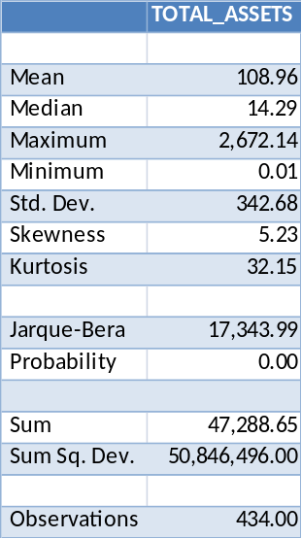

Table 5.1: descriptive statistics of total assets

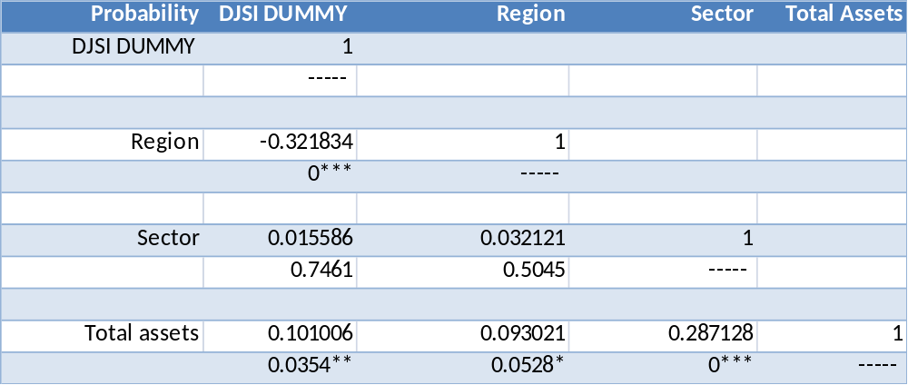

Table 5.2: correlation matrix (*p<0.1, **p<0.05, ***p<0.01)

5.3 Model output and interpretation
The outcome of the first model is presented in table 5.3. The continuous variable total assets is highly (positively) significant indicating that the larger a firm, the more likely it is to implement CSR practices, meaning our results are in agreement with hypothesis 1a. The sector variable is not significant, indicating that the probability of firms implementing CSR practices is not different across clean and dirty sectors leading us to reject hypothesis 1b. The region variable is highly significant and has a negative coefficient value. While the value of the coefficient does not give a clear interpretation of the relationship when using a binary logit model, the sign of the coefficient does have the same interpretation as with an OLS model. In this case the region sign is negative, meaning that North-American firms (reference category) are more likely to implement CSR practices than European firms are.
Dependent Variable: DJSI_DUMMY
Method: ML - Binary Logit (Quadratic hill climbing)
Sample: 1 434
Included observations: 434
Convergence achieved after 3 iterations
Covariance matrix computed using second derivatives
 | Coefficient | Std. Error | z-Statistic | Prob.
C | 0.595237 | 0.162637 | 3.659914 | 0.0003
REGION | -1.407517 | 0.206634 | -6.811627 | 0.0000
SECTOR | -0.062433 | 0.223730 | -0.279057 | 0.7802
TOTAL_ASSETS | 0.000928 | 0.000358 | 2.593011 | 0.0095
McFadden R-squared | 0.090096 | Mean dependent var |  | 0.486175
S.D. dependent var | 0.500386 | S.E. of regression |  | 0.469879
Akaike info criterion | 1.279132 | Sum squared resid |  | 94.93810
Schwarz criterion | 1.316671 | Log likelihood |  | -273.5716
Hannan-Quinn criter. | 1.293950 | Restr. log likelihood |  | -300.6600
LR statistic | 54.17668 | Avg. log likelihood |  | -0.630349
Prob(LR statistic) | 0.000000
Obs with Dep=0 | 223 | Total obs |  | 434
Obs with Dep=1 | 211
Table 5.3: EViews output of the Logistic regression for model 1
Since the marginal effects are not obtained as straightforwardly in the binary logit model and vary over different values of the explanatory variables, table 5.4 gives the output of the mean marginal effect. Note that the scale factor here is calculated using the part $\frac{1}{n}P\left[y_{i}=1\right](1-P\left[y_{i}=1\right])$ in formula 4.6

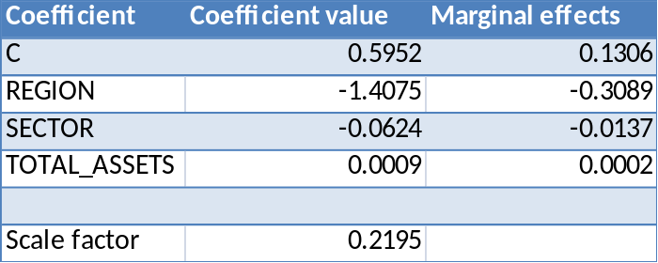

Table 5.4: marginal effects of model 1
Because the sector variable is not significant the emphasis is put on the region variable. This variable has a marginal effect of -0.31 which means that for an average firm the probability of being listed on the DJSI is decreased by 0.31 when comparing North-American versus European firms. This is a clear sign that on average North-American firms are far more likely to engage in CSR than European firms. Furthermore the marginal effect for the variable total assets show that a increase of one billion USD in total assets increases the probability of being listed on the DJSI by 0.0002 holding all other variables constant.
Despite the above calculation of the marginal effects being valid for continuous as well as dummy variables, many econometric literatures (Heij et al., 2004) show that another method is often used when it comes to calculating these effects for dummy variables. Formula 4.7 shows this method and when using it the marginal effects for the region variable decreases from -0.31 to -0.34, meaning that when comparing an average North-American and European firm the latter has a probability of being listed on the DJSI that is 0.34 less than the former.

Equation: EQ01
Success cutoff: C = 0.5
 | Estimated Equation
 | Dep=0 | Dep=1 | Total
P(Dep=1)<=C | 147 | 68 | 215
P(Dep=1)>C | 76 | 143 | 219
Total | 223 | 211 | 434
Correct | 147 | 143 | 290
% Correct | 65.92 | 67.77 | 66.82
% Incorrect | 34.08 | 32.23 | 33.18
Total Gain* | -34.08 | 67.77 | 15.44
Percent Gain** | NA | 67.77 | 31.75
Table 5.5: Expectation-Prediction-Evaluation output of model 1

When analyzing the predictive quality of this model the Expectation-Prediction-Evaluation table 5.5 shows that it is at correctly predicting the firms listed on the DJSI (with a hit-rate of 67.77%), but a bit less good at predicting the firms not listed on the DJSI (with a hit-rate of 65.92%). The overall hit-rate is 66.82% which is higher than the random hit-rate of around 50%. In order to test whether this model is significantly better at predicting whether or not a firm is listed on DJSI than a random selection, a test is performed using the test-statistic defined in formula 4.9 The value of the test-statistic is 7.59 which is highly significant. This outcome shows that this model is better at predicting the outcomes than would be achieved by random predictions.
Finally the likelihood ratio test on joint parameter restrictions has a test-statistic of 54.1 with a P-value of 0.000, indicating that the overall goodness of fit for this model is good, despite the relatively low value of the McFadden R-squared of 0.09. This is a very typical combination (high statistical significance and relatively low fit) for models that explain individual behaviour. This indicates that the model would not be able to correctly describe individual cases, but that it gives a good insight into the overall pattern.

Another relevant measure is analyzing the relative preference of option 1 (listed on the DJSI) versus option 0 (not listed at DJSI) as given in formula 4.8

Graph 5.1: estimated odds ratio of North-American firms against firm size (total assets in billions USD) of model 1.
The graph above clearly shows that for bigger North-American firms the probability of being listed on the DJSI increases. For firms with total assets of around 2 trillion USD the probability of being listed is around 10 times greater than the probability of not being listed.

Graph 5.2: estimated odds ratio of European firms against firm size (total assets in billions USD) of model 1.

When analyzing the odds ratios of European firms in graph 5.2, it is very clear that for European firms the probability of being listed on the DJSI also increases. For firms with total assets of around 2 trillion USD the probability of being listed is around 2.5 times greater than the probability of not being listed. What is interesting to note is that the odds ratios for European firms are smaller than those of North-American firms. The marginal effects already showed that on average North-American firms are more likely to be listed on the DJSI than European firms. The odds ratio graphs give a clearer picture of the differences.
Finally another interesting point to note is that the probability of being listed against not being listed is equal for European firms with total assets worth around 1 trillion USD.

Model 2 examines the possible presence of an interaction effect between the variables region and total assets. Table 5.6 below shows that this interaction variable is not significant. Furthermore the variable total assets itself is no longer significant anymore. This leads to the conclusion that there is no presence of an interaction effect between region and total assets.

Dependent Variable: DJSI_DUMMY
Method: ML - Binary Logit (Quadratic hill climbing)
Sample: 1 434
Included observations: 434
Convergence achieved after 4 iterations
Covariance matrix computed using second derivatives
 | Coefficient | Std. Error | z-Statistic | Prob.
C | 0.592172 | 0.168688 | 3.510456 | 0.0004
REGION | -1.402896 | 0.217350 | -6.454544 | 0.0000
SECTOR | -0.063305 | 0.224097 | -0.282490 | 0.7776
TOTAL_ASSETS | 0.000987 | 0.000942 | 1.047448 | 0.2949
REGION*TOTAL_ASSETS | -6.83E-05 | 0.001004 | -0.068058 | 0.9457
McFadden R-squared | 0.090104 | Mean dependent var |  | 0.486175
S.D. dependent var | 0.500386 | S.E. of regression |  | 0.470338
Akaike info criterion | 1.283729 | Sum squared resid |  | 94.90241
Schwarz criterion | 1.330654 | Log likelihood |  | -273.5693
Hannan-Quinn criter. | 1.302251 | Restr. log likelihood |  | -300.6600
LR statistic | 54.18138 | Avg. log likelihood |  | -0.630344
Prob(LR statistic) | 0.000000
Obs with Dep=0 | 223 | Total obs |  | 434
Obs with Dep=1 | 211
Table 5.6: EViews output of the Logistic regression for model 2
Model 3 examines the possibility of a quadratic effect of the continuous variable total assets. Table 5.7 shown below, gives the EViews output of model 3. As was the case in our initial model (model 1), the region and the total assets variables are significant while the sector variable is not. Furthermore the table displays that the quadratic total asset variable is also significant, indicating the presence of a curvilinear relationship between firm size and probability of being listed on the DJSI, which is not in agreement with hypothesis 1a (which states that larger firms have a higher probability of being listed on the DJSI than smaller firms). Since the quadratic variable is negative, this means that firm size has an effect that first increases up to a maximum point and then decreases.

Dependent Variable: DJSI_DUMMY
Method: ML - Binary Logit (Quadratic hill climbing)
Sample: 1 434
Included observations: 434
Convergence achieved after 9 iterations
Covariance matrix computed using second derivatives
 | Coefficient | Std. Error | z-Statistic | Prob.
C | 0.525602 | 0.165540 | 3.175073 | 0.0015
REGION | -1.429184 | 0.209070 | -6.835926 | 0.0000
SECTOR | -0.140469 | 0.227519 | -0.617394 | 0.5370
TOTAL_ASSETS | 0.003363 | 0.001082 | 3.109230 | 0.0019
TOTAL_ASSETS^2 | -1.19E-06 | 4.86E-07 | -2.449110 | 0.0143
McFadden R-squared | 0.100632 | Mean dependent var |  | 0.486175
S.D. dependent var | 0.500386 | S.E. of regression |  | 0.467478
Akaike info criterion | 1.269143 | Sum squared resid |  | 93.75165
Schwarz criterion | 1.316067 | Log likelihood |  | -270.4039
Hannan-Quinn criter. | 1.287665 | Restr. log likelihood |  | -300.6600
LR statistic | 60.51205 | Avg. log likelihood |  | -0.623051
Prob(LR statistic) | 0.000000
Obs with Dep=0 | 223 | Total obs |  | 434
Obs with Dep=1 | 211
Table 5.7: EViews output of the Logistic regression for model 3

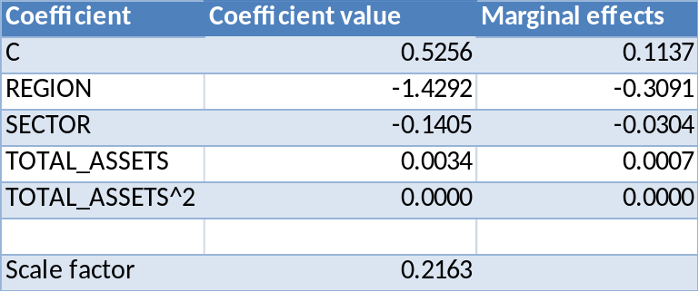

Table 5.8: marginal effects of model 3
Table 5.8 gives an overview of the marginal effects in model 3. Given that the sector variable again is not significant the emphasis is put on the region variable. This variable now has a marginal effect of -0.31 which means that for an average firm the probability of being listed on the DJSI is decreased by 0.31 when comparing North-American versus European firms. Note that this is similar to the marginal effect found for the region variable in the first model where there was no quadratic total assets variable.
When calculating the marginal effect using formula 4.7 the effect decreases to around -0.34 (which is again similar to the value obtained in model 1).

Equation: EQ3
Success cutoff: C = 0.5
 | Estimated Equation
 | Dep=0 | Dep=1 | Total
P(Dep=1)<=C | 142 | 66 | 208
P(Dep=1)>C | 81 | 145 | 226
Total | 223 | 211 | 434
Correct | 142 | 145 | 287
% Correct | 63.68 | 68.72 | 66.13
% Incorrect | 36.32 | 31.28 | 33.87
Total Gain* | -36.32 | 68.72 | 14.75
Percent Gain** | NA | 68.72 | 30.33
Table 5.9: Expectation-Prediction-Evaluation output of model 3
When analyzing the predictive quality of this model the Expectation-Prediction-Evaluation table shows that it is at correctly predicting the firms listed on the DJSI (with a hit-rate of 68.72%), which is somewhat higher than the hit-rate of the first model. The hit-rate for the unlisted firms however is a bit lower than that of the first model (with a hit-rate of 63.68%). The overall hit-rate is 66.13% which is slightly lower than the overall hit-rate of model 1 which was 66.82%. In order to test whether this model is significantly better at predicting whether or not a firm is listed on DJSI than a random selection, we again test this with formula 4.9 The value of the test-statistic is 7.30 which is higher than the critical value of 1.645. This outcome shows that this model is better at predicting the outcomes than would be achieved by random predictions.
The likelihood ratio test on joint parameter restrictions has a test-statistic of 60.51 with a P-value of 0.000, indicating that the overall goodness of fit for this model is good, despite the relatively low value of the McFadden R-squared of 0.10 (which is slightly higher than the R-squared obtained in model 1).

The odds ratios of model three are shown below for North-American firms. We can see a clear difference between the odds ratios when comparing them with the first model.
The graph shows a curvilinear relationship being present. The probability of being listed on the DJSI increases up to a maximum of around 12 (for firms with total assets of around 2 trillion USD), after which the odds ratios decrease again. This shows that firm size has a positive impact on the probability of implementing CSR measures, up to a certain size. After that, firms are still more likely to be engaged in CSR than not, however the probability decreases.

Graph 5.3: estimated odds ratio of North-American firms against firm size (total assets in billions USD) of model 3.
When analyzing the odds ratios of European firms in graph 5.4 an even clearer curvilinear relationship can be seen. For bigger European firms the probability of being listed on the DJSI also increases until it reaches a maximum odds ratio of around 3.7, after which the odds ratio decreases again. Note that for firms who have total assets over 2.5 trillion USD, the odds ratio is below 1, indicating that for these very large firms the probability of being listed on the DJSI is smaller than the probability of not being listed on the DJSI.

Graph 5.4: estimated odds ratio of European firms against firm size (total assets in billions USD) of model 3.

6 Conclusion
This thesis examined the characteristics of firms implementing CSR measures against those that do not implement CSR measures. Listing on the Dow Jones Sustainability Index was used as a proxy for implementing CSR measures.

The outcome of the empirical analysis showed that there is a curvilinear relationship between firm size and probability of being listed on the DJSI. Initially a positive relationship can be found between firm size and the probability of a DJSI listing. After a certain point however, the probability does not increase anymore (North-America), or even declines to a point where it is more likely for very large firms to not be listed on the DJSI than it is to be listed (Europe).
This finding is in contrast with the first hypothesis formulated, which stated that firm size would have a positive effect on the probability of being listed on the DJSI.

Furthermore this thesis did not find any relationship between the sector that a firm operates in and the probability of being listed on the DJSI, thus the second hypothesis did not hold.
All the models showed that the region variable was (negatively) significant, meaning that the North-American firms are more likely to be listed on the DJSI than European firms. The marginal effect of the region variable was -0.31 or -0.34 (depending on the manner in which this effect is calculated), meaning that when comparing an average North-American and European firm the probability of being listed on the DJSI decreases with about one-third.
Furthermore diagnostic tests revealed that the models have a good predictive quality. The percentage of correct predictions for the models is about two-third, with the percentage of correct predictions being slightly higher for firms listed on the DJSI than for firms unlisted.

6.1 Limitations and suggestions for further research
Despite this thesis having extensively examined and compared the characteristics of firms listed on the DJSI against those not listed on the DJSI, there are several limitations.
First the usage of DJSI listing is used as a proxy for implementing CSR measures is far too narrow. Firms are split into two categories and the presumption that those not listed are not implanting CSR measures is too restricted. Despite the point that being listed on the Dow Jones Sustainability Index requires firms to give a detailed overview of their economic, social and environmental practices, there is no distinction made within the groups and the data used in this thesis does not take into account possible differences within the two subgroups when it comes to CSR implementation.
Future research could be conducted where there is an ordering in the data regarding implementation of CSR measures. When there is a limited scale of possible rankings of CSR score (e.g. very high, high, low, very low), the results would give more insight into the effects of CSR implementation and different performances regarding CSR.

Furthermore using a firms total assets as an indication of firm size could be biased. While a study by Orlitzky et al. (2003) found a higher correlation between corporate social performance and corporate financial performance when using accounting-based measures, this does not indicate the presence of a high correlation between firm size and corporate social performance using accounting-based measures. Measuring firm size by using finance-based variables (e.g. market capitalisation), could have led to other conclusions.

Another limitation is that this thesis examines the characteristics of firms listed on the DJSI against those unlisted on the DJSI for North-America and Europe only. With the rise of emerging markets like China, India and Brazil, future research should take these regions into account and analyse whether there are differences in CSR implementation.

Finally while this thesis did not find the sector variable to be significant, this could have been due to the narrow and subjective distinction between “clean” and “dirty” sectors. Future research should carefully examine how best to handle differences over sectors.

REFERENCES
Aaronson, S.A. (2003), Corporate social responsibility in the global village: The British role model and the American laggard, Business and Society Review, Vol. 108, No. 3, pp. 309–38, 2003
Barnett, M.L. and Salomon, R.M. (2006), Beyond dichotomy: the curvilinear relationship between social responsibility and financial performance, Strategic Management Journal, 29(11): 1101-1122
Botosan, C.A. (2000), Evidence that greater disclosure lowers the cost of equity capital, Journal of Applied Corporate Finance, 12(4): 60-69
Brammer, S., C. Brooks and S. Pavelin, (2005), Corporate social performance and stock returns: UK evidence from disaggregate measures Financial Management 35, 97-116
Brown, N., Deegan, C. (1998), The public disclosure of environmental performance information – a dual test of media agenda setting theory and legitimacy theory", Accounting & Business Research, Vol. 3 No.21, pp.21-41
Brundtland, G.H. (1987), Our Common Future: Report of the World Commission on Environment and Development: Oxford University Press
Cramer, J.S. (2003): Logit models from economics and other fields, 3rd ed, Cambridge University Press
Cramer, J.S., Franses, P.H. and E. Slagter (1999), Censored regression analysis in large samples with many zero observations, Econometric Institute Report 9939/A, Erasmus University Rotterdam
Dougherty, C. (2007): Introduction to econometrics, 3rd ed, Oxford University Press
European Commission (2010), Promoting a European framework for corporate social responsibility, Green paper 264, Final, Brussels
Fortanier, F. & Kolk, A. (2007), Internationalization and environmental disclosure. Paper for the Academy of International Business annual conference, Indianapolis

Franses, P.H. and R. Paap (2001): Quantitative models in marketing research, 1st ed, Cambridge University Press
Freeman, R.E. (1984): Strategic management: A stakeholder approach, 1st ed, Cambridge University Press
Friedman, M. (1970) “The social responsibility of business is to increase its profits.” New York Times Magazine, September 13:32-33, 122, 124, 126
Heij, C., De Boer, P., Franses, P.H., Kloek, T., and H.K. Van Dijk (2004): Econometric Methods with Applications in Business and Economics, Oxford University Press
Husted, B.W., de Jesus Salazar, J. (2006), Taking Friedman seriously: Maximizing profits and social performance, Journal of Management Studies, 43(1): 75-91
Kristoffersen I., Gerrans, P. and M.C. Clark-Murphy (2005), The corporate social responsibility and the theory of the firm, School of Accounting, Finance and Economics & FIMARC Working Paper Series, Edith Cowan University Working Paper 0505
Maas, K.E.H. (2009), Corporate Social Performance: from output measurement to impact measurement, Erasmus University Rotterdam (197 pag.), Erasmus Research Institute of Management (PhD Serie 182)
Margolish, J.D, Elfenbein, H.A., Walsh, J.P. (2007), Does it pay to be good? A meta-analysis and redirection of research on the relationship between corporate social and financial performance, Working Paper, Ross School of Business - University of Michigan
McWilliams, A., and D. Siegel (2000), Corporate social responsibility and financial performance: Correlation or misspecification? Strategic Management Journal, 21 (5): 603-609
Meek, G., Roberts, C. and S. Gray, Factors influencing voluntarily annual report disclosure by U.S., U.K., and continental European multinational corporations, Journal of International Business Studies, v. 26, p. 555-572, 1995
Orlitzky, M., Schmidt F.L., Rynes S.L. (2003), Corporate social and financial performance: A meta-analysis, Organization Studies, 24(3): 403-441
PricewaterhouseCoopers LLP (2010), CSR Trends in 2010: Stacking up the results
Seifert, B., Morris, S.A., Bartkus, B.R. (2003), Comparing big givers and small givers: Financial correlates of corporate philanthropy. Journal of Business Ethics, 45(3): 195-211
Sustainable Investment Research Analysis Network (2010), S&P 100 Sustainability Reporting Comparison
Tsoutsoura, M. (2004), Corporate social responsibility and financial performance. Haas School of Business, University of California at Berkeley
Waddock, S. A., and Samuel B. Graves (1997), The corporate social performance-financial performance link. Strategic Management Journal, 18 (4):303-319
Wooldridge, J.M. (2002): Econometric analysis of cross section and panel data, 1st ed, MIT Press ltd.
Wood, D. J. (2010), Measuring corporate social performance: A review. International Journal of Management Reviews, Vol. 12, Issue 1, pp. 50-84

APPENDIX
A
Data set

DJSI listed North-American firms


DJSI listed North-American firms continued


DJSI listed North-American firms continued

DJSI listed European firms
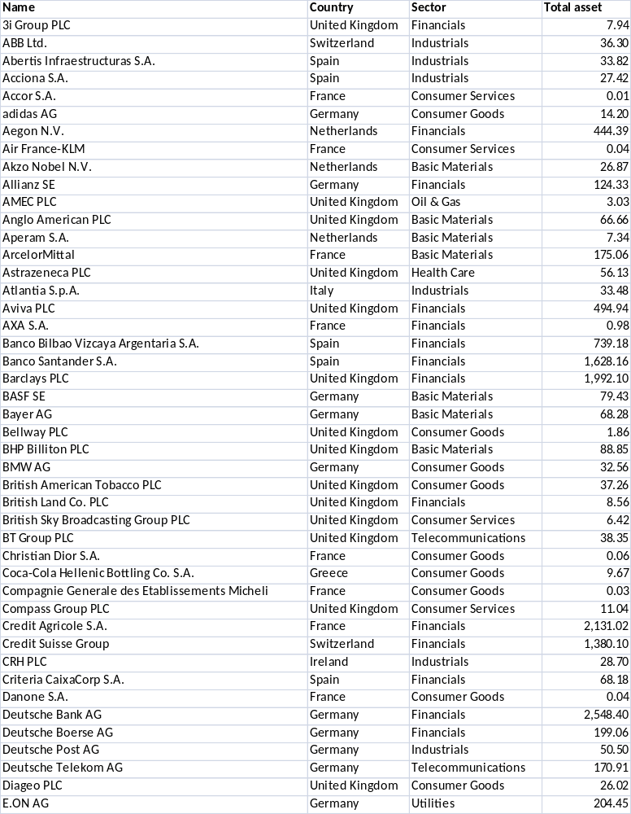

DJSI listed European firms continued
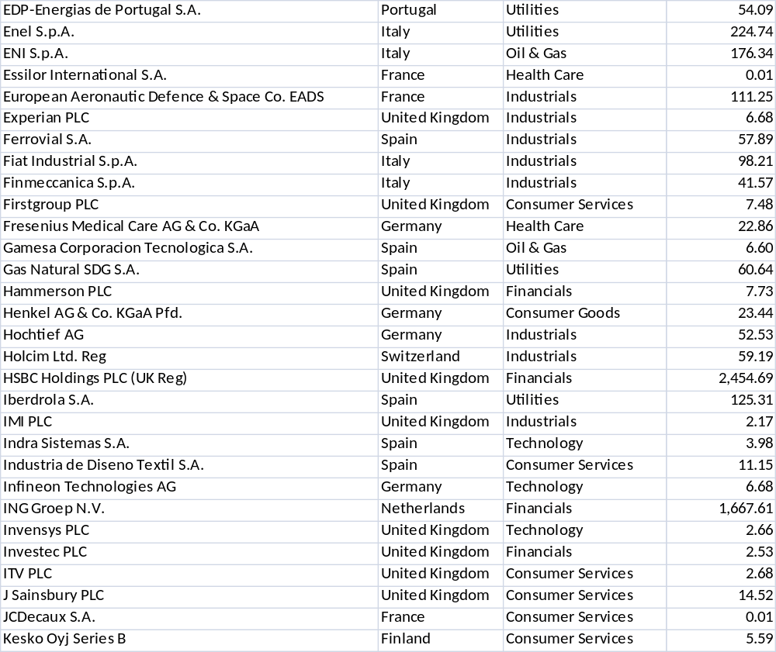

Non-DJSI listed North-American firms
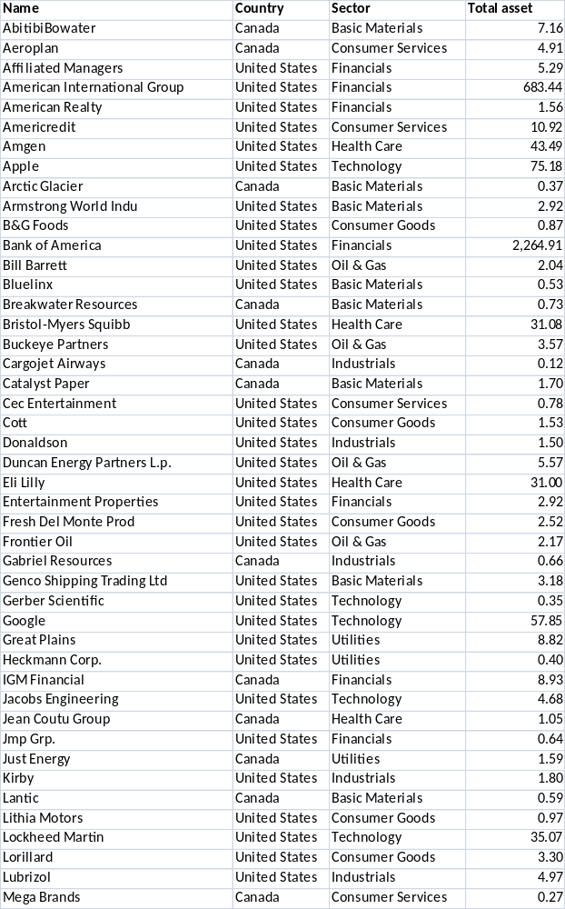

Non-DJSI listed North-American firms continued
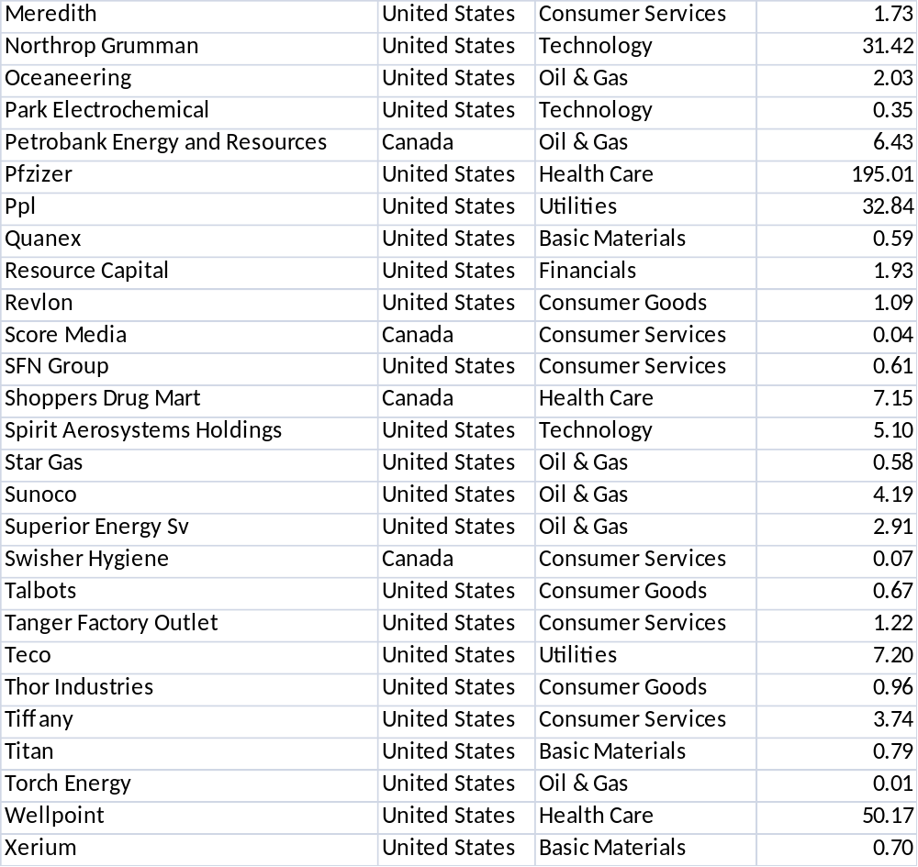

Non-DJSI listed European firms
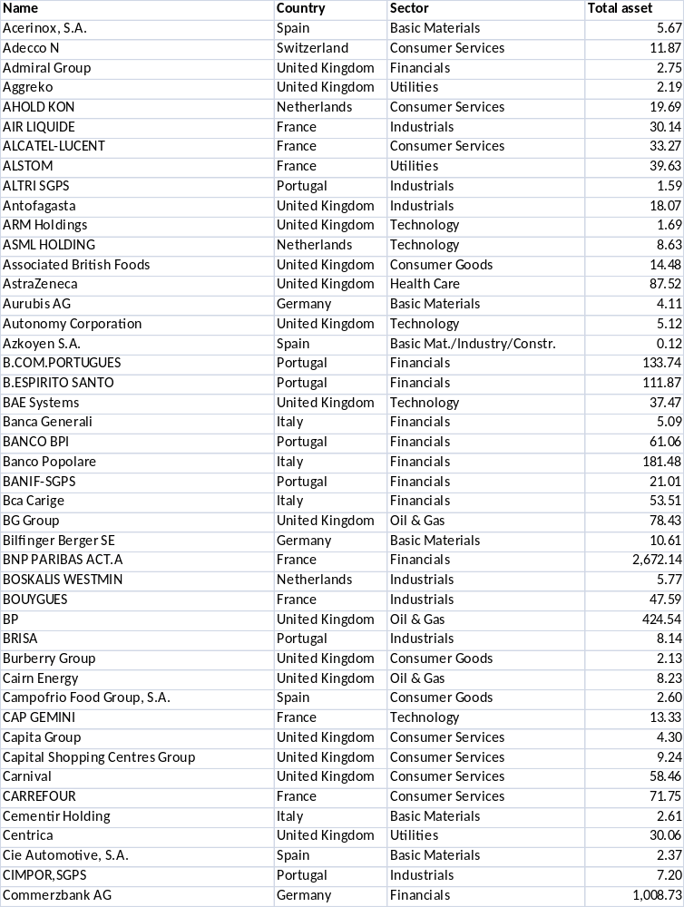

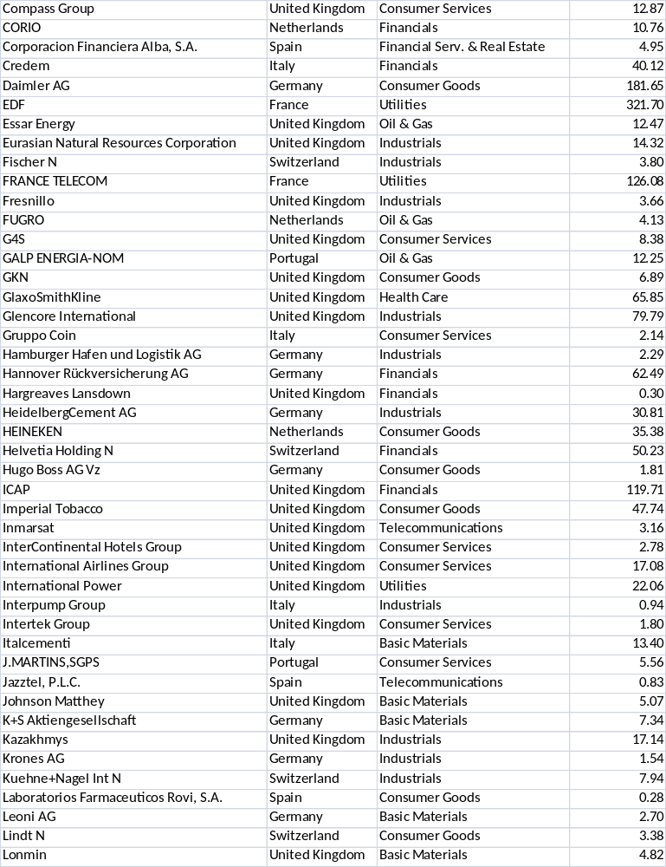
Non-DJSI listed European firms continued

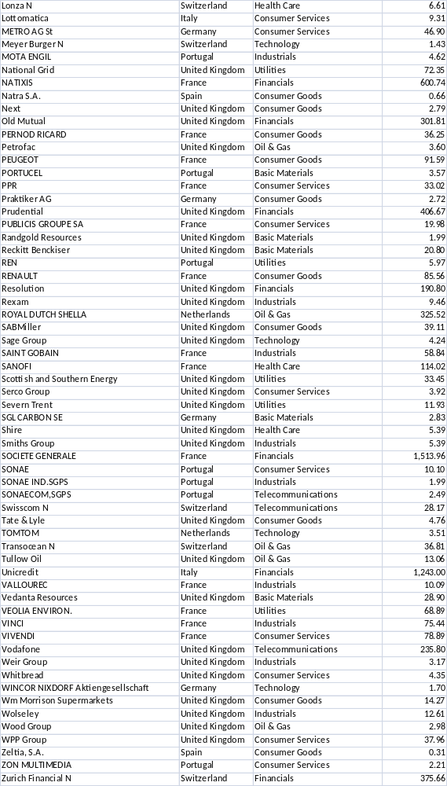
Non-DJSI listed European firms continued

B
Derivations
There are many cases where the population can chose two possible outcomes and the number of one is relatively small in comparison to the other. In order to limit the database, a fraction $f_{1}$ of the observations with outcome $y_{i}=1$ and a fraction $f_{1}f_{2}$ of the observations with outcome $y_{i}=0$ is selected. If $z_{i}=1$is the selection variable for selected observations in the smaller sample and $z_{i}=0$if the observations are deleted then it can be shown that the sample probability $p_{i}^{s}=P[y_{i}=1|z_{i}=1]$ can be rewritten as $\frac{p_{i}}{p_{i}+f_{2}(1-p_{i})}$
$$P\left[y_{i}=1 | z_{i}=1\right]=\frac{P(y_{i}=1,z_{i}=1)}{P(z_{i}=1)}=\frac{P\left(z_{i}=1 | y_{i}=1\right)P(y_{i}=1)}{P(z_{i}=1)}=\frac{f_{1}p_{i}}{P(z_{i}=1)}$$
$$=\frac{f_{1}p_{i}}{P(z_{i}=1,y_{i}=1)+P(z_{i}=1,y_{i}=0)}=\frac{f_{1}p_{i}}{f_{1}p_{i}+f_{1}{f_{2}(1-p}_{i})}=\frac{p_{i}}{p_{i}+f_{2}(1-p_{i})}$$
To examine the effect this has on the parameter estimates we insert $p_{i}=F\left(x_{i}^{'}β\right)=\frac{1}{1+e^{\left(-x_{i}^{'}β\right)}}$ which gives us
$$\frac{\frac{1}{1+e^{\left(-x_{i}^{'}β\right)}}}{\frac{1}{1+e^{\left(-x_{i}^{'}β\right)}}+f_{2}(1-\frac{1}{1+e^{\left(-x_{i}^{'}β\right)}})}=\frac{\frac{1}{1+e^{\left(-x_{i}^{'}β\right)}}}{\frac{1}{1+e^{\left(-x_{i}^{'}β\right)}}+\frac{f_{2}e^{\left(-x_{i}^{'}β\right)}}{1+e^{\left(-x_{i}^{'}β\right)}}}$$
$$=\frac{\frac{1}{1+e^{\left(-x_{i}^{'}β\right)}}}{\frac{1+f_{2}e^{\left(-x_{i}^{'}β\right)}}{1+e^{\left(-x_{i}^{'}β\right)}}}=\frac{1}{1+{f_{2}e}^{\left(-x_{i}^{'}β\right)}}=\frac{1}{1+{e^{log⁡(f_{2})}e}^{\left(-x_{i}^{'}β\right)}}=\frac{1}{1+e^{\left(-x_{i}^{'}β\right)+log⁡(f_{2})⁡}}$$
$$=\frac{1}{1+e^{-(β_{0}-log\left(f_{2}\right)+β_{1}x_{1}+…+β_{k}x_{k})⁡}}$$
So deleting part of our initial sample only has an effect on our constant. We must subtract the log of the fraction that we keep in our sample in order to get the correct probabilities. Note however that this has no impact on the marginal effects

See Appendix B for a full derivation
Taking the derivative of $y_{i}$with respect to $x_{i}$will give the coefficient $β$as the value of the marginal effect.

