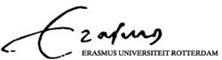

international bachelor for economics and business economics
erasmus university rotterdam
department of economics

The Effect of the Oil Price Volatility on the US Stock Market
Bachelor Thesis

Olivia Prajitno
321697

1-8-2011

Supervisor: Mehtap Kilic MSc. LLM

This paper focuses on determining the relationship between oil price volatility and economic variables. Interest rates, oil prices, industrial production, and real stock returns for US from January 1987 until May 2011 are used in this analysis. The paper of Sadorksy (1999) already did an investigation and they focused on the impact of oil price shocks on the real stock return. Our findings are overall in agreement with his and we find that the oil price shocks have a negative impact on the real stock return.

Table of Contents

- Introduction..........................................................................................................................3
- Theoretical Framework.........................................................................................................5
- Data......................................................................................................................................7
- Methodology
  - Unit Root Test................................................................................................................8
  - Cointegration..................................................................................................................9
  - GARCH model..............................................................................................................12
  - Vector Autoregressive Model.......................................................................................13
- Results and Interpretation
  - Unit Root Test..............................................................................................................15
  - Cointegration...................................................................................................................16
  - GARCH model.............................................................................................................17
  - Vector Autoregressive Model.........................................................................................20
    - Variance Decomposition...................................................................................21
    - Impulse Responses.............................................................................................22
- Conclusion and Discussion.................................................................................................29
- Bibliography.......................................................................................................................30
- Appendix............................................................................................................................32

Introduction

Being one of the most important commodities, the oil existence is crucial for the world’s economy. Therefore, a change in the price of oil has a significant and large impact on the economy. As illustrated in figure 1, oil prices began to rise steeply in the beginning of 1970s. From 1973 until 1974, oil price increased by 70% which is caused by the oil embargo proclaimed by Organization of Arab Petroleum Exporting Countries (OAPEC). The shock happened again in 1979 because of the Iranian Revolution and reached its peak in 1980. Afterwards, the world oil price started to fall which is due to worse economic activity caused by the previous oil price shocks. From 1986 to 2000, the oil price was beginning to adjust and there were only soft fluctuations. Nevertheless, the price rose sharply by 298% in six years starting 2001 until it reached the peak in 2008.
Figure 1: History of Oil Price

Source: British Petroleum Statistical Review
A high variation of the oil price, in other words the sharp decreases and increases in price, can be seen as high price volatility. This high volatility makes oil one of the major macro-economic factors which create an unstable economic condition for countries around the world. Oil price volatility has an impact on both oil-exporting and oil-importing countries. For oil-importing countries, an increase in the oil prices influences their economy negatively. When the price rises, they will experience harmful impacts such as increase in inflation and economic recession (Ferderer, 1996). On the other hand, the oil-exporting countries are positively correlated to the increase in oil prices. However, a decrease in the oil price exhibits a negative relationship with the economic development and it creates some political and social instability. (Yang, Hwang. and Huang, 2002)
Demand and supply are said to be the main reason to trigger the rise in oil price. Demand generally exhibits a positive correlation with the oil price, whereas oil supply is negatively correlated with the movement in the oil price. Energy Information Administration reports that demand for oil increased with an average of 1.76% every year from 1994 to 2006 and is predicted to increase by another 37% until 2030. United States Energy Information (2009) believes that oil demand is divided into four major sectors: transportation, household, industrial, and commercial. Transportation is the biggest sector in consuming oil; United States Bureau of Transportation Statistics (2007) reported this sector accounts for 68.9% of the oil consumed in 2006. Moreover, supply for oil is proofed to be heavily related to the oil production. This is because production capacity determines the limitation of oil supply, and therefore when production decreases, the oil supply will decrease as well.
The purpose of this paper is to explore the dynamic relationship between interest rates, oil prices, industrial production, and real stock returns in US; and more specifically to discover the consequence of the raising oil price on the stock market. The paper of Sadorsky (1999) already investigated this topic and therefore will be the basic guideline for this paper. The results of this paper are mostly in agreement with his, for instance we found oil price shocks have some influence in stock market returns and economic variables, but the relationship cannot be found otherwise.
This empirical paper is constructed as follows: Section two concentrates on the literature over past works regarding oil price volatility. All the data and methodology used are described in section three. This paper employs VAR’s variance decompositions and impulse responses to see the dynamic relationships between the economic variables. All results of the analysis are presented and discussed in section four. Finally, section five concludes the paper.

Theoretical Framework

Initiated by the work of Hamilton (1983), which concluded that positive oil price shocks are a substantial cause for economic recession in the US, many researchers began to analyze the importance of oil price volatility to economic activity. The research of oil price volatility was conducted in many different ways, for example by analyzing the relationship between oil price shocks and stock market as done by Huang et al. (1996), Sadorsky (1999), and Guo and Kliesen (2005) for US, Papapetrou (2001) for Greece, Park and Ratti (2008) for US and 13 European countries, and Cong, Wei, Jiao, and Fan (2008) for China.
Research conducted by Sadorsky (1999) concluded that oil price changes influence the economic activity. More specifically they found that an increase in the oil price is followed by declining stock returns, this is especially true for after the mid 1980s. Papapetrou (2001) and Park and Ratti (2008) came with the same conclusion for Greece and some European countries. Moreover, Guo and Kliesen (2005) concluded that oil price uncertainty has a negative impact on economic activity especially when they included oil price changes. Cong, Wei, Jiao, and Fan (2008) did not find any statistical significant results at 5 percent level, however they noted that some “important” shocks to oil prices do have a negative impact on the stock market. On the other hand, work by Huang et al. (1996) came to a different conclusion. Results revealed that the oil future price does not play any role in determining the stock returns.
A recent contribution is also done by Rafiq, Salim, and Bloch (2009) for Thailand. This research is quite unusual since research concerning the relationship of oil price volatility and economic activity is rarely done for developing countries. This is usually due to the limited amount of reliable data and the lack of dependence these countries have on oil. The results concluded that oil price volatility has influence in the short time horizon and it has a big impact on investment and unemployment rate. These results support the theory that oil price volatility has a negative impact on investments, which in turn increases the unemployment rate.
Moreover, recent studies also tried to forecast the volatility of oil price. One of these studies is conducted by Kang, Kang, and Yoon (2009). They argued that it is very important to forecast the oil price volatility because oil price shocks plays an important role in explaining the reason for the recent adverse macroeconomic influence on industrial production, employment, and prices in most countries. They compared four models in order to find the best model for forecasting, which were GARCH, IGARCH, CGARCH, and FIGARCH. They concluded that both CGARCH and FIGARCH are the better models to forecast the oil price volatility because they can capture the persistence that GARCH and IGARCH are not able to do.
Moreover, Narayan and Narayan (2007) argued the literature regarding the modeling of oil price volatility is not sufficient enough, for instance there has been no research conducted using daily data yet. Therefore, by employing EGARCH model, they modeled the daily data of crude oil prices and concluded that shocks influence volatility permanently and asymmetrically over a long term period. Permanent effect implies oil prices are highly volatile over short run period and therefore it is very important for investors to notice this behavior. Asymmetric effect indicates that positive shocks affect oil price differently than negative shocks.
A research conducted by Burbidge and Harrison (1984) investigated the influence of the steep increase in oil price in the 1970s on the economies of five OECD countries which are US, Japan, Germany, England, and Canada. The impulse responses analysis revealed that positive shocks on oil price have a significant effect on the price level in both US and Canada, and on industrial output for both England and US. Burbidge and Harrison also implemented historical decompositions to investigate the consequences of the rising oil prices and they concluded that two different periods of time generated significantly different impacts. From 1973 to 1974, oil price shocks generate a significant effect for all five OECD countries, whereas from 1979 to 1980, an increase in oil prices has a significant effect only on Japan.
In addition, the paper of Heriques and Sadorsky (2011) related oil price volatility with investment. Early work by Bernanke (1983) found that during a high volatility of oil price, firms find that waiting for new information is the best investment behavior. Even though waiting can result in losses for the firm (since they lose opportunities), it is still often in the best interest for the firm to wait since it could sometimes help firms make the right investment decision. Inspired by Bernanke (1983), Heriques and Sadorsky employed panel data sets and found a U shape relationship between oil price and investment.

Data

This empirical paper replicates the paper written by Sadorsky (1999) by using monthly data with the sample covers from January 1987 until May 2011 and has a total of 293 observations. The variables used are the natural logarithms of industrial production (to measure output), three-month T-bill rate, real oil prices, and real stock returns for United States denoted as lip, lr, lo, and rsr respectively. All data are obtained from Datastream. Lo and rsr are calculated by the following equation:
$$Real oil prices=\frac{Producer price index of fuels}{Consumer price index} *100$$
$$Real stock returns=∆\left(S\&P Stock price index\right)-∆\left(Consumer price index\right)$$
Both producer price index and consumer price index are obtained from Datastream as well, and ∆ means the difference between today’s price and last month’s price. The summary of the series is presented in table 1:
Table 1: Series’ descriptive analysis
 | lip | lo | lr | rsr
Mean | 4.368 | 4.570 | 0.996 | 2.745
Median | 4.451 | 4.569 | 1.515 | 5.401
Std. Deviation | 0.181 | 0.216 | 1.178 | 36.482
Skewness | -0.386 | 0.001 | -1.802 | -1.256
Kurtosis | 1.568 | 3.763 | 5.391 | 8.663
Jarcque-Bera | 32.319 | 7.116 | 228.331 | 467.002
Source: Eviews
Table 1 reports all series except lo exhibit negative skewness, which indicates that the series have an asymmetric distribution with a longer left tail. Moreover, most observations of the series take a value centered at the right side of the mean (possibly including the median). Every variable has a relatively high kurtosis compared to the normal value which is three and very high Jarcque-Bera test statistics which strongly suggest a rejection of normality.

Methodology

  - Unit Root Test
A time series is said to be stationary when it has constant mean and variance over time, and the covariance between two variables does not depend on the actual observed time, but rather on their lag length of time. Consider a simple auto-regression model of order one:
$$y_{t}=ρy_{t-1}+ε_{t}$$
Where ρ is the parameter to be estimated and $ε_{t}$ is an independent error with zero mean and constant variance. The model is said to have a property of stationary when the absolute parameter, |ρ|, is smaller than one. For the special case when |ρ|= 1, the series is not stationary and it is called a random walk class of models:
$$y_{t}=y_{t-1}+ε_{t}$$
The above equation is known as a random walk model because this time series appears to wander upward or downward unpredictably. In comparison with stationary variables, a random walk series has constant mean but has an increasing value of variance that will eventually become infinite. This behavior implies that even though the mean is constant, the series might not return to its mean. In other words, the behavior indicates that the sample means will not be the same unless it is taken from the same period. There are two forms of random walk, random walk with drift $(y_{t}=α+y_{t-1}+ε_{t})$ and random walk with drift and a time trend$(y_{t}=α+δt+y_{t-1}+ε_{t})$.
There are many tests available to determine whether the series is a stationary or non-stationary, but the most common test used is the Dickey-Fuller test. The test is basically focuses on determining value ρ, whether it is equal to one, or it is less than one. Dickey-Fuller model can be acquired by subtracting $y_{t-1}$ from the auto-regression model:
$$∆y_{t}=γy_{t-1}+ε_{t}$$
where $γ = ρ-1$ and $∆y_{t}=y_{t}-y_{t-1}$. The hypotheses are as follows:
$Ho:$ The series is non-stationary or contain a unit root: $γ=0$
$Ha:$ The series is stationary: $γ<0$
Unfortunately, the Dickey-Fuller test does not allow for autocorrelation in the error term. Such autocorrelation seems to occur more for the higher level of lag in order to capture the full dynamic nature of the process. Thus, an extension of the Dickey-Fuller test is introduced and referred as the Augmented Dickey-Fuller (ADF) test:
$$∆y_{t}=α+γy_{t-1}+\sum_{l}^{n}{a_{l}{∆y}_{t-l}}+ε_{t}$$
In above equation, lagged first difference terms of the dependent variables are added in order to assure no autocorrelation contained in the residuals. The hypotheses of this test are the same as the hypothesis used by Dickey-Fuller test.
Furthermore, there is one more unit root test that is commonly used to support the ADF test, namely the Kwiatkowski–Phillips–Schmidt–Shin (KPSS) test. This test is most likely the same as ADF, but there is one substantial difference which is its hypotheses. The hypotheses employed by the KPSS test are exactly the opposite of ADF test. Thus, the KPSS test hypotheses are:
$H_{0}:$ The series is stationary
$H_{a}:$ The series has a unit root or non-stationary
This empirical paper will employ ADF test as well as KPSS test to support the results, with Schwarz Information Criterion to determine the lag.

  - Cointegration
Relation between variables is said to be cointegrated when they exhibit a stationary linear combination, even though the individual variables are non-stationary. Cointegrating relationship may be seen as a long run equilibrium phenomenon due to the influences that appear in the long run even if the variables are independent in the short run.
This paper employs the techniques developed by Johansen (1988, 1991) to test for the cointegration. First, suppose a set of n non-stationary variables and consider a VAR with k lags:
$$y_{t}=β_{1}y_{t-1}+β_{2}y_{t-2}+…+β_{k}y_{t-k}+ϵ_{t}$$
where y is an $n×1$ vector variables, β is an $n×n$ matrix parameter, and $ϵ_{t}$ is a white noise disturbance.
In order to use the Johansen test, the VAR equation needs to be converted into a vector error correction model (VECM):
$$∆y_{t}=∏y_{t-k}+Г_{1}∆y_{t-1}+Г_{2}∆y_{t-2}+…+ Г_{k-1}∆y_{t-\left(k-1\right)}+ε_{t}$$
where $∏=(\sum_{i=1}^{k}{β_{i})-I_{n}}$ and ${ Г}_{i}=\left(\sum_{j=1}^{i}{β_{j}}\right)-I_{n}$
$I$ is the identity matrix, ∏ is the long run coefficient matrix, and Γ is the short run dynamic. Johansen test focuses on identifying the ∏ matrix by looking at the rank via its eigenvalues (λ). The number of its eigenvalues which are significantly different from zero will determine the rank (r) of matrix (i.e. when the rank is significantly different from zero, it shows that the variables are cointegrated).
Before conducting the Johansen test, it is very important to select for the appropriate lag that can be acquired from the VAR equation. An empirical research by Emerson (2007) shows that the number of lag derived from the VAR equation has a high influence in determining the result of the cointegration test. However, deriving a lag order is quite complicated considering if the lag order is too high, it will confirm that the errors are approximately white noise. And yet, it should be low enough to make an estimation. This paper uses the Akaike information criteria to determine the lag.
Johansen approach consists of two test statistics in order to test for the cointegration, namely the trace test and the maximum eigenvalue test. These tests are formulated as follows:
- Trace test:
$$λ_{trace}\left(r\right)=-T\sum_{i=r+1}^{n}{ln⁡(1-}{\hat{λ}}_{i})$$
A joint test with null and alternative hypothesis of:
$Ho:$ Number of cointegration vectors ≤ r
$Ha$: Number of cointegration vectors > r

- Maximum eigenvalue test:
$$λ_{(r,r+1)}=-T ln(1-{\hat{λ}}_{r+1})$$
A separate test for each eigenvalue with null and alternative hypothesis of:
$Ho:$ Number of cointegration vectors = r
$Ha:$ Number of cointegration vectors = r+1

For both tests, r is the number of cointegrating vectors under the null hypothesis and $\hat{λ}$ is the estimated value for the ith ordered eigenvalue from the ∏ matrix. It is showed from the equations that the larger the$\hat{λ}$, the larger the test statistic will be as a consequence of the larger and more negative the variable$ln(1-{\hat{λ}}_{r+1})$. In addition, a significant cointegrating vectors is showed by a significantly non-zero eigenvalue. The distribution of the test statistics is non-standard with the critical values are provided by Johansen and Juselius (1990), and determined by the value of$n-r$.
Consider an example of maximum eigenvalue test:
$Ho:r=0$ Versus $Ha:0<r≤n$
$Ho:r=1$ Versus $Ha:1<r≤n$
$Ho:r=2$ Versus $Ha:2<r≤n$
:
$Ho:r=n-1$ Versus $Ha:r=n$
The test is conducted in a sequence and when the test statistic is larger than the critical value, the null of there are r cointegrating vectors is rejected. Looking from the example, the first test has a null of no cointegrating vectors and in a case of the null cannot be rejected, it is concluded that there is no cointegration and the test is completed. However, if the null of ∏ has zero rank is rejected; the testing null of $r=1$ will be conducted and so on until the null can no longer be rejected. The ∏ cannot be of full rank (n) since this would imply that the dependent variable $(y_{t})$ is stationary. If$r=0$, it can be concluded that there is no long-run relationship between variables${ y}_{t-1}$. Thus, cointegration exists if the rank of ∏ is between 0 and n (i.e.$0<r<n$ ).
The long run matrix ∏ is divined as$αβ'$. The matrix α is the adjustment parameters that measure each amount of cointegrating vector used in VECM equation and β gives the cointegrating vectors. In addition, unlike Engle-Granger, the method by Johansen allowed for the test for these coefficients.

  - GARCH Model
Generalized Autoregressive Conditional Heteroskedasticity (GARCH) is a model that is mainly used to model volatility. GARCH, introduced by Bollerslev (1986), is a development from ARCH model which has some limitations to capture the dynamic patterns in conditional volatility. Even though ARCH is an applicable model because of its ability to capture time-varying variance (i.e. variance that changes over time), it cannot be used when the parameter is too high due to a possibility of loss in precision. Moreover, due to the difficulty of estimating the parameter, because it is imposed by some restrictions to make sure that the parameter is stationary and positive, a lagged conditional variance is added to the ARCH model to minor the calculation problem. Conditional variance is a one-period future estimation for the variance which is dependent upon its previous lags. The most common model used in GARCH is the GARCH(1,1):
$$σ_{t}^{2}=α_{0}+α_{1}ε_{t-1}^{2}+α_{2}{σ^{2}}_{t-1}$$
The equation above explains that it is possible to interpret the current fitted variance,$σ_{t}^{2}$, as a weighted function of a long term average value, which is dependent on $α_{0}$, the volatility information during the previous period ($α_{1}∙ε_{t-1}^{2})$, and the fitted variance from the model during the first lag($α_{2}∙σ_{t-1}^{2})$. Furthermore, the parameters in this model should satisfy${ α}_{0}>0$,$α_{1}>1$, and $α_{2}$ ≥ 0 in order for $σ_{t}^{2}$ to be ≥ 0.
Additionally, by adding the lagged $ε_{t}^{2}$ terms to both sides of the above equation and moving $σ_{t}^{2}$ to the right-hand side, the GARCH(1,1) model can be rewritten as an ARMA(1,1) process for the squared errors:
$$ε_{t}^{2}= α_{0}+\left(α_{1}+ β_{1}\right)∙ε_{t-1}^{2}+v_{t}- β_{1}∙v_{t-1}$$
where $v_{t}= ε_{t}^{2}- σ_{t}^{2}$.
Supported by ARMA models, GARCH(1,1) is termed stationary in variance as long as $α_{1}+β_{1}<1$. This is the case where the unconditional variance of $ε_{t}$ is constant and given by
$$var\left(ε_{t}\right)= \frac{α_{0}}{1-(α_{1}+β_{1})}$$
The non-stationarity in variance is the case where $α_{1}+β_{1}≥1$ and the unconditional variance of $ε_{t}$ is not defined. Moreover, $α_{1}+β_{1}=1$ is known as a unit root in variance, termed as ‘intergrated GARCH’ or IGARCH.

  - Vector Autoregressive Model (VAR)
In brief, VAR is an econometrics tool that shows the dynamic interrelationship between stationary variables. Thus, VAR is used when the variables are either stationary, or non-stationary and not cointegrated. When the variables are non-stationary and not cointegrated, a VAR in first differences are used in order to determine the interrelation between them. However, if the variables are non-stationary and cointegrated, VEC model is estimated. This paper focuses only on VAR.
VAR is a model which consists only of endogenous variables and allows for the variables to depend not only on its own lags. Consider a case of bivariate VAR which consists of two variables, $y_{1t}$ and${ y}_{2t}$, which each dependent variable depends on the combination of their lags, k, and error terms:
$$y_{1t}={β_{10}+β}_{11}y_{1t-1}+…+β_{1k}y_{1t-k}+α_{11}y_{2t-1}+…+α_{1k}y_{2t-k}+ε_{1t}$$
$$y_{2t}={β_{20}+β}_{21}y_{2t-1}+…+β_{2k}y_{2t-k}+α_{21}y_{1t-1}+…+α_{2k}y_{1t-k}+ε_{2t}$$
where $ϵ_{it}$ is a white noise disturbance with $E(ε_{it})=0, \left(i=1,2\right), E\left(ε_{1t}ε_{2t}\right)=0.$
Moreover, there are two techniques from VAR employed in order to show the statistically significant impacts of each variables on the future values, for example whether the changes of a variable have a positive or negative effect on other variables in the system, namely the VAR’s impulse responses and variance decompositions. In determining both techniques, ordering of the variables plays a very important role.
Impulse responses show how the shocks to any single variable affect the dependent variable in the VAR. More specifically, impulse responses record the size of the impact inflicted by single shocks to the errors to the VAR system. Moreover, $n^{2}$ impulse responses will be generated afterwards for the total of n variables in the system. Impulse responses are achieved by writing VAR as Vector Moving Average (VMA).
Another way to explain the effects of the shocks is to analyze the variance decompositions. Variance decompositions analysis is slightly different with impulse responses in term of how the shocks are applied. It records the effect on dependent variable due to its own shocks against shocks to other variables in the system. Moreover, variance decompositions analysis focuses not only on the movement of the dependent variable, but also on the forecast error variance produced by the shocks which helps to show the sources of the volatility.

Results and Interpretation

  - Unit root test
Before conducting the Augmented Dickey-Fuller test and the Kwiatkowski–Phillips–Schmidt–Shin test, it is important to investigate first whether the series exhibit a trend or not. Based on figure 2, both series LIP and LR show trend and intercept, whereas series LO and RSR include only an intercept.
Figure 2: Time series plot for all economic variables
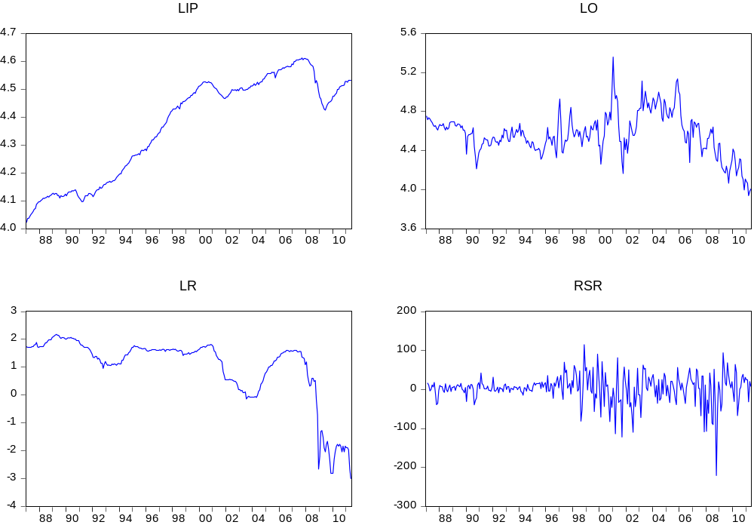
Source: Eviews
The test for unit root is done by employing a Schwarz Information Criterion to determine the automatic lag. The results of ADF and KPSS test are presented in table 2. All KPSS results support the ADF test by rejecting the null hypotheses while ADF cannot reject and vice versa. According to the ADF test in levels, both the variables LO and RSR reject the null of non-stationary. This means that both variables are integrated in order zero. Furthermore, both tests in first differences show that all variables are stationary.
Moreover, the cointegration test is conducted for non-stationary variables to ensure that they are not cointegrated before employing a VAR test. And as showed by the ADF and KPSS test, only LIP and LR will be tested for the cointegration.
Table 2: Unit Root test – Augmented Dickey Fuller and Kwiatkowski-Phillips-Schmidt-Shin Test
 | Augmented Dickey-Fuller Test |  |  | Kwiatkowski-Phillips-Schmidt-Shin
In levels
 | t-statistic | critical value |  | test statistic | critical value
lip | -1.614 | -3.426 |  | 0.349* | 0.146
lo | -3.760* | -2.871 |  | 0.259 | 0.463
lr | -1.130 | -3.425 |  | 0.184* | 0.146
rsr | -14.095* | -2.871 |  | 0.107 | 0.463
In first differences
Δlip | -4.556* |  | -3.426 | 0.073 | 0.146
Δlo | -14.618* |  | -2.871 | 0.175 | 0.463
Δlr | -13.599* |  | -3.425 | 0.097 | 0.146
Δrsr | -11.227* |  | -2.871 | 0.006 | 0.463
(*) denotes rejection of the hypothesis at the 0.05 level
Source: Eviews

  - Cointegration Test
The result of cointegration test between lip and lr is presented in table 3. The lag is eight and is based on Akaike Information Criterion. Results show that both trace test and maximum eigenvalue test indicate no cointegration in 5% level. This implies that the VAR model can be conducted for all variables including Δlip and Δlr, and both variables are not correlated in the long run.

Table 3: Cointegration test for lip and lr using Johansen test
Unrestricted Cointegration Rank Test (Trace)
Hypothesis | Eigenvalue | Trace | 0.05 Critical Value | Probability Value **
None | 0.014652 | 4.590287 | 15.49471 | 0.8507
At most 1 | 0.001402 | 0.398439 | 3.841466 | 0.5279
Unrestricted Cointegration Rank Test (Maximum Eigenvalue)
Hypothesis | Eigenvalue | λ - Max | 0.05 Critical Value | Probability Value**
None | 0.014652 | 4.191848 | 14.2646 | 0.8386
At most 1 | 0.001402 | 0.398439 | 3.841466 | 0.5279
(*) denotes rejection of the hypothesis at the 0.05 level
(**) MacKinnon-Haug-Michelis (1999) p-values
Source: Eviews

  - GARCH Model
Figure 3 shows the time series plot of real oil prices in 24 years. Real oil prices are volatile and reach a peak in 2001. Moreover, the series appears to display a volatility clustering, which means that large changes are followed by large changes as well, and vice versa. For instance the large increase in oil price is followed by large decrease between year 2000 and 2001. Volatility clustering could appear due to information arrivals which impacts prices in such a way that prices move in groups rather than are distributed constantly over time.
Figure 3: Real Oil Prices
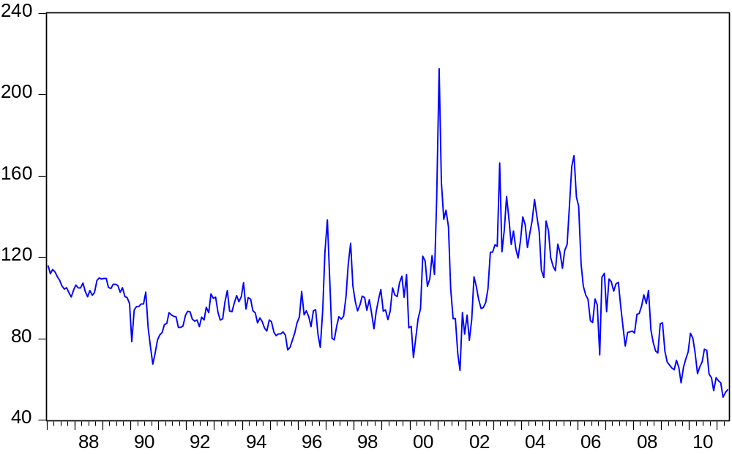
Source: Eviews
Moreover, figure 4 presents the histogram of log real oil prices (lo). The histogram explains that log of real oil prices exhibit a leptokurtosis. Leptokurtosis is a common feature in a financial data that shows that the series tend to have an excess peak at the mean and rather fat tails in the distribution. To be more accurate, the descriptive analysis summarized in table 4 shows a relatively high value of kurtosis. The Jarcque-Bera test indicates a rejection of normality with a p-value of 0.028.
Figure 4: Histogram of lo Table 4: Analysis of lo
Descriptive Analysis
Mean | 4.570
Median | 4.569
Std.Deviation | 0.216
Skewness | 0.001
Kurtosis | 3.764
Jarcque-Bera | 7.116
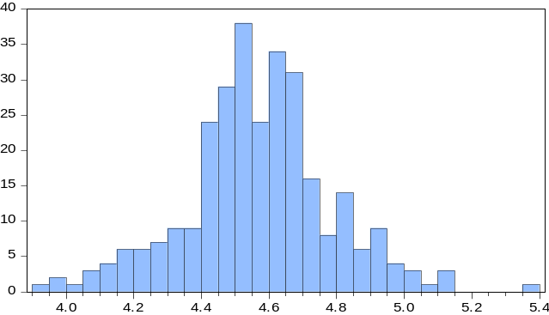
Source: Eviews
Lee et al. (1995) and Ferderer (1996) argue that volatility is a major concern in finance by its role in affecting the economic activity. Volatility, which generally measured by standard deviation, is often used in finance to measure the total risk of asset. In order to capture the features of volatility, this paper employs a low order of GARCH to model lo.
Consider a GARCH(1,1) model:
$${lo}_{1}=β_{0}+β_{1}{lo}_{t-1}+ε_{t}$$
$$σ_{t}^{2}=α_{0}+α_{1}ε_{t-1}^{2}+α_{2}{σ^{2}}_{t-1}$$
Table 5 shows the estimation result from the GARCH(1,1) model. Based on the test, all parameters are significant at five percent level and exhibit a positive value. Parameter$α_{1}$ explains the influence of price at time t-1 to the price at time t, whereas parameter$α_{2}$ points out the effect of the variable at time t-1 on the variable at time t. Both $α_{1}$ and $α_{2}$ combined yields the short term power in determining the oil price. The bigger the value${(α}_{1}+α_{2}≤1)$, the stronger the short term variable becomes. With the sum of 0.992, it is concluded that the long term value plays very little role in determining the oil price. The Ljung-Box Q statistics cannot reject the null hypothesis of no autocorrelation in every lags up to the 24th lag for both standardized residuals and squared standardized residuals. Thus, it can then be concluded that series lo does not contain autocorrelation.
Table 5: GARCH(1,1) estimation result
Parameter | Estimate | Standard Error | Probability value
$$β_{0}$$ | 0.336 | 0.133 | 0.011
$$β_{1}$$ | 0.926 | 0.029 | 0.000
$$α_{0}$$ | 0.000 | 0.000 | 0.000
$$α_{1}$$ | 0.144 | 0.032 | 0.000
$$α_{2}$$ | 0.848 | 0.028 | 0.000
R² = 0.788 S.E.E = 0.100 D.W = 2.006
Ljung-Box Q-statistics (residuals) for autocorrelation:
Q(6): Q-statistics = 3.9205
Probability value = 0.687
Q(12): Q-statistics = 16.673
Probability value = 0.162
Q(24): Q-statistics = 31.686
Probability value = 0.135
Ljung-Box Q statistics (squared residuals) for autocorrelation:
Q(6): Q-statistics = 7.323
Probability value = 0.292
Q(12): Q-statistics = 8.3311
Probability value = 0.759
Q(24): Q-statistics = 15.004
Probability value = 0.921
Source: Eviews

  - VAR
An unrestricted vector-autoregression is generated to explore the significant relationship between interest rates, real oil prices, industrial production, and real stock returns. Table 6 presents the matrix generated from VAR. In VAR, ordering of the endogenous variables and the right length of lag is very essential. Using the Choleski factorization, the interest rates is placed in the first followed by real oil prices, industrial production, and real stock returns. Sadorsky (1999) argued that this way of ordering assumes contemporaneous disturbances do not have any influence over the monetary policy shocks. The same ordering was done by Ferderer (1996), and he claimed that the influence of interest rates on real oil prices can be captured with this ordering. The lag order is four as suggested by Akaike Information Criterion.
The equation used in order to determine VAR for Δlr, lo, Δlip, and rsr is as follows:
$${Δlr}_{t}=β_{1,1}{Δlr}_{t-1}+…+β_{1,4}{Δlr}_{t-4}+β_{1,5}{lo}_{t-1}+…+β_{1,8}{lo}_{t-4}+β_{1,9}{Δlip}_{t-1}+…+β_{1,12}{Δlip}_{t-4}+β_{1,13}{rsr}_{t-1}+…+β_{1,16}{rsr}_{t-4}+β_{1,17}$$
$${lo}_{t}=β_{2,1}{Δlr}_{t-1}+…+β_{2,4}{Δlr}_{t-4}+β_{2,5}{lo}_{t-1}+…+β_{2,8}{lo}_{t-4}+β_{2,9}{Δlip}_{t-1}+…+β_{2,12}{Δlip}_{t-4}+β_{2,13}{rsr}_{t-1}+…+β_{2,16}{rsr}_{t-4}+β_{2,17}$$
$$Δlip=β_{3,1}{Δlr}_{t-1}+…+β_{3,4}{Δlr}_{t-4}+β_{3,5}{lo}_{t-1}+…+β_{3,8}{lo}_{t-4}+β_{3,9}{Δlip}_{t-1}+…+β_{3,12}{Δlip}_{t-4}+β_{3,13}{rsr}_{t-1}+…+β_{3,16}{rsr}_{t-4}+β_{3,17}$$
$${rsr}_{t}=β_{4,1}{Δlr}_{t-1}+…+β_{4,4}{Δlr}_{t-4}+β_{4,5}{lo}_{t-1}+…+β_{4,8}{lo}_{t-4}+β_{4,9}{Δlip}_{t-1}+…+β_{4,12}{Δlip}_{t-4}+β_{4,13}{rsr}_{t-1}+…+β_{4,16}{rsr}_{t-4}+β_{4,17}$$

The results in table 6 clearly indicate a negative relationship between changes in interest rates and real stock returns and a negative relationship to itself for each variable except for changes in industrial production. Moreover, there is a negative correlation from changes in industrial production to real oil prices and from real stock returns to changes in industrial production, but no negative correlation found in the other way around.
Table 6: VAR
 | Δlr | lo | Δlip | rsr
Δlr | -0.198 | 0.051 | 1.050E-04 | -21.764
lo | 0.060 | -0.028 | -0.004 | 50.124
Δlip | 1.132 | 0.620 | 0.097 | -622.775
rsr | -4.260E-04 | 2.040E-04 | 4.350E-06 | -0.019
Source: Eviews
  - Variance Decomposition
The results of the variance decompositions are presented in table 7. The disturbances $ε^{r},ε^{o},ε^{ip},$ and $ε^{rsr}$ denote the shocks to errors of changes in interest rates, real oil prices, changes in industrial production, and real stock returns respectively. The test is done by using Cholesky Decomposition after 24 periods and adding Monte Carlo standard errors of 1000 repetitions as used as well by McCue and Kling (1994). The results explain that for the changes in interest rates variable, the variance decompositions are mainly explained by itself.
For real oil prices variable, own shocks are dominating the variance decomposition. Oil price shocks accounts for 98% whereas other shocks are only about 1%. This argues that US economic variables almost unable to influence oil real oil prices, whereas oil price movements have some impact on US economic variables.
The variance decomposition for variable changes in industrial production is determined mainly by own movement. Stock returns explain for 17% followed by oil prices and interest rates which are 3% and 1% respectively. This result is corresponding with Lee (1992) who argued that movement in changes in industrial production explains 98% of the variance decompositions.
After 24 months, real stock returns shocks account for 90% of the forecast error variance. Three other shocks do not have much influence as they account for less than 5%.
Table 7: Variance Decomposition
 | S.E. | $$ε^{r}$$ | $$ε^{o}$$ | $$ε^{ip}$$ | $$ε^{rsr}$$
Δlr | 0.181 | 73.920 | 4.124 | 12.732 | 9.225
 |  | (4.919) | (2.529) | (3.275) | (2.957)
lo | 0.236 | 0.368 | 98.233 | 0.404 | 0.996
 |  | (1.662) | (5.134) | (2.998) | (2.948)
Δlip | 0.007 | 1.104 | 3.382 | 78.105 | 17.409
 |  | (1.419) | (3.643) | (6.145) | (5.257)
rsr | 37.819 | 1.161 | 4.173 | 4.820 | 89.846
 |  | (1.457) | (2.657) | (2.749) | (3.935)
ᵃ Monte Carlo’s standard errors are shown in parentheses

Source: Eviews

  - Impulse Responses
Figure 5a-d present the results of the Cholesky one standard deviation shocks to each economic variable accommodates by Monte Carlo’s 95% confidence interval to generate the standard error bands for the assurance of the statistical significance of the responses. The impulse responses are generated for 1, 12, and 24 months ahead and to be more precise with the proportion of responses, table 8a-d are generated.
In interest rates shock showed in figure 5a and table 8a, the majority response is acquired from real stock returns for every period, while it has almost no impact on industrial production. This result is corresponding to Sadorsky (1999) who argues that interest rates have a big influence on stock market because of three reasons. Firstly, interest rate is the determinant of the price for the equity that the investors have to pay. The higher the price, the more the investors have to pay and this will influence the stock market activity. Secondly, every movement of interest rates heavily affects the price of financial assets. And thirdly, the increase of the interest rate will lower the stock returns because of the rising cost of margin that discourages investors to speculate. Furthermore, the interest rate shock creates generally a positive effect on oil price. This supports the theory which claims that an increase in interest rate will lead to an increase in price.

Figure 5a: Interest rate shocks
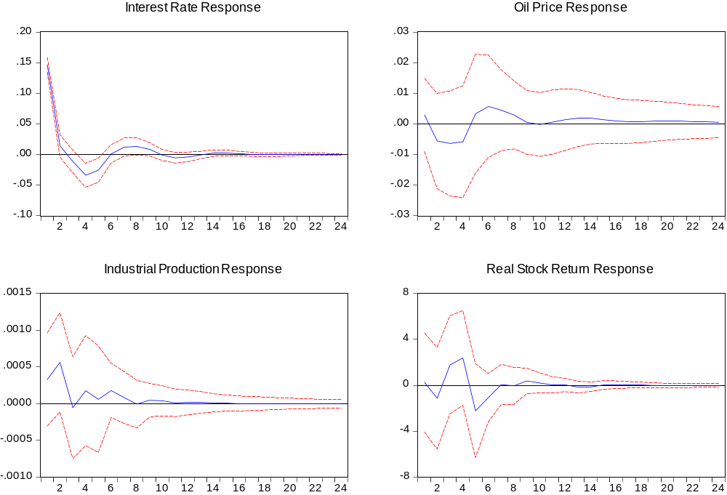
Source: Eviews

Table 8a: Interest rates shocks
$$ε^{lr}$$ |  | Δlr | lo | Δlip | rsr
$$ε^{lr}$$ | 1 | 0.1467 | 0.0029 | 0.0003 | 0.2462
$$ε^{lr}$$ |  | (0.006) | (0.006) | (0.000) | (2.079)
$$ε^{lr}$$ | 12 | -0.0041 | 0.0014 | 0.0000 | 0.0126
$$ε^{lr}$$ |  | (0.004) | (0.005) | (0.000) | (0.291)
$$ε^{lr}$$ | 24 | 0.0001 | 0.0005 | 0.0000 | 0.0008
$$ε^{lr}$$ |  | (0.001) | (0.003) | (0.000) | (0.091)
ᵃ Monte Carlo’s standard errors are shown in parentheses
Source: Eviews

Figure 5b and table 8b shows the response for oil price shocks. Table 8b finds that shocks to oil prices generate a significantly positive real stock return for the first three months, followed by negative impacts further until the 24th period. This result is in accordance with research conducted by Papatrou (2001) for Greece, and Park and Ratti (2008) for US and many European countries. Papatrou discovered that oil price movement is an important component in determining real stock return. Specifically, a positive oil price shock will create a negative impact on real stock return. Moreover, oil price shocks generate very little positive impact on industrial production for a third of the periods and a negative minor impact for the rest of the period. The negative impact is in line with research conducted by Uri (1996). Uri found that positive oil price shocks will lower the industrial production because of the increasing price that causes the production costs to increase as well. This condition will force industries to decrease the size of production. In addition, the shocks have insignificant influence on interest rates.
Figure 5b: Oil price shocks
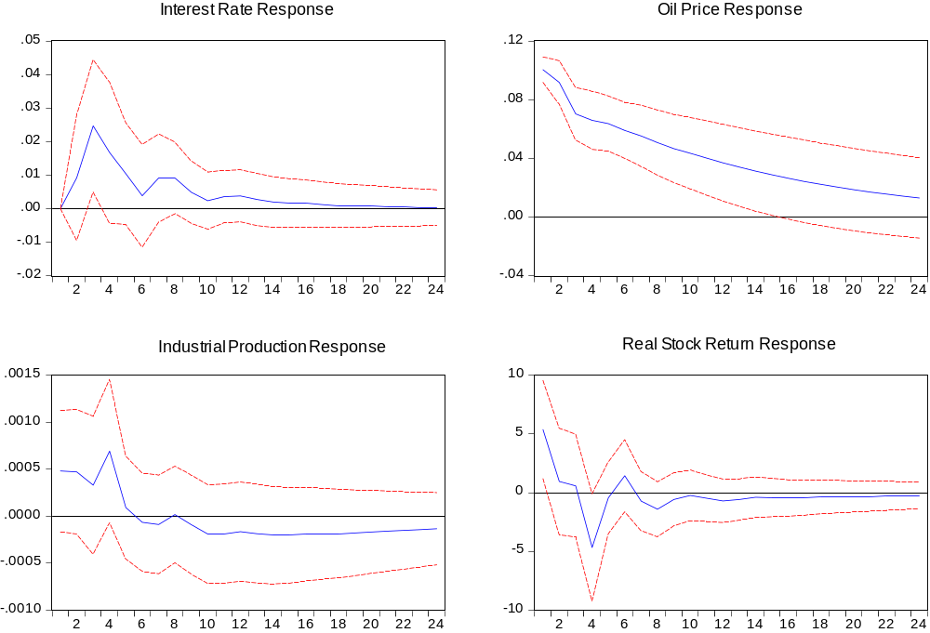
Source: Eviews
Table 8b: Oil price shocks
$$ε^{o}$$ |  | Δlr | lo | Δlip | rsr
$$ε^{o}$$ | 1 | 0.0000 | 0.1005 | 0.0005 | 5.3803
$$ε^{o}$$ |  | (0.000) | (0.004) | (0.000) | (2.002)
$$ε^{o}$$ | 12 | 0.0038 | 0.0370 | -0.0002 | -0.7076
$$ε^{o}$$ |  | (0.004) | (0.014) | (0.000) | (0.940)
$$ε^{o}$$ | 24 | 0.0003 | 0.0131 | -0.0001 | -0.2432
$$ε^{o}$$ |  | (0.003) | (0.016) | (0.000) | (0.576)
ᵃ Monte Carlo’s standard errors are shown in parentheses
Source: Eviews
Figure 5c demonstrates the impulse responses of the industrial production shocks to interest rate, oil price, industrial production itself, and real stock return. It is shown that interest rates are not affected by the shocks in the first month, but then it fluctuates and reaches its peak three months later and then continually decreases to zero by another three months. A positive shock in industrial production generates a positive impact on the oil price. This is in accordance with results found by Leonard (2011) in his research for China. He discovered that industrial production in China plays an important role in influencing the movement in global oil market. Meanwhile, real stock returns responses with fluctuations in the first eight months and do not show any significant impact later on. However, in general, real stock returns do respond positively to the shocks. This is consistent with the theory that explains higher production creates a better economic condition that will then induce the stock prices to increase.

Figure 5c: Industrial production shocks
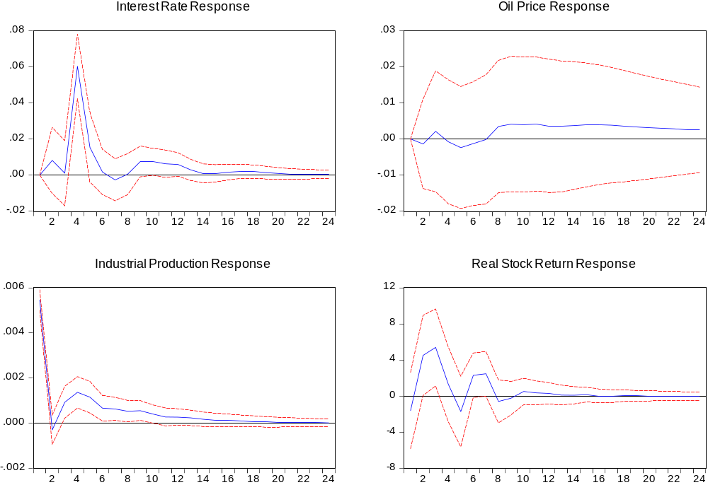
Source: Eviews

Table 8c: Industrial production shocks
$$ε^{ip}$$ |  | Δlr | lo | Δlip | rsr
$$ε^{ip}$$ | 1 | 0.0000 | 0.0000 | 0.0055 | -1.6059
$$ε^{ip}$$ |  | (0.000) | (0.000) | (0.000) | (2.059)
$$ε^{ip}$$ | 12 | 0.0058 | 0.0036 | 0.0003 | 0.2943
$$ε^{ip}$$ |  | (0.003) | (0.009) | (0.000) | (0.602)
$$ε^{ip}$$ | 24 | 0.0005 | 0.0025 | 0.0000 | -0.0192
$$ε^{ip}$$ |  | (0.001) | (0.006) | (0.000) | (0.230)
ᵃ Monte Carlo’s standard errors are shown in parentheses
Source: Eviews

Figure 5d presents the dynamic reaction caused by the shocks to the real stock returns. Based on the result, own variable receive the most impact from the shocks especially for the first three months. Corresponding with Lee (1992) and Sadorsky (1999), stock return shocks create statistically insignificant positive responses for oil price and other variables. It is confirmed by looking at table 8d that the responses are an estimated 0.001 percent for interest rates, oil prices, and industrial production. Papapetrou discovered a different result for the industrial production responses. She found that industrial production reacts positively to the shock in the first two periods, but this impact declines with time.
Figure 5d: Real stock returns shocks
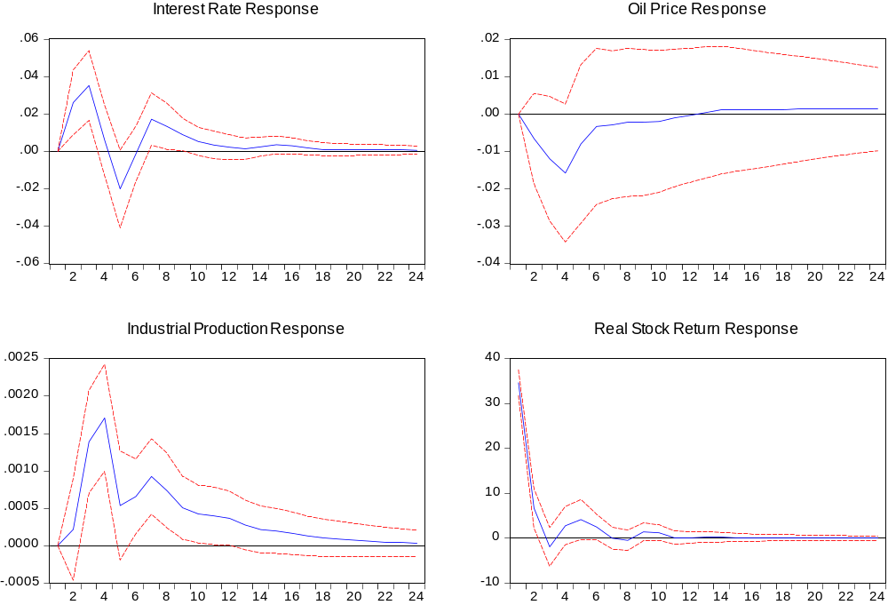
Source: Eviews

Table 8d: Real stock returns shocks
$$ε^{rsr}$$ |  | Δlr | lo | Δlip | rsr
$$ε^{rsr}$$ | 1 | 0.0000 | 0.0000 | 0.0000 | 34.6637
$$ε^{rsr}$$ |  | (0.000) | (0.000) | (0.000) | (1.445)
$$ε^{rsr}$$ | 12 | 0.0023 | -0.0003 | 0.0004 | 0.1136
$$ε^{rsr}$$ |  | (0.003) | (0.009) | (0.000) | (0.692)
$$ε^{rsr}$$ | 24 | 0.0006 | 0.0013 | 0.0000 | 0.0115
$$ε^{rsr}$$ |  | (0.001) | (0.006) | (0.000) | (0.234)
ᵃ Monte Carlo’s standard errors are shown in parentheses
Source: Eviews

Conclusion and Discussion

This paper examines the dynamic interactions among industrial production (ip), interest rates (r), real oil prices (o), and real stock returns (rsr). More specifically, the effect of oil price shocks on stock return is analyzed by using multivariate vector autoregressive model (VAR). Before employing VAR, a cointegration test needs to be conducted for non-stationary variables. The cointegration test result shows no long run relationship between variables lip and lr, which implies that VAR can be carry out for all four variables.
The precise clarification of VAR is given by variance decompositions analysis and impulse responses functions. Overall, variance decompositions analysis shows that own shocks explain most of the forecast error variance for all the variables. One important result is that the movements in oil prices have some influences on the economic activity, but this is not true when determining the impact of economic activity on oil prices.
Furthermore, the impulse responses result indicates that interest rates shocks have a statistically significant impact on real stock returns and in general a positive effect on oil prices. Moreover, positive shocks on industrial production increase prices and the shocks generally have a positive impact on real stock return. Shocks to oil prices create a positive impact to all other variables.
One important finding showed by this paper which is in accordance with the result found by Sadorsky (1999) is that positive shocks on oil prices create a weaker economic condition because of two reasons. Firstly, increase in oil prices have a negative effect on stock return. Secondly, positive shocks on oil prices decrease the industrial production. Negative impact on industrial production is caused by the raise in the cost of production that forces the producer to decrease oil supply to avoid losses.
The analysis of this paper has some limitation. Firstly, this paper does not take into account the oil crisis that happened in the 1970s. Secondly, as mentioned above regarding the research conducted by Kang, Kang, and Yoon (2009), CGARCH and FIGARCH model are better to use in comparison with the standard GARCH model because those models are able to capture the persistence in the oil price volatility. Therefore, further research should be conducted by taking these problems into account.

Bibliography

Bernanke, B.S. 1983. “Irreversibility, Uncertainty and Cyclical Investment”. Journal of Economics 98: 85-106.
Bollerslev, T. 1986. “Generalized Autoregressive Heteroskedasticity”. J. Economet. 52: 307-327.
Brooks, C. 2008. Introductory Econometrics for Finance. New York: Cambridge University Press.
Burbidge, J. and Alan Harrison. 1984. “Testing for the Effects of Oil Price Rises Using Vector Autoregressions”. International Economic Review Vol. 25, No. 2.
Cong, R.G., Yi-Ming Wei, Jian-Lin Jiao, and Ying Fan. 2008. “Relationships between Oil Price Shocks and Stock Market: An Empirical Analysis from China”. Energy Policy 36: 3544-3553.
Duncan, R. C. 2001. “The Peak of World Oil Production and the Road to the Olduvai Gorge” Population and Environment 22(5): 503-522.
Ferderer, J.P. 1996. “Oil Price Volatility and the Macroeconomy”. Journal of Macroeconomics Vol. 18 1: 1-26.
Franses, P.H. and Dick van Dijk. 2009. “Time Series Models for Business and Economic Forecasting”. Working Paper. Cambridge University Press.
Guo, H. and Kevin L. Kliesen. 2005. “Oil Price Volatility and U.S. Macroeconomic Activity”. Federal Reserve Bank of St. Louis Review 87(6): 669-683.
Hamilton, J.D. 1983. “Oil and the macroeconomy since World War II”. Journal of Political Eonomy 92(2): 228-248.
Hamilton, J.D. 1994. “Time Series Analysis”. Princeton: Princeton University Press.
Henriques, I. and Perry Sadorsky. 2011. “The Effect of Oil Price Volatiity on Strategic Investment”. Energy Economics 33: 79-81.
Hill, R.C., William E. Griffiths, and Guay C. Lim. 2008. Principles of Econometrics. Hoboken, NJ: Wiley.
Johansen, S. 1988. “Statistical Analysis of Cointegration Vectors. Journal of Economic Dynamics and Control 12: 231-254.
Johansen, S. and Katarina Juselius. 1990. “The Full Information Maximum Likelihood Procedure for Inference on Cointegration with Application to the Demand for Money. Oxford Bulletin of Economics and Statistics 52: 169-210.
Kang, S.H., Sang-Mok Kang, and Seong-Min Yoon. 2009. “Forecasting Volatility of Crude Oil Markets”. Energy Economics 31: 119-125.
Kuper, G.H. 2002. “Measuring Oil Price Volatility”. Working Paper. University of Groningen.
Lee, B.S. 1992. “Causal Relations among Stock Returns, Interest Rates, Real Activity, and Inflation”. The Journal of Finance Vol. 47, 4: 1591-1603.
Lee, K., Shawn Ni, and Ronald A. Ratti. 1995. “Oil Shocks and the Macroeconomy: The Role of Price Variability”. Energy Journal Vol. 16: 39-56.
Leonard, J. 2011. “A Macroeconomic Model of Key Commodity Prices: Quantifying the Impact of China”. MAPI Report (ER-714).
Narayan, P.K. and Seema Narayan. 2007. “Modelling Oil Price Volatility”. Energy Policy 35: 6549-6553.
Narayan, P.K. and Seema Narayan. 2010. “Modelling the Impact of Oil Prices on Vietnam’s Stock Prices”. Applied Energy 87: 356-361.
Papapetrou, E. 2001. “Oil Price Shocks, Stock Market, Economic Activity and Employment in Greece”. Energy Economics 23: 511-532.
Park, J. and Ronald A. Ratti. 2008. “Oil Price Shocks and Stock Markets in the US and 13 European Countries”. Energy Economics 30: 2587-2608.
Rafiq, S., Ruhul Salim, and Harry Bloch. 2009. “Impact of Crude Oil Price Volatility on Economic Activities: An Empirical Investigation in the Thai Economy”. Resources Policy 35: 121-132
Sadorsky, P. 1999. “Oil Price Shocks and Stock Market Activity”. Energy Economics 21: 449-469.
Sadorsky, P. 2004. “Stock Markets and Energy Prices”. Encyclopedia of Energy, vol. 5. Elsevier, New York: 707-717.
Uri, N.D. 1980. “Energy as a Determinant of Investment Behavior”. Energy Economics 2: 179-183.
Yang, C.W., Ming-Jeng Hwang, Bwo-Nung Huang. 2002. “An Analysis of Factors Affecting Price Volatility of the US oil Market”. Energy Economics 24: 107-119.
Zivot, E. 2008. “Practical Issues in the Analysis of Univariate GARCH Models”

Appendix: Summary of the Literature

Study | Methodology | Data | Results
Guo, H. and Kliesen, K.L. (2005).  “Oil Price Volatility and U.S. Macroeconomic Activity” |  | Daily prices of crude oil future  The New York Mercantile Exchange (NYMEX)  Period: 1983:12 – 2004:12  Oil price changes  Period: 1974-2004 | Oil price volatility has a negative and significant effect on future gross domestic product (GDP) and after adding new variable, oil price change, the volatility effect becomes more significant, which means that both variables are significant.  But, after controlling for Hamilton’s (2003) nonlinear oil shock measure, both the oil price change and its volatility lose their significance.
Sadorsky,P. (1999).  “Oil Price Shocks and Stock Market Activity” | GARCH(1,1) to model conditional variation in oil price changes  VAR to estimate the variance-covariance from each variables  Variance decompositions to have information about the impact of shocks to the variance for each endogenous variables  Impulse response functions to represent the response of an endogenous variable over time given a shock | Natural logarithms of:  - US industrial production (IP) as a measure of output  - Interest rates taken from 3-month T-bill rate, r  - Real oil prices taken from producer price index for fuels, o  - Real stock returns, rsr  Monthly data  Period: 1947:1 – 1996:4 | GARCH(1,1) model generate the conditional variance that are closely related to ∆lo.  Negative correlation between ∆lo and rsr and also between ∆lr and rsr are generated from VAR variance-covariance matrices.  Variance decompositions conclude that all the shocks are captured mostly from the movement in itself.  Changes in oil prices impact the economic activity, but not the other way around.
Kang, S.H., Kang, S.M., and Yoon, S.M. (2009).  “Forecasting Volatility of Crude Oil Markets” |  | Oil spot prices of Brent, Dubai, and WTI.  Daily closing prices from period 6/1/1992 to 29/12/2006 | CGARCH and FIGARCH models are a better in modeling and forecasting the volatility persistence than GARCH and IGARCH models
Narayan, P.K. and Narayan, S. (2007).  “Modelling Oil Price Volatility” | EGARCH to model volatility | Daily crude oil price  Period: 13/9/1991 to 15/9/2006 | Oil price shocks have both permanent and inconsistent asymmetric effects on volatility
Narayan, P.K. and Narayan, S. (2009). “Modelling the Impact of Oil Prices on Vietnam’s Stock Prices” | Cointegration test to test for the long run relationship  Ordinary Least Squares (OLS) and Dynamic OLS to test for the long-run elasticities | Daily data of stock prices, nominal exchange rates, and oil price  Period: 28/07/2000 to 16/06/20082008 | There is a cointegration between all the variables  Long run elasticity finds a positive relationship from oil prices and exchange rates to stock prices
Park, J. and Ratti, R.A. (2008). “Oil Price Shocks and Stock Markets in the U.S. and 13 European Countries” | Multivariate VAR with linear and non-linear specification | Monthly data for stock prices, consumer prices, interest rates, and industrial production for US and 13 European countries  Period: 1986:1 - 2005:12 | Real stock returns are affected by oil price shocks and the resut is robust  US have significantly different result with some European countries in how the increase in oil price volatility affect the stock market
Papapetrou, E. (2001). “Oil Price Shcoks, Stock Market, Economic Activity, and Unemployment in Greece” | Multivariate Vector Autoregressive Model  Variance decompositions and Impulse Responses | Monthly data for interest rates, industrial production, real oil price, and real stock returns  Period: 1986:1 – 1999:6 | Oil price shocks generates a negative impact on industrial production, employment, and real stock returns

