Graduate School of Development Studies

Infrastructure Development and National Rural Employment Guarantee Scheme in India:
The case of Bankura District, West Bengal

A Research Paper presented by:
Jitendra Roy
(India)
in partial fulfillment of the requirements for obtaining the degree of
MASTERS OF ARTS IN DEVELOPMENT STUDIES
Specialization:
Public Policy and Management
(PPM)
Members of the examining committee:
Prof. Dr. Arjun Singh Bedi
Dr. Anirban Dasgupta
The Hague, The Netherlands
November, 2011
Disclaimer:
This document represents part of the author’s study programme while at the Institute of Social Studies. The views stated therein are those of the author and not necessarily those of the Institute.

Inquiries:
Postal address: Institute of Social Studies
P.O. Box 29776
2502 LT The Hague
The Netherlands
Location: Kortenaerkade 12
2518 AX The Hague
The Netherlands
Telephone: +31 70 426 0460
Fax: +31 70 426 0799

Acknowledgement:
I am deeply indebted to Professor Dr. Arjun Singh Bedi for his continuous guidance in producing this paper. Every interaction with him has been a learning experience not only in terms of this paper but Development Studies as a whole. He has been phenomenal in changing my whole thought process. It is surely going to have a lasting impression on me. I am grateful to my second reader, Dr. Anirban Dasgupta for his insightful comments which helped me to understand my research from more critical perspective. I thank the faculty members of the PPM specialization of ISS particularly Dr.Sunil Tankha, Dr. Joop W. de Wit and Prof. Joes E. Mooij for giving me insightful thoughts from time to time.
I am thankful to Dr. Arabinda Ghosh, Joint Director, Administrative Training Institute, West Bengal and my mentor for motivating me to take up such a study and his support in building up my confidence whenever things became difficult. I am thankful to the BDOs of Barjora, Taldangra, Sonamukhi, Mejia, Joypur, Khatra and Chhatna and the District Officers of Bankura for their support and cooperation during the field work. Special thanks to BDO Barasat – I, North 24-Parganas district for helping me conduct the pilot survey. Thanks is also due to the 10 enumerators and the village respondents of Bankura District who made it possible to collect the field data in a very short period of time.
I am very thankful to Mr. H Mohan, Secretary to the Govt. of West Bengal for his kind cooperation during the entire period of my study.
Special gratitude to Maa for her loving blessings which always encourage me.
And finally…
My heart goes out to Pushpa, my wife, and my sons Darshan and Samyak who had to bear with my continuous absence while at ISS and face all the hardship of life alone. My heart-felt thanks to Pushpa for continuously keeping up my morale and giving her support to undergo the course and this research work. Without her support nothing would have been possible.
Contents
List of Tables v
List of Figures vi
List of Maps vi
List of Acronyms vii
Abstract viii
Chapter 1 Introduction 1
1.1 Background 1

1.1.1 Poverty alleviation in India and MGNREGA 1

1.1.2 Decentralisation, Durable Asset creation and NREGS 2

1.1.3 Decentralisation and West Bengal 5

1.2 Relevance and Objectives 6
1.2.1 Relevance of the current research 6

Research objectives 7
Chapter 2 Theoretical-Analytical Framework 8

Chapter 3 Survey Instruments, Sampling process and the Sample 11
3.1 Survey Instruments 11
3.2 Sampling Strategy 12
3.3 The Sample 15
3.3.1 Ground Realities and the Final Sample 15
3.4 Methodology 16
Chapter 4 The Data 18
4.1 Socio-economic profile of the villages 18
4.2 Type of assets created under NREGS 20
Chapter 5 Results and Findings 21
5.1 Preference Targeting 21
5.1.1 Planning 'Top Down' or 'Bottom Up' 21
5.1.2 Project selection and Participation 21
5.2 Quality of Assets created 25
5.2.1 Maintaining Quality 25
5.2.2 The Findings on Quality 25
5.2.3 Physical and Functional states vs Quality 26
5.2.4 GP specific analysis of Quality 28
5.3Maintenance of Projects 31
5.3.1 The Maintenance Debate 31
5.3.2 Maintenance Mechanism 31
5.3.3 Participation and Maintenance 33
5.4 Effectiveness of Use of NREGS Projects 35
5.4.1 Usefulness and NREGS 35
5.4.2 Measuring usefulness of the Project 35
5.4.3 Assets and Corresponding Benefits 36
5.4.4 Benefits and Growth - a Discussion 36
Chapter 6 : Conclusion 37
Appendix 38
Appendix- I: Zonewise list of GPs of Bankura 38
Appendix-II: No of GPs to be surveyed per Zone 43
Appendix-III: Survey Instruments 44
Reference 65

List of Tables
Table Number | Description |  | Page Number
Table 1 | Roles & Responsibilities under NREGS |  | 3
Table2 | Hydro-geomorphic zones of Bankura District and GPs selected for sampling. |  | 14
Table 3 | Sector-wise & year-wise stratified sample size |  | 14
Table 4 | GP wise summary of projects selected for sample |  | 15
Table 5 | GP-wise summary of projects selected for sample |  | 16
Table6 | Distribution of projects in the selected 10 GPs |  | 16
Table 7 | Participation in project selection |  | 22
Table 8 | Participation in project selection in various GPs |  | 22
Table 9 | Participation in project site selection across GPs |  | 23
Table 10 | Community participation in project selection across GPs |  | 23
Table 11 |  | Participation in project design & project scale selection | 24
Table 12 |  | Project Quality | 26
Table 13 |  | Physical condition of project | 27
Table 14 |  | Current Operational state of projects | 27
Table 15 |  | Project quality of material intensive Projects | 27
Table 16 |  | Project Quality of labour intensive projects | 28
Table 17 |  | Project Quality (GP-wise) vs Project selection type | 28
Table 18 |  | Physical Condition of the project (GP-Wise) | 29
Table 19 |  | Current operational state of the Project(GP-wise) | 29
Table 20 |  | Project maintenance | 32
Table 21 |  | GP-wise damage percentage of projects & project selection type | 32
Table 22 |  | Project maintenance vs. Maintenance Committee | 33
Table 23 |  | Need Perception | 35
Table 24 |  | Assets and Benefits | 36

List of Figures
Chart 1 | Land holding Pattern | 18
Chart 2 | Non-farm income Pattern | 19
Chart 3 | Projects implemented and Expenditure incurred in the sample villages | 20

List of Maps
Map 1 | Land holding Pattern | 12
Map 2 | Non-farm income Pattern list of Villages | 13

List of Acronyms
NREGA- National Rural Employment Guarantee Act
MGNREGA- Mahatma Gandhi National Rural Employment Guarantee Act
NREGS- National Rural Employment Guarantee Schemes.
NREGP- National Rural Employment Guarantee Programme
HH- Household
USD- United States Dollar
EGP- Employment Guarantee Programme
EGS- Employment Guarantee Schemes
GP- Gram Panchayat
PS- Panchayat Samity
ZP-Zilla Parisgad
WB- West Bengal
SGRY- Sampoorna Grameen Rojgar Yojona
PRI- Panchayati Raj Institution
GUS- Gram Unnayan Samity
Rs. Rupees
CPI (M) - Communist Party of India (Marxist)
AITMC- All India Trinomul Congress
SC- Scheduled Caste
ST- Scheduled Tribe

Abstract
The National Rural Employment Guarantee Scheme (NREGS) of India is the world’s largest workfare programme that comes with a guarantee of 100 days of employment to every citizen of India as guaranteed by the Mahatma Gandhi National Rural Employment Guarantee Act, 2005 (MGNREGA). Thus MGNREGA is expected to ensure a social safety net for vulnerable groups by providing a fall-back source of employment as a matter of right, which is undoubtedly its immediate goal. However, the long-term goal of MGNREGA is to create durable rural assets and infrastructure as per local need in order to address chronic poverty and to foster a model of governance based on the principles of grass-root democracy and transparency. The present study looks at the performance of NREGS under three aspects – the type and quality of the assets created; the use and upkeep of the projects and community participation in planning, implementation and maintenance of the projects. The study is based on primary data collected from 82 completed projects of various types executed in the period 2008 – 10 in 23 villages located in 10 Gram Panchayats in Bankura district of West Bengal in (eastern) India.

On the basis of this primary data, the study reveals that at least in Bankura district, most of the projects under NREGS pertain to local need and are of good quality. The projects are being utilized by the local villagers for various economic and social activities. But, there is no system of maintenance of the projects once they are constructed. However, wherever community participation in NREGS is good, it is seen that the projects are well-maintained…

Key Words: NREGS, MGNREGA, durable assets, infrastructure, decentralisation, community participation, maintenance, Bankura, West Bengal

Chapter 1
Introduction

1.1 Background

1.1.1 Poverty alleviation in India and MGNREGA
Ever since independence from colonial rule, India has undertaken concerted efforts to reduce poverty through various poverty alleviation programmes. Agriculture being the chief source of employment for a vast majority of the Indian population, the rural poor has to face a lean period every year when there is hardly any work available in the fields. Irregular monsoons and the vagaries of nature further add to the degree of livelihood uncertainty of the poor. These typical features of rural India increase destitution. The resulting food insecurity increases the dependence of the rural poor on non-farm activities. In the event of non-availability of such opportunities in the villages, they are often forced to migrate to urban areas in search of manual work or informal jobs, thereby worsening the already sordid situation of urban poverty.
To tackle this problem, since the 1960s, the Government of India (GoI) has been carrying on rural wage – employment programmes in one form or the other. Starting with Rural Works Program (RWP) in 1961, the country has initiated a series of programs like Food for Work (FFW), National Rural Employment Programme (NREP), Rural Labour Employment Guarantee Program (RLEGP), Jawahar Rojgar Yojana (JRY), Employment Assurance Scheme(EAS), Sampoorna Gramin Rojgar Yojana (SGRY) and the most recent National Rural Employment Guarantee Programme (henceforth NREGP) which was launched in 2006. Compared to welfare programmes involving only income transfers, the workfare programmes, in addition to providing income support are also expected to ead to the creation of remunerative assets and infrastructure that may help tackle poverty in a sustainable manner.
The NREGP is unique in the sense that, for the first time such a workfare programme has been designed with an employment guarantee. The programme has been given a statutory form by the GoI. The programme is supported by the National Rural Employment Guarantee Act, 2005 (later amended and renamed as Mahatma Gandhi National Rural Employment Guarantee Act, henceforth MGNREGA) passed by the Indian Parliament in September 2005. The objective of MGNREGA is to enhance livelihood security in rural areas by providing at least 100 days of guaranteed wage employment in a financial year to every household whose adult members volunteer to do unskilled manual work (MGNREG Act: http://rural.nic.in/rajaswa.pdf). To give effect to this, the Act makes it binding on every State Government to make a Scheme, namely, National Rural Employment Guarantee Scheme (henceforth NREGS) for providing such guaranteed employment. Work is to be provided on demand to the registered applicants. In the event of failure to provide work the applicants are entitled to “unemployment benefits”.
The Act also regulates the conditions for providing such employment and the minimum entitlements of the labourers (as laid down in Schedule II of the Act). Some of the salient features of MGNREGA enforcing such entitlements are as follows:
- The Projects taken up under NREGS have to be wage intensive. An overall 60:40 wage-material ratio is mandatory.
- Adult members of a rural household, willing to do unskilled manual work, have to register their names at the local Gram Panchayat (GP) whereby they will be issued a ‘job-card’.
- Any person having a job-card can apply for work at the GP. Employment has to be provided within 15 days of application for work.
- Work should ordinarily be provided within a 5 km radius of the village of residence otherwise 10% extra wage has to be paid as transport cost.
- Wages are to be paid according to piece rate or daily rate on a weekly basis and never beyond a fortnight from the date of such work. In case of delay beyond the specified period labourers are entitled to compensation as per provisions of the Payment of Wages Act, 1936 (4 of 1936).
- The wage rate shall be specified by the Central Government from time to time by notification, subject to an assured minimum wage.
- One-third of the total employment must be ensured to women job-seekers
- Work site facilities such as crèche, drinking water etc. have to be provided.
- In case of accident while on job, labourers are entitled to free medical treatment and daily allowances. In the event of death or permanent disability due to such accident there is entitlement for ex gratia payment.
- A strong grievance redressal mechanism is assured with monitoring at the highest level.

Thus the Act is expected to ensure a social safety net for vulnerable groups by providing a fall-back source of employment as a matter of right, which is undoubtedly the immediate goal of NREGP.
While newspaper reports have raised concerns about corruption and other irregularities, at least in terms of access to employment and achievement of the immediate goal of livelihood security NREGS appears to have been a qualified success. Launched in 200 backward districts in February 2006 the programme was extended to all 625 districts of the country by the end of 2008. The annual central budget for the programme steadily increased from USD 5 Billion in 2006-7 to USD 8.72 Billion in 2010-11. The coverage in terms of number of households increased more than two-fold during the same period. In the financial year 2010-11 the coverage was 51.7 million rural households (up from 21.0 million in 2006-7), which is larger than coverage in any other workfare programme in the world (www.nrega.nic.in).

1.1.2 Decentralisation, Durable Asset creation and NREGS
In addition to the short-term immediate goal of providing livelihood security, a long-term goal of the programme is to create durable rural assets and infrastructure in order to address chronic poverty and to foster a model of governance based on the principles of grass-root democracy and transparency. Schedule – I of the Act emphasizes to this aspect and also directs preparation of a list of preferred works for different areas based on the local ability to create durable assets and to maintain them.
While the programme is funded jointly by the central and state governments it is implemented in a decentralised manner through Local Self Governments (LSG). The programme also involves the whole political structure right from the Central Government level to the community level for supervision and monitoring of the scheme. A brief description of the political – administrative structure prevalent in India will help understand the set-up for implementation of NREGS.

India is a federal democratic republic of a number of States. At the center there is the Central Government which is accountable to the Parliament and has jurisdiction over whole of the territory of India. At the State level, there is the State Government which is accountable to the State Legislature and has its jurisdiction only within the territory of that particular State. The Constitution of India demarcates the powers of the Center and the State. For administrative purpose, a State is divided into several Districts each of which is further divided into several sub-district units called Blocks (rural) and Municipalities (urban). Each Block consists of several Gram Panchayats (GP).

A GP is the lowest level of the three tiers LSG called Panchayats or Panchayati Raj Institutions (PRI) formed by political functionaries elected directly by the people through voting. The PRIs are the institutions for democratic decentralisation of power and were universalised throughout India by amendment of the Constitution in 1992. Elections to PRIs are held every five years. In West Bengal, the Panchayat at the district level is called Zilla Parishad (ZP) and at the intermediate (or block) level Panchayat Samity (PS) (The West Bengal Panchayat Act, 1973: Chapter-II). The administrative head of a district is the District Magistrate or Collector and that of the block is the Block Development Officer (BDO).

The GP is accountable to the Gram Sabha which is a council of all the voters of the villages under the GP and meets twice a year to prepare the GP development plan and to vet the GP accounts. The GP is further divided into several village constituencies called Ward Sabhas or Gram Sansads (in West Bengal). Each Gram Sansad elects one or two representatives called GP Members (GPM) depending on the total number of electors (ibid). The number of such members in a typical GP varies from 10 – 20. These GPMs constitute the ‘general body’ of the GP which selects one of the GPM as ‘Pradhan’ who heads the GP. Another GPM is selected as the Upa (or vice) Pradhan who is the second-in-command. Party affiliation is the main criteria for such selection. The Pradhan and Upa-Pradhan hold office till they have confidence of the ‘general body’ or till the term of the Panchayat lasts. They are assisted by some government officials in running the activities of the GP. The Gram Sansad is also a council of all the electors of the constituency and meets twice a year under the chairmanship of the GPM to discuss development matters. Thus the Gram Sabha and Gram Sansad are the platforms for direct participation of the community in governance matters.
The following chart lists the various authorities involved in the implementation process of NREGS and their responsibilities.
Table-1: Roles and Responsibilities under NREGS
Sl. No. | Authority | Responsibility
1. | Central Government | To make rules for proper implementation of MGNREGA;  to establish National Employment Guarantee fund to meet wage cost, 75% cost of materials and administrative expenses.
2. | Central Employment Guarantee Council (or Central Council) | To advise the Central Government on all matters of implementation of the Act;  review monitoring and redressal mechanism and undertake evaluation of various Schemes
3 | State Government | To establish State Employment Guarantee fund to meet cost of unemployment allowance, 25% cost of materials and administrative expenses of the State Council;  to make rules for proper implementation of NREGS
4. | State Employment Guarantee Council (or State Council) | To advise the State Government on all matters concerning NREGS and its implementation;  to determine the preferred work; and  to monitor and review implementation of the Act and NREGS in the State.
5. | Panchayat at the district level or Zilla Parishad (ZP) | To approve the Development plans;  to supervise and monitor project implementation.
6. | District Programme Coordinator (DPC)  (the District Magistrate or Collector of the district is designated as DPC) | To supervise the implementation of NREGS in the district in accordance with MGNREGA;  to prepare annual labour budget;  to consolidate the plans prepared by the Blocks;  to assist ZP in discharging its functions;  to allocate fund to the Programme Implementing Agencies (PIA) for implementing the projects;  to conduct periodic inspections:  to redress grievances of applicants.
7. | Panchayat at the intermediate level or Panchayat Samity (PS) | To supervise and monitor projects taken up within the Block;  to forward the Block plan for approval to ZP.
8. | Programme Officer (PO)  (the BDO of the Block is designated as the PO) | To prepare the Block plan from GP plans and proposals received from the PS;  to match the demand for work with the employment opportunities arising from projects;  sanctioning & ensuring payment of unemployment allowance;  ensuring prompt and fair payment of wages;  to assist the PS in its functions;  ensuring social audit in every GP;  redressing grievances,  inspecting, supervising and monitoring projects.
9. | Gram Panchayat | Identification of projects for the annual plan as per recommendations of the Gram Sabha and Gram Sansads;  maintain a shelf of projects ready to be taken up when demand for employment arises;  implement the projects sanctioned by the PO;  register the job applicants and provide them work when demanded.
10. | Gram Sabha and Ward Sabha (or Gram Sansad) | To recommend projects for inclusion in the GP plan;  to monitor execution of all project within the GP; undertake social audit of all projects executed.

Thus the Gram Panchayat (GP) is responsible for identification of the projects to be taken up under NREGS in the GP area as per recommendations of the Gram Sabha and the Ward Sabhas and prepare a development plan as well as a shelf of possible works. It is also the main programme implementing agency (henceforth PIA) of the projects sanctioned by the Programme Officer under the scheme. In West Bengal, a village level beneficiary committee known as Gram Unnayan Samity (GUS) is also supposed to be formed in every Gram Sansad to aid and assist it in its function of selection and monitoring of the projects including social audit.
Thus decentralization calls on GPs to design and implement projects and calls for collective action from the community towards project selection, monitoring and maintenance. Previous workfare programmes have been lacking in this respect (Devereux and Solomon, 2006).
Again, the Gram Sabha is empowered to undertake Social Audit of all the schemes implemented in the GP. Thus, MGNREGA provides a mechanism for “inclusive growth” ranging from wage security and recharging of rural economy to a transformative empowerment process of democracy.

1.1.3 Decentralisation and West Bengal
Local Self Government (LSG) has a long history in India. However, the present form of three tier Panchayat system was initiated in West Bengal in the year 1978 by the then Left Front Government led by the Communist Party of India (Marxist) [CPI (M)] by enforcing the Panchayat Act,1973 which is a State Act. For the first time political party based elections were held to all the three tiers i.e. Zilla Parishad (district level), Panchayat Samity (intermediate level) and Gram Panchayat (village level) in a unique attempt of democratic decentralisation of power to the people. Thereafter, the Panchayat elections have been held in the state regularly after every five years. This system was later adopted by the Indian Government for all the states by an Act of the Parliament in 1992. So in the matter of institutionalising decentralisation of power, West Bengal can be said to be the fore-runner in the country. While the extent of representation of the socio-economically backward class in such elected LSGs is a matter of great debate, the representation of women was poor till the coming into effect of 73rd Constitutional Amendment Act in1993 which reserved one-third of the seats for women apart from reservation for the socially backward classes. It also introduced the concept of Village Council or Gram Sabha, to create a platform for direct participation of the community in governance. The West Bengal Government had implemented these changes. Since the very beginning the panchayats were involved by the Left Government in implementation of various poverty alleviation programmes like land reforms, rural employment generating infrastructure development projects, self-employment programmes etc. “It is widely believed that these programs were effectively targeted in favour of the poor, due in part to the involvement of the panchayats in their implementation”(Bardhan & Mookherjee, 2003: 1). In more than three decades the LSG system in West Bengal has come of age with devolution of more power to the lowest tier i.e. GP in phases. As discussed above, to take the decentralisation of power closer to the people, the village council has now been further broken into several smaller councils called Gram Sansad on the basis of a constituency approach. The Gram Sansads are given the power to propose development plans for their respective wards. These are e then vetted by the Gram Sabha and compiled by the GP to form the Development Plan for the concerned GP.

1.2 Relevance and Objectives
1.2.1 Relevance of the current research
With rapidly increasing population in the low-income countries, the land – man ratio is becoming increasingly adverse. Most of the poor have only one resource: their own labour. Utilizing that resource effectively and increasing its productivity are the objectives of employment policies and related human-resource improvement for eradicating poverty (von Braun, 1995). In other words, to bring about a sustainable reduction of poverty it is necessary to address the problems of poverty and hunger in conjunction with the issue of economic growth (Radwan 1995, World Bank 1990, Lipton and van der Gaag 1993). An enhanced resource base (terracing, watershed protection, and so forth) and improved infrastructure are prerequisites for achieving sustained economic growth. Such infrastructure improvements may be created and maintained through labor-intensive programs (Platteau 1993). Broadening strategic thinking on employment – growth –poverty links, Streeten (1994) places employment into the context of an antipoverty strategy with a mix of four components: structural reform, employment creation, social services and participation. A comparative study by Burki et al. (1976) concluded that public works can make a significant contribution to reducing poverty, provided there is sustained political commitment and close attention to detail in the design and administration of the program.
In recent years, driven by disenchantment with centralized modes of governance, waves of decentralization have occurred in countries covering half the world’s population (Bardhan and Mukherjee, 2006). The main motivation behind such a trend is that a centralized government is less accountable and breeds corruption and rent-seeking. So decentralization of planning and implementation coupled with community led monitoring has been offered as an alternative approach to improve service delivery. Theoretically, however, there is no guarantee that outcomes will be better (Waller, Verdier and Gardner, 2002). The logic behind decentralization is that the decisions taken will be based on local knowledge and would be laden by a sense of “community ownership”. This has a direct bearing on the maintenance of the public assets created in the community to sustain them. However, according Olson (1965) the free rider problem may act as a major obstacle to interest mobilization when individuals have little or no incentive to join the group and work for collective good of maintaining the assets.
It is also possible that corruption may actually increase through “local capture” as bureaucratic and political power moves downward due to decentralization. In fact, there have been a number of cases of corruption in NREGS in different parts of the country. A government sponsored study by the V.V. Giri National Labour Institute has reported large scale corruption and irregularities in NREGS in several states. (http://zeenews.india.com/news628589.html). In a recent public interest litigation [WP (Civil) No. 645 of 2007] against the Union of India and the State of Orissa regarding irregularities in implementation of NREGS in the state of Orissa, the Supreme Court has made a stringent remark, “A statutory obligation under the provisions of the Act, i.e. right to livelihood ... … is being frustrated by the very functionaries who are responsible for proper and effective implementation of the Act.”

Although NREGS is expected to usher in inclusive growth through the twin aspects of decentralized implementation entrusted by the Act to the GP and monitoring entrusted to the community, there is no guarantee that expected results will follow suit. If NREGS is to generate multiplier effects and successfully tackle chronic poverty, it is pertinent to assess the effect and the ability of the programme in creating infrastructure and to understand the interactions between the GPs and the community in influencing project choices and outcomes. So an interactive study at the project level would be apt to gain insights into the “interactive policy process” prevalent among the actors at the grass-roots level.

Research objectives
The purpose of this research work is to assess how far the NREGS has been able to achieve its long-term objective of creating durable assets and rural infrastructure like roads, irrigation canals, ponds, social forestry and the like and what has been its impact in strengthening livelihood resource base for the rural poor. In this aspect it is also necessary to examine the capabilities of the grass-root level bodies/committees involved in selection, execution and monitoring of the projects. It will also be interesting to identify how the created assets are being used and maintained by the community and to identify the factors that are responsible for the success or the failure of NREGS created projects.

Objectives of the research:
The objectives of this research work are:
- First, to find out the type and quality of assets/infrastructures created under NREGS;
- Second, to assess the extent to which various decisions regarding NREGA funded projects are taken in a participatory manner and what is the interaction between the various stakeholders (GP, Gram Sabha, Gram Sansad and GUS ) regarding selection, implementation and monitoring. The main idea is to examine preference targeting.
- Finally, to examine the effectiveness of use and maintenance of the assets;
The next chapter will deal with the theoretical-analytical framework, chapter-3 describes the survey instruments, sampling strategy, the sample and the methodology of this research, chapter-4 outlines the socio-economic setting and also discusses type of assets created, chapter-5 discusses the results and findings and chapter-6 concludes.

Chapter 2
Theoretical – Analytical framework:

In spite of concerted efforts for ‘development’ by the international development community for more than six decades, poverty and unemployment have still remained as menace to the developing and under-developed world. In fact, ‘employment expansion’ had been a fundamental concern of the early development theories (Lewis 1955, Fei and Ranis 1964). Achieving a high level of employment- preferably “full employment” is virtually a universal goal among policymakers (von Braun, 1995: 3). Employment creation programmes are an important policy instrument as a means to achieve such a goal, particularly in low- and middle income countries where rates of unemployment and underemployment are high, the employment intensity of growth is low or even declining, and macroeconomic shocks or natural disasters can undermine livelihoods and require income-stabilising interventions (Devereux and Solomon, 2006).
While it is now widely accepted that productive and remunerative employment is fundamental to overcoming food entitlement failure among the poor (Dreze and Sen 1989), there is still only limited understanding and agreement as to how to go about providing such employment. In this light, development-oriented strategies for poverty reduction are of growing interest to governments, non-governmental organizations, and development assistance and other agencies. Such strategies function both by creating assets through employment programmes that benefit the poor and by raising the productivity of the poor through education, public health, and other human-resource related measures (von Braun, 1995). However, the effective implementation of such policies and programs necessitates an appropriate institutional and operational setting.
Traditional modes of service delivery involving centralised bureaucracies are wrought with problems of accountability including cost padding, service diversion, limited responsiveness to local needs, limited access and high prices charged especially to the poor (Bardhan & Mookherjee, 2006). So decentralization of authority over targeting for poverty reduction programs or service delivery to local governments or NGOs is being increasingly resorted to by central governments in many developing countries. It is thought that such decentralisation has its merits in the sense that more information is available at the local level about who is poor than at the centre, and that local institutions tend to be more accountable to local people, and hence have an incentive to use the locally available information to improve program performance (Galasso and Ravallion, 2005: 705 -706).
The World Development Report 2004 advocates for such decentralization as is evident from its theme set by its opening paragraph:
“Too often, services fail poor people – in access, in quantity, in quality. But the fact that there are strong examples where services do work means governments and citizens can do better. How? By putting poor people at the center of service provision: by enabling them to monitor and discipline service providers, by amplifying their voice in policymaking, and by strengthening the incentives for providers to serve the poor.” (WDR, 2004:1)
The accountability problem in the bureaucratic system comes in because it is difficult for the center to monitor their actions due to the high cost of communication and the difficulty in carrying on regular audit. This may brew corruption because the bureaucrats can extract bribes for providing the service. Alternatively, it may also cause inefficiency as the local bureaucrats may be incapable of delivering public goods and services due to lack proper training. Decentralisation shifts control rights over service distribution to a local government subject to electoral pressure from residents (Bardhan & Mookherjee, 2006). In terms of Principal-Agency theory, it can be said that the agency is now brought closer to the principal as far as public service delivery is concerned. It provides greater control to citizen groups on the service provider as the latter has to depend on the votes of the citizens to remain in power and thus increases the probability of better service.
Although decentralization has now come to stay, much debate has surfaced recently regarding its merits. The claim that more information is available locally is logical and also observable (Alderman, 2002), however, the contention that local institutions in developing countries are more accountable to the poor than the centralized bureaucracy is doubtful. The accountability argument is persuasive in settings in which there is little or no distributional conflict at local level (Galasso & Ravallion, 2005). There is too much of inequality in the underdeveloped rural economies and consequently a lot of scope of local capture of the program by the local elites. So the theoretical case for decentralization will then depend critically on the extent of local capture by the non-poor (Bardhan & Mookherjee, 2000).
Main reason for such capture is again information asymmetry, where the elites being close to the position holders are well informed and hence are able to capture the gains thereby depriving the intended beneficiaries of the benefits of programs meant for them. The apparent solution to this problem lies in the community-based or community-driven development approaches which revolve round the community or the beneficiary and not the delivery system. Community-based development actively includes beneficiaries in design and management of the projects. Community-driven development projects go one step further where the communities have direct control over key project decisions including fund management. In a nut-shell these approaches call for direct community participation in development matters. The World Bank’s preference for such projects is quite evident from rise in its investment from USD 325 million in 1996 to USD 2 billion in 2003 (Mansuri and Rao, 2003). Its Poverty Reduction Strategy Paper Sourcebook (Dongier and others, 2001) views such approaches to make development more inclusive and sustainable. Sen’s (1985, 1999) effort to shift the focus of development to a broad based “capability” approach deeply swayed the development community to take up the strategy to “empower” the poor as an alternative to the top-down development approach.
“Participatory Development” as advocated by Chambers (1983) and others led to inclusion of participation as a crucial means of empowering the poor to have control over decisions. It relies on communities to use their social capital and participate in development processes to incorporate local knowledge into the project’s decision making process. Participation is expected to lead to better targeting, more cost-effective and timely delivery of project inputs and equitable distribution project benefits with less corruption and rent-seeking activities (Mansuri and Rao, 2003). Whether it does so or not is a matter of empirical assessment.

Evidence suggests that decentralized targeting has not always been effective in targeting the poor within communities. Such targeting is markedly worse in communities with socioe-conomic heterogeneity. Moreover, preferences of the poor have not been considered sufficiently in project selection. However, there are evidences that decentralized targeting can be made more effective by monitoring projects to improve performance incentives. Community participation in selection, implementation and management of a public good has been mostly found to be dominated by local elites even in the most equal societies and greater share of the benefits accrue to them. But wherever the social culture permits tight control of community decisions by the elites, it has resulted into malevolent “capture” (ibid).
On the issue of social capital, some studies show an association between the level of some index of participation and project effectiveness but the direction of causality is obscure. However, the sustainability of community-based development initiatives have been found to depend on a supportive institutional setting (ibid).
Coming to our present context of NREGS, it can be seen that proper application of both decentralization and community participation is the key to its success. The stated goals of NREGA are to ensure:
a. Strong social safety net for the vulnerable groups by providing a fall-back employment source, when other employment alternatives are scarce or inadequate
b. Growth engine for sustainable development of an agricultural economy. Through the process of providing employment on works that address causes of chronic poverty such as drought, deforestation and soil erosion, the Act seeks to strengthen the natural resource base of rural livelihood and create durable assets in rural areas. Effectively implemented, NREGA has the potential to transform the geography of poverty
c. Empowerment of rural poor through the processes of a rights-based Law
d. New ways of doing business, as a model of governance reform anchored on the principles of transparency and grass root democracy (NREGS Operational Guidelines, 2008).
The implementation of NREGS has been thoroughly decentralized by provisions of the MGNREG Act whereby the Panchayats have been made the principal planning and implementing authorities. To ensure grass-root democracy, the lowest tier of Panchayat i.e. the GP has been entrusted with the role of identifying the projects to be taken up under NREGS on recommendation from the Gram Sabha and Gram Sansad. This is so because for fulfilling the second goal, it is necessary that planning be done as per local need. This calls for community participation in planning. Secondly to ensure the first goal, it is necessary that jobs are available at the village level. This is possible only if implementation of the Scheme is decentralized to the GP level.
Again, to ensure transparency, the Act has empowered the Gram Sabha to monitor the execution of works within the GP and conduct social audit of all projects implemented under NREGS within the GP area. With this provision, NREGA aspires to provide greater control to the community over the PIA. In both cases it calls for active participation by the community. Such participation right from planning to implementation to social audit seeks to result into beneficial effects participatory development as quoted above and to enthuse a sense of ‘ownership’ of the assets being created through NREGS.

Chapter 3
Survey Instruments, Sampling process and the sample
3.1 Survey Instruments:
The field work for this research concerns a survey of a number of projects implemented under NREGS in various GPs of Bankura district of West Bengal and gathering information about the type and quality as well as physical and functional condition of each project, its use and maintenance. The study also intends to look into the extent and quality of participation of the villagers in planning, implementation and monitoring of the projects undertaken and the role if any they play in their maintenance. An idea about the socio-economic profile of the villages under study was also necessary to judge the nature of the community. To gather the required information a detailed questionnaire was developed and administered to a mixed group (in terms of age and gender) of 8 – 12 villagers whom I call “Village Respondent group (VRG)”.
It was essential to take account of the various actors in implementation of NREGS, their roles and capabilities. As is evident from the discussion in previous chapter, the main players involved in implementation of NREGS are the GPs. However, Gram Sabha and Gram Sansad participate in planning and monitoring. Again, the project is implemented by the GP in the village. So another instrument was required to collect data about the activities of the GP. Further, the works of the GP is monitored and supervised by the BDO (PO). So a third instrument was developed to capture the BDO’s view about the state of affairs at the GP so that the data could be used to triangulate the information obtained from the GP questionnaire.
These instruments were prepared keeping in mind the objectives of the research and the different stakeholders involved in implementation of NREGS. Then I conducted a pilot survey at a village called Bajitpur in Chhoto-jagulia GP of Barasat – I Block in the district of North 24-Parganas with the help of the BDO and some of her staff to whom I provided training. The questionnaires were modified and finalised as per experience gathered from the pilot. A brief description of the instruments is given below. The instruments are also attached at Appendix – III.
1. Group Questionnaire:
The “Group Questionnaire” was developed for the survey at the project level. It was administered upon the VRG for the respective villages. It consists of the following five sections:
- Village socio-economic profile
- Project specific question (common to all projects)
- Project maintenance
- Participation and Leadership
- Project type specific questions (regarding benefit and maintenance)
2. Gram Panchayat Questionnaire:
The main responsibility of implementation of NREGS rests upon the GP. It also has the obligation to facilitate people’s participation in decision making. So the ‘Gram Panchayat questionnaire’ was prepared for running a focussed group discussion with the GP functionaries (like the Pradhan who is the elected head of the GP, the Upa-Pradhan who is the second in command, the GP Members etc.) and the GP staff (public recruits) to obtain their views on the above points as well as for assessing the knowledge-power, skill and leadership qualities available at the GP level to facilitate implementation of NREGS. It is also devised to capture the perceptions of the GP functionaries regarding effectiveness of the GP staff and vice versa.

3. Block Questionnairre:
The ‘Block Questionnaire’ was devised for conducting a structured interview with the POs to obtain their views about the effectiveness of the concerned GPs regarding implementation of NREGS and their perceptions about the efficiency of the employees and efficacy of the leadership attributes of the GP functionaries. This would help to triangulate the findings from the other two instruments.

3.2 Sampling strategy:
As mentioned earlier, I selected the district of Bankura for my field survey to gather primary data/information for this research project. The weight of policy inferences regarding NREGS that may be drawn with the help of the survey data will obviously depend on how effectively such data reflects the district’s picture as a whole. So the sample chosen for the survey was made representative of the district by adopting a stratified sampling strategy.
The main aim of NREGS is to augment rural livelihood which heavily depends on natural resources. Bankura is one of the backward districts of West Bengal and is heavily dependent on agriculture. So the livelihood strategy of the district is in a way determined by the type of soil and water availability in its different regions. The district of Bankura can be divided into three distinct topographical regions – the hilly western part, undulating central part and alluvial plains in the eastern part, unidentifiably merging into one another. The hilly region is characterized by large granite rocks, the central part by red laterite and eastern part by alluvial loamy soil (DHDR, 2007: pp 5). As is evident, the western and central parts have low soil fertility while the eastern part is rich in agricultural produce. The maps-1 & 2 of Bankura prepared by Natural Resources Data Management System (NRDMS), Bankura display the physiography and soil-types of the district. It is highly probable that such characteristic features will commensurately influence the implementation of NREGS in different parts of the district. The specific type of projects implemented and their number is likely to vary across the district due to such reasons. So these features were considered during sampling.

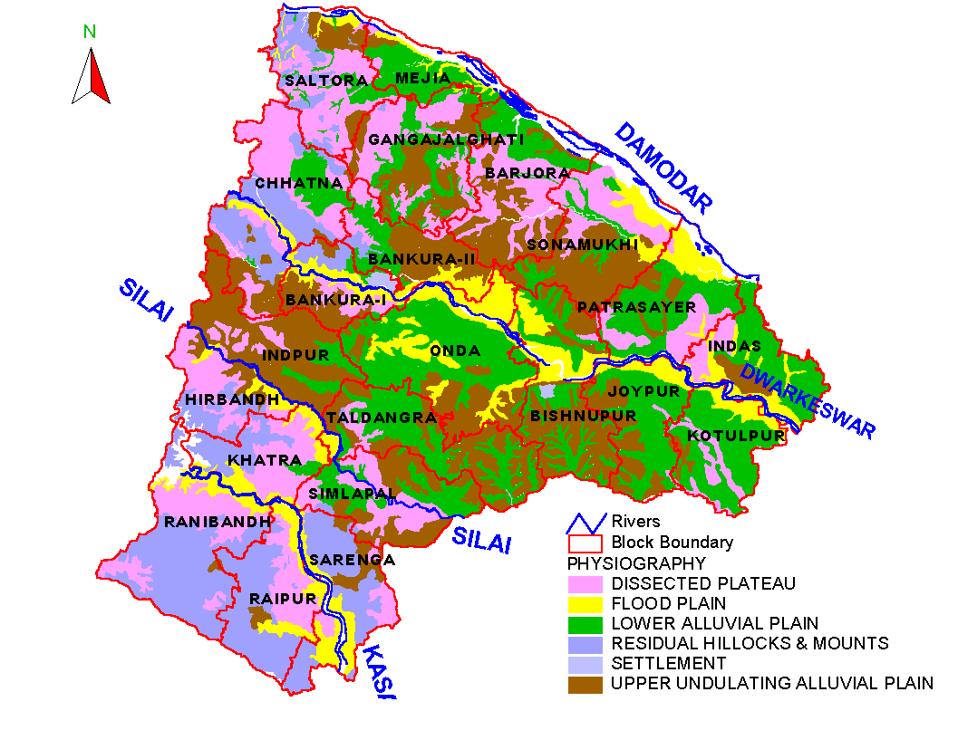
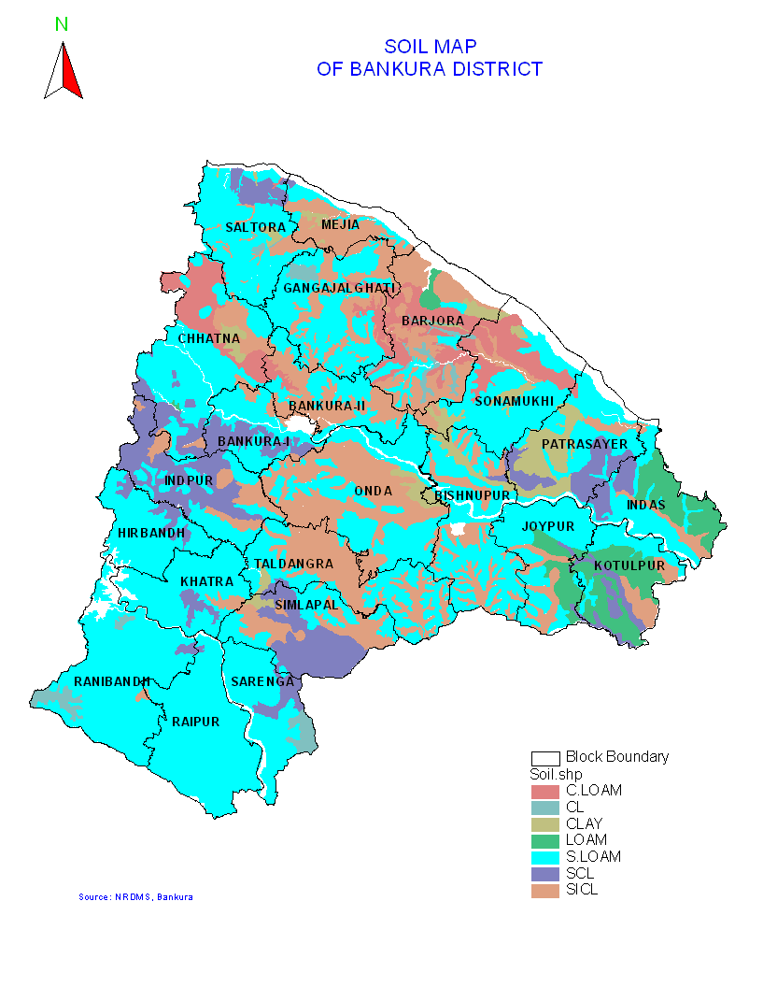
The implementation of NREGS has gradually picked up across the years in the district since its launch in 2006. So the data for the initial years or for the most recent time may not reveal the actual state of affairs. Hence, for this study I decided to consider the projects implemented between the financial years 2008-09 to 2010-11. Within this period, the number of projects executed rose from 1703 in 2008-09 to 9601 in 2010-11 in the district and correspondingly, the expenditure incurred on such projects increased from Rs.112.7 million to Rs.1023 million (http://nrega.nic.in/MISreport.htm). Proper weightage was given to this factor too.
For the purpose of clustering the projects into geographical divisions, I made use of a hydro-geomorphic zoning of the district done during the period 1998 – 2002, by the State Water Investigation Directorate (SWID), West Bengal, which is quoted in the District Human Development Report of Bankura (2007, pp. 43). This classification is particularly useful because it divides the district into three zones in terms of Blocks and also gives the area covered under each (see Table-2). However, the three zones are not completely separable. Parts of some Blocks at the fringes fall in two adjoining zones (e.g. Mejia, Bishnupur etc.). However for this sampling purpose the whole of Mejia and Raipur were considered in Zone-I and the whole of Bishnupur and Sarenga in Zone-II. This did not affect the quality of the sample much because the attempt here is to have a district representative sample and not a zone representative one.
Secondly, since the MGNREGA considers the Panchayats as the principal authorities for planning and implementation of NREGS, I have taken the GP as the unit for cluster formation. The district consists of 190 GPs of which 86 fall in Zone-I, 57 in Zone-II and 47 in Zone-III (see Appendix-I). I decided to undertake the survey in 5% of the GPs which in numbers comes to around 10 GPs. Now, Zones I, II and III account for 44%, 30% and 26% respectively, of the total population of the district (as per Census 2001; see Appendix-II). So I have selected 10 GPs for the field survey in a stratified manner from the three Zones on the basis of the zonal population percentage rounded to nearest integer. Thus 4 GPs have been selected from Zone-I and 3 GPs each from Zones-II & III. Within each zone however, the GPs were randomly chosen. The details are given in Table-2 below:
Table-2: Hydro-geomorphic zones of Bankura district and GPs selected for sampling.
Description | Zone – I | Zone – II | Zone – III
Rock type | Hard rock area in the west | Hard rock fringe area of the middle | Alluvial area of the east
Blocks covered | Bankura – I, Bankura – II, Chhatna, Saltora, Gangajalghati, Indpur, Khatra, Ranibandh, Mejia (part) and Raipur (part) | Bishnupur, Onda, Barjora, Simlapal, Taldangra, Mejia (part), eastern part of Sarenga | Bishnupur, Joypur, Kotulpur, Sonamukhi, Patrasayer and Indus
Area in sq. km. | 2904 | 2129 | 1848
Population (2001 Census) | 1300035 (44%) | 890667 (30%) | 758277 (26%)
GPs selected (with name of Block) | - Dahala (Khatra)  - Khatragram-I (-do-)  - Dhaban (Chhatna)  - Ramchandrapur (Mejia) | - Barjora (Barjora)  - Khanrari (-do-)  - Satmauli (Taldangra) | - Maynapur(Joypur)  - Jagannathpur(-do-)  - Dhanshimla (Sonamukhi)

Thirdly, from the “Work Status Report” of the district as retrieved from the official website of MGNREGA (www.nerga.nic.in), I obtained the number of projects implemented and the amount spent in each sector (as identified in the Schedule – I of the Act) for each financial year. The total population of the eligible projects for this study was 15771 (see Table-2). Considering constraints of time and fund, I decided to have a sample size of about 1% of the total project-population. That gave us a sample size of 158 projects. An analysis of the expenditures incurred in the various sectors reveals more or less a uniform sector-wise trend of expenditure as a ratio of the total expenditure on NREGS in a particular year in the selected time period. The sector-wise trend of number of projects implemented each year is also similar. However to avoid any bias in selection, I first stratified on the basis of percentage of sector-wise total expenditure and then on the basis of number of each kind of projects implemented in each year to arrive at the number of projects to be selected from each sector (see Table-3).
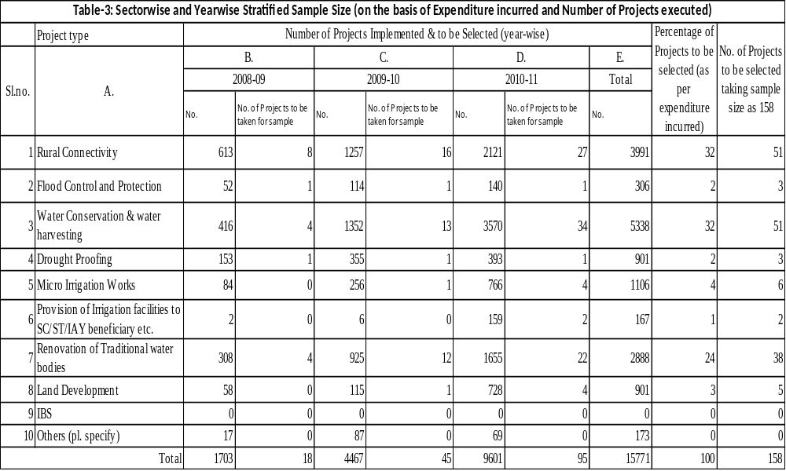

3.3 The Sample:
With the above strategy as the basis, the projects executed in the selected GPs were first clustered sector-wise and year-wise. All information on the projects executed, were obtained from the official website of MGNREGA viz. www.nrega.nic.in. Only completed projects were considered for this study. Thereafter, the requisite number of projects of each kind and for each year was randomly selected from the respective clusters. For example, in the ‘Rural Connectivity’ sector there were 76 projects in 2008-09, 186 in 2009-10 and 182 in 2010-11. Now out of this, according to the strategy employed in this sampling, 8 Projects were to be taken from 2008-09, 16 from 2009-10 and 27 from 2010-11. So I selected every 10th Project from the cluster for 2008-09, every 11th from that of 2009-10 and every 7th from that of 2010-11to arrive at the sample for this sector. Projects from the other main sectors i.e. ‘Water Conservation & Water Harvesting’ and ‘Renovation of Traditional Water Bodies’ were also selected exactly in the same manner. These three sectors account for 88% and all the other remaining sectors contribute to only about 12% of the total (project) population. So the latter were clubbed together under the heading ‘Miscellaneous Projects’ and requisite number of them were selected from the mix for separate financial years to finally obtain the sample of 158 projects. Table-4 gives the GP-wise summary of the 158 projects selected for the sample.
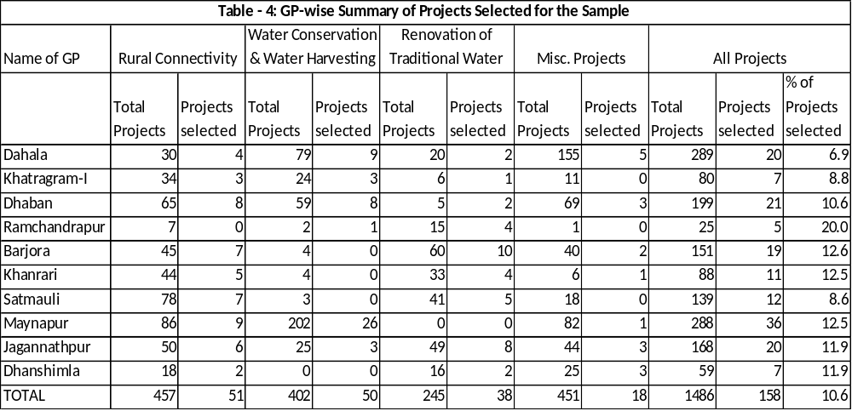

3.3.1 Ground realities and the Final Sample:
When I reached my field with the above sample in mind, I was faced with two practical problems. Firstly, the political scenario had changed in the state with the defeat of the Left Coalition and a new Coalition had moved into power. Emboldened by the success of their party at the state level, the followers of the latter threatened and drove away many Panchayat functionaries who belonged to the Left Coalition. So a political crisis got created in many GPs. One of the GPs from my intended sample, namely Satmauli GP fell in this category. The BDO warned me that situation was tense in that GP and advised me to choose some other GP. So I chose Fulmati GP in place of Satmauli.
Secondly, on verification with the POs I found that the physical locations of the above sample projects were scattered all over the GPs. Now each GP on an average consists of ten villages. So for the 10 GPs it comes around 100 villages which were physically not possible to be surveyed within the short period of time that I had in hand. So I selected 2 to 3 villages from each of the 10 GPs at random to have a final list of 23 villages (or Gram Sansads). Then I selected 3 to 5 projects from each village keeping in mind the original stratified sampling strategy undertaken for this research project. Ultimately I arrived at a sample of 82 projects spread over 23 villages in the 10 GPs of seven CD Blocks for my field work. The sector-wise details are given in table-5 below.
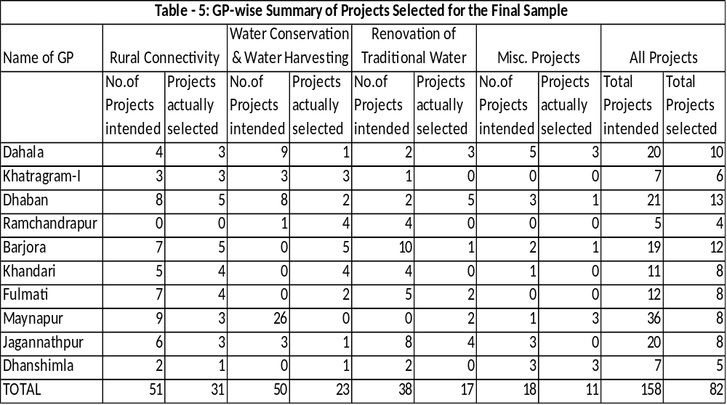

A comparison of the percentage of number of projects of each type in the sample and that in the total number of projects for the whole district is given in Table-6 below:
Table-6: Distribution of Projects in the Selected 10 GPs
Project type | Rural Connectivity | Water Conservation & water Harvesting | Renovation of Traditional Water Bodies | All three sectors | Miscell-aneous
Sample | 37.8 | 29.3 | 21.9 | 89.0 | 11.0
Whole District | 32.0 | 32.0 | 24.0 | 88.0 | 12.0

Thus the sector-wise trend in the final sample is similar to the distribution of projects in case of the district (see table-3) although there are differences in absolute percentage terms.

3.4 Methodology:
Both qualitative and quantitative research techniques were used for the study. A participatory approach was followed for the qualitative part of the study. For the quantitative part, use of available secondary data on NREGS and primary data collection through a field survey of a sample of projects implemented under NREGS was resorted to. The steps are elaborated below:
- I first gathered secondary data to assess quantity and diversity of NREGS projects implemented in Bankura between 2008 – 2010 were collected. Structured interviews of the Key Informants were done and document review was undertaken to gather these information on the project and the process of implementation. Based on these information and research requirements, questionnaires were developed for project survey and focused group discussions (FGD).
- Thereafter, a field survey was conducted to collect primary data regarding the type and quality of assets and infrastructures created, how they are used and maintained.
- FGD were conducted with the members of the community to assess the level of their participation in the decision making process regarding selection, implementation and upkeep of the projects and for identifying the direct and indirect benefits accrued to them from the projects. The GP Pradhan had already informed some villagers about our intended visit. After reaching each village we first explained the people our purpose of visit and requested them to volunteer for the VRG. Although we tried to form the VRG as planned earlier to have people of both sex and various age, in some cases this could not be followed strictly as women did not come out. Thereafter we started our conversation with the general questions on socio-economic issues which was followed by project inspection and then project specific questions were asked. When the survey of one project was over, we walked along with the VRG to another project.
- FGDs were conducted with the functionaries and staff of GP to assess their decision making capabilities regarding selection, implementation and monitoring the projects.
- This was followed by a structured interview of the concerned PO to judge his/her perception about the GP’s functioning.
- Thereafter, I explored the data to draw inferences and answer my research questions.

Chapter 4
The Data
4.1 Socio–economic profile of the Villages:

The socio-economic profile of the villages surveyed is typical of any backward area of West Bengal. There are in all 8811 households (HH) in the 23 villages. Out of these one-third HH are landless while another third of the HHs possesses only small areas of land the average of which comes to 0.23 acres. Only 8% of the HHs have considerable area of land (average 7.08 acres per HH) and 26% have medium land holdings of average area 2.06 acres. The chart - 1 gives an idea of the land holding pattern of the villages:

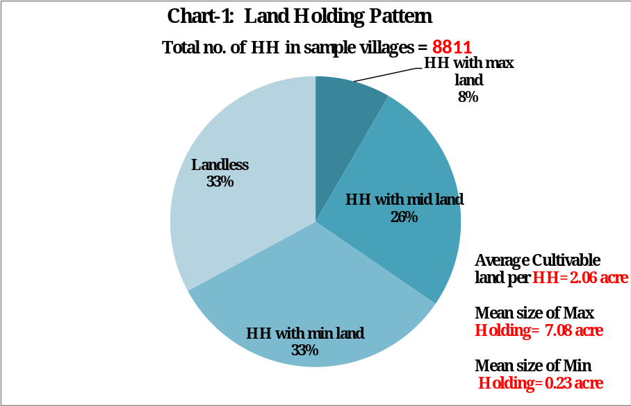

Barring Zone-3 GPs (see chapter-3) the other villages mostly fall in single cropping zone and agricultural productivity is quite low. The cropping intensity of the surveyed area is only 139% which is close to the district average of 147% (DHDR, 2007: 5). Although two-third of the HHs are directly dependent on agriculture, only one third have substantial land for cultivation. Thus underemployment in agriculture is quite high.

The remaining one-third HHs are landless labourers. This shows that about two-third of the HHs might be dependent on non-farm activities or wage-employments. This is exactly what we find from the survey also. Chart-2 shows that about 70% HH have to depend on some kind of non-farm income for their livelihood.

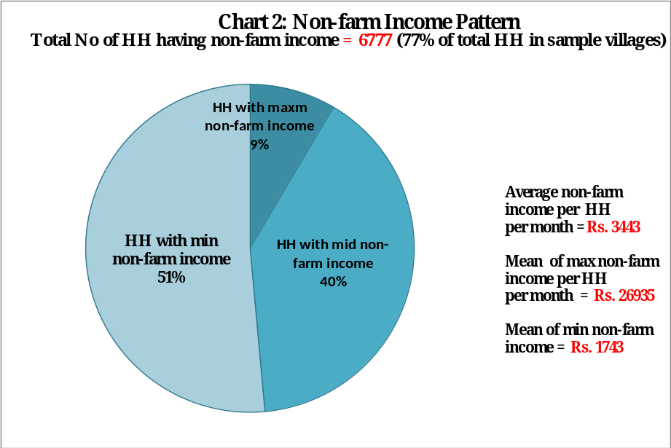

It also shows that there is a lot of disparity among the villagers in non-farm income. More than half of the HHs have non-farm income near the minimum and another 40% near the average.
From the survey we also found that seasonality of income is also high. On an average the villagers face cash-shortage for at least three months within the period July-October every year. Other than manual labour, sources of non-farm income are limited for the poor.
In other words, the setting is an ideal one for execution of NREGS works.

Political environment:
Results of the last Panchayat General Elections held in 2008 showed a major shift of elector preference towards non-Left candidates. In majority of the districts the lower tiers of the Panchayati Raj Institutions (PRI) i.e. Gram Panchayat and Panchayat Samity were captured by non-Left parties while the Left remained strong at the district level i.e. Zilla Parishad. However, in Bankura, which has been known to be a Left-stronghold, there has not been much change. It has retained Left Candidates in most of the seats of all the three tiers of Panchayati Raj Institutions (PRI). Out of the 10 GPs surveyed, 7 were governed by Leftists while 3 GPs (Barjora, Dhanshimla and Dhaban) were under AITMC (All India Trinamul Congress). However, in the recent Assembly elections, the Left has been defeated and a new government under AITMC has come to power. This has brought a wind of change throughout the state. Often conflict situations occur due to arm flexing of either party. This has disturbed the working situation in many GPs.

4.2 Type of assets created under NREGS:
If we consider the 23 villages as our universe for data-collection purpose, we see the following trend for the number of projects implemented and expenditure incurred in the three years 2008 – 2010 that has been chosen for this study:

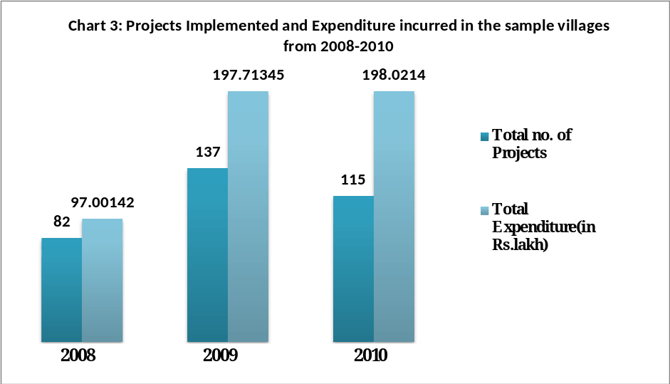

Most of the projects that have been implemented are rural roads, water conservation, minor irrigation and flood protection types. Table-4 (see Chapter-3) gives a GP-wise distribution of all the projects executed under NREGS in the 10 GPs selected for this study. There are in all 1486 projects of 457 are rural-connectivity, 402 water-conservation, 245 renovation of traditional water bodies and 451 miscellaneous projects including minor irrigation projects. Thus water-conservation water-harvesting schemes are the most popular schemes in Bankura. This is obvious recalling that the district is a drought prone one.
Most rural roads are constructed semi-metallic out of bolders and hard red laterite soil called ‘morum’. But in some GPs like Khatragram-I, Barjora, Khandari and Dhaban the villagers have a lot of demand for cement concrete roads. While Khatragram-I and parts of Barjora are urbanized, a portion of Khandari is also getting urbanized. So the demand for concrete roads instead of semi-metallic or earthern roads is understandable. However, the case of Dhaban GP is not clear because it is predominantly a rural area. When asked, one of the interviewees commented that the semi-metallic roads get regularly damaged by the bullock-carts, which are generally fitted with iron wheels and so they have to face trouble in commuting during the rainy season. Whatever may be the reason, from the point of durability; these concrete roads are far better and do not need regular repairs as the semi-metallic ones.
Minor irrigation projects constructed in Bankura are mostly dug-wells and huppa (or small tanks) in individual lands. Some of the areas like Dhansimla are flood prone. So a number of flood protection embankments have been constructed mostly to protect agricultural land.
So it is evident that the type of projects implemented in the GPs were as per feasibility and need of the local area.

Chapter 5
Results and Findings

5.1 Preference Targeting:

5.1.1 Planning – ‘Top Down’ or ‘Bottom Up’
The success of NREGS depends heavily upon proper planning. Providing employment within 15 days of demand and simultaneously ensuring that the design and selection of works are such that quality assets are created are not only the chief requirements of NREGA but also the key indicator for success of NREGS. So the ‘Development Plan’ is of paramount importance in NREGS. It comprises of an Annual Work Plan that consists of a shelf of projects for every village along with administrative and technical approvals so that works can be started as soon as there is a demand for work by registered job-seekers (NREGA Operational Guidelines, 2008).

The starting point of the planning exercise is preparation of an annual ‘Labour Budget’ by the District Programme Coordinator. [MGNREGA, Section-14(6)], Projections made in the Labour Budget are used by MoRD as the basis for estimating fund requirements and allocating fund to the individual districts.

However, the first point of consideration here is to see how the projects are selected for this development plan. NREGA envisages a ‘bottom-up’ approach for selection of the projects. The pivotal role for both planning and implementation is entrusted upon the GP. So it bridges the gap between planning and implementation as the local authority itself decides ‘what to do’ and ‘how to do’. This is unprecedented because most development programmes are generally ‘top-down’ and planning and implementation are dealt by separate authorities. Such programmes, consequently, suffer from information asymmetry and are thus handicapped from achieving their desired targets. Secondly, the Gram Sabha has been given the right to recommend the works to be taken up under NREGS. This creates a unique platform for community participation in development planning. This may stimulate a sense of ‘ownership’ among the people for the plan so prepared. In this way it ensures decentralization in the true sense where the people can actually exercise the power of having their ‘choice’.

5.1.2 Project-selection and Participation:

Information obtained through interviews of key informants like the ADM and DNO of Bankura district and the BDOs of the concerned blocks reveal that a decentralized selection procedure for the projects implemented under NREGS had been followed at least during the period 2008 – 2010. But this claim may suffer from information asymmetry because the ‘action’ takes place in the village while these authorities are stationed far away at the district or block headquarters and have to depend on information made available to them by the GP. So it would need an empirical grounding to establish the claim. The essence of empirical evidence becomes more important because of existence of evidences both for and against such claims in some other rural settings. For example, in a survey conducted by Besley et al (2005) in South India it has been found that targeting was preferentially in favour of the disadvantaged groups wherever Gram Sabha meetings were held. In another survey in Jharkhand conducted by Bhatia and Dreze, no evidence of any NREGA-related Gram Sabha was found in the survey area (Bhatia, B & J Dreze 2006).

So in the present survey, to examine validity of the above claim it will be pertinent to deal with issues such as ‘who selects the project and how’, ‘is there enough participation of the people at grass-roots level and if so then in what manner’ etc. The project selection process involves further smaller issues like selection of ‘project type’, ‘project site’, ‘project scale’ and ‘project design’. Let us first have an overall picture of the whole sample and then we may examine patterns, if any across the GPs. A comparison of the agencies involved in ‘project-type selection’ and ‘proect-site selection’ has been presented in the following Table-7. The figures indicate number of projects.
Table-7: Participation in project selection
 | Project Type selection
Project Site selection | GP | Gram Sabha | Gram Sansad | GUS | GP Member | Total
GP | 1 | 0 | 0 | 0 | 0 | 1
Gram Sansad | 6 | 0 | 5 | 0 | 7 | 18
GUS | 20 | 0 | 0 | 27 | 0 | 47
GP Member | 4 | 12 | 0 | 0 | 0 | 16
Total | 31 | 12 | 5 | 27 | 7 | 82

It is evident from Table-7 that as far as project-type selection is concerned; the most frequent approach is that the GP decides. However, this is followed by the GUS, Gram Sabha, GP Member and Gram Sansad. Considering the fact that, Gram Sabha and Gram Sansad are the two people’s forum at the grass-root level and the GUS is a committee of villagers, it can be said that there is a fair amount of participation of the villagers in the project-type selection.
On the other hand, Table-7 also reveals that the GP hardly plays any role in project-site selection. The GUS is the most frequent player in deciding the sites for the projects taken up for implementation. This is followed by the Gram Sansad and the GP Member. The above table tells that the villagers were directly involved in deciding the sites for 65 out of the 82 projects (i.e. 79% of the projects). So there is overall a good participation of the villagers in case of project-site selection.
To examine patterns across the GPs, we may consider a bivariate analysis of the above factors with the GPs under study. First, we may analyze the relationship for project-type selection:
Table-8: Participation in project selection in various GPs
 | Project Type selection
GP Name | GP | Gram Sabha | Gram Sansad | GUS | GP Member | Total
Barjora | 0 | 12 | 0 | 0 | 0 | 12
Khandari | 1 | 0 | 0 | 0 | 7 | 8
Dhaban | 0 | 0 | 0 | 13 | 0 | 13
Jagannathpur | 8 | 0 | 0 | 0 | 0 | 8
Maynapur | 8 | 0 | 0 | 0 | 0 | 8
Dahala | 10 | 0 | 0 | 0 | 0 | 10
Khatragram-I | 0 | 0 | 0 | 6 | 0 | 6
Ramchandrapur | 4 | 0 | 0 | 0 | 0 | 4
Dhanshimla | 0 | 0 | 5 | 0 | 0 | 5
Fulmati | 0 | 0 | 0 | 8 | 0 | 8
Total | 31 | 12 | 5 | 27 | 7 | 82

The Table-8 reveals that there are sharp differences in the decision making process across the GPs. Almost all the projects in Jagannathpur, Maynapur, Dahala and Ramchandrapur GPs have been selected by the ‘GP’ and in Khandari GP by the concerned GP Members. So there is hardly any people’s participation in the true sense in the above GPs. However, in Dhaban, Khatragram and Fulmati GPs all the projects have been selected by the GUS. In case of Barjora GP all the projects have been selected by the Gram Sabha and in Dhanshimla GP by the Gram Sansad. So it can be said that there is fair amount of participation by the people in the latter five GPs.
However, considering process of project-site selection, we see that in 9 out of the 10 GPs, either the GUS or the Gram Sansad has decided upon the sites where the projects were to be implemented. Only in case of Barjora, the project sites have been selected by the GP Members. So overall there is better participation of the villagers in decision making for site selection across all GPs except Barjora which is the outlier in this case. The following table reveals this:

Table-9: Participation in project site selection across GPs
 | Project Site selection
GP Name | GP | Gram Sansad | GUS | GP Member | Total
Barjora | 0 | 0 | 0 | 12 | 12
Khandari | 0 | 8 | 0 | 0 | 8
Dhaban | 0 | 0 | 13 | 0 | 13
Jagannathpur | 0 | 0 | 8 | 0 | 8
Maynapur | 0 | 4 | 0 | 4 | 8
Dahala | 0 | 0 | 10 | 0 | 10
Khatragram-I | 0 | 0 | 6 | 0 | 6
Ramchandrapur | 1 | 1 | 2 | 0 | 4
Dhanshimla | 0 | 5 | 0 | 0 | 5
Fulmati | 0 | 0 | 8 | 0 | 8
Total | 1 | 18 | 47 | 16 | 82

Combining the above two trends, it can be said that there is people’s participation in one form or the other either for project type selection or project site selection or both. Table-10 explains the trend.
Table-10: Community Participation in Project Selection across GPs
GP Name→ | Barjora | Khandari | Dhaban | Jagannath-pur | Maynapur | Dahala | Khatragram-I | Ramchandra-pur | Dhanshimla | Fulmati
Project type selection | Gram Sabha | GP Member | GUS | GP | GP | GP | GUS | GP | Gram Sansad | GUS
Project Site selection | GP Member | Gram Sansad | GUS | GUS | Gram Sansad | GUS | GUS | GUS | Gram Sansad | GUS

In Dhanshimla GP the Gram Sansad appears to be very active. The GUS appears to be most actively participating in project selection in Dhaban, Khatragram-I and Fulmati GPs. Thus we can say that there is good participation in these 4 GPs. But in rest of the 6 GPs we find that the GP or the GP Member is instrumental in deciding one of the two aspects while the other aspect is decided upon by the GUS, Gram Sansad or Gram Sabha. So there is only partial participation by the people in the latter GPs.
But if we consider the decision making process regarding the issues of ‘project scale’ (i.e.length or size of the project)and ‘project design (i.e. technical design)’, we find that in sharp contrast to the above, decision making is highly centralized in the hands of the GPs. The following table discloses this fact:

Table-11: Participation in project-design and project-scale selection
 | Project Design
Project Scale | GP | Govt. Agency | Total
GP | 75 | 2 | 77
Gram Sansad | 2 | 0 | 2
GUS | 1 | 2 | 3
Total | 78 | 4 | 82

This is understandable because project design and scale are technical matters and should be decided by technical persons for the purpose of ensuring soundness of the projects. The Nirman Sahayak (i.e. the civil engineer of the GP) takes such decisions. Ordinary people may not be able to contribute fruitfully in such technical aspects. In fact there are empirical evidences from a study by A. I. Khwaja in Northern Pakistan indicating, “While community participation in non-technical decisions (e.g. selecting project type, usage rules etc.) of projects is beneficial, community participation in technical decisions that have to be made in the same project (e.g. deciding project design, scale etc.) is detrimental” (Khwaja, 2009:900).
To sum up, NREGA calls for community participation in project selection to ensure that the projects taken up are as per local need and ability to maintain the assets created through implementation of such projects. However, in the present case we see that out of the 10 GPs studied, community has participated in ‘project type selection’ in only half of the GPs while that for ‘project site selection’ in 8 GPs. The community has very little say in ‘project design’ and ‘project scale’ selection. Final decisions on these aspects were taken by the GPs.
The extent of community participation in project selection varies across the GPs. In some GPs like Dhanshimla, Fulmati, Dhaban and Khatragram-I community participation appears to be good while in other GPs it is lackadaisical. In case of the latter, the GP happens to be the most important player in identification and selection of the projects. The main reason behind this is that, the GUS/Gram Sansad in the above four GPs are more active than the others. They have more number of people having leadership qualities. In other words they are rich in social capital and consequently preference targeting is better in these GPs.

5.2 Quality of Assets created:

5.2.1 Maintaining quality:
As mentioned earlier ‘creation of durable assets’ is an important objective of NREGS (NREG Act: Schedule I, Para-2). This calls for technically sound project design, proper implementation and good monitoring. The Act gives a lot of emphasis on all these aspects. Section 16(8) of the Act categorically states that “the works taken up under NREGS shall meet the required technical standards and measurements”. To facilitate this, Section 18 of the Act makes the State Government responsible to ensure technical support to the DPC and the PO for effective implementation of the scheme. The State Government may constitute panels of accredited engineers at the District and Block levels for the purpose of assisting with the estimation and measurement of works (NREGS Operational Guidelines, 2008).
Quality being a subjective feature, a set standard is needed for measuring it. So the Technical Secretariat has been formed at the highest level, as a part of the Central Council within Ministry of Rural Development (MoRD) for setting the quality standards and monitoring and evaluation of the assets created under NREGS. At the GP level the Nirman Sahayak has been permanently engaged for technical supervision of NREGS works. Apart from that at every worksite a Supervisor is engaged whose main task is to record attendance of the workers and ensure that quality of work is maintained.
Again to keep checks and balances, the Act (as per Section 17) has empowered the Gram Sabhas to monitor the execution of works and also to conduct social audit of all projects under the scheme. Schedule I (Para-14) says that provisions for regular inspection and supervision of works taken up under NREGS shall be made to ensure proper quality of work. In West Bengal, at the Gram Sansad level the GUS has been authorized to monitor all development works taken up in their ward to keep a check on the quality of work. Furthermore, specific targets have been fixed up for quarterly internal verification of the works at the field level by the official functionaries.
Such an elaborate in-built monitoring arrangements and emphasis on transparency is obviously expected to facilitate a sustainable infrastructure development under NREGS. However, some empirical findings are on the contrary. In the study by Bhatia and Dreze in Jharkhand (2006) it was observed that “most of the works had remained incomplete, and were in danger of being washed away in the coming monsoon. In other cases, the work had been completed but its productive value was doubtful”. In a study conducted in Madhya Pradesh (a state in Central India) by Centre for Environment and Food Security (CEFS), New Delhi (with support from HIVOS, Netherlands) in 2008 it was found that innumerable tree plantation projects were executed under NREGS without a single surviving sapling or plant (Rai, P 2008:4).

5.2.2 The Findings on Quality:
However, the picture that emerges from my survey is a lot brighter. We find the first signs of the desired project characteristics in the sense that the assets created in all the 82 sample projects existed physically at the time of the field work. But one project namely “earthern check dam on Jagannathpur Kasichata Khal” (project code: 330614086) in Jagannathpur GP was in a severely damaged state. (In fact, such check dams are of purely temporary and seasonal nature. These are built to obstruct river water for irrigation during winter cultivation season. They get washed away by river current during the monsoons.).
However, since the primary aim of NREGS is to provide employment to the jobless, the projects selected for execution are mostly labour intensive ones and use of machines is not allowed. In fact, Para-9 of Schedule I to the Act stipulates that the cost of material component of the projects including wages of the semi-skilled and skilled workers taken up under the scheme shall not exceed 40% of the total project cost. While this ensures more manual wage, it may potentially lead to important trade-offs like creation of low quality and less durable assets. We will return to this argument later.
In order to judge the quality of the projects, the study focuses on two dimensions. First, the physical condition of the projects which is determined by (i) the perception of the users (whether the projects were ‘well made’ or not) and (ii) the present physical status of the projects as judged by site verification during the survey. The second point of consideration in quality assessment is the functional state of the projects i.e. whether the projects are operational.

The following table provides an idea of the people’s perception about the quality of the projects:
Table-12: | Project Quality
Project Quality | Frequency | Percent | Cumulative %
Not so well made | 11 | 13.41 | 13.41
Well made | 71 | 86.59 | 100.00
Total | 82 | 100

From the above table, we can say that according to the villagers, implementation of most (87%) of the projects were of good quality while some (13%) of them were of not so good quality. However, delving a bit deeper into some more tangible parameters, we try to look at physical condition operational status of the projects.

5.2.3 Physical & Functional states vs. Quality
As stated earlier each and every project was visited during the survey and their physical conditions were taken note of. Taking the services of some technical personnel would have been best for such an assessment, but that is quite costly and time consuming. So, to assess the physical condition we used ‘eye estimation’ of the extent of damage compared to the total length or size of the project. Depending upon extent of damage we selected the projects into one of the following five categories – severely (almost all) damaged, moderately (around 50%) damaged, slightly (less than 50%) damaged, very little damaged and undamaged. The Table-13 gives a picture of the physical condition of the projects:

Table-13: Physical condition of the Project
Physical condition | Frequency | Percent | Cumulative %
Severely damaged | 1 | 1.22 | 1.22
Moderately damaged | 1 | 1.22 | 2.44
Slightly damaged | 17 | 20.73 | 23.17
Very little damaged | 37 | 45.12 | 68.29
Undamaged | 26 | 31.71 | 100.00
Total | 82 | 100

From the above table we can say that 77% of the projects are either in the undamaged state or have very little damages. 21% of them are slightly damaged while only 2% have moderate to severe damages. This trend is more or less in tandem with the people’s perception of the quality of the projects mentioned above.
Considering the current operational state of the project i.e. whether they are operational or not, we have the following figures:
Table-14: Current Operational State of Projects
Current status | Frequency | Percent | Cumulative %
Fully operational | 43 | 52.44 | 52.44
More or less operational | 32 | 39.02 | 91.46
Partially operational | 6 | 7.32 | 98.78
Non operational | 1 | 1.22 | 100.00
Total | 82 | 100

The above table shows that 52% of the sample projects are fully operational and another 39% of them are more or less operational. Combined together it can be said that 91% of the projects are operational. 9% of the projects are partially operational or non-operational. These figures also resemble very closely the figures regarding people’s perception of quality.
Thus overall it can be said that majority of the projects implemented under NREGS in Bankura are of good quality. But, there are a few projects which are not so good in quality.
Two questions arise here. Firstly, whether the restriction of mandatory 60:40 wage : material ratio responsible for low quality of some projects and secondly, what could be the driving force for the better quality of most of the projects.
To answer the first question we need to figure out the quality of material intensive projects (i.e. for which material cost>labour cost) and the labour intensive ones (i.e. for which material cost<labour cost) in the sample and draw a comparison between them. This is portrayed in the following two tables:
Table-15: Project Quality of Material intensive projects
Project Quality | Frequency | Percent | Cumulative %
Not so well made | 3 | 14.29 | 14.29
Well made | 18 | 85.71 | 100.00
Total | 21 | 100
Table-16: | Project Quality of labour intensive projects
Project Quality | Frequency | Percent | Cumulative %
Not so well made | 7 | 13.73 | 13.73
Well made | 44 | 86.27 | 100.00
Total | 51 | 100

As it is seen from the above tables, the ratio of ‘well made’ to ‘not so well made’ projects is almost same in case of both material intensive and labour intensive projects taken as a whole and it is also similar to that for the whole sample (see Table-12). This however, does not overrule the possibility of individual material intensive projects outperforming the labour intensive ones. But in general there is no improvement of quality only if the expenditure on material component is higher. This is because of the fact that quality depends on factors such as project design, quality of materials used and superior implementation. However, whether a project should be material intensive or labour intensive depends on the type of the project and its purpose.

5.2.4 GP specific analysis of quality:
To answer the second question we begin by analyzing variations in quality across GPs. Tabulating the people’s perception about the quality of projects in each GP, we get the following table:
Table-17: Project Quality (GP wise) & Project selection type
GP Name | Not so well made | Well made | Total | Project type selection | Project Site selection
Barjora | 0 | 12 | 12 | Gram Sabha | GP Member
Khandari | 0 | 8 | 8 | GP Member | Gram Sansad
Dhaban | 7 | 6 | 13 | GUS | GUS
Jagannathpur | 1 | 7 | 8 | GP | GUS
Maynapur | 0 | 8 | 8 | GP | Gram Sansad
Dahala | 0 | 10 | 10 | GP | GUS
Khatragram-I | 0 | 6 | 6 | GUS | GUS
Ramchandrapur | 2 | 2 | 4 | GP | GUS
Dhanshimla | 0 | 5 | 5 | GramSansad | Gram Sansad
Fulmati | 1 | 7 | 8 | GUS | GUS
Total | 11 | 71 | 82

The table reveals that in most GPs the people’s perception is that the projects were ‘well-made’. However in Dhaban, Ramchandrapur, Fulmati and Jagannathpur GPs some of the projects were ‘not-so-well-made’. The table also shows side by side the agencies involved in project selection. A close study reveals that in whichever GP if either the Gram Sabha or the Gram Sansad is involved in project selection, all the projects are of good quality. In other words, greater community participation in project selection is likely to facilitate creation of good quality infrastructure.

Next we consider the physical condition of the projects across the GPs in the following table:
 | Table-18: Physical condition of the project (GP wise)
GP Name | Severely damaged | Moderately damaged | Slightly damaged | Very little damaged | Undamaged | Total
Barjora | 0 | 0 | 0 | 9 | 3 | 12
Khandari | 0 | 0 | 6 | 0 | 2 | 8
Dhaban | 0 | 0 | 7 | 4 | 2 | 13
Jagannathpur | 1 | 1 | 1 | 4 | 1 | 8
Maynapur | 0 | 0 | 1 | 5 | 2 | 8
Dahala | 0 | 0 | 0 | 3 | 7 | 10
Khatragram-I | 0 | 0 | 0 | 0 | 6 | 6
Ramchandrapur | 0 | 0 | 0 | 3 | 1 | 4
Dhanshimla | 0 | 0 | 0 | 3 | 2 | 5
Fulmati | 0 | 0 | 2 | 6 | 0 | 8
Total | 1 | 1 | 17 | 37 | 26 | 82

From the above table we can see that all the projects in Khatragram-I GP are in ‘undamaged’ state and hence can be said to be physically of the best quality or in other words most durable among the sample projects. Again, in Barjora, Dahala, Ramchandrapur and Dhanshimla GPs the projects are a mix of ‘undamaged’ ones and ‘very little damaged’ ones and thus can be placed one grade lower in quality in comparison to Khatragram-I GP. In Khandari, Dhaban, Maynapur and Fulmati GPs the projects are a mix of more number of ‘slightly damaged’ and ‘very little damaged’ ones and fewer ‘undamaged’ ones. So these projects can be said to be further one step lower in quality. But Jagannathpur GP has only one undamaged project while rest of them range from ‘very little damaged’ to ‘severely damaged’ ones and hence can be placed at the bottom of the ladder. For the sake of comparison, we can say that on an average quality of the projects on the basis durability decreases from Khatragram-I GP to Jagannathpur GP in the above sequence.
Considering the operational status of the projects we find from the following table that most of the projects across the GPs are either fully or more or less operational.
Table-19: | Current operational state of the project
GP Name | Fully operational | More or less operational | Partially operational | Non operational | Total
Barjora | 8 | 0 | 4 | 0 | 12
Khandari | 2 | 6 | 0 | 0 | 8
Dhaban | 4 | 9 | 0 | 0 | 13
Jagannathpur | 6 | 1 | 0 | 1 | 8
Maynapur | 2 | 6 | 0 | 0 | 8
Dahala | 7 | 3 | 0 | 0 | 10
Khatragram-I | 5 | 1 | 0 | 0 | 6
Ramchandrapur | 2 | 1 | 1 | 0 | 4
Dhanshimla | 3 | 2 | 0 | 0 | 5
Fulmati | 4 | 3 | 1 | 0 | 8
Total | 43 | 32 | 6 | 1 | 82

We find that in each of the GPs Khatragram-I, Dahala, Barjora,Jagannathpur and Dhanshimla, majority of the projects are of ‘fully operational’ category and hence can be said to be of better quality from the operational point of view. Again, in each of the GPs Fulmati, Ramchandrapur, Dhaban, Khandari and Maynapur less than half of the projects are ‘fully operational’ while the rest are either ‘more or less operational’ or ‘partially operational’. So these later GPs can be said to be lagging behind in operational quality of the projects.

It thus transpires that quality is a relative criterion and its measure is dependent on the parameter chosen to judge it. However, from the analysis produced at Table-17, it can be said that quality of projects is likely to be better if community participation is higher.

5.3 Maintenance of the projects:

5.3.1 The Maintenance debate:
Maintenance of the assets created in NREGS appears to be the lopsided part of NREGA. The Act (Schedule I, Para-4) suggests that the State Council shall prepare a list of preferred works for different areas based on their ability to create durable assets. Strengthening of livelihood resource base of the rural poor through creation of such assets is an important objective of NREGS (Schedule I, Para-2). To achieve this, the assets need to be maintained properly so that they continue delivering the intended benefits to the people in a sustainable manner. The Act further provides that the State Government shall make rules for proper maintenance of the public assets created under NREGS (Schedule I, Para-5). However, no such specific rules pertaining to maintenance of the assets have been made yet, although implementation of NREGS has passed into the sixth year. The Operational Guidelines of NREGA is also silent in this matter. As such this has remained a grey area in the policy for NREGS. So only empirical findings can throw some light on this issue of maintenance of the assets. Unfortunately there has been no specific study to evaluate the maintenance of NREGS created assets.We thus turn to the findings in our sample survey to investigate what is being done on the maintenance front and whether there is any set pattern. Most of the sample projects have been constructed on public lands. However, there are some projects like excavation of ponds, tanks, dug-wells etc. which have been taken up on private lands. Maintenance of the latter projects is looked after by the concerned owner(s) as they have specific economic gains from the projects. But there is a lot of confusion regarding responsibility of maintaining the projects constructed on public land.

Maintenance has a very close relationship with quality of implementation. Well-made projects generally need lesser maintenance efforts than the not so well-made ones. We saw earlier that 86% of the projects were well-made according to the villagers. During the FGDs with the villagers we came to know that 91% of the projects were operational and 68% of them were performing well. On physical verification of the projects it was found that 77% of the projects were more or less in good shape. This suggests that requisite efforts are necessary for upkeep of the projects even if they are of good quality. In the present case there is scope for improvement of performance of 32% of the projects. Again 23% of projects would require some repair works to become fully functional. Thus maintenance of the projects is quite essential.

5.3.2 Maintenance Mechanism:

But the irony is that, there is no formal maintenance mechanism in any of the GPs. When asked about what was being done for maintenance of the projects, the POs stated that it was up to the villagers to maintain the community assets for their own benefit. There was no direction upon them from higher authorities or under the statute to arrange for maintenance of assets on regular basis. The Pradhans also expressed their helplessness to take up regular maintenance work because they did not have any fund earmarked for the purpose. Another handicap they pointed out was that only those works could be executed under NREGS that were already included in the Annual Action Plan. However, at times there are strong demands from the villagers for repair of certain projects. Under such circumstances, the Pradhans are forced to take up urgent repair works by diverting funds meant for other schemes (not NREGS).
To assess maintenance, we asked the VRG questions like who was responsible for the maintenance, how it is done, was there any committee, whether the villagers contributed anything and the like. The responses of the VRG as well as our assessment of the physical and functional conditions of the projects were used to gage their maintenance. A project was categorized “well-maintained” if it had no physical damage and was fully functional.
Table-20: Project Maintenance
Project Maintenance | Frequency | Percent | Cumulative %
Not maintained | 8 | 9.76 | 9.76
Not so well maintained | 30 | 36.59 | 46.34
Well maintained | 44 | 53.66 | 100.00
Total | 82 | 100

The above table shows that 54% of the projects are ‘well maintained’ while another 36% are ‘not so well’ maintained. 10% of the projects were either not maintained or did not need any maintenance. So even though the statute does not make any provision for maintenance, the above table clearly shows that there is some sort of maintenance procedure in existence in majority of the projects.
To find how the maintenance of projects differs across the GPs we take “percentage-damage” as the variable and show the mean and standard deviation in the table below. the argument is that if maintenance is good then the project will be less damaged and vice-versa. The predominant “project-selection type” has also been shown against each GP.

Table-21: | GP-wise damage percentage of Projects & project selection type
GP Name | No. of Projects | Percentage Damage |  | Project selection by
 |  | Mean | Standard Deviation
Barjora | 12 | 4.92 | 3.55 | Gram Sabha
Khandari | 8 | 16.25 | 10.26 | GP Member
Dhaban | 13 | 7.69 | 3.88 | GUS
Jagannathpur | 8 | 18.87 | 23.18 | GP Member
Maynapur | 8 | 7.5 | 6.55 | GUS
Dahala | 10 | 3 | 4.83 | GUS
Khatragram-I | 6 | 0 | 0 | GUS
Ramchandrapur | 4 | 4.25 | 4.35 | GP Member
Dhanshimla | 5 | 5 | 5 | Gram Sansad
Fulmati | 8 | 10 | 5.34 | Gram Sansad
Total | 82

The trend above shows that damage is comparatively less in Barjora, Dhaban, Maynapur, Dahala, Khatragram-I, Dhanshimla and Ramchandrapur GPs while high in Khandari, Jagannathpur and Fulmati GPs. It is intriguing to investigate what might be the reason behind it.

In the survey we found that there was no formal maintenance committee in most of the projects. However, in a number of projects, the GUS performed the function of maintenance committee by default because it is the permanent beneficiary committee for all development projects of the village. In some projects (at Barjora), traditional committees like “sholo-ana-committee” (meaning an all-representative committee) looked after the projects. From field experience it can be said that wherever the GUS was active, maintenance had been better. Like in Khatragram-I GP, the GUS had taken initiative to hold meetings with their fellow villagers and divide the responsibility of maintaining different projects among themselves. Minor repair works were taken up by the villagers themselves while the major ones were reported to the GUS who in turn took it up with the GP. In Barjora GP, it was the GP member who took the initiative to repair minor damages with the help of the local villagers and locally available materials. In both places when the villagers were asked as to why they gave voluntary labour for the maintenance, they replied that the project was theirs and hence they repaired it for their own benefit. In other words they had a sense of “ownership” for the projects which motivated them to work voluntarily for maintenance.

5.3.3 Participation & Maintenance

Since the GUS is a sort of permanent committee in the village we can consider it as maintenance committee. It would be of interest to examine if there was any correlation between presence of such committees and project maintenance.
The following table gives the status of maintenance committees and the corresponding state of maintenance for the sample projects:

Table-22: | Maintenance Committee
Project Maintenance | None | Formal | Traditional | Total
Not maintained | 8 | 0 | 0 | 8
Not so well maintained | 15 | 15 | 0 | 30
Well maintained | 13 | 30 | 1 | 44
Total | 36 | 45 | 1 | 82

Table-22 shows that the number of ‘well maintained’ projects is more than two times higher in case of presence of a maintenance committee (compared to the situation of having no maintenance committee). Thus it can be said that having a maintenance committee in place ensures better maintenance of the projects to a large extent. This becomes clearer if we see table-21 where we find that the GUS was active (as it played the major role in project selection) in Khatragram-I, Dahala, Maynapur and Dhaban. Again in Barjora the traditional-committees were active. In all these GPs maintenance of the projects was better than some other GPs like Khandari and Jagannathpur where such committees were not active. In other words participation of the villagers in an organised manner (e.g. in the form of GUS etc.) generally ensures better maintenance of the projects. This implies that participation in planning and monitoring of development projects brings a sense of ownership among the people. Such feeling facilitates spontaneous participation in maintenance of the projects too. So although the statute has remained silent on this issue majority of the projects are being maintained though somewhat informally.

However, there are other GPs like Ramchandrapur where damage is less and so is social capital. In some cases, the local villagers who draw benefit from the projects look after the minor maintenance issues themselves without being prompted by anyone else. So the association between project-maintenance and community participation is clear but the direction of causality is not very distinct.

Notwithstanding the above, there is hardly any formal maintenance system in vogue. The users do not contribute any cash for the maintenance although at times they do offer free labour for minor repairs. There is no practice of collecting any ‘user charge’ in any of the projects. Often, the villagers are of the opinion that they have a right to the benefits of the projects but their responsibility extends only up to seeing that there is no misuse of the project and informing the GP to repair the damages. Such repair works are generally taken up by the GP as fresh projects under NREGS in the next financial year.

5.4 Effectiveness of use of NREGS projects:

5.4.1 Usefulness & NREGS
Labor-intensive programs with food security goals attempt to maximize poverty reduction and thereby achieve food security, while also encouraging growth and providing development oriented public goods, that is, infrastructure (von Braun, 1995). Although the main purpose of implementing projects under NREGS is to provide employment to the job-card holders who demand work and generate immediate short-term income for them, because of its inherent ‘employment guarantee’ feature it also ensures risk insurance against unemployment and hunger which is most important for food security of the poor. However, in the long run, the assets created under NREGS become more important through their cascading effect on employment and income both direct and indirect, by expanding the livelihood resources (like water for irrigation, land development etc.) and building infrastructure (like roads, irrigation channels etc.).

5.4.2 Measuring ‘usefulness’ of the projects:
During the survey, all the 82 projects were visited physically and information was gathered from the community regarding the ‘usefulness’ of each and every project. Questions were asked on issues such as who were using the project, how useful the project was, what benefits they were drawing from it and how much did they value those benefits. It was a bit difficult to get the pecuniary value for the benefits from them for two reasons. Firstly, they believed that it was a public project and hence free of cost. Secondly, many were of the opinion that they had voted for the ‘party’ (i.e. political party in power) and so it was the duty of the ‘Pradhan’ to execute such projects for the welfare of the locality. Consequently, according to them they were entitled to enjoy the benefits as a matter of right and that there was no question of any pecuniary value for the benefits. However, after explaining them that none is going to charge them for the benefit and that the surveyor was just interested to assess how important the benefit was for the community then they expressed their views about the possible values for the benefits.

Now the ‘usefulness’ of a given project is expected to be greater if the ‘need’ for the benefits accruing from it is higher. We call this ‘need perception’ of the people about the projects which can also be used as an indicator to measure the ‘usefulness’ of the said projects. The people were asked whether the need for the project will increase, decrease or remain the same over time and their responses were tabulated.
The following table gives a general idea of the ‘need perception’ of the projects:
Table-23: Need Perception
Project Need with time | Frequency | Percent | Cumulative %
Will decrease | 3 | 3.66 | 3.66
Remain same | 26 | 31.71 | 35.37
Increase | 53 | 64.63 | 100.00
Total | 82 | 100

The above table shows that according to the users, except for three projects the need for all other projects will either increase or remain the same as present. It is interesting to note that in majority of the projects (65%) the users think that the usefulness will increase with time. On analyzing further we find that about two-third of these projects are related to water harvesting or water conservation. This is obvious considering the fact that the district is a drought prone one.

5.4.3 Assets and corresponding Benefits:
Bankura being a backward and a drought prone district there is need for infrastructure development projects as well as projects facilitating water conservation. Thus about 50% of the projects executed in the district under NREGS are related to water conservation (like ponds, tanks, happas etc.) and another 30% of them are link road construction projects. In the low lying areas there are also flood protection projects like river embankments and drainage canals.
The benefits that the people are getting from the various projects are specific to the type of asset created. The following table gives the details (Table-24):
Table-24: Assets and Benefits
Sl. No. | Assets created | Description of Benefits
1. | Roads | Better communication; local development; opportunities for new economic activities.
2. | Ponds/Tanks | Water conservation for future use, domestic use, water for irrigation, fisheries.
3. | Embankments/drainage canals | Protection of residential and cultivable areas from inundation
4. | Dug-wells | Source of drinking water, irrigation of individual plots
5. | Happas (small tanks) | Water for irrigation

5.4.4 Benefits and Growth – a discussion:
From table-24 we can see that the NREGS projects are generating a host of economic benefits apart from social benefits. Creation of the above assets is adding to the development of the localities and potentially opening up new opportunities. The main economic benefits accruing out of the assets are availability of water for irrigation and opportunity to do fishery in case of the ponds/tanks; local area development, opportunities of newer economic activities and increase in land price in case of link roads. In some areas like Khatragram-I economic development is markedly observable where according to the villagers, construction of roads had led to new economic activities for a sizeable number of HH. In Barjora GP the villagers stated that the water holding capacity of the ponds and tanks excavated under NREGS has increased over the years. This has helped to increase the productivity of soil in that area. Farmers are now reaping better produce since the last couple of years. So it can be said that NREGS created assets are definitely facilitating economic development. Although an assessment of such growth is beyond the scope of this paper, the following case-study gives anecdotal evidence.

Case Study: Swapan Bauri – the lucky farmer:
Swapan Bauri is a middle-aged farmer of Taljharia, a backward village. He has 1.7acres of land but could grow crops only once a year depending on the monsoon. Every year he use to dig out a temporary dug-well to store some water for irrigation. However with offset of monsoon the dug-well also dried up soon. So he approached the Pradhan along with his neighbours in end 2009 with a prayer for a concrete dug-well. The Pradhan considered his case compassionately and next year a concrete dug-well was constructed in his plot next year with a total investment of Rs.115000/-. Winter of 2010-11was the first time in his life that he could reap a fair harvest. He earned Rs. 20000/- by selling vegetables in that season. He also shares the water with three of his neighbours who have plots adjacent to his. A total area of 3acres now get water for irrigation from this project.

Summing up, it can be said that the assets being created under NREGS are really leading to development of the rural areas. But these economic benefits can be accessed only by those who have the ‘means’ of it. In other words, only those who own land can use the water for irrigation or muster good value by selling a road-side land or those who are economically well off will be best placed to grab the opportunity to start a new (more profitable) economic activity. Out of the 8811 HH in this survey only 3016 HH own considerable cultivable land. Naturally the greater part of the benefits will go to the economically better placed and the HH at the lowest strata get only minuscule gain from the assets created under NREGS.

So apparently although it appears that by strengthening the rural livelihood resource base by creation of assets through NREGS would help eradicate chronic rural poverty, in reality the majority of the gains from the whole exercise is accruing to the already well off. In essence this might be increasing the gap between the rich and the poor even further. In other words, the productive assets created through NREGS are more often than not regressively distributed. But there is no system of ‘user charge’ or taxation for using these benefits. The assets get created through huge investment of public money and naturally involve high opportunity cost. Thus, if NREGS has to really achieve its long term goal of tackling rural poverty and recharging the rural economy, serious thought needs to be given regarding linking of the incremental income and productive assets with taxation.

Chapter 6:
Conclusion
This paper set out to address three pertinent issues regarding India’s (and also the world’s) largest workfare program NREGS. The paper examined the type and quality of assets and infrastructures created under NREGS; the extent of preference targeting of NREGS projects and the effectiveness of use and maintenance of the assets. The study was based on field survey of 82 completed projects under NREGS spread across the district in 23 villages under 10 GPs of 7 Blocks. Separate FGDs were held with users group of every project and GP functionaries of all GPs. In depth interviews were held with District Officials and BDOs too.

The study shows that the projects chosen under NREGS for execution were as per local need. Bankura is a drought prone and backward district. So water-conservation and water-harvesting projects are most important for the district. From the survey it was found that about 50% of the schemes were of this type. Thus the provisions of Schedule-I of MGNREGA have been followed in choosing the project type. Most of these are community projects but some are individual beneficiary projects too like dug-wells. A number of water-harvesting projects have been constructed on private land but are used as community assets.

In terms of preference targeting, the study finds that the community’s role is important in project selection at least in Bankura district. The Gram Sabha, Gram Sansad and the Gram Unnayan Samity (or Village Development Committee) are the citizens forum which participate with elected representatives of the GP to formulate the development plan. The study shows that in selection of three-fifths of the NREGS projects, the community had been the main player. However, across the GPs, a lot of variation in community participation was detected in the study. In some GPs community participation was found to be profound while in some others it was less. But in whichever GP community participation was high, projects were found to be of better quality. Secondly, villages where GUS had been active, project outcomes were even better. So nurturing activity-wise focussed citizen groups is likely to enable preference targeting.

Regarding maintenance it was found that there was no maintenance system in any of the GPs. Still it was found that more than 50% of the projects were well-maintained. A lot of variation was found among the GPs regarding the maintenance issue also. On detailed analysis it was found that maintenance had been better in those GPs where community participation was higher. However, the causal relation was not very clear because project condition was good in some other GP also where community participation was less.

Finally, regarding effectiveness of use, it can be said that most projects have been identified by the community to be quite beneficial. It was also found that the NREGS created assets enabled development of the rural areas facilitated economic growth through better productivity of land and opening up opportunities for new economic activities. But the possibility of income enhancement of the affluent was higher than the weaker section of people.

Overall it can be said that community participation is a prerequisite for generating appropriate project outcomes under NREGS.

Appendices
Appendix – I
Zone-wise List of GPs of Bankura District
Sl. No. | Zone | Block | GP | Population
1 | I | Bankura - I | ANCHURI | 19765
2 |  |  | ANDHARTHOL | 18018
3 |  |  | JAGADALLA-I | 13241
4 |  |  | JAGADALLA-II | 12113
5 |  |  | KALPATHAR | 12635
6 |  |  | KENJAKURA | 20068
7 |  | Bankura - II | BIKNA | 17969
8 |  |  | JUNBEDIA | 25414
9 |  |  | KUSHTIA | 12538
10 |  |  | MANKANALI | 18559
11 |  |  | NARRAH | 18142
12 |  |  | PURANDARPUR | 16267
13 |  |  | SANBANDA | 14526
14 |  | Chhatna | ARRAH | 16015
15 |  |  | CHHATNA-I | 13555
16 |  |  | CHHATNA-II | 9614
17 |  |  | CHINABARI | 12966
18 |  |  | DHABAN | 13385
19 |  |  | GHOSERGRAM | 14696
20 |  |  | JAMTORA | 10607
21 |  |  | JHUNJKA | 13777
22 |  |  | JIRRAH | 14582
23 |  |  | METYALA | 12154
24 |  |  | SALDIHA | 11992
25 |  |  | SUSUNIA | 11236
26 |  |  | TEGHARI | 14636
27 |  | Saltora | BAMUNTORE | 15657
28 |  |  | DHEKIA | 13645
29 |  |  | GOGRA | 12325
30 |  |  | KUNURI | 15431
31 |  |  | PABRA | 14483
32 |  |  | SALMA | 16109
33 |  |  | SALTORA | 18906
34 |  |  | TILURI | 14996
35 |  | Gangajalghati | BAN ASURIA | 16070
36 |  |  | BARSOL | 18923
37 |  |  | BHAKTABANDH | 13945
38 |  |  | GOBINDADHAM | 35177
39 |  |  | KAPISTA | 15239
40 |  |  | LACHMANPUR | 14338
41 |  |  | LATIABANI | 16522
42 |  |  | NITYANANDAPUR | 15735
43 |  |  | PIRRABANI | 16058
44 |  | Mejia | ARDHAGRAM | 16946
45 |  |  | BANJORA | 9620
46 |  |  | KUSTORA | 15289
47 |  |  | MEJHIA | 18979
48 |  |  | RAMCHANDRAPUR | 15289
49 |  | Indpur | BHEDUASOLE | 22478
50 |  |  | BRAHMANDIHA | 21808
51 |  |  | BRAJARAJPUR | 21445
52 |  |  | GOURBAZAR | 17047
53 |  |  | HATGRAM | 16913
54 |  |  | INDPUR | 20057
55 |  |  | RAGHUNATHPUR | 18077
56 |  | Khatra | BAIDYANATHPUR | 13010
57 |  |  | DAHALA | 17242
58 |  |  | DHANARA | 14073
59 |  |  | GORABARI | 10911
60 |  |  | KHATRA-I | 311
61 |  |  | KHATRA-II | 13037
62 |  |  | SUPUR | 17353
63 |  | Hirbandh | BAHARAMURI | 14658
64 |  |  | GOPALPUR | 13363
65 |  |  | HIRBANDH | 15092
66 |  |  | MALIAN | 16784
67 |  |  | MASHIARA | 12605
68 |  | Ranibandh | AMBIKANAGAR | 14713
69 |  |  | BARIKUL | 13141
70 |  |  | HALUDKANALI | 14056
71 |  |  | PUDDI | 5326
72 |  |  | RAJAKATA | 14285
73 |  |  | RANIBANDH | 13525
74 |  |  | ROUTORA | 17991
75 |  |  | RUDRA | 11289
76 |  | Raipur | DHANARA | 15520
77 |  |  | DHEKO | 13083
78 |  |  | DUNDAR | 13733
79 |  |  | MANDALKULI | 16827
80 |  |  | MATGODA | 16766
81 |  |  | MELERA | 18348
82 |  |  | PHULKUSMA | 13824
83 |  |  | RAIPUR | 20552
84 |  |  | SHYAMSUNDARPUR | 13280
85 |  |  | SONAGARA | 9360
86 | II | Barjora | BARJORA | 26776
87 |  |  | BELIATORE | 18090
88 |  |  | BRINDABANPUR | 10374
89 |  |  | CHHANDAR | 12573
90 |  |  | GHUTGORIA | 20653
91 |  |  | GODARDIHI | 13338
92 |  |  | HAT ASURIA | 15647
93 |  |  | KHANRARI | 13154
94 |  |  | MALIARA | 16535
95 |  |  | PAKHARNA | 19683
96 |  |  | SAHARJORA | 12184
97 |  | Onda | CHINGANI | 11878
98 |  |  | CHURAMANIPUR | 10758
99 |  |  | KALYANI | 10208
100 |  |  | KANTABERIA | 10945
101 |  |  | LODNA | 14334
102 |  |  | MAJDIHA | 8586
103 |  |  | MEDINIPUR | 15119
104 |  |  | NAKAIJURI | 9755
105 |  |  | NIKUNGAPUR | 17226
106 |  |  | ONDA-I | 13033
107 |  |  | ONDA-II | 12005
108 |  |  | PUNISOLE | 26891
109 |  |  | RAMSAGAR | 23859
110 |  |  | RATANPUR | 17276
111 |  |  | SANTORE | 18699
112 |  | Bishnupur | AJODHYA | 11439
113 |  |  | BANKADAHA | 17353
114 |  |  | BELSULIA | 17058
115 |  |  | BHORA | 12355
116 |  |  | DWARIKA-GOSAIN | 14865
117 |  |  | LAYEKBANDH | 13249
118 |  |  | MARAR | 19999
119 |  |  | RADHANAGAR | 16445
120 |  |  | ULIARA | 16005
121 |  | Simlapal | BIKRAMPUR | 21150
122 |  |  | DUBRAJPUR | 17423
123 |  |  | LAXMISAGAR | 21362
124 |  |  | MACHATORA | 11261
125 |  |  | MANDALGRAM | 17954
126 |  |  | PARSOLA | 14573
127 |  |  | SIMLAPAL | 23722
128 |  | Taldangra | AMDANGRA | 16640
129 |  |  | BIBARDA | 17108
130 |  |  | FULMATI | 14437
131 |  |  | HARMASRA | 13491
132 |  |  | KHALAGRAM | 13965
133 |  |  | PANCHMURA | 17839
134 |  |  | SALTORA | 10408
135 |  |  | SATMOULI | 12182
136 |  |  | TALDANGRA | 12677
137 |  | Sarenga | BIKRAMPUR | 12826
138 |  |  | CHILTORA | 16873
139 |  |  | GARGARYA | 17362
140 |  |  | GOALBARI | 13746
141 |  |  | NUTURPUR | 13606
142 |  |  | SARENGA | 21715
143 | III | Joypur | GELIA | 16392
144 |  |  | HETIA | 17101
145 |  |  | JAGANNATHPUR | 14616
146 |  |  | KUCHIAKOLE | 8314
147 |  |  | MAYNAPUR | 18043
148 |  |  | ROUTHKHANDA | 19461
149 |  |  | SALDA | 16226
150 |  |  | SHYAMNAGAR | 11672
151 |  |  | UTTARBAR | 19672
152 |  | Kotulpur | DESHRA-KOALPAR | 20297
153 |  |  | GOPINATHPUR | 23765
154 |  |  | KOTULPUR | 24998
155 |  |  | LEGO | 19739
156 |  |  | LOWGRAM | 19094
157 |  |  | MADANMOHANPUR | 20640
158 |  |  | MIRZAPUR | 16852
159 |  |  | SIHAR | 22162
160 |  | Sonamukhi | DHANSIMLA | 11085
161 |  |  | DHULAI | 17464
162 |  |  | DIHIPARA | 15249
163 |  |  | HAMIRHATI | 9827
164 |  |  | KOCHDIHI | 9100
165 |  |  | MANIK-BAZAR | 8715
166 |  |  | PANCHAL | 10508
167 |  |  | PEARBERA | 15711
168 |  |  | PURBANABASAN | 22312
169 |  |  | SONAMUKHI MUNI | 22357
170 |  | Patrasayer | BALSI I | 9898
171 |  |  | BALSI II | 13997
172 |  |  | BELUT RASULPUR | 20969
173 |  |  | BIRSINGHA | 10890
174 |  |  | BIUR-BETUR | 18522
175 |  |  | HAMIRPUR | 17313
176 |  |  | JAMKURI | 16739
177 |  |  | KUSHADWIP | 15466
178 |  |  | NARAYANPUR | 18468
179 |  |  | PATRASAYER | 11796
180 |  | Indus | AKUI-I | 12046
181 |  |  | AKUI-II | 9684
182 |  |  | AMRUL | 16518
183 |  |  | DIGHALGRAM | 15541
184 |  |  | INDUS-I | 12602
185 |  |  | INDUS-II | 12687
186 |  |  | KARISUNDA | 15717
187 |  |  | MANGALPUR | 17216
188 |  |  | ROL | 19231
189 |  |  | SASHPUR | 21605

Source: NRDMS Bankura

Appendix – II

Number of GPs to be surveyed per Zone on the basis of Population%
ZONE | CD BLOCK | POPULATION (as per 2001 Census) | Population of the Zone | Population % in the Zone |  | No. of GPs to be selected for survey
I | Bankura – I | 95840
 | Bankura – II | 123415
 | Chhatna | 169215
 | Saltora | 121552
 | Gangajalghati | 162007
 | Indpur | 137825
 | Khatra | 85937
 | Hirbandh | 72502
 | Ranibandh | 104326
 | Mejia | 76123
 | Raipur | 151293
 | TOTAL ZONE-I |  | 1300035 | 44 |  | 4
II | Barjora | 179007
 | Onda | 220572
 | Bishnupur | 138768
 | Simlapal | 127445
 | Taldangra | 128747
 | Sarenga | 96128
 | TOTAL ZONE-II |  | 890667 | 30 |  | 3
III | Joypur | 141497
 | Kotulpur | 167547
 | Sonamukhi | 142328
 | Patrasayer | 154058
 | Indus | 152847
 | TOTAL ZONE-III |  | 758277 | 26 |  | 3
 | TOTAL Poplation | 2948979
Source: Census of India 2001

Appendix – III

Survey Instruments:
- Village Questionnaire:
Group Questionnaire

 Date ________ Questionnaire No: VQ………… (To be filled in office)
 Enumerator’s name _____________________________

Section I: Village Socio-economic Profile
(Information regarding Q. Nos. 1 to 21 shall be obtained from Officials of the Gram Panchayatoffice.)
(Unless otherwise mentioned, Q. No. 22 onwards shall be asked to a ‘Village Respondent Group’(VRG) of 6 to 10 persons from the catchment area of the Project. The VRG should be representative of the local community in terms of gender and age. Enumerator shall note down sex and age of the persons in the VRG.)
Answers to questions marked with * should also be verified from VRG.)
- Name of Village/Mouza (with JL no.) ___________________________________________
- Name and No. of Gram Sansad (GS) ____________________________________________
- Name of the Hamlet (Para/social name) _________________________________________
- Name of Gram Panchayat (GP) ________________________________________________
- Name of Block/PanchayatSamiti (PS) ___________________________________________
- Total number of Households in GS______________________________________________

- Provide details on all the infrastructure projects undertaken under NREGS in the Gram Sansad area from 2008 – 2010:

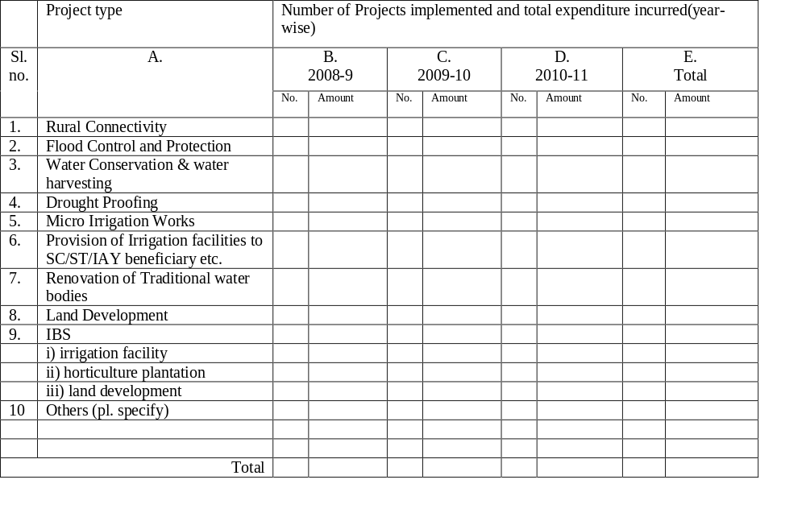

- *Distance of Village from nearest (large) market-place:
i) ________ km
ii) ________ minutes of travel time by motorized transport (on road) [during summer]
iii) ________ any Additional minutes of travel time by foot [during summer]
iv) ________ Rs cost/person of two-way transport travel
- *Number of commercial enterprises (general stores, workshops etc.) in Village:
i) Retail Stores (general stores, grocery etc.) ___________
ii) Productive & Service enterprises (eatery, tea-stall, wholesalers, steel, auto shop, barber, tailor etc.)___________

- *Does the Village have facility for potable water? Yes/No

- *What type of school does the village have? _____________
[0 = none, 1= primary, 2 = middle, 3 = high, 4= college, 5= others (pl. specify) e.g. religious madrassa]

- *Does the Village have electricity? Yes/No

- If ‘Yes’, give approximate number of Households that use electricity for:
(i) domestic purposes - ______________ (ii) other purposes - ________________

- *Does the Village have health center/facilities? Yes/No

- Total land-holding (agricultural and homestead) for all Households in village _________ acre

- *Average Price of land: (i) Agricultural_________ Rs/Katha.(ii) Homestead___________Rs/Katha

- *Can people from outside buy/sell land in the Village? Yes/No
- If ‘yes’ above, has anyone done so recently? Yes/No

- Total cultivable land for all Households in the GS area_____________ acre

- Distribution of cultivable land-holdings in GS area:
i) Choose the Household with the Maximum cultivable land-holding and give that amount _______acre
ii) Choose the Household with the Minimum cultivable land-holding and give that amount _______ acre
iii) _____ number of Households that have cultivable land holdings near the Maximum
iv) _____number of Households that have cultivable land holdings near the middle
v) _____number of Households that have cultivable land holdings near the Minimum

- *Cropping Zone with area (in acres): Single(1) _______ / Double(2) ________/Triple(3) _______
Composition of VRG:
- How many Households have farming as their only occupation: _____________
- How many Households have farming as their primary occupation: _____________

- Average non-farm income perHousehold ___________ Rs/month.
- Mention three main sources of non-farm income in the GS in order of priority: __________________________________________________________________________

- Distribution of non-farm income in GS (only include those Households that earn something):
i) Choose the Household with the maximum non-farm Income and give that amount _______Rs/month
ii) Choose the Household with the minimum non-farm Income and give that amount _______Rs/month
iii) _______number of Households that earn near maximumincome
iv) _______ number of Households that earn near the middle Income
v) _______number of Households that earn near the minimumincome

- During which months in the year do the villagers suffer serious cash shortages:
- Number of months________ ii) Name of months __________________________

- How hard is it for village workers to get unskilled labor work in the (please tick √):
a) Peak (for labor demand) season
i) Almost Impossible ii) Very Hard iii) Slightly Hard iv) Easy
b) Slack (for labor demand) season
i) Almost Impossible ii) Very Hard iii) Slightly Hard iv) Easy

- Mention average number of days of employment per month an unskilled worker gets from all sources of income during: (i) peak season - _____________ (ii) slack season - ____________

- What is the average wage for such work?
a) Peak season __________Rs/day
b) Slack season __________Rs/day

- Educational background: approximate number of individuals in the GS area whose educational level is:
i) Primary_________
ii) Middle _______
iii) Matric/Higher Secondary _________
iv) Graduate ________
v) Post-Graduate ___________
vi) Other education __________________________________________________ (specify)
- How many Households have at least one person with at least 5 years of schooling? _______

- Status of civil societies (like local club, NGO, SHG etc.) in the GS area:
Sl.  No | A  Type of Civil Society | B  No. of members | C  Primary role/ Nature

- Has there been any conflict in the GS in the past two years? Yes/No

- If ‘Yes’ then mention the type of conflicts taken place (like land disputes, violence, religious etc.):
___________________________________________________________________________
___________________________________________________________________________

- How many dispute cases of the GS area have gone outside the village (police, court etc.) in the past two years? _______

- Give the number of conflicts with neighboring GS areas/Villages in the past years: _______

- At present, how many serious conflicts are there in the GS area (both inside and outside) regarding:
i) Land disputes ____________
ii) Violent cases _____________
iii) Religious __________
iv) Others (describe)___________

- What kind of mutual relationship currently exists in the GS area (please tick √):
a) Extremely united b) Average unity c) Some conflict d) High conflict

- How hard is it to get villagers to contribute, for community works, their (please tick √):
a) Voluntary Labor
i) Almost Impossible ii) Very Hard iii) Slightly hard iv) Easy
b) Materials/Cash
i) Almost Impossible ii) Very Hard iii) Slightly Hard iv) Easy

- Nowadays do the villagers cooperate/provide free-labor/money for the following tasks:
a) Animal grazing management (controlling free-grazing etc.) Yes/No
b) Community Wood-lot management (prevent illegal felling etc.) Yes/No
c) House building Yes/No
d) Help for unexpected expenditures in:
i) Birth Yes/No
ii) Death Yes/No
iii) Wedding Yes/No
iv) Natural disasters (flood etc.) Yes/No
v) Sickness (expenditure to send to hospital etc.) Yes/No
vi) Business help (loans, bailing out etc.) Yes/No
e) Collective agricultural tasks on a villager’s fields (land development, harvesting etc.) Yes/No
f) Collective festivals, village events etc. Yes/No

- *Are Gram Sansad meetings held regularly? (Yes, twice a year/Once a year/No) __________
- *If ‘yes’ above, what is the average attendance (as % of the total voters) in the meetings? ___

- Has the GUS been formed? If ‘Yes’, then give the month & year of formation. Yes/No___
- If ‘Yes’, how often does it meet? _________ times/year.

- If ‘yes’, how active is the GUS [on a scale of 1(inactive) to 5(extremely active)] in monitoring and implementation of NREGS projects: ______________________

- List what you believe are the most important attributes for a leader?____________________________________________________________________________________________________________________________________________________

- How many members of the GUS have all/most of such attributes? _______________

- Have the members of the GUS received any formal training? Yes/Some of them /No___

- Do the GUS members have any previous experience of development works? Yes/Some of them /No___

- Give the number of members of the GUS whose educational level is
a) Illiterate_____ b) Primary_____ c)High School_____ d) Graduate_____ e) Other (specify)________

Section II: Project Specific Questions
Generic Questions (common to all projects)
(Information regarding Q. Nos. 52 to 66 shall be obtained from the Officials of the Gram Panchayat office.)
- Project Type (see Q. 7): ______________________________________________(specify)
- Project code&name: ________________________________________________________
- Did the Programme Implementing agency (PIA) make the Project (please tick √):
i) Completely anew
ii) Built upon/extended an existing project
- Which PIA did this work? _____________________________________________________
- Month & year the Project was:physically started ______________ ; completed__________
- Total amount sanctioned by Govt. for the Project ________________________________Rs
- Total cost involved in the Project ____________________________Rs
- Materials cost _________________________Rs (including cost paid for any land acquired)
- Labor-cost _______________________________Rs
- Cost of any land given up without compensation________________________Rs
- Village labor employed:
i) ______________Persons ii) _______________Days
- Outside Village labor employed
i) ______________ Persons ii) _______________Days
- Total expenditure on skilled workers ______________Rs (including semi-skilled workers)
- *Did the villagers contribute to the cost of the Project? Yes/No
- *If ‘Yes’ then:
a)
i) Number of Households that paid for materials cost ______________
ii) Amount paid per Household _________________Rs
b) Number of Households that contributed free or partially paid labor ____________
c) Number of Households that gave up land without full compensation ___________

(Ask the following questions to the Village Respondent Group)
- Who selected this particular Project? _____________________________________________________
- Please describe in detail how the Project was actually chosen(who decided, how many people agreed and participated in decision, who took final decision, why not some other project etc.):_______________________________________________________________________
___________________________________________________________________________
______________________________________________________________________________________________________________________________________________________
______________________________________________________________________________________________________________________________________________________
- Was the Project (please tick √):
a) Badly made (used bad design, poor materials, insufficient labor etc.)
b) Not so well made
c) Well made(used good design, good materials, sufficient labor etc.)
- Was there any suggestion to the design of the Project made by the villagers? Yes/No
- If ‘Yes’ please describe the suggestions given_____________________________________
___________________________________________________________________________

- Was local suggestion included in project design(please tick √)?
a) Not at all b) A bit c) A lot
- If answer to above is (b) or (c), state the part of the suggestion that was included in the design by the PIA________________________________________________________________________
- Do you think that the Project was:
a) Socially feasible (i.e. there were no serious social problems/conflicts in it)? Yes/No
b) Technically feasible (i.e. engineering design wise)? Yes/No
c) Economically feasible (cost of making, running, obtaining benefits was reasonable)? Yes/No
- Has social audit of the Project been done by the GS? Yes/No
- If ‘yes’, mention the date ______________________________
- If ‘yes’, did the GP show all books and records of the Project during social audit? Yes/No
- If ‘Yes’, please describe any flaws/mistakes in the project design, construction etc. identified:_______________________________________________________________________
__________________________________________________________________________
___________________________________________________________________________
__________________________________________________________________________
__________________________________________________________________________
- What action was taken by concerned agency based on the social audit report? _____________________________________________________________________________________________________________________________________________________
General: Try to get at villagers’ perceived benefits – both tangible and intangible
- Total # of Village Households that have benefited from the Project usage (i.e. received benefits from using the Project) _________________
- List and give details for each Project benefit (actually accrued) in order of importance:
Benefit no. (1=most important) | A  Description of benefit | B  Number of HH that got the particular benefit | C  Maximum value in Rs. that you would ascribe tothe benefit (for a year) | D  Remarks  (Mention non-pecuniary value of the benefit, if any)
1
2
3
4
5
6
7
- Method of benefit distribution (please tick √):
a) Random draw
b) Leader (e.g. GP Member, other political leader etc.) decides (specify) _______________
c) Elders decide
d) GP decides
e) Benefits cannot be divided (e.g. like for a road project)
f) Benefit is customarily equally divided
g) Other (specify) __________________________________________________________

- Perceptions:
a) Were the benefits of the Project equitably distributed amongst the villagers? Yes/No
b) Are the maintenance costs of the Project equitably distributed amongst the villagers? Yes/No
c) Over time, is the need of this Project going to:
i) Decrease ii) Stay the same iii) Increase
Explain why _________________________________________________________________________
- Has a villager ever been excluded from the Project’s benefits? Yes/No
- If one villager gets a Project’s benefit, does it lessen the benefit of other villagers? Yes/No
- Is there any user charge for benefiting from the Project? Yes/No
- If ‘Yes’ above then givethe amount charged_______________Rsper Householdper year
- Has the price of any land in the village increased due to the Project? Yes/No
- If ‘Yes’ above, then:
a) Land price before the Project _________________Rs/Katha
b) Land price after the Project __________________Rs/Katha

Section-III: Project maintenance:
(Attention: The Project should be examined in person)

- What is the current state of the Project (please tick √)?
a) Fully Operational b) More or less operational c) Partially operational d) Non-operational
- How long has it been in this state? _______________ months
- How well is the Project performing now, in terms of generating the expected benefits, as compared to when it first started operating (please tick √):
a) Much worse than when it first started operating (less than half the benefits)
b) Slightly worse than when it first started operating
c) Just the same as when it first started operating
d) Slightly better than when it first started operating
e) Much better than when it first started operating (more than double the benefits)
- What is the reason for the above? ___________________________________________________
___________________________________________________________________________
- What is the physical condition of the Project (please tick √)?
a) Severely damaged (almost all damaged)
b) Moderately damaged (around half damaged)
c) Slightly damaged (less than half damaged)
d) Very little damage
e) Undamaged
- Approximately what percentage of the Project is damaged ________ %
- Is there a maintenance committee set up for the Project(please tick √)?
a) Yes, Formal (i.e. setup by GS/GUS/GP/Block); name __________________________
b) Yes, Traditional; name ______________________________________________
c) No
- If ‘Yes’ above, how often does the committee/group meet? ________ times/year
- If ‘Yes’ above, how many months has it been since the committee last met? ____________
- Does the committee/group collect any money for maintenance? Yes/No
- If ‘Yes’ then give the amount ____________Rs/year per Household.
- Does the committee/group take initiatives for regular maintenance? Yes/No
- If ‘Yes’ above, then how often and at what cost is regular maintenance of the Project done:
a) Number of times/year _______
b) Labor cost per year
i) Person-days ____________ ii) Amount______________Rs
c) Total non-labor cost per year _______________Rs
d) Total number of GS Households involved _____________
e) Total number of non-GS Households involved __________
- Was the Project maintained (please tick √):
a) Well b) Not so well c) Badly d) Not at all
- Briefly state the reasons for the above state of maintenance: ___________________________________________________________________________
_________________________________________________________________________
- If answer to Q. No. 103 above is not (a) then mention if the main problem in project maintenance is due to initial problems in project design/cost estimate etc.? Yes/No
- Which one of the following is needed more in maintaining the Project (please tick √):
a) Money (to buy materials, hire outside technicians etc.)
b) Non-monetary (village labor, local materials) work
- Briefly describe the maintenance system that is used for this Project (i.e. division of work, when, where and how much):
___________________________________________________________________________
___________________________________________________________________________

- Which, material/cash or labor, do you prefer to give in order to maintain a Project and explain why (i.e. instead of a day’s labor, the equivalent cash amount):
a) Cash
b) Labor
___________________________________________________________________________
___________________________________________________________________________
- Who is the individual responsible for managing the Project? ___________________
- Please answer the following questions about the individual responsible (either directly or as the head of a committee e.g. GUS) for monitoring the Project (implementation & maintenance):
a) Education level:(i) Illiterate (ii) Primary (iii) Below X (iv) X to XII (v) Graduate (vi) PG (vii) Others b) Age ___________
c) Past profession ____________________________________________________________
d) Current profession _________________________________________________________
e) Total land holdings __________________ acre
f) Cultivable land holdings ______________ acre
g) Does he belong to the:
i) Majority political group in the Village Yes/No; If ‘Yes’ name the party ___
ii) Village traditional authority group Yes/No
h) How much interaction does he have with the villagers?
i) A lot ii) Some iii) Very little
i) Is he present in the village throughout the year? Yes/No
j) Is he trained/skilled? Yes/No
l) Has he had any prior experience with any social development program? Yes/No
- Were there any conflicts regarding the Project between the project beneficiaries and outsiders (non-beneficiaries, other villages etc.) before or during project construction? Yes/No
- Please provide the details below for all unrepaired serious damages to the Project in order of severity:
Damage number (1=worst) | A  Damage description&cause | B  Year

Section-IV: Participation &Leadership

- Describe what you believe are the main rights that villagers have concerning all aspects of the Project (since its inception to eventual end):
_________________________________________________________________________________________________________________________________________________________________________________________________________________________________
- Describe what you believe are the main responsibilities/duties that villagers have concerning all aspects of the Project (from its inception to eventual end):____________________________________________________________________________________________________________________________________________________________________________________________________________________________
- List what you believe are the most important attributes for a leader?
_____________________________________________________________________________________________________________________________________________________
- Are there any individuals in the GS who have all/most of the above attributes (please tick √):
i)None ii)One or two iii)Four to five iv)More than ten
- Are any of the individuals mentioned above actually managing the Project? Yes/No
- If ‘Yes’ above, specify the role __________________________________________
- Select the main player in each of the following decisions/actions:
[The choices of main players are:1= Gram Panchayat, 2 = Gram Sabha, 3 = Gram Sansad, 4 = Gram UnnayanSamity, 5 = GP Member, 6 = Other Panchayat bodies (pl. specify), 7= Govt. agency(pl. specify), 8 = Others (please specify), 9 = Not done]
a) Project type selection ___________
b) Project site selection ______________
c) Project scale (length, capacity etc.) _________
d) Project design (route of road etc.) ________
e) Time-frame of Project construction (start time, total duration etc.) _____________
h) Village labor wage rate (i.e. what amount villagers were paid for their work) __________
i) Village Non-labor contribution compensation (e.g. cost of any land given up etc.) ________
j) Project usage rules (who gets to use the project when) _________
k) Nature of sanctions for Project misuse (i.e. are people fined etc.) _______
n) Distribution of Project benefits (division of new land etc.) ____________
o) Maintenance system, policy & rules of Project ____________
p) Cost contribution, level and distribution, in maintenance of Project ___________
q) Labor contribution, level and distribution, in maintenance of Project ___________
r) Nature of sanctions for failure to contribute in Project maintenance (i.e. are people fined etc.) ______
- Explain why you think the Project is in a good/poor state of maintenance. What are the reasons for its relative success/failure?
_____________________________________________________________________________________________________________________________________________________
__________________________________________________________________________

Section-V: Project Type Specific Questions:
Minor Irrigation Canals/Water Conservation Tanks/Ponds (Benefits)

- If this Project stops/has stopped operating, how hard is it to supply sufficient water to the new/existing land (please tick √)?
a) Almost Impossible b) Very hard c) Slightly hard d) Easy
- If this Project were/is only partially (50%) operational, how hard is it to supply sufficient water to the new/existing land (please tick √)?
a) Almost Impossible b) Very hard c) Slightly hard d) Easy
- What was the main purpose of the irrigation/water conservation Project (please tick √):
a) To irrigate new land
b) To provide more (quantity and/or duration) water for existing land
c) Others (pl. specify) _____________________________________________________
- If answered (b) above, give
i) Total land over which this change occurred ________ acres
ii) Crop changes (different crops or yields etc.) on the existing lands:
A.  Before Project:  Crop/fruits/non-fruit  trees name | B.  Annual production before Project:  For crops (kg/bigha), for fruits (kg), for non-fruit trees give number | C.  After Project:  Crop/fruits/non-fruit  trees name | D.  Annual production after Project:  For crops (kg/bigha), for fruits (kg), for non-fruit trees give number
- If answered (a) above, mentiontotal area of new irrigated land in GS_________ acres.

Minor Irrigation Canals/Water Conservation tanks/ponds(Maintenance)

- Are the canal/tank/pond walls fallen in/ damaged on any part of it? Yes/No
- If ‘Yes’ above, what is the extent of the damage?
a) Number of places damaged _______________
b) Total project length ___________________ meter
c) Total damaged length __________________ meter
- Has the canal/tank bed been cleared of siltation etc.? Yes/No/Not required
- As compared to the year of its completion,is the canal/tank now delivering/storing:
a) No water
b) Less water (less than half)
c) A bit less water
d) The same amount of water
e) More water
- As compared to the year of its completion, is the canal/tank now delivering/storing water for:
a) Not delivering/storing at all
b) A lot shorter duration (less than half of the total months it used to before)
c) A bit shorter duration
d) The same duration
e) A longer duration
- What amount of the initial expected command area is actually getting water?
a) Initial expected area ________________ acres
b) Area getting water _________________ acres

Rural Connectivity (Benefits)

- Average Price of land before Project _________ Rs/Katha
- Average Price of land afterProject ___________ Rs/Katha
- Time taken to reach nearest market place before Project _________ minutes
- Time taken to reach nearest market place (using the road) after Project _________ minutes
- Cost of two-way trip/person to nearest market place before Project __________ Rs
- Cost of two-way trip/person to nearest market place after Project __________ Rs
- Average number of two-way trips per Household per month __________
- Distribution of Trips:
a) Choose the Household with the Maximum Trips and give that amount ________ number
b) Choose the Household with the Minimum Trips and give that amount ________ number
c) ___________ Households near Maximum number of trips
d) ___________Households near the middle
e) ___________Households near Minimum number of trips
- Daily wage rate (unskilled) ______________Rs/day
- Have there been any changes in cropping patterns due to the Project? Yes/No

- If yes above, provide information on cropping pattern changes:
A.  Before Project:  Crop/fruits/non-fruit  trees name | B.  Annual production before Project:  For crops (kg/acre), for fruits (kg), for non-fruit trees give number | C.  After Project:  Crop/fruits/non-fruit  trees name | D.  Annual production after Project:  For crops (kg/acre), for fruits (kg), for non-fruit trees give number
1
2
3
4
- If the road were not operational (totally blocked) there, how hard would it be to reach the nearest town/market-place in (please tick √):
a) Winter
i) Almost Impossible ii) Very Hard iii) Possible iv) Easy
b) Summer
i) Almost Impossible ii) Very Hard iii) Possible iv) Easy
c) Rainy
i) Almost Impossible ii) Very Hard iii) Possible iv) Easy
- If the road is/were partially (50%) operational/damaged, how hard would it be to reach the nearest town/ market-place in (please tick √):
a) Winter
i) Almost Impossible ii) Very Hard iii) Possible iv) Easy
b) Summer
i) Almost Impossible ii) Very Hard iii) Possible iv) Easy
c) Rainy
i) Almost Impossible ii) Very Hard iii) Possible iv) Easy

Rural Connectivity (Maintenance)

- Has the road been damaged (by rains etc.) in any part? Yes/No
- If ‘Yes’ above, what is the extent of the damage?
a) Number of places damaged _________
b) Total length of road _______________ meter
c) Total damaged length ______________ meter
- If the road was ever damaged, was it repaired according to:
a) The same material as in the original design? Yes/No
b) The same width as in the original design? Yes/No
- How many times has the road been smoothened since it was first made? ___________
- Has travel time on the road (on a similar car) now (please tick √):
a) Increased a lot (more than doubled)
b) Increased a bit
c) Stayed the same
d) Decreased
- The road currently has (please tick √):
a) Lots of bumps/jumps (on more than half the road)
b) A few bumps/jumps
- Are there proper drainage facilities for the road (i.e. side channels)? Yes/No
- Is there a culvert on the road? Yes/No
- If ‘yes’ has it been made according to the original RCC design? Yes/No

Flood Control and Protection (Benefits)

- What was the main purpose of the flood protectionProject (please tick √):
a) To protect new land
b) To provide more protection for existing protected land
c) Prevent water-logging
- Mentiontotal area of the GS protected by the Project___________ acres.
- Has any crop change taken place on the protected lands? Yes/No
If ‘Yes’ please give the following details:
A.  Before Project:  Crop/fruits/non-fruit  trees name | B.  Annual production before Project:  For crops (kg/bigha), for fruits (kg), for non-fruit trees give number | C.  After Project:  Crop/fruits/non-fruit  trees name | D.  Annual production after Project:  For crops (kg/bigha), for fruits (kg), for non-fruit trees give number
- If this Project stops/has stopped operating, how hard is it to protect the area (please tick √)?
a) Almost Impossible b) Very hard c) Slightly hard d) Easy
- If this Project were/is only partially (50%) operational, how hard is it to protect the area (please tick √)?
a) Almost Impossible b) Very hard c) Slightly hard d) Easy

Flood Control and Protection (Maintenance)
- Are the protection walls/drains fallen in/ damaged on any part of it? Yes/No
- If ‘Yes’ above, what is the extent of the damage?
a) Number of places damaged _______________
b) Total project length ___________________ meter
c) Total damaged length __________________ meter
- For any damaged protective wall/drainthat was repaired, was it done according to:
a) The same material as in the original design? Yes/No
b) The same height/depth as in the original design? Yes/No
c) The same thickness/width as in the original design? Yes/No

- Special Remarks (if any) of the Enumerator: ____________________________________________________________________________________________________________________________________________________________________________________________________________________________________________________________________________________________________________

- GP Questionnaire:

Gram Panchayat Questionnaire
Date: _________ Name of enumerator: _____________ GPQ No._________
Question nos.1 to 15 shall be asked to a mixed group of GP functionaries and GP staff:
- Name of the Gram Panchayat:_________________________; Block: ___________________
- Name of Pradhan:
- Name of Upa-pradhan:
- Number of GP members:
 | All Members | Ruling group | Opposition | Others
Male
Female
Total

- Have the GP members received training regarding their roles and responsibilities? ___________
- Yes , all of them b. Only some of them c. None
- Give the number of GP Members whose educational level is:
 | Primary | Middle | Matric/HS | Graduate or above | Others  (please specify) | Illiterate
All Members
Ruling group
Opposition
Others

- What is the staff position of the GP?
Sl.no | Position | Educational qualification | Date of |  | Main responsibilities in implementation of MGNREGS
Sl.no | Position | Educational qualification | Appoint-ment | Joining the GP | Main responsibilities in implementation of MGNREGS
1. | Executive Assistant
2. | Secretary
3. | Nirman Sahayak
4. | Sahayak
5. | Rojgar Sevak
6. | Others (specify)
- How frequently are meetings held in GP regarding NREGS issues? ____________________
- How were the projects for NREGS selected by the GP? ______________________________________________________________________________________________________________________________________________________
- What procedure was followed to prioritize the projects in the Annual Action Plan (AAP)? ________________________________________________________________________________________________________________________________________________________________________________________________________________________________
- Did the Gram Sansads send their recommendations for projects to be executed under NREGS? (Yes/No) __________
- If ‘yes’, were their recommendations considered for the AAP? (Yes/To some extent/No) _______
- How did the GP implement the projects sanctioned by the Programme Officer? _________________________________________________________________________________________________________________________________________________________________________________________________________________________________
- What checks and balances did the GP follow to maintain technical standards of the projects? ________________________________________________________________________________________________________________________________________________________________________________________________________________________________
- State the problems, if any, the GP faced in implementing the projects and how did it overcome? _________________________________________________________________________________________________________________________________________________________________________________________________________________________________
Question nos. 16 to 18 should be asked to the GP Pradhan and Upa-Pradhan separately:
- List three most important qualities that you believe the main GP staff managing NREGS should possess in order to execute their work effectively.
________________________________________________________________________________________________________________________________________________________________________________________________________________________________

- On a scale of 1(poor) to 5(excellent) how will you rate the staff on the basis of their demonstrating such qualities through their work:
Sl.no | Position | Quality 1 | Quality 2 | Quality 3 | Overall
1. | Executive Assistant
2. | Secretary
3. | Nirman Sahayak
4.

- What effect do you believe the above has on effective implementation of NREGS projects?
_________________________________________________________________________________________________________________________________________________________________________________________________________________________________
Question nos. 19 to 21 should be asked to the main GP staff separately:
- List what you believe are three most important leadership attributes that the GP functionaries should possess for effective implementation of NREGS works?
_________________________________________________________________________________________________________________________________________________________________________________________________________________________________
- On a scale of 1(poor) to 5(excellent) how will you rate the leadership qualities demonstrated by the GP functionaries through their work:
Sl.no | Position | Quality 1 | Quality 2 | Quality 3 | Overall
1. | Pradhan
2. | Upa-Pradhan
3. | Others
4.

- What effect do you believe the above has on effective implementation of NREGS projects?
_________________________________________________________________________________________________________________________________________________________________________________________________________________________________

- Block questionnaire:
Block Questionnaire
(Questions to be asked to the Programme Officer) BQ No.:______
- Name of the Block: ________________________________________________________
- Name of Gram Panchayat: __________________________________________________
- According to you, how has the GP performed in terms of NREGS in the period 2008 – 10?
______________________________________________________________________________________________________________________________________________________
- What do you believe are the reasons for such performance? ______________________________________________________________________________________________________________________________________________________
- List three most important qualities that you believe the main GP staff managing NREGS should possess in order to execute their work effectively:
______________________________________________________________________________________________________________________________________________________
- On a scale of 1(poor) to 5(excellent) how will you rate the staff on the basis of their demonstrating such qualities through their work:
Sl.no | Position | Quality 1 | Quality 2 | Quality 3 | Overall
1. | Executive Assistant
2. | Secretary
3. | Nirman Sahayak
4. | Others(specify)

- What effect do you believe the above has on effective implementation of NREGS projects?
_________________________________________________________________________________________________________________________________________________________________________________________________________________________________
- List what you believe are three most important leadership attributes that the GP functionaries should possess for effective implementation of NREGS works?
_____________________________________________________________________________________________________________________________________________________
- On a scale of 1(poor) to 5(excellent) how will you rate the leadership qualities demonstrated by the GP functionaries through their work:
Sl.no | Position | Quality 1 | Quality 2 | Quality 3 | Overall
1. | Pradhan
2. | Upa-Pradhan
3. | Others

- What effect do you believe the above has on effective implementation of NREGS projects?
___________________________________________________________________________
Map – 1: Physiography of Bankura

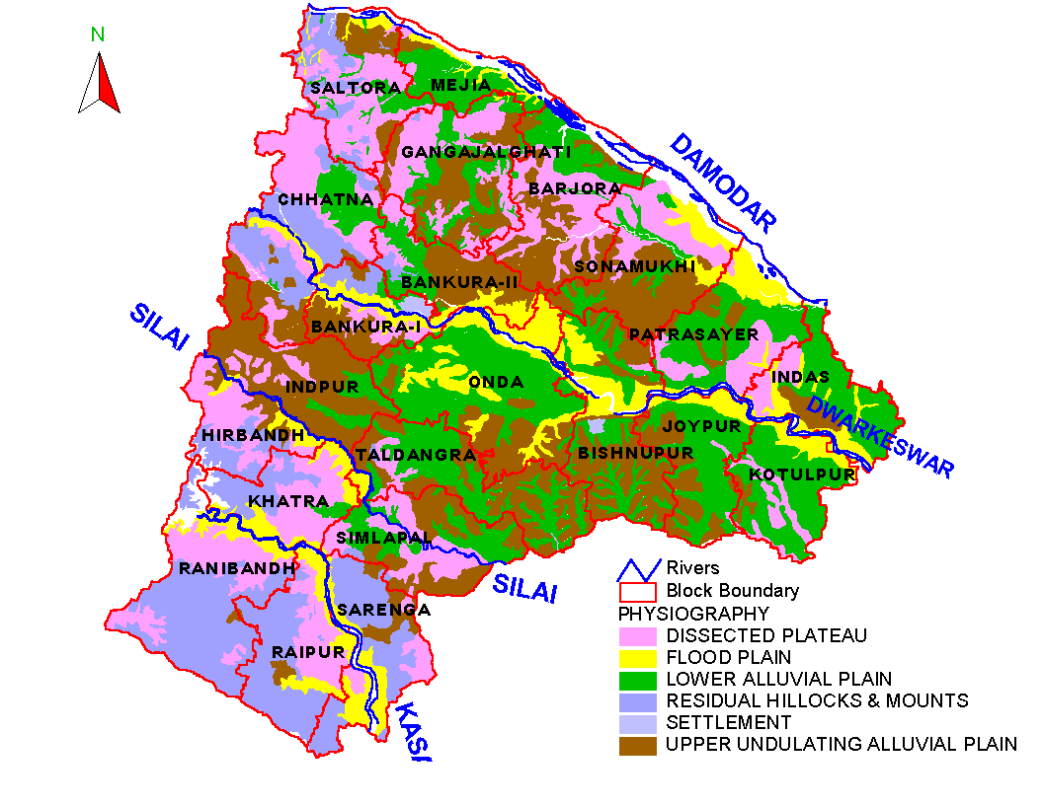

Map – 2: Soil map of Bankura
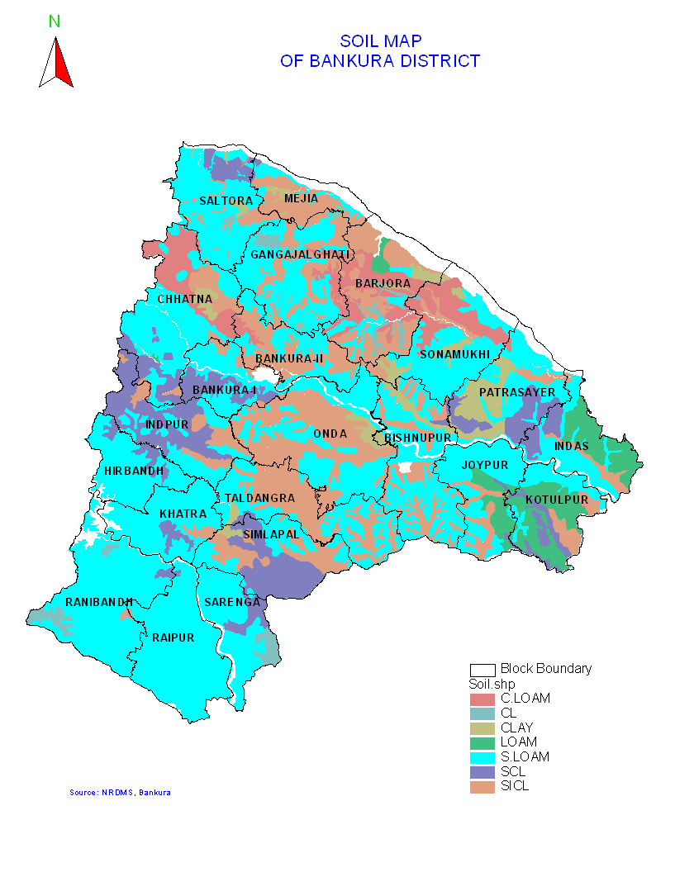
References
- http://www.nrega.net/pin/reports-and-resources/reports-submitted-to-the-ministry-of-rural-development/reports-28-jan-2010/2007-08%20IHD%20report.pdf
- http://www.nrega.net/pin/reports-and-resources/reports-submitted-to-the-ministry-of-rural-development/reports-28-jan-2010/IIM%20Calcutta.pdf
- http://www.nrega.net/pin/reports-and-resources/reports-submitted-to-the-ministry-of-rural-development/reports-28-jan-2010/2007-08%20IHD%20report.pdf
- http://rural.nic.in/rajaswa.pdf
- http://www.nrega.net/pin
- http://zeenews.india.com/news628589.html
- http://www.nrega.net/pin
- http://zeenews.india.com/news628589.html
- 'PARTICIPATORY DEMOCRACY IN ACTION: SURVEY EVIDENCE FROM SOUTH INDIA'(2010) , Journal of the European Economic Association 3(2‐3): 648-657.
- 'West Bengal Releases Three Human Development Reports' One India News,Accessed 4 August 2011<http://news.oneindia.in/2010/07/12/westbengal-releases-three-district-human-developmentreport.html>.
- Alderman, H. (2002) 'Do Local Officials Know Something we Don't? Decentralization of Targeted Transfers in Albania', Journal of Public Economics 83(3): 375-404.
- Bardhan, P. and D. Mookherjee (2006) 'Decentralisation and Accountability in Infrastructure Delivery in Developing Countries*', The Economic Journal 116(508): 101-127.
- Bardhan, P. and D. Mookherjee (2003) , POVERTY ALLEVIATION EFFORT OF WEST BENGAL PANCHAYATS: 1-21.
- Bardhan, P. and D. Mookherjee (2000) 'Capture and Governance at Local and National Levels', The American Economic Review 90(2): 135-139.
- Besley, T., R. Pande, L. Rahman and V. Rao (2004) 'The Politics of Public Good Provision: Evidence from Indian Local Governments', Journal of the European Economic Association 2(2‐3): 416-426.
- Bhatia, B. and J. Dreze (2006) 'Employment Guarantee in Jharkhand: Ground Realities', Economic and Political Weekly : 3198-3202.
- Conning Michael, J. (2002) 'Community-Based Targeting Mechanisms for Social Safety Nets: A Critical Review', World Development 30(3): 375-394.
- Devereux, S. and C. Solomon (2006) 'Employment Creation Programmes: The International Experience', Issues in Employment and Poverty, Discussion Paper 24.
- Dreze, J. and A. Sen (1989) 'Hunger and Public Action’, Clarendon Press: Oxford.
- Fisman, R. and R. Gatti (2002) 'Decentralization and Corruption: Evidence Across Countries', Journal of Public Economics 83(3): 325-345.
- Galasso, E. and M. Ravallion (2005) 'Decentralized Targeting of an Antipoverty Program', Journal of Public Economics 89(4): 705-727.
- Holland, P.W. (1986) 'Statistics and Causal Inference', Journal of the American Statistical Association : 945-960.
- Khwaja, A.I. (2009) 'Can Good Projects Succeed in Bad Communities?’ , Harvard Journal of Public Economics 93 (7-8): 899-916.
- Mansuri, G. and V. Rao (2004) 'Community-Based and-Driven Development: A Critical Review', The World Bank Research Observer 19(1): 1-39.
- Ministry of Law and Justice (Legistative Department), Government of India (2005) 'The National Rural Employment Gurantee Act, 2005 (no. 42 of 2005)'. Act, The territory of India (except Jammu and Kashmir). Accessed 26-07-2011 <http://rural.nic.in/rajaswa.pdf>.
- Olson, M.(1965) ‘The Logic of Collective Action: Cambridge, Mass: Harvard University Press
- Osmani, S.R. (2005) 'Exploring the Employment Nexus: Topics in Employment and Poverty', The Employment Route to Poverty Reduction.ILO: Geneva.(forthcoming) .
- Panchayat and Rural Development Department, Government of West Bengal (2010) 'Information on West Bengal Panchayats, their Members and Functionaries', pp. 10-35. Kolkata, India: Panchayat and Rural Development Department, Government of West Bengal. Accessed 26-07-2011 <http://www.wbprd.nic.in/html/asp/writereaddata/newsdoc/Information_wb_panchayats_and_Their_Members_and_Functionaries.pdf>.
- Panchayat and Rural Development Department, Government of West Bengal 'Implementation of NREGA, 2005 in West Bengal in the Year 2008-09'Accessed 28 July 2011 <http://wbprd.nic.in/html/aboutus/AASR2008-09.pdf>.
- Park, A. and S. Wang (2010) 'Community-Based Development and Poverty Alleviation: An Evaluation of China's Poor Village Investment Program', Journal of Public Economics 94(9-10): 790-799.
- Platteau, J.P. (2004) 'Monitoring Elite Capture in Community‐Driven Development', Development and Change 35(2): 223-246.
- Sen, A.K. (1999) Development as Freedom. Anchor.
- UNDP 'District Human Development Report'Accessed 04 August 2011 <http://hdr.undp.org/en/reports/nationalreports/asiathepacific/india/Bankura_india_hdr_2007.pdf>.
- Von Braun, J. (1995) Employment for Poverty Reduction and Food Security. Intl Food Policy Research Inst.
- Waller, C.J., T. Verdier and R. Gardner (2002) 'Corruption: Top Down Or Bottom Up?', Economic inquiry 40(4): 688-703.

The Wage Employment Programme of Government of Maharashtra in India, launched in 1965 and transformed into an employment guarantee programme by a State Act in 1979, is actually the first such programme in the world
The Gram Panchayat is the lowest level rural Local Self Government in India.
A State Act is a law made by the State Legislature and it is applicable only within the territory of the State concerned.
Social audit means an evaluation by the community of a completed project. This involves both physical inspection of the project and verification of books and records. The community is assisted in this task by a social audit team which has people from different social strata
A project is characterised ‘Well-made’ if it has a sound design and uses good materials and sufficient labour; ‘not-so-well-made’ if inadequate design and mediocre material and less labour.
Site Verification was done by myself and the enumerator jointly and the apparent physical state of the project and damage if any was assessed by eye estimation. Having served as a BDO for seven years I have a fair knowledge of such projects.
A project is characterized ‘fully-operational’ if it is working well and generating intended benefits and ‘non-operational’ if not working at all.
Strike off whichever is not required

