Erasmus University Rotterdam
Erasmus School of Economics
Master Accounting, Auditing and Control

Ownership structure and voluntary disclosures in Europe

Abstract: The financial crisis has led to increasing hesitations for people to invest. Prior to making an investment, investors aim to get a thorough understanding of the firm and its performance. Mandatory and voluntary information disclosures provided by firms help investors in creating this understanding. The aim of this study is to gain more insight in the disclosure practices of European firms by examining the relation between ownership structure and the extent of voluntary disclosures. This study demonstrates that there is a negative association between blockholder ownership and voluntary disclosures. In addition, a positive association exists between government ownership and voluntary disclosures. No significant association is observed between managerial ownership and voluntary disclosures. Overall, it is recommended that investors who aim to acquire a high degree of voluntary disclosures invest in firms with low blockholder ownership and high government ownership.
Keywords: voluntary disclosures, blockholder ownership, managerial ownership, government ownership, content analysis.

Author: S.C. Elmans

StudentnumBer: 303104
Supervisor: A.H. van der boom
Date: 24-03-2012

acknowledgements

This thesis is the last step in the completion of the Master of Accounting, Auditing and Control at the Erasmus University Rotterdam. For the completion of this thesis I owe various people my gratitude for their advice and support.

First of all, I would like to thank my thesis supervisor Mr. van der Boom for all his useful comments and suggestions. Your advice has been very helpful. In addition, I would like to thank Mr. Martina, my supervisor from KPMG, for his advice and feedback. Furthermore, I would like to thank KPMG for giving me the opportunity to write this thesis at their office in Rotterdam and providing me with valuable guidance.

I would also like to thank my fellow students from the Seminar Advanced Financial Accounting where the topic of this thesis originates from and whom have given me useful feedback on this idea.

At last, I would like to thank my family and friends for supporting me during this process. In specific, I would like to thank my parents, who have always supported me throughout my studies.

Thank you,

Sofie Elmans
Rotterdam, March 2012

Table of Contents
Introduction 5
Relevance 5
Research question and sub questions 6
Methodology 7
Structure of the thesis 7
Chapter 1. Voluntary disclosures 8
1.1 Introduction 8
1.2 Voluntary disclosures 8
1.3 Incentives of voluntary disclosures 8
1.4 Credibility of voluntary disclosures 10
1.5 Conclusion 10
Chapter 2. Ownership structure 11
2.1 Introduction 11
2.2 Ownership structure 11
2.3 Corporate governance 11
2.4 Ownership structure within Europe 12
2.5 Ownership structure outside Europe 12
2.6 Conclusion 13
Chapter 3. Research approach 15
3.1 Introduction 15
3.2 Research approaches 15
3.3 Positive Accounting Theory 16
3.4 Agency Theory 17
3.5 Conclusion 17
Chapter 4. Content Analysis 19
4.1 Introduction 19
4.2 Measuring voluntary disclosures according to prior literature 19
4.3 Measuring voluntary disclosures 21
4.3.1 Selection of Disclosure Score Sheet 21
4.3.2 Selection of voluntary disclosure items 22
4.3.3 Allocation of points 22
4.4 Limitations 22
4.5 Conclusion 24
Chapter 5. Measuring Ownership structure 25
5.1 Introduction 25
5.2 Measuring ownership structure according to prior literature 25
5.3 Measuring Ownership structure 26
5.3 Measurement of the relation 27
5.4 Conclusion 28
Chapter 6. Literature Review 29
6.1 Introduction 29
6.2 Literature review 29
6.3 Conclusion 36
Chapter 7. Research Design 38
7.1 Introduction 38
7.2 Hypotheses 38
7.3 Sample 39
7.4 Methodology 39
7.4.1 Collection of the data 40
7.4.2 The model employed 40
7.4.3 Steps to conduct the research 41
7.5 Conclusion 42
Chapter 8. Results 43
8.1 Introduction 43
8.2 Descriptives and normal distribution 44
8.3 Tests and Regressions 46
8.4 Country 49
8.5 Information type 50
8.6 Cross Listed firms 51
8.7 Conclusion 51
Chapter 9. Analysis and discussion 52
9.1 Introduction 52
9.2 Regression analysis 52
9.3 Country analysis 56
9.4 Information type analysis 57
9.5 Conclusion 58
Chapter 10. Summary and Conclusion 59
10.1 Summary 59
10.2 Limitations 61
10.3 Recommendations for future research 61
Reference list 62
Appendix I: Dislosure score sheet 65
Appendix II: Protocol 66
Appendix III: Literature review 74
Appendix IV: Boxplots and Q-Q plots 76
Appendix V: Information type analysis 79
Appendix VI: Disclosure score sheets from prior studies 80

Introduction
Investors watching their life savings evaporate and stock prices reaching new lows day after day, it all became reality after the global financial crisis in 2008. The reduced trust and high debt of many European countries makes investors think twice before investing. Investors are now increasingly aware of the risks of investing and aim to obtain a thorough understanding of a firm and its performance before making an actual investment. Information provided by the firm helps the investors to create this thorough understanding. Each year, European listed firms mandatory disclose information in accordance with the International Financial Reporting Standards (IFRS). Besides mandatory disclosures required by the IFRS such as information about current cash flows and balance sheets, firms can also voluntary disclose information. This can consist of various types of information; from information about corporate strategy to information about environment protection. In this paper, voluntary disclosures are defined as disclosures of information that management of companies can provide aside of their mandatory disclosures. As investors aim to obtain all relevant information about the firm in which they are investing, voluntary disclosures are an increasing focus of attention.
The provision of voluntary disclosures is an interesting topic for investors and standards setters as there remain unanswered questions regarding what motivates or influences managers to disclose information. For example, on the 15th of December 2010 the Financial News headed that ‘some of the UK's largest businesses fail to provide even the most basic information about their relations to their owners, in spite of calls for transparency that started three years ago’. This seems that while investors called for more transparency; firms failed to do so. The question is why do these companies not provide this information and what could influence the provision or disclosure of this information?
Prior studies investigated multiple aspects that could influence the extent of voluntary disclosures provided such as the size of the firm and the degree of profitability. Another factor which has been investigated before is if the way shares of publicly held firms are dispersed is related to the extent of voluntary disclosures. The way the shares are dispersed is also referred to as ownership structure. For example, when the shares are held by few large shareholders will there be less or more voluntary disclosures then when the shares held by multiple small shareholders? Or when governments have a high proportion of shares, will there be more or less voluntary disclosures compared to when governments own none or a small proportion of the shares? These questions are investigated in this study.

Relevance
Prior literature has shown that ownership structure can significantly influence voluntary disclosures. Most of these studies showed that more dispersed ownership leads to a larger extent of voluntary disclosures. However, these studies have been conducted in Australia, Kenya, the UK, China, Hong Kong and Singapore. Due to cultural differences and continental differences in ownership structures, these results do not automatically apply for Europe. For example, the results from Enriques and Volpin (2007) showed that ownership structure in west-continental European countries (Germany, France and Italy) is more concentrated than in the UK and US. Furthermore, ownership of these European firms is mainly in the hands of a small number of individuals and is frequently family controlled (Enriques and Volpin, 2007). These differences in ownership structure make studying ownership structure specifically in Europe interesting. Furthermore most results of prior studies are based on relatively old data and might not be applicable anymore in the current situation. Therefore, this study investigates the relation between ownership structure and voluntary disclosures in the most influential countries of Europe with data from 2010.
The results can be useful for investors as they gain more insight in the disclosure practices of European firms. Besides investors, other users and preparers of accounting information can benefit as well as they gain more information in understanding why firms disclosure information voluntarily.). The results of this study show how the selected determinants of ownership structure; blockholder-, managerial- and government ownership are associated with the extent of information provided by the firm. The obtained evidence shows that blockholder ownership is negatively associated with the extent of voluntary disclosures. Therefore, investors can decide not to invest in a European listed company with a high degree of blockholder ownership. Furthermore, the results show that a high degree of government ownership leads to more voluntary disclosures. As a result, investors could decide to invest in firms where the government owns a high proportion of shares. At last, no significant association is observed between managerial ownership and voluntary disclosures.

Research question and sub questions
The main research question of this study is:
“What is the relation between ownership structure and the extent of voluntary disclosures provided by stock exchange listed firms in Europe in 2010?”
The sub questions used to answer the main question are:
- What are voluntary disclosures?
- What is ownership structure?
- Which research approach can be used to study the relation between ownership structure and voluntary disclosures?
- How can voluntary disclosures be measured?
- How can ownership structure be measured?
- How can we measure the influence of ownership structure on voluntary disclosures?
- How does ownership structure affect the extent of voluntary disclosures according to prior literature?
- Which research design is used to answer the research question?
- What are the results of this research?
- What is the influence of ownership structure on the extent of voluntary disclosures?

Methodology
In order to measure the relation between ownership structure and voluntary disclosure, first it needs to be determined how to measure these concepts individually. Voluntary disclosures are measured by using a self created disclosure score sheet. However, all the items on the sheet are based on disclosure score sheets used in prior studies (Meek et al., (1995), Botosan (1997), Chau and Gray (2002), Eng and Mak (2003), Huafang and Jianguo (2007) and the Dutch transparency benchmark (2009)). The annual reports of 2010 are analyzed for their presence according to this score sheet. This method is a type of ‘content analysis’. ‘Content analysis is a research technique for making replicable and valid inferences from texts (or other meaningful matter) to the contexts of their use’ (Krippendorff, 2004). The disclosure score sheet is shown in appendix I.
Furthermore, the research is restricted to five of the most influential countries in Europe that are also members of the Eurozone (Germany, France, Italy, The Netherlands, and Belgium). Not all countries of the Eurozone are analyzed in this study due to time limitations. The selection chosen contains the main west-continental European countries. As a result, when ‘Europe’ is mentioned the countries referred to are Germany, France, Italy, The Netherlands, and Belgium. The content analysis is performed on the annual reports from 2010. This is because these are the most recent annual reports available. The extent of information disclosed could be influenced by the current financial crisis. However, in this paper the most recent information is expected to provide the most accurate results. The ownership structure variables used in this study are managerial ownership, blockholder ownership and government ownership. The control variables used are firm size, leverage and profitability.

Structure of the thesis
In chapter one the definition of voluntary disclosures is stated and in addition, information is provided concerning the incentives to provide voluntary disclosures and the credibility of voluntary disclosures. In the second chapter the definition of ownership structure is stated. Furthermore, information concerning the ownership structures inside and outside the EU is provided. In addition, the term corporate governance and how it relates to ownership structure is explained. In the third chapter multiple research approaches are described and analyzed. In chapter four the method to measure voluntary disclosures is discussed; content analysis. Chapter five describes the methods to measure ownership structure and the measurements of the variables and relation are explained. The literature review is provided and discussed in chapter six. In chapter seven, the research design and the hypotheses are stated. The statistical results and the analysis of the results are presented in chapter eight and nine. At last, the main question is answered and the conclusion presented in chapter ten.

Chapter 1. Voluntary disclosures

1.1 Introduction
In this chapter the definition of voluntary disclosures is stated and the main incentives to provide these are mentioned. Furthermore, it is described how the credibility of voluntary disclosures can be assessed.

1.2 Voluntary disclosures
As mentioned in the introduction, in this paper voluntary disclosures are defined as disclosures of information that management of companies can provide aside of their mandatory disclosures. Mandatory disclosures concern the required disclosures according to standard setters such as IFRS or US GAAP. Voluntary disclosures are frequently divided in three types of information: strategic, financial and non-financial. The first study to take these three information types into account was Meek et al. (1995). Obviously, strategic and financial information are relevant to investors and other decision makers. Non-financial information focuses more on the social accountability of a firm and is, besides for investors, also relevant to the general public. For this reason it is likely that the factors influencing disclosure choices differ among type of information. In this paper, the voluntary disclosure items are also subdivided into the three categories; strategic, non-financial and financial. Examples of strategic, non-financial and financial disclosures are respectively: information on corporate strategy, information on environmental policy and earnings forecasts.
There are various ways to provide voluntary disclosures; via annual, semi-annually and quarterly reports, separate sustainability reports, footnotes, interviews, press releases and more. In this study only annual reports are used. There are numerous studies investigating the incentives of management to provide these voluntary disclosures. For example, in 1990 Wagenhofer provided a theory for voluntary disclosures. It is based on the game theory where he argues: ‘Any entity contemplating making a disclosure will disclose information that is favorable to the entity, and will not disclose information that is unfavorable to then entity’. For decision makers this is important to keep in mind when interpreting the (absence of) voluntary disclosures (Wagenhofer, 1990). This way decision-makers can anticipate on the incentives of entities’ management. In other studies more incentives for management to provide voluntary disclosures are discovered which are explained in the next paragraph.

1.3 Incentives of voluntary disclosures
From the research of Healy and Palepu (2001) it appears that current literature defines six separate incentives for management to provide voluntary disclosures. In this paragraph these incentives are stated and a short explanation is provided. First, the incentive of capital market transactions; when an entities’ management anticipates capital market transactions in the near future, a voluntary disclosure is used to reduce the information asymmetry between the firm and the investor. The reason for management to do so is that it could reduce the costs of external financing. Various studies also found empirical evidence for this theory. For example, in 2006 Botosan concludes that greater disclosure results in lower cost of capital.
The second incentive is the corporate control contest incentive. This incentive assumes that managers are held accountable for stock performance. Various empirical studies (e.g. Warner, Watts and Wruck 1988) show that there is a relation between poor stock performance and changes in top management. Therefore, when there is poor stock performance or poor earnings performance, management has an incentive to disclose information in order to explain the poor performances and as a result is able to maintain his job. The third incentive is the stock compensation incentive. It appears that being compensated in stock creates multiple incentives; to increase the liquidity of the firm’s stock, reduce contracting costs and to reduce the risk of misevaluation of stock. Empirically it is revealed by Noe (1999) that when firms use stock compensation (which can affect ownership structure) this would result in the entity disclosing more information.
Furthermore, there is the litigation cost incentive which has two effects; first, managers are likely to disclose more information in order to avoid litigation costs from users blaming managers with inadequate or untimely disclosures. Second, managers are likely to disclose less voluntary information in order to avoid litigation costs from users blaming managers for incorrect information and predictions. Therefore, the results of this incentive remain ambiguous. The fifth incentive is the management signaling incentive. This is in a normative study described by Trueman (1986) who argues that talented managers have more incentives to provide voluntary disclosures such as earning forecasts to positively influence the investor’s perception about the managers’ ability of obtaining and responding to important information. A very positive perception of the manager can result in a higher market value of the firm. No empirical evidence is found for this incentive. The last incentive is the propriety cost incentive. This incentive argues that the decision to disclose information is influenced by the concern that these disclosures might damage their competitive position. This was also what Wagenhofer (1990) meant as we described previously. Most studies on this incentive are normative. However, there is some empirical evidence provided by Piotroski (2000) that supports this incentive.
In addition to the above stated incentives, several theories exist which can help to explain the provision of voluntary disclosures. These are legitimacy theory, stakeholder theory and institutional theory. Legitimacy theory suggests that organizations act in order to ensure that they operate within the norms and bounds set by society; the so called ‘social contract’ (Deegan and Unerman, 2011). Therefore, according to this theory voluntary disclosures are provided to meet to expectations of society and to continue to legitimize the organization. Stakeholder theory suggests that there are various stakeholders an organization has to maintain a relation with. Voluntary disclosures can be either provided according to the ethical branch; as stakeholders have a ‘right to know’ or according to the managerial branch; to satisfy the needs of the most important stakeholders. Lastly, institutional theory explains why organizations facing the same conditions tend to look and act similar. According to institutional theory voluntary disclosures are provided because a. pressure from institutions/stakeholders b. competing firms are doing so or c. pressure from group norms (Deegan and Unerman, 2011).
Now the incentives for voluntary disclosures are described in this paragraph it is important to describe how one can determine the reliability and relevance of voluntary disclosures. Therefore, the credibility of voluntary disclosures is outlined in the next paragraph.

1.4 Credibility of voluntary disclosures
The incentives provided above describe that, the main reason why voluntary disclosures are provided, is because the firm or management appears to benefit from providing this information. Therefore, it makes sense to question the credibility of voluntary disclosures. To increase the credibility one can do two things according to Healy and Palepu (2001); either let an independent third party provide assurance about the quality of the disclosure or assess the quality of prior voluntary disclosures. The second method is most effective when there are consequences for managers who knowingly prepare incorrect voluntary disclosures. Empirical evidence shows that voluntary disclosures, for example management forecasts, are generally seen as credible. For example, Waymire (1984) and Ajinkya and Gift (1984) show that when there is a management forecast of an expected increase in earnings the stock price also increases, hence, it is believed that the expected increase is correct. Waymire (1984) used for his study 479 projections of earnings per share. These projections were published in the Wall Street Journal during the period 1969-1973. Ajinkya and Gift (1984) used a sample of 259 observations of management forecasts. The forecasts were also obtained from the Wall Street Journal in period 1970-1977. In addition, Pownall and Waymire (1989) discover that the magnitude of the reaction to a forecast of unexpected increased earnings is similar to the actual announcement of the increased earnings itself. This advocates that the disclosures of earnings forecasts are generally seen as credible. For their study also the management forecasts form the Wall Street Journal were used. Their final sample consisted of 313 forecasts from 314 companies. Furthermore, a study from Frost (1997) also showed that the credibility of a disclosure declines when the firm is in a financially stressed situation. It appears from these studies that in general voluntary disclosures are seen as credible but perhaps less credible when the firm is in a difficult financial situation.

1.5 Conclusion
In this chapter information about the main theme of this study ‘voluntary disclosures’ is provided. Voluntary disclosures are defined as: the disclosures of information that management of companies can provide aside of their mandatory disclosures. Furthermore, the main incentives of management to voluntary disclose information are described. This study is related to the stock compensation incentive. As empirically argued by Noe (1999); when firms use stock compensation (which affects managerial ownership) this results in the firm disclosing more information. As this incentive is related to the way ‘ownership structure’ affects the disclosure of information, the results of this study might add relevant insights to the empirical literature related to this incentive. Regarding the credibility of voluntary disclosure research shows that in general voluntary disclosures are seen as credible. To improve the credibility even further one can ask an independent third party to provide assurance on the voluntary disclosure or analyze the results from prior voluntary disclosures to see for example, if the disclosed earnings forecast from last year was indeed correct. As this chapter elaborated on the topic voluntary disclosures, the next chapter describes the topic ownership structure.

Chapter 2. Ownership structure

2.1 Introduction
In this chapter ownership structure is defined and information is provided regarding the current ownership structure in the most influential European countries. Furthermore, a comparison is made between ownership structure in the EU and outside the EU. In addition, corporate governance, an aspect related to ownership structure is explained.

2.2 Ownership structure
In this study, ownership structure of listed firms is defined as the distribution of shares to amongst owners similar to the definition employed in prior studies such as Jensen and Meckling (1976) and Eng and Mak (2003). Ownership structure can influence the incentives of managers. These incentives are discussed in the agency theory in chapter three. Eng and Mak (2003) use in their study three different determinants for ownership structure; managerial, blockholder and government ownership. They provide the following definitions: ‘Blockholder ownership is the proportion of ordinary shares owned by substantial shareholders (with equity of 5% or more). Government ownership is the proportion of ordinary shares owned by the government. Managerial ownership is the proportion of ordinary shares held by CEO and executive directors and shares in which they are deemed to have interest’ (Eng, Mak, 2003). The last words can be interpreted as share options. In this study the same determinants are used. In chapter five is explained how managerial-, blockholder and government ownership are measured in this study.

2.3 Corporate governance
According to Blair (2004) corporate governance refers to ‘the legal rules, institutional arrangements, and practices that determine who controls business corporations and who gets the benefits that flow from them. Corporate governance issues also include how major policy decisions are made in business corporations, how various stakeholders can influence the process, who is held accountable for performance, and what performance standards are applied.’ As this statement shows, corporate governance is a broad topic relating to the way a firm is organized. Subcomponents of corporate governance are among others the board of directors, independent auditors and ownership structure. Ownership structure is a subcomponent of corporate governance as it is also related to the way a firm is organized and how stakeholders can influence the processes of a firm.
Corporate governance is also related to investor protection because when an investor invests in a firm he obtains certain rights that are usually protected through the enforcement of laws and policies (La Porta et al., 2000). Such rights can contain regulations to disclose certain information necessary for investors or to let investors take part in shareholder’s meetings. Investor protection is important because otherwise insiders would have no legal reasons to pay dividends and repay loans to investors and could expropriate investors. A good corporate governance structure is crucial for a proper enforcement of laws and regulations to protect investors.
A difference in corporate governance is the distinction between the frequently described models: Anglo-American- and Rhineland model. One of the main differences is that the Anglo-American model is rule-based and the Rhineland model is principle-based. According to van den Berghe (2002) ownership in countries with the Anglo-American model is greatly diffused among multiple shareholders whereas ownership in countries with the Rhineland model is more concentrated. Most European countries belong to the Rhineland model, an exception is the UK which belongs to the Anglo-American model (van den Berghe, 2002). Therefore this study of the most influential European countries can provide results that differ from the UK and other countries.
Each member state of the EU has its own traditions and its own approach to corporate governance, which has resulted in a mixture of practices within the EU. Although European companies are allowed to depart from the national corporate governance code, they have to explain why they deviate (comply or explain model) (EU, 2009).

2.4 Ownership structure within Europe
For this paragraph a study of the European Union (2009) concerning ownership structure in Europe is utilized. This study was conducted in order of the European Union with the goal to obtain a clearer understanding of presence and workings of the various corporate governance codes in the European member states. Furthermore, in this study attention is paid to ownership structures within the European member states. The results related to the countries of this study are described. First of all the results showed that in Italy and Germany ownership is usually concentrated. In France and The Netherlands there is a lower level of ownership concentration and Belgium lies in an intermediate position. The most diffused ownership was observed in the UK, which could be due to their different corporate governance structure as explained in the prior paragraph.
The nature of ownership, such as blockholder ownership also varies per country. Blockholders in listed firms in Italy and Belgium are typically individual or family shareholders. In Germany blockholders are a mix of non-financial institutions and family. Typical blockholders in France, the Netherlands and to an even greater extent in the UK are financial institutions. The origin of the ownership structures is also noteworthy. In the Netherlands ownership is mainly held by foreigners (foreign ownership), whereas other member states such as Germany and Italy, rely on a significant domestic ownership (EU, 2009). France and the UK remain around the European average with about 40 percent foreign ownership. These differences in ownership structure and its nature might be visible in the results obtained in study. The results found regarding the differences per country are compared with the results from this study.

2.5 Ownership structure outside Europe

Besides the Anglo-American and Rhineland model another difference exists in the so called ‘stakeholder’ and ‘shareholder’ governance model. The stakeholder model applies to firms where there is heavy political involvement from multiple stakeholders. Here it can be noted that various agents are contracting with the firm (Ball et al., 2000). The stakeholder model is mainly seen in code law countries; here exists a strong political influence on a national and firm level’s accounting policies and practices. The income of the firm in the stakeholder model tends to be seen as a pie which is shared among the stakeholders; shareholders, governmental institutions, employees etc. (Ball et al., 2000). The shareholder model is mainly seen in common law countries; here there is not so much political influence, for example, only the shareholders elect the members of the board of directors. Here the shareholders are the main agent contracting with the firm.

In both models an information asymmetry problem exists. However, both models provide different solutions to this problem. The information asymmetry problem in the stakeholder model arises because multiple stakeholders all possess different information which causes the information asymmetry. This problem can be solved by public disclosure. The information asymmetry problem in the shareholder model exists because of the different information gap between managers and stakeholders. This can be solved by insider communication so no additional disclosure is necessary (Ball et al., 2000). As can be concluded from this difference; it is expected that in firms with a stakeholder model (code law countries) firms disclose more information as there is more demand for the disclosure from various stakeholders. Subsequently, in common law countries less voluntary disclosures are expected as the information asymmetry problem is solved by insider communication. In the sample of Ball et al. (2000) Germany, France and Japan are categorized as code law countries and Australia, Canada, UK and USA are categorized as common law countries.

That investor protection is important was already mentioned in paragraph 2.3 but how investors are protected in west-European countries is stated here. As Germany and France are code law countries it is noted that in code law countries shareholder protection is usually lower compared to rich common law countries (La Porta et al., 1999). Common law countries usually have good legal protection for minority shareholders. Here shareholders do not have to fear expropriation and hence do not need to be a controlling shareholder to ensure their investment (La Porta et al., 1999). Therefore, they are willing to accept a lower stake or can even prefer a low stake in order to diversify their portfolio. This results that in situation where there is high share holder protection ownership is usually more diversified (La Porta et al., 1999).

2.6 Conclusion
In this chapter the definitions of ownership structure and corporate governance are stated. Ownership structure of listed firms is the distribution of shares to amongst owners. Corporate governance is the way the firm is organized and handles various problems/decisions/processes. Regarding ownership structure within Europe it was shown by the study of the EU(2009) that ownership in Italy and Germany is usually concentrated, The Netherlands and France have a lower ownership concentration and Belgium lies in an intermediate position. By comparing the European countries with countries outside the EU, it is noted that according to Ball et al. (2000) the most influential west- European countries (France and Germany) belong to the code-law countries where there is a stakeholder model. In stakeholder models there is information asymmetry between the various stakeholders which is resolved by public disclosure. Hence, it can be expected that in regards to the stakeholder and shareholder model, that west-European firms disclose more information. However, as investors are usually not very well protected in code law countries it can be expected that in this study ownership is relatively concentrated as investors aim to ensure that they their investment is safeguarded and therefore hold larger stakes (La Porta et al., 1999). In the next chapter several research approaches are analyzed to find out which one is best to use for this research.

Chapter 3. Research approach

3.1 Introduction
In this chapter several research approaches are described and explained. Subsequently, the research approach for study is determined. Furthermore, the Agency Theory is described as it is related to this research.

3.2 Research approaches
For this study the empirical approach is used in order to provide strong evidence and to make sure a profound conclusion can be drawn from the obtained results. The empirical approach is preferred to the normative approach, because here the results are based on empirical evidence and not just on literature and expectations. There are various empirical approaches. In this paragraph three main empirical approaches are described; the Market-Based Accounting Research approach, the Behavioral Accounting Theory approach and the Positive Accounting Theory approach.
The Market-Based Accounting Research approach examines the market reaction to changes/observations in accounting data. This approach is used for analyzing relations between stock performance and financial information (Deegan and Unerman, 2011). As in this study stock performance is not examined, this approach is not appropriate for this study.
The Behavioral Accounting Theory approach examines how individuals react and behave when they obtain information. This approach is used in a so called ‘laboratory setting’ where the reactions and behavior of the participants can be observed (Deegan and Unerman, 2011). As this study does not examine the behavior of individuals but the disclosure behavior of the firm as a whole this approach is not the most appropriate for this study.
Positive theories consider all theories based on empirical observations. Positive Accounting Theory, first described by Watts and Zimmerman (1978), tries to explain and predict actual accounting practices based on empirical evidence. From a positive accounting perspective it can be examined what factors explain the behavior of management concerning the provision of voluntary disclosures. As this study analyzes the relation of ownership structure and voluntary disclosures, we try to describe and explain what the association between ownership structure and voluntary disclosures is. Therefore, the positive accounting theory is appropriate for this study. In addition, positive accounting theory helps explain choices of managers regarding accounting methods (Beattie et al., 1994). The choices are based on the underlying trade-off between multiple incentives. This study seeks to explain the choice of managers’ disclosure practices. In the next paragraph the assumptions of this theory and three hypotheses related to the positive accounting theory are explained.

3.3 Positive Accounting Theory
There are two underlying assumptions in the Positive Accounting Theory; information asymmetry and the self-interest assumption (Beattie et al., 1994). The first assumption means that there exists information asymmetry between the owners and the managers. The manager is hired by the owners and possesses valuable knowledge about the firm which the owner might not possess hence; the information of the owner and manager is dissimilar/asymmetric. The second assumption is that people act in self-interest to maximize their personal welfare. Because the manager and the owner have different interests (conflicting interests) the manager might not act in the interest of the owner. Hence, the manager might not act in the best interest of the firm. The assumption that people act in self-interest is closely related to the agency theory which is explained in the following paragraph. Frequently related to the positive accounting theory are the following three hypotheses (Watts and Zimmerman 1990):
- Bonus plan Hypothesis
- Debt/equity Hypothesis
- Political cost Hypothesis
The bonus plan hypothesis implies that managers of a firm with compensation schemes are more likely to use accounting methods that improve reported income to ensure or increase their compensation/bonus. The debt/equity hypothesis entails that when the firm’s debt/equity ratio is high managers are more likely to use accounting methods which increase income. This is because when the debt/equity ratio is high and certain agreements/covenants have been made with lenders that for example, the debt/equity ratio will not exceed a certain value, management might be under a high pressure to meet these agreements. Due to this high pressure accounting methods which increase income and cause the debt constraint to loosen are chosen. However, sometimes the contract agreements are violated which leads to unexpected costs. These costs can consist of an immediate increase in interest expense or in an immediate repay of the loan.
Furthermore, the political cost hypothesis assumes that large, susceptible, highly profitable or notable firms are more likely to employ accounting methods that reduce reported profits for the current year compared to opposite type of firms. The reason for this is that these firms are expected to receive more political/public attention and hence, have higher political costs. Furthermore, this hypothesis assumes that it is costly for individuals to assess whether the accounting profits are correct (Watts and Zimmerman 1990).
All three hypotheses are related to this study; if more voluntary disclosures increase firm performance, managers will disclose more information according to the bonus plan hypothesis. Continuously, if voluntary disclosures reduce risk for investors which results in lower costs of attracting new capital or looser contract constraints, managers will disclose more information according to the debt/equity hypothesis. Furthermore, in order to reduce political costs managers might disclose more information to reduce media attention regarding some ambiguities.

3.4 Agency Theory

As mentioned above positive accounting theory and agency theory both assume that all individuals act in self-interest. According to Jensen and Meckling (1976) the agency problem arises in a situation where the managers (agents) and the owners (principals) have different interests. It is believed that the agent and principal both act in self-interest to maximize their personal welfare. The underlying assumption is again that there is information asymmetry between the agents and principals. Continuously, as the principal hires the agent for some kind of decision making purposes it is expected that the agent will not always act in the best interest of the principal. Agency costs arise due to this inefficient relation between the agent and the principal. The reduction in welfare caused by the agent who does not act in the best interest of the principals is called ‘residual loss’ by Jensen and Meckling (1976). Total agency costs include the residual loss, the costs of monitoring and the bonding expenditures by the agent (Jensen and Meckling, 1976). With monitoring expenditures is referred to the costs of monitoring the behavior of the agent and performing efforts to control this behavior via setting budget restrictions or establishing compensation policies etc. (Jenson and Meckling, 1976). Bonding expenditures consists of: ‘resources spend by the agent (bonding costs) to guarantee that he will not take certain actions which would harm the principal or to ensure that the principal will be compensated if he does take such actions’ (Jensen and Meckling, 1976).
Solutions to the agency problem are provided by, among others, Healy and Palepu (2001). They suggest creating optimal contracts between the agent and the principal as a potential solution. An optimal contract can align the interests of the principal and the agent in for example, a compensation agreement. In addition, the agent is monitored to observe his compliance with the contractual agreement. Another solution is to let the Board of Directors or an audit committee actively service as an intermediary and monitoring instrument for the owners. The last solution Healy and Palepu (2001) examined is the role of information intermediaries such as external analysts. Analysts can be used to obtain private information about potential misbehavior or misuse of resources by a manager. Therefore, information intermediaries can reduce information asymmetry. Financial intermediaries such as banks can also reduce information asymmetry by putting constraints on a loan and monitoring the agent. Another solution provided by several researchers, for example Huafang and Jianguo (2007) is that because agents and principals have different interests; giving the agent partial ownership (shares) reduces the agency problem by aligning the interests of the agent and the principal and that therefore a more widely held ownership structure would lead to a larger extent of voluntary disclosures.

3.5 Conclusion
To conclude, the positive accounting theory approach is used in study. From a positive accounting perspective it can be examined what factors can explain and predict the behavior of management concerning voluntary disclosures. Here the factor ‘ownership structure’ is examined. It is assumed that all individuals act in self-interest and aim to maximize their personal welfare. This closely relates to the agency theory. Agency theory describes the agency problem which arises due to conflicting interests of the manager (agent) and owner (principal). To align these interests a solution is to provide the managers partial ownership (shares). This way the ownership structure is more widely held and it is expected that as managers now have the same interests as the owners they will disclose more information. Therefore, Huafang and Jianguo (2007) hypothesize that there is a positive relation between managerial ownership and the extent of voluntary disclosure.
On the other hand, Eng and Mak (2003) argue that, based on the agency theory, there is a negative relation between managerial ownership and voluntary disclosures. The reason for this is if there is low managerial ownership and the manager and the owners have different interests, the manager might not act in the best interest of the company. Subsequently, the owners (shareholders) will increasingly monitor the manager to observe if the manager acts in the best interest of the company (reduce the agency problem). However, monitoring introduces the costs to the firm. These monitoring costs can be reduced if voluntary disclosures are provided by managers. Therefore, Eng and Mak (2003) argue that voluntary disclosure can be a substitute for monitoring and when managerial ownership is low, the extent of voluntary disclosures is high. This reasoning is also where Eng and Mak (2003) and Zourarakis (2009) based their hypotheses on; that when managerial ownership is low, voluntary disclosures are high. So when managerial ownership increases less monitoring (voluntary disclosures) is required and the extent of voluntary disclosures decreases. Therefore, they argue that is a negative relation between managerial ownership and the extent of voluntary disclosures.
As can be noted the agency theory is used to ground both a positive and a negative relation. In this study the first interpretation of the agency theory is used, so it is expected that when managerial ownership increases the interests of the owners and managers are more alike and hence, managers will disclose more information. Thereby assuming that owners prefer more information disclosures over less. In the next chapter it is explained how voluntary disclosures are measured in this research.

Chapter 4. Content Analysis

4.1 Introduction
In this chapter information about how voluntary disclosures can be measured is provided. Prior research showed that content analysis is the main technique used for measuring the degree of voluntary disclosures. These prior studies are described in the literature review in chapter six. Furthermore, the limitations of this approach are stated and the measurement of voluntary disclosures used for this study is explained, including the selection process of the disclosure score sheet, voluntary disclosure items and the allocation of the points.

4.2 Measuring voluntary disclosures according to prior literature

As mentioned in the introduction several studies already investigated voluntary disclosures and potential influences on the provision of voluntary disclosures. In order to measure voluntary disclosures one can make use of content analysis. ‘Content analysis is a research technique for making replicable and valid inferences from texts (or other meaningful matter) to the contexts of their use’ (Krippendorff, 2004). Babbie (2007) adds to this ‘it is the study of recorded human communication’. There are various types of content analysis as can be observed in the following figure from Beattie et al. (2004).

Figure 1: Approaches to the Analysis of Narratives in Annual Reports (Beattie et al., 2004)
As the table shows a division is made between the subjective and semi-objective approach. Subjective refers to subjective ratings by analysts, which has been commonly used in the US to determine disclose quality. These ratings were disclosed by The Association of Investment Management and Research (AIMR) until 1995. Major critics were that the ratings are based on the perception of the analyst and not as a direct measure of the actual disclosure (Lang and Lundhold, 1993). In addition, critics from Healy and Palepu (2001) were that it was unclear whether ‘the analysts took the ratings seriously, what the basis was for the selection process for firms to be included and what biases the analysts bring to the ratings’.
Currently the semi-objective approach is most used; this approach uses the amount of disclosure as a proxy for the quality of disclosure (Beattie et al., 2004). In addition, ‘often a list of items is made ex ante and subsequently the text is scrutinized for their presence, ignoring sections of text that do not relate to this list’ (Beattie et al., 2004). The semi-objective approach is again divided in Textual analysis and Disclosure Index Studies. Textual analysis is, as its name entails, the analysis of text; this can be in the form of thematic content analysis, readability studies and linguistic analysis. Thematic content analysis looks at which themes are stated in the text, this can be either in the whole text or in a certain section. Readability studies assess the difficulty of text which is usually done by using a readability formula (Beattie et al., 2004). The obtained scores are then compared to external benchmarks to determine the level of difficulty/readability. Linguistic analysis is also called ‘the texture index’, ‘a text-focused method of scoring narratives’ (Beattie et al., 2004). There are two main limitations regarding textual analysis according to Beattie et al. (2004); the analysis is one-dimensional as the focus is mainly on the classification of the topic and the absence or presence of information on this topic. Secondly, usually not the entire content of the annual report is analyzed and therefore the analysis is partial.
Another semi-objective approach is Disclosure Index Studies. Here, the quantity of information provided in the annual report regarding a specific topic is measured and used as a proxy for the quality of disclosure (Beattie et al., 2004). Disclosure index studies have two common forms; binary/ordinal measurement of items and the weighted/unweigthed index. The binary measurement is relatively simple, here a coding scheme is used which records the presence or absence of an item. Ordinal measurement is rank-ordered and the interval between the measurements is not meaningful, for example; good-better-best. The weighted approach is when various weights (for example from 1-10) are assigned to the information. The unweighted approach is when only two weights are assigned; either ‘0’ or ‘1’; ‘1’ when the information is present and ‘0’ if not. The unweighted approach is seen as a less subjective method (Babbie, 2007).
According to Krippendorff (2004) it is highly important to have a reliable and valid coding method and procedure of allocating the scores when using content analysis. With valid is meant that ‘the variables generated from the classification procedure represent what the researcher intended to represent’ (Beattie et al., 2004). With reliable is meant that every coder uses the same coding procedures to arrive at the same outcomes. There are three types of reliability that Krippendorff (2004) defines: stability, reproducibility and accuracy. Stability refers to which extent consistent coding takes place over time by the same coder; this is known as the weakest form of reliability. Reproducibility is a stronger form and refers to which extent different coders can reproduce the same outcome when coding the same text. Accuracy is the most appropriate form to create reliability and refers to which extent coding a content corresponds to a predetermined standard or known standard from prior studies.

Whereas Krippendorff (2004) argues that content analysis should be both valid and reliable, Babbie (2007) states that a choice has to be made between validity and reliability; latent coding or manifest coding. Latent coding refers to interpretive reading and scoring the items accordingly, whereas manifest coding is coding the elements that are physically present and countable in the annual reports. Latent coding is better designed for ‘tapping the underlying meaning of communications’ (Babbie, 2007). However, this might lead to more valid coding but is less reliable as one person might interpret the text different than the other which can lead to different outcomes (Babbie, 2007). Manifest coding is relatively simple and reliable but might be less valid. For example, information is provided about environment protection activities of a firm. However, the information provided is that they do not engage in any environment protection as they think this is unnecessary. In manifest coding they would obtain a score as there is information present regarding ‘environment protection’, however, in latent coding they would not obtain a score as the information shows that the firm is not engaging in environment protection (Babbie, 2007). In this study the extent of voluntary disclosures in general is analyzed. Therefore, whether the information is positive or negative is not most relevant, only that the information is provided. This study only analyzes if ownership structure can influence the extent of voluntary disclosures (the level of transparency of the firm) and therefore manifest coding is used.

4.3 Measuring voluntary disclosures
In order to determine which approach is best to measure voluntary disclosures for this study, it can be noted that subjective ratings are no longer available and also were only available in US which automatically means a semi-objective approach is used. Regarding the choice between textual analysis and disclosure index studies it can be argued that disclosure index studies are more appropriate for this research as it is the aim to create an amount/score regarding the information provided on specific items by means of an index. This approach is also commonly used in prior studies. Subsequently, the unweighted approach is employed as this study aims to assign a score to the amount of information provided, but it is not preferred to assess the quality of that information by assigning different amounts to the information (for example, one obtains a score of ‘8’and the other one a score of ‘2’) as this is very subjective. Therefore in this study the unweighted approach is used.

4.3.1 Selection of Disclosure Score Sheet
Various disclosure score sheets were already established at the start of this research. Unfortunately, due to constant changes in accounting standards and changes in mandatory and voluntary information in the annual reports and the differences between IFRS in Europe and the accounting standards used abroad, a new disclosure score sheet had to be established. Nowadays, a score sheet from the Netherlands is frequently used: the Dutch Transparency Benchmark. The Dutch transparency benchmark is a research conducted by PwC commissioned by the Dutch ministry of Economic Affairs in order to determine the degree of transparency of the largest Dutch firms regarding corporate social responsibility. As their score sheet is rather extensive and mainly focused on non-financial information (CSR), it is not applicable for this study as here the degree of disclosure in general is examined, so also financial and strategic information disclosures are taken into account. Therefore the disclosure score sheet in this study is self-created.

4.3.2 Selection of voluntary disclosure items
The self-created disclosure score sheet is based on five prior score sheets from Meek et al., (1995), Botosan (1997), Chau and Gray (2002), Eng and Mak (2003), Huafang and Jianguo (2007) and the Dutch transparency benchmark (2009). All thirty items on the score sheet are from at least one of these studies. Furthermore, the items are checked with the current IFRS standards to see if the items are still voluntary. Therefore, the KPMG Disclosure checklist from June 2010 was employed. As the disclosure score sheet is especially created for this study, the sheet is undeniably subjective. However, in order to reduce the subjectivity as much as possible, no items are on the list are self-created; all came from at least one prior disclosure score sheet. From which study the item is obtained can be found in appendix II. Furthermore, the items that were in most score sheets (and voluntary according to IFRS) were immediately included. However, there are still some items on the list that are only derived from one other score sheet. The list of disclosure items can be found in appendix I. In order to allocate the points consistently a protocol of when to allocate the points is established. The protocol for allocating the points can be found in appendix II.

4.3.3 Allocation of points
Here is explained how the annual reports were analyzed and the scores assigned. The first step of the analysis was to clearly assess the table of contents of the annual report in order to understand were the voluntary disclosure items could potentially be stated. According to this method several points were obtained already. In order to make sure that the information was not stated elsewhere in the annual report a set of keywords was used. All annual reports are available in pdf format and here the keywords are typed in the search format. The keywords are mentioned in appendix II. If no information by analyzing the table of contents and by using the keywords was obtained; the item obtained the score ‘0’. If there was information concerning the item, the score of ‘1’ is assigned if the information sufficed the standards of the protocol (see appendix II). If the information does not suffice the standards a score of ‘0’ is assigned. As the points are either ‘0’ or ‘1’, the maximum amount of obtainable points is ‘30’.

4.4 Limitations

Concerning the content analysis there are various important limitations that are brought to attention in this paragraph. A common accepted disadvantage of content analysis is that one does not measure what an organization does, but only what the organization says what it does. For example, a firm might state that it engages in various research and development projects but in fact this information could be false or the information could be exaggerated. Even though this study uses a less subjective approach of content analysis, it is still always subjective to a certain degree. In order to reduce this subjectivity a protocol is created (appendix II). The total annual reports from the year 2010 were analyzed. This includes also the unaudited part of the annual report which means that this information is less reliable as no independent third party verified the accuracy of this information.
The requirements for a proper content analysis according to Krippendorff (2004) are: validity and reliability. The content analysis in this study is expected to be both valid and reliable. The intention is to measure the extent of voluntary disclosures provided by the firm and even though only a selection of thirty information items is measured it is expected that the outcome reasonably reflects the degree of transparency of the firm. A list of thirty items was chosen in order to keep this study attainable within the given period to complete this thesis. It could be that the validity further increases if the number of information items increased. However, not all items can be included in the score sheet, at some point a selection has to be made. Overall, this selection is expected to represent the information provided in the annual report. Furthermore looking at reliability, this study suffices the norms for stability; consistent coding takes place over time by the same coder by means of the protocol and the keywords used. Furthermore, regarding reproducibility it is harder to determine whether the outcomes would be similar if this research would be carried out by more persons. However, due to the protocol and set of keywords it is expected that (almost) the same outcomes would be generated. At last looking at accuracy, due to the self generated disclosure score sheet the level of accuracy is low. It would be better to for example, completely make use of the score sheet in the Dutch transparency benchmark. Due to prior mentioned reasons this was however unfortunately not appropriate for this study. However, because all information items come from prior studies or the Dutch transparency benchmark, the content analysis is expected to be reasonably accurate.

Another limitation in this study is that only the annual reports are analyzed. As mentioned before disclosure can take place in many forms; via annual, half-yearly and quarterly reports, separate sustainability reports, footnotes, interviews, press releases and more. So is analyzing annual reports best way to measure voluntary disclosures? Maybe more information is provided in half-yearly reports, forecasts etc. This is an important limitation however, in most prior studies annual reports were used as well. From this it appears that annual reports can be useful for measuring the degree of voluntary disclosures. In addition, annual reports remain the main annual document available for investors to obtain useful information. Therefore, it can be expected that the information in the annual report is relevant for the investor and that a degree of firm transparency can be obtained whilst analyzing the annual reports.

4.5 Conclusion

There are various approaches to perform content analysis as is shown in figure 1. In this study the unweighted index approach is used because this study aims to assign a score to the amount of information provided by firms whilst maintaining a low degree of subjectivity. Krippendorff (2004) and Babbie (2007) showed that validity and reliability are important terms in the process of content analysis and are therefore considerably taken into account in the process of determining the execution of the content analysis of this study. However some limitations regarding content analysis remain inevitable. To sum up the limitations regarding the content analysis of this study; it is still subjective to a certain degree, it is not completely valid and reliable, it could be that the information is included in other documents than the annual report, firms might state false or overstated/understated information in the annual report. As can be noted content analysis is a far from perfect research method. However, due to a lack of alternatives it is ‘one of the most important research techniques in social sciences’ (Krippendorff, 2004) and also used in this study. However, as major efforts were conducted to lower the degree of subjectivity and improve the extent of validity and reliability I expect that the outcomes of the content analysis are in fact useful. After explaining how voluntary disclosures are measured, the next chapter will explain how ownership structure is measured in this research.

Chapter 5. Measuring Ownership structure

5.1 Introduction
In this chapter it is explained how ownership structure is measured according to prior literature and in this study. Furthermore, it is shown how the control variables are measured and how the relation between voluntary disclosure, ownership structure and the control variables is examined. These measurements are based on the methods used in prior research which is further explained in chapter six.

5.2 Measuring ownership structure according to prior literature
Several studies have investigated the association between ownership structure and voluntary disclosures. Here the measurements they used for obtaining the ownership structure data are briefly mentioned. This information is also available in the literature review in chapter six. In the study of Haniffa and Cooke (2001) ownership structure is measured by analyzing the proportion of shares owned by the ten largest shareholders. Subsequently Chau and Grey (2002) used the proportion of shares owned by outsiders (non directors or dominant shareholders) to measure ownership structure. Eng and Mak (2003) used three proxies to measure ownership structure: managerial, blockholder and government ownership. They measured managerial ownership as the proportion of shares held by the CEO and inside directors, blockholder ownership is measured by the proportion of shares held by substantial shareholders (5% or more) and government ownership is measured by a dummy variable; whether the firm is a government-linked company (GLC) or not (Eng and Mak, 2003).
The study of Barako et al. (2006) analyzed shareholder concentration. Shareholder concentration is measured by the proportion held by the top twenty shareholders. In addition they also examined institutional ownership and foreign ownership. Continuously, the study of Huafang and Jianguo (2007) examined blockholder, managerial, state, legal-person and foreign ownership as proxies for ownership structure. Blockholder ownership is measured by the proportion of shares held by substantial shareholders (5% or more). Managerial ownership is measured by the proportion of shares held by senior managers, including directors and supervisors. State ownership is measured by the proportion of shares owned by the state. Legal-person shares are shares owned by separate legal entities and cannot be traded on the stock exchange (Huafang and Jianguo, 2007). Foreign ownership is the proportion of shares held by foreigners. At last, the study of Zourarakis (2009) analyzed managerial ownership and ownership structure. Managerial ownership is measured by the proportion of shares held by executive directors. Ownership structure is measured by the sum of substantial shareholders (more than 3%).
As can be observed, in some cases the methods of measuring are almost alike but the definition given differs. For example the sum of substantial shareholders is used by Eng and Mak (2003) as blockholder ownership but by Zourarakis (2009) as ownership structure. In the next paragraph is explained which proxies for ownership structure are used in this study.

5.3 Measuring Ownership structure

After analyzing the methods used in prior studies for measuring ownership structure it can be noted that most studies analyzed some type of shareholder concentration; either by measuring the proportion of shares owned by the ten/twenty largest shareholders or by measuring the proportion of substantial shareholders (larger than 3% or 5%). This proxy is also taken into account in this study (as blockholder ownership). After analyzing the ownership data available for European listed firms the proxies blockholder, managerial and government ownership were chosen. As these proxies are also used by Eng and Mak (2003) and Huafang and Jianguo (2007) this study is most related to these studies. Legal-person ownership used by Huafang and Jianguo (2007) is not applicable in Europe; their study was conducted in China. In addition, foreign ownership is not analyzed in this study as this data is very hard to obtain but for future research it can be interesting to use this proxy as well. Hereafter the methods of measuring these proxies in this research are stated. Further the control variables used in this study are also explained. The control variables used are firm size, leverage and profitability. These control variables have also been used in prior studies as can be observed in chapter six.

Blockholder ownership
‘Blockholder ownership is the proportion of ordinary shares owned by substantial shareholders (with equity of 5% or more)’ (Eng and Mak, 2003). In this research the same definition of blockholder ownership as Eng and Mak (2003) is employed. Information concerning blockholders is available at Orbis; the total proportion per firm has to be obtained manually by adding up the percentages of the substantial blockholders.

Government ownership
‘Government ownership is the proportion of ordinary shares owned by the government’ (Eng and Mak, 2003). In this research the definition of government ownership is similar to the one from Eng and Mak (2003). Government ownership information is available at the program Orbis; similar to blockholder ownership the individual percentages of government ownership have to be added up manually to obtain the necessary percentage.
Managerial ownership Whereas the definitions of blockholder and government ownership are the same among prior studies, for managerial ownership some differences exist. Eng and Mak (2003) describe managerial ownership as ‘the proportion of ordinary shares held by CEO and executive directors and shares in which they are deemed to have interest’. According to Huafang and Jianguo (2007) managerial ownership is measured by the ‘proportion of shares held by senior managers, including directors and supervisors’. And by Zourarakis (2009) as ‘the proportion of shares held by executive directors’. For measuring managerial ownership in this study a proxy was found via the database Thomson One Banker (TF.CloselyHeldSharesPct). This is the number of closely held shares; the proportion of shares held by officers, directors and immediate family. Thomson One Banker does not state what includes immediate family so unfortunately no further information can be provided regarding this definition.
Firm size Foster (1986) noted that ‘the variable most consistently reported as significant in studies examining differences across firms in their disclosure policy is firm size.’ Meek et al. (1995) argue that large firms usually disclose more information compared to smaller companies. This is because large firms have more agency costs and a wider ownership distribution so they are triggered to disclose more information. Nearly all prior studies controlled their regression for firm size as can be observed in the literature review. In this study ‘sales’ is used to determine firm size. (In ThomsonOneBanker: TF.Sales)
Leverage Several studies also included the variable leverage as a control variable (Chau and Grey (2002), Eng and Mak (2003), Huafang and Jianguo (2007) and Zourarakis (2009)). In this study leverage is also included as a control variable because firms with high debt levels are expected to be monitored closely by the owners. Continuously, in order to decrease the associated monitoring costs managers of high debt firms disclose more information (Huafang and Jianguo, 2007). In this study leverage is measured as the percentage of total debt to total assets. (In ThomsonOneBanker: TF.TotalDebtPctTotalAssets).
Profitability Under the political cost hypothesis it can be argued that more profitable firms are under more political/public attention, to decrease this attention and prevent potential investigations they increase their voluntary disclosures. To measure profitability the ‘Return on Assets’ (ROA) ratio is used. This is the net profit plus interest costs divided by the total assets. (In ThomsonOneBanker: TF.ReturnOnAssets). ROA as a proxy of profitability has also been used in multiple prior studies such as Eng and Mak (2003) and Zourarakis (2009).

5.3 Measurement of the relation
The data is compared with using a least squares regression similar to the approach of many previous studies as can be observed in the literature review in chapter six. The regression model for this study is based on the models from prior studies. The model is a linear multiple regression analysis:
DSCORE=β₀+β₁MOWN+β₂BOWN+β₃GOWN+ β₄SIZE+β₅LEV+β₆PROF+
Where:
DSCORE = extent of voluntary disclosure scores
β₀ = regression intercept;
β_{i} = parameters to be estimated; i=1, …, 6.
MOWN = managerial ownership; number of closely held shares
BOWN = blockholder ownership; the proportion of equity ownership by substantial shareholders (5% or more)
GOWN = government ownership; the proportion of shares held by the government
SIZE = firm size; sales
LEV = leverage; total debt to total assets
PROF = profitability; return on assets (ROA)
= error term
In this regression model DSCORE is the y- or response variable and MOWN, BOWN, GOWN, SIZE, LEV, & PROF are the x- or explanatory variables. From the data histograms, box plots and Q-Q plots are drawn to look if the data is normally distributed and look at the general trend. Furthermore potential data-entry errors or outliers are corrected for. If the data is not normally distributed, the data is corrected to allow for a normal distribution. Subsequently a correlation table is made to view the relations between the variables. The coefficients β0-6 are estimated by using the principle of least squares (Moore et al. 2003). This regression analysis is also separately performed for each country, in this way the results per country can be easily compared.

5.4 Conclusion
In this chapter is explained how ownership structure, the control variables and the relation are measured. The ownership structure variables are blockholder-, managerial-, and government ownership. The control variables are firm size, leverage and profitability. Furthermore, the results are also analyzed per country. The relation is measured by using a least squares regression model. As mentioned before the methods of measuring ownership structure and voluntary disclosures are based on the methods used in prior literature. In the next chapter these studies are further explained.

Chapter 6. Literature Review

6.1 Introduction
In this chapter prior studies and their methodologies are described in a literature review. Prior studies conducted in various countries used different approaches to analyze the relation between ownership structure and voluntary disclosures. The researches that are relevant for this study are explained in the following paragraph. Furthermore, for the clarity of this literature review only the aspects relevant for this study are explained. A summary of the literature review is provided in appendix III.

6.2 Literature review
McKinnon and Dalimunthe (1993)
The study performed by McKinnon and Dalimunthe (1993) examines the economic incentives that motivate listed diversified companies in Australia to voluntarily disclose information. They analyze the following incentives: diversification into related versus unrelated industries, ownership diffusion, level of minority (outside) interest in subsidiaries, firm size, industry membership and leverage. Their sample contains 65 Australian listed firms. They measured ownership diffusion by the proportion of shares that is not held by the twenty largest shareholders. The higher the percentage, the more widely held the firm is. They made the following hypothesis:
H1: ‘Australian diversified companies with widely held shareholdings are more likely to voluntary disclose segment information than are such companies that are closely held’
Size is measured by the total assets, the number of shareholders and the number of subsidiaries and the following is expected:
H2: ‘Large Australian diversified companies are more likely to voluntarily disclose segment information than are small diversified companies.’
Leverage is measured by the total liabilities plus the contingent liabilities divided by the total tangible assets and the following is expected:
H3: ‘Australian diversified companies with high levels of leverage are more likely to voluntary disclose segment information than are such companies with low levels of leverage’
To obtain the results various statistical tests were employed: a two-sample t test, the Mann-Whitney U test, a Chi-square test and a probit analysis. Their results show there is a strong significant relation between voluntary disclosure and firm size, so H2 is accepted. For ownership diffusion they found a moderate significant relation (significant at 5%) so H1 is accepted as well; when the shares are widely held firms are more likely to provide voluntary disclosures. For leverage no significant relation was observed and therefore, H3 is rejected.
Meek, Roberts and Grey (1995)
A study from Meek, Roberts and Grey (1995) also contributes with some valuable insights. Their study analyzed factors influencing the disclosure of voluntary information for companies in the US, UK and Europe. Their sample consists of companies in the Business Week 1000, Financial Times UK top 500 and Financial Times European top 500 in the year 1989. They used a disclosure score sheet to measure the voluntary disclosure score (see appendix VI) and subdivided disclosure in strategic, financial and non-financial disclosures. The factors examined were size, country/region, listing status, industry, leverage, multinationality and profitability. They did not examine ownership structure. They measure size by the amount of revenue. Leverage is measured by the long term debt/equity ratio. Profitability is measured by the return on sales. The following is expected:
H1: Size is positively related to the extent of voluntary disclosures.
H2: Leverage is positively related to the extent of voluntary disclosures.
H3: Profitability is positively related to the extent of voluntary disclosures.
To obtain their results a regression analysis was employed. Their findings show that size and country/region are the most important factors explaining voluntary disclosure, hence, H1 is accepted. Regarding country/region it is shown that there are clear variations. For example, west-European firms significantly provide more strategic information compared to firms in the UK and US.
For leverage a significant negative relation was observed instead of the expected significant positive relation, therefore, H2 is rejected. Furthermore, no significant evidence was found for profitability and therefore, H3 is rejected as well.
Botosan (1997)
The study of Botosan (1997) examines the relation between voluntary disclosures and the cost of equity capital. She measured voluntary disclosures by using a self created disclosure score sheet with 35 voluntary information items and used a sample of 122 firms. She used data from the annual reports of 1990. The outcomes of her research are not exactly insightful for this study but as the self created disclosure sheet is useful for the creation of the disclosure score sheet of this study, her study is shortly described. Her disclosure score sheet can be found in appendix VI. Botosan expected that large firms would disclose more information compared to small firms, mainly because the increased complexity allows for more disclosure possibilities. The obtained results showed that there is an association between higher disclosure and lower cost of equity capital when there is low analyst following. No significant association was found when there is high analyst following.
Haniffa and Cooke (2001)
The study of Haniffa and Cooke (2001) examines the relation between various corporate governance variables, cultural and firm specific factors and the extent of voluntary disclosures of Malaysian firms. The corporate governance variables are board composition, role duality, position of chairperson, ownership structure and more. Ownership structure is measured by the proportion of shares owned by the ten largest shareholders. Their sample consists of 167 listed firms in Malaysia. They expected the following:

H1: ’There is a positive association between diffusion of ownership and the extent of voluntary disclosure of information’.

The extent of voluntary disclosures is measured by using a disclosure index. Furthermore, a multiple regression model is employed to obtain the results. From the model it shows that ownership diffusion is significantly positively related to the extent of voluntary disclosures and therefore, H1 is accepted.
Ho and Wong (2001)
The study of Ho and Wong (2001) concerned the relation between corporate governance and the extent of voluntary disclosures of listed firms in Hong Kong. Regarding the corporate governance variables they analyzed the proportion of independent directors, the existence of a voluntary audit committee, the existence of dominant personalities (CEO/Chairman duality) and the percentage of family members on board. They sent out 1145 surveys to CFO’s and financial analysts and received 190 surveys in return. They expected:
H1: ‘Companies with a higher proportion of family members sitting on the board are more likely to have a lower extent of voluntary disclosure’
The results were obtained by using a regression analysis. They found support for H1; their results showed that that the percentage of family members on board is the most significant variable influencing the extent of voluntary disclosures. Therefore, they argue that when there are more family members on board it is less likely that firms have a high level of voluntary disclosures. Furthermore, the results also show that the existence of a voluntary audit committee is positively related to the extent of voluntary disclosures. The other two variables; independent directors and dominant personalities show no significant relation with the extent of voluntary disclosures.
Chau and Gray (2002)
Chau and Gray (2002) analyzed the relation between ownership structure and corporate voluntary disclosure in Hong Kong and Singapore. Their sample was selected out of only industrial companies and consists of 60 firms of which annual reports were available in the end of year 1997. They used a disclosure score sheet to measure the voluntary disclosure score (see appendix VI). Ownership structure is measured by the proportion of shares owned by outsiders (non directors or dominant shareholders). They made the following hypotheses:
H1: ‘There is a positive association between wider ownership and the extent of voluntary disclosure by Hong Kong and Singapore companies’.
H2: ‘There is a negative association between family or concentrated ownership and the extent of disclosure by Hong Kong companies’.
They obtained their results using a linear multiple regression analysis and used a number of control variables; size, leverage, size of auditors, profitability and multinationality. This is their regression model:
VOEXT=β₀+β₁SIZE+β₂LEV+β₃AUD+β₄OOWN+β₅PROF+β₆MULT
Where:
VOEXT = extent of voluntary disclosure scores
β₀ = regression intercept;
SIZE = firm size;
LEV = leverage;
AUD = size of auditors;
OOWN = ownership structure;
PROF = profitability;
MULT = multinationality;
β_{i}=parameters to be estimated; i=1, …, 6.
The results show that there is support for their first hypothesis and hence H1 can be accepted. Furthermore, they also showed that there is a significant negative relation between family ownership or concentrated ownership and voluntary disclosures; therefore H2 is accepted as well.
Eng and Mak (2003)
Eng and Mak (2003) examined the relation between corporate governance and voluntary disclosures in Singapore. They used a sample of 158 listed firms at the end of year 1995. The authors developed a disclosure score sheet for measuring the extent of voluntary disclosures (appendix VI). For corporate governance they employed the proxies ‘board composition’ and ‘ownership structure’. For ownership structure they used managerial, blockholder and government ownership. They measured managerial ownership as the proportion of shares held by the CEO and inside directors, blockholder ownership is measured by the proportion of shares held by substantial shareholders (5% or more) and government ownership is measured by a dummy variable; whether the firm is a government-linked company (GLC) or not. They expected the following:
H1: There is a negative association between managerial ownership and the level of voluntary disclosure.
H2: There is a negative association between blockholder ownership and the level of voluntary disclosure.
H3: There is a positive association between government ownership and the level of voluntary disclosure.
They employed an ordinary least squares regression analysis to measure the voluntary disclosure score on the ownership variables and board composition after controlling for debt, firm size, growth opportunities, industry, analyst following, auditor reputation, profitability and stock performance. This is their regression model:
(1)DSCORE=β₀+β₁MOWN+β₂BLOCK+β₃GLC+β₄OUTDIR+β₅GROWTH+β₆FSIZE+β₇DEBT+β₈INDUSTRY+β₉AUDITOR+β₁₀ANALYST+β₁₁STOCKRET+β₁₂ROE+
Where:
DSCORE = disclosure score
MOWN = percentage of equity ownership by CEO and inside directors
BLOCK = percentage of equity ownership by substantial shareholders (with equity of 5% or more)
GLC = dummy variable for government ownership, coded as 1 for GLCs and 0 otherwise
OUTDIR = percentage of outside directors on the board
GROWTH = factor score of growth opportunities
FSIZE = logarithm of market value of firm
DEBT = total liabilities divided by total assets
INDUSTRY = dummy variable for industry, coded as 1 for finance industry and 0 otherwise
AUDITOR = dummy variable for auditor reputation, coded as 1 for Big-Six firm and 0 otherwise
ANALYST = number of analysts following the firm
STOCKRET = stock return measured by change in stock price over the year
ROE = return on shareholders’ equity
The findings show that lower managerial ownership is associated with increased voluntary disclosure (a negative association) and so H1 is accepted. Furthermore, they found no significant association between blockholder ownership and the level of voluntary disclosures and therefore H2 is rejected. Regarding government ownership they found that more government ownership leads to more voluntary disclosures hence, H3 is accepted.
Barako, Hancock and Izan (2006)
Examining the study from Barako, Hancock and Izan (2006) it can be noted that their research involved analyzing factors influencing voluntary corporate disclosure by Kenyan companies. The factors used in their study are the presence of an audit committee, board composition, foreign ownership, institutional ownership, shareholder concentration, firm size, external auditor firm, profitability, liquidity, industry type and leverage ratio. Their sample consists of 54 firms listed on the NSE. Shareholder concentration is measured by the proportion held by the top twenty shareholders. Firm size is measured by the total assets. Leverage is measured as the ratio of total debt to total assets. Board composition is ‘the ratio of non-executive directors to the total number of directors on the board’. Foreign and institutional ownership are the proportion of shares held by foreigners and institutions respectively. The results clearly show that the presence of an audit committee positively relates to the extent of voluntary disclosures. The study was performed over multiple years and in the first few years there appeared to be a negative relation between board composition and the amount of voluntary disclosures whereas in the later years this appeared to be a positive relationship. In addition, foreign ownership, institutional ownership, firm size and leverage also have a significant positive relation with the extent of voluntary disclosures. Shareholder concentration, however, shows a significant negative relation with the extent of voluntary disclosures which corresponds to the results found by McKinnon and Dalimunthe (1993) and Eng and Mak (2003).
Huafang and Jianguo (2007)
Huafang and Jianguo (2007) studied the relation between ownership structure, board composition and voluntary disclosures in China. For ownership structure they use blockholder, managerial, state, legal-person and foreign listings/shares ownership. Board composition is measured by the proportion of outside directors and CEO duality; CEO’s who both act as board chairs. Their sample consists of 559 firm observations in the year 2002. Blockholder ownership is measured by the proportion of shares held by substantial shareholders (5% or more). Managerial ownership is measured by the proportion of shares held by senior managers, including directors and supervisors. State ownership is measured by the proportion of shares owned by the state. Furthermore they controlled for firm size, leverage, intangible assets and auditor reputation. They expected the following:
H1. There is a positive association between blockholder ownership and the extent of voluntary disclosure.
H2. There is a positive association between managerial ownership and the level of voluntary disclosure.
H3. There is a negative association between state ownership and the level of voluntary disclosure.
They employed a disclosure score sheet to measure the extent of voluntary disclosures (appendix VI). Furthermore, an ordinary least squares regression model was used to obtain the results. This is their regression model:
DSCOREi = b0 +b1BLOCKi +b2MOWNi +b3SOEi +b4LEGALi +b5FSHi +b6IDRi +b7DUALi +b8FSIZEi +b9DEBTi +b10INTANi +b11BIG4i + 1i
Where:
DSCORE = voluntary disclosure score
BLOCK = proportion of equity ownership by substantial shareholders (with equity of 5 percent or more)
MOWN = proportion of equity ownership by senior managers, including directors and supervisors
SOE = proportion of equity ownership by the state
LEGAL = proportion of equity ownership by legal person
FSH = dummy variable for foreign listing/shares ownership, 1 if the firm had issued H-share or B-share, 0 otherwise
IDR = proportion of IND on the board of directors;
DUAL = dummy variable for CEO duality, 1 if the CEO is also chairman of the board, 0 otherwise
FSIZE = logarithm of firm’s total assets at fiscal year end of 2002;
DEBT = total liabilities divided by total assets; INTAN – total intangible assets divided by total assets
BIG4 = dummy variable for auditor reputation, 1 if the firm is audited by Big 4 auditor, 0 otherwise.
Their results show that higher blockholder ownership is significantly related to an increased degree of voluntary disclosure therefore, H1 is accepted. However, their results indicate that managerial ownership and state ownership are not significantly related to the extent of voluntary disclosure and hence, H2 and H3 are rejected. Furthermore, their results also show that large firms disclose to a larger extent than small firms.
Zourarakis (2009)
The study of Zourarakis (2009) examines the association between corporate governance and a specific voluntary disclosure; the disclosure of intellectual capital information. He examines 97 British listed firms at the end of year 2007 and analyzes them on board composition, ownership structure, managerial ownership, size, industry, profitability and leverage ratio. Managerial ownership is measured by the proportion of shares held by executive directors. Ownership structure is measured by the sum of substantial shareholders (more than 3%). Size is determined by the natural logarithm of total assets, leverage by the total assets divided by the total liabilities. Profitability is measured by the ROA (return on assets and ROE (return on equity). He expected the following:
H1 = IC disclosure is negatively associated with the proportion of shares held by substantial shareholders (ownership structure).
H2 = IC disclosure is negatively associated with managerial ownership.
Zourarakis performed a content analysis and a regression analysis. The content analysis was performed to measure the extent of voluntary disclosure. The following regression analysis is employed:
Di= a+b1BC+b2OS+b3MO+b4Ln(TA)+b5ROA+b6ROE+b7LR+b8IND
a = Constant
b = Coefficients for each variable
D = Disclosure index (Total Disclosure, Internal capital, External capital, Human capital)
BC = Board composition (percentage of independent directors in the board of directors)
OS = Ownership structure (Sum of substantial shareholders, who hold more than 3% of
ordinary share capital)
MO = Managerial ownership (Percentage of ordinary shares held by executive directors)
Ln(TA) = Natural Logarithm of Total Assets (as at 31/12/07)
ROA = Return on assets
ROE = Return on equity
LR = Leverage ratio (defined as Total Assets/Total Liabilities)
IND = Industry (Dummy Variable; 0 for Financial companies and 1 for non-financial companies)
The results of the regression analyses show that the factors ownership structure, size and industry significantly influence the level of voluntary disclosures. For ownership structure; he concludes that a higher number of ordinary shares held by substantial shareholders results in a lower degree of intellectual capital disclosure and hence, H1 is accepted. For managerial ownership he finds no significant negative relation with the extent of voluntary disclosures and therefore, H2 is rejected. On the other hand size is positively related to the amount of voluntary disclosures. For type of industry they only selected on financial and non-financial firms and the results show that non-financial firms disclose more information than financial firms. On the other factors in his analysis he found no significant evidence to draw any conclusions.

6.3 Conclusion
First of all, the results from most of the prior researches examining the relation between ownership structure and voluntary disclosures show a significant positive relation between ownership diffusion and voluntary disclosures (or vice versa; a negative relation between ownership concentration and voluntary disclosures). Therefore, when ownership is widely diffused, the results of the prior studies show that firms are more likely to provide voluntary disclosures (McKinnon and Dalimunthe (1993), Haniffa and Cooke (2001), Chau and Gray (2002) and Barako et al. (2006)). Furthermore, the study of Chau and Gray (2002) also found a significant negative relation between family ownership and voluntary disclosures.
The empirical evidence by Eng and Mak (2003) regarding managerial ownership shows that there is a significant negative relation. On the other hand, Huafang and Jianguo (2007) and Zourarakis (2009) found no evidence for a significant relation. As the evidence is ambiguous, in this study this relation is also tested in order to obtain more evidence this association.
Analyzing the empirical evidence on blockholder ownership it can be noted that Eng and Mak (2003) found no significant relation. Furthermore, Huafang and Jianguo (2007) found a significant positive relation, whereas Zourarakis (2009) found a significant negative relation. Here the results are ambivalent as well and therefore this relation will also be tested for. Blockholder ownership is related to ownership diffusion; a higher degree of blockholders leads to lower ownership diffusion and hence ownership is more concentrated. When ownership is very concentrated it is expected that less voluntary disclosures are provided as mentioned at the beginning of this paragraph. Therefore in this study a negative relation is expected similar to the study of Zourarakis.
Regarding government ownership, Eng and Mak (2003) show that more government ownership leads to more voluntary disclosures, so there is a positive relation. Huafang and Jianguo (2007) expected the same result but found no significant relation between government (state) ownership and the extent of voluntary disclosures. To see whether the results in Europe differ from these studies, this relation is also tested for and a positive relation is also expected.
In addition, most studies also took the control variables size, leverage, profitability and country into account. Whereas the results from examining size mainly show that there is a significant positive relation with voluntary disclosures, there is less evidence on a significant relation with country, profitability and leverage. In this study the variables; size, profitability, leverage, country are also taken into account as control variables. In the next chapter the expectations of this study are described in detail followed by the method of how the research is conducted in this research.

Chapter 7. Research Design

7.1 Introduction
In this chapter the research design to conduct the research and the steps necessary in order to obtain the results are explained. It is already stated in chapter four and five how voluntary disclosures, ownership structure, the control variables and the relation are measured. Here the hypothesis, the sample and methodology are stated.

7.2 Hypotheses
As mentioned in the prior chapter, evidence is found by Eng and Mak (2003) that managerial ownership is negatively related to voluntary disclosures. So when there is a large degree of managerial ownership the extent of voluntary disclosures is low. However, in the research of Huafang and Jianguo (2007) and Zourarakis (2009) no significant relation between managerial ownership and voluntary disclosures is observed. The expectations of this study are related to the agency theory as explained in chapter three. To align the interests between the owners and principals a solution is to provide the managers partial ownership (shares). This way the ownership structure is more widely held and it is expected that as managers now have the same interests as the owners they will disclose more information. Therefore, a positive relationship between managerial ownership and voluntary disclosures is expected. The subsequent hypothesis is used to test this relation.
H1: Managerial ownership is positively related to the extent of voluntary disclosures.
Concerning blockholder ownership it was expected by Eng and Mak (2003) there is a negative relation between blockholder ownership and the level of voluntary disclosures. However, they found no empirical evidence for this. Huafang and Jianguo (2007) found that there is a significant positive relation whereas Zourarakis (2009) found a significant negative relation. As explained in paragraph 6.3 higher blockholder ownership means that the shares are controlled by a small group of people, hence ownership is concentrated. In this research it is expected that concentrated ownership leads to less voluntary disclosures. When ownership is very concentrated, less monitoring is required compared to when ownership is highly dispersed as now there are only a few large shareholders. In addition, it is expected that besides less monitoring there is also more insider communication and hence less need for voluntary disclosures. Furthermore, according to the stakeholder theory; fewer stakeholders can lead in fewer stakeholders to contract with. Usually voluntary disclosures are provided to satisfy the needs of various stakeholders. As there are now fewer stakeholders, less voluntary disclosures are expected to be provided by management. This is translated in the following hypothesis:
H2: Blockholder ownership is negatively related to the extent of voluntary disclosures.
Regarding government ownership it is noted that only two studies analyzed this relation before. The study of Eng and Mak (2003) showed that government-linked companies (GLC’s) provide more voluntary disclosure than non-GLC’s so there exists a positive relation. Furthermore, Huafang and Jianguo (2007) expected a positive relation as well. However, they found no significant evidence that state ownership is related to the extent of voluntary disclosures. In this study it is expected that governments request more transparency from the firms and hence the need for voluntary disclosures increases and subsequently the supply of voluntary disclosures also increases. The subsequent hypothesis is used to test this relation.
H3: Government ownership is positively related to the extent of voluntary disclosures.
All hypotheses are based on the results from prior research and personal expectations. As can be noted these hypotheses are the same hypotheses Eng and Mak (2003) made in their study, besides the hypothesis on managerial ownership. The results from these hypotheses are used to draw conclusions concerning the relation between ownership structure and voluntary disclosures.

7.3 Sample
The sample consists of 100 listed European firms. This sample of 100 firms is chosen to keep this study attainable whilst being able to draw conclusions from this sample. This is because the content analysis of 100 annual reports is already very time-consuming. Before the selection of 100 firms, financial firms are excluded because the unique nature of their products might influence the information in the annual reports. In addition, banks are often required to disclose information more regularly so there is an increased chance that the information is not present in the annual report but in a separate disclosure. The sample is conducted in the five most influential European countries (Germany, France, Italy, The Netherlands and Belgium) so from each country 20 listed firms are analyzed. A selection of countries is chosen so the differences between the countries can be analyzed as well. If all 17 countries of the Eurozone would be included, describing the differences would reach beyond the scope of this thesis. When we would have selected the top 100 European listed firms, an analysis between the countries is not possible as some countries have multiple firms in the top 100 (Germany, France) but some countries (Cyprus or Ireland) might have none firms in the top 100.
The data is obtained from annual reports of 2010. The extent of information disclosed could be influenced by the current financial crisis. However, in this paper the most recent information is expected to provide the most accurate results, therefore the year 2010 is chosen. Per country 20 listed firms are randomly selected from the total number of listed firms. The lists of all listed firms per country are obtained via Thomson One Banker.

7.4 Methodology
The research started by obtaining the 100 annual reports and the ownership data. Subsequently, the annual reports are analyzed for the presence of voluntary disclosure items which created the voluntary disclosure data. Continuously, the data is analyzed by using the four steps described in 7.4.3. After that the results are described and interpreted. Finally, a conclusion can be drawn on whether there is a relation between ownership structure and voluntary disclosures.

7.4.1 Collection of the data
Ownership data
The data regarding ownership structure is obtained in different manners. First, managerial ownership data was obtained via the program Thomson One Banker and the item used is pct.closelyheldshares (the percentage of closely held shares). The blockholder ownership data is obtained via the program Orbis; here ‘shareholder data’ on the date 31-12-2010 was selected. Subsequently, the individual percentages of direct ownership above 5% were added which created a total percentage of blockholder ownership. Unfortunately, in some cases the total amount exceeded 100% which lead to doubt whether the numbers where correct. Therefore, the data from Orbis was compared with the data on ownership available in the annual reports. Usually, the percentages were similar. In the case of a dissimilarity, the ownership data from the annual report was used as this information is more accurate than the information available in Orbis. In the rare case that there was no ownership data available in the annual report, the ownership data from Orbis was used. Information concerning government ownership was also obtained via Orbis. Here the selection was made for type of shareholder: Public authority, State, Government. Subsequently, the percentages were added to create the total number of government ownership.
Voluntary disclosures
The data for voluntary disclosures is obtained by analyzing the annual reports of 2010. The annual reports are obtained via Thomson One Banker or the company’s website. As mentioned in paragraph 4.3.3 the annual reports were analyzed by using two steps. First step is to assess the table of contents on the various voluntary disclosure topics. Here some points could be obtained if the information obliged the conditions described in the specifically designed protocol (appendix II). The second step is the use the set of key words (appendix II). Here as well, points can be obtained if the information regarding the score on the key words sufficed the standards of the protocol. The total number of points is added up which created the disclosure score of a company.

7.4.2 The model employed
The regression model employed in this study is:
DSCORE=β₀+β₁MOWN+β₂BOWN+β₃GOWN+ β₄SIZE+β₅LEV+β₆PROF+
Where:
DSCORE = extent of voluntary disclosure scores
β₀ = regression intercept;
β_{i} = parameters to be estimated; i=1, …, 6.
MOWN = managerial ownership; number of closely held shares
BOWN = blockholder ownership; the proportion of equity ownership by substantial shareholders (5% or more)
GOWN = government ownership; the proportion of shares held by the government
SIZE = firm size; sales
LEV = leverage; total debt to total assets
PROF = profitability; return on assets (ROA)
= error term
Various regressions are executed in this research to determine whether the variables influence each other:
- Dscore = β₀+β₁MOWN+β₂BOWN+ β₃SIZE+β₄LEV+β₅PROF+
- Dscore= β₀+β₁BOWN + β₂SIZE+β₃LEV+β₇PROF+
- Dscore= β₀+β₁MOWN + β₂SIZE+β₃LEV+β₇PROF+
Government ownership is not included in these regressions as this variable is not normally distributed. This is further explained in chapter 8.

7.4.3 Steps to conduct the research
The data is analyzed by using four steps. The first step is to create descriptives of the data, here the mean, median and mode can be observed. This is done to create a general overview of the gathered data and here first observations can be made, for example to see whether the mean blockholder ownership is the same as the mean of managerial ownership. As this study aims to use a multiple linear regression test (which is a parametric test) the data has to be normally distributed. Therefore the second step is to test for normality and correct potential outliers. Here for the skewness and kurtosis values, histograms, box plots and Q-Q plots are created and analyzed. The skewness and kurtosis values, histograms and Q-Q plots show if the data is normally distributed. The box plots show if the data contains outliers. If the data is not normally distributed the Spearman’s test will be used. Here the correlation coefficient can be measured to see whether there is an association between the independent and dependent variable. The third step is to make a normal correlations table to see how the variables are related to one and another. This is important because it could be that an explanatory variable does not influence the response variable but appears to do so due to another explanatory variable. The fourth step is to run the regression analyses from which three tables are obtained. At first the model summary table, here the R square is stated which ‘represents the percentage of the variation in the outcome that can be explained by the model’ (Field, 2005). Second is the ANOVA table that shows the significance of the entire model. Last is the coefficients table which indicates the actual regression model. By the use of this table the sign (positive or negative) of the relation can be tested in order to reject or accept the hypotheses. In addition, the regressions are also performed separately per country and information type.

7.5 Conclusion
In this chapter the hypotheses, sample selection and methodology are stated. It is expected that managerial and blockholder ownership are negatively related to the extent of voluntary disclosures and government ownership positively related. A sample of 100 random companies is selected (20 per country). The multiple linear regression model employed in this study is based on models used in various prior studies as can be observed in the literature review in chapter six. In the next chapter the empirical results are stated.

Chapter 8. Results

8.1 Introduction
In this chapter the statistical results are presented. The statistical procedure used in this study is a parametric test (regression) which means that it is based on a normal distribution. The data is analyzed by using the four steps described in the methodology in paragraph 7.4.3. The statistical results are obtained by using PSAW SPSS 18. After analyzing the annual reports by performing the content analysis, all points are assigned. The next table shows the disclosure score per company. The higher the score, the more information they disclose.
Table 1: Disclosure score per company
Belgium | DScore | Germany | DScore | France | DScore
Ablynx | 9 | Alstria Office Reit | 13 | Air Liquide | 21
Arseus | 15 | Axel Springer | 19 | AXA | 23
Barco | 17 | Biolitec | 11 | Boiron | 17
Belgacom | 24 | Centrosolar Group | 15 | Cegedim | 22
Campine | 13 | Continental | 22 | Christian Dior | 20
Compagnie Du Bois Sauvage | 8 | Delticom | 18 | Ciments Francais | 21
Deceuninck | 20 | Deutsche Telekom | 22 | Colas | 16
Elia System Operator | 16 | Envitec Biogas | 16 | Danone | 24
Fluxys | 16 | Fresenius | 23 | Ipsos | 19
Hansen Transmissions | 23 | Gerry Weber International | 14 | Euler Hermes | 18
Intervest Offices | 14 | Henkel & Company Kgaa | 26 | Faurecia | 23
Miko | 15 | Hochtief | 23 | GDF Suez | 26
Omega Pharma | 19 | Integralis | 12 | Gecina | 21
Quest For Growth | 13 | Koenig & Bauer | 18 | Inter Parfums | 8
RHJ International | 8 | Leica Camera | 11 | Lafarge | 19
Sofina | 2 | Marseille-Kliniken | 15 | Lectra | 19
Telenet Group Holding | 21 | Morphosys | 18 | Nexans | 16
Van De Velde | 17 | OVB Holding | 13 | Publicis Groupe | 6
Wereldhave Belgium | 16 | SAF-Holland | 23 | Touax | 20
Zenitel | 16 | QSC | 12 | Valeo | 22

Italy | DScore | The Netherlands | DScore
Acotel Group | 10 | Aalberts Industries | 24
Atlantia | 15 | Akzo Nobel | 24
Benetton | 13 | ASM International | 18
Bulgari | 16 | Beter Bed Holding | 19
Cofide | 10 | Delta Lloyd Group | 19
Davide Campari | 7 | Fugro | 23
ENI | 15 | Grontmij | 22
Exprivia | 13 | Groothandelsgebouwen | 11
Fiera Milano | 17 | HES-Beheer | 18
Geox | 12 | James Hardie Industries | 18
Hera | 19 | Koninklijke BAM Groep | 22
Italcementi | 19 | KoninklijkePhilips Electronics | 25
Lottomatica | 14 | Macintosh Retail Group | 22
Mondadori Editore | 10 | New World Resources | 17
Piaggio & Company | 20 | Nutreco | 25
Prelios | 14 | Randstad Holding | 23
Recordati | 17 | RoyalBoskalis Westminster | 19
Saras | 15 | Simac Techniek | 20
Sorin | 15 | Teleplan International | 13
Vianini Lavori | 7 | USG People | 20

8.2 Descriptives and normal distribution
In table 2 the descriptive statistics of the dependent and independent variables are provided. This table shows that whereas the average percentage for blockholder and managerial ownership are respectively 54,12% and 43,85%, government ownership is only 2,80%. Furthermore the average Dscore (voluntary disclosures score) per company is 17,07. This means that on average firms provide 17 of the 30 voluntary information items. As can be noted from the table the standard deviations from managerial ownership, blockholder ownership and leverage are rather high. As the variance is the standard deviation squared this also applies for the variance. A high variance/standard deviation means that the data points are distant from the mean. The Skewness and Kurtosis values can be used to determine normality. Skewness refers to the symmetry of the distribution; data if not normal, can be either left- or right skewed. When the value for skewness is positive it indicates a left-skewed distribution and when the value is negative it indicates a right-skewed distribution (Field, 2005). Kurtosis refers to the pointiness of the distribution. Positive kurtosis values indicate a pointy distribution and a negative value indicates a flat distribution (Field, 2005). As can be observed from the table, the values for skewness and kurtosis show high values for government ownership and size. This means that these variables are probably not normally distributed. In the next step further tests of normality are performed.
Table 2: Descriptive Statistics
 | Managerial ownership | Blockholder ownership | Government ownership | Size | Leverage | Profitability | Dscore
Mean | 43.8513 | 54.12 | 2.8043 | 7025.66560 | 23.84864 | 5.82330 | 17.07
Std. Error of Mean | 2.56442 | 2.280 | .76114 | 1783.549933 | 1.625755 | .646321 | .501
Median | 49.3116 | 54.93 | .9150 | 911.83650 | 22.74282 | 4.73338 | 17.50
Mode | .83 | 0a | .00 | 15.592a | .000a | -20.965a | 19
Std. Deviation | 25.64418 | 22.795 | 7.61140 | 1.783550E4 | 16.257551 | 6.463210 | 5.010
Variance | 657.624 | 519.625 | 57.933 | 3.181E8 | 264.308 | 41.773 | 25.096
Skewness | -.058 | -.076 | 5.443 | 4.248 | .605 | .348 | -.463
Std. Error of Skewness | .241 | .241 | .241 | .241 | .241 | .241 | .241
Kurtosis | -.688 | -.359 | 33.356 | 18.876 | .378 | 4.028 | -.143
Std. Error of Kurtosis | .478 | .478 | .478 | .478 | .478 | .478 | .478
Range | 98.59 | 100 | 58.18 | 104445.408 | 78.352 | 46.848 | 24
Minimum | .01 | 0 | .00 | 15.592 | .000 | -20.965 | 2
Maximum | 98.60 | 100 | 58.18 | 104461.000 | 78.352 | 25.883 | 26
After the descriptive statistics it is important to see if the variables are normally distributed or not. The skewness and kurtosis values already provided some useful information; here further tests are performed to determine normality. To see how the variables are distributed histograms and Q-Q plots are created (appendix IV). By analyzing these it shows that blockholder ownership, managerial ownership, profitability and Dscore appear to be normally distributed but government ownership, size and leverage not. Subsequently, all variables were also transformed by using a logarithm, square root and reciprocal transformation to see which form allowed for the most normal distribution. For managerial ownership, blockholder ownership, profitability and Dscore no transformation is necessary, the data itself already allows for a normal distribution. For size a logarithm of the data allowed for normal distribution. For leverage a square root allowed for normal distribution. In addition, box plots are created to determine potential outliers; these are stated in appendix IV. For managerial ownership, blockholder ownership, size and leverage no outliers are detected. However, Dscore and profitability contain outliers. Due to the small sample size it is preferred not to exclude the outliers but to change the outliers. Changing the score is executed according to the ‘next highest score plus one: change the score to be one unit above the next highest score in the data set’ (Field, 2005). For example, the only outlier in Dscore is no. 16 (Sofina) which was ‘2’ and now becomes ‘5’. After the corrections of the outliers, Dscore and profitability allow for a normal distribution as well. All Q-Q plots of the variables after the corrections are shown in appendix IV. Only government ownership is not normally distributed (also by means of logarithm-, square root and reciprocal transformation as shown in appendix IV). There are also too many outliers to correct for, therefore for government ownership a non-parametric test is used (the Spearman correlation). For the other variables a parametric test can be used and therefore a multiple linear regression is employed.

8.3 Tests and Regressions
Table 4 shows the correlations between the variables.
Table 4: Pearson Correlation Table
 |  | DScore | Managerial ownership | Blockholder ownership | Size | Leverage | Profitability
DScore | Pearson Correlation | 1 | -.254* | -.282** | .548** | .239* | .079
 | Sig.  (2-tailed) |  | .011 | .004 | .000 | .016 | .437
Managerial ownership | Pearson Correlation | -.254* | 1 | .714** | -.298** | -.062 | .045
 | Sig.  (2-tailed) | .011 |  | .000 | .003 | .538 | .656
Blockholder ownership | Pearson Correlation | -.282** | .714** | 1 | -.211* | -.009 | -.009
 | Sig.  (2-tailed) | .004 | .000 |  | .035 | .930 | .930
Size | Pearson Correlation | .548** | -.298** | -.211* | 1 | .260** | -.099
 | Sig.  (2-tailed) | .000 | .003 | .035 |  | .009 | .325
Leverage | Pearson Correlation |  | -.062 | -.009 | .260** | 1 | -.165
 | Sig.  (2-tailed) |  | .538 | .930 | .009 |  | .100
Profitability | Pearson Correlation | .079 | .045 | -.009 | -.099 | -.165 | 1
 | Sig.  (2-tailed) | .437 | .656 | .930 | .325 | .100
The associations are only described once; if managerial ownership is significantly associated with size, size is also significantly associated with managerial ownership. Here the associations are described:
The results show that various variables are significantly associated. Managerial ownership is negatively associated with Dscore with a coefficient of r=-.254 which is also significant at p<0.05. This means that there is less than 0.05 probability that this correlation coefficient would have occurred by chance in this sample (Field, 2005). Blockholder ownership is also negatively associated with Dscore with a coefficient of r=-.282 at a significance level of p<0.01. Size is positively associated with Dscore with a coefficient of r=.548 at a significance level of p<0.01. Leverage is also positively associated with Dscore with a coefficient of r=.239 at a significance level of p<0.05. Profitability is positively but not significantly associated with Dscore.
Managerial ownership is positively associated with blockholder ownership with a coefficient of r=.714 and is also significant at p<0.01. Managerial ownership is negatively associated with size with a coefficient of r=-.298 and is significant at p<0.01. Profitability and leverage are negatively but not significantly associated with managerial ownership.
Blockholder ownership is negatively related with size with a coefficient of r=-.211 and is also significant at p<0.05. Furthermore, both profitability and leverage are negatively but not significantly associated with blockholder ownership. Size is negatively associated with profitability with a coefficient of r=-.099 but not significant. Size is positively associated with leverage with a coefficient of r=.260 and significant at p<0.01. Profitability is negatively associated with leverage with a coefficient of r=-.165 but not significant. As blockholder ownership and managerial ownership are significantly associated, the regression will also be tested on blockholder ownership and managerial ownership separately (incl. control variables).
Non-parametric analysis
First, the relation between government ownership and voluntary disclosures is tested via a non-parametric test, as the data is not normally distributed. Table 5 gives the results of this test.
Table 5: Spearman Correlation Table
 |  |  | DScore | Government ownership | Size | Leverage | Profitability
Spearman's rho | DScore | Correlation Coefficient | 1.000 | .427** | .577** | .197* | .080
 |  | Sig. (2-tailed) | . | .000 | .000 | .049 | .426
 | Government ownership | Correlation Coefficient | .427** | 1.000 | .583** | .114 | -.090
 |  | Sig. (2-tailed) | .000 | . | .000 | .258 | .375
 | Size | Correlation Coefficient | .577** | .583** | 1.000 | .227* | -.085
 |  | Sig. (2-tailed) | .000 | .000 | . | .023 | .403
 | Leverage | Correlation Coefficient | .197* | .114 | .227* | 1.000 | -.165
 |  | Sig. (2-tailed) | .049 | .258 | .023 | . | .100
 | Profitability | Correlation Coefficient | .080 | -.090 | -.085 | -.165 | 1.000
 |  | Sig. (2-tailed) | .426 | .375 | .403 | .100 | .
The table shows that government ownership is positively associated with Dscore with a coefficient of r=.427 and is significant at P<0.01. Furthermore, size and leverage are also significantly positively associated with Dscore. Size is also positively associated with government ownership and significant at p<0.01. The last significant association is between size and leverage, at p<0.05 level.
Regression analysis
Now the regression analysis is conducted; as government ownership is not normally distributed this variable is excluded from the regression. Furthermore three types of regressions are made:
- Dscore = β₀+β₁MOWN+β₂BOWN+ β₃SIZE+β₄LEV+β₅PROF+
- Dscore= β₀+β₁BOWN + β₂SIZE+β₃LEV+β₇PROF+
- Dscore= β₀+β₁MOWN + β₂SIZE+β₃LEV+β₇PROF+

Table 6: Regression 1,2 and 3
 | Regression 1 | Significance | Regression 2 | Significance | Regression 3 | Significance
R-Square | 36,4% |  | 36,3% |  | 34,3%
Sig. ANOVA | 0.000 |  | 0.000 |  | 0.000
Coefficients
Managerial | .008 | .730 |  |  | -.020 | .233
Blockholder | -.044 | .085 | -.038 | .038
Size | 2.823 | .000 | 2.788 | .000 | 2.835 | .000
Leverage | .345 | .120 | .343 | .119 | .328 | .142
Profitability | .149 | .083 | .150 | .078 | .156 | .071
Results of regression 1: (Managerial ownership, Blockholder ownership, Size, Leverage and Profitability)
The R-square of this regression is 0,364 which means that 36,4% of the variance in Dscore is explained by the variables managerial ownership, blockholder ownership, size, leverage and profitability. Furthermore, the ANOVA table tests whether the entire model is significant. The score is 0.000 which is therefore significant at the 0.01 level (P< 0.01). The coefficients table provides the results of the actual regression. The regression coefficients are shown in the column ‘regression 1’. The values indicate the amount of change in the dependent variable (Dscore). As can be observed from the table an increase in managerial ownership is associated with an increase in voluntary disclosures, the coefficient is B=0.008. However, this association is not significant. Furthermore, there is a negative association between blockholder ownership and in voluntary disclosures with the coefficient B=-.044. This association is significant at p<0.10. An increase in size, leverage and profitability are associated with an increase in voluntary disclosures, so they are all positively associated. The control variable size is significantly associated to voluntary disclosures with B=2.823 at p<0.01, profitability is similar to blockholder ownership significant at p<0.10 with B=.345. Leverage appears to be not significantly associated with voluntary disclosures with a coefficient of B=0.149.
Results of regression 2: (Blockholder ownership, size, leverage and profitability)
Here the results show R-square is 0,363 so 36,3% of the variance in Dscore is explained by the variables blockholder ownership, size, leverage and profitability. Furthermore the model is significant at the 0.01 level as the ANOVA table shows a score of 0.000. In the table under the column ‘regression 2’ it is shown that an increase in blockholder ownership is negatively associated with the extent of voluntary disclosures with the coefficient B=-.038 and is significant at p<0.05. Furthermore, size is again positively associated with voluntary disclosures with the coefficient B=2.788 and significant at p<0.01. Leverage is also positively associated with voluntary disclosures with the coefficient B=.343, however the association is not significant. Finally, profitability is also positively associated with voluntary disclosures with the coefficient B4=.150 and is significant at P<0.10.
Results of regression 3: (Managerial ownership, Size, Leverage and Profitability)
The results from regression 3 show that 34,3% of the variance in Dscore is explained by the variables managerial ownership, size, leverage and profitability. The model is also significant at the 0.01 level as a score of 0.000 as can be observed from the ANOVA table. The column ‘regression 3’ in table 5 shows that managerial ownership is slightly negatively related to the degree of voluntary disclosures with the coefficient B=-0.020. However, this association is not significant. The control variables are all positively associated with the degree of voluntary disclosures. The control variable size is significantly associated to voluntary disclosures with B=2.835 at p<0.01 and profitability is significant at p<0.10 with B=.156.
The outcomes of the three regressions and the interpretations of the results are analyzed and further described in the next chapter.

8.4 Country
As the data is collected from five different European countries, it is interesting to see if differences exist between the countries. Regarding the 20 firms analyzed per country it was shown that the Netherlands discloses the most information (average of 20,1). After that is was France (19,05) followed by Germany (17,2) and Belgium (15,1). Last was Italy with an average score of 13,9. Analyzing the ownership variables it is observed that no crucial differences exist regarding government ownership; in all countries it is around 2 or 3%. The highest blockholder ownership was observed in Italy with 61,48% followed by Germany with 61,12%. Subsequently France with 54%, Belgium with 50,19% and the Netherlands with 43,81%. The highest managerial ownership was observed in Germany with 49,45%. Subsequently, Belgium scored 46,24%, France scored 44,21%, Italy scored 43,85% and the Netherlands scored 35,50%. The next table provides the results of regression 1 (managerial ownership, blockholder ownership, size, leverage and profitability) per country.
Table 7: Regression per country (Spearman correlation for government ownership)
 | Belgium | Sig. | Germany | Sig. | France | Sig. | Italy | Sig. | Netherlands | Sig.
R-square | 26,8% |  | 76,7% |  | 39,7% |  | 26,0% |  | 59,5%
Sig. ANOVA | 0.439 |  | 0.000 |  | 0.169 |  | 0.461 |  | 0.017
Coefficients:
Managerial | .055 | .822 | -.035 | .286 | -.024 | .766 | .036 | .449 | .012 | .705
Blockholder | -.034 | .902 | -.029 | .385 | .048 | .544 | -.105 | .158 | -.044 | .335
Government | .494 | .027 | .403 | .078 | .337 | .146 | .572 | .008 | .706 | .001
Size | 3.668 | .118 | 3.298 | .001 | 3.097 | .082 | .601 | .696 | 2.794 | .030
Leverage | -.044 | .952 | .148 | .631 | 1.287 | .078 | -2.341 | .579 | -.421 | .447
Profitability | .063 | .805 | -.008 | .955 | .144 | .724 | .789 | .242 | -.002 | .987
Examining the regressions of the countries individually no significant associations between managerial and blockholder ownership and voluntary disclosures are observed. Government ownership is significantly associated with Dscore in all countries except France. Furthermore, the control variable size has a strong positive association with the extent of voluntary disclosures in all countries; in Germany and in The Netherlands significant at p<0.05, in France at p<0.10. At last, leverage significantly positively associated with voluntary disclosures in France at p<0.10.

8.5 Information type
In the disclosure score sheet a distinction is made between financial, non-financial and strategic information. As mentioned before, the results could differ amongst information type. The disclosure scores show that in general firms scored best on strategic information; the highest score is 145 in The Netherlands followed by France (143), Germany (142), Belgium (126) and Italy (115). Subsequently, the second most points are obtained for the non-financial information type. The Netherlands scored here the highest as well with a score of 150 followed by France (148), Belgium (102), Italy (89) and Germany (97). At last the scores on financial information; again the Netherlands scores the highest with 107 points, closely followed by Germany (105). France scored 90 points and Italy and Belgium both obtained 74 points. Looking at whether the information types are normal distributed histograms and Q-Q plots are created (appendix V) and as can be noted the information types are normally distributed. Therefore, a multiple linear regression can be used in order to analyze whether there is a difference between information type and ownership structure. The results are shown in the following table.
Table 8: Regression per information type
 | Strategic | Significance | Non-Financial | Significance | Financial | Significance
R-Square | 14,6% |  | 40,1% |  | 21,7%
Sig. ANOVA | 0.010 |  | 0.000 |  | 0.000
Coefficients:
Managerial | -.009 | .414 | 0.023 | .050 | -.007 | .453
Blockholder | -.005 | .640 | -0.033 | .011 | -.005 | .629
Size | .460 | .052 | 1.670 | .000 | .715 | .000
Leverage | .180 | .077 | .126 | .251 | .061 | .469
Profitability | .055 | .161 | .041 | .331 | .057 | .084
Strategic information has an R-square of 14,6% (so again this percentage presents the variation in the strategic information score that can be explained by managerial ownership, blockholder ownership, size, leverage and profitability). In addition, the model is significant at 0.01. Size and leverage are significantly and positively associated with the provision of strategic information. Non-financial information has an R-square of 40,1% and the model is also significant at 0.000. Furthermore here the ownership variables are significantly associated to the disclosure of non-financial information. Size is positively associated with a value of 0.000, managerial ownership is also positively associated with a significant level of 0.05. Blockholder ownership is negatively associated with the disclosure of non-financial information with significance level of 0.05. At last, financial information has an R-square of 21,7% and the model is significant at 0.000. Looking at the coefficients it can be observed that size and profitability are significantly positively related to the provision of financial information.

8.6 Cross Listed firms
It could be that the results are influenced because some firms could be listed in these countries but their primary listing could be somewhere else which could lead to other disclosure scores. Therefore, the regressions were also conducted whilst excluding these cross listed firms. Two firms from the sample selection were primary listed in another country: Hansen Transmission in London and James Hardie Industries in Sydney. In the regression these two were excluded. However, almost no significant results changed after controlling for cross listed firms. Only one of the control variables profitability is now significant at the 0.05 level instead of the 0.10 level.

8.7 Conclusion
To conclude, various interesting significant associations are observed in the results. Blockholder ownership is significantly and negatively associated with the extent of voluntary disclosures. Government ownership is significantly positively associated with the extent of voluntary disclosures and managerial ownership shows no significant association with voluntary disclosures. These observations are analyzed in the subsequent chapter.

Chapter 9. Analysis and discussion

9.1 Introduction
In this chapter the results are analyzed and compared to the expectations from prior research and the formulated hypotheses. Potential interpretations of the obtained results are also discussed.

9.2 Regression analysis
By examining the results from the multiple linear regressions and Pearson correlation table, first is noted that the variables blockholder ownership and managerial ownership are significantly and positively associated. There are various explanations for this positive relation. It could be that managers are often also blockholders, so that when managerial ownership increases blockholder ownership increases as well. In addition, it could be that the variable ‘size’ controls for this effect as blockholder ownership and managerial ownership are both significantly associated with size. When size increases, blockholder ownership and managerial ownership both decrease according to the correlations table (table 3). This could be as blockholder ownership decreases (as due an increase in size) managerial ownership also decreases. So it appears that blockholder and managerial ownership are associated but in fact they are both more associated with size than with each other.
In the Pearson correlation table both blockholder and managerial ownership are negatively associated with voluntary disclosures and are significant; blockholder ownership at p<0.01 and managerial ownership at p<0.05. This contrasts the results from the regression 1 which show that only blockholder ownership is negatively associated with voluntary disclosures and managerial ownership is slightly positively associated with voluntary disclosures. The results from the regression and Pearson correlation differ because at the Pearson correlation table no control or other variables are taken into account. Because of the strong association between blockholder ownership and managerial ownership the regressions were also conducted separately in regression 2 and 3. Hereafter the results from all three regressions are described per hypothesis.
H1: Managerial ownership is positively related to the extent of voluntary disclosures.
Results
This is the first association expected. As mentioned above in the Pearson correlation table it is observed that managerial ownership is negatively associated with Dscore and significant at the 0.05 level. However, when the regression analysis is executed it is noted that this association is eliminated due to the control variables. When the control variables are included (as in regression 3) the association is still negative but not significant anymore. Apparently, managerial ownership has no significant association with voluntary disclosures when the control variables are taken into account. Furthermore, when blockholder ownership enters the regression as well (regression 1) the association is still insignificant but now turns from negative to slightly positive (B=0.008). Overall can be concluded that managerial ownership is not significantly related to the extent of voluntary disclosures and therefore, H1 is rejected.
Prior research
Prior literature was inconclusive about this association. Eng and Mak (2003) found evidence for a significant negative association whereas Huafang and Jianguo (2007) and Zourarakis (2009) found no significant association. In fact, the results are similar to the results from Huafang and Jianguo (2007) and Zourarakis (2009). Apparently, evidence suggests that the level of managerial ownership has no significant relation with the amount of voluntary disclosures. The reason why a positive relation was expected is: To align the interests between the owners and principals a solution is to provide the managers partial ownership (shares). This way the ownership structure is more widely held and it is expected that as managers now have the same interests as the owners they will disclose more information.
Interpretation
There are various explanations why there is no significant positive association between managerial ownership and voluntary disclosures. First, it could be that when the interests of the owners and managers are more alike this does not necessarily imply that more voluntary disclosures are actually beneficial for the firm and hence are provided. On the contrary, it could be in the managers’ self-interest to keep the information disclosed limited and as a result some information is only available to the him. Furthermore, it could be that managers do not necessarily always know which information provided could lead to benefits for the firm. These are potential explanations of the insignificant association.
Overall, it is expected that managers will disclose more information if that is in their self-interest. It could be in their interest to increase disclosures if it reduces for example political or capital costs for the firm. Lower cost for the firm could lead to higher profit and subsequently higher bonuses and increased share prices. The results showed that while there is an overall insignificant association, managerial ownership is significantly positively associated with the disclosure of non-financial information. Therefore, when managerial ownership increases it is likely that the voluntary disclosures on non-financial information increase. A logical explanation is that strategic and financial information is provided more often throughout the year compared with non-financial information. Via for example, earnings announcements and quarterly reports. Non-financial information is however, disclosed less frequently, mainly in the annual report once a year. Therefore, it is likely that managerial ownership has more influence on the disclosure of non-financial information in the annual report than on strategic and financial information as this information is already disclosed elsewhere.
In this study it is expected that additional voluntary disclosure will be provided if this is beneficial for the firm and hence for the managers. The information disclosed also depends on whether the self-interest focus is short term of long term. For example, a manager could withhold some information if it aims an increase in share prices in the short term while in the long run it would have been better to disclose the information. To conclude, it is expected that important strategic and financial information is already disclosed throughout the year in other reports/announcements and that is why evidence shows an insignificant overall association.

H2: Blockholder ownership is negatively related to the extent of voluntary disclosures.
Results
Blockholder ownership, as mentioned above, is negatively associated with voluntary disclosures in the Pearson correlation table at the significance level of 0.01. When the control variables are introduced in regression 2, the association between blockholder ownership and voluntary disclosures is still negatively associated and now at the significance level of 0.05. Apparently, the control variables slightly mitigate the effect of blockholder ownership on voluntary disclosures. When managerial ownership is included in regression 1, the association between blockholder ownership and voluntary disclosures is still negative but becomes less strong; it is now significant at 0.10. Overall, when the control variables and managerial ownership are included the association becomes less strong, nonetheless it remains significant. Therefore, H2 is accepted.
Prior Research
Regarding prior literature on blockholder ownership the results obtained are similar to the results from Zourarakis (2009), who also found a negative association between blockholder ownership is disclosure scores. Eng and Mak (2003) also expected this relation but found no significant evidence for this. The results however contrast the evidence found by Huafang and Jianguo (2007), who found a significant positive association. The results from Huafang and Jianguo (2007) could differ as their study was conducted in China. The average disclosure score in their study is 23,43% whereas the average disclosure score in this study is 56,90%. So in general (even tough different disclosure score sheets are used) it appears that the disclosure environment in China is lower than in Europe. Furthermore it is noted that China has a week legal system (Huafang and Jianguo, 2007.) Therefore, a possible reason for the differences in results could be that shareholders are not very well protected in China compared to Europe (even though in shareholder protection in Europe is also not very high as described in paragraph 2.5). Therefore, blockholders in China can be more influential and powerful compared to small shareholders. So, when there are more blockholders in Chinese firms they can serve as monitoring agents and influence management. Hence managers will disclose more information when there is higher degree of blockholder ownership. Also as in general, Chinese firms disclose less information; blockholders can have relatively more influence on the provision of voluntary disclosures compared to Europe where on average firms already disclose a high degree of information.
Contrary to China were it is expected that higher blockholder ownership leads to increased monitoring, in Europe it is expected that higher blockholder ownership leads to decreased monitoring. In this study it is expected that the negative association between blockholder ownership and voluntary disclosures exists because; higher blockholder ownership means that the shares are controlled by a small group of people, hence ownership is concentrated. When ownership is very concentrated, less monitoring is required and more insider communication takes place. Less monitoring and more insider communication lead to less need for voluntary disclosures.

H3: Government ownership is positively related to the extent of voluntary disclosures.
Results
Lastly, the non-parametric test is analyzed; the association between government ownership and voluntary disclosures. As mentioned before the Spearman correlation test showed that there is a significant positive association between government ownership and voluntary disclosures. So a higher degree of government ownership is associated with a higher voluntary disclosure score. It could be that the control variables would have (slightly) eliminated this association; however, as government ownership is not normally distributed the results of the regression would not be reliable. Therefore, it is assumed that the results from the Spearman correlation are useful. This positive association is in line with what was expected and hence, H3 can be accepted.
Prior Research
This result is similar to the study of Eng and Mak (2003) who found a positive association between government-linked companies (GLC’s) and voluntary disclosure score. Furthermore, the result is also similar to the expectations of Huafang and Jianguo (2007). However, they found no significant evidence that state ownership is positively related to the extent of voluntary disclosures. The expected reason of this positive association between government ownership and voluntary disclosures is that governments request more transparency from the firms they invest in and hence the demand for voluntary disclosures increases and subsequently the supply of voluntary disclosures also increases.
Control variables
The control variable size is clearly associated with the extent of voluntary disclosures as the significance in all three regressions is 0.000. This result is similar to prior studies who all found significant positive associations between size and voluntary disclosures. A relatively simple explanation for this is that the larger the firm is the more components are available to disclose. In addition, it was argued by Meek et al. (1995) that large firms usually disclose more information compared to smaller companies because large firms have more agency costs and a wider ownership distribution so they are triggered to disclose more information. The control variable leverage is positively but not significantly associated with the extent of voluntary disclosures. So the debt situation of the firm is not significantly associated with the extent of voluntary disclosures provided. At last, profitability is positively associated with the extent of voluntary disclosures at the 0.10 level. So when a firm is more profitable, it is more likely to disclose more information. The expected reason for this is related to the Political cost hypothesis; more profitable firms are under more political attention, so to decrease this attention and prevent potential investigations they increase voluntary disclosures. In addition, more profitable firms also might have more activities to disclose about or more money to spend time and effort in providing voluntary disclosures. It is also noted by Meek et al. (1995) that more profitable companies will disclose more information because they want to differentiate themselves from companies which are less profitable.

9.3 Country analysis
Examining the results per country shows that no significant results regarding the ownership variables are observed, it is expected that this is related to the small sample size. The total sample size is 100 but the sample size per country is only 20; if the sample size was larger significant results might have been obtained. However, it was interesting to see that the signs (positive/negative) of the associations with voluntary disclosures differed per country. Overall, blockholder ownership is negatively associated with voluntary disclosures and now is examined if this negative associated is present in all countries. Blockholder ownership was negatively associated with voluntary disclosures in Germany, Italy, Belgium and the Netherlands but positively associated in France. This could be related to whether a country allows for a one-tier, two-tier or both as board models. German firms are mandated to operate in the two-tier board model; by having a management board and a supervisory board (Hopt and Leyens, 2004). According to the French law, firms can choose between the one-tier and two-tier board model (Millet-Reyes and Zhao, 2010). Millet-Reyes and Zhao (2010) also argue that in France ‘institutional blockholders play a positive role as monitors of one-tier structures’. Italian and Belgian firms are also allowed to choose between the one-tier and two-tier board model and in the Netherlands the two-tier board model is in use similar to Germany (Krivogorsky, 2006). It is expected that the reason for the positive association in France is caused due to their board structure and the role of blockholders in France; blockholders serve as monitors and as monitoring increases managers provide more voluntary disclosures to decrease monitoring costs. Here the same phenomenon as in China appears to occur, an increase in blockholder ownership leads to an increase in monitoring. However the association is not significant so no conclusions can be drawn from this expectation.
The variable size showed a significant positive relation with voluntary disclosures in Germany, France and the Netherlands. Furthermore, leverage was also significantly positively associated in France. No other significant associations were observed in the country analysis. It was however, interesting to see that the disclosure scores differed per country and item, for example the voluntary disclosure items regarding the Board of Directors (BoD)/Supervisory Board. Information about their age and educational background was very common in the Netherlands were 19 out of 20 firms provided some additional information about the BoD, contrasting to Italy and Germany where only 3 out of the 20 firms provided some additional information about the BoD. Apparently, information about the BoD in The Netherlands is usually requested by the owners whereas this is not very common in Italy and Germany. Also in general the Dutch firms disclosed the most information with an average of 20.1 and Italian firms the least with an average score of 13.9. So it appears that owners from Dutch firms in general request (or management provides) more information than owners from Italian firms.
When comparing the results obtained with the results from the EU study described in paragraph 2.4 it can be noted that there are some similarities. The EU study (2009) described that that in Italy and Germany ownership is usually concentrated. Subsequently, in France and The Netherlands there is a lower level of ownership concentration and Belgium lies in an intermediate position. The results from this study showed that the highest blockholder ownership was observed in Italy with 61,48% followed by Germany with 61,12%. Subsequently France with 54%, Belgium with 50,19% and the Netherlands with 43,81%. So here ownership in Italy and Germany is also found to be the most concentrated. Furthermore, the Netherlands and Belgium have lower ownership concentrations and France lies in an intermediate position. So except the ownership concentration in France and Belgium, the results are similar.

9.4 Information type analysis
The results on information type show some interesting findings. As mentioned in paragraph 8.5 in the disclosure score sheet three types of information were mentioned: strategic, financial and non-financial information. The average score per firm on strategic information was the highest with 6.71 followed by non-financial information 5.86 and financial information 4.50 (all scores out of 10).
The most interesting result from the regressions per information type is that managerial and blockholder ownership are significantly associated to the disclosure of non-financial information at p<0.05. Managerial ownership is positively associated and blockholder ownership is negatively associated. The other information types (strategic and financial) had no significant association with the ownership variables. A potential reason for the positive association between managerial ownership and non-financial information is that managers are aware of the increasing importance of providing non-financial disclosures. In general, the public is increasingly focused on investing in or buying products from green, social and sustainable firms so information that the firm is engaged in these activities can be beneficial for the firm. However, when the manager does not have a direct interest in the firm, and is not immediately benefited by providing this information he will most likely not provide this information. Non-financial information is usually not most requested by the outside shareholders (owners) who care more about the strategic and financial information compared to non-financial information. Therefore, when the manager is directly involved in the firm by being a shareholder, he is more likely to provide non-financial information as this can benefit the firm directly (more consumers) and indirectly (easier to obtain new investors). In addition, as mentioned before it is expected that that strategic and financial information are disclosed more frequently throughout the year in announcements and reports, non-financial information is usually disclosed less frequently and mainly in the annual report. Therefore, the association with non-financial information is much stronger than with strategic and financial information.
The main reason for the negative association between blockholder ownership and non-financial information is the same as stated before; more blockholders means less monitoring and less monitoring means less voluntary disclosures. In specific less non-financial information is disclosed because for most shareholders, strategic and financial information are the most important types of information. Therefore, the provision of non-financial information is easily reduced. In addition, blockholders are more interested in information directly involving their investments; they can sell their interest and leave whenever they like, whereas managerial owners cannot just leave the firm as it is their job. Therefore, managerial owners might be more persistent in providing all information about the firm; so also the non-financial information.

9.5 Conclusion
To conclude, no significant positive association is found between managerial ownership and voluntary disclosures, hence H1 is rejected. A significant negative association is found between blockholder ownership and voluntary disclosures, hence H2 is accepted. A significant positive association is found between government ownership and voluntary disclosures, hence H3 is accepted. Furthermore size is significantly positively associated with voluntary disclosures similar to many prior studies. Leverage is positively but not significantly associated with voluntary disclosures and profitability is positively and significantly associated with the amount of voluntary disclosures. No significant results are observed between the ownership variables and voluntary disclosures within countries, main reason for this is expected to be the small sample size. Finally, managerial ownership and blockholder ownership show in specific a significant association with the disclosure of non-financial information. In the next chapter the conclusions regarding these findings are drawn.

Chapter 10. Summary and Conclusion

10.1 Summary
As investors are more and more uncertain about which investments to make due to the financial crisis, information about the firm and its performance is of high importance. Mandatory disclosures established by standard setters help to provide reliable information for investors. Besides these mandatory disclosures, firms can voluntary disclose information as well, which has been the main topic of this thesis. Multiple studies examined the motivations of firms to voluntary disclose information. As investors aim to obtain as much information possible to make well informed decisions, voluntary disclosures are an important focus of attention. In this study one of the motivations that could be related to voluntary disclosures is examined: ownership structure. This thesis aims to give more insight in the disclosure practices of the most influential European countries in 2010. The research question of this study is therefore:
“What is the relation between ownership structure and the extent of voluntary disclosures provided by stock exchange listed firms in Europe in 2010?”
Before the empirical research, important definitions and theories have been explained. In addition, a literature review of the association between ownership structure and voluntary disclosures is provided and discussed. The first element of the empirical research was to conduct the content analysis on 100 annual reports of the selected European firms. The voluntary disclosure score was measured by using a disclosure score sheet which contained three types of information: strategic, non-financial and financial information. The scores were allocated by means of a content analysis protocol and a set of defined key words. The results of the content analysis showed the extent of voluntary information European firms disclose. In general, the European firms obtained a disclosure score of 17,07 out of 30. The disclosure score was the highest in The Netherlands (20,1). Followed by France (19,05), Germany (17,2), Belgium (15,1) and Italy (13,9).
The second part of the empirical analysis was to obtain the ownership data. In order to examine ownership structure three variables are used: managerial-, blockholder-, and government ownership. Furthermore, the control variables used are size, leverage and profitability. This data was obtained via Thomson One Banker and Orbis. The results showed that on average managerial ownership is 43,85%, blockholder ownership is 42,12% and government ownership only 2,80%. In Italy and France the highest ownership concentration (blockholder ownership) was observed which is similar to the result from the study conducted by the EU(2009).
The last part of the empirical research is to test the relationships between the obtained voluntary disclosure scores and ownership data. The model employed for this is a linear multiple regression analysis. The results from the regression show that the independent variables (managerial ownership, blockholder ownership, size, leverage and profitability) explain 36,4% of the variance in the extent of voluntary disclosures. In addition, the overall model is significant with a score of 0.000. Blockholder ownership is negatively associated with the extent of voluntary disclosures as was expected. Furthermore, government ownership is positively associated with the extent of voluntary disclosures as was expected as well. Managerial ownership on the other hand, is not significantly associated with the extent of voluntary disclosures. Originally, it was expected that an increase in managerial ownership results in more similar interests between managers and owners and hence there more voluntary disclosures. This effect was only observed for the disclosure of non-financial information. Strategic and financial disclosures are likely to be provided more timely throughout the year in other reports or kept within the firm. This can explain the overall insignificant association.
The control variables size and profitability are significantly and positively associated with voluntary disclosures. Hence, larger and more profitable firms are likely to disclose more information. These findings are in line with prior studies and reasons are that when the firm is larger the firm simply has more elements to provide information about and usually has more owners who request information. In addition, more profitable firms are likely under more public attention, have the goal to differentiate themselves, and simply have more resources to create and present voluntary disclosures. The control variable leverage is not significantly associated with voluntary disclosures. In the examination of the results per country there are unfortunately no significant associations between the ownership variables and voluntary disclosures observed. The reason is probably that the sample size is too small for this; total sample size is 100 but sample size per country is only 20. As the association between size and voluntary disclosures is very strong some countries do show a significant association between size and voluntary disclosures; these are Germany, France and The Netherlands.
The results of the regression per information type show that managerial ownership is significantly positively associated with the provision of non-financial information. This is because managers are aware of the increasing importance of providing non-financial disclosures and because strategic and financial information are likely to be provided outside the annual report. Continuously, blockholder ownership is significantly negatively associated with non-financial information. This is because an increase in blockholder ownership leads to a decrease in monitoring and subsequently in a decrease in voluntary disclosures. In specific, it leads to a decrease in the disclosure of non-financial information as this is less important for shareholder compared to strategic and financial disclosures.
To conclude the research question: Yes, this study finds evidence for a relation between ownership structure and voluntary disclosures. However, the significance depends per ownership variable and information type. The results of this study can be used as follows. Investors aiming to obtain as much information as possible are best to invest in firms with high government ownership or firms with low blockholder ownership. In addition, if the investor is particularly interested in non-financial information, he can invest best in a firm where managerial ownership is high and blockholder ownership is low. Finally, investors can best invest in large and profitable firms as it appears that they disclose more information. The results of this study contribute to the scientific knowledge available on disclosure practices of European firms. The observations contribute to the assumption that more dispersed ownership (lower blockholder ownership) leads to more voluntary disclosures as stated by various researchers. This assumption holds for the European countries analyzed in this study, except for France. Furthermore, it is noted that managerial ownership and non-financial information disclosure are positively associated. This contributes to the stock compensation incentive analyzed by Noe (1999) that stock compensation could lead to more information disclosed in annual reports, in this study evidence shows it leads to more non-financial disclosures in annual reports.

10.2 Limitations
The most important limitation of this study is the subjectivity of the content analysis as explained in chapter five. However, various efforts were conducted to reduce this subjectivity as far as possible by creating a protocol and a defined set of key words. Furthermore, in this study only the variables managerial-, blockholder- and government ownership are used as determinants of ownership structure, there could be other ownership variables that are better related to the provision of voluntary disclosures. In addition, only the five most influential European countries are analyzed; the results are therefore only applicable to these countries. It could be that there exist differences in ownership structure and voluntary disclosures within industries, however for this study it is not feasible to also categorize for industry as due a sample size of 100 firms (due to time limitations of the content analysis). Furthermore the study from Zourarakis (2009) has not been published therefore; the results should be interpreted with caution. The information in the annual reports from 2010 could be influenced by the financial crisis. However, in this study a higher value is assigned to analyzing the most recent information versus information that is potentially influenced by the financial crisis. Furthermore, the results regarding the association with government ownership could be influenced by the control variables. However, as government ownership is not normally distributed, the results from the linear regression model would not be reliable. Furthermore, excluding government ownership from the regression could lead to omitted variable bias. However, the regression was also performed whilst including government ownership and the results showed almost no changes at all. Although, being aware of the limitations, the results showed multiple similarities with prior conducted studies, which suggests that the research in general is reliable and the results can be used to found proper conclusions.

10.3 Recommendations for future research
For future research it would be interesting to compare the results from this study with results from after the financial crisis. It could be that due to the financial crisis firms now disclose more or less information. In addition, a larger sample size including countries from the entire European Union (not the most influential countries) could lead to more conclusive findings for the disclosure practices in Europe. It could also be interesting to look at other determinants of ownership structure or corporate governance such as the percentage of foreign ownership or presence and activities of the Board of Directors. Another recommendation is to only use a non-financial information based disclosure score sheet such as the Dutch Transparency Benchmark and test this for the entire EU, as the results from this study show that the ownership variables blockholder ownership and managerial ownership are especially significantly associated with the disclosure of non-financial information. Furthermore, it would be interesting to, besides the annual reports, take into account other communications to stakeholders throughout the year; in earnings announcements, quarterly reports, press releases etc. In specific, by including these reports, the effect of ownership structure on voluntary disclosures can be further examined.

Reference list
- Ajinkya, B., Gift, M., (1984). Corporate managers’ earnings forecasts and symmetrical adjustments of market expectations. Journal of Accounting Research 22, 425–444.
- Babbie, E. (2007). The Practice of Social Research, Wadsworth Cengage Learning, Wadsworth, pp.333-344
- Ball, R., Kothari, S.P., Robin, A. (2000). The effect of international institutional factors on properties of accounting earnings. Journal of Accounting and Economics 29, 1–51.
- Barako, D.G, Hancock P, and Izan H. Y, (2006), Factors Influencing Voluntary Corporate Disclosure by Kenyan Companies, Corporate Governance, pp 107-125
- Beattie, V., Brown, S., Ewers, D., John, B., Manson, S., Thomas, D., Turner, M. (1994). Extraordinary items and income smoothing: a positive accounting approach. Journal of Business Finance and Accounting 21(6),791-811
- Beattie, V., McInness, B. and Fearnley, S. (2004). A methodology for analyzing and evaluating narratives in annual reports: A comprehensive descriptive profile and metrics for disclosure quality attributes. Accounting Forum 28, 205 - 236
- Berghe, van den, L. (2002). Corporate governance in a globalizing world: Convergence or Divergence? A European perspective. Kluwer Academic Publishers.
- Blair, M.M. (2003), International Encyclopedia of the Social & Behavioral Sciences. P 2797-2803
- Botosan, C.A. (1997), Disclosure level and the cost of equity capital. The Accounting Review 72, 323-349.
- Botosan, C.A. (2006), Disclosure and the cost of capital: what do we know? Accounting and Business Research, International Accounting Policy Forum, 31-40.
- Chau, G.K., Gray, S.J., (2002). Ownership structure and corporate voluntary disclosure in Hong Kong and Singapore. The International Journal of Accounting 37, 247-265
- Deegan, C., Unerman, J. (2011). Financial Accounting Theory. Second European Edition. McGraw-Hill Education, New York.
- Dutch Transparency Benchmark (2009). (retrieved from: www.rijksoverheid.nl)
- Eng L.L., Mak Y.T. (2003). Corporate governance and voluntary disclosure. Journal of Accounting and Public Policy, 325-345
- Enriques and Volpin (2007). Corporate governance reforms in Continental Europe. Journal of Economic Perspectives, 21 (1), 117-140
- European Union, (2009), Study on monitoring and enforcement practices in corporate governance in member states.
- Field, A. (2005). Discovering Statistics using SPSS.
- Foster, G. (1986). Financial Statement Analysis. Englewood Cliffs, N.J.: Prentice-Hall
- Frost, C.A., (1997). Disclosure policy choices of UK firms receiving modified audit reports. Journal of Accounting and Economics 23, 163–188.
- Healy, P.M., & Palepu, K.G (2001). Information asymmetry, corporate disclosure, and the capital markets: A review of the empirical disclosure literature. Journal of Accounting and Economics, 31(1-3), 405-440.
- Ho S.M, Wong, K.S, (2001) A study of the relationship between corporate governance structures and the extent of voluntary disclosure, Journal of International Accounting, Auditing & Taxation, pp. 139–156
- Hopt, K.J., Leyens, P.C. (2004). Board Models in Europe - Recent Developments of Internal Corporate Governance Structures in Germany, the United Kingdom, France, and Italy. European Company and Financial Law Review ECFR (1), 135-168.
- Huafang, X., Jianguo, Y. (2007) Ownership structure, board composition and corporate voluntary disclosure: Evidence from listed companies in China. Managerial Auditing Journal 22(6), 604-619
- Jensen, M.C, Meckling, W.H, (1976). Theory of the firm: Managerial behavior, agency costs and ownership structure. Journal of Financial Economics 3, 305-360.
- KPMG, 2010. Disclosure checklist International Financial Reporting Standards, June 2010.
- Krippendorff, K. (2004). Content Analysis: an introduction to its methodology, Newbury Park, CA: Sage
- Krivogorsky, V. (2006). Ownership, board structure, and performance in continental Europe. The International Journal of Accounting 41 (2), 176-197.
- La Porta, R. Lopez-de-Silanes, F., Shleifer, A. (1999). Corporate ownership around the world. Journal of Finance 54 (2), 471-517.
- La Porta, R., Lopez-de-Silanes, F., Shleifer, A., Vishny, R. (2000). Investor protection and corporate governance. Journal of Financial Economics 58, 3-27.
- Lang, M., and R. Lundhold. (1993). Cross-sectional determinants of analyst ratings of corporate disclosures. Journal of Accounting Research 31, 246-271.
- McKinnon, J.L., and L. Dalimunthe. (1993). Voluntary disclosure of segment information by Australian diversified companies. Accounting and Finance 33, 33–50.
- Meek, G.K., Roberts, C.B., Gray, S.J. (1995). Factors Influencing Voluntary Annual Report Disclosures by U.S., U.K. and Continental European Multinational Corporations. Journal of International Business Studies. 26 (3) 555-572
- Millet-Reyes, B., Zhao, R. (2010). A Comparison between one-tier and two-tier Board Structures in France. Journal of International Financial Management & Accounting21(3), 279-310.
- Moore, D., McCabe, G., Duckworth, M., Sclove, S. (2003). The Practice of Business Statistics. W.H. Freeman and company, New York.
- Noe, C., (1999). Voluntary disclosures and insider transactions. Journal of Accounting and Economics 27, 305–327.
- Piotroski, J., (2000). Discretionary segment reporting decisions and the precision of investor beliefs. Working paper, University of Chicago.
- Pownall, G., Waymire, G., (1989). Voluntary disclosure credibility and securities prices: evidence from management earnings forecasts. Journal of Accounting Research 27, 227–246.
- Trueman, B., (1986). Why do managers voluntarily release earnings forecasts? Journal of Accounting and Economics 8, 53–72.
- Wagenhofer A. (1990). Voluntary disclosure with a strategic opponent. Journal of Accounting & Economics 12, 341-363.
- Warner, J., Watts, R., Wruck, K., (1988). Stock prices and top management changes. Journal of Financial Economics 20, 461–493.
- Watts, R.L., Zimmerman, J.L., (1978). Towards a positive theory of the determination of accounting standards. The Accounting Review 53(1), 112-134.
- Watts, R.L., Zimmerman, J.L., (1990). Positive Accounting Theory: A Ten Year Perspective. The Accounting Review, 65 (1): 131-156.
- Waymire, G., (1984). Additional evidence on the information content of management earnings forecasts. Journal of Accounting Research 22, 703–719.
- Zourarakis, N.S. (2009), Voluntary disclosure: Evidence from UK.
Newspaper:
- http://www.efinancialnews.com/story/2010-12-15/walker-transparency-regulation-buyout

Appendix I: Dislosure score sheet
Disclosure score sheet | Score '0'or '1'
Voluntary disclosure items
Strategic information
1.1 Brief history of the company
1.2 Description of most important products/services
1.3 Description of countries in which the firm operates
1.4 Description of the industry/market in which the firm operates
1.5 General statement of corporate strategy
1.6 Statement of goals and/or objectives
1.7 Description on R&D projects
1.8 Market/competition analyses
1.9 Future strategy and expected developments/activities
1.10 Internal guidelines for desirable behavior of employees
2. Non-financial information
2.1 Number of employees
2.2 Information on employee training
2.3 Information on employee gender
2.4 Statement of the most important stakeholders/shareholders
2.5 Age of the members of the Board of Directors
2.6 Information about the educational/work background of the Board of Directors
2.7 Environment policy/activities
2.8 Goals/objectives regarding environment aspects of business
2.9 Social policy/activities
2.10 Goals and objectives related to social aspects of business
3. Financial information
3.1 Historical figures for last five years or more
3.2 Financial-economic policy
3.3 Goals and objectives regarding financial aspects of business
3.4 Explanation of the improvement/deterioration of the results compared to 2009
3.5 Results (sales or profit) specified per region or/products or/services
3.6 Sales/earnings forecast
3.7 Return on equity
3.8 Return on assets
3.9 Gearing ratio
3.10 Liquidity ratio

Appendix II: Protocol
Keywords:
Strategic Information
1.1 History, founded, foundation, created, creation, background, originate, establish, general information.
1.2 Product, service
1.3 Country, countries, locate, location, foreign, abroad, international
1.4 Industry, market, chain, sector
1.5 Strategy, policy
1.6 Goal, objective, target
1.7 Research and development, research
1.8 Market share, competition, competitor
1.9 Future, outlook, 2011, strategy, expectation, prospects
1.10 Ethics, code, guidelines, behavior, employees, core value, principles
Non-financial information
2.1 Employees, staff
2.2 Training, education, learning
2.3 Gender, female, women,
2.4 Stakeholder, shareholder, ownership, structure
2.5 Board of directors, supervisory board, board
2.6 Board of directors, supervisory board, board
2.7 Environment, emission, sustainable, responsible
2.8 Goals, objectives, target
2.9 Social, community, society, safety and health, diversity, human rights
2.10 Goals, objectives, target
Financial Information
3.1 History, historical, 2006, overview, figures
3.2 Financial, policy, strategy,
3.3 Goals, objectives, target
3.4 Improvements/deterioration, results, 2009, prior period, last year
3.5 Results, region, breakdown,
3.6 Forecast, outlook, 2011, sales, earnings, profit
3.7 Return on equity
3.8 Return on assets, ROA
3.9 Gearing, gearing ratio, debt ratio, equity ratio, debt to equity, interest coverage, times interest earned
3.10 Liquidity, liquidity ratio, current ratio, quick ratio, cash ratio

Content Analysis Protocol:
Strategic Information
  - Brief history of the company.
A brief history of the company is provided. This should at least include information about when the company was founded.
0 = no brief history of the company is provided
1 = a brief history of the company is provided
Why: item present in study of Meek et al. (1995), Chau and Gray (2002) and Eng and Mak (2003)
1.2 Description of most important products/services.
The most important products and/or services are described.
0 = no description
1 = description of the main products and/or services the firm delivers.
Why: item present in transparency benchmark (2009), Botosan (1997) and Eng and Mak (2003)
  - Description of countries in which the firm operates.
The countries wherein the firm operates are stated.
0= no description
1= A description of the location of operations abroad is included or it is clear that the firm does not engage in activities abroad. In the case of foreign activities an overview of establishments abroad is provided (at least per country).
Why: item present in transparency benchmark (2009)
  - Description of the industry/market in which the firm operates.
The main industries/markets in which the firm operates are described (not just a statement of e.g. we operate in the energy market, but also some information about the energy market itself).
0= no description
1= the main industries/markets in which the firm operates are described.
Why: item present in Botosan (1997) and Eng and Mak (2003)
  - General statement of corporate strategy.
A (general) statement of the firms’ strategy is provided.
0 = no statement
1= a (general) statement of the firms’ strategy is provided.
Why: item partial in transparency benchmark 2009, Chau and Gray (2002), Eng and Mak (2003), Huafang and Jianguo (2007), Meek et al. (1995)
1.6 Statement of goals and/or objectives.
A statement of the firms goals and or objectives is provided.
0 = no statement
1 = a statement of the firms goals and or objectives is provided.
Why: item in Huafang and Jianguo (2007), Botosan (1997), Chau and Gray (2002) and Meek et al. (1995)
  - Description on Research & Development projects
0 = no description
1 = description on R&D projects; not the amount spend on R&D but the (type of) projects the company engaged in.
Why: item in Meek et al. (1995), Chau and Gray (2002)
  - Market/competition analyses.
An analysis is made of the competitive environment and the current market share of the firm is provided.
0 = no analysis
1 = an analysis of the competitive environment is included, should include either information on the firm’s market share or their main competitor(s).
Why: item in Huafang and Jiaguo (2007), Botosan (1997), Meek et al. (1995), Chau and Gray (2002) and Eng and Mak (2003).
  - Future strategy and expected developments/activities.
Information concerning the strategy in the future or future developments and activities of the firm is provided.
0 = no information is provided
1 = Information concerning future strategy or future expectations about development and activities is shown.
Why: item partial in Transparency benchmark (2009) and in Eng and Mak (2003)
1.10 Internal guidelines for desirable behavior of employees (core values, codes of ethics, company culture).
Information is provided regarding firm guidelines for desirable behavior of employees such as core values, codes of conduct and more.
0 = no information
1 = information is provided regarding firm guidelines for desirable behavior of employees such as core values, codes of ethics, company principles and more).
Why: in transparency benchmark 2009
Non-Financial information
2.1 Number of employees.
The number of employees is stated.
0 = not stated
1 = the number of employees is stated.
Why: item partial in transparency benchmark 2009, Meek et al. (1995), Botosan (1997), Chau and Gray (2002) and Eng and Mak (2003)
2.2 Information on employee training.
Information regarding engagement in employee training and education is provided (not just money spend but also the aim of providing training or hours employees engaged in training during the year).
0= no information
1= information concerning employee training/education is included.
Why: item in Meek et al. (1995), Chau and Grey (2002), Huafang and Jianguo (2007)
2.3 Information on employee gender.
0 = no information
1 = Information is provided about the gender of the employees (usually percentage of females).
Why: item in Meek et al. (1995), Chau and Grey (2002)
2.4 Statement of the most important stakeholders/shareholders.
The most important stakeholders/shareholders are stated.
0= no explanation
1= The most important stakeholders/shareholders are stated.
Why: in transparency benchmark 2009, partial in Huafang and Jianguo (2007).
2.5 Age of the members of the Board of Directors
The age of the members of the Board of Directors or Supervisory Board is provided.
0 = no information
1 = The age of the members of the Board of Directors or Supervisory board is provided.
Why: Meek et al. (1995), Chau and Grey (2002)
2.6 Information about the educational/work background of the Board of Directors
0 = no information
1 = information concerning the educational/work background of the Board of Directors or Supervisory Board is provided.
Why: item in transparency benchmark 2009, Meek et al. (1995), Chau and Grey (2002)
2.7 Environment policy (regarding environment protection and sustainability).
Information is provided concerning the environmental policy of the firm.
0= no information
1= information concerning the environmental policy of the firm is provided. The items amongst others can concern environment protection and sustainability.
Why: in transparency benchmark 2009, Meek et al. (1995), Chau and Gray (2002) and Huafang and Jianguo (2007)
2.8 Goals/objectives regarding environment aspects of business.
Information is provided about the goals of the environment policy
0= no information
1= Information is provided about one or more of the goals, objectives or targets of the environmental policy.
Why: in transparency benchmark 2009
2.9 Social policy (related to social aspects of business).
Information is provided concerning the social policy of the firm.
0= no information
1= information concerning the social policy of the firm is provided. (e.g. community involvement, safety and health, diversity, human rights)
Why: in transparency benchmark 2009, Huafang and Jianguo (2007)
2.10 Goals and objectives related to social aspects of business.
Information is provided about the goals of the social policy
0= no information
1= Information is provided about one or more of the goals, objectives or targets of the social policy.
Why: in transparency benchmark 2009, Meek et al. (1995) and Chau and Gray (2002).
Financial Information
3.1 Historical figures for last five years or more.
An overview of the historical financial figures for the last five years or more is included.
0 = no overview
1= an overview of the historical figures for five years or more is shown. (e.g. Not just a five year overview of profit but a schematic overview of the five year results regarding sales, cost of sales, profit etc.)
Why: item in Eng and Mak (2003), Meek et al. (1995) and Chau and Gray (2002)
3.2 Financial-economic policy (related to the financial aspects of business).
The policy concerning the financial-economic aspects of the business is presented.
0 = no financial policy
1= A financial-economic policy is included in the report.
Why: in Transparency benchmark 2009
3.3 Goals and objectives regarding financial aspects of business.
The goals and objectives concerning the financial aspects of the firm are included.
0 = no goals and/or objectives
1= Information is provided about one or more of the goals, objectives or targets of the financial policy.
Why: in Transparency benchmark 2009, Meet et al. (1995) and Chau and Gray (2002).
3.4 Explanation of the improvements/deterioration of the financial results of 2009.
The report explains improvements/deterioration relating the financial results compared to the prior reporting period
0= no information
1= The report shows improvements/deterioration relating the financial results compared to the prior reporting period. (not just number but also why a firm made a profit or a loss).
Why: in Transparency benchmark 2009
3.5 Results (sales or profit) specified per region or/products or/services.
The results of the year are specified per region or/products or/services.
0 = no specification
1= the results are specified per region or/products or/services (can be on base of sales of profit.
Why: in Transparency benchmark 2009
  - Sales and/or earnings forecast.
A sales and/or earnings forecast is provided
0 = no sales and earnings forecast
1 = a sales and or/earnings forecast is provided (this does not have to be an exact number but a percentage will suffice).
Why: Item in Eng and Mak (2003), Botosan (1997), Chau and Gray (2002) and Huafang and Jianguo (2007)
3.7 Return on equity.
The return on equity is shown in the report
0 = no information
1 = the return on equity (ROE) is shown
Why: item in Botosan (1997), Eng and Mak (2003)
3.8 Return on assets.
The return on assets is shown in the report
0= no information
1= the return on assets (ROA) is shown
Why: item in Eng and Mak (2003) and Botosan (1997)
3.9 Gearing ratio.
The gearing ratio is shown in the report
0= no information
1= the gearing ratio is shown in the report; this can also be: debt ratio, equity ratio, debt-to-equity ratio, times interest earned or interest coverage ratio.
Why: item in Eng and Mak (2003), Huafang and Jianguo (2007), Chau and Gray (2002) and Meek et al. (1995)
3.10 Liquidity ratio.
The liquidity ratio is shown in the report
0= no information
1= the liquidity ratio is shown in the report; this can also be: current ratio, quick ratio or cash ratio.
Why: item in Meek et al. (1995), Huafang and Jianguo (2007), Chau and Gray (2002) and Eng and Mak (2003)

Appendix III: Literature review
Authors | Object of study | Sample | Methodology | Outcome
McKinnon, J.L., Dalimunthe, L, 1993. | This paper examines the economic incentives that motivate listed diversified companies in Australia to voluntarily disclose segment information. | The study is based on a sample of 65 listed Australian diversified companies. | Univariate and multivariate tests. | This study finds support for the factors ownership diffusion, the level of minority interest in subsidiaries, firm size and industry membership to influence voluntary disclosures. No support is found for leverage or diversification into related versus unrelated industries.
Meek, G.K., Roberts, C.B., Gray, S.J. (1995). | This study examines factors influencing the voluntary disclosures of three types of information (strategic, non-financial, financial) contained in the annual reports of MNCs from the U.S., U.K. and  Continental Europe. | Companies were selected from The  Business Week 1000, Financial Times UK Top 500, and Financial Times European Top 500. (1989) | Regression analysis | They study found that while company size, country/region, listing status, and, to a lesser extent, industry are the most important factors explaining voluntary disclosures overall, the importance of the factors varies by information type.
Botosan, C.A. (1997) | She examines the relation between voluntary disclosures and the cost of equity capital | Her sample consists of 122 firms | Regression analysis | The results show that there is an association between higher disclosure and lower cost of equity capital when there is low analyst following. No significant association was found when there is high analyst following.
Haniffa, R.M., Cooke, T.E. (2001) | They examine the relation between various corporate governance variables, cultural and firm specific factors and the extent of voluntary disclosures of Malaysian firms. | Their sample consists of 167 listed firms in Malaysia. | A multiple regression analysis. | The results show that ownership structure is significantly positively related to the extent of voluntary disclosures.
Ho, S.M, Wong, K.S, (2001) | A study of the relationship between corporate governance structures and the extent of voluntary disclosure. | They received surveys from 98 CFOs and 92 financial analysts. 190 in total. The study was conducted in Hong Kong | Regression Analysis. | Companies with a higher ratio of independent nonexecutive directors to total directors on board and firms with an audit committee would have a higher extent of voluntary disclosure. Another outcome is that they found a negative (but non-significant) relation between dominant personality and a lower extent of disclosure. The last outcome is that companies with a higher proportion of family members on board are more likely to have a lower extent of voluntary disclosure
Chau and Gray (2002) | Analyze the relation between ownership structure and corporate voluntary disclosure in Hong Kong and Singapore. | 60 firms of which annual reports were available in the end of year 1997 | Linear multiple regression analysis. | Their results showed that there is support for their hypothesis (based on the agency-theory) that there is a positive relation between more diffused ownership structure and the degree of voluntary disclosures.
Eng, L.L. Mak, Y.T. (2003) | Corporate governance and voluntary disclosure. Analyze the relation of corporate governance (ownership structure and board composition) and voluntary disclosures. | 158 firms listed on the Stock Exchange of Singapore at the end of 1995. | Content analysis and an ‘Ordinary Least Squares’ regression | Lower managerial ownership and significant governmental ownership (parts of ownership structure) are associated with increased voluntary disclosure. Total blockholder ownership is not related to disclosure. On board composition they concluded that there is negative relation between the proportion of outside directors and voluntary disclosure.
Barako, D.G, Hancock , P, Izan, H.Y., (2006) | This study examines factors influencing voluntary corporate disclosure by Kenyan companies. | All (54) companies listed on the NSE.(Nairobi Stock Exchange) | Multiple regression analysis | The results show that the audit committee, board composition, foreign ownership and percentage of stocks owned by institutional shareholders are the most statistically significant corporate governance measures that influence voluntary disclosure. Among the other factors, size and leverage ratio were positively related to the extent of disclosures.
Huafang and Jianguo (2007) | Huafang and Jianguo (2007) studied the relation between ownership structure, board composition and voluntary disclosures in China | 559 firm observations in the year 2002. | Ordinary least squares regression model | Their results show that higher blockholder ownership and foreign ownership is significantly related to an increased degree of voluntary disclosures. However, their results indicate that managerial ownership and state ownership are not significantly related to the extent of voluntary disclosure.
Zourarakis, N.S, (2009) | The object of this study is to investigate the extent of voluntary disclosure for British firms and whether measures of corporate governance as well as other firm’s characteristics are associated with the disclosure of intellectual capital information. | 97 (UK) companies, which were listed on FTSE 100 as at 31th  December 2007. | First content analysis. The second model is regression analysis. | British firms disclose more information about their human capital. In addition, findings indicate that ownership structure, size and industry are important factors in describing disclosure trends of intellectual capital. To conclude, the outcomes of the study support the notions of Agency theory that refer to manager’s opportunism and information asymmetry.

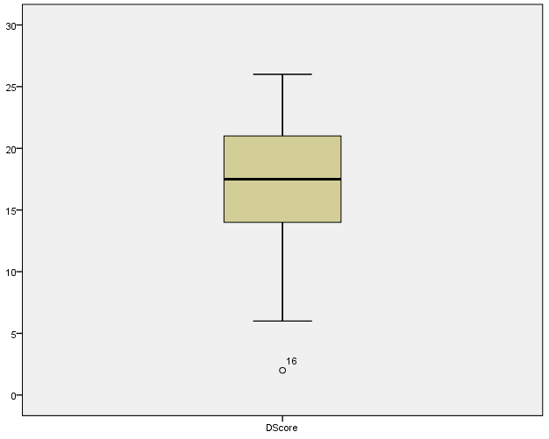
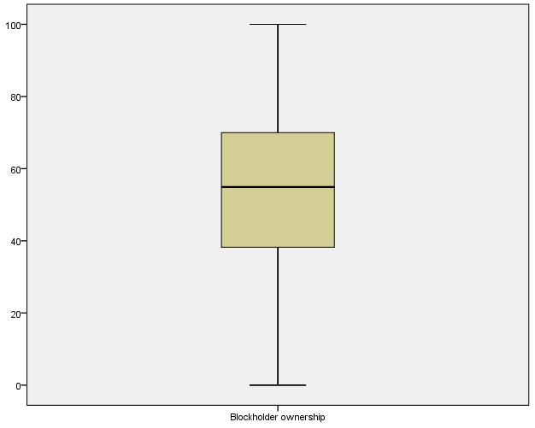
Appendix IV: Boxplots and Q-Q plots
Figure 2: Box plots to detect outliers
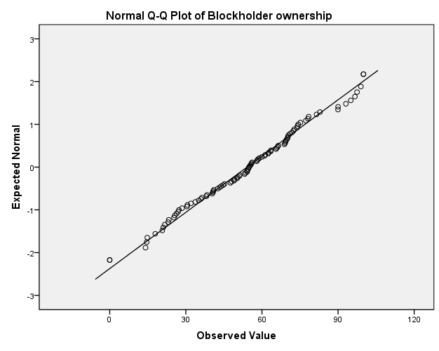
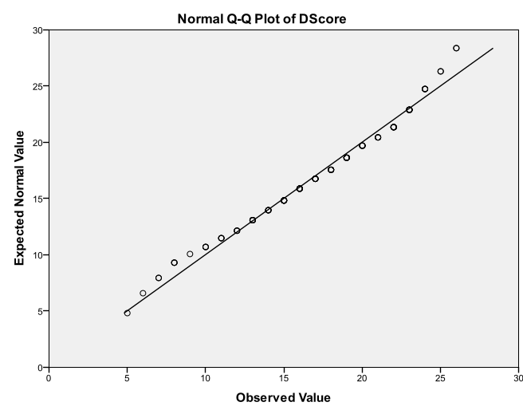
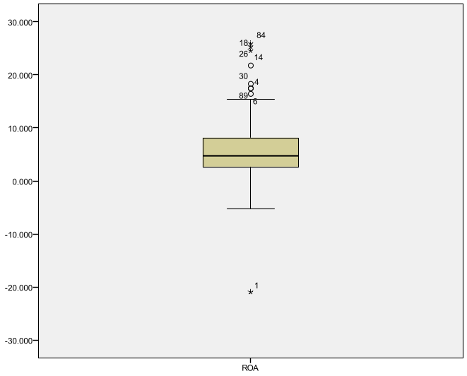
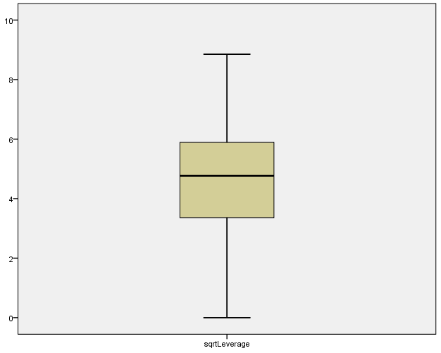
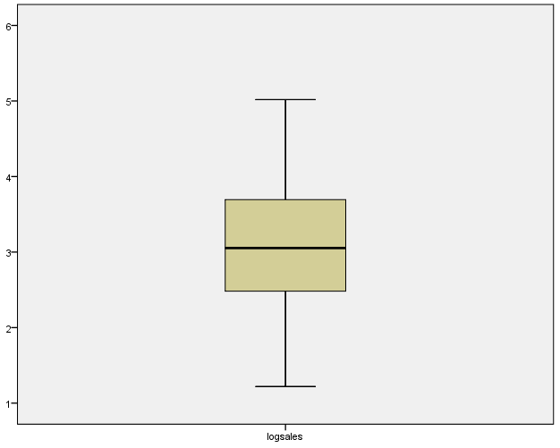
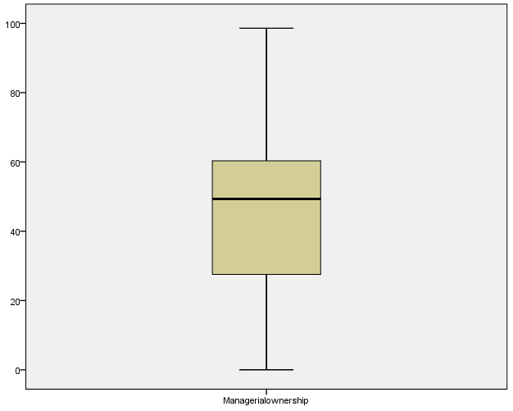
Figure 3: Q-Q plots after the corrections (except Government ownership)
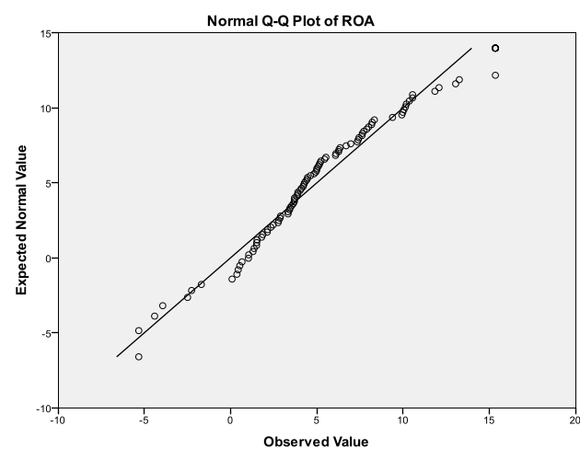
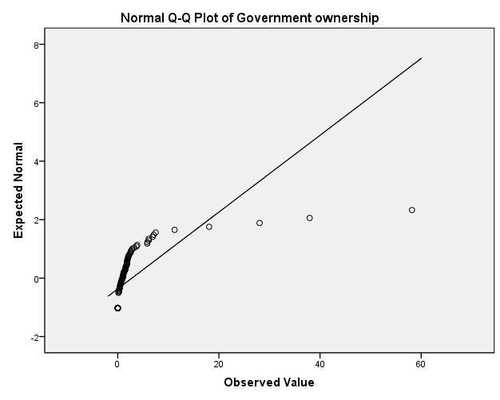
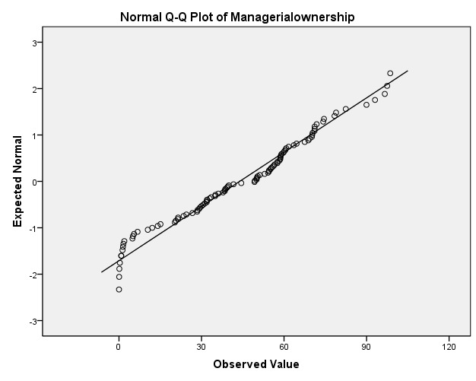
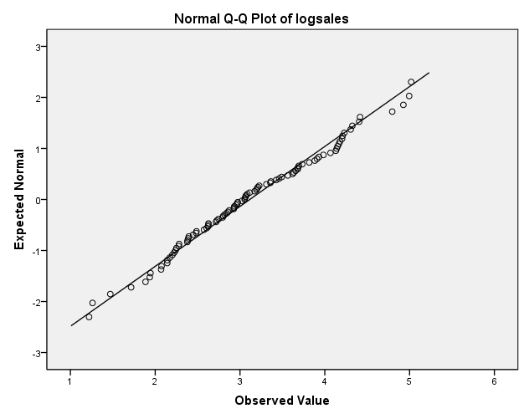
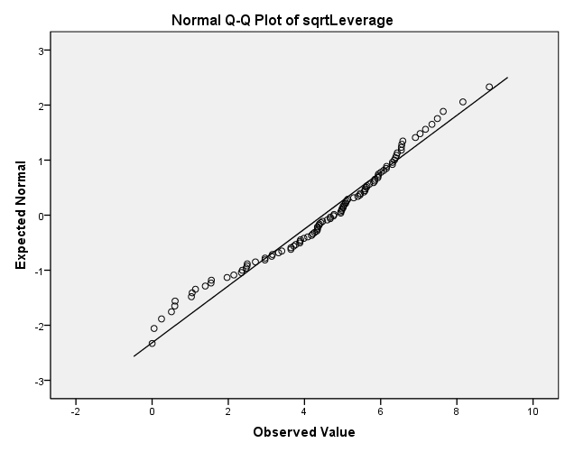

Appendix V: Information type analysis
Figure 4: Q-Q plots information type
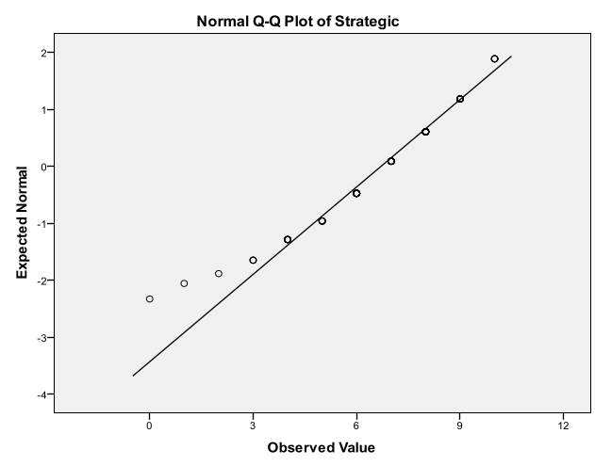
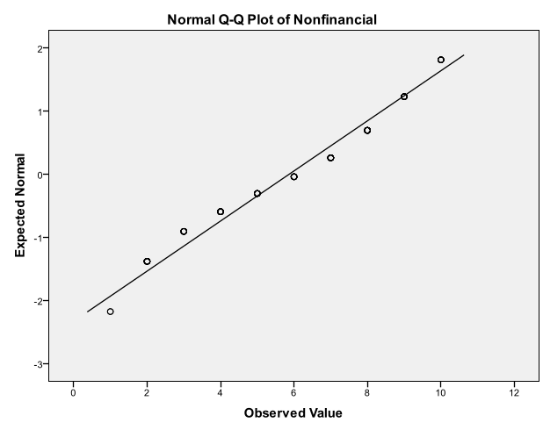
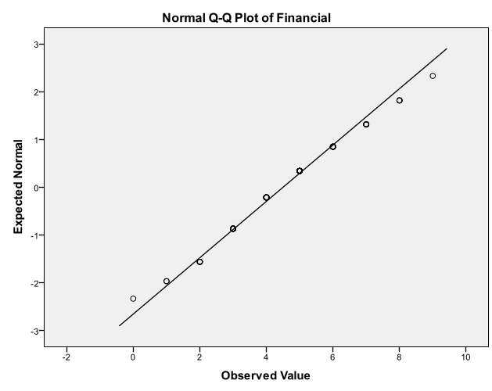

Appendix VI: Disclosure score sheets from prior studies

Meek et al. (1995)
Strategic information
1. General Corporate Information
1 Brief history of company
2 Organizational structure
2. Corporate Strategy
3 Statement of strategy and objectives - general
4 Statement of strategy and objectives - financial
5 Statement of strategy and objectives - marketing
6 Statement of strategy and objectives - social
7 Impact of strategy on current results
8 Impact of strategy on future results
3. Acquisitions and Disposals
9 Reasons for the acquisitions
10 Reasons for the disposals
4. Research and Development
11 Corporate policy on research and development
12 Location of research and development activities
13 Number employed in research and development
5. Future Prospects
14 Qualitative forecast of sales
15 Quantitative forecast of sales
16 Qualitative forecast of profits
17 Quantitative forecast of profits
18 Qualitative forecast of cash flows
19 Quantitative forecast of cash flows
20 Assumptions underlying the forecasts
21 Current period trading results - qualitative
22 Current period trading results - quantitative
23 Order book or backlog information
Nonfinancial information
6. Information About Directors
24 Age of the directors
25 Educational qualifications (academic and professional)
26 Commercial experience of the executive directors
27 Other directorships held by executive directors
7. Employee Information
28 Geographical distribution of employees
29 Line-of-business distribution of employees
30 Categories of employees by gender
31 Identification of senior management and their functions
32 Number of employees for two or more years
33 Reasons for changes in employee numbers or categories
34 Amount spent on training
35 Nature of training
36 Categories of employees trained
37 Number of employees trained
38 Data on accidents
39 Cost of safety measures
40 Redundancy information (general)
41 Equal opportunity policy statement
42 Recruitment problems and related policy
8. Social Policy and Value Added Information
43 Safety of products (general)
44 Environmental protection programs - quantitative
45 Charitable donations (amount)
46 Community programs (general)
47 Value added statement
48 Value added data
49 Value added ratios
50 Qualitative value added information
Financial information
9. Segmental Information
51 Geographical capital expenditure - quantitative
52 Geographical production - quantitative
53 Line-of-business production - quantitative
54 Competitor analysis - qualitative
55 Competitor analysis - quantitative
56 Market share analysis - qualitative
57 Market share analysis - quantitative
10. Financial Review
58 Profitability ratios
59 Cash flow ratios
60 Liquidity ratios
61 Gearing ratios
62 Disclosure of intangible valuations (except goodwill and brands)
63 Dividend payout policy
64 Financial history or summary - six or more years
65 Restatement of financial information to non-U.S./U.K. GAAP
66 Off balance sheet financing information
67 Advertising information - qualitative
68 Advertising expenditure - quantitative
69 Effects of inflation on future operations - qualitative
70 Effects of inflation on results - qualitative
71 Effects of inflation on results - quantitative
72 Effects of inflation on assets - qualitative
73 Effects of inflation on assets - quantitative
74 Effects of interest rates on results
75 Effects of interest rates on future operations
11. Foreign Currency Information
76 Effects of foreign currency fluctuations on future operations - qualitative
77 Effects of foreign currency fluctuations on current results - qualitative
78 Major exchange rates used in the accounts
79 Long-term debt by currency
80 Short-term debt by currency
81 Foreign currency exposure management description
12. Stock Price Information
82 Market capitalization at year end
83 Market capitalization trend
84 Size of shareholdings
85 Type of shareholder

Botosan (1997)
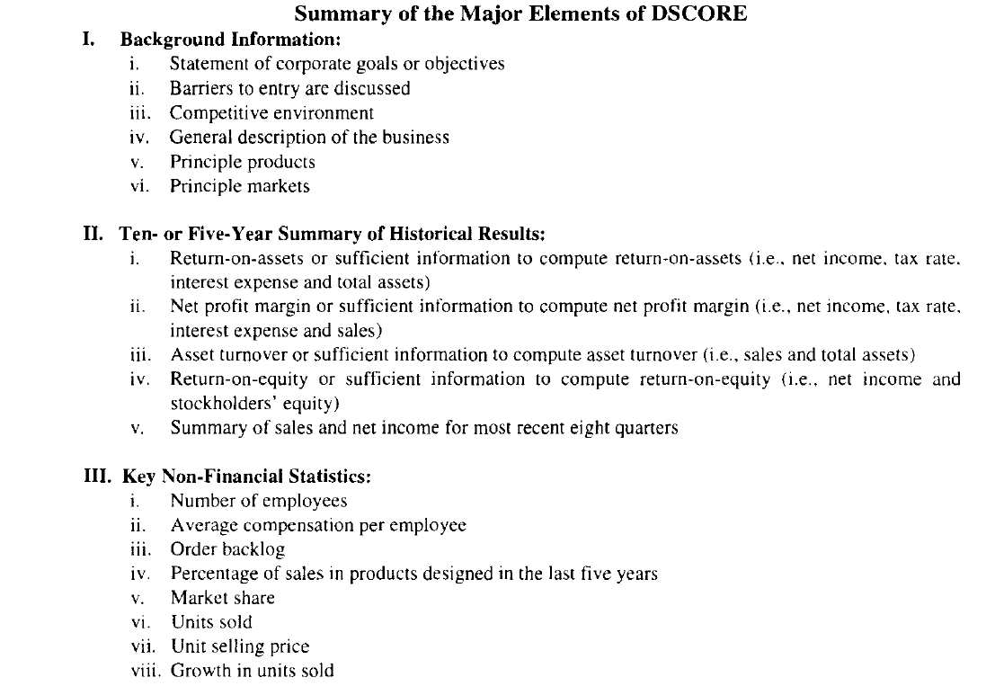
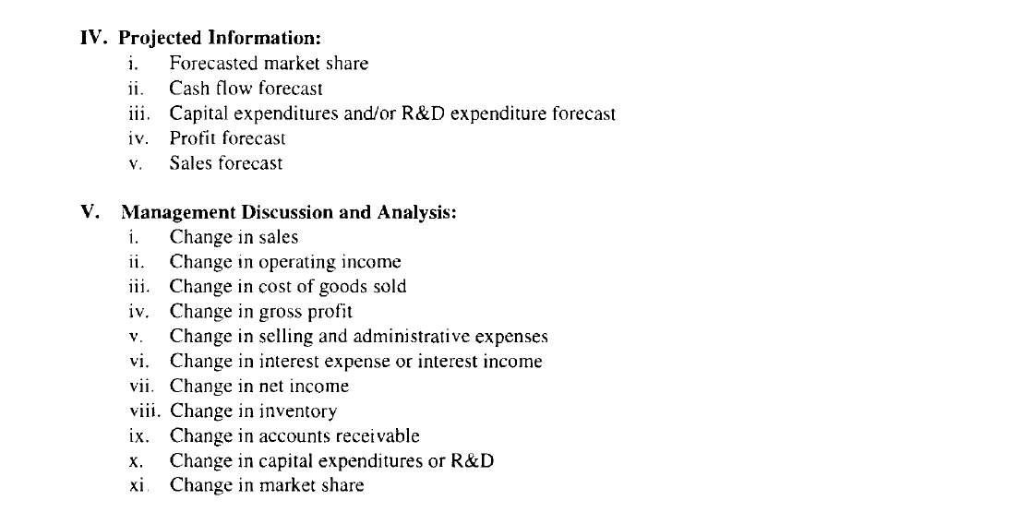

Chau and Gray (2002)
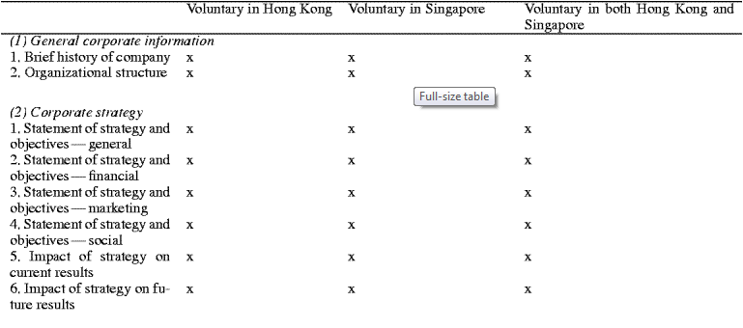
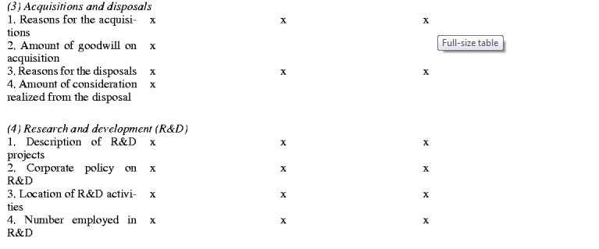
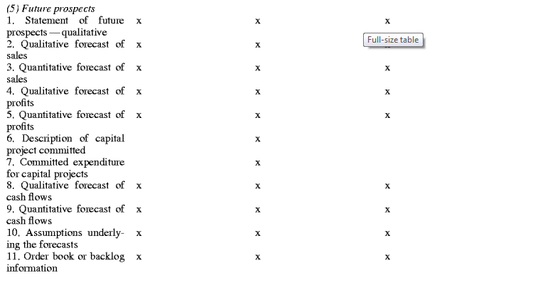
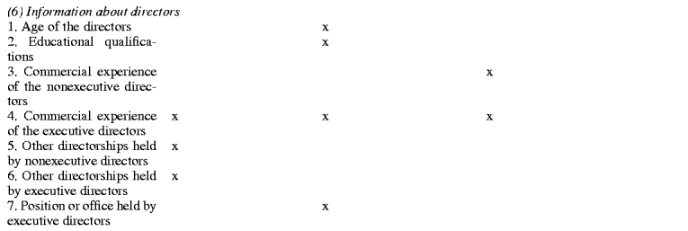
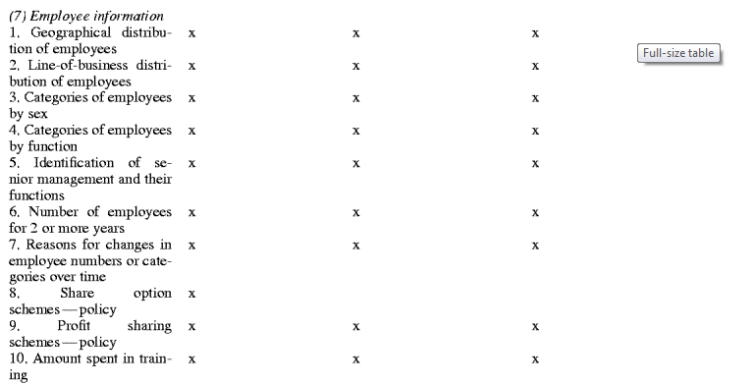
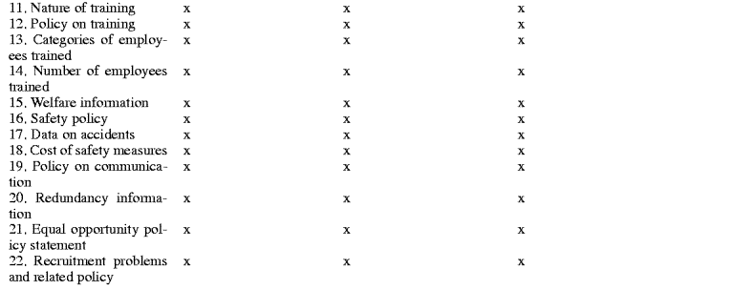
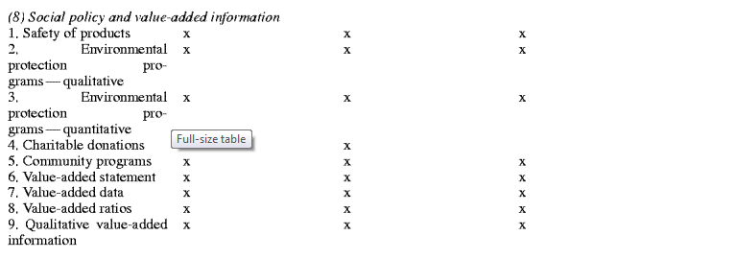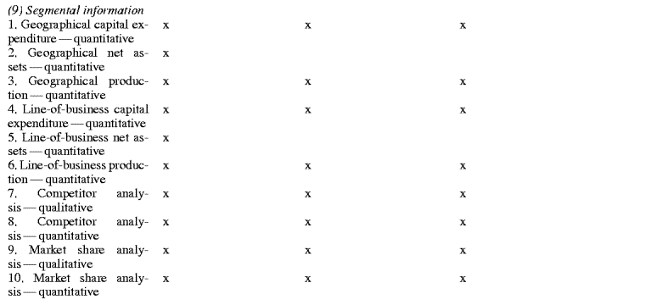
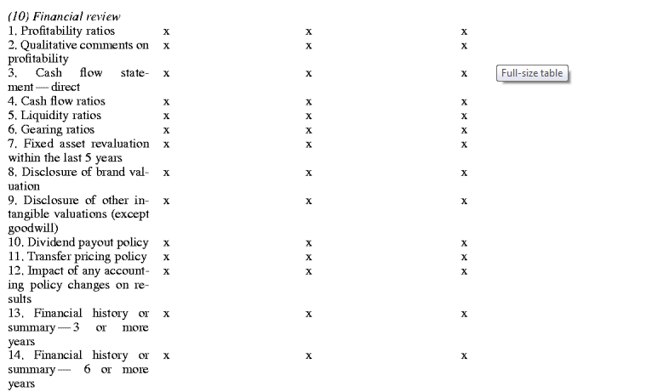
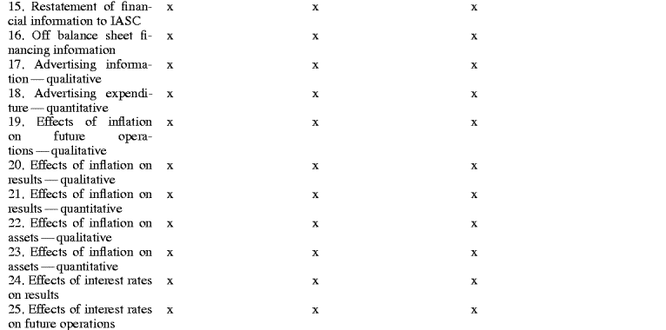
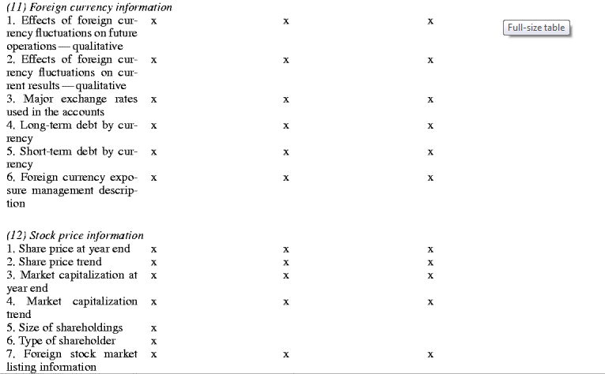

Eng and Mak (2003)
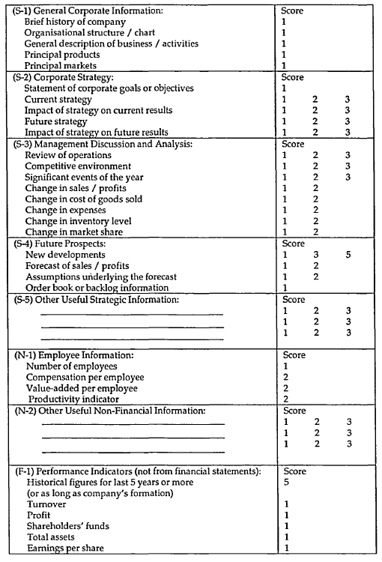
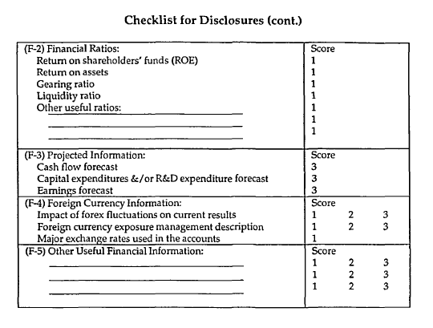

Huafang and Jianguo (2007)
Items of voluntary disclosure index (DSCORE)
1. Background information
1.1 A statement of corporate goals is provided.
1.2 General statement of corporate strategy is provided.
1.3 Actions to be taken in future year discussed.
1.4 Competitive environment discussed.
1.5 Trade status discussed.
2. Business Information
2.1 Change in sales
2.2 Change in cost of goods sold
2.3 Change in gross profits
2.4 Change in administration expenses
2.5 Change in operating expenses
2.6 Change in financial expenses
2.7 Change in inventory
2.8 Change in accounts receivable
2.9 R&D expenditures
2.10 Comparison of previous plan to actual achievement
2.11 Operating plan next year
2.12 Future profits forecasted
2.13 Order backlog
3. Financial information
3.1 Liquidity ratio
3.2 Gearing ratio
3.3 Inventory turnover
3.4 Turnover of receivables
4. Non-financial information
4.1 Staff training
4.2 ISO or other quality awards
4.3 Other awards
4.4 Social commonwealth
4.5 Brand
4.6 Names of the top five suppliers/customers
4.7 Enterprise culture
4.8 Environment protection

Dutch Transparancy Benchmark (2009)
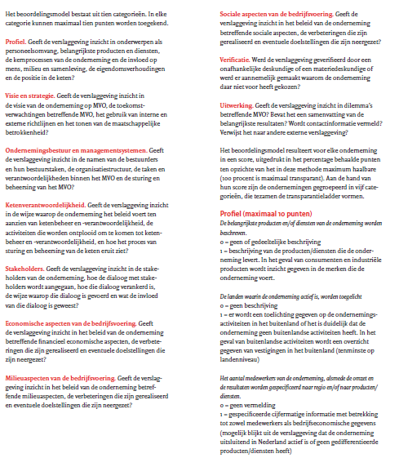)
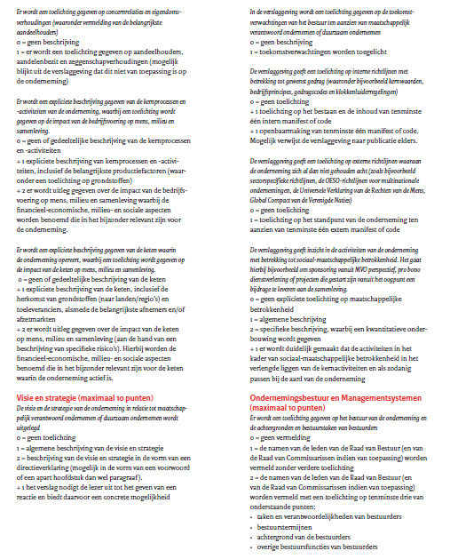
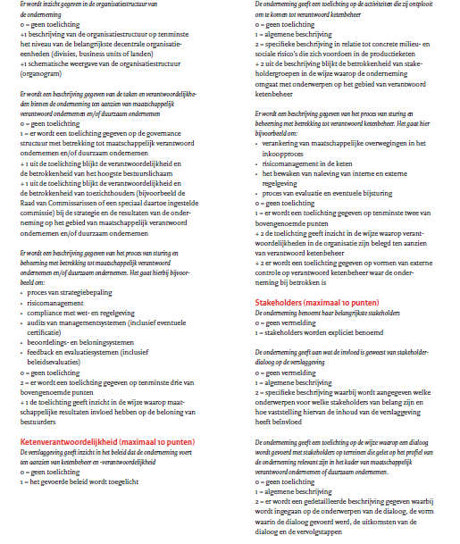
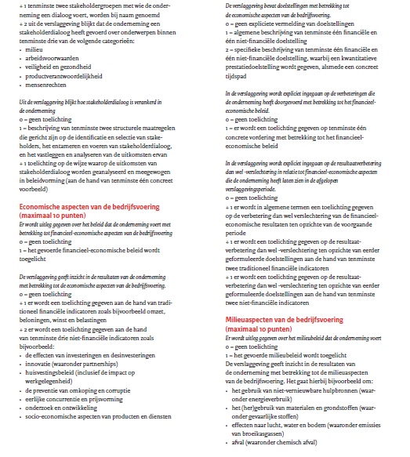
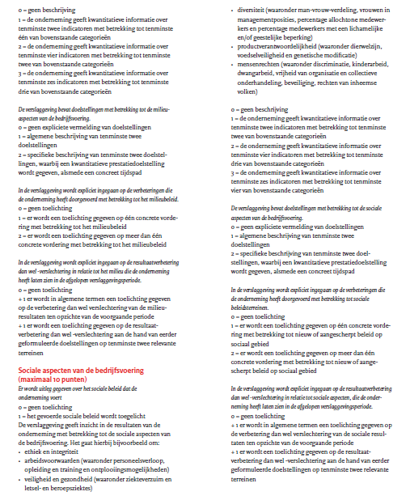
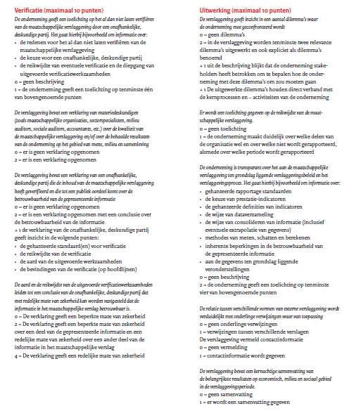

Financial Times, 15 December 2010.
There is also a Transparency benchmark from 2010. However, this 2010 benchmark is far more extended and also focuses a lot more on CSR. As CSR is one, but not the only voluntary disclosure that is measured, the focus was to keep the items on the disclosure sheet more general and therefore, the benchmark from 2009 was used.

