Web-aesthetics in different purchasing stages to enhance credibility and satisfaction

Master thesis

Student Omar Abokanj
Student number 337274
Supervisor D. Tsekouras
Msc in Marketing

Erasmus University Rotterdam 2012

Acknowledgements

The past few years on the EUR has been quite an adventure. After finishing my bachelor, I realized that I had much more to learn as a person overall, in addition to the educational part. The master marketing on the department of Economics & Business fulfilled my wildest expectations and I knew that I made the right decision. This master’s thesis demanded a lot of discipline and dedication, which was hard to maintain next to a serious job.

This thesis could not be finished without my supervisor Dimitrios Tsekouras. He stood by me the entire process, from the beginning to the very end. He was always open for new directions and suggestions which produced some positive discussions. Another aspect that I really appreciated was his speed and accurateness with his feedback, even when I contacted him multiple times a week. In the end we developed a great working relationship with openness and respect. Besides him, I want to thank my family and friends who always supported me throughout the years, especially when it mattered.

While this chapter of my life is closing, I am really looking forward to the next one. Although there is some relieve after graduating, there is some tension as well in picking my next step towards the mature life and career.

Rotterdam, April 2012

Omar Abokanj

Executive Summary

The number of online sales and web shops are rising every year, but the two relating issues of low conversion rates and shopping card abandonment are preventing further growth. Web aesthetics can (partially) solve these problems by improving both behavioural outcomes during the purchase process, namely satisfaction and credibility. In order to clarify the concept of aesthetics there has been chosen for a bi-dimensional division, specifically classical and visual aesthetics.
Classical aesthetics is associated with organization, clarity, cleanliness, symmetry, and with user perceptions of the website’s usability. The expressive part stresses more the creativity of web designers, like originality, creativity, colourfulness and diversity. These sub-dimensions can be considered distinctly, but they are not necessarily irrelevant.
The relationship between aesthetics and both credibility and satisfaction have been examined by multiple researchers. However, this thesis offered a unique concept with purchase processes as changing conditions. The purchase process in this research is divided into the search stage and the transaction stage. The executed survey examined which aesthetics were effective towards satisfaction and credibility at both purchase stages. In order to include two diverse and proper websites, a test survey was completed in an earlier stage. Besides the elementary variables, there was decided to include additional variables like gender age and online purchase experience. Unfortunately this produced disappointed results as no remarkable outcomes were detected.
Overall, the amount and quality of results were both very satisfying as almost all hypotheses were accepted, except for H5a and H6b. In other words, classical aesthetics had a significant stronger positive effect on satisfaction than visual aesthetics at the search stage. This was exactly the opposite of what was expected and the same applied for the other finding. This contained the fact that visual aesthetics had more of a positive influence on credibility than the classical element at the transaction stage.
One of the objectives was to discover a pattern along the purchase stages with the bi-dimensional division of aesthetics. However, there was no consistency found throughout the process, in contrast to the impact towards the behavioral outcomes. In the entire purchase process, visual aesthetics have a stronger positive effect on credibility as the classical elements have a similar effect towards satisfaction. Fortunately, the single web aesthetic cues are more consistent regarding the stages; especially two aesthetic elements, clarity and creativity, seem to have a significant positive effect on satisfaction and credibility throughout the search stage. The transaction stage showed less of consistency as diversity and colorfulness were the single cues that affected significant positively towards different behavioral outcomes. This last finding could be a reason for future researchers to focus more on the transaction stage, as it is critical to solve the online marketing issues nowadays.

Table of contents

1. Introduction 8
1.1 Introduction 8
1.2 Research relevance 9
1.3 Problem definition & research questions 10
1.4 Thesis structure 11
2. Literature review 12
2.1 Web aesthetics 12
2.2 Behavioral outcomes 18
2.2.1 Satisfaction 18
2.2.2 Credibility 19
3. Hypotheses and conceptual framework 22
3.1 Effects on satisfaction 22
3.2 Effects on credibility 23
3.3 Effect of aesthetics in the search stage of the purchase process 25
3.4 Effect of aesthetics in the transaction stage of the purchase process 28
3.5 Conceptual framework 30
4. Methodology 31
4.1 Research method 31
4.2 Sample selection 33
4.3 Variables 34
4.4 Data Analysis 37
4.5 Reliability and Validity 37
5. Results 39
5.1 Test survey 39
5.2 Reliability analyses 40
5.3 Results of hypotheses 42
5.4 Additional results 53
6. Discussion 55
6.1 Conclusions 55
6.2 Implications 57
6.3 Limitations 60
6.4 Future research 60
References 62
Appendix 66

1. Introduction

1.1 Introduction
One of the most developing business channels nowadays is the internet. In the end of the 20th century the online channels were just a supporting dimension to a company's promotion platform. The view of 'average consumer' on internet changed, as fast broadband internet access statistics explains. For instance in the Netherlands, this number rose from 5.8% in 2001 to 38.1% in 2010 (OPTA). The internet became an important channel to gain different sorts of information, for the consumer, as well as performing social activities (i.e. social media). Over the last few years 'the website' became more and more an important channel, as for some organizations it developed into the most important channel of their business (i.e. web-shops). Especially for this last group, sales online are essential.
To achieve this, the online purchase process has to be arranged in a proper way. As the bricks-and-mortar purchase process is different than the online version, this has to be executed as well as possible. This issue is illustrated by the low conversion rates nowadays as these numbers are estimated at an average of 5% (Van den Poel, 2005 & Moe and Fader, 2004). Web-aesthetics is an important aspect to contribute to this process as it contains both design (expressive aesthetics) and organization (classical aesthetics) of the website.
Wang et al. (2010) showed the importance of web aesthetics in the perspective of commercial websites. Eventually, these aesthetics have to accomplish certain behavioural outcomes (such as satisfaction) to improve potential purchases. Web aesthetics, especially expressive aesthetics, have a major effect on satisfaction which will ultimately lead to purchase by the website visitor. Although this article shows the connection between web aesthetics and purchasing behavior, it is obvious that satisfaction plays a significant role. This satisfaction has to be applied for multiple phases as purchasing can be divided into multiple stages, for instance into a search and transactional stage. Robins & Holmes (2007) addressed the positive effect of aesthetics on credibility, which is essential to the purchase intention of consumers. This thesis is focused on the appliance of web aesthetics on these different stages to enhance these behavioural outcomes. This phenomenon is under-researched in the web literature and therefore will be valuable for the industry.

1.2 Research relevance

1.2.1 Academic relevance
Many researchers have discussed the concept of web aesthetics and its importance to e-commerce. Wang (2010) for instance examined the effect of aesthetics on online service quality and satisfaction. Robins & Holmes (2007) and Alsudani (2009) discussed the effects of aesthetics on credibility and in what way this is perceived by the customer. Tractinsky (2000, 2004 & 2007) discussed highlighted the importance of aesthetics in e-tail in general.
In the introduction the purchasing process has been divided into two stages, namely the search and transaction stage (Liao et al., 2010). As there is little known about the fullness of the purchasing process, the search stage has been discussed in other approaches. Some literature regards this particular stage as seeking information for a product or service. Detlor et al. (2003) discussed the difference between browsers and searchers. Searchers already have a certain goal to achieve, whereas browsers have a more explorative behavior. Both groups have one feature in common; a high level of aesthetics will be more pleasing for both browsers and searchers.
Web visitors need less than a second to judge if the website is interesting enough for their particular goal. Therefore the visual appeal of a website has a significant influence on visitors' perceived credibility, usability and ultimately their purchase decisions. But these actual judgments will be formed only after a while. One of the assumptions is that time on a website should be maximized to realize transactions made by visitors. Bucklin & Sismeiro (2003) wrote an interesting article about this subject. One of their implications is that website designers should emphasize reducing the number of page views needed to complete a transaction. Longer page-view time periods do not increase the chance of a completed transaction, with other words visit-depth does have a negative effect on completed transactions. Aesthetics can play a vital role in this aspect, specifically to emphasize on the navigation element.
Finally, the first impression has to be appealing to the visitor and therefore it is necessary to have a fit between expectation/needs of the visitors and the website. If the proper aesthetics are not used for this fit, visitors will leave the website and continue their search elsewhere.

1.2.2 Managerial relevance
This thesis incorporates the consumers' behavioural response related to satisfaction and credibility. Ultimately these outcomes have to reach the actual purchase of the service or product, at least for managers who are responsible for the turnover rates (online). These managers are confronted nowadays with the issue of 'low' conversion rates. As this thesis will go more into the online purchase process (together with aesthetics), it will have an attempt to solve this issue and improve these rates.
Another worrying problem for the managers is the abandoned shopping carts. Approximately 71% of customers which start the check-out process (put goods in shopping cart) do not complete their purchase process. By addressing the problem, this thesis gives some additional insights on how a website should be arranged along the purchase.
Finally, the outcome of this thesis can be very important for marketing managers as well as online marketers. In this way the website can be designed as effective and efficient as possible. Moreover the purchasing process can be even customized as well to achieve the ultimate business goal: keep customers satisfied, re-buying products and so generating more revenues.

1.3 Problem definition & research questions
The proper design of the several purchasing stages has to lead to high credibility perceptions and satisfaction of consumers. Robins and Holmes (2007) showed that there is a significant interaction between design and credibility. It is not the aesthetics alone that create a credible website, but also the high aesthetic treatment (HAT) that incrementally increases the level of credibility. Together with the positive effect of high expressive aesthetics on satisfaction, this should lead to the intention of purchasing a product or service (Wang et al., 2010). As the lack of literature on the buying process in relation with aesthetics is a “blind spot” in web science, the outcome of this thesis will be highly relevant.
The following problem statement can be setup:
In which way can web aesthetic cues improve both customers’ credibility and satisfaction during the purchasing process of a service?

To answer the problem statement properly, it is necessary to set up the following research sub-questions:
- Which web-aesthetic cues will have the most positive effect on customers’ satisfaction?
- Which web-aesthetic cues will have the most positive effect on customers’ credibility?
- Do different purchase stages require a different emphasis of aesthetics to enhance credibility and satisfaction?

1.4 Thesis structure
In the following part the theoretical foundations as well as a literature review regarding the main constructs of the thesis are presented. First the concept of web aesthetics will be introduced, followed by various literatures about purchase stages and behavioural outcomes. This is followed by the set-up of the hypotheses and the conceptual framework in chapter 3. The next part contains the methodology of the empirical study. In chapter 5, the results are presented. Finally the discussion section includes the main conclusions, managerial and academic implications, limitations and future research.

2. Literature review

The internet is becoming a more important channel to companies each year. As in the earlier years the company website was more of an introduction, nowadays it becomes a complete distribution channel including an online shop. For some companies it turned to be their main selling platform. A lot of research has been done on web aesthetics but less on this in relation with purchases online. This process has to be implemented in the proper way to enhance the purchase intention. To examine this entire process at the best possible way, some clarifications have to be made.
The literature review will contain the following. First a detailed definition will be given of the concept web aesthetics among usability. The online purchase process will be clarified in the following paragraph. This has to lead in a clarifying layout for the research. Lastly, the purchase intention will be discussed as achieving this phase is the main objective.

2.1 Web aesthetics
Web-aesthetics is a relatively vague concept as it evolved during the most recent decades alongside the technology development. In a more traditional approach, web aesthetics were generally defined as the ‘design’ of a website. Many researchers suggested different approaches of the construct of (web) aesthetics. However there is one similarity along the relating literature, namely the bi-dimensional distinction.
Aesthetics have been divided in the context of other disciplines such as arts and architecture Beardsley (1982) and Lang (1988). The distinction was based on the functional quality and utilitarian value of a design (e.g., simplicity). In addition, there is the dimension of hedonic value of the design and emotional quality (e.g., meaningfulness). Schenkman and Jonsson (2000) applied the same concept into web aesthetics as it was called respectively the aesthetic formality and aesthetic appeal. Similarly, the formality dimension is referred to the perceived organization and order of a website, and the appeal dimension is related to the perceived novelty and meaningfulness of a website.
Van der Heijden (2003), Tractinsky (2007) and Tuch (2010) had a slightly other interpretation as the concepts classical and expressive aesthetics is introduced. Classical aesthetics is associated with organization, clarity, cleanliness, symmetry, and with user perceptions of the website’s usability. The expressive part stresses more the creativity of web designers, like originality, fascinating design and the usage of special effects. These sub-dimensions can be considered distinctly, but they are not necessarily irrelevant. In fact, both are necessary to reach a proper level (depending on product/service, to actually be appealing for the visitor. In the next sub-paragraphs this approach will be elaborated further more to have a clear on the subject.
To address the importance of the right utilization of web aesthetics, some aspects will be explained. Robins and Holmes (2008) discussed that a low level of aesthetics create a “low-budget” impression by the visitor. This impression is closely related to the credibility of the website, which is effected by the low level of aesthetics.
Aesthetics involve both design concepts and individual objects. Aesthetics can be seen as the relationship of several objects which contain both design principles and elements. A certain balance in this case is necessary to produce the website as 'one entity'. If this is not the case, for instance emphasizing more on displaying objects individually, this can lead to a design failure (Cai & Xu, 2011). In this case, design failure can have a significant impact on users' satisfaction and even purchase intention.

2.1.1 Visual (expressive) aesthetics
As was stated earlier, expressive aesthetics contains the creative side of a website such as originality, fascinating design (e.g. colours, graphics) and the usage of special effects (e.g. videos, pictures, sounds). Zettl (1999) stated that applied visual aesthetics is about effective communication, as it involves selecting elements and techniques that are most suitable for shaping a message or content to make it as effective as possible. The aim of visual aesthetics is to persuade the website visitor to unconsciously, unsuspectingly and unknowingly choose to become involved in the message and the website of concern (Krauss, 2004).
Moshagen and Thiesh (2010) mentioned these elements of expressive (visual) web aesthetics. The authors mention four elements that describe the perceived visual web aesthetics: simplicity, diversity, colourfulness and craftsmanship. Simplicity consists of aspects related to the Gestalt psychologists’ figural goodness concept such as unity, homogeneity, clarity, orderliness, and balance (Arnheim, 1974). Many companies tend to put more and more information on their web pages without taking into account that the website has to change simultaneously. Customers perceive information on a different way and have several levels of expertise on their disposal. To solve these inconsistent factors, simplicity is often a good solution.
Another perceived element of visual web aesthetics is diversity, as it consists of dynamics, novelty and creativity. Diversity counteracts low arousal by provoking interest and tension (Hekkert et al. 2003) and therefore an important component with respect to the aesthetic evaluation of websites (Tuch et al. 2009). Novelty can also be described as information that is updated.
Kawabata and Zeki (2004) agree on the unique effect of colors and their composition on aesthetic evaluation in general and with respect to the design of websites in particular (Moshagen et al., 2009). This element is dependent of the selection, placement, and combination of colors. Websites nowadays accommodate this aspect to their target group. It can be assumed that a ‘young’ target group appeals to fierce colors and an older group to softer, more ‘peaceful’ colors. Craftsmanship can be characterized as the skilful and coherent integration of all relevant design dimensions. A website needs to be harmoniously designed and the artistic ideas need to be implemented with skill and care.
These elements together form the visual web aesthetics but are still distinguishable from each other and carry unique meaning. As this article overlaps usability as well, this article can be used very well for the research that will be conducted for the thesis.

2.1.2 Classical aesthetics
The dimension of classical aesthetics represents order, clarity, clean design and symmetry (Lavie and Tractinsky 2004). An important element of aesthetics is (vertical) symmetry. Vertical symmetry in this context means that a website is (nearly) symmetrical along the vertical axis. Tuch (2010) showed the overall conclusion: “vertical symmetry has an impact on intuitive straightforward beauty appraisals and on classical and expressive aesthetics judgments made by the participants”. Asymmetrically designed web pages were considered as less beautiful and achieved lower scores on the classical and expressive dimensions. As expected, the effect was more pronounced on the classical than on the expressive dimension. These results suggest that prior findings on symmetry from experimental psychology are also highly relevant for websites. Moreover, the study indicates that the effect only occurs among male participants. It seems that only men react unfavorably towards asymmetrically designed websites. It seems that male visitors of a website needs more ‘structure’ than the females. This could be an important feature for target group that contain many males.
Classical aesthetics are also closely related to the usability of the aesthetics (orderly structured design). Findings are that perceptions of aesthetics and usability are highly correlated (Kurosu & Kasimura, 2003, Tractinsky et al., 2000, Lavie et al. 2003). However, classical aesthetics are strongly related to the perceived usability of the site while the expressive component is significant less. Thus, the classical aesthetic dimension may serve as a linkage between usability and aesthetics, being both an aesthetic concept and a usability principle (e.g. Karvonen, 2000).
Lee and Koubek (2010) have a certain view of usability on user preference of websites. The authors state that pre-use usability has a more positive influence on user preference than the time the task is completed (on online bookstores). This clarifies that consumers prefer a satisfactory first sight of the main page above an actual usable e-shop. In other words, the first impression is very important as the main page should have a clear overview and less disorder.
The strong relation between aesthetics and usability is also showed by Di Angeli (2006). In this research, one of the analyses concludes that differences in evaluation of usability and expressive aesthetics were good predictors of the overall preference. Two styles were introduced, namely the menu-based and metaphor-based website. Menu-based style is a style that adopted a more serious interaction style, displaying a static picture instead of the animated head, and with no humorous effects. In context of this thesis can be considered as a less expressive, but more a classical aesthetic website. Metaphor-based style is a style that adopted a playful and engaging interaction style, with animated picture characters providing information by speech bubbles, and generating other pictures and information from inside their head. In context of this thesis can be considered as a less classical, but a more expressive aesthetic website. People who preferred the menu-based style were much more severe in evaluating usability and content of the metaphor-based style, and more positive in evaluating these dimensions of their favourite style. Similarly, people who preferred the metaphor-based style were much more negative in evaluating both expressive aesthetics and engagement of the menu-based style. A relating conclusion is that a menu-based style is preferred for more serious content as the metaphor-based style is suited for less serious content.

2.1.3 Visual vs. Classical aesthetics
As the research earlier had been conducted on just one or two products, it is interesting what kind of aesthetic cues are important across different product categories. Tractinsky (2007) integrated research findings from different areas to propose that the role of aesthetics can be examined using a conceptual framework that takes into account the contingent nature of the consumer, the product, and the shopping process. Particularly the product nature is interesting for this research. There was concluded that expressive design is relevant to specialty goods because of their uniqueness and because of the emphasis on the shopping experience often associated with this type of goods. With convenience goods, expressive designs may interfere with the shopping process. Therefore, selling convenience goods online should be characterized by low levels of expressive aesthetics. Customer heterogeneity is also addressed as important for the design of a website. The analysis suggests that design for younger consumers should stress expressive qualities, whereas design for older consumers should stress classical aesthetics. (Tractinsky, 2007)
Wang, Hernandez and Minor (2010) addressed the correlation between classical and expressive aesthetics from another perspective. Both dimensions can be present in different quantities. When consumers deal with certain purchase tasks, aesthetic formality (classical aesthetics) may be important to consumer satisfaction. Szymanski and Hise (2000) found that consumer satisfaction with a website increases when the website is more organized.
In marketing research, it has been well recognized that a service providers' effort in assisting consumers' information processing and decision making can positively influence consumer satisfaction (Mohr and Bitner, 1995). An organized, clear, and simple website reflects the service provider's effort in providing assistance to consumers' information processing and thus, positively influences consumer satisfaction. To emphasize the variety between these dimensions, Eroglu et al. (2001) showed that consumers who are not involved with online purchase tasks are more contented by the hedonic quality of an e-tail website and thus expressive aesthetics. On the contrary, consumers who are involved with online purchase tasks are more concerned about the information of products and services in order to achieve the purchasing goal. Classical aesthetics can further facilitate information processing and help to establish consumer satisfaction. Discussing the variety and change between the aesthetic dimensions in several situations, it is very clear how they interact. However the interaction of these dimensions is not recognized in the perspective of stage in the purchasing process.

2.1.4 Consequences of web aesthetics
Both dimensions of web aesthetics play their essential role to reach a proper experience for the user on a particular website. Van der Heijden (2004) discussed that design elements such as color, graphics, and layout can play an important role in enhancing both usage and enjoyment of information systems as well as improving work quality.
Emotions are another aspect where aesthetics do have a significant influence on. Pleasure, fun and excitement are some of the emotions that are affected by aesthetics (Tractinsky, 2006). In particular colors and layout can enhance the aesthetic level. When executed in a proper way, these elements can create thoughts of fantasy or arousal (Cai & Xu, 2011). Other outcomes that can result from web aesthetics are satisfaction and credibility. The relevance and outcomes of these concepts will be discussed elaborately in paragraph 2.3.
Regarding the bi-dimensional distinction of aesthetics, classical aesthetics do have a significant effect on web visitors. When a particular website is viewed as clear and orderliness, this will give the visitor a confident feeling of control and lead to cognitive pleasure (Webster et al., 1993). Ultimately, this can lead to a state of “flow” with the user where the time will pass rapidly and an enjoyable experience will be achieved.
Negative feelings occur as well, especially when certain aesthetic elements are used “incorrectly”. One possibility is, when there is a misfit between aesthetics and the target group. For example young consumers are more appealing towards high expressive aesthetic websites; conversely older consumers are more attracted to classical aesthetics. When there is no proper fit, in this case older consumers with high expressive aesthetics, the group of consumers can be confused and overwhelmed by the stimuli. Again, this can have negative effects and eventually lead to abandoning the website.
There is also the misfit of aesthetic dimensions with the website's intention or products. Certain products do fit with a particular usage of aesthetic dimensions. For instance, within the shopping process of convenience goods the emphasis is on efficiency. In this case a high level of expressive aesthetics can intervene with this objective and even lead to negative feelings (confusion, dissatisfaction) about the website (Tractinsky & Lowengart, 2007).

2.2 Behavioral outcomes
This sub-chapter will actually put these terms in a customer's emotions regarding websites. It is important to this research as these are the elements that have to be accomplished to actually sell a certain product or service in this case.

2.2.1 Satisfaction
The most important behavioural reaction that customers have towards website stimuli is satisfaction. As some aspects of this concept are already explained throughout this review, now the specific topic will be discussed. Satisfaction is a function of the direction and magnitude of disconfirmation experience of expectations (Peterson and Wilson, 1992). Szymanski and Hise (2000) conceptualized e-satisfaction as the consumers’ judgment of their internet retail experience as compared to their experiences with traditional retail stores. This article actually examined the concept of e-satisfaction and what elements will lead to this particular level. The results were actually very complementary to the contents of this thesis. Site design and convenience (and financial security) play an important role in e-satisfaction according to Szymanski and Hise (2000). As website design and convenience have a slight different meanings, both concepts can be seen as a mix of classical and visual aesthetics.
The outcome of the previous study has a number of similarities with other literature on the subject of e-satisfaction drivers. Donthu (2001) for instance, discussed site-related factors (together with vendor-related factors) which has an impact on e-satisfaction. Site-related factors, in this context, contains elements such as aesthetic design, ease-of-use, processing speed and security. Bansal et al. (2004) executed a complementary research as price, availability of information, product selection; transaction duration and ease-of-use are revealed as the important drivers of e-satisfaction. Ease-of-use though, in contrary to previous articles, contained navigation of a website including the organization of the graphics and information as well as the effectiveness of the layout. A distinction on this matter, regarding the bi-dimensional division of aesthetics, has not been clarified yet.
In Lindgaard and Dudek’s (2003) study, satisfaction of online viewers comes from highly appealing websites, regardless of whether the websites are useful to them. Satisfaction or e-satisfaction plays a very important role in the performance ratings of a website. Besides it is a good predictor of loyalty, it is the key to build and keep hold of a loyal base of long-term customers (Evanschitzky et al., 2004). Besides loyalty, satisfaction has other effects as well in an online perspective. Bansal et al. (2004) discussed the significant impact of satisfaction on both retention/referral and online conversion. Especially online conversion, addressed earlier as a major issue in e-commerce, is an outcome several managers want to improve. Retention and referral can be regarded as an act of loyalty, similar to the phenomenon of ‘word-of-mouth’. The importance of satisfaction is obvious, as loyalty (word-of-mouth), online conversion and re-purchasing are critical to the continuity of an organization.

2.2.2 Credibility
Many studies in the marketing literature have focused on about the credibility of a website and what kind of effect it has on online (buying) behavior. Credibility is described as the extent to which users trust the informational content on a website (Robin and Holmes, 2008). Credibility judgment of a website’s information and overall content is a critical matter for showing information or selling products online. If a website is not recognized as credible, it is unlikely it will be used. The first credibility cues are noticed very rapidly, even before any reading or other cognitive processes take place. This is also discussed by Alsudani et al. (2009). This article showed that instant credibility is applied by web visitors. Experiments have shown that users can judge a web site’s credibility in as little as 3.42 seconds merely on the basis of its aesthetic appeal.
After addressing the significance of credibility, it is interesting to see what influence aesthetics have on this phenomenon. Robins and Holmes (2008) described credibility in relation with aesthetics. This study suggested there is a significant interaction between design and credibility. The design has an influence beyond the overall decoration; specifically it contributes to a more credible website. It can’t create the credibility on itself, but it gives an incremental boost to it.
‘Unity’ in design with its elements of balance, harmony, contrast and dominance was found to be an effective aesthetic factor resulting in immediate judgments on web credibility. This harmony can be regarded as the classical element of aesthetics as it indicates the clear and orderly design of the webpage (Alsudani et al., 2009).
To reach a certain level of website credibility, there is a particular content or message needed on the website (Schlosser et al. 2006). This paper investigated the impact of website design investments on consumers’ trusting beliefs and credibility. Many marketing managers assume that they do not have to invest on trust issues as consumers gain online purchase experience. The contrary is true, as recent reports indicate that consumers at all levels of internet experience are increasingly cautious about buying online (Penn et al., 2005).
Fogg et al. (2003) addressed the significance of aesthetic design in relation to credibility as well. In a rather large research (> 2500 respondents), users were asked how they evaluate a website’s credibility. In almost 50% of the evaluations “the look of design” was the most prominent topic in their motivation. Though, this topic contained a wide perspective as layout, typography, white space, images, color schemes are all included. The next significant topic on respondents’ comments is the information design/structure. As this concept is relative vague it is difficult to set boundaries within the perspective of classical and expressive aesthetics. .
Website design investments signal the component of trusting beliefs that is most strongly related to online purchase intentions: ability (reflect consumers’ confidence that the firm has the skills necessary to perform the job). These effects were stronger when consumers’ goals were to search rather than to browse and when purchases involved risk. Besides ability there are two more elements that play a part in trust, specifically goodwill and integrity (Schlosser et al., 2006). To fulfill these elements it is more effective to use privacy/security statements rather than invest in the website. For browsers, the most personal component of trust (i.e., goodwill rather than ability) influences their online purchase intentions. Consequently, even if browsers recognized that website investment signals ability, it had relatively little influence on their online purchase intentions. In the end, credibility can be achieved in different ways, but this all depends on the particular product/content that is presented on a website (Bart et al., 2005). Besides this fact, the article shows other determinants for credibility as well, such as content-related factors (advice, absence of errors, community features, etc), brand-strength and customer experience/expertise. In short, if a website is considered as credible, purchase intention is more likely to be realized (Schlosser et al., 2006; Fogg et al., 2003; Yoon, 2002).

3. Hypotheses and conceptual framework
In order to answer the research question, a series of hypotheses are introduced in this chapter. Every hypothesis will be explained as well as which references lead to these statements. The several variables will be clarified as well as their relation to each other.

3.1 Effects on satisfaction
The importance of satisfaction about websites is highlighted by Evanschitzky et al. (2004). There is stated that e-satisfaction is a good predictor for loyalty and therefore success. To fulfil a certain level of customer satisfaction, both site design and convenience are necessary. A complementary recommendation made in the specific article is that a website should be easy to navigate, this to enhance the shopping value for the online consumer.
Another uncertainty rose from the article of Szymanski and Hise (2000). They discussed a new concept of e-satisfaction among other elements. As the effect of aesthetics on satisfaction was already secured, this article made a distinction between site design and convenience. They found that consumer satisfaction with a website increases when the website is more organized. The relevant factors for this are: (1) site design (fast, uncluttered and easy-to-navigate) and (2) convenience (saving time and making browsing easy). Regarding the bi-dimensional division in this thesis, these relevant factors are more tending to classical aesthetics than the expressive aesthetics.
Eroglu et al. (2001) showed that consumers who are involved with online purchase tasks are more concerned about the information of products and services in order to achieve the purchasing goal. Classical aesthetics can further facilitate information processing and help to establish consumer satisfaction. Besides the particular purchase task a consumer will apply, “pre-knowledge” seem to be important as well, regarding the preference of classical elements.
Donthu (2001) discussed site-related factors which has an impact on e-satisfaction. Especially ease-of-use and aesthetic design are elements that point to the classical element. Bansal et al. (2004) supported the fact that ease-of-use is an important driver of e-satisfaction. As was earlier stated, ease-of-use in this context, include in particular the navigation throughout the website. This indication leads to the following hypothesis:
H1: The higher the classical aesthetic treatment on a website, the higher is the customers' satisfaction from a website

Regarding the first hypothesis, there is a lot of support for the positive relation between classical aesthetics and satisfaction. There seems to be a significant foundation for this fact, but it does not exclude the fact that expressive aesthetics can have a positive relation towards satisfaction as well. This is supported by Lindgaard (2007), as he suggests that aesthetics have a significant (positive) effect on satisfaction. This is supported by Lindgaard's (2003) earlier study, in which is discussed that satisfaction of online viewers comes from highly appealing websites, regardless of whether the websites are useful to them. Conversely, there is the prominent fact of Tractinsky et al. (2000), ‘what beautiful is usable’. As Hiltz and Johnson (1990) found that first perceptions of usability were correlated with long-term users' satisfaction with the system's interface. There can be assumed that these facts are tending to the expressive side of aesthetics.
Eroglu et al. (2001) discussed that purchase tasks are involved in the process of aesthetics to reach consumer satisfaction. If the consumers seem to have minor or no involvement in their shopping process, visual aesthetics are more likely to support satisfaction. The cause of this effect is that consumers in this process seek more hedonic value to fulfill their needs. If consumers are involved in highly elaborated decision processes when purchasing for specialty goods, expressive aesthetics will contribute to the persuasive message of the store and thus satisfaction (Tractinsky & Lowengart, 2007). The same applies for younger consumers as they more appreciate visual aesthetics than the older consumer.
They are more open to new forms of expression and expectations within this perspective rise simultaneously. These suggestions are just some (indirect) examples, but do support the fact that expressive aesthetics can play an important role in certain circumstances. Considering other variables to play a part in consumer satisfaction, the expectation is that visual aesthetics play a significant role in this process. To examine this particular effect, the following hypothesis is set up:
H2: The higher the visual aesthetic treatment on a website, the higher is the customers' satisfaction from a website

3.2 Effects on credibility
The preference of a particular design, i.e. the implementation of classical and expressive aesthetics, depends on the company as well as the offered products. This preference will depend on its’ credibility and satisfaction. For instance, to be credible as an insurance company a clear and ordered structure is necessary, as product and website need to be equal to maintain consistent. Other websites need to have a more expressive design, for instance luxury and holiday websites. Relating to this aspect, Robins and Holmes (2008) suggested that website design have significant contribution to the credibility of a website. The authors actually did not use any distinction between classical and expressive aesthetics, but separated between high and low aesthetics level. They stated that customers can judge a website/page credible within a few seconds. This is called “instant credibility”. Furthermore, Alsudani et al. (2009) mentioned that customers need approximately 3.42 seconds to make a judgment based on the aesthetic appeal. Although aesthetics are indicated to have a positive effect on the website's credibility, it is still unknown which dimension in particular is playing a crucial role in the phenomenon of credibility.
Fogg et al. (2003) showed that aesthetic design is important to the credibility of a website. Although the significance was showed, the concepts that there were used were rather broad. The two most common topics ( “look of design” and “information design/structure”) seem to be too much affected by each other. Moreover, respondents did not have a deeply motivation. According to ELM (Elaboration Likelihood Model) by Petty & Cacioppo (1986), people will rely on peripheral cues such as appearance, for making assessments. ELM would predict that if the participants had both the ability and the motivation to study these sites carefully, the percentages in this study would change (in this case declining), with peripheral cues playing a less significant role. Referring to this several question and the lack of setting boundaries between visual and classical aesthetics, both dimensions will be evaluated in this research.
This discussion is also supported by Wathen and Burkell (2002). Although they conducted research on the overall credibility of a website, including the source, receiver, medium, message and context, the presentation is significant for the online credibility. Focusing on the key aspects of credibility outlined above, it is clear that such a site should accentuate a good interface and project a professional image, making use of established design principles, including layering, colors, graphics, ease of use and menus to organize information. In addition, these design principles contribute positively to the surface credibility of a website. The concept surface credibility is very similar to “instant credibility”, earlier discussed. Information coupled with a well-designed interface and attractive graphics may result in a tendency for users to make a positive credibility judgment (Critchfield, 1998).
There can be concluded, that the total concept of aesthetics play a significant role in the credibility of a website. Classical aesthetics as a single dimension though, is very important to achieve credibility. One way to turn a website into a credible channel is to take care of the 'unity' aspect. Key in this process is looking after harmony, i.e. (consistent) clean and orderly design throughout the web page/site (Alsudani et al., 2009). As this is closely related to classical aesthetics, the following hypothesis is proposed:
H3: The higher the classical aesthetic treatment on a website, the higher is the customers' perception regarding the credibility of the website

Besides the classical element, there is also information about the positive relation between visual aesthetics and credibility, not only jointly with classical aesthetics, but the single visual element as well. Fogg et al. (2003) confirmed these results in a large survey on credibility. The most repeated motivation on the respondents' judgment was “the look of design”. The look of design can be regarded as the expressive or creative element of a website. Together with the concept of “instant credibility” the following hypothesis can be proposed:
H4: The higher the visual aesthetic treatment on a website, the higher is the customers' perception regarding the credibility of the website

3.3 Effect of aesthetics in the search stage of the purchase process
Aesthetics and their role towards satisfaction and credibility already have been discussed. These two outcomes are vital to turn visitors into customers, that is intention to purchase. Reaching this stage is not the final stage. In the introduction, the common 'problem' of abandoned shopping carts was highlighted. To prevent this phenomenon, one solution is to design the purchase process in a best possible way. And in this process, aesthetics is an under-researched topic. However, Wang et al. (2011) suggested that the online process consists of five different stages: problem recognition, information search, evaluation of alternatives, purchase decision, and post-purchase behaviour. Solomon (2006) emphasized that this given process followed rational perspective. Nevertheless, consumer behaviour differs from each other and so is their buying process. As not all consumers do follow this entire sequence, the buying process can be regarded as dynamic. This phenomenon depends of several variables like involved products, consumer knowledge, website information, degree of involvement, etc. (Grant et al., 2007).
The mentioned articles about the buying process all have certain stages that return in their research; namely search, ordering (transaction) and post-purchase stage. Ultimately this thesis is about online aesthetics and the outcome of it. Liao et al. (2010) discussed that websites have no influence on the post-purchase stage. As Liao discussed, satisfaction of ordering can be regarded separately to satisfaction of post-purchase (delivery, after-sales support, etc.) because of the time period between these stages and distinct expectations. As the “online aspect” in this thesis stands central, the purchase stages in here will be divided into (1) the search stage and (2) the transaction (ordering) stage.
The importance of the search (stage) has been discussed by Shim et al. (2001) among others. This research indicates that an intention to search the internet for product information leads to an intention to purchase through the same medium. Therefore, information search and its selected channel should be considered extremely crucial elements leading to a choice in purchase format. In addition, the transaction stage is the stage where customers make a decision based on their search for particular products or services.
The first step most customers commit is the search stage to obtain the right information before the actual purchase is made. This information aspect plays an important role in the search phase as it can be considered as a starting point. Detlor et al. (2003) distinguished two groups at this stage, namely browsers and searchers. In this article searchers are considered as customers who already have a certain amount of information of the product or service. It is a more goal-oriented action with a view to make a purchase decision. In contrast, there are browsers who are not sure how, or if, their shopping requirements can be fulfilled. It is more about exploring the market as they seek information about the product, in other words it’s a shopping experience without an actual objective.
As these different search-modes are discussed separately, consumers do not remain in a particular search-mode. Rather, consumers may refine their strategies, approaches, and information requirements as they reflect upon and consider the information they collect along the way during the initial stages of the buying process (Hodkinson et al. 2000). Some studies suggest that consumers usually start in an exploratory seeking mode and then gradually move towards goal-directed search with a progressively narrow focus. Such strategies and mix of seeking modes may lower transaction and cognitive costs for online shoppers (Liang and Huang 1998). Other studies suggest that browsing and searching can lead to consumer disorientation in the online context (Bryan and Gershman 1999). For instance, with goal-directed search, users may never be afforded a view of the entire shopping space; rather, they jump from subset to subset of an e-tailing site via a local search engine. In terms of browsing, online consumers may experience sudden changes in page design and formats.
The added value of this thesis will be around the statement of the aesthetic applications in the different purchase stages. A division was made into two options; a (1) metaphor- and (2) menu-based style website (Di Angeli, 2006). The emphasis of the first option was more on visual aesthetics and less on the classical component. The accent of the second option was on the opposite: more on classical aesthetics and less on the visual component. While customers seek information during a purchase process, customers need to be induced or convinced to purchase. High expressive aesthetics should give the best view of the product (depending of product or service). The aim of expressive aesthetics is to persuade the website visitor to unconsciously, unsuspectingly and unknowingly choose to become involved in the message and the website of concern (Krauss, 2004).Pretending that visual aesthetics can be considered as the metaphor-based style, this should have a stronger positive effect on satisfaction (and credibility) in the search stage.
H5a: In the search stage of the purchase process, the effect of visual aesthetics on satisfaction is stronger than the effect of classical aesthetics

As was earlier stated for the search stage, it is very important which product is sought. Huang et al. (2009) made a clear distinction as the difference in consumer behavior for search and experience goods is highlighted. For instance, experience goods involves greater depth (time per page) and lower breadth (amount of pages) of search than search goods. Especially when experience goods are involved, it is relevant that the website's presentation is in line with the product(s). When consistency in the message can be achieved (harmony), credibility can be reached in a greater way. Too much emphasis on visual aesthetics can be a danger as a high level can intervene with its' objective and even lead to negative feelings like confusion and dissatisfaction (Tractinsky & Lowengart, 2007). For these reasons the following hypothesis is proposed at the moment.
H5b: In the search stage of the purchase process, the effect of visual aesthetics on credibility is stronger than the effect of classical aesthetics

3.4 Effect of aesthetics in the transaction stage of the purchase process
After the consumers make their selection of product or service, they will reach the transaction stage. Consumers have made a preliminary decision until now, because the actual transaction is still not executed. Most consumers are still not totally assured about their decision at this stage. This uncertainty can lead to the common “problem” of abandoning the shopping card, which was earlier discussed. This means that every tool should be used to strengthen the decision to purchase. With other words: aesthetics (and content-related factors) should be applied in the right way to “push the consumer across the final threshold” and purchase the product.
Eroglu et al. (2001) showed earlier that online consumers with a particular purchase tasks are more concerned about the information of products and services in order to achieve the purchasing goal. This is the case because these consumers seek a more utilitarian value while shopping online. Classical aesthetics ease this information processing and help to establish consumer satisfaction. Especially in the latter purchase stage it is important that consumers will be informed in a correct way. Unforeseen surprises in this stage can easily lead to abandonment of the shopping card.
A related factor that plays a significant role in preventing these negative surprises, is the easiness of use. Consumers demand clarity and simplicity among other factors. Classical aesthetics can be very important to deliver these aspects. This is supported by Bansal et al. (2004), who supported the fact that ease-of-use is an important driver of e-satisfaction. While Szymanski and Hise (2000) introduced “e-satisfaction”, they found out that consumer satisfaction with a website increases when the website is more organized. When the transaction pages are organized as well, this should improve the ease-of-use and therefore satisfaction. Most consumers that reach the transaction stage are seeking for utilitarian value. This means that information processing and ease-of-use are vital to attain this shopping value. Classical aesthetics therefore, should be more suited for this stage of the purchase process. For this reason the following hypothesis is set up:
H6a: In transaction stage of the purchase process, the effect of classical aesthetics on satisfaction is stronger than the effect of visual aesthetics

Trustworthiness and credibility are important when a transaction is involved. Therefore, there is the belief that classical aesthetics will be more suited to the demands of the customer on the transaction phase relating to credibility. This is supported by the discussion of Eroglu et. (2001) which indicates that classical aesthetics are more suitable to high-involved consumers. Closely related to this discussion is the fit between expectation/needs of the visitors and the website. This can be converted to the page or phase of transaction. Consumers expect a transaction page where information processing will be appropriate and discrete. No fit at this particular stage, will cause distractions and can lead to abandonment of their purchasing task. There can be assumed that expressions in the appearance of visual aesthetics can lead to negative feelings/actions, because this will interfere with the transactional objective at this stage (Tractinsky & Lowengart, 2007).
H6b: In transaction stage of the purchase process, the effect of classical aesthetics on credibility is stronger than the effect of visual aesthetics

3.5 Conceptual framework
In order to visualize the research question and give a clear overview of which variables are involved and how they are interlinked, the structure of this thesis can be defined into a conceptual framework as can be seen below. Moreover the several hypotheses are highlighted, this in order to show which brick stone they form into the whole.

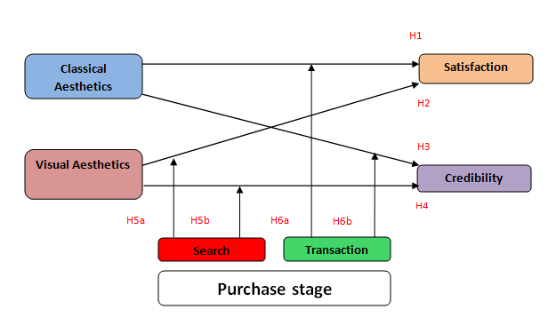
Figure 1: Conceptual Framework

4. Methodology

4.1 Research method
The objective of this study is to examine in which way web aesthetics can improve customers' credibility and satisfaction during the purchasing process of a service or product. In this particular case, two different travel websites will be used for the research. The first reason for this particular choice is personal: it is my ambition to develop a luxury travel website in the near future. Combining this with my research is really efficient and ultimately will produce a greater meaning for this research.
Another reason for the choice of travel websites is the nature of this product/service. In the end, travelling is all about experiences and it is interesting to analyze how several travel agencies are dealing with the issue. The challenge is to use the right web aesthetic cues to win over customers to order the holiday online. Besides the fact that a holiday is an experience good, the whole experience and excitement should be presented in a best possible manner, in order to satisfy the customer at this stage. In the past, customers found this feeling of experience or excitement, by visiting the travel agency shop. The task of online travel agencies is to exceed the 'shop' at a convenience and experience level. Web aesthetics can play a significant role in this process which will be examined in this research.

4.1.1 Data Collection
Analysing satisfaction and credibility of customers/people on web aesthetics, means that opinions and judgements are requested. Obviously, there are assumptions that websites do have a classical or visual aesthetic nature. But it is important that this assumption is shared by more people, in order to select the right stimuli for the research. To check this particular manipulation of aesthetic findings, a test survey has been set up, see Appendix VIII. In this way, the correlation could be tested between the variables and the selected websites. Moreover it is important for this research, that different aesthetic websites are utilized in favour of the results. With this fact in mind, it was necessary to find the proper websites. After some research on the web, the following websites have been chosen:
The first website (expedia.nl) is the world's largest online holiday agency. The website of Expedia is visited by 70 million users worldwide on a monthly basis. Besides this is a popular website, it is well organized and the emphasis is tending more to classical aesthetics. Alexia.com shows a wide range of statistics of this website because of its’ popularity in the Netherlands (traffic rank #476 ). The first relevant statistic is the average of around 4 page views per user and a mean duration of around five minutes. Expedia.nl is classified as “very slow” concerning load time, as it takes an average of more than 4 seconds to load a particular page. According to alexa.com, there are 95% websites faster in loading their web pages.
Silktravel.nl is specialized in offering diverse luxury holidays across the globe. Their market approach is translated into their web-design and their offer can be classified as 'unique holidays to unique destinations'. Their web-design can be regarded as unique as well, with the emphasis more on visual aesthetics rather than the classical element. Alexa.com shows that, users visit an average of three web pages of this website which take around one minute, before they abandon the website. Referring to these statistics, a significant difference can be noticed with expedia.nl.
By selecting these two websites, most of the spectrum of web aesthetics (from classical to visual) will be examined. Another criterion that was applied for this selection was the presence of both stages in the purchase process. There were doubts whether to include “silktravel.nl” within the research because web visitors are not able to execute the actual transaction online. Instead, these customers are obligated to make an appointment at their office to finalize the transaction. Main reasons behind this are the high amounts as well as the 'unique' experience they want to offer. At first this could be threshold, but after some discussions this seemed to be an opportunity, as diversity within the transaction stage would only benefit the research. Different results could be collected and ultimately lead to interesting results. For practical reasons, print screens were offered to the respondents that represented the websites in the best possible way, in my opinion. By showing print screens, it is very straightforward when it comes to “controlling” respondents throughout the process/survey. In this way the correct variables can be gathered of the particular web pages that are chosen. To offer the respondents an alternative, hyper-links of the particular print screens were included.

4.1.2 Data collection method

The main data collection method was the online survey (see Appendix IX). The questionnaire was chosen for efficiency end effective reasons. This research needed specific variables about certain websites and a questionnaire proofed to be a very effective method to attain the right results. This was concluded after several discussions as well as the test survey. Moreover there is the benefit of time, as more questionnaires can be completed in a shorter time. Questions in the survey are both open and close-ended, to attain the most accurate information as possible. Besides the necessary aesthetic information about the websites, some demographic questions were set up to detect whether these facts could relate to their findings.
An online tool was used to construct the survey, presenting it, and collecting data in a proper manner. Respondents could complete the survey by using a link. The data was directly stored by "thesistools.com” and extracted in a clear excel worksheet. The tool made the survey more respondent-friendly as it was more clarifying and less time-consuming. These aspects made it more likely that more questionnaires would be completed.
In order to be respondent friendly, these last aspects were simply not enough. As was previously discussed, the two different websites (in an aesthetic manner) are crucial for this research. Ideally, both websites are used in one survey as comparisons and similarities can easily be made out of the results. The actual survey however, would be too long, as abandoning the survey is more likely. For this reason there has been chosen to divide this over two different surveys. Both questionnaires include the same questions and scales, except for the controlled variables (used websites). It was necessary that both versions are completed by about the same amount of respondents. To control this aspect, the randomize-option was enabled. By using the link, respondents were redirected randomly to one of both surveys.

4.2 Sample selection
For this research, a very broad sample has been used in order to gain as much data as possible on the matter of web aesthetics. Priority was to collect data on respondents who will order a holiday in 'simulation'. Although this is a difficult task, the objective was to lead respondents along the purchasing process. As this was the main objective, there is the possibility of gaining more information about the respondents, for instance age, gender, online purchase experience and monthly income. By excluding a certain group of respondents, these significant additions to this research are not possible. Therefore, different kind of respondents were part of the sample, from students to full time employees, from wealthy to less wealthy people and from online purchasers to offline purchasers. The interesting aspect of this matter is, that several trends can be picked up in the gathered results. This means additional findings or recommendations can be revealed besides the primary objectives.
The respondents were contacted by several channels. First, there is my own network of friends and family. By emailing these contacts, the link of thesistools.com could easily be included, and are able to start the questionnaire instantly. Another channel in the process, were particular groups on Facebook. Groups that were interesting are official pages of travel agencies, online marketing followers and travel enthusiasts. In this way, a large group of people could be contacted in an instant.

4.3 Variables
This study focuses on the influence of web aesthetics (independent variables) on the customers' credibility and satisfaction (dependent variables) during the purchase process. As was earlier discussed, web aesthetics is a relative blurred concept, as different definitions were given in the last few years. Therefore it was important to set certain boundaries, by dividing aesthetics into two dimensions: classical and visual. In order to examine both dimensions in the best possible way, the correct aesthetic variables should be included in the research. By doing so, the right conclusions can be made by the particular results.

4.3.1 Aesthetic variables
In the literature review a lot of research has been done about the two dimensions of web aesthetics. Therefore it was possible to select the most suited variables for this research. It is important to include variables that are clear for the average respondent as well as measurable in a significant manner. For this last matter, several scales were examined to use for the several variables. As a lot of variables will be included, the most suitable solution would be the semantic differential scale. In this way, the collection of variables could simply be lined up with a “low” and “high” standard, instead of setting up every variable with a Likert-scale. Besides this offers a clear overview of the respondents' findings, it also enhances the convenience for the respondents.
As earlier stated, a choice has been made to integrate each website in one particular survey. For this reason, a considerable wide range of results is expected for the two questionnaires. There can be assumed that these results would be skewed. In order to reflect this matter in the best possible way, the results will be reflected properly in a 7-point semantic differential scale.
In order to measure a website's classical aesthetic level or extent, it was necessary to divide this vague concept into multiple measurable variables. In response to the literature research and the test-survey, the following variables have been selected for classical aesthetics: symmetry, organization, clarity, perception of usability and simplicity.
Symmetry is actually vertical symmetry, symmetrical along the vertical axis, with other words from left to right. It has an impact on the perception of the website's structure, especially regarding male visitors. The organizational variable is quite straightforward as is stands for the structure and order of the website. The concepts clarity and simplicity are closely related, but can be judged separately. Moshagen and Thiesh (2010) actually assigned to visual aesthetics (see chapter 2.1.1). After some discussions and the test results there was decided that simplicity suited better to the classical dimension. Besides this finding, simplicity does not contribute to the 'expressive' dimension of a website, in our opinion.
Ease-of-use plays a significant role in aesthetics, especially regarding the classical dimension. The perception of usability can really be described as pre-use usability, as it the perception of the first page, so it should have a clear overview and less disorder. As classical aesthetics should contain measurable variables, the same applies for visual aesthetics. After literature research and evaluations, visual aesthetics consists of the following variables: diversity, colourfulness, creativity and novelty.
Creativity stands for the fascinating design of the website like special effects and dynamics. Novelty, or originality, concerns the use of new technical elements in the design. In the test survey another variable was used, namely dynamics. Despite of the good results, it is difficult to assess a website as dynamic, because of print screen usage. For this reason, dynamics has been replaced by diversity. Diversity counteracts low arousal by provoking interest and tension (Hekkert et al., 2003), an element that will fascinate the visitor in larger extent. Diversity is regarded as an important component with respect to the (visual) aesthetic evaluation of websites (Tuch et al., 2009).
All of the aesthetic variables can be considered as the independent variables within the research. These variables will affect the dependent variables in the end, namely satisfaction and credibility.

4.3.2 Satisfaction and credibility
These concepts are very important for this study as well as the purchasing process. Although both of these concepts are described elaborately in the literature review, it is important to define it into the right measurable variables. From a respondent perspective, it is essential to 'translate' this into clear and understandable concepts and questions. In order to prevent a certain level of vagueness or misunderstanding at this point, there is decided to divide both concepts in multiple variables. At first, this is more appealing to respondents, and more importantly, it is an effective method to examine these (behavioural) outcomes from more perspectives. In this way, an ultimate score can be measured for both satisfaction and credibility.
To measure the outcome 'satisfaction', there is decided to use the 7-point semantic differential scale again. During literature research, interesting scales were found to describe satisfaction in a certain article (Wang et al., 2009). Seven concepts were divided into 14 extremes (see also question 2, Appendix IX). These concepts are more clear and understandable for respondents than just the use of a single concept satisfaction. Moreover a more precise and elaborate examination can be executed on this matter.
During research, five variables were found that expresses credibility in a best possible manner (Robins & Holmes (2008), Schlosser et al. (2006)). First the extent of trust is questioned, as this applies to the “total picture” of the website. This is closely related to the next variable, namely organization's ability. For this variable, a score (between 1 and 7) is requested that reflects the respondents' confidence in the firms' ability to perform the 'job'. Integrity is the next variable in this line-up, as it stands for the confidence in the moral principles of the website/organization. In order to express the opinion of the respondent, again a score between 1 and 7 is requested. Another important feature of credibility is the belief in the goodwill of the website and organization. This is set up as the fourth variable. Last but not least there is the overall credibility. This is included to enhance accurateness of this score, as well as to check for manipulation at this point.
The distinction of credibility and satisfaction in multiple variables is believed to be the right way to describe these blurred concepts, which will ultimately lead to a more significant foundation of this research.

4.4 Data Analysis
The data that is collected during the research is mainly of quantitative nature. The objective is to develop hypotheses which can be tested by the results that are gathered. . Quantitative data require narrowed questions and statement, so the respondent can give a proper score, for instance the 7-point semantic differential scale. In this way a lot of data can be gathered and analysed with the assistance of statistics. The goal is to reach unbiased results within this research that ideally can be implemented for larger populations. There will be two statistical methods of analyses. First, descriptive analyses will be executed to gather more information about the sample. Secondly, Pearson Correlation tests are used to examine relationships between the several variables.
Another advantage of quantitative data is the speed and convenience of analysing data. The questionnaire tool (www.thesistools.com) collects the data in excel which can easily be exported to SPSS. Before this can be realized, it is necessary to re-code the results in such a manner that it can be analysed directly within SPSS. The different relationships between the variables will be examined in SPSS, so these results are able to test the hypotheses (set up in chapter 3) as well as gathering enough information to answer the research questions, both main and sub-questions (chapter 1.3).

4.5 Reliability and Validity
Reliability refers to the consistency and stability of findings that enables findings to be replicated (Burns & Burns, 2008). In other words, there should be a consistency within the results even when the research is repeated multiple times, while all factors kept the same. The survey used in this research can be regarded as reliable, as the results will be replicable when it is executed again with a similar sample, while other factors are kept equivalently. This phenomenon can only be reached when random errors are reduced to a minimum. This is taken into account by including manipulation check questions. At first, the test-survey has been executed to use the right factors within the research, in this case the websites or print screens.
Validity can be considered as the level to which the tool measures what it claims to measure. Therefore it is necessary to make the questions both understandable and unambiguous. In the final questionnaire (both versions), the variables satisfaction and credibility are verified multiple times by splitting it up into similar variables. This controlling aspect is both clarifying and necessary to enhance validity. Questions about behavioural outcomes especially are dependent of the respondent's feelings and mood at that time. In order to gain an extent of certainty and validity, it is important that multiple variables are included to describe these emotions. Furthermore, to discuss the validity of this research, it will be assessed by the following two types: criterion validity and content validity. Criterion validity is whether the instrument is measuring what it claims to measure. This is realized, because the results reflect the objective of this research; the right web aesthetics do improve both credibility and satisfaction along the purchasing process. Content validity is ensured as the used questionnaire does include every aspect of the essential variables. For this reason, the decision is made to create two versions of the questionnaire. In this way, two different websites are included from an aesthetic perspective. (Field, 2009)

5. Analysis & Results
The results, which are obtained in the research, will be discussed in this chapter. As mentioned, the analyses are executed in SPSS and a total overview can be seen in the Appendices XI and XII. The results will be discussed in line with the structure of this thesis. So first, the test survey’s results are discussed including its importance for the ultimate questionnaire. Thereafter, reliability tests will be executed for the created variables including classical aesthetics, visual aesthetics, satisfaction and credibility. Consequently, the analyses of the hypothesis (H1-H6) are discussed, which results in accepting or rejecting these assumptions. And, last but not least, some additional results will be discussed which are captured during research.

5.1 Test survey
Before generating the actual survey, it was essential to use the proper stimuli. In the previous chapter, the selected websites are considered and analyzed. One of the assumptions was that both websites covered most of the ‘web aesthetics spectrum’. Before these websites could be implemented for the ultimate research, it was necessary to conduct a test survey to examine this fact. Around twenty respondents were selected randomly to give their opinion about both websites and the present aesthetics. The classical and visual aesthetics are divided in multiple elements and respondents were asked to rate (1-7) these elements. In the end, the several elements together form an ultimate rating for both classical and visual aesthetics.
As the results show (see appendix X), both websites focus on different aesthetics. According to the statistics of Expedia.nl, 5.2 and 3.3 for respectively classical and visual, this website focuses more on the classical dimension of aesthetics. In the contrary there is Silktravel.nl as it scores a 5.7 for visual and a 4.7 for the classical element. According to these numbers, silktravel.nl accentuates the visual aspects more than the other website. In other words, both websites are complementary regarding the ‘aesthetic spectrum’. This test survey confirms that these stimuli are well suitable for the ultimate questionnaire, in order to examine the effects of both aesthetic dimensions on satisfaction and credibility.

5.2 Reliability analyses

5.2.1 Classical aesthetics
Before the numerous hypotheses can be analyzed, it is essential to test the reliability of the new variables. These variables play a key role in this research and can be computed out of several variables, such as classical aesthetics. To obtain this new variable, all five elements described in paragraph 4.3.1, can be included. To analyze whether these elements embody such a variable, a reliability analysis is executed (fig. 2). An often used coefficient for this matter is the “Cronbach’s alpha”. For this particular analysis, the Cronbach’s alpha resulted in .811, well above the required .7, often used as the minimum to consider the set as reliable. Moreover, figure 2 shows correct numbers if the particular element is deleted from the group. These numbers clearly demonstrate that the new variable classical aesthetics can be regarded as reliable. Above all, the high factor loadings (extracted from the rotated component matrix) show that these elements all relate to classical aesthetics.
 | Factor  Loadings | Corrected Item-Total Correlation | Cronbach's Alpha if Item Deleted
Organization/Structure | .796 | .662 | .755
Clarity | .790 | .647 | .760
Symmetric (left to right) | .643 | .513 | .800
Usability | .834 | .695 | .746
Simplicity | .686 | .490 | .807

Figure 2: Reliability and factor analysis on classical aesthetics

5.2.2 Visual aesthetics
The same structure applies for visual aesthetics, as multiple variables will form a new variable visual aesthetics. The single difference with classical aesthetics is the fact that visual aesthetics contains four variables instead of five. As described in paragraph 4.3.1, the corresponding variables are: diversity, colourfulness, creativity and novelty. The same reliability analysis is carried out for this group which results in a Cronbach’s alpha of .855. A very acceptable number and indicates a higher reliability than classical aesthetics. To support this fact, the reliability is showed when one variable is deleted (see figure 3). The last column shows that the Cronbach’s alpha is barely influenced after the particular element is removed. These statistics indicate that the new variable visual aesthetics can be considered as a homogenous group, or either reliable. The factor loadings confirm the homogeneity relation as well.
 | Factor  Loadings | Corrected Item-Total Correlation | Cronbach's Alpha if Item Deleted
Diversity | .786 | .640 | .840
Novelty/Originality | .821 | .713 | .810
Colorfulness | .841 | .678 | .824
Creativity | .870 | .774 | .782
Figure 3: Reliability and factor analysis on visual aesthetics

5.2.3 Satisfaction
The next important new variable that will be formed is the behavioural outcome satisfaction. The paragraph 4.3.2 described the various elements that describe satisfaction and the difficulty it brings along. Especially on this matter, it is crucial to analyze the reliability and the corresponding homogeneity. Statistics show a satisfactory Cronbach’s alpha of .920, a high number compared to the previous. Additional results are outlined in figure 4. The last column shows that the reliability of the collective is hardly changed when a particular element is deleted. These statistics indicate that the new variable satisfaction can be considered as very reliable. Besides, these elements show high factor loadings which confirm the intense relation they have.
 | Factor loadings | Corrected Item-Total Correlation | Cronbach's Alpha if Item Deleted
Dissatisfied - Satisfied | .768 | .746 | .909
Displeased - Pleased | .852 | .840 | .899
Unfavorable - Favorable | .784 | .769 | .907
Unpleasant - Pleasant | .856 | .813 | .903
Did not like it - Like it very much | .799 | .769 | .907
Frustrated - Contented | .691 | .644 | .919
Terrible - Delighted | .764 | .697 | .914
Figure 4: Reliability and factor analysis on satisfaction

5.2.3 Credibility
The last important new variable that will be formed is the other behavioural outcome credibility. The four elements that describe credibility are discussed in paragraph 4.3.2. Similar to satisfaction, it is vital to analyze the reliability and the corresponding homogeneity of this variable. Statistics show a pleasing cronbach’s alpha of .865, slightly less than satisfaction but still well above .70. Further results are outlined in figure 5. After deletion of a particular element there can be concluded that reliability is affected in a minor way and maintain a Cronbach’s alpha even above .80. Similar to the previous, credibility can be regarded as reliable and therefore usable for the following analyses. As previous new variables were also verified by the fact of high factor loadings, the same applies for credibility.
 | Factor  Loadings | Corrected Item-Total Correlation | Cronbach's Alpha if Item Deleted
Trust | .776 | .718 | .826
Organization's ability | .836 | .717 | .829
Integrity | .873 | .766 | .807
Goodwill-of-website/organization | .740 | .665 | .847
Figure 5: Reliability and factor analysis on credibility

5.3 Results of hypotheses

5.3.1 The effect of aesthetics on satisfaction
After examining the reliability of the four key variables, and its’ confirmation, there will be a closer look on the relationships between these elements. The first and second hypotheses concern the positive relationship of classical and visual aesthetics towards satisfaction. In order to analyze the relationship between dependent and independent variables, the regression analysis is the solution and in particular the multiple regression method. When executing the regression analyses, the elaborate model is preferred, including demographics. This in order to have a complete analyze about that specific situation. However, the demographic variables could disorder the effects of the variables that matter, namely classical and visual aesthetics. In that case, the basic model will be used for analyses as it is ‘cleaner’ than the elaborate model.
Figure 6 shows the analyzed data that is extracted from SPSS. In figure 6, the R² statistic is especially important. This number (.541) shows in which extent this model is effecting the satisfaction, the dependent variable. This means that this model, in this case the effect of both classical and visual aesthetics on satisfaction, can account for 48.8% of the variation in satisfaction. A proper amount, especially regarding the fact this includes just two independent variables. A further analysis, which included other available variables into the model, did not contribute to the current model.
Given the fact that both classical and visual aesthetics both contribute for almost half of the variation of satisfaction, it is essential to have a look at the independent variables separately. When executing a regression analysis within SPSS, the model parameters are presented including the beta values (fig. 6). From the table, there can be said that the Constant (β₀) is .387. This assumes that the model predicts a satisfaction level of almost .5, even with the absence of both classical and visual aesthetics. A further look however, shows that this constant is not significant within this model (.056), which means an exclusion of the model of this particular element.
The next important statistic is the coefficient of classical aesthetics, or β₁. The coefficient of .567 means satisfaction will rise subsequently by that number, when the predictor (i.e. classical aesthetics) is raised with a rate of 1. An example: When the total evaluation of classical aesthetics increases from 4.5 to 5.5, satisfaction will further rise from 4.300 to 4.871. This only applies when the other independent variable (visual aesthetics or β₂) remains constant in the equation. Switching to β₂, there can be seen that the coefficient is .255. So, the satisfaction rate will rise by .255 when visual aesthetic will increase by a ‘whole’ level (level 1-7). This entire model would not be approved if the independent variables are not significant. However, the last column shows that both variables are significant. Returning to the stated hypotheses 1 & 2, there can be concluded that both hypotheses are accepted, since a higher level of visual or classical aesthetics in this research is resulting in a higher level of satisfaction online. Besides this analysis, an additional examination has been constructed about the effect of the separate aesthetic cues on satisfaction (see paragraph 5.4).

Model |  | Unstandardized Coefficients |  | Standardized Coefficients | t | Sig.
 |  | B | Std. Error | Beta | t | Sig.
1 | (Constant) | .387 | .401 |  | .965 | .336
1 | Classical Aesthetics | .567 | .065 | .525 | 8.786 | .000
1 | Visual Aesthetics | .255 | .047 | .339 | 5.476 | .000
1 | Did you use the links or print screens during the questionnaire? | .119 | .284 | .026 | .420 | .675
1 | What is your age? | -.006 | .010 | -.043 | -.613 | .541
1 | Gender | .171 | .112 | .093 | 1.526 | .129
1 | What is your net income each month (in euros)? | .167 | .100 | .132 | 1.667 | .098
1 | Yes, how many times the last 3 years? | -.015 | .026 | -.039 | -.581 | .562
1 | Did you ever visit expedia.nl before? | .319 | .117 | .163 | 2.735 | .007
a. Dependent Variable: Satisfaction R²=541
Figure 6: Model parameters

5.3.2 The effect of aesthetics on credibility
The third and fourth hypotheses concern the positive relationship of classical and visual aesthetics towards credibility. Similar to the previous two hypotheses, regression analyses will be executed to examine the relationship. The analyzed data that is extracted from SPSS as well and is illustrated in figure 7. Figure 7 shows that this model stands for 42.8% of the variation of credibility, applying for both aesthetics. A proper amount, but still a certain share with no explanation yet. A further analysis, which included other available variables into the model, did not contribute to the current model.
Given the fact that the R² has a low rate, questions rise about the correlation between these elements. To eliminate the doubts on this matter, the following figure 7 will clarify this issue (model parameters). Figure 7 shows a significance of .000 for all variables in the model, so all elements can be included in the model.
Further, this figure illustrates that the Constant (or β₀) is 1.092. So, without any level of both aesthetics, credibility starts at a level of 1.092. This is quite surreal, given the fact that aesthetics (both visual and classical) are always there in some extent.
The coefficient of classical aesthetics, or β₁, is the next important feature of this model. The coefficient of .361 means that satisfaction will rise by this number, if the level of satisfaction rises by 1. Observing β₂, there can be seen that the coefficient is .340. So, the satisfaction rate will rise by .340 when visual aesthetic will increase by a ‘whole’ level.
Model |  | Unstandardized Coefficients |  | Standardized Coefficients | t | Sig.
 |  | B | Std. Error | Beta | t | Sig.
1 | (Constant) | 1.690 | .446 |  | 3.785 | .000
1 | Classical Aesthetics | .396 | .072 | .367 | 5.509 | .000
1 | Visual Aesthetics | .318 | .052 | .422 | 6.122 | .000
1 | Did you use the links or print screens during the questionnaire? | .045 | .316 | .010 | .143 | .887
1 | What is your age? | -.019 | .012 | -.126 | -1.614 | .109
1 | Gender | -.140 | .125 | -.077 | -1.125 | .262
1 | What is your net income each month (in euros)? | .227 | .112 | .180 | 2.029 | .044
1 | Yes, how many times the last 3 years? | -.041 | .029 | -.107 | -1.422 | .157
1 | Did you ever visit the website before? | -.125 | .130 | -.064 | -.958 | .340
a. Dependent Variable: Credibility R²=428
Figure 7: Model parameters
Returning to the stated hypotheses 3 & 4, there can be concluded that both hypotheses are accepted, because a higher level of classical or visual aesthetics in this research is resulting in a higher level of credibility online. Besides this analysis, an additional examination has been constructed about the effect of the separate aesthetic cues on credibility (see paragraph 5.4).

5.3.3 The effect of aesthetics on satisfaction in the search stage
With previous hypotheses concerning aesthetics with satisfaction and credibility in general, now the focus will on different purchase stages, specifically the search stage. The expectation is that visual aesthetics will satisfy more at this stage, because the visual aspect is more important. To examine this phenomenon, a regression analysis has been executed where both aesthetic dimensions are included in the model towards satisfaction. The model summary is illustrated with figure 8. The R² statistics shows that this model covers 62.6% of the outcome, in this case satisfaction, in the search stage. A reasonable amount as it shows the importance of both aesthetic dimensions while consumers seek for product information. To evaluate hypothesis H5a, it is necessary to find out which of both dimensions have a stronger positive effect on satisfaction. The model parameters and beta values, will clarify this subject. Figure 8 show is the presentation of this analysis.

Model |  | Unstandardized Coefficients |  | Standardized Coefficients | t | Sig.
 |  | B | Std. Error | Beta | t | Sig.
1 | (Constant) | .239 | .527 |  | .452 | .652
1 | Classical Aesthetics | .623 | .087 | .572 | 7.173 | .000
1 | Visual Aesthetics | .224 | .077 | .248 | 2.903 | .005
1 | Did you use the links or print screens during the questionnaire? | .324 | .400 | .066 | .811 | .420
1 | What is your age? | -.007 | .015 | -.043 | -.457 | .649
1 | Gender | .290 | .156 | .150 | 1.853 | .068
1 | What is your net income each month (in euros)? | .064 | .138 | .048 | .459 | .647
1 | Yes, how many times the last 3 years? | -.045 | .036 | -.111 | -1.241 | .219
1 | Did you ever visit the website before? | .532 | .167 | .257 | 3.190 | .002
a. Dependent Variable: Satisfaction R²=.626
b. Purchase stage = Search
Figure 8: Model parameters
As beta values (standardized coefficients) tell more about the comparison of effects, classical aesthetics show a value of .572 and visual aesthetics .248 (both variables are significant at the level of .05). These numbers contradict with hypothesis H5a, as classical aesthetics clearly has a stronger effect on satisfaction than visual aesthetics, approximately three times more. So it is fair to say that H5a, stated as it was, is rejected. An additional remarkable result is the significance of the last variable as the earlier experience of the specific website has a positive effect on satisfaction. Besides the complete model, illustrated in figure 8, it is interesting to have an outline of the single web aesthetic cues effecting satisfaction in this stage (see figure 9). These results are equally important for this research.

Model |  | Unstandardized Coefficients |  | Standardized Coefficients | t | Sig.
 |  | B | Std. Error | Beta | t | Sig.
1 | (Constant) | .777 | .412 |  | 1.885 | .063
1 | Organization/Structure | .192 | .077 | .232 | 2.479 | .015
1 | Clarity | .259 | .075 | .303 | 3.434 | .001
1 | Symmetric (left to right) | .017 | .068 | .020 | .247 | .806
1 | Usability | -.044 | .078 | -.050 | -.555 | .580
1 | Simplicity | .184 | .068 | .242 | 2.719 | .008
1 | Diversity | -.160 | .066 | -.185 | -2.415 | .018
1 | Novelty/Originality | .076 | .070 | .117 | 1.094 | .277
1 | Colorfulness | .015 | .076 | .018 | .192 | .848
1 | Creativity | .258 | .075 | .366 | 3.422 | .001
a. Dependent Variable: Satisfaction R²=.649
b. Selecting only cases for which Purchase stage = Search
Figure 9: Model parameters
From figure 9 there can be concluded that five cues have a significant effect on satisfaction during the search stage. Classical aesthetics does contain three cues, explicitly Organization/Structure, Clarity and Simplicity with beta values of .232; .303 and .242. Visual aesthetics contributes with two significant elements, these are Diversity and Creativity. Creativity has a relative high beta value of .366. However, Diversity does have a negative effect on satisfaction with a beta value of -.185.

5.3.4 The effect of aesthetics on credibility in the search stage
This hypothesis is very similar to the previous, apart from the fact that the behavioural outcome is now changed in credibility. Obviously the same analysis setup will be used, namely the regression analysis. To give a proper indication of the execution, the model summary is illustrated in figure 9.
As the previous model with satisfaction showed a reasonable R², this model just stands for 36.1%. Both aesthetic dimensions do not predict credibility in a similar way to satisfaction. In order to compare the effects of both aesthetic dimensions the model parameters are shown within figure 9.

Model |  | Unstandardized Coefficients |  | Standardized Coefficients | t | Sig.
 |  | B | Std. Error | Beta | t | Sig.
1 | (Constant) | 1.721 | .668 |  | 2.576 | .012
1 | Classical Aesthetics | .319 | .110 | .302 | 2.898 | .005
1 | Visual Aesthetics | .372 | .098 | .425 | 3.805 | .000
1 | Did you use the links or print screens during the questionnaire? | .006 | .507 | .001 | .011 | .991
1 | What is your age? | -.013 | .019 | -.088 | -.723 | .473
1 | Gender | -.143 | .198 | -.076 | -.721 | .473
1 | What is your net income each month (in euros)? | .269 | .175 | .208 | 1.532 | .130
1 | Yes, how many times the last 3 years? | -.038 | .046 | -.097 | -.831 | .409
1 | Did you ever visit the website before? | -.255 | .211 | -.127 | -1.209 | .231
a. Dependent Variable: Credibility R²=.361
b. Purchase stage = Search
Figure 10: Model parameters
As visual and classical aesthetics are both significant on the level of .05, both variables do not avoid one another much. Visual aesthetics has a value of .425 whereas classical aesthetics show a value of .302. According to these numbers, hypothesis H5b can be accepted as visual aesthetics has a stronger positive effect on credibility than classical aesthetics. Like the previous, a model is added containing the web aesthetic cues and their effect on credibility during the transaction stage. The web aesthetic elements that have a significant effect on credibility are Clarity and Creativity. Both elements do have a relative strong effect with values of respectively .304 and .460. This illustrated in figure 11.
Model |  | Unstandardized Coefficients |  | Standardized Coefficients | t | Sig.
 |  | B | Std. Error | Beta | t | Sig.
1 | (Constant) | 1.802 | .570 |  | 3.164 | .002
1 | Organization/Structure | -.175 | .107 | -.210 | -1.636 | .106
1 | Clarity | .261 | .104 | .304 | 2.505 | .014
1 | Symmetric (left to right) | .086 | .094 | .102 | .921 | .360
1 | Usability | .091 | .108 | .104 | .836 | .406
1 | Simplicity | .004 | .094 | .006 | .048 | .962
1 | Diversity | .036 | .091 | .042 | .397 | .692
1 | Novelty/Originality | .012 | .096 | .019 | .127 | .900
1 | Colorfulness | -.102 | .105 | -.122 | -.967 | .337
1 | Creativity | .326 | .104 | .460 | 3.134 | .002
a. Dependent Variable: Credibility R²=.338
b. Selecting only cases for which Purchase stage = Search
Figure 11: Model parameters

5.3.5 The effect of aesthetics on satisfaction in the transaction stage
Again there is the comparison of effect between both aesthetic dimensions, but this time it is concerning the transaction stage. In order to compare both variables, regression analyses will offer the solution. As indicated, classical and visual aesthetics (including the demographics) contribute reasonably well towards satisfaction with a rate of 53.1%. So, as aesthetics plat an important role in this stage, it is interesting to which dimensions has a stronger effect on satisfaction. Figure 10 shed more light on this matter.
Model |  | Unstandardized Coefficients |  | Standardized Coefficients | t | Sig.
 |  | B | Std. Error | Beta | t | Sig.
1 | (Constant) | .675 | .617 |  | 1.094 | .278
1 | Classical Aesthetics | .485 | .107 | .429 | 4.549 | .000
1 | Visual Aesthetics | .291 | .065 | .437 | 4.483 | .000
1 | Did you use the links or print screens during the questionnaire? | -.132 | .398 | -.030 | -.332 | .741
1 | What is your age? | -.007 | .014 | -.052 | -.500 | .619
1 | Gender | .049 | .155 | .028 | .313 | .755
1 | What is your net income each month (in euros)? | .254 | .141 | .215 | 1.797 | .077
1 | Yes, how many times the last 3 years? | .022 | .037 | .061 | .588 | .559
1 | Did you ever visit the website before? | .113 | .161 | .062 | .705 | .483
a. Dependent Variable: Satisfaction R²=.531
b. Purchase stage = Transaction
Figure 12: Model parameters
As the table indicates the coefficients of classical and visual aesthetics are respectively .429 and .437. Regarding these numbers, there can be concluded that visual aesthetics have a stronger positive effect on satisfaction while consumers enter the transaction stage. To eliminate uncertainty about this conclusion, the basic model will clarify this fact (figure 13).
Model |  | Unstandardized Coefficients |  | Standardized Coefficients | t | Sig.
 |  | B | Std. Error | Beta | t | Sig.
1 | (Constant) | .923 | .368 |  | 2.505 | .014
1 | Classical Aesthetics | .471 | .085 | .450 | 5.514 | .000
1 | Visual Aesthetics | .272 | .056 | .398 | 4.883 | .000
a. Dependent Variable: Satisfaction R²=.465
b. Selecting only cases for which Purchase stage = Transaction
Figure 13: Model parameters
The basic model shows a clear difference in effect in favour of classical aesthetics. So there can be concluded that hypothesis H6a is true in this case and can be accepted. To complete the state of satisfaction in the transaction stage, figure 14 includes the effect of web aesthetic elements.
Model |  | Unstandardized Coefficients |  | Standardized Coefficients | t | Sig.
 |  | B | Std. Error | Beta | t | Sig.
1 | (Constant) | .888 | .388 |  | 2.290 | .025
1 | Organization/Structure | .123 | .086 | .172 | 1.430 | .157
1 | Clarity | .183 | .093 | .235 | 1.969 | .052
1 | Symmetric (left to right) | -.113 | .074 | -.142 | -1.536 | .129
1 | Usability | .093 | .101 | .111 | .918 | .361
1 | Simplicity | .116 | .079 | .135 | 1.466 | .147
1 | Diversity | .245 | .086 | .338 | 2.863 | .005
1 | Novelty/Originality | -.060 | .079 | -.110 | -.762 | .448
1 | Colorfulness | .016 | .070 | .028 | .225 | .822
1 | Creativity | .158 | .080 | .262 | 1.968 | .053
a. Dependent Variable: Satisfaction R²=.547
b. Selecting only cases for which Purchase stage = Transaction
Figure 14: Model parameters
In contrast to other situations, just one web aesthetic element has a significant effect on satisfaction. Diversity has a beta value of .338 and at this stage it is positive correlated with satisfaction. Clarity and Creativity are elements within a small margin of being significant towards satisfaction.

5.3.6 The Effect of aesthetics on credibility in the transaction stage
The last hypothesis in this research is about the effect of aesthetics in the transaction stage as well, but towards credibility. In this stage an important phenomenon and substantial for this study. The first part of regression analyses results in the following figure:
Model |  | Unstandardized Coefficients |  | Standardized Coefficients | t | Sig.
 |  | B | Std. Error | Beta | t | Sig.
1 | (Constant) | 1.448 | .639 |  | 2.265 | .027
1 | Classical Aesthetics | .500 | .111 | .427 | 4.520 | .000
1 | Visual Aesthetics | .273 | .067 | .396 | 4.062 | .000
1 | Did you use the links or print screens during the questionnaire? | .124 | .413 | .027 | .301 | .764
1 | What is your age? | -.022 | .015 | -.152 | -1.468 | .147
1 | Gender | -.139 | .161 | -.078 | -.864 | .391
1 | What is your net income each month (in euros)? | .202 | .147 | .165 | 1.377 | .173
1 | Yes, how many times the last 3 years? | -.054 | .039 | -.144 | -1.393 | .168
1 | Did you ever visit the website before? | -.011 | .167 | -.006 | -.067 | .946
a. Dependent Variable: Credibility R²=.531
b. Purchase stage = Transaction
Figure 15: Model parameters
As the previous model, aesthetics have a significant contribution in the transaction stage but the 53.1% indicate a similar significant towards credibility. Almost half of the credibility model in this stage is predictable with aesthetics. To clarify the distinctive effects of the aesthetic dimensions, the model parameters will offer a solution (Figure 16).
The table shows a stronger positive effect of classical aesthetics than visual aesthetics, respectively .427 and .396. So the basic model will be brought in, as there is a minor difference between both effects, similar to the previous hypothesis.

Model |  | Unstandardized Coefficients |  | Standardized Coefficients | t | Sig.
 |  | B | Std. Error | Beta | t | Sig.
1 | (Constant) | .710 | .395 |  | 1.800 | .075
1 | Classical Aesthetics | .430 | .091 | .374 | 4.703 | .000
1 | Visual Aesthetics | .372 | .060 | .494 | 6.222 | .000
a. Dependent Variable: Credibility R²=.492
b. Selecting only cases for which Purchase stage = Transaction
Figure 16: Model parameters
This basic model demonstrates a significant difference, namely that visual aesthetics have a more positive influence on credibility. Following this finding, there can be concluded that hypothesis H6b is false and will be rejected.
Similar to the previous, the model including the web aesthetic elements will be showed to complete the results (figure 17).

Model |  | Unstandardized Coefficients |  | Standardized Coefficients | t | Sig.
 |  | B | Std. Error | Beta | t | Sig.
1 | (Constant) | 1.130 | .426 |  | 2.654 | .010
1 | Organization/Structure | .104 | .095 | .132 | 1.097 | .276
1 | Clarity | .136 | .102 | .159 | 1.334 | .186
1 | Symmetric (left to right) | -.047 | .081 | -.054 | -.584 | .561
1 | Usability | .203 | .111 | .223 | 1.837 | .070
1 | Simplicity | -.053 | .087 | -.056 | -.609 | .544
1 | Diversity | .004 | .094 | .005 | .045 | .964
1 | Novelty/Originality | .082 | .087 | .137 | .951 | .345
1 | Colorfulness | .212 | .077 | .339 | 2.742 | .008
1 | Creativity | .066 | .088 | .100 | .750 | .456
a. Dependent Variable: Credibility R²=.548
b. Selecting only cases for which Purchase stage = Transaction
Figure 17: Model parameters
Especially at this stage, it is remarkable that just the element of colorfulness has a significant positive effect on credibility with a value of .339.

5.4 Additional results
Last but not least, there are some results regarding the sub-questions of this research. These research questions concern the relation between web aesthetic cues/elements and satisfaction/credibility. In order to answer these questions, the results are shown in figure 14 & 15. Figure 14 shows the effect of these elements towards satisfaction.
Model |  | Unstandardized Coefficients |  | Standardized Coefficients | t | Sig.
 |  | B | Std. Error | Beta | t | Sig.
1 | (Constant) | .668 | .262 |  | 2.548 | .012
1 | Organization/Structure | .165 | .058 | .215 | 2.850 | .005
1 | Clarity | .248 | .058 | .305 | 4.241 | .000
1 | Symmetric (left to right) | -.019 | .048 | -.023 | -.387 | .699
1 | Usability | -.007 | .062 | -.008 | -.108 | .914
1 | Simplicity | .158 | .051 | .203 | 3.078 | .002
1 | Diversity | -.029 | .051 | -.037 | -.560 | .576
1 | Novelty/Originality | .042 | .049 | .070 | .857 | .393
1 | Colorfulness | .019 | .046 | .031 | .418 | .676
1 | Creativity | .225 | .055 | .345 | 4.057 | .000
a. Dependent Variable: Satisfaction R²=.563
Figure 18: Model parameters
Four elements stand out from the others, namely: organization/structure (.215), clarity (.305), simplicity (.203) and creativity (.345). All four elements are significant (<.05) in contrast to the other elements. Therefore this model can predict satisfaction properly with an according R square-rate of .563. The Figure 15 shows the effect of these similar elements towards credibility.
Model |  | Unstandardized Coefficients |  | Standardized Coefficients | t | Sig.
 |  | B | Std. Error | Beta | t | Sig.
1 | (Constant) | 1.110 | .327 |  | 3.392 | .001
1 | Organization/Structure | -.049 | .072 | -.061 | -.675 | .501
1 | Clarity | .224 | .073 | .264 | 3.074 | .002
1 | Symmetric (left to right) | .024 | .060 | .028 | .394 | .694
1 | Usability | .148 | .077 | .168 | 1.918 | .057
1 | Simplicity | .006 | .064 | .007 | .093 | .926
1 | Diversity | .023 | .064 | .028 | .356 | .722
1 | Novelty/Originality | .054 | .061 | .086 | .884 | .378
1 | Colorfulness | .070 | .057 | .108 | 1.232 | .220
1 | Creativity | .195 | .069 | .286 | 2.821 | .005
a. Dependent Variable: Credibility R²=.377
Figure 19: Model parameters
In contrast to satisfaction, there are just two elements with a significant effect on credibility. With respectively .264 and .286, the elements clarity and creativity play an important role in improving credibility. It is harder to predict credibility with these elements, as it just represents 37.7%.

6. Discussion
As can be seen in the last chapter, several findings were obtained from the research. To provide a deeper understanding and actual implications from these findings, this chapter will contain several conclusions. At first, sub questions will be discussed and answered using the executed analyses. Subsequently, these answers will be converted into practical implications, both managerial and academic. At last, limitations of this research will be described together with prospects for future research.

6.1 Conclusions
6.1.1 Web-aesthetic cues in relation towards satisfaction and credibility
In general, the effect of aesthetics on satisfaction has been described through the bi-dimensional elements, both classical and visual. In the sub questions, there is actually a focus on the single web aesthetic cues and their effect. Besides this commitment, it is interesting as well to distinguish the cues in importance in relation towards behavioural outcomes. Paragraph 5.4 shows that just four cues have a significance of below .05 and therefore play an important role in realizing satisfaction. The four important elements are: Organization / Structure, Clarity, Simplicity and Creativity. Explaining this in ‘bi-dimensional’ language, classical and visual aesthetics both contain two cues that are significant at this stage.
Analyzing these four important elements, it is interesting to examine which has the greatest effect. There is not a single cue that stands out of the rest, but both creativity and clarity show a coefficient of .345 and .305 respectively. In the end there can be concluded that creativity and clarity are the key factors to realize satisfaction with the visitors. The results in paragraph 5.4, reflect the fact that just two elements are significant important to credibility. Clarity and creativity, key factors towards satisfaction as well, show coefficients of .264 and .286 in the specific model. There can be concluded that clarity and creativity are the web aesthetic cues with the most positive effect on credibility, similar towards satisfaction. Another conclusion that can be drawn is the importance of both bi-dimensional aesthetics in reaching credibility. Rephrasing, an emphasis on either visual or classical aesthetics is not effective to attain credibility.

6.1.2 Change of emphasis within aesthetics during the purchase stages
Looking at the results, both purchase stages require a different design of web aesthetics to realize the highest level of satisfaction and credibility as possible. Focusing on the search stage, there is a clear distinction between the effects of aesthetics. While consumers are in the search phase, classical aesthetics do have the most positive effect towards satisfaction. When credibility is priority, it is much more effective to lay the accent more on visual aesthetics. Similar to satisfaction in this stage, there is a significant difference between both aesthetical dimensions. For the search stage there can be concluded that both visual and classical aesthetics are important, depending on the behavioural outcome that is sought.
While the search stage do not accentuate on one of the aesthetical dimensions, it is interesting to see if the same applies for the transaction stage. The results show a nearly similar effect of both visual and classical aesthetics, the coefficients are respectively .398 and .450 after cleaning the data (figure 11). The difference in the beta values suggests that classical aesthetics have the strongest positive effect towards satisfaction in the transaction stage. The same goes for credibility in the latter stage, as the data had to be cleaned after the initial analyze. The data showed a beta value of .374 for classical aesthetics and .494 concerning visual aesthetics. Difference in both values clearly shows that visual aesthetics have a stronger effect on credibility. Similar to the search stage, for the transaction stage can be concluded that both aesthetics, visual and classical, are equally important in the transaction stage. In the end there is no difference in emphasis of aesthetics during both purchase stages. Visual aesthetics as well as classical aesthetics are both important during the purchase process online. However, there is a clear distinction in effects towards the behavioural outcomes. Visual aesthetics is particularly effective in improving credibility, applying for both purchase stages. On the opposite, classical aesthetic is mainly effective in increasing satisfaction during the purchase process. The initial assumption contained the statement that purchase stages would have a leading role in the relation of aesthetics towards the behavioural outcomes. Nevertheless, the relation between aesthetics and satisfaction/credibility doesn’t change, while the online purchase process proceeds.
It is important to analyze the results in the right way, as a change in emphasis reaches a particular goal, in this case satisfaction or credibility. However, these goals can only be achieved when both aesthetic dimensions are at a proper level. The results in chapter 5 show that both dimensions are significant effective in almost every situation, but one dimension does have a stronger effect than the other. In other words, both aesthetic dimensions should be at a proper level but an emphasis on one of both will present the best results.

6.1.3 Web aesthetics improving credibility & satisfaction along the purchase stages
From the previous conclusions there can be seen that the purchase stages do not interfere with the effects of bi-dimensional aesthetics towards the behavioural outcomes. However, the single web aesthetic elements can play an important role in this matter. Results of this examination will be given a further look.
Satisfaction during the search stage is effected by the following elements: Organization/structure, Clarity, Simplicity, Diversity and Creativity (figure 9). All elements are positively related towards satisfaction, apart from diversity that is negative related. These cues are therefore necessary to realize or improve satisfaction at the search stage.
Switching to credibility in the same stage is a small step, but there is a significant change of elements that enhances it. In contrast to the previous, just the cues Clarity and Creativity have significant positive effects towards credibility (figure 11). The same two cues are important as well in improving satisfaction. For that reason there can be stated that both elements are vital during the search stage online. Without these elements, credibility and satisfaction would be affected significantly.
As the transaction stage has a different purpose, the relevant web aesthetic cues are different as well. Looking at figure 14, there can be stated that just Diversity play an important role in improving satisfaction in the transaction stage. Initially, there was assumed that classical aesthetic elements would play a strong positive role at this stage. However, the results show the opposite with no classical element in a positive function. A similar statement was made about credibility in the transactional stage. Analyses of this phenomenon illustrate that barely one cue is significant towards credibility, namely colourfulness. Again this is the exact opposite of what was expected as the transaction stage is a phase in which consumers seek actually credibility. But, presuming from this research there can be concluded that a proper mix of colours is essential in realizing credibility at this stage.

6.2 Implications
6.2.1 Managerial Implications
The target of every research should be an addition, contribution or solution to a practical problem or situation. The same applies for this research as it tries to provide an insight towards trending problems. The introduction described the fact that online businesses are confronted with two relating problems, namely low conversion rates and ‘shopping card abandonment’. In order to solve these problems, it is essential that the level of credibility and satisfaction is maximized during customer visits.
The first important implementation is to improve certain web aesthetic cues on the website. The two elements clarity and creativity are in particular relevant to the design, as they improve credibility as well as satisfaction in general. Practically, this means finding a compromise between the two cues, as the two can be regarded as opposites. A clear website without disruptions and disorder with necessary components only, which should be applied creatively (e.g. new techniques, special effects). Organization/structure and simplicity are two other elements that improve satisfaction in general. This sounds rational as both elements are closely related to clarity. Moreover, it is critical that the applied aesthetics are suitable for the purpose of the website as well as the target audience.
As these are general implications, the uniqueness of this research is concerning the purchase process. One of the first findings is the counteraction of the visual element diversity towards satisfaction during the search stage. Because of this, the aesthetic appearance should be harmonized while visitors are seeking the right product or service. However, there are enough elements that enhance satisfaction at this stage. The earlier discussed elements Organization/structure, clarity, simplicity and creativity. This means a clear and simple overview of the website’s offer, while creativity should be maintained. In other words, a strict compromise is needed in the search stage to maximize satisfaction. While this implementation is executed, it is important that the fit between expectation and needs are not overlooked.
Besides satisfaction, it is essential that a certain level of credibility is reached to improve the conversion rates. A frequently mentioned concept in this situation is ‘instant credibility’, meaning that credibility is perceived within a second. Elements that contribute to this phenomenon are clarity and creativity. Referring to bi-dimensional aesthetics, the visual component overall is beneficial towards credibility. So, together with clarity, this stage should be designed creative and original but with a proper diversity.
The transaction stage is especially important as it is critical in relation towards ‘shopping card abandonment’. Diversity in this stage enhances satisfaction as the single element. There can be assumed that visitors should be captivated at all time even at the final stage. Another perspective was provided by the fact that classical aesthetics in general would enhance satisfaction. So, the aesthetic implementation has to be emphasized on organization and simplicity. Together with a certain level of diversity, satisfaction will be improved while visitors will finalize their purchase.
Credibility plays an important role at this stage as well, because visitors have to trust the organization with their credit. Visual aesthetics have a stronger positive effect on this matter, especially the colourfulness. Online marketers should draw attention to the elements of visual aesthetics by implementing creativity and a proper mix of colours. Again, it is crucial that the fit between needs and expectation is not ignored.
6.2.2 Academic
Besides the managerial implications there is an academic value to this research as well. The introduction showed several issues around the existing literature and in which extent aesthetics can offer a solution.
Some articles examined the fact that longer page-view time periods was a common problem in the incompletion of transactions. In order to reduce this matter, navigation of the entire website has to have a clear outline and page loadings should be as short as possible. The first addressed solution in particular, could be improved by aesthetics. The conclusions verified the importance of clarity and organization/structure, especially throughout the search stage. There can be imagined that navigation is essential when visitors are seeking for the right product or service. This research confirms the importance of particular aesthetic cues in relation towards navigation. Ultimately, this will prevent the practical issue of low conversion rates as well.
From the beginning of the research there has been decided that aesthetics are divided into the classical and visual division. The division is also illustrated in the conceptual framework in chapter 3. The main reasons were the characteristics and its’ purposes. Along the research and the collected results, some doubts raised about its’ effectiveness. Particularly, the results along the purchase stages appeared not to be consistent as presumed. During the search stage, classical aesthetics had a stronger effect on satisfaction and visual aesthetics towards credibility. The same results were found for the transaction stage. The purchase stages do not stand for a difference concerning the aesthetic dimensions. As it shows consistency towards the behavioural outcomes, it appeared not to be the right instrument to find a pattern along the purchase process. In other words, “if it is beautiful it is credible” and “organized and clear websites have a satisfying effect”.

6.3 Limitations
The additional value of this research contained the importance of web aesthetics during the purchase process. The most difficult part was to simulate the purchase process, in particular the transaction stage. In the questionnaire there was an attempt to simulate the situation with a short description on the transactional stage. Respondents were asked to behave like they were about to make a decision and carry out a purchase. It is extremely difficult to act in this way which might affect the actual results. The best results will therefore be gathered when consumers are observed while completing a (real) purchase.
An additional difficulty of the research was the use of print screens in most of the cases, while the possibility was given to use the website. The shortcoming of print screens is the fact that it is static, not showing the entire webpage and missing certain steps within the stage. To keep the respondents focused during the questionnaire, the choice has been made to illustrate a maximum of two print screens each stage. When print screens are used, an important factor in the internet is kept out, namely loading time of webpage’s. As it is an important feature towards customer satisfaction, this could be regarded as a significant limitation. However, respondents were for that reason more focused on the web aesthetics.

6.4 Future research
Following the limitations, a recommendation can be to minimize the use of print screens as it is not a proper representation of the actual website. However, it is extremely important to keep the element of control of the viewed web pages, because it is the only method to relate aesthetics towards behavioural outcomes. A solution could be the execution of more individual observation of respondents. In this way their actions and behaviour can be measured more precise regarding the viewed web pages.
Besides this observation, the transactional task is an issue as well. It is almost impossible to simulate the fact that respondents spend their own cash for the purpose of a research. A recommendation is that only respondents with a real purchase task will be included for the research. The assumption is that results will change slightly and be more representative in comparison with this research.
Focusing more on the results, web aesthetics have a significant in the different models towards behavioural outcomes and purchase stages. However, one statistic raised questions about a specific model. This model included the effect of web aesthetics towards credibility in the search stage (see paragraph 5.3.4) and represented just 36.1% of credibility, a low R² value compared to the others. This model suggests that other factors play an important role in this stage as well. A recommendation towards the future can be a research concerning credibility in the search stage, including factors like privacy/security licenses, technology like Java/Shockwave and firm’s goodwill (Schlosser et al. 2006).

References

- Alsudani, Farah and Casey, Matthew (2009). The Effect of Aesthetics on Web Credibility. Published by the British Computer Society.
- Arnheim, R. (1974). Art and Visual Perception: A Psychology of the Creative Eye. University of California Press, Berkeley.
- Bansal, H.S., McDougall, G.H.G., Dikolli, S.S. and Sedatole, K.L. (2004). Relating e-satisfaction to behavioral outcomes: an empirical study. Journal of Services Marketing, Vol. 18 Iss: 4, pp.290 – 302.
- Barwise, Patrick, Anita Elberse, and Kathy Hammond (2002). Marketing and the Internet In Handbook of Marketing . Eds. Weitz, B. and R. Wensley. London: Sage Publishing.
- Beardsley, M.C. (1982). The aesthetic point of view: selected essays. Cornell, Ithaca, NY.
- Bryan, Doug and Gershman, Anatole (1999). Opportunistic Exploration of Large Consumer Product Spaces. Proceedings of e-Commerce.
- Bucklin, Randolph E. and Sismeiro, Catarina (2003). A Model of Web Site Browsing Behavior Estimated on Clickstream Data. Journal of Marketing Research, Vol. 40, No. 3, pp. 249-267.
- Burns, R. and Burns, R. (2008). Business Research Methods and Statistics Using SPSS. Sage Publications.
- Cai, Shun and Xu, Yunjie (2011). Designing Not Just for Pleasure: Effects of Web Site Aesthetics on Consumer Shopping Value. International Journal of Electronic Commerce / Summer 2011, Vol. 15, No. 4, pp.159–187.
- Detlor, B., Sproule, S., and Gupta, C. (2003). Pre -Purchase Online Information Seeking: search versus browse. Journal of Electronic Commerce Research, Vol. 4, No. 2.
- Di Angeli, A.; Sutcliffe, A. and Hartmann, J. (2006). Interaction, Usability and Aesthetics: What Influences Users’ Preferences? DIS '06 Proceedings of the 6th conference on Designing Interactive systems.
- Donthu, N. (2001). Does your web site measure up? Marketing Management, 10(4), pp.29–32.
- Eroglu, Sevgin. A, Machleit, Karen. A, and Davis, Lenita. M. (2001). Atmospheric qualities of online retailing a conceptual model and implications. J Bus Res, Vol. 54 (2), 177-84.
- Evanschitzky, Heiner; Gopalkrishnan, R. Iyer; Hessea, Josef and Ahlerta, Dieter (2004). E-Satisfaction: A Re-Examination. Journal of Retailing, 80 (3), pp.239–47.
- Field, Andy P. (2009). Discovering Statistics Using SPSS. Sage Publications.
- Fogg, B.J; Marshall, J.; Kameda, T.; Solomon, J.; Rangnekar, A.; Boyd, J.; and Brown, B. (2001). Web credibility research: a method for online experiments and early study results. In CHI ’01 extended abstracts on Human factors in computing systems, CHI ’01, 295–296.
- Grant, R., Clarke, R.J. and Kyriazis, E. (2007). A review of factors affecting online consumer search behaviour from an information value perspective. The Journal of Marketing Management, 23.
- Hekkert, Paul; Snelders, Dirk & van Wieringen, Piet C.W. (2003). Most advanced, yet acceptable: typicality and novelty as joint predictors of aesthetic preference in industrial design. British Journal of Psychology 94
- Hodkinson, Kiel, McColl-Kennedy (2000). Consumer Web Search Behaviour: Diagrammatic Illustration of Wayfinding on the Web. International Journal of Human-Computer Studies, Vol. 52.
- Kawabata, Hideaki & Zeki, Semir (2004). Neural correlates of beauty. Journal of Neurophysiology 91.
- Kim, J.H., Kim, M., Kandampully, J. (2007). The Impact of Buying Environment Characteristics of Retail Websites. The Service Industries Journal, Vol.27, No.7.
- Kim, J.H., Kim, M. and Lennon, Sharron J. (2009). Effects of website atmospherics on consumer responses. In Direct Marketing: An International Journal.
- Krauss, Kirstin & Hofmann, Ralf (2004). A critical evaluation of literature on visual aesthetics for the web. South African Institute for Computer Scientists and Information Technologists.
- Lang, J. (1988). Symbolic aesthetics in architecture: toward a research agenda. J. Nasar (Ed.), Environmental Aesthetics: Theory, Research and Applications, Cambridge Press, Cambridge.
- Lee, S. and Koubek, R.J. (2010). The effects of usability and web design attributes on user preference for e-commerce web sites. In Elsevier from ScienceDirect.
- Liang, Ting-Peng and Huang, Jin-Shiang (1998). An Empirical Study on Consumer Acceptance of Products in Electronic Markets: A Transaction Cost Model. Decision Support Systems, Vol. 24.
- Liao, Chechen; Palvia, Pashant and Lin Hong-Nan(2010). Stage antecedents of consumer online buying behavior. Electron Markets (2010) 20: pp.53–65.
- Lindgaard, G., Gitte and CathyDudek (2003). What is this evasive beast we call user Satisfaction? Interacting with Computers, 15 (3), pp.429–52.
- Lindgaard, G. (2007). Aesthetics, Visual Appeal, Usability and User Satisfaction: What Do the User’s Eyes Tell the User’s Brain? In Australian Journal of Emerging Technologies and Society
- Lorenzo, Carlota; Constantinides, Efthymios; Gómez-Borja, Miguel Angel (2010). Effects of Web Experience factors on virtual retail purchase preferences. In International Retail and Marketing Review, Volume 5, Issue 1.
- Moe, Wendy W. and Fader, Peter S. (2004). Dynamic Conversion Behavior at E-Commerce Sites. Management Science, Vol. 50 (3), pp.326-335.
- Mohr, Lois A. and Bitner, Mary Jo (1995). The role of employee effort in satisfaction with service transactions. Journal of Business Research, Volume 32(3), pp. 239–252.
- Moshagen, Morten and Thielsch, Meinald T. (2010). Facets of visual aesthetics. In International Journal Human-Computer Studies.
- Moshagen, Morten; Musch, Jochen; Goritz, Anja S. (2009). A blessing, not a curse: experimental evidence for beneficial effects of visual aesthetics on performance. Ergonomics, Vol. 52, Issue 10, pp.1311-1320.
- OPTA.www.opta.nl http://jaarverslag2010.opta.nl/jaarverslag/marktmonitor/breedband/
- Peng Huang, Lurie and Mitra (2009). Searching for Experience on the Web: An Empirical Examination of Consumer Behaviour for Search and Experience Goods. Journal of Marketing Vol. 73.
- Penn, Jonathan, Bill Doyle and Adele Sage (2005). Rebuilding Consumers’ Trust in the Internet. [available at
www.forrester.com/Research/Document/Excerpt/0,7211,35612,00.html
- Peterson, R.A. and Wilson, W.R. (1992). Measuring customer satisfaction: Fact and artefact. Journal of the Academy of Marketing Science Vol.20.
- Robins, David and Holmes, Jason (2007). Aesthetics and credibility in web site design. In Elsevier from ScienceDirect.
- Schenkman, B. and Jonsson, F. (2000). Aesthetics and preferences of web pages. Behaviour & Information Technology , Taylor & Francis Ltd.
- Schlosser, Ann E., White, Tiffany Barnett & Lloyd, Susan M. (2006). Converting Web Site Visitors into Buyers: How Web Site Investment Increases Consumer Trusting Beliefs and Online Purchase Intentions. In Journal of Marketing Vol. 70.
- Solomon, M. R. (2006). Consumer behavior: buying, having, and being. Upper Saddle River: Person Prentice Hall.
- Szymanski, David M., & Hise, Richard T. (2000). E-satisfaction: An initial examination. Journal of Retailing, 76(3), pp.309–322.
- Tractinsky, N (2006). Aesthetics in Information Technology: Motivation and Future Research Directions. In P. Zhang and D. Galletta (eds.), Human–Computer Interaction and Management Information Systems: Foundations. Advances in Management Information Systems, vol. 5. Armonk, NY: M.E. Sharpe 2006, pp.330–347.
- Tractinsky, N. and Lowengart, O. (2007). Web-store aesthetics in E-retailing. In Academy of Marketing Science Review.
- Tuch, A.N.; Bargas-Avila, J.A., and Opwis, K. (2010). Symmetry and aesthetics in website design: It’s a man’s business. In Elsevier from ScienceDirect.
- Tuch, A.N., Bargas-Avila, J.A., Opwis, K. and Wilhelm, F.H. (2009). Visual complexity of websites: effects on users’ experience, physiology, performance, and memory. International Journal of Human–Computer Studies 67.
- Van der Heijden, H. (2004). User acceptance of hedonic information systems. MIS Quarterly, 28 (4), pp.695–704.
- Van den Poel, Dirk and Bickinx, Wouter (2005). Predicting online purchase behaviour. European Journal of Operational Research, Vol. 166, Issue 2, pp.557–575.
- Wang, Jiazhen; Erdelez, Sanda and Thome, James (2011). Online consumer information encountering experience for planned purchase and unplanned purchase. Proceedings of 2011 iConference, pp.794-795. ACM New York, NY, USA.
- Wang, Yong-Jian; Hernandez, Monica D. and Minor, Michael S. (2008). Web aesthetics effect on perceived online service quality and satisfaction in an e-tail environment: the moderating role of purchasing task. In Journal of Business Research from ScienceDirect.
- Webster, J.; Trevino, L.K.; and Ryan, L (1993). The dimensionality and correlates of flow in human-computer interactions. Computers in Human Behavior, Vol. 9, Issue 4, pp.411–426.
- Zettl, Herbert (1999). Sight, Sound, Motion: Applied Media Aesthetics. Wadsworth Publishing Company, USA.
- Zhang, Dong ; Qui, Lingyun ;Choi, Ben and Jiang, Zhenhui (2010). An Investigation of the Effects of Website Aesthetics and Usability on Online Shoppers’ Purchase Intention. AMCIS 2010 Proceedings. Paper 145.

Appendix

Appendix I: Examples of websites with different levels of aesthetics with same content (Robins and Holmes, 2008)
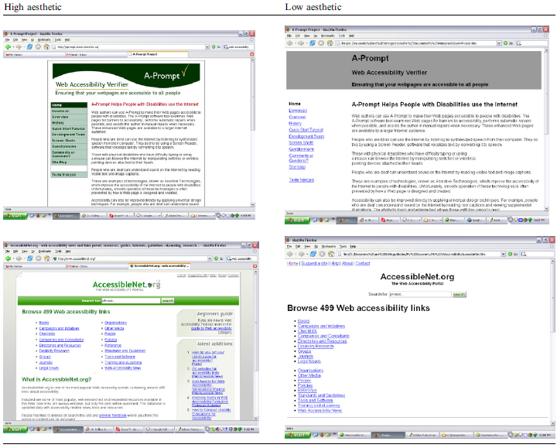

Appendix II: Aesthetics in relation to product categories (Tractinsky and Lowengart, 2007)
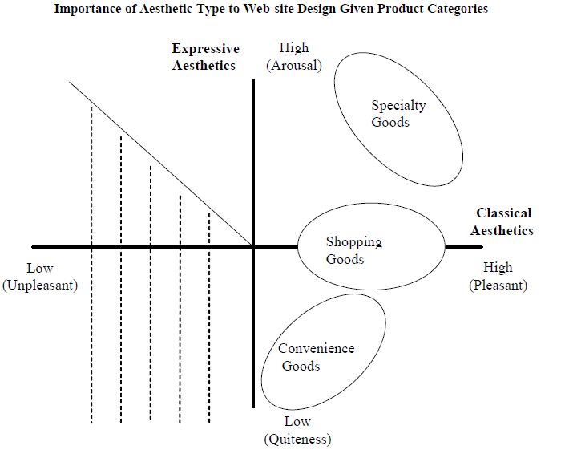

Appendix III Web Aesthetics and cognitive, affective and outcomes (Wang et al., 2010)
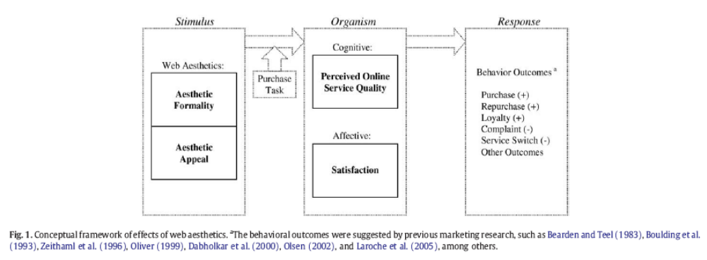

Appendix IV: Vertical symmetry by Tuch (2010)

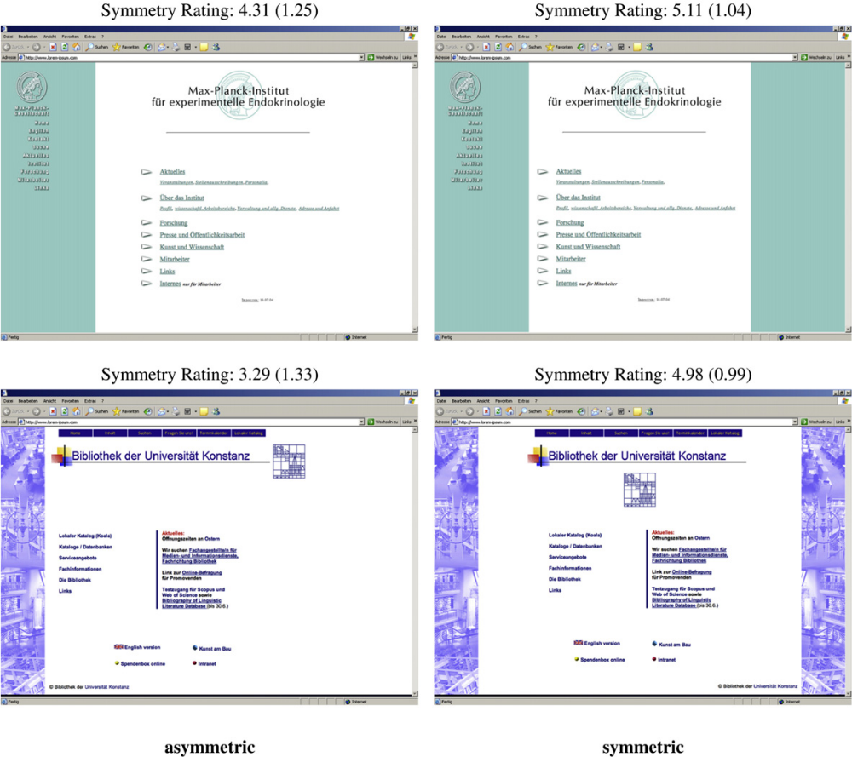

Appendix V Web-store Aesthetics by Tractinsky and Lowengart (2007)

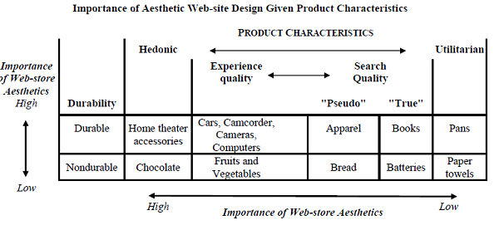

Appendix VI Impact of Buying Environment Characteristics of Retail Websites by Kim, Kim and Kandampully (2007)

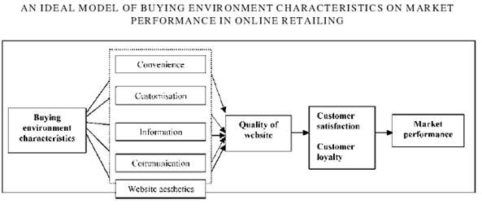

Appendix VII Pre-purchase online information seeking: search versus browse by Detlor, Sproule and Gupta (2003)

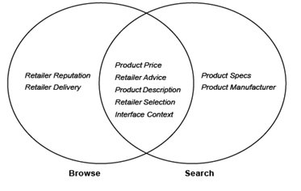

Appendix VIII Test Survey

Please watch both print screens closely here below and answer the 20 statements please


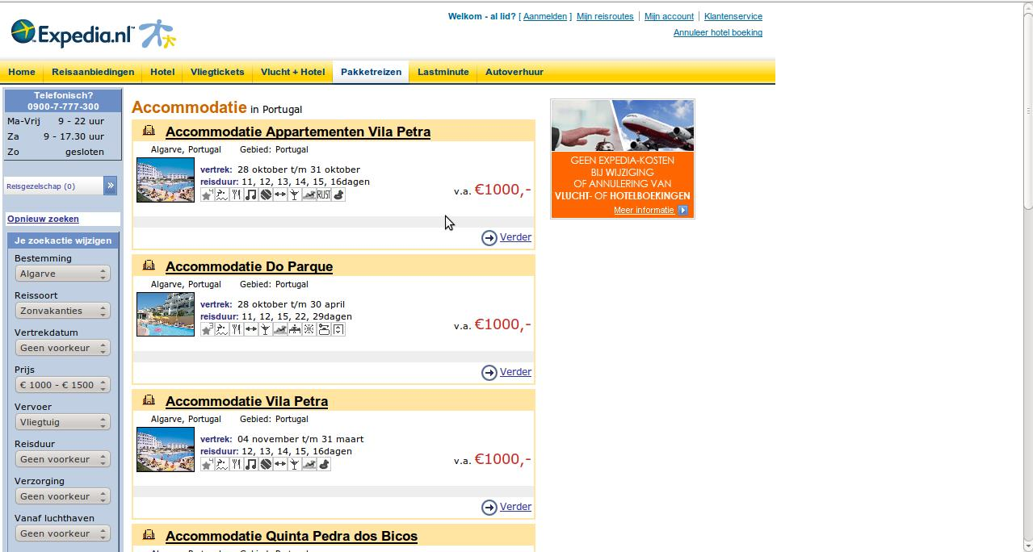
After viewing both print screens, please rate the next elements

I Organization
1 2 3 4 5 6 7
Low High

II Clarity
1 2 3 4 5 6 7
Low High

III Symmetry (=The left side with regard to the right side)
1 2 3 4 5 6 7
Low High

IV Usability
1 2 3 4 5 6 7
Low High

V Dynamics
1 2 3 4 5 6 7
Low High

VI Originality
1 2 3 4 5 6 7
Low High

VII Colorfulness
1 2 3 4 5 6 7
Low High

VIII Creativity
1 2 3 4 5 6 7
Low High

IX Unity/Harmony
1 2 3 4 5 6 7
Low High

X Simplicity
1 2 3 4 5 6 7
Low High

What is your overall rating regarding the website? (please rate between1-10)
…....

Have you visited this website in the past?
Yes
No

After these questions, my request is to answer the same questions for another two print screens of a particular website. The next two are illustrated on the next page
Two other print screens, watch them closely (questions are at next page)



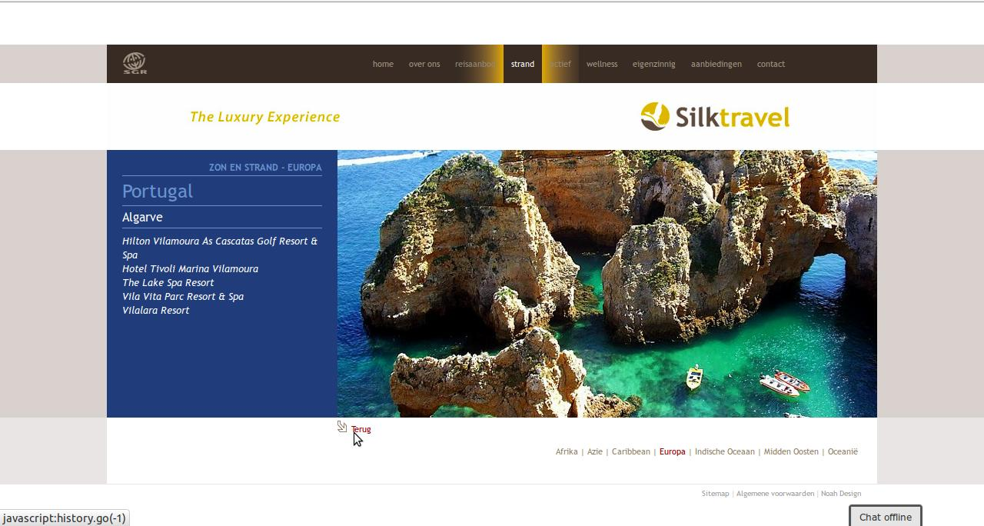
After viewing both print screens, please rate the next elements
I Organization
1 2 3 4 5 6 7
Low High

II Clarity
1 2 3 4 5 6 7
Low High

III Symmetry (=The left side with regard to the right side)
1 2 3 4 5 6 7
Low High

IV Usability
1 2 3 4 5 6 7
Low High

V Dynamics
1 2 3 4 5 6 7
Low High

VI Originality
1 2 3 4 5 6 7
Low High

VII Colorfulness
1 2 3 4 5 6 7
Low High

VIII Creativity
1 2 3 4 5 6 7
Low High

IX Unity/Harmony
1 2 3 4 5 6 7
Low High

X Simplicity
1 2 3 4 5 6 7
Low High

What is your overall rating regarding the website? (please rate between1-10)
…....

Have you visited this website in the past?
Yes
No

Appendix IX Main survey (example Expedia)

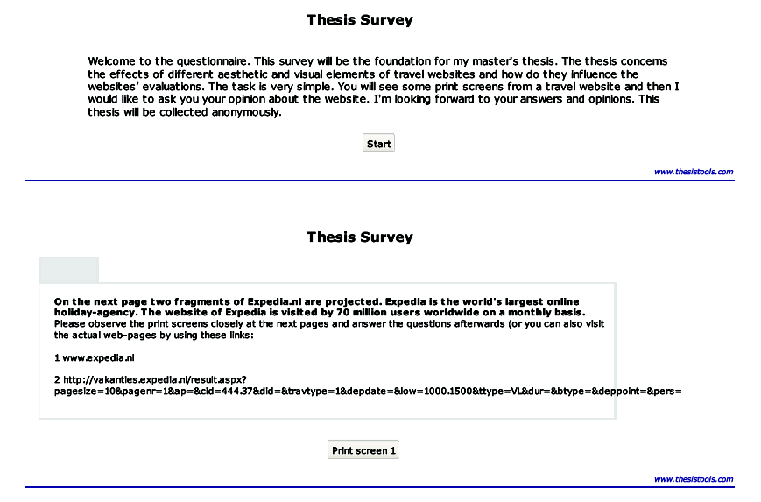
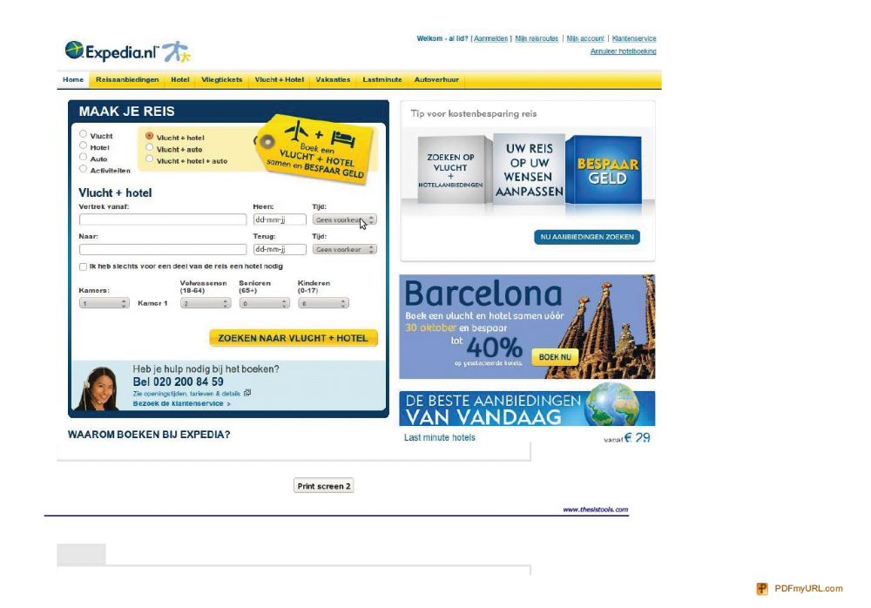

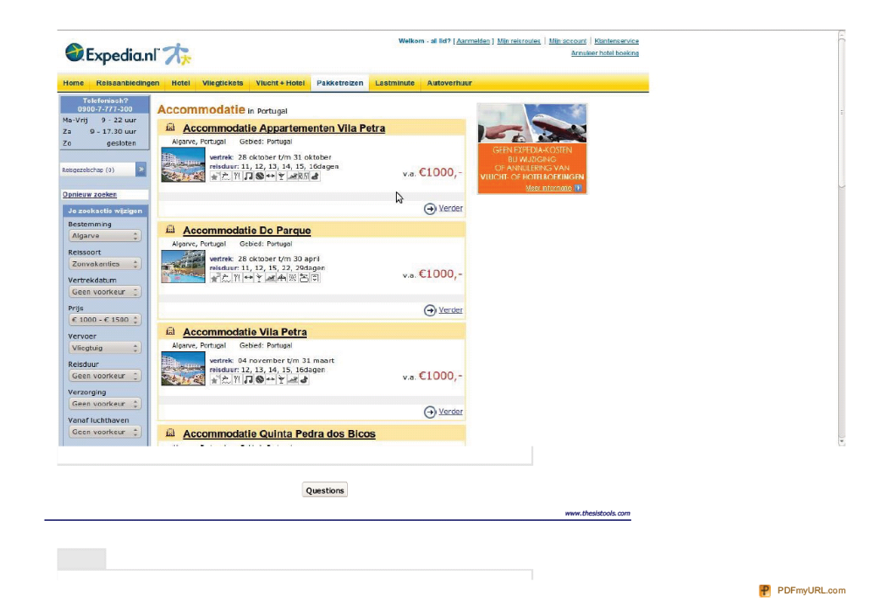
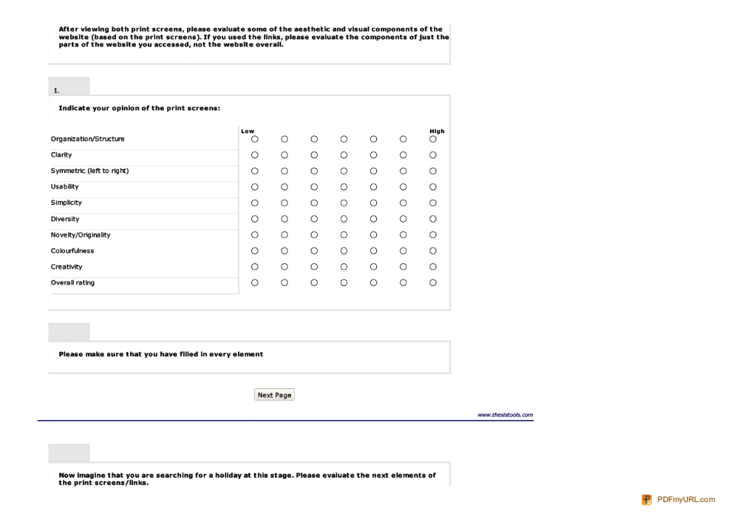

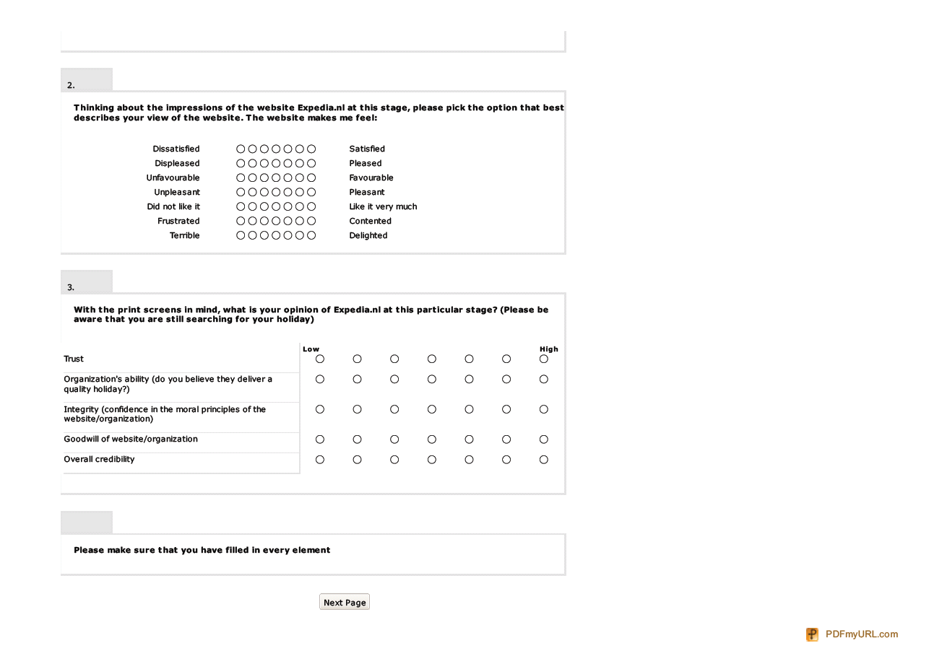

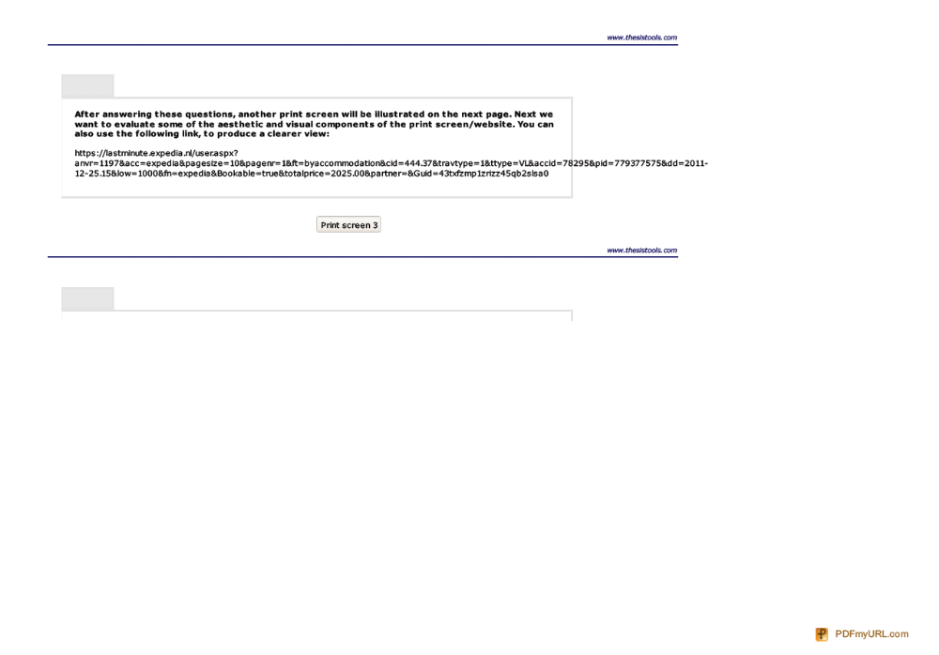

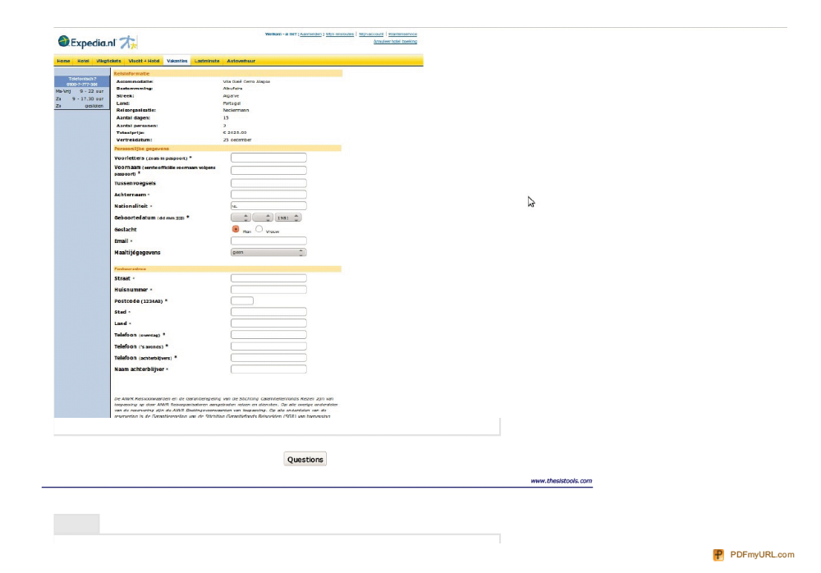
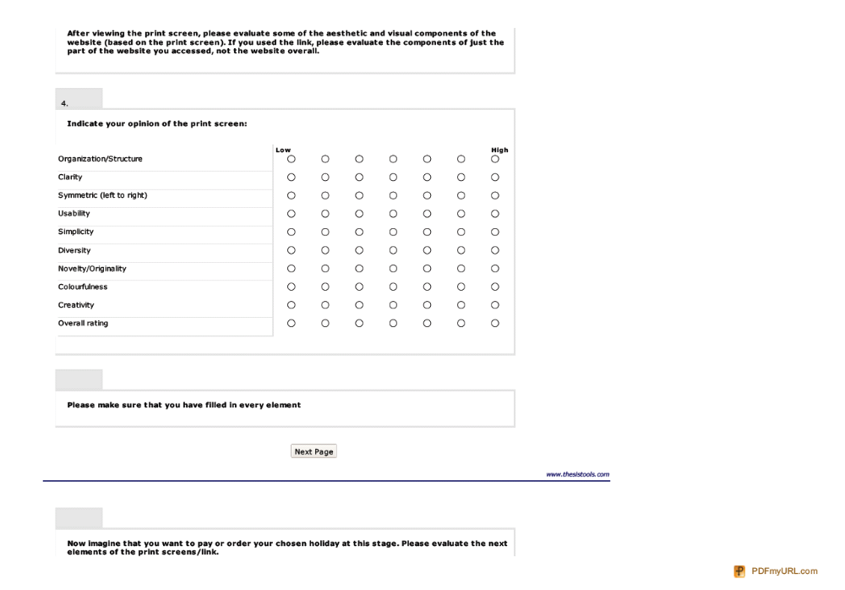

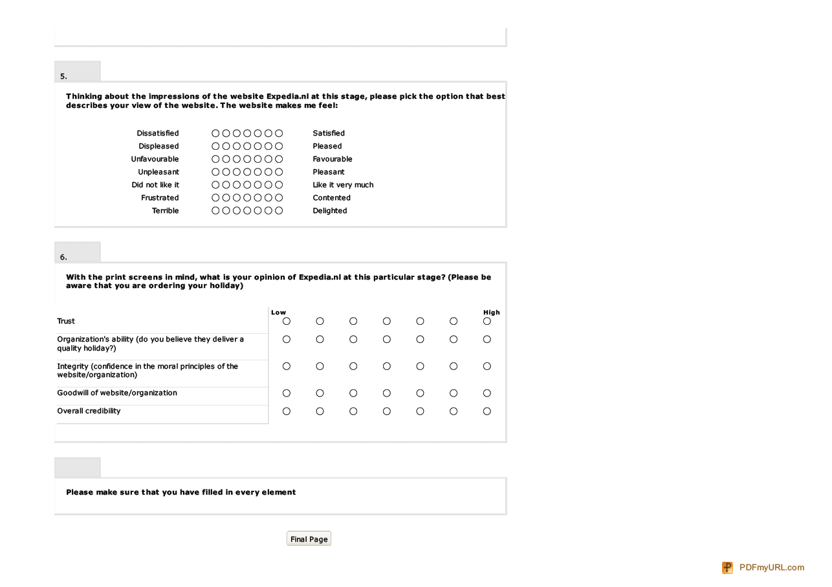

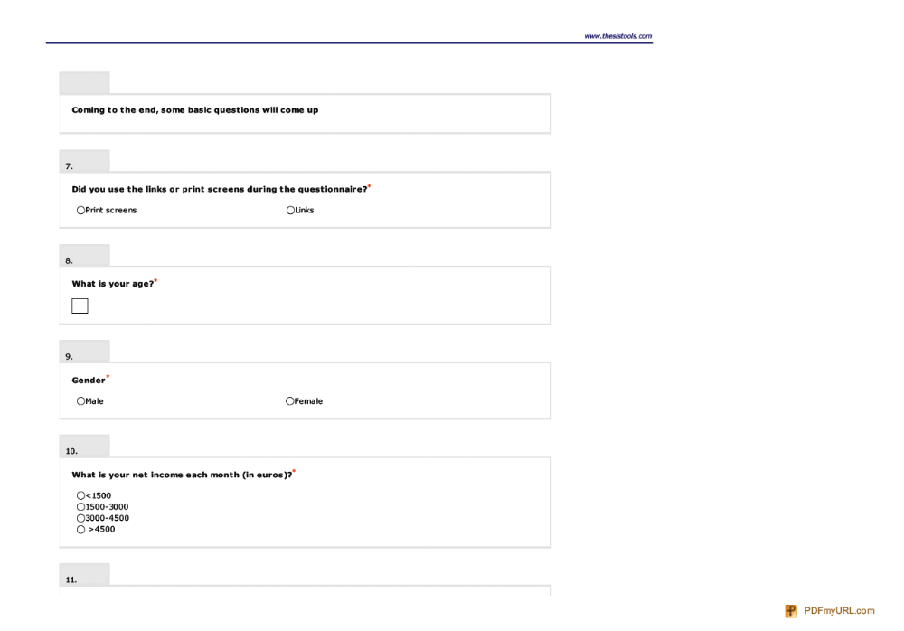



Appendix X Results of test survey
*The upper half of the sheet concerns the website Expedia.nl

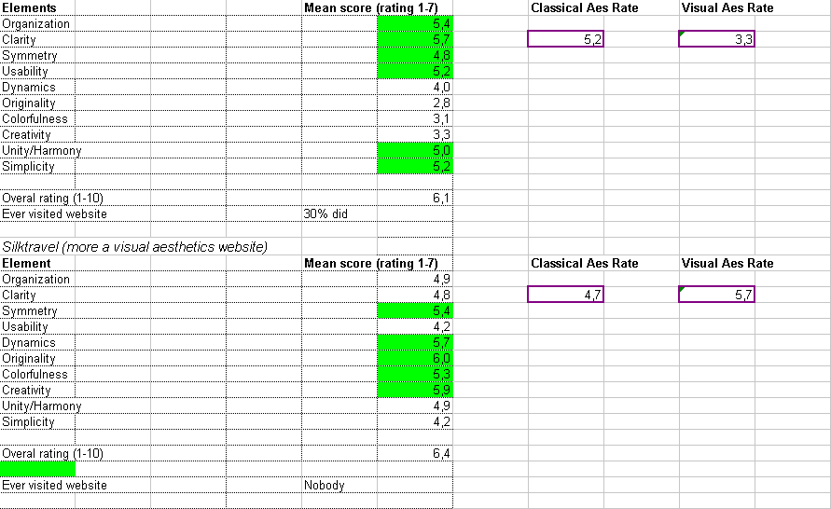

Conversion rates: number of purchases / website visitors
Conceptual framework by Wang et al. (2010), see appendix 1. In this case aesthetic appeal can be regarded as the expressive dimension and aesthetic formality as classical aesthetics.
HAT presents a professional look and feel appropriate to the organization it represents. Sites employing HAT use principles of layout to enhance communication and strategically and professionally use color and graphics to build brand and concept.
Appendix 1: examples of low and high aesthetic websites
Appendix 3: Vertical symmetry
Appendix 3: Web-store Aesthetics (2007)
Appendix 2: Aesthetics in relation to product categories
Fast, uncluttered, and easy-to-navigate websites
Saving time and making browsing easy
Retention: intention of purchasing online from a particular website again Referral: Referring a friend or family member to a particular website
Alexa is the leading provider of free, global web metrics.
An estimate of expedia.nl's popularity in a specific country (alexa.com)

