Trade and Wage Premium: A theoretical and empirical analysis
The Case of Eastern Europe and Central Asia

Erasmus University Rotterdam- Erasmus School of Economics
Master Thesis
Msc International Economics
Merker, JHA
Student Number: 360728
Supervisor: Dr Zubanov, N.V.

Abstract
This research paper investigates the existence of an export wage premium in Eastern Europe and Central Asian Countries. Based on the theoretical model of Helpman, Itskhoki and Redding (2012), an exporter offers higher wages than a non-exporter at a given productivity level. Due to unobservable worker abilities, firms use screening tools in order to find out about the abilities of the screened workers. Exporters are using more stringent screening procedures; therefore they hire workers with higher average ability and eventually pay higher wages. Firm level data from Eastern European and Central Asian countries from the World Bank Enterprise Survey are used to investigate this outcome empirically. The findings for an export wage premium are positive and statistically significant. Moreover, firms entering the export market experience higher wage growth. However, the statistical evidence is rather weak and only significant at a 10% level.

Acknowledgement
The Master Thesis would not have been possible without the help of several individuals who contributed to the completion of this work. First at all, I would like to express my gratitude to my supervisor Dr Nick Zubanov who was abundantly helpful. I really appreciate his enthusiastic and direct way of being and how he constantly challenged my work. Without his guidance and input, this thesis would not have been possible. Moreover, I would like to thank my fellow students from the Master in International Economics. It was a very pleasant and intellectually stimulating year. I wish them all the best and success in everything they do. Lastly, I dedicate my love and affection to my parents, who have been constantly supporting and encouraging me throughout my studies.

Table of contents:
- Introduction p.4
- Theoretical Model p.10
- Methodology and Empirics p.21
- Results p.31
- Conclusion p.43
- References p.46
- Appendix p.49

1) Introduction
It is a well-established empirical fact that firms who are involved in trading differ in many aspects from their counterparts who are producing solely for the domestic market. Bernard & Jensen (1995) launched the debate by analyzing the American manufacturing market and revealed the discrepancies existing between exporters and non-exporters in terms of size, employment composition, wage and productivity. Exporters are generally believed to be “good” for the economy. They are more competitive than non-exporters and provide the economy with better employment opportunities. Free trade is generally considered to have a positive impact on the economy. Proponents of free trade stress the welfare gains due to cheaper imports and new business opportunities for exporters to expand. However, opponents of free trade fear the effects it might have on society and environment and blame rising globalization for the loss of jobs in import competing industries. This ongoing debate has led various governments to implement preventive measures in order to protect import sensitive industries.
In Europe, which named itself as the most open Economy in the World (European commission Trade, 2010), the European Commission expects that if they put through all current free trade negotiations, this would add more than 0.5% to the GDP of the 27 member states of the European Union (EU). Moreover, the commission highlights that consumer benefits due to cheaper imports are estimated at 600 Euros per year and that around 36 Million jobs are directly and indirectly related to Europe’s trade performance. They further point out that trade plays a very important role in job creation and trade opening actually creates more jobs than it destroys. Additionally, trade generates as well an estimated wage premium of 7%. This leads us to the main topic of this paper. Setting back the previous discussion about the merits and controversies about free trade, this paper focuses more on the performance of exporters in terms of wages and employment. Within industries, companies differ in various aspects and several factors have to be taken into consideration by a firm when taking up the decision to export or not. The fact of being an exporter may change a firm’s perception of how to run a business, which in turn affects the allocation of resources. The heterogeneity between firms within a sector is rooted in the differences of technology, endowments, the production process and the product per se. This induced for instance Melitz (2003) to develop a theoretical framework, which explains the discrepancies in performance and productivity between exporters and non-exporters.
When relating the labor market outcome with the export status of a firm, one should consider the features of the product and the labor market. In international trade the allocation of resources and the distribution of income of production factors do not happen in a frictionless manner. At the first sight the link between exporting and wage structure might not be immediately clear. In order to grasp the relation, it is important to take into account for labor market frictions, screening costs or heterogeneous labor skills. This has been done in a thoroughly way in the theoretical work of Helpman, Itskhoki & Redding (HIR, 2010). In their empirical paper (HIR, 2012), their theoretical framework is slightly extended. The theoretical part will be built on these two papers, and help explain the mechanism behind the wage dispersion between exporters and non-exporters.
The theoretical framework of HIR takes into account the frictions that may arise when matching firms and employees. A worker’s ability is not directly observable to a firm, hence employers are willing to invest valuable resources in order to improve their workforce composition. The concept of screening is crucial in this setting, as it allows getting more valuable information about the worker’s capacities. According to HIR, more productive companies screen more rigorously than less productive firms. It allows firms to improve their match quality when hiring. A worker will be hired when his revealed abilities are above the firm specific ability threshold. The firm will not hire workers with abilities below the threshold line. As high productivity firms have a higher ability threshold, they will pay higher wages to their workers. This kind of productivity related firm heterogeneity is the driving force for wage discrepancies between firms. Trade intensifies this effect. The additional earnings from the export market incentivizes exporters to screen more for a given productivity level. Hence, exporters have higher ability workers and pay higher wages. This mechanism allows for the existence of an export wage premium.
The empirical research about the export wage premium is vast and the magnitude differs depending on the industry and location. This research uses a large panel dataset from the World Bank Enterprise survey (2012) with firm level information from 26 Eastern European and Central Asian countries. Three regressions have been set up in order to investigate the relation between trade and wages. Based on the theoretical outcome, this paper established 2 hypotheses, which have been confirmed by the empirical results. Indeed, exporters do pay higher wages to their workforce for a given productivity level. Moreover, the dynamics of entering and exiting the export are investigated leading to the result that a firm entering the export market experience higher wage growth. The dependent variable is the log of average labor costs per worker, which includes beside wages as well benefits and bonuses paid out to the workers. The main independent variables are the export status (dummy or export share) and the proxy for productivity (log of domestic sales per worker). Fixed effects and other firm related control variables are added in order to control for firm characteristics that might influence the average labor costs per worker.
The paper is structured as follows. Firstly, an overview of the theoretical and empirical literature about trade and wages is presented. Afterwards in section 2 the theoretical model of HIR is introduced and its outcome is used to set up the hypotheses. Section 3 presents the methodology with further explanations about the dataset, the descriptive statistics and the empirical framework. Section 4 presents the results and section 5 will conclude the paper.

Theoretical Literature Review
The debate about the role of trade and globalization and their impact on wage distribution has been splitting opinions for decades. In the past, new international economics theories emerged in the debate of how trade may affect wage dispersion and hence affect wage inequality within industries and countries. The Hekscher-Ohlin (HO) model, probably the most illustrious and leading model in the previous decades in International economics, gave a possible explanation for the relationship between trade and wage dispersion. The HO model, in its most basic form, simulates a trade pattern with 2 factors, 2 goods and 2 countries. It predicts that the country exports the good that uses intensively the production factor, which is most abundantly available in relative terms. Moreover, one of the basic conditions is that production factors can move freely between sectors but not between countries. While exporting the good that uses the relatively abundant factor intensively, the real return to the relatively abundant factor increases in each country and the real return to the other factor decreases. This phenomenon is commonly described as the Stolper-Samuelson theorem. For instance, in a country where high skilled labor force is relatively more abundant than in the trading partner country, the real return (wages) to high skilled workers is higher in relative terms than for unskilled workers. The demand for the services of unskilled workers is lower as the country, which is highly abundant in relative terms in skilled workers, exports only skill-intensive goods. Thus, export-sector workers in this case will have higher wages leading to higher wage inequality within the country. For countries that are relatively abundant in low skilled workers the opposite applies. Hence, the real return to low skilled workers actually increases as they export goods, which are low skilled labor intensive. Thus, according to the HO model wage inequality is supposed to decline under such circumstances. However, reality does not entirely behave according to theory. Developing countries, generally well endowed with low skilled labor force, experienced a rise in wage inequality during periods of trade reforms (Harrison et al., 2010).
This led major economists to doubt whether the HO model has sufficient explanatory power to describe the link between trade and wage dispersion. For instance, product differentiation is not taken into account (this would invalidate the Stolper-Samuelson theorem). Labor market frictions are persistent and might hamper the re-allocation of factors between industries. Moreover, real returns to factors differ only between sectors and do not take into account the heterogeneities between firms within an industry. Melitz (2003) achieved a major breakthrough in the field of international economics. Although his research is about the relation between free trade and productivity and there is no direct link to the distribution of wages and income between firms, Melitz’s research is of utmost importance as it provides the basics for HIR.
Melitz (2003) was the first to introduce heterogeneous firms and monopolistic competition into the current trade theory. The production function of a firm in the model depends on its productivity ($θ)$, which is different for all participating firms and a random variable. Additionally, before entering the market a firm has to pay fixed entry costs, which is the same for all participants. Only after paying these fixed costs, the firm will be able to learn about his productivity draw. Some firms may have to leave the market immediately as their productivity draw is not sufficiently large to cover the entry costs. Melitz designates the threshold of entering or leaving the market as a cutoff point. He creates a similar cutoff point for the export market, which is larger than the cutoff point for the domestic market. Thus, firms who are exporters are the most productive firms in the economy and generate additional profits through the export channel. Through the channel of exit and entry of firms, Melitz manages to prove that free trade increases productivity in the market. Although Melitz does not clearly state the implications for wage distribution in his model, he briefly mentions in his paper a mechanism for why the least productive firms are forced to exit. He states that all the effects of trade on the distribution of firms in his model are channeled through the competition for the common source of labor on the domestic market. The increased labor demand by the most productive firms active in the export market bids up wages and induces weaker firms to exit the market.
Yeaple (2005) conducted similar research as Melitz (2003). However, his model starts with homogenous firms who later on, depending on their choices, acquire heterogeneous traits. Firms at the beginning face four different choices. First, they have to choose whether to enter the market or not, second they have to choose what kind of technology they will use for their production process, thirdly they have to decide upon whether to export or not and lastly what kind of worker they will employ. The interaction of these four choices gives the firm a certain heterogeneous trait and which are consistent with some empirical facts. Exporters in his model are on average larger, pay higher wages and are more productive than firms who do not export. Moreover the model predicts that when trade frictions decrease (lower fixed export costs) it will induce firms to switch technologies, hence increasing their trade volume and increase in the wage premium for skilled workers.
The research of Egger and Kreickemeier (2009) is as well based to a certain extent on the Melitz Model. They introduced the concept of fair wages as a labor market friction. This means that workers only provide the optimal work effort if they perceive their wages as fair. Hence, employers may be reluctant to reduce the workers’ wage as they might reduce their level of effort. The authors include the assumption that workers at high productive firms feel that they should be paid higher wages. This leads to wage dispersion between firms, especially when firms enter the export market.

Empirical Literature Review
The empirical literature about this topic is vast. As previously mentioned, the paper of Bernard & Jensen (1995) was one of the first to investigate the discrepancies in performance between exporters and non-exporters. Although only a small number of firms export, they had a disproportionate weight in employment and output. Moreover, the authors found out that non-production and production workers received 14.5% higher wages when working for exporters. The difference in benefits was even larger.
The paper of Bernard & Jensen (1995) induced several researchers to apply the same research to other countries. Alvarez and Lopez (2005) investigated the wage premium for Chilean manufacturing plants. The average plant wage was 21% higher for exporters than for non-exporters. The authors were controlling for plant size, 3-digit sector, year and foreign ownership. Hansson and Lundin (2005) did similar research for Sweden by investigating a panel data of 3275 manufacturing firms. By using the average annual labor costs per employee and earnings per (un-) skilled labor, the authors get a significant and positive wage premium for exporters. Other research analyzing the relation between trade and wage has been done for Germany, Korea, Taiwan, United Kingdom or Spain. I will not further comment on the research done in these countries, as the outcome is generally the same for the key and the control variables.
Krishna, Poole and Senses (2011) use a detailed matched employer-employee dataset in order to exploit the effect of trade on labor markets. More detailed information about worker specific characteristics allows to investigate more precisely the driving forces behind the wage premium paid by exporters. Previous empirical research relied mainly on firm characteristics, which only captured workers characteristics to a certain extent. They find that work force composition plays an important role as it systematically improves the performance of exporting firms relative to non-exporting firms.
Schank, Schnabel & Wagner (2007) investigate the wage premium for exporters with an extensive linked employer-employee dataset from Germany. Their results reveal a significant wage premium for white-collar and blue-collar workers e.g. a 60% export/sales ratio means that they are earning 1.8 (0.9) % more compared if they would work for a plant which does not export. They further claim that their results are more consistent as they controlled for observed and unobserved individual characteristics.
Verhoogen (2008) looked into the Mexican manufacturing sector and analyzed how currency devaluation would impact the performance of firms. This kind of trade liberalization has induced firms to invest more in product quality, expand exports, and increase wages of blue-collar and white-collar worker. As counterfactual the author used a period where the peso exchange rate was rather stable (1989-1993) and compared it with the following period where the peso devaluated abruptly. As the peso devaluation fostered the performance of exporters during that period, wages increased significantly more than in the previous period. Exporters improved their performance relatively to non-exporters and the dispersion of wages within the manufacturing sector became more substantial.

2) Theoretical Model
The model estimates the effect of international trade on the distributions of employment and wages. In Melitz (2003), firm heterogeneity was one-dimensional, meaning that firms distinguish from each other only by their different level of productivity. HIR (2012) introduce firm heterogeneity on a tree-dimensional level. In addition to the firm-specific productivity draw, companies have heterogeneous export and screening costs. Without these additional idiosyncratic characteristics, the productivity draw would perfectly predict the export status and wage bill.
More productive firms pay on average higher wages and exporting increases wage given the same productivity. This is due to the tougher screening measures of exporting firms. They do so by raising the screening threshold, thus gaining better insights into the worker’s characteristics and discard those workers with abilities below the threshold line. By complementing their firm specific productivity with better matching workforce, the firm will be able to improve their performance. Since exporters implemented tougher screening methods, workers of higher average ability have a better bargaining position, hence leading to higher wages in exporting firms. As exporting firms are touching higher revenues from the export market, they are able to face those higher wage demands. Pelizarri (2005) found empirical evidence in his working paper that firms with higher screening efforts pay on average higher wages. It leads to matches of better quality and the employers are more satisfied with the work performance of the hired workers.

Framework:
As previously mentioned, the model is based on the theoretical work of HIR (2012), which is basically the same as the theoretical framework of HIR (2010), with the only difference that they included heterogeneous screening and export costs. The model considers a world of two countries (home and foreign) and focuses on between-firm wage dispersion within a sector. Additionally, dispersions in revenues and employment are as well derived from the sectoral equilibrium. Important to note is that the derived values hold irrespective of a worker’s expected wage in other sectors. Their decision to mainly focus on the between firm dispersion is based on their less stringent empirical pre-analysis and is backed by research done by Lazear and Shaw (2009). Moreover, their model that is partly based on Melitz (2003), assumes monopolistic competition. Previous research from Hopenhayn (1992) assumed perfect competition. Monopolistic competition captures market imperfections, meaning that firms are offering differentiated products that are not perfectly substitutable.
Demand within the sector emanates from a continuum of horizontally differentiated products and is based on constant elasticity of substitution (CES) preferences. Firms have limited market power and are price takers in this setting. $β$ indicates the elasticity of substitution. When $β$ approaches 1, the varieties become perfect substitutes. Whenever $β$ approaches 0, the varieties are perfectly differentiated and demand is dictated by the concept of love for variety.
$$Q={\left[\int{q{(j)}^{β}dj}\right]}^{1/β}, 0<β<1$$
The variety is indexed by j and belongs to a set of varieties. The function q(j) denotes the output of the variety j.
The revenues of the heterogeneous firms depend on the output produced $Y_{m}$ in the respective market and a demand shifter $A_{m}$. The demand shifter $A_{m}$ depends on the sectorial expenditure and the sectorial market price. The demand shifter is given. Output can be sold on the domestic and the export market.
$R_{m}=A_{m}Y_{m}^{β} m∈(d,x)$ ,

where d denotes the domestic market and x the export market.
In order to serve the export market, a firm has to incur a fixed entry cost which is firm specific. The specificity of such costs reflects the heterogeneous nature of firms concerning their export status. High productive firms may decide not to export due to higher export costs, while a small firm may decide to export.
$e^{ε}F_{x}$,
where $F_{x}$is common to all firms and $ε$ varies across firms.
A firm can allocate his output between the domestic and the foreign market in order to maximize its profits. If the firm solely serves the domestic market, the domestic revenues $(R=R_{d})$ are based on the domestic demand shifter and domestic output. If a firm can afford the specific entry costs for the export market, the additional revenues retrieved from the export market, which are based on the demand shifter specific for the export market, complement the domestic revenues$(R=R_{d}+R_{x})$. Thus, the revenue function can be expressed as a function of its output, the domestic demand shifter and the market access variable $(Υ_{x})$.
$R={\left[1+ι(Υ_{x}-1)\right]}^{1-β}A_{d}Y^{β}$ (1),
where $ι$ takes the value equal to one if the firm exports and zero otherwise. The market access variable $(Υ_{x})$ depicts the additional revenues perceived by an exporter,
$Υ_{x}=1+τ^{\frac{-β}{1-β}}{(\frac{A_{x}}{A_{d}})}^{\frac{1}{1-β}}$,
where $τ$ represents variable trade costs ($τ>1)$ and $A_{x}$ the foreign demand shifter. The revenue for a non-exporter is $R_{m}=A_{d}Y^{β}$ and an exporter $R_{m}={{Υ_{x}}^{1-β}A}_{d}Y^{β}$. The export market access variable is decreasing with rising transport costs and increasing with the foreign demand shifter relative to the domestic demand shifter. As a reminder, the demand shifter depends on the sectorial expenditure and the sectorial market price. Thus, a higher foreign demand shifter makes the export market more compelling and enables to touch higher revenues.
So far, the model explained the role of the demand shifter and the market access variable in the revenue function. Another important variable affecting a firm’s revenue is its output. The model assumes that output depends on firm productivity ($θ$), measure of workers hired (H), and the average ability of the workforce ($\overline{a}$).

The output function:
$Y=e^{θ}H^{γ}\overline{a}, 0<γ<1$ (2)
The productivity variable $θ$is individually observed and retrieved from a Pareto distribution represented as $G_{θ}\left(θ\right)=1-{(\frac{θ_{min}}{θ})}^{z}$ for $θ≥θ_{min}>0$ and $z>1$. This distribution indicates that the fraction of firms observing a relatively high level of productivity is rather small, whereas the probability of observing firms with low productivity level is rather high. Z is a shape parameter; the bigger Z, the lower the fraction of firms observing a high level of productivity. This is a quite reasonable observation in the distribution of firms within a sector. In order to keep it simple, firms are now indexed by $θ$.
Just like in the case of productivity distribution, worker ability is assumed to be independently distributed and emanates from a Pareto distribution $G_{a}\left(a\right)=1-{(\frac{a_{min}}{a})}^{k}$ for $a≥a_{min}>0$ and $k>1$. The labor market, where workers and firms are matched, reveals search and matching frictions. These imperfections are based on the theories of Diamond-Mortensen-Pissarides (DMP). A Firm has to bear search costs bN (b is endogenously determined by the tightness of the labor market) in order to be randomly matched with N workers. b is assumed to increase with labor market tightness (x), where tightness is indicated by the ratio of workers sampled (N) to workers searching for employment in this sector (L): $x=N/L$. A high ratio means that firms have troubles to fill up their vacancies, hence leading to higher search costs. Before being matched, a worker draws his ability level from a Pareto distribution. As the workers are all ex ante identical, a firm can invest a certain amount into screening in order to receive a signal from their abilities. By choosing an ability threshold ($a_{c})$, firms can identify all the workers below this threshold. However, firms cannot identify the exact ability of workers above the threshold. They only know that those workers meet the minimum ability level requirements. Hence, firms with a higher ability threshold have on average higher ability workers. Screening costs are defined as follows,
$\frac{Ce^{-η}{(a_{c})}^{δ}}{δ} , C>0 and δ>0$,
where $η$ vary across firms and $δ$ respectively $C$ are common to all firms. Screening costs increase with the ability threshold, as lengthier and more complex screening tests are needed. Without the idiosyncratic nature of screening costs, the wage bill and employment level would be the same across firms with the same productivity level. The variation in screening costs is an important factor in explaining the variation in wages.
An important characteristic is complementarities in work abilities and firm productivity. This provides a firm with the incentive to screen thoroughly the sampled workforce, as workers exhibiting ability below the threshold are not compatible with the firm’s productivity. Hence, more productive firms invest more into screening, have a labor force of higher ability, employ more workers and pay higher wages, as demonstrated below. In comparison to less productive firms, high profile firms experience higher returns to screening due to the complementarity feature. Hence, the threshold level determines the expected average ability of its workforce,
$\overline{a}(a_{c})=E\left\{a⊺a≥a_{c}\right\}=\frac{k}{k-1}a_{c}$ (3),
where k is the shape parameter of the Pareto distribution (a sufficiently low k gives a higher worker dispersion).
Each firm in a given sector has drawn the components of productivity, screening costs, and fixed export costs $(θ, η, ε)$, which are distinctive to each firm. Depending on these three factors, a firm decides whether to export or solely serve the domestic market.
H in the output function represents the measure of workers hired. Just like in the classical production functions, it is assumed that H shows decreasing returns to scale. The firm is matched with several workers and the measure of hiring depends on the ability threshold $a_{c}$ and the number of workers to match $N$.
$H(N,a_{c})=N\left(1-G\left(a_{c}\right)\right)=N{({a_{min}}/{a_{c}})}^{k}$ , (4)
where $a_{min}$ indicates the minimum ability level of a worker
The equations (1)-(4) define now the revenue function. In this function the demand shifter, variable trade costs and the productivity level are given, while the revenue function varies positively with the number of matched workers $(N)$, the screening threshold $(a_{c})$ and the descision whether to export or not $(ι)$.
$R\left(N,a_{c},ι;θ\right)={\left[1+ι(Υ_{x}-1)\right]}^{1-β}A_{d}{Y\left(N,a_{c};θ\right)}^{β}$ (5),
$$Y\left(N,a_{c};θ\right)=\frac{ka_{min}^{γk}}{1-k}e^{θ}N^{γ}{(a_{c})}^{1-γk}$$
After the firms paid all the costs in exporting, matching and screening, the firm gets involved in a multilateral bargaining with its H number of workers. The wage rate is a fixed proportion of a firm’s revenues where each worker receives the fraction $\frac{βγ}{1+βγ}$ of the average revenues per worker, while the firm receives the residual of the revenues $\frac{1}{1+βγ}$. The solution to this bargaining game, which equalizes the marginal surplus of the firm and the surplus of the worker from employment, is as follows,
$W\left(N,a_{c},ι;θ\right)=\frac{βγ}{1+βγ}\frac{R}{H}$ (6)

The optimization problem:
Anticipating the previous bargaining outcome a firm maximizes its profits by choosing the number of workers to match, the screening level and whether to export or not. $\frac{1}{1+βγ}R\left(N,a_{c},ι\right)$ represents the fraction of revenues left over after the bargaining. The revenues are maximized by taking into account the costs related to matching, screening and, if relevant, exporting. The firm’s problem can be written as:
$Π=\max_{N,a_{c},ι}{\{\frac{1}{1+βγ}R\left(N,a_{c},ι\right)-bN-\frac{Ce^{-η}}{δ}}{(a_{c})}^{δ}-ιF_{x}e^{ε}\}$ (7)
Where $\frac{Ce^{-η}{(a_{c})}^{δ}}{δ}$ indicates the screening costs which are heterogeneous across firms and $ιF_{x}e^{ε}$gives the export costs which are as well heterogeneous across firms.
Results when maximizing firm’s profits by taking the first order conditions and using the expressions in (4), (5) and (6) we get:
$R=κ_{r}{\left[1+ι(Υ_{x}-1)\right]}^{\frac{1-β}{Γ}}{{(e}^{θ})}^{\frac{β}{Γ}}{{(e}^{η})}^{\frac{β(1-γk)}{Γ}}$, (8)

$H=κ_{h}{\left[1+ι(Υ_{x}-1)\right]}^{\frac{(1-β)(1-k/{δ)}}{Γ}}{{(e}^{θ})}^{\frac{β(1-k/{δ)}}{Γ}}{{(e}^{η})}^{\frac{β(1-γk)(1-k/{δ)}}{δΓ}-\frac{k}{δ}}$, (9)

$W=κ_{w}{\left[1+ι(Υ_{x}-1)\right]}^{\frac{k(1-β)}{δΓ}}{{(e}^{θ})}^{\frac{βk}{δΓ}}{{(e}^{η})}^{(1+\frac{β(1-γk)}{δΓ})\frac{k}{δ}}$, (10)

$κ_{s}, s ϵ(r,h,w)$ represents the parameters and variables which are common to all the firms in the same sector.

Computations for equilibrium revenue, employment and revenue level:
The focus of the following analysis will remain on the computation of the equilibrium in (8), (9) and (10). As previously explained one can conclude from the equation (10) that firms with a higher productivity and screening productivity draw are paying on average higher wages. Moreover, exporters pay a higher wage controlling for productivity. The same conclusion can be drawn for revenues and employment. Given the productivity and screening draw an exporter generates more revenues and hires more workers. The derivations for the aforementioned expressions are the following:
Referring back to the profit maximization function, the firm’s first order conditions for the measure of workers sampled (N) and the ability threshold $a_{c}$ are:
$\frac{βγ}{1+βγ}R\left(θ\right)=bN\left(θ\right)$, (11)
$\frac{β\left(1-γk\right)}{1+βγ}R\left(θ\right)=Ce^{-η}{a_{c}(θ)}^{δ}$, (12)
Combining (11) and (12) will give the following relationship between the number of workers sampled and the ability threshold
$bN\left(θ\right)\left(1-γk\right)=γCe^{-η}{a_{c}(θ)}^{δ}$, (13)
N and $a_{c}$ can be solved by plugging (13) in the revenue function (5) and (5) into (11) and (12) respectively.
$N\left(θ\right)=ϕ_{1}ϕ_{2}^{\left(1-γk\right)β}A_{d}^{\frac{1}{Γ}}C^{-\frac{\left(1-γk\right)β}{δΓ}}b^{-\frac{\left(βγ+Γ\right)}{Γ}}{\left[1+ι\left(Υ_{x}-1\right)\right]}^{\frac{1-β}{Γ}}{(e^{θ})}^{\frac{β}{Γ}}{{(e}^{η})}^{\frac{(1-γk)β}{δΓ}}$, (14)
$a_{c}\left(θ\right)=ϕ_{1}^{\frac{1}{δ}}ϕ_{2}^{\left(1-γβ\right)}A_{d}^{\frac{1}{Γδ}}C^{-\frac{\left(1-γβ\right)}{δΓ}}b^{-\frac{\left(βγ\right)}{Γ}}{\left[1+ι\left(Υ_{x}-1\right)\right]}^{\frac{1-β}{δΓ}}{(e^{θ})}^{\frac{β}{δΓ}}{{(e}^{η})}^{\frac{(1-γβ)}{δΓ}}$, (15)
where $Γ=1-βγ-β(1-γk)/δ$; $ϕ_{1}={\left[\frac{βγ}{1+βγ}{(\frac{ka_{min}^{γk}}{k-1})}^{β}\right]}^{\frac{1}{Γ}}$; $ϕ_{2}={(\frac{1-γk}{γ})}^{\frac{1}{δΓ}}$
As defined in (11) the equilibrium for the revenues (R) can be solved:
$\frac{βγ}{1+βγ}R\left(θ\right)=bN(θ)=ϕ_{1}ϕ_{2}^{\left(1-γk\right)β}A_{d}^{\frac{1}{Γ}}C^{-\frac{\left(1-γk\right)β}{δΓ}}b^{-\frac{\left(βγ\right)}{Γ}}{\left[1+ι(Υ_{x}-1\right]}^{\frac{1-β}{Γ}}{{(e}^{θ})}^{\frac{β}{Γ}}{{(e}^{η})}^{\frac{(1-γk)β}{δΓ}}$,
$R(θ)=κ_{r}{\left[1+ι(Υ_{x}-1)\right]}^{\frac{1-β}{Γ}}{{(e}^{θ})}^{\frac{β}{Γ}}{{(e}^{η})}^{\frac{β(1-γk)}{Γ}}$,
with $κ_{r}={\frac{1+βγ}{βγ}ϕ}_{1}ϕ_{2}^{\left(1-γk\right)β}A_{d}^{\frac{1}{Γ}}C^{-\frac{\left(1-γk\right)β}{δΓ}}b^{-\frac{\left(βγ\right)}{Γ}}$
As previously mentioned, the number of workers hired (H) is defined as follows:
$$H\left(θ\right)=N\left(θ\right){\left({a_{min}}/{a_{c}\left(θ\right)}\right)}^{k}={a_{min}}^{k}N(θ){a_{c}\left(θ\right)}^{-k}$$
$H\left(θ\right)=$ $κ_{h}{\left[1+ι(Υ_{x}-1)\right]}^{\frac{(1-β)(1-\frac{k}{δ})}{Γ}}{{(e}^{θ})}^{\frac{β(1-\frac{k}{δ})}{Γ}}{{(e}^{η})}^{\frac{β-k}{Γ}}$,
with $κ_{h}=a_{min}^{k}ϕ_{1}^{(1-\frac{k}{δ})}ϕ_{2}^{-(k-β)}A_{d}^{\frac{δ-k}{δΓ}}C^{\frac{k-β}{δΓ}}b^{-\frac{1-\frac{β}{δ}}{Γ}}$
Finally, the wage rate (W) is derived from the bargaining outcome:
$$W\left(θ\right)=\frac{βγ}{1+βγ}\frac{R(θ)}{H(θ)}=b\frac{N(θ)}{H(θ)}=b{\left(\frac{a_{c}(θ)}{a_{min}}\right)}^{k}$$
$$W\left(θ\right)=κ_{w}{\left[1+ι(Υ_{x}-1)\right]}^{\frac{k(1-β)}{δΓ}}{{(e}^{θ})}^{\frac{βk}{δΓ}}{{(e}^{η})}^{\frac{k(1-γβ)}{δΓ}},$$
with $κ_{w}=a_{min}^{-k}ϕ_{1}^{\frac{k}{δ}}ϕ_{2}^{k(1-γβ)}A_{d}^{\frac{k}{δΓ}}C^{-\frac{k(1-βγ)}{δΓ}}b^{\frac{1-βγ-\frac{β}{δ}}{Γ}}$

Given the solutions for R, H and W, a firm has to decide whether to export in addition to the home market. In order to be able to export, the additional revenues from the export market have to cover at least the costs related to exporting. Thus,
$$R^{x}\left(θ\right)-R^{d}(θ)≥F_{x}e^{ε}$$
$κ_{r}{{(Υ}_{x}}^{\frac{1-β}{Γ}}-1){{(e}^{θ})}^{\frac{β}{Γ}}{{(e}^{η})}^{\frac{β(1-γk)}{Γ}}≥F_{x}e^{ε}$, (16)

When this inequality does not hold, the firm only serves the domestic market. Moreover, (16) holds if the exports costs, which are of heterogeneous nature, are sufficiently low. The equation reveals that firms with better screening productivity and higher productivity draw will have a higher probability of making additional profits on the export market. Without the firm specific export costs, the revenue of a firm, which is based on productivity and the average ability of the workforce, would perfectly predict the export status of the firm. The heterogeneous export costs imply that productivity only imperfectly determines the export status of a firm. A less productive firm might find it profitable to export while a highly productive firm may not export. Regarding the data, these imperfections are quite common. However, on average exporters pay higher wages than non-exporters. So the decision to export basically relies on the combination of productivity draw, the screening costs, and fixed export costs.
Based on the results from the theoretical model, HIR (2012) display 2 channels explaining the relationship between export participation, wage structure and employment size. The first channel refers to the selection effect. Export status, employment and wage structure are determined through the productivity distribution across firms. Firms with a higher productivity draw are on average more likely to export, hire more workers and pay higher wages. The complimentary nature of firm productivity and average worker ability drives high productivity firms to screen more. The concept of heterogeneous export costs makes it impossible to predict exactly the export status with the underlying productivity draw of a firm.
The second channel is based on the market access affect, which ensures that exporting firms are on average larger and pay higher wages than non-exporting firms (eq. 9&10). Exporters generate more revenues relative to non-exporters after controlling for productivity (eq. 8). This gives exporters further incentives to apply tougher screening methods and to exclude workers with lower abilities. Taking a closer look at the equations (14) and (15), optimal outcome for the number of matched workers and the optimal ability threshold is higher for exporters. Thus, exporters screen more intensively, share their additional revenues with their workers (van Reenen, 2006) and have a workforce of higher average ability. Consequently, the workers have an improved bargaining position, as they are more costly to replace, hence leading to an export wage premium. The higher wages for exporters due to the higher labor market selectivity is driven by the “the complementarity between a larger scale of operation and higher average worker ability” (HIR, 2012). The wage difference between exporters and non-exporters in the model is accompanied by differences in workforce composition, as found empirically by Schank, Schanbel and Wagner (2007), Munch and Skaksen (2008) or Frias, Kaplan, and Verhoogen (2009).
Firm participation in the export market is one of the main factors in the theoretical model linking trade and wage dispersion. However, using firm participation in imports could also be used in this model. HIR did not use this approach as firm exporting and importing are strongly correlated, hence their model captures most of the effect of trade participation.

Dynamics of entering firms into the export market:
This part investigates the dynamics of firms entering the export market. As explained in the previous sector export status is determined from a theoretical point of view by productivity draw, screening costs and export costs. In Melitz (2003) the productivity draw perfectly predicts whether a firm will export or not. In the HIR (2012) model it is not necessarily the case. A highly productive firm may have the characteristics of an exporter but may face higher costs related to exporting. Figure 1 depicts the relation between productivity, export and wage. Heterogeneous export costs and screening costs are not taken into account in this figure. The figure is only a support in order to figuratively explain what happens to the wage structure when a firm starts trading. When a firm experience an idiosyncratic shock (e.g. lower fixed export costs) and enters the export market, it will experience a jump in revenues. The additional revenues are shared with the workers and the firm will be more selective in their workforce composition; hence workers will experience a rise in their wages as well. Wages are positively related with productivity through the concept of screening explained in the previous section. A positive change in productivity (generated through a productivity shock) should lead to a positive change in wages, and the impact is even stronger when a firm enters the export market. An export wage premium is generated through the channels of profit sharing and differences in workforce composition. As depicted in the formulas below a firm entering the export market will adjust the wage from $W_{d,t}$ to $W_{x,t+1}$.

$$W_{x,t+1}=κ_{w}{\left[1+ι\left(Υ_{x}-1\right)\right]}^{\frac{k\left(1-β\right)}{δΓ}}{{(e}^{θ})}^{\frac{βk}{δΓ}}{{(e}^{η})}^{\left(1+\frac{β\left(1-γk\right)}{δΓ}\right)\frac{k}{δ}}$$
$$W_{d,t}=κ_{w}{{(e}^{θ})}^{\frac{βk}{δΓ}}{{(e}^{η})}^{(1+\frac{β(1-γk)}{δΓ})\frac{k}{δ}}$$
Hence, it allows to check whether firms who enter the export market actually experience higher wage growth.
Figure 1: Wage as function of productivity
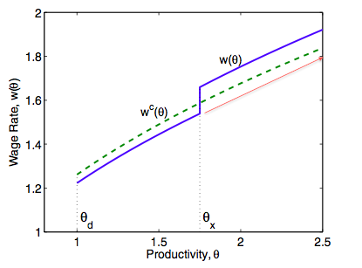
Source: HIR (2010)

The theoretical results can be summarized as follows:
Exporters perform in terms of revenues, employment, and wages better than firms who are not involved in export activities. This result can be retrieved from the optimization problem, which a firm faces when being active in the market. A firm maximizes its profit by taking into account their firm specific characteristics, namely productivity draw, screening costs and fixed export costs $(θ, η, ε)$. The heterogeneous nature of export costs entails that screening and productivity draw imperfectly predict a firm’s export status. Hence, having two firms with the same productivity and screening draw but the one is an exporter and the other not, is a possible outcome in the model. The results predict that, controlling for productivity and screening draw, an exporter generates more revenues, hire more workers and offer higher wages. The wage outcome is the most interesting part for this paper. Exporters pay a higher wage through tougher market selectivity. They will hire workers with higher average ability in order to complement the larger business scale, which leads to higher average wages, as those kinds of workers are more costly to replace (Market Access effect). The higher screening level for exporters can be financed through the additional earnings from the export market. Moreover, firms who are entering the export market experience a higher wage growth, as they will screen more and pay more to their high ability workers.

3) Methodology
Dataset:
In order to test the theoretical outcome established in the previous section, the empirical analysis requires data on a firm level in order to capture the heterogeneous nature of firms. The analysis will focus on Eastern European and Central Asian countries. The World Bank Enterprise Survey (2012) constructed a comprehensive panel data set based on the joint effort of the World Bank and the European Bank for Reconstruction and Development by gathering and harmonizing variables and observation for 26 countries. The 26 countries are Albania, Armenia, Azerbaijan, Belarus, Bosnia, Bulgaria, Croatia, Czech Republic, Estonia, the Former Yugoslav Republic of Macedonia (FYROM), Georgia, Hungary, Kazakhstan, Kyrgyz, Latvia, Lithuania, Moldova, Poland, Romania, Russia, Serbia, Slovakia, Slovenia, Tajikistan, Ukraine and Uzbekistan. Depending on which country, they have been interviewed in 2002, 2005, 2007, and 2009 and where asked quantitative and qualitative questions concerning their performance in the previous fiscal year. For instance the questionnaire contained questions about ownership structure, location, industry, age, issues with electricity and water supply, involvement in corruption, export volume, financial indicators, government-firm relation, firm strategic decisions, licenses and certificates, or workforce composition. The number of firms interviewed per country varied between 610 for Kyrgyz and 2111 for Russia. The World Bank hired private contractors to conduct the enterprise survey and business owners or top managers generally answer the questionnaire. As the survey contains sensitive questions addressing business government relation and bribery related topics it was safer to hire private contractors instead of government agencies. Firms active in the manufacturing and services sector were the target group of the survey. The interviewed firms correspond to the classified International Standard Industrial Classification (ISIC) codes 15-37, 45, 50-52, 55, 60-64, and 72. The industries include food processing, textiles, garments, chemicals, plastic and rubber, non-metallic mineral products, basic metals, fabricate metal products, machinery and equipment and electronics. The surveyed service sector includes wholesale, retail, hotel, information technology, and transport section. The survey reports as well 4-digit ISIC codes, however the number of firms reporting the 4-digit code is limited. The sampling methodology for the survey is stratified random sampling. This means that all firms of the population have the same probability being picked and surveyed. Thus, there is no need for weighting the observations.
Descriptive Statistics:
This part of the paper will look into the characteristics of the data set. As previously mentioned in the introduction the discrepancies between exporters and non-exporters are quite notable. As depicted in Figure 2 the majority of the firms actually do not export. For those who export the share of export/sales is evenly distributed, so no exporter with a specific export share seems to stand out. This characteristic is quite common, and in line with previous empirical research. Additionally, across industries the share of exporter in a certain sector takes a maximum value of 44% in the machinery and equipment industry. The service sector has generally a lower export share in comparison to the manufacturing industries. Moreover, by taking a closer look at table 1, a company that is exporting is on average larger than non-exporters in almost every industry.

Figure 2: Distribution of Exports as Percentage Sales
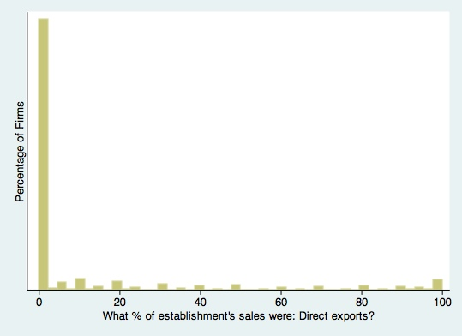
Source: Author’s own calculation based on the Data set from the World Bank Enterprise Survey (2012)

In the appendix, country specific information is listed and gives an idea about the diverse characteristics between the different countries For instance, the data regroups countries from the low-income group (e.g. Republic of Kyrgyz) and countries with a GDP per capita similar to OECD countries (e.g. Slovenia).
As one might see in the descriptive statistics, the incidence of exporting may vary considerably across location and industry. Therefore it is important to control for this variation as it might account for most of the differences between firms serving the export market and those who sell their products only on the domestic market. This will be taken into account in the empirical analysis.

Table 1: Industry Characteristics
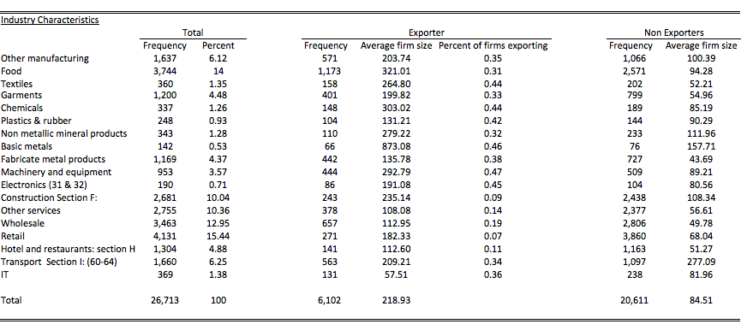
Source: Author’s own calculation based on the Data set from the World Bank Enterprise Survey (2012)

Choice of variables
The variables have been chosen in a way to fit the model as closely as possible. This research will mainly focus on the relation between export status and wage structure. The main dependent variable will be the logarithm of labor cost per worker and an extensive set of control variables is added to control for firm specific characteristics. The World Bank Enterprise Survey (2012) provides information about ownership structure, educational and skills achievement, and size, which will be used in the regressions.
The dependent variable average labor cost per worker contains not only information about wages but as well about additional earnings and bonuses paid out to the workforce ($). The total labor costs from the previous fiscal year occurred by the firm will be divided by the average number of workers employed in the past fiscal year. The survey question about the total labor costs has been asked in 2005, 2007 and 2009. Thus, the observations from the survey of 2002 will not be taken into account in the further analysis. It is important to note that due to the presence of bonuses, benefits and other earnings in addition to wages, the impact of trade might be stronger. Zhou (2003) and Bernard and Jensen (1995) found statistical evidence for a premium in benefits and bonuses paid out by exporters.
The first independent variable in the model is the export status variable. In the first regression the export status will figure as a dummy variable and takes the value 1 if the firm is involved in direct export activities and the value 0 when the firm does not export at all at the time given. Alternatively in a separate regression, the export status can be expressed as percentage share of total sales. A higher value for the export share means that the concerned firm is more integrated in the export market and more exposed to the economic shocks of their trading partners. Using the export share of total sales is quite common in empirical research in order to measure trade intensity.
The second independent variable is a proxy for productivity. As explained in the theoretical part the productivity variable is needed in order to check whether an exporter pays on average more to its workforce given the productivity level. The sign of the productivity variable is expected to be positive as more productive firms generate more revenues, hence they have more resources available to increase the screening level. In the regression productivity is proxied through the logarithm of domestic sales per worker ($). This variable has been constructed by multiplying the domestic percentage share with the total sales of the previous fiscal year and divided by the average number of workers employed in the previous fiscal year. Verhoogen (2008) uses the domestic sales per worker variable as well in his analysis. He states that domestic sales is the only variable observed beside the production line. Another candidate for the productivity proxy would have been total factor productivity (TFP). The classical production function can provide a proxy for TFP. Regressing log capital input, log labor input and log materials on log sales, one can retrieve the residuals, which captures TFP. They are as well called Solow residuals. However, this approach may cause some simultaneity issues as stressed by Levinsohn and Petrin (2003).
The other control variables added to the regression control for size, age, education and foreign ownership. The average number of workers employed full time in the past fiscal year represents size and squared size has been added to capture the decreasing returns to size (Schank et al., 2007). All in all the expected sign of the coefficient for size is positive.
The variable age allows controlling for firm maturity. It is computed by subtracting the year of formal establishment from the year of when the survey took place. It is interesting to incorporate this variable as firms with more experience on the market may behave differently from their younger counterparts. Farinas and Martin-Marcos (2003) use in their regression firm maturity in order to control for firm heterogeneities related to experience with production.
In order to control for skills and education the variables share of skilled workforce and share of university degree holders are added to the regression. The share of skilled workforce is constructed by dividing the average number of skilled workforce employed in the previous fiscal year by the average total number of workers employed full time in the previous fiscal year. Skilled workers have specific abilities, which are valuable to the employer, as they create significant economic value through their work. They may be acquired through learning by doing, training courses or schooling. In contrast, an unskilled worker performs simple duties, which can be done by every worker without having a lot of job experience and schooling. Skilled workforce are involved in several tasks and is defined by the World Bank Enterprise Survey (2012) as follows: “skilled workers (up through the line supervisor level) engaged in fabricating, processing, assembling, inspecting, receiving, storing, handling, packing, warehousing, shipping (but not delivering), maintenance, repair, product development, auxiliary production for plant‘s own use (e.g., power plant), recordkeeping, and other services closely associated with these production operations. Employees above the working-supervisor level are excluded from this item.” The share of skilled workers can vary between 0 and 100%, meaning that a firm with a value of 0 does not employ skilled workers at all and a value of 100% means that the entire workforce possesses at least a specific set of skills valuable to the firm. The sign of the coefficient is expected to be positive. As the return to education and experience is supposed to be positive, a firm with a higher share of skilled workers should pay on average higher wages.
The variable share of workers with a university degree is an additional control variable capturing firm specific characteristics in terms of education. Here again, similarly as for the share of skilled workers, the return to the share of workers holding a University degree should be positively correlated with firm average labor cost per worker.
Finally, variables about foreign influence within the firm are added as control variables. Ownership structure varies a lot across firms. In the World Bank Enterprise Survey (2012) firms are questioned whether the owners are foreigners, locals or the government. According to the World Bank Enterprise survey foreign ownership is defined by whether the owner is a foreign national resident or an institution respectively a company from abroad. Additionally, companies operating under a franchise agreement are classified according to the nationality of those who awarded the franchise. Harrison and Scorse (2008) investigated the Indonesian manufacturing sector and observed a significant positive impact of foreign ownership on average wages. According to the authors they were hiring more skilled workforces and invested more in training, hence paid higher wages in order to retain the workers. Moreover, the control dummy variable foreign technology is introduced. Firms may acquire sophisticated foreign technology in order to improve their production process. Usually, when a firm imports technology, it is either non available in the home country or the available technology is inferior. Consequently, skilled labor force or additional training is required in order to make use of the new technology. The dummy variable takes the value 1 if the firm possesses foreign technology and 0 otherwise.

Table 2: Correlation Matrix
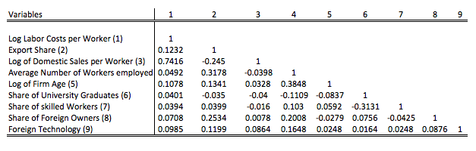
Table 3: Characteristics of the Variables
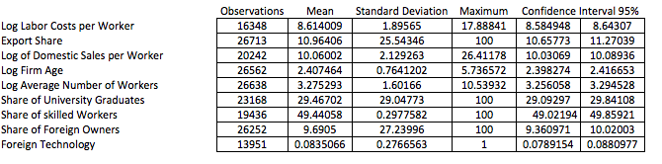Source: Author’s own calculation based on the Data set from the World Bank Enterprise Survey (2012)
Empirical Framework
For the empirical part, the relation between export status and wage structure will be analyzed. The panel data set from the World Bank Enterprise survey contains 26713 firm observations for the period for 4 years of surveys (2002, 2005, 2007 & 2009) in 26 countries for 21 industries. The vast cross section allows capturing the discrepancies between exporting and non-exporting firms and the comparison over years allows investigating firm dynamics in exporting. The hypotheses for the empirical part will be based on the theoretical framework and will assess whether exporters do really pay higher wages:
- Firms involved in export activities pay on average higher wages (benefits and bonuses) to their workers than firms only serving the domestic market, given the productivity level.
- New entrants in the export market experience higher wage (benefits and bonuses) growth than firms who do not change their export status, given the change in the productivity level.
Empirical evidence in favor of those hypotheses would support the belief that exporters are paying “good wages” and hence making them a more attractive employer. The regressions for the empirical analysis are as follows:

$Log Avg {Labor Costs per worker}_{i,t}=α+β_{1}{Export Dummy}_{i,t}+{β_{2}θ}_{i,t}+β{\hat{X}}_{i,t}+δ_{c}*δ_{j}+δ_{t}$+$ℇ_{i,t}$ (1),
where the logarithm of labor costs per worker ($) act as dependent variable. As previously explained, labor costs not only contain wages but as well other benefits and bonuses. The indices i and t represents the firm i at year t. The export dummy indicates whether the firm is involved in export activities. It takes the value of 1 when the export percentage share of total sales is bigger than 0. $θ$ is the proxy for productivity and represented by the log of domestic sales per worker ($). Productivity is supposed to be positively correlated with wages as more productive firms invest more resources in screening their workers. Moreover, it is important to have productivity as variable in order to control whether the coefficient for export status remains significant. If this is the case, even after incorporating the control variables, it would support the hypothesis that exporters do actually pay higher wages to their workers than non-exporters. This would fit out theoretical model, which predicts that exporters are investing more resources in screening; hence have workers with higher average ability and higher remunerations. Additionally, ${\hat{X}}_{i,t}$represents a vector of control variables, which have been described previously. They control for education, firm related characteristics and foreign ownership. $δ_{c},δ_{j} and δ_{t}$ are dummies for the 26 countries, the 21 2-digit ISIC industries and 4 survey years. As previously shown in the descriptive part, industries and countries vary a lot and may account for most of the differences between exporters and non-exporters. Moreover, in order to capture as much as possible of the differences related to industry and countries, the model uses a country and industry fixed effect as an interaction variable. Hence, this country-industry specific dummy allows to capture all (un)observable time-invariant differences across the country-industry groups (Verbeek, 2008). Without the country-industry and year dummy, valuable information would be omitted and lead to inconsistent results.

$Log {Avg Labor Costs per worker}_{i,t}=α+β_{1}{Export Share}_{i,t}+β_{2}θ_{i,t}+β{\hat{X}}_{i,t}+δ_{c}*δ_{j}+δ_{t}$+ $ℇ_{i,t}$ (2)
The second regression is basically the same as the first regression, with the only difference that the variable export share replaces the export dummy variable. It represents the percentage share of total sales a firm exports. It indicates how intensively a firm is involved in the export market. Here again, a vector of control variables and fixed effects (country-industry, year) are included. A positive and significant coefficient of the export share while taking into account control variables would support the hypothesis that exporters pay a wage premium to their workers.
A third model analyzes the dynamics of exporters and how export status affects wage growth. It allows finding empirical support for the second hypothesis, which states that firms changing their export status (from non-exporter to exporter) should experience higher wage growth than firms without change in export status, given the change in productivity level. The regression is defined as follows:

$ΔLog Avg {Labor Costs per worker}_{i,t}=α+β_{1}Δ{Export Status}_{i,t}+β_{2}Δθ_{i,t}+β{\hat{X}}_{i,t}+δ_{c}*δ_{j}+δ_{t}$+$ℇ_{i,t}$ (3),
where $Δ$ indicates the change in the variables. Changes occur over a 2-3 year period because the survey did not take place every year. Hence, this is more convenient to track the changes in wages. In a very short time frame wages may not change immediately when a firm enters the export market. The firm still has to adapt. The changes in export status will be divided in 4 dummy variables: a dummy for remaining an exporter over the period (exporter-exporter), a dummy for changing the export status from non-exporter to exporter over the period (non-exporter, exporter), a dummy for remaining an non-exporter over the period (non-exporter, non-exporter) and dummy for changing the export status from exporter to non-exporter over the period (exporter, non-exporter). The change in productivity is expected to be positively correlated with change in average labor costs per worker. The vector of control variables in this regression is in comparison to the previous regressions smaller. Data limitations did not allow using more control variables, as the number of observations would decrease tremendously. The retained control variable in this case is the initial log of employment which is a common control variable in other empirical papers (Verhoogen, 2008) or (Bernard & Jensen, 1995). Additionally, the fixed effects dummies country-industry and year are added to the regression.

4) Empirical Results:
Results with Export Dummy as Independent Variable:
The results for the first regression are depicted in table 4. As it has been outlined in the empirical framework, the first regression tries to figure out whether exporters do actually pay a wage premium after controlling for productivity level, control variables and fixed effects dummies. Regression [1] portrays the relation between export status and log wage per worker. The fixed effects interaction dummy country-industry and the fixed effects dummy year are included from the beginning on. The coefficient of the export status is positive and highly significant. The adjusted R-squared is 0.53 and quite high when considering that export status is the sole independent variable in the regression. This supports the belief that geographical location and industry sector have a lot of explanatory power with regards to differences in wages. Intuitively this makes sense as for instance the data group contains low-income countries such as Kyrgyz Republic and high-income countries such as Slovenia. The fixed effect country-industry controls for observable and unobservable country-industry specific heterogeneities.
Regression [2] in table 4 adds the variable log domestic sales per worker. It acts as a proxy for productivity and the coefficient is positive and highly significant. A 10-point percentage increase would lead to a 5.7 percentage point increase, ceteris paribus. This supports the belief that more productive firms pay higher wages to their employees. As outlined in the theoretical part, firms with a higher productivity draw screen more intensively than firms with a lower productivity draw. As the screening threshold is higher for high productivity firms, the worker match quality will be better. The firm hires workers who are revealed to be above the threshold line. The higher the threshold line, the higher the abilities of the worker. Hence, this high revealed match quality match quality improves the worker’s bargaining position hence leading to a high wage. The coefficient of the export status remained positive and significant at a 1% level when introducing the productivity proxy. This means that even after controlling for productivity, exporters do pay more on average than non-exporters. According to regression [2] an exporter pays on average 32% more than a non-exporter to his workers, ceteris paribus. Moreover the magnitude is quite large, but there is an explanation for this. The dependent variable does not only contain wages paid to their workers, but as well benefits and bonuses. Bernard & Jensen (1995) found empirical evidence that exporters offer on average larger bonuses and benefits than non-exporters. This might amplify the coefficient values. Nonetheless, the other control variables have not been added yet to the regression. Thus, the magnitude of the coefficient of the export status might decrease further. The adjusted R-squared increased tremendously after adding the variable log domestic sales per worker (from 0.53 to 0.76). This indicates that the productivity proxy has a lot of explanatory power and is highly relevant for the regression.
In the following regressions [3-9] the vector of control variables are added step by step. Those variables control for differences in firm structure, education, size and foreign influence. Firstly, variables capturing firm specific characteristics are added to the regression. The exogenous variable log age of firm is positive and significant at a 10% level. This supports the findings by Thompson (2009) who found empirical evidence that more mature firms pay higher wages than their younger counterparts. He has various explanation for this finding, for instance older firms survive longer on the market and hence invest more in training. Moreover, there are differences in workforce composition between older and younger firms. Workers at more long lasting firms have longer tenure and more work experience. In the regressions [4-5] the control variable log of establishment size is added. The average number of full-time workers employed during a year measures the establishment
Table 4: Firm Level Regressions with Export Dummy
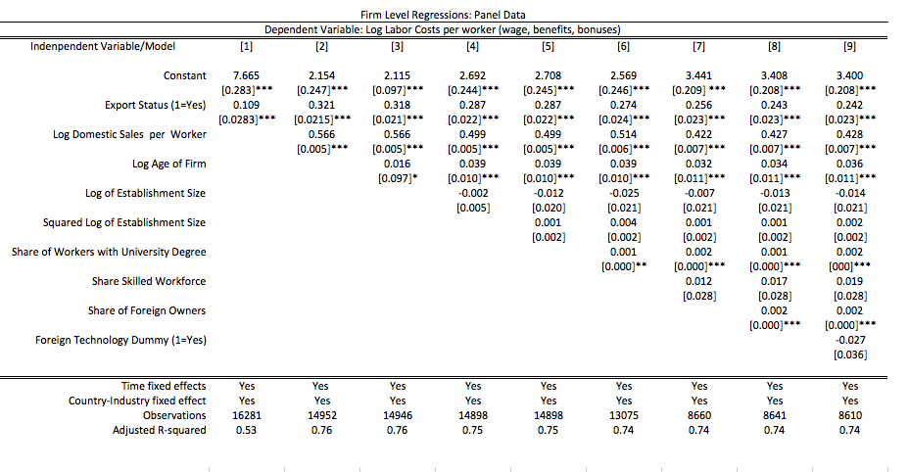

Notes: *** significant at a 1% level, ** significant at a 5% level and * significant at a 10% level. Between brackets is the Standard deviation reported. Column (1) includes only the export dummy; Column (2) includes productivity proxy; Column (3-5) includes firm related characteristics (age, size, size squared); Column (6-7) adds education and skill related variables; Column (8-9) includes Foreign influence variables. Fixed effects for year and country-industry are included in all the regressions.
size of a firm. The squared version of log establishment size is added as well in order to capture decreasing returns of establishment size. Schank et al. (2007) included as well this pair of variables in their regressions and were significant. However, in the regression the variable log of size of establishment and its square remain insignificant.
In columns [6] and [7] the control variables for education and skills are added. It captures to a certain extent the characteristics of the labor force hired by the firms. The variable share of workers with a University degree is positive and significant at a 5% level. Intuitively this makes sense, as workers with university degrees may have a better bargaining position. Moreover, the variable skilled share is positive. Although the coefficient is pointing in the right direction, it is insignificant.
In columns [8] and [9] control variable for foreign influence are added. The variable share of foreign owners is positive and highly significant at a 1% level. This is in line with the research of Harrison and Scorse (2008) and Martins (2004). They find empirical evidence for positive impact of foreign ownership on wages. Moreover, the coefficient for foreign technology is negative and insignificant.
While including step by step the control variables, the magnitude of the coefficient of the export dummy and the log domestic sales per workers are decreasing gradually. In regression [9] an exporter pays on average 24.2% higher wages than a non-exporter, ceteris paribus. However, the most important finding is that the export dummy remained positive and highly significant despite the presence of control variables and country-industry fixed effects respectively year effects. This finding supports the hypothesis that exporters pay higher wages than non-exporters. In line with the explanation in the theoretical part, the higher wages are explained due to the differences in workforce composition. Trough tougher screening methods, exporters select workers that are more skilled in their unobservable characteristics. Moreover, a 10% rise in the log domestic sales per worker increases the log of average labor costs per worker by 4.28 percentage points.
Figure 3 gives an insight into the relation between average labor costs per worker and log domestic sales per worker. Moreover, the relationship distinguishes between average labor costs per worker paid by exporters and non-exporters. Optically, it seems that exporters (red) offer on average a higher wage per worker than non-exporters (blue) given the level of log domestic sales per worker.
Figure 3: Relation between Average wage per worker and log domestic sales per worker
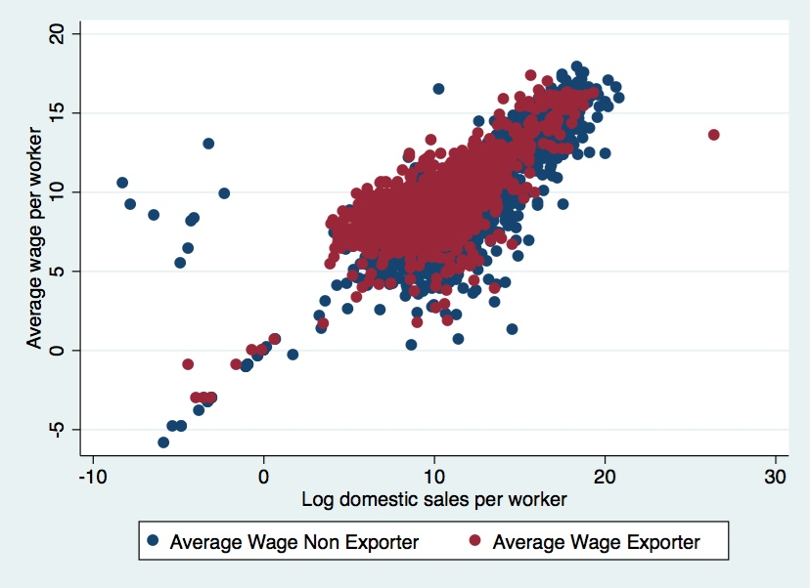 Source: Author’s own calculation based on the Data set from the World Bank Enterprise Survey (2012)

Results with Export Share as Independent Variable:
Table 5 presents the results of the 2nd regression outlined in the empirical framework. The variables are basically the same except for the export variable. Instead of export status, the variable export percentage share of total sales is used. As described in the descriptive part, the majority of the firms actually does no export and has an export share of 0. Some firms ship their entire sales abroad. All in all, the coefficient of the export share remains positive and significant in all the columns presented in table 5. The magnitude of the coefficient predicts that a 10-percentage point rise in the proportion share of exports in total sales increases average wage by 0.12%, ceteris paribus. Here again the dummies controlling country-industry heterogeneities and year play an important role. With an adjusted R-squared of 0.53 in regression [1], a large part is explained through the differences in country-industry characteristics. The coefficient of log domestic sales per workers is as well positive and highly significant at a 1% level and in terms of magnitude similar to the results in table 4. A 10% point increase in domestic sales per worker increases average wage by about 5 percentage points. Among the control variables, the log of firm age is positive and significant at a 1% level. Similar is the outcome for share of workers with university degree, which is as well positive and significant at a 1% level. On the whole, the results from table 5 seem to be in line with the hypothesis that exporters do pay higher wages than non-exporters.
Results for change in export status:
In the outline of the empirical framework, a second hypothesis has been set up. It has the purpose to check whether firms entering the export market experience higher wage growth than their counterparts. The first column in table 6 shows the relation between the change in log average labor costs per worker, export status, change in log domestic sales per worker and initial log employment. Not surprisingly the coefficient of the change in log domestic sales per worker is highly significant at a 1% level. A 10% change in the change in log of domestic sales per worker increases the change in log average labor costs per worker by approximately 3.6%. Hence, growth in average labor costs per worker goes along with productivity growth. The coefficient of the export status in column 1 remains insignificant and indicates that there is not sufficient statistical evidence that an exporter experience higher average labor costs growth than a non-exporter. In order to grasp more in detail the relation between export status and average labor costs growth, the table contains a second regression taking into account the changes in export status. Hence, column 2 distinguishes four different dummy variables: first a firm continues to be a non-exporter over the investigated period (no change from t-1 to t), second a firm changes its export status from non-exporter to exporter from year t-1 to t, third a firm continues exporting during the period t-1 to t and lastly a firm stops exporting from period t-1 to t. The variable change in log domestic sales per worker remained positive and highly significant at a 1% level and did not change in magnitude in comparison to the regression in column 1. The most interesting variable in column 2 is the export status indicating whether a firm starts exporting over the investigated period. The dummy variable “Non-exporter in year 0 & Exporter in year 1” is positive and significant at a 10% level. In terms of magnitude of the coefficient, a firm entering the export market experiences a 24.5% higher wage growth than a non-exporter, ceteris paribus. This finding seems to confirm the hypothesis that new entrants into the export market experience a higher growth in average labor costs per worker. However, one has to take into account that the
Table 5: Firm Level Regressions with Export Share
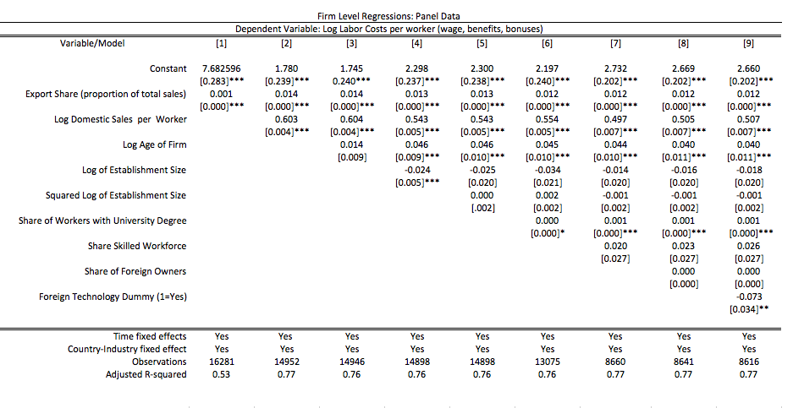
Notes: *** significant at a 1% level, ** significant at a 5% level and * significant at a 10% level. Between brackets is the Standard deviation reported. Column (1) includes only the export share of total sales; Column (2) includes productivity proxy; Column (3-5) includes firm related characteristics (age, size, size squared); Column (6-7) adds education and skill related variables; Column (8-9) includes Foreign influence variables. Fixed effects for year and country-industry are included in all the regressions.
statistical evidence is rather weak. Moreover, due to data limitations, the model only contains one control variable (initial log employment), which is statistically insignificant. Additional control variables may have improved the model and probably weakened the explanatory power of the dummy variable “Non-exporter in year 0 & Exporter in year 1”.

Table 6: Firm Level Regressions –Change in Export Status
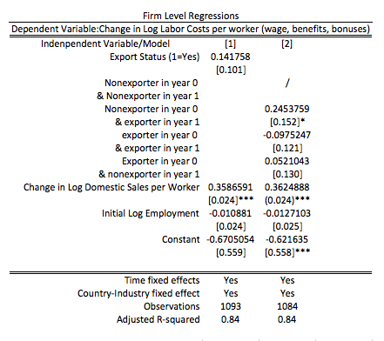
Notes: *** significant at a 1% level, ** significant at a 5% level and * significant at a 10% level. Between brackets is the Standard deviation reported. Column (1) includes only the current export status; Column (2) includes the various changes in export status; effects for year and country-industry are included in both regressions.

Robustness Check for Subsamples:
In this part the regressions set up in the empirical part will be applied to a selection of subsamples in order to check whether the results are as well consistent. In the previous part the regressions have been used with the overall sample containing all industries and firms of all sizes. The first subsample focuses only on the manufacturing sector. For this purpose all sectors related to services are dropped from the sample. Moreover, in comparison to the service sector a larger share of firms within the various industry-sectors are exporting (table 1). This is probably due to the fact that the service sector offers their services mainly on a local basis and probably only highly specific services may be exported (e.g. engineering services). Table 7 and 8 portrays the results for the manufacturing sector. In terms of significance and magnitude of the coefficients the outcome does not remarkably differ from the results based on the overall sample set. Hence, the export wage premium remains statistically significant even with a smaller sample size. In column [9] in table 5 a worker employed by an exporting firm earns on average 24.1% more than a worker employed by a non-exporter. Similarly for table 6, a 10-percentage point rise in export share increases the average labor costs per worker by 0.13%.
Table 7: Firm Level Regressions –Only manufacturing firms, Export Dummy
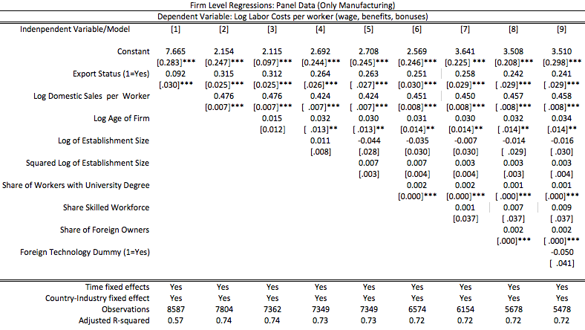

Notes: *** significant at a 1% level, ** significant at a 5% level and * significant at a 10% level. Between brackets is the Standard deviation reported. Column (1) includes only the export share of total sales; Column (2) includes productivity proxy; Column (3-5) includes firm related characteristics (age, size, size squared); Column (6-7) adds education and skill related variables; Column (8-9) includes Foreign influence variables. Fixed effects for year and country-industry are included in all the regression.

Table 8: Firm Level Regressions –Only manufacturing firms, Export Share

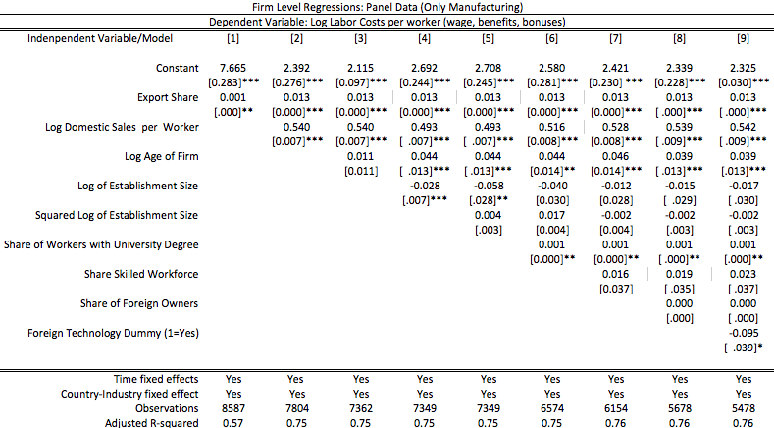

Notes: *** significant at a 1% level, ** significant at a 5% level and * significant at a 10% level. Between brackets is the Standard deviation reported. Column (1) includes only the export share of total sales; Column (2) includes productivity proxy; Column (3-5) includes firm related characteristics (age, size, size squared); Column (6-7) adds education and skill related variables; Column (8-9) includes Foreign influence variables. Fixed effects for year and country-industry are included in all the regression.

Table 9 and Table 10 split the overall data set into two subsamples, namely large firms and small/medium firms. According to the World Bank Enterprise Survey (2012) large firms are defined as entities with at least 100 workers, whereas small & medium firms have less than 100 workers. For simplicity the tables only report the results for the export variable and the log domestic sales per worker variable. The control variables (not shown in the table) are the same as in the previous regressions, namely: log age, log establishment size, share of university graduates, share of skilled workforce, share of foreign owners and foreign technology. They are added step by step. On the whole the results for the two subgroups are supporting the hypothesis of an export wage premium. Both export variables (dummy and export share) are positive and significant at a 1% level. An interesting finding is the difference of 3.3 percentage points between the coefficient value of the export dummy variable for large firms (19.8%) and the one for small and medium firms (23.1%). The export premium seems to be statistically larger for small and medium firms.

Table 9: Firm Level Regressions –Only Large firms, Export Share & Export Dummy
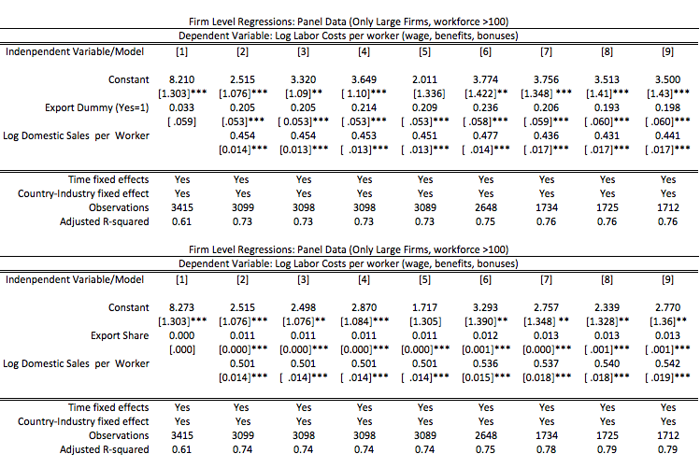

Notes: *** significant at a 1% level, ** significant at a 5% level and * significant at a 10% level. Between brackets is the Standard deviation reported. For simplicity, the control variables are not portrayed in the regressions. Column (1) includes only the export share of total sales; Column (2) includes productivity proxy; Column (3-5) includes firm related characteristics (age, size, size squared); Column (6-7) adds education and skill related variables; Column (8-9) includes Foreign influence variables. Fixed effects for year and country-industry are included in all the regression.

Table 10: Firm Level Regressions –Only small & medium firms, Export Share & Export Dummy
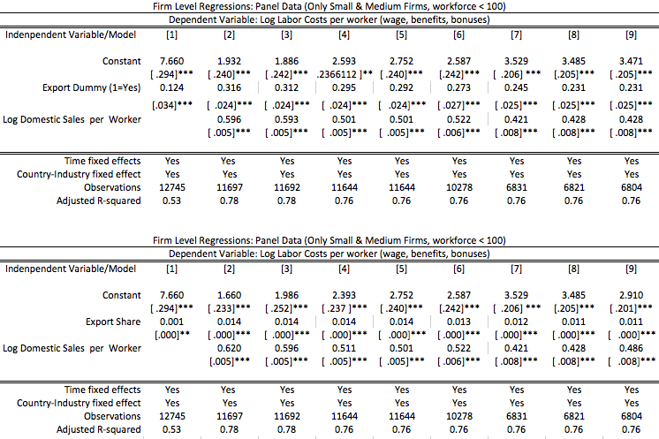
Notes: *** significant at a 1% level, ** significant at a 5% level and * significant at a 10% level. Between brackets is the Standard deviation reported. For simplicity, the control variables are not portrayed in the regressions. Column (1) includes only the export share of total sales; Column (2) includes productivity proxy; Column (3-5) includes firm related characteristics (age, size, size squared); Column (6-7) adds education and skill related variables; Column (8-9) includes Foreign influence variables. Fixed effects for year and country-industry are included in all the regression.

Thoughts & Comments

The quest for the existence of an export premium intrigued a lot of researcher to investigate this phenomenon for various countries or regions. This paper found empirical evidence that in eastern European and central Asian countries exporters pay higher wages than non-exporters. Nonetheless, it is important to reveal as well the limitations of this research. The first limitation is the nature of the dataset. It contains a large variety of variables on a firm level but misses out worker specific information. Firm level estimation may be biased due to the aggregation effect and the model cannot control for observable and unobservable worker characteristics relevant for the determination of wages. Applying the theoretical framework to a matched employer-employee dataset would have been more appropriate and might have led to more comprehensive results. However, as a student it is rather a delicate proceeding to get in possession of a linked employer-employee dataset.
Another limitation of the dataset is the low number of firms surveyed over several years. Most of the firms included in the dataset have been surveyed only once. This explains as well the low number of observations for the regressions investigating the relation between wage growth and change in export status. A larger set of observations may have helped to draw more consistent conclusions.
Moreover, this research could have used other proxies for productivity. The proxy log domestic sales per worker has proven to be a reliable estimator in predicting wages. It is in line with the theoretical outcome that firms with high productivity screen more and hence pay higher wages to their high ability workforce. By using other proxies for productivity, I could have checked for robustness of the results.

5) Concluding Remarks:

This research is in line with the previous literature that found statistical evidence for the concept of export wage premium. The reason why exporters offer higher wages is based on the mechanism of screening. As suggested by the outcome of the theoretical model, exporters screen more assiduously than non-exporters given the level of productivity. The theoretical framework of HIR is one of the first theoretical concepts explaining the link of firm heterogeneity and wage dispersion. Firms are heterogeneous in as sense that they have different productivity levels. Hence, those differences stir firms to screen more or less. High productivity firms screen in general more as they want to have high-quality matches (Selection effect). Firms set an ability threshold, which workers have to meet if they want to get hired by that firm. A higher the threshold implies more resource intensive screening, eventually leading to a higher bargained wage for workers. HIR (2012) complement their theoretical framework in HIR (2010) by introducing heterogeneity on a 3-dimensional level (export costs, screening costs, and productivity draw). In HIR (2010), the productivity draw of a firm perfectly predicted the export status of a firm. With heterogeneous costs this is not necessary case, as a firm facing high fixed export costs may decide not to export although the firm might have a high productivity draw. Linking this concept to trade, the model predicts that exporter apply more intensive screening techniques. As exporters have access to foreign markets (Market Access effect), they generate more revenues, hence hire workers with higher ability implied by the larger scale of operation. This leads to a reallocation of high ability workforce to exporters, and creates a wage gap between exporters and non-exporters. Based on the theoretical outcome two hypotheses have been established. The first hypothesis states that an exporter pays on average a higher wage to his workers than a non-exporter given the level of productivity. By using a dataset of the World Bank Enterprises Survey (2012) containing firm-level information from 26 eastern European and central Asian countries, the regressions find enough statistical evidence to confirm the hypothesis. E.g. the coefficient of the export dummy is positive and significant at a 1% level. The empirical model used log average labor costs as dependent variable, which contained beside wages as well benefits and bonuses. On average labor costs per worker are 24.2% higher for an exporter than for a non-exporter. The main independent variables were the export status (dummy or export share) and the proxy for productivity (represented by log sales per worker). Additional control variables are used in order to control for firm related heterogeneities such as size, education or foreign influence. Moreover, a year dummy and a country-industry (2-ISIC code) pair dummy capture the differences across years, industries and countries. Those fixed effects are crucial to the model as they contribute the most in explaining the wage variations. Additionally, regressions are run for a group of subsamples (manufacturing, large firms, small & medium firms) in order to check whether the hypotheses hold for smaller sample sizes. The second hypothesis relates to firm entry into the export market. Firms entering the export market should experience higher wage growth than firms who do not change their export status, controlling for change in in productivity. A regression is run to investigate the relation between relative change in average labor costs and change in export status. The coefficient for a firm switching its status from non-exporter to exporter is positive, however the statistical evidence is rather weak as the result is only significant at a 10% level.
Recapitulating all aspects and data, exporters seem to outperform non-exporters in terms of wages, benefits or bonuses. They put more effort into screening in order to capture a worker’s unobservable abilities. It would be interesting for future research to investigate more in detail the differences in screening efforts between exporters and non-exporters. Unfortunately, this kind of information was not enclosed in the dataset; hence this leaves room for further research in this area.

References:
Alvarez, R. and López, R.A. (2005). “Exporting and performance: evidence from Chilean plants,” Canadian Journal of Economics, 38, 1384–1400.
Bernard, A. B. & Jensen (1995). “Exporters, Jobs, and Wages in U.S Manufacturing: 1976-1987,” Brookings Papers on Economic Activity. Microeconomics, 1995, 67-112.
Egger, H. and Kreickemeier U. (2009).”Firm Heterogeneity and the Labor Market effects of Trade Liberalization,” International Economic Review, 50(1), 187-216.
European Commission Trade (2010). “Trade as driver of prosperity.” Communication from the Commission to the European Parliament, the Council, the European Economic and Social Committee and the Committee of the Regions,” Staff Working Document. Retrieved from: trade.ec.europa.eu/doclib/html/146940.htm
Farinas, J.C. and Martin-Marcos A. (2003).”Exporting and Economic Performance: Firm-Level Evidence for Spanish Manufacturing,” Universidad Complutense de Madrid.
Frias, Kaplan, and Verhoogen (2009).”Exports and Wage Premia: Evidence from Mexican Employer-Employee Data”, Working Paper. Retrieved from: http://www.columbia.edu/~ev2124/
Hansson, P. and Lundin, N.N. (2004). “Exports as an indicator on or promoter of successful Swedish manufacturing firms in the 1990s,” Review of World Economics, 140, 415–445.
Harrison, A., McLaren, J., and McMillan M. S. (2010).” Recent Findings on Trade and Wage Inequality,” NBER Working Paper Series. Working Paper 16525.
Helpman E., Itskhoki O. and Redding S. (2010). “Inequality and Unemployment in a Global Economy,” Econometrica, 78 (4), 1239-1283.
Helpman, E., Itskhoki, O. and Redding, S. (2012).”Trade and Inequality: From Theory to Estimation”. Unpublished Retrieved from: http://scholar.harvard.edu/helpman/publications/trade-and-inequality-theory-estimation
Hopenhayn, H. (1992).”Entry, Exit and Firm Dynamics in Long Run Equilibrium”. Econometrica, 60, 1127-1150.
Krishna, P., Poole J.P. and Senses, M.Z. (2011).”Wage Effects of Trade Reform with Endogenous Worker Mobility,” NBER Working Paper Series, Working paper 17256.
Lazear, E.P. and Shaw, K.L. (2009). “Wage Structure, Raises and Mobility: An Introduction to International Comparisons of the Structure of Wages within and Across Firms,” in the Structure of Wages: An International Comparison, ed. by E. P. Lazear, and K. L. Shaw, chap. 1. University of Chicago Press, Chicago.
Levinsohn, J. and Petrin, A. (2003).Estimating production functions using inputs to control for unobservables The Review of Economic Studies, 70, 317-341.
Melitz, M.J. (2003). “The impact of Trade on Intra-Industry Reallocations and Aggregate Industry Productivity,” Econometrica, 71(6), 1695-1725.
Munch, J.R. and Skaksen, J.R. (2008).”Human Capital and Wages in Exporting Firms”, Journal of International Economics, 75, 363-372.
Pellizzari, M. (2005): “Employers’ Search and the Efficiency of Matching,” Discussion Paper 1862, IZA.

Schank, T., Schanbel, C. and Wagner, J. (2007): “Do Exporters Really Pay Higher Wages? First Evidence from German Linked Employer–Employee Data,” Journal of International Economics, 72, 52–74.

Stole, L. A. and Zwiebel J. (1996). “Organizational Design and Technology Choice Under Intrafirm Bargaining,” American Economic Review, 86, 195–222.

Thompson, P. (2009). “Managers, Coordination, and the Firm Age –Wage Relationship,” Working Paper Florida International University.

Van Reenen, J. (1996). “The Creation and Capture of Economic Rents: Wages and Innovation in a Panel of UK Companies,” Quarterly Journal of Economics, 111, 195–226.
Verbeek, M. (2008). “A guide to Modern Econometrics”, John Wiley and Sons Ltd, 3rd edition.
Verhoogen, E. (2008). “Trade, Quality Upgrading and Wage Inequality in the Mexican Manufacturing Sector,” Quarterly Journal of Economics, 123, 489–530.
World Bank Enterprise Survey (2012).”Business Environment and Enterprise Performance Surveys: Eastern Europe and Central Asia”, The World Bank Enterprise Survey, Retrieved from: http://www.enterprisesurvey.org
Yeaple, S. R. (2005): “A Simple Model of Firm Heterogeneity, International Trade, and Wages”. Journal of International Economics, 65, 1–20.
Zhou, L., (2003). Why do Exporting Firms Pay Higher Wages? Mimeo, Emory University, Atlanta.

Appendix A: Stole Zwiebel Model
At the bargaining phase the firm’s costs are sunk and the firm bargains and shares the revenues from production $R\left(N,a_{c},ι;θ\right)$ with its employees. The revenue function is related with H (employment) with the power of $γβ$, and the form knows that the workers have a minimum ability of $a_{c}$and with an expected ability of $\overline{a}$. The Stole and Zwiebel (1996) bargaining condition is
$\frac{∂}{∂H}\left[R\left(H\right)-W\left(H\right)H\right]=W\left(H\right),$
Where the authors emphasize that the revenues and the wage rate depend on H of the firm. The result of the derivation $W=\frac{βγ}{1+βγ}\frac{R}{H}$.
Appendix B: Characteristics Countries
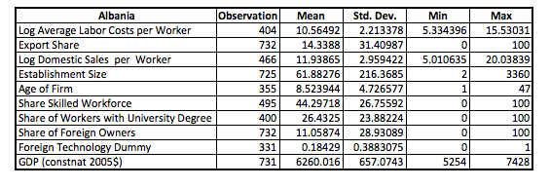
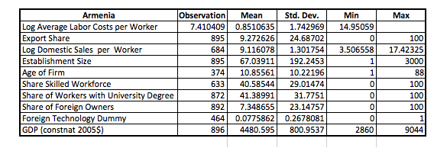

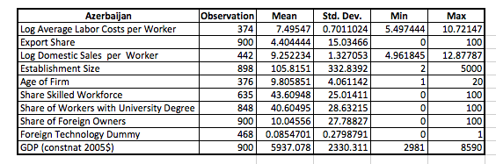
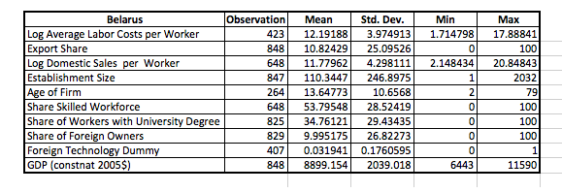
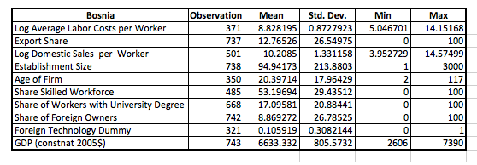
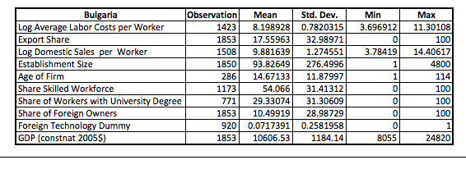
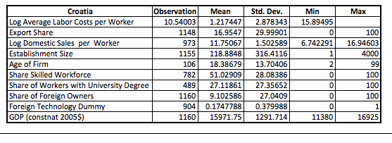
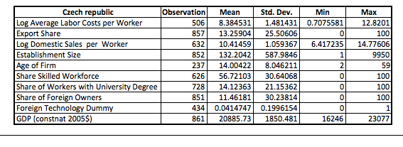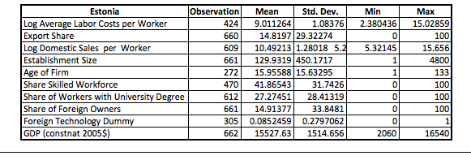
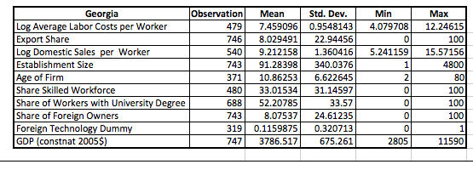
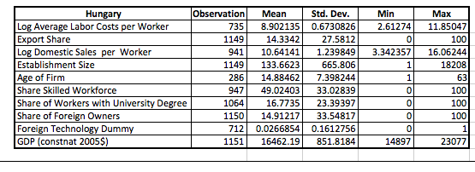
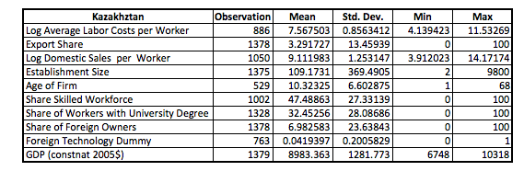
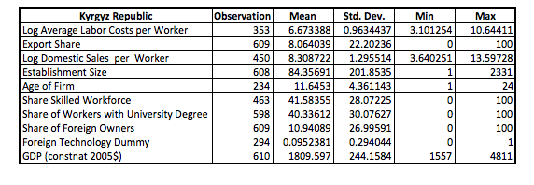
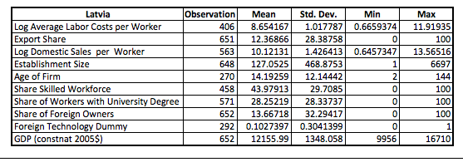
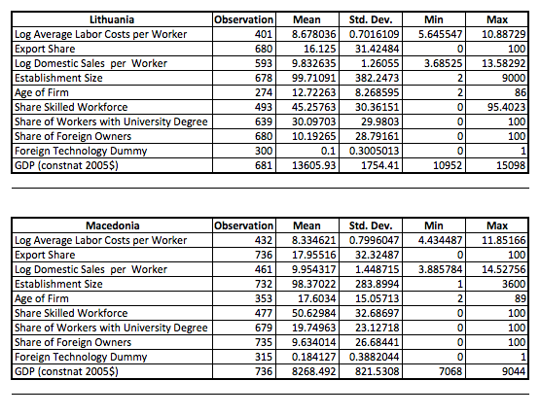
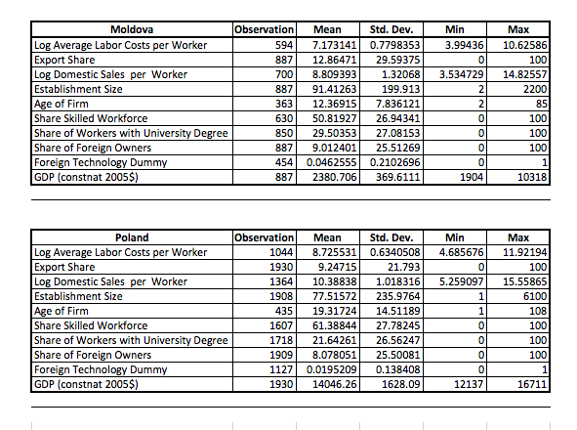
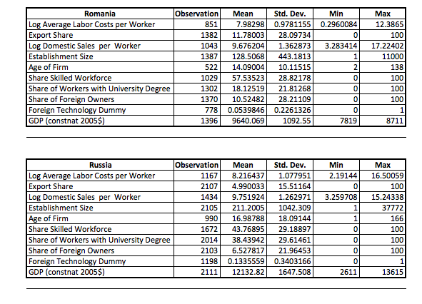
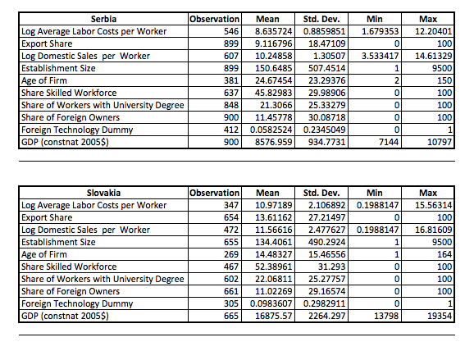
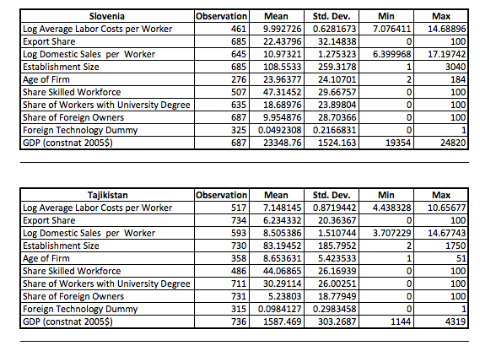
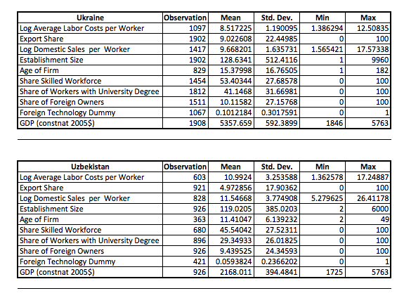

HIR explain in detail the implication of the complementarities in work abilities and firm productivity. In their technical appendix they show a worker with an ability level below the threshold $a_{c}$ has a negative marginal productivity, which provides an incentive to the firm to screen.
A short guideline to the bargaining equilibrium is given in the appendix).
The total revenues including exports $R^{x}\left(θ\right)$ can be retrieved from equation (8) when $ι=1$. If $ι=0$ the firm only generate revenues in the domestic market $R^{d}$.
The dataset of HIR 2012 shows these characteristics
In total 223 firms changed their export status from non-exporting to exporting and 304 firms changed their status from exporting to non-exporting.

