Performance Evaluation, Motivation and Career Development in the Police of the Republic of Mozambique (2006-2011)
Case Study of Boane and KaMubukwana-Maputo Province and Maputo City Districts
A Research Paper presented by:
Manuel Carlos Capece

(Mozambique)
in partial fulfilment of the requirements for obtaining the degree of
MASTERS OF ARTS IN DEVELOPMENT STUDIES
Specialization:
Public Policy and Management
(PPM)
Members of the Examining Committee:
Dr. Freek Schiphorst
Dr. Joop de Wit
The Hague, The Netherlands
December 2012
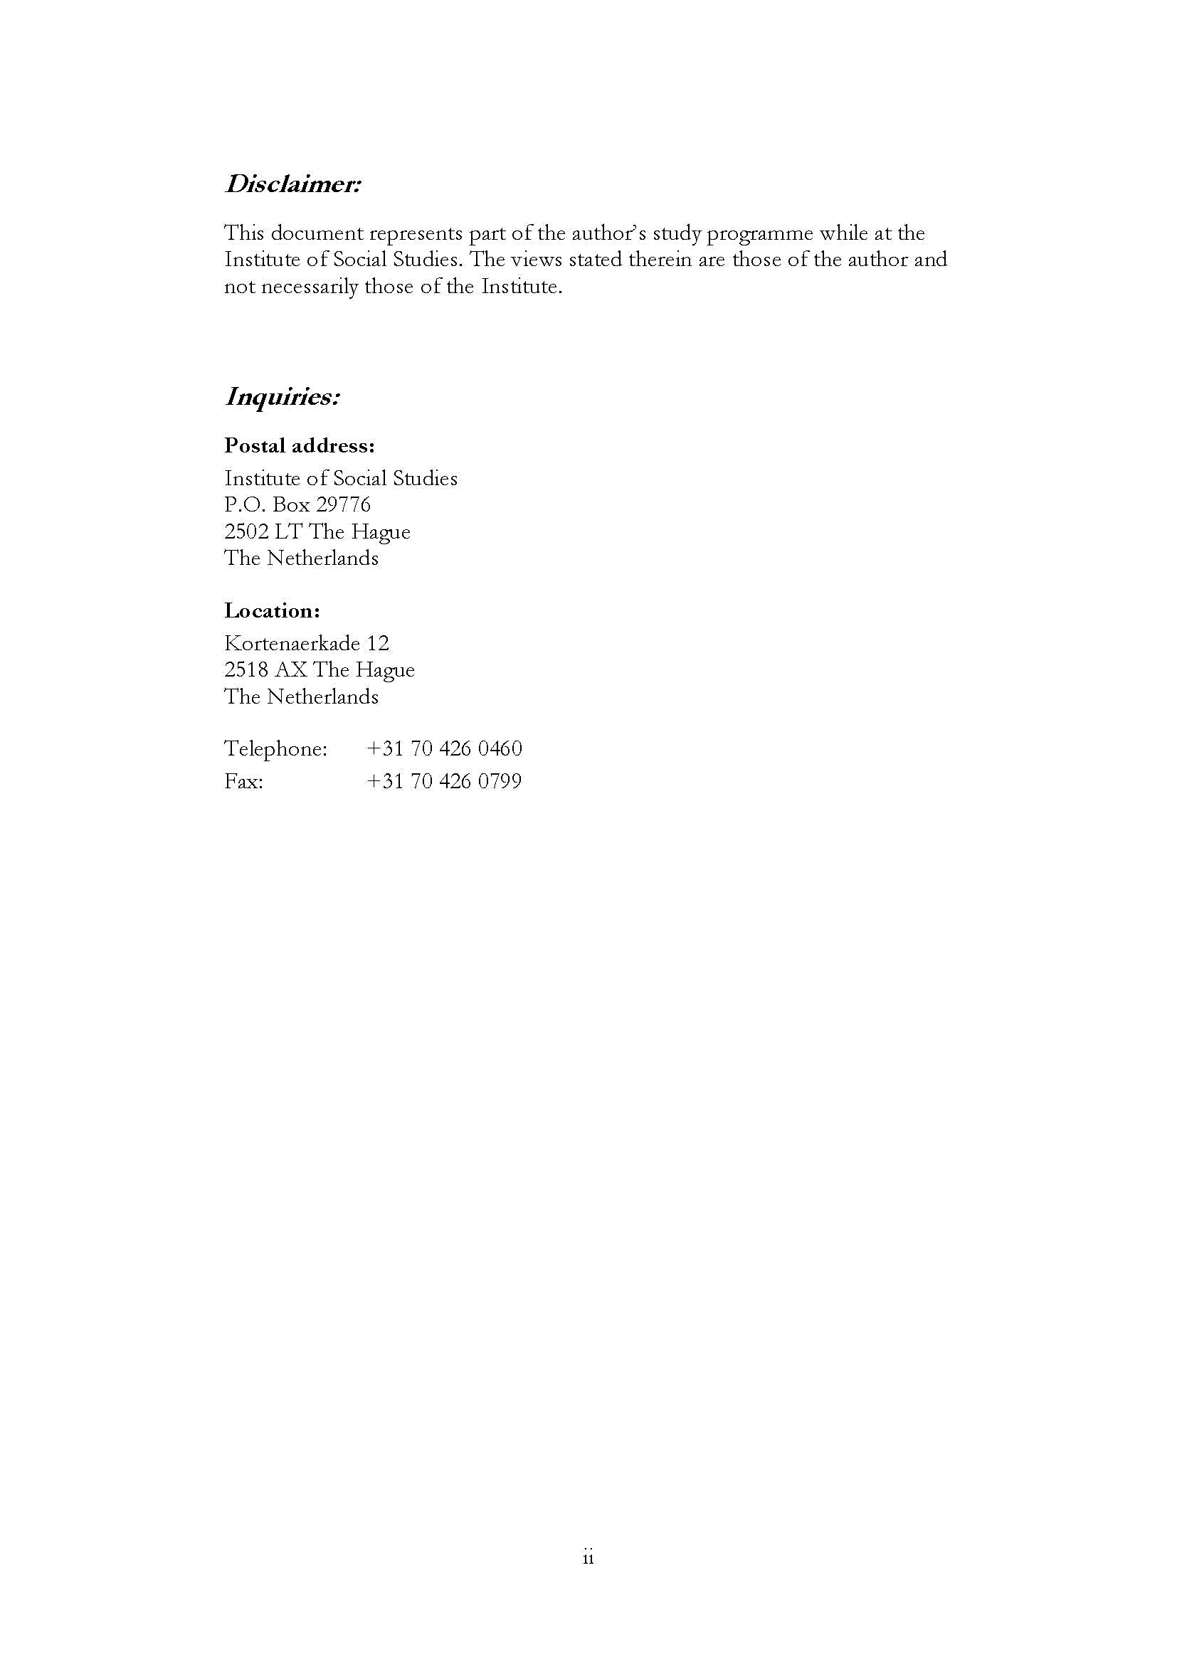
Contents
List of tables
List of figures
List of Maps
List of Acronyms
Abstract
Relevance to development studies
Keywords
Dedication
Acknowledgment
Chapter 1: Introduction 1
1.1 Background 1
1.2. Research Problem 2
1.3 Objectives of the research 3
1.4. Research Questions 4
1.4.1 Main research questions 4
1.4.2 Sub-questions 4
1.5. Justification 4
1.6. Research Methodology 5
1.6.1. Methods of data collection 5
1.6.3. Universe and Sample 6
1.7. Limitations of the Research 6
1.8. Structure of the Research 7
Chapter 2: Literature Review
2.2. Definition of Concepts 8
2.2.1. Performance Evaluation 9
2.2.2. Public Sestor Reform 9
2.2.3. New Public Management 9
2.2.4. Human Resource Management 10
2.2.5. Performance Management 11
2.2.6. Organizational Culture 12
2.2.7. Motivation 15
Chapter 3: Description of Public Sector Reform and Human Resource 17 Management in Mozambique

3.1. Contextualisation 17
3.1.1. Organization of the Police of the Republic of Mozambique 18
3.1.2. Functions of the PRM 18
3.1.3. nature of reforms of PRM (current procedures/system and practices), special reference to HRM and PE of the 2001 policy. 19
3.1.4. Implementing Frameworks of PSR 20
3.1.5. Management model of people in PRM 22
3.1.6. What are the motivation factors that are applied in the performance evaluation and how are these currently applied. 22
Chapter 4: Presentation of findings 25
4.1. Introduction 25
4.1.2. Findings 25
4.1.3. Career development of the police in Mozambique 30
4.1.4. What are the motivation factors that are applied in the performance evaluation and how are these currently applied. 31
Chapter 5: Conclusions and Recommendations 35
5.1. Conclusions 35
5.2. Recommendations 37
References 39
List of Appendix 42
Appendix 1: Tables 42
Appendix 2: Graphs 47
Appendix 3: Questionnaires and interview guide 49

List of Tables
Table 1.Main problems in Boane and Kamubukwana districts 37
Table 2: Impact of the problems 37
List of Figures
Figure 1 Illustration of levels of cultural assessment from the overall occupational through individual officer styles 15
Figure 2 - Representation of ‘Performance Management cycle’ 17
List of Maps
Map 1- District of Boane 20
Map 2-District of KaMubukwana 20
List of Appendices
Appendix 1 : Tables 47
Appendix 2: Graphs 51
Appendix 3: Questionnaires and interview guide 52

List of Acronyms
ACIPOL Police Sciences Academy
CRM Constitution of Republic of Mozambique
CIRESP Comissão Interministerial da Reforma do Sector Público
DK Don’t know
EGFAE Estatuto Geral dos Funcionários e Agentes do Estado
EGRSP Estratégia Global da Reforma do Sector Público
HRM Human Resources and Management
ISS International Institute of Social Studies
NPM- New Public and Management
PRM Police of Republic of Mozambique
UTRESP Unidade Técnica da Reforma do Sector Público
SIGEDAP Sistema de Avaliação de Desempenho na Função Pública
REGFAE Regulamento do Estatuto Geral dos Funcionários e Agentes do Estado
RM República de Moçambique
RSP Reforma do Sector Publico
SA Strongly Agree
SDA Strongly Disagree
PE Performance Evaluation
PSR Public Sector Reform
RM República de Moçambique

Abstract
Focussing on socio-political development of the Police force in the Republic of Mozambique (PRM), this paper seeks to examine the circumstances and organizational culture that undergird the motivation and the career development of its officers. I argue that police officer performance can only be considered adequate and professional through a transparent and fair system. The purpose of this paper is to explore and understand the current state of performance evaluation in the PRM and how it can be improved in the future. This research is qualitatively focused on a case study of police officers in Boone and KaMubukwana, situated in Maputo Province and Maputo City, respectively. Thus, data collection included anonymous questionnaires and semi-structured interviews of police officers, police commanders and human resource managers were used. This research is focused on a case study of police officers in Boone and KaMubukwana, situated in Maputo Province and Maputo City, respectively.
The results of the research show that in generally the respondents shared negative views on the process of performance evaluation. A majority of respondents did not understand the value of performance evaluation because the results are not used according to the law in Mozambique, particularly the EGFAE and statute of the police.

Relevance to Development Studies
The relevance and importance of this study is with its contribution to the evaluation of the strengths and weaknesses of performance evaluation in the police force. The main objective is to identify the problems and to suggest possible solutions in order to learn about what has been done for motivation and career development of the people who are given the task of maintaining law and order (enforcing the law, maintaining order, security and public tranquillity).
The paper highlights the first-hand opinions and feelings of the police force in the Republic of Mozambique (PRM) on the socio-political development of their organization. The study fits well within the context of good governance and management of public policies
Keywords
evaluation, performance, management, and police.

Dedication
I dedicate this research to my wife Maimuna Ussene, who patiently carried out family duties and who had to deal alone with diverse families’ problems, in the past two years.
I also dedicate this research to my mother Helena Chundiza, my suns Amina, Carla Manuela and Edipo, my sisters Alice, Joana and brothers Pio, Joana and Dr. Adriano, my nephew Manuel, and my grandsons Shanil, Koury and Adila. I want to make a special mention of Dr. Simão Capece Sacatucua, who contributed a lot to the process of my studies.
I finally dedicate this research to my later father, Carlos Kaphesse Sacatucua, and my later brother, Mathias Kaphesse Sacatucua, whom I owe my inspiration.

Manuel Carlos Capece

--------------------------------
December, 2012

Chapter 1:
1. Introduction

1.1 Background
The study is about performance evaluation and motivation in career development of the police of the Republic of Mozambique, in the period 2006-2011. “Performance is not only concept, but also an agenda. The term ‘performance’ ‘expresses a programme of change and improvement, which is promoted by group of like-minded actors that usually only loosely coupled.”(Halligan at al. 2010:4). Thus, a correct evaluation of the performance of the police force is an important human resource management strategy to ascertain how the so-called people of law and order are performing and, how they are responding to their working environment and the incentives provided.
The Police of Republic of Mozambique (PRM) is a paramilitary institution ruled by democratic principles charged with the process of law enforcement. It has been established by the Law 19/92 of 31st of December, 1992. The main mission of the police of the Republic of Mozambique is to ensure order, security and tranquility. As such the institution is very sensitive to the gaze of citizens, and there requiring best possible professional performance.
“Historically, according to the Strategic Plan of the PRM for the period 2003-2012, the emergence of PRM has gone through several phases and all of them were accompanied by social and political transformations starting from the signing of the agreements that ended the armed struggle for national liberation driven by Liberation Front of Mozambique (FRELIMO), on 7th of September, 1974. This agreement resulted in the creation of the Government of Transition. For the maintenance of order, security and public tranquility the Body of the Police of Mozambique (Force of the Police of Mozambique) was created integrating officers of the Police Public Security (police of the colonial regime) and FRELIMO.
After the end of the transition process, the Body Police of Mozambique (CPM) was created through the decree. 54/75, of 17 May of 1975, to guarantee security conditions for the proclamation of the independence of Mozambique in 1975.In the context of major socio-political transformations, the Government of Mozambique in 1979 created the Police Popular of Mozambique (PPM), through the Law 5/79 of 26 May, as a consequence of the revision of the first constitution of independent Mozambique. The police was expanded and strengthened with the creation of special branches, such as Criminal investigation Police, Traffic Police, and Police of transport and communications.
In 1990, in the wake of the end of the civil war driven by Resistência Nacional de Mozambique (RENAMO) (Mozambican National Resistance) (MNR), supported by the enemies of the independence of Mozambique, such as Portugal’s colonial regime, South Africa's apartheid regime, former Rhodesia, Malawi and others, a new multiparty constitution was adopted. Thus, to fit the new socio-political reality of the country, a new police force was created, called Police of the Republic of Mozambique (PRM), through the Law 19/92 of December 31st, 1992 based on democratic principles and the rule of law, according to the Article 59 and followings of the Constitution of the Republic (CRM).
In fact, the emergence of the democratic constitution of 1990 and consequently the transformation of Popular Police of Mozambique (PPM) to Police of the Republic of Mozambique (PRM), the Mozambican government embarked in 2001 on several reforms in the public sector. Therefore, new challenges were imposed for the police force and a better service for citizens became a demand. Thus, in the context of reforms, a correct evaluation of the police force was seen as an important human resource management strategy.

1.2. Research Problem

Since the Ministry of the Public Sector (MPS) attempted to strengthen Human Resource Management (HRM) in the public sector of Mozambique, the results of individual performance evaluation (PE) of police officers have not been linked to career development.
Actually, the fact that little was done with the poor results of performance evaluation within the police force of the republic of Mozambique sparked off negative reactions such as demotivation, low performance at work, apathy, job dissatisfaction, poor responses to criminal complaints, practices of bribery and even sympathy for criminals. These reactions put a lot of pressure on the government and finally it recognized the need to establish a transparent and coherent HRM system in the public sector. On that note therefore, the government launched a broad public sector reform in the year 2001, which was meant to bring a shift from the traditional performance evaluation to performance measurement and management.
The problem of the police performance is an issue of concern in society at large. Often unfavourable comments are given about the police performance. For example, a private newspaper (Savana 20.04.10), reported that some Mozambican polices officers have been involved with criminal group.
Against this backdrop, the government decided to establish a transparent and coherent HRM in the public sector. To pursue this, a broad public sector reform was launched in the year 2001, which aimed at changing the traditional performance evaluation to a system of performance measurement and management.
Despite these attempts to strengthen in the public sector of Mozambique, the results of individual performance evaluation in the police force have not been linked to their career development.
The paramilitary nature of the police with its strong hierarchal internal structure has always interfered with the technical procedures of HRM at different levels and this resulted in violation of the general principles of the public sector. For instance, focusing on the individual level, it appears as if a significant proportion of the police force is not evaluated. The MPS established evaluation criteria yet where these criteria are used they seem to be inadequate, subjective and ambiguous.
So, due to incorrect evaluation procedures, there are indications that police officers have to wait for years for expected benefits and privileges which formally can be only granted on the basis of performance evaluation.
It is known by the common members of the police that the performance evaluations which are carried out generate constraints, such as the feeling of lack recognition by managers of PRM and absence of career progression. Police officers have nowhere to go with their complaints such as feelings of insecurity due to poor working conditions.
Indeed, on many occasions little or no further actions are performed with the evaluation results. Thus, this situation has been causing a negative reaction and therefore the police officers may become demotivated and dissatisfied with their job. Police officers could feel unrecognized and undervalued and this negatively affects their activities. In turns this poses a problem of the realization of the full potential of the force as an institution.
These aspects mentioned above, lead to disinterest and lack of motivation, and in turn decreases the quality of results of the police force. A demotivated police force is not capable of fulfilling its mission of ensuring social order, public security and tranquillity.
In summary, the problem is that police officers appear not to be motivated to fulfil their duties and this lack of motivation could be attributed to an inadequate system of performance evaluation. There are procedures in place but these are not applied; performance reviews are not conducted and where they are conducted they are not acted upon. The result is that police officers cannot be promoted and cannot develop their careers. This deepens their lack of motivation.

1.3 Objectives of the Research
This study seeks to explore the link between performance evaluation and motivation. Therefore, we are interested to identify the problems, constraints, and weaknesses of performance assessment in the police force of Mozambique, based on the standards laid down in the legal instruments, and internal regulations of the institution. Once the current practice of the performance evaluation is clear, we can explore ways to find improvement aiming and motivating the police officers.
Essentially, the research is to:
- To Describe and analyze the existing strategies used to enhance the performance of the police officers in the Republic of Mozambique;
- To identify challenges faced by the police forces to implement the procedures of the HRM rules on performance assessment as introduced by the Public Sector Reform Programme.;
- To recommend ‘smart motivation strategies’ and incentives for PRM officers according to the principles of the HRM.

1.4. Research Questions

1.4.1 Main research question
- How has the individual performance evaluation (PE) been implemented in the police, since the introduction of the Global Public Sector Reform (RGSP) in Mozambique in 2001, and to what extent has this evaluation system contributed to improve motivation and performance of individual’s police officers?

1.4.2 Sub-questions
- What is the nature (current procedures/system and practices) of the performance evaluation arrangements in the 2001 policy
- What are implementing frameworks of these arrangements?
- What are the motivation factors that are applied in the performance evaluation and how are these currently applied.
- How is the process of promotion and career progression perceived by the police officers in the districts of Boane and KaMubukuana and how do they view the role of performance evaluation in this?

1.5. Justification

The PRM is an institution that has as its fundamental mission to maintain order, public security and tranquillity (Article 2 of the decree 19/92, of 1992). In its capacity and as a public agency, PRM serves the state and society. It is imperative then, for PRM officers to require psychological and material incentives to feel motivated, and to achieve the goals and objectives of the institution.
A well applied individual performance evaluation is considered a prerequisite to know which kind of police force the PRM has. Evaluation meetings can inform the management which aspects can encourage or motivate the performance of individual police officers. These factors can include issues, such as increased salary, a promotion, or prospects for career development, but also employment security, working conditions, and the like.
My hope is that the findings of this study are used in the context of HRM in the Ministry of Interior and in the General Command of the PRM. It is my understanding that this study will contribute to acknowledge of the importance of professional performance evaluation within the police force.
The choice of this topic and research are based fundamentally on the knowledge by the candidate in practical cases within the PRM in various situations around the process of performance evaluation.

1.6. Research Methodology

1.6.1. Methods of data collection
This study was based essentially on the qualitative method, and to some extent on the quantitative method using descriptive statistics. This research was carried out in the two district police commands of KaMabukuana and Boane in Maputo City and Maputo Province, respectively. The period under study is 2006-2011.
Seliger & Shohamy (1989:23), claim that “Research methodologies may be are determined by such factors as the philosophy of the researcher, the theory motivating the research, and objective factors such as the conditions under the research is being conducted and the question being investigated”.
Thus, due to the qualitative nature of the present research, descriptive techniques were adopted in order to analyze the data obtained from semi-structured interviews and questionnaires. In order to know more about the perception and opinions of police officers it was decided to collect information from two police commands in Maputo Province.
For collecting data directly from the police officers, researcher has used survey and interview. As started by O’Leary ( 2010:196 ), survey is “The process of collecting data by asking a range of individuals the same questions related to their characteristics, attributes, how they live, or their opinions through a questionnaire. “Interviews provide the researcher ‘rich, in-depth qualitative data”
Secondary data were obtained from relevant readings, journals, books, newspapers, relevant legislature texts, such as the Constitution of Republic, the state civil service rules, general statute of staff and state agents, the statute of Police of the Republic of Mozambique, the law creating the Police of Republic of Mozambique, and others legal instrument, reports and government documents.
Questionnaires were distributed in particular to fifty ordinary members of the police force in Boane and KaMubukwana districts at different levels (twenty five respondents for each of the districts). However, only 35 police officers answered the questions. KaMubukwana is a suburban district and Boane is a rural district of Maputo Province, both are densely populated, inhabited by poor people and prone to crime.
In addition, informal and formal semi-structured interviews were conducted with key informants, such as police commanders, experts in HRM, heads of HR departments, and police officers.
Finally, one of the sources of information which can enhance this research was the research papers already undertaken to obtain academic degrees at honors , master and doctoral levels, for example the thesis written by (Alar, 2010), to obtain the degree of Doctor of Philosophy from the Erasmus University (entitled ‘Performance Management of Police in the context of Public Sector Reform in Mozambique’ and thesis to obtain honor’s degree in Public Administration at the Eduardo Mondlane University of Mozambique, by (Dava 2011) “Análise do Processo de Avaliação de Desempenho Humano no Ministério da Função Pública”-Analysis of the process performance evaluation in Ministry of Public Service.
This current research design differs in from the two mentioned above on the following grounds:
In relation to the doctoral thesis, the difference is essentially in its subject matter and context. In fact, the approach of the PhD thesis is focusing very broadly on the institutional performance evaluation of the PRM in different and general aspects and its relation with the reform of the public sector. However, this research focuses on a specific issue, i.e., the effects of motivation on the professional performance of the police officer and its relation with the career development as human resource.
In terms of the honors’ degree dissertation, in spite of addressing the public sector, it is in order to analyze the relationship between performance on the Ministry of Public Function Service and its relation with the improvement of the quality services. However, this research does not have a direct focus on the objectives of this present research.
Triangulating sources and data as well as the qualitative and quantitative methods have been used to analyze the data. For the particular case of quantitative data descriptive statistics have been used, as taken from the questionnaires.

1.6.3. Universe and Sample

This research was carried out in two police commands of Maputo Province Boane and KaMubukwana, the first in a rural area and the other in the city, involving in total fifty police officers and including human resource managers in different levels and sectors). In addition, one HR manager in the General Command of PRM was interviewed. The choice of this sample is according to a stakeholder’s analysis, and the objectives of the research.

1.7. Limitations of the Research
The researcher faced a range of difficulties and constraints in conducting this research, such as the refusal to collaborate on the part of some leaders and police officers, time, transport, constant electricity cuts in the city of Maputo, difficult access to the internet, and financial constraints, lack information of the police officers about the importance of the research. These limitations were an obstacle and somehow diluted the capacity of the researcher to attain some objectives of the research. Therefore, these limitations reduced the effectiveness of the interviews and the questionnaires, which may have somehow affected the richness of the field work.
A relevant constraint was that several police officers did not want to cooperate in collecting data because for them it is not important. Answers such as the following were very common:
Estes estudantes da ACIPOL sempre vêm-nos incomodar com as suas entrevistas e questionários como se isso resolvesse os problemas crónicos que a Polícia tem (These students from ACIPOL always come bothering us with their interviews and questionnaires as if that solve the chronic problems that the police has)
Estes gajos querem ter diploma a nossa custa, não-lhes digo nada ('they want to get diploma at our expense, I do not tell them anything).
Anualmente estes da ACIPOL vêm buscar dados, mas não há mudanças na polícia, continuamos estagnados, sem condições de trabalho, sem promoções, sem progressões (Every year they come from ACIPOL to fetch data, but there is no change in the police, we are still stagnant, without conditions to work, no promotions, no progressions).
The translation of the semi-structured interview questions and questionnaires into Portuguese might have affected the original meaning of the questions. But in a general way, the researcher thinks that the objectives and research questions have not been affected dramatically.

1.8. Structure of the Research
This paper has five chapters. The first offers the background for this research, in order to make the review of the historical context of the object of this study, for this concrete case the Police of Republic of Mozambique (PPM). It defines the research problem and the justification of this problem, its objectives and the respective research questions and discusses the methodology used for this research. It contains an explanation of how the research was conducted in terms of techniques, and covers difficulties and limitations encountered.
The second chapter contains a literature review in which are presented the concepts on Performance Evaluation, Public Sector Reform, New Public Management, Human Resource Management, Organizational Structure and Motivation.
Chapter three presents a description of the performance assessment in Mozambique. The fourth chapter provides a presentation of the findings of the research. Finally, chapter five gives conclusions and recommendations.

Literature Review

2.1. Introduction
This chapter presents the key concepts and theories on Performance Evaluation, Public Sector Reform, New Public Management, Human Recourse Management, Organizational culture, and Motivation in the of Police of Republic of Mozambique.

2.2. Definition of Concepts

2.2.1. Performance evaluation
Performance evaluation is an important systematic tool to assess workers performance of their functions or their positions.
According (Chiavenato 1999:190), the concept of performance evaluation cannot be regarded as static, it is dynamic, through a continuous process centered on the person exercising any function in a particular organization in order to improve the results of that organization, through the adequacy of the individual to perform the job, training, improvement of human relations between workers and their superiors, increase productivity, promotions and career progressions, determine human potential, among other objectives.
On the other hand, Rocha (1977), quoted by Rego (2012:45) started that "performance evaluation is a systematization of the performance of the individual who occupies the function, based on objective analysis of the behavior of man”.
The performance evaluation in the public sector like the police, the object of this research, has a particular significance, because of its public character. Of course, its performance has visibility to the ordinary citizen, who observes systematically what the police do. The observation of the police activity by the society can generate positive or negative opinions, according to what they observe and evaluate.
Rego (2012:45) argues that "the demands of police work should be strictly controlled through an instrument that can measure effectively and efficiently the realization of police work”. Further, she states that the police force is a special institution, with paramilitary’s rules. Despite its specificity, it must be competitive, and one of focus is on evaluation and performance of its employees" (ibid).
Although, it is not easy to assess properly people, and in this case, the police, appears to be necessary to ensure the success of this organization. "The performance evaluation represents one of the most powerful tools for organization (company) in order to maintain and increase productivity, besides facilitating the goals and strategies attainment " (Bohlander el al 2003:214).The results of the evaluation shall be reported to the person assessed. The purpose of communication is to provide the basic information about the process of performance evaluation, promoting interaction between the superior and subordinate (Chiavenato 1999:92).
According to Rego (2012:45),”the requirements of the police work should be strictly controlled through an instrument that can measure effectively and efficiently performing police work. Police is a special institution, with paramilitary’s rules, and despite its specificity, should be drawn competitive strategies, one of which is focusing on assessing the performance of its employees”.
She concludes that the only way to have performance evaluation in this environment is to: “Organize a training system and organize a system of promotions to ensure motivated employees” (ibid.).

2.2.2. Public Sector Reform

Public sector reform is important for creating much needed conditions surrounding the redefinition of the role of agencies and public institutions. The reform of the public sector can aid in effectively implementing newer more simplified and modern administrative procedures.
Schick (1998), quoted by Alar (2010:45), (Alar, 2010:45)asserts that “Public Sector Reform are deliberate changes to the structure and process of public organizations with the objective of getting them better”. Indeed, PSR can guide the various institutions or public organizations to provide a better quality services ever closer to the citizen as a recipient, create conditions for the adoption of a culture based on ethics and professional integrity, transparency and accountability.
In fact, according to the Mozambican experience, the public sector reform is created with the objective to promote a new dynamic and better performance in the public sector, through changing behaviour, attitude and work ethos. This point of view was specified by(CIRESP 2001:9), quoted by Dava (2011:2), that: “the reform pretends that the public services should be more operational, oriented towards results and focused on the citizens”. Therefore, the concept of PSR seems to be relevant for this research, because it can support the improvement of police officers performance in Mozambique.

2.2.3. New Public Management
Public Sector Reform draws heavily on the tenets of a new approach to public administration. Labeled New Public Management (NPM).NPM emerged in the 1980s, especially in New Zealand, Australia, Britain, and the United States and it gained greater expression and diffusion in 1990s.(Gasper 2011:19). NPM is defined as…”a label used both to define a general trend to towards changing the style of governance and administration in the Public Sector and describe a number of reforms that were carried out in several countries during the 1980s”.
Firstly, the public sector over time developed a reputation being of poor quality, too costly, highly bureaucratic, not-client oriented, and uninterested its citizens. According to Minogue as cited by Vondee (2006:17)” the reform model is driven by the assumptions that state bureaucracies are naturally wasteful and imperfect; the market is better equipped in providing most goods and services than the state”. NPM is thus a public sector reform that borrows principles from private sector to address the public management.
According to Deakin and Walsh (1996:2)”there is a strong tendency to focus on quantifiable elements of performance and quality as a result of development of markets for public sector”. Therefore, NPM is seen as the most effective way to improve public sector services. Based on idea that by bringing elements, such as accountability, transparency and legitimacy, from the private sector it will create an effective public administration, which was seen in the past as inefficient, did not give to citizens what they wanted.
For (Lane 2000:2), the public sector model is applicable in several countries of the world despite the cultural differences between them and public sector management is closely connected both with public policy, policy making and policy implantation as well as with public administration.
Similarly, Hoyer (2011:422),(Hoyer 2011:422) states that “one of the main reasons for undertaking an NPM public sector reform programme is to implement a performance management system. Implementing a NPM programme is a deliberate action taken to improve the efficiency and effectiveness of the public service and organisations, and has a view to promoting accountable and improved service delivery.” Therefore, as we have seen, NPM plays an important role in the process of changes towards to development and consolidation of good governance.
In the private sector, individual performance management is part of a new form of personnel management called Human Resource Management. This will be elaborated in the next section.

2.2.4. Human Resource Management
Human Resource Management (HRM), entered in the public sector as part of a new public management strategy. As stated by Armstrong and Baron (2002:1),(Michael Armstrong and Baron 2002:14)quoting Storey (2001)“human resource management[…]seeks to achieve competitive advantage through the strategic development of a highly committed and capable work force, using an integrated array of cultural, structural and personnel techniques”. HRM has two important approaches: “the soft model and the hard model”
As stated by Brown (2004:304), quoting Stone (1995:4),“human Resource Management has its central focus in ‘managing people within the employer-employee relationship’ and involves marshaling the productive capacity of an organization’s members”. HRM draws attention to the two different models: the “soft” and the “hard “one. The soft model, focus on trust, and training, the hard one focus on control and monitoring of performance.
Soft model’ HRM is hypothesized to fulfil employees’ needs, which subsequently enhance favourable HRM outcomes of increased organizational performance Soft HRM. “Emphasizes treating employees as humans with a personal touch” (Maurescaux et al 2012:1). The soft HRM insists on training people in order that they can perform better.
In other words Milapo (2001:7), quoting Storey (1992), summarizes that “the soft model places more burden on developing employee′s capabilities because they are seen to be proactive towards development”.
In theory, a trusting atmosphere in the workplace will improve employee performance. According to Norton (2010:42):
A strategy for increasing engagement through the work environment will be generally concerned with developing a culture which encourages positive attitudes to work, promoting interest and excitement in the jobs people do and reducing stress. The strategy also needs to consider particular aspects of the work environment, especially communications, involvement, work-life balance and working conditions. It can include the formulation and application of ‘‘talent relationship management’’ policies which are concerned with building effective relationships with people in their roles, treating individual employees fairly, recognizing their value, giving them a voice and providing opportunities for growth.
On the other hand hard model claims that the ultimate control of workers is necessary because people inherently do not want to work. This theory concludes that most managerial control strategies are based on views of human resource nature contained in theory X (e.g. people dislike work). As stated by Truss (1997:55) “hard HRM, stress the quantitative, calculative, and business-strategic aspects of maintaining the “headcount resource” in as “rational” as a way for another factor of production”. Therefore, the main focus of the hard model of HRM is on “resource” and on the need to count people that the organization is composed of and analyse how to achieve efficiency.

2.2.5. Performance Management
Performance Management has strong links with the hard model above due to its endorsement of worker control as a performance tool. However, it is also encompasses characteristics of the soft model, including training for performance development. Armstrong (2006:1), defines ‘performance management as “… getting better results from the organization, teams and individuals by understanding and managing performance within an agreed framework of planned goals, standards and competence requirements”.
Similarly, Moynihan (2008:5), points out that: “performance management is a system that generates performance information through strategy planning and performance measurement routines and that connects this information to a decision venue, which, ideally, influences a range of possible decisions.”
Performance Management in organization has to take into account the set of objectives to attain, including the main strategies to achieve them focusing special attention on ‛human resource development. According to (Armstrong 1993) cited by Vondee (2006:17), broadly speaking, performance management would require an organization to:
Determine, express and communicate objectives for all parts of the organization;
Design organizations such that individual employees can be held accountable through the process of monitoring and reviewing performance;
Express all preferably objectives in quantified from using performance targets, standards, indicators and measures;
Utilize appropriate reward and punishment mechanisms to induce behaviour in order that enables the organization to achieve its objectives.
The following figure from Schiphorst (2001) illustrates the “performance management cycle’’. This figure, according to Bechan (2011: 11) quoting Schiphorst (2001), “explains that employees and their organization have a need to interact mutually and employees can interactively give their opinion about the functioning of the organization and the foundation of the employee in the whole process”
Figure: 2.1 Representation of ‘Performance Management cycle’

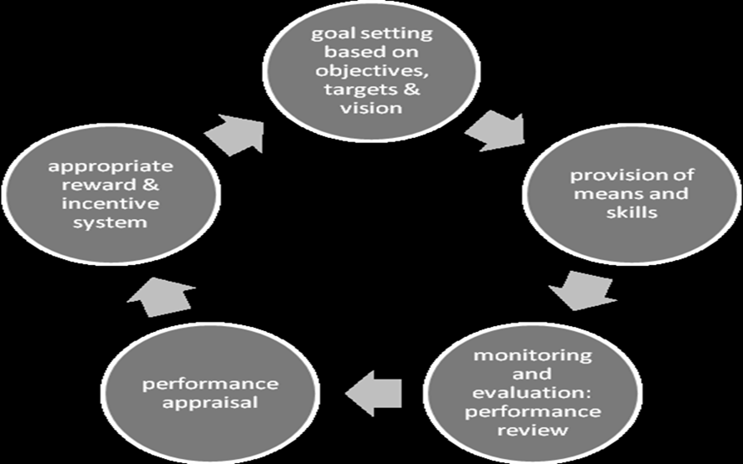

Upon examining the history of the Police force in the Republic of Mozambique it is found that many of the serious problems at different levels were related to the bureaucratic organization of the department. The assumption is that several problems are related to the administration and resistance to changes. Unfortunately these problems may reduce worker motivation and can generate a number of potential constraints.

Managing and developing performance do not operate in a vacuum. The context in which this takes place is important. Custom and practice are part and parcel of this context. It is relevant, therefore, that we elaborate on the notion of organizational culture.

2.2.6. Organizational Culture
The concept of organizational culture addressed widely by researchers. Commonalities among theories that discuss this concept include a focus on the variables that integrate and interact in a particular organization. According to Lins (2007:53),“we can say that organizational culture reflects a social energy that stimulates the components to act, adding meaning and orientation, as well as a control mechanism, allowing informally to approve or prohibit behavior”.
For further elucidation, Lins (2007: 53): continues by stating that organization needs to produce a series of patterns, habits, values and attitudes of the people who compose it.
Shein (1986:15): argues that organizational culture is a set of essential designs of the authorship of a particular group in the process of analyzing and solving various problems facing of internal and external environment and a review made by the group is valid and serves as a good model for the insertion of new elements of the group.
Culture is one of the key elements that characterize a particular organization and that causes an organization and causes it to be different in relation with others. This assumption is supported for instance, by (Wiley 1996:81), who states that 'Organizational culture is a widely acclaimed metaphor for understanding how organizations differ, how their members cohere, and how members and organizations interact’. Therefore, an analysis of different ways to consider the concept of organization manifests tree key issues. The first is the common goal to achieve the objectives due to the fact that not enough people express willingness to work together. However, teamwork is necessary in order to achieve a common goal, thus cohesive organization must conduct their activities through harmonious and controlled actions, based on the desired objectives.
A Second key issue are the resources that organization uses to effectively carry out its duties goals, (beyond the financial ones), and which enable organizations to compete and create credibility to the outside world.
Lastly, managing and applying the few resources available by an organization is usually scarce, hence the need to devise for consistent and adequate resource management is imperative.
When approaching an organization, it is important to have discourse on human performance as an essential factor for realization of the organizations’ activities.
Lucena (1992: 20): argues that the logic of the process in the organization clearly demonstrates that all actions must be oriented to the pursuit of mission accomplishment. For Lucena (1992: 21), the requirements or conditions for human performance are namely: “vocational skills, organizational culture, management style and the external environment”.
As stated earlier, all organizations need to be cognizant and clear about the objectives and how they should be achieved, taking into account the rational use of human and material resources available and the factors influencing human performance.
For the purpose of this research, we explore the organizational culture in the police forces in the Republic of Mozambique. Lucena (1999) and Chiavenato (2006) approaches are particularly relevant because they consider the functions of an organization, how organizations develop their work, the working relationship among its members and the organization’s role in relation with citizens. Another extremely important aspect of this approach is the fact that they think and say that the police forces resist the changes in the reforms due to dogmatic and uncompromising way of their work.
Indeed, it is of utmost importance to understand the organizational culture within the police force because (Paoline 2003: 200). She argues that the organizational culture of this particular organization is so important because the police officers are directly and intensely involved with the mass public, and also that historically the police force have been viewed as an authoritative , disciplined and intolerant institution. Moreover, there is a strong sense of solidarity, or spirit de corps. “Researchers have found that efforts to ensure accountability of the police have been met with cultural resistance stemming from the credo that polices should never “rat” on fellow officers and the “impenetrable” blue wall of silence “that thwarts often investigations of officer wrongdoing”.
The police have a cross-function, i.e., it has, beyond the general aspects of employees and agents of the state, several other specific missions that differentiate it from the others institutions in the same state, even private sectors. Examples of this are: the police intervention in cases of crime prevention, enforcement of law, and intervention against criminals, representing the state and society (law 19/92, creating PRM). About this issue, Salih ( 2010) stated that:
The Police can be defined as those non-military individuals or organization that are given the general right by Government to use coercion to enforce the low and to respond to individual and group conflict involving illegal behaviour. Although, the military can be given police powers, of course the police use methods other than coercion, but this is what distinguishes them from other government agencies and employers.
Police officers make use of the means that the State gives them, including the uniform, to acquire a new and specific cultural-based values system with norms that differentiates them from the rest of community in which they live. The organizational subculture of policing is illustrated in the fallowing figure:
Figure 1 Illustration of levels of cultural assessment from the overall occupational through individual officer styles
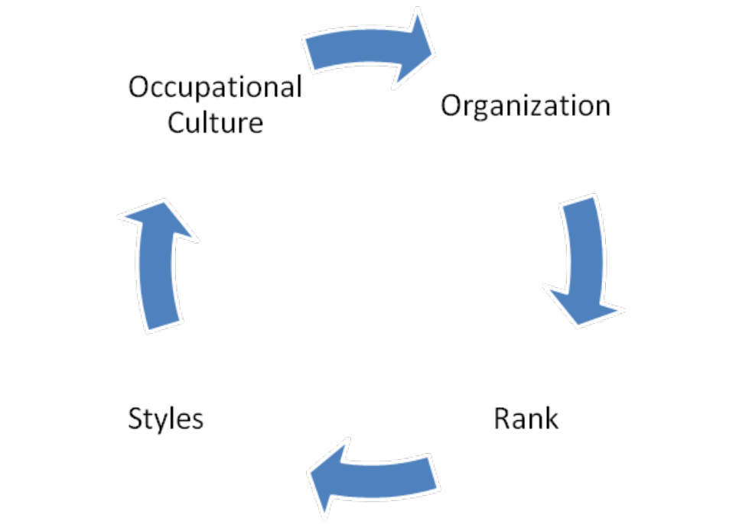
Source 1:Paoline,( 2003) adapted by the researcher.

This figure ‘illustrates the different levels of cultural assessment from the overall occupational through individual officer styles. “Police culture is best understood as a filtering process that is mediated through the organization and within by rank and style. At the most fundamental level, one can begin as members. Finally, it is when officers become patrols that they are said to develop their “style” of policing” (Paoline 2003:209).

In the next section we will elaborate on theories of motivation.

2.2.7. Motivation
Herzberg (1966:56) says that if we want to motivate people it is important to consider the basic elements: hygiene factors and motivational factors, that means that in the process of motivation we need to look on it. In fact, we have to have basis otherwise we do not motivate people.
Herzberg highlights two factors of motivation:
The first are hygiene factors such as: salary, job challenges, social benefits, work environment, organization policies, social benefits, job recognition, job security, and training, among others. The second are motivator factors, such as responsibility, job environment, recognition, progression and achievement, among others.
According to Stella (2008:25), “Herzberg argues that hygiene factors must be initially observed in the job before motivators can be used to stimulate the job and the resultant feeling of motivation to be achieved. This implies that you cannot use motivators until all the hygiene factors have been fulfilled. Hygiene’s theory spells out unique and distinct issues which people need in their work to enable them feel motivated to perform well”.
Similarly, as stated by Stella (2008:20), in reference to Harris in (Milapo 2001:29) “Motivation is significant because even people with the required knowledge, skills and abilities will perform poorly if they are not motivated to devote their work”. Therefore, institutions must satisfy workers needs at workplace. Further, Stella (2008:20),sustains that “when workers have lack motivation they tend to resort to anti-work behaviours such as absenteeism, negligence of duty, late coming, failure to meet deadlines, display of open frustration, and all these factors work negative to the performance and credibility on an organisation.
The motivation for workers ( in particular for public servants) is crucial in providing high quality service, as motivation is seen as an essential tool for increasing productivity and the realization of the objectives pursued by the organization. When workers are more motivated, they will exert more efforts, commitment, and consequently have a better job performance.
Of course, if these elements are well applied it is possible to motivate people because it is supposed to be created the environment in which people feel motivated.
For (Herzberg 1966), quoted by Rocha (2005:78), argues that where hygiene factors affect motivation, while the motivational factors are leading to job satisfaction.
In sum, the concepts and theories above are useful as an academic tool to frame the reality of the police force in Mozambique. The concepts above are interrelated in the framework of human performance; hence, they are crucial into analysing how managing people through motivation and finally are useful tool for reforms, taking into account the following aspects:
- The specific problems affecting the PRM in Mozambique ;
- The Mozambican police force is a paramilitary organization with specific characteristics, including a strong hierarchy with a high degree of discipline and order. The chief officer (boss) determines all that occurs in the organization and the subordinate officers must fulfill this order (given order, order fulfilled), thus there is no participatory process in decision-making.

Chapter 3:
Description of Public Sector Reform and Human Resource Management in Mozambique

3.1. Contextualisation
As we have seen before, the study focuses on performance evaluation, motivation and career development of PRM using the case of Boane and KaMabuKuana, both districts of Maputo Province. The first being located at the southwest of Maputo Province and the other is located in suburban area of Maputo, the capital city of Mozambique. The respective maps are presented below.
Map 1- District of Boane
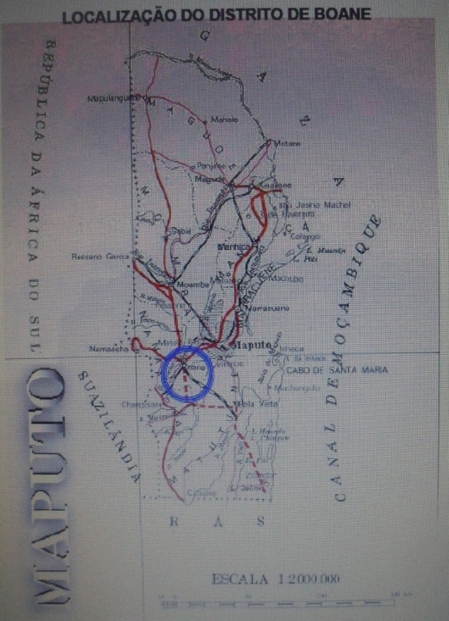
Source: www.google.com, accessed 21/07/12

Map 2-District of KaMubukwana
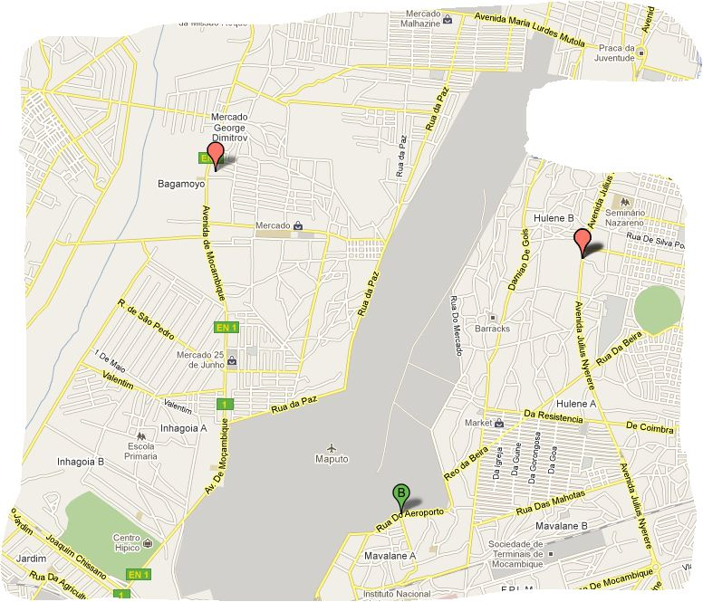
Source: www.google.com, accessed 21/07/12

3.1.1. Organization of the Police of the Republic of Mozambique
Under decree 27/99 of 24 May establishing the Organic Statute, the Police of the Republic of Mozambique, known by the acronym PRM, lies within the Ministry of Interior is organized into units and sub-units.The Police of the Republic of Mozambique also designated as PRM (The art.2 of Law n. 27/99) establishes that PRM is organized into units and sub-units:

Units are:
a) The General Command;
b) The Provincial Commands;
c) Special Forces and Reserve;
d) Educational establishments.

Sub-units are:
a) The Commands of District;
b) The Squadrons;
c) The Police Stations
d) The Special Forces Detachments and Reserve.

The Police of Republic of Mozambique develop activities in context of public safety services in whole national territory. Its main functions are to protect lakes and rivers, traffic police and Air police, among others.
The PRM has a Directorate of Criminal Investigation which has under its responsibility the management and preparation of methodologies for investigating crimes and conducting activities pertaining to preparatory instruction of criminal cases, conducting diligences required by the judiciary and the Public Ministry (Article n. 12 of decree-law 35 007, text introduced by ordinance n° 17076 of 20 March, 1959).

3.1.2. Functions of the PRM
The PRM has multiple functions, but basically, according to the Law 19/92, of 31st of December (which creates the Police of the Republic of Mozambique) they are:
- To ensure order, security and public peace, respect for the rule of law, the strict observance of the rights and fundamental freedoms of citizens.
- To ensure compliance with legality, ensuring order, security and tranquillity; protect property; adopt adequate measures to prevent crime and other acts contrary to the law and regulations, without prejudice to the powers conferred by specific law to other organisms.
In 1999, the Mozambican government approved a new organic structure of the Police of Republic of Mozambique by Decree 27/1999, of 24th of May. According to this Decree, the PRM is hierarchically organized. It is headed by a General Inspector and co-adjuvant by a Vice- General Commander
The article 23 of the organic statute of the police establishes the existence of PRM District Police Command and defines it as ‘ a territorial organ that has direct dependence on the Provincial Command.’ The Command of the District is headed by a police officer with the rank of Superintendent, Deputy Superintendent of Police or Inspector, if the level of Districts are classified in A, B and C, respectively, according to the diagram below.

Figure 3- Organization Chart of the PRM Command of District and Police Station

Source: Decree 27/99 of 24 of May, 1999, adapted by researcher

The figure shows how organically a Command PRM is organized and structured from the top to bottom. All components, including the police stations of District Command are subordinated to the District Commander who is the top manager and he is co-adjuvant by the head of operations.

3.1.3. The nature of reforms of PRM (current procedures/system and practices), special reference to HRM and PE of the 2001 policy.
The Mozambican Government approved in 2001 the Global Strategy in Public Sector Reform, abbreviated by (EGRSP). For the process of monitoring the activities related to this reform. The Mozambican government created a public unit with full power, known as Technical Unit of the Public Sector Reform, abbreviated by (UTRESP), whose mission is to manage the reform in all its measurements and areas of public administration throughout the national territory.
The PSR in Mozambique is the result of a thorough analysis based on three phases of the construction of the Mozambican State Apparatus since 1975, when Mozambique became independent from Portuguese colonial system.
According to CIRESP (2001: 6), the he first phase starts with the proclamation of independence in 1975 and the immediate adoption of model based on centralism, under the aegis of FRELIMO who ran the State and Society. The second stage took place in 1986 under the program of rehabilitation, consisting of the passing of centralized economy model to the economy of western model widely known as market’s economy.
The third and final phase begins with the introduction of new legal and constitutional order based on a multiparty system and rule of law.
One of the main objective of the Global Public Sector Reform, in the period 2001-2011, is to build a new policy performance management system in order to create conditions for the improvement of the performance evaluation in the public service, both to the institution and in the context of individual performance (Statistical yearbook of the employees and agents of the State 2001:19)
The Police of Mozambique has been integrated in all stages of development of independent Mozambique and has developing followed all reforms that have been taken place as part of the active element of the process. However, the most significant moment come at the time in the context of public sector reforms; the Police of the Republic of Mozambique approved its Strategic Plan in 2003. “The police strategic plan was to guide the intended changes and improve the policing sector between 2003 and 2012. It stresses the need for the PRM to adjust to the present socio-political development Mozambican context”. (Alar 2010: 119).
As a result of the PSR, in 2003, the PRM began to undertake a series of activities aimed at internal implementation of the reform. In fact as stated by Alar (2010: 121),“in the process of designing the police strategic plan, the PRM tried to conform to the PSR recommendations with regard to involvement of interest groups in public policy-making.”
From this perspective, both the Ministry of Interior of Mozambique, as well as all central and local organs of the General Command of the Police of the Republic of Mozambique were urged to prepare indispensable conditions for the effective implementation of the reform. As we can see, the process of PSR in the PRM is developing gradually and is one of the key issues being debated in the management of human resources.

3.1.4. Implementing Frameworks of PSR
‘What is the basic problem now?
There is not the absence of reform, but the lack of a comprehensive strategy for reform. This distinction is fundamental. (Prime Minister, Dr. Pascoal Mocumbi, 2001)’.
Systematic knowledge of administrative procedures by the public servants, allows the adjustment of public administration to the needs of the redefinition of the role within the State institutions, in which the PRM fits.
The overall objective of the Reform, as it was regarded in the Global Reform Strategy (2001-2011), regulate, among several issues, that the public sector apply the administrative and simple service, effective and modernized. It is intended to guide all public institutions in order to provide quality services closer and closer to the citizen; to promote a public culture based on integrity, transparency and accountability, stimulating participatory democracy, to fight against corruption and to ensure the strengthening of the rule of law.
Regarding the nature of the reform, the Inter-ministerial Commission of Public Sector Reform (CIRESP: 9) says:
The main challenge of reform refers to changes in the public services and especially to change the culture, attitude and behavior of public servants towards their work. The aim of the reform is that public services can be more operational, working for results-oriented and focused on the citizen.
It is in the context of consolidation of global public sector strategy, that, in 2009 the Mozambican Government approved the General Statute of Employees and Agents of the State by the decree n.º 14/2009, of 17 March, with the main objective of the need to enhance the dignity and self-esteem of Employees and Agents of the State. This objective emerged as a legal platform to ensure that employees, in their capacity as State servants at all levels, perform their duties with diligence, professionalism, transparency, fairness, responsibility and always concerned to better quality of service provided to the citizens’ (decree n. 14/2009:3).
On the other hand, the statute of the PRM, approved by the decree nº 28/99, of 24th of May, states, in the article nº. 29, that: the purposes of performance appraisals in PRM, as administrative procedures are:
Designed to ensure a fair career and a proper human resource management, allowing the development of the sort order, namely:
a) Assessment of suitability for promotion to higher rank or position.
b) Requisites of merit of the performance in certain duties and functions
c) Selection of the candidates for promotion.
d) Determination of insufficient physical and mental fitness.
The PRM has an organizational structure and internal rules and specific norms in which it operates. It has a hierarchical system and paramilitary’s features. For this kind of organizations, performance evaluation is important because of its utility in matter of career development, regarding progressions, promotions, and other acts specified in the statutes of PRM. In fact, the problems of managing the process of performance evaluation have drastic effects on motivation and performance of police officers.
As part of the on-going reforms in the public sector in Mozambique, the government, recognizing the importance of representing the system of performance management in public administration approved the decree nº 55/2009, of 12th of October, establishing SIGEDAP, which means the Performance Management System in Public Administration.
SIGEDAP appears in response to a numerous transformations brought in the system of functioning within the public institutions in the world, in Africa and particularly in Mozambique. The main objective is to provide a better quality of service delivery to the citizens. This was recognized by the government in the preamble of the decree above mentioned, when the former Prime Minister Luisa Diogo wrote that” this is a management tool system that will create an atmosphere of responsibility, merit and transparency in the operation of services’ (SIGEDAP 2009:1).

In the context of desired transparency in public sector, the article 249 of the Constitution of Mozambique states that “the organs of public administration obey the Constitution and the laws, observing the principles of equality, impartiality, ethics and justice”. Also, the article 62 of the Law nº 14/2009 (general statute of the civil servants and agents of State) highlights that performance evaluation of civil servants and agents of State must be done in a systematic and periodic way, according to the existing regulations in Republic of Mozambique.

3.1.5. Management model of people in PRM
In PRM, are the Directorates of Personnel and Training (DPF) and their representations in the provinces, are responsible of planning and promoting career and human resource development (decree 27/99). In fact, the article 15 of the statute of police determines that the DPF has to, among other duties,' prepare the overall program, as well as to ensure the permanent staff management of PRM as the guarantee of the control, provisional management of the staff, including recruitment and selection, transfers of service promotions, dismissals, assessments, and others'.
This option of the legislature to create the figure of the Directorate of Personnel and Formation (training) seems to have been inspired by the specificity of activities and characteristics of the Police. This assumption leads us to believe that seems to be relevant the consideration of specific aspects of the police officers as the most precious resource of this organization.

3.1.6. The motivation factors that are applied in the performance evaluation and how these are currently applied.

Work conditions and physical environment

The working conditions and physical environment are seen as important incentive, such as to create or to improve working relations between them by providing satisfactory office facilities, good sanitation and more capacity building. These aspects are related to hygiene and safety conditions of employees and agents of the State under the article 81 of decree 62/2009, establishing the rules of the General Statute of State employees and agents of State. This article determines that the entities have to create and develop conditions of hygiene and safety to ensure appropriate 'physical and mental integrity of workers, and constant improvement of working conditions.

Training
The core objective of training the police officers in Mozambique, according to the provisions of the article 22 of the Statute of Police, is to promote technical and vocational preparation. Its implementation is done by training courses, improvement courses, refresher courses, and courses for promotion.
Salary and remunerations
The salary is the basis that allows the satisfaction of many basic materials requirements of the member of the Police and is undoubtedly one of the greatest incentives for workplace motivation. Good policies to give more appropriate wages for police officers in order to satisfy their material basic needs, allow them to feel motivated and less vulnerable to corruption.
The issue of salary is touted as a big concern in PRM. In fact, the minimum wage is estimated at 4000 MT, equivalent to about USD 148, including all subsides per month.
Actually, how well we can see, the salary that a police officer receives, compared to what happens with the majority of private services is extremely low in terms of the level of life cost in Mozambique. Is the case to say that the police members and other workers of PRM “do not live; they are surviving as the majority of ordinary people”. The argument is that what is paid to the police as salary does not solve half of the primary needs. The structure of remuneration for members of the Police was approved by decree nº 29/99, of 24th of May.

Job Security and Social benefits

The Law n° 23/97, of 20 of June (labour law), attributes responsibility to all institutions and companies for ensuring safety at work. In this context, the Mozambican government, determined through this law to create committees of safety at work, especially for those who are carrying out high risk of accidents and illnesses that may result from the exercise of the functions of workers. Also, the same Law considers important to pay special attention to the medical assistance, medical tests, and prevention of accidents, insurance and assistance in case of illnesses.

Opportunities to promotion in PRM

The decree n° 28/99 of 24th , of May (of the PRM) makes explicit that the career development is based on different ranks, obeying the rules and prerequisites for promotion based on specific course, promotion by seniority, promotion by selection and exceptional promotion. According to the article 33 and followings of the decree 28/99, police officers can be promoted by four conditions: Education level, seniority, selection and appointment.
As it is clear demonstrated by the content of the decree above, the progression and promotion in the PRM does not depend on the performance evaluation and professional merit.

Performance Evaluation in the PRM

According to the article 29 of the statute of the police ‘performance evaluation of the member of the PRM is intended to ensure a fair and career progression in the proper management of human resources, allowing the elaboration of the order of classification under the various items concerning of the career development or determination inadequacies of human development.
For implementation of the evaluation process, the performance evaluation system in PRM is guided by the general rules applicable to state employees and internal rules of PRM, due to specific characteristics of the institution. The legal instruments that reinforce the performance evaluation are: the Constitution of the Republic of Mozambique, Law nº 14/2009 of 17 March, creating the general statute of employees and agents of State, decree nº 55/2009 of 12 October ,establishing the performance evaluation process in the public sector (SIGEDAP), decree nº 28/99, of 24th of May, approving the statute of the Police, decree nº 62/2009 approving the Regulation of Law nº 14/2009 of the General Statutes of the employees and agents of State.. This last decree, among other things, regulates the performance management system and applies to officials and other agents of the State engaged in public administration in Mozambique and abroad.

Chapter 4:
Presentation of findings

4.1. Findings
As pointed out previously, this research addresses the performance evaluation process in the police of the Republic of Mozambique, and the districts of Boone and KaMubukwana were selected and respective maps are presented below. Thus, this chapter provides the data which were collected during the field work. In this chapter the results will be presented in a framework based on the four key questions suggested for this research work.
The subject of this research was the Police of the Republic of Mozambique described in chapter 3.
From the literature review presented in the chapter two, we can see that it is crucial the link between performance evaluation, motivation and career development in order to attain a good performance within organizations or institutions.

4.1.2. Performance Evaluation arrangements in the 2001 policy

The findings of the study indicated that, in general, in PRM there is an understanding of the performance evaluation value as an important of human resource management instrument, in order to motivate and to promote transparent career development. However, the implementation of norms and rules tends to be a chronic problem affecting performance, motivation and career development of police officers in Mozambique.
For instance police officers interviewed in two districts, mentioned previously, revealed that they feel subjectivity and absence of transparency in the performance evaluation. According to their opinions there is a very high level of subjectivity and too low level of transparency. Consequently, they consider that this problem remains to be a great concern among police officers in PRM.
Comparing the views with the laws and norms, these anomalies pointed out by the respondents, contrasts severely with the article 249 of the Constitution of Mozambique, and the article 62 of the general statute of the civil servants and agents of State (Law nº 14/2009, of 17th of March) as we have described before.
As an example, According to Florentino Sagres, head of the Department of Administration and Personnel Management of the General Command of the PRM, the implementation of the public sector reform, introduced in 2001 is still in several constraints in PRM, due the resistance to changes, lack of culture of activities’ planning and the absence of providing information about the activities that have done.
He further indicated that, “in the context of public sector reforms, two years after the entry into force of the new model of performance evaluation in the public sector, called Performance Management System in public administration, abbreviated by (SIGEDAP), most units and subunits of the PRM have not yet started its implementation”.
To explain how the SIGIDAP is implemented in PRM, Dr. Florentino Sagres argued that the process was introduced in January 2010 and it is supposed to be applied in PRM between the months of March and April. The process began with training the police commanders and chiefs of all provinces of Mozambique and the General Command of the PRM, which who serve as sources of information acquired to other workers of the police.
Dr Sagres added that, despite the existing instructions in order to start the process of evaluation under the new model, only the Provincial Commands of Sofala, Nampula, Inhumane, Maputo City and General Command itself reacted positively. He attributed as causes of this fact the apathy and resistance to change. Given this reality, it becomes evident that PRM is in ‘a mixed state’ in which some police officers are evaluated and others, unfortunately, are not evaluated.
In fact, from the 35 respondents, out of the 11 police officers and commanders (evaluators) who answered the question (if it is difficult to apply the public sector reforms) , 5 of them, which corresponds to 45% said that they did not know (DK), 4 strongly disagree (SDA), which corresponds to 36%, 1 strongly agree (SA), which corresponds to 9% and 1, which corresponds 9%, agree (A),.This may be one of the causes that make them discouraged and not satisfied because they do not feel that their work is not recognized and valued.
Nevertheless, according to police officers, respondents in the districts of Boone and KaMubukwana, these principles are not taken into account by the superiors in process of analysis of promotions. In fact, they feel that there is a lack of equity between effort employed and reward received or receivable that never comes, developing a situation of tension.
This problem is usually characterized by decreasing of performance at work and dedication missing a duty of probity with which public server must be present in his performance.
From the total of 35 respondents (11 evaluators and 24 evaluated), 29 police officers, this is, 9 evaluators and 20 evaluated) answered the questions about the question of performance evaluation and asserted that they have not been evaluated for the last 5 years. This numbers represent a dramatic situation in which the process of performance evaluation seems to be in stagnation. They pointed out as the causes the resistance to changes and absence of planning of activities.
For stance, according to an inspector of the PRM, the professional development of members of the PRM has been performed with many problems related to human resources management: practices.
Performance evaluation is not felt as important by the evaluators. In fact, they are the same people who have power over their subordinates, but they do not respect and do not act according to the criteria set out in current legislation on this matter. For this reason, the horizontal progression scheduled to take place every tree years and the vertical progression which should take place every five years do not take place. This problem undermines and discourages police officers who are engaged in the fight against crime (anonymous officer of the District Urban KaMubukwana, (interviewed- 21.10/2012 and translated from the Portuguese).
In an implicit criticism one of the respondents indicated that:
Despite the existence of constitutional law and other subsidiaries laws related to performance evaluation, we can find situations where the police officers are evaluated in the local level, but when the proposals are sent to the higher levels, especially when they are sent to the Directorate of Personnel and Formation of the General Command of the PRM, the final results are not corresponding to their expectations. This problem has a negative repercussion, because it causes discontent, weakens of professionalism, and creates poor dedication of the police officers in their duty of maintaining order, security and peace. For example, career progression is destined only for certain people without regard of the results of professional performance, without transparency".(Police Commander of Mozambique of Boane District- 17/08/12).
Also in this matter one of the respondents highlighted that:
In PRM, some chiefs and commanders think that the Police is their private business and has no rights that a member has duties only. So here within the police there is no law or rules governing its operation and is why many do not work. The interviewed clarified saying that the main problem is based on the problem of internal organization, corruption, favoritism and nepotism (anonymous interviewee informally in the District of KaMubuKwana, (28/08/12) and translated from Portuguese)
Meanwhile, Superintendent of Police Manuel Ubisse, commander of Police Station in the district of KaMabukwana, , said that he recognizes the importance of performance evaluation, but that, in his opinion, they should have their own rules and regulations for the performance evaluation, similar to what would happen to the doctors, nurses and others whose specific task differs from the normal operating regime. He argued that::
I think that performance evaluation of the police officers is a fundamental tool for human resources management which currently has, unfortunately, a lot of problems, because it often does not take place and it generates dissatisfaction that is aggravated by the lack of material resources. However, we need to understand that the police should not be valued as any civil servant work normally. The police, because, for example, their schedule is different, because they work 24 over 24 hours per day (although they have a rest of 48 hours), unlike the eight employee's normal. Police, also is required by law to maintain the order, peace and public security, and these tasks are not for other employees of the State or private organisations. But even so, we have tried to sensitize our subordinates not to be demoralized and to combat crime. '(Interviewed (28/08/12) and translated from Portuguese).
For instance Dr. Florentino Sagres, interviewed in 23/7/12, mentioned that Sources indicate that based on the legal instruments mentioned above, members of the Police should, in principle, be evaluated taking into account the principles of SIGIDAP, according to its article no. 3 (Decree n. 55/2009. These principals were mentioned before.
However, the respondent recognized that the present situation is not satisfactory because as he said before except 4 provinces of the country and the General Command of PRM are implanting the SIGIDAP.
Unfortunately, due to apathy and resistance to changes, the Police of Republic of Mozambique still continue to face serious problems in the implementation process of performance evaluation, and a serious violation and blame can be attributed to the multipliers of knowledge that were duly transmitted to the nationwide level all commands provincial and autonomous units. (Dr. Florentine Sagres interviewed on the day 23/07/12 and translated from Portuguese).
In fact, despite the existing statutory instruments and norms for that, its implementation is still a bottleneck due to factors related to human resource management in the police of the Republic of Mozambique which can jeopardize the motivation and career development of police officers, creating preconditions for poor performance in its task of preventing and combating crime.
Regarding the open-ended question, (if they can comment about the process of performance evaluation, and can give freely suggestions in order to improve the process of performance evaluation, motivation and career development of police in PRM).
Taking into account the similarities and the differences of responses of 24 police officers from the group of evaluated, said the following and represented bellow in the graphic 3:
- Do not feel the effects of the performance evaluation, because the results are not used for carrier development
- In the PRM, there is no interest in evaluating performance, because the superior do not want to use the results
- The superiors are not interested in performance evaluation because they abuse their power.
In conclusion, in the open-ended question (opinions and suggestion about the reforms in PRM, specially about performance evaluation, motivation and career development) , the police officers evaluators recognize that in general performance evaluation is not felt or reflected in the career development of police officers in Mozambique. In fact, the view is that people who have power in their subordinates do not respect and do not meet the criteria set out in current legislation on this matter. For this reason, the horizontal progression scheduled to take place between the period of 3 years and the vertical line should take place 2-5 years do not take place, thus this situation is undermining and discouraging police officers.
As we have seen before in the fourth chapter, the type of violation of the rules’ HRM undermines what is provided for in the General Statute of Employees and Agents of the State (EGFAE), However the Article 62 of that legal instrument establish that ' the performance for employees and agents of state is systematically and periodically evaluated under the regulatory and performance assessment and is for the employee or agent of the state prerequisite to access the perks'. In this context, most of the respondents shared generally negative views on the performance evaluation process within the PRM. They pointed to several negative points of view that discredit the process of performance evaluation, such as:
In the Police, the performance evaluation only benefits people who have personal confidence of the chiefs. Only those who provide favour "lambe- botas” (‘Boot- licking’) to the bosses are well regarded and promoted. That situation is creating unhappiness and low performance and low interest in the job. - (Anonymous interviewed in KaMubukuana, 28/8/12), Translated from Portuguese).
The performance evaluation is not seen as important “para Inglês ver”. Why to evaluate if often are only is promoted who do not do anything because he is friend of the boss' (anonymous interview informally in Boane, 17:08:12, translated from Portuguese).
According to the respondents the non-transparent way, subjectivity and unfairness are aspects that characterizes the evaluation process and this breakdown the expectations of police officers.

Performance evaluation in PRM
The respondents revealed that the motivation may have an intrinsic relationship with the professional performance and especially when that performance is recognized and valued through the proper evaluation and implementation of concrete actions.
However, the general perception in reality is that performance evaluation in PRM is not done according to their expectations, because the evaluators (police commanders) in PRM do not create harmonious “marriage” between performance evaluation and career development. Supporting this, police officers said that, despite a several problems related to the underdevelopment of the country, the existing efforts by the government in order to solve them are not enough. Also there is no interest in creating visible incentives within the police of the Republic of Mozambique.
The respondents mentioned problems related to hygiene and motivator factors as: low income, lack of transportation, lack of food during working time, the lack of incentives, social inequalities in treatment, problems of job security, not recognition for their efforts, dedication and sacrifice at work and low salary. According to the opinion of the respondents, these problems cause discontent and apathy. Consequently, some police officers have been involving in criminal cases.

4.1.3. The police officers’ perception of the promotion process, career progression and performance evaluation in the districts of Boane and KaMubukuana.
The general view in the PRM on the process of promotion is that it is not essential regarded to the performance of the police officers and it is not transparent. The respondents believe that it continues along the lines assumed when Mozambique became independent in 1975.In the period in reference, Mozambique was been ruled by a single party. Actually, in that time the workers were evaluated based on the political trust by their evaluators. The respondents said that: The PRM does not observe the decree n° 28/99 of 24th, of May that establish the requisites towards to promotion.
The situation above contrasts drastically with the legal instruments that underpin the performance evaluation such as the Constitution of the Republic of Mozambique, 2004, Law nº 14/2009 of 17 March, approving the Staff and Agents of State; decree nº 55/2009 of 12th of October; SIGIDAP, which guide the full process of performance management system in public Administration); decree nº 28/99, of 24th of May, approving the statute of the police ;decree nº 62/2009, of 8th of September, approving the Regulation of Law nº 14/2009 (General Statutes of employees and agents of the State). The last decree, among other things regulates the performance management system that is applied to employers and agents of the State engaged in public sector in Mozambique and abroad.
To demonstrate the seriousness of the problems linked to promotion, the Superintendent Mulhovo, police commander in Boone explained that:
In spite of theories, laws and regulations, in many cases, the promotion is not taking place. Several police officers remain several years without benefits, career progression or promotion for reasons that are not shown. Sometimes police officers are correctly evaluated at level of the districts, but when they send proposals for promotion to the higher levels, especially when they are sent to the Directorate of Personnel and training of the General Command of the PRM, the expected results are not satisfied. (Interviewed in Boane- 17.08.2012).
The police commander added saying that police officers know that they have the right to promotion by choice, by antiquity, by merit, by qualification with appropriate course, but the progression does not take place in required time, and the directorates of personal are disorganized, which creates conditions for subjectivism in promotions.
To support this, different police officers have presented their opinions as are shown below:
There are cases of police officers who entered in the PRM, for example in 1974, in 1980, 1985 and 1990 that should be promoted by seniority, but are do not receive this benefit. This is not because of lack of vacancies, but because, in reality, always are the same people that have this benefit '(Anonymous interviewee in the KaMubukwana 28/08/12)
These problems can generate negative repercussions, such as Job dissatisfaction, declines of professionalism, demotivation or less dedication of the police officers.

Implementing frameworks of the arrangements’ policy, in context of Public Sector Reform.in the 2001
There are numerous legal instruments that can contribute to the correct implementation process of PSR in PRM, such as the statute of the PRM, the general statue of employees and agents of state, the system of evaluation, among others. Also, the existence of these laws, regulations and norms can help to solve the problems of organizational culture, resistance of changes and concerted efforts to motivate police officers through creation of conditions to make successful the goals and objectives of preventing and combating crime.

Human Resource Management in PRM

As we have seen in the literature review and supported by the respondents, it seems to be relevant for PRM as a public institution to have police officers with a good performance, with a strong commitment by improving civil service performance, management approaches, intrinsic and extrinsic factors of motivation. The motivator factors are very important to achieve the objectives and goals in the context of its mission.

4.1.4. Career development of the police in Mozambique
The respondents pointed out as l causes of the dissatisfaction as to be the lack of recognition for their work and inequality in its treatment, as well as disparities in the process of promotions and career progressions.
To support this, they said that there are cases of individuals who have many years of service without any progression in their careers and without explanations about the causes. However, a career progression of the police officers in Mozambique is pursued according to Article 31 of the decree nº 28/99 of 24 May, guided by the norms indicated beforeThis contrasts with the content of the law in reference and with the hygiene factors advocated by Herzberg which are those that increase job satisfaction.

4.1.5. Motivation factors that are applied in the performance evaluation and how these are currently applied.

Salary
The issue of salary is touted as quite concerned by all 35 members of the police who responded interviews and surveys in the districts of Boane and KaMubukwana. In fact, the minimum wage, according to the sources is estimated at 4000 MT, equivalent to about USD 148, including all subsides.
According to the respondents, the salary of the police officers in Mozambique is very low compared to others similar organizations in public sector, such as customer services and judiciary institutions. The argument of this situation is demonstrated in the table below:

Professional category | Institution | Salary | Difference
Ordinary officer of Justice  Ordinary police officer | Judiciary--------  PRM------------- | 6,224,00 Meticais  4,000,00 Meticais | 2.224,00
Customs Inspector  Inspector of PRM | ----------------------  Tax Authority( with similar functions of Police)  PRM------------ | 24.256,00  12,623,00 Meticais | 11.633,00

Source: Decree n. 14/2011 of 25 of May-Pay scale of careers in general regime of systematic and specific careers and salaries of public sector in Mozambique.
This is evidenced by a senior official of the Police District KaMubukana, who requested anonymity, said that:
Due to the insufficient salary of the police officers in Mozambique, a large number of them are involving in other activities that contrast with their police duties, pointing out as an example the exercise of activities related to private security, and even worse is that some of them engage in criminal acts. (Senior police officer interviewed KaMubuKwana on 14/08/12).
The findings demonstrate that the respondents felt that the salary is very low and this does not encourage them and to be motivated because the current monetary payment is not enough to sustain the needs of police officers life, According to the life level, in the context of market economy of the respondents, they felt that the monetary payment in PRM is bad. In fact, if we reflect around the Herzberg theory of motivational and Hygiene factors, good payment to employees can contribute or can determine to better performance because good salary can provide motivation.
The respondents said that the incentives are written in the paper and the Ministry of Interior and General Police Command know these rights, but unfortunately they do not make effort to satisfy them in minimums. It means that the reality is demonstrated differently because there are not adequate conditions to promote performance. They said that: The incentives are well written in the paper and the Ministry of Interior and General Police Command know these rights, but, unfortunately, they do not make effort to satisfy them accordingly.

Job security

Regarding job security of police officers in the districts of Boane and KaMubukwane, the general view of the all 35, which corresponds 100% of the respondents was really negative, because for them the situation is absolutely inadequate and insecure.to support these views the respondents said that: There is no job safety.The reasons presented are related to the structural problems of PRM, such as leadership and human resource management system”.

Job recognition

The 35 respondents said that the recognition of their job by the police commanders and other superiors at high level is one of the critical problems that they have been facing. This problem, according to their opinions, affects their motivation, but they recognize that at the low level the recognition tends to be good and somehow effective. However, They mentioned that: the general feeling of the police officers is that at high level of General Police Command the concern of superiors is to pay greater attention to the failures and problems of each police officer for punishments, leaving aside the positives result of the good performance that have done. Consequently, they are not promoted and their carrier does not developing for several years.

Social benefits

All 35 respondents shared a negative view in the context of social benefits. They converge in pointing out that in PRM there is no concern on considering as important tool these issues. Therefore, the reason is because there is no job safety. The respondents pointed out, as examples, in inadequate medical assistance and medication, the lack of life insurance and medical tests that are not performed to determine the physical and intellectual capabilities of the police and the social services do not operate well and others. All these problems contrast with what was mentioned before, and according to the Labour law of Mozambique.

Job relations

The respondents said that harmonious relations between employees in certain organizations are seen as an important human resource management. Of course, according to them, they facilitate the interaction between group members. PRM is a complex institution with a strong sense of hierarchy that, unfortunately, increases the distance between police commanders and subordinates. Therefore, if relations are harmonious it can help motivation. However, according to the respondents in PRM, there is a great distance between police commanders and subordinates because of strong hierarchy. This problem cannot contribute to trust of each other.

Training

The findings indicated that the completion of the training of Police officers has two different ways. The primary is held in Basic Training Centers, as is the case of the Practice School of Matalane, the second at the Academy of Police Sciences, abbreviated to ACIPOL including intensive training, known as Executive Course lasting two years, after which period acquire the Bachelor level. The opinion of the respondents is that training police officers shows necessary and relevant both from the standpoint of physical and mental. However, the respondents guess the need of improvement in order to match the requirements of the development of modern societies and the "modus operandi" of criminals.
To confirm this position, the police officers interviewed in the two districts were unanimous in their opinion that: the current process training of the police officers and new staff cannot encourage a good performance and does not create objective conditions for improving the performance of their duties The they added that they feel demotivated, because the formation is not seen as a form of recognition.
For general illustration of the problems, the details are illustrated in the table below:
Summary of the main problems
Table 1.Main problems in Boane and Kamubukwana districts

Facing Problems | Total of respondents | Members of PRM that indicated kind of problem | Percentage
Performance appraisal does not follow the criteria established in the laws and internal rules in PRM | 35 | 25 | 71%
There is delay in promotion of members of the PRM | 35 | 32 | 91%
PRM do not pay attention to social benefits for members of the PRM | 35 | 30 | 86%
The salary of the members of the PRM is low | 35 | 35 | 100%
Working conditions in the PRM commands are inadequate | 35 | 35 | 100%
Lack of job security | 35 | 27 | 77%

Answering the question about the possible impacts that could result from problems encountered, 35 police officers gave their opinion as follow:
17 officers of PRM, corresponding to 49%, said that the impact of the problems affecting the Police of the Republic of Mozambique may cause demotivation, 12, corresponding to 34%, indicated low performance at work, 5, corresponding to 14% guess that can originate apathy, 29 corresponds to 83 % presume the trend in bribery practices, 30 corresponding to 86% think that the problems can cause discontent or job dissatisfaction. In summary, the data are presented in table and graph below:

Table 2: Impact of the problems

Impact | Total of respondents | Members of PRM that indicated kind of problem | Percentage
Demotivation | 35 | 17 | 49 %
Low performance at work | 35 | 12 | 34%
Apathy | 35 | 5 | 14%
Trend in practices of bribery | 35 | 29 | 83 %
Discontent/job dissatisfaction | 35 | 30 | 86%

Graph 1. Impact of the problems
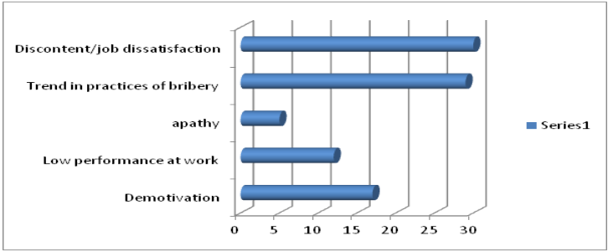

Chapter 5:
Conclusions and Recommendations

5.1. Conclusions
This part of the paper provides a sort of interpretation as toward conclusion of the research and the data which were collected during the field work in the districts of Boane and Kamubukwana, in the context of public sector reforms in the period between 2006 and 2011.
In fact, the study intended to inform and awareness amongst policy makers within the PRM and society in general in Mozambique, on certain aspects useful to performance evaluation within the police force. It is also intended to point to factors that may hinder the process of police officers and how these can be taken into consideration.
The researcher started this study with the main questions and according to the literature review concluded that the performance evaluation and correct application of hygiene and motivational factors are necessary conditions to motivate workers in context of human resource management system, because through them the activities of the police officers in Mozambique became more effective and productive.
Motivation Theory has revealed in the history of organization to be a fundamental base for the fulfillment of their visions and missions, within the context of their operations or activities.
The Police Force of Mozambique is not an exception in this context, and indeed, the key challenge of several organizations resides in the need for consciousness on motivators and hygiene factors that can be vital for the success of an organization.
From the findings of this study, we can draw the following conclusions:

5.1.2. What we have looked in Mozambique in process of implementing frameworks?

Firstly, the major findings of the study, indicated that the main problem in PRM is that the performance evaluation is not done regular or in some cases is not done, and nor according to the rules and regulations. Also, the study showed that the PRM does not put in consideration the hygiene factors such as performance evaluation, training, job security, working conditions, social benefits, among others. This situation contrast with Herzberg’s theory, in order to motivate people in organizations.

Secondly, the police officers are not satisfied in their job, because PRM does not compliance with the legal criteria established by law, norms and internal regulations to manage properly the issues related to human resources, such as promotions and career progressions. Also, the problem is that these provisions, unfortunately, are based on friendship, favoritism, and partiality in treatment at the assessments, breach of legislation and standards, and paternalism, resulting in the doubtfully about their performance and motivation.

Moreover, it became clear that police officers in Mozambique cannot be evaluated because of resistance to changes by the police hierarchy in the context of public sector reforms underway in public administration in Mozambique. This situation is really negative because results in interruption of their career development.
Similarly it became clear that the PRM have been facing serious difficulties in interpretation and connection between the Herzberg’s theories of motivation that was shown in chapter two and their work’s conditions. The reserch showed that hygiene and motvational factors of Herzberg are not good applied because of strong hierarchical culture, discipline and obedience of PRM. Thus, we can see that police officers do what the supriors say. This situation can led to resistence of changes and consequently can criate problems in implementig PSR.
It became clear to the researcher that members of the PRM feel dissatisfied and one of the serious problems is the lack of interaction and communication between the police officers and their commanders and chiefs, characterized by the nonexistence of space for the exchange of ideas and the lack of interest in hearing to their worries.
The study confirmed that there is a great concern among members of the Police of the Republic of Mozambique in relation to the process of evaluating job performance, problems on job security, low salary, poor job conditions and non-existence of social benefits. In reality, most of the respondents recognize that the PRM faces serious problems in the implementation of public sector reform started in 2001 due to the lack of clear definition or strategies of human resource management, and this fact is undoubtedly reflected in their performance.
The members of the PRM feel that their job conditions are chaotic and they are not satisfied with their salary considered too low in order to satisfy the basic needs when compared with similar institutions
It is a common opinion of the police officers that the PRM does not pay attention to the social benefits, such as housing, medical assistance for all PRM workers and their first-degree relatives and dependents. Also, they stated that do not feel that their job is secure and their efforts is not recognized by their superiors in the Ministry of Home Affairs as government representatives. As was seen in the literature review and pointed out by many respondents, performance evaluation is an important instrument to promote a good human recourse management and create conditions to motivation and career development in the PRM, based on existing legal instruments.
The research showed clearly that, in general, the majority of the respondents have a negative views regarding the key questions of this research as when they claimed that since introduction of the reforms in public sector in 2001, the issue of performance evaluation, as a system of human recourse and management, is still more project than a reality.
As we have seen before, the promotion system is made by rank of the police officers, observing the organic structure of PRM, from probationary constable to General Commander who has the highest level of General Inspector of PRM. However, the promotion is not taking into account the performance evaluation results and merit of the police officers in order to avoid the lack of transparency and subjectivity mentioned in the chapter of findings.
The organizational culture is one of the most important issues in the PRM as institution.Of course this has a link with motivation. Actually,this contribute to the atmosphere in the context that people can perform.. It is enough clear that salaries are bad enough, there is a bad invoronmental working conditions, there is a problem of social benefits. However, If we want to motivate peolple we need to attentive what Herberg said in this context, as we have seen before.
Also, as we mentioned in chapter two about hard and soft models, it is important to recognise that if we want to motivate people we have to do efforts by ensuring people on the trust, by trainnming them, by trusting them, by promoting them.
Actually, if the ordinary people see that there is a nepotism, there is a favoretism, the hygine and motivational factors are not putting in consideration in order to motivate police forces because there is a hard model , based on strong discipline and care and stick, according to the organizational cultural based on discipline, hyrarquy, etc.it is not going well because of these factors of organizational cultural of the police forces, they cannot be motivated.
Then, we whould do what the models describe, having for stance every six months to have meetings, but the hard model is based in charater and stick, it is not perform, but what we see in Mozambique is oly the base on stick. If people get punishment or sansion, if they all perform is nothing. In Mozambique if we apply this model incorrectly they get negative results.
As we have seen in chapter three and four they do not apply the models correctly. Actually, there are the rules, but the results of the study showed that are not applied, because of resistence to changes. Therefore, the most important is that we have presented in the theories in the chapter two ,wehere we have to deal HRM based on PSR, being elenents from the public sector approach to individual appoach to making peolple to perform well.

5.2. Recommendations
According to the results of the study, are recommended the following aspects:
    - The need to improve on working conditions and job security in all units of police forces in Mozambique.

    - To take into account the theories of motivation, because in general, could serve as a catalyst and instrument suitable solution to the problems of human resource management and the best use of the theories but for that what is required, taking into account their value. These theories should be used involving them in the process of decision making in order to decrease the disincentive to work.

    - To create in PRM areas of planning and supervision in all units and subunits of the PRM linked to human resource management.
    - To pay special attention on the motivational and hygiene factors recommend by Herzberg, such as material and human conditions, socio-economic and psychological as motivational factors of police mission.

    - Looking for alternatives, the Mozambican government, through Ministries of Finance and MINT, to adopt adequate system of wage and better remunerations policies for public institutions related to administration of justice and others public institutions.
    - The need to promote greater and more systematic communication, interaction and consultation among police commanders and their subordinates.

    - Finally, this study cannot be seen as the end of the research and neither as bringing definitive proposals for solutions. In fact, while there were earlier studies in doctoral, honours degree and bachelor level do not finish the issues and indeed, even taking into account the unquestionable value and dimension of these researches, they do not go into specifics issues of the police as an individual and member of the organization. Therefore, I recommend needing of subsequent studies that can identify better performance issues, motivation and career development of the police officers in Mozambique.

References
Alar, F. (2010) 'Performance Management of the Police in the Context of Public Sector Reform in Mozambique', PhD Thesis, The Hague: Institute of Social Studies, Erasmus University
Armstrong, M.(2009). Armstrong's handbook of human resource management practice. London: Kogan Page.
Armstrong, M. (2006) Performance Management: Key Strategies and Practical Guidelines. London: Kogan Page.
Armstrong, M. and A. Baron (2002) Strategic HRM. The Key Improved Business Performance: Chartered Institute of Personnel and development. London..
Bechan, V (2011) ' Performance Management within the Ministry of Justice and Police’. Master’s Research Paper of Public Administration in Governance Degree, The Hague: Institute of Social Studies, Erasmus University
Bohlander, G., , S.A. Snell, and A. Sherman (2003).Administração de Recursos Humanos. Sao Paulo: Editora Thonsom.
Brown, K.(2004).'Human Resource Manangement in the Public Sector Management Review'(6(3), 303-309.
Buvana, F. and C.A.A. Ventura (2011) 'International Cooperation in Combating Illicit Drugs in Mozambique', Revista latino-americana de enfermagem 19(SPE): 762-770.
Chiavenato, I. (2005) Gestao de Pessoas.Sao Paulo:Campos Elservier 2ª Edição.
Dava, H.(2011) 'Avaliação de Desempenho Humano no Ministério da Função Publica ' Honors Degree Thesis (Public Administration). Maputo: Eduardo Mondlane University
Deakin, N. and K. Walsh (1996). The Enabling State: The Role of Market and Contracts. Public Administration (London)
Gaynes, K. L.,N.V.Turbergen and M.A Paiva (1984) 'Police Officers perceptions of promotion as a source of motivation: Journal of Criminal Justice. Vol. 12. Pergamon Press .
Gasper, D. (2002). Fashion, learning and values in public management: Reflections on south African and international experience. Africa development-Senegal.
Halligan, J., Bouckaert, G., & Van Dooren, W. (2010). Performance management in the public sector Taylor & Francis. Harris (1977) Human Resource Management. A Practical Approach. Forth Worth. Harcourt Brace College Publishers.
Halligan,J., G. Bouckaert and W. Van Dooren (2010) Performance Management in the Public Sector. Taylor & Francis.
Harris (1977) Human Resource Management. A Practical Aproach. Forth Worth. Harcourt Brace College Publishers.
Herzberg, F. (1966) 'Work and Nature of Man, Cleveland Vol.3 N. 3': World Publishing Company.
Hoyer G., (2011),’new public management: A strategy for democratic police reform in transitioning and developing’ countries", Policing: An International Journal of Police Strategies & Management, Vol. 34: 419 - 433
Hoyer, G. (2011). New public management: A strategy for democratic police reform in transitioning and developing countries. Policing: An International Journal of Police Strategies & Management, 34(3), 419-433.
Lane, J. E. (2000). New public management Psychology Press Routledge London.
Lins, S. L. B. (2008). 'Dimensões básicas de análise das organizações'. Revista de Administração da Unimep, 5(3), 50.
Lucena, D. M. S. (1995).' Avaliacao de desempenho, Sao Paulo, McGraw-Hill.
Lane, J.E. (2000) 'New Public Management'..
Mathis R. L. and J. H. Jackson (2000) Human Resource Management. Cincinnati: South-Western College Publishing.
Marescaux, E. et.al. (2012),'HR Practices and HRM Outcomes: the Role of Basic Need Satisfaction', Personnel Review, Vol. 42 Iss: 1 (Date online 18/9/2012)
Metcalfe, B. and D. Gavin (2001)' Exploring Organization in the Police: Implications for the Human Resource Strategy: An International Journal of Public Strategy and Management, Vol. 24 ISS.pp. 399-420.
Milapo, L. T. (2001)’Performance Enhancement in the Civil Service: A Comparative Analysis of the use of HRM Tools in Uganda, Zambia and Zimbabwe’, Master‘s Research Paper, The Hague: Institute of Social Studies, Erasmus University
Minogue, M. (2000). Should flawed models of public management be exported? issues and practices IDPM, The University of Manchester.
Moynihan, D.P. (2008) The Dynamics of Performance Management: Constructing Information and Reform. Georgetown University.
Norton, J.(2010)'Human Resource Management Digest': Interview with Michael Armstrong, co-author of Evidence. Based Reward Management. Vol 18.
O'Leary, Z. (2009). The essential guide to doing your research project Sage Publications Limited.
Paoline E. A.(2003) Talking Stok:Toward a Richer Understanding of Police Culture, Journal of Criminal Justice, Vol 31. University of Central Florida, Usa
Stella,O. (2008) 'Motivation and Work Performance: Complexities in Achieving Good Performance Outcomes; A Study Focosing on Motivation Measures and Imroving Workers Performance in Kitgum District Local Government ', PhD Thesis, The Hague: Institute of Social Studies, Erasmus University
RM, CIRESP(2001). Estratégia Global Da Reforma do Sector Público 2001-2011,
RM, EDMINT(2008),Plano Estratégico de Desenvolvimento institucional do Ministério do Interior.
RM,Plano Estratégico da Policia da Republica de Moçambique (2003-2012).Ministerio do Interior de Mcocambique.
RM,Anuário Estatístico dos Funcionários e Agentes do Estado (2008). Ministerio da Funcao Publica de Mocambique.
RM,Constituição da Republica de Moçambique (2004).Imprensa Nacional de Moçambique, Maputo.
RM, Comissao Interministerial da Reforma do Sector Publico, Estratégia Global da Reforma do Sector Publico, Maputo (2001).
RM, Decreto n.º 21/93 de 16 de Setembro(1993), aprova o Estatuto Orgânico da Policia da Republica de Mocambique.Boletim da Republica de Moçambique, Maputo, 16 Setembro.I SERIE-numero 27.
RM, Decreto n.º 28/99, de 24 de Maio(1999). Cria o Estatuto do Policia da Republica de Moçambique, publicado pelo boletim da Republica, Muputo, 24 de Maio
RM- Decreto n.º 28/99 de 24 de Maio. Estatuto do Policia. Imprensa Nacional de Mocambique.
RM, Lei n.º 14/2009, de 17 de Marco, aprova o Estatuto dos Funcionários e Agentes do Estado, abreviadamente designado por EGFAE, Imprensa Nacional, Maputo 2009.
RM, Lei n.º 19/92, de 31 de Dezembro, cria a Policia da Republica de Moçambique. Boletim da Republica, Maputo, 31 de Dezembro de 1992.
RM, Decreto n.º 55, de 12 de Outubro (2009). Cria o Sistema de Gestão de Desempenho na Administração Publica, publicado pelo boletim da Republica, Maputo.
RM, Decreto n.º 62 de 8 de Setembro (2009),. Cria o Regulamento do Estatuto Geral dos Funcionários e Agentes do Estado publicado pelo boletim da Republica, Maputo, 8 de Setembro de 2009.
RM, Lei n.º 19/92, de 31 de Dezembro (1992). Cria a Polícia da República de Moçambique. 3. Boletim Da República [Publicação Oficial da República a deMoçambique], Maputo,. I- SERIE -numero 5.
RM, Decreto n.º 21/93, de 16 de Setembro (1993). Aprova o Estatuto Orgânico da Polícia da República de Moçambique. Boletim Da República [Publicação Oficial da República de Moçambique], Maputo. I- SERIE -numero 27.
RM, Decreto n.º 27/99, de 24 de Maio (1999). Aprova o Estatuto Orgânico, o Quadro de Pessoal, o Quadro de Funções de Comando, Direcção e Chefia e Organigramas da Polícia da República de Moçambique. Boletim Da República [Publicação Oficial da República de Moçambique.
RM, Decreto n.º 28/99, de 24 de Maio (1999). Aprova o Estatuto da Polícia daRepública de Moçambique. Boletim Da República [Publicação Oficial da República de Moçambique], Maputo.
Rego, I.E.M. Dos Recursos Humanos Competitivos na Policia(2000), Edição Publifix Lda.
Richardson, R.J.(1999). Pesquisa Social, Metodos e Tecnicas. 3ª Edição.
Rocha, J. O. (2005). Gestão de Recursos Humanos na Administracao Publica. Lisboa: Escolar Editora.
Salih, M. (2010) 'Police Society and the Rule of law', lecture at the Academy of Police Sciences (ACIPOL), Mozambique.
Schick, A. (1998). Why most developing countries should not try new zealand's reforms. The World Bank Research Observer, 13(1), 123-131.
Schiporst F.B. (2001)'Consultancy Report Work Re-organization &Performance Development. Findings & Recommendations, Volume One. The Labour Sector' Dubai: Ministry of Labour & Social Affairs.
Seliger, H and E. Shohamy (1989). Second Language Research Methods.O.UP.
Strategic Plan of the Republic of Mozambique (SPPRM) -2003-2012
Storey, J. (2001) Human Resource Mnagement: London: Routledge.
Truss, C. and others (1997) 'Soft and Hard wares of Human Resource
Management': a Reappraisal journal of Management 34(1) 53-73.
Moynihan, D.P.(2008)The Dynamics of Performance Management Constructing Information and Reform. Georgetown University Press.
Vondee, J. (2006) ‘Motivation & Management for Performance in State & Private Companies in the Provision of Telecom Services in Gana’, Master’s Research Paper, The Hague: Institute of Social Studies, Erasmus University.Personnel Review, Vol. 42 Iss: 1 (Date online 18/9/2012)
Wiley & sons, J.(1996). 'Human Resource Management’. Spring 1986, Vol. 25.

Media Sources:
- Jornal Macua Moçambique
- Jornal Privado Savana de Moçambique
- TIM- Televisão Independente de Moçambique

List of Appendix

Appendix 1: Tables
Table 3: List interviewees
N/O | Name | Category/Function | Local of work
1 | Florentino Valentino Azevedo Duarte Sagres, | National Chief of the Department of Administration and Personnel Management | General Command of the PRM
2 | Superintendent of the Police Alberto Mudlhovo | Police Commander | District of Boane
3 | Superintendent of the Police Manuel Alberto Ubisse | Police Commander | District of KaMubukwana
4 | Police officer Maria Isabel Raul Saguate, | Head of Secretariat | District of Boane
5 | Police officer Lucia Saimbane | Head of Secretariat | District of KaMubukwana
6 | Police officer Adelia Conjo | Secretary | District of Boane
7 | Police officer Nelson | Member of secretariat | District of KaMubukwana
8 | 5 Anonymous | Police officers | District of Boone
9 | 4 Anonymous | Police officers | District of KaMubukwana

Table 4: Respondents of the Districts of KaMubukwana and Boane

NAME OF DISTRICT | QUESTIONAIRES ADNINSTRATED | RESPONSES
KAMUBUKWANA | 25 | 23
BOANE | 25 | 12
TOTAL | 50 | 35

Table 5: Survey results about ‘Situation of Performance Evaluation and career development-Boane & KaMuBukwana’
EVALUATED (24)
situation of evaluation and performance-Boane& KamuBukwana | Questionaires | Replies | %
Q- Assessed in the last five years | 24 | 4 | 17
Q-Not assessed in the last five years | 24 | 20 | 83
Q -Correct P.E. SA | 24 | 1 | 4
Q-correct P.E. system -A | 24 | 1 | 4
Q-Correct P,E. System- DN | 24 | 2 | 8
QCorrect P.E. System- SDA | 24 | 20 | 83
Q-P.A.Motivates and influences the Career development - SA | 24 | 1 | 4
Q-P.A. Motivates and influences the Carrer development -A | 24 | 2 | 8
Q-P.A.Motivates and influences the Carrer development - DN | 24 | 6 | 25
Q-P.A.Motivates and influences the Carrer development - SDA | 24 | 15 | 63
Q-Fair P.A. system-SA | 24 | 1 | 4
Q-Fair P.A. system-A | 24
Q-Fair P.A. system-DN | 24 | 5 | 21
Fair P.A. system-SDA | 24 | 18 | 75
Q-High degree of P.A. subjectivity scale 5 | 24 | 9 | 38
Q-High degree of P.A. subjectivity Range 4 | 24
Q-Third scale degree of P.A.subjectivity-3 | 24 | 2 | 8
Q-Second scale degree of P.A. subjectivity-2 | 24 | 4 | 17
Q-Low grade of P.A. Subjectivity scale 1-Lower | 24 | 9 | 38
Q-Degree of Satisfaction too high \ scale 5 of P.A. | 24 | 3 | 13
Q-Degree of Satisfaction \ scale 4 of P.A. | 24
Q-Degree of Satisfaction \ scale 3 of P. A. | 24
Q-Degree of Satisfaction \ scale 2 of P.A. | 24 | 2 | 8
Q-Degree of Satisfaction very low-scale 1 of P.A. | 24 | 19 | 79
-Year when have you been evaluated for the last time in the last five years (2007) (Open ended) | 24
Q-Year when have you been evaluated for the last time in the last five years (2008) (Open ended) | 24
Q-Year when have you been evaluated for the last time in the last five years (2009) (Open ended) | 24
Q-Year when have you been evaluated for the last time in the last five years (2010) | 24
Q-Year when have you been evaluated for the last time in the last five years (2011) (Open ended) | 24
Q-not appreciate the effort of those who actually works (Open ended) | 24 | 7 | 29
Q-assess based on friendship and personal interests(Open ended) | 24 | 2 | 8
Q-We are as fatherless children(Open ended) | 24 | 4 | 17
Q-A performance evaluation and positive, but should be done quarterly(Open ended) | 24 | 2 | 8
Q- Comments if the Performance Evaluation should serve for career progression and motivation (Open ended) | 24 | 4 | 17
Null response | 24 | 5 | 21

Table 6. Survey results about ‘Situation of Performance Evaluation and career development-Boane & KaMuBukwana.

EVALUATORS (11)
situation of evaluation and performance-Boane& KamuBukwana | Questionaires | Replies | % | Observation
Q-Assessed in the last five years | 11 | 2 | 18
Q-Not assessed in the last five years | 11 | 9 | 89
Q-Dificult implementation of SIGIDAP-SA | 11 | 1 | 9
Q-Dificult implementation of SIGIDAP-A | 11 | 1 | 9
Q-Dificult implementation of SIGIDAP-DN | 11 | 5 | 45
Q-Dificult implementation do SIGIDAP-DAS | 11 | 4 | 36
Q-P.A.Motivates and influences the Career development - SA | 11 | 1 | 9
Q-P.A. Motivates and influences the Carrer development -A
Q-P.A.Motivates and influences the Carrer development - DN | 11 | 3 | 27
Q-P.E.Motivates and influences the Carrer development – SDA | 11 | 7 | 64
Q-PE promotes good insertion, merit of police officers-SA | 11
Q-PE promotes good insertion, merit of police officers-A | 11 | 1 | 9
Q-PE promotes good insertion, merit of police officers-DN | 11 | 4 | 36
Q-PE promotes good insertion, merit of police officers-SDA | 11 | 5 | 45
Q-High degree of PE subjectivity scale 5 |  | 6 | 55
Q-High degree of PE subjectivity Range 4
Q-Third scale degree of PEsubjectivity-3
Q-Second scale degree of PE subjectivity-2 |  | 3 | 27
Q-Low grade of PE Subjectivity scale 1-Lower |  | 2 | 18
Q-Degree of Satisfaction too high \ scale 5 of PE
Q-Degree of Satisfaction \ scale 4 of PE
Q-Degree of Satisfaction \ scale 3 of PE
Q-Degree of Satisfaction \ scale 2 of PE |  | 2 | 18
Q-Degree of Satisfaction very low-scale 1 of PE |  | 9 | 81
Q-Results of PE are monitored .-SA
Q-Results of PE. are monitored .-A
Q-Results of PE are monitored-DN
Q-The results are monitored PE-SDA
-Year when assessed for the last time in the last five years (2007) | 11 | 1 | 9
Q-Year when assessed for the last time in the last five years (2008) | 11 | 0 | 0
Q-Year when assessed for the last time in the last five years (2009) | 11 | 0 | 0
Q-Year when assessed for the last time in the last five years (2010) | 11 | 0 | 0
Q-Year when assessed for the last time in the last five years (2011) | 11 | 0 | 0
Q-Do not give importance to Performance Evaluation | 11 | 3 | 27
Q-A Performance evaluation serves no purpose in the PRM | 11 | 1 | 9
Q-9-evaluate because not only are the favors and friends who provide favors | 11 | 4 | 36
Q9-Rate of 3 in 3 months | 11 | 1 | 9
Q9-evaluate systematically | 11 | 1 | 9
Q9-null response | 11 | 1 | 9

Appendix 2: Graphs

Graph 2: Number of questionnaires administrated and responses in District of Boone.

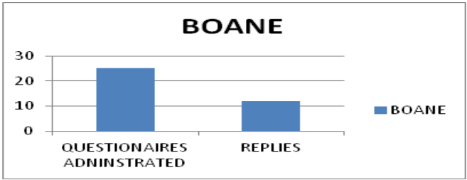

Graph 3: Number of questionnaires administrated and responses in District of Kamubukwana
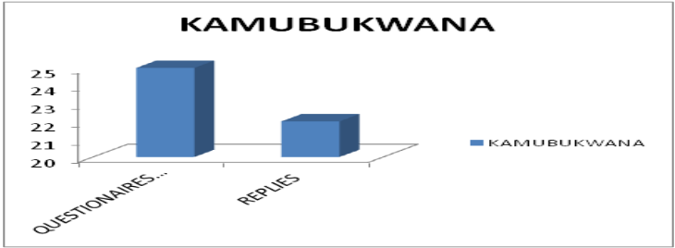

Graph 4: Survey results about ‘Situation of Performance Evaluation and career development-Boane & KaMuBukwana’ (Evaluated)
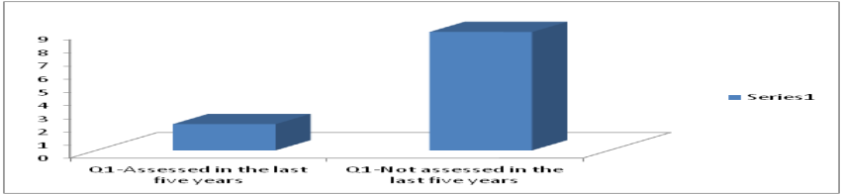

Graph 5: Survey results about ‘Situation of Performance Evaluation and career development-Boane & KaMuBukwana’ (Evaluators)

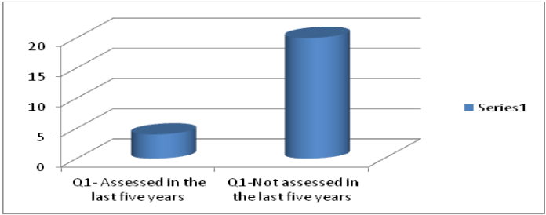

Graph 6- Survey results about ‘Situation of Performance Evaluation and career development-Boane & KaMuBukwana’ Question (open-ended from evaluated)

Graph 7: Transparency and Subjectivity in the process of Performance Evaluation in PRM
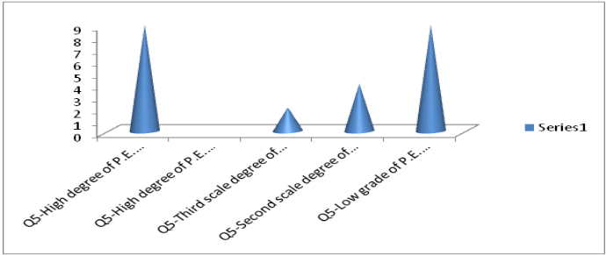

Appendix 3: Questionnaires and interview guide

I.QUESTIONÁRIO PARA OS AVALIADOS DA PRM (questionaires for evaluators of PRM)
Instruções
- Este questionário foi desenhado para identificar a sua opinião sobre como encarara o processo da avaliação de desempenho profissional e a motivação dos membros da PRM no contexto do desenvolvimento da carreira policial;
- Por favor queira dispensar alguns minutos para responder as seguintes questões. Assegura-se que as suas respostas serão completamente confidenciais;
- Não há limite de tempo para responder ao questionário, embora seja normal gastar entre vinte a trinta minutos para o fazer;
- Deverá responder com o sinal de certo nos espaços que correspondem a sua forma de ver as coisas;
- O questionário é anónimo

Muito obrigado.

1- O seu desempenho pessoal foi avaliado nos últimos 5 (cinco) anos?

2001 ( ) 2002( ) 2003 ( ) 2004 ( ) 2005 ( ) 2006 ( ) 2007 ( ) 2008 ( ) 2009 ( ) 2010 ( ) 2011 ( )
2 -Por favor manifeste a sua concordancia ou discordacia com os seguites afirmacoes:
“É difícil a implementação do novo sistema de avaliação profissional no contexto das Reformas do Sector Público na PRM”
( ) ( ) ( ) ( )
Absolutamente de acordo De acordo Não sei Nao concordo absolutamente
3-Por favor manifeste a sua concordância ou discordância com a seguinte afirmação:
O processo de avaliação na PRM é justo.
( ) ( ) ( ) ( )
Absolutamente de acordo De acordo Não sei Não concordo absolutamente
4- Por favor manifeste a sua concordância ou discordância com a seguinte afirmação:
“Há relação directa entre os resultados da avaliação de desempenho profissional, a motivação e desenvolvimento da carreira na PRM”.
( ) ( ) ( ) ( )
Absolutamente de acordo De acordo Não sei Não concordo absolutamente
5- Por favor manifeste a sua concordância ou discordância com a seguinte afirmação:
Absolutamente de acordo De acordo Não sei Não concordo absolutamente
6-Por favor indique de acordo com a escala abaixo o grau da subjectividade no processo de avaliação de desempenho profissional na PRM.
Muito baixo 1 2 3 4 5 Muito alto .
8-.Por favor indique de acordo com a escala o grau de satisfacção com relação ao processo da avaliaçao na PRM.
Muito baixo 1 2 3 4 5 Muito alto .
7-Você tem algum comentário acerca dos aspectos positivos e negativos do processo da avaliação de desempenho na PRM.
Pode apresentar algumas sugestões para permitir o desenvolvimento do processo da avaliação de desempenho profissional na PRM.
---------------------------------------------------------------------------------------------------------------------------------------------------ã----------------------------------------------------------------------------------------------------------------------------------------------------------------------------------------------------------------------------------------------------------------------------------------------------------------------------------------------------------------------------------------------------------------------------------------------------------------------------------------------------------------------------------------------------------------------------------------------------------------------------------------------------------------------------------------------------------------------------------------------------------------------------------------------------------------------------------------------------------------------
8-. De entre as hipóteses que apresetandos a baixo, queira indicar aquela ou aquelas que
a) constituem problemas para os membros e funcionarios da PRM
( )- A Avaliação de Desempenho não segue os criterios estabelecidos na Lei e nas normas internas da PRM
( )- Existe morosidade na promocao e progressao na carreira dos membros da PRM
( )- Não se presta atencao aos benefícios sociais para os funcionários da PRM
- As condições de trabalho não são adequadas
( ) – Falta de segurança no trabalho

b) Impactos dos problemas indicados
( )- Desmotivação
( )- Fraco desempenho no trabalho
( )-Apatia
( )-Tendência para a pratica de actos de suborno
( )-Descontentamento/insatisfacao no trabalho

-----------------------------------------------------------------------------------------------------------------------------------------------------------------------------------------------------------------------------------------------------------------------------------------------------------------------------------------------------------------------------------------------------------------------------------------------------------------------------------------------------------------------------------------------------------------------------------------------------------------------------------------------------------------------------------------------------------------

II.QUESTIONÁRIO PARA OS AVALIADORES PRM(QUSTIONAIRES FOR EVALUATORS)
Instruções
- Este questionário foi desenhado para identificar a sua opinião sobre como encarara o processo da avaliação de desempenho profissional e a motivação dos membros da PRM no contexto do desenvolvimento da carreira policial;
- Por favor queira dispensar alguns minutos para responder as seguintes questões. Assegura-se que as suas respostas serão completamente confidenciais;
- Não há limite de tempo para responder ao questionário, embora seja normal gastar entre vinte a trinta minutos para o fazer;
- Deverá responder com o sinal de certo nos espaços que correspondem a sua forma de ver as coisas;
- O questionário é anónimo

Muito obrigado.
1-Em que ano o senhor avaliou pela última vez o seu efectivo?
2001 ( ) 2002( ) 2003 ( ) 2004 ( ) 2005 ( ) 2006 ( ) 2007 ( ) 2008 ( ) 2009 ( ) 2010 ( ) 2011 ( )
2 -Por favor manifeste a sua concordancia ou discordacia com os seguites afirmacoes:
“É difícil a implementação do novo sistema de avaliação profissional no contexto das Reformas do Sector Público na PRM”
( ) ( ) ( ) ( )
Absolutamente de acordo De acordo Não sei Nao concordo absolutamente
3-Por favor manifeste a sua concordância ou discordância com a seguinte afirmação:
O processo de avaliação na PRM é justo.
( ) ( ) ( ) ( )
Absolutamente de acordo De acordo Não sei Não concordo absolutamente
4- Por favor manifeste a sua concordância ou discordância com a seguinte afirmação:
“Há relação directa entre os resultados da avaliação de desempenho profissional, a motivação e desenvolvimento da carreira na PRM”.
( ) ( ) ( ) ( )
Absolutamente de acordo De acordo Não sei Não concordo absolutamente
5- Por favor manifeste a sua concordância ou discordância com a seguinte afirmação:
“Os objectivos e competências são correctamente monitorados e avaliados entre os avaliadores e os avaliados”.
( ) ( ) ( ) ( )
Absolutamente de acordo De acordo Não sei Não concordo absolutamente
6-Por favor manifeste a sua concordância ou discordância com a seguinte afirmação:
7-Por favor indique de acordo com a escala abaixo o grau da subjectividade no processo de avaliação de desempenho profissional na PRM.
Muito baixa 1 2 3 4 5 Muito alta .
8-.Por favor indique de acordo com a escala o grau de satisfacção com relação ao processo da avaliaçao na PRM.
Muito baixa 1 2 3 4 5 Muito alta .
9-Você tem algum comentário acerca dos aspectos positivos e negativos do processo da avaliação de desempenho na PRM.
Pode apresentar algumas sugestões para permitir o desenvolvimento do processo da avaliação de desempenho profissional na PRM.
---------------------------------------------------------------------------------------------------------------------------------------------------ã----------------------------------------------------------------------------------------------------------------------------------------------------------------------------------------------------------------------------------------------------------------------------------------------------------------------------------------------------------------------------------------------------------------------------------------------------------------------------------------------------------------------------------------------------------------------------------------------------------------------------------------------------------------------------------------------------------------------------------------------------------------------------------------------------------------------------------------------------------------------
10-. De entre as hipóteses que apresetandos a baixo, queira indicar aquela ou aquelas que
a) constituem problemas para os membros e funcionarios da PRM
( )- A Avaliação de Desempenho não segue os criterios estabelecidos na Lei e nas normas internas da PRM
( )- Existe morosidade na promocao e progressao na carreira dos membros da PRM
( )- Não se presta atencao aos benefícios sociais para os funcionários da PRM
- As condições de trabalho não são adequadas
( ) – Falta de segurança no trabalho

b) Impactos dos problemas indicados
( )- Desmotivação
( )- Fraco desempenho no trabalho
( )-Apatia
( )-Tendência para a pratica de actos de suborno
( )-Descontentamento/insatisfacao no trabalho

----------------------------------------------------------------------------------------------------------------------------------------------------------------------------------------------------------------------------------------------------------------------------------------------------------------------------------------------------------------------------------------------------------------------------------------------------------------------------------------------------------------------------------------------------------------------------------------------------------------------------------------------------------------------------------------------------------------

Guião de entrevista(Interview Guide)
Asunto | Objectivos | Observação
!-O processo de avaliação na Policia da Republica de Moçambique: sucessos e problema da avaliação de desempenho profissional | -Explorar quando o entrevistado começou a lidar com a experiência em torno de avaliação de desempenho na PRM.  -Saber a cerca dos pontos forte e pontos fracos do processo da avaliação profissional doa membros da PRM | -Você pensa que os resultados da avaliação de desempenho profissional podem ajudar na motivação e no potencial do desenvolvimento na PRM
2-Sucessos e problemas na aplicação do processo da avaliação do desempenho na PRM | Perguntar a cerca dos pontos fortes e pontos fortes do processo de avaliação de desempenho profissional na PRM. | -Você pensa que os resultados de avaliação de desempenho profissional podem ajudar na motivação potencial para o desenvolvimento da carreira dos membros da PRM?  -A sua unidade ou sub- unidade tem feito sempre avaliação de desempenho profissional  -Você encontra dificuldades no novo modelo de avaliação de desempenho na PRM?  -Você pensa que o resultado de avaliação de desempenho profissional pode ajudar na motivação do potencial para o desenvolvimento da carreira dos membros da PRM?  -A sua unidade ou subunidade tem feito sempre a avaliação de
3-Avaliação de desempenho com vista ao mérito profissional do membro da Policia | Em que medida a avaliação de desempenho profissional na PRM tem contribuído na valorização do mérito do membro da PRM e na Gestão dos Recursos Humanos. | Você acredita na forma como avaliação de desempenho e levado a cabo ?  -Como você vê a sua evolução pessoal como resultado directo do seu desempenho?
4-Monitorização dos objectivos e competências sobre a avaliação de desempenho | Encontrar informações acerca de como os objectivos e competências são objecto de consenso entre os líderes e membros da polícia | -Você pensa que os membros da PRM devem ser avaliados como qualquer funcionários ou Agentes do Estado?  -Está satisfeito com a forma como você e avaliado ou avalia?

Details can be seen in the page 6 of the chapter 1

