Erasmus Universiteit Rotterdam
Willingness to pay for mobile apps
Key words: Paid Apps, Willingness To Pay, Conjoint Analysis,


Supervisor: Dr. F. Adiguzel
Author: Philip Hebly student nr. 375422
27-6-2012





Management Summary
The App economy is showing huge growth and attracts interest of worldwide technology companies who seek new business opportunities. The App economy already copes with huge saturation of Apps. However, there are some issues. People churn through Apps fairly frequently, the cost of acquiring users through advertising continues to rise with double digits year-on-year, and new companies who seek to introduce a new Apps, force the startups to better tune their spending, based on data about how people are discovering and choose their Apps.
On the customer’s side it is uncertainty about product value that is a pervasive feature of many markets. This applies to paid Apps as well, since the customer is not able assess the products real value until they have purchased the product. This research aims to investigate the Willingness To Pay(WTP) for paid Mobile Applications (Paid Apps). Especially the importance of antecedents on likelihood to purchase paid Apps is subject to this study. Features that are displayed at the moment of purchase reduce the customer’s difficulty associated with choosing between options. These features were taken as attributes in a Choice Based Conjoint Analysis to distract the relative importance of these attributes and to measure WTP. Also interaction with involvement, payment method and demographics were subject of analysis.
The results show that all displayed attributes have direct effect on the customer’s WTP. Price has been the most important factor in the customers decisions followed by customer rating(worth €0.62 per level upgrade), editors choice(worth €0.32), top developers hallmark (worth €0.15) and best seller rank (€0.16 per level upgrade). Furthermore customer driven features, such as customer rating and best seller rank, have a much stronger effect on WTP than platform driven features, like top developers hallmark and editors choice.
Concerning interactions, Females(19%) and Credit Card users(16.7%) are in general willing to pay less for Apps. Application Developers and Platform Providers could respond to this knowledge with, for instance, price promotions. For Click-and-buy users the effects of the attributes customer rating(worth €0.13 less per level upgrade) and editors choice(worth €0.21 less) are less important for making their decisions, but they are less affected by price. Application Developers can only use this information if they are in possession of the customers payment information. These results are of interest for the Platform Providers since they know which customer is using which payment method. In this way they are able to personalize the store environment to the preference structure of the customer, potentially leading to higher revenues. Another finding is that the older people are, the less they attribute utility to the top developer hallmark. This could be explained by the fact older people are less familiar with Application Stores.
Moderate supports was found for the effect of involvement. Involved customers are in general willing to pay more for apps and the more a person is involved the more he attributes utility to best seller rank.
With these results Application Developers and Platform Providers can allocate resources based on evidence. Managing the features in the Application Store and targeted offerings are examples of activities that can be implemented using the results of this research.
Considering the different types of Apps, it turned out that respondents were most likely to pay for Productivity/Utility Apps (mean= 3.27) followed by Sports/Health Apps(mean= 3.02) and Informative Apps (mean= 3.01). Games were stated as the type of App that they were least likely to pay for (Mean= 2.52).

Management Summary 2
Chapter 1) Introduction 6
Chapter 2) Literature Review 9
2.1 M-Commerce: History 9
2.2 M-Commerce: App economy 10
2.3 Adoption of m-commerce services 12
2.4 Type of Apps 15
2.5 Willingness to pay 15
2.6 Measuring willingness to pay 16
2.7 Drivers of WTP (Conjoint variables) 17
2.8 Product Involvement (control variable) 19
2.9 Consumer’s payment method (control variable) 20
2.10 Demographic control variables 21
2.11 Conceptual model 23
Chapter 3 Methodology 24
3.1 Empirical Application 24
3.2 Data descriptive 24
3.3 Measuring App attributes 26
3.4 Measuring Control variables 26
3.5 Measuring WTP 27
Chapter 4 Analysis and Results 29
4.1 Factor Analysis m-commerce involvement 29
4.2 Self-reported importance of displayed attributes 30
4.3 Type of app 30
4.4 Model 1: Conjoint Analysis 30
4.5 Model 2: Conjoint Analysis with interactions; Involvement and Payment Method 31
4.6 Model 3: Conjoint Analysis with interactions; Involvement, Payment Method, Age, Gender and Income. 32
4.7 Coefficient overview of all 3 conjoint models: 34
4.8 Model Summary 35
4.9 Willingness to Pay Calculations 36
Chapter 5 Conclusions and Discussion 36
5.1 Displayed attributes 36
5.2 Involvement and Payment method 37
5.3 Demographic control variables 38
5.4 Academic and managerial implications 40
5.5 Limitations and future research 40
5.6 Conclusion 41
References: 42
Appendices 47
Appendix A : Web based Survey 47
Appendix B: Orthogonal design 65
Appendix C : Respondent description 66
Appendix D: Involvement Variable Dimension Reduction 68
Appendix E : Importance of Attributes 69
Appendix F: Model 1. Conjoint Analysis 70
Appendix G: model 2. Conjoint analysis with interactions; Involvement and Payment Method 71
Appendix H: Model 3. Conjoint analysis with interactions; Involvement, Payment Method, Age, Gender and income. 72
Appendix I: Type of App 75
Appendix J: WTP calculations 75
Chapter 1) Introduction
In the past 2 decades the internet has dramatically changed the way people live, buy, search and communicate. At first e-commerce took over a lot of time in daily live followed by mobile commerce (m-commerce), which is a new form of e-commerce. M-commerce differs from e-commerce in that information transport(data) goes via mobile internet and is used via portable devices that are constantly at hand and have features like location services. M-commerce is therefore clearly different to the traditional approach of e-commerce in usage situation, presentation and user-interaction. Since m-commerce is showing huge growth and attracting the interest of the technology industry, already 3 different era’s have occurred (Kourouthanassis and Giaglis, 2012). From the year 2007, with the launch of Apple’s App Store followed by the Play Store from Google, the 3rd era was a fact. This 3rd era, in which device and platform developers dominate, the Mobile Application Markets(App Markets) became an economy on its own. From that moment the App-economy has grown tremendously fast. Since the introduction of Smartphones people are increasingly using Apps that contribute to their needs in their everyday life. The tremendously growing market already copes with huge saturation of Apps and the available Apps are getting more professionalized each day. Where the total downloads of Apps was 10.9 billion in 2010, this numbers is expected to increase to 76.9 billion in 2014 (IDC.com 2010-12-13). Recently the wall street journal released an article in which the author state that the profits of mobile applications will reach 25 billion dollars in 2013, which is a growth of 62% compared to 2012 (online.wsj.com 2013-03-04). Moreover, according to Flurry, customers have doubled the time spent using Apps to about two hours a day in the past two years. However, this fast growing market does have some issues. People churn through Apps fairly frequently, making it hard for developers to retain users (Simon Khalaf, Chief executive at mobile analytics firm Flurry Inc.). The cost of acquiring users through advertising continues to rise by double digits year-over-year and sometimes, when bigger companies seek to introduce a new game, it forces the startups to better tune their spending based on data about how people are discovering and choosing their games (Michael Sandwick, manager of strategic partnerships at TinyCo Inc.). Research also shows that in the maturing market, the revenue, will concentrate to fewer larger developers due large technology companies entering the market. In the end they will depress the opportunities for early entrants (Flurry.com 2012-07-31). Market researcher Gartner also states that players, in the quick growing business, scramble to figure out best ways to attract users and turn a profit (online.wsj.com 2013-03-04). Pauwels and Weiss(2008) mention the fear among content providers to lose against free alternatives in the market, due to the general consensus among users that “content is free”. This also counts for Application Developers in de App economy since there are plenty of free alternatives to their Apps. On the customer’s side it is uncertainty about product value that is a pervasive feature of many markets (Kuksov and Xie, 2010). This also count for Paid Apps since the customer is not able to know the value of the product until they have purchased the product. Therefore it is, for application developers, important to study the important antecedents that contribute to the choice of the customers. This research aims to investigate the Willingness To Pay(WTP) for Paid Mobile Applications ( Paid Apps). Especially the importance of antecedents on likelihood to purchase paid Apps. Features that are displayed as attributed at the moment of purchase reduce the customer’s difficulty associated with choosing between options (Fritzsimons and Lehman, 2004). Therefore it is important to know which attributes, that are displayed in the presentation of the App in the store environment, contribute to the consumers perception of the App’s value. This gets us to the following research question:
- How do the different attributes of Apps shown in the Application Market affect the willingness to pay for a paid App?
Another general believe of marketing practitioners (e.g. Lichtenstein, Bloch and Black , 1988) is that product involvement has a substantial influence on a customer’s willingness to pay. Since it is reasonable to assume that this might also apply to Apps, the following sub question is set for this study:
- How does Product involvement affect the willingness to pay for a Paid App?
In the App economy there are several types of Apps that are used by customers. Nysveen, Pedersen, and Thorbjørnsen (2005) already found that people use different positions in their social networks to gain knowledge for different types of Apps. It is of empirical interest to know to which extend the effect of attributes differs between the type of App. Therefore also the following sub question is set for this study:
- To which extend does the effect of attributes on the WTP differ between different type of paid App?
In Application Markets on the mobile platforms like iOS and Android, the customers have multiple payment options. Research has shown that different payment methods influence customer’s intention on future purchase behavior (Soman 2001). This research shows that direct depletion of wealth has a higher negative effect on future purchase behavior than delayed depletion, which is the case when a credit card is used. It is therefore of interest to this study to examine the effect of payment method on the customer’s willingness to pay. This gets us to the following sub question for this study:
- To which extent does payment method affect the customer’s WTP for paid apps?
Scientific relevance:
The key empirical issue of this research is the extent to which the attributes of applications differ in their relative importance across the type of application and different type of users. Empirical findings on these issues are scarce because firms are uneasy sharing data with academic researchers for confidentiality and competitive reasons. Multiple studies in the field of m-commerce have studied the constructs of information system adoption (e.g. Davis et al.,1989; Delone and McLean,2003; Oliver, 1980; Kim et al.,2009) and m-service adoption (Ko et al., 2009; Mahatanankoon et al., 2005; Venkatesh et al., 2003) and found several construct that contribute to the adoption of new technology. Hence, these studies did not study the impact of the displayed attributes in the application markets. Some of the attributes that are displayed wile purchasing Apps are similar to attributes that are used in e-commerce or book sales. Sridhar and Srinivasan (2012) found that a higher online consumer rating has a positive effect on buying decisions and WTP for online purchases. Carare (2012) found, from real data from Apple’s Apps Store, that the WTP for an “top ranked app” is about $4.50 greater than for the same unranked app. But none of these studies compared the set of attributes that are displayed while an app is purchased in an mobile retail environment. By comparing the importance of the attributes, this study aims to document the relative importance of the different attributes that are shown in the mobile retail environment of the application stores.
Managerial relevance:
The App economy is a fast growing market where many Application Developers have entered the marked and try to turn profit. Due to huge saturation of Apps in the Application Markets, it becomes increasingly difficult to gain awareness and to attract customers. For many relative small companies the entrance of big companies form a threat because their resources cannot compete with the resources of those big companies. Research on the WTP for Apps can give the Application Developers more knowledge about how their customers evaluate their Apps during the purchase process. It will therefore give guidelines to better allocate resources, and gain competitive advantage.
The remainder of this paper is organized as follows. In the second section a literature review is conducted in which hypotheses are developed and a conceptual framework is drawn. In the third section of the paper the appropriate methodology for analyzing the data is discussed along with estimation issues. Thereafter, the paper reports the results and discuss managerial implications. Finally the paper concludes and offer direction for future research.

Chapter 2) Literature Review
Table 1: Three eras in mobile-commerce (Kourouthanassis and Giaglis, 2012)

2.1 M-Commerce: History
As mentioned, m-commerce is a completely new form of e-commerce which emerged in parallel with the mobile devices (smartphones, tablets, digital television etc.) and mobile internet connectivity. Kourouthanassis and Giaglis (2012) describe the new form of m-commerce in 3 different era’s which are summarized in table 1 and figure 1. In the first era, beginning around 1997, Mobile Network Operators (MNO’s) began offering early forms of mobile data services in the form of m-portals which contained bundled thematic applications such as weather, ringtone downloads, etc. Despite heavy promotions, the m-portals never really managed to reach critical levels of user adoption. It’s assumed that this was due to their closed nature that didn’t fit well, in the minds of the users, with the open nature of the internet in general. The second era, beginning in around the year 2000, began with the introduction of mobile broadband internet access (3G) and the introduction of internet enabled smartphones that gave the user direct access to the open internet on their mobile devices(m-internet). E-commerce businesses now had the opportunity to offer their services via mobile internet as well and consumers began to adopt these services, which resulted in the first successful era of m-commerce. After its first successes, m-commerce drew the attention of the largest players in the ICT market. They saw tremendous market opportunities. Google, Apple and Microsoft developed platform innovations that capture large audience in various forms, mostly closed-ended, Mobile Applications (Apps). This opened the third era of m-commerce, beginning around 2007. This new form of m-commerce offered opportunities to third-party Application Developers to offer their applications and services as well. This development paved the way for great freedom of choice and the open nature of m-commerce, which now can be seen as an m-commerce ecosystem.
Table 1: Three eras in mobile commerce ((Kourouthanassis and Giaglis, 2012)
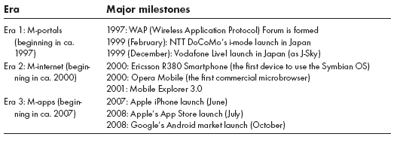

Figure 1: Three eras in mobile-commerce (Kourouthanassis and Giaglis, 2012)
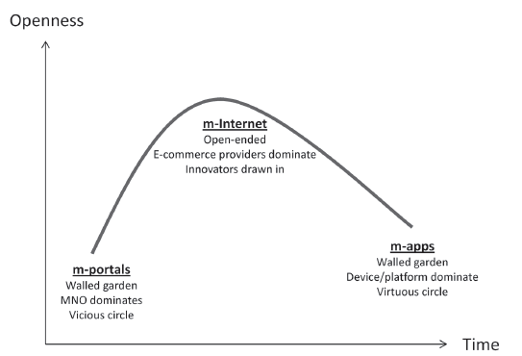

Following the observation m-commerce currently operates as an ecosystem, the next section will describe the App-economy to help us better understand it’s nature.

2.2 M-Commerce: App economy
The App Economy, introduced in 2007 with the launch of Apple’s App Storem, followed by Google’s play store in 2008, has grown incredibly fast. Both platforms now have a catalogue of 700.000+ Apps and the total estimated revenue for 2013 for the whole App Economy is 25 Billion dollars, representing a growth of 62% compared to 2012(online.wsj.com 2012-03-04). Application Developers are third party software developers who build Apps for several Mobile Device Platforms, such as iOS (Apple), Android(Google), Windows 8 Mobile(Microsoft), Blackberry, Kindle(Amazon). The Platform Providers have a dominant role in this economy (e.g. Kourouthanassis and Giaglis 2012; Gans 2012). In his paper Mobile Application Pricing, Gans (2012) studied the way in which application providers offer their products via mobile platforms. App are offered via Application Markets of Mobile Platforms, for which the Application Developer in return pays the Platform Provider a percentage per sale. Example: Apple’s App Store charges Application Developers 30% of the retail value of sold items, both purchases directly in the App Store and in-App purchases. Usually, Developers also agree with the condition that they cannot offer the product for a lower price via a different channel (e.g. internet browser). Such conditions are in harmony with examined practices by firms who sell durable goods and then related complementary items in after-markets like cartridges for printers and films for cameras(Carlton and Waldman, 2010). In case of Platform Providers this is not exactly the same since the platform provider is not the same party who also offers the durable product as the complementary product. Application Developers, in general, have 3 different business models:
Paid apps (premium apps) have a baseline price when the App is purchased. The App will be paid via an Application Market on a platform using a Credit Card or Click-and-Buy process. A percentage of the revenue of the App is returned to the Platform Operator. The advantage of premium apps is that they result in direct revenues and the developer is not dependent on user frequency for income from advertisements. Although direct revenues seem to be preferable, the percentage of these revenues declined from 82% in 2011 to 77% in 2012 due to rising mobile advertising expenditure (Flurry.com 2012-07-31). This seems reasonable since companies are increasingly interested in mobile advertising.
Free apps (most with advertisements) can be acquired for free in the Application Stores, but the consumer will be exposed to advertisements during the use of the App. This is a popular way for fast penetration of Apps into large audiences, but has the negative effect of advertisements being shown during usage of the App. The revenues for Application Developers via advertisements seem to increase. While in 2011 advertisements made up 18% of profits, this increased 23% in 2012 (Flurry.com 2012-07-31). This shift is likely because companies are increasingly interested in targeted mobile advertising.
Freemium apps (in-app purchases for content or functionalities) can be acquired for free in the applications stores, but have restricted content and features, for which the consumer has to pay a premium. This business model is popular for Information Systems in general and is also widely used in the App Economy. David Sacks, founder and CEO of Yammer, confirms the great opportunities that the Freemium model offers (blog.wsj.com 2013-03-01). He mentions the opportunity to attract a huge audience and allow a product to go viral, which is unlikely to happen with paid products. “You give the consumer the ability to try before you buy” he says. The only pitfall of this model is that the free version cannibalizes the paid offering of the product. Therefore a precise analysis is needed to distinguish the most important features against less important features, and then make them premium features. In their article, Pauwels and Weiss (2008) mention the fear among content providers to lose against free alternatives in the market, due to the general assumption among users that “content is free”. This is also the case for Application Providers in de App economy since there are plenty of free alternatives to their Apps. Therefore it is important to study the important antecedents of likelihood to purchase Apps.
For the purpose of this study only Premium Apps are considered. Customers do not have to pay for Free Apps and, dependening on their usage, they might may not have to pay for Freemium Apps either. This study will only focus on Apps that have baseline prices. This way the monetary value for different levels of attributes can be distracted from the analysis.

2.3 Adoption of m-commerce services
Customers must acquire a satisfactory amount of information about services that are new to them before they are able or willing to use them (Moorman et al. 2004). They want to learn about specific characteristics, such as capabilities of the service, characteristics of the products and pricing issues (Kleijen et al., 2007). This information is often obtained by the customers’ social network (e.g. Nyblom et al., 2003, Kleijen et al., 2009). Despite knowledge created by the social network, people remain uncertain and look for additional signals (Kirmani and Rao, 2000). Trust and credibility are the most important factors in reducing this uncertainty (Levin and Cross 2004). Many researchers in the past decade have studied the factors that drive m-commerce service adoption. Many of those studies have used dependent variables like customer satisfaction, loyalty, and intentions from different kind of perspectives. Existing theories, commonly used and extended in e-commerce, are used to investigate the adoption of m-commerce services. The Technology Acceptance Model (TAM) by Davis et al.(1989), the Information System Success Model(ISSM) by Delone and McLean(2003), the expectancy disconfirmation model (EDM) by Oliver (1980) and the dimensions of trust by Kim et al. (2009) are all examples of these commonly used theories to investigate adoption of m-commerce services. The TAM and the ISSM are the most used models for assessing adoption of m-commerce services. Despite the good fit for e-commerce systems, these models are frequently extended by researchers to better measure adoption for m-services. The TAM and ISSM focus most on the technological perspective of the system, which causes them to be less effective in incorporating the individual and organizational factors that influence the adoption process. In table 2 a summary is given of the existing adoption theories that are commonly used to assess m-service adoption.
Wang and Li (2012) argue that m-services are distinct from e-commerce services due to a number of distinguishable m-commerce features, such as ubiquity and location-based. Examining the adoption of these m-services, without explicitly considering key m-commerce features, cannot provide a comprehensive understanding of what drives favorable consumer perception regarding performance measures such as satisfaction, trust and service quality factors. Therefore, issues of m-service adoption must be examined considering key m-commerce attributes in order to help m-service providers better understand why a new m-service is accepted by the market. Ko et al.(2009), Mahatanankoon et al.(2005) and Venkatesh et al.(2003) all examined the effects of key m-commerce attributes on the adoption of m-commerce and distinguish the following key attributes for m-services:
Usability: Usability is defined as the extent to which a technology can ensure a positive user experience and, in turn, satisfy both their sensory and functional needs (Venkatesh et al., 2003). There are 3 key features for usability in m-commerce: ubiquity, location-awareness, and convenience.
Personalization: Personalization is defined as the use of mobile technologies with reference to the user, context, and content information, to provide personalized products/services in order to meet the specific needs of a particular customer (Ko et al., 2009). Identifiability: Identifiability refers to the ability to recognize the identity of a user through a mobile device. Since a mobile device, particularly a smartphone, is registered by one unique subscriber and is normally carried by that person, it becomes possible to identify a particular user, perform individual-based marketing, and deliver personalized services (Mahatanankoon et al., 2005).
Perceived enjoyment: Perceived enjoyment refers to the extent to which the activity of using a technology is perceived to be enjoyable in its own right, regardless of any performance consequences resulting from its use (Ko et al., 2009; Venkatesh, 2000).
Table 2: Overview of existing adoption theories
model | Key constructs | Adoption measure | Context of recent applications | literature
TAM | -Perceived usefulness  -Perceived ease of use  - Attitudes toward use  -Intention to use  -Actual use | Behavioral intention  Adoption intention  Intention to use  Actual use behavior | Mobile technology  Mobile shopping  Messaging  Mobile payments  Mobile healthcare services | Davis et al. (1989)
ISSM | -System quality  -Information quality  -Service quality | Satisfaction  Actual use behavior | Mobile shopping  Mobile banking  Computing services | De Lone and McLean (2003)
EDM | -Pre purchase attitude  -Immediate post purchase attitude  -Revised post purchase attitude | Disconfirmation  Satisfaction  Attitude  Intention | Mobile internet services | Oliver (1980)
Trust related | - Trust propensity  - Structural assurance  - Firm reputation  - Relative benefits | Adoption intention  Purchase intention  Post-purchase intention | Mobile value added services  Mobile banking adoption | Kim et al. (2009)
Besides the customers social network connections and the key attributes of m-services, none of these theories take into consideration the attributes that are displayed in the purchase environment of the Application Markets. However, it is likely that displayed information in the store environment, such as customer rating, top ranks, editors choice and price, will have an effect on the adoption and, thus, the willingness to pay for these App. Nysveen, Pedersen, and Thorbjørnsen (2005) describe the intention to use a mobile service as a function of motivational, attitudinal, social and resource influences. This study aims to investigate the influence of displayed attributes in the store environment on the willingness to pay for mobile applications, which can be seen as a resource influence described by Nysveen, Pedersen, and Thorbjørnsen (2005).

2.4 Type of Apps
Recent research demonstrates that mobile service innovations occur in four categories (e.g., Nysveen, Pedersen, and Thorbjørnsen, 2005) in which apps can be assigned. These mobile service innovations are the following;
Communication: Interactive services which enable customers to transmit and receive animated text, sound, pictures, and video. Kleijnen et al. (2009) find in their results that this type of service is easily adopted due to the fact that customers were already familiar with services like SMS or chat on the internet. Personal connectedness, which implies the person to use a wide range of social network connections to gain knowledge (Kleijen et al., 2009), is the most determinant factor in adopting this type of mobile innovation compared to Personal Integration, which implies the intenseness of the person’s social network connections.
Mobile gaming: Services that enable customers to play interactive, multiplayer games with other mobile users through their smartphones. The findings of Kleijnen et al.(2009) for communication services also apply to gaming. People are already familiar with interactive games, both together in person and on the internet. For games personal connectedness is also the more important social property to gain knowledge before adopting this innovative service.
Mobile transactions: Services that facilitate business like transactions such as banking and brokerage. This type of innovative service could have much higher consequences for the user than the first 2 types of services. A customer will need credible knowledge in order to adopt this type of service and will therefore use their Personal Integration property to gain knowledge about the service, which refers to the more intense and better known social connections (Kleijnen et al., 2009).
Mobile information: Services that provide the customer with all kinds of information that he wants or likes to receive (e.g., weather, traffic, and sports updates). From the findings of Kleijnen et al. (2009) the personal connectedness property is the most used social network property that is used to gain knowledge before adopting this kind of services.

2.5 Willingness to pay
Willingness To Pay (WTP) can be defined as the economic value that a consumer is willing to sacrifice in order to acquire a certain utility (Shogren et al. , 1994). Another commonly used definition of WTP is that it is the maximum amount of money that a customer is willing to spend for a product or service (Cameron and James, 1987). The measurement of WTP is an important analysis for companies that want to offer their products. It is important how Pricing, importance of attributes, and consumers membership to a specific segment are influencing the WTP to obtain competitive strategies. When measuring WTP, it is important to collect data in a setting that is as realistic as possible (Miller et al., 2011).

2.6 Measuring willingness to pay
Conjoint Analysis is one of the most popular methods used by marketing researchers to analyze consumer trade-off’s when assessing WTP (Green and Srinivasan, 1990). The nature of Conjoint Analysis facilitates the researcher to replicate a realistic situation in which a consumer can rank or choose between alternatives. Practitioners can use rankings, ratings or discrete choice exercises to let the respondent represent their preferences concerning a given scenario. With Rank Based Conjoint (RBC), the respondent ranks the given alternatives from best to worst case scenario. With Rating Based Conjoint Analysis (RBC) the respondent gives individual ratings to the presented alternatives. With Choice Based Conjoint (CBC) a respondent is asked to compare a set of alternatives with a different set of attributes where after the respondent should choose the preferred option. Researchers argue that choice tasks need to be designed as close as possible to the actual purchase context. Consumers often construct their preferences and form utility levels in response to the choice context rather than that they re-enact a previously formed value (e.g. Thaler, 1985; Bettman, Luce and Payne, 1998). Moreover, it is commonly known that respondents cannot evaluate more than six to eight attributes at a time (e.g. Green and Srinivasan, 1990). Miller et al. (2011) describes several approaches to measure WTP, which can be divided in direct (open-ended question) and indirect (choice-based) measures of WTP and actual (obligation to buy in experimental setting) and hypothetical (no obligation to buy) measures for WTP. Due to the fact that actual measures in an experimental setting with obligation to buy from an Application Markets is not possible in this research, this study can only assess hypothetical measures of WTP for Apps. However Miller at al. (2011) argue that even when hypothetically CBC Analysis generates a bias, it may still lead to the right demand curves and pricing decisions. The intercept of the corresponding demand curve might be biased, but the slope of the curve is usually not. Which indicates that a hypothetical measure of WTP would probably still lead to a right ranking of the attributes that are displayed in the retail environment of the Apps in this research.

2.7 Drivers of WTP (Conjoint variables)
Nysveen, Pedersen, and Thorbjørnsen (2005) describe the intention to use a mobile service as a function of motivational, attitudinal, social and resource influences. This study will focus on the resource influences that are displayed in the purchase environment of the application markets. These features reduce the customer’s difficulty associated with choosing between options as mentioned by Fritzsimons and Lehman (2004). Note that apart from price, customer rating and best seller rank are customer driven quality indicators, since they are distracted from customers. Top developer hallmark and editors choice are platform driven quality indicators, since they are given based on criteria set by the Platform Provider.
Customer rating:
One of the most important and clearly displayed features for customers to reduce difficulty associated with choosing between options is customers product rating. This customer driven quality indicator is clearly displayed in the online store environment of the application markets next to the price and the other features of the App. Customer rating could be an indicator for information quality and system quality (e.g. DeLone and Mclean, 2004), ease of use and usability (e.g. Davis, 1989) and perceived enjoyment (e.g. Ko et al., 2009; Venkatesh, 2000). In E-commerce, websites prominently display consumer’s product rating, which influences customer’s buying decisions and WTP(e.g. Sridhar and Srinivasan, 2012). This effect is already measured in multiple industries; High product rating increase the online market shares of books (e.g. Chevalier and Mayzlin, 2006), offline sales of television shows (e.g. Godes and Mayzlin, 2004), sales of wine (e.g. Horverak, 2009) and sales of video games (e.g. Zhu and Zhang, 2010). A Comscore Inc. survey (2007) also shows that consumers are willing to pay more for a product with excellent rating (5-stars) than for one with a good rating (4-star). Therefore the following hypothesis is set for this study:
H1a : Customer ratings positively affect the WTP for Premium Apps(i.e. Higher customer ratings leads to higher WTP for premium Apps).
Best seller rank
In multiple industries bestseller lists keep track of the most sold items in the market. Especially in de book and music markets, which can be defined as experience goods just like Apps, there are plenty of examples of acknowledged bestseller ranks that contribute to the customers WTP. Sorensen (2007) highlights the positive effect that the New York Times bestseller list has on books sales. Another interesting finding in this study is that the effects for new authors are even more dramatic. Both Apple and Google show a list of the “most popular paid apps” in their Application Stores. In his study, Carare (2012) studies the effect of appearance in the top 100 ranks on the future demand of the App. The results show that the WTP for a “top ranked app” is about $4.50 greater than for the same unranked app. The results also indicate that the effect of bestseller rank declines steeply with rank at the top ranks, but remains economically significant in the first half of the top 100. This proves that bestseller rank, a consumer driven quality indicator, is also an important feature for customers to reduce difficulty associated with choosing between options. Therefore the following hypothesis is set for this study:
H1b: “Best seller rank” positively affects the WTP for Premium Apps.
Top Developer Hallmark
To achieve stronger competitive positions, manufacturers, and in this case service providers (e.g. Apple and Google), begin to implement preferred supplier programs. Many preferred supplier programs are designed to identify and partner with suppliers that provide high quality, low priced products (e.g. Dorsch et al, 1998). Linking this with the adoption theory for mobile services this platform driven hallmark is likely to affect the perception of system quality and information quality of the system, mentioned by DeLone and McLean (2004). Besides price, advertising, warranty and brand name, the importance of the effect that retailers have on the customer’s product quality perceptions has proven to be very important (e.g. Chu and Chu, 1994; Purohit and Srivastava ,2001). Retailers provide the interface between manufacturer and consumer and thus have an important role in the mind of the customer(e.g. Purohit and Srivastava, 2001). Chu and Chu (1994) highlight that for the retailer (e.g. Apple and Google) there is an incentive to truthfully represent the quality of the product it sells in order to protect their reputation. Kim et al. (2009) also highlight the Firm’s reputation as a key dimension of trust that influences the intention to use. As such, a top developer hallmark is a clear quality indicator, which is expected to reduce perceived risk and uncertainty (e.g. Levin and Cross, 2004) and therefore to influence WTP for Apps. Concerning this issue, the following hypothesis is set for this study:
H1c : A top developer hallmark positively affect the WTP for Premium Apps.
Editors choice
Another attribute displayed in the Application markets is the editor’s choice. Both Apple and Google have a column in their Application Stores with a list of Apps that are preferred by an editorial office that recommends the Apps for use. This platform driven feature is likely to give an indication of an App’s high usefulness, ease of use and perceived enjoyment, as mentioned in the adoption theories for m-services (e.g. Ko et al.,2009; Venkatesh, 2000; davis et al., 1989). Editors choice is different from a top developer hallmark in terms of being specifically assigned to a certain app, where a top developer hallmark is a feature given to a certain Application Developer. Due to the fact this displayed feature is likely to have positive effect on the WTP for an App, the following hypothesis is set to asses this effect:
H1d: Editor’s choice positively affects the WTP for premium apps.
Price
To measure willingness to pay with Conjoint Analysis, the price should be incorporated as one of the attributes(Miller et al., 2011). In their study Miller at al. (2011) describe this as an indirect method to measure WTP. The price of an app is also one of the clearly displayed attributes in the application markets. Moreover, it is generally known that price has a negative effect on demand of goods, with exception of luxury goods. Since apps can be seen as convenience goods the effect of price on WTP for an App is expected to be negative. In this study we try to use realistic price ranges, bound by the high and low prices of comparable apps to avoid the ad hoc nature of price range effects. Besides the price attribute being the indirect dependent variable in this study, the following hypothesis is set:
H1e: Price negatively affects WTP for premium Apps.

2.8 Product Involvement (control variable)
Lichtenstein, Bloch and Black (1988) found a strong link between WTP and a customers product involvement. They distinguish price conscious customers from product involved customers, where price conscious customers are characterized by concerning more about price relative to the product quality and product involved customers to be characterized by concerning more about the product relative to the price. As a consequence the product involved customers are generally willing to pay higher prices. In many industries, research showed that product involvement does have an effect on WTP. For instance, involvement has a positive effect on music consumption (Flynn, Eastman and Newell , 1993). They explain that more involved customers had higher quality needs and thus were willing to pay more for a higher quality product. The same argument could go up for Apps, involved m-commerce customers are likely to want better quality Apps compared to novices and therefore also likely to be willing to pay more for this quality. No research yet is available to confirm this statement. Therefore the following hypothesis is set:
H2: M-commerce involvement positively affects the WTP for Apps.
Customers involved in m-commerce are actively engaged with their phones and have several ways in which they acquire information. An example is using recommendation Apps (e.g. App Of The Day) in which paid Apps are highlighted or given away for free. As mentioned already by Nysveen, Pedersen, and Thorbjørnsen (2005), the intention to use a mobile service is a function of motivational, attitudinal, social and resource influences. For involved customers it is likely that the resource influences, such as the displayed attributes in the Application Markets, have a more important role than the other influences. This is because they are already motivated and have a positive attitude towards this innovative service and so they are likely to have more knowledge than their social environment. For this study it is of interest to know if the effects of displayed attributes in the Application Markets are different for involved customers. As aforementioned, this effect is expected to be higher due to the fact they rely more on resource influences. The following hypothesis is set to assess this moderating effect:
H3: Customers m-commerce involvement leads to stronger effects of displayed attributes on the WTP for an App (moderator).

2.9 Consumer’s payment method (control variable)
In the Application Markets customers can choose between two kinds of payment options. The first being Credit Card that facilitates the customer to purchase the desired Apps directly, where it in the end will be subtracted from their bank account. Soman(2001) gives clear evidence in his article that when wealth depletion is delayed, as is the case with credit cards, that the intention for future purchase behavior is less effected than with immediate depletion of wealth. On the other hand Forsythe and Shi(2003) argue that customers face perceived financial risk when they shop on the internet. Perceived financial risk indicates the customers perception that one’s Credit Card information could potentially be misused (Forsythe and Shi, 2003). Secondly, there is a Click-And-Buy possibility where the customer purchases the app where after the Mobile Network Operator(MNO)(e.g. Vodafone and KPN) will add the costs to the monthly bill. After purchase the MNO will directly inform the consumer about the amount that will be added to the bill. This rehearsal of the final price will improve the memory of past expenses and therefore negatively affect future purchase behavior (Soman, 2001). On the other hand, a customer does not need to fill in Credit Card information, which does not manifest the perceived financial risk as mentioned by Forsythe and Shi(2003). Credit Cards are lower in salience and vividness and hence, they might result in a weaker memory trace, although they can confront the consumer with perceived financial risk. For this research it is interesting no know how the customers payment mechanism affects the WTP for Apps. Therefore the following hypothesis is set:
H4: The use of Credit Card as payment method negatively affects the WTP for Apps.
For the study it is of interest to know if the payment method affects how customers gather their information to reduce their risk and uncertainty. People that use Credit Cards might have higher perceptions of risk and are therefore seeking for signals that reduce those perceptions. The following hypothesis is set to asses different preference structures for displayed attributes:
H5: Credit Card usage moderates the effects of displayed attributes on the users WTP for an App (moderator).

2.10 Demographic control variables
Since it is likely that differences exist in buying behavior between different demographic groups, this research will include control variables to find if a consumers age, gender and income affect the WTP.
Younger people and people with higher incomes are more likely risk takers than older people and they are also likely to be more familiar with the new technologies. Older people might be less risk taking and therefore more affected by the displayed attributes. Younger people and people with higher incomes might also be more easy in spending money via a Smartphone. Females are more likely to be risk avoiders, which could lead to a stronger influence of the attributes and a lower WTP in general. The following hypotheses are set to assess the effects of the control variables.
Age:
H6a: For younger people the displayed attributes have less effect on the user’s WTP for an App
H6b: Customers age affects customer’s WTP for Apps
Gender:
H7a: Customers gender moderates the effect of displayed attributes on the user’s WTP for an App
H7b: Customers gender affects customer’s WTP for Apps
Income:
H8a: Customers income moderates the effect of displayed attributes on the user’s WTP for an App
H8b: Customers income affects customer’s WTP for Apps

2.11 Conceptual model
Figure 2 summarizes the purpose of this thesis:
Figure 2. Conceptual Model
Age
Consumer’s Payment mechanism: Creditcard or Click-and-Buy.
Customer Rating: (Customer driven Feature)

Top Developer Hallmark:
(Platform driven feature)
Willingness to pay
for paid apps
Best Seller Rank:
(Customer driven feature)
Editor’s Choice
(Platform driven feature)
Costomer’s involvement:
high or low involvement
Gender
Income
Price

Chapter 3 Methodology

3.1 Empirical Application
Because WTP should be measured as realistically as possible and the fact that Apps are bought in a retail environment where customers need to choose between options, a Choice Based Conjoint (CBC) analysis is used to assess hypothetical WTP for Apps. With CBC analysis we can asses WTP indirectly by including the price as one of the attributes of the Apps(e.g. Srinivasan, 1982; miller et al., 2011). To determine the appropriate attributes and attribute levels for our conjoint study we did an analysis of both Apple’s App Store and Google’s Play Store to identify the most clearly displayed attributes that affect the customers choice and thus WTP. The attributes and their levels are shown in table 3. A web based questionnaire is used for the study. In Appendix A you can find the whole survey. The survey is divided in three parts. The first part describes the relevant attributes. The second part consists of the WTP part, where the respondents are faced with choice sets from which they have to choose their preferred alternative. In the third part of the questionnaire we conducted a brief survey to find the values for the control variables: involvement and payment method. Socio economics and socio demographics were also measured in the last part of the survey. The data was gathered via social networks Facebook and LinkedIn, direct mailing and direct and indirect personal environment. This non-probability sampling method could result in a non-representative sample and therefore the outcomes should be handled with caution. Besides the criteria that respondents should have a smartphone, the sample is randomly taken. Smartphone users are all familiar with Apps and the Application Stores since all App (free or paid) are chosen and downloaded from the Application Stores. It is very likely that respondents understand the different attributes and are able to choose between options. The action ability of the results are therefore likely to be high for Apps.

3.2 Data descriptive
For this research the data was collected via a web based survey that was spread via Facebook, LinkedIn, direct mailings and direct and indirect personal environment. On social media, personal messages were used to send the link to the web based survey. The respondents were told that they could contribute to a relevant scientific research project of a graduate student. Most of the respondents that were approached for the study have the Dutch nationality and some are international students from Erasmus University. Data was collected from June 8th 2013 till June 15th 2013. In this period 199 respondents have filled in the survey of which 156 respondents were used in the analysis. 43 responses were not completed correctly. All general information of the respondents is reported in the tables of Appendix C : Respondent descriptives.
The average age of the respondents was 29.33 years, from which 57% is male and 43% is female. The majority of the respondents is higher educated (87% ), this could be explain by several things. At first the researcher spread the survey in his personal environment, which is represented by a high amount of higher educated people. Secondly, the survey could have been hard to fill in for lower educated Dutch respondents due to the fact it was conducted in English. Another explanation can be found in the fact that more highly educated students and people with higher incomes have higher levels in adoption of Smartphone’s. This corresponds with research that studied the adoption of smartphones in several demographic groups (pewinternet.org, 03-01-2012). Moreover, 45% of the population are students against 55% who are working. From all respondents 37.8% have never bought an App against 62.2% who have. From the people who have paid for an App 51% states that they have paid for Apps occasionally and 10.9% states that they have paid for Apps frequently. On average the respondents indicate that they are most likely to pay for Utility/Productivity Apps (mean score: 3.27) followed by Sport/Health Apps and Informational Apps (mean scores: 3.02 and 3.01 respectively). The respondents indicate that they are least likely to pay for Game Apps (mean score: 2.52). For purchasing Apps 37.8% uses their Credit Card to pay in the Application Store and 62.2% use Click-and-Buy.
Concerning involvement it is interesting to find that 47% of the respondents state that they are interested in the Mobile Market where only 28% indicate that they are not interested in the mobile market, the other 25% find themselfs neutral. From all respondents 35% have downloaded an App that describes, offers and/or suggest Apps to them. 65% did not have such an App. Finally 31% of the respondents state that they visit their Application Store quite often to very often, 23% state they rarely or never visit their Application store and 46% state they visit the Application store sometimes.

Table 3: conjoint attributes and attribute levels
Attribute | Atribute levels
Customer rating | 1 stars
Customer rating | 2 stars
Customer rating | 3 stars
Customer rating | 4 stars
Customer rating | 5 stars
Top Developer Hallmark | Yes
Top Developer Hallmark | No
Best seller rank | Top 25
Best seller rank | Top 100
Best seller rank | None
Editors Choice | Yes
Editors Choice | No
Price | €0.89
Price | €1,79
Price | €2,69
Price | €3,59
Price | €4,49

3.3 Measuring App attributes
For this study we use the full profile method in which all used attributes of the App are presented to the respondent. A benefit of the full profile method is the ability to measure overall preference judgments directly, using behaviorally oriented constructs like intention to buy, likelihood of trail and so on (Green and Srinivasan, 1990). Determination of the relevant attributes and the relevant levels of each attribute (table 3) resulted in a 52, 22, 31 attribute space with 300 possible combinations. Price is included in the orthogonal design because it will probably have an effect in its own right for on the customer in making his choice. Another argument is that developers do not base their prices on the level of attributes that are subject to this study, but based on their own perceptions of the value of the app or pricing strategy (the price could also be seen as quality indicator). We created stimuli and conjoint choice sets according to a computer-generated orthogonal design that accounted for the design principles of minimal overlap, level balance, and orthogonality (Huber and Zwerina, 1996). To administer the study, we used SPSS Software. “Generate Orthogonal Design” in SPSS generates a data file containing an orthogonal main-effects design that permits the statistical testing of several factors without testing every combination of factor levels. The minimal number of cards for the 300 possible combinations was 25. Appendix B outlines all the 25 choice cards generated by the orthogonal design procedure in SPSS. The respondent will be presented with 13 choices between 2 choice cards (i.e. conjoint stimuli) so that all the cards are evaluated. The respondents are told to imagine that they need to choose among the product alternatives in an Application Store “right here” and “right now.”

3.4 Measuring control variables
As discussed in the previous chapter, individual properties like m-commerce involvement and a person’s payment method could contribute to different preference structures of the displayed attributes in the Application Stores. To know if these personal properties have effect on a person’s preference structure, we added a couple of questions in the 3rd part of the survey to measure control variables. In table 4 and table 6 you can find the constructs for the control variables, involvement and payment method. For this study we are also interested in the potential difference between the types of Apps. To investigate this we included the 4 categories mentioned in paragraph 2.8. In table 5 you can find these categories together with the chosen Apps that will be presented in the choice sets of the respondents. For an appropriate analysis of the type of apps, every type should have a conjoint design that accounts for the design principles of minimal overlap, level balance, and orthogonality. Unfortunately, due to limited time and resources, this is not possible in this research.
Table 4
Construct of control variable: Payment Mechanism
Construct | Measurement | Variable
Payment mechanism | Credit card or click-and-buy | Payment

Table 5
Construct of control variable: App type
Genre of app | Related Apps | Variable name
Productivity/Utility | Notes, Calender, Photo editor, Office | Productivity
Gaming | Puzzle, motor racing, game, | Game
Sports and heath | Sportstracker, Recipes, Sleep stats | Health
Information | News paper, weather facts, music stream | Info
Table 6
Constructs of control variable: Involvement
Construct | Measurement | Variable
Objective app involvement | Frequency of app market visit | App Market Visit
Objective app involvement | Possession of suggesting app | Suggestion App
Subjective involvement | Self-stated App involvement | Subjective involvement

3.5 Measuring WTP
Choice Based Conjoint analysis facilitates the researcher to distract the customer’s WTP for an App by adding Price as one of the attributes. The respondents choose their option in an experimental environment in which they do not actually buy the app. As a consequence, we can only assess hypothetical WTP. Along with price, the Apps are showed to the respondent with 5 attributes in a setting that clearly reconstructs the way in which Apps are presented in their actual retail environments. Respondents have to choose between products and not between attributes. With 5 attributes to evaluate, the construction of the choices meet the criteria that a consumer can only judge six to eight attributes at the same time (e.g. Green and Srinivasan, 1990).
The dependent variable only has 2 options, so a binary choice model is constructed. The choice that a respondent makes between options is seen as the alternative that renders the highest utility for the respondent. This utility is affected by the various attributes that are displayed during the choice. Utility is given by the random utility model:
Utility = β0 + β1Attribute1 + β2Attribute2 + …+ε (1)
Where βs captures the importance of the attribute. In this way each of the 2 alternatives have a linear model for utility:
Alternative 1: Utility1 = α1 + β1 Attr_11 + β2Attr_21 …+ε1
Alternative 2: Utility2 = α2 + β1 Attr_12 + β2Attr_22 …+ε2
αj is the intrinsic utility of the App which could be seen as brand equity of the alternative. For the purpose of the study we assume that the effect of other attributes are the same across the alternatives. This was also mentioned in the introduction of the survey, where it was stated, that besides the shown attributes, both alternatives had exactly the same specifications and functionality.
The choice of the respondent is based on utility maximization, where the alternative with the highest utility is chosen. This can be assessed by the following equation:
ΔU=Ui1-Ui2 = (α1-α2) + β1 (Attr_11 -Attr_12) + β2 (Attr_21 - Attr_22)+(ε1 - ε2) (2)
As such, there is a higher probability (or likelihood) to choose option 1 if:
Prob (choice = 1) = Prob (Ui1 > Ui2) = Prob (ΔU > 0)
To asses this probability the following equation is used:
Prob (ΔU > 0) = Prob (α + β1 ΔAttr_1 + β2 ΔAttr_2 + Δε > 0) (3) Prob [Δε > -(α + β1 ΔAttr_1 + β2 ΔAttr_2)]
Prob (Δε > -X’β)
The models are estimated by SPSS using Binary Logit Method. Here the dependent variable is the choice of the respondent between alternative 1 and 2, the explanatory variables, inserted as covariates, are the ΔU of the 5 different attributes. This binary choice model, based on random utility model, can use interactions similar to linear regression. As such, differences between respondents involvement, payment method, income, age and gender can be found.
Chapter 4 Analysis and Results

4.1 Factor Analysis m-commerce involvement
To measure differences in preference structures between higher involved and lower involved respondents. And to prevent multicollinearity issues, the 3 variable shown in table 6 are summarized into one variable. The variable “Suggestion App” was recorded into the value 2 for not present and 4 for present. These values were taken to improve the importance of the variable since the other questions have a range from 1 to 5. The gap between 2 and 4 represents the difference in involvement overall. Factor Analysis suggest only 1 factor for all 3 questions. The new variable is called “objective involvement”. For complete analysis see Appendix D: ‘Dimension reduction’ for correlation. The original values were also tested using Cronbach’s α. The value α = 0.629 is little lower than the general accepted α = 0.7. However, since removal of one of the questions does not improve this value and α = 0.629 is little lower than α = 0.7, this value was viewed as acceptable to work with. To assess objective m-commerce involvement, a new scale was constructed as follows:
Scale _{obj m-commerce involvement} = (Scale _{Application store visit} + Scale _{Suggestion App} + Scale _{Sub m-commerce involvement})/3
This yields a scale from 1.33 to 4.67. The distribution of the new Scale _{obj m-commerce involvement} is normally distributed as can be seen in Appendix D. The new variable Objective m-commerce involvement will be used as scale variable to assess the influence of involvement on the respondents preference structures concerning the displayed attributes.

4.2 Self-reported importance of displayed attributes
In Appendix E: Importance of attributes, the results are shown for the question: “indicate on a scale from 1 to 5 how important you think the following attribute were for the decisions you made”. This question was asked after the respondent had finished the CBC part of the survey. The attributes that seemed the most important were price (mean= 4.38) and customer rating (mean= 4.21). Bestseller rank (mean=3.54) was stated by the respondents as a neutral factor in making their decisions. The least important attributes were top developer hallmark (mean=2.99) and editors choice (mean=2.88). This indicates that after price the platform driven quality indicators are less important than the customer driven quality indicators.

4.3 Type of app
Due to the fact that the type of App was not taken as one of the attributes in generating the orthogonal design (otherwise the design would be too big and too many cards should have been evaluated by the respondents), it was not possible to analyze the differences in WTP for the different type of Apps with the Conjoint Analysis. While we could have selected only the choices that concerned a specific type of app, the problem occurred that in those selected cases the attributes did not have all the possible levels included. As a consequence, SPSS could not calculate the coefficients.
Nevertheless, the respondents were asked how likely it was that they would pay for a specific type of app. A 1 to 5 Likert scale was used to indicate how likely it was that the respondent would pay for the type of App. The results of the question are presented in Appendix I: Type of App. It turned out that respondent were most likely to pay for Productivity/Utility Apps (mean= 3.27) followed by Sports/Health Apps(mean= 3.02) and Informative Apps (mean= 3.01). Games were stated as the type of App that they were least likely to pay for (Mean= 2.52).

4.4 Model 1: Conjoint Analysis
To assess the validity of the hypotheses, Conjoint Analysis was done on the WTP choice data. The dependent variable is the choice between product 1 and product 2 in the choice sets. Price is taken, together with the other attributes as an independent variable in the binary logit model. The results of the model can be found in Appendix F: Model 1. All attributes have significant effect on the respondents choice and therefore Hypothesis 1.a – 1.e can be accepted. The most influential attribute for the customer is the negative effect of price (β=-1.44), followed by the positive effects of customer rating (β=0.993), editors choice(β=0.509), top developers hallmark(β=0.263) and as least influential best seller rank(β=0.234). To asses WTP for Apps we can now write the equation and calculate the monetary value for each upgrade per attribute.
Table 7: WTP calculations
Attribute | Monetary value of an one level upgrade
Customer Rating | € 0.62
Top Developer Hallmark | € 0.16
Best Seller Rank | € 0.15
Editors Choice | € 0.32
Full analysis can be found in Appendix F: Model 1. The results are shown in table 7 . Here we can see that an increase of 1 Star in customer rating yields the same utility as an increase of €0.62 in price. The same way editors choice is worth € 0.32, top developer hallmark is worth €0.16 and best seller rank is worth €0.15 per 1 level upgrade. The model performs well in the R² statistics. The high values of the Cox and Snell R² (R² = 0.404) and Nagelkerke R² (R²= 0.539) indicate that the explanatory variables are very useful in predicting the response variable. With sample classification, the model was able to correctly classify 76% of those who have chosen for alternative #1 and 82.2% of those who have chosen alternative #2, for an overall success rate of 79.2%. The Hosmer and Lemeshow X² test has a significant value (p=0.000), which would indicate that the model does not fit the data. However, as we have a large dataset in which 2,028 choices were made, even very small divergencies of the model from the data would be flagged up and cause significance. Therefore other indicators for fit, like the R² statistics, are more appropriate for this model. The model equation is as follows:
Model Equation:
Choice 2 = >0 = -0.087 -1.44Price + 0.993CR + 0.509ECH + 0.263TDH + 0.234BSR + є

4.5 Model 2: Conjoint Analysis with interactions; Involvement and Payment Method
In Appendix G: Model 2, the results are shown for the second model that includes the interaction effects of the control variables involvement and payment method. The second model has a better fit with the data since the R² statistics have increased. The Cox and Snell R² increased from 0.404 to 0.409 and the Nagelkerke R² increased from 0.539 to 0.546. The model was able to correctly classify 77.1% of those who have chosen for alternative #1 and 81.8% of those who have chosen alternative #2, for an overall success rate of 79.5%. Although the adjusted X² test is of less importance, the Hosmer and Lemeshow X² (p value = 0.016) also indicates that the second model fits the data better than the first model. The outcome of the model is as follows:
Model Equation (variables inserted when significance value P < 0.05):
Choice 2 = >0 = – 1.952Price + 1.403CR + 1.055ECH – 0.309PAY*CR - 0.588PAY*ECH + є
Model equation(variables inserted when significance value P < 0.1)
Choice 2 = >0 = – 1.952Price + 1.403CR + 1.055ECH – 0.309PAY*CR - 0.588PAY*ECH + 0.156INV*BSR + 0.169INV*Price + є
In the model the main effects of best seller rank and top developer hallmark were not significant. Also, the direct effects of the control variables were not significant. As such, H1a, H1d and H1e can be adopted and H1b and H1c can be rejected for this model. Concerning the control variable payment method the model shows that respondents with Click-and-Buy as payment method yield less utility from the editors choice and customer rating attributes compared to Credit Card users. For the control variable involvement, the interaction effects with best seller rank and price were only significant at p<0.1(see appendix G). This indicates that the more a person is involved, the more it yields utility from the best selling rank attribute and that they are in general more willing to pay for Apps. Due to the fact the editors choice and customer rating is affected by a person’s payment method, hypothesis 4 can be accepted for these attributes in this second model. Because there is no significant interaction between price and payment method H5 is rejected. With significance criteria p<0.1 H2 and H3 can also be adopted.

4.6 Model 3: Conjoint Analysis with interactions; Involvement, Payment Method, Age, Gender and Income.
In Appendix H: model 3, the results are shown for the third and final model that includes the interaction effects of demographic variables. The third model has the best fit with the data compared to the previous two models since the R² statistics have increased. The Cox and Snell R² increased from 0.409 to 0.419 and the Nagelkerke R² increased from 0.546 to 0.559 compared to the second model. The third model was able to correctly classify 80.2% of those who have chosen for alternative #1 and 80.3% of those who have chosen alternative #2, the overall success rate was 80.3%. The Hosmer and Lemeshow X² (P value = 0.026) indicates that the third model fits the data better than the first and the second model. The outcome of the model is as follows:
Model equation (variables inserted when significance value P < 0.05):
Choice 2 = >0 = – 2.181Price + 1.513CR + 0.804TDH + 1.003ECH - 0.018Age*TDH – 0.315Pay*CR – 0.546Pay*ECH + 0.354Pay*Price – 0.416Gender*Price + є
Model equation ( variables inserted when significance value P < 0,1):
Choice 2 = >0 = – 2.181Price + 1.513CR + 0.804TDH + 1.003ECH - 0.018Age*TDH – 0.315Pay*CR – 0.546Pay*ECH + 0.354Pay*Price – 0.416Gender*Price + 0.157INV*BSR + є
In the third and final model customer rating, top developer hallmark, editors choice and price have significant main effects. Best seller rank (p=0.763) seems not to have any affect in predicting the consumers choice. Therefore H1a, H1b, H1d and H1e can be adopted. The second model equation above is given to be able to include the interaction effect between involvement and best seller rank if significance criteria is p<0.1. With respect to the interactions with payment method, the model shows that, just like in the first model, respondents with Click-and-Buy value customer rating (β = -0.315) and editors choice(β = -0.546) as less important than Credit Card users do. Therefore H5 can be adopted for the attributes customer rating and editors choice. The significant interaction effect between payment method and price in this model shows us that for Click-and-Buy users price has a less negative effect their choice, so they are willing to pay more for Apps in general. This supports H4 and tells us that the use of Credit Card negatively affect WTP. An interesting finding in the last model is that gender interacts with price(β=-0.416, p=0.013), which implies that the negative effect of price is larger for females. Females are therefore less willing to pay for apps than male respondents. This supports H7a. The significant interaction effect between age and top developer hallmark (β= -0.018) implies that older customers attribute less utility to the hallmark than younger people. Although the effect is very small, H6b can be accepted for this model. In the final model, a respondents involvement or income does not affect the way in which the attributes are evaluated. Only the effect that involvement has on the evaluation of best seller rank(β=0.157, p=0.075) is almost significant. H3 could be accepted with significance criteria P<0.1. Hypotheses H8a, H8b and H2 are rejected.
In table 8 a summary of the models are given.

4.7 Coefficient overview of all 3 conjoint models:
Table 8: Coefficient overview
 | Model 1 | Model 2 | Model 3
R2 statistics  Cox and Snell / Nagelkerke | 0.404 / 0.539 | 0.409 / 0.546 | 0.419 / 0.559
Over all Succes Rate | 79.2% | 79.5% | 80.3%
Hosmer and Lemeshow X² test, significance value | P = 0.000 | P = 0.016 | P = 0.026
Variables
Constant | -.087 | -,086 | -,065
Customer Rating | ,993*** | 1,403*** | 1,513***
Top Developer Hallmark | ,263*** | ,306 | -,804**
Best Seller Rank | ,234*** | -,153 | ,080
Editors Choice | ,509*** | ,937*** | 1,003**
Price | -1,440*** | -1,952*** | -2,181***
Obj_INV |  | -,002 | ,008
PAY |  | ,226 | ,185
Gender |  |  | ,193
Income |  |  | -,047
Pay_CR |  | -,309** | -,315**
Pay_TDH |  | -,097 | -,137
Pay_BSR |  | ,127 | ,090
Pay_ECH |  | -,588** | -,546**
Pay_Price |  | ,246 | ,354**
Inv_CR |  | -,100 | -,084
Inv_TDH |  | ,011 | ,047
Inv_BSR |  | ,156* | ,157*
Inv_ECH |  | -,080 | -,084
Inv_Price |  | ,169* | ,106
Age_CR |  |  | -,005
Age_TDH |  |  | -,018**
Age_BSR |  |  | ,005
Age_ECH |  |  | -,005
Age_Price |  |  | ,012
Income_CR |  |  | ,036
Income_TDH |  |  | -,001
Income_BSR |  |  | -,073
Income_ECH |  |  | ,088
Income_Price |  |  | ,042
Gender_CR |  |  | ,097
Gender_TDH |  |  | -,048
Gender_BSR |  |  | -,114
Gender_ECH |  |  | ,062
Gender_Price |  |  | -,416**
Independent variable: Choice between product 1 or 2
* Significant at p < 0,1; ** Significant at p < 0,05; *** Significant at p < 0,01

4.8 Model Summary
Figure 3 summarizes the outcome of the final model that is tested in this research
Figure 3: model Summary
Consumer’s Payment mechanism: Credit Card=0, Click-and-buy=1
Age
Continuous variable
Customer Rating:
(Customer driven feature)

Top Developper Hallmark:
(Platform driven feature)
Bestseller rank:
(Customer driven feature)
Respondents choice between #1 and #2
Editor’s Choice
(Platform driven feature)
Price
Customer’s involvement:
Continuous variable
Gender
male=0, female=1

Significant at P<0.05
Significant at P<0.1

4.9 Willingness to Pay Calculations
Now that we have generated the final model, we can calculate the effect of the different attributes on a customer’s WTP. Also, the difference in WTP for different type of users can be calculated, based on the interaction effects with the control variables. The calculations are based on the influence price has on the choice of the respondent. The negative utility of price can be compensated with the positive utility of the other attributes. This way, like in paragraph 5.4, we are able to assign a monetary value to the different attributes and see the differences between the different respondents. The calculations are based on the final model, with variables inserted that meet significant criteria at p<0.05. All calculations can be found in Appendix J: WTP calculations.
The results show that in general a 1 level upgrade in customer rating compensates an increase of €0.62 in price and a top developers hallmark compensates an increase of €0.33. If an App is recommended by the editorial office this compensates an price of €0.41. Analyzing the difference between Click-and-Buy users and Credit Card users shows us that for Click-and-Buy users a one level upgrade in customer rating only compensates a €0.44 increase in price. Click-and-Buy users also seem to be less influenced by editors choice, which is worth €0.22 less for them than for Credit Card users. Besides the lesser value Click-and-Buy assign to the attributes of the Apps, they are less influenced by the negative effect of price. Overall, WTP for Click-and-Buy users was 16.7% higher than for Credit Card users. The model also shows that, for female customers, the negative effect of price is higher compared to males. Females are in general willing to pay 17.8% less for Apps than male customers.

Chapter 5 Conclusions and Discussion

5.1 Displayed attributes
Model 1 shows that all 4 attributes (price excluded) lead to higher utility levels for the respondents group. Price yields a negative utility. Therefore, it can be stated that for the attributes there is at least some WTP in the respondents group. This provides some first support for H1a – H1e. Per level upgrade, customer rating(β = 0.993) yields the highest utility for the respondents followed by editors choice(β = 0.509), top developer hallmark(β = 0.263) and as least important best selling rank(0.234). The results show that customer rating, as a customer driven quality indicator, is far more important than the other customer driven quality indicator, the best seller rank. Linking this with the nature of the attributes, Application Developers should focus their resources more on User Experience Design, which is an umbrella for system and information quality, ease of use, usability and perceived enjoyment as mentioned in the adoption theories. Looking at the platform driven attributes, editors choice has a much higher effect than top developer hallmark. Linking this with the nature of these attributes, it is for Application Developers more important to focus on the quality of specific Apps than to focus on the quality as Application Developer in general. When we compared the influence of customer driven attributes with platform driven attributes, it seems that customer driven attributes yield more utility to a customer compared to the platform driven attributes. When all attributes have value 1, the customer driven attributes yield a utility of 0.993+0.234= 1.227 compared to 0.509+0.263=0.772 for the platform driven attributes. This while customer driven attributes can take values higher than 1 and the platform driven attributes only values of zero or one. This clearly indicated that Application Developers should allocate their resources a lot more in line with customer focused activities and less into platform focused activities.

5.2 Involvement and Payment method
The second model included the interactions with a customer’s involvement and payment method. The model had increased R² statistics, a better fit with the data and a better success rate in predicting customers choices compared to the first model. In the model the main effects of best seller rank and top developers hallmark did not meet significant values. This confirms that customer rating is the most important customer driven attribute and that editors choice is the most important platform driven attribute. Price (β = -1.952) still has the biggest effect on the customer’s choice, followed by customer rating(β = 1.403) and editors choice(β = 1.055). The effect of editors choice increased dramatically in this model. This could be explained by the consideration of involvement in the model. Involved customers are likely to have more knowledge about the attributes and therefore, for them, this attribute could be more important because they give more credits to experts compared to novices.
The significant effect of the interaction between payment method and editors choice(β = -0.588) implies a moderation effect of a customer’s payment method. Editors choice is more important for Credit Card users than it is for customers with Click-and-Buy. Credit Card users were willing to pay €0.41 more if an app is an editor’s choice and click and buy users were only willing to pay €0.19 cents more. If Application Developers know that their customer base is represented by a majority of Credit Card users they could invest in relations with platforms and the editorial office. These results are also of interest for the Platform Providers since they know which customer is using which payment method. As such, they are able to personalize the store environment to the preference structure of the customer, which could lead to higher revenues. Note that often Platform Providers often receive a percentage of sales in their Application Markets.
The interaction between payment method and customer rating (β = -0,309) implies a moderation effect of a customer’s payment on customer rating. Users with Click-and-Buy evaluate customer rating less important compared to Credit Card users.
The effects of involvement can only be used with significance criteria at p<0.1. However, they indicate that involvement acts as moderator for best seller rank(β = 0.156). This implies that the effect of best seller rank only influences WTP trough the level in which a customer is involved into m-commerce. Involvement also seemed to have a direct effect on the price attribute, which means that in general involved customers are willing to pay more for Apps. For Application Developers who to attract the type of customer that is involved in the m-commerce environment, it is important to know that bestseller rank yields for them more utility. A solution could be to introduce a Freemium model as mentioned by Pauwels and Weiss (2008) to drive fast adoption of the App.

5.3 Demographic control variables
The final model includes interactions with the demographic variables age, gender and income. The model performs better than the previous two models with increased R² statistics (Cox and Snell R²= 0.419, Nagelkerke R²= 0.559), a better success rate in predicting customers choices (overall success rate = 80.3%) and a better fit with the data (Holmes and Lemeshow X²= 0.026). In the model, the main effects of price (β = -2.181), customer rating (β = 1.513), top developer hallmark (β = 0.804) and editors choice (β = 1.003) meet significant levels at P<0.05, which results in adoption of H1a, H1b, H1d and H1e. The non significant effect of bestseller rank(β = 0.080, p=0.763) lead to rejection of H1c. These results show that price is still the most important factor in the choice of a respondent, although this could be easily compensated with a higher performance in customer rating. In contrast to the less performing second model this model shows that a top developer hallmark does contribute to the consumers WTP. Also, the editors choice is still significant at p<0.05. Editors choice and top developer hallmark together yield a utility of 1.807 which equals a 1.807/1.513= 1.2 star upgrade in customer rating. Still customer driven attributes are more important for the Application Developers since customer rating could go up to 5 stars. Of the main effects of the control variables, none were significant. Which implies that the control variables did not affect the customer’s choice directly.
In the model, involvement does not have any significant interaction effects with the attributes. Only the interaction with best seller rank (β = 0.157, p=0.075) could be used with significance criteria of p<0.1. This suggest that best seller rank is more important for more involved customers. Application Developers could use this information to realize fast adoption for app that are targeted to more involved users.
The significant interactions of payment method with customer rating(β = -0.237) and editors choice(β = -0.401) show that H5 can be adopted with regards to customer rating and editors choice. The interactions with editors choice and customer rating were already discussed in the previous paragraph and they still valid in this model. Concerning the interaction between payment method and customer rating, it seems that for Click-and-Buy users customer rating is less important than for Credit Card users. A credit card user is willing to pay €0.62 for a 1 level upgrade of customer rating while Click-and-Buy users are only willing to pay €0.49. In addition, editors choice is worth €0.41 for Credit Card users and €0.19 for Click-and-Buy users. The significant interaction of payment method with price(β = 0.359) show that H4 can be adopted. Click-and buy users are in general willing to pay 16.7% more for Apps than Credit Card users. This knowledge about the differences in payment method of the customer can be used by Application Developers to respond to the different preferences. An example could be that Application Developers offer Credit Card users price promotions to incentivize them to buy. Platform Providers can also use this information since they are in possession of this information. One opportunity is to personalize the store environment based on the payment method the customer uses. This way they could stimulate customers to buy.
Another interesting finding in the final model is the significant interaction effect that gender has with price(β =-0.389), which allows us to accept H7a. WTP calculations show that females are generally willing to pay 19% less for apps than male customers. For Application Developers this is useful information, since there are plenty Apps that are specifically targeted at female users. Price promotions could potentially incentivize females buy more and buy sooner. Gender did not have any other significant effect, which rejects H7b.
The interaction between age and top developer hallmark(β = -0.018, p=0.047) shows that older respondents attribute less utility to the top developer hallmark than younger people. The results from this model show us that the customer’s income does not have any effect on the customers preference structure.

5.4 Academic and managerial implications
Ko et al.(2009), Mahatanankoon et al.(2005) and Venkatesh et al.(2003) all examined the effects of key m-commerce attributes on the adoption of m-services. They focus on the characteristics like usability, personalization, identifiability and perceived enjoyment of m-services. Although these App specific characteristic are of great importance to measure m-service adoption, none of the research done examined the influence that store related features have on customers buying behavior. By using Choice Based Conjoint Analysis in this research, we were able to asses WTP and to capture the relative importance of each displayed feature in the Application Stores. The results show that, for customers in the App economy, price is the most important factor in the choices they make. Since price has proven itself to be that important, and the above mentioned adoption theories do not include this factor in their theories, Value for Money could be includes as one of the key m-commerce attributes.
The high influence of customer rating on the customers WTP confirms the importance of the other key m-commerce attributes such as Usability, Personalization, Identifiability and Perceived Enjoyment, since high levels of these key attributes will lead to higher customer satisfaction and thus higher customer ratings. The results of the study show that all attributes have significant effect on the WTP for the customer. Managing these displayed attributes as Application Developer could yield faster adoption and sales. In addition to previous studies, this research indicates the relative importance of the displayed attributes in Application Stores. For all models the customer driven features (customer rating and best seller rank) yield more utility than platform driven features(top developer hallmark and editors choice). With this knowledge Application Developers are able to better allocate their resources based on evidence. The research also provides useful knowledge about the difference in preferences between man and women, involved and not involved customers and customers with different types of payment method. This knowledge can be used to personalize offers and to adapt to different target groups.

5.5 Limitations and future research
Due to the fact this research is a Master’s thesis, limitations in budget and time are factors that have influenced the completeness and reliability of the study. At first we were able to only measure Hypothetical WTP as was mentioned in “2.6 Measuring Willingness to pay”. For actual WTP, real data should have been used, but since both Application Developers and Platform providers are uneasy sharing data with academic researchers for confidentiality and competitive reasons, this was not in the scope of this research. However Miller at al. (2011) argues that even when CBC analysis hypothetically generates a bias, it may still lead to the right demand curves and pricing decisions. The intercept of the corresponding demand curve might be biased, but the slope of the curve is usually not. Which indicates that a hypothetical measure of WTP would probably still lead to a right ranking of the attributes that are displayed in the retail environment of the Apps in this research. Secondly, the amount of statistical techniques were limited. For conjoint studies several specialized software packages are available for this type of analysis. Sawtooth Software is an example of such an specialized software package that could be used for more reliable analysis of WTP.
We were able to collect a balanced representation of respondents. Therefore the result of the study are reliable for Application Developers and Platform Providers. Only the level of higher educated respondents could lead to biased results, but since the adoption of Smartphone’s is the highest in this group of respondent, as discussed in “3.2 data descriptive”, this could be acceptable.
Since the majority of Apps belong to a price range of €0.89 to €4.49, this research have only studied Apps that were in this range. We can asses WTP for the biggest part of all apps, but for Apps with higher price levels this research is less relevant.
In this study it was also impossible to asses differences between the type of apps. To asses these differences, every type of app should have an own conjoint design that meet all design principles as mentioned in “3.4 Measuring control variables”. For future research it could add important knowledge about how preference structures of customers for displayed features differ over different type of apps.
A final remark lies in the fact that the reconstructed store environment, in which the respondent had to choose between options, was a reconstruction of Goolge’s Play Store. Although the Application Stores of the different platforms show many comparisons, it could be that respondents who, for instance, use iOS or Windows, have other ways in which they gather information to reduce their risk perception. Future research could study differences in behavior over the different platforms.

5.6 Conclusion
Strong support was found for hypothesis H1a, H1b, H1d and H1e. Only H1c did not meet significance in model 2 as well as in model 3. Therefore it can be stated that all displayed attributes, apart from best seller rank, have direct effect on the customer’s WTP. Price is been the most important factor in the customers decisions and customer rating has the biggest effect on WTP of all other attributes. Customer driven features have a much stronger effect on WTP than platform driven features. Concerning interactions, strong support was found for H4 H5 H6b and H7a. Gender and a customer’s payment method directly affect WTP for Apps. Payment method moderates the effects of customer rating and editors choice and Age moderated the effect of top developer hallmark.
Moderate supports was found for H2 and H3 since they were significant at P<0.1 in model 2. Here customer involvement moderates the effect of best seller rank and directly influences a customer’s WTP. Comparing the conjoint result to the self-stated importance of attributes, price and customer rating were equal. In the self-stated results, best seller rank seemed much more important than in the conjoint models. Editors choice seemed to have a much larger effect than the respondents stated.
References:
Blog.flurry.com (2012-07-31), “ The Great Distribution of Wealth Across iOS and Android Apps”, Author: Farago, P., [ available at http://blog.flurry.com/bid/88014/The-Great-Distribution-of- Wealth-Across-iOS-and-Android-Apps].
Blog.wsj.com (2013-03-01), “ When Freemium Beats premium”, Author: Sack, d., [ available at http://blogs.wsj.com/accelerators/2013/03/01/when-freemium-beats-premium/].
Bettman, J.R., M.F. Luce and J.W. Payne (1998), “Constructive Consumer Choice Processes,” Journal of Consumer Research.
Cameron T.A. and M.D. James (1987), “Estimating Willingness to Pay from Survey Data - An alternative pre-test-market evaluation procedure”, Journal of Marketing Research.
Carlton, D., Waldman, M., 2010. Competition, Monopoly and aftermarkets. Journal of Law, Economics and Orginazation 6, 54-91.
Carare, O. (2012),“The Impact of Besteller Rank on Demand: Evidence from the App Market,” International Economic Review, 53 (3),717-742

Chevalier, J. and Dina M. (2006), "The Effect of Word of Mouth on Sales: Online Book Reviews," Journal of Marketing Research, 43 (August), 345-354.

Chu, W., Chu, W.(1994),” Signaling Quality by Selling Through a Reputable Retailer: an Example of Renting the Reputation of Another Agent,” Marketing Science, 13 (2), 177- 189.
cornscore (2007), "Online Consumer-Generated Reviews Have Significant Impact on Offline Purchase Behavior," press release, (November 29), (accessed December 201 I ), [available at http://www.comscore.com/Press~Events/Press~Releases/2007/1l/Online~Consum er~Reviews~Impact~Offline~Purchasing~Behavior]
Davis, F.D., Bagozzi, R.P. and Warshaw, P.R. (1989), “User acceptance of computer technology –
a comparison of two theoretical models”, Management Science, Vol. 35 No. 8, pp. 982-1003.
DeLone, W.H. and McLean, E.R. (2003), “The DeLone and McLean model of information systems
success: a ten-year update”, Journal of Management Information Systems, Vol. 19 No. 4, 9-30.
DeLone, W.H. and McLean, E.R. (2004), “Measuring e-Commerce Success: Applying the DeLone & McLean Information Systems Success Model”, International Journal of Electronic Commerce.
Dorsch, M.J., Kelley, S.R., Swanson, S.W.(1998),”The Role of Relationship Quality in the Stratification of Vendors as Perceived by Customers,” Journal of Academy of Marketing Science, 26 (2), 128-142.
Flynn, L. R., J.L. Eastman and S.J. Newell (1993), “Predicting rock music consumption behaviors of undergraduates: Demographic versus psychological variables”, Popular Music and Society.
Forsythe, S.M., Shi, B. (2003), “Consumers patronage and risk perceptions in internet shopping”, Journal of Business Research, 56, 867-875.
Fritzsimons, G.J., Lehman, D.R.(2004), “Reactance to Recommendations: When Unsolicited Advice Yields Contrary Responses,” Marketing Science, 23 (1), 82-94.
Gans, J.S., (2012). “Mobile application pricing”. Journal of Information, Economics and Policy 24, 52-59.

Godes, David and Dina Mayzlin (2004), "Using Online Conversations to Study Word-of-Mouth Communication," Marketing Science, 23 (4), 545-560.

Green, P.E., Srinivasan V. (1990), "Conjoint Analysis in Marketing Research: New Developments and Directions," Journal of Marketing.

Hartog van Banda, M. (2011), “ Willingness to Pay for Music Stream Systems”, Master’s Thesis, Erasmus University Rotterdam.
Horverak, O.(2009), “Wine journalism- Marketing or consumers guide?,” Marketing Science, 28 (3), 573-579

Huber, J., and Zwerina, K. (1996), “The Importance of Utility Balance in Efficient Choice Designs,” Journal of Marketing Research, 33 (August), 307–317.

IDC.com (2010-12-13), “Forecasts Worldwide Mobile Applications Revenues to Experience More Than 60% Compound Annual Growth Through 2014”, Author: Ellison, S., [ available at http://www.idc.com/about/viewpressrelease.jsp?containerId=prUS22617910&sectionId=null &elementId=null&pageType=SYNOPSIS ].

Kerke, S., Krishnan, S., Srinivasan, K.(1995), “Drivers of Customer Satisfaction for Software Products: Implications for design and Service Support,” Management Science, 41 (9), 1456- 1470.
Kim, G., Shin, B.S. and Lee, H.G. (2009), “Understanding dynamics between initial trust and
usage intentions of mobile banking”, Information Systems Journal, Vol. 19 No. 3,
pp. 283-311.

Kirmani, Amna and Akshay R. Rao (2000), “No Pain, No Gain: A Critical Review of the Literature on Signaling Unobservable Product Quality,” Journal of Marketing, 64 (April), 66-79.

Kleijenen, Mirella H.P., Lievens, A., de Ruyter, K., Wetzels, M.G.M. (2009), “Knowledge Creation Through Mobile Social Networks and Its Impact on Intentions to Use Innovative Mobile Services,” Journal of service Research, 12(1), 15-35.

Kleijnen, Mirella H. P., Ko de Ruyter, and Martin G. M. Wetzels (2007), “An Assessment of Value Creation in Mobile Service Delivery and the Moderating Role of Time Consciousness,” Journal of Retailing, 83 (1), 33-46.

Ko, E., Kim, E.Y. and Lee, E.K. (2009), “Modeling consumer adoption of mobile shopping for
fashion products in Korea”, Psychology & Marketing, Vol. 26 No. 7, pp. 669-87.

Kourouthanassis, P. E. and Giaglis, G. M. (2012), “Introduction into Special Issue Mobile Commerce: The Past, Present, and Future of Mobile Commerce Research”, International Journal of Electronic Commerce, 16(4), 5-17.
Kuksov, D., Xie, Y.(2010), “Pricing, Frills and Customer Rating,” Marketing Science, 29 (5), 925- 943.
Levin, Daniel Z. and Rob Cross (2004), “The Strength of Weak Ties You Can Trust: The Mediating Role of Trust in Effective Knowledge Transfer,” Management Science, 50 (11), 1477-1490.

Lichtenstein, D.R., Bloch, P.H., Black, W.C. (1988), “Correlates of Price Acceptability”, Journal of Consumer Research. 15(2), 243-252.
Mahatanankoon, P., Wen, H.J. and Lim, B. (2005), “Consumer-based m-commerce: exploring
consumer perception of mobile applications”, Computer Standards & Interfaces, Vol. 27 No. 4, pp. 347-57.
Miller, K.M., R. Hofstetter, H. Krohmer and Z.J. Zhang (2011), “How should Consumers’ Willingness to Pay Be Measured? An Empirical Comparison of State-of-the-Art Approaches”, Journal of Marketing Research.
Moorman, Christine, Kristin Diehl, David Brinberg, and Blair Kidwell (2004), “Subjective Knowledge, Search Locations, and Consumer Choice,” Journal of Consumer Research, 31 (3), 673-680.

Nyblom, Jukka, Steve P. Borgatti, Juha Roslakka, and Mikko A. Salo (2003), “Statistical Analysis of Network Data—An Application to Diffusion of Innovation,” Social Networks, 25, 175–195.

Nysveen, Herbjørn, Per E. Pedersen, and Helge Thorbjørnsen (2005), “Intentions to Use Mobile Services: Antecedents and Cross-Service Comparisons,” Journal of the Academy of Marketing Science, 33 (3), 330-346.

Oliver, R.L. (1980), “A cognitive model of the antecedents and consequences of satisfaction
decisions”, Journal of Marketing Research, Vol. 17 No. 4, pp. 460-9.
Online.wsj.com (2013-03-04), “App Rocket Toward $25 Billion in Sales: Players in Quickly Growing Market Scramble to Figure Out Best Ways to Turn a Profit”, Author: Lessin, J.E., [ available at http://online.wsj.com/article/SB10001424127887323293704578334401534217 878.html?mod=e2tw#articleTabs%3Darticle].
Pauwels, K. and A. Weiss (2008), "Moving from Free to Fee: How Online Firms Market to Change their Business Model Successfully", Journal of Marketing, 72, 14-31.
Purohit, D., Srivastava, J.(2001),” Effect of Manufacturer Reputation, Retailer Reputation, and Product Warranty on Consumer Judgments of Product Quality: A Cue Diagnosticity Framework,” Journal of Consumer Psychology, 10 (3), 123-134.
Shogren, J.F., S.Y. Shin, D.J. Hayes and J.B. Kliebenstein (1994), “Resolving Differences in Willingness to Pay and Willingness To Accept”, The American Economic Review.
Sridhar, S. and Srinivasan, R.(2012), “social effect in Online Product Ratings,” Journal of Marketing, 76(September), 70-88.

Soman, D.(2001), “Effects of Payment Mechanism on Spending Behavior: The Role of Rehearsal and Immediacy of Payments,” Journal of Consumer Research, 27 (4), 460-474
Sorensen, A. T. (2007), “Bestseller Lists and Product Variety,” Journal of Industrial Economics, 55(4), 715–38.

Thaler, R. (1985), “Mental Accounting and Consumer Choice,” Marketing Science.
Venkatesh, V. (2000), “Determinants of perceived ease of use: integrating control, intrinsic
motivation, and emotion into the Technology Acceptance Model”, Information Systems
Research, Vol. 11 No. 4, pp. 342-65.

Venkatesh, V., Davis, F.D. (2000), “A Theoretical Extension of the Technology Acceptance Model: Four Longutudinal Studies”, Management Science, 46(2), 186-204.

Venkatesh, V., Ramesh, V. and Massey, A.P. (2003), “Understanding usability: in mobile commerce”, Communications of the ACM, Vol. 46 No. 12, pp. 53-6.

Vock, M., Dolen, van W., Ruyter, de K.(2013), “ Understanding Willingness to Pay for Social Netwok Sites”, Journal of Service Research.
Wang, W.T., Li, H.M. (2012), “Factors influencing mobile services adoption: a brand-equity perspective”, Internet Research, 22(2), 142-179.

Appendices

Appendix A : Web based Survey
Dear Participants,
For my Master’s Thesis I am conducting a research on customer purchase decisions on mobile applications (Apps) in the Application Markets (e.g. Apple’s App store/ Google’s Play store). With regard to this research your preference and opinion is of great importance. I appreciate it very much that you are willing to take the time to fill in this survey. Filling in the survey will take approximately 5 minutes of your time and the answers you give will stay completely anonymous. It is important that you read the question carefully and that you fill in all the options, otherwise your input will be lost. To answer the questions you should imagine that you are planning to buy an App that you are willing to pay for. In the questions you will be presented with 2 Apps that have different sets of attributes. Note that the 2 Apps from which you have to choose have exactly the same function, but that they are offered by different developers. You need to choose the one of which you think is the best option for you. The main question in the survey is: Imagine that you need to choose among the product alternatives in the Application Store “right here” and “right now” Which one of the alternatives would you choose?
The Apps from which you have to choose from will have different attributes. In the table below you can find a brief description of the attributes and their possible levels.

Feature: | Definition: | Levels:
Customer rating | The rating that current users have given to the App. | - 1-5 Star Rating
Top Developer Hallmark | A Hallmark that the Developer gets from Apple or Google when they are acknowledged by them to be a Top Developer.   | - Yes  - No
Best seller rank | Indicates whether an App is in the list of best bought apps in the Application Store.   | - Top 25  - Top 100  - No Rank
Editors Choice | An App in the application store can be recommended by the editorial office of the Application Store. This suggest that the editors find the app interesting for probably different kind of reasons.   | - Yes  - No
Price | The Price that the app will cost you | - €0.89  - €1.79  - €2.69  - €3.59  - €4.49
The Presentation of the apps is in the same enviroment as in Google's Play Store. If you have another Platform on your Smartphone (e.g. iOS, Windows or BlackBerry) you should imagine the App as if you buy it in the Application Store on your own device. In the following part of this survey you have to choose one of the two presented apps in every question.

Imagine that you need to choose among the product alternatives in the Application Store “right here” and “right now” Which one of the Alternative would you choose?
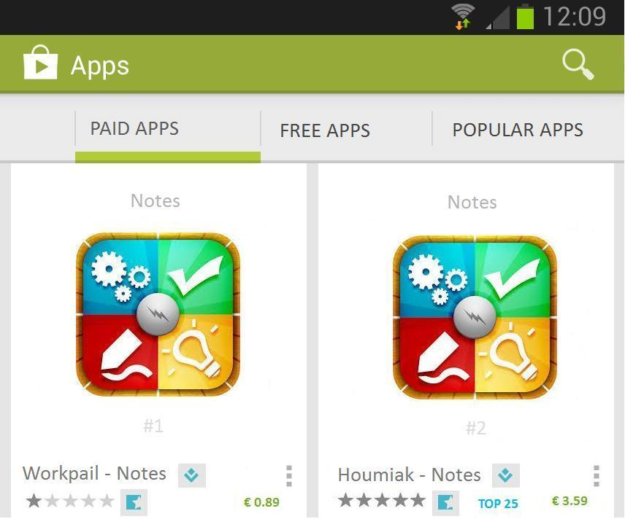
#1 | #2

Imagine that you need to choose among the product alternatives in the Application Store “right here” and “right now” Which one of the Alternative would you choose?
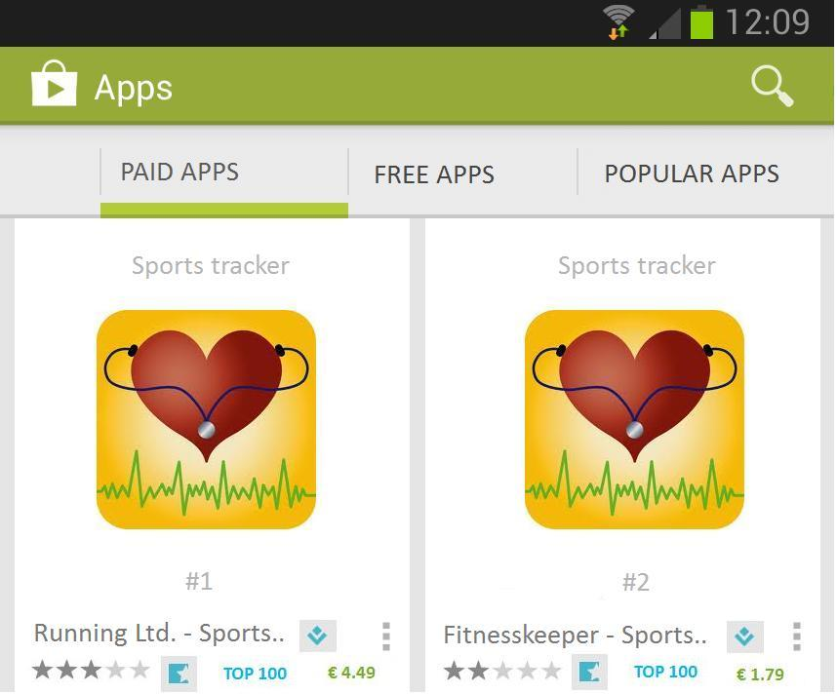
#1 | #2

Imagine that you need to choose among the product alternatives in the Application Store “right here” and “right now” Which one of the Alternative would you choose?
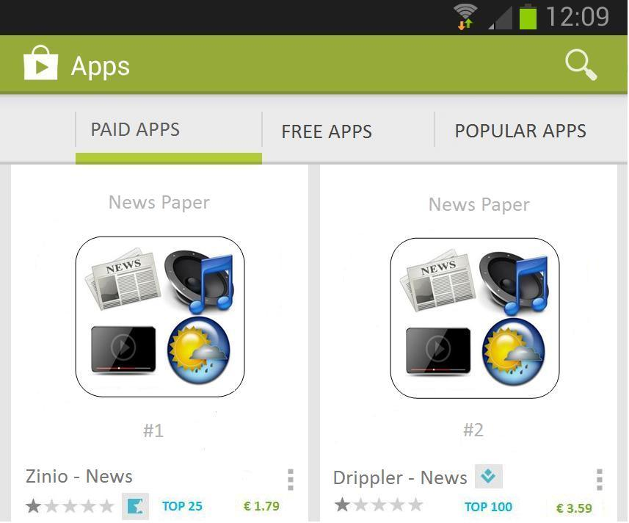
#1 | #2

Imagine that you need to choose among the product alternatives in the Application Store “right here” and “right now” Which one of the Alternative would you choose?
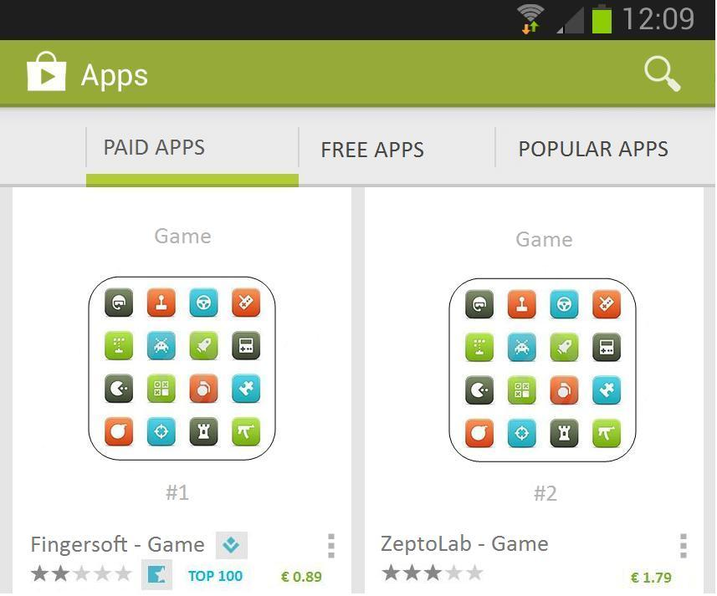
#1 | #2

Imagine that you need to choose among the product alternatives in the Application Store “right here” and “right now” Which one of the Alternative would you choose?
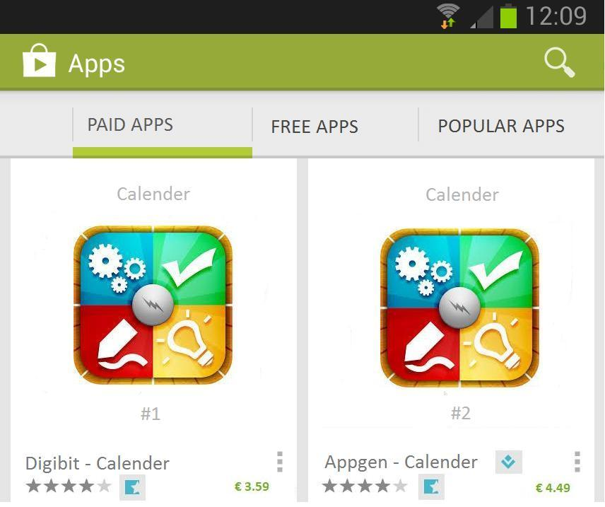
#1 | #2

Imagine that you need to choose among the product alternatives in the Application Store “right here” and “right now” Which one of the Alternative would you choose?

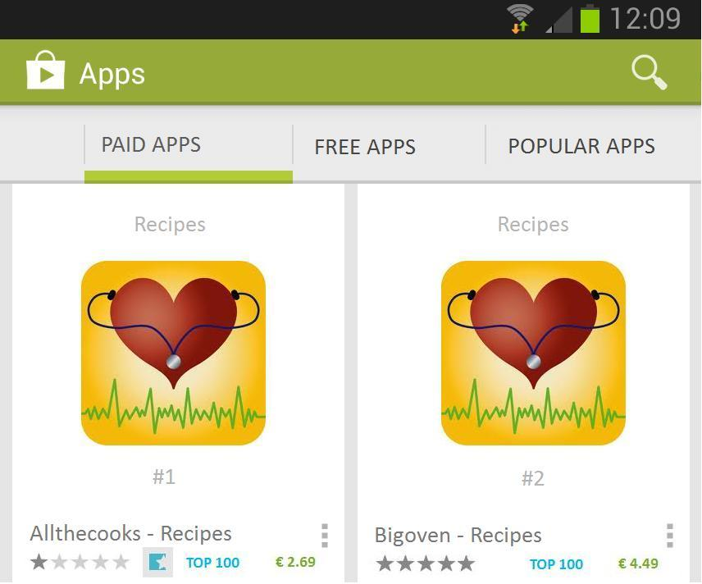

#1 | #2

Imagine that you need to choose among the product alternatives in the Application Store “right here” and “right now” Which one of the Alternative would you choose?
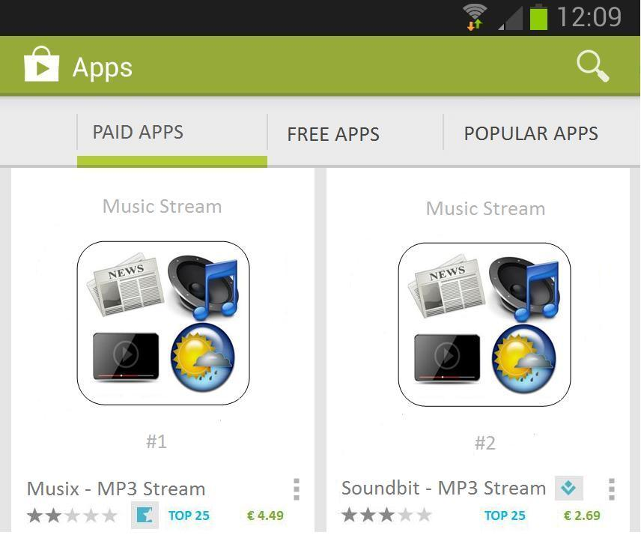
#1 | #2

Imagine that you need to choose among the product alternatives in the Application Store “right here” and “right now” Which one of the Alternative would you choose?
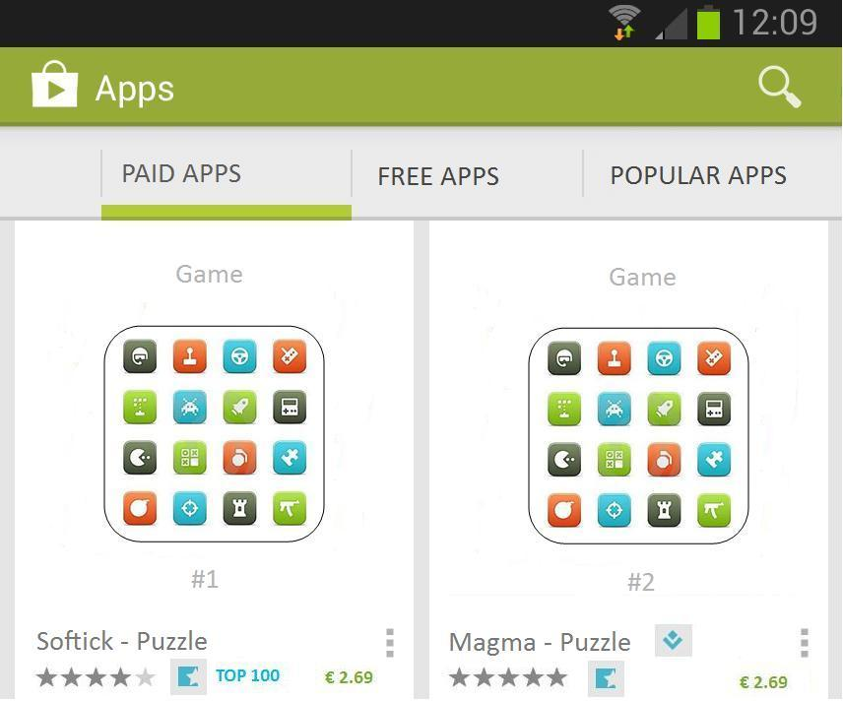
#1 | #2

Imagine that you need to choose among the product alternatives in the Application Store “right here” and “right now” Which one of the Alternative would you choose?
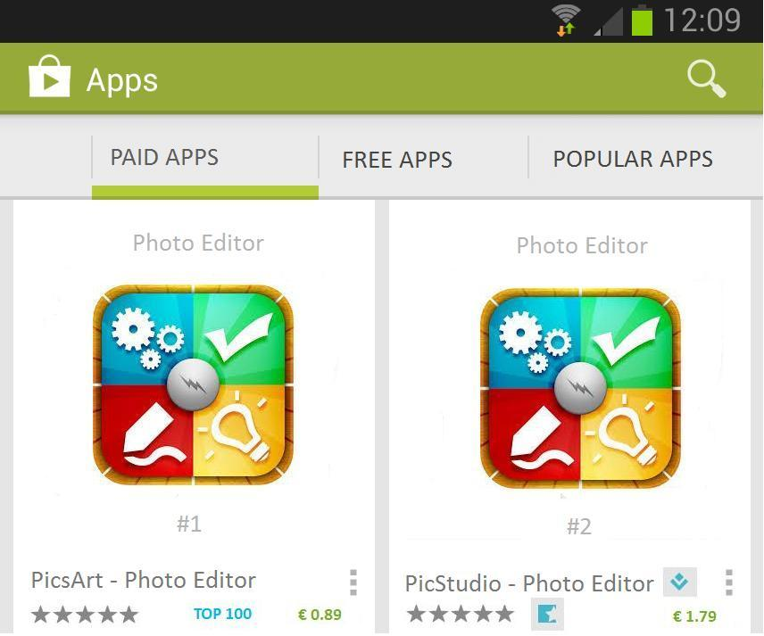
#1 | #2

Imagine that you need to choose among the product alternatives in the Application Store “right here” and “right now” Which one of the Alternative would you choose?
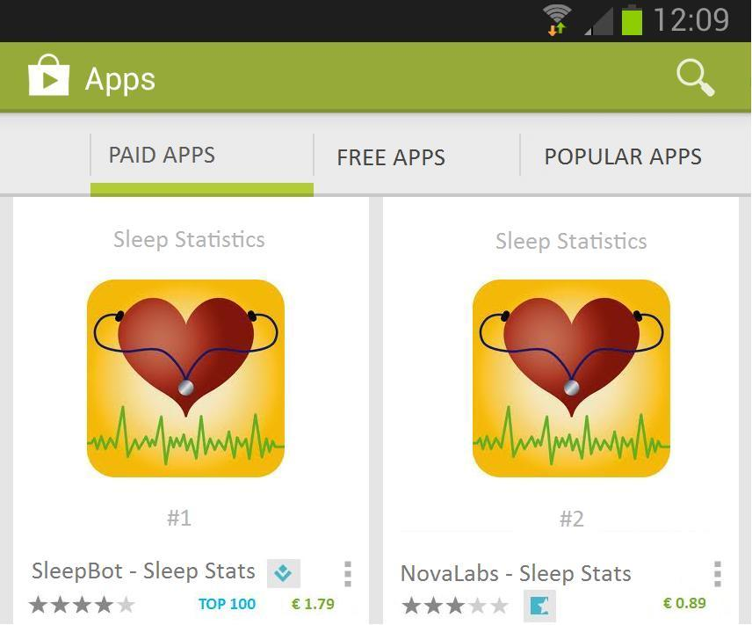
#1 | #2

Imagine that you need to choose among the product alternatives in the Application Store “right here” and “right now” Which one of the Alternative would you choose?
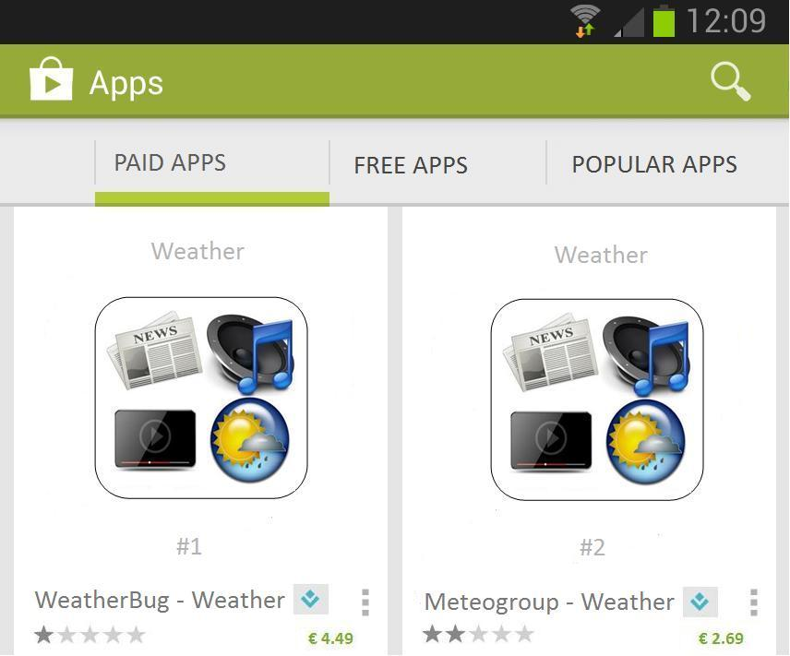
#1 | #2

Imagine that you need to choose among the product alternatives in the Application Store “right here” and “right now” Which one of the Alternative would you choose?
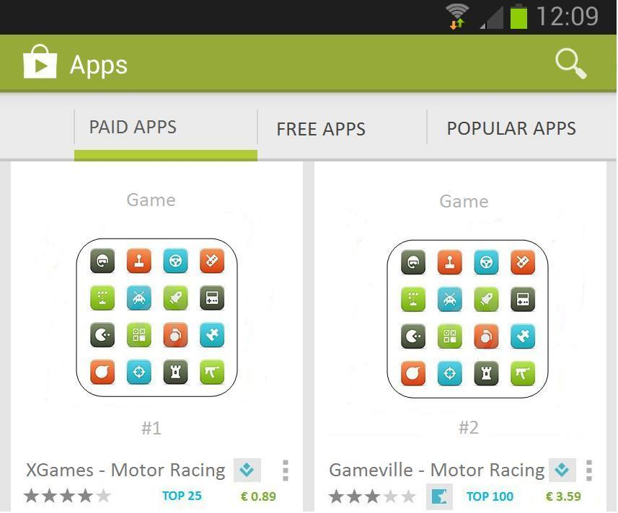
#1 | #2

Imagine that you need to choose among the product alternatives in the Application Store “right here” and “right now” Which one of the Alternative would you choose?

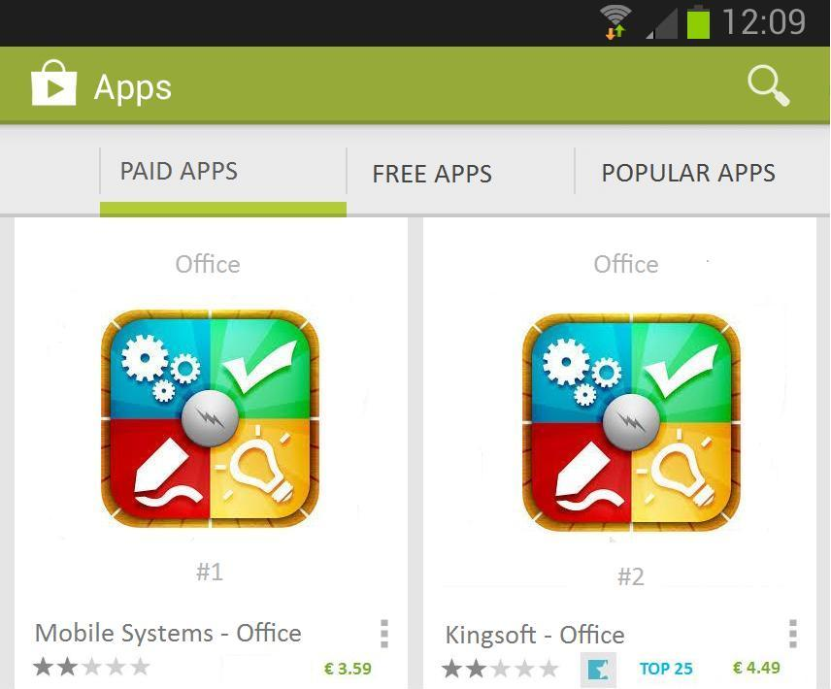
#1 | #2

Q17 Indicate for every attribute on a scale from 1 to 5 how important you think it were for the decisions you made?
 | Certainly not important (1) | Not Important (2) | Neutral (3) | Important (4) | Very Important (5)
Customer Rating (1)
Top Developer Hallmark (2)
Top Rank (3)
Editor's Choice (4)
Price (5)

Q18 Indicate on a scale from 1 to 5 for every type of App how likely it is that you would pay for the type of App?
 | Very Unlikely (1) | Unlikely (2) | Undecided (3) | Likely (4) | Very Likely (5)
Games (1)
Productivity / Utility (2)
Sports and Health (3)
Informational Apps (4)

Q19 What type of Payment Method do you use in the Application Market on your Smartphone?
- Credit Card (1)
- Click-and-buy (Default if you do not use Credit card) (2)
Q20 Indicate how frequent you have purchased Apps for which you had to pay for?
- Not at all (1)
- Occasionally (2)
- Frequently (3)
Q21 What was the most recent App you purchased for which you had to pay for? (don't fill in the question if you didn't bought any App for which you had to pay for)
Q22 Indicate on a scale from 1 to 5 how often you visit the Application Store of your Smartphone?
- Never (1)
- Rarely (2)
- Sometimes (3)
- Quite Often (4)
- Very Often (5)
Q23 Have you installed an App that describes and/or suggests Apps from the Application Store (e.g. App of the Day, App suggest)?
- Yes (1)
- No (2)
Q24 If you have to describe your own involvement in the Mobile Market (e.g. your interest in Devices, Platforms, Apps etc.), how would you, on a scale from 1 to 5, describe yourself?
- Not at all interested (1)
- Not very interested (2)
- Neutral (3)
- Somewhat Interested (4)
- Very interested (5)
Q25 Almost done! On this page we only ask you for some general Infromation.
Q26 What is your Age? (In whole years)
Q27 What is your Gender?
- Male (1)
- Female (2)
Q28 What is your level of education?
- Primary School (Lagere school) (1)
- Highschool (VMBO) (2)
- College (HAVO/VWO) (3)
- Higher Education (HBO/WO) (4)
Q29 What is your yearly income?
- 0 - 10.000 (1)
- 10.000 - 20.000 (2)
- 20.000 - 30.000 (3)
- 30.000 - 40.000 (4)
- 40.000 - 50.000 (5)
- > 50.000 (6)
Q30 What is your current professional status?
- Working (1)
- Studying (2)
THE END!
THANK U VERY MUCH!!
(Please Click through one more time to the next page to submit the survey)

Appendix B: Orthogonal design

Plan Cards generated by Orthogonal design procedure in SPSS

Card List
 | Card ID | Customer Rating | Top Developer Hallmark | Best Seller Rank | Editors Choice | Price of the App
1 | 1 | 1 Star | Yes | None | Yes | € 0.89
2 | 2 | 5 Stars | Yes | Top 25 | Yes | € 3.59
3 | 3 | 3 Stars | Yes | Top 100 | Yes | € 4.49
4 | 4 | 2 Stars | Yes | Top 100 | Yes | € 1.79
5 | 5 | 1 Star | No | Top 25 | Yes | € 1.79
6 | 6 | 1 Star | Yes | Top 100 | No | € 3.59
7 | 7 | 2 Stars | Yes | Top 100 | Yes | € 0.89
8 | 8 | 3 Stars | No | None | No | € 1.79
9 | 9 | 4 Stars | No | None | Yes | € 3.59
10 | 10 | 4 Stars | Yes | None | Yes | € 4.49
11 | 11 | 1 Star | No | Top 100 | Yes | € 2.69
12 | 12 | 5 Stars | No | Top 100 | No | € 4.49
13 | 13 | 2 Stars | No | Top 25 | Yes | € 4.49
14 | 14 | 3 Stars | Yes | Top 25 | No | € 2.69
15 | 15 | 4 Stars | No | Top 100 | Yes | € 2.69
16 | 16 | 5 Stars | Yes | None | Yes | € 2.69
17 | 17 | 5 Stars | No | Top 100 | No | € 0.89
18 | 18 | 5 Stars | Yes | None | Yes | € 1.79
19 | 19 | 4 Stars | Yes | Top 100 | No | € 1.79
20 | 20 | 3 Stars | No | None | Yes | € 0.89
21 | 21 | 1 Star | Yes | None | No | € 4.49
22 | 22 | 2 Stars | Yes | None | No | € 2.69
23 | 23 | 4 Stars | Yes | Top 25 | No | € 0.89
24 | 24 | 3 Stars | Yes | Top 100 | Yes | € 3.59
25 | 25 | 2 Stars | No | None | No | € 3.59

Appendix C : Respondent description
Respondents age
 | N | Minimum | Maximum | Mean | Std. Deviation
Age | 156 | 19,00 | 61,00 | 29,3397 | 10,65742

Respondents gender
 |  | Frequency | Percent
 | Male | 89 | 57,1
 | Female | 67 | 42,9
 | Total | 156 | 100,0

Respondents education Level
 |  | Frequency | Percent
 | Highschool (VMBO) | 8 | 5,1
 | College (HAVO/VWO) | 11 | 7,1
 | Higher Education (HBO/WO) | 137 | 87,8
 | Total | 156 | 100,0

Respondents professional status
 |  | Frequency | Percent
 | Working | 86 | 55,1
 | Studying | 70 | 44,9
 | Total | 156 | 100,0

Respondents yearly income
 |  | Frequency | Percent
 | 0 - 10.000 | 53 | 34,0
 | 10.000 - 20.000 | 31 | 19,9
 | 20.000 - 30.000 | 27 | 17,3
 | 30.000 - 40.000 | 23 | 14,7
 | 40.000 - 50.000 | 8 | 5,1
 | > 50.000 | 14 | 9,0
 | Total | 156 | 100,0

Respondents purchase frequency for paid apps
 |  | Frequency | Percent
 | Not at all | 59 | 37,8
 | Occasionally | 80 | 51,3
 | Frequently | 17 | 10,9
 | Total | 156 | 100,0

Respondents payment method
 |  | Frequency | Percent
 | Credit Card | 59 | 37,8
 | Click-and-buy | 97 | 62,2
 | Total | 156 | 100,0

Respondents Indication From 1-5 how likely it is they would pay for the following type of Apps
 | Games | Productivity / Utility | Sports and Health | Informational Apps
Mean | 2,52 | 3,27 | 3,02 | 3,01

Respondents indication of how frequent they visit the Application Store on their Smartphone
 |  | Frequency | Percent
 | Never | 5 | 3,2
 | Rarely | 32 | 20,5
 | Sometimes | 72 | 46,2
 | Quite Often | 40 | 25,6
 | Very Often | 7 | 4,5
 | Total | 156 | 100,0

Respondents who poses an App that describes and/or suggests Apps from the Application Store
 |  | Frequency | Percent
 | Yes | 54 | 34,6
 | No | 102 | 65,4
 | Total | 156 | 100,0

Respondents indication of their own involvement in the Mobile Market
 |  | Frequency | Percent
 | Not at all interested | 13 | 8,3
 | Not very interested | 31 | 19,9
 | Neutral | 39 | 25,0
 | Somewhat Interested | 59 | 37,8
 | Very interested | 14 | 9,0
 | Total | 156 | 100,0

Appendix D: Involvement Variable Dimension Reduction

Total Variance Explained
Component | Initial Eigenvalues |  |  | Extraction Sums of Squared Loadings
Component | Total | % of Variance | Cumulative % | Total | % of Variance | Cumulative %
1 | 1,772 | 59,077 | 59,077 | 1,772 | 59,077 | 59,077
2 | ,849 | 28,289 | 87,366
3 | ,379 | 12,634 | 100,000
Extraction Method: Principal Component Analysis.

Component Matrixª
 | Component
 | 1
Recoded suggestion App question | ,608
Indicate on a scale from 1 to 5 how often you visit the Application Store of your Smartphone? | ,885
If you have to describe your own involvement in the Mobile Market (e.g. your interest in Devices, Pl... | ,787
Extraction Method: Principal Component Analysis.
a. 1 components extracted.

Statistics
Objective Involvement
N | Valid | 156
N | Missing | 0
Mean |  | 2,9872
Std. Deviation |  | ,74765
Minimum |  | 1,33
Maximum |  | 4,67

Reliability Statistics
Cronbach's Alpha | N of Items
,629 | 3

Appendix E : Importance of Attributes
Indicate on a scale from 1 to 5 how important you think the attribute was for the decisions you made?
 | N | Minimum | Maximum | Mean | Std. Deviation
Customer Rating | 156 | 1 | 5 | 4,21 | ,833
Top Developer Hallmark | 156 | 1 | 5 | 2,99 | ,869
Top Rank | 156 | 1 | 5 | 3,54 | ,853
Editor's Choice | 156 | 1 | 5 | 2,88 | ,890
Price | 156 | 2 | 5 | 4,38 | ,714
Valid N (listwise) | 156

Appendix F: Model 1. Conjoint Analysis
Variables in the Equation
 |  | B | S.E. | Wald | df | Sig. | Exp(B)
Step 1ª | Cust_Rat | ,993 | ,065 | 236,917 | 1 | ,000 | 2,699
Step 1ª | Top_Dev_Hal | ,263 | ,080 | 10,714 | 1 | ,001 | 1,300
Step 1ª | Best_Sel_Rank | ,234 | ,063 | 13,723 | 1 | ,000 | 1,264
Step 1ª | Price | -1,440 | ,071 | 408,978 | 1 | ,000 | ,237
Step 1ª | Edit_Choice | ,509 | ,113 | 20,502 | 1 | ,000 | 1,664
Step 1ª | Constant | -,087 | ,088 | ,979 | 1 | ,322 | ,917
a. Variable(s) entered on step 1: Cust_Rat, Top_Dev_Hal, Best_Sel_Rank, Price, Edit_Choice.

Model Summary
Step | -2 Log likelihood | Cox & Snell R Square | Nagelkerke R Square
1 | 1760,708ª | ,404 | ,539
a. Estimation terminated at iteration number 6 because parameter estimates changed by less than ,001.

Classification Tableª
 |  | Observed |  |  |  | Predicted
 |  |  |  |  |  | Respondents choice between option 1 and 2 |  | Percentage Correct
 |  |  |  |  |  | Option #1 is chosen | Option #2 is chosen | Percentage Correct
Step 1 |  | Respondents choice between option 1 and 2 |  | Option #1 is chosen |  | 753 | 238 | 76,0
 |  |  |  | Option #2 is chosen |  | 183 | 854 | 82,4
 |  | Overall Percentage |  |  |  |  |  | 79,2
a. The cut value is ,500

Hosmer and Lemeshow Test
Step | Chi-square |  | df | Sig.
1 | 30,068 |  | 8 | ,000

Model Equation:
Choice 2 = >0 = -1.44Price + 0.993CR + 0.509ECH + 0.263TDH + 0.234BSR + є

WTP per upgrade of 1 level per attribute:
Variable | Calculation | WTP per 1 level upgrade
Customer Rating | 1.44/0.993= 1.45 | € 0.90/1.45 = €0.62
Editors Choice | 1.44/0.509= 2.83 | € 0.90/2.83 = €0.32
Top Developer Hallmark | 1.44/0.263= 5.47 | € 0.90/5.47 = €0.16
Best Selling Rank | 1.44/0.234= 6.15 | € 0.90/6.15 = €0.15

Appendix G: model 2. Conjoint analysis with interactions; Involvement and Payment Method

Variables in the Equation
 |  | B | S.E. | Wald | df | Sig. | Exp(B)
Step 1ª | Cust_Rat | 1,403 | ,216 | 42,375 | 1 | ,000 | 4,067
Step 1ª | Top_Dev_Hal | ,306 | ,266 | 1,324 | 1 | ,250 | 1,358
Step 1ª | Best_Sel_Rank | -,153 | ,209 | ,539 | 1 | ,463 | ,858
Step 1ª | Edit_Choice | 1,055 | ,374 | 7,977 | 1 | ,005 | 2,873
Step 1ª | Price | -1,952 | ,243 | 64,632 | 1 | ,000 | ,142
Step 1ª | OBJ_INVOLV | -,002 | ,119 | ,000 | 1 | ,990 | ,998
Step 1ª | Dummy_Pay | ,226 | ,189 | 1,431 | 1 | ,232 | 1,254
Step 1ª | PAY_CR | -,309 | ,141 | 4,813 | 1 | ,028 | ,735
Step 1ª | PAY_TDH | -,097 | ,171 | ,323 | 1 | ,570 | ,907
Step 1ª | PAY_BSR | ,127 | ,132 | ,930 | 1 | ,335 | 1,135
Step 1ª | PAY_ECH | -,588 | ,244 | 5,810 | 1 | ,016 | ,555
Step 1ª | PAY_PRICE | ,246 | ,154 | 2,546 | 1 | ,111 | 1,279
Step 1ª | INV_CR | -,100 | ,087 | 1,338 | 1 | ,247 | ,905
Step 1ª | INV_TDH | ,011 | ,109 | ,011 | 1 | ,917 | 1,011
Step 1ª | INV_BSR | ,156 | ,086 | 3,272 | 1 | ,070 | 1,169
Step 1ª | INV_ECH | -,080 | ,151 | ,278 | 1 | ,598 | ,923
Step 1ª | INV_PRICE | ,169 | ,096 | 3,120 | 1 | ,077 | 1,185
Step 1ª | Constant | -,233 | ,402 | ,335 | 1 | ,563 | ,792
a. Variable(s) entered on step 1: Cust_Rat, Top_Dev_Hal, Best_Sel_Rank, Edit_Choice, Price, OBJ_INVOLV, Dummy_Pay, PAY_CR, PAY_TDH, PAY_BSR, PAY_ECH, PAY_PRICE, INV_CR, INV_TDH, INV_BSR, INV_ECH, INV_PRICE.

Model Summary
Step | -2 Log likelihood | Cox & Snell R Square | Nagelkerke R Square
1 | 1742,787ª | ,409 | ,546

Classification Tableª
 | Observed |  | Predicted
 |  |  | Respondents choice between option 1 and 2 |  | Percentage Correct
 |  |  | Option #1 is chosen | Option #2 is chosen | Percentage Correct
Step 1 | Respondents choice between option 1 and 2 | Option #1 is chosen | 764 | 227 | 77,1
Step 1 | Respondents choice between option 1 and 2 | Option #2 is chosen | 189 | 848 | 81,8
Step 1 | Overall Percentage |  |  |  | 79,5
a. The cut value is ,500

Hosmer and Lemeshow Test
Step | Chi-square | df | Sig.
1 | 18,758 | 8 | ,016

Model Equation:
Choice 2 = >0 = – 1.952Price + 1.403CR + 1.055ECH – 0.309PAY*CR - 0.588PAY*ECH + є

Appendix H: Model 3. Conjoint analysis with interactions; Involvement, Payment Method, Age, Gender and income.

Variables in the Equation
 |  | B | S.E. | Wald | df | Sig. | Exp(B)
Step 1ª | Cust_Rat | 1,513 | ,273 | 30,774 | 1 | ,000 | 4,539
Step 1ª | Top_Dev_Hal | ,804 | ,338 | 5,669 | 1 | ,017 | 2,234
Step 1ª | Best_Sel_Rank | -,080 | ,265 | ,091 | 1 | ,763 | ,923
Step 1ª | Edit_Choice | 1,003 | ,472 | 4,509 | 1 | ,034 | 2,725
Step 1ª | Price | -2,181 | ,294 | 55,030 | 1 | ,000 | ,113
Step 1ª | OBJ_INVOLV | ,008 | ,121 | ,004 | 1 | ,948 | 1,008
Step 1ª | Dummy_Pay | ,185 | ,196 | ,895 | 1 | ,344 | 1,203
Step 1ª | Dummy_Gender | ,193 | ,197 | ,957 | 1 | ,328 | 1,213
Step 1ª | Income | -,047 | ,067 | ,502 | 1 | ,478 | ,954
Step 1ª | Age | ,007 | ,009 | ,542 | 1 | ,462 | 1,007
Step 1ª | AGE_PR | ,012 | ,007 | 2,650 | 1 | ,104 | 1,012
Step 1ª | AGE_CR | -,008 | ,007 | 1,138 | 1 | ,286 | ,992
Step 1ª | AGE_TDH | -,018 | ,009 | 3,937 | 1 | ,047 | ,982
Step 1ª | AGE_BSR | ,005 | ,007 | ,528 | 1 | ,468 | 1,005
Step 1ª | AGE_ECH | -,005 | ,012 | ,187 | 1 | ,666 | ,995
Step 1ª | PAY_CR | -,315 | ,146 | 4,648 | 1 | ,031 | ,730
Step 1ª | PAY_TDH | -,137 | ,178 | ,594 | 1 | ,441 | ,872
Step 1ª | PAY_BSR | ,090 | ,137 | ,431 | 1 | ,511 | 1,094
Step 1ª | PAY_ECH | -,546 | ,253 | 4,647 | 1 | ,031 | ,579
Step 1ª | PAY_PRICE | ,354 | ,159 | 4,960 | 1 | ,026 | 1,424
Step 1ª | INV_CR | -,084 | ,089 | ,879 | 1 | ,348 | ,920
Step 1ª | INV_TDH | ,047 | ,112 | ,176 | 1 | ,675 | 1,048
Step 1ª | INV_BSR | ,157 | ,088 | 3,173 | 1 | ,075 | 1,170
Step 1ª | INV_ECH | -,084 | ,156 | ,288 | 1 | ,591 | ,920
Step 1ª | INV_PRICE | ,106 | ,098 | 1,162 | 1 | ,281 | 1,111
Step 1ª | Income_CR | ,036 | ,050 | ,521 | 1 | ,470 | 1,037
Step 1ª | Income_TDH | ,001 | ,063 | ,000 | 1 | ,992 | 1,001
Step 1ª | Income_BSR | -,073 | ,049 | 2,250 | 1 | ,134 | ,930
Step 1ª | Income_ECH | ,088 | ,087 | 1,021 | 1 | ,312 | 1,092
Step 1ª | Income_Price | ,042 | ,053 | ,651 | 1 | ,420 | 1,043
Step 1ª | Gender_CR | ,097 | ,139 | ,484 | 1 | ,487 | 1,102
Step 1ª | Gender_TDH | -,048 | ,175 | ,075 | 1 | ,784 | ,953
Step 1ª | Gender_BSR | -,114 | ,139 | ,670 | 1 | ,413 | ,892
Step 1ª | Gender_ECH | ,062 | ,245 | ,064 | 1 | ,800 | 1,064
Step 1ª | Gender_Price | -,416 | ,168 | 6,128 | 1 | ,013 | ,660
Step 1ª | Constant | -,359 | ,460 | ,610 | 1 | ,435 | ,698

Classification Tableª
 | Observed |  | Predicted
 |  |  | Respondents choice between option 1 and 2 |  | Percentage Correct
 |  |  | Option #1 is chosen | Option #2 is chosen | Percentage Correct
Step 1 | Respondents choice between option 1 and 2 | Option #1 is chosen | 795 | 196 | 80,2
Step 1 | Respondents choice between option 1 and 2 | Option #2 is chosen | 204 | 833 | 80,3
Step 1 | Overall Percentage |  |  |  | 80,3
a. The cut value is ,500

Model Summary
Step | -2 Log likelihood | Cox & Snell R Square | Nagelkerke R Square
1 | 1709,034ª | ,419 | ,559
a. Estimation terminated at iteration number 6 because parameter estimates changed by less than ,001.

Hosmer and Lemeshow Test
Step | Chi-square | df | Sig.
1 | 17,424 | 8 | ,026

Model equation (variables inserted when significance value P < 0.05) :
Choice 2 = >0 = – 2.181Price + 1.513CR + 0.804TDH + 1.003ECH - 0.018Age*TDH – 0.315Pay*CR – 0.546Pay*ECH + 0.354Pay*Price – 0.416Gender*Price + є
Model equation ( variables inserted when significance value P < 0,1):
Choice 2 = >0 = – 2.181Price + 1.513CR + 0.804TDH + 1.003ECH - 0.018Age*TDH – 0.315Pay*CR – 0.546Pay*ECH + 0.354Pay*Price – 0.416Gender*Price + 0.157INV*BSR + є

Appendix I: Type of App
Indicate on a scale from 1 to 5 for every type of App how likely it is that you would pay for it?
 | N | Minimum | Maximum | Mean | Std. Deviation
Games | 156 | 1 | 5 | 2,52 | 1,307
Productivity / Utility | 156 | 1 | 5 | 3,27 | 1,144
Sports and Health | 156 | 1 | 5 | 3,02 | 1,210
Informational Apps | 156 | 1 | 5 | 3,01 | 1,164
Valid N (listwise) | 156

Appendix J: WTP calculations
Model equation ( variables inserted when significant at P < 0,05):
Choice 2 = >0 = – 2.181Price + 1.513CR + 0.804TDH + 1.003ECH - 0.018Age*TDH – 0.315Pay*CR – 0.546Pay*ECH + 0.354Pay*Price – 0.416Gender*Price + є
General attributes: WTP for 1 level upgrade of the attribute
Attributes | Calculation | WTP per 1 level upgrade
Customer Rating | €0.90/(2.181/1.513) | € 0.62
Top Developer Hallmark | €0.90/(2.181/0.804) | € 0.33
Editors Choice | €0.90/(2.181/1.003) | €0.41
Differences in WTP between Credit Card and Klick-and-Buy users for a one level upgrade in the following attributes.
Attribute | WTP for Credit Card users | WTP for Click-and-Buy users
Customer rating | €0.90/(2.181/1.513) = €0.62 | €0.90/(2.181/(1.513-0.315)= €0.49
Editors Choice | €0.90/(2.181/1.003) = €0.41 | €0.90/(2.181/(1.003-0.546)= €0.19
Differences in WTP between Credit Card users and Klick-and-Buy users for Apps with the same attribute levels:
€0.90/(2.181/0.354)= €0.15 €0.15/0.90*100%= 16.7%
Differences in WTP between Male and female for Apps with same Attribute levels:
€ 0.90/(2.181/0.416)= €0.17 €0.17/0.9*100%= 19%

http://www.idc.com/about/viewpressrelease.jsp?containerId=prUS22617910&sectionId=null&elementId=null&pageType=SYNOPSIS
http://online.wsj.com/article/SB10001424127887323293704578334401534217878.html?mod=e2tw#articleTabs%3Darticle
http://blog.flurry.com/bid/88014/The-Great-Distribution-of-Wealth-Across-iOS-and-Android-Apps
http://blogs.wsj.com/accelerators/2013/03/01/when-freemium-beats-premium/
http://pewinternet.org/Reports/2012/Smartphone-Update-2012/Findings.aspx

