Erasmus University Rotterdam
Erasmus School of Economics
Master’s Thesis Accounting, Auditing & Control

2013

Conservatism and Corporate Governance
U.S. Setting

Date:
Author : D.M. van de Vrie
Student number : 324088

Supervisor : E.A. de Knecht, RA
Co-reader : Drs. R.v.d. Wal RA

Abstract: This research focuses on the relation between conservatism and corporate governance during the time period 2007 up to an included 2011. In this research conservatism is measured using the conditional conservatism measure of Basu (1997). This measure of conditional conservatism is related to five proxies of internal corporate governance: (i) independence, (ii) board size, (iii) expertise, (iv) committee and (v) CEO/chairman Duality. In this research it is found that (i) board size is positively related to the use of conservatism and (ii) CEO/Chairman duality is positively related to the use of conservatism, except for the year 2009. The variables independence and expertise are both positively related (2007 and 2011) and negatively related (2009 and 2010) to the use of conservatism. A reason for this might be the lack of specific business expertise by (independent board members). In this research no clear relation between committees and the use of conservatism is found.
Keywords: conservatism, corporate governance, board of directors, independence, board size, expertise, committees, CEO/Chairman duality, Basu (1997)

Contents

1. Introduction 6
1.1 Introduction 6
1.2 Introduction to the main theme 6
1.3 Motivation, contribution and objectives 7
1.4 The problem definition 7
1.5 Methodology 8
1.6 Limitations and demarcations 8
1.7 Structure 9
2. Economic theories 10
2.1 Introduction 10
2.2 The agency theory 10
2.3 The efficient market hypothesis 10
2.4 The positive accounting theory 11
2.5 The stakeholder theory 11
2.6 The shareholder theory 12
2.7 Summary 12
3. Background 13
3.1 Introduction 13
3.2 What is the content of the term corporate governance? 13
3.2.1 Aspects of corporate governance 13
3.3 What is the content of the term conservatism? 16
3.3.1 Explanations of conservatism 17
3.3.2 Measuring the use of conservatism 20
3.3.3 Models to measure the use of conservatism 21
3.4 Summary 25
4. Prior research 27
4.1 Introduction 27
4.2 The relation between the use of conservatism and corporate governance 27
4.3 Measuring the relation between corporate governance and the use of conservatism 28
4.3.1 Independence 29
4.3.2 Board Size 30
4.3.3 Expertise 31
4.3.4 Committees 32
4.3.5 CEO/Chairman duality 33
4.4 Accounting research 34
4.5 Summary 35

5 Research design 37
5.1 Introduction 37
5.2 Research approach 37
5.3 Methodology 38
5.4 Measuring the use of conditional conservatism and internal corporate governance 38
5.4.1 Conditional Conservatism 38
5.4.2 Internal Corporate Governance 39
5.5 Control variables 40
5.5.1 Firm Size 40
5.5.2 Leverage 41
5.5.3 Growth 41
5.6 The research model 41
5.7 Data collection 41
5.8 Regression assumptions 43
5.9 Summary 44
6 Results 46
6.1 Introduction 46
6.2 General assumption 46
6.3 The comments concerning 2007 47
6.3.1 Regression assumptions 47
6.3.2 Results 48
6.4 The comments concerning 2008 49
6.4.1 Regression assumptions 49
6.5 The comments concerning 2009 50
6.5.1 Regression assumptions 50
6.5.2 Results 51
6.6 The comments concerning 2010 53
6.6.1 Regression assumptions 53
6.6.2 Results 54
6.7 The comments concerning 2011 55
6.7.1 Regression assumptions 55
6.7.2 Results 56
6.8 The Discussion 57
6.9 Summary 59
7 Conclusion 60
7.1 Summary 60
7.2 Findings 60
7.3 Conclusion 62
7.4 Limitations 62
7.5 Suggestions for future research 63
Reference list 65
Appendix 69
Appendix 1: Literature Study 69
Appendix 2: Gillan’s framework of corporate governance 73
Appendix 3: Descriptive statistics with outliers 74
Appendix 4: Descriptive statistics without outliers 104
Appendix 5: Results 139

1. Introduction

1.1 Introduction

Due to major financial scandals, like the Dutch Ahold and WorldCom, the trust in financial markets and firms declined. Paul Sarbanes and Michael Oxley first created their own corporate governance code, in order to restore the decline in trust by share- and other stakeholders. Both corporate governance codes were not accepted, however the combination of the codes of Paul Sarbanes and Michael Oxley (the Sarbanes-Oxley act) was accepted and implemented the U.S. in July 2002. The implementation of this corporate governance code was necessary, since the tension among society increased. The Sarbanes Oxley Act (SOX) required companies that are listed with the U.S. Securities and Exchange Commission (SEC) applied the regulation of SOX. This means, that even when the headquarters of the firm is located in another country than the U.S., they have to comply with SOX. In order to increase the trust in financial markets and firms, SOX developed regulations in order to improve the transparency, timeliness and the quality of financial reporting. After the implementation of SOX many other countries followed, for example the “Tabaksblat Code” (in the Netherlands). Ashbaugh-Skaife et al. (2006) found evidence that the implementation of corporate governance influences the credit ratings of companies. Lobo and Zhou (2002) in their study found evidence that since the implementation of the Sarbanes-Oxley act in 2002 the use of conservatism has increased.

1.2 Introduction to the main theme

This study examines the relationship between internal corporate governance and the use of conditional conservatism in a U.S. setting. According to Gillan (2006) there are two corporate governance categories: internal corporate governance and external corporate governance. As the terms of these categories already suggest, internal corporate governance is about corporate governance inside the firm and external corporate governance is about the relation between outside parties and the firm. Gillan (2006) defines external governance as the need of the firm of financing by investors outside the company. According to Gillan (2006) the managers of the firm have to act in favor of these investors from outside the firm. In order to do so, these managers need authority to make the decisions to act on behalf of these investors. This principle-agent relationship can be described as internal corporate governance, which will be used in this study.
Conservatism can be seen as understating net assets and cumulative income (Balanchandran and Mohanram, 2011). Conservatism increases when the level of verification between gains and losses increases. Further, there can be made a distinction between unconditional conservatism and conditional conservatism. Unconditional conservatism consists of the fact that assets and liabilities contain not recorded goodwill; conditional conservatism consists of the fact that the amortization of book values takes place under opposite conditions. In this study conditional conservatism will be used.

1.3 Motivation, contribution and objectives

This study examines the relationship between the internal corporate governance and the use of conditional conservatism. Prior scientific research has already focused on the relation between corporate governance on either the use of unconditional conservatism or the use of conditional conservatism. The objectives of this study are (1) create an overview of prior research on conservatism and corporate governance, (2) investigate the relation between conservatism and corporate governance and (3) determine whether there are areas that have to be investigated in future research.
This research will investigate the period 2007 up to and included 2011. This period consist of the financial crisis (since 2007) and the period after the implementation of the Sarbanes Oxley Act (SOX). Consequently, this study is able to investigate whether these two events increased the relation between the use of conditional conservatism and the internal corporate governance. The outcomes of this study will contribute to the existing scientific economic literature. Because research on the use of conservatism and corporate governance can be relevant in developing standards, the most important contribution is the extension of knowledge for the standard setters and the regulators.

1.4 The problem definition

The problem definition of this research is defined as:

In which way is internal corporate governance related to the use of conditional conservatism?

To answer the before formulated problem definition, there has to be taken a closer look to the terms conservatism and corporate governance. The next sub-questions are developed to give an answer on the before formulated problem definition:
- Theories: What are the relevant economic theories behind external financial accounting?
- Corporate governance and conservatism: What are the definitions of these terms?
- Corporate governance and conservatism discussed: What does evidence tell so far about the relation between corporate governance and conservatism?
- Research: What is the relation between corporate governance and internal corporate governance?

1.5 Methodology

The methodology that will be used to investigate the object of this study consists of a literature review and an empirical research. The first part of this master thesis consists of a discussion of prior research in which the definitions of these terms and prior research on the relation between these terms will be commented. The second part of this master thesis is the empirical research on the association between the internal corporate governance and the use of conditional conservatism. In this second part historical data will be used to investigate the sample period 2007 up to and included 2011 in which the firms of the S&P 500 will be investigated. This quantitative research consists of multiple regressions between the use of conditional conservatism and proxies for internal corporate governance.

1.6 Limitations and demarcations

Several limitations exist that might influence the outcomes of this thesis. An important limitation is that the relation between the use of conservatism and internal corporate governance will be investigated by using conditional conservatism. According to Beaver and Ryan (2005), the use of conditional conservatism is more useful than unconditional conservatism. However, to realize a total overview it might be useful to measure the relation between the use of unconditional conservatism and internal corporate governance.

According to Gillan (2006) more proxies exist to investigate the relation with the use of conservatism in addition, to investigate the relation between the use of conditional conservatism and internal corporate governance only the structure of the board of directors will be used. It might be interesting for future research to investigate the relation between the use of conservatism and the total framework developed by Gillan (2006). In this way not only the relation between the use of conservatism and internal corporate governance will be investigated, but also the relation between external corporate governance and the use of conservatism.

The proxy expertise used for internal corporate governance does not have a common used measure; consequently this is a subjective proxy. In this thesis, based on the research by Barro and Barro (1990), the measure of the CEO age will be used. Despite the fact these researchers found that turnovers increased when the CEO turned the age of 52 years, this can still be qualified as a subjective measure.

Regarding to the external validity, the sample used in this study only consists of U.S. companies. The outcomes are generalizable to U.S. firms, but since the U.S. has other regulations than for example in the European Union this study will not realize a comparison between the different regulations.

1.7 Structure

Chapter 2 contains an exposition of the relevant economic theories behind external financial accounting. These economic theories will be presented in the context of the relation between the use of conservatism and corporate governance. In chapter 3 the theoretical background of this study will be explained. This chapter contains the definitions of the term conservatism and the term corporate governance. Further chapter 3 consists of prior scientific research on internal corporate governance and the use of conservatism. Chapter 4 starts with the exposition of specific prior research on in which way corporate governance and the use of conservatism are related to each other. After the theoretical discussion of prior research the hypotheses will be developed. Chapter 5 contains the research design for the empirical part of this research. In this chapter the model, the data selection, and the control variables will be explained.
In order to answer the sub-questions about the relation between the internal corporate governance and the use of conditional conservatism chapter 6 contains the descriptive statistics and results. In chapter 7 the conclusions will be presented. In addition, the limitations and suggestions for further scientific research will be presented.

2. Economic theories

2.1 Introduction

In this chapter different economic theories behind the external financial accounting are presented. Based on the explanation of the different theories the first sub-question “What are the relevant economic theories behind external financial accounting?” will be answered. The different theories will be commented in the context of the terms conservatism and corporate governance. In paragraph 2.2 the agency theory will be explained, in paragraph 2.3 the efficient market hypothesis, in 2.4 the positive accounting theory, in 2.5 the stakeholder theory and in 2.6 the shareholder theory. The last paragraph contains the summary.

2.2 The agency theory

In this theory an information bias exists between the agents (the management of the firm) and the principals (the shareholders and the other stakeholders of the firm). This information bias creates problems in motivating agents to act in the benefits of the principals. Because of this information bias, the agents of the firm might be self-interested and instead of acting in the interest of the principals they choose to maximize their own wealth. Due to the fact that the interests of principals do not match the interests of the agents, the agency costs increase.
In order to reduce these agency costs, corporate governance and the use of conservatism can be used. Due to the implementation of corporate governance codes, the use of conservatism in the annual financial statement might increase. LaFond and Roychowdhur (2008) argued that both the use of conservatism and corporate governance are factors that can ensure a decline in the agency costs.

2.3 The efficient market hypothesis

The efficient market hypothesis (EMH) is a theory that consists of the fact that public and future information will be absorbed into the share prices immediately. Three possible situations exist: weak, semi-strong and strong form of the EMH. In the weak form only information about share prices from the past are known. A distinction exists between public information and private information. In the semi-strong form of the EMH all public available information is reflected in the share price. If in addition private information is reflected in the share price, the strong form of the EMH is assumed. Because the available information is perfect, in the strong form of the EMH it is not possible to realize an abnormal return. Accounting conservatism consists of the fact that losses are reported on a timelier basis compared to reporting gains. Consequently, it is not necessary to investigate the use of conservatism in the strong EMH form, since all information is already absorbed into the share prices.
Due to the use of strong corporate governance codes the information bias and the agency costs might be reduced, as signaled before. Due to the decrease in the agency costs and the decline of the information bias, the management of the firm might become less opportunistic consequently the use of conservatism in the financial statements might increase.

2.4 The positive accounting theory

The positive accounting theory (PAT) seeks to describe accounting practices, based on empirical observations. In contrast to the PAT, normative theories seek to prescribe accounting practices. Besides explaining accounting practices, the PAT of Watts and Zimmerman (1986) tries to predict the accounting method that will be used by the management of the firm and how/what decisions are made. In contrast to normative theories, positive theories do not seek to find an answer on the question which accounting method a company should use The relation between this theory, corporate governance and the use of conservatism can be found by using the agency theory. As explained before, management might not decide in the best interest of the stakeholders.
The PAT tries to predict, explain and describe accounting practices. Therefore the PAT might describe and explain why the management of the firm implements corporate governance codes and uses conservatism in their financial statements. Besides explaining and describing, the PAT might predict the use of conservatism or the implementation of corporate governance codes in a particular situation.

2.5 The stakeholder theory

The stakeholder theory is a normative theory which is often used in the context of corporate social responsibility and other ethical issues. According to Freeman (1984) the stakeholder theory expects a firm to be part of a social system in which different stakeholders operate. These stakeholders influence the management in operating and disclosing information. However, a distinction exists between stakeholders who have a high level of influencing power and stakeholders who have a low level of influencing power. The management of the firm is responsible for balancing the interests of both groups. The stakeholder theory contains two approaches: the managerial approach and the ethical approach (Hoozée, 2013). The managerial approach consists of the fact that the management of the firm use information to manipulate stakeholders in their own benefit. Because the management of the firm might be subject to powerful stakeholder in contrast to less powerful stakeholders, the ethical approach assumes that every stakeholder has the same right of fair treatment.
Corporate governance might be able to prevent the management from acting in their own benefit or responding only to powerful stakeholders due to use of strict corporate governance codes. The use of accounting conservatism in the annual financial statements reduce the opportunistic behavior of the management, consequently stakeholders have more reliable information on which they can base their decisions.

2.6 The shareholder theory

In contrast to the stakeholder theory that focuses on different stakeholders, the shareholder theory focuses only on shareholders. The origin of the shareholder theory can be found in the article “The Social Responsibility of Business is to Increase its Profits” by Milton Friedman (1970). In this article Friedman (1970) argued that the social responsibility of business is using the resources of the firm to increase its profit while it operates within the boundaries of the mandatory regulation or other social values.
Corporate governance might restrict opportunistic behavior of management in that way that they act within the rules of the game. Consequently, because opportunistic behavior of management is restricted, this might result in using more conservatism in the annual financial statements.

2.7 Summary

In this chapter several economic theories have been commented in the context of the use of conservatism and internal corporate governance. According to the agency theory agency costs can be reduced by using conservatism or corporate governance. Since all information is already absorbed into the share price, the efficient market hypothesis argues that investigating conservatism in the strong form of the EMH is not applicable. The positive accounting theory might describe or predict the use of conservatism or the implementation of corporate governance codes. The final two presented theories are the stakeholder theory and the shareholder theory. The difference between these two theories is that the stakeholder theory argues that a company is part of a social system in which different stakeholders operate; the shareholder theory only focuses on the shareholder. In both theories, implementing corporate governance might restrict the management from opportunistic behavior so that the use of conservatism might increase.
In the next chapter the background of this research will be commented.

3. Background

3.1 Introduction

In this chapter the second sub-question “Corporate governance and conservatism: What are the definitions of these terms?” will be answered. In order to present these definitions, in paragraph 3.2 the definition of the term corporate governance and in paragraph 3.3 the term conservatism will be commented. Paragraph 3.4 contains the summary of this chapter.

3.2 What is the content of the term corporate governance?

Gillan (2006) developed a framework in which he performs the comparison between internal and external corporate governance. Gillan (2006) defines external governance as the need of the firm of financing by investors outside the company. According to Gillan (2006) the managers of the firm have to act in the favor of these outside investors. In order to do so, these managers need authority to decide on behalf of these investors. This principle-agent relationship can be qualified as the internal corporate governance, which in this thesis will be used. Based on this distinction he argued that the definition of corporate governance is subsidiary to the perspectives someone has. In 1998, Gillan and Stark defined corporate governance as “the laws, rules, and factors that control operations at a company” (p. 4). La Porta et al. (2000) approach corporate governance from the agency theory perspective. The way in which principals protect themselves against opportunistic agents, is according to La Porta et al. (2000) the definition of corporate governance. This definition of La Porta et al. (2000) shows similarities with the definition of Shleifer and Vishny (1997) who argue that corporate governance are all mechanisms that the principals attempt to ensure that they will receive their return on their invested money. The previous signaled definitions are all implemented in the definition of Denis and McConnel (2003): “the set of mechanisms – both institutional and market based – that induce the self-interested controllers of a company to make decisions that maximize the value of the company to its owners” (p.2).

3.2.1 Aspects of corporate governance
Gillan (2006) developed a framework for corporate governance, in which he distinguishes between internal and external corporate governance. He divided internal corporate governance into five categories: board of directors, managerial incentives, capital structure, bylaw and charter provisions and internal control systems. Based on a literature overview he divided external corporate governance into: laws and regulation, (1) markets, (2) markets capital information/analysis, (3) markets accounting, financial and legal services and private sources of external oversight. Denis and McConnel (2003) investigated prior research on corporate governance. In this research they analyze different corporate governance mechanisms that can be internal or external. According to Denis and McConnel (2003) important external corporate governance measures are the legal system of a company and the takeover market. The most important internal corporate governance proxies are equity ownership and the board of directors. In addition Denis and McConnel (2003) argued that the decline in the firm value, due to the separation of ownership and control (Jensen and Meckling, 1976), is the beginning of corporate governance. Because of the monitor costs, according to Jensen and Meckling (2003) the separation between the ownership and the control the firm value will decline. In order to reduce these monitor costs, due to the contracting explanation, the agents and the principles use the mechanism of corporate governance. The before signaled internal and external corporate governance proxies by Denis and McConnel (2003) will below be commented in more detail below:
- Board of Directors
According to Gillan (2006) the board of directors is an important proxy for internal corporate governance. Besides the preparation of the compensation schemes, the board of directors is responsible to take actions, including firing when the management of the firm does not take the interests of the share- and other stakeholders into account. Besides the monitoring task, the board of directors in addition is responsible for hiring new management. Consequently, in order to increase the total firm value the importance of the board of directors is to keep the interests of both insiders and outsiders balanced.

- Ownership and control
Denis and McConnel (2003) argued that the level of the separation of the ownership and the control in every company can be different. This difference might result in different trade-offs. In a situation in which many small shareholders exist who are depending on the monitoring capabilities of the board of directors, the separation of the ownership and the control can be classified as high. However, in the case that the management of this firm is self-interested, instead of interested in the total firm value, a chance of conflicts with outside parties might exist. Another possible situation of the separation between the ownership and the control occurs when the management of the firm owns shares of this company. Because between the two variables an overlap exists, the separation in this situation between the ownership and the control is weak. Researchers have different opinions about the overlap between the ownership and the control. Dalton et al. (2003) presented the alignment approach. Because both the two parties want to maximize the total firm value, they argued that when the management of the firm owns shares of this firm, the interests of the management and the shareholders are more matched. Because the alignment effect is able to reduce the information bias (agency theory) between the agents and the principals and will encourage the use of corporate governance, Denis and McConnel (2003) agreed with Dalton et al. (2003). In contrast to the alignment effect the entrenchment effect exists. This effect consists of the possibility that management will be more self-interested, in the situation that they own shares that have a higher ownership level, when the interests of the shareholders and management are not the same. Another approach Dalton et al. (2003) developed is the control approach. In this approach they use outside blockholders as a possible mechanism for the internal corporate governance. Prior research has commented the influence of these blockholders extensively. Shleifer and Vishny (1997) stated that blockholders will be triggered to measure the influence of the management of the firm. Further they argue that blockholders will use their power to personally benefit from their power. In this case they will try to increase their earnings, at the cost of earnings by smaller shareholders. Bethel et al. (1998) communicated that blockholders are able to punish the management when they do not take the interests of the shareholders into account. Daily et al. (2003) argued that this shareholder activism will contribute to the use of corporate governance. Denis and McConnel (2003) communicated that blockholders have enough power to influence the management of the firm. Consequently they are able to increase the firm value which will benefit themselves, but also other smaller shareholders.
- The takeover market
The takeover market can be qualified as a final resort, when other corporate governance methods do not show the desired outcomes. The idea behind the takeover market is that outsiders are going to take over and control the firm. Keeping this in mind, the management of the firm will act in the interests of the shareholders. Consequently the firm value will be increased and the information bias between the agents and the principles will decline.

3.3 What is the content of the term conservatism?

The definition of the term conservatism has been subject to change over time. In 1924, Bliss defined conservatism as: “anticipate no profit, but anticipate all losses” (Bliss, 1924, cited in Watts, 2003a). The intention of the phrase anticipating no profit is that profits cannot be recognized before a legal claim exists that the revenues can be verified. This definition of conservatism can be qualified as a strict and extreme version of conservatism. For example Basu (1997) defined conservatism as: “Denoting accountant’s tendency to require a higher degree of verification to recognize good news as to recognize bad news as losses” (p. 7). This less severe definition of conservatism is used by Watts (2003) in his article. According to Balachandran and Mohanram (2011) conservatism is “the choice (by regulators, standard setters, or firms) of accounting treatments likely to understate the net assets and the cumulative income” (p. 275).

The Financial Accounting Standards Board (FASB) (2005) compares prudence with conservatism, which they define as: “a prudent reaction to uncertainty to try to ensure that uncertainty and risks inherent in business situations are adequately considered” (p. 9). The International Accounting Standards Board (IASB) (2005) extent this definition of the FASB: “the exercise of prudence does not allow, for example, the creation of hidden reserves or excessive provisions, the deliberate understatement of assets or income, or the deliberate overstatement of liabilities or expenses, because the financial statement would not be neutral and, therefore, not have the quality of reliability” (p. 9). The importance of the use of conservatism is present in the article of Basu (1997). Basu state that the use of conservatism is influencing the accounting practice since the 15th century. The IASB argued that the use of conservatism is a characteristic of accountants, but questions whether this accounting term is helping stakeholders in making their decisions. The FASB (concepts statements 2, paragraph 49) argued that accounting information is relevant when a stakeholder is able to decide based on this information. Consequently the question remains: Is the use of conservatism desirable? Although the use of conservatism will not be a qualitative characteristic of accounting information, the IASB argues that prudence (an important characteristic of the use of conservatism) is part of the reliability of the accounting information and consequently the use of conservatism might be desirable and need to be implemented in the framework of the IASB. In contrast to the IASB, the FASB tries to prevent the use of conservatism to realize that the published information is neutral.

Prior research distinguishes between conditional conservatism and unconditional conservatism. Unconditional conservatism consists of the fact that at the inception of assets and liabilities, these assets and liabilities contain unrecorded goodwill, while conditional conservatism consists of the fact that the amortization of the book values is based on opposite conditions. According to Penman & Zhang (2002) conditional conservatism focuses on the profit and loss account, while unconditional conservatism focuses on the balance sheet. Several arguments exist in which conditional conservatism can be qualified as more preferable in current research than the use of unconditional conservatism:
- According to Watts (2003) the use of conditional conservatism create stewardship and the usefulness of the published information,
- Basu (1997) found evidence that the use of conditional conservatism create a asymmetric recognition of gains and losses, and
- Beaver and Ryan (2005) state that conditional conservatism is used more often than unconditional conservatism, consequently they signaled that conditional conservatism is more important for accounting researchers.

3.3.1 Explanations of conservatism
According to Watts (2003a, b) four alternative explanations of the use of conservatism exist. These explanations are: the contracting explanation, the shareholder litigation explanation, the taxation explanation and the accounting explanation. According to Watts (2003b) the contracting explanation and the shareholder litigation explanation are the most important. The explanations of the use of conservatism will be commented below:
- The contracting explanation
In contrast to the three other explanations, the contracting explanation is an old accounting method. Because this accounting method is very often used, this method in addition is thoroughly investigated. In the compensation process of debt, the use of conservatism appears almost automatically. Consequently the use of conservatism in this process is important. Due to the influence of the use of conservatism, the standards for profit recognition are more stringent than the recognition of losses. Consequently, the possibility that the net assets of a company are overstated is less likely. In order to reduce the moral hazard problems, parties with asymmetrical information use accounting conservatism. In order to reduce this asymmetrical information between the agents (the management of the firm) and the principals (share- and other stakeholders) Watts (2003a) presented three illustrations:
- Debt covenants
In order to ensure that the debtors receive their contracted sum, debtors created debt covenants. These covenants reduce the opportunistic and the self-interested managers. Without these covenants managers might overstate the published net assets, but if the firm is not able to create enough net assets they will not be able to pay the contracted sum to the debtors of the company.

- Compensation contracts
Compensation contracts have been created to reduce the self-interested behavior of managers. This illustration is derived from the agency theory, as signaled before, in which an information bias exists between the agents and the principals of a firm. In order to reduce the possibility that managers increase their own benefit, at the expense of the total firm value, the use of accounting conservatism ensures that strict rules exist regarding to recognizing the published earnings.

- Corporate governance
Due to the use of accounting conservatism, when a net present value turns out to be negative, managers and shareholders will receive a signal on a timely basis. Because both managers and shareholders will be signaled on a timely basis, both parties will benefit of the use of conservatism. Shareholders will be protected against declining stock prices and managers will be protected against declining firm performance.

According to Shleifer and Vishny (1997) the contracting theory describes a firm as a concatenation of contracts. According to Jensen and Meckling (1976) the agency-principal problem is a contract between the agents (management of the firm) and the principals (share- and stakeholders). Emanuel et al. (2003) describes that efficient contracting will be accomplished using capital structures, ownership structures and compensation arrangements. In addition, Emanuel et al. (2003) argue that accounting is part of the governance mechanisms just as, for example, finance and sales. Consequently they argue that the choice of the accounting method in the governance mechanism and in the contracting theory is important.

- The shareholder litigation explanation
The shareholder litigation explanation is, in contrast to the contracting explanation, a relatively new explanation of the use of conservatism. The beginning of this explanation is in the U.S. in the 1960s. Kellog (1984) found evidence that lawsuits (litigation costs) from buying parties against auditors and companies outnumbered lawsuits from selling parties. To prevent the company against unwanted lawsuits, the management of the firm used conservative mechanisms. In order to reduce the estimated lawsuits expenditures, in this way they will understate the published net assets.
- The taxation explanation
In accordance with the shareholder litigation explanation, the taxations explanation in addition is a relatively new explanation of the use of conservatism. The origin of this explanation is in the U.S. in 1909. The use of conservatism will reduce the total value of the current taxes. As signaled earlier due to the asymmetric recognition of gains and losses, tax income will be differed consequently the current value of the tax will be lower.
- The accounting explanation
As signaled before, because they want to achieve the neutrality of published accounting information, the FASB tries to ban the use of conservatism. However, the assumptions used in the reporting standards in the Securities acts of 1933 and of 1934 increase the use of conservatism. The consequence of overstating the published assets and the published revenues of firms might be that society will be opposed against this development. In order to decline the outrage among society, the accounting explanation consists of the fact that regulators and standards setters will implement standards that are more conservative orientated. In this way companies are not able to overstate their published assets and published revenues anymore.

Garcia Lara et al. (2009) investigated whether the four explanations, as signaled before, influences the choice of using conditional conservatism, unconditional conservatism or both. In this study Garcia Lara et al. (2009) found evidence, in accordance with Qiang (2007), that
- contracting induces conditional conservatism and
- litigation, taxation and regulation induce conditional conservatism and unconditional conservatism.

3.3.2 Measuring the use of conservatism

According to Watts (2003b), researchers used three types of methods to investigate the level of the used conservatism. These types of measurements are: net asset measures, accrual/earnings measures and earnings/stock returns relation measures. These measurements will be explained below:

- Net asset measures
The effect of using conservatism is that when assets decrease, while they are not completely verifiable, they are recorded. When the same scenario arises when assets increase, this increase in assets will not be recorded. Consequently, net assets will be recorded against a value below the market value. In prior research investigators use book-to-market models and valuation models to predict the understatement of the published net assets, due to the use of accounting conservatism. Feltham and Ohlson (1995) developed a model to estimate the underestimation of the operating assets. This cross-sectional regression is based on the assumption that economic depreciation is less than the accounting depreciation and is used often. Ahmed et al. (2002) developed a model which is able to measure conservatism due to a regression between goodwill on abnormal earnings, operating assets and investments in operating assets. Beaver and Ryan (2000) measure conservatism using a book-to-market ratio. In this model Beaver and Ryan (2000) use cross-sectional data in time series to perform an estimation of the understatement of published net assets due to the use of conservatism.
- Earnings/Accrual Measures
As signaled earlier the recognition of gains and losses are asymmetric among the use of accounting conservatism. Besides the asymmetric recognition of gains and losses, in addition the recognition of accruals is asymmetrical. Consequently another measure to predict the level of the used conservatism is by using the asymmetrical recognition of gains and losses and accruals. Basu (1997) argued that due to the use of conservatism, “bad” news is reflected earlier than “good” news. The earning measure of Basu (1997) used stock returns to measure good or bad news. In order to measure the use of conservatism, the accrual measure of Givoly and Hayn (2000) uses the sign and the magnitude of the accumulated accruals. They state that a constant dominance of the negative accruals (sign) is an indicator of the use of conservatism, and the magnitude of the negative accruals is an indicator for the change in the use of conservatism. In addition, Givoly and Hayn (2000) found, in accordance with Basu (1997), that “bad” news is reported earlier than “good” news. Bushman and Piotroski (2006) found evidence that firms report bad news earlier than good news in countries in which a higher quality of justice enforcement exists.

- Earnings/Stock returns measure
As signaled before according to the EMH, stock prices will absorb new information immediately. Due to the use of conservatism, the trend of losses will be more similar with the trend of stock returns than with gains (since these gains are recorded less timely). To investigate this prediction, Basu (1997) investigated whether the R² and the coefficient of stock returns will be higher in the case of accounting losses compared to accounting gains. In this study Basu (1997) found evidence for this prediction. Consequently Basu (1997) concluded that stock returns reflect losses in the similar period, while gains will be reported on a timelier basis than the earnings.

3.3.3 Models to measure the use of conservatism

In this sub-paragraph the different models to measure the use of conditional conservatism will be presented.

3.3.3.1 Basu
The study of Basu (1997) re-investigates the principle of the use of conservatism. In this study Basu developed a model to investigate his predictions. He predicts that:
- earnings reflect “bad” news earlier than “good” news,
- the cash flow association is weaker than the earnings return association accessible “bad” news compared to “good” news,
- an increase in earnings, which is unexpected, is more likely to be persistent in contrast to a decline in the unexpected earnings and
- the return on unexpected earnings will be higher for “good” news than for “bad” news.

In order to investigate these predictions Basu (1997) used three models. The first model is used to investigate the first prediction:

$\frac{X\text{it} }{P\text{it-1}} = α\text{0} + α\text{1}DR\text{it} + β\text{0}R\text{it} +β\text{1}R\text{it}*DR\text{it}$ (1)

X_{it} / P_{it-1} =the earnings per share for company i in fiscal year t divided by the price per share at the start of the fiscal year
R_{it} = the return on company i from nine months before the end of the fiscal year and three months after the end of the fiscal year
DR_{it} = a dummy variable which is “1” when R_{it} is smaller than zero and “0” when R_{it} is not smaller than zero
Since he argues that “good” news is reflected later in the share price than “bad” news, based on this prediction Basu (1997) expects the coefficient (β) of “bad” news to be greater than of “good” news. In addition Basu (1997) assumes that the R² of “bad” news is higher for the same matter.
The second hypothesis about the earnings return association and the cash flow association is measures using the following formula:

$XE\text{it}= α\text{0} + α\text{1}DR\text{it} + β\text{0}R\text{it} +β\text{1}R\text{it}*DR\text{it}$ (2)
$CFO\text{it}= α\text{0} + α\text{1}DR\text{it} + β\text{0}R\text{it} +β\text{1}R\text{it}*DR\text{it}$ (3)
$CFOI\text{it}= α\text{0} + α\text{1}DR\text{it} + β\text{0}R\text{it} +β\text{1}R\text{it}*DR\text{it}$ (4)

XE_{it} = earnings per share before extraordinary items and discounted operations for company i in fiscal year t divided by the price per share at the start of the fiscal year.
CFO_{it} = cash flow from operations for company i in fiscal year t divided by the price per share at the start of the fiscal year.
CFOI_{it} = cash flow from operating and investing activities for company i in fiscal year t divided by the price per share at the start of the fiscal year.
R_{it} = the return on company i from nine months before the end of the fiscal year and three months after the end of the fiscal year
DR_{it} = a dummy variable which is “1” when R_{it} is smaller than zero and “0” when R_{it} is not smaller than zero
Earnings are the sum of the accruals and the cash flows. When losses are not realized the current published earnings will decline, however they will not influence the cash flow. When gains are not realized this will not have an effect on the published cash flow and the published earnings. In addition, accruals are used by auditors to recognize “bad” news on an asymmetrical basis. Consequently Basu (1997) expects that the published earnings are more conservative in contrast to the cash flows.
The third hypothesis about the persistence of unexpected earnings is measured using the following formula:

$\frac{ΔX\text{it} }{P\text{it}}= α\text{0} + α\text{1}D + β\text{0}\frac{X\text{it-1} }{P\text{it-2}} +β1\frac{D*ΔX\text{it-1} }{P\text{it-2}}$ (5)

X_{it} = earnings per share for company i in fiscal year t
ΔX_{it} = change in earnings per share for company i over fiscal year t
P_{it-n} = Price per share for company i at the end of fiscal year t-n
D = a dummy variable which is “1” when R_{it} is smaller than zero and “0” when R_{it} is not smaller than zero
According to Basu (1997) timeliness and persistence are different terms that both investigate the level of the use of accounting conservatism. The idea behind timeliness is that news becomes available to the market at a timely basis, and consequently a minor part of the relevant news will become available in the future. The idea behind persistence is that the minor part of the relevant news will become available on a timely basis. Since “bad” will be reflected in the earnings immediately “bad” news will be less persistent, in contrast to “good” news which will be more persistent.
The final hypothesis Basu (1997) investigated, about the return on the unexpected earnings, is measured using the following hypothesis:

$U\text{ij} = α\text{0} + α\text{1}DX\text{it} + β\text{0} \frac{ΔX\text{it} }{P\text{it}}+β\text{1}\frac{D*ΔX\text{it} }{P\text{it-1}}*DX\text{it}$ (6)

u = abnormal return for company i in month j
X_{it} = earnings per share for company i in fiscal year t
ΔX_{it} = change in earnings per share for company i over fiscal year t
P_{it-1} = price per share at the start of the fiscal year
D = a dummy variable which is “1” when R_{it} is smaller than zero and “0” when R_{it} is not smaller than zero
The last prediction Basu (1997) investigates is in what way the use of accounting conservatism is able to influence the capital markets response to news about the published earnings. These reactions are measured using an earnings response coefficient (ERC). This coefficient consists of the abnormal return of the published earnings which are not expected at the time the news becomes available to the market. As signaled earlier, “good” news is more persistent than “bad” news. These positive earnings changes will contribute to increase in the ERC. Because this ERC will increase, since “bad” news can be qualified as a one-time change, the capital market will capitalize the “good” news at a higher value than “bad” news.

3.3.3.2 Ball and Shivakumar

Ball and Shivakumar (2005) developed the Asymmetric Accrual to Cash-flow Measure (AACF) to investigate the use of accounting conservatism. In contrast to the Basu (1997) measure of accounting conservatism, this measure is able to estimate the use of accounting conservatism in private companies. Since the Basu model (1997) uses stock prices, Basu (1997) was only able to investigate firms that were listed on a stock exchange market. Therefore Ball and Shivakumar (2005) developed the following model to investigate the use of accounting conservatism in private firms:

$ACC\text{t} = β\text{0} + β\text{1}DCFO\text{t} + β\text{2}CFO\text{t} + β\text{3}DCFO\text{t}*CFO\text{t} + µ\text{t}$ (7)

ACC_{t} = Accruals measured as Δ inventory + Δ debtors + Δ other current assets – Δ creditors – Δ other current liabilities – depreciation
CFO_{t} = Cash-flow for period t
DCFO_{t} = Dummy variable that is “0” if CFO_{t} ≥ “0”, but “1” if CFO_{t} < “0”
Both the Basu (1997) and the Ball and Shivakumar (2005) models are based on the asymmetrical timeliness of “good” and “bad” news. Therefore the two models show similarities, however the main differences between de two models can be derived from the fact that other proxy variables are used for news and earnings. As discussed before, the Ball and Shivakumar (2005) model tries to estimate the use of accounting conservatism among private companies. Consequently they are not able to use stock prices because private companies are not listed on a stock exchange market. Instead of stock prices they use the proxy variable operating cash-flow to estimate “good” or “bad” news. To estimate the earnings of the company Ball and Shivakumar (2005) uses the accrual component of the total earnings, whereas Basu (1997) uses total earnings.

3.4 Summary
The definition of the term conservatism has been subject to change over time. The extreme
definition of Bliss (1924) is replaced by less extreme definitions. Basu (1997) defined the use of conservatism as: “Denoting accountant’s tendency to require a higher degree of verification to recognize good news as to recognize bad news as losses” (p. 7). The use of conservatism is an important accounting method. Basu (1997) argued that the use of conservatism is influencing the accounting since the 15th century. The IASB compares the use of conservatism with prudence. According to the FASB and the IASB the use of conservatism is not a qualitative characteristic of the published accounting information (like relevance and reliability), but can be qualified as a part of these qualitative characteristics. Consequently, the use of conservatism has to be adopted in the framework of the IASB. The use of conservatism can be divided into conditional conservatism and unconditional conservatism. Basu (1997), Watts (2003) and Beaver and Ryan (2005) argue that the use of conditional conservatism is more preferable than the use of unconditional conservatism. Overall, the use conservatism consists of the fact that the recognition of gains is more strictly than losses.
The origin of the term corporate governance can be found in the agency theory. This theory explains that an information bias exists between the agents and the principals of a firm. Due to this information bias, agents (managers) might act in their own benefit instead of in the benefits of the principals (share- and other stakeholders). Denis and McConnel (2003) define corporate governance as: “the set of mechanisms – both institutional and market based – that induce the self-interested controllers of a company to make decisions that maximize the value of the company to its owners” (p. 2).
In this chapter background on conservatism and corporate governance is signaled. According to Watts (2003a) four possible explanations of the use of conservatism exist, which are: the contracting explanation, the shareholder litigation explanation, the taxation explanation and the accounting explanation. In the second paper of Watts (2003b), Watts signaled different models to measure the use of conservatism, which are: net assets measures, earnings/accrual measures and earnings/stock returns measures. After the theoretical explanation of the different measurements, the models of Basu (1997) and Ball and Shivakumar (2005) have been explained. Next, prior research about the term corporate governance was signaled. Gillan (2006) provided an overview of corporate governance in which he distinguishes between internal and external corporate governance. Denis and McConnel (2003) argued that the takeover market, board of directors and the separation of the ownership and the control are the most important proxies for internal and external corporate governance.
In the next chapter prior economic scientific research will be presented.

4. Prior research

4.1 Introduction

In order to answer the sub-question “Corporate governance and conservatism discussed: What does evidence tell so far about the relation between corporate governance and conservatism?” in this chapter the relationship between the use of conservatism and corporate governance will be presented. Paragraph 4.2 contains an overview of prior scientific research on the relation between these terms. Paragraph 4.3 contains the explanation of the relation between specific proxies for corporate governance and the use of conservatism. Based on this explanation the hypotheses will be developed. In subparagraph 4.3.1 the relation between independence and the use of conservatism will be presented, in 4.3.2 the relationship between the board size and the use of conservatism, in 4.3.3 the relation between the expertise and the use of conservatism, in 4.3.4 the relationship between the committees and the use of conservatism and in 4.3.5 the relationship between the CEO/chairman duality and the use of conservatism. Paragraph 4.4 contains an overview of accounting research methods. Paragraph 4.5 contains the summary of this chapter.

4.2 The relation between the use of conservatism and corporate governance
Although prior scientific research has focused on the relation between corporate governance and the use of conservatism, this subject is not investigated as extensively as the use of earnings management and the use of conservatism. Watts (2003a, b) signaled that corporate governance might be an explanation of the use of conservatism. The use of conservatism provides signals to managers and shareholders of the existence of a negative net present value projects. Discovering this is an early stage will prevent shareholders from declining stock and bad performing managers. LaFond and Roychowdhur (2008) investigated the relation between managerial ownership and accounting conservatism. To investigate this relation they used two hypotheses. The first hypothesis assumed that accounting conservatism is negatively related to the use of conservatism. The second hypothesis assumed that after controlling for investing opportunities the relation between the use of conservatism and managerial ownership is negatively related. Using the Basu model (1997) LaFond and Roychowdhur (2008) argued that the level of corporate governance will decreased when the level of the use conservatism is decreasing. Chi et al. (2009) investigated two possible relationships between the use of accounting conservatism and corporate governance. First, they predict that the demand for the use of conservatism will be higher in a situation when more agency problems exist. Second, they predict that due to a strong level of corporate governance, the manager will be better monitored; consequently the implementation of the use of conservative accounting will be accelerated. Using the C-score (Khan and Watts, 2009) they found evidence that companies which do not have strong corporate governance are more conservative. Consequently they conclude that the use of conservatism can be used as a substitute for corporate governance. Garcia Lara et al. (2009) found evidence among U.S. companies that firms in which the influence of the Chief Executive Officer (CEO) is low, the protection against takeovers is low and governance standards are strong, these companies will be more conservative. In order to come to this conclusion Garcia Lara et al. (2009) assumed that corporate governance and the use of conservatism are positively related. Due to developing internal and external corporate structures, conservatism will decrease agency problems. The before signaled hypothesis is investigated using the Basu model (1997).
Brown et al. (2006) investigate the relation between the use of conservatism, corporate governance and value relevance. In this study Brown et al. (2006) used the Basu model (1997) to measure conditional conservatism and external corporate governance. Shareholder protection was used as proxy for the external corporate governance. More specifically they investigated the relationship between the use of conditional conservatism and the value relevance of the published earnings, which they assume to be positively related. Accruals were used as proxy for the value relevance of the published earnings. Based on the before signaled relationship, Brown et al. (2006) investigated whether an incremental relation exists between shareholder protection and the value relevance. Brown et al. (2006) concluded that countries in which they relatively use accruals more than in other countries, the relation between the use of (conditional) conservatism and the value relevance is positive. In addition, they found that this relation is incremental taking the relation between external corporate governance and the value relevance into account.

4.3 Measuring the relation between corporate governance and the use of conservatism
In this research, internal corporate governance will be used. Gillan (2006) developed a framework in which he commented the differences between internal and external corporate governance, using a literature research. In this study the proxies of board structure will be used to investigate the relation between the internal corporate governance and the use of conservatism. Gillan (2006) showed that the structure of the board can be investigated by using five proxies: Independence, Board Size, Expertise, Committees and CEO/chairman Duality.

4.3.1 Independence
The independence of the board of directors can be, according to Klein (2002), measured by investigating whether a majority exists between the inside and the outside directors. Klein (2002) in addition argued a grey area, which are directors that are affiliated with the firm. Except for being a board member, outsiders have no ties to the firm in which they are member of the board. According to Klein (2002) “affiliated directors are past employees, relatives of the CEO or have significant transactions and/or business relationships with the firm” (p. 7). Ahmed and Duellman (2007) investigate between board characteristics and the use of conservatism. Consequently, to measure the relation between inside and outside directors and the use of conservatism, they used three methods: (i) Market-value based proxy for conservatism, (ii) the accrual based proxy for conservatism and (iii) the Basu model (1997). In their study they investigate five proxies for board characteristics. One of these proxies for board characteristics is the percentage inside directors. In this study they used the period 1999 – 2001 and found evidence that inside directors are negatively related to the use of conservatism. Ahmed and Duellman (2007) argue that a majority of inside directors (or a high amount inside directors) will lead to an opportunity to use aggressive accounting methods. In this way there will be a lower level of conservatism. Outside directors can use conservatism to perform their task in monitoring important decisions. Ho (2009) found the same evidence on inside directors and the use of conservatism in Malaysia. Because, according to Ho (2009), research showed mixed results when investigating the relation between the use of conservatism and the percentage inside directors, Ho (2009) did not formulate a hypothesis on this relation. The relation between inside directors and the use of conservatism was investigated using the following models: (i) the accrual-based measure for conservatism, (ii) the market based measure for conservatism and (iii) the C-score. In addition, the percentage outside directors was positively related to the use of conservatism. Ball (2001) stated that conservatism can be used to identify negative net present value projects in an early stage. Consequently when the majority of the board members are outside directors, a higher level of the use of conservatism exists. This creates the first hypothesis.

H1
The number of outside directors is positively related to the use of conservatism.

4.3.2 Board Size
Ho (2009) measures different board characteristics with the use of conservatism. Ho (2009) assumed the relation between board size and the use of conservatism to be negative. This hypothesis is measured using the models: (i) the accrual-based measure for conservatism, (ii) the market based measure for conservatism and (iii) the C-score. Ho (2009) found evidence that the board size is negatively associated with the use of conservatism. Ahmed and Duellman (2007), however, found evidence that the size of the board of directors is positive, which they also assumed in their hypothesis, but not significantly associated with the use of conservatism using the models signaled in the paragraph before. This difference might be due to the fact that the study of Ho (2009) was performed in Malaysia and Ahmed and Duellman (2007) used the S&P 500 index, which is the market index of the United States. Chaganti et al. (2007) assumed that the board size of failed companies is smaller than the board size of non-failed companies. Due to making a comparison between pairs of failed and non-failed firms Chaganti et al. (2007) found evidence that in the retailing industry, non-failed companies tend to have more members in the board of directors, than failed companies. This indicates that a higher amount of directors influence the existence of the company. However, Duellman (2006) argued that because of the “free-rider problem” large boards might not be accurate. This problem is based on the fact that the members of the board are not willing to do their best, and consequently they do not contribute to their tasks as member of the board. Guest (2009) assumes that using a large board, communicating and decision making problems might arise. Using the Wintoki (2007 model), Guest (2009) found evidence that in U.K. companies the size of the board is negatively associated with the firm performance. Based on prior research, they argue that the size of the board is dependent on different variables, such as the size of the firm and the complexity of the firm (Coles et al. 2008). Coles et al. (2008) assumed that complex firms have larger boards and make use of more outside directors. Making use of the Tobin’s Q, Coles et al. (2008) found evidence for their hypothesis.
Because in this research US companies will be investigate, the prediction is that, according to Ahmed and Duellman (2007), a positive relation exists between the use of conservatism and corporate governance.

H2
A positive relationship exists between the size of the board and the use of conservatism.

4.3.3 Expertise
Wang et al. (2010) investigated if a relation exists between the use of accounting conservatism and the managerial ownership. Their hypothesis stated that firms with more inside debt (pension benefits and deferred compensation from the managers of the firm) less conservatism will be used in the financial statements. Using Basu model (1997) they found significant evidence for their hypotheses. In this research they controlled for CEO age and tenure. They found that CEO age has a positive effect on the use of conservatism, while CEO tenure has a negative effect. Li (2010) assumed that the relationship between the use of conservatism and audit tenure is not the same for all firms. In contrast to the CEO tenure, Li (2010) found a positive relation between the use of accounting conservatism and the audit tenure, using a regression between the Basu model (1997) and a proxy variable for audit tenure. This indicates that the level of the use of accounting conservatism increases when the relation between the auditor and client is longer. However this positive relation was only observed in large companies or in companies in which the monitoring level of auditors is strong. Because no measurement exists of the level of the expertise of the board members, it is difficult to examine the level of their expertise. Barro and Barro (1990) used the Rosen's matching model to investigate the CEO age to investigate the effect on the turnover. They assumed that the turnover increased when the CEO is older. In their study they found evidence that the turnover decreased until a CEO age of 52 and after that it increased. Using the investigation of Barro and Barro (1990) is assumed that the level of expertise is high from the moment that the CEO age is 52 years. This creates the next hypothesis:

H3
A positive relation exists between the expertise and the use of conservatism.

4.3.4 Committees
Besides the audit committee, other committees exist like the remuneration commission (responsible for advising the board of directors for the remuneration). Because the audit committee can be qualified as the most important committee in this thesis only the audit committee will be investigated. According to Arens et al. (2012):
“An audit committee is a selected number of members of a company’s board of directors whose responsibilities include helping auditors remain independent of management. The Sarbanes-Oxley Act requires the audit committee of a public company to be responsible for the appointment, compensation, and oversight of the work of the auditor.” (p. 135)
In prior scientific research focusing on the use of earnings management, the influence of the audit committee has been widely investigated. Klein (2002) assumed a negative relation between the independence of the audit committee and the use of abnormal accruals. To investigate this relationship Klein (2002) used Jones model (1991) in which proxy variables were implemented for audit committee independence. The results of the study of Klein (2002) showed that when the structure of the company (by using independent audit committees) is more independent of the CEO the controlling process of the corporate financial accounting process will be more effective. According to DeZoort et al. (2002), using a literature study, to be effective the characteristics of the audit committee are: the audit committee composition, the authority, the resources and the diligence. According to Krishnan and Visvanathan (2008) a higher level of expertise in the audit committee will lead to a higher level of conservatism. They assumed that financial expertise in the audit committee is positively related to the use of conservatism. They argue that higher levels of expertise in the audit committee will increase the efficiency and the accuracy on the board of directors. They found this relation using the accrual-based measure of Givoly and Hayn (2000) and the book-to-market ratio (Beaver and Ryan, 2000). In accordance with Krishnan and Visvanathan (2008) the prediction is that the presence of an audit committee will increase the level of the use of conservatism. To expand on Krishnan and Visvanathan (2008) and because audit committees are implemented in most companies, the relation will be measured between the use of conservatism and fully independent audit committees. This creates the next hypothesis:

H4
The presence of a fully independent audit committee is positively related to the use of conservatism.

4.3.5 CEO/Chairman duality
Chief Executive Officer (CEO)/chairman duality occurs when in addition the CEO is the chairman of the board of directors. In this way the CEO has an important role in the company and consequently the CEO is able to perform important decisions. Fama and Jensen (1983) argue that to prevent the CEO from conflicts of interests there need to be a separation of duties. The separation of duties will contribute to an efficient monitoring process. The opposite effect, in the case no separation of duties exists, Ahmed and Duellman (2007) argued that the CEO will exert more power. Consequently this might result in conflicts of interests in which the CEO might influence the strategy of the firm to increase its personnel interests. Ahmed and Duellman (2007) assumed that a positive relation exist between the separation of the CEO and the chairman of the board and the use of conservatism. Using the models, signaled before, Ahmed and Duellman (2007) found evidence for their hypothesis.
CEO/chairman duality is possible in a one-tier board. In a one-tier board the members who are responsible for the daily affairs and the members who have to control the members who are responsible for the daily affairs are members of the same board. For example in the Netherlands, normally a two-tier board exists. This board consists of two different boards, one who is responsible for the daily affairs and one who is responsible for the control on the board that is responsible for the daily affairs. In this way the separation of duties according to Fama and Jensen (1983) is achieved. Because the major influence a CEO has when he in addition is chairman in a one-tier board, this can be qualified as weak corporate governance. When the CEO is not the chairman of the board of directors, the power of the CEO will be reduced. Hereby, the level of corporate governance will increase which will result in more possibilities to monitor and to control the CEO. In that case the CEO will not be able anymore to use aggressive accounting methods, in which the level of the used conservatism will be increased. Lobo and Zhou (2006) assumed that firms use more conservatism after the implementation of SOX, than before the implementation of SOX. Using the Basu model (1997) Lobo and Zhou (2006) found that after the development and the implementation of SOX, both the level of the corporate governance and the level of the used conditional conservatism increased. Because the level of corporate governance decreased when the CEO in addition is the chairman, the expectation is that the use of conservatism will decrease. This creates the next hypothesis.

H5
A negative relation exists between the CEO/chairman duality and the use of conservatism.

4.4 Accounting research
Because it is able to investigate the influence of accounting in the world and in which way the world influences accounting according to Gordon and Porter (2009) research in accounting is important In addition because it expands (develops) prior (new) insights for auditors and for regulators, research in accounting is essential. Because accounting research is about human behavior, accounting research can be classified as a social science. Accounting research can be divided into the following categories:
- Auditing research
The purpose of auditing research is to investigate in which way auditors audit financial statements and the consequences of the differences in work methods.
- Financial accounting
The purpose of financial accounting is to investigate in which way managers prepare the financial statements for stakeholder and the reaction of these stakeholders on differences in the preparation of the financial statements.
- Management accounting
The purpose of management accounting is to investigate in which way agents inside a company produce and use the financial information.
Besides the three different categories, accounting research has two major approaches, which are qualitative research and quantitative research. These approaches will be discussed below:

- Qualitative research
Qualitative research can be characterized as more soft science and subjective. Qualitative research is used for the development of theories. Because this kind of research is used for the development of theories, researchers use different research methods than in quantitative research. Important research methods are interviews and the use of focus groups.
- Quantitative research
Quantitative research can be characterized as more hard science and objective. Quantitative research is used for testing theories, consequently researchers use large numbers of data. Due to the use of hard data and statistical data researchers are able to test theories.
Because qualitative research requires researchers to interpret information that is collected during interviews and observing focus groups, it might have difficulties determining the reliability and the validity of the obtained data. However, well trained researchers with knowledge interpreting this kind of data are able to communicate detailed and important information. Another disadvantage of using qualitative research is that it might be expensive and time consuming.
Within the quantitative research approach different methods can be used. Often used methods are the experiment, the survey and the desk research. These methods will be discussed below:

- Survey
According to Smith (2011) survey methods are appropriate when the researcher tries to answer “what do you think” questions.

- Experiment
According to Smith (2011) experimental studies are appropriate when the researcher want to know “what” individuals will do in a particular situation.
- Desk Research
A desk research is a research in which a researcher gathers and analyses information and data that already exist.

4.5 Summary
After the theoretical explanation of the relation between corporate governance and the use of conservatism, five proxies of internal corporate governance have been signaled and the relation to the use of conservatism: independence, board size, and expertise, committees and CEO/chairman duality. Watts (2003a, b) argued that corporate governance is a possible explanation of the use of accounting conservatism. Garcia Lara et al. (2009) found evidence that among U.S. companies, which have strong corporate governance, more conservatism will be used.
Based on the relation between the proxies for corporate governance and the use of conservatism, the hypotheses of this research were developed. First the prediction is presented that a positive relation exists between the outside directors and the use of conservatism. The second hypothesis expects a positive relationship between the board size and the use of conservatism. The third hypothesis expects the relation between the expertise and the use of conservatism will be positive. The fourth hypothesis expects that the presence of a fully independent audit committee is positively related to the use of conservatism. The last hypothesis state that CEO/chairman duality is negatively related to the use of conservatism. The last paragraph consists of different accounting research categories and approaches. According to Gordon and Porter (2009) the different categories are: auditing research, financial accounting and management accounting. The different approaches are qualitative research and quantitative research. Based on these categories and approaches often used methods are a survey, an experiment of a desk research.
In the next chapter the research design will be presented.

5 Research design

5.1 Introduction

The theoretical part of this study is presented in the previous chapters. In these chapters the definitions are explained and prior research is investigated and presented on the topics of the use of conservatism and corporate governance. Based on this overview of prior research the hypotheses are formulated. In order to investigate the before formulated hypotheses in this chapter the methodology is presented. In paragraph 5.2 the research approach will be presented. In paragraph 5.3 the methodology of this research will be presented. In the next paragraph the measurements to measure the use of conservatism and corporate governance will be explained. In paragraph 5.5 the control variables that will be used will be presented, and in paragraph 5.6 the total research model will be presented. After the presentation of the research model the data selection will be explained in paragraph 5.7, and the last paragraph contains the summary of this chapter.

5.2 Research approach
In chapter 4, the three categories of accounting research were discussed, which are: (i) auditing research, (ii) financial accounting and (iii) management accounting (Gordon and Porter, 2009). Since this master thesis investigates the relation between the use of conservatism and corporate governance, this thesis is about in which way managers prepare the financial statements and in which way auditors audit these financial statements. Consequently this thesis is an overlap between auditing research and financial research. In this research the quantitative approach will be used. Based on the definitions of the methods (Smith, 2011) experiment, survey and desk research, it might be clear that this research will not perform a survey or an experiment. Instead of interviews, questionnaires or an experiment, existing data will be used. Besides the time consuming argument, it is difficult to investigate the level of use of conservatism in financial statements based on a questionnaire. It might be the case that managers do not want to answer whether or not they use conservatism in preparing the financial statements. Consequently, in order to investigate the hypotheses which are presented before, because a large set of data will be investigated a desk research will be performed.

5.3 Methodology

During the literature review different models to measure the use of conservatism were presented. These models were developed by Basu (1997) and Ball and Shivakumar (2005). Wang et al. (2009) identified the most common used models to measure the use of conservatism, which are: the asymmetric timeliness of earnings measure (Basu, 1997), the asymmetric –accruals-to-cash-flow measure (Ball and Shivakumar, 2005), the market-to-book ratio measure, the hidden reserve measure (Penman and Zhang, 2002) and the negative accruals measure (Givoly and Hayn, 2002). According to Wang et al. (2009) the market-to-book ratio measure, the hidden reserve measure and the negative accruals measure are models to measure the use of unconditional conservatism. Since in this research the relation between the use of conditional conservatism and the internal corporate governance will be investigated, these models cannot be used. The asymmetric timeliness of earnings measure (Basu, 1997) and the asymmetric-accruals-to-cash-flow measure (Ball and Shivakumar, 2005) are models to measure the use of conditional conservatism. Because the model of Basu (1997) was not suitable for private firms, Ball and Shivakumar (2005) developed their model to measure the use of conservatism. To measure the use of conservatism, the Basu model (1997) requires the stock prices of the firm. Since private companies are not stock exchange quoted, they do not have stock prices. In this research the S&P 500 will be investigated, consequently the Basu model (1997) will be used. Further, Wang et al. (2009) found evidence that the Basu model is the most often used model to measure the use of conservatism (out of the 53 papers used in their research, 36 papers used the Basu model).

5.4 Measuring the use of conditional conservatism and internal corporate governance

In this paragraph the measurements to measure the use of conditional conservatism and internal corporate governance will be presented. In chapter 3 the models to measure the use of conservatism were presented. In chapter 4 the relation between the use of conservatism and corporate governance was presented. In sub-paragraph 5.4.1 the model to measure the use of conditional conservatism will be presented and in sub-paragraph 5.4.2 the proxies for internal corporate governance will be presented.

5.4.1 Conditional Conservatism

In chapter 3 the Basu model (1997) is already presented. According to Wang et al. (2009) the model of Basu (1997) has different strength and weaknesses. Wang et al. (2009) presented an overview of these strengths and weaknesses. Givoly et al. (2007) found that the model of Basu showed weak performances in time series and when the information is aggregated over a time period the model shows poor performance. Dietrich et al. (2007) found different econometric deficiencies in the Basu model and as already presented before Ball and Shivakumar (2005) argued that the Basu model is only applicable on stock exchange quoted firms. Despite the criticism on the asymmetric timeliness of the earnings measure of Basu, because the Basu model is often used in researches, the results when using the Basu model showed similarities with the theoretical predictions and the Basu model is often used in international studies that compared large samples in a cross sectional analyses, in this research this method will be used. The formula presented below is the Basu model that in this research will be used to measure the use of conservatism:

$$\frac{X\text{it} }{P\text{it-1}} = α\text{0} + α\text{1}DR\text{it} + β\text{0}R\text{it} +β\text{1}R\text{it}*DR\text{it}$$

Definition of variables:
X_{it} / P_{it-1} =the earnings per share for company i in fiscal year t divided by the price per share at the start of the fiscal year.
R_{it} = the return on company i from nine months before the end of the fiscal year and three months after the end of the fiscal year.
DR_{it} = a dummy variable which is “1” when R_{it} is smaller than zero and “0” when R_{it} is not smaller than zero.

5.4.2 Internal Corporate Governance

The proxies for internal corporate governance used in this research are:
- Independence,
- Board size,
- Expertise,
- Audit Committees,
- CEO/chairman duality.

Independence
Indep Outside directors (%) in the board of directors.

Board size
Bsize The natural logarithm of the total directors in the board.

Expertise
Exp 1 = the CEO is older than 52 years, 0 = the CEO is younger than 52 years.

Audit Committees
AuditCom 1 = a fully independent audit committee in the firm exists, 0 = the audit committee is not fully independent.

CEO/chairman duality
CEOduality 0 = Separation between the CEO and the chairman of the board, 1 = CEO is in addition chairman of the board.

5.5 Control variables

In order to investigate the relation between the use of conditional conservatism and internal corporate governance, other variables than the before signaled dependent and independent variables might influence the relation. To reduce the effect of other influencing variables, control variables are used to keep these other variables constant. Based on prior researches which investigate the use of conservatism, corporate governance and the relation between the use of conservatism and corporate governance in this research the control variables are: Firm size, Leverage and Growth.

5.5.1 Firm Size

In this research will be controlled for firm size. Since large companies tend to be more complex strong corporate governance might be necessary to reduce the information asymmetry between the firm and the stakeholder of the firm. Because large firms have to produce public information LaFond and Watts (2006) argued that compared to small firms large firms tend to have less information asymmetry. Watts and Zimmerman (1978) argued that because of possible political costs, large companies will increase the use of accounting conservatism. In order to control for firm size the total assets of the firm will be used.

5.5.2 Leverage

According to Ahmed and Duellman (2007) firms with a high level of leverage might have conflicts with shareholders that can be reduced by using accounting conservatism. Ahmed et al. (2002) found evidence that using accounting conservatism reduces the cost of debt. In this research will be controlled for leverage using the control variable leverage which is calculated as the sum of long-term debt and the current liabilities divided by the total assets.

5.5.3 Growth

According to Roychowdhury and Watts (2007) it is essential to control for growth. When not will be controlled for growth, the results of the research might be biased because strong upcoming firms will show a rising growth trend which does not have to be caused by the use of conservatism. Since growing firms might not have strong corporate governance codes since important decisions are made by the entrepreneur, Garcia Lara et al. (2009) expect a negative relation between corporate governance and growth. In accordance with Ahmed and Duellman (2007) the percentage of sales growth will be used to control for growth.

5.6 The research model

In this sub-paragraph the research model that will be investigated will presented based on the conditional conservatism model of Basu (1997), the proxies for internal corporate governance and the control variables:
$$\frac{X\text{it} }{P\text{it-1}} = α\text{0} + α\text{1}DR\text{it} + β\text{0}R\text{it} + β\text{1}R\text{it}*DR\text{it} + β\text{2} \left(INDEP\right) i, t+ β\text{3} \left(BSIZE\right) i, t+ β\text{4}D\text{2} (EXP) i,t + β\text{5}D\text{3} (AUDITCOM) i,t + β\text{6}D\text{4} (CEODUALITY) i,t + β\text{7} (FIRMSIZE) i,t + β\text{8} (LEVERAGE) i,t + β\text{9} (GROWTH) i,t + ε i,t$$

5.7 Data collection
The firms that in this master thesis will be used are obtained from the S&P 500, which implies that the firms are quoted on the American Exchange Market. This research will investigate the period 2007 up to and included 2011. Since the Basu model will be used specific data requirements are necessary. Consequently the data selection process will be presented below:

- Using the Wharton Research Data Service (WRDS), the firms of the S&P 500 will be selected. The COMPUSTAT database provides information about the date when the company is included into the S&P 500, and the date when the company is excluded from the S&P 500, the fiscal year-end month, the active or inactive status of a company and the Standard Industry Classification Code (SIC-Code). The data will be merged into a file in which the different years will be separated.
- To perform the comparison between the different years, the companies that are included into the sample have to be included into the S&P 500 for every year. Consequently companies that are included after January 2007 and were excluded before December 2011 are excluded from the sample.
- Next, firms with an inactive status will be excluded. In addition, the model of Basu (1997) requires stock prices of specific days based on the fiscal year. Consequently the firms with another fiscal year end month than December will be excluded.
- According to Li (2010) firms with SIC-codes 6000-6999 have different accounting rules and are more regulated. Consequently the SIC-codes 6000-6999 (financial, insurance and real estate industries) will be excluded.
Based on the before signaled sample requirements the data can be gathered using different databases:
- The CRSP database will be used to acquire the specific share prices that will be used in the Basu model.
- The Computstat database will be used to acquire the total assets, the current liabilities, the total liabilities, the total revenue and the earnings per share.
- The Execucomp database will be used to acquire the age of the CEO.
- The Corporate Library database will be used to acquire the variables CEO/Chairman duality, board size, Independence and whether a fully independent audit committee exists or not.
- When data is not available or the required data is not available for every year, the company is excluded.
- The final sample requirement will be determined when the regression assumption are tested. An important regression assumption (Field, 2009) consists of the fact that data is normal distributed (paragraph 5.8). Because outliers might prevent the data to be normal distributed, so that they might bias the outcome of this study, it has to be determined whether these outliers have to be excluded from the sample. A boxplot will be used to determine the potential outliers.
Sample S&P 500 (2007-2011) | 638
Companies that were not listed in the S&P 500 at the beginning of 2007. | 138
Companies that were deleted from the S&P500 during the time period 2007-2011 | 126
Companies with SIC-codes 6000-6999 | 68
Firms that are/become inactive during the time period 2007-2011 | 56
Firms with another fiscal year end month than December | 63
Firms with missing data | 39
Total | 148
The total sample consists of 148 companies that were part of the S&P 500 during the years 2007 up to and included 2011. During the collection of the data used in this research the variable “fully independent audit committee” was not available for the year 2010. Consequently, this variable will not be investigated in 2010. When obtaining the variable CEO age from the Execucomp database, some data consist of multiple CEO ages during the year. This is possible because a CEO might leave the company during the year. Consequently the weighted (per month) average CEO age in this research will be used.

5.8 Regression assumptions
In order to formulate conclusions about a population, according to (Field, 2009) several assumptions have to be met. The first important regression assumption is that data has to be normally distributed. According to Field (2009) a histogram or a boxplot can be used. In this master thesis both the histogram and the boxplot will be used to investigate whether the data is normal distributed or not. In order to determine whether the histogram or boxplot is normal distributed, the model should meet the following requirements:

- The model is linear,
- The residuals are normal distributed, and
- The model is homoscedastic.

Based on these requirements the outliers of the sample can be identified. Because these outliers might bias the outcome of the results, they will be deleted. Another important regression assumption is the assumption of no perfect multicollinearity. In order to meet this requirement, it has to be determined that no perfect linear relationship exist between two or more predicting variables. According to Field (2009) the two most used possibilities to determine the level of multicollinearity are:

- Scan a Pearson’s correlation matrix, or
- Determine the Variance Inflation Factor (VIF).

Both the correlation matrix and the VIF can be determined using SPSS. Because it is more reliable than the Pearson’s correlation matrix (Field, 2009) in this master thesis the VIF will be used. Because in that case variables might be correlated with each other, when the value of VIF exceeds 10, serious problems might arise. The third assumption consists of an investigation whether the observations are correlated or not, which in addition is known as autocorrelation. In order to determine autocorrelation, a Durbin-Watson test will be performed. Finally the data needs to be quantitative or categorical; the predicting variables have some variation and the values of the outcome variable need to be independent.

5.9 Summary

In this chapter the research methodology is presented. This thesis is a quantitative research in which a desk research will be performed. This thesis consists of the S&P 500 companies during the period 2007 up to and included 2009 and 2011. To measure the use of conditional conservatism the Basu model (1997) will be used. In order to measure the internal corporate governance five variables will be used. To reduce the influence of the other variables in the research will be controlled for firm size, leverage and growth. Deleted from the sample are firms which are included in the S&P 500 after January 2007, were excluded from the S&P 500 before December 2011, have a SIC-code between or equal to 6000 – 6999, with an inactive status or firms with a fiscal year end month other than December. To acquire the specific share prices that in the Basu model will be used the CRSP database will be used, the Computstat database will be used to acquire the total assets, the current liabilities, the total liabilities, the total revenue and the earnings per share, the Execucomp database will be used to acquire the age of the CEO and the Corporate Library database will be used to acquire the variables CEO/Chairman duality, board size, Independence and whether a fully independent audit committee exists or not. When the required data was not available, the company was excluded from the sample. After deleting firms which do not met the data requirements, the sample consists of 148 companies. After the sample requirements, the regression assumptions were commented. Based on the discussion of these regression assumptions the data has to meet the following requirements: the data has to be (I) normal distributed, (II) no perfect multicollinearity exists and (III) no autocorrelation exist.

In the next chapter the regression assumptions and the results will be presented.

6 Results

6.1 Introduction
In this chapter the results of this study will be presented. In the paragraph 6.2 some general assumption are presented. The results will be commented per year: 2007 (paragraph 6.3), 2008 (paragraph 6.4), 2009 (paragraph 6.5), 2010 (paragraph 6.6) and 2011 (6.7). In order to answer the question whether the data meets the regression assumptions, every paragraph starts with the elaboration of the descriptive statistics. After the presentation of the descriptive statistics, the results of this study will be presented and commented. Paragraph 6.8 contains the discussion in which the results of this research will be compared with the results of prior research and the hypotheses of this research. The last paragraph (6.9) contains the summary of this chapter.

6.2 General assumption

Concerning the comments of the different years, first the regression assumptions will be commented. In order to perform a reliable comparison between the years, every year should consist of the same amount of firms. Consequently, when an outlier is identified in a specific year this firm will be deleted from the total sample. Based on the regression assumption presented in chapter 5, the data has to meet to following requirements: normal distribution, no perfect multicollinearity and no autocorrelation. In appendix 3, the SPSS output is presented from the data which meets the sample requirements except the deletion of outliers. In Appendix 4 the SPSS output is presented form the data without the outliers. Because they can be qualified as outlier in total 47 firms form the sample are deleted. The outliers have been determined based on a boxplot. Consequently this research consists of 116 firms that will be analyzed. In Appendix 5 the results, without outliers, are presented. Based on the regression assumptions, the dummy variables and the other quantitative variables will be commented. Because the normal distribution, multicollinearity and the autocorrelation cannot be determined from dummy variables, only the frequencies will be commented. In addition, the variable independence is not normal distributed. In prior research (Ahmed and Duellman 2007; Ho 2009) independence was measured using the percentage of inside directors. This variable was, like in this research, not normal distributed. Consequently, only the outliers of this variable will be deleted.

6.3 The comments concerning 2007

6.3.1 Regression assumptions

Appendix 3 consists of the histogram, boxplot and the PP-plot of the variables X_{it} / P_{it-}1, R_{it} , INDEP and BSIZE. From the histogram can be derived that the dependent variable X_{it} / P_{it-1} and the independent variables R_{it} and BSIZE are normal distributed. Consequently the variable INDEP does not have a normal distribution. In addition this is visible when looking at the PP-plots of the different variables. From these PP-plots can be derived that the observations are in line with the 45 degrees line, except for the variable INDEP that shows deviations. In order to delete the extreme outliers, a boxplot will be used. In total 47 firms are deleted from the sample. In appendix 4 the histogram, the boxplot and the PP-plot of the variables X_{it} / P_{it-}1, R_{it} , INDEP and BSIZE are included after deleting the extreme outliers indicated by SPSS. From the different boxplots can be derived that there are still some outliers, however SPSS does not classify them as extreme outlier. The histograms, boxplots and PP-plots indicate that the variables X_{it} / P_{it-1}, R_{it} , INDEP and BSIZE are still normal distributed. The histograms show a normal distribution, the boxplots show even sized rectangles (indicating that the variables are normal distributed) and the PP-plots indicate that the observations are in line with the 45 degrees line. The independent variable INDEP is not normal distributed after the deletion of the extreme outliers, in accordance with Ahmed and Duellman (2007) and Ho (2009).
After the removal of the 47 outlying firms, all the variables show a normal distribution (appendix 4) except the independent variable INDEP. After the removal (appendix 4) of the outliers, 68 out of the 116 firms showed a negative return, 23 out of the 116 did not have a CEO who was 52 or older, 15 out of the 116 firms did not have a fully independent audit committee and 34 out of the 116 firms did not have a separation between the CEO and the chairman of the board.
Appendix 5 shows that no variable exists with a VIF-value that exceeds the value of 10. Consequently, no perfect multicollinearity exists in the year 2007. In order to determine whether autocorrelation exist, the Durbin-Watson test is used. The Durbin-Watson test showed a score of 1,955. Since this score does not exceeds the maximum level (the maximum level of the Durbin-Watson test is 2), no autocorrelation exists.

6.3.2 Results

Model Summary
Model | R | R Square
 | ,526 | ,277

The explaining power (R²) of the regression model in 2007 is 27,7%. The use of conservatism can be determined when the sum of the coefficients of the variables R_{it} and R_{it} * DR_{it} is higher than the coefficient of R_{it}. In 2007 the sum of both coefficients is 0,036 (β₀: 0,024, β₁: 0,012), because the amount exceeds the coefficient of R_{it} the use of conservatism exist.

Coefficients
Model |  | Unstandardized Coefficients | Sig.
 |  | B | Sig.
 | (Constant) | -,016 | ,661
 | DR | ,004 | ,499
 | R | ,024 | ,167
 | R*DR | ,012 | ,597
 | INDEP | ,027 | ,468
 | BSIZE | ,021** | ,091
 | EXP | ,001 | ,848
 | AUDITCOM | -,008 | ,173
 | CEODUALITY | ,014*** | ,003
 | FIRMSIZE | -4,827E-009 | ,848
 | LEVERAGE | -,004 | ,797
 | GROWTH | ,000 | ,230
***/**/* stands for significant level 1%/5%/10%

Next the relation with corporate governance will be investigated. Independence (0,027) is positively associated with the use of conservatism. Although this variable is not significant, outside directors is positively related to the use of conservatism. The variable Board size (0,021) is positively related to the use of conservatism. In contrast to the variable independence, the relation between the use of conservatism and board size is significant. Consequently it can be determined that the size of the board is positively associated with the use of conservatism. In accordance with the hypothesis, expertise (0,001) is positively related to the use of conservatism. Consequently an experienced CEO contributes to the use of conservatism in the financial statements. The relation between committees and the use of conservatism is negative (-0,008). Consequently, a fully independent audit committee does not contribute to the use of more conservatism in the financial statements. In contrast to the hypothesis of the relation between CEO/Chairman duality and the use of conservatism, the relation between these variables is positive and significant (0,014). Consequently can be determined that the separation between the CEO and the chairman of the board does not contribute to the use of conservatism. The control variables firm size (-4,827E-009) and leverage (0,004) are negatively associated with the use of conservatism. In contrast to Ahmed and Duellman (2007) the control variable growth (0,000) is not related to the use of conservatism.

6.4 The comments concerning 2008

6.4.1 Regression assumptions

As can be deducted from the histograms in appendix 3, the variables X_{it} / P_{it-1} and INDEP are not normal distributed. From the histogram of the variable X_{it} / P_{it-1} can be deducted that there are outlying observations. The boxplot in appendix 3 illustrates that this variable is subject to these extreme values, which will be deleted from the sample. In addition, the variable INDEP is subject to extreme values, which can be derived from the boxplot. Due to the not normal distribution of these variables, the PP-Plots of these variables indicate that the observations are not in line with the 45 degrees line. The variables BSIZE and R_{it} are already normal distributed, which can be deducted from histogram. Because of the normal distributions, the PP-Plots show that the observations are in line with the 45 degrees line. In contrast to the other variables, concerning variable BSIZE in histograms some empty places are visible these are caused by taken the natural logarithm of the total members of the board. After the removal of the outliers, the histograms, boxplots and PP-Plots of the variables in appendix 4 show a normal distribution except for the variable INDEP. From the boxplots can be derived that there are still outliers, however these outliers are not classified as extreme outlier so that they may not be deleted from the sample. Since the size of the rectangles in each specific boxplot are even sized, it can be concluded that the variables X_{it} / P_{it-1}, R_{it} and BSIZE are normal distributed. Further research, shows that the histograms of these variables are normal distributed and that the observations are in line with the 45 degrees line of the PP-plot. Consequently, due to the deletion of the extreme outliers, using a boxplot, the dependent variable X_{it} / P_{it-1} became normal distributed so that this variable meets the normality requirement.
After the removal of the outliers, 112 out of the 116 firms showed a negative return, 21 out of the 116 firms did not have a CEO who was 52 or older, 15 out of the 116 firms did not have a fully independent audit committee and 34 out of the 116 firms did not have a separation between the CEO and the chairman of the board.
The Durbin-Watson test showed a score (2,216) that exceeds the maximum level, so that autocorrelation might be a problem in this year. The VIF of the variables R_{it} and R_{it} * DR_{it} exceed the maximum VIF level of 10. Consequently multicollinearity problems might exist. Since the variables R_{it} and R_{it} * DR_{it} are multicollinear, these predictors are highly correlated with each other. Due to the high correlation, they explain the same variation in the dependent variable (X_{it} / P_{it-1}). From the histogram of the variable R_{it} can be derived that the returns from the sample firms are mostly negative in the year 2008. Since de dummy variable is set as “1” if the return of a company is negative, it is not strange that the variable R_{it} * DR_{it} is highly correlating with the variable R_{it}. A solution for multicollinearity is the deletion of one of the highly correlating variables. Since the variables R_{it} and R_{it} * DR_{it} are the indicators of the existence of the use of conditional conservatism (i.e. the difference between respectively “good” and “bad news”) these variables cannot be deleted from the regression. Consequently the outcomes of the year 2008 are not reliable and therefore they will not be discussed in this research.

6.5 The comments concerning 2009

6.5.1 Regression assumptions

From the P-P plot and histogram in appendix 3 can be derived that the variables X_{it} / P_{it-1} and BSIZE are normal distributed. Although the histogram of the variable X_{it} / P_{it-1} shows a normal distribution, the boxplot indicates the existence of extreme values which have to be excluded from the sample. From the PP-Plot of X_{it} / P_{it-1} and BSIZE can be deducted that the observations are in line with the 45 degrees line, indicating that the variables are normal distributed. As already has been argued, the variable BSIZE shows missing values which are the result of taken the natural logarithm of the total members of the board. The variable R_{it} does not have a normal distribution. After the removal of the 47 outliers, the histograms of the variables X_{it} / P_{it-1} and BSIZE show a normal distribution and the observations are in line with the 45 degrees line of the PP-Plot. The boxplot of the variables X_{it} / P_{it-1} and BSIZE indicate the existence of outliers; however they are not qualified as extreme outlier. The variable R_{it} shows a better normal distribution than before the deletion of the outliers, however it does not have a perfect normal distribution. The boxplot of the variable R_{it} illustrates that the rectangles are not even sized, indicating a not even spread of the observations. In addition, from the boxplot can be derived that the variable R_{it} does not have a perfect normal distribution. The variable INDEP is not normal distributed (both before and after the removal of the outliers), which is in accordance with prior research as discussed during the general assumptions.
After the removal (appendix 4) of the outliers, 4 out of the 116 firms showed a negative return, 16 out of the 116 firms did not have a CEO who was 52 or older, 12 out of the 116 firms did not have a fully independent audit committee and 31 out of the 116 firms did not have a separation between the CEO and the chairman of the board.
The VIF score of DR and R*DR showed a higher value than the maximum VIF score, which can be derived from the results in appendix 5. However, the scores (DR: 10,615 and R*DR: 10,343) just exceeds the maximum level of 10. Since SPSS did not delete them from the research model no problems of multicollinearity arise. The Durbin-Watson test showed a score of 1,836 which implies no problems of autocorrelation exists.

6.5.2 Results

Model Summary
Model | R | R Square
 | ,435 | ,189

The explaining power (R²) of the regression model in 2009 is 18,9%. The sum of the coefficients (0,533) of the variables R_{it} and R_{it} * DR_{it} is higher than the coefficient of R_{it} (0,009). Consequently the use of conservatism is present in the year 2009. Since the difference (0,524) between the sum of the coefficients and the coefficient of variable R_{it} is higher than the difference between these two variables in 2007, in 2009 the financial statements consist of more conservatism.

Model |  | Unstandardized Coefficients | Sig.
 |  | B | Sig.
 | (Constant) | ,025 | ,666
 | DR | ,002 | ,952
 | R | ,009 | ,193
 | R*DR | ,524 | ,720
 | INDEP | -,052 | ,378
 | BSIZE | ,035** | ,024
 | EXP | -,009 | ,207
 | AUDITCOM | ,013* | ,093
 | CEODUALITY | ,000 | ,943
 | FIRMSIZE | -2,506E-008 | ,416
 | LEVERAGE | ,020 | ,289
 | GROWTH | ,001*** | ,002
***/**/* stands for significant level 1%/5%/10%

In 2009 the relation between independence of the board of directors and the use of conservatism is negative (-0,052). This relation was assumed to be positive, which consequently result in rejecting the hypothesis of a positive relation. Therefore the use of outside directors in the board of directors does not contribute to using conservatism in financial statements. The variable board size (0,035) is significant and positively related to the use of conservatism. Consequently it can be concluded that the size of the board does contribute to the level of conservatism in financial statements. In contrast to 2007, the variable expertise (-0,009) is negatively associated with the use of conservatism. In 2007 it is found that a fully independent audit committee was negatively related to the use of conservatism in financial statements. In 2009, the relation between committees (0,035) and the use of conservatism is positive and significant. Further it is found that CEO / Chairman duality (0,000) is not related to the use of conservatism. The control variable firm size (-2,506E-008) is negatively related to the use of conservatism, while leverage (0,020) is positively related to the use of conservatism. In contrast to Garcia Lara et al. (2009) it is found that growth (0,001) is not negatively associated with the use of conservatism at the 1% significant level.

6.6 The comments concerning 2010

6.6.1 Regression assumptions

According to the histogram, in appendix 3, of X_{it} / P_{it-1} this variable shows a normal distribution, however it is observable that extreme outliers exist. These outliers can be derived from the boxplot which is in addition included in appendix 3. The normal distribution of the variable X_{it} / P_{it-1} is, in accordance with the histogram, observable in the PP-Plot since the observations are in line with the 45 degrees line. Because of the existence of potential outliers, the line of the observation does not show a perfect 45 degrees line. The variable R_{it} is, before the removal of potential outliers, normal distributed, which can be observed when investigating the boxplot and PP-Plot. In accordance with the descriptive statistics of prior years and prior research (Ahmed and Duellman 2007 and Ho 2009) the variable INDEP does not have a normal distribution, since the mean of this variable is 0,8790, it can be concluded that outside members of the board are in majority. In addition, this not normal distribution can be observed in the boxplot (a large spread in the observations) and the PP-Plot (the observations are not in line with the 45 degrees line). The variable BISZE, before the removal of potential outliers, is normal distributed. After the removal of the outliers all the variables are normal distrusted, except for the variable INDEP. In accordance with prior years, the boxplot (appendix 4) of the variables indicate the existence of outliers. However, SPSS does not classify these outliers as extreme outliers so that they cannot be deleted from the sample. Since the rectangles of the boxplot of the variable X_{it} / P_{it-1}, R_{it} and BSIZE are even sized and the median is in between the minimum and maximum value of the boxplot, it can be concluded that the variables have a normal distribution. In addition the histograms and PP-Plots in appendix 4 show evidence that the variables are normal distributed. In accordance with prior years, the variable INDEP is not normal distributed after the deletion of the extreme values. From the histograms in appendix 4 can be derived that most firms have a percentage outside directors in between 90% and 92,5%. Since most firms have a high percentage of outside directors, the PP-Plot of the variable INDEP shows that the observations are not in line with the 45 degrees line.
After the removal (appendix 4) of the outliers, 25 out of the 116 firms showed a negative return, 12 out of the 116 firms did not have a CEO who was 52 or older and 27 out of the 116 firms did not have a separation between the CEO and the chairman of the board. Because de variable fully independent audit committee was not available for the year 2010, this variable is not taken into account. In the year 2010 no VIF scores exceeds the maximum level of the VIF, consequently no multicollinearity problems arise. The Durbin-Watson test showed a score of 1,718, since this score is lower than the maximum score of the Durbin-Watson no autocorrelation problems arise.

6.6.2 Results

Model Summary
Model | R | R Square
 | ,355 | ,126

The explaining power (R²) of the regression model in 2010 is 12,6%. As can be derived from the table below, the sum of the coefficients (0,114) of the variables R_{it} and R_{it} * DR_{it} is higher than the coefficient of variable R_{it} (0,029). Consequently, the use of conservatism is present in the year 2010.
Model |  | Unstandardized Coefficients | Sig.
 |  | B | Sig.
 | (Constant) | ,052 | ,410
 | DR | -,001 | ,903
 | R | ,029 | ,104
 | R*DR | ,085 | ,168
 | INDEP | -,058 | ,372
 | BSIZE | ,032** | ,043
 | EXP | -,007 | ,448
 | CEODUALITY | ,008 | ,203
 | FIRMSIZE | 2,081E-008 | ,532
 | LEVERAGE | -,042* | ,054
 | GROWTH | ,000* | ,098
***/**/* stands for significant level 1%/5%/10%

In this year the relation between the use of conservatism and the proxy variable for internal corporate governance fully independent audit committee cannot be determined since this variable was not available for this specific year. Consequently, only the relation between the use of conservatism and the variables independence, board size, expertise and CEO/Chairman duality can be discussed for the year 2010. In contrast to the hypothesis of the relation between independence and the use of conservatism, it is found that independence (-0,058) is negatively related to the use of conservatism. In accordance with the hypothesis and the years 2007 and 2009 it is found that board size (0,032) is positively associated with the use of conservatism at the 5% significant level. The variable expertise (-0,007) is negatively associated with the use of conservatism. The final proxy for internal corporate governance, CEO/Chairman duality (0,08), is positively associated with the use of conservatism while this was assumed to be negative. The control variable firm size (2,081E-008) is positively associated with the use of conservatism, leverage (-0,042) is negatively related to the use of conservatism at the 1% significant level and growth (0,000) is not related to the use of conservatism.

6.7 The comments concerning 2011

6.7.1 Regression assumptions

From appendix 3 can be derived that the histograms of the variables X_{it} / P_{it-1}, R_{it} and BSIZE are normal distributed. From the PP-Plots of these variables can be derived that they are in line with the 45 degrees line. Because the line of the observations is not perfect in line with the 45 degrees line, the variables might be subject to the existence of potential extreme outliers. In accordance with prior years, these extreme outliers are determined based on a boxplot. From the boxplot in appendix 3 can be derived that the variables are subject to extreme outliers. These extreme outliers will be deleted from the sample. In accordance with prior years, the variable INDEP shows high frequencies around 90%, indicating that most firms have a high majority of outside directors in the board of directors. Due to this high percentage the distribution of the variable INDEP is not normal. The histograms, boxplots and PP-Plots after the deletion of the extreme outliers are presented in appendix 4. The existence of outliers of the variables X_{it} / P_{it-1}, R_{it}, INDEP and BSIZE can be derived from the boxplots in appendix 4, however these outliers cannot be classified as extreme outliers so that they may not be deleted from the sample. Another fact that can be obtained from the boxplots is that the rectangles of the individual boxplots of the variables X_{it} / P_{it-1}, R_{it} and BSIZE are even sized, indicating that the spread of the observations are equal. The PP-plots of the variables X_{it} / P_{it-1}, R_{it} and BSIZE show that the line of the observations are in line with the 45 degrees line, indicating a normal distribution of the variables. In addition, due to the normal distribution of the histograms in appendix 4 the regression assumption of normality is met. After the deletion of the extreme outliers the distribution of the variable INDEP cannot be classified as normal, as already discussed in the general assumptions this is in accordance with prior research (Ahmed and Duellman 2007 and Ho 2009).
After the removal (appendix 4) of the outliers, 48 out of the 116 firms showed a negative return, 12 out of the 116 firms did not have a CEO who was 52 or older, 9 out of the 116 firms did not have a fully independent audit committee and 32 out of the 116 firms did not have a separation between the CEO and the chairman of the board.
The VIF scores of 2011 did not exceeds the maximum level of the VIF, consequently multicollinearity problems do not arise in this year. Further, the Durbin-Watson test (1,888) is below the maximum level of this test which results in no autocorrelation problems.

6.7.2 Results

Model Summary
Model | R | R Square
 | ,321 | ,103

The explaining power of this regression model is 10,3%. The use of conservatism is present since the sum of the coefficients (0,028) R_{it} and R_{it} * DR_{it} is higher than the coefficient of R_{it} (0,012). Because the difference between the coefficients is not very high, the level of conservatism is low.

Coefficients
Model |  | Unstandardized Coefficients | Sig.
 |  | B | Sig.
 | (Constant) | ,022 | ,726
 | DR | -,001 | ,870
 | R | ,012 | ,641
 | R*DR | ,016 | ,682
 | INDEP | ,038 | ,556
 | BSIZE | ,005 | ,776
 | EXP | ,005 | ,596
 | AUDITCOM | ,000 | ,963
 | CEODUALITY | ,009 | ,160
 | FIRMSIZE | 1,370E-008 | ,678
 | LEVERAGE | -,040* | ,053
 | GROWTH | -7,020E-005 | ,628
***/**/* stands for significant level 1%/5%/10%

As can be deducted from the table above, the variable Independence (0,038) is positively related to the use of conservatism. Consequently, including outside directors in the board of directors contributes to the use of conservatism in earnings. The size of the board (0,005) is positively associated with the use of conservatism in 2011. In previous years it is found that this variable is significant at the 5% significant level, this is not the case in 2011. As assumed in the hypothesis of expertise, the relation between the uses of conservatism is positively related to the use of conservatism (0,005). Therefore it can be determined that the expertise of the CEO contributes to the level of conservatism inside the firm. In contrast with previous year (2007: negatively related and 2009: positively related) in 2011 there is no relation between the use of conservatism and a fully independent audit committee (0,000). The variable CEO/Chairman duality (0,009) is positively related to the use of conservatism. In accordance with previous years 2007 and 2009, no separation between the CEO and the chairman of the board contributes to the use of conservatism inside the firm. The control variable firm size (1,370E-008) is positively related to the use of conservatism while the variables leverage (-0,040 at 10% significant level) and growth (-7,020E-005) are negatively related to the use of conservatism. In accordance with Garcia Lara et al. (2009) it is found that growth is negatively related to the use of conservatism.

6.8 The Discussion

The variable independence was assumed to be positive related to the use of conservatism. In 2007, independence (0,027) was positively related to the use of conservatism. In 2009 the relation became negative (-0,052) and in 2010 it dropped down to -0,058. The relation between independence and the use of conservatism became positive in the year 2011 (0,038). After beginning of the financial crisis in 2007, the relation between independence and the use of conservatism became negative, after the heaviest shocks of the credit crisis the relation became positive. In this research both a positive and a negative relation has been found between the use of conservatism and the independence of the board of directors. In accordance with Ahmed and Duellman (2007) and Ho (2009) a positive relation between outside directors and the use of conservatism in 2007 and in 2011 is found. A reason for the negative relation in the years 2009 and in 2010 might be found in the consequences of the credit crisis, since outside directors might not have enough business knowledge to insert business tactics to be effective against the effects of the credit crisis.

The relation between board size and the use of conservatism was assumed to be positive. In this research it is found that variable board size is positively related to the use of conservatism in all years (2007: 0,021, 2009: 0,035, 2010: 0,032 and 2011: 0,005). The coefficients of the years 2007, 2009 and 2010 are significant at the 5% level. Consequently during the financial crisis the variable board size contributes to the use of conservatism. These positive relations are in accordance with Ahmed and Duellman (2007), however in contrast to Ahmed and Duellman (2007) it is found that the relation between the use of conservatism and the board size is significant in the years 2007, 2009 and 2010. Due to the positive relation between the board size and the use of conservatism it can be argued that larger boards are more effective than smaller boards. Consequently, a larger board increases the corporate governance structure inside the firm so that the demand for using conservatism becomes larger.

In the hypotheses of the relation between the expertise and the use of conservatism, it is assumed that the relation between these variables was positive. Consequently expertise contributes to the use of earnings conservatism. In the year 2007 (0,001), it is found that the variable is positively related to the use of conservatism. However, like the variable independence, in the years 2009 (-0,009) and 2010 (-0,007) the relation between expertise and conservatism became negative. Consequently expertise does not contribute to the use of earnings conservatism inside the firm. Because in the year 2011 (0,005) it is found that the relation became positive again (as with the variable independence), the variables independence and expertise during the financial crisis were no important proxies for internal corporate governance. In accordance with the variable independence, using the experienced CEO age of 52 (Barro and Barro, 1990) the variable expertise shows a positive relation in the years 2007 and 2011 and a negative relation in the years 2009 and 2010. A reason for this might be that the board of directors did not have enough expertise to react on the effects of the credit crisis.

Another proxy variable for internal corporate governance was committees. In this research committees is measured as the fully independence of an audit committee. The relation between the audit committee and the use of conservatism was assumed to be positive. In 2007 the coefficient-0,008 was found, indicating that the relation between the use of conservatism and committees is negative. In the year 2009 a positive relation (0,013) is found at the 10% significant level. Since the variable fully independent audit committee for this year was not available, the year 2010 could not be investigated. In the last year of this research no relation was found between the use of conservatism and corporate governance. In contrast to Krishnan and Visvanathan (2008), no clear relation between the use of conservatism and the fully independent audit committees is found. In contrast to Klein (2002) it is not found that an independent audit committee will increase the effectiveness of the controlling process of the corporate financial accounting process. Since the outcomes of the relation between the use of conservatism and a fully independent audit committee are different across the sample years, other characteristics of the audit committee might be used to measure the relation with the use of conservatism. According to DeZoort et al. (2002) the audit committee composition, the authority, the resources and the diligence might be useful to investigate the effectiveness of an audit committee.
The last variable for which the relation was measured with the use of conservatism was CEO/Chairman Duality. The relation between no separation between the CEO and the chairman of the board was assumed to be negative. However, in this research it is found that this relation is positive in the years 2007 (0,014 at the 1% significant level), 2010 (0,08) and 2011 (0,009). In the year 2009 (0,000) no relation between CEO/chairman duality and the use of conservatism is found. In contrast to Lobo and Zhou (2006) and Ahmed and Duellman (2009) it is found that CEO/Chairman duality is positively related to the use of conservatism. Consequently, it might be argued that although the CEO has much power when he/she is in addition the chairman of the board, this will not result in less conservatism in the financial statements. A reason for this can be found in the fact that when the CEO becomes more opportunistic, stakeholders will not tolerate these actions of the CEO and come into action. Consequently this will result in more agency costs, which is not preferable for the company.

6.9 Summary

In this chapter the descriptive statistics and results were presented. After the removal of the 47 outliers, which are determined using a boxplot, the variables BSIZE, R_{it} and X_{it} / P_{it-1} were normal distributed. In accordance with prior research (Ahmed and Duellman, 2007; Ho, 2009) the variable INDEP is not normally distributed. Because both the VIF and the Durbin-Watson test exceed the maximum level in 2008, the results of 2008 are not reliable. Consequently the results of 2008 were not commented. In the remaining years (2007, 2009, 2010 and 2011) the use of conservatism was found, so that the relation with corporate governance could be investigated.
In this research it is found that (i) board size is positively related to the use of conservatism and (ii) CEO/Chairman duality is positively related to the use of conservatism, except for the year 2009. The variables independence and expertise are positively related to the use of conservatism in the year 2007 and 2011. In the years 2009 and 2010 these variables are not related to the use of conservatism, which might come due to the fact that members of the board do not have enough business knowledge to arm the company against the consequences of the credit crisis. In this research no clear relation is found between committees and the use of conservatism.
In the next chapter the conclusion of this research will be presented.

7 Conclusion

This chapter consists of the summary, the findings, the conclusion, the limitations and the suggestions for future research. In paragraph 7.1 the summary of chapter 1 up to and included chapter 4 will be presented. Paragraph 7.2 contains the overview of the findings of this research. In paragraph 7.3 the research question of this master thesis will be answered. In paragraph 7.4 and in chapter 7.5 respectively the limitations and the suggestions for future research will be presented.

7.1 Summary

The financial crisis resulted in serious consequences concerning many firms. During this period, many firms were not able to finance their company and went bankrupt. Other firms showed lower profits, or even losses. Besides the financial crisis, firms might show “bad” news earlier than “good” news. According to Basu (1997) this process can be defined as the use of conservatism. Watts (2003a) came up with four explanations for the use of conservatism, which are: (i) the contracting explanation, (ii) the shareholder litigation explanation, (iii) the taxation explanation and (iv) the accounting explanation. The contracting explanation can be divided into (i) debt contracts, (ii) compensations contracts and (iii) corporate governance. In this master thesis de relation between conservatism and corporate governance have been be investigated. Denis and McConnel (2003) define corporate governance as: “the set of mechanisms – both institutional and market based – that induce the self-interested controllers of a company to make decisions that maximize the value of the company to its owners” (p. 2). According to Gillan (2006) corporate governance can be divided into internal and external corporate governance. In this master thesis the relation between the internal corporate governance (the structure of the board) and the use of conservatism have been investigated. Conservatism can be divided into conditional and unconditional conservatism. According to Basu (1997), Watts (2003a, b) and Beaver and Ryan (2005) conditional conservatism is more preferable in current research than unconditional conservatism. Consequently, conditional conservatism has been investigated. During the literature review prior research is presented, in which the association between the use of conservatism and corporate governance is signaled. Based on prior research the hypothesis were developed which functions as question to investigate the association of this master thesis during the period 2007 up to and included 2011.

7.2 Findings

In this research the relation between the use of conditional conservatism and the internal corporate governance is measured. Conditional conservatism is measured using the Basu model (1997). Basu (1997) argued that the use of conservatism can be found when “bad” news is reported earlier than “good” news. To investigate the relation between the use of conservatism and corporate governance, for internal corporate governance proxy variables have been used. Gillan (2006) developed a framework in which he divided internal and external corporate governance. To measure the internal corporate governance in this research proxies have been used for the board of directors. These proxy variables are: independence, board size, and expertise, committees and CEO/Chairman duality.
The R² of the 2007 model is 27,7%, which indicates that 72,3% is explained by other factors. In this year it is found that the variables independence, board size and expertise are positively associated with the use of conservatism. The internal corporate governance variable committee is negatively related to the use of conservatism. In contrast to what was expected, CEO/Chairman duality is positively related to the use of conservatism. This indicates that CEO duality, the CEO is in additional the chairman of the board, contributes to the use of conservatism.
The R² of the year 2009 is 18,9%, which indicates that 81,1% is explained by other factors. In this year a positive relation is found between the use of conservatism and the variables board size and committees. In contrast to the year 2007, independence and expertise are negatively related to the use of conservatism. This might be caused due to the lack of business expertise by independent board members. The variable CEO/chairman duality in this year is not related to the use of conservatism.
The R² of the year 2010 is 12,6%, which indicates that 87,4% is explained by other factors. In this year the data for the variable committees was not available, consequently the relation between the committees and the use of conservatism could not investigated. The variable board size was positively related to the use of conservatism. The variables are, in accordance with the year 2009, negatively related to the use of conservatism. The variable CEO/Chairman duality was positively related to the use of conservatism.
The R² of the year 2011 is 10,3%, which indicates that 89,7% is explained by other factors. In this year positive relation are found between independence, board size, expertise and CEO/chairman duality. Further, no relation exists between the use of conservatism and committees.
Remarkable is that in contrast to what was expected, the variable CEO/chairman duality was positively related to the use of conservatism in every year, except the year 2009 in which no relation was found with the use of conservatism. This indicates that when the CEO is in addition the chairman of the board, this contributes to the use of conservatism. Further, the variables independence and expertise are positively related to the use of conservatism in the years 2007 and 2011. However, in the years 2009 and 2010 a negative relation is found. This might be cause that independent members of the board did not have expertise to set out business tactics or that the board of directors on the whole has no expertise to arm the company against the consequences of the financial crisis. Another remarkable fact is that a negative, positive and no relation has been found when investigating the relation between the use of conservatism and committees. This indicates that it might be appropriate to use another proxy variable when investigating the relation between the use of conservatism and the committees.

7.3 Conclusion

The research question that is investigated in this research is:
In which way is internal corporate governance related to the use of conditional conservatism?

The relation between the use of conditional conservatism and internal corporate governance is measured using the Basu model (1997) and internal corporate governance is measured using the proxy variables for the characteristics of the board in the framework of Gillan (2006). These proxy variables are independence – percentage of outside directors –, board size – total members of the board of directors –, expertise – CEO is older than 52 –, committees – the existence of a fully independent audit committee – and CEO/Chairman duality – a separation between the CEO and the chairman of the board –. The control variables used in this research to control for the results are total assets – the total assets of the firm –, leverage – the sum of the long term and current debts divided by the total assets – and growth – the percentage of sales growth –.
Based on the results it can be concluded that during the sample period of 2007 up to and included 2011 the variable board size is positively related to the use of conservatism. In contrast to what was expected the variable CEO/Chairman duality is positively related to the use of conservatism, except for the year 2009 in which no relation is found. Before the financial crisis and after the financial crisis the variables independence and expertise are positively related to the use of conservatism. During the financial crisis, these variables are negatively related to the use of conservatism. The variable committee is across the sample year negatively related, not related and positively related to the use of conservatism.

7.4 Limitations

Since the investigated period in this master thesis consists of the financial crisis, firms were subject to declining confidence in the financial markets. Consequently, stock prices declined and returns became negative. To investigate the relation between the use of conditional conservatism and corporate governance the Basu model (1997) was used. This model assumes that the use of conservatism in financial statements can be found in the fact that bad news is reported earlier than good news. However, since firms were subject to declining stock prices and negative returns, it might be that the financial statements become more conservative due to the financial crisis than due to decisions by the board of directors.
Another limitation is that because of multicollinearity and autocorrelation problems, the outcomes of the year 2008 are not reliable. Consequently, the outcomes of the relation between the use of conservatism and corporate governance have not been commented. In the year 2011 the variable fully independent audit committee was not available. Consequently, it was not possible to investigate the relation between the use of conditional conservatism and this proxy variable for the internal corporate governance. Further, it is found that the variable committee showed different results (negative relation, no relation and positive relation) across the sample years in this research. Consequently the variable fully independent audit committee might not an appropriate variable to measure committees with the use of conservatism. Another limitation with respect to the proxy variables of internal corporate governance was the variable for expertise. Since no common used measure for expertise exists, the age of the CEO was used.
A limitation according to the external validity of this master thesis is that only American listed firms (S&P 500) were investigated. Consequently the results of this research are only generalizable among American listed firms.

7.5 Suggestions for future research

In this master thesis the relation between the use of conditional conservatism and corporate governance concerning American stock exchange quoted companies during the years 2007 up to and included 2011 have been investigated. Consequently, the contribution of this thesis was the investigation of the financial crisis. A suggestion for future research might be the relation between before, during and after the financial crisis. In this way, an overview can present whether the relation between the use of conservatism and corporate governance over time changed. During the investigation of the three periods, it might be interesting to investigate whether companies, which use more conservative, were able to survive during the crisis in contrast to firms that use less conservatism. It might be the case that firms which use more conservatism were able to borrow and invest more so that they experience less negative returns.
Another suggestion for future research is based on the relatively small sample size of this research. In this research only 116 firms were investigated. Consequently a suggestion for future research might be the investigation of all stock exchange quoted companies in America during the financial crisis. A logical next step is the investigation of all firms in America (including not-listed firms). Since the Basu model (1997) is not appropriate to investigate these firms, the Ball and Shivakumar model (2005) might be used. With regard to the sample size of this master thesis, another suggestion can communicates. Since this thesis only investigated American firms, a comparison can be performing between other continents (for example Europe).
In this master thesis expertise was used for investigating internal corporate governance. Since no common used measure for expertise exists, the age of the CEO was used. Since expertise is an important proxy for the board of directors, it might be a relevant suggestion to develop a measure for expertise.
In this master thesis conditional conservatism was used to investigate the relation between the use of conservatism and corporate governance. In the literature study it is suggested that the use of conditional conservatism since it is relatively more used in investigating the use of conservatism is qualified as more preferable. Conditional conservatism is news dependent and can be found in earnings, unconditional conservatism is news-independent and can be found in the balance-sheet. To present a total overview it might be interesting to use a measure for unconditional to investigate the association between the use of conservatism and corporate governance during the financial crisis.
The last suggestion refers to the framework of Gillan (2006). In this framework an overview of both external and internal corporate governance is given. In this research only the board of directors (internal corporate governance) was used. Consequently the relation between the use of conservatism and other proxies, by Gillan (2006), can be investigate

Reference list

- Ahmed, A.S., Billings Bruce, K., Morton, R.M., & Stanford-Harris, M. (2002). The role of accounting conservatism in mitigating bondholder-shareholder conflicts over dividends policy and in reducing debt costs. The Accounting Review, 77(4), 867-890.

- Ahmed, A., & Duellman, S., 2007. Accounting conservatism and board of director characteristics: An empirical analysis. Journal of Accounting and Economics 43(2-3), 411–437.

- Arens, A. A., Elder, R. J. & Beasley, M. S., 2012. Auditing and assurance services: an integrated approach. Pearson.

- Ashbaugh-Skaife, H., Collins, D. W., & LaFond, R. (2006). The effects of corporate governance on firms’ credit ratings. Journal of Accounting and Economic, 42 (1-2), 203-243.

- Balachandran, S., & Mohanram, P. (2011). Is the decline in the value relevance of accounting driven by increased conservatism? Review of Accounting Studies, 16(2), 272-301.

- Ball, R., 2001. Infrastructure requirements for an economically efficient system of public financial reporting and disclosure. Brookings–Wharton Papers on Financial Services, 127–169.

- Barro, R. J., & Barro, R. J. (1990). Pay, Performance, and Turnover of Bank CEOs. Journal of Labor Economics, 8(4), 448-481.

- Barth, M. E., Beaver, W. H., & Landsman, W. R. (2001). The relevance of the value relevance literature for financial accounting standard setting: another view. Journal of Accounting and Economics, 31(1-3), 77-104.

- Basu, S. (1997). The conservatism principle and the asymmetric timeliness of earnings. Journal of Accounting and Economics, 24(1), 3–37.

- Beaver, W. H., & Ryan, S. G. (2000). Biases and lags in book value and their effects on the ability of the book-to-market ratio to predict book return on equity. Journal of Accounting Research, 38(1), 127-148.

- Beaver, W. H., & Ryan, S. G. (2005). Conditional and Unconditional Conservatism: Concepts and Modelling. Review of Accounting Studies, 10(2-3), 269-309.

- Bethel, J. E., Liebeskind, J. P., & Opler, T. (1998). Block share purchases and corporate performance. Journal of Finance, 53(2), 605-634.

- Bliss, J. H. (1924). Management through accounts. New York, NY: The Ronald Press Co.

- Brown, Jr., W. D., He, H., & Teitel, K. (2006). Conditional Conservatism and the Value Relevance of Accounting Earnings: An international Study. European Accounting Review, 15(4), 605-626.
- Bushman, R. M., & Piotroski, J. D. (2006). Financial reporting incentives for conservative accounting: The influence of legal and political institutions. Journal of accounting and Economics, 42, 107-148.

- Chaganti, R. S., Mahajan, V., Sharma, S. (1985). Corporate Board Size, Composition and Corporate Failures in Retailing Industry. Journal of Management Studies, 22(4), 400-417.

- Chi, W., Liu, T., & Wang, T. (2009). What affects accounting conservatism: a corporate governance perspective. Journal of Contemporary Accounting & Economics, 5(1), 47-59.
- Coles, J. L., Daniel, N. D., & Naveen, L. (2008). Boards: Does One Size Fit All? Journal of Financial Economics, 87(2), 329-356.
- Daily, C. M., Dalton, D. R., & Canella, J. A. (2003). Corporate governance: decades of dialogue and data. Academy of Management Review, 28(3), 371-382.

- Dalton, D. R., Daily, C. M., Certo, T. S., & Roengpitya, R. (2003). Meta-analysis of financial performance and equity: Fusion or confusion? Academy of Management Journal, 46(1), 13-26.

- Denis, D. K., & McConnell, J. J. (2003). International Corporate Governance. Journal of Financial and Quantitative Analysis, 38(1), 1-36.

- DeZoort, T. F., Hermanson, D. R., Archambeault, D. S., & R., R. S. (2002). Audit committee effectiveness; a synthesis of empirical audit committee literature. Journal of Accounting Literature, 21, 38-75.

- Dietrich, D., Muller, K., & Riedl, E. (2007). Asymmetric timeliness tests of accounting conservatism. Review of Accounting Studies, 12, 95-124.
- Duellman, S. (2006). Evidence on the role of accounting conservatism in corporate governance. Business Administration - Dissertations. Paper 1. North Dakota State University, North Dakota.

- Fama, E. F., & Jensen, M. C. (1983). Separation of ownership and control. Journal of Law and Economics, 26(June), 301-325.

- Feltham, G. A., & Ohlson, J. A. (1995). Valuation and clean surplus accounting for operating and financial activities. Contemporary Accounting Research, 11(2), 689-731.
- Field, A. (2009). Discovering Statistics Using SPSS. Sage.

- Francis, J., & Schipper, K. (1999). Have Financial Statements Lost Their Relevance? Journal of Accounting Research, 37(2), 319-352.
- Freeman R.E. (1984). Strategic Management: A stakeholder approach. Boston: Pitman.
- Friedman M. (1970). The Social responsibility of Business is to Increase its Profits. The New York Times Magazine. September 13.

- Garcia Lara, J. M., Garcia Osma, B., Penalva, F. (2009). Accounting Conservatism and Corporate Governance. Review of Accounting Studies, 14(1), 161-201.

- Garcia Lara, J. M., Garcia Osma, B., Penalva, F. (2009). The Economic Determinants of Conditional Conservatism. Journal of Business Finance & Accounting, 36(3-4), 336-372.

- Gillan, S. L. (2006). Recent Developments in Corporate Governance: An Overview. Journal of Corporate Finance, 12(3), 381-402.

- Gillan, S. L., & Starks, L. T. (1998). Corporate governance proposals and shareholder activism: the role of institutional investors. Journal of Financial Economics, 57(2), 275-305.

- Givoly, D., & Hayn, C. (2000). The changing time-series properties of earnings, cash flows and accruals: Has financial reporting become more conservative? Journal of Accounting and Economics, 29(3), 287-320.

- Givoly, D., Hayn, C., & Natarajan, A., (2007). Measuring reporting conservatism. The Accounting Review, 82, 65-106.
- Gordon, T.P., & Porter, J.C. (2009). Reading and Understanding Academic Research in Accounting. Global Perspectives on Accounting Education, 6, 25-45.
- Guest, P.M. (2009). The impact of board size on firm performance: evidence from the UK. The European Journal of Finance, 15(4), 386-404.

- Ho, J. A. (2009). Association between Board Characteristics and Accounting Conservatism: Empirical Evidence from Malaysia. Master Thesis Auckland University of Technology (AUT).

- Hoozée, S. M. (2013). Corporate Social Responsibility. Lecture 3 – Social and environment reporting. Slide 65.

- Holthausen, R. W., & Watts, R. L. (2001). The value relevance of value relevance literature for financial accounting standard setting. Journal of Accounting and Economics, 31(1-3), 3-75.

- IASB (2005, Mei). Conceptual Framework. Downloaded March 12, 2013 from the website of the IFRS foundation and IASB:
http://www.ifrs.org/Current-Projects/IASB-Projects/Conceptual-Framework/Meeting-Summaries-and-Observer-Notes/Documents/May050505ob07_b.pdf
- Jensen , M. C., & Meckling, W. H. (1976). Theory of the firm: Managerial behavior, agency costs and ownership structure. Journal of Financial Economics, 3(4), 305-360.

- Kellogg, R. L. (1984). Accounting activities, security prices, and class action lawsuits. Journal of Accounting and Economics, 6(3), 185–204.

- Khan, M., & Watts, R. L. (2009). Estimation and empirical properties of a firm-year measure of accounting conservatism. Journal of Accounting and Economics, 48(1-2), 132-150.

- Klein, A. (2002). Audit committee, board of director characteristics, and earnings management. Journal of Accounting and Economics, 33(3), 375-400.

- Krishnan, G. V., & Visvanathan, G. (2008). Does the SOX definition of an accounting expert matter? The association between audit committee directors' accounting expertise and accounting conservatism. Contemporary Accounting Research, 25(3), 827-858.

- LaFond, R., & Roychowdhur, S. (2008). Managerial Ownership and Accounting Conservatism. Journal of Accounting Research, 46(1), 101-135.
- LaFond, R., & Watts, R.L. (2008). The information role of conservatism. The Accounting Review,
83(2), 447-478.

- Lev, B., & Zarowin, P. (1999). The Boundaries of Financial Reporting and How to Extend Them. Journal of Accounting Research, 37(2), 353-385.

- Li, D. (2010). Does auditor tenure affect accounting conservatism? Journal of Accounting and Public Policy, 29, 226–241.

- Lobo, G. L., & Zhou, J. (2006). Did conservatism in financial reporting increase after the Sarbanes–Oxley Act? Initial evidence. Accounting Horizons, 20(1), 57–74.

- Penman, S. H., & Zhang, X. (2002). Accounting conservatism, the quality of earnings and stock returns. The Accounting Review, 77(2), 237-264.

- La Porta, R., Lopez-de-Silanes, F., Shleifer, A., & Vishny, R. W. (2000). Investor Protection and Corporate Governance. Journal of Financial Economics, 58(1-2), 3-27.

- Guest, P. M. (2009). The Impact of Board Size on Firm Performance: Evidence from the UK. The European Journal of Finance, 15(4), 385-404.

- Roychowdhury, S., & Watts, R.L. (2007). Asymmetric timeliness of earnings, market-to-book and conservatism in financial reporting. Journal of Accounting and Economics, 44(1-2), 2-31.

- Shleifer, A., & Vishny, R. W. (1997). A Survey of Corporate Governance. The Journal of Finance, 52(2), 737-783.
- Smith, M. (2011). Research Methods in Accounting. Sage.

- Wang, W., Fei, X., Xin, X. (2010). Managerial Ownership of Debt and Accounting Conservatism. Working Paper. Last revised December 2, 2010.

- Wang, R.Z., Ó Hogartaig, C., & van Zijl, T. (2009). Measures of Accounting Conservatism: A Construct Validity Perspective. Journal of Accounting Literature, 28, 165-203.

- Watts, R. L. (2003a). Conservatism in Accounting Part I: Explanations and Implications. Accounting Horizons, 17(3), 207-221.

- Watts, R. L. (2003b). Conservatism in Accounting Part II: Evidence and Research Opportunities. Accounting Horizons, 17(4), 287-301.

- Watts, R.L., & Zimmerman, J.L. (1978). Towards a positive theory of the determination of accounting standards. The Accounting Review, 53, 112–134.

- Watts, R. L., & Zimmerman J. L. (1986). Positive Accounting Theory. Prentice-Hall Inc. 1986.

Appendix

Appendix 1: Literature Study
Author | Object of study | Sample |  | Methodology | Outcome
Ahmed and Duellman (2007) | Ahmed and Duellman did an empirical analysis on accounting conservatism and board of director characteristics to investigate whether there is a relation between the two variables. | The sample of this research consists of 306 firms of the S&P 500 over the fiscal years 1999, 2000 and 2001. They used the Corporate Library to obtain the data for the year 2001 and Lexis-Nexis database for the years 1999 and 2000. |  | The marked based, accrual based and the asymmetric timeliness of earnings measure. | Inside directors are negatively associated to conservatism, while outside directors are positively related to conservatism. Further they found that the size of the board is not significantly associated with conservatism.
Brown, He and Teitel (2006) | Whether the use of conditional conservatism affects the value relevance of accounting earnings. | The sample of this research consists of observations in the time period 1993 up to and included 2004 from 20 countries. | Brown et al. (2006) used their own developed model including the accrual index by Coopers and Lybrand (1993). Conditional conservatism was measured using the models of Basu (1997) and Ball and Shivakumar (2005). |  | Countries in which they relatively use accruals more than in other countries, the relation between the use of conditional conservatism and the value relevance is positive.
Barro and Barro (1990) | The object of the study of Barro and Barro (1990) was to investigate the relationship between CEO pay, turnovers, performance and characteristics of banks. | The researchers used large commercial banks in the period 1982 – 1987 to investigate the object of this research. The data was obtained from Compuserve, Business Week’s annual listing of the top 200 banks and S&P company reports. |  | Regressions between the compensations of the CEO’s and the assets of the firm. Further the used logit regressions of investigate the relation between CEO departure to age and performance. | The turnover decreased until a CEO age of 52 and after that it increased.
DeZoort et al. (2002) | This article discusses the effectiveness of the use of audit committees and which factors contribute to the effectiveness of these audit committees. | Inapplicable |  | DeZoort et al. used prior research to discuss the factors which increase the effectiveness of audit committees. | According to DeZoort et al. (2002) to be effective the characteristics of the audit committee are: the audit committee composition, authority, resources and diligence.
Garcia Lara et al. (2009) | The object of the study of Garcia Lara et al. is to investigate the relation between accounting conservatism and corporate governance. | The researcher used a relative large sample that consisted of the year 1993 up to and included 2003. The firms used in this research are from the S&P 500, the MidCap and the SmallCap indices. |  | The Basu model (1997), the Ball and Shivakumar model (2005) and the model developed by Givoly and Hayn (2000). The used proxies for investigating corporate governance are external governance, CEO involvement, board composition and board effectiveness. | Garcia Lara et al. (2009) found evidence that among U.S. companies, which have strong corporate governance, more conservatism will be used.
Gillan (2006) | Providing an overview of external and internal corporate governance, since the amount of research on corporate governance increased dramatically. | Inapplicable |  | Gillan used prior research to provide an overview of internal and external corporate governance | Gillan provided a framework, based, in which the categories of internal and external corporate governance are discussed. According to Gillan (2006), the structure of the board can be investigated by using five proxies: independence, board size, and expertise, committees and CEO/chairman duality.
Ho (2009) | The research of Ho investigates the relation between characteristics of the board and the use of conservatism. | The sample of consist of 716 listed Malaysian firms. In this research only the year 2008 is investigated. |  | Ho used the board characteristics board size, percentage of inside directors, CEO/Chairman separation, board meetings and managerial ownership. The use of accounting conservatism was measured using the accruals-based measure of conservatism, the market-based measure of conservatism and the measure of conservatism by Khan and Watts (2009) | Ho found evidence that firms that have strong board characteristics use more conservatism in their financial statements.
Krishnan and Visvanathan (2008) | The relation between the expertise of audit committees and accounting conservatism. | The sample of this research consists of the S&P 500, excluding financial services firms (SIC 6000-6999), during the years 2000 until 2002. |  | To measure the use of conservatism the model developed by Basu (1997) was used. To measure audit committee expertise they use accounting financial experts, non-accounting financial experts and nonfinancial experts. | The presence of an audit committee will increase the level of the use of conservatism.
Lobo and Zhou (2006) | The object of the study of Lobo and Zhou is to investigate managerial discretion in financial reporting. | Lobo and Zhou included listed firms. The data was gathered using the Compustat database. To be included into the sample, data had to be available before the implementation of SOX and after the implementation of SOX. |  | To investigate the managerial discretion in financial reporting the model of Basu (1997) was used. | After the implementation of SOX, the financial statements are more conservative. Consequently they found that management reporting behavior become more conservative.
Watts (2003a, b) | The object of the study of Watts (2003a, b) is to give an overview of conservatism is accounting. In the first part Watts (2003a) gives an overview of explanations and implications and in the second part Watts (2003b) describes the evidence and research opportunities. | Inapplicable |  | Watts used prior literature to give an overview of conservatism in accounting | The use of conservatism might be explained by corporate governance.

Appendix 2: Gillan’s framework of corporate governance

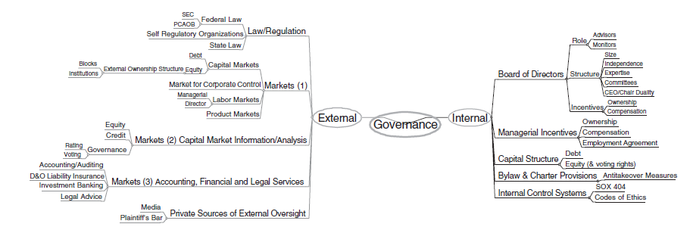

Appendix 3: Descriptive statistics with outliers

2007: Boxplot
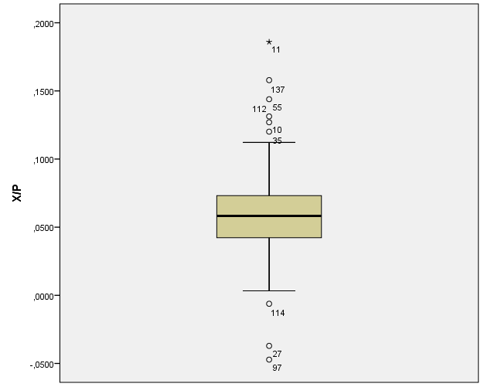

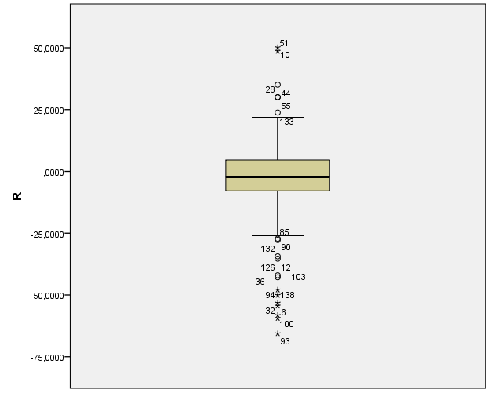

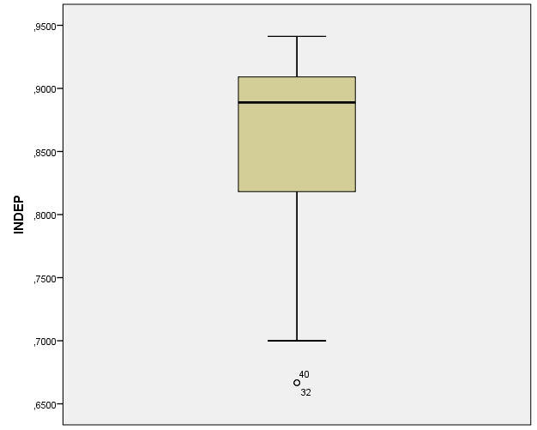

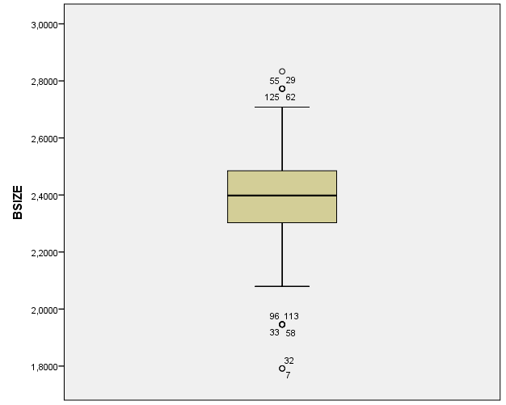

2007: Histogram
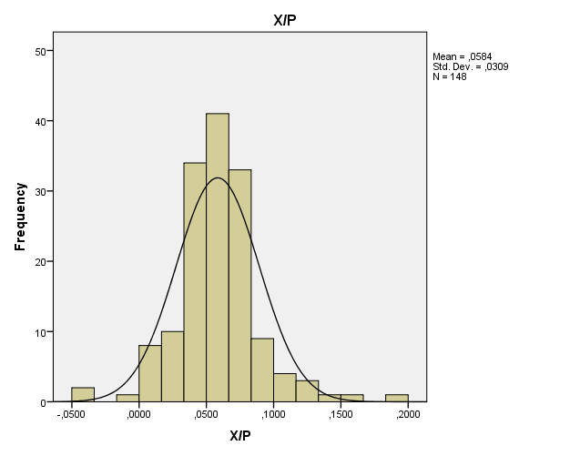
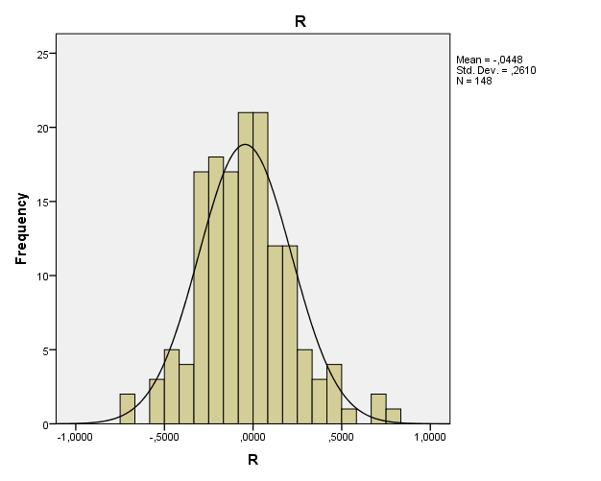

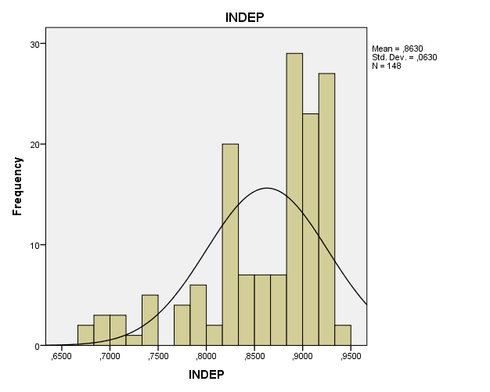
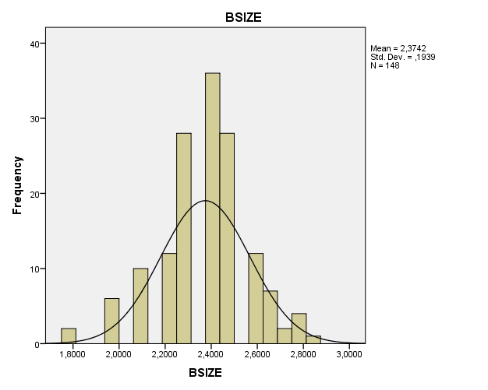

2007: PP-Plot

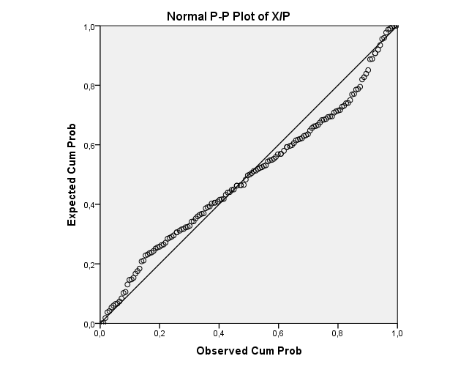
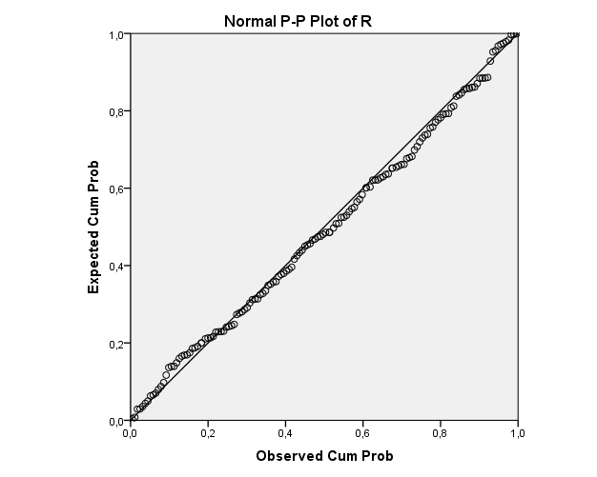

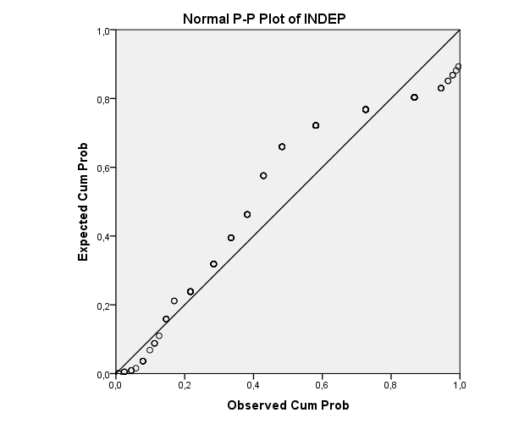
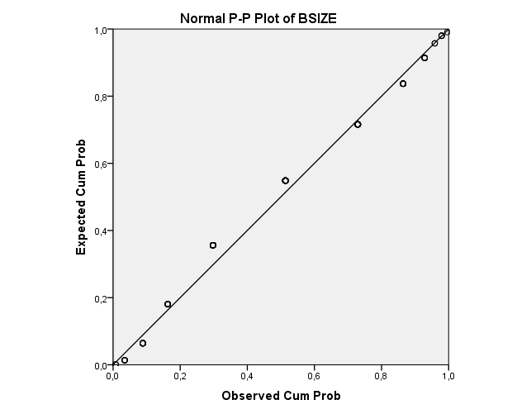

2008: Boxplot
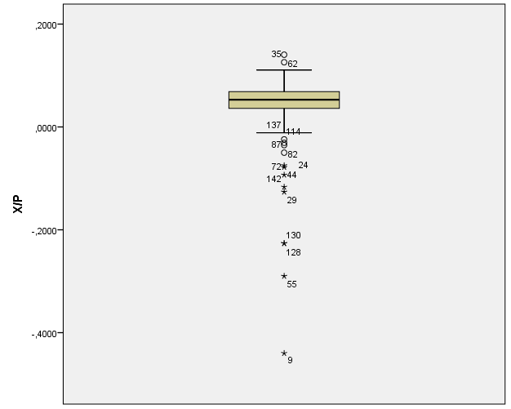

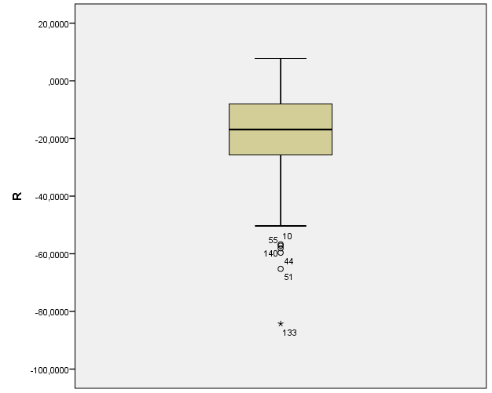

2008: Histogram
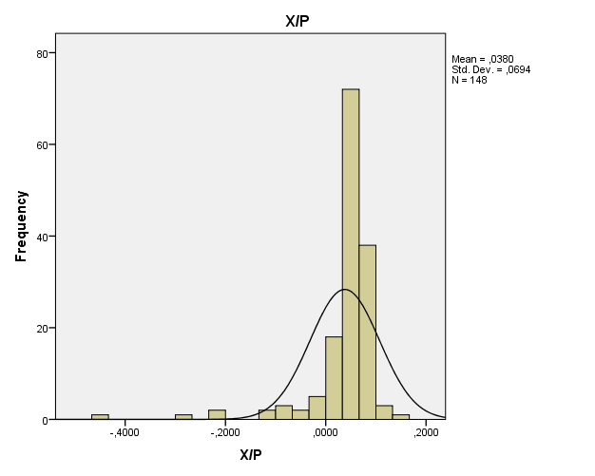
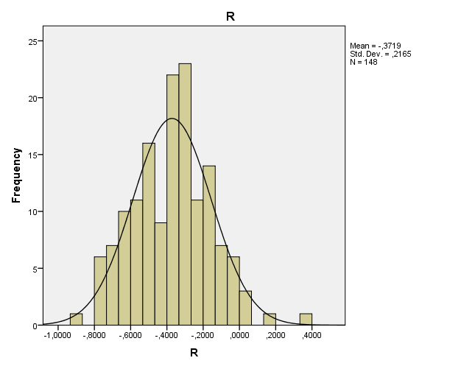

2008: PP-Plot

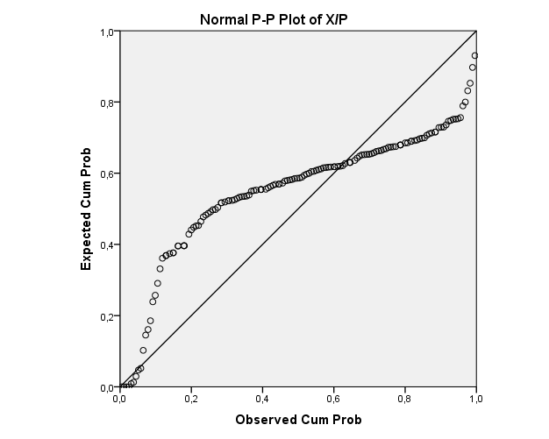
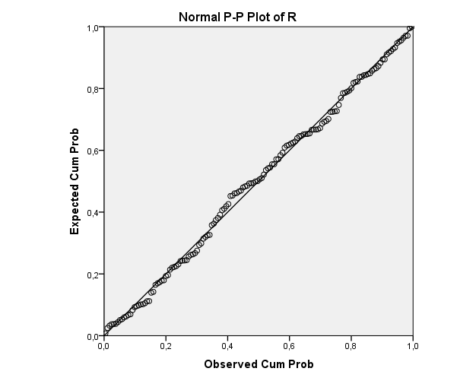

2009: Boxplot
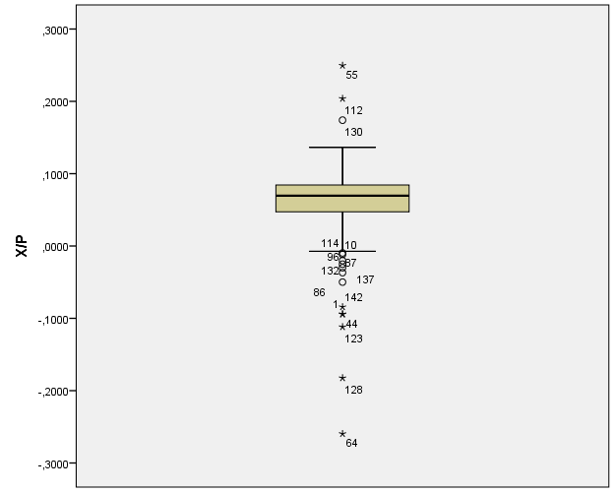

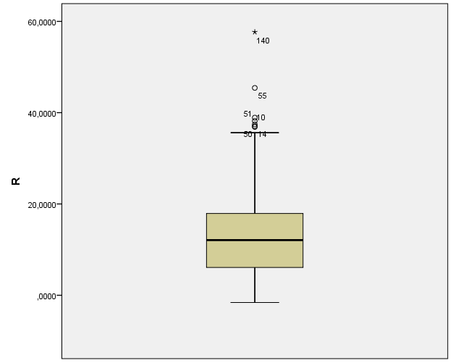

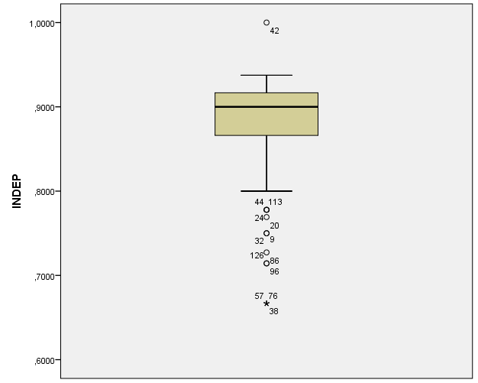

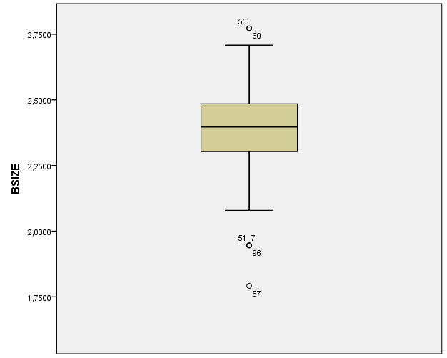

2009: Histogram
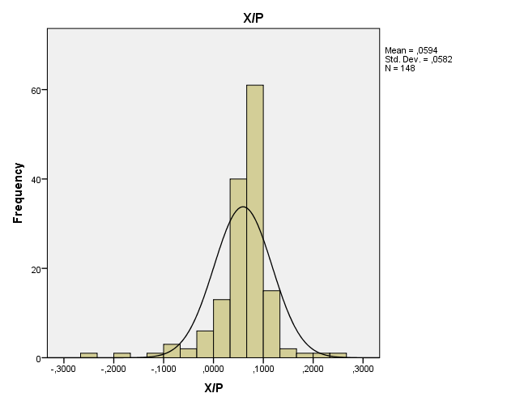
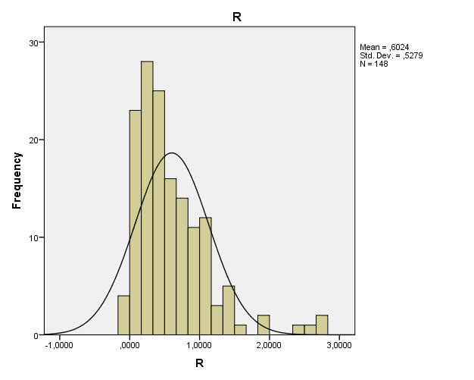

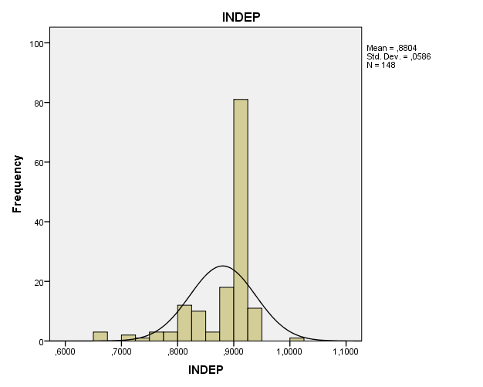
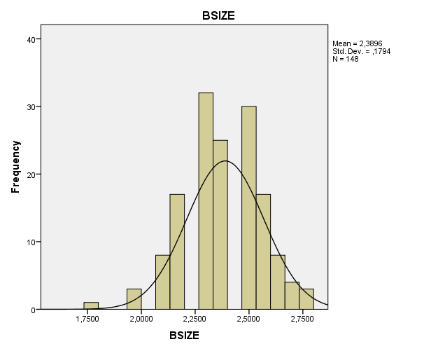

2009: PP-Plot
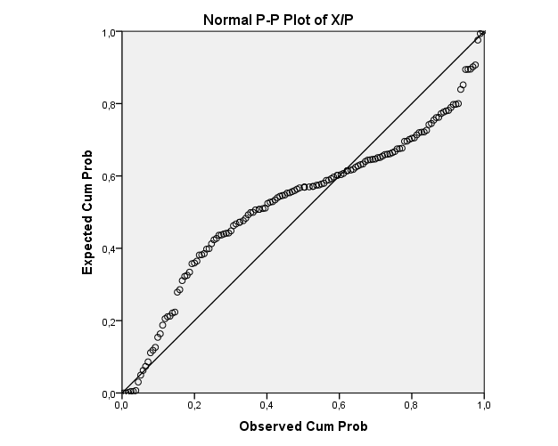
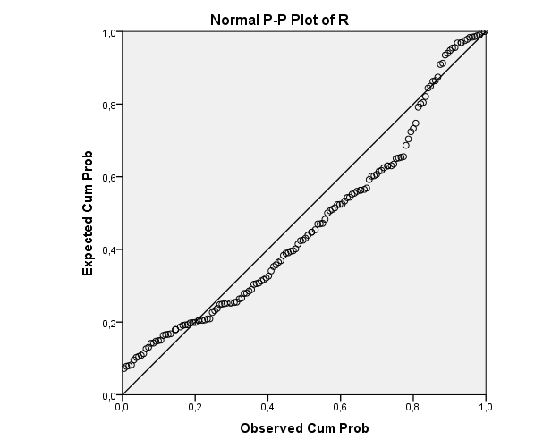

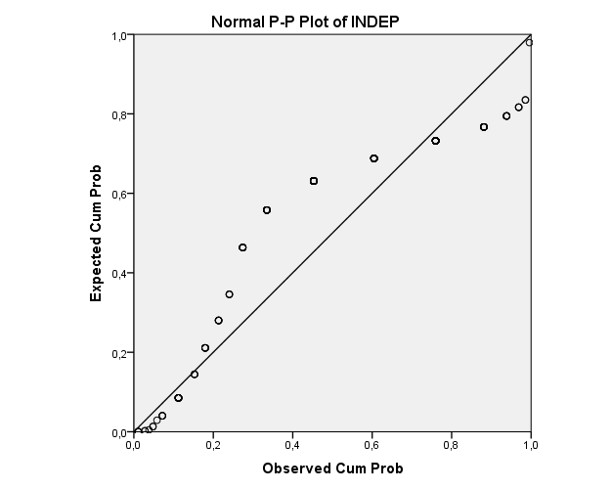

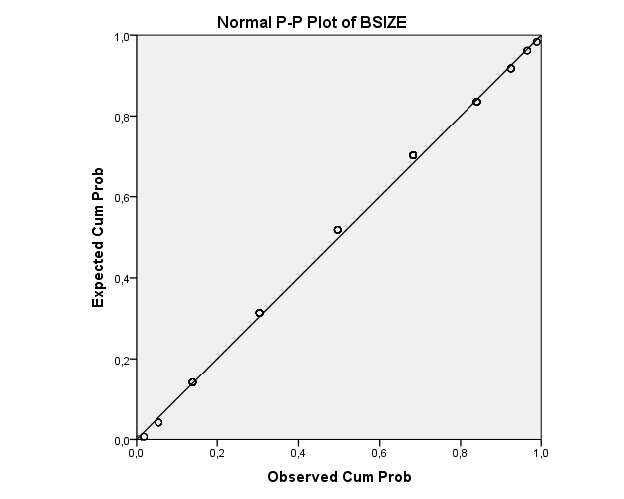

2010: Boxplot

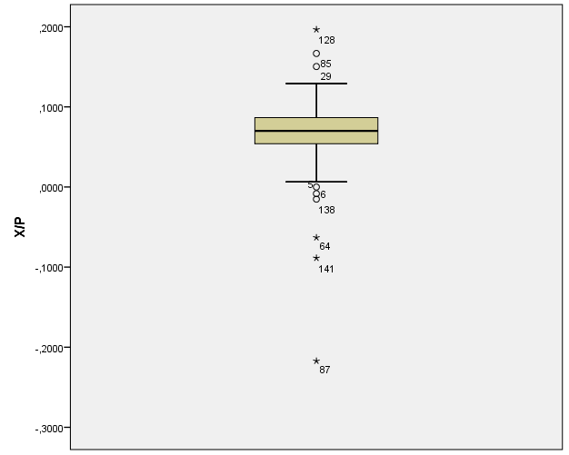

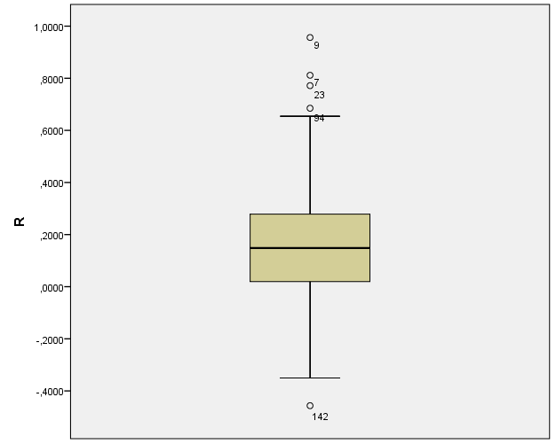

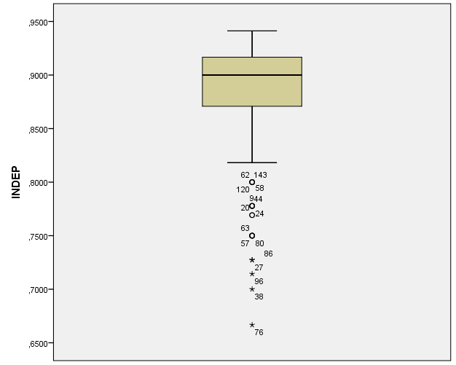

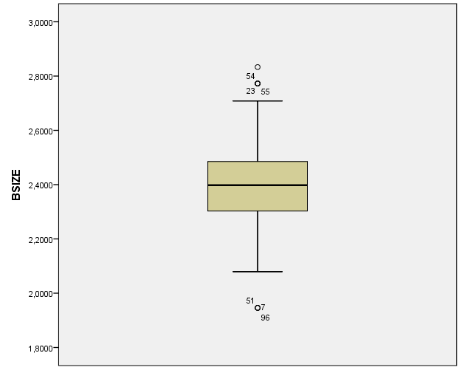

2010: Histogram

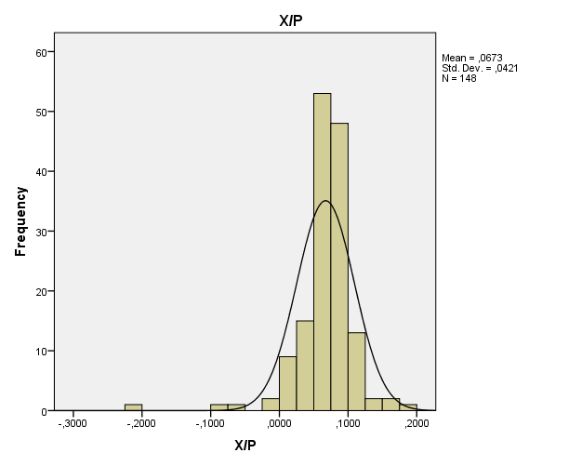
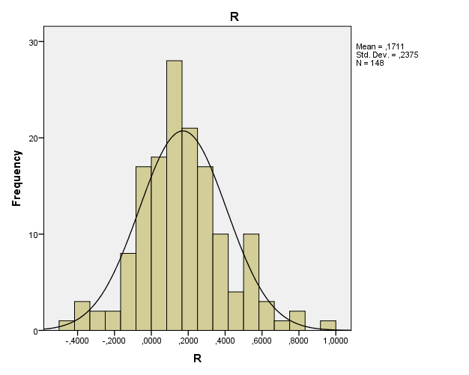

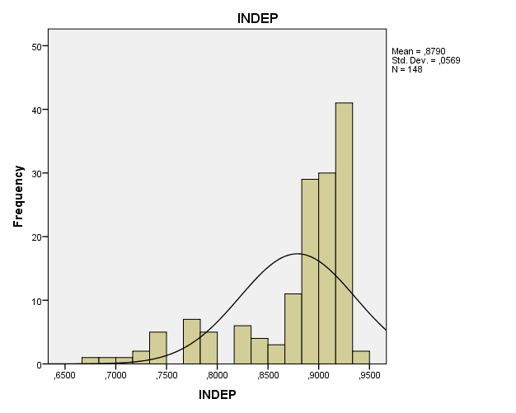

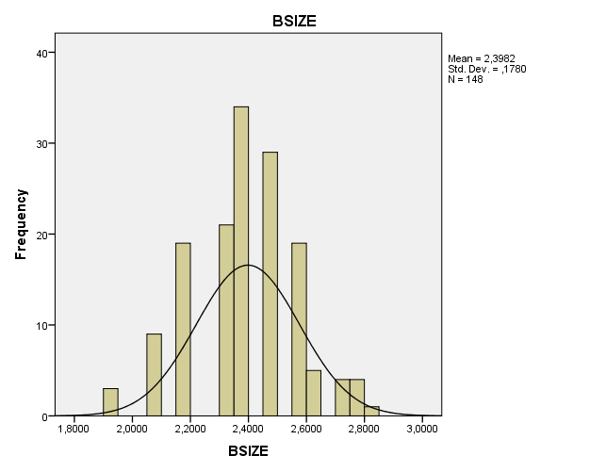

2010: PP-Plot
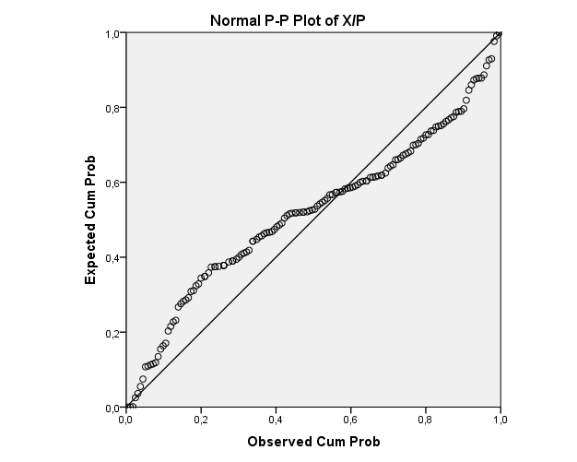

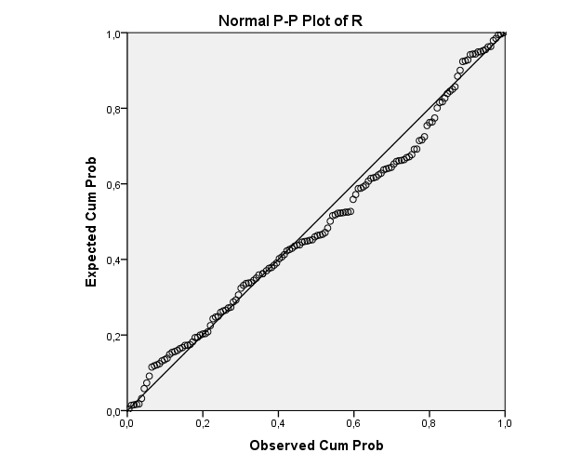

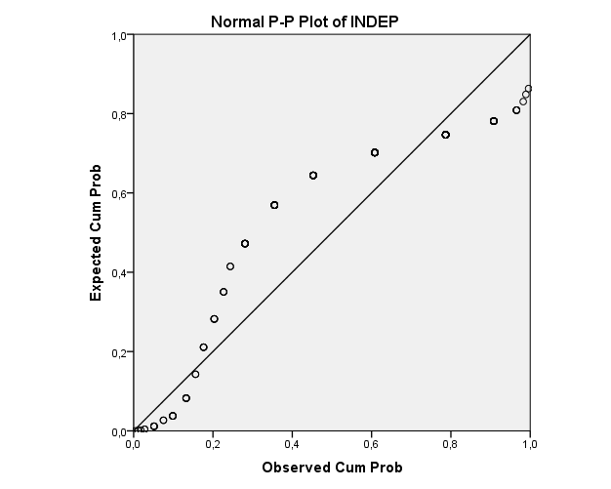

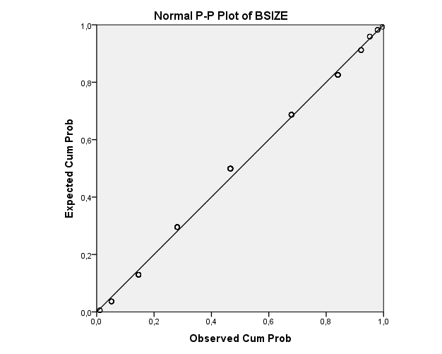

2011: Boxplot
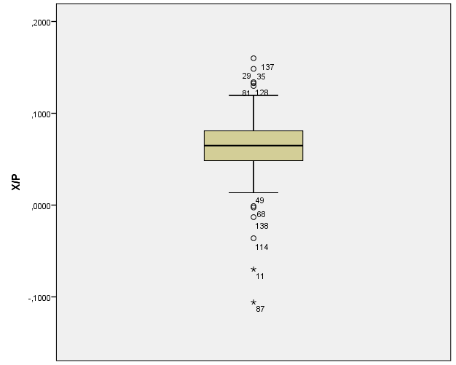

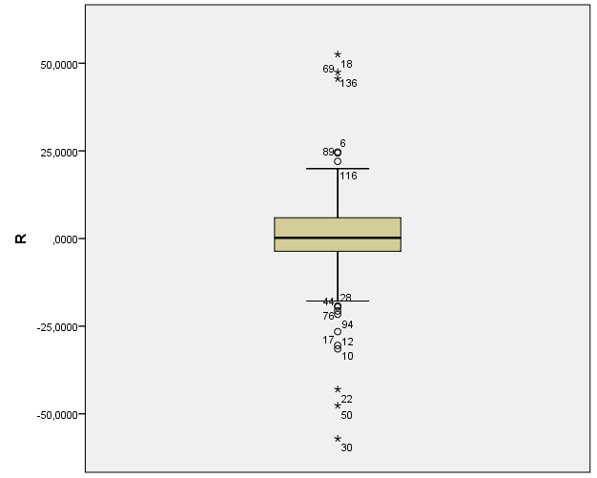

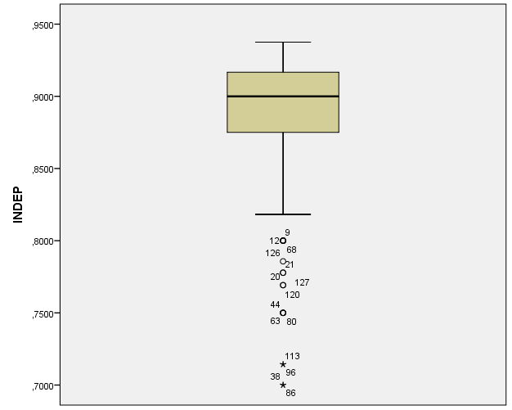

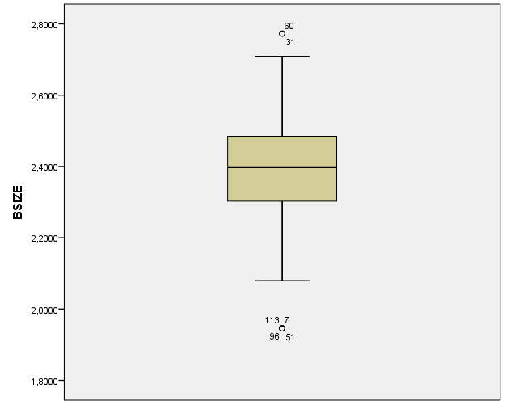

2011: Histogram

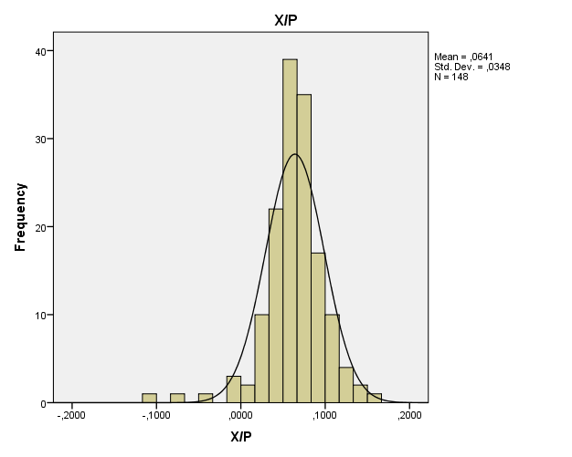
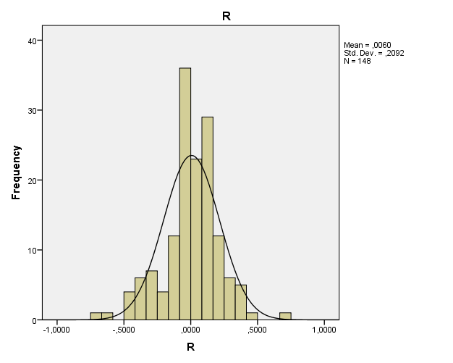

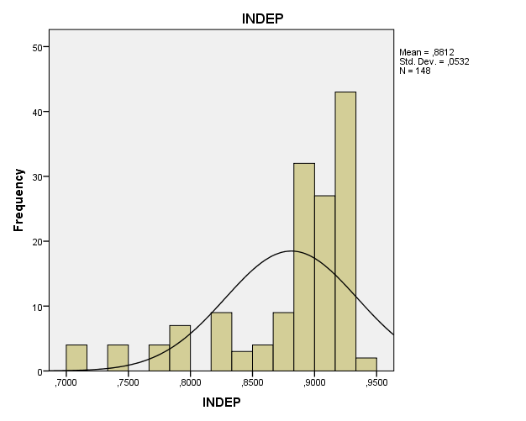

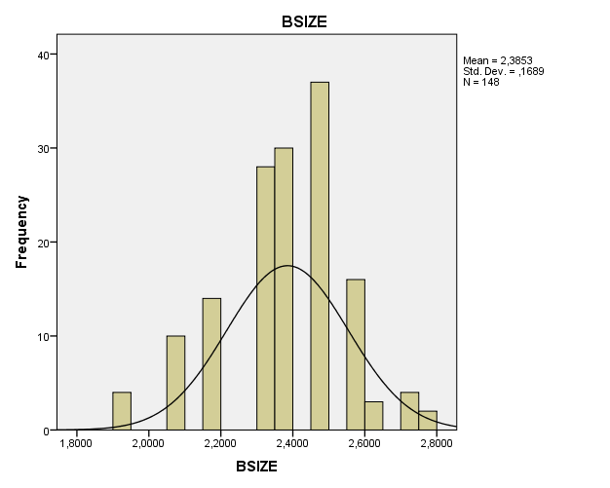

2011: PP-Plot

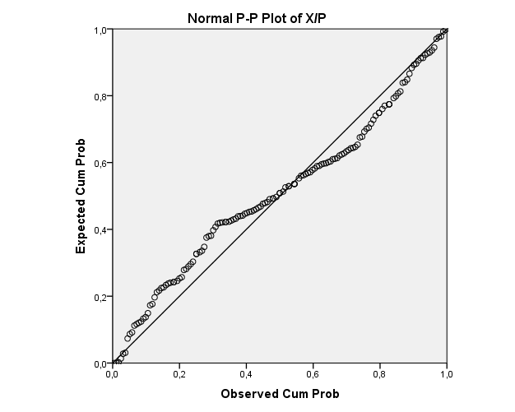
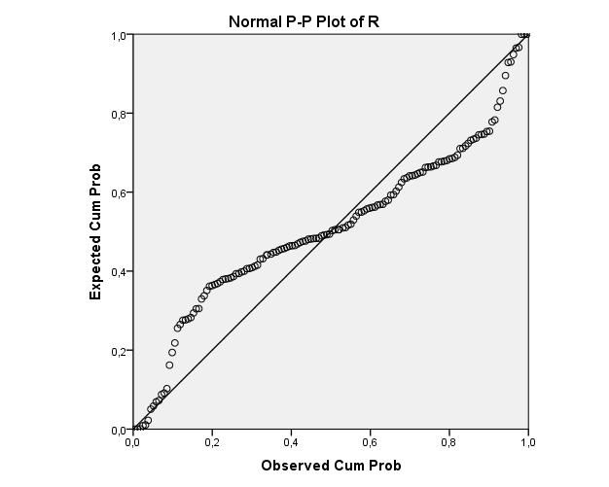

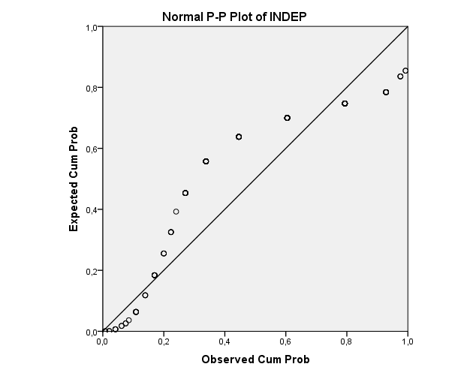

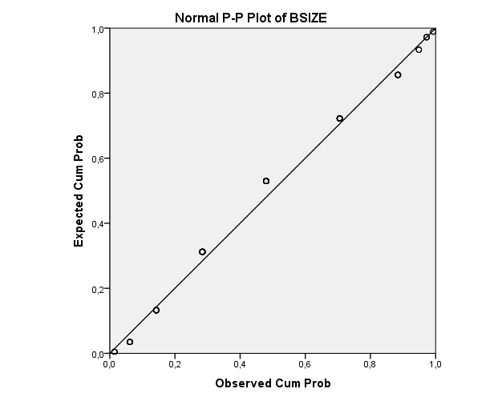

Appendix 4: Descriptive statistics without outliers

2007: Boxplot
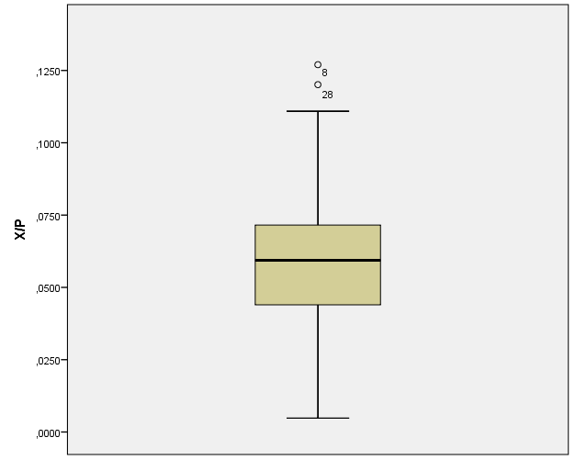

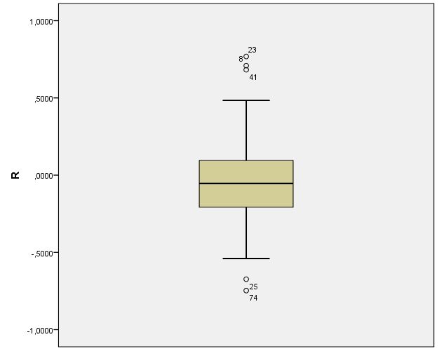

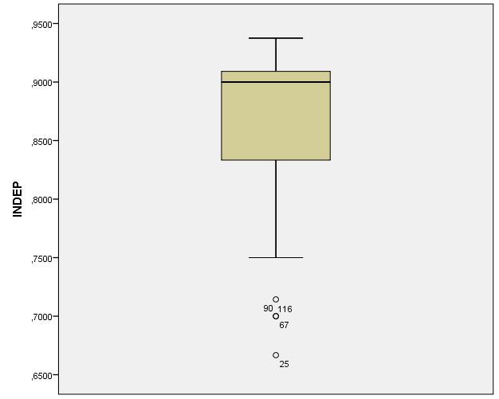

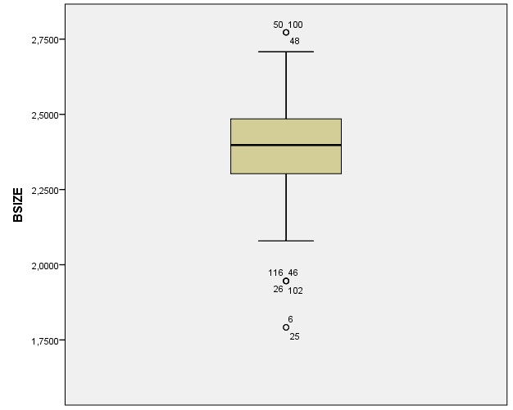

2007: Histogram
Descriptive Statistics
 | N | Minimum | Maximum | Mean | Std. Deviation
X/P | 116 | ,0048 | ,1270 | ,057741 | ,0222317
R | 116 | -,7472 | ,7682 | -,045139 | ,2596845
INDEP | 116 | ,6667 | ,9375 | ,870056 | ,0563872
BSIZE | 116 | 1,7918 | 2,7726 | 2,379480 | ,1882344
Valid N (listwise) | 116
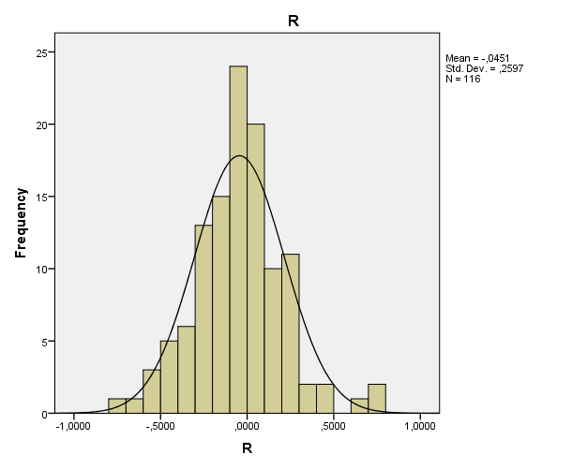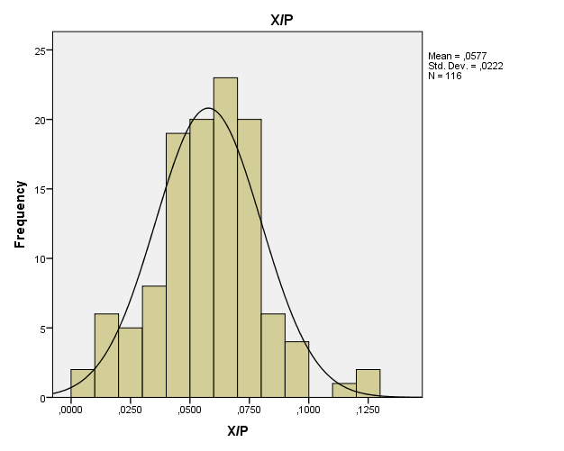
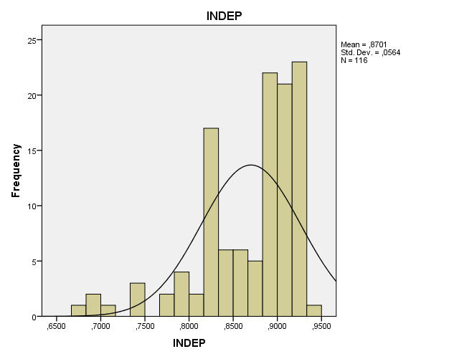

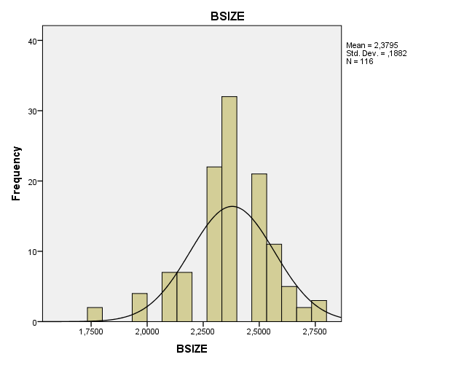

2007: PP-Plot

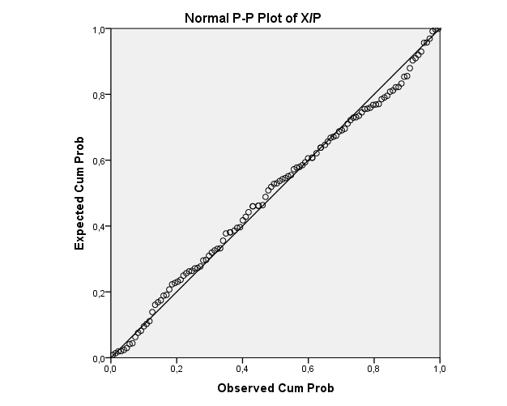

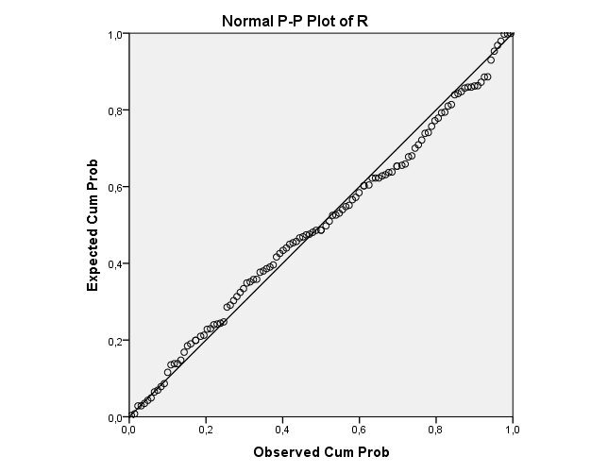

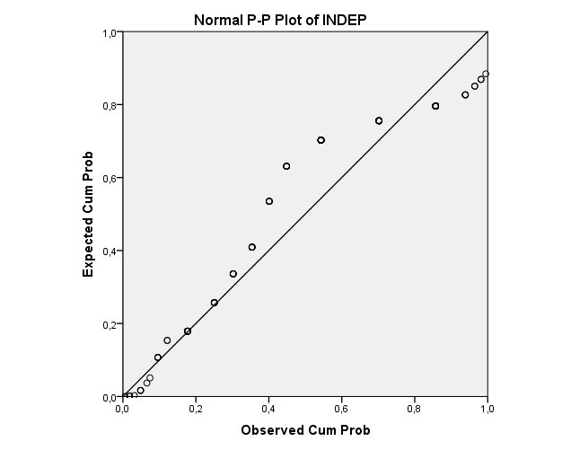

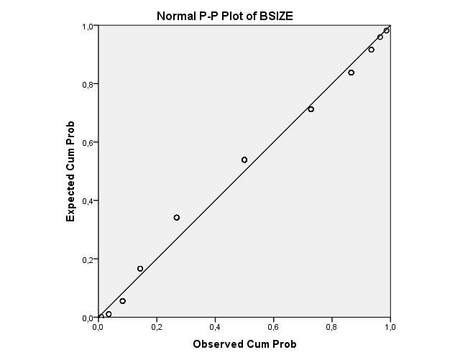

2007: Dummy variables

DR
 |  | Frequency | Percent | Valid Percent | Cumulative Percent
Valid | 0 | 48 | 41,4 | 41,4 | 41,4
Valid | 1 | 68 | 58,6 | 58,6 | 100,0
Valid | Total | 116 | 100,0 | 100,0

EXP
 |  | Frequency | Percent | Valid Percent | Cumulative Percent
Valid | ,0000 | 23 | 19,8 | 19,8 | 19,8
Valid | 1,0000 | 93 | 80,2 | 80,2 | 100,0
Valid | Total | 116 | 100,0 | 100,0

AUDITCOM
 |  | Frequency | Percent | Valid Percent | Cumulative Percent
Valid | ,0000 | 15 | 12,9 | 12,9 | 12,9
Valid | 1,0000 | 101 | 87,1 | 87,1 | 100,0
Valid | Total | 116 | 100,0 | 100,0

CEODUALITY
 |  | Frequency | Percent | Valid Percent | Cumulative Percent
Valid | ,0000 | 34 | 29,3 | 29,3 | 29,3
Valid | 1,0000 | 82 | 70,7 | 70,7 | 100,0
Valid | Total | 116 | 100,0 | 100,0

2008: Boxplot

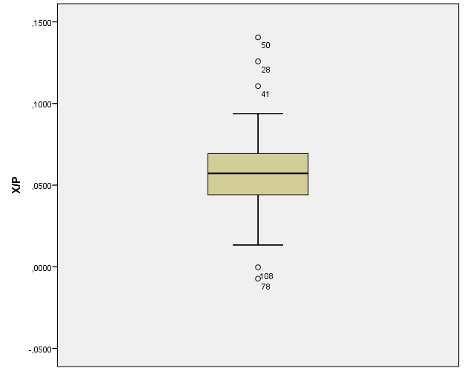

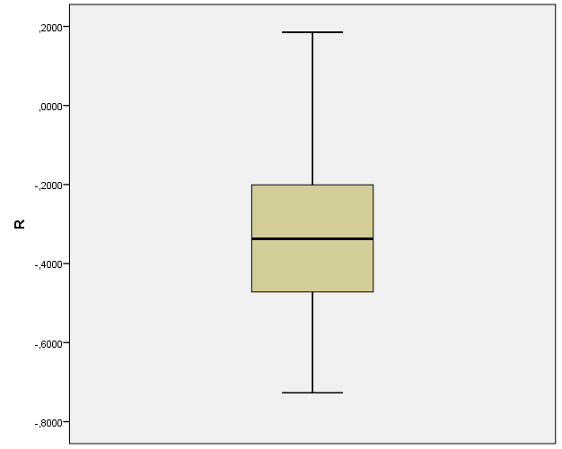

2008: Histogram

Descriptive Statistics
 | N | Minimum | Maximum | Mean | Std. Deviation
X/P | 116 | -,0073 | ,1405 | ,056491 | ,0222920
R | 116 | -,7268 | ,1853 | -,338391 | ,1853794
INDEP | 116 | ,6667 | ,9375 | ,870056 | ,0563872
BSIZE | 116 | 1,7918 | 2,7726 | 2,379480 | ,1882344
Valid N (listwise) | 116

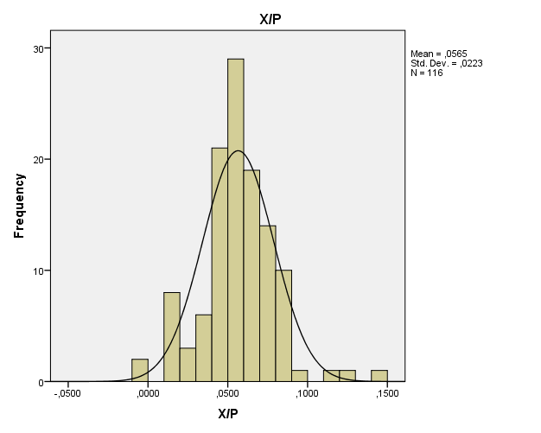
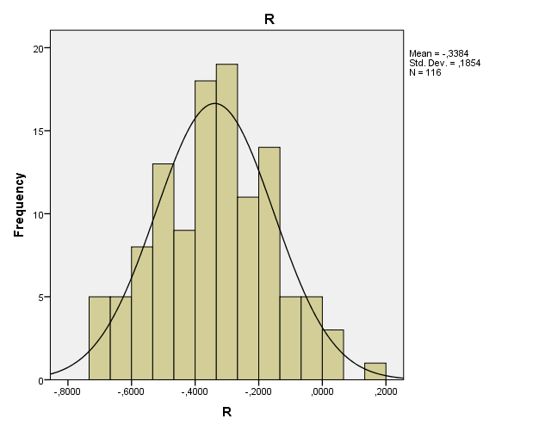

2008: PP-Plot
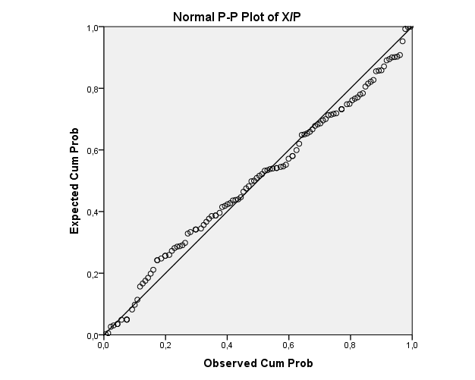
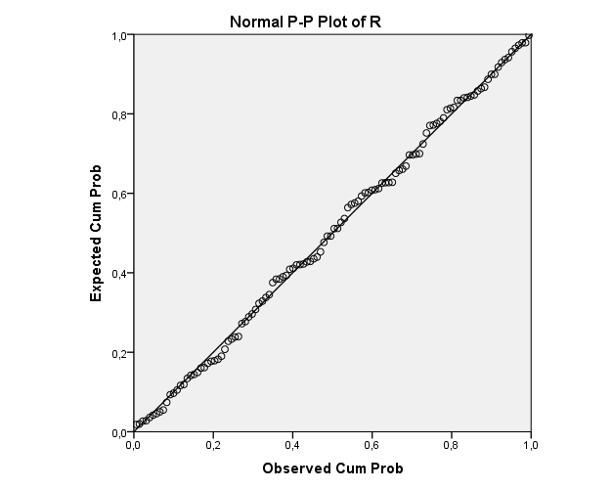

2008: Dummy variables

DR
 |  | Frequency | Percent | Valid Percent | Cumulative Percent
Valid | 0 | 4 | 3,4 | 3,4 | 3,4
Valid | 1 | 112 | 96,6 | 96,6 | 100,0
Valid | Total | 116 | 100,0 | 100,0

EXP
 |  | Frequency | Percent | Valid Percent | Cumulative Percent
Valid | ,0000 | 21 | 18,1 | 18,1 | 18,1
Valid | 1,0000 | 95 | 81,9 | 81,9 | 100,0
Valid | Total | 116 | 100,0 | 100,0

AUDITCOM
 |  | Frequency | Percent | Valid Percent | Cumulative Percent
Valid | ,0000 | 15 | 12,9 | 12,9 | 12,9
Valid | 1,0000 | 101 | 87,1 | 87,1 | 100,0
Valid | Total | 116 | 100,0 | 100,0

CEODUALITY
 |  | Frequency | Percent | Valid Percent | Cumulative Percent
Valid | ,0000 | 34 | 29,3 | 29,3 | 29,3
Valid | 1,0000 | 82 | 70,7 | 70,7 | 100,0
Valid | Total | 116 | 100,0 | 100,0

2009: Boxplot
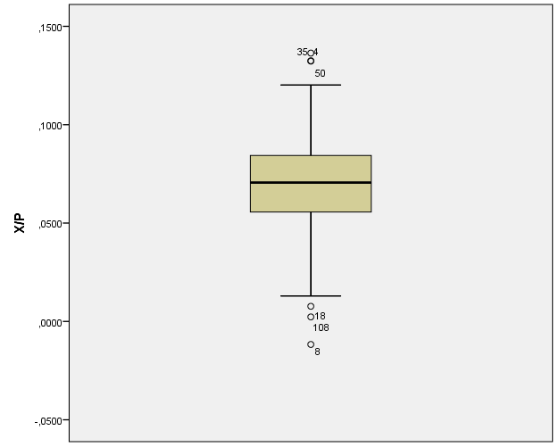
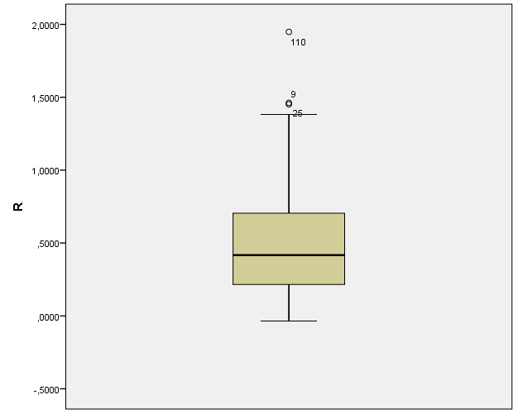

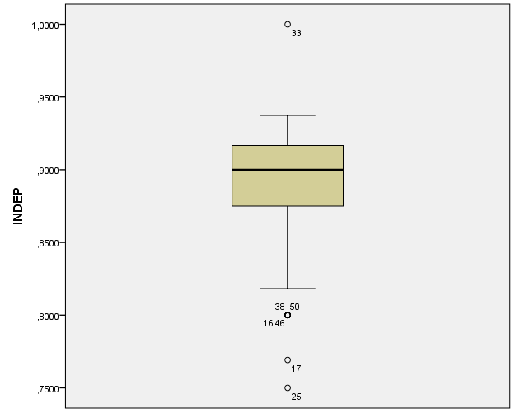

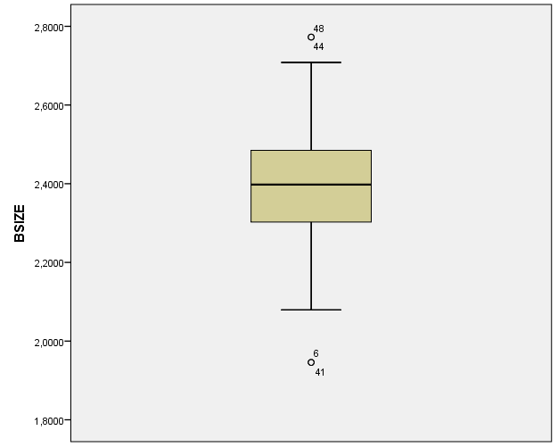

2009: Histogram
Descriptive Statistics
 | N | Minimum | Maximum | Mean | Std. Deviation
X/P | 116 | -,0117 | ,1364 | ,070735 | ,0259975
R | 116 | -,0348 | 1,9486 | ,503903 | ,3880938
INDEP | 116 | ,7500 | 1,0000 | ,889310 | ,0427769
BSIZE | 116 | 1,9459 | 2,7726 | 2,399988 | ,1705092
Valid N (listwise) | 116
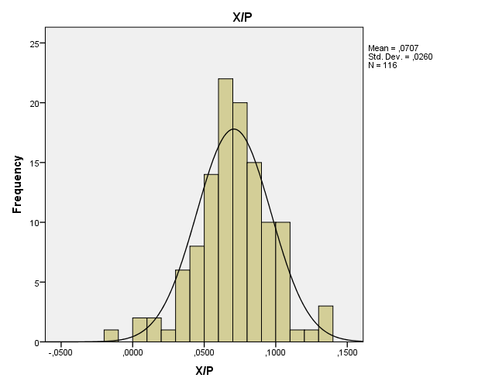
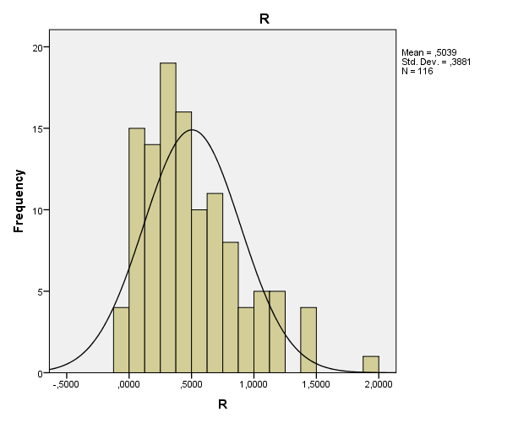

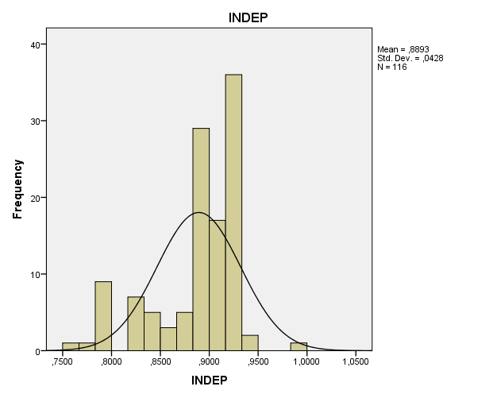
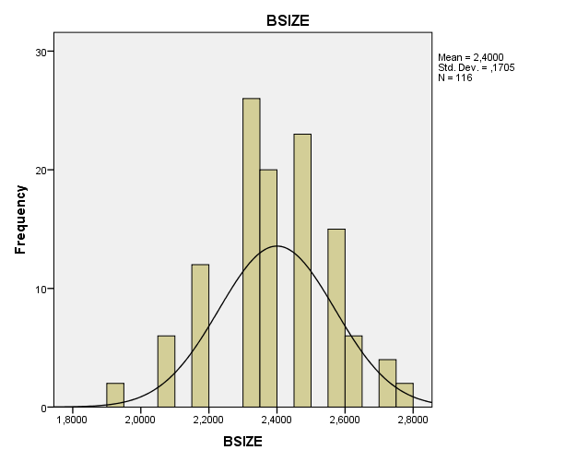

2009: PP-Plot

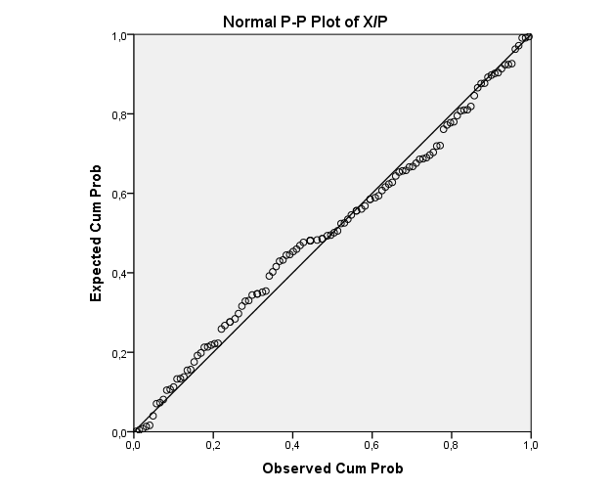
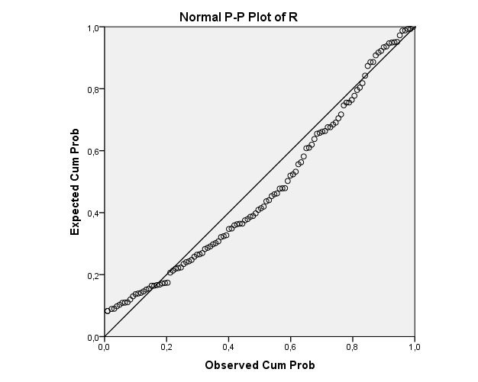

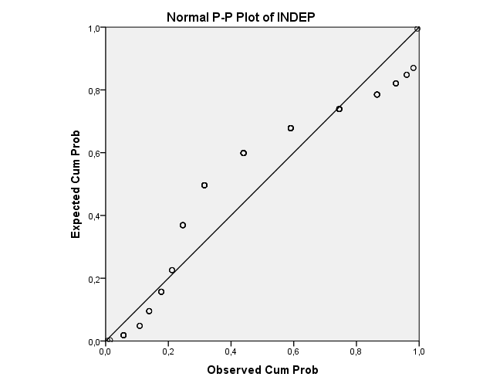

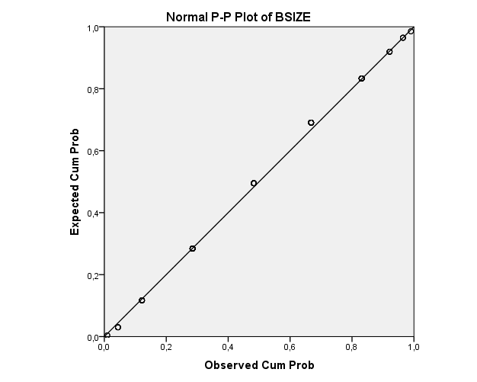

2009: Dummy variables

DR
 |  | Frequency | Percent | Valid Percent | Cumulative Percent
Valid | 0 | 112 | 96,6 | 96,6 | 96,6
Valid | 1 | 4 | 3,4 | 3,4 | 100,0
Valid | Total | 116 | 100,0 | 100,0

EXP
 |  | Frequency | Percent | Valid Percent | Cumulative Percent
Valid | ,0000 | 16 | 13,8 | 13,8 | 13,8
Valid | 1,0000 | 100 | 86,2 | 86,2 | 100,0
Valid | Total | 116 | 100,0 | 100,0

AUDITCOM
 |  | Frequency | Percent | Valid Percent | Cumulative Percent
Valid | ,0000 | 12 | 10,3 | 10,3 | 10,3
Valid | 1,0000 | 104 | 89,7 | 89,7 | 100,0
Valid | Total | 116 | 100,0 | 100,0

CEODUALITY
 |  | Frequency | Percent | Valid Percent | Cumulative Percent
Valid | ,0000 | 31 | 26,7 | 26,7 | 26,7
Valid | 1,0000 | 85 | 73,3 | 73,3 | 100,0
Valid | Total | 116 | 100,0 | 100,0

2010: Boxplot

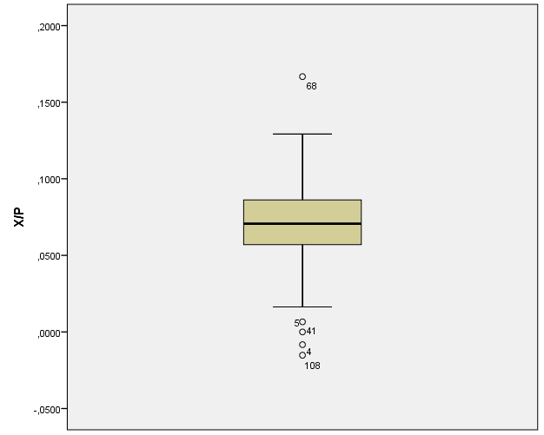

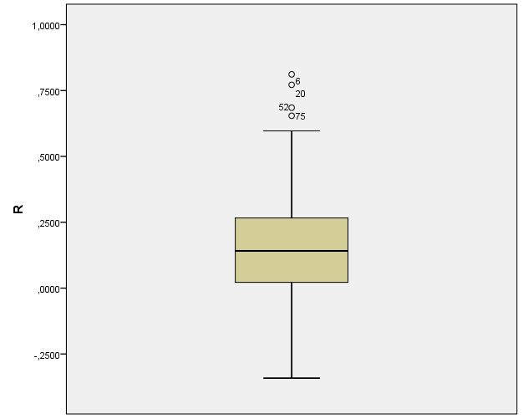

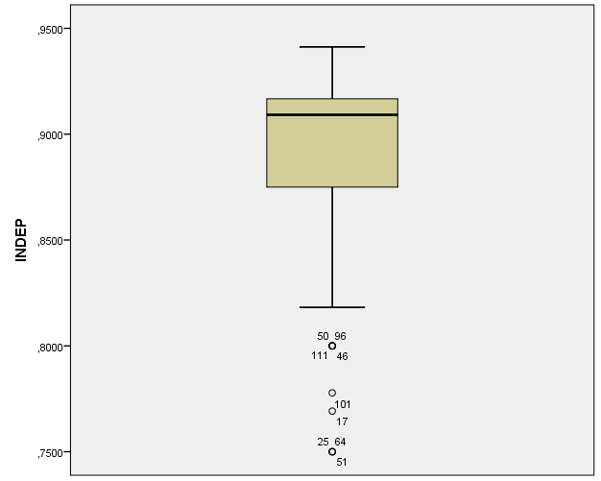

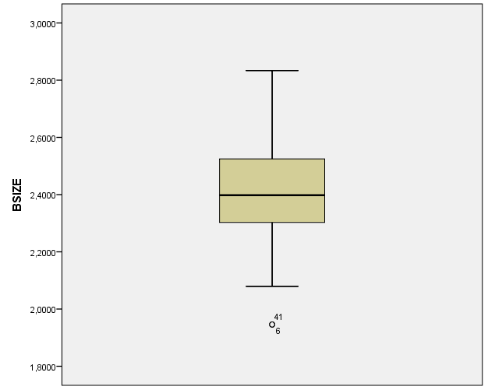

2010: Histogram
Descriptive Statistics
 | N | Minimum | Maximum | Mean | Std. Deviation
X/P | 116 | -,0152 | ,1667 | ,071166 | ,0270953
R | 116 | -,3418 | ,8115 | ,161483 | ,2148080
INDEP | 116 | ,7500 | ,9412 | ,889102 | ,0425156
BSIZE | 116 | 1,9459 | 2,8332 | 2,413797 | ,1748500
Valid N (listwise) | 116
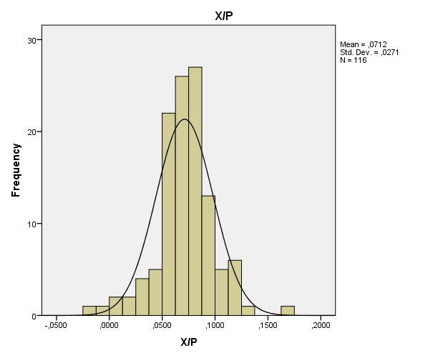
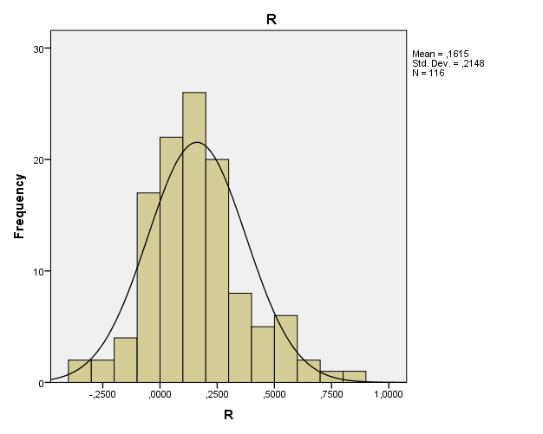
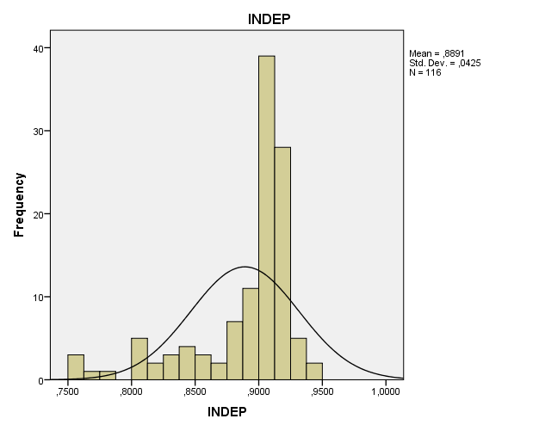
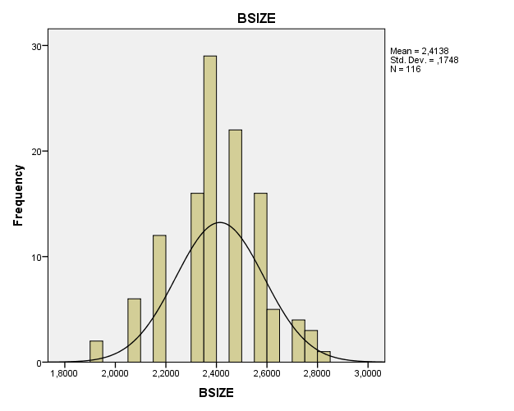

2010: PP-Plot
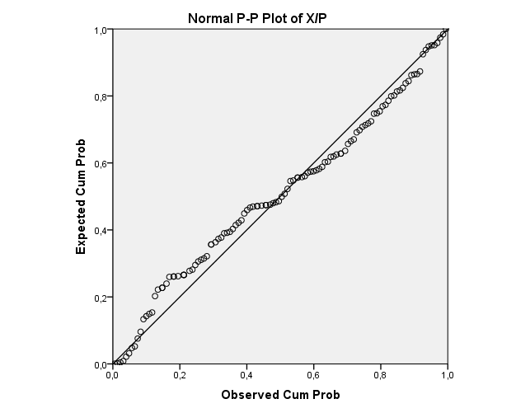

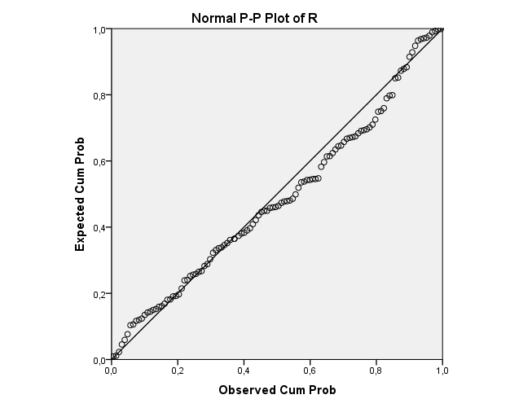

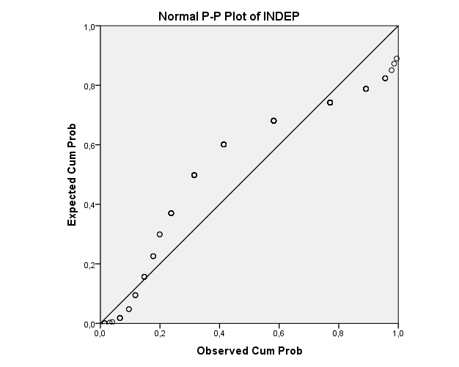

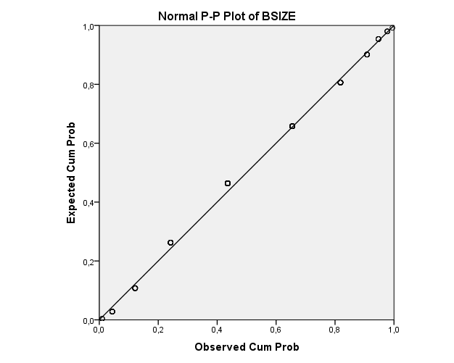

2010: Dummy Variables
DR
 |  | Frequency | Percent | Valid Percent | Cumulative Percent
Valid | ,0000 | 91 | 78,4 | 78,4 | 78,4
Valid | 1,0000 | 25 | 21,6 | 21,6 | 100,0
Valid | Total | 116 | 100,0 | 100,0

EXP
 |  | Frequency | Percent | Valid Percent | Cumulative Percent
Valid | ,0000 | 12 | 10,3 | 10,3 | 10,3
Valid | 1,0000 | 104 | 89,7 | 89,7 | 100,0
Valid | Total | 116 | 100,0 | 100,0

AUDITCOM
 |  | Frequency | Percent
Missing | System | 116 | 100,0

CEODUALITY
 |  | Frequency | Percent | Valid Percent | Cumulative Percent
Valid | ,0000 | 27 | 23,3 | 23,3 | 23,3
Valid | 1,0000 | 89 | 76,7 | 76,7 | 100,0
Valid | Total | 116 | 100,0 | 100,0

2011: Boxplot
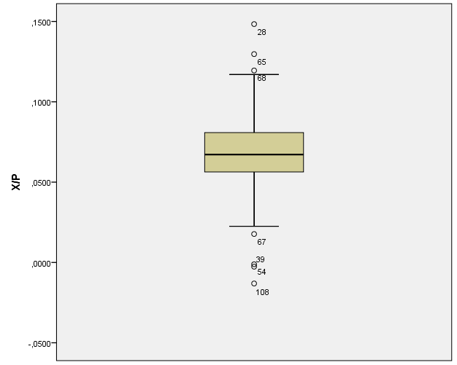

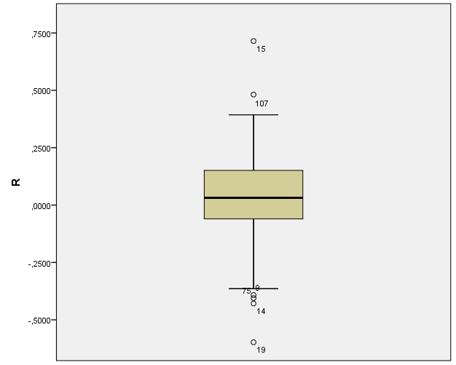

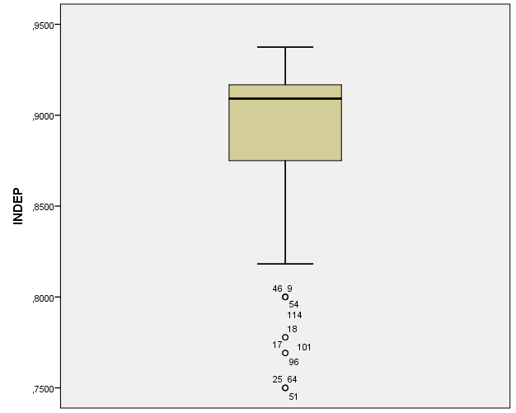

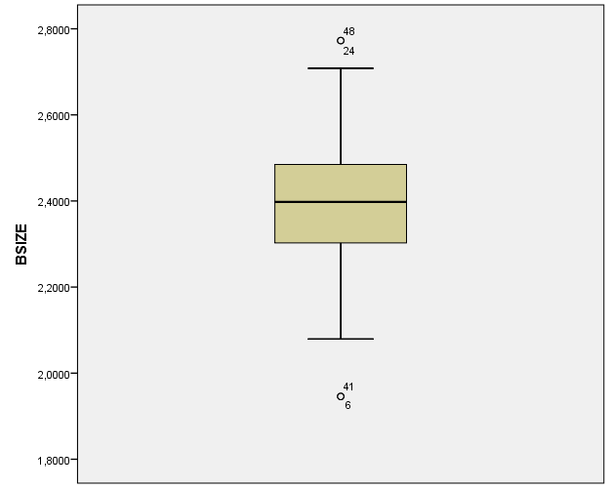

2011: Histogram
Descriptive Statistics
 | N | Minimum | Maximum | Mean | Std. Deviation
X/P | 116 | -,0131 | ,1484 | ,067513 | ,0262242
R | 116 | -,5976 | ,7150 | ,035704 | ,1983101
INDEP | 116 | ,7500 | ,9375 | ,886952 | ,0444361
BSIZE | 116 | 1,9459 | 2,7726 | 2,397663 | ,1614244
Valid N (listwise) | 116
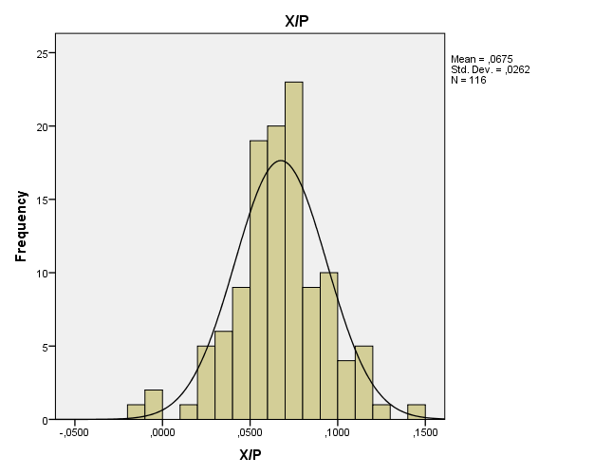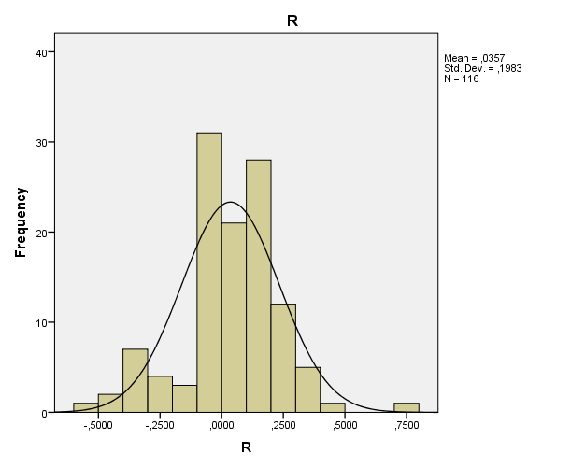

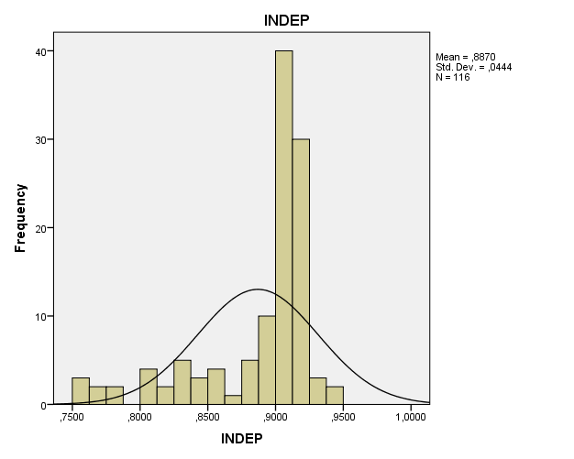

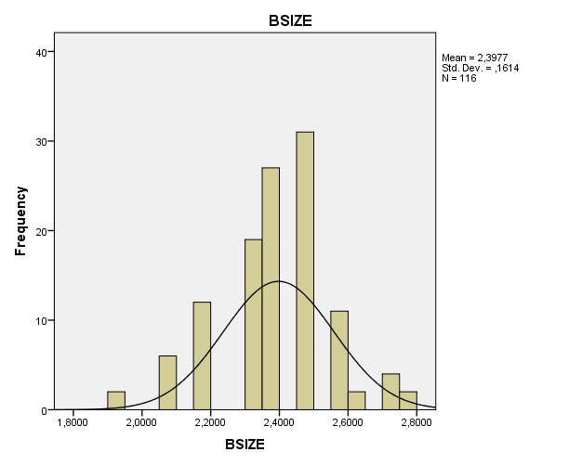

2011: PP-Plot
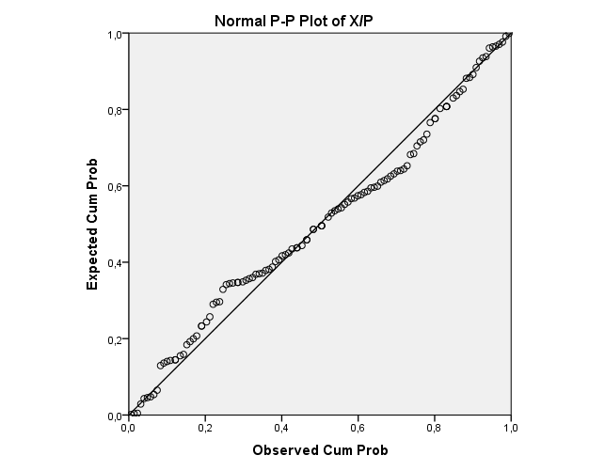
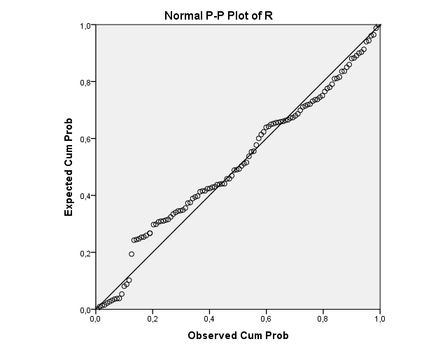

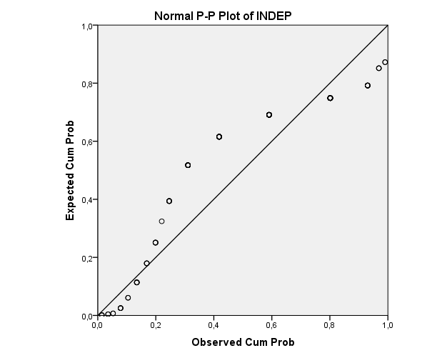

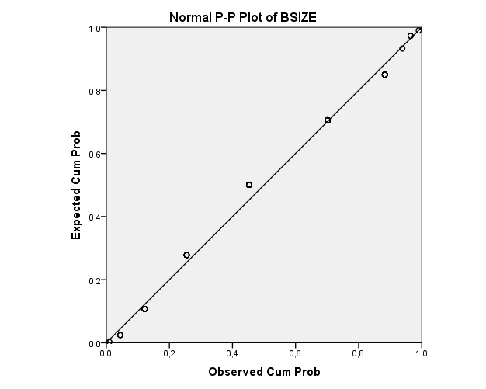

2011: Dummy variables
DR
 |  | Frequency | Percent | Valid Percent | Cumulative Percent
Valid | 0 | 68 | 58,6 | 58,6 | 58,6
Valid | 1 | 48 | 41,4 | 41,4 | 100,0
Valid | Total | 116 | 100,0 | 100,0

EXP
 |  | Frequency | Percent | Valid Percent | Cumulative Percent
Valid | ,0000 | 12 | 10,3 | 10,3 | 10,3
Valid | 1,0000 | 104 | 89,7 | 89,7 | 100,0
Valid | Total | 116 | 100,0 | 100,0

AUDITCOM
 |  | Frequency | Percent | Valid Percent | Cumulative Percent
Valid | ,0000 | 9 | 7,8 | 7,8 | 7,8
Valid | 1,0000 | 107 | 92,2 | 92,2 | 100,0
Valid | Total | 116 | 100,0 | 100,0

CEODUALITY
 |  | Frequency | Percent | Valid Percent | Cumulative Percent
Valid | ,0000 | 32 | 27,6 | 27,6 | 27,6
Valid | 1,0000 | 84 | 72,4 | 72,4 | 100,0
Valid | Total | 116 | 100,0 | 100,0

Appendix 5: Results

2007: Results
Model Summary^{b}
Model | R | R Square | Adjusted R Square | Std. Error of the Estimate | Durbin-Watson
1 | ,526ª | ,277 | ,200 | ,0198822 | 1,955
a. Predictors: (Constant), GROWTH, AUDITCOM, FIRMSIZE, INDEP, R, LEVERAGE, EXP, CEODUALITY, BSIZE, DR, R*DR
b. Dependent Variable: X/P

Coefficientsª
Model |  | Unstandardized Coefficients |  | Standardized Coefficients | t | Sig. | Collinearity Statistics
 |  | B | Std. Error | Beta | t | Sig. | Tolerance | VIF
1 | (Constant) | -,016 | ,037 |  | -,440 | ,661
1 | DR | ,004 | ,006 | ,087 | ,679 | ,499 | ,427 | 2,344
1 | R | ,024 | ,017 | ,278 | 1,390 | ,167 | ,174 | 5,748
1 | R*DR | ,012 | ,023 | ,090 | ,531 | ,597 | ,241 | 4,141
1 | INDEP | ,027 | ,038 | ,069 | ,728 | ,468 | ,766 | 1,306
1 | BSIZE | ,021 | ,012 | ,175 | 1,704 | ,091 | ,658 | 1,520
1 | EXP | ,001 | ,005 | ,018 | ,192 | ,848 | ,807 | 1,240
1 | AUDITCOM | -,008 | ,006 | -,117 | -1,372 | ,173 | ,956 | 1,046
1 | CEODUALITY | ,014 | ,004 | ,281 | 3,041 | ,003 | ,815 | 1,227
1 | FIRMSIZE | -4,827E-009 | ,000 | -,018 | -,192 | ,848 | ,789 | 1,267
1 | LEVERAGE | -,004 | ,014 | -,023 | -,258 | ,797 | ,872 | 1,147
1 | GROWTH | ,000 | ,000 | -,108 | -1,207 | ,230 | ,861 | 1,161
a. Dependent Variable: X/P

2008: Results

Model Summary^{b}
Model | R | R Square | Adjusted R Square | Std. Error of the Estimate | Durbin-Watson
1 | ,440ª | ,194 | ,108 | ,0210509 | 2,216
a. Predictors: (Constant), GROWTH, FIRMSIZE, DR, AUDITCOM, EXP, INDEP, LEVERAGE, CEODUALITY, DR*R, BSIZE, R
b. Dependent Variable: X/P

Coefficientsª
Model |  | Unstandardized Coefficients |  | Standardized Coefficients | t | Sig. | Collinearity Statistics
 |  | B | Std. Error | Beta | t | Sig. | Tolerance | VIF
1 | (Constant) | -,010 | ,040 |  | -,255 | ,800
1 | DR | ,010 | ,016 | ,083 | ,629 | ,531 | ,445 | 2,247
1 | R | ,193 | ,158 | 1,608 | 1,228 | ,222 | ,005 | 221,241
1 | DR*R | -,182 | ,158 | -1,470 | -1,152 | ,252 | ,005 | 209,905
1 | INDEP | -,037 | ,040 | -,093 | -,929 | ,355 | ,777 | 1,288
1 | BSIZE | ,037 | ,012 | ,317 | 3,020 | ,003 | ,706 | 1,417
1 | EXP | 2,673E-006 | ,005 | ,000 | ,000 | 1,000 | ,897 | 1,115
1 | AUDITCOM | -,007 | ,006 | -,102 | -1,138 | ,258 | ,968 | 1,033
1 | CEODUALITY | ,012 | ,005 | ,239 | 2,501 | ,014 | ,852 | 1,174
1 | FIRMSIZE | -1,734E-008 | ,000 | -,064 | -,650 | ,517 | ,789 | 1,267
1 | LEVERAGE | -,005 | ,015 | -,032 | -,335 | ,738 | ,874 | 1,145
1 | GROWTH | ,000 | ,000 | ,190 | 2,050 | ,043 | ,901 | 1,110
a. Dependent Variable: X/P

2009: Results

Model Summary^{b}
Model | R | R Square | Adjusted R Square | Std. Error of the Estimate | Durbin-Watson
1 | ,435ª | ,189 | ,103 | ,0246161 | 1,836
a. Predictors: (Constant), GROWTH, CEODUALITY, BSIZE, DR, AUDITCOM, EXP, LEVERAGE, INDEP, FIRMSIZE, R, R*DR
b. Dependent Variable: X/P

Coefficientsª
Model |  | Unstandardized Coefficients |  | Standardized Coefficients | t | Sig. | Collinearity Statistics
 |  | B | Std. Error | Beta | t | Sig. | Tolerance | VIF
1 | (Constant) | ,025 | ,058 |  | ,433 | ,666
1 | DR | ,002 | ,041 | ,017 | ,060 | ,952 | ,094 | 10,615
1 | R | ,009 | ,007 | ,128 | 1,310 | ,193 | ,822 | 1,217
1 | R*DR | ,524 | 1,461 | ,102 | ,359 | ,720 | ,097 | 10,343
1 | INDEP | -,052 | ,059 | -,085 | -,886 | ,378 | ,840 | 1,190
1 | BSIZE | ,035 | ,015 | ,228 | 2,296 | ,024 | ,790 | 1,265
1 | EXP | -,009 | ,007 | -,119 | -1,271 | ,207 | ,895 | 1,118
1 | AUDITCOM | ,013 | ,008 | ,154 | 1,696 | ,093 | ,944 | 1,059
1 | CEODUALITY | ,000 | ,005 | -,007 | -,072 | ,943 | ,888 | 1,127
1 | FIRMSIZE | -2,506E-008 | ,000 | -,081 | -,816 | ,416 | ,800 | 1,250
1 | LEVERAGE | ,020 | ,019 | ,102 | 1,066 | ,289 | ,851 | 1,176
1 | GROWTH | ,001 | ,000 | ,296 | 3,191 | ,002 | ,908 | 1,101
a. Dependent Variable: X/P

2010: Results

Model Summary^{b}
Model | R | R Square | Adjusted R Square | Std. Error of the Estimate | Durbin-Watson
1 | ,355ª | ,126 | ,043 | ,0265129 | 1,718
a. Predictors: (Constant), GROWTH, EXP, FIRMSIZE, R*DR, LEVERAGE, INDEP, BSIZE, CEODUALITY, R, DR
b. Dependent Variable: X/P

Coefficientsª
Model |  | Unstandardized Coefficients |  | Standardized Coefficients | t | Sig. | Collinearity Statistics
 |  | B | Std. Error | Beta | t | Sig. | Tolerance | VIF
1 | (Constant) | ,052 | ,063 |  | ,827 | ,410
1 | DR | -,001 | ,010 | -,018 | -,123 | ,903 | ,396 | 2,523
1 | R | ,029 | ,017 | ,228 | 1,642 | ,104 | ,433 | 2,308
1 | R*DR | ,085 | ,061 | -,189 | -1,388 | ,168 | ,451 | 2,218
1 | INDEP | -,058 | ,065 | -,092 | -,896 | ,372 | ,798 | 1,254
1 | BSIZE | ,032 | ,016 | ,208 | 2,045 | ,043 | ,801 | 1,248
1 | EXP | -,007 | ,009 | -,076 | -,762 | ,448 | ,837 | 1,195
1 | CEODUALITY | ,008 | ,006 | ,130 | 1,281 | ,203 | ,804 | 1,244
1 | FIRMSIZE | 2,081E-008 | ,000 | ,064 | ,627 | ,532 | ,807 | 1,239
1 | LEVERAGE | -,042 | ,021 | -,191 | -1,946 | ,054 | ,866 | 1,155
1 | GROWTH | ,000 | ,000 | -,176 | -1,667 | ,098 | ,745 | 1,342
a. Dependent Variable: X/P

2011: Results

Model Summary^{b}
Model | R | R Square | Adjusted R Square | Std. Error of the Estimate | Durbin-Watson
1 | ,321ª | ,103 | ,008 | ,0261152 | 1,888
a. Predictors: (Constant), GROWTH, EXP, R, FIRMSIZE, LEVERAGE, INDEP, AUDITCOM, BSIZE, CEODUALITY, DR, R*DR
b. Dependent Variable: X/P

Coefficientsª
Model |  | Unstandardized Coefficients |  | Standardized Coefficients | t | Sig. | Collinearity Statistics
 |  | B | Std. Error | Beta | t | Sig. | Tolerance | VIF
1 | (Constant) | ,022 | ,064 |  | ,352 | ,726
1 | DR | -,001 | ,008 | -,024 | -,164 | ,870 | ,408 | 2,452
1 | R | ,012 | ,027 | ,094 | ,467 | ,641 | ,213 | 4,700
1 | R*DR | ,016 | ,039 | ,070 | ,411 | ,682 | ,300 | 3,329
1 | INDEP | ,038 | ,064 | ,064 | ,591 | ,556 | ,741 | 1,349
1 | BSIZE | ,005 | ,018 | ,031 | ,285 | ,776 | ,712 | 1,404
1 | EXP | ,005 | ,009 | ,055 | ,532 | ,596 | ,794 | 1,260
1 | AUDITCOM | ,000 | ,010 | ,005 | ,047 | ,963 | ,815 | 1,227
1 | CEODUALITY | ,009 | ,007 | ,159 | 1,414 | ,160 | ,681 | 1,468
1 | FIRMSIZE | 1,370E-008 | ,000 | ,043 | ,416 | ,678 | ,810 | 1,235
1 | LEVERAGE | -,040 | ,020 | -,190 | -1,960 | ,053 | ,913 | 1,095
1 | GROWTH | -7,020E-005 | ,000 | -,048 | -,486 | ,628 | ,869 | 1,151
a. Dependent Variable: X/P

