Managing currency risk in emerging markets
A case study of Triodos Investment Management: which currency management strategies should TIM EM adopt?

By Monique Berlee (360943)
Master thesis: Financial Economics - Erasmus School of Economics
Supervisor: Justinas Brazys
February 13, 2014
CONTENTS
1.0 INTRODUCTION 4
2.0 THEORETICAL FRAMEWORK 7
2.1 Drivers of currency movements 7
2.1.1 Demand and Supply 7
2.1.2. Classical theories 9
2.2 Currency risk 11
2.3 Currency risk in emerging markets 12
2.4 Risk management 14
2.5 Hedging strategies 16
2.5.1 Non derivative strategies 16
Self insurance/ Diversification 16
Transferring risk 16
Back to back loans 17
Letters of credit 17
Purchase insurance products 18
Risk sharing 18
Currency movements and local interest rates 19
2.5.2 Financial derivative strategies 19
Forward contracts 20
Futures 21
Swap contracts 21
Options 22
2.6 Risk management and hedging strategies in emerging markets 22
3.0 PREVIOUS RESEARCH 26
3.1 Currency volatility and currency risk 26
3.2 Strategies to manage currency risk 27
4.0 TRIODOS INVESTMENT MANAGEMENT 33
5.0 HYPOTHESES 36
6.0 ANALYSIS 37
6.1 Data and descriptive statistics 37
6.2 Diversification 42
6.2.1 Graphical analysis 42
6.2.2 Principal Component Analysis 44
6.2.3 Optimal portfolio analysis 45
6.3 Proxy hedging 48
6.3.1. Proxy hedging with USD-EUR forwards 48
6.3.2 Proxy hedging with equity 51
6.4 Spot changes and local interest rates 52
6.4.1 Graphic analysis 53
6.4.2 Actual cash flows 58
6.4.3 Empirical relationship 61
7.0 CONCLUSION………………………………………………………………………………………………………………………………………64
8.0 REFERENCES 65
APPENDIX 1 - ACRONYMS 69
APPENDIX 2 – CLASSIFICATIONS EXCHANGE RATE REGIME 70
APPENDIX 3 – Interest rate benchmarks 72

1.0 INTRODUCTION
In this period of time, companies are becoming more and more global. Once companies commence to operate internationally, exchange rate dynamics come in to play. Exchange rates refer to the price of one currency in terms of another (Catão, 2007; p.1). There are over 160 currencies in the world and the relative values of these currencies are constantly subject to change. These changes in exchange rate can lead to currency risk for international companies. Currency risk occurs when a company is subject to an unexpected gain or loss in business value or value of investments due to movements of the exchange rate (Jorion, 2003). Currency risk can have negative impacts on revenue and debt-to equity ratios, possibly leading to bankruptcy when insufficient buffers are in place.
Companies may therefore want to reduce risk to limit exposure to downside currency losses or overall currency variation. “Hedging consists of taking positions that lower the risk profile of the portfolio” (Jorion, 2003; p.311). There are several strategies available for international companies to hedge currency risk. These strategies include: diversification strategies, self-insurance, transferring risk, back to back loans, letters of credit, insurance products and risk sharing. It is also possible to purchase financial derivatives to hedge currency exposure. Financial derivatives derive their value from an underlying asset, such as a stock, bond currency or commodity. In case of currency hedging, the value of the derivative changes opposite to the value of the currency thereby covering the currency loss. Available currency derivatives include forwards, futures, swaps and options (Jorion, 2003).
Hedging currency exposure is not a new topic and the effectiveness of several hedging strategies is examined by different academics in the existing literature. However, the picture becomes a lot more complicated when considering hedging currency exposure for emerging market currencies rather than developed currencies. The term Emerging Market (EM) reflects the potential of the market (country) and their relatively short period on the global market place (Sullivan, 1996). Emerging markets can be contrasted with Developed Markets (DM). Management of currency risk for emerging markets faces several challenges. First of all, the magnitude of potential losses is higher for EM currencies and secondly not all strategies to manage currency risk are feasible for EM currencies. The use of existing strategies to manage currency risk is limited by the unique characteristics of EM currencies, and the low availability or high costs of financial derivatives.
First, currency risk is substantially higher for emerging markets. The higher risk stems firstly from the higher volatility and unpredictability in the volatility of EM currencies (Jorion, 2003). In the short term, currency volatility is driven by forces of demand and supply, macroeconomic developments, and political events. These forces differ for EM, which have more volatile trade flows (Hakura, 2007), capital flows (Broner and Rigobon, 2005), more government intervention (Sullivan, 1996), and higher investor fear. Investor fear makes investors flee from exotic currencies in times of crisis, causing large jumps in exchange rates in times of crisis. Also, in general political risk and country risk is higher for emerging markets (Miyajima, 2013). This makes emerging currencies more volatile. The unpredictability and large swings in exchange rates make currency hedging valuable. Moreover, EM currencies tend to depreciate overall rather than appreciate, therefore potential downside losses are greater than upside gains.
Secondly, fewer hedging strategies are available to EM, which further increases EM currency risk. Conventional hedging strategies are not directly applicable to emerging markets due to the specific characteristics of EM currencies. Diversification strategy for instance suffers from the high contagion of EM currencies in case of financial crisis, increasing the risk of this strategy (Diamantini, 2010). Moreover, transferring currency risk to emerging market countries for loans may increase default risk, especially since EM countries are often not able to bear the currency risk. Hedging with financial derivatives is also complicated for EM. The financial derivatives markets for EM are poorly developed. Many of the products are not available on markets. If they are, contract sizes are often too large, products are illiquid, derivatives suffer from large spreads and long-term contracts are not traded (Crabb, 2004). This means that derivative trading is either not possible or costly.
This thesis addresses the controversy of the higher need for hedging EM currency risk due to the high volatility and unpredictability of its movements and the limited applicability of conventional currency hedging strategies. The following research question is answered:
What are the opportunities to manage foreign exchange risk in emerging markets?
The research at hand uses Triodos Investment Management (TIM) EM as a case study to investigate the currency risk and hedging strategies available for companies active in emerging markets. TIM EM manages four investment funds with a total portfolio value of over EUR 500 million, providing debt (70%) and equity finance (30%) to banks and other financial institutions in emerging markets that provide financial services to lower income segments of the market. Ideally, TIM strives for a low risk strategy, free from currency speculation. Also, TIM wishes not to place the burden of currency risk at the end client. Currently, currencies are only hedged when the cost of hedging is low enough to ascertain the minimum required return on loans.
This paper attempts to answer the research question by considering four different hypotheses. Hypothesis one concerns the appropriateness of the strategy of not managing EM currency risk. The second hypothesis looks at diversification possibilities for EM currencies. Thirdly, proxy hedging strategies are considered. Under proxy-hedging the LCY exposure is hedged with a different currency or asset (highly correlated to the exposed currency) for which lower cost derivatives are available. Lastly, the relationship between local interest rates and LCY-EUR spot changes is considered. More specifically, this hypothesis determines whether positive interest rate differentials can predict currency depreciation as predicted by the conditional interest rate parity.
The question of hedging currency exposure in emerging markets bears relevance for several reasons. As mentioned before, currency risk is greater in EM than DM, due to higher swings in exchange rate returns. There thus is a high potential impact of currency movements, however, the methods available to reduce this impact are fewer. The academic literature on hedging EM currency exposure is limited. This research can contribute to the existing literature by examining hedging currency exposure in emerging market for a portfolio of over 40 EM currencies, consisting of both debt and equity. In the case of TIM, proper hedging practices could result in lower (fairer) priced loans, increased access to capital markets for the benefit of microfinance (Matthӓus-maier and von Pischke, 2007). In general, conclusive results on optimal hedging strategies for emerging currencies could lead to increased capital flows to emerging countries due to reduced currency risk, benefiting their economic development. Therefore, the research also bears societal relevance.
This study concludes that currency exchange rate risk requires active management. Both spot returns and excess returns can be highly negative for individual currencies. Secondly, diversification benefits are present to some extent. The standard deviation of the portfolio can be reduced by altering the optimal weights. However, changes in LCY-EUR rates exhibit a large share of co-movement as indicated by the PCA analysis. Thirdly, proxy-hedging cannot fully compensate for negative spot returns. Although correlations for USD-EUR forwards and LCY-EUR spot changes are high, the negative drifts in some currencies cannot be hedged with a USD-EUR forward proxy. Lastly, local interest rate benchmarks can mitigate spot losses for some currencies, (Kazakhstani Tenge and Kyrgyzstani Som) indicated by the significant and negative carry. However, this strategy may increase currency risk for others (Kenyan Shilling and Dominican Peso) due to the forward premium puzzle, where higher interest rate differentials predict appreciation of the local currency.
The remainder of the paper is structured as follows. The theoretical concepts associated with currency hedging are discussed in section 2. Section 3 provides an overview of the existing literature on currency hedging, and where possible related topics for emerging markets specifically. Section 4 provides an overview of TIM which proxies as a case study for this research. In section 5, the hypotheses are explained. In section 6 descriptive statistics for the EM currencies are provided and analyses on the different strategies are conducted. Finally, section 7 combines theoretical insights and results from the analysis to form conclusions and recommendations.

2.0 THEORETICAL FRAMEWORK
A bilateral exchange rate is “the price of one currency in terms of another” (Catão, 2007; p.1) this definition describes the nominal exchange rate. Usually exchange rates are expressed in European terms (units of the foreign currency per dollar or euro). So for the Ugandan Schilling, for example this could be quoted as 2521, which means 2521 Schilling per U.S. Dollar. Next to the nominal exchange rate, the real exchange rate is used in economics. The real exchange rate: ”measures the value of a country’s goods against those of another country, a group of countries, or the rest of the world at the prevailing nominal exchange rate” (Catão, 2007; p.1). Mathematically it is expressed as the product of the nominal exchange rate and the ratio of prices between two countries (Catão, 2007). This research focuses on nominal exchange rates, since the currency risk associated with the business of TIM emerging markets refers to nominal exchange rate risk. This will be explained in more detail in further parts of the paper.

2.1 Drivers of currency movements
There are over 160 currencies in the world. The relative value of these currencies is constantly subject to change. There are many theories as to why relative values of currencies alter over time. Demand and supply forces are used to explain short-run exchange rate fluctuations. To explain the long-run value of currencies, classical theories are often mentioned.

2.1.1 Demand and Supply
Four factors can be distinguished which are the main drivers of supply and demand. These drivers are: trade flows, investment flows of foreign investors and banks, government interventions and speculators. Furthermore, political events and macro-economic fundamentals affect the value of a currency.
Goods and services are purchased internationally which affects the money flowing from one country to another. An increase in imports of a country (with stable exports) reduces the value of the local currency and increases the value of the foreign currency. On the other hand, an increase in exports (with stable imports) increases the value of the local currency due to increased demand and reduces the value of the foreign currency due to an increased supply in that currency. This theory of changes in prices due to demand and supply is called the balance of payments theory. Under this theory the currency markets are self-regulating. Depreciation (loss in value) of the local exchange rate will make local products more attractive, which increases exports of the local country thereby strengthening its currency again and vice versa (Jagerson and Hansen, 2011). Volatile exports can thus increase currency volatility since exports increase foreign currency reserves. Countries with mono economies, reliant on one export product are therefore thus more susceptible to currency movements. This is one of the reasons why Zambia wants to diversify its economy from a mining based export economy, thereby increasing foreign currency earnings through two export industries. The government believes this will aid in ensuring a stable foreign currency market (Zambia Daily Mail, 2013). However, trade flows alone cannot fully explain the demand and supply of currencies. Investment flows provide an additional explanation (Jagerson and Hansen, 2011).
Investment flows are defined as “money that flows from one country to another as a result of the purchase or sale of assets in one country by an investor from another country” (Jagerson and Hansen, 2011; p.15). The magnitude of the investment flows is determined by the foreign demand of domestic assets, domestic demand for foreign assets and repatriation of assets. For example, an investment flow arises when a local firm opens a branch outside the home country and needs to buy land, or a building in the foreign country. Repatriation of assets, for example entails bringing profits from an international branch of the local company back to the home country (Jagerson and Hansen, 2011). Interest rate differentials between countries influence investment flows (CMSFOREX, 2013). Central banks often use the interest rate as an instrument to battle inflation. When inflation is high, domestic banks are forced to offer high interest rates in order to attract savings and discourage borrowing (Featherston, Littlefield and Mwangi, 2006). Higher interest rates lead to higher investment inflows.
The government can also do interventions to deliberately alter the value of its currency. The government can intervene by either buying or selling the currency on the market or changing the interest rate. Furthermore, the governments’ choice for the exchange rate system has a large impact on currency movements. In general, three different exchange rate systems are in practice around the world. Existing exchange rate systems include: a pure currency float, a fixed currency system (pegged exchange rate) and a soft peg exchange rate with capital controls. In 2008, 48 countries had a pure currency float, 60 countries had a soft peg system and 79 countries had floating rates. The number of countries with floating exchange rate systems has been steadily increasing since 1990 (Stone, Anderson and Veyrune, 2008). The choice for a system depends upon the economic and monetary objectives of the government. Three important drivers for this decision include: exchange rate stability, freedom of capital flows across borders and monetary policy autonomy (Featherston, Littlefield and Mwangi, 2006). In a pure currency float, the foreign currency is free to float in response to market forces. A change in the relative value of the currency, where the value of the local currency increases with respect to the foreign currency (or currencies) is called an appreciation of the local currency. Appreciation allows holders of the local currency to exchange the same amount of the local currency for a higher amount of the foreign currency than before the appreciation. For example, the Ugandan Schilling would appreciate when the exchange rate changes from 1 Dollar = 2521 Schilling to 1 Dollar = 2000 Schilling. This means that one Ugandan Schilling buys more dollars than before the change in exchange rate. Under depreciation there is a decrease in the relative value of a currency with respect to other currencies. There is no minimum or maximum in the depreciation and appreciation of the currency. When an emerging market has a floating exchange rate regime this implies that the domestic monetary policy can focus on the economic conditions within the country as for instance maintaining low and stable inflation (Taylor, 2000). In a free floating system the exchange rate can absorb foreign and domestic shocks by appreciating or depreciating. The main disadvantage of a free float is high nominal (and real) appreciation and depreciation which can distort resource allocation (Edwards and Savastano, 1999). Another exchange rate system is a fixed currency system where the value of one currency is fixed to that of another value in order to create stability. Examples of countries that still have their exchange rate fixed to the US Dollar include Venezuela, Cuba and Hong Kong (Shalifay, 2013). The strictness of the parity depends per country. Under some fixed arrangements revaluations cannot occur, under other arrangements the central bank does not have to keep parity indefinitely. Moreover, it is possible that the central bank cannot guarantee the fixed exchange rate, introducing a new risk. The fixed exchange rate can be readjusted, these readjustments are called devaluations (resulting in a lower relative value of the currency) or revaluations. Overall, volatility is lower for fixed exchange rates. Also, the fixed exchange rate enforces macroeconomic stability by maintaining stable tradable good prices. However, fixed exchange rates can be subject to devaluation. This means that most days/months there will be no changes. However, when changes (devaluation/revaluation) do happen they usually do not occur orderly and smooth, but changes are large and disruptive, which causes uncertainty (Edwards and Savastano, 1999). Moreover, maintaining the pegged currency involves constant intervention in the forex market. For instance, if demand for a local currency is high, the government will have to increase supply of the currency in order to keep up stable prices (Jagerson and Hansen, 2011) requiring forex reserves. The third general exchange rate system is the soft peg, several variations of the soft peg are in place. For instance, some countries allow the exchange rate to change within certain predefined limits (floating within a band). Next, in a sliding band system the exchange rate is altered periodically. Soft peg systems have the benefits of flexibility and at the same time credibility of the exchange rate. On the other hand, the decision for the bandwidth is difficult and usually based on historical information (Edwards and Savastano, 1999).
Lastly, speculators influence the demand and supply of foreign currencies. Speculation increases in times of crises where some currencies are perceived safer than others. Moreover, financial institutions and individuals use forex trading to generate income. They influence the price of currencies. When these investors expect the currency will depreciate in the future, they will sell the currency, thereby decreasing its price (Jagerson and Hansen, 2011).
Other factors that not directly cause changes in supply and demand but do drive currency movements more fundamentally are geopolitical events, macroeconomic indicators and political influences. Political events for instance include elections, political crises, such as terrorist attacks. Such big political events such as terrorist attacks can have a large impact on the values of currencies and are typically difficult to predict. Often, during times of political crises investors will move their money towards a ‘safe currency’, for many investors this is the US dollar (for instance when North Korea announced nuclear testing). The US Dollar does not function as a safe currency, when the US itself is involved in a political crisis. For instance when the US would announce war to a country this will probably lead to a depreciation of the US dollar (CMSFOREX, 2013). During times of both domestic and global crises crisis investors tend to retrench from foreign markets. This refers to direct investments, portfolio debt and portfolio equity. Therefore, financially integrated countries will have more volatile investment flows than more closed countries (Broner, Didier, Erce, Schmukler, 2013). Indicators of other fundamental economical factors in a country also influence the exchange rate. For instance, a release of the United States Department of Labor on November 3rd, 2006 showed a higher employment than expected by most. This release caused an appreciation in the dollar due to the strong labor sector in the US. In general, the currencies of economically ‘healthy’ countries are more attractive. Macroeconomic indicators indicating ‘healthiness’ include: GDP, GNP, building permits, stock prices and employment indicators (CMSFOREX, 2013).

2.1.2. Classical theories
Many theories attempt to explain movements in exchange rates. However, since prediction of exchange rates remains a difficult topic, a full explanation does not yet exist. Existing theories, as the purchasing power parity and the uncovered interest rate parity have to make simplifying assumptions. A combination of classical theories and parity conditions link exchange rates with inflation and interest rates. These combined theories can be used to make predictions on the long-run exchange rate. Combining the Purchasing Power Parity theory, the Interest Rate Parities and the unbiased Forward rate theory allows drawing conclusions on the effect of exchange rate movements on international businesses (Giddy and Dufey, n.d.).
The idea of the value of money and theory of one price is expressed in the Purchasing Power Parity (PPP) and derives from the “law of one price”. This theory states that a basket of goods should be priced similarly in two countries. If this is not the case then the relative value of the currency must alter, and consequently price differentials cease to exist (Jagerson and Hansen, 2011). If PPP does not hold then the price differential would be arbitraged away. Therefore a change in the exchange rate is caused by different inflation rates in two countries. The rate of change in the exchange rate is equal to the difference in inflation rates (Giddy and Dufey, n.d.).
The Interest Rate Parity theories link interest rate differentials and exchange rates. The Covered Interest Rate Parity (CIP) theory states that the interest rate differential between two countries is equal to the differential between the forward and the spot exchange rate (under the assumption of free capital flow). More specifically the % forward premium is equal to the % interest rate differential, where the forward premium is defined as (F-S)/S. Therefore, similar as under the PPP, arbitrage opportunities do not exist. The theory assumes that the exchange transaction is conducted at the same time as the forward hedge. So, for example an investor should earn the same return when investing an amount locally at a low interest rate as when the investor invests the same amount in a foreign currency at a higher interest rate (under the same risk profile). To invest in the foreign currency the investor has to convert its domestic currency into foreign currency, and buy forward contracts for the maturity of the investment. Then the returns of the interest on the account converted at the forward price at the end of maturity should be similar to the returns of the domestic currency on an account for the lower domestic interest rate.
The Uncovered Interest Rate Parity (UIP), sometimes referred to as the International Fisher Effect (IFE) draws on the Interest Rate Parity. The International Fisher Effect (IFE) links interest rate differentials to expectations concerning the exchange rate. More specifically, an interest rate differential can only exist when the advantage of a higher interest rate in one country is compensated with an expected unfavourable change in the exchange rate. It relates the interest rate differential with changes in the spot exchange rate, rather than with the difference in the spot and forward rate (as the CIP does). It states that the future FX spot rate should be equal to the forward rate implied by CIP. The CIP is driven by no-arbitrage, whereas the UIP is not (Levich, 2001). UIP also requires that agents are risk neutral and that markets are efficient (Ickes, 2006). In reality, the UIP does not appear to hold. High interest rates tend to lead to an appreciation of the currency rather than depreciation. This contradictory finding is often termed as the “forward premium puzzle”.

Lastly, the Unbiased Forward Rate Theory makes inferences on the future spot exchange rate. The theory is based on the notion that the expected future spot exchange rate can be predicted the best and without bias by the forward exchange rate. Unbiased implies that the future rate has a similar probability of being above or below the expected rate. This statement derives from efficient market theory (Giddy and Dufey, n.d.).
These three theories combined allow for making inferences on the impact of unanticipated changes in exchange rates on international firms. If all parity conditions hold exchange rate management would not be necessary. The effect of exchange rate changes on the return of assets will disappear over time due to the opposite movements in exchange rates and inflation differentials. Since debt is re-priced at the end of the contract period based on exchange rate predictions, the cost of debt also alters. Moreover, a company is expected to earn similar expected returns under a strategy of not hedging as when hedging exposure with forward contracts based on the unbiased forward rate theory. However, even though these conclusions might be expected to hold in the long run the same is not true for the medium run due to for instance strategic commitments. Because temporary deviations are apparent managing foreign exchange rate exposure can be valuable (Giddy and Dufey, n.d.). The general consensus in the academic literature is that the UIP and PPP do not hold for short horizons. There is evidence especially that the PPP does hold for longer horizons. Moreover, most academics agree that exchange rates are difficult to predict on the basis of macroeconomic data and demand and supply factors alone (Carlson, Dahl and Osler, 2008).

2.2 Currency risk
As explained in the previous section, relative values of currencies are under continuous change. International companies that are exposed to movements in the exchange rate are faced with currency risk. Currency risk or foreign exchange risk is a type of market risk. Currency risk occurs when a company is subject to a gain or a loss in business value or value of investments due to movements of the exchange rate (Jorion, 2003). Most companies fear for downside risk: the possibility of experiencing a loss. For a loss to be a risk, the loss needs to be unexpected. Therefore, downside risk differs from costs, which are anticipated, risk only includes deviations from expected losses. So, for instance if currency devaluation is expected to be 2% and this is priced into the loan, the remaining risk refers to deviations above 2%. Also, the loss must be valued against the present value of the business or portfolio. The present value is the size of the investment that would need to be invested under current market conditions to recreate anticipated revenues and payment at an identical level of risk in the future.
Currency risk is a type of market risk. Next to market risk, other risk classifications include: credit risk, liquidity risk, business risk, operating risk and legal risk (Soler Ramos, Staking, Ayuso Calle, Beato, Botín O’Shea, Escrig Meliá, and Falero Carrasco, 2000). Currency risk can be divided into several components. One distinction can be made with respect to the sources of the currency risk, including: devaluation or depreciation risk, convertibility risk and transfer risk. Depreciation risk and devaluation risk include the risk of an adverse currency movement (reduction in the value of the currency) for the firm. Currency convertibility refers to the freedom to convert a currency into other internationally accepted currencies. Convertibility may be low or restricted when a foreign government has low hard currency reserves. A government requires hard currency in order to manage the exchange rate, therefore a government may temporarily restrict currency convertibility. Transfer risk occurs when the government does not allow foreign currency to exit the country (Featherston, Littlefield,and Mwangi, 2006).
Another classification of types of risks is based on the different channels through which currency risk can affect firm value. Common risk types include: transaction risk, translation risk, and economic risk. Transaction risk relates to the exchange risk on the receivables and payables (cash flow risk) or dividends repatriation. Transaction risk also affects the value of foreign loans since repayments are made at a later time. Secondly, translation risk affects the balance sheet of the company. Exchange rate movements change the value of a company’s assets and liabilities (although arguably the value of real assets remains unchanged). Thirdly, economic risk relates to the risk of the present value of future operating cash flows subject to exchange rate movements. It deals with the effect of exchange rate movements on revenues (thereby looking at sales and exports and operating expenses), thereby focusing on profitability of the firm (Papaioannou, 2006).
A company is exposed to exchange rate risk when the “present value of its assets in each currency does not match the present value of its liabilities in the same currency, and the difference is not completely offset by off-balance sheet instruments” (such as for instance financial derivatives). Moreover, if the company is exposed to risk factors in a currency other than its own currency, due to for instance floating interest rates, this can also generate gains and losses. Also, margins may depend directly on exchange rates in the case of importing raw materials. Finally, if competitors have cost dependent on foreign currencies this affects the business as well (Soler Ramos et al., 2000).
Currency risks can have several consequences when not hedged. In case receivables are in local currencies and the local currency depreciates, revenues will suffer. Further troubling the situation is the relation between extreme currency depreciation and a general worsening of economic conditions. For financial institutions this means that the effect of local currency depreciation is more loan delinquencies and a decrease in the profitability (Diamantini, 2010). When a company does not have a proper financial buffer extreme currency depreciation may lead to bankruptcy. Lastly, currency exposure affects the debt to equity ratio.
For financial institutions in particular the World Bank argues that “There are many activities of banks that involve risk-taking, but there are few in which a bank may so quickly incur large losses as in uncovered foreign exchange transactions” (Van Greuning and Bratanovic, 2009; p. 257). Foreign exchange movements relevant for currency risk entail volatility specific to the currency, correlation across currencies and devaluation risk (Jorion, 2003). Currencies in floating exchange regimes are subject to depreciation risk, whereas devaluation risk is a possible problem in fixed exchange regimes. When a company is exposed to several foreign currencies, correlations affect the exposure of firms as well. How negative correlations can reduce currency risk is explained in section 2.5 where the diversification strategy is discussed.

2.3 Currency risk in emerging markets

The extent of currency risk is dependent upon the size and the frequency of the currency movements and the possibilities to limit the effect of these movements on the business. This paragraph lists the differences in the underlying forces of exchange rate movements between EM and DM and more general contrasts in the behavior of EM currencies and DM currencies and currency risk.

First, differences in the drivers of currency movements are discussed. First of all, trade flows are more volatile for emerging markets. Hakura (2007) has analyzed the volatility of the output in particular. The research shows that output volatility remains higher for EM than for DM. At the same time the output volatility and size of the output drops has decreased across the period 1970-2003. Two of the reasons for the remaining volatility in this period are changes in government spending and changing terms of trade and fiscal policies.
Second, capital flows are more volatile for EM than for DM. Broner and Rigobon (2005) have found that capital flows to emerging markets are 80% more volatile than capital flows in developed markets. The higher volatility arises from a higher number of crises and more persistent crises in emerging countries. Moreover, the contagion effect of shocks is greater in emerging markets. A large part of the volatility between countries can be explained by country characteristics, such as: financial development, institutions, and income per capita. Higher development on these three characteristics is associated with lower capital flow volatility. Sullivan (1996) provides additional reasons for the higher volatility. For emerging countries a decline in one sector leading to decreasing investment flows in this sector can alter the exchange rate and also affect other sectors. This is less likely to happen in developed markets which have a larger base of domestic investment flows.
Thirdly, government intervention influences the extent of value change in the currency. Over the last decade, foreign exchange reserves of emerging countries have increased rapidly, making it easier for central banks to intervene. Sullivan (1996) argues that during the 90s risk of dramatic exchange rate changes was higher. During this period emerging countries government’s followed practices including controls on foreign exchange trading and frequent intervention. Currency intervention in emerging markets has happened in almost all EM and often is persistent. Reasons for the intervention of central banks in the emerging countries include: price stability of exports, maintaining financial stability, or achieving monetary objectives, such as inflation targeting (Miyajima, 2013). Also, some emerging markets still have fixed currency regimes. This means that in general when changes in the exchange rate occur these are disruptive and not smooth and orderly (Edwards and Savastano, 1999). Intervention has decreased since the crisis in 2008. Possible reasons for this finding include: lower appreciation pressure, higher intervention costs or increased tolerance towards appreciation. Intervention differs among countries. Brazil for instance has been very active in intervening. In general, Asia and Latin American authorities have been more active in intervening due to their higher foreign capital inflows (Miyajima, 2013). Moreover, the existence of currency regimes in emerging markets can be paired to lower currency convertibility in these countries, thereby increasing currency risk.
Also, investor fear can be problematic for exotic currencies. Exotic currencies are traded less for speculation purposes. However, herd mentality and fear of investors will influence the value of exotic currencies. Often in times of crisis the investors buy perceived safe currencies, such as the US dollar (and other developed currencies). The fled to safe currencies during times of crisis, causes exotic currencies to depreciate (Western Union, n.d.).
For most EM, political risk is higher than in developed markets and therefore a more important factor in currency movements. Miyajima (2013) states that historic data shows that exchange rates of emerging markets have in the past, depreciated strongly in response to worsening country risk. However, political risk differs among emerging markets (Eurasia group, 2013).
On the other hand, economic indicators for emerging markets are improving. Especially looking at GDP growth, emerging markets tend to grow faster than developed markets causing their currencies to appreciate. Over the past 15 years emerging market currencies in general have appreciated against the dollar (Mc Nelly and Murray, 2010). The development of improving macroeconomic indicators has become mostly apparent from 2000 onwards (Miyajima, 2013).
Next to volatile drivers of currency demand and supply, EM currencies are typically characterized by: low trading volumes, illiquidity, lower transparency, larger spreads (making them more expensive), limited derivatives available for them, capital controls, increased carrying risk, pricing distortions, limited risk sharing options, minimal internal hedging risks, and transfer risks (Diamantini, 2010). EM currencies are associated with a lower volume of transaction, and overall less developed financial markets. This lower transaction volume can be explained by the low willingness to hold emerging market currencies. A currency becomes more attractive to hold and to trade when there is underlying macroeconomic stability of the currency. Low and stable inflation and GDP growth make a currency more attractive. In general, empirical research has shown that for the international use of a currency economic weight, trade centrality, macroeconomic stability, and financial depth are important factors (Maziad, Farahmand, Wang, Segal and Ahmed, 2011). Although macroeconomic indicators are improving for EM, DM possess an advantage in this area compared to EM. The uncertainty on future economic growth and inflation pressures will probably lead to high volatility in emerging market currencies for the coming period (Diamantini, 2010). Moreover, fewer financial derivatives are available for emerging market currencies. Increasing foreign investment flows can be an incentive to create financial derivatives in the exotic currency. However, the market needs to attract sufficiently high trading volume. This depends in part on the interest for these products to hedge, but also on the speculative interest in the currency. Speculators make up an important part of the trading volume and they have a preference for currencies with liquid spot markets and high trading volumes (Sullivan, 1996). More information on the available derivatives for hedging exotic currency risk is in section 2.6.
Arguably, the type of currency risks for emerging currencies also differs from currency risk for developed currencies. Sullivan argues that currency volatility itself is not necessarily causing the risk, but variation in the currency volatility is more dangerous. Meaning that for emerging market currencies periods of relatively low currency volatility can easily be followed by periods of high volatility. So, rather than the day to day changes in the value of the currency, the move in the level of risk can potentially be harmful (Sullivan, 1996).
In conclusion, the drivers of currency movements are more volatile for EM leading to higher volatility and also greater risk of depreciation. Trade flows and investment flows are more volatile, government intervention is more present, investor fear negatively affects EM currencies, and finally political and country risk is higher for EM than for DM. There is improvement in macroeconomic fundamentals which could benefit EM currencies. Moreover, typically emerging market currencies are characterized by: illiquidity, extreme volatility (usually involving depreciations), lower transparency, limited derivatives available for them, capital controls, increased carrying risk, pricing distortions, limited risk sharing options, minimal internal hedging risks, and transfer risks (First National Bank, n.d.). Therefore, currency risk is in general higher for emerging markets than for developed markets and substantially different (Diamantini, 2010).

2.4 Risk management
Companies exposed to currency risk can decide to manage this risk and try to reduce potential negative impacts caused by exposure to exchange rate volatility; this activity is often called the hedging of risks. “Hedging consists of taking positions that lower the risk profile of the portfolio” (Jorion, 2003; p.311). In a perfect hedge, risk is completely eliminated, however in reality perfect hedges rarely occur. However, in some situations a company may find it favorable not to hedge currency exposure even though it causes uncertainty in company earnings. The different reasons in favor and against hedging are discussed in this section. Moreover, factors that should be consulted in the hedging decision are outlined.
In general, some considerations aid in deciding whether to hedge or not. First of all, a company should assess whether the risk considered is part of the core activity of the company. When the company is awarded for the risk, for instance a hedge fund engaging in speculative currency trade, the exposure should not be hedged since it is the core value creator of the firm. However, when it is not the core activity, the company is better off hedging the risk. This will also make financial statements of those companies more informative. Also the size of the potential loss is important in the hedging decision. An important question to ask is whether the company would be able to survive financially under an open position or not. Also, the cost of hedging should be compared to the potential cost of not hedging (Giddy, n.d.).
In some instances companies may prefer not to hedge. Hedging can reduce overall variation; however, it also limits the upside gains in positions. Therefore in deciding whether to hedge the risk return relationship should be examined (Jorion, 2003). Mc Nelly and Murray (2010) show that for a diversified portfolio with a 40/60 division of bonds and equity EM currencies should be fully hedged if the desired return is zero. However, allocation changes when a small return is required resulting in an unhedged portfolio.
Moreover, some companies use the argument that hedging is not necessary since currency returns converge to zero in the long term. This means that currency losses in one period will be followed by currency gains in the next period. Under this argumentation, hedging involves an unnecessary cost (Chen, Kritzman and Turkington, 2013). Diamantini (2010) warns against this reasoning. Although DM exchange rate returns average out over a long term investment horizon (8 to 10 years) short term deviations might differ substantially from the long-term equilibrium leading to potentially large negative cash flow events. For the EUR/USD exposure, unhedged exposure would balance out after a period of 5 years. Also, the adjustment process may take longer than anticipated. Furthermore, the long-term equilibriums are difficult to estimate and may change over time especially for EM due to regime shifts for instance.
Hedging can also harm the business, especially if the hedging policy is not designed well. For example if there is a maturity mismatch, which can arise if the contract-length of the hedging product is shorter than the length of the loan. In this case the contract is settled before maturity of the loan and needs to be re-extended. This could lead to problems when the payment obligation is not met with available liquidity (Diamantini, 2010). Also in case of illiquidity in the FX market the hedging products may be associated with substantial premiums. Moreover, hedging can also create problems in financial reporting (PWC and Knowledge@Wharton, 2013). Furthermore, developing hedging strategies takes time away from the company to focus on other important aspects such as creating a strong return on assets (reducing defaults etc) (Crabb, 2004).
Another reason to decide against hedging with financial derivatives is the lack of understanding of the financial derivatives used to hedge currency exposure. Complicated derivatives can cause the organization not to understand the remaining risks (PWC and Knowledge@Wharton, 2013). In general, the conclusion can be drawn that the decision to hedge or not to hedge currency exposure is highly case specific. The best practice will depend upon the individual circumstances of the company (PWC and Knowledge@Wharton, 2013)
When a company decides to engage in risk management it is important to define the scope of risk management that should be undertaken. Soler Ramos et al (2000) address topics to determine the appropriate scope. These topics concern the risk appetite, the evaluating of existing risk, the risk-reward profile, the pricing of risk, evaluation of performance, implementation, and communication of risk strategies. Furthermore, Schneider-Moretto (2005) stresses the importance of identifying the risks, good information management systems and data tracking.
One reason in favor of hedging is potential tax benefits. Hedging smoothens earnings. In case there is low risk hedging will lower earnings, in cases of high risk hedging will increase earnings. In tax systems where higher incomes get taxed at higher rates, hedging can be beneficial. An additional tax advantage can arise when the cost of hedging is tax deductable but the benefit of insurance is not (Damodaran, n.d.).
Not hedging also brings about indirect costs. The indirect cost of distress can be substantial. This is clear for bankruptcy, but it already arises in intermediate stages of distress. Customers may stop buying products, suppliers may impose stricter arrangements and employees possibly start looking for different employers (Damodaran, n.d.). Therefore, a company can decide to hedge part of the exposure. A company can assess the tolerance for variability in earnings and adopt a strategy for managing currency risk. By calculating the size of the currency losses (maximum depreciation or devaluation) that can be absorbed by the MFI’s equity companies can calculate how much FX exposure it can sustain. The hedging strategies available to reduce currency risk are outlined in the next section (section 2.5).

2.5 Hedging strategies

There are many different hedging strategies available to reduce the impact of currency risk. The appropriateness of the strategy depends on the currencies, and the activities and business type of the local company. A broad distinction can be made between non derivative strategies and hedging strategies involving financial derivatives.

2.5.1 Non derivative strategies

Self insurance/ Diversification
In some cases, companies may decide not to hedge using financial derivatives due to the existence of diversification benefits. The argumentation is based on the notion that different currency pairs move in different directions. Therefore, over time the movements of currency pairs can reduce currency risk. Engaging in hedging is therefore deemed an unnecessary cost. This notion draws from modern portfolio theory. The theory states that a portfolio existing of different securities, for which the returns are weakly or negatively correlated can lead to an overall superior return than the individual securities, when adjusted for risk. In other words, “the volatility of the whole is less than the sum of its parts” (Dodd and Spiegel, 2005; p. 6). Companies can also actively try to create a portfolio of currencies that are negatively correlated so that diversification benefits are created. When a company uses the proceeds from beneficial currency movements in one market as a buffer for possible negative currency movements in another, the company is said to self-insure against currency risk. It should be noted that diversification strategy only eliminates idiosyncratic risk. The total risk of a security consists of both idiosyncratic risk and systematic risk. In this analysis idiosyncratic risk refers to variation in the relative value of a currency that is dependent upon country/currency specific news or events or economic conditions. Systematic risk entails the risk that arises from market-wide news/events or conditions that affects all or a group of currencies at the same time. This risk is also called undiversifiable risk. Diversification will thus not completely eliminate currency risk, since systematic risk, or undiversifiable risk will remain (Berk and Demarzo, 2013).

Transferring risk
An easy strategy to avoid currency risk is to have receivables and payables, or assets and liabilities in the same currency. In the instance of issuing a loan to a foreign country, when the loan is issued in the own currency (for instance euro) the issuer of the loan has no currency risk. This means that the payments to be made by the end client have to be in hard currency. This strategy removes the foreign currency risk from the international organization. Another possibility is to index the value of the payments by the end clients in local currency to the hard currency. Under indexing, when the local currency depreciates payments for the end client increase. This strategy is similar to issuing hard currency loans. Both strategies shifts the risk completely to the client which is often least able to bear this risk (Crabb, 2004). Under both strategies, convertibility and transfer risks remain. The strategy of issuing in hard loans is popular in the microfinance industry. The strategy can also be used in other sectors and does not necessarily only apply to loans. For instance, international companies can make arrangements to pay foreign suppliers in the hard currency.
Strategies that are specific to the microfinance sector include back to back loans and letters of credit (Featherston, Littlefield and Mwangi, 2006).

Back to back loans
This option is only relevant for financial institutions and especially common for MIV’s. Under this strategy the MIV provides a hard currency loan to the MFI. The MFI can deposit the hard currency proceeds in an interest bearing deposit account held at a local bank. This account then serves as collateral to support a loan in local currency. Therefore, the end client (the small business) can receive a local currency loan and repay in local currency, and is not exposed to the currency risk. Since the MFI receives its income in local currency (from the end client) it will be able to repay the local currency loan at the local bank. Furthermore, the hard currency loan is not subject to currency risk anymore since the MFI has a hard currency deposit available for repaying the loan. However, this alternative is not a full hedge. The MFI will still have to pay interest on the hard currency loan, while receiving the local currency loan amount. This risk is only partially offset by the interest earned on the hard currency deposit at the local bank. Furthermore, the MFI is now exposed to appreciation risk. In case of appreciation of the foreign currency the value of the hard currency deposit will reduce possibly requiring the MFI to put up additional collateral. Back to back lending can also be a costly solution. Even though the MFI earns interest on the hard currency deposit, it needs to pay interest on both the hard currency and the local currency loan. Also, convertibility and transfer risk remains a problem. Next, because of the deposit at the local bank the organization is now exposed to credit risk at the local bank. Lastly, if there is a difference in maturity and amortization in the hard currency loan and the hard currency deposit the MFI has exposure on a part of the loan (MFX Microfinance Currency Risk Solutions, n.d. b).

Letters of credit
Under this alternative the MFI also uses the hard currency loan as collateral as with the back to back loan. An international bank uses this deposit to issue a letter of credit to a bank located in the MFIs jurisdiction. The bank issuing the letter of credit hereby enters an obligation of paying a certain amount of hard currency to the local bank. The local bank provides a loan in local currency to the MFI, which the MFI can use to finance the end client. Under this strategy the MFI is protected against depreciation risk. Also convertibility and transfer risk is eliminated since hard currency does not need to cross borders. However, there still is exposure to currency risk of the interest payments on the hard currency loan. Also, there is risk of appreciation of the local currency depreciating the value of the letter of credit. Moreover, letters of credit can be difficult to acquire and can be costly due to a fee charged for the letter and the MFI has to pay interest on the hard currency loan and the local currency loan. Also, it may not be accepted by all local banks (MFX Microfinance Currency Risk Solutions, n.d. b).
Other options include the issue of guarantees and credit enhancements. In this strategy no hard currency is involved. Instead the provider of capital issues a guarantee to a local bank which allows the MFI to obtain a loan at the local bank and use this loan to finance the end client. This can however be a costly procedure due to the fee charged by the investor for this service (MFX Microfinance Currency Risk Solutions, n.d.).

Local currency loans payable in hard currency with a currency devaluation account
This strategy is also specific to the microfinance sector. In this case the MFI receives funds in hard currency from the lender that needs to be repaid at the exchange rate at the time of issue. The MFI uses these funds to issue a local currency loan to the end client. The MFI makes interest payments to the lender, but in addition also deposits amounts of hard currency (pre-agreed amounts) in a currency devaluation account. At maturity the MFI repays the loan according to the original exchange rate. Any potential shortfall (due to exchange rate movements) is backed up by the devaluation account. When the amount in the devaluation account is not enough to cover the entire loss, the lender takes the loss. If the devaluation account is more than the loss, the excess is returned to the MFI. Therefore, the risk is shared by the MFI and the lender, limiting the risk of the MFI. The lender does still bear a part of the risk (losses in excess of the devaluation account), however, credit risk is reduced and risks are shared. The MFI is still subject to devaluation risk for the interest payments and payments to the devaluation account. Depending on the location of the devaluation account convertibility and transfer risk may remain an issue, these risks are minimized when the account is located offshore (Featherston, Littlefield and Mwangi, 2006).

Purchase insurance products
With insurance against risk the company pays a premium and in return the company is protected against risk that has a low probability of occurring, but a large impact if it does occur. Insurance shifts the risk from the company to the insurer. The insurer has expertise on the matter and has potential diversification benefits of holding a diversified portfolio of insured risks. In general, insurance products are used for risks for events, such as natural disasters or terrorist attacks. Insurance products are less equipped to deal with continuous types of risk, such as exchange rate risk. Also, it is most efficient for large risks. For smaller risk the company is better off self-insuring for small risks (Damodaran, n.d.). In some cases currency risk can also be associated with event risk. For example, for some currencies the risk exists that the local currency cannot be converted to the hard currency or that the currency cannot be transferred out of the country. This refers mostly to political risk where countries, which may face hard currency shortages have arbitrary decisions made by the local government. This type of insurance does not cover devaluation risk only inconvertibility risk. The risks of non convertibility and non-transfer are specific to emerging markets (Meridian Finance Group, n.d.). The latter type of insurance is available from Meridian Finance Group or AIG.

Risk sharing
Another opportunity to limit currency risk is to have the two parties share the risk. Meaning that in the case of a currency loss this loss is split between the two parties. In case of a loan this would mean that the end client pays a bit more and the lender receives a bit less. This does not eliminate transaction exposure, but only splits the risk (PWC and Knowledge@Wharton, 2013). Risk sharing opportunities are also offered by an outside party, the Local Currency Risk Fund (LCRF) by Oikocredit. In this scenario the end-client also receives a local currency loan and repays in local currency. This local currency repayment is deducted from the loan value in Euros at moment of receiving. At the end of the loan the value of the total of local currency payments is compared with the hard currency loan amount and interest rate. When the received amounts are lower than the comparable hard currency amount and interest rate the difference is received from the LCRF. If on the other hand, the payments made are higher than the initial euro amount + interest, the difference is paid into the LCRF (Kumar and Kumar, 2009).

Currency movements and local interest rates
Another example of risk sharing for loans is connecting the interest rate to a local central bank in the emerging market. This strategy is based on Interest Rate Parity, and the notion that interest rates reflect exchange rate expectations. Therefore, in the cases of local currency depreciation, interest rates are expected to go up mitigating the exchange loss. This does not present a full proof solution. Even if this relationship holds, one can expect that in extreme depreciation such as 30% changes interest rates will not rise with 30%.
The solutions presented above all have several aspects in common. First, they all present an alternative to hedging with financial derivatives which is often not possible for EM currencies or is too expensive. However, none of these strategies completely eliminate currency risk or create new risks. Transferring risk by settling in hard currencies creates credit risk for instance. Moreover, risk sharing only reduces the size of the potential loss, however, losses can still be incurred.

2.5.2 Financial derivative strategies
One possible method to hedge foreign currency exposure is by using derivatives. “Derivatives are contracts traded in private over-the-counter (OTC) markets or on organized exchanges” (Jorion, 2003; p.105). Derivative instruments derive their value from an underlying asset, this asset can be a stock, bond, currency or commodity. Dependent upon movements in the underlying asset the value of the derivative also changes. A derivative is always a contract between two parties; therefore the total value of the derivative contracts (total of gains and losses) is always zero unlike with securities, such as stocks and bonds.
For hedging with financial derivatives, several aspects should be taken into account. The hedging horizon, hedging ratio and hedging instrument should be carefully chosen. With regard to the hedging horizon, this implies choosing expiry dates of the hedging instrument that best offsets the underlying currency exposure. Long hedging horizons usually have a higher associated interest rate differential and thus higher cost due to the lower market liquidity. The more liquid short term hedge has cost advantages, however, it creates a mismatch in cash flows, with cash flow obligations before inflows with renewal. When the hedge is not renewed currency exposure is not completely eliminated (Diamantini, 2010). The hedging ratio refers to futures (possibly forwards), where one has to determine the number of contracts (the optimal position) so that the total variance of the position is minimized. When the amount of contracts sold is the same as the underlying amount this is named a unitary hedge. When the position in futures contracts is lower than the underlying exposure, the hedging ratio is lower than one (Jorion, 2003). Moreover, a static and a dynamic hedging approach can be taken. With static hedging at the on-set one hedging position is taken in and this is left unchanged during the hedging horizon. This is the only option for linear hedging instruments. On the other hand, dynamic hedging means that the portfolio is rebalanced during the hedging horizon. The latter is appropriate when hedging with options (Jorion, 2003).
Derivatives can be traded onshore and offshore. The difference is that for onshore hedges the provider of the hedge is a local bank and for offshore hedging contracts the provider is abroad in a developed market (Introduction to hedging emerging markets currency risk, n.d.).
Lastly, it should be noted that risk can almost never be completely eliminated. Basis risk occurs when the changes in the value of the derivative do not perfectly offset changes in the value of the position being hedged (Jorion, 2003). This can arise when the financial derivative used to hedge the foreign currency exposure is another foreign currency (named proxy hedging or cross-hedging). It can also arise when the contract size does not fully correspond with the size of the exposure. Lastly, basis risk arises when the maturity of the financial derivative does not match the end date of the currency exposure (Janakiramanan, 2011).
Derivatives can roughly be divided in two classes: linear and nonlinear instruments. Forward contracts, futures and swaps constitute the first category. Linear refers to the fact that the payoff of the derivative instrument is linear in the underlying spot price. All of the instruments have an associated obligation to trade payments according to a specified schedule. Derivatives can also be characterized by their type of trading: OTC versus organized exchanges. The most popular currency contracts traded on the OTC markets are forwards and forex swaps (Diamantini, 2010).

Forward contracts
Forward currency contracts are agreements to trade a certain amount of one currency for a certain amount of another currency at a specified time in the future. The contract always specifies the date, quantity and price (in this case the exchange rate). The exchange rate for which the one currency can be traded for the other at the specified date in the future is called the forward rate. The forward rate differs from the spot or nominal exchange rate which is the current price of foreign exchange. When hedging with currency forwards it is possible to take a long (buying) or a short (selling) position. The notional amount, or face amount, or principal value is the amount that is exchanged at maturity of the contract. On the currency market, forwards make up roughly 9% of the total market. Since forward contracts make it possible to take positions that are economically equivalent to those in the underlying markets but do not require substantial up-front payments, forward contracts are sometimes said to have leverage (Jorion, 2003).
Among forwards there are deliverable and non-deliverable forwards (NDF). In contrast with the deliverable forward for the NDF there is no actual exchange on the underlying currencies. At the settlement date the contract is ‘cash settled’, this means that the difference between the NDF rate and the spot rate at the time of fixing is transferred. For NDFs there is no initial payment. NDFs are often used for currencies which are not traded actively in the forward market (Diamantini, 2010).
Forward contracts are usually preferred because of their beneficial accounting treatment. Also they are relatively simple and easy to understand. On the other hand, a general disadvantage of a forward contract is the risk of default. The seller of a forward contract only receives his or her money at the maturity date, since there is only a very small up-front payment this introduces default risk (Jorion, 2003). This is not a disadvantage for the buyer of the forward contract. The difference between the forward price and the spot price of a currency reflect the expectations of the market. A lower forward price than spot price means that the market expects a depreciation of the currency (Ickes, 2006).

Futures
Futures are set up in order to minimize credit risk for all counterparties. “Future contracts are standardized, negotiable and exchange-traded contracts to buy or sell an underlying asset” (Jorion, 2003; p. 117). In contrast to forward contracts, futures trade on organized exchanges, are standardized, a clearing house is involved, gains and losses on the contract are settled every day, and there are margins (up-front posting of collateral) to function as a buffer for losses. Standardization entails that the futures contracts only have a limited number of expiration dates and contract sizes are fixed. This has the advantage that futures can easily be resold or purchased generating good liquidity. On the other hand, the use of futures gives rise to basis risk, due to a mismatch in for example maturity and contract size. Therefore, forwards are often preferred (Jorion, 2003). Just as with forwards futures can be deliverable and non deliverable.

Swap contracts
“Swap contracts are OTC agreements to exchange a series of cash flows according to pre-specified terms” (Jorion, 2003; p. 119). In general, swaps have longer maturities than forwards and futures. A basic 5-year currency swap could for instance look as following. It could be an arrangement to exchange every year 4 million Euros against 5 million dollars over the next five years. Additionally, a principal amount of 100 million Euros against 150 million dollars at expiration. This principal amount is sometimes also named notional principal. Swap contracts are the most popular derivatives on the currency market and account for 51% of the total market (Jorion, 2003).
In case of loans, cross-currency swaps (CCS) provide protection against both interest rate risk and currency risk. Usually parties engage in a cross-currency swap at the start of the loan. A cross-currency swap allows the exchange of specific amounts of two different currencies at the start and making repayments and interest rate payments over time. A cross-currency swap involves a principal amount that is repaid either at maturity or following a defined amortization schedule. Next to the principal amount, interest payments in two currencies are exchanged over the life of the contract. So one party makes the interest payments due in local currency and the other party in return provides the interest payments due on the hard currency loan. Cross-currency swaps allow to convert debt (or a different asset) synthetically from one currency to another (Diamantini, 2010).
Swap contracts arise when there is a comparative advantage for companies to raise funds in their own currency. When both companies have a comparative advantage in a different currency then both parties could benefit from engaging in a swap, benefiting from lower total funding cost (Jorion, 2003). An important concept for understanding currency swaps is that “a position in a receive-foreign currency swap is equivalent to a long position in a foreign currency bond offset by a short position in a dollar bond” (Jorion, 2003; p. 229).
Specializations of cross-currency swaps such as cross-currency floating-rate swaps exist. Cross-currency floating-rate swaps are not available for all emerging markets, but are used in many Asian countries. Unlike with a forward contract a specific exchange rate is not locked in. Instead,
“the hedger agrees to receive a fixed hard currency interest rate, and in return offers to pay a floating rate in the currency to be hedged” (Introduction to hedging emerging markets currency risk, n.d.; p.6). Some risk remains in that the hedger is not completely covered for the remaining interest rate risk in the local country. This risk can be quite large, especially because local currency devaluation is often met with a rise in the local interest rate, increasing losses. This strategy makes most sense when the flow to be hedged is also a floating interest rate (Introduction to hedging emerging markets currency risk, n.d.).

Although forwards are usually named the most cost effective hedging derivative, in some instances swaps can be more attractive. Swaps are for instance better suited to hedge forex exposure on loans, which involve multiple payments over time (Kumar and Kumar, 2009).

Options
A forex option gives the right but not the obligation to buy or sell a specific currency at a specified time in the future for a specified price. So in case the foreign currency depreciates the value of the put option will increase, thereby covering the loss that otherwise would have occurred. Since the owner of the option does not have the obligation to sell in case the foreign currency appreciates the option will not be exercised. In this case the price of the option will be the loss incurred. There are American and European options. For the American option it is possible to exercise the option at any date before maturity, whereas European options can only be exercised at maturity. An option thus functions as a type of insurance (Cleveland, 2011). A spot currency or a futures contract can be the underlying asset for a currency option. Options can also be non-deliverable. In this case the currencies are not delivered at maturity but the contracts are cash settled in hard currency (Diamantini, 2010).
In short, futures and forwards provide a means to hedge existing market exposure (reducing overall variation). Options limit downside risk while retaining upside potential. Lastly, swaps change the nature of an exposure (Sundaram, 2013).
Proxy hedging
Proxy hedging can provide a solution to hedge currency exposure with financial derivatives if no direct derivatives are available for the exposed currency, or when these derivatives are costly. In a proxy hedge, instead of hedging the currency under exposure the equivalent amount in another currency is hedged. So for instance a company based in the Netherlands which has exposure to the Brazilian real uses EUR/USD forward contracts to hedge its exposure to the Brazilian real. This strategy can be followed when the movements of two currencies (in this case the US Dollar and the Brazilian real) are correlated. This strategy will not result in a complete hedge, however, it can be a lower cost alternative (De Kiewit Treasurer Search, n.d.).

2.6 Risk management and hedging strategies in emerging markets
Although some general lessons for proper risk management can be defined, the approach for emerging markets differs due to the defining characteristics of emerging markets.
Firstly, risk management for EM transactions suffers from a general difficulty arising from the limited data available. For instance, long-term fixed-rate government bonds are often not quoted making it difficult to set interest rates on long-term loans for instance. Even when financial benchmarks are available, the more dynamic environment of EM makes it difficult to utilize historical data to predict future changes in prices. Therefore, risk management in EM also entails estimation of the success of governments and authorities to maintain stability as a prediction of the events in financial markets in case of a crisis. Due to the low trading volume of financial derivatives such as options, information from option prices cannot be used to measure volatility (Soler Ramos et al, 2000).
Next, the usefulness of existing non-derivative hedging strategies for EM is considered. Starting with diversification, relying on diversification is arguably a more risky strategy for EM than for DM. Even when correlations imply diversification benefits (weakly positive or negative correlations) diversification strategy is not without risk. Diamantini (2010) shows that currencies that moved opposite with respect to the USD during the period of October 2007 until October 2008 all depreciated against the USD during the credit crunch of November 2008. Also, contagion of financial crises among emerging markets is high. Therefore, a financial crisis would affect the performance of loans in all the emerging markets. A longer sample will be taken to evaluate this risk and dynamic hedging may provide a solution for the different behavior of EM currencies during crisis. More information on existing research on the movements of emerging market currencies is provided in the literature review in section 3. Secondly, the strategy of transferring risk may also be less applicable for emerging markets, since generally EM countries are less able to bear the risk and also the risk is greater (due to higher volatility of the currency). Thirdly, back to back loans, letters of credit, local currency loans payable in hard currency with a devaluation account are strategies specific to the microfinance industry and are thus applicable for companies with EM currency exposure active in the microfinance industry. However, they can be costly and do not eliminate risk completely and sometimes create new risk. Lastly, purchase of insurance products to cover forex exposure might not be necessary for DM currency exposure, but due to convertibility risk evident in some EM, might be attractive for EM forex exposure. Also, risk sharing is an option to manage forex risk, although this alternative does not eliminate risk but merely shares it among several parties.
Next, financial derivative hedging strategies are considered. Hedging with financial derivatives is also complicated due to the poorly developed markets for financial derivatives in EM. Emerging market reflects the potential of the market and at their relatively short period on the global market place (Sullivan, 1996). Therefore, EM forex markets are much smaller than DM forex markets. Problematically, many emerging economies do not allow the trading of currency derivatives on their exchanges (Cleveland, 2011). When they do, the derivative market for exotic currencies is still far less developed. Many of the products are not available for emerging countries and the contract sizes are often too large (Crabb, 2004). At the same time forex derivatives do make up 50% of total turnover of traded derivatives in EM exchanges. This share is higher in EM than DM and highlights that currency risk is a major concern in EM, but that general underdevelopment of EM financial markets is the source of the problem. The market for financial derivatives, including currency derivatives remains to grow faster in emerging markets than developed market and financial instruments are becoming more common. Three factors that positively influence the growth of FX derivatives are: trade, financial activity and GDP per capita (Mihaljek and Packer, 2010). These developments mean that liquidity for exotic currency derivatives is increasing. Longer-term contracts remain more illiquid, but due to high growth rates in the EM this is also improving. Lastly, decreasing government intervention also makes currency hedging more attractive (Ostro, 1997).
OTC derivatives are more important for emerging countries than they are for developed countries, constituting the largest share of derivatives. Dollar domination of currency trades in emerging markets is greater than elsewhere (95% compared to 85% where one of the currencies in the trade is the dollar). Another development existing in derivative markets is the increasing share of emerging market currencies in the traded derivatives (Mihaljek and Packer, 2010). In general, the more liquid, deep and sophisticated currency markets in Asia and South America have generated several instruments for limiting currency risk. However, the instruments available for African currencies are restricted (Diamantini, 2010). More specific, EM with active derivate markets include: Mexico, South Africa, Thailand, Brazil and India (Women’s World Banking, 2004).
The most popular emerging market financial derivative is the NDF, since it provides a good alternative when currencies are not actively traded (First National Bank, n.d.). However, forward contracts can be expensive especially for emerging markets. For instance a US company trading with Brazil and looking to fully hedge its exposure to the Brazilian real (BRL) with quarterly forward contracts would over the last decade have been faced with a payout of 150 per cent over the notional amount. This was caused by the relatively high interest rates in Brazil increasing the price during periods of devaluation (Hedging emerging market currency risk, 2013). A standardized alternative to a forward is futures hedging. Futures hedging can however become expensive in case of loans when payments are received at several dates this would require multiple futures contracts. Also, futures maturities are only available for short terms for emerging markets. On the MCX Stock Exchange Limited in India for example the maximum maturity of the futures contracts is 12 months (Kumar and Kumar, 2009). The standardization of the products gives rise to basis risk.
Options present another possibility. Option markets are illiquid and especially illiquid for currencies with a fixed currency regime. In a fixed exchange rate system only two scenarios are possible, namely: the situation remains unchanged or there is a revaluation. The option provides insurance against devaluation risk. Very few parties will be willing to write this option. The writer has to pay out in case of devaluation, however, the provider has very few possibilities to hedge himself. For the emerging markets where options are present the pricing is different from DM options. The higher pricing can be explained by the underlying currency movements of exotic currencies. The distribution for the underlying currency movements is not normal and is characterized by ‘fait tails’ (higher expectations of large movements in the exchange rate). Volatility of a currency typically increases after a currency crisis. The possibility of another currency crisis is priced in the option (Introduction to hedging emerging markets currency risk, n.d.).
Swaps can be a very attractive option but are not available in all EM. For Latin America for example swaps are only available for Mexico, Brazil and Colombia (Holden and Holden, 2004).
With regard to the decision for onshore or offshore markets, offshore hedging contracts might offer better protection due to the low development derivative markets of EM. The largest derivatives markets are placed in the emerging markets of Korea, Brazil, and Hong Kong. A large and increasing part of the trading takes place offshore (Mihaljek and Packer, 2010). Offshore contracts do not have convertibility risk associated with them since hard currency is guaranteed to be delivered. Also, the counterparty in offshore contracts usually has higher credit. Lastly, offshore contracts tend to offer better legal protection due to the better developed legal environment in offshore countries. When the domestic market is relatively underdeveloped, offshore markets tend to develop in these countries (Introduction to hedging emerging markets currency risk, n.d.). Also, offshore derivative markets often develop in response to foreign exchange or capital controls in the emerging market (Mihaljek and Packer, 2010). For countries where there is no free convertibility of currencies onshore markets tend to develop. In general, instability in the underlying market dries up the offshore market since investors do not want to sell hard currency, forcing investors to onshore markets (Introduction to hedging emerging markets currency risk, n.d.).
Hedging costs, limited liquidity and foreign exchange restrictions of emerging markets can in many cases make it unattractive to hedge with EM financial derivatives. A possible solution for this problem is to use financial derivatives of more liquid currencies, where possible. A general caveat of this strategy is the tendency for emerging markets to depreciate sharply during periods of crisis (De Kiewit Treasurer Search, n.d.).
In conclusion, the high volatility, unexpected movements and susceptibility to crisis movements make exotic currency movements difficult to hedge. Relying on diversification becomes more risky due to the high unpredictability of the exchange rate movements. Alternatives specific to the microfinance sector such as back to back loans and letters of credit may provide a less risky solution. Derivative strategies are less attractive for hedging EM currency exposure due to their lower availability, liquidity, larger spreads and low trading volume. This makes hedging with derivatives an expensive option compared to DM currencies. However, derivative markets are developing, possibly providing more possibilities in the future. At the moment, proxy hedging may provide a more cost-effective derivative strategy, however contagion during periods of crisis remains a problem for this strategy.

3. PREVIOUS RESEARCH

3.1 Currency volatility and currency risk
Women’s World Banking (2004) analyses exchange rate movements for 23 developing currencies to generate general conclusions on the movements and behavior of EM exchange rates. Looking at the sample period 1998-2002 they conclude that more than half of the currencies exhibit depreciation. Nine of the 23 countries had depreciation every year of the sample. All countries, except for Thailand experienced depreciation against the US dollar over the five year period, with an average of 7.8 per cent per annum.
Clark, Tamirisa, and Wei (2004) also look at currency volatility, but compare EM currency volatility with DM currency volatility. They look at real exchange rate volatilities of both developed and developing countries over a longer time period (1970-2002). They define volatility as the standard deviation of the difference of the logarithms of the exchange rates, computing the yearly volatility based on end of month exchange rates. They find that in general, currency volatility is lower for the developed countries in the sample. The authors attribute the lower volatility to greater macroeconomic stability and better resilience to shocks. Another explanation they mention is the more developed and liquid foreign exchange market allowing the developed countries to hedge, softening the large foreign exchange shocks. For their period of analysis, the volatilities of currencies from sub-Saharan Africa showed the highest volatility. Asian countries had relatively low volatilities especially when the period of the Asian crisis (1997-1998) is excluded.
Fratzscher (2009) does not look at exchange rates over a long period of time, but investigates the development of exchange rates during times of crisis specifically, looking at EM performance. Focusing on the 2008 crisis, data shows that the US appreciated against most currencies. Normally, negative US shocks would lead to a depreciation of the US dollar against other currencies. However in the 2008 crisis, the current account deficits of the US led to the reverse effect. The study yielded three key factors explaining this phenomenon. First of all, countries with large financial liabilities (financial exposure to the US) versus the US showed larger depreciations than others. Secondly, countries with below average FX reserves (with respect to GDP) witnessed higher depreciation than countries with higher FX reserves. Thirdly, countries with above average current account positions experienced lower depreciation against the dollar compared to others. Furthermore, the paper analyzes why most currencies moved in similar directions against the US dollar during the financial crisis.
Fong Chan, Powell and Treepongkaruna (2012) also compare EM volatility to DM volatility just as Clark, Tamirisia and Wei (2004), but focus on jumps especially. Most of the volatility in the exchange rates of emerging markets is caused by jumps. Jumps in exchange rate can be harmful for investors. The authors have compared jumps in the exchange rates between developed and developing countries. They have found that in contrast with developed currencies, emerging market currencies tend to move together. This finding means that short term risk is greater for emerging market currencies. Moreover, they find that significant jumps occur more often for emerging markets. Next to occurring more often, these jumps are also possibly of higher magnitude and variability. The study analyzed the jumps through a bipower variation method developed by Bandorff-Nielsen and Shephard (BNS). This method separates return variation in two components, namely its continuous sample path variation and a potential discontinuous jump component. A last interesting conclusion of the research is that the jumps in EM currencies are especially severe during crisis periods.
Frankel and Rose also look at currency jumps, focusing only on extreme negative jumps, which they label currency crashes. Frankel and Rose (1996) have looked at the empirical indicators for currency crashes in emerging markets. In their research a “currency crash” is defined as a nominal depreciation of the currency of at least 25 percent that is also at least a 10 per cent increase in depreciation” (Frankel and Rose, 1996; p. 3). The main findings of the study are that countries that experienced currency crashes in general had low relative levels of FDI. Also a fall in FDI of 1% expressed as a percentage of debt is associated with an increase in the probability of a crash of 3%. External effects appear important predictors of a crash. Lower reserves, higher debt, and an overvalued real exchange rate jointly increase the odds of a crash occurring. Moreover, domestic fundamentals are also important. A recession in the country and domestic credit growth increase the crash probability. Lastly, increases in the foreign interest rate make the probability of a crash occurring more likely. Current account and government budget deficits were not found to affect the likelihood of a crash. A combination of several factors appears most dangerous. The combination of relatively high debt levels and rising foreign interest rates increase the probability of a crash occurring.
Schnatz (1998) elaborated on the findings of Frankel and Rose. Snatchz also investigated the determinants of currency turbulences, but focusing on macro-economic determinants. Taking a sample of 26 countries over more than 25 years, they draw some general conclusions. Schnatz develops a foreign exchange market indicator to measure whether there was a turbulence. This indicator takes into account the percentage change in the real exchange rate and the percentage change in the foreign exchange reserves. The severity of the crisis is determined by looking at the deviation of the measure in comparison with other countries. The main results are in accordance with Frankel and Rose (1996) and show that prior to a currency turbulence the country witnessed, excessive real appreciation of the currency, low levels of foreign exchange reserves and sub-par export growth (Schnatz, 1998). Moreover, Schnatz also presents statistical evidence that current-account deficits were greater just before currency turbulences. Both studies give additional insights in the predictability of EM exchange rates. Identification of crashes can aid companies in hedging their FX risk.
Sullivan (1996) not only looks at drivers of currency movements and currency movements in themselves, but also considers the extent and impact of currency risk of emerging market equity investments. To determine currency risk the price indices for equity markets were used to calculate local returns which were converted to US dollar term returns by adjusting for monthly percent changes in exchange rates. As a group, the standard deviation of dollar returns was lower for the developed countries. However, this does not imply that investing in developed markets yields higher returns. For Argentina and Brazil, dollar returns had lower risk than local currency returns. This finding can be explained by high inflation in the markets leading to high variation in equity market returns and exchange rates. Meaning that average rates of depreciation occur when equity returns are higher than average. This moderates risks for US investors. For Asian currencies overall variability is low leading to only small differences in local currency and US dollar returns. What is striking in the results is the high extent of heterogeneity in the group of EM, showing vastly different behavior.

3.2 Strategies to manage currency risk
Most of the existing studies focus on the volatility of EM currencies rather than the strategies available to manage EM currency risk. However, some studies have attempted to evaluate the effectiveness of several hedging strategies.
First of all, Kim (2011) examines whether hedging is necessary at all for currency exposure in emerging market equity investments. For the equity investment they consider the MCSI index of every country. They find that the returns of the hedged portfolio are not significantly different from the returns of the unhedged portfolio. An explanation for this finding is the relatively low volatility of carry returns. This finding implies that not hedging currency exposure possibly is a defendable strategy for EM investors.
Bansal and Dahlquist (2000) do not look at hedging strategies directly, but do generate conclusions relevant for hedging strategies. Section 2.1 went into the drivers of currency movements. For the long run equilibrium value the interest rate parity theory states that the interest rate differential between two countries is equal to the differential between the forward and the spot exchange rate. In practice, the theory states that country’s expecting depreciation will have higher interest rates than other countries. Empirical evidence however suggests a reverse relation, showing that higher depreciation leads to lower interest differentials. This finding is called the Forward Premium Puzzle. Bansal and Dahlquist (2000) look into the forward premium puzzle, since conclusions on its’ existence have been based almost primarily on DM data. Including time-series information on 1-month forward rates and 1-month interest rates from 28 emerging and developed economies they find that the forward premium puzzle is not existent in every economy, and is not evident in emerging markets. They find that the forward premium puzzle is only evident in developed economies with high GNP per capita. This implies that linking interest rates on local currency loans to domestic interest rates might be a good strategy to control for EM currency depreciation, since currency depreciation does not lead to lower local interest rates.
Poghosyan and Kocenda (2006) similarly to Bansal and Dahlquist (2000) look into the relation of depreciation and interest rates. In contrast to Bansal and Dahlquist, they do not look at a group of countries, but evaluate the problem in the single country context of the floating currency regime of Armenia. They find that for the case of Armenia, investors require a risk premium for holding local currency deposit compared to a foreign currency deposit. Therefore, the authors conclude that higher interest rate differentials are associated with depreciation risk. This risk premium is larger for longer investment horizons. This conclusion implies that local financial markets include information on currency risk.
Dodd and Spiegel (2005) do directly examine a specific hedging strategy for EM currency exposure. They look into portfolio diversification of emerging market debt from the viewpoint of the lender. They suggest diversification as a way to circumvent market risk (interest rate risk and exchange rate risk) in the portfolio. First they examine yields on local currency debt for 46 developing currencies. These yields were not high enough to justify investment in one local currency debt, since average volatility of country returns on local currency debt securities was 16 per cent and returns were only 13.7 percent. They continued to examine exchange rate volatility. For the period 1990-2004, the average rate of change in the exchange rate was 10.2%. Next, Dodd and Spiegel considered correlations between the rates of change of the currencies of 47 developing countries for the period 1980-2004. They found that the average correlation was 0.0713, which is a weak correlation. They also find that there are more possibilities to circumvent currency risk through diversification than there are for credit risk. In their example, looking from the 1990s onwards an optimal diversified portfolio needs at least 20 securities to obtain an effective diversification. It must be noted that the portfolio exhibited negative returns in one year 1997 (during the East Asian crisis). They compose a diversified portfolio which has returns of 8-10 percent with the risk of the portfolio dropping to 5.5% (1994-2003). Therefore, composing a diversified portfolio of emerging market debt securities can be a good solution to circumvent currency volatility.
Richards, Aller and Brown (2007) also look for a way to hedge exchange risk in emerging markets, looking at microfinance investments in particular. They examine the possibility of creating a natural hedge by pooling EM debt denominated in different EM currencies. In contrast to Dodd and Spiegel, they separate credit and currency risk completely. They propose the creating of a risk management service (RMS) that takes upon the FX risk by entering a forward contract with the MIV, allowing the MIV to lock in the exchange rate. The MIV, therefore has no exchange risk and the RMS can control its exchange risk through diversification. The authors create a hypothetical portfolio with 200 million dollar worth of microfinance investments in 30 EM currencies over the period 1996-2007. Over the 11 year period, the portfolio performs well gaining almost 30 million dollars. However, this entire gain was achieved in the last 4 years. This means that losses would be made in the first 7 years of the analysis, requiring a substantial financial buffer. The most important take-away from this research is that diversification strategies require a long-term view.
Holden and Holden (2004) also look at pooling forex risks across countries. Looking at a smaller sample than Richards, Allers and Brown (2007), namely: Colombia, Bolivia, and Peru for the period 1997-2004 they find that correlations are high. This implies that diversifying across these three countries would not have worked. Also, all three currencies depreciated over time against the dollar. They then consider whether a diversification strategy might work for a broader region (Africa, Asia and Latin America). Looking at 12 currencies with developed MFI sectors over the period 1997-2004 they again find relatively high correlation. Also they find that very high losses would have occurred for Indonesia as result of the Asian crisis. The contrasting findings with for instance Richards, Aller and Brown (2007) highlight the importance for the choice of currencies. Arguably, a minimum number of currencies is required to gain from diversification benefits, for instance the 20 currencies as suggested by Dodd and Spiegel (2005). Also, the period of analysis is crucial for the gains or losses from diversification. In times of crisis, losses can be substantial.
Women’s World Banking (2004) also examines currency risk in the microfinance sector. They compare the impact of a 3-year US-dollar loan compared to a 3-year Peso loan in Colombia. It concerns two loan scenarios at the end of 1999 where the Colombian MFI can borrow either lend in US dollars or lend the equivalent in Colombian pesos. The US dollar loan charges Libor + 5%, whereas the peso loan charges the local interest rate + 6%. During the three years of the loan the peso depreciated. Under the hard currency loan this means that the peso amount to be paid back at maturity is a lot higher than the initial amount received. For the MFI it would therefore have been beneficial to take the peso loan. Even though interest payments over the course of the loan are higher in this instance this is compensated for by the lower amount to be repaid at maturity. The relative performance of the two options is also dependent upon the development of interest rates (in this case study both decreased as depreciation occurred). Implications of these findings are that under scenarios of depreciation, local currency loans probably constitute lower risk for the MFI. Also, the gains and losses of the alternatives are highly dependent upon the relationship of interest rates and depreciation. The latter therefore should receive more attention.
In general, the studies conclude that currency behavior of EM currencies is different than of DM currencies. EM currencies are more volatile, experience jumps more often, and are susceptible to crises. The effectiveness of diversification strategy is debated. Potentially important for this strategy are the number of currencies and the time period. Moreover, it appears that a currency risk premium exists in EM meaning that local interest rates are higher when there is depreciation risk. This finding provides arguments for applying local interest rates when issuing local currency loans to EM.
A summary of the main findings of the studies, their sample and techniques used is shown in table 1.
Table 1 – Overview of previous literature on currency movements & hedging EM currency risk
Author(s), year | Sample and statistical technique | Issue studied | Main findings
Fong Chan, Powell, and Treepongkaruna (2012) | Sample: 1996-2010 tick by tick data 13 developed and emerging countries  Statistical technique:  Bipower variation measure (BNS) | Do developed and emerging market currencies move together? | EM currencies have higher volatility than DM currencies, and experience jumps 3 times more often. The jumps explain most of EM volatility and are most pronounced during crises. Lastly, EM currencies tend to move together more often than DM currencies.
Bansal and Dahlquist (2000) | Sample: Weekly data on spot exchange rates, forward rates, and interest rates for 16 developed and 12 developing countries for January 1976- 1988  Statistical technique: pooled time series using generalized method of moment of Hansen regression | Determinants of exchange rate in emerging markets and evidence for the forward premium puzzle | The forward premium puzzle is evident in developed markets but not in emerging markets. Therefore positive interest rate differentials are related to depreciation in EM.
Clark, Timirisa and Wei (2004) | Sample: 1970-2002 for 124 industrial, developing, emerging and transition economies  Statistical techniques: difference in st dev of the first-difference of the monthly natural logarithm of the bilateral real exchange rate | Exchange rate volatility of developed and developing countries | Exchange rate volatility is higher for developing countries. This can be attributed to macroeconomic stability and greater resilience to shocks of DM.
Dodd and Spiegel (2005) | Sample: 1980-2004, 47 developing countries  Statistical technique: portfolio diversification and returns | Portfolio diversification of foreign currencies | Diversification benefits in local currency debt securities of emerging countries are evident for investors.
Frankel and Rose (1996) | Sample: 100 developing countries, 1971-1992  Statistical technique: Probit model using maximum likelihood | What are the empirical indicators of currency crashes in emerging markets | Crashes tend to occur when output growth is low, domestic debt grows at a high rate and when foreign interest rates are high. Lastly, a low ratio of FDI to debt is associated with crashes.
Fratzscher (2009) | Exchange rate movements of 54 currencies against the US (both EM and DM) from 1 July 2008 – 31 January 2009  Statistical technique: cross-country regressions | What explains global exchange rate movements during the crisis | In particular countries with low  FX reserves, weak current account positions and high direct financial exposure vis-à-vis  the United States have experienced substantially larger currency depreciations  during the crisis overall, and to US shocks in particular.
Holden and Holden (2004) | Sample: 3 and 12 EM currencies 1997-2004  Statistical technique: correlation analysis | Diversification strategy for hedging EM currency risk | Correlations among EM currencies are relatively high. Losses when relying on diversification can be high especially in times of crisis.
Gilmore and Hayashi (2008) | Sample: 20 EM currencies and 9 major currencies  Statistical technique: t-test and OLS regression | Forward premium puzzle for EM currencies | A basket of EM currencies provides significant equity-like excess returns. The carry cannot predict the excess return.
Kim (2011) | Sample: 12 DM countries 11 EM countries January 2001- December 2010  Statistical technique: test statistical differences between the sharpe ratios | Is currency hedging necessary for emerging-market equity investment? | For developed market investors investing in EM stocks a strategy of no hedging often outperforms full hedging (with a portfolio consisting of EM and DM stocks). This can be explained by a carry-profit-based explanation.
Poghosyan and Kocenda (2006) | Armenian banking system for period 1997-2004.  weekly interest rates on foreign and domestic currency denominated deposits for 30,  60, 90, 180 and 360 days maturities.  Statistical technique: mean equality test and GMM | Determinants of foreign exchange risk premium in Armenia | Exchange rate risk in Armenia leads to a risk premium required by investors. The size of the premium depends on exchange rate regime, income level, macroeconomic stability and liberalization of the capital market.
Richards, Aller and Brown (2007) | Sample: 30 currencies September 1996 – July 2007  Statistical technique: portfolio value and VaR | Solution for hedging foreign exchange risk (creating a natural hedge) | Diversification benefits exist, however this requires a long-term approach to cover up possible short-term losses.
Schnatz (1998) | Sample: 26 emerging countries 1970 – mid-1997  Statistical technique: t-test and Mann-Witney test to test whether macroeconomic variables are significantly different before a turbulence and otherwise. | Are there peculiarities in macroeconomic fundamentals prior to a currency turbulence | Prior to a currency turbulence countries witness excessive real appreciation of the currency, low levels of foreign exchange reserves and sub-par export growth.
Sullivan (1996) | Sample: 12 countries (8 emerging and 4 developed) for January 1980 – June 1995 monthly local currency returns  Statistical technique: comparing st dev of local currency returns, currency changes and US dollar return | What are the currency risks associated with equity investments in emerging markets? | Although US returns on a whole are more volatile for EM. Characteristics of EM are unique. Therefore, for certain EM countries currency risk does not lower equity returns.
Women’s World Banking (2004) | Sample: 23 emerging market currencies  19978-2002  Statistical technique: exchange rate analysis and case study | Development of EM currencies and hedging strategies | In general EM currencies showed depreciation compared to the dollar. Moreover, local currency loans can be a lower risk strategy to mitigate currency risk.

4. TRIODOS INVESTMENT MANAGEMENT
TIM is a Microfinance Investment Vehicle (MIV) that provides loans to Microfinance Institutions (MFIs). MFIs often are local banks which provide loans to several end-clients or micro-entrepreneurs TIM itself attracts funding from investors. The investment chain is shown in figure 1.
Figure 1: Microfinance investment chain
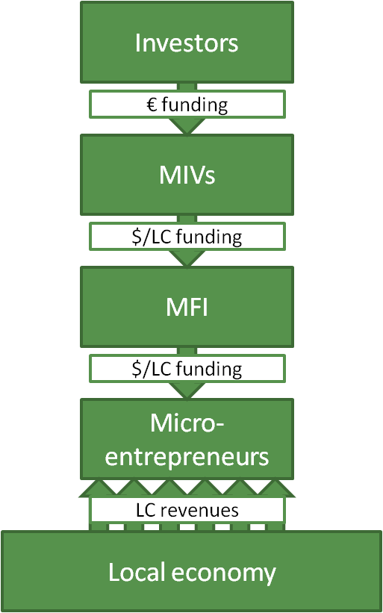
Source: (MFX Microfinance Currency Risk Solutions, n.d. a)
Currency risk can arise at several positions in the chain. When the MIV provides local currency loans, currency risk is borne by the MIV (since the MIV attracts funding in euro). Currency risk is evident at the MFI, when the MFI receives hard currency loans and provides local currency loans to the end-client. Lastly, the end-client can also be the one to incur currency risk when the end-client creates revenues in local currencies, but have to make repayments on a hard currency loan.
For TIM, activity in the FX market does not arise from its core activity but to meet the funding needs. Therefore they do not have the knowledge and time to start trading short-term currencies for the means of making profits. Therefore, rather than engaging in currency speculation the FX policy should focus on reducing risks associated with currency movements (Diamantini, 2010). The advantages of hedging for TIM include a minimization in deviations of the forecasted cash flows. This in turn can improve communications between various departments. Moreover, lower uncertainty aids in firmer and clearer balance sheet figures exposed to external stakeholders (for instance investors). This is beneficial for the securing of steady sources of funding. Moreover, a stable balance sheet decreases the chances of breaching debt/equity covenants. In short, hedging fosters long-term business sustainability and prevents financial distress as a result of volatility in the financial markets (Diamantini, 2010).
The fund structure of TIM EM should be taken into account in the currency management decision. In 2012, 99 microfinance institutions were reached through 4 separate funds: Triodos Sustainable Finance Foundation (TSFF), Hivos-Triodos fund (HTF), Triodos Fair Share Fund (TFSF), and Triodos SICAV II – Triodos Microfinance Fund (TMF). TSFF was established in 1994 and assumes the most risk and is active in smaller newer established MFI’s in higher risk countries (total assets as per 31 December 2012: 92 million). HTF is a joint initiative of Hivos and Triodos Bank and was also founded in 1994. It focuses on young innovative MFI’s that are active in underdeveloped markets (total assets as per 31 December 2012: 71 million). TFSF started in 2002 and focuses on MFI’s with a proven track record, the investments are low risk (total assets as per 30 June 2013: 179 million). TMF was founded in 2009 and has shares available for institutional investors, high net worth individuals and private banking clients across Europe. The primary focus is also on financial institutions with a proven track record (total assets as per 29 November 2013: 155 million). HTF and TSFF are not commercial and are not open to private investors. In total, the value of outstanding investments was 421 million Euros beginning of 2013. The loan amounts start at around EUR 500,000 euro or the corresponding local currency amount. The period of the loan is maximum five years. Repayment schedules differ among the financial institutions.
Loans are provided in USD, Euro and local currencies. The decision to provide a loan in USD, Euro or local currency depends on several factors. At the moment, still more than half of the total portfolio is in USD. Moreover, two thirds of the current outstanding portfolio is hedged through financial derivatives. Included in the currency decision are the wishes of the client, the risk profile of the different funds and the cost of a potential hedge. TIM EM aims to reduce currency risk for the end client. Providing hard currency loans places the risk at the MFI or end client. This can be dangerous if the MFI (client) attracts funding from Triodos in hard currency (has liabilities in dollars) and has assets in local currencies. For this reason, TIM EM and Triodos funds HTF and TD especially consider the provision of loans in local currency as a key aspect of their vision.
However, open exposures are limited in the regulations in order to restrict downside losses due to lack of diversification and adverse currency movements. The regulations concerning the allowed open currency exposure differ per fund. First of all regulation for the Hivos-Triodos Fund and TSFF fund states that only 15% of the total assets in open exposure can be in one currency. For Hivos-Triodos fund local currency exposure is highest for the Ugandan Schilling and Peru. For TSFF open local currency exposure is highest in Peru and Kenya. Since HTF and TSFF are not commercial funds the aim really is to restrict risk for the end client. Triodos Fair Share can have at most 50% of total assets in unhedged exposure (currently this is less than 15%). A maximum of 10% of unhedged exposure can be invested in a single local currency (currently the highest single currency exposure is 2.7% for Mongolia). The Microfinance fund can invest a maximum of 90% of total assets in local currency investments (including equity, subordinated debt, convertible debt and senior debt). In total, 60% of total assets can be exposed in unhedged local currency investments (currently this is only at 10.6%). Furthermore, unhedged exposure in a single local currency cannot make up more than 30% of total assets (at the latest date of 30 November 2013 this was only 2%). The highest unhedged local currency exposure for this fund is in the Dominican Republic and Peru. Next to financial derivatives as options and currency forwards cross hedging can be applied, when their value does not exceed that of the transaction and the duration is not longer than the anticipated end of the deal.
Hard currency loans (USD loans) are always hedged, so open USD positions are never held. For dollar loans there is no minimum return, but there is a proposed annual USD interest rate. The party associated with the Euro USD hedge is Triodos bank who operates their hedge via Rabobank. KC decides on the dollar interest rate, since the hedge is not completed immediately after this decision there is some risk taken by TIM, since hedging costs can still change.
For local currency loans it is considered whether it is possible to hedge together with the client and MFX. MFX is the partner for TIM for hedging local currency exposure. MFX is an organization set-up to meet the needs of microfinance lenders for affordable currency hedging possibilities. MFX offers hedging products in more than 30 currencies and has hedged almost half a billion dollar dollars of loans over the last 4 years (MFX, 2013). The hedging instruments used are forwards and cross currency swaps. Moreover, the decision for deliverable or non deliverable hedging instrument can be made. The costs of the hedge are calculated by the back office. TIM decides on a minimum euro return. The client has a maximum local currency interest rate it is willing to pay, creating a range of possible returns. When the return taking into account the hedging costs does not fall in the range, an open position can be held. An alternative to a complete open position is the linking of loan interest rates to local short term variable interest rate benchmarks. This strategy is based on the notion that interest rate reflect exchange rate expectations. Therefore the benchmark interest rate is required to increase when the local currency depreciates. In most cases a minimum and maximum interest rate will also be established in order to limit downside risk for both parties. An evaluation of this strategy is provided in section 6.4.

5.0 HYPOTHESES
After consulting the theoretical literature, prior research and some of the goals and characteristics of TIM EM it is possible to set up hypotheses. The aim of this research is to consider the appropriateness of existing and alternative methods/strategies to manage currency risk for EM currencies for TIM EM. In order to come to a conclusion on this matter, four hypotheses are tested.
The theoretical overview showed that the forces of supply and demand are more volatile for EM, which causes EM currencies to have greater swings and spot exchange rates are difficult to predict. Not only is volatility larger, the level of volatility is also not stable. Moreover, crises occur more often in EM and they are more persistent, investor fear plays a large role in this. These observations lead to the first hypothesis that active management of EM currencies is required to avoid currency losses.
The second hypothesis is based on the finding of Women’s World Banking (2004) that more than half of EM currencies tend to depreciate. Clark, Tamirisa, and Wei (2004) document EMs lower resilience to shocks, which makes them more susceptible to crises. Fong Chan, Powell and Treepongkaruna (2012) also find that jumps occur more often for EM and the jumps are more severe. Moreover, Dodd and Spiegel (2005) found that from a sample of 46 EM currencies at least 20 were needed in order to benefit from diversification possibilities in a local currency debt portfolio. Also, Richards, Aller and Brown (2007) concluded that a diversification strategy requires a long-term view. Last, Holden and Holden (2004) found low diversification benefits for their sample of Colombia, Bolivia and Peru. It therefore appears that EM spot rates have a high share of co-movement, which troubles diversification.
The third hypothesis states that proxy-hedging is an interesting alternative. This hypothesis is based on the information that financial derivatives for EM currencies are limited, creating necessity of alternative hedging products. The option of hedging with USD-EUR forwards is discussed in line with de Kiewit Treasurer Search (n.d.) suggesting the approach for Brazilian Real exposure.
Lastly, the fourth hypothesis states that connecting depreciation to local interest rates may reduce currency losses. Bansal and Dahlquist (2000) find that the forward premium puzzle does not hold for EM, whereas it does for many DM currencies. If it were to hold, the strategy could not be defended because it would mean that negative exchange rate returns would also be associated with lower interest rates.
Hypotheses:
H₁: Not managing currency risk at all is unadvisable since volatility of emerging market currencies is higher and unpredictable
H₂: An active diversification strategy is possible, however, would require inclusion of around 20 currencies.
H₃: Proxy-hedging is able to reduce variance in LCY-EUR spot returns.
H₄: Linking interest rates to a local interest rate benchmark to account for depreciation limits currency losses.

6.0 ANALYSIS

6.1 Data and descriptive statistics
Table 2 includes the exchange rates and exchange rate regimes for the countries in which TIM EM is active (open and hedged exposure). The exchange rate regime is relevant since it has a large impact on the frequency and extent of appreciation and depreciation that can be expected. Appendix 2 shows the overview of the terminology considering the different exchange rate regimes.
Table 2 – Exchange rate regimes in the EM countries
Country | Currency (CODE) Symbol | Exchange rate regime – Anchor rate/Monetary Goal
Latin America
Argentina (AR) | Argentine Peso (ARS) $ | Crawl-like arrangement - Goal: monetary aggregate target3
Bolivia (BO) | Bolivian Boliviano (BOB) $b | Crawling Peg - Goal: other monetary policies3
Colombia (CO) | Colombian Peso (COP) $ | Floating - Goal: inflation targeting
Dominican Republic (DO) | Dominican Peso (DOP) RD$ | Crawl-like arrangement –Goal: inflation targeting framework3
Ecuador (EC) | US Dollar (USD) $ | Exchange arrangement with no separate legal tender - Exchange rate anchor: U.S. Dollar
Guatemala (GU) | Guatemalan Quetzal (GTQ) Q | Stabilized arrangement - Goal: Inflation targeting framework
Honduras (HO) | Honduran Lempira (HNL) L | Crawl-like arrangement - Exchange rate anchor: U.S. Dollar
Nicaragua (NI) | Nicaraguan Cordoba (NIO) C$ | Crawling peg -Exchange rate anchor: U.S. Dollar
Paraguay (PY) | Paraguayan Guarani (PYG) Gs | Other managed arrangement - Goal: monetary aggregate target
Peru (PE) | Peruvian Nuevo Sol (PEN) S/. | Floating- Goal: inflation targeting framework
El Salvador (SV) | Salvadoran Colon (SVC) $ | Exchange arrangement with no separate legal tender -Exchange rate anchor: U.S. Dollar
Uruguay (UY) | Uruguayan Peso (UYU) $U | Floating -Goal: inflation targeting
Africa and Middle East
Angola (AO) | Angolan Kwanza (AOA) Kz | Stabilized arrangement -Goal: other monetary policy3
Benin (BJ) | CFA Franc (XOF) | Conventional peg - Exchange rate anchor: Euro
Ghana (GH) | Ghanaian Cedi (GHS) GH¢ | Floating - Goal: inflation targeting
Jordan (JO) | Jordanian Dinar (JOD) | Conventional peg -Exchange rate anchor: U.S. Dollar
Kenya (KE) | Kenyan Shilling (KES) KSh | Floating - Goal: Monetary aggregate target
Madagascar (MG) | Malagasy Ariary (MGA) Ar | Floating - Goal: Monetary aggregate target
Malawi (MW) | Malawian Kwacha (MWK) MK | Other managed arrangement - Goal: monetary aggregate target.
Nigeria (NG) | Nigerian Naira (NGN) ₦ | Other managed arrangement - Goal: monetary aggregate target
Senegal (SN) | CFA Franc (XOF) | Conventional peg - Exchange rate anchor: Euro
Tanzania (TZ) | Tanzanian Shilling (TZS) | Floating - Goal: Monetary aggregate target
Uganda (UG) | Ugandan Shilling (UGX) USh | Floating - Goal: Monetary aggregate target
South Africa (ZA) | South African Rand (ZAR) R | Floating -Goal: inflation targeting
Zambia (ZM) | Zambian Kwacha (ZMW/ZMK) ZK | Floating -Goal: Monetary aggregate target
East Asia and Pacific
Cambodia (KH) | Cambodian Riel (KHR) | Stabilized arrangement - Exchange rate anchor: U.S. Dollar
Indonesia (ID) | Indonesian Rupiah (IDR) Rp | Floating - Goal: inflation targeting
Laos (LA) | Lao Kip (LAK) ₭ | Stabilized arrangement - Goal: other monetary policy3
Mongolia (MN) | Mongolian Tughrik (MNT) ₮ | Floating - Goal: Monetary aggregate target
The Philippines (PH) | Philippine Peso (PHP) ₱ | Floating - Goal: inflation targeting
Timor-Leste (TL) | US Dollar (USD) $ | Exchange rate with no separate legal tender - Exchange rate anchor: U.S. Dollar
Vietnam (VN) | Vietnamese Dong (VND) ₫ | Stabilized arrangement - exchange rate anchor: composite3
South Asia
Bangladesh (BD) | Bangladeshi Taki (BDT) Tk | Other managed arrangement - Goal: monetary aggregate target
India (IN) | Indian Rupee (INR) | Floating – Goal: other
Pakistan (PK) | Pakistani Rupee (PKR) ₨ | Floating - goal: monetary aggregate target
Sri Lanka (LK) | Sri Lankan Rupee (LKR) ₨ | Floating - Goal: monetary aggregate target
Eastern Europe and Central Asia
Azerbaijan (AZ) | Azerbaijani New Manat (AZN) ман | Stabilized arrangement - Goal: other monetary policy3
Bosnia Herzegovina (BA) | Bosnian Convertible Marka (BAM) KM | Currency board -Exchange rate anchor: Euro
Georgia (GS) | Georgian Lari (GEL) | Floating - Goal: inflation targeting
Kazakhstan (KZ) | Kazakhstani Tenge (KZT) | Crawl-like arrangement - Exchange rate anchor: U.S. Dollar
Kyrgyzstan (KG) | Kyrgyzstani Som (KGS) лв | Other managed arrangement - Goal: Monetary aggregate target
Moldova (MD) | Moldovan Leu (MDL) | Floating -Goal: inflation targeting
Tajikistan (TJ) | Tajikistani Somoni (TJS) | Stabilized arrangement - goal: Monetary aggregate target3
Information on local currencies, currency codes and symbols is retrieved from XE (n.d.). Exchange rate classification is based on 2012 data from International Monetary Fund (2012)
The exchange rates are retrieved from Thomson Datastream. End of month exchange rates are downloaded for the past 10 years. The choice of this data period is motivated by the practical use for TIM, since the purpose is to evaluate past performance and base future actions on most recent data. Moreover, the past 10 years provide a wide enough span to analyze currency movements through different economic circumstances (e.g. the period includes the 2008 financial crisis). As pointed out by for instance Fong Chan, Powell and Treepongkaruna (2012) behavior of exchange rates differs during a period of crisis. When WM Reuters closing spot rates are available, these rates are preferred and otherwise Thomson Reuters spot rates are used. The middle exchange rates are used rather than bid or ask rates and represent the arithmetic mean of bids and offers. The spot exchange rates include forty EM exchange rates against the Euro.
Before evaluating the effectiveness of different strategies, a general impression of the behavior of the EM currencies is provided. Table 3 provides an overview of the historical means of returns of the different currencies and their volatilities.
Table 3 - descriptive statistics LCY spot exchange rates with respect to the Euro
Variable | Obs | Mean Spot LCY-EUR rate | Min Spot LCY-EUR | Max Spot LCY-EUR | Average monthly % change Spot | Std. Dev. Spot | Min % change spot rate | Max % change spot rate | Average monthly  excess return
Latin America
arseur | 122 | 4,899 | 3,345 | 8,355 | -0,756 | 3,246 | -11,596 | 7,332 | 0,117
bobeur | 122 | 9,842 | 8,590 | 11,784 | -0,036 | 3,158 | -9,180 | 9,708 | 0,065
copeur | 122 | 2800,371 | 2205,398 | 3506,175 | 0,199 | 3,561 | -10,269 | 11,491 | 0,525*
dopeur | 119 | 48,121 | 34,320 | 61,620 | 0,056 | 4,359 | -10,467 | 16,859 | 0,594*
svceur | 91 | 11,918 | 10,704 | 13,805 | -0,065 | 3,369 | -9,703 | 10,311 | 0,023
gtqeur | 97 | 10,577 | 8,990 | 12,445 | -0,185 | 3,329 | -10,672 | 8,627 | 0,041
hnleur | 61 | 26,041 | 23,118 | 28,356 | -0,152 | 2,740 | -10,176 | 8,323 | 0,240
nioeur | 72 | 29,778 | 25,090 | 34,180 | -0,312 | 3,954 | -11,408 | 9,741 | -0,214
pygeur | 122 | 6628,682 | 5124,820 | 8329,130 | 0,158 | 3,647 | -8,511 | 11,512 | 0,355
peneur | 122 | 3,994 | 3,231 | 4,666 | 0,045 | 3,011 | -11,069 | 7,766 | 0,194
uyueur | 122 | 29,833 | 23,621 | 36,976 | 0,119 | 3,690 | -12,135 | 15,573 | 0,645**
Africa and Middle East
aoaeur | 119 | 114,402 | 95,140 | 138,380 | -0,242 | 3,547 | -9,311 | 11,102 | 0,172
xofeur | 122 | 375,888 | 261,252 | 485,391 | 0,261 | 6,225 | -20,461 | 18,237 | 0,263
ghseur | 122 | 1,728 | 1,016 | 3,098 | -0,921 | 3,422 | -13,823 | 9,203 | 0,163
jodeur | 122 | 0,943 | 0,824 | 1,123 | -0,130 | 3,115 | -9,151 | 10,194 | 0,142
keseur | 122 | 103,416 | 85,458 | 138,573 | -0,218 | 3,387 | -13,352 | 13,657 | 0,181
mgaeur | 111 | 2705,572 | 2308,500 | 3064,500 | -0,157 | 2,973 | -10,700 | 8,470 | 0,509**
mwkeur | 122 | 223,668 | 123,690 | 558,238 | -1,245 | 5,501 | -41,119 | 20,449 | -0,086
ngneur | 122 | 187,899 | 149,250 | 229,439 | -0,276 | 3,805 | -24,884 | 10,159 | 0,207
tzseur | 122 | 1783,785 | 1218,882 | 2399,057 | -0,487 | 3,498 | -12,791 | 9,820 | 0,036
ugxeur | 122 | 2746,623 | 2083,025 | 4065,996 | -0,329 | 3,763 | -11,220 | 9,305 | 0,345
zareur | 122 | 10,015 | 7,355 | 13,842 | -0,452 | 4,196 | -12,027 | 11,704 | -0,059
zmweur | 122 | 6,094 | 3,867 | 7,536 | -0,250 | 4,817 | -14,144 | 27,378 | 0,526
East Asia and Pacific
khreur | 113 | 5416,979 | 4627,699 | 6360,000 | -0,140 | 3,388 | -9,473 | 11,155 | -0,258
idreur | 122 | 12558,69 | 9877,180 | 16287,540 | -0,413 | 3,346 | -9,890 | 8,964 | 0,209
lakeur | 122 | 11488,33 | 8803,840 | 13934,590 | -0,175 | 4,009 | -27,114 | 10,037 | -
mnteur | 119 | 1712,773 | 1402,540 | 2360,250 | -0,412 | 3,866 | -18,732 | 10,296 | 0,249
phpeur | 122 | 63,040 | 51,411 | 76,288 | 0,063 | 2,820 | -7,458 | 8,510 | 0,453**
vndeur | 122 | 23853,55 | 18183,820 | 30628,940 | -0,379 | 3,311 | -12,085 | 8,884 | 0,180
South Asia
bdteur | 122 | 93,233 | 67,931 | 110,569 | -0,366 | 3,240 | -9,373 | 10,034 | -0,049
inreur | 122 | 62,601 | 52,639 | 87,120 | -0,396 | 2,842 | -7,605 | 7,803 | -0,016
pkreur | 122 | 100,451 | 66,669 | 147,694 | -0,657 | 2,978 | -9,435 | 8,226 | -0,063
lkreur | 122 | 148,752 | 110,159 | 178,704 | -0,400 | 3,351 | -11,796 | 9,516 | 0,399*
Eastern Europe and Central Asia
azneur | 119 | 1,127 | 0,966 | 1,336 | 0,119 | 3,061 | -8,343 | 10,043 | 0,449*
bameur | 99 | 1,955 | 1,904 | 2,002 | -0,006 | 0,911 | -2,731 | 2,729 | 0,054
geleur | 119 | 2,272 | 1,810 | 2,620 | 0,049 | 3,446 | -15,470 | 8,190 | 0,685**
kzteur | 122 | 183,726 | 151,020 | 223,228 | -0,223 | 3,684 | -22,435 | 9,687 | 0,121
kgseur | 119 | 56,911 | 48,560 | 69,400 | -0,262 | 3,169 | -10,247 | 7,136 | 0,071
mdleur | 122 | 15,988 | 13,180 | 17,875 | -0,182 | 3,085 | -9,860 | 9,539 | 0,431**
tjseur | 95 | 5,582 | 3,822 | 6,910 | -0,605 | 3,473 | -15,038 | 11,266 | -0,064
The XOF excess return refers to Benin, for Senegal no benchmark data was available. Moreover, no data for a short term interest rate for Laos was available.
The number of observations refers to the spot statistics, fewer observations were available for computing the excess returns.
The stars indicate significance levels: *=10%, **=5%, ***=1%.
Table 3 provides the mean value and the minimum and maximum of the exchange rates with respect to the Euro. This gives insight in the average spot exchange rate and the lowest and the highest it has been over the past ten years, providing a first indication of the extent of exchange rate movements.
An indication of the movements of the exchange rates is given by the average monthly % change in exchange rate. This number indicates how the exchange rate on average changed with respect to the dollar. The spot returns are calculated as the negative log change in the monthly spot exchange rate (spot LCY-EUR_{t+1}/spot LCY-EUR_{t}). A positive monthly change indicates that the local currency has on average appreciated with respect to the Euro (gain in value with respect to the euro). A negative sign indicates that the local currency has depreciated with respect to the euro. The analysis shows that on average several Latin American countries had average monthly appreciation against the Euro (Colombia, Paraguay, Peru, and Uruguay). For Africa only the CFA Frank, which is pegged to the euro had average appreciation against the euro. For the Asian currencies, the Philippine Peso is the only currency that shows an average monthly appreciation. For Eastern Europe and Central Asia, Azerbaijan and Georgia had average appreciation with respect to the euro.
The standard deviation of the monthly % change in the exchange rate is also of importance, since it measures the volatility of a currency. A currency may for instance have low average depreciation, however if this is caused by high appreciation one month followed by high depreciation the other month this is troublesome. The formula for the standard deviation is given by equation 1:
$σ=\sqrt{\frac{1}{N}\sum_{i=1}^{N}{(x_{i}-μ)^{2}}}$ (equation 1)
Where σ is the standard deviation, µ represents the average of all the observations (average exchange rate return), x represents all the observations for the monthly exchange rate return, and N is the number of observations. For the currencies in the sample, the Malawian Kwacha has the highest standard deviation of monthly spot % changes in the exchange rate of 6,091%. This is also reflected by the high maximum depreciation (minimum monthly % change), indicating that the currency is volatile and subject to large swings in the exchange rate. The lowest volatility with respect to the EUR is achieved by the Bosnian Marka, which has a standard deviation of change of 0.6%.
The minimum percentage change of the currency gives an indication of the worst case scenario. For instance, for the Malawian Kwacha the minimum monthly percentage change is -41.12%. This means that in one month the spot rate depreciated with -41.12% with respect to the previous month. If a loan would be repaid in Malawian Kwacha in that particular month, the depreciation loss suffered by TIM would lead to a loss on that loan. Information on the extreme movements is therefore relevant in sketching a worst-case scenario. Conversely, the maximum percentage change tells something about the maximum appreciation gains on the local currency exposure.
Lastly the excess return is computed for the different currencies. The excess return is defined as the sum of the monthly interest rate differential (short term LCY interest rate – 3 month Libor) and the monthly log change in the LCY-EUR spot exchange rate. Table 3 shows that the average monthly excess return is positive for most countries. Only Nicaragua, Malawi, South Africa, Cambodia, Bangladesh, India, Pakistan and Tajikistan exhibit negative average monthly excess returns. Therefore, the currency movements appear to be compensated by interest rate differentials. A t-test is also run for the different excess returns. The t-test tests whether the excess returns are significantly different from zero. The results show that for Colombia, Uruguay, Sri Lanka, Azerbaijan, Georgia and Moldova there are significant positive excess returns. Positive excess returns provide an indication that currency risk does not need to be managed, since it is compensated for by the interest rate differential (this is analyzed further in section 6.4). A table of the interest benchmarks for the different countries is provided in Appendix 3. Where possible the benchmark listed on the Currency Exchange Fund (TCX) is downloaded. TCX is a special purpose fund that offers OTC derivatives in order to hedge currency risk with a special focus on less liquid emerging markets. TCX uses these benchmarks to price financial products and therefore those benchmarks seem suitable for estimating the forward premium.
In conclusion, the descriptive statistics indicate that emerging market exchange rates are volatile and overall (spot rates) tend to show depreciation on average compared to the euro. The average monthly excess return is positive for more than half of the currencies in the sample, however negative average monthly excess returns are also present across the regions. Therefore, the data support the first hypothesis that currency risk in EM has to be managed actively in order to prevent losses and that a strategy of ‘doing nothing’ can result in high volatility of returns and potential losses. It must be noted that the illustrated descriptives may be different for a different time-span. The next section will investigate the effect of active portfolio building to reduce currency risk.

6.2 Diversification

6.2.1 Graphical analysis
In order to investigate whether it is possible to benefit from diversification possibilities, exchange rate movements must be analyzed in relation to each other. First, the figures show the cumulative monthly % change in the spot exchange rate with respect to the euro.
Figure 2- Monthly returns Latin America
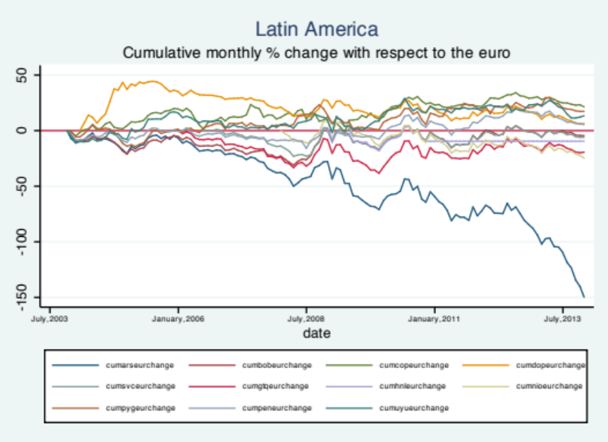
Figure 2 confirms the notion that overall diversification benefits within a region are limited, since most currencies have similar movements. The graph shows that in general the currencies exhibit appreciations and depreciations with respect to the euro at the same time, although there can be a short delay in this pattern. Moreover, the magnitude of depreciation /appreciation may differ per currency. However, the overall trend is similar for most currencies in the region. For Latin America the currencies move together very closely as can be seen in figure 2. Especially after 2008 the pattern of all currencies except for the Argentinean Peso is very similar.
For Africa and the Middle East (figure 3), the currencies appear to move slightly more independent than the Latin American currencies. The depreciation of the Malawian Kwacha stands out from this figure. Moreover, this picture shows that over the past ten years only the CFA franc appreciated slightly with respect to the euro. Therefore, there appear to be more diversification possibilities within the region in Africa.

Figure 3 – Cumulative monthly returns Africa and Middle East
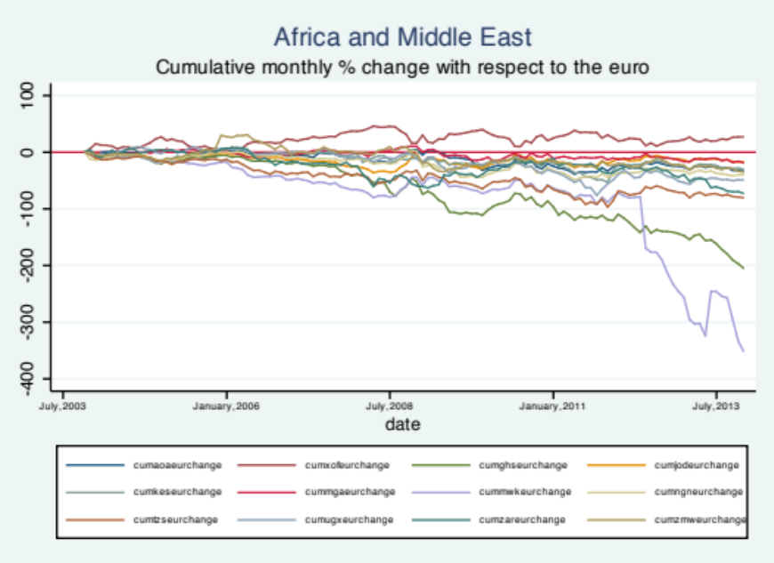
Figure 4 shows that in Asia, currency movements appear closely related. Almost all currencies tend to appreciate and depreciate at similar times. An exception for this pattern occurred around the second half of 2008, where some currencies depreciated and others appreciated.
Figure 4 – Cumulative monthly returns South Asia, East Asia and Pacific
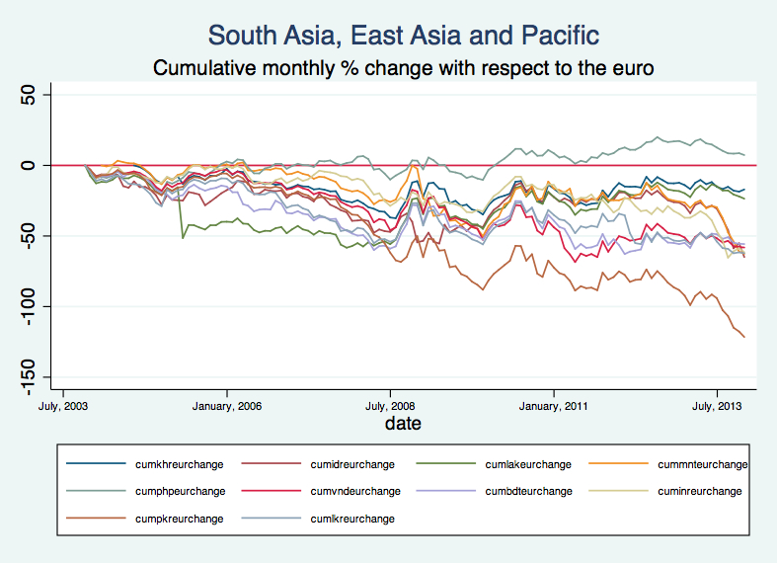

Figure 5 – Cumulative monthly returns Eastern Europe and Central Asia
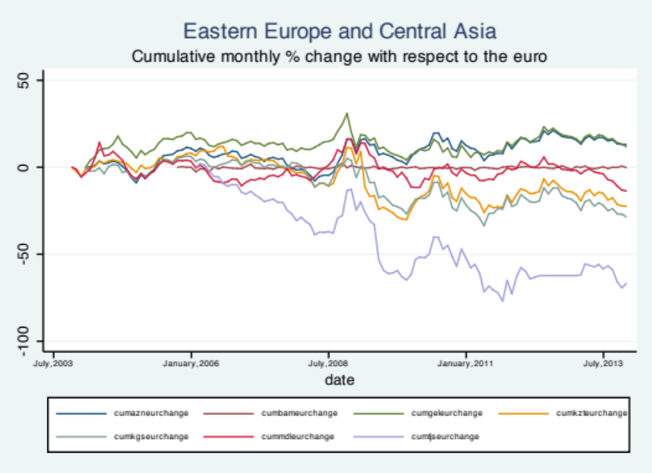
Lastly, Eastern Europe and Central Asia is considered. For the last region the different individual currency returns also have similar patterns as shown in figure 5. Also for this region, the differences in movements were greatest during the second half of 2008. Outstanding in this picture is the fact that although the patterns of the different currency movements are similar there is quite a distance between the different lines. Meaning that the average percentage of depreciation/appreciation differs among the currencies.
Next, the co-movement of the different currencies is tested through PCA analysis.

6.2.2 Principal Component Analysis
The aim of the Principal Component Analysis (PCA) is to investigate whether the exchange rate changes of the different local currencies with respect to the euro can be explained by common factors. PCA is a method to reduce data and uses the monthly returns of 40 LCYs with respect to the EUR. PCA creates a number of linear combinations of variables that include most of the variance in the sample (Stata, n.d.). The greater the percentage of variance explained by the first components the greater the commonality in the factors that explain the LCY-EUR exchange rate movements. Table 4 shows the percentage explained of the first three components both for log changes in spot returns and for log changes in excess returns.
The results of the PCA show that co-movement of the different spot rates is greatest in Latin America, where the first component explains the most variance (79.5%). In Africa the first component explains the least variance (57.3%). This implies that common factors are least able to explain spot changes for the African currencies and the Jordanian Dinar. Even across the different regions it appears that common factors are able to explain the currency movements. For the 40 currencies, the first component explains 71% of the variance in currency movements.
Excess returns of the different currencies also share a large share of variance. For the entire region, the first component explains 72.6% of the variance. The three components together explain 81.9% of the total variance in the excess returns. The co-movement of the excess returns is greatest in Latin America, where the first component explains 80.4% and the first three components explain 92.1%. In Africa the first component explains the least variance (53.5%). The PCA does not allow determining what common factor drives the variation in the excess returns only the percentage of shared variation. Further analysis would have to determine the common driver of EM excess returns.
Table 4 - PCA of the correlation matrix of monthly percentage changes LCY-EUR exchange rate
 | Changes in spot returns |  | Excess returns
Principal component | Percentage explained | Cumulative percentage  explained | Percentage explained | Cumulative percentage explained
World
First | 0.711 | 0.711 | 0.726 | 0.726
Second | 0.046 | 0.757 | 0.055 | 0.782
Third | 0.028 | 0.786 | 0.037 | 0.819
Latin America
First | 0.795 | 0.795 | 0.804 | 0.804
Second | 0.067 | 0.862 | 0.066 | 0.870
Third | 0.046 | 0.908 | 0.051 | 0.921
Africa and Middle East
First | 0.573 | 0.573 | 0.548 | 0.548
Second | 0.096 | 0.669 | 0.100 | 0.648
Third | 0.074 | 0.742 | 0.078 | 0.726
South Asia, East Asia and Pacific
First | 0.732 | 0.732 | 0.761 | 0.761
Second | 0.081 | 0.813 | 0.081 | 0.841
Third | 0.051 | 0.865 | 0.062 | 0.903
Eastern Europe and Central Asia
First | 0.672 | 0.672 | 0.670 | 0.670
Second | 0.146 | 0.817 | 0.147 | 0.817
Third | 0.061 | 0.878 | 0.062 | 0.878

6.2.3 Optimal portfolio analysis
Next to the cumulative returns and PCA analysis, another indication of diversification benefits can be deduced from the returns and standard deviation of the currencies separately compared to the return and standard deviation of a combined portfolio including multiple currencies. The standard deviation of return provides a good measure of risk since the measure is intuitive, widely recognized and it has been used in most of the theoretical asset pricing models (Reilly and Brown, 2003). The standard deviation of the portfolio is lower than the average standard deviation of the different currencies in the portfolio. This can be understood from the formula of the standard deviation (σ) of a portfolio, which is given by equation 2:
$σ_{portfolio}= \sqrt{w_{1}^{2}σ_{1}^{2}+w_{2}^{2}σ_{2}^{2}+2w_{1}2w_{2}{Cov}_{1,2}}$ (equation 2)
Equation 2 shows that the standard deviation not only depends on the standard deviation of the different currencies and the weight (w= relative share of the currency in the total portfolio), but also on the covariance between the different currencies. The covariance is a number that indicates how two assets relate to each other.
If the returns and standard deviation of the individual currencies are known it is possible to estimate the variance covariance matrix. From the individual returns and the variance covariance matrix it is possible to estimate the return and standard deviation of a portfolio. This allows seeing what happens to the return and the standard deviation of a portfolio under different weightings of the different currencies in the total portfolio. The returns and variance covariance matrix make it possible to compute the optimal weights. Optimal weights are those relative shares of the individual currencies that satisfy a constraint in the best possible way. For instance it allows calculating the optimal weights of the different currencies in order to achieve the highest possible return or the lowest variance. In the case of currency risk management, it is interesting to see the composition and inclusion of currencies that yields the lowest standard deviation of the portfolio. This analysis is conducted using the solver function in excel. Since the variance covariance matrix cannot deal with missing values, observations of 26 months are used (January 2011 – February 2013). An important caveat of this analysis is that the calculations are based on the assumption that future currency returns can be predicted from past returns.
The first column in table 5 shows a portfolio for which all the currencies have the same relative share in the portfolio (equally weighted portfolio). Under this portfolio, the portfolio return is 0.36% and the standard deviation of the portfolio returns is 2.11%. The weights of the different currencies can be altered to determine whether a better return, and or lower standard deviation can be achieved. The second column shows a scenario in which the return of the portfolio is maximized. This leads to a portfolio return of 1,23%. The third column is most interesting from a risk perspective. In this column the weights are constructed in order to achieve the lowest portfolio standard deviation as possible. Under this portfolio, the standard deviation of the portfolio is as low as 0.03%. High shares in this portfolio are for the Argentinean Peso, Honduran Lempira and CFA Frank. Many of the other currencies are not included in this portfolio at all (indicated by portfolio weight of 0%). The goal of TIM EM however is to offer as many local currency loans as possible. Therefore, the optimal portfolio analysis gives an indication of the relative attractiveness of holding several currencies. However, cannot be followed completely as a guideline. The results do show the power of diversification. The lowest individual standard deviation is 0.10%, and for most individual currencies the standard deviation is around 3%. The portfolio standard deviation of the minimal standard deviation portfolio, is only 0.03%. Therefore, the characteristics of the different currencies can be utilized to generate combinations of individual currencies that yield higher returns with lower risk.
Since TIM EM does not always use local interest rate benchmarks to set the interest rate on loans it is also interesting to conduct a similar analysis on LCY-EUR spot returns. Under this approach the portfolio return and standard deviation for the equally weighted portfolio is -0.36% and 2.77% respectively. The portfolio standard deviation can be reduced to 0.05%, however the portfolio return becomes slightly negative in this scenario (-0.02%). Also in this portfolio three currencies make up more than 90% of the exposure (CFA Frank, Jordanian Dinar, and the Azberbaijani New Manat). This analysis shows that it is difficult to get positive returns from EM spot returns solely.

Table 5 – Optimal weights for LCY debt portfolios
 | (1) Equal weightings | (2)Maximal return | (3)Min St Dev | (4)Maximal Sharpe ratio
 | Portfolio weights
ars_excess | 2,56% | 0,00% | 13,24% | 11,31%
bob_excess | 2,56% | 0,00% | 1,99% | 2,64%
cop_excess | 2,56% | 0,00% | 0,00% | 0,00%
dop_excess | 2,56% | 0,00% | 2,35% | 1,89%
svc_excess | 2,56% | 0,00% | 8,31% | 0,05%
gtq_excess | 2,56% | 0,00% | 2,23% | 1,71%
hnl_excess | 2,56% | 0,00% | 16,64% | 40,72%
nio_excess | 2,56% | 0,00% | 0,02% | 0,00%
pyg_excess | 2,56% | 0,00% | 0,00% | 0,00%
pen_excess | 2,56% | 0,00% | 1,39% | 1,42%
uyu_excess | 2,56% | 0,00% | 0,00% | 0,00%
aoa_excess | 2,56% | 0,00% | 4,93% | 4,38%
benin_excess | 2,56% | 0,00% | 27,38% | 19,11%
ghs_excess | 2,56% | 0,00% | 0,00% | 0,00%
jod_excess | 2,56% | 0,00% | 9,69% | 11,25%
kes_excess | 2,56% | 0,00% | 0,00% | 0,00%
mga_excess | 2,56% | 0,00% | 0,72% | 0,27%
mwk_excess | 2,56% | 0,00% | 0,00% | 0,00%
ngn_excess | 2,56% | 0,00% | 0,00% | 0,00%
tzs_excess | 2,56% | 0,00% | 1,18% | 0,10%
ugx_excess | 2,56% | 0,00% | 0,17% | 0,00%
zar_excess | 2,56% | 0,00% | 0,00% | 0,00%
zmw_excess | 2,56% | 0,00% | 0,00% | 0,00%
khr_excess | 2,56% | 0,00% | 0,73% | 0,79%
idr_excess | 2,56% | 0,00% | 0,00% | 0,00%
mnt_excess | 2,56% | 0,00% | 0,53% | 0,62%
php_excess | 2,56% | 0,00% | 0,00% | 0,00%
vnd_excess | 2,56% | 0,00% | 0,64% | 0,00%
bdt_excess | 2,56% | 0,00% | 1,50% | 0,17%
inr_excess | 2,56% | 0,00% | 0,00% | 0,00%
pkr_excess | 2,56% | 0,00% | 0,00% | 0,00%
lkr_excess | 2,56% | 0,00% | 1,63% | 0,65%
azn_excess | 2,56% | 0,00% | 4,29% | 0,87%
bam_excess | 2,56% | 0,00% | 0,00% | 0,89%
gel_excess | 2,56% | 100,00% | 0,00% | 0,00%
kzt_excess | 2,56% | 0,00% | 0,00% | 0,00%
kgs_excess | 2,56% | 0,00% | 0,00% | 0,00%
mdl_excess | 2,56% | 0,00% | 0,25% | 1,15%
tjs_excess | 2,56% | 0,00% | 0,19% | 0,00%
sum weights | 1 | 1 | 1 | 1
mu | 0,36% | 1,23% | 0,27% | 0,31%
st dev portfolio | 2,11% | 2,84% | 0,03% | 0,03%
mu/sigma | 0,168944 | 0,43311858 | 8,927754 | 12,38731

In conclusion, diversification benefits appear to be limited for the EM currencies in the sample. PCA analysis reveals a high share of common variance for both spot returns and excess returns. The graphs also indicate a high share of co-movement among the different currencies. Lastly, the optimal weights analysis shows that the standard deviation of the LCY debt portfolio can be reduced, however, by excluding a large number of local currencies. Therefore, it appears that there are few possibilities to benefit from favorable contrasting characteristics in the different EM excess returns. Therefore, H2 is for most part not accepted. Diversification possibilities appear to be relatively small.

6.3 Proxy hedging

6.3.1. Proxy hedging with USD-EUR forwards
This paragraph investigates the possibility of hedging LCY exchange rate exposure with USD-EUR derivative. The PCA conducted in section 5.2, revealed a high extent of common variation in the different local currencies. At world level, the first component explained more than 70% of the variance in the changes of LCY-EUR excess returns. To see whether the common variance may be explained by changes in the USD-EUR spot exchange rate, the first component of the PCA analysis is regressed on the log of USD-EUR changes. The results show that USDEUR significantly explain the first component (p=0.000<0.001). The R-squared of this regression is 0.9818, which indicates that changes in the USD-EUR spot rate explain 98.12% of the variance in the first component retrieved from the PCA Analysis. USD-EUR spot changes also significantly explain the first component of LCY-EUR spot returns on the 1% level, with an R-squared of 0.975.
Another method to look at the relationship between the LCY-EUR movements and USD-EUR movements is the correlation coefficient. Table 6 shows the correlation coefficients of LCY-EUR spot returns and the USD-EUR spot returns.

Table 6 – correlations USD-EUR returns and LCY-EUR return
Correlation with % change USD-EUR (N=60)
arseurchange | 0,967 | zareurchange | 0,164
bobeurchange | 0,993 | zmweurchange | 0,613
copeurchange | 0,485 | bdteurchange | 0,946
dopeurchange | 0,987 | khreurchange | 0,967
svceurchange | 0,997 | inreurchange | 0,558
gtqeurchange | 0,963 | idreurchange | 0,687
hnleurchange | 0,755 | kzteurchange | 0,747
nioeurchange | 0,968 | kgseurchange | 0,959
pygeurchange | 0,676 | lakeurchange | 0,987
peneurchange | 0,920 | mnteurchange | 0,746
uyueurchange | 0,734 | pkreurchange | 0,972
aoaeurchange | 0,936 | lkreurchange | 0,901
xofeurchange | -1,000 | tjseurchange | 0,803
ghseurchange | 0,864 | phpeurchange | 0,866
keseurchange | 0,802 | vndeurchange | 0,951
mgaeurchange | 0,640 | azneurchange | 0,998
mwkeurchange | 0,311 | bameurchange | 0,142
ngneurchange | 0,821 | geleurchange | 0,942
tzseurchange | 0,912 | jodeurchange | 0,990
ugxeurchange | 0,681 | mdleurchange | 0,767

It must be noted that the correlation coefficient is highly dependent upon the period of analysis chosen. For this correlation table the choice is made to take the longest period as possible, consisting of the most recent 60 observations. The positive sign of almost all correlation coefficients shows that overall local currencies tend to appreciate/depreciate in line with the dollar-euro exchange rate. However, for a proxy hedge to be effective correlations need to be as high as possible. The highest correlation coefficients (>0.9) are present for Argentina, Bolivia, the Dominican Republic, El Salvador, Guatemala, Nicaragua , Angola, Cambodia, Kazakhstan, Kyrgyzstan, Laos, Pakistan, Vietnam, Azerbaijan, Georgia and Jordan. In general, the Latin American currencies thus follow the USD-EUR exchange rate returns most closely. In order to determine whether proxy hedging would be beneficial for these countries some hypothetical investment scenario’s are outlined. Since proxy-hedging has never been done by TIM EM, real cases cannot be studied. The analysis compares a strategy of not hedging the currency exposure to a strategy of hedging with a EUR/USD forward. Since in practice, the proxy hedge would be relevant in cases where it is deemed too costly to hedge with a financial LCY derivative.
Ideally the delivery of the forward contract should be as close to but not before the end of the open exposure (Hull, 2012). There for in this example, it is assumed that one year loans are hedged with one year forwards. Since, changes in the LCY-EUR exchange rate are not matched by equally sized changes in the USD-EUR exchange rate the optimal hedging ratio is first calculated.
The optimal hedge ratio can be calculated by use of the formula for equation 3:
$h=ρ* \frac{σ_{s}}{σ_{F}}$ (equation 3)
$ρ$ represents the correlation coefficient of the standard deviation of the change in the spot price S and the standard deviation of the change in the rice of the hedging instrument (Hull, 2012). It is also possible to obtain the optimal hedging ratio through regression analysis. To find the optimal hedging ratio through regression analysis, Stata is used to run times series regression on the returns. This analysis allows determining whether the EUR-USD significantly affects the LCY-EUR exchange rate, which the correlation coefficient does not provide.
The linear regression estimates equation 4:
$y=α+βX+ ε$ (equation 4)
In equation 4, y represents the dependent variable: the monthly log-returns of the LCY-EUR spot exchange rate. X corresponds with the monthly log-returns of the EUR-USD spot exchange rate, and $ε$ represents the error term. The beta can be interpreted as the hedge ratio, since “the optimal hedge ratio is the slope of the best fit line obtained when the change in spot price are regressed against changes in the futures prices” (Hull, 2012). In this case, rather than hedging with futures, a forward hedge is conducted. The R-squared of the regression states how much of the variance of the change in the spot price of the LCY versus the euro is explained by the variance in the change of the forward price (University of Virginia Darden School of Business, n.d.).
USD-EUR forwards are common financial derivatives and different contract sizes are possible. In practice, TIM EM has access to 1,2,3,4, and 5 year forwards. To calculate the return of the forward, the actual forward rates that TIM would have to pay have been used. Table 7 shows an example of a hedge with a 1 year forward. To calculate the hedge ratio, yearly spot returns and yearly changes in forward prices have been used. Since very few observations would remain to calculate hedging ratios for the longer period hedges, the one-year hedge is evaluated.
Table 7 shows the optimal hedge ratio for the different currencies. The hedge ratio is retrieved from the regression analysis in Stata by regressing yearly LCY-EUR returns and changes in the yearly USDEUR forward prices prior to the hedge. The LCY-EUR return is computed as the natural log of the LCY-EUR exchange rate at the end of the hedge period divided by the LCY-EUR exchange rate at start of the period. The forward ‘return’ is calculated as the natural log of the spot exchange rate on the end of the hedge (date of repayment) and the forward rate. The effective return is calculated by the sum of the LCY-EUR return and the ‘forward return’ multiplied with the hedge ratio. For this example, table 7 shows that if a one year LCY loan was disbursed on the 31st of December in 2012 and hedged with a USDEUR forward, volatility of earnings would have been partly mitigated by the proxy hedge for all the currencies. The result on the forward is positive, and all currencies experienced a negative currency result. However, as the final column shows that high negative returns still occurred for some of the currencies. For instance, for Argentina the effective return still was -28,85%. However, total return is also dependent upon the interest rate differential (which is shown in the next column). The excess return is the sum of the effective return (after the hedge) and the interest rate differential. Table 7 shows that due to developments in the spot rate even after hedging with USD-EUR forwards, the excess return would still have been negative for several currencies. The biggest losses are for the Argentinean Peso, the Dominican Peso, the Nicaraguan Cordoba and the Pakistani Rupee. All these currencies have a high and significant negative value for the constant. This indicates that although the variation in the LCY-EUR spot rate might be hedged well by the forward there is a negative drift in the LCY-EUR exchange rate that cannot be hedged. Therefore, proxy hedging with USD-EUR is not a recommended strategy.
Table 7 – USD-EUR hedge 1 year forward
Hypothethical one year Loan (start date 31 dec 2012 - end date nov 2013)
Currency | α | SE | β (hedge ratio) | SE | R² | LCY-EUR return | Effective spot return hedge | Interest rate Differential | Excess return
arseur | -5,153** | 1.815 | 1,049*** | 0.162 | 0,857 | -30,24% | -28,71% | 13,78% | -14,93%
bobeur | 1,449 | 0,967 | 1,130*** | 0,086 | 0,961 | -3,31% | -1,67% | -0,13% | -1,80%
dopeur | -5,146* | 2,442 | 0,744** | 0,220 | 0,657 | -12,25% | -11,16% | 4,07% | -7,09%
svceur | -0,158 | 0,268 | 1,037*** | 0,024 | 0,998 | -4,75% | -3,24% | 2,56% | -0,68%
gtqeur | -0,425 | 1,052 | 1,242*** | 0,094 | 0,972 | -5,58% | -3,77% | 4,47% | 0,70%
nioeur | -4,796*** | 0,157 | 1,030*** | 0,014 | 0,999 | -9,73% | -8,23% | 0,12% | -8,11%
aoaeur | -1,344 | 2,545 | 1,245*** | 0,229 | 0,803 | -6,59% | -4,78% | 2,58% | -2,20%
khreur | -0,492 | 1,107 | 0,990*** | 0,100 | 0,943 | -3,74% | -2,30% | 0,76% | -1,54%
kzteur | -0,039 | 3,298 | 1,102*** | 0,294 | 0,667 | -7,23% | -5,63% | 3,47% | -2,16%
kgseur | -1,615 | 2,864 | 0,801** | 0,258 | 0,617 | -8,73% | -7,56% | 3,47% | -4,09%
lakeur | -0,177 | 3,814 | 0,847** | 0,341 | 0,469 | -4,81% | -3,58% | . | .
pkreur | -5,898* | 2,534 | 0,775** | 0,227 | 0,626 | -17,30% | -16,17% | 8,89% | -7,29%
vndeur | -3,028* | 1,295 | 1,033*** | 0,116 | 0,919 | -6,24% | -4,73% | 7,80% | 3,07%
azneur | 2,743** | 0,953 | 1,090*** | 0,086 | 0,964 | -4,84% | -3,25% | 4,72% | 1,47%
geleur | 0,998 | 1,32 | 0,881*** | 0,119 | 0,902 | -7,18% | -5,89% | 8,52% | 2,63%
jodeur | 0,198 | 0,341 | 1,036*** | 0,030 | 0,994 | -5,01% | -3,50% | 4,97% | 1,47%
The forward rate is 1,3394 USD-EUR and the return realized on the forward is 1,46%
The hedge ratios are retrieved from the Stata regression (Beta coefficient)
The stars indicate significance levels: *=10%, **=5%, ***=1%.

6.3.2 Proxy hedging with equity
Next to USD-EUR forward, EM equity can be considered for a proxy hedge. Murray (2011) points out that one of the big differences in EM currencies and DM currencies is the higher correlation of EM currencies with its equity. This can be explained by the importance of capital flows arising from foreign direct investment in determining the value of the exchange rate.
Similarly, the first PCA component can be regressed on changes in the leading EM equity index the MSCI, to see whether changes in the index can explain variation in the first PCA component. Results show that changes in the MSCI EM index significantly explain the first PCA from the excess return PCA analysis (p=0.000). R-squared of the regression is 41,06%. For the spot returns, the effect is also significant (p=0.000), with an R-squared of 38,85%. The R-squared is lower than that of USD-EUR changes. However, the countries included in the MSCI EM index do not correspond one-to-one with the EM countries included in this sample. Therefore, results of individual regressions are considered. Only those countries and corresponding currencies were considered for which equity indices are available.
Table 8 – Proxy hedge with EM equity indices
Currency | Equity index | α | SE | β (hedge ratio) | SE | R²
ARS | MSCI Argentina | -0.607** | 0.280 | 0.092*** | 0.025 | 0.1026
COP | MSCI Colombia | 0.110 | 0.335 | -0.062 | 0.049 | 0.0138
PEN | MSCI Peru | 0.187 | 0.258 | 0.113*** | 0.026 | 0.134
GHS | MSCI Ghana | -1.420*** | 0.486 | -0.147** | 0.068 | 0.075
KES | MSCI Kenya | -2.12 | 0.314 | 0.004 | 0.044 | 0.0001
NGN | MSCI Nigeria | -0.150 | 0.337 | 0.040 | 0.035 | 0.011
ZAR | MSCI South Africa | -0.619 | 0.393 | -0.111 | 0.086 | 0.014
BDT | MSCI Bangladesh | -0.019 | 0.491 | -0.046 | 0.059 | 0.013
INR | MSCI India | -0.411 | 0.261 | -0.041 | 0.034 | 0.012
IDR | MSCI Indonesia | -0.484 | 0.311 | -0.059 | 0.041 | 0.018
KZT | MSCI Kazakhstan | -0.214 | 0.381 | 0.087*** | 0.028 | 0.092
PKR | MSCI Pakistan | -0.6755** | 0.272 | -0.041 | 0.028 | 0.018
LKR | MSCI Sri Lanka | -0.357 | 0.308 | 0.007 | 0.035 | 0.000
VND | MSCI Vietnam | -0.359 | 0.403 | 0.027 | 0.033 | 0.008
BAM | MSCI Bosnia | 0.002 | 0.110 | -0.005 | 0.021 | 0.001
JOD | MSCI Jordan | -0.122 | 0.274 | 0.139 | 0.043 | 0.083
TZS | Tanzania Share (TSI) | -0.314 | -0.546 | 0.037 | 0.120 | 0.002
UGX | Uganda SE All Share (ALSI) | -0.364 | 0.368 | 0.064 | 0.046 | 0.018
ZMW | S&P Zambia | -0.599 | 0.510 | -0.167 | 0.125 | 0.0394
The stars indicate significance levels: *=10%, **=5%, ***=1%.

Overall, the table shows that equity is a poor proxy hedge for most of the currencies. Only for Argentina, Peru, Ghana, and Kazakhstan do changes in the MSCI index significantly affect changes in the spot rate. On average the variance explained by the regression (indicated by the R-squared) is low.
In conclusion, the proxy hedges both with USD-EUR forwards and with equity indices cannot eliminate variation completely. Moreover the USD-EUR forward seems better suited to hedge the risk then the country equity indices (indicated by the R-squared). However, due to the negative drift in the spot changes of many currencies the USD-EUR forwards cannot hedge completely and high negative returns can remain. Therefore, H3 cannot be accepted, proxy hedges do not appear suited to manage EM currency risk.

6.4 Spot changes and local interest rates
When a loan is deemed too costly to hedge with a financial derivative an open exposure can be held. An alternative to complete open exposure is the linking of interest rates to a local variable short term interest rate benchmark with the aim of managing exchange rate changes. This strategy is based on the rationale that local interest rates go up to compensate for depreciation of the local currency. Exchange rate movements and interest rates do not move together one-to-one. Therefore, in effect the risk of currency movements is shared by the borrower and the lender. TIM EM has implemented this strategy widely in the past. Therefore, the performance of these loans over the past 4 years is analyzed.

6.4.1 Graphic analysis
First of all, monthly spot returns are plotted against the interest rate of the variable interest rate benchmark + the margin included in the agreement. Often the agreed interest rate is subject to a minimum and maximum interest rate. Moreover, tickers are added in the graphs to indicate the start of the loan, the end of the loan, or a change in loan characteristics (e.g. change in the margin, minimum or maximum) these events are indicated by the words: start, end, and change respectively.
Figure 6 depicts one of the loans disbursed to a client in Ghana. The blue line represents the monthly change in the KESEUR exchange rate. The red line represents the interest rate that was charged to the client and the green line represents the euro yield realized on the loan (the sum of the monthly change in the exchange rate and the interest rate charged). For the client in Ghana, the interest rate was coupled to the 91-day T-bill, with a margin of 4.8% and a minimum interest rate of 15%. The graph shows that interest rates were higher than currency returns every month. Also, the trend in interest rate appears to follow exchange rate movements very roughly. However, movements do not occur one to one and this method is not full proof to cover interest rate risk. A similar analysis can be conducted for other loans.

Figure 6 – Ghana currency returns and 91-day T-bill on a local currency loan

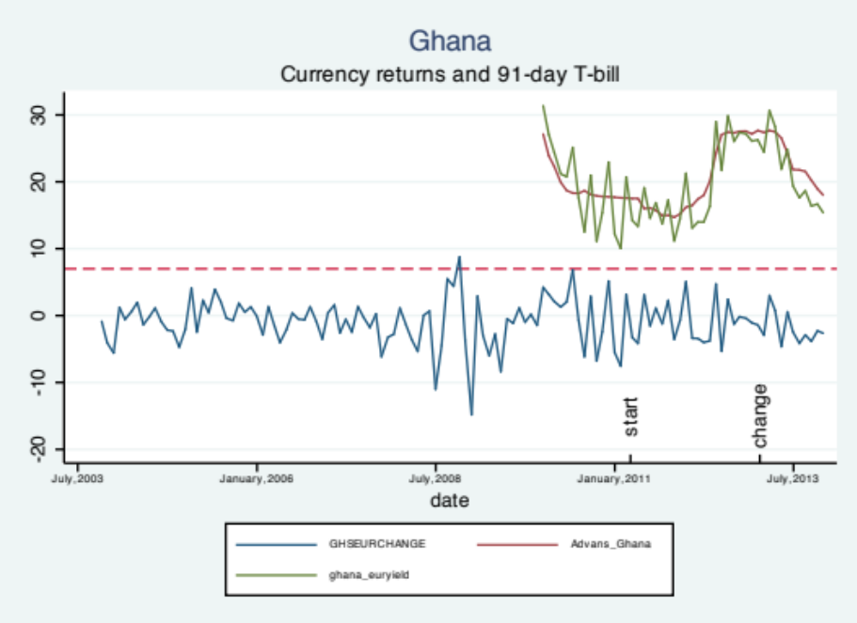

For Kenya (figure 7) for the first period of the loan the charged interest rate was the minimum of 12.5% due to low rates on the 91-day T-bill. Interestingly, the charged interest rate does not appear to rise when there is depreciation in one month. The graph shows that in the second half of 2011, when interest rates started to rise there actually was appreciation of the currency in subsequent months.
Figure 7 – Kenya currency returns and 91-day T-bill on a local currency returns

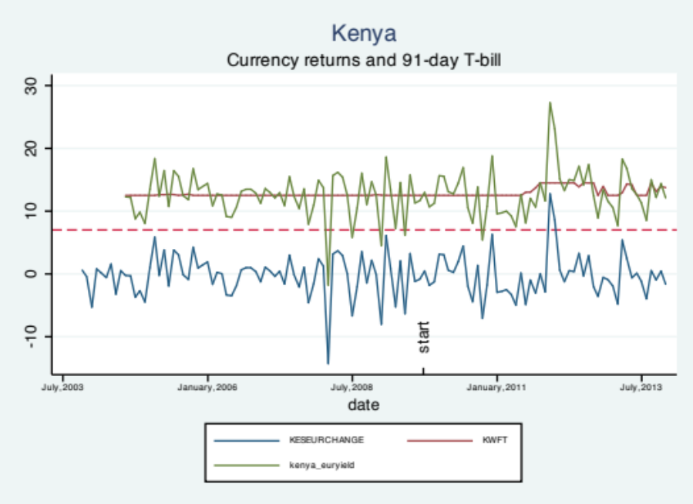

Figure 8 – Madagascar currency returns and 24-day T-bill on a local currency return
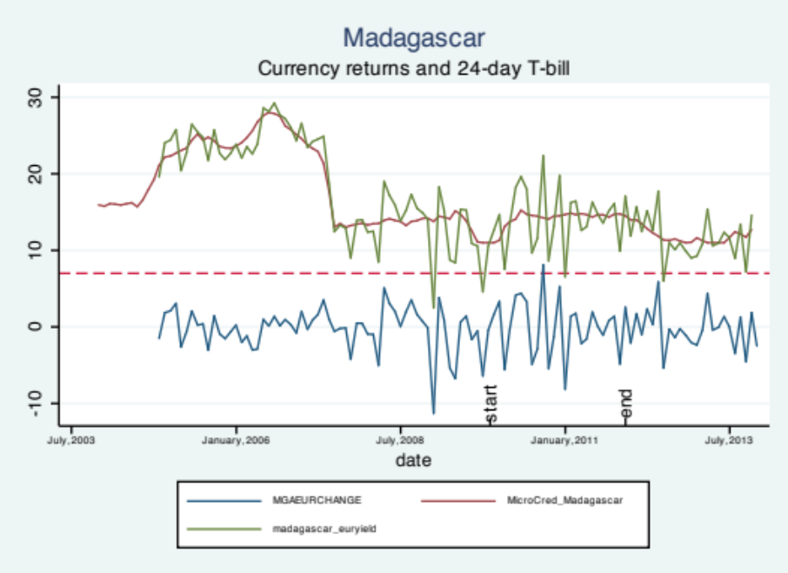
Also for Madagascar the picture shows that currency returns are more volatile than interest rates. Therefore, interest rates will not mitigate currency changes one to one, but more likely follow the broader trend.

For the loan in Indonesia (figure 9) the situation is slightly different. It appears that changes in the 6-month JIBOR were extremely small not compensating for volatility in currency returns. Therefore the 6-month JIBOR does not seem appropriate for a currency risk management strategy.
Figure 9 – Indonesia currency returns and 6-month JIBOR on a local currency loan
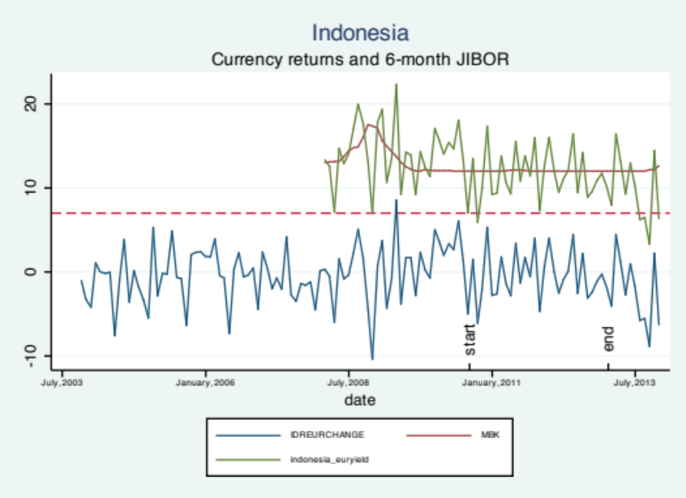
Figure 10 – Kyrgyzstan currency returns and NBKR discount rate on a local currency loan

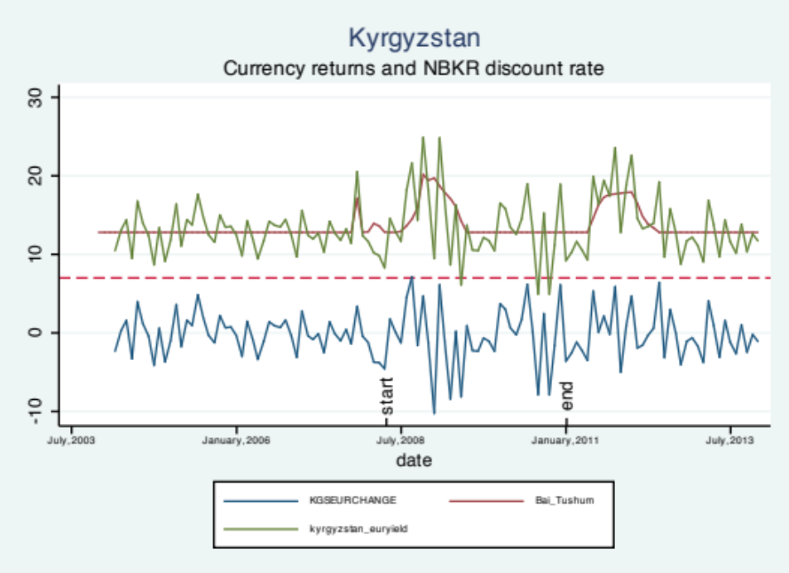
Figure 10 shows that for Kyrgyzstan there were some large changes in the interest rate charged to the end client. It appears that the depreciation around September 2008 was followed by an increase in the interest rate. This means that currency losses were mitigated through this strategy. This provides evidence in favor of this currency mitigation strategy.
Figure 11 – Kazakhstan currency returns and 3-month Kazprime rate on a local currency loan
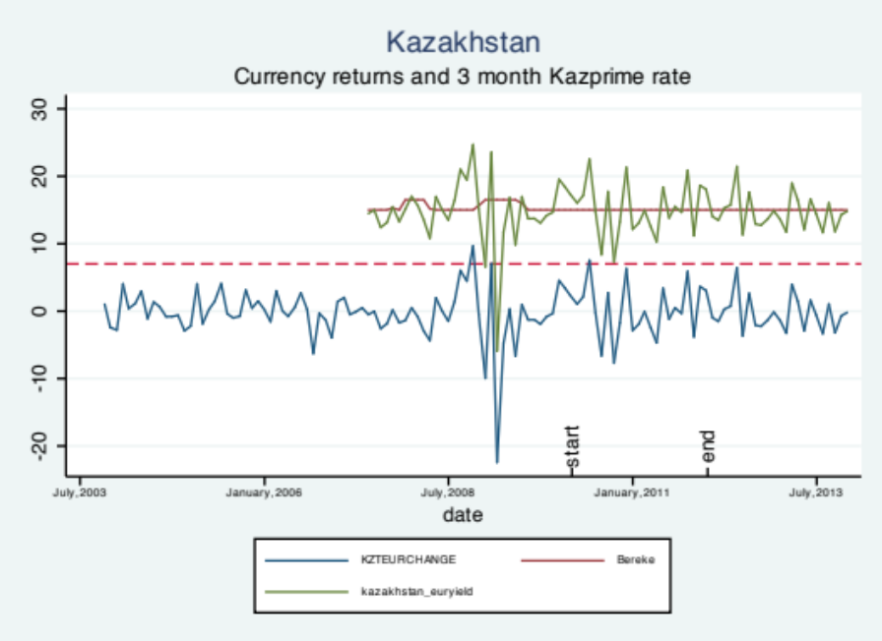
Figure 11 shows that the 3-month Kazprime in most situations was so low that the minimum interest rate of 15 percent was charged. Overall this does not appear to be problematic since there are roughly as many months with appreciation as with depreciation of the LCY.
Figure 12 – Paraguay currency returns and TIP rate on a local currency loan

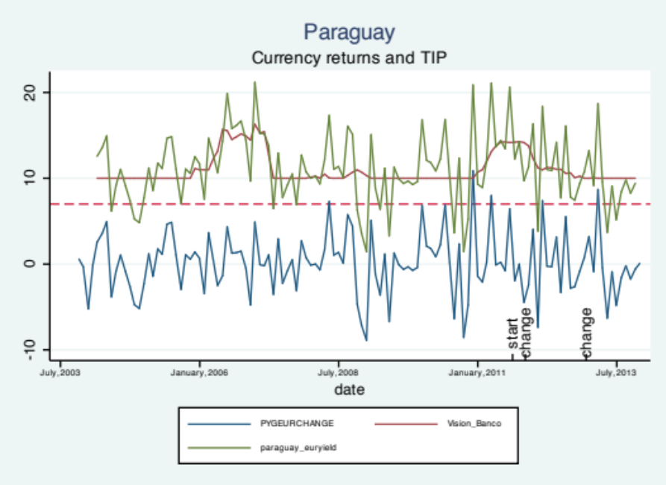
Figure 12 shows the local currency loan issued to a client in Paraguay. A minimum interest rate of 10% was agreed upon. Interestingly, the development of the interest rate shows higher interest rates in the first half of 2011. However, in this period average currency returns were positive. So appreciation of the local currency was accompanied by higher interest rates. This relation actually results in greater volatility of cash flows rather than lower volatility. Ideally, depreciation should be accompanied by higher interest rates and appreciation should be accompanied by lower interest rates and not vice versa.
Figure 13 – Dominican Republic Currency returns and TPPP rate on a local currency loan
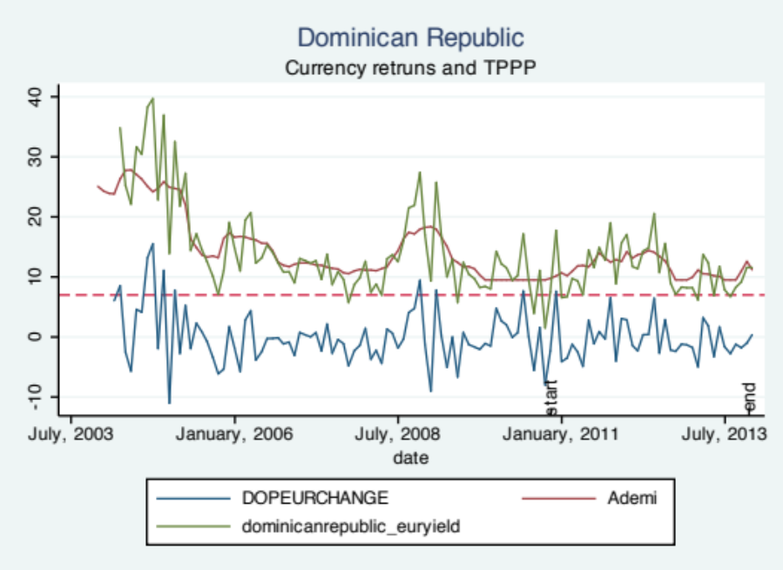
For the client in the Dominican Republic, interest rates were volatile. The broader trend appears to follow changes in the value of the currency. For example, around 2012 the interest rate charged (red line) slightly dropped after two months of relatively high appreciation.
Figure 14 – Guatemala currency returns and Tasa Lider on a local currency loan
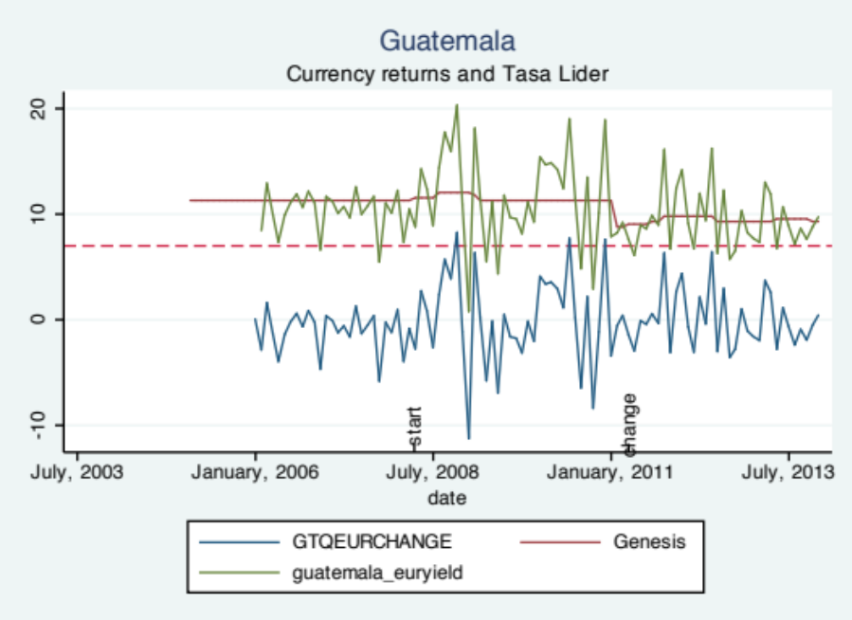
For Guatemala, the picture also shows a relatively stable interest rate which was not met with the same stability in the exchange rate. This again provides evidence that charging local interest rate benchmarks is not a full proof strategy to mitigate currency risk.
Overall the graphic analysis shows that the suitability of linking interest rates to local benchmarks to mitigate currency losses is dependent upon the country and local benchmark. Some local benchmarks are relatively responsive, whereas others remain relatively stable regardless of spot changes. Pricing is thus of key importance for this strategy. Moreover, in Paraguay the data even shows that increasing local interest rates were in some instances accompanied with appreciation.

6.4.2 Actual cash flows
Although the above overview provides a theoretical indication of the success of the strategy, actual returns may differ in practice. This deviation arises since all loan contracts are different. The exact interest rate payment date and maturity schedule can have a large impact on actual currency gains or losses. To get an indication of this difference, the theoretical result is compared to actual cash flows received for a few exemplary cases. The three exemplary cases are KWFT in Kenya, MBK in Indonesia and Genesis in Guatemala. All three loans were outstanding for a relatively long period and are located in different regions.
Table 9 - Kenya KWFT return on LCY loan
Date | Interest received (KES) | Interest % (annual) | KES/EUR | EUR amount
23-dec-09 | 4760765,550 | 12,740 | 111,500 | 40132,977
1-apr-10 | 4607192,470 | 12,329 | 100,662 | 45769,144
28-jun-10 | 4658383,490 | 12,466 | 101,780 | 45769,144
20-sep-10 | 4709574,520 | 12,603 | 104,928 | 44884,039
29-dec-10 | 4709574,520 | 12,603 | 113,300 | 41567,295
1-apr-11 | 4607192,470 | 12,329 | 117,673 | 39152,403
1-jul-11 | 4658383,490 | 12,466 | 130,500 | 35696,426
30-sep-11 | 4900218,100 | 13,113 | 139,350 | 35164,823
30-dec-11 | 5463106,440 | 14,619 | 109,430 | 49923,165
30-mar-12 | 5388960,580 | 14,421 | 110,701 | 48680,151
3-jul-12 | 5388960,580 | 14,421 | 105,960 | 50858,395
4-jan-13 | 4696706,830 | 12,568 | 113,672 | 41318,096
3-apr-13 | 4607192,470 | 12,329 | 105,250 | 43773,800
1-jul-13 | 4607192,470 | 12,329 | 111,610 | 41279,388
3-oct-13 | 4709574,520 | 12,603 | 116,883 | 40293,042
3-jan-14 | 4939024,990 | 13,217 | 119,223 | 41426,777
 | A | Total EUR interest received |  | 685689,064
 | B | EUR principal value now (3 Jan 2014) |  | 1253766,370
 | C | A+B |  | 1939455,434
 | D | EUR principal disbursed on 30 sept 2009 |  | 1266761,017
 | E | Total return = C/D-100% |  | 53,103%
 | F | Total years tenor up to now (3 jan 2014) |  | 4,263
 | G | Return per annum = E/F |  | 12,457%
 |  | KES principal disbursed (30 sept 2009) |  | 149477800,000
 |  | Exchange rate at disbursement (30 sept 2009) |  | 118,000

Table 9 shows that for Kenya a loan total of 149477800 Kenyan Schilling was disbursed (equal to at the time 1266761) Euros. Interest rates are linked to the 91day T-bill with a margin of 4% a minimum of 12,5 and a maximum of 14,5%. So far 685689 of Euros in interest payments has been received. The current EUR value of the KES principle has depreciated slightly to 1253766 Euros. If the principal were to be repaid on January 3, 2014, and the received EUR interest payments are added to the repayment the total return is 53% (equal to 12,457% per annum). The Euro interest amount does fluctuate. However, not as heavily as the KES interest amount. Therefore, the higher interest rates mitigate depreciation. However, it must be noted that the last observed exchange rate of 119 is very close to the exchange rate at the date of disbursement of 118. The exchange rate at the date of repayment has a large effect on the achieved return.
Next, table 10 shows that for MBK Indonesia a loan total of 5000000000 Indonesian Rupiah was disbursed (at the time equal to 298381 Euros). Interest rates are linked to the 6month JIBOR with a margin of 5% and a minimum interest rate of 12%. So far 137932 EUR of interest payments have been received. The current EUR value of the IDR principle has appreciated to 316997 Euros. If the principal were to be repaid after the most recent interest date of 9 October 2013 and the EUR interest payments are added, the total return is 52% (equal to 18,886% per annum). In most months, the minimum interest rate of 12% has been charged. This is understandable since there has been general appreciation of the local currency rather than depreciation.
Table 10 – Indonesia MBK return on a LCY loan
Date | Interest received | Interest% | IDR/EUR | EUR received
29-dec-10 | 72328767,120 | 12,399 | . | 6039,980
6-jun-11 | 297534246,580 | 11,901 | 12400,845 | 23993,063
30-sep-11 | 155719452,050 | 12,458 | 10589,846 | 14704,600
28-dec-11 | 151232876,710 | 12,099 | 12040,000 | 12560,870
29-jun-12 | 298360655,740 | 11,934 | 11707,893 | 25483,720
28-dec-12 | 301639344,260 | 12,066 | 12969,998 | 23256,700
2-jul-13 | 297534246,580 | 11,901 | 13338,998 | 22305,593
9-oct-13 | 151232876,710 | 12,099 | 15772,977 | 9588,100
 | A | Total EUR interest received |  | 137932,625
 | B | EUR principal value now (9 okt 2013) |  | 316997,871
 | C | A+B |  | 454930,497
 | D | EUR principal disbursed on disbursement date |  | 298381,092
 | E | Total return = C/D-100% |  | 52,466%
 | F | Total years tenor up to now (2013) |  | 2,778
 | G | Return per annum = E/F |  | 18,886%
 |  | IDR principal disbursed |  | 5000000000,000
 |  | Exchange rate at disbursement |  | 16757,094

Lastly, for Genesis in Guatemala two loans were disbursed (see table 11). The first loan was disbursed on the 24th of April 2008 with a total of 11900000 Guatemalen Quetzal (GTQ) (at the time equal to 1104178 euros). Interest rates are linked to the Tasa de Interes Lider with a margin of 4.8% and a minimum of 11.3% for the first loan. The second loan was also linked to the Tasa de Interes Lider, however, with a margin of 4.3% and a minimum of 8.8%. The first loan has accumulated interest payments worth 359102 euros. Moreover, the GTQ principal has been repaid at April 4, 2011. At the time of repayment, the GTQ principal had depreciated slightly to 1082846 Euros. The total return on the loan is 30% (equal to 10,197% per annum).

Table 11 – Guatemala Genesis return LCY loan
date | GTQ received | Interest % | GTQ EUR | EUR received
27-jun-08 | 251606,97 | 12,68606571 | 11,929 | 21092,04
05-jan-08 | 690980,33 | 11,61311479 | 11,288 | 61213,61
01-jul-09 | 711082,05 | 11,95095882 | 11,527 | 61690,6
31-dec-09 | 677876,16 | 11,39287664 | 12,246 | 55356,71
29-jun-10 | 666823,84 | 11,20712336 | 10,058 | 66301,09
03-jan-11 | 677876,16 | 11,39287664 | 10,713 | 63276,61
04-apr-11 | 11.900.000,00 | REPAYMENT | 10,990 | 1082846,883
04-apr-11 | 331.569,86 | 11,14520538 | 10,990 | 30171,37725
03-jan-12 | 907554,79 | 9,470136939 | 10,459 | 86770,54
06-jul-12 | 1115122,95 | 9,696721304 | 10,119 | 110205,76
31-dec-12 | 1070819,67 | 9,311475391 | 9,8337 | 108892,8552
28-jun-13 | 1055006,85 | 9,173972609 | 9,8337 | 107284,8318
24-dec-13 | 1101479,45 | 9,578082174 | 9,8337 | 112010,6827
 | First loan
 | A | Total EUR interest received |  | 359102,037
 | B | EUR principal at repayment (4 april 2011) |  | 1082846,883
 | C | A+B |  | 1441948,920
 | D | EUR principal disbursed on disbursement date 24 april 2008 |  | 1104178,806
 | E | Total return = C/D-100% |  | 30,590%
 | F | Total years tenor up to repayment at 4 april 2011 |  | 3,000
 | G | Return per annum = E/F |  | 10,197%
 |  | GTQ principal disbursed |  | 11900000,000
 |  | Exchange rate at disbursement |  | 10,777
 | Second loan
 | A | Total EUR interest received |  | 555336,047
 | B | EUR principal at 24 dec 2013 |  | 2338895,838
 | C | A+B |  | 2894231,885
 | D | EUR principal disbursed on disbursement date 15 July 2011 |  | 2134127,105
 | E | Total return = C/D-100% |  | 35,617%
 | F | Total years tenor up to 24 dec 2013 |  | 2,523
 | G | Return per annum = E/F |  | 14,115%
 |  | GTQ principal disbursed |  | 23000000,000
 |  | Exchange rate at disbursement |  | 10,777

The second loan to the same client involved the disbursement of 23000000 GTQ on July 15, 2011 (equal to 2134127 Euros at disbursement). Interest rates are linked to the 6-month JIBOR with a margin of 4,3% and a minimum interest rate of 8.8%. So far the total EUR amount of interest received amounts to 555336 Euros. The value of the GTQ principal at the last interest payment date (24 December 2013) appreciated to 2338895 Euros. Therefore, if the principal was paid after the last interest date and the EUR interest was added, the total return is 35%, which equals 14% per annum. The appreciation of the GTQ with respect to the EUR increased the return achieved on the investment.
The three case studies show that on average relatively high returns have been achieved on the loans linked to variable interest rate benchmarks. However, it is impossible to tell what will happen to local interest rates in case of extreme depreciation, since two loans had appreciation and one only had minor depreciation. Lastly, the interest rate currency relation is tested empirically.

6.4.3 Empirical relationship
In order to allow generalizations on the interest rate-currency relationship, the relation is tested empirically. In section 6.1, table 3 already reports whether excess returns are significantly greater than zero. This t-test is sometimes also referred to as the unconditional test of UIP (Gilmore and Hayashi, 2008). The unconditional UIP holds for most currencies, except for Colombia, Uruguay, Sri Lanka, Azerbaijan, Georgia and Moldova, where there are positive excess returns.
The conditional Uncovered Interest Rate Parity (UIP) can be tested empirically by regressing the rate of change of the spot exchange rate on the interest rate differential (or carry). The UIP would imply that a positive interest rate differential would lead to depreciation of the local currency. See equation 5:
$E_{t}\left(\log\left(S_{t+1}\right)\right)=log⁡(F_{t})$ (equation 5)
Where the forward premium at time t can be estimated by the interest rate differential (local monthly interest rate – 3month Libor at time t).
Table 12 shows that the carry only predicts the change in the LCY-EUR spot rate in the next period for a few currencies. The insignificant result for the effect of the carry for most currencies is in line with the study of Gilmore and Hayashi (2008). For the Kazakhstani Tenge and the Kyrgyzstani Som the beta coefficient is significant at the 1% level and has a negative sign. This is in line with Purchasing Power Theory that states that a greater interest differential leads to depreciation in the next period. The reverse relationship is found for the Dominican Peso and the Kenyan Shilling for which higher interest rate differentials predict appreciation of the local currency, this phenomenon is named the Forward premium puzzle. In conclusion, the interest rate differentials is not enough to predict future spot changes, since the effect of the carry was insignificant in all currencies, except four. The countries where the Forward Premium Puzzle holds (Kenya, Dominican Republic) do not lend themselves for a strategy of linking loan interest rates to mitigate losses in the spot rate.

Table 12 – Excess Returns ${ER}_{t+1}=α+β*{carry}_{t}+ε_{t}$
Currency | Obs | α | STD Error | β | Std. Error | R2
ARS (Argentine Peso) | 113 | -0.205 | 0.596 | -0.547 | 0.709 | 0.0053
BOB (Bolivian Boliviano) | 117 | -0.014 | 0.318 | -0.158 | 1.987 | 0.0001
COP (Colombian Peso) | 120 | 0.356 | 1.012 | -0.467 | 3.147 | 0.0002
DOP (Dominican Peso) | 118 | -1.982*** | 0.684 | 3.741*** | 1.041 | 0.1003
SVC (Salvadoran Colon) | 90 | -0.003 | 0.409 | -0.737 | 2.360 | 0.0011
GTQ (Guatemalan Quetzal) | 96 | -0.469 | 0.556 | 1.290 | 1.991 | 0.0044
HNL (Honduran Lempira) | 60 | -0.675 | 1.340 | 1.340 | 3.481 | 0.0025
NIO (Nicaraguan Cordoba) | 71 | -0.014 | 0.614 | -3.08 | 4.078 | 0.0082
PYG (Paraguayan Guarani) | 110 | 0.111 | 0.374 | -0.048 | 1.180 | 0.0000
PEN (Peruvian Nuevo Sol) | 120 | 0.171 | 0.362 | -0.642 | 1.595 | 0.0014
UYU (Uruguayan Peso) | 120 | 0.043 | 0.526 | 0.358 | 0.835 | 0.0016
AOA (Angolan Kwanza) | 118 | -0.342 | 0.490 | 0.239 | 0.862 | 0.0007
XOF (CFA Frank) | 117 | 0.347 | 0.654 | -1.700 | 4.130 | 0.0015
GHS (Ghanaian Cedi) | 116 | -0.862 | 0.683 | 0.018 | 0.586 | 0.0000
JOD (Jordanian Dinar) | 99 | 0.096 | 0.710 | -0.782 | 2.488 | 0.0010
KES (Kenyan Shilling) | 120 | -0.936 | 0.424 | 1.822** | 0.748 | 0.0478
MGA (Malagasy Ariary) | 106 | -0.354 | 0.620 | 1.99 | 0.788 | 0.0006
MWK (Malawian Kwacha) | 120 | -1.573* | 0.936 | 0.289 | 0.683 | 0.0015
NGN (Nigerian Naira) | 118 | -0.337 | 0.583 | 0.112 | 0.950 | 0.0001
TZS (Tanzanian Shilling) | 116 | -0.550 | 0.666 | 0.173 | 1.132 | 0.0002
UGX (Ugandan Shilling) | 120 | -0.964 | 0.737 | 0.959 | 0.971 | 0.0082
ZAR (South African Rand) | 120 | -1.792 | 1.267 | 3.310 | 3.080 | 0.0097
ZMW (Zambian Kwacha) | 119 | -1.069 | 1.092 | 1.136 | 1.342 | 0.0061
KHR (Cambodian Riel) | 111 | -0.102 | 0.389 | 0.466 | 1.944 | 0.0005
IDR (Indonesian Rupiah) | 70 | -1.094 | 1.570 | 1.892 | 3.371 | 0.0046
MNT (Mongolian Tughrik) | 80 | 0.024 | 1.243 | -0.707 | 1.467 | 0.0030
PHP (Philippine Peso) | 121 | -0.303 | 0.779 | 0.931 | 1.872 | 0.0021
VND (Vietnamese Dong) | 121 | -1.129* | 0.604 | 1.348 | 0.941 | 0.0169
BDT (Bangladeshi Taki) | 109 | -0.577 | 0.467 | 1.067 | 1.118 | 0.0084
INR (Indian Rupee) | 121 | -0.059 | 0.457 | -0.899 | 1.007 | 0.0067
PKR (Pakistani Rupee) | 121 | -0.934* | 0.495 | 0.477 | 0.704 | 0.0038
LKR (Sri Lankan Rupee) | 121 | -0.510 | 0.922 | 0.139 | 1.095 | 0.0001
AZN (Azerbaijani New Manat) | 118 | -0.510 | 0.625 | 1.908 | 1.696 | 0.0108
BAM (Bosnian Convertible Marka) | 98 | -0.000 | 0.097 | -0.036 | 0.532 | 0.0000
GEL (Georgian Lari) | 118 | 0.181 | 0.750 | -0.130 | 1.184 | 0.0001
KZT (Kazakhstani Tenge) | 117 | 1.182** | 0.472 | -4.796*** | 1.244 | 0.1144
KGS (Kyrgyzstani Som) | 117 | 0.690 | 0.423 | -3.142*** | 1.115 | 0.0646
MDL (Moldovan Leu) | 121 | -0.212 | 0.564 | 0.199 | 0.905 | 0.0004
TJS (Tajikistani Somoni) | 94 | -1.020 | 1.138 | 0.945 | 2.147 | 0.0021
The base currency is the Euro. An OLS regression is estimated with monthly data. The stars indicate significance, *=significant at 10%, **=5%, *=1%.
In conclusion, the relationship between local interest rates and spot changes appears to be highly currency specific. Past performance of local interest rate loans in the portfolio has shown relatively high returns, however, losses under extreme depreciation are difficult to predict. Empirically, interest rate differentials do not explain spot changes. This indicates that other factors besides interest rate differentials drive spot changes to the largest extent. For Kenya and the Dominican Republic the reverse relationship is found. For Kazakhstan and Kyrgyzstan, linking local interest rates to manage spot changes appears recommendable. Therefore hypothesis 4, can be accepted in part only, since the relationship only holds for certain currencies.
7.0 CONCLUSIONS AND DISCUSSION
This research was intended to retrieve additional insights into the behavior of EM currencies and strategies to manage EM currency risk. The academic literature has widely discussed currency risk and management of currency risk for DM currencies, but not for EM currencies. However, EM currencies tend to be more volatile and more difficult to predict exchange rate movements for. Additionally, fewer strategies to manage currency risk are available for EM currencies. This is in part caused by the limited diversification benefits and the absence of low cost financial currency derivatives. Therefore, one could argue the need for EM currency risk management is higher. Establishing additional EM currency management strategies also bears societal relevance. Currency risk mitigation possibilities could increase possibilities of (fair priced) local currency finance to EM markets.
The results show that most EM currencies are fairly volatile and show a depreciating trend with regard to the Euro. In most (but not all) cases this depreciation in spot returns is compensated for by a positive interest rate differential. Therefore, LCY exposure does require active management.
Secondly, limited diversification benefits are present. LCY debt portfolio’s can be formed with a lower standard deviation than of the different currencies. However, there also is a large share in common variation in both spot and excess returns of the EM currencies, illustrated by the PCA analysis. Therefore, relying on diversification benefits and generating a portfolio with open positions in EM currencies is not an advisable strategy.
Thirdly, spot exchange rate changes in LCY-EUR rates are highly correlated with USD-EUR spot changes. This does however not imply that proxy hedging with USD-EUR forwards can mitigate LCY-EUR currency risk. Even though the variation in LCY-EUR spot changes is explained well by changes in LCY-EUR rate, many LCY spots experience a significant and negative drift in its local exchange rate. This negative drift cannot be hedged with a USD-EUR forward. Therefore, hedging LCY-EUR exposure with USD-EUR forwards is also not recommended.
Lastly, the relation of local short term interest rate benchmarks and depreciation is investigated. Analysis on past loans shows that the strategy of linking loan rates to local interest rate benchmarks has worked rather well. However, none of the analyzed cases showed extreme depreciation of the spot rate. Furthermore, results of the empirical analysis of interest rate differentials and spot changes are alarming. The empirical results show that the conditional interest rate parity only holds for two currencies (Kazakhstani Tenge and Kyrgyzstani Som). This means that the interest rate differential does not significantly predict spot changes in the following month for the other currencies. For the Domincan Peso and the Kenyan Shilling the forward premium was detected empirically. This means that higher interest rate differentials are associated with appreciation of the local currency. This finding is dangerous under depreciation of the local currency. The recommendation of the strategy of linking loan rates to local benchmarks is therefore country specific.
On a final note, the PCA analysis revealed that there is a rather large share of shared variance among the local currency excess returns. It would be interesting to determine the common cause of variation in these excess returns in further research.

8.0 REFERENCES
Abrams, J. (2011). Risky Business – An empirical analysis of foreign exchange risk exposure in microfinance. Retrieved November 13, 2013 from MFX website: http://www.mfxsolutions.com/educationcenter/
Berk, J., and Demarzo, P. (2013). Corporate finance the core. Pearson Education (3rd ed).
Berrospide, J. (2008). Exchanges rates, optimal debt composition, and hedging in small open economies. Finance and Economics Discussion Series 2008-18 Retrieved October 1, 2013 from The Federal Reserve Board website: http://www.federalreserve.gov/pubs/feds/2008/200818/200818pap.pdf
Broner, F., Didier, T., Erce, A., Schmukler, S.L. (2013). Gross capital flows: dynamics and crises. Journal of Monetary Economics, 60, pp. 113-133.
Broner, F.A., and Rigobon, R. (2005). Why are capital flows so much more volatile in emerging than in developed countries? Central Bank of Chile, Working Papers Central Bank of Chile 328.
Busarakamwong, J., Loong Ng, Y., and Stamenovic, I. (2004). A framework for assessing the diversification benefits of additional securities on portfolio risk. Retrieved January 3, 2013 from Kellogg School of Management website: http://www.kellogg.northwestern.edu/research/fimrc/papers/framework_for_assessing.pdf
Carlson, J.A., Dahl, C.M., and Osler, C.L. (2008). Short-run exchange-rate dynamics: theory and evidence. Retrieved November 8, 2013 from Brandeis University website: http://www.brandeis.edu/departments/economics/RePEc/brd/doc/Brandeis_WP39.pdf
Catão, L.A.V.(2007). Why real exchange rates?, Finance & Development, 44(3), pp. 46-47.
Chen, J. (n.d.). To hedge or not to hedge? Retrieved October 4, 2013 from JP Morgan website: http://www.jpmorgan.com/tss/General/To_Hedge_or_Not_to_Hedge_/1312755547007
Chen, W., Kritzman, M., and Turkington, D. (2013). Which currency hedging strategy is best? MIT School of Management, MIT Sloan School Working Paper 5003-13.
Churchill, C., and Coster, D. (2001). Microfinance risk management handbook. Retrieved October 1, 2013 from Triling Global website: http://kb.trilincanalytics.com/upload/f5/f546502afcea3e5.pdf
Clark, P., Tamirisa, N., and Wei, S-J. (2004). Exchange rate volatility and trade flows – some new evidence. Retrieved November 7, 2013 from International Monetary Fund website: http://www.imf.org/external/np/res/exrate/2004/eng/051904.pdf
Cleveland, T. (2011). Emerging markets seem attractive, but forex risks abound. Retrieved September 24, 2013 from Business Insider website: http://www.businessinsider.com/emerging-markets-seem-attractive-but-forex-risks-abound-2011-1
CMSFOREX. (2013). Online Forex Course. Retrieved November 5, 2013 from CMSFOREX website: http://www.cmsfx.com/en/forex-education/online-forex-course/chapter-1-forex-basics/introduction-to-forex-exchange/
Crabb, P.R. (2004). Foreign exchange risk: management practices of microfinance institutions. Journal of Microfinance, 6(2), pp.51-63.
Damodaran, A. (n.d.). Risk management: profiling and hedging. Retrieved November 11, 2013 from the New York University website: http://people.stern.nyu.edu/adamodar/pdfiles/papers/hedging.pdf
De Kiewit Treasurer Search. (n.d.). The value of good treasury 4 ‘proxy hedging’ emerging market currencies. Retrieved November 8, 2013 from De Kiewit Treasurer Search website: http://www.treasurersearch.com/nieuws/artikel_the_value_of_good_treasury_4_%E2%80%98proxy_hedging%E2%80%99_emerging_market_currencies_20267.html
Diamantini, S. (2010). A primer on currency risk management for microfinance institutions. Retrieved September 25, 2013 from JP Morgan Chase & Co website: http://www.jpmorganchase.com/corporate/socialfinance/document/MFI_FX.pdf
Dodd, R., and Spiegel, S. (2004). Up from sin: a portfolio approach to financial salvation. Washington, D.C.: Financial Policy Forum.
Domowitz, I., Glen, J., and Madhaven, A. (1998). Country and currency risk premia in an emerging market. The Journal of Financial and Quantitative Analysis, 33(2), pp. 189-216.
First National Bank. (n.d.). Emerging markets: hedging FX risk. Retrieved October 1, 2013 from First National Bank website: http://www.fnbglobal.com/gb/html/en/site/assets/documents/recent_documents/emerging_markets.pdf
Featherston, S., Littlefield, E., and Mwangi, P. (2006). Foreign exchange rate risk in microfinance: what is it and how can it be managed? Retrieved October 9, 2013 from CGAP website: http://www.cgap.org/sites/default/files/CGAP-Focus-Note-Foreign-Exchange-Rate-Risk-in-Microfinance-What-Is-It-and-How-Can-It-Be-Managed-Jan-2006.pdf
Fong Chan, K., Powell, J.G., and Treepongkaruna, S. (2012). Currency jumps and crisis: Do developed and emerging market currencies move together? Retrieved September 24, 2013 from National Centre for Econometric Research website: http://www.ncer.edu.au/events/documents/Kam%20Fong%20Chan%20Currency%20Jumps%20and%20Crises%20Do%20Developed%20and%20Emerging%20Market%20Currencies%20Jump%20Together.pdf
Frankel, J.A., and Rose, A.K. (1996). Currency crashes in emerging markets: empirical indicators. National Bureau of Economic Research, Working Paper 5437.
Fratzscher, M. (2009). What explains global exchange rate movements during the financial crisis? European Central Bank, Working Paper Series NO 1060.
Giddy, I.H. (n.d.). The corporate hedging process. Retrieved October 4, 2013 from New York University website: http://people.stern.nyu.edu/igiddy/corphdg.htm
Giddy, I.H., and Dufey, G. (n.d.). The management of foreign exchange risk. Retrieved October 7, 2013 from the New York University website: http://people.stern.nyu.edu/igiddy/fxrisk.htm
Hedging emerging market currency risk. (2013). Retrieved September 24, 2013 from World Finance website: http://www.worldfinance.com/markets/hedging-emerging-market-currency-risk
Holden, P., and Holden, S. (2004). Foreign exchange risk and microfinance institutions. Retrieved November 14, 2013 from the Microfinance Gateway website: http://www.spanish.microfinancegateway.org/files/23345_file_23345.pdf
Eurasia group. (2013). Top risks 2013. Retrieved November 6, 2013 from Eurasia group website: http://www.eurasiagroup.net/pages/top-risks-2013
Hakura, D.S. (2007). Output volatility and large output drops in emerging market and developing countries. International Monetary Fund, IMF Working Paper 07/114.
Hull, J. (2012). Options, futures and other derivatives. Essex: Pearson.
Ickes, B.W. (2006). The foreign exchange market. Retrieved September 30, 2013 from Penn State Department of Economics website: http://econ.la.psu.edu/~bickes/forex.pdf
Edwards, S., and Svastano, M.A. (1999). Exchange rates in emerging economies: what do we know? What do we need to know? National Bureau of Economic Research, NBER Working Paper 7228.
International Monetary Fund. (2012). Annual report on exchange arrangements and exchange restrictions 2012. International Monetary Fund, October 2012.
Gilmore, S., and Hayashi, F. (2008). Emerging market currency excess returns. National Bureau of Economic Research, Working Paper 14528.
Habermeier, K., Kokenyne, A., Veyrune, R., and Anderson, H. (2009). Revised system for the classification of exchange rate arrangements. International Monetary Fund, IMF Working Paper 09/211.
Introduction to hedging emerging markets currency risk. (n.d.). Retrieved November 13, 2013 from New York University website: http://www.google.nl/url?sa=t&rct=j&q=&esrc=s&frm=1&source=web&cd=1&ved=0CDMQFjAA&url=http%3A%2F%2Fwww.stern.nyu.edu%2F~msiegel%2Fintrotohed.doc&ei=OJCDUqqiJsWg7Aaco4FA&usg=AFQjCNFoVP7OqbbWvNU_Oj3eIzD3TCO-sQ&bvm=bv.56343320,d.bGE
Jagerson, J., and Hansen, S.W. (2011). All about forex trading. McGraw Hill Education.
Janakiramanan, S. (2011). Derivatives and risk management. Pearson Education.
Jorion, P. (2003). Financial risk manager handbook. John Wiley and Sons (2nd ed). NJ: Hoboken.
Kim, D. (2011). Is currency hedging necessary for emerging market equity investment? Retrieved September 23, 2013 from Social Science Research Network website: http://papers.ssrn.com/sol3/papers.cfm?abstract_id=2005676
Kumar, N., and Kumar, J. (2009). Risk management for microfinance institutions toolkit. Retrieved October 1, 2013 from MicroSave website: http://www.microsave.net/files/pdf/Risk_Management_Overview.pdf
Levich, R.M. (2001). International financial markets. McGraw-Hill/Irwin (2nd ed).
Matthӓus-maier, I., and von Pischke, J.D. (2007). Microfinance Funds: leveraging private capital for economic growth and poverty reduction. Springer.
Maziad, S., Farahmand, P, Wang, S., Segal, S., and Ahmed, F. (2011). Internationalization of emerging market currencies: a balance between risks and rewards. International Monetary Fund, IMF Staff Discussion Notes 11/17.
Mc Nelly, D., and Murray, E. (2010). Strategic currency hedging in emerging markets. Journal of Investment Strategy, May issue.
Meridian Finance Group. (n.d.). Political risk insurance. Retrieved November 11, 2013 from Meridian Finance Group website: http://www.meridianfinance.com/political_risk.html
MFX.(2013). About MFX. Retrieved January 8, 2013 from MFX website: http://mfxsolutions.com/about/
MFX Microfinance Currency Risk Solutions. (n.d. a). MFX summary on FX risk in microfinance. Retrieved October 8, 2013 from MFX website: http://www.mfxsolutions.com/educationcenter/
MFX Microfinance Currency Risk Solutions. (n.d. b) Understanding non-derivative alternatives for mitigating FX risk. Retrieved October 8, 2013 from MFX website: http://www.mfxsolutions.com/educationcenter/
Mihaljek, D., and Packer, F. (2010). Derivatives in emerging markets. Bank for International Settlements, BIS Quarterly Review December 2010.
Miyajima, K. (2013). Foreign exchange intervention and expectation in emerging economies. Bank for International Settlements, BIS Working Papers No 414.
Murray, E. (2011). Strategic currency hedging in emerging markets. Retrieved February 12, 2014 from FX week website: http://www.fxweek.com/fx-week/opinion/2131286/strategic-currency-hedging-emerging-markets
Ostro, N. (1997). Hedging emerging market currencies. Retrieved November 14, 2013 from Derivatives Strategy website: http://www.derivativesstrategy.com/magazine/archive/1997/0697fea2.asp
Papaioannou, M. (2006). Exchange rate risk measurement and management: issues and approaches for firms. International Monetary Fund, IMF Working Paper 06/255.
PWC and Knowledge@Wharton. (2013). Currency hedging: The risks and benefits aren’t limited to financial issues. Retrieved September 29, 2013 from PWC website: http://www.pwc.com/us/en/audit-assurance-services/accounting-advisory/publications/pwc-wharton-currency-hedging-risks-benefits.jhtml
Reilly, F., Brown, K. (2003). Investment analysis and portfolio management. South-Western/Thomson Learning (7th ed).
Richards, S., Aller, E., and Brown, P. (2007). Solution for hedging foreign exchange risk in microfinance investment: the case for a private sector-philanthropic community partnership. Financial Times.
Schnatz, B. (1998). Macroeconomic determinants of currency turbulences in emerging markets. Economic Research Group of the Deutsche Bundesbank, Discussion paper 3/98.
Schneider-Moretto, L. (2005). Tool for developing a financial risk management policy. Women’s World Banking, Financial Management Series.
Shalifay. (2013). Investor’s list: countries with fixed currency exchange rates. Retrieved October 25, 2013 from Investment Frontier website: http://www.investmentfrontier.com/2013/02/19/investors-list-countries-with-fixed-currency-exchange-rates/
Soler Ramos, J.A., Staking, K.B., Ayuso Calle, A., Beato, P., Botín O’Shea, E. Escrig Meliá, M., and Falero Carrasco, B. (2000). Financial risk management - A practical approach for emerging markets. Inter-American Development Bank. Washington, DC: John Hopkins University Press.
Stata (n.d.). Stata manual PCA, Retrieved January 24, 2013 from http://www.stata.com/manuals13/mvpca.pdf
Stone, M., Anderson, H., and Veyrune, R. (2008). Exchange rate regimes: fix or float. Finance and Development A Quarterly Magazine of the IMF, 45(1).
Sullivan, M.A. (1996). Currency risks in emerging market investments. Managerial Finance, 22(12), pp. 54-62.
Sundaram, R.K. (2013). Derivatives in financial market development. International Growth Centre, Working Paper February 2013.
Taylor, J.B. (2000). Using monetary policy rules in emerging market economies. Retrieved October 14, 2013 from Stanford University website: http://www.stanford.edu/~johntayl/Onlinepaperscombinedbyyear/2001/Using_Monetary_Policy_Rules_in_Emerging_Market_Economies.pdf
University of Virginia Darden School of Business. (n.d.). Hedging with forwards and futures. Retrieved January 20, 2013 from University of Virginia Darden School of Business website: http://faculty.darden.virginia.edu/conroyb/derivatives/Hedging%20with%20Forwards%20and%20Futures.pdf
Van Greuning, H., and Bratanovic, S.J. (2009). Analyzing Banking Risk: A Framework for Assessing Corporate Governance and Risk Management. Washington, DC: The World Bank (3rd ed).
Western Union. (n.d.). Understand your risk exposure in the currency market. Retrieved November 6, 2013 from Western Union website: http://onlinefx.westernunion.com/personal/learning-center/foreign-exchange-(fx-101)/understand-your-risk-exposure-in-the-currency-market/
Women’s World Banking. (2004). Foreign exchange risk management in microfinance. Retrieved November 14, 2013 from Women’s World Banking website: http://www.womensworldbanking.org/wp-content/uploads/imported/pdf/english/foreign_exchange_risk_management_in_microfinance_e.pdf
XE. (n.d.). Currency encyclopedia. Retrieved November 25, 2013 from XE website: http://www.xe.com/currency/
Zambia Daily Mail. (2013). Diversify economy to agriculture. Retrieved December 1, 2013 from Zambia Daily Mail website: http://daily-mail.co.zm/blog/2013/04/17/diversify-economy-to-agriculture/

APPENDIX 1 - ACRONYMS

DFI: Development Finance Institutions (often investors in the markets or institutions in which TIM invests)
CIP: Covered Interest Rate Parity
DM: Developed Markets
EM: Emerging Markets
FX: Foreign Exchange
HTF: Hivos-Triodos fund
LCY: Local currency
MFI: Microfinance Institution
MIV: Microfinance Investment Vehicle
NDF: non-deliverable-forward
OTC: over-the-counter
PCA: Principal Component Analysis
PPP: Purchasing Power Parity
TFSF: Triodos Fair Share Fund
TMF: Triodos Microfinance Fund
TSFF: Triodos Sustainable Finance Foundation
UIP: Uncovered Interest Rate Parity

APPENDIX 2 – CLASSIFICATIONS EXCHANGE RATE REGIME

- Hard pegs
Exchange arrangement with no separate legal tender: For this classification the exchange rate arrangement is confirmed by the country authorities’ de jure. There is one country which serves as the sole legal tender. The implication of this exchange rate regime is that authorities do not have control over domestic monetary policy anymore.
Currency board arrangement: This classification is also concerned with the de jure exchange rate arrangement of a country. “A currency board arrangement is a monetary arrangement based on an explicit legislative commitment to exchange domestic currency for a specified foreign currency at a fixed exchange rate, combined with restrictions on the issuing authority to ensure the fulfillment of its legal obligation”(International Monetary Fund, 2012; p. 11). Domestic currency is therefore always backed by foreign assets and only issued against foreign exchange. The adaptation of this system limits possibilities for monetary policy.
- Soft pegs
Conventional pegged arrangement: under this regime the currency of the country is formally pegged to another currency or basket of currencies at a fixed rate. The anchor currency must be publicly known. The parity is realized through intervention by authorities. To qualify as a conventional pegged arrangement the formal arrangement must be confirmed empirically. This means that either the exchange rate fluctuates around the central rate with a margin of less than 1%. Or the spot market exchange rate must remain in a band width of 2% for at least six months.
Stabilized arrangement: A stabilized arrangement does not require a formal peg, but is based on statistical criteria which are met after official action (intervention). The statistical criteria are: a maximum margin of 2% for movements of spot market exchange rates for a period of minimally six months, where spot market exchange rates are not floating.
Crawling peg: “classification involves the confirmation of the country authorities’ de jure exchange rate arrangement. The currency is adjusted in small amounts at a fixed rate or in response to changes in selected quantitative indicators, such as past inflation differentials vis-à-vis major trading partners or differentials between the inflation target and expected inflation in major trading partners” (International Monetary Fund, 2012; p. 13). The crawl rate can be either backward looking or forward looking. The conditions of the arrangement must be public.
Crawl-like arrangement: when the exchange rate regime does not qualify as floating and the exchange rate stays within a margin of 2% compared to a statistically identified trend, for a period of at least 6 months, the regime can be classified as crawl-like. The regime will be classified as crawl-like when annual rates of changes are at least 1% and the exchange rate adjusts in a continuous and monotone manner.
- Floating arrangements
Floating: under the floating exchange arrangement the exchange rate is in most part determined by market forces. Therefore, the exchange rate is difficult to predict. There may be some intervention by local authorities in the exchange rate in response to large fluctuations. However, these interventions do not serve the purpose of targeting a specific level of the exchange rate. Also, stability of floating exchange rates may be high with low exchange rate movements consistent with movements under soft pegs. The classification in this case depends on whether the stability was a result of official actions or not.
- Residual
Other managed arrangement: when the exchange rate regime does not correspond with any of the other categories it is labelled as other managed arrangement. Exchange arrangements which often have change in policies can be under this category.

APPENDIX 3 – Interest rate benchmarks
Country | Benchmark used | TCX benchmark | Source
Argentina (AR) | 180 day BAIBOR Buenos Aires Interbank Offer Rate | 180 day BAIBOR Buenos Aires Interbank Offer Rate | Datastream
Bolivia (BO) | 3m treasury bill | 6m Treasury bill | Bloomberg
Colombia (CO) | 180 day DTF | 180 day DTF | Bloomberg
Dominican Republic (DO) | 3-month TPPP | 3-month TPPP | Datastream
Ecuador (EC) | short term deposit rate | Short term deposit rate | Datastream
Guatemala (GU) | Tasa Lider (Leading monetary interest rate) | 6m TPPP | Bloomberg
Honduras (HO) | Policy rate | 6-month T-bills | Datastream
Nicaragua (NI) | deposit rate | No floating benchmark available | Datastream
Paraguay (PY) | TIP | 365 CDA
Peru (PE) | 6m limabor | 6m Limabor | Datastream
El Salvador (SV) | deposit rate | No floating benchmark available | Datastream
Uruguay (UY) | T-bill | ITLUP | Datastream
Angola (AO) | deposit rate | 6-month T-bill* | Datastream
Benin (BJ) | Money market rate | No floating benchmark available | Datastream
Ghana (GH) | 6-month T-bill | 6-month T-bill | Central Bank Ghana
Jordan (JO) | 6-month JODIBOR | 6-month JODIBOR | Datastream
Kenya (KE) | 6-month T-bill | 6-month T-bill | Central Bank Kenya
Madagascar (MG) | 6-month T-bill | 6-month T-bill | Central Bank Madagascar
Malawi (MW) | 6-month T-bill | 6-month T-bill | Bloomberg
Nigeria (NG) | Average T-bill rate | 6-month T-bill** | Datastream
Senegal (SN) | . | No floating benchmark available | -
Tanzania (TZ) | 3-month T-bill | 182-day T-bill*** | Datastream
Uganda (UG) | 182-day T-bill | 182-day T-bill | Datastream
South Africa (ZA) | 6-month jibar | 6-month jibar | Datastream
Zambia (ZM) | 182-day T-bill | 182-day T-bill | Datastream
Cambodia (KH) | deposit rate | No floating benchmark available | Datastream
Indonesia (ID) | 6-month JIBOR | 6-month JIBOR | Central Bank Indonesia
Laos (LA) | - | No floating benchmark available | -
Mongolia (MN) | 6-month UBIBOR | 6-month UBIBOR | Central bank
The Philippines (PH) | 6-month reference rate | 6-month reference rate | Datastream
Vietnam (VN) | 6-month VNIBOR | 6-month VNIBOR | Datastream
Bangladesh (BD) | 3-month T-bill | 182-day T-bill | Datastream
India (IN) | 3-month MIFOR | 3-month MIFOR | Datastream
Pakistan (PK) | 6-month KIBOR | 6-month KIBOR | Datastream
Sri Lanka (LK) | 6-month SlIBOR | 6-month SLIBOR | Datastream
Azerbaijan (AZ) | refinancing rate | no floating benchmark available | Datastream
Bosnia Herzegovina (BA) | deposit rate | no floating benchmark available | Datastream
Georgia (GS) | deposit rate | 6-month certificate of deposit | Datastream
Kazakhstan (KZ) | 3-month KZIBOR | 3-month KZIBOR | Datastream
Kyrgyzstan (KG) | 3-month NBKR rate | no floating benchmark available | Central Bank Kyrgyzstan
Moldova (MD) | Interbank rate | 6m to 12m total deposits | Datastream
Tajikistan (TJ) | deposit rate | No floating benchmark available | Datastream
*Angola 6m treasury bills are only available on Bloomberg from 2005-2009 therefore another benchmark is chosen
**Nigeria 6m treasury bills are only available on Bloomberg For 2007-mid 20013, therefore the average T-bill rate from Datastream is preferred
** Tanzania 6m Treasury bills are only available on Bloomberg for 2008 – mid 2013, therefore the 3-month T-bill is preferred

For an overview of all abbreviations used in this paper, see appendix 1.
F = forward price, S = spot price
Instead of local banks MFIs can also be: NGOs, NBFIs, and cooperations
The de facto monetary policy framework is an exchange rate anchor to the dollar.
Analysis based on excess returns provides very similar correlations, with the exception of tzs and kzt for which excess returns are no longer above 0.9. For the correlation of excess returns PHP and USD, PHP now has a coefficient above 0.9
The stata command: tsset date is used to inform Stata that the same variables are measured over time and allows running a time- series regression. Monthly returns over the past 10 years are used to compute the hedge ratio’s.
Classification is based on information from: Habermeier, K., Kokenyne, A., Veyrune, R., and Anderson, H. (2009). Revised system for the classification of exchange rate arrangements. International Monetary Fund, IMF Working Paper 09/211.

