ERASMUS UNIVERSITY ROTTERDAM
ERASMUS SCHOOL OF ECONOMICS
MSc Economics & Business
Master Specialisation Financial Economics

The influence of international football matches on the stock market

A research to abnormal returns on the stock market as a result of the performance of the national football team

Author: J.G.Köhler
Student number: 321977
Thesis supervisor: Dr. R. Huisman
Finish date: June 2014
Preface and acknowledgements

NON-PLAGIARISM STATEMENT
By submitting this thesis the author declares to have written this thesis completely by himself/herself, and not to have used sources or resources other than the ones mentioned. All sources used, quotes and citations that were literally taken from publications, or that were in close accordance with the meaning of those publications, are indicated as such.

COPYRIGHT STATEMENT
The author has copyright of this thesis, but also acknowledges the intellectual copyright of contributions made by the thesis supervisor, which may include important research ideas and data. Author and thesis supervisor will have made clear agreements about issues such as confidentiality.

Electronic versions of the thesis are in principle available for inclusion in any EUR thesis database and repository, such as the Master Thesis Repository of the Erasmus University Rotterdam
Abstract

Keywords: Investor sentiment, stock returns, abnormal returns, event study, international football performances.

Table of contents
1. Introduction 1
2. Literature review 3
2.1 Economical neutral events on stock market exchange 3
2.2 Traders sentiment and sports performance 4
2.3 Asymmetric results 5
2.4 The importance of the matches 6
2.5 Outperformance 6
2.6 Benchmark 7
2.7 Expectations of a match and the Efficient Market Hypothesis 8
2.8 Day of the week effect 9
2.9 The draw 9
3. Data 11
4. Methodology 14
4.1 Returns 14
4.2 Normal returns 14
4.3 Outperformance 15
4.4 Event study 15
4.4.1 Event window 16
4.4.2 Estimation period 16
4.4.3 Normal returns 16
4.4.4 Abnormal Returns 16
4.5 Robustness test 17
4.5.1 GARCH (1.1) 17
5. Results 20
5.1 Outperformance 20
5.2 The influence of the importance of a match 22
5.3 The influence of expectations about a match result 23
5.4 Asymmetric results 26
5.5 The draw effect 27
5.6 Robustness test 27
5.6.1 The AAR and the importance of a match 27
5.6.2 The AAR and expectations of a match 29
7 Conclusion 31
8 Recommendations and further research 34
9. Literature 35
9.1 Articles 35
9.2 Books 37
9.3 Internet sites: 38
9.4 Newspaper articles 38
Appendix A 39

Table of Tables:

Table 1. Descriptive statistics 13
Table 2. Binomial statistics about the importance of a match 21
Table 3. Average Abnormal Returns and importance of a match 22
Table 4. Binominal statistics about the expectations of a match 25
Table 5. Average Abnormal Returns and expectations about a match 26
Table 6. Average Abnormal Returns and importance of a match as a robustness check 29
Table 7. Average Abnormal Returns and expectations about a match as a robustness check 30

Introduction
Since a few decades football is the most popular sport in the world (Junge et al.. 2004). Therefore football has become increasingly important in our current economy. During a World- or European Championship, companies are willing to pay over 200.000 euros for a 30-second commercial break on the Dutch television (Beeten, 2014). Moreover, organizing the World Championship will give the economy of Brazil a boost of 102 billion euro in 2014 according to a forecast by EY Brazil.
During an international football tournament whole nations support their national team. The performance of the national team has influence on people’s mood. This phenomenon is comparable with the influence of weather on people; a rainy day may unconsciously influence someone’s behavior (Hirshleifer and Shumway 2003). Since mood has significant influence on consumer behavior (Goodstein 1994), one can conclude that the performance of the national football team has influence on the economy of that country.
By combining those ideas, one could argue that an international football match has influence on the stock market. This is the case because an international football match has influence on people’s mood, mood has influence on the economy and the stock market is supposed to reflect the current economy according to the standard finance model (Baker and Wurgler 2007). However, after winning the World Championship in 2010, the average return on the Spanish stock market was negative. The Netherlands, who lost the final, generated a positive average stock market return the trading day after the match. Therefore, the stock market does not seem to react on national football results. Due to this discrepancy between theory and realized stock returns it is worthwhile to do an investigation to the relationship between the stock market return and international football matches.
This thesis contains an investigation to the correlation between the performances of a national football team and the stock market return of that country. In order to investigate this correlation a dataset has been created which includes all historical football results from England, France, The Netherland, Spain and Germany from 1987 until 2014 combined with the closure price of their most important index.
The research question of this thesis is: Does the performance of the national football team have significant influence on the stock market return?
The relevance of this paper is based on a few motives. First of all, this thesis tests the expectations about irrational decision making by investors driven by a mood proxy. Secondly, if there is a relationship between the performance of the national football team and the stock exchange as proven by Edmans et al. (2007), it is possible for rational traders to anticipate on it and create an abnormal return. Moreover, one could create arbitrage opportunities if there is a systematic under- or overpricing after an international football match.
The outline of this thesis is as follows: in chapter 2 the relevant literature is discussed and hypotheses are formulated. In chapter 3 the dataset will be explained. In chapter 4 the methodology which has been used will be explained. Chapter 6 contains the results of this research. Chapter 7 contains the conclusion and Chapter 8 the shortcomings of this research and suggestions for further research.

Literature review
In this chapter the relevant literature will be discussed. According to the literature there will be prepared 1 main research question and 5 hypotheses.

2.1 Economical neutral events on stock market exchange
Since a football match is an economical-neutral event (Boyle and Walter, 2010), this should not have influence on the stock market. However, many psychological investigations have been done to the effect of mood on behavior and rationality in decision making. Brief and Weiss (2002) argue that peoples thoughts and feelings affects their performance in the workplace, whereas Forgas (1995) found evidence that mood has significant influence on peoples social judgments. Loewenstein et al. (2001) combined several behavior theories about the decision making process and concluded that mood has significant influence on the rationality of a decision. Cao and Wei (2004) mixed the behavioral theory with the stock market and found significant evidence that the weather temperature has influence on the stock market returns.
Rational traders should not react on economically-neutral events like weather or sports events according to Boyle and Walter (2010). In reality this is not the case, which could be explained by under- or over-confidence. Luce et al. (1999) pointed out that mood has significant influence on human decision making. If the team supported by the trader wins, this leads to a rise in confidence, which leads to more investments by the investor (Boyle and Walter 2003). After a loss it works the other way around.
Boyle and Walter (2003) added to the previous findings that a minimal requirement for a significant change in the stock market return is that the majority of the investors have to support the same team. Edman et al. (2007) argue that a ‘mood’ variable, which has influence on the stock return, must satisfy at least the following three characteristics:
- It must drive the mood in a substantial and unambiguous way, so the effect is powerful enough to show up in asset price.
- The variable must impact the mood of a large proportion of the population, so it is likely to affect investors.
- The effect must be correlated across the majority of individuals within a country.
International football results are one of the rare events which satisfy all requirements mentioned above, so one could expect a significant result. Moreover, during international football tournaments there are significant more heart attacks and suicides according to Viera (2012). This gives an indication of the effect of an international football match has on humans’ mood. Since humans’ mood has influence on the economy (Baker and Wurgler, 2007) one could argue whether or not the stock market significantly changes after an international football match.
These findings have led to the following research question:
Research question: Does the performance of the national football team have significant influence on the stock market return?

2.2 Traders sentiment and sports performance
Bernile and Lyandress(2011) define traders sentiment as irrational behavior which leads to a deviation between the security price and the present value from the future cash flows. According to Baker and Wurgler (2007) it is possible to create a predictive market model based on systematic traders’ sentiment, which is in line with the findings of Bernile and Lyandress (2011). They concluded that there is no reaction on the event date itself, but the trading day after the match there is a significant effect which is related to the result of the match.
Many studies have proven that sports performances have influence on the return on the stock market. An investigation by Edmans et al. (2007) made clear that on average sports performances have influence on stock market return; this effect is with football by far the most extreme as a consequence of a mood change by the investors (Asthon et al. 2003). However, these researches were focused on the relationship between football clubs and their stock price. Renneboog and Vanbrabant (2000) investigated whether the stock price of a football club listed on the FTSE 100, which is de largest index of England, significant fluctuates after a win, draw or loss of the particular football club. Their event study made clear that the weekly performance of the football team could possibly lead to an abnormal return of 1% after a win, respectively, a negative abnormal return after a draw or loss of 0.6% and 1.4%. In line with Renneboog and Vanbrabant(2000), Scholtens and Peenstra(2010) found a significant and positive effect for victories and a negative and significant correlation between the stock market response after a loss.
To measure investors sentiment after a national football match the best way is to observe a ‘broad based index’, which reflects the movements of the entire market according to Boyle and Walter (2010) and Edmans et al. (2007).

2.3 Asymmetric results
Bernille and Landress (2011) and Edman et al. (2007) found an insignificant positive correlation between the stock market return and a win, but a significant negative correlation between a draw or loss and the stock market return. Therefore, they conclude that the reaction of the market after a football match is asymmetric. This implicates that the stock market’s response after a defeat is significantly stronger compared to the response after a win. Asymmetric results are in line with the findings of Baker and Wagler (2007), Bernile and Lyandress(2011), Edmans et al. (2007), Renneboog and Vanbrabant (2000), Scholtens and Peenstra(2009),). Moreover, Bernille and Landress (2011), Edmans et al. (2007) and Viera (2012) did not found any significant positive abnormal return between the market return and a win.
Author | Significant positive abnormal return after a win | Significant negative abnormal return after a loss | Asymmetric results
Ashton et al. (2003) | x | x | x
Baker and Wagler(2007) | x | x | x
Bernile and Lyandress(2011) |  | x | x
Boido and Fasano ( 2007) | x | x
Brown and Hartzell (2009) | x | x | x
Edmans, Garcia and Norli (2007) |  | x | x
Palamino et al. (2009) | x | x | x
Renneboog and Vanbrabant (2000) | X | x | x
Scholtens and Peenstra(2009) | x | x | x
Viera (2012
The table above makes clear that authors, who recently have written about the performance of a football team and its relation to stock return, resulted in a significant stronger negative result after a loss rather than a positive result after a win. However, Boido and Fasano (2007) did find a greater reaction after a win rather than a loss on the Italian market.
All findings above have led to the following hypothesis in order to check if a loss has a stronger influence on the stock market compared to a win or draw:
$H_{0 }$: The size of the effect does not depend on the result of the match.
$H_{a }$: The negative effect after a loss is greater than the positive effect after a win.

2.4 The importance of the matches
Bernyle and Lyandres (2011) found evidence that, the closer the match is to the final in a tournament, the higher the reaction after a loss. The reaction after a win also increased, but is still not significant. In contrary to the findings of Bernyle and Lyandress (2011), Leeuwen and Kalshoven (2006) found a positive significant correlation between winning the World Championship and the market return the trading day after the final. Moreover, they found significant evidence for an abnormal economic growth of 0.7% after winning the final.
Scholtens and Scheenstra (2010) mentioned that an international match, which is in general more important than a regular league match, results into higher fluctuations in the stock market return. This is in line with the results of Renneboog and Vanbrabant (2000). They pointed out that, if the media pays a lot attention to the match and there are many sponsoring activities, the importance of the match increases. The abnormal returns on the stock market will be higher after an important match compared to an unimportant match.
Therefore, the following hypothesis has been formulated in order to check if the importance of a match has significant influence on the abnormal returns:
$H_{0 }$: The importance of a match does not have significant influence on the stock market’s reaction.
$H_{a }$: The importance of a match has significant influence on the stock market’s reaction.

2.5 Outperformance
Previous studies have proven that that stock market returns are getting influenced by the results of football matches. However, none of them speaks of an outperformance of the market. To outperform on the stock market, one stock has to generate significant a higher return compared to the return on the benchmarked according to Lakonishook and Shapiro (1984). Asthon et al. (2003) determined an outperformance according to a deviation from the mean return. If, after a win (loss), the return was higher (lower) compared to the mean return it counts as an outperformance; the size of the deviation does not make sense. Cao and Wei (2005) and Kamstra et al. (2000) used the same methodology. However, they calculated the normal returns by using the market model. Aston et al. (2003) and Kamstra et al. (2000) both found significant more deviations from the normal return the day after an event compared to no event.
All findings mentioned above have led to the following hypothesis in order to check if a football match leads to a significant market reaction:
$H_{0 }$: Either after a match or after no match the rate of deviations from the normal return is equal.
$H_{a }$: The day after an international football match the rate of deviations from the normal return is higher compared to the day after no event.

2.6 Benchmark
There exist a significant correlation between the performance of the English national football team and the FTSE 100, which contains the 100 most highly capitalized companies traded on the London Stock Exchange (Ashton et al., 2010). The fact that they have based their conclusions on a comparison with the mean return of the FTSE 100 rather than an external index makes the results less reliable. It is possible that the results are based on just coincidence or luck since it is unknown how the benchmark has performed in that period.
In order to determine if there is an outperformance, it is not suitable to compare with the indexes’ own mean return as Ashton et al. (2010) did. Edmans et al. (2007) used the Datastream World Market index as a benchmark. Bernile and Lyandres(2011), Renneboog and Vanbrabant (2000) and Scholtens and Peenstra (2009), all used broad indexes as benchmark. However, they all did an investigation to football clubs stock price rather than national football team.
Bloomberg suggest using the MSCI world index as benchmark by comparing indices. Possibly, there will be a small overlap between the European indices and the MSCI world index, but this overlap will not change the results.

2.7 Expectations of a match and the Efficient Market Hypothesis
Boyle and Walter (2003) pointed out that the opponent is an important factor in terms of abnormal returns the trading day after a match, which they classified as a major or a minor opponent. A victory against a major opponent results in a significant higher stock market return compared to a victory on minor opponent. Scholtens and Peenstra (2010) diversified their results into an expected and unexpected win, loss or draw. They based their expectations on information provided by bookmakers, which is in line with the ideas of Forrest et al. (2005) and Palomino et al. (2005). Boyle and Walter (2003), Scholtens and Scheenstra (2010) found a higher reaction on the stock market after an unexpected rather than expected result. This is in line with the Efficient Market Hypothesis, which implies that markets are efficient and reflects all available information in the stock price (Malkiel, 2011). According to the Efficient Market Hypothesis one could assume that the expected performances already have been adapted in the stock prices. However, an unexpected result should lead to a correction in the stock price.
Conform the Efficient Market Hypothesis, one can assume that an expected result should have had less influence on the stock market compared to an unexpected result. In order to check if an expected return had been followed by a significant lower response on the stockmarket Bernile and Lyandress (2011) and Scholtens and Peenstra (2010) made use of historical bookmaker’s odds and compared it with the stock market. However, unfortunately, both Bernile and Lyandress(2011) and Scholtens and Peenstra(2010) did an investigation to listed football clubs rather than the national football team. The historical bookmakers’ odds are not available for historical international football matches. Therefore, Boyle and Walter (2010) and Viera(2012), made use of the FIFA World Ranking list in order to determine whether an result was expected or not.
The following hypothesis has been prepared in order to check if the expectations about a match have significant influence on the stock market:
$H_{0 }$: The market reaction is equal either after an expected or unexpected result.
$H_{a }$: Conform the Efficient Market Hypothesis, the reaction on the stock market is significant stronger after an unexpected result compared to an expected result.

2.8 Day of the week effect
Since many football matches have been played on Friday, Saturday or Sunday and the stock market return the trading day after the event will be investigated (Monday), this may introduce a day-of the week relationship according to Edmans et al. (2007) and Viera(2012). A day-of-the-week relationship implicates that the average results on some days are significantly higher compared to other days. Dubois and Louvret (1995) have concluded that the stock market returns in general are lower at the beginning of the week. Their evidence indicates that Monday and Tuesday generate a lower return. This possibly could lead to misinterpretation of the regression coefficients since seasonality in the data might lead to serial correlation (Brooks, 2008).

2.9 The draw
The literature is very clear in terms of wins and losses. After a win (loss) one could expect a higher (lower) return on stock market the trading day after an international football match. On the other hand, in almost every previous study of football the effect of a draw on the stock return has been calculated, sometimes even with significant results. However, there is not one clear expectation after a draw. Despite the fact that Bernile & lyandres (2011), Renneboog and Vanbrabant (2000) and Scholtens and Peenstra (2007) found significant evidence that a draw will be followed by negative stock market returns, the most attention goes to a victory or a loss. This is the case even if the victory does not give significant results.
In order to check if a draw will be followed by a negative market reaction the following hypothesis has been prepared:
$H_{0 }$: A draw will be followed by no stock market movement.
$H_{a }$: A draw will be followed by a negative stock market return.
In this chapter the relevant literature has been described in order to prepare the research question and 5 research hypotheses.
The research question is as follows: does the performance of an international football team have significant influence on the stock market return?

The hypotheses are:
$H_{0 }$: The size of the effect does not depend on the result of the match.
$H_{a }$: The negative effect after a loss is greater than the positive effect after a win.

$H_{0 }$: The importance of a match does not have significant influence on the stock market’s reaction.
$H_{a }$: The importance of a match has significant influence on the stock market’s reaction.

$H_{0 }$: Either after a match or after no match the rate of deviations from the normal return is equal.
$H_{a }$: The day after an international football match the rate of deviations from the normal return is higher compared to the day after no event.

$H_{0 }$: The market reaction is equal either after an expected or unexpected result.
$H_{a }$: Conform the Efficient Market Hypothesis, the reaction on the stock market is significant stronger after an unexpected result compared to an expected result.

$H_{0 }$: A draw will be followed by no stock market movement.
$H_{a}$: A draw will be followed by a negative stock market return.

In the next chapter the data will be described which will be used in order to answer the research question and hypotheses.

Data
In this chapter the dataset which will be used for this investigation will be discussed. At first, the indices which are picked will be described. Secondly there will be made a differentiation between the importance of matches and expectations about a match. At last, the descriptive statistics will be described.
A dataset with every historical match result from 9/7/1987 until 18/3/2014 from The Netherlands, Spain, Germany, England and France has been collected from http://www.rsssf.com and combined with the index price of the most important index of that country. The importance of an index is based on the market capitalization, the index with the highest market capitalization per country has been chosen for this study. This manner of selecting indices is in line with Viera (2012):
Country | Index with the highest market capitalization
England | FTSE 100
Germany | DAX 30
France | CAC 40
Spain | IBEX 35
The Netherlands | AEX
The closing prices of the indices, in euros, have been provided by DataStream. These countries belong to the best 15 football nations in world according to the Fédération Internationale de Football Association (from now on: FIFA) World ranking on 13 of March 2014. Italy and Belgium also belong to the top 15. However, their indices were founded after 1990. This possibly might lead to insignificant results due to a lack of observations. Therefore, they are not included in this dataset and investigation. As mentioned, the benchmark during this investigation will be the MSCI World index. The closing prices of the MSCI, in euros, have been provided by Datastream.
The matches have been divided into five different groups: World Cup, World Cup Qualification, European Championship, European Championship Qualification and Friendly matches. Other matches as Confederation Cup matches have been eliminated from the dataset since not every country has entered this tournament once.

The importance of the matches from most import tot least important is as follows:
- World Cup
- European Championship
- World Cup Qualification
- European Championship qualification.
- Friendly
The expectations of a match have been added to the database according to the FIFA World Ranking list. If a team played against an opponent which was higher (lower) on the FIFA World list at the first month of that year one could expect a loss (win). This methodology is in line with Viera(2012). Only matches after 1993 are classified as expected or unexpected, since the FIFA world ranking list was founded that year.
There are 887 ‘win’ and 247 ‘loss’ observation. This gap could be explained by the fact that the selected countries are the best of Europe, so they often win.
The descriptive statistics after correcting for outliers are shown in table 1 on the next page. This table shows the daily mean return of the 5 countries, the trading day after an international football match. The number of matches has been mentioned in brackets. In general, after a win a positive mean return could be expected the trading day after the event. France seems to react really strong after a loss, whereas Germany does not seem to react at all. The market return is higher after a win rather than a loss for England, France and Germany, which is not in line with the asymmetric results expectation. According to the literature it has been expected that a World Cup or European Championship match has a greater impact on the stock market compared to a friendly or qualification match. However, there is no evidence according to the descriptive statistics to assume that this statement is true. A draw seems to have a positive effect on the stock market, which is in contrast with the expectations.
This chapter has described the dataset. The next chapter will discuss the methodology which will be used in order to check the hypothesis and research question.

Table 1. Descriptive statistics
This table presents descriptive statistics, which includes the number of observed matches and its mean return for the FTSE100 (England), CAC40 (France), DAX30 (Germany), AEX (The Netherlands) and IBEX35 (Spain) from 9-7-1987 until 18-3-2014. There has been made a differentiation between countries and the kind of match. There are World Cup matches, World Qualification matches, European Championship matches, European Championship Qualification matches and Friendly matches. In the second column the total number of matches is mentioned. The third, fourth and fifth column present the mean return with the number of observations in brackets.
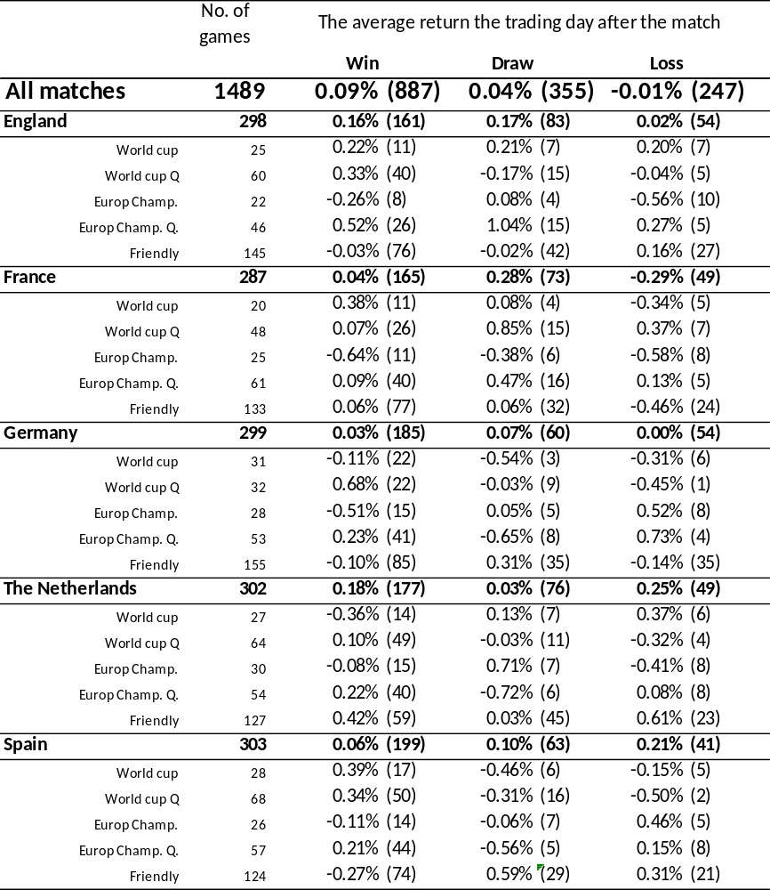

Methodology
In this chapter the methodology has been described. First the data set has been normalized and corrected for first order serial correlation. At second, there has been determined if there was an outperformance the trading day after football event by using a binomial test. Third, in order to determine a precise correlation between the stock market and international football matches an event study has been done. Finally, the relevant methodology for the robustness test has been described.

4.1 Returns
In order to normalize the returns the daily log returns have been calculated according to the following formula (Christenson 2003):
$R_{t+1 }=\ln{ \left(S_{t+1}\right)}-\ln\left(S_{t}\right)=\ln{ (S_{t+1}/S_{t})}$ (1)
Where $R_{t+1 }$is the change in the logarithm of the daily closing index price, $S_{t+1}$ is the closing price tomorrow and $S_{t}$ the closing price today.

4.2 Normal returns
The normal returns have been calculated according to the following formula, which is in line with Edmans et al. (2003) and Viera (2012). In order to run the regression as mentioned below Eviews 7 has been used.
$R_{i,t}^{0}=α+ β_{1}R_{it-1}+ β_{2}R_{msci-1}+β_{3}R_{msci}+β_{4}R_{msci+1}+β_{5}D_{t}+ ε_{it}$ (2)
$α$ = the constant parameter
$β$ = the slope
$R_{it-1}$ = the log return of index i at t-1
$R_{msci-1}$= the log return of the MSCI World index at t=-1
$R_{msci}$ = the log return of the MSCI World index at t=0
$R_{msci+1}$= the log return of the MSCI World index at t=+1
$D_{t}$ = ($D_{t1},D_{t2},D_{t3},D_{t4})$ are dummy variables which contain 1 for Monday until Thursday
$ε_{it}$ = the error term
In order to solve the problem of first order serial correlation the lagged index return $R_{it-1}$ has been used (Cao and Wei, 2004, Kamstra et al., 2003). Because some countries lag the MSCI and some countries lead the MSCI the $R_{msci-1}$ and $R_{msci+1}$are included, which is in line with Bernile and Lyandress (2011) and Edmans et al.(2007). The dummy variables $D_{t}$ reduce the problem of the day-of-the week relationship, which is in line with Edman et al. (2007), Viera (2012) and according to the methodology of Brooks (2008).

4.3 Outperformance
An outperformance is defined as whether the stock market has reacted relatively stronger after a win or loss compared to the expected market return. To determine if there had been an outperformance the trading day after the event, a research has been done if the normal return deviates from the expected return the trading day after the event (Bernyile and Lyandres, 2011). The positive deviation after a win and negative deviations after a loss have been counted. After running the regression model and creating new returns as described in formula 2, one can assume that the chance on an over- or underperformance is for both 50% at a random day. The binomial test investigates if the rate of outperformances is significantly higher than 50%. A binomial test is suitable to determine if the deviations are significant higher after an event compared to no event, since this test is robust for the underlying distribution according to Ashton et al. (2003), Cao and Wei(2004) Kamstra et al. (2000). The Binomial test formula is (Alan et al., 1998):
$$P\left(X=k\right)=\sum_{k=0}^{n}{\left({n \atop k}\right)P^{k}{(1-P^{k})}^{n-k}} (3)$$
n = the number of trials
k = the number of successes
n-k = the number of failures
p = probability of success of one trial

4.4 Event study
The binomial test can only test for an association between the football performance and the stock market return (Asthon et al., 2003). In order to determine a correlation a regression model is needed to calculate the abnormal return (from now on: AR) and the level of significance. A method to determine an AR is an event study; which is used in similar researches by Bernile and Lyandress (2011), Renneboog and Vanbrabant (2000) and Scholtens and Peenstra (2010). For this method again the statistical program Eviews 7 will be used.

4.4.1 Event window
The event window which has been chosen for this investigation is extremely short, 1 day. Despite the fact that Renneboog and Vanbrabant (2003) used a 5 day event window, Dyckman et al. (1984) argue that it is useful to take the shortest event window possible in order to focus on the direct effects of the event. A longer event window could possibly lead to inaccurate results. Besides the possible treat of inaccuracy an event window of 1 day also avoid the problem of overlap between the events. These ideas are in line with Bernile and Leandress (2011) and Scholtens and Peenstra (2009). There are no days included before the event date.

Estimation period
Given the fact that there are at least every 2 months international football matches, it is not possible to find a suitable period without events in the estimation period, as suggested by Mackinley (1997). Neither Renneboog and Vanbrabant (2000) nor Scholtens and Peenstra (2003) found a solution to eliminate this problem. Brown and Warner (1985) and Brown and Hartzell (2001) both used a different approach in order to select a proper estimation period. Brown and Warner (1985) used 250 trading days (1 year), whereas Brown and Hartzell (2001) used the whole sample as the estimation period. In this thesis the Brown and Warner approach will be followed.

Normal returns
The normal returns used for the event study are in line with formula 2. This is in contrast with Renneboog and Vanbrabant (2000) and Scholtens and Peenstra (2009) who did use a more simplified model. However, according to Edmans et al.(2003) and Bernile and Lyandres (2011) this model provides normalized returns which are robust for serial correlation.

4.4.4 Abnormal Returns
Abnormal Returns (from now on: AR) will be calculated according to the following formula:
${AR}_{i,t}=R_{i,t}^{0}-(α_{i}+β_{i}R_{msci,t}$) (4)
${AR}_{i,t}$ = the abnormal return of index i at time t
$R_{it}^{0},$ = the return on index i at time t
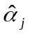 = the intercept
$β_{i}$ = the risk of share i
$R_{msci,t}$ = return of MSCI world index at time t
The average abnormal returns (from now on: AAR) will be calculated by determining the average over all independent ARs, according to the following formula:
${AAR}_{i,t} =1/N\sum_{t-1}^{N}{{AR}_{i,t}}$ (5)
${AAR}_{i,t}$ = the average abnormal return of index i at time t
$N$ = number of abnormal returns
${AR}_{i,t}$ = the abnormal return of index I at time t
The last step is a test for significance, which can be done according to the following formula:
$T statistic=\frac{{AAR}_{t}}{Ŝ(AAR)}$ (6)
${AAR}_{t}$ = the average abnormal return of index j at time t
Ŝ(AAR) = the standard deviation of the average abnormal returns during the estimation period

4.5 Robustness test
A problem with the data analyses is the constant volatility assumption according to Edmans, et al. (2011) and Viera(2012). French et al. (1987) and Bollerslev et al.(1994) have proven that the stock index returns does not have a constant but a time varying volatility. In other words, if we test our events during a low (high) volatile period, the standard errors of the regression would be biased upwards (downwards). This could lead to misinterpretations of the coefficients, since the standard errors affect the T-test. In order to solve this problem Bollerslev (1986) created the Generalized AutoRegressive Conditional Heteroskedasticity model (from now on: GARCH).

4.5.1 GARCH (1.1)
Therefore, in order to check for robustness, the GARCH (1.1) model will be used. This methodology is in line with Viera (2012) and Edmans et al. (2007).
The GARCH (1.1) model uses the past returns and volatility in order to calculate the future variance (Christofferson, 2003):
$σ_{t}^{2}= ω+ αR_{t-1}^{2}+ βσ_{t-1}^{2}$ with $α+β<1$ (7)
$σ_{t}^{2}$ = todays variance
$ω$ = the constant parameter
$R_{t-1}^{2}$ = the squared stock market return at t=-1
$α andβ$= the variable parameter
$σ_{t-1}^{2}$ = the squared variance at t=-1
These variables are the same for formula 8, 9 and 10 below.
One of the most important assumptions Bollerslev (1986) made while creating the GARCH model was that the long term variance should stay relatively stable over time. He formulated this into the following formula:
$σ^{2}=ω/(1-α-β)$ (8)
The values of the unknown parameters ω, α and β are estimated by using the maximum likelihood estimation. One crucial limitation is that $α+β<1$ . Christofferson (2003) assumed that all returns are independently and identically normally distributed.
$l_{t}=\frac{1}{\sqrt{{2πσ}_{t}^{2}}}exp\left(-\frac{R_{t}^{2}}{{2σ}_{t}^{2}}\right)$ (9)
In continuation, the joint likelihood of the index becomes:
$L=\prod_{t=1}^{T}{l_{t}}=\prod_{t=1}^{T}{\frac{1}{\sqrt{{2πσ}_{t}^{2}}}}exp\left(-\frac{R_{t}^{2}}{{2σ}_{t}^{2}}\right)$ (10)
By using the Microsoft Excel Solver in order to maximize the following formula the proper values of the parameters can be found.
$Max\ln{L=Max \sum_{t=1}^{T}{\ln\left(l_{t}\right)=Max\sum_{t=1}^{T}{\left[-\frac{1}{2}\ln\left(2π\right)-\frac{1}{2}\ln\left(σ_{t}^{2}\right)-\frac{1}{2}\frac{R_{t}^{2}}{σ_{t}^{2}}\right]}}}$ (11)
The $σ_{t}^{2}$ have been used to calculate new time series of normalized stock market returns according to the following formula (Chistofferson, 2003).
$R_{it}^{0}= α+ β\frac{1}{σ_{t}}R_{it}$ (12)
$R_{it}^{0}$ = the new normalized stock index returns of index i
$α$ = the constant parameter
$β$ = the variable parameter
$σ_{t}$ = the time varying volatility calculated by the GARCH model
$R_{it}$ = the stock market return of index i according to formula 2
By using the Microsoft Excel Solver, the $α$ and $β$ are chosen in order to normalize the $R_{it}^{0}$; the mean is 0 and the standard deviation is 1 (Edmans et al., 2003).
Finally, with these new returns the same event study methodology has been used as mentioned in chapter 5.3. Since the binominal test, as mentioned in chapter 5.2, is robust against the underlying distribution there is no need for using the GARCH (1.1) model as a robustness check.
In this chapter the methodology has been described. In the next Chapter the results will be discussed in order to check the hypotheses.

Results
In this chapter the results will be discussed in order to check the hypothesis as formulated in chapter 2.
In order to calculate normal returns the regression as described in formula 2 in chapter 4.2 has run. The regression coefficients and its T value can be observed in Appendix A.
Since the number of friendly matches is large and this possibly might have influence on the results, there has been done an investigation to both all matches and all matches without friendly matches. This has been done in order to avoid the problem of drawing conclusions based on inaccurate or wrong data.

5.1 Outperformance
In order to check for outperformances a binomial test has been done as described in formula 3 in chapter 5.2. After running this test the results are shown in table 2. As one can observe a win does not significantly lead to a positive outperformance, neither without the friendly matches. A draw will lead at a 5% significance level to a negative outperformance for all matches, after removing the friendly matches it becomes significant at a 1% level. A loss will lead to a negative outperformance at a 1% level, either for all matches or without friendly matches.
As to the following hypothesis:
$H_{0 }$: Either after a match or after no match the rate of deviations from the normal return is equal.
$H_{a }$: The day after an international football match the rate of deviations from the normal return is higher compared to the day after no event.
After analyzing the upper part of table 2, one cannot reject the $H_{0}$ hypothesis for wins. However, for draws $H_{0}$ can be rejected at a 5% level, without friendly matches even at a 1% level. Moreover, for a loss $H_{0}$ hypothesis can be rejected at a 1% level either for all matches or without friendly matches. Being able to reject $H_{0 }$ for losses is in line with the findings of Ashton et al. (2010); however, they were able to reject the $H_{0 }$also for wins during a tournaments final, which is not the case according to this results as shown in table 2.
In order to check whether the outperformances lead to a significant AAR, an event study has been done. Table 3 shows that the AAR after a win is negative for all matches and all matches without friendly. This is in contrast with the expectation that a win will lead to a positive stock market return. However, the AAR after a win is not significant. A draw will lead to a negative AAR of -0.03% at a 5% significance level and at a 10% level for losses. After excluding the friendly matches wins still do not lead to a significant AAR. A draw and a loss both lead to a significant negative AAR of -0.04% at a 5% level.
The lack of significant AAR’s after wins is in line with the findings of Boyle and Walter (2010), Edmans et al. (2007) and Viera (2012). Renneboog and Vanbrabant (2000) and Scholtens and Peenstra (2010) did find significant positive results. But their negative significant findings about a draw are in line with table 3. The significant negative findings after a loss are in line with Baker and Wagler(2007), Bernile and Lyandress(2011), Edmans et al. (2007), Renneboog and Vanbrabant (2000) and Scholtens and Peenstra(2009).
Table 2. Binomial statistics about the importance of a match
This table reports the results of the binominal test and the importance of a match:
$$P\left(X=k\right)=\sum_{k=0}^{n}{\left({n \atop k}\right)P^{k}{(1-P^{k})}^{n-k}}$$Where n is the number of trials, k is the number of successes and p is the probability of success of one trial, which is 0.5. For this test outperformances, defined as whether the realized stock returns differs from their normal stock returns, has been counted. In order to calculate the normal returns the following formula has been used:
$$R_{i,t}^{0}=α+ β_{1}R_{it-1}+ β_{2}R_{msci-1}+β_{3}R_{msci}+β_{4}R_{msci+1}+β_{5}D_{t}+ ε_{it}$$
Where $α$ is the constant parameter, $β$ is the slope, $R_{it-1}$ is the index return at t=-1, $R_{msci-1}$is the return of the MSCI World index at t=-1, $R_{msci}$is the return of the MSCI World index at t=0, $R_{msci+1}$is the return of the MSCI World index at t=+1, $D_{t}$is the dummy variable which contains 1 for Monday until Tuesday and $ε_{it}$is the error term. The number of positive outperformances has been mentioned for wins with the total number of observations in brackets. The number of negative outperformances has been mentioned for draws and losses with the total number of observations in brackets. There have been made a differentiation between the importance of match. There are: World Cup matches, World Qualification matches, European Championship matches, European Championship Qualification matches and Friendly matches. Also there has been made a differentiation between all matches and all matches without friendly matches.
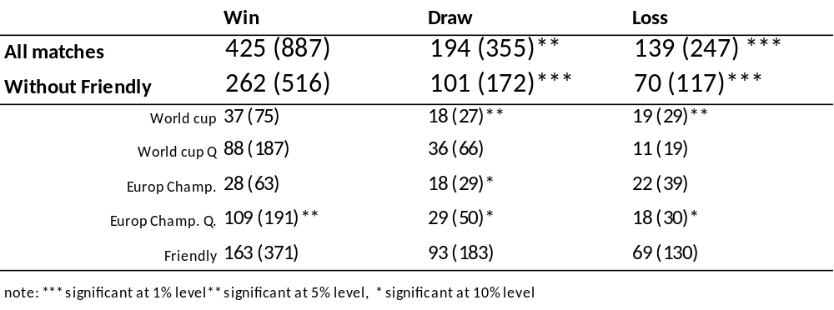
Table 3. Average Abnormal Returns and importance of a match
This table shows the average abnormal returns (AAR) and the importance of a match:
${AAR}_{i,t} =1/N\sum_{t-1}^{N}{{AR}_{i,t}}$
Where n is the number of observations and ${AR}_{i,t}$ is the abnormal return of index j. ${AR}_{i,t}$ has been defined as follows:
${AR}_{i,t}=R_{i,t}^{0}-(α_{i}+β_{i}R_{msci,t}$)
Where $R_{i,t}^{0}$the normal return of index j is and has been calculated with formula 2 of chapter 2.2 and mentioned in table 2, $α_{i}$ is the intercept, $β_{i}$ is the risk of a share and $R_{msci,t}$ is the return of the MSCI World Index. Finally the T statistic has been determined according to the following formula:
$T statistic=\frac{{AAR}_{t}}{Ŝ(AAR)}$
Where the AAR has been divided by Ŝ(AAR), which is the standard deviation of the AAR during the estimation period. There have been made a differentiation between the significance of matches. There are: World Cup matches, World Qualification matches, European Championship matches, European Championship Qualification matches and Friendly matches. Also there has been made a differentiation between all matches and all matches without friendly matches.
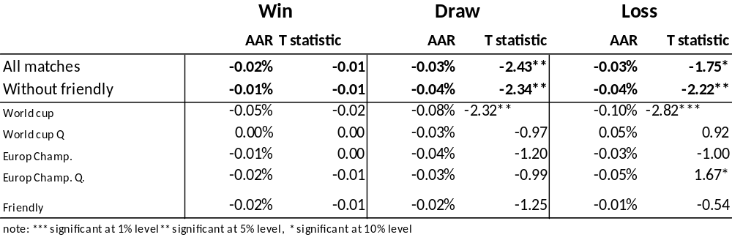

5.2 The influence of the importance of a match
The lower part of table 2 shows the relation between the outperformance and importance of a match. The importance of a match is as follows, with the most important match on top and the least important match on the bottom:
- World Cup
- European Championship
- World Cup Qualification
- European Championship qualification.
- Friendly
Table 2 reports that after a European Championship Qualification win, a positive outperformance can be expected at a 5% significance level. However, since this is fourth important match this is not line with the expectations. A draw and a loss during a World Championship will lead to a negative outperformance of the stock market at a 5% significance level. A draw during the European Championship or the qualification matches for the European Championship will lead to a negative outperformance at a 10% level, which is also the case for losses during the qualification round for the European Championship.
The bottom part of table 3 shows that the AAR after win is negative, no matter which kind of match there has been played. However, these results are insignificant at any level. A draw during the World Championship will lead to a negative AAR of -0.08 at a 5% significance level. More extreme, a loss during the World Championship will lead to a negative AAR of -0.10% at a 1% significance level.
As to the hypothesis which was prepared in order to check for the influence of importance of a match on the stock market:
$H_{0 }$: The importance of a match does not have significant influence on the stock market’s reaction.
$H_{a }$: The importance of a match has significant influence on the stock market’s reaction.
Based on the findings mentioned above, one could conclude that one is not able to reject $H_{0 }$ for wins. However, since a draw and loss lead to a significant outperformance and a negative AAR at a 5% and 1% significance level for World Cup matches, which are the most important matches, $H_{0 }$can be rejected. Therefore it can be assumed that the importance of a match has significant influence on the stock market’s reaction.
The fact that a World Cup draw or loss leads a significant negative AAR is in contrast with the findings of Leeuwen and Kalshoven (2006) and Viera (2012). However, that importance of a match has influence on the AAR is in line with Bernyle and Lyandress(2011).

The influence of expectations about a match result
In order to check the hypothesis about expectations, table 4 shows the binominal statistics about outperformances and expectations. It could be observed that a win neither for all matches nor all matches without friendly matches leads to a significant outperformance of the stock market. A loss leads to significant more negative outperformances, driven by unexpected losses. These results do not change after excluding the friendly matches. After a draw one could expect a significant negative outperformance. A draw whether a win was expected leads to a significant negative outperformance at a 10% level. However, after excluding friendly matches this effect is significant at a 5% level. A draw whether a loss was expected leads to a negative outperformance at a 5% level for all matches. However, this effect does not appear after excluding the friendly matches.
As to check the following hypothesis which was prepared in order to check the influence of expectations on the stock market’s reaction:
$H_{0 }$: The market reaction is equal either after an expected or unexpected result.
$H_{a }$: Conform the Efficient Market Hypothesis, the reaction on the stock market is significant stronger after an unexpected result compared to an expected result.
Based on table 4 one can conclude that an unexpected loss has significant more influence on the stock market compared to an expected loss. Therefore $H_{0 }$can be rejected and it can be assumed that according to the Efficient Market Hypothesis an unexpected result will lead to a stronger market reaction. However, based on a win $H_{0 }$cannot be rejected. Both expected and unexpected results have no significant influence on the rate of outperformances. A draw will lead to a significant negative outperformance at a 5% level, either after all matches or all matches without friendly matches. The effect of a draw after an expected win increased in level of significance from 10% to 5% after excluding friendly matches. For a draw whether a loss was expected the level of significance decreased from 5% to not significant at any level.
However, table 5 does not completely support this conclusion. It does support the conclusion that a win has not significant influence on the stock market at any level even without friendly matches. A loss does lead to a 5% significant negative AAR of -0.03%, which is driven by a 1% significant expected loss AAR of -0.05 and an unexpected loss AAR of -0.03 at a 10% significance level. However, after excluding friendly matches, the AAR after a loss becomes -0.05% at a 1% significance level. This effect is driven by expected losses with an AAR of -0.05% at a 5% significance level since the unexpected losses does not lead to a significant effect. A draw will lead to negative AAR of -0.03% at a 5% significance level, driven by losses whether a win was expected. A draw after a match where a loss was expected does not lead to a significant AAR. For all matches without friendly matches a draw will lead to a negative AAR of -0.04% at a 5% significance level which is also driven by matches whether a win was expected.
Therefore, based on the results of the event study, one is not able to reject $H_{0 }$for wins. After a loss it is possible to reject $H_{0 }$. However, unexpectedly, an expected loss does have more impact on the stock returns compared to unexpected losses. A draw does lead to a rejection of $H_{0 }$, since a draw whether a win was expected does lead to a larger and significant stock market reaction .
Since the market reaction does not react significantly stronger after an expected compared to an unexpected performance for wins and losses these findings are in line with Boyle and Walter (2003). Scholtens and Peenstra (2010) did find a significant stronger reaction after unexpected results, which is in line with the efficient market hypothesis. However, the fact that a draw whether a win was expected does lead to a larger significant stock market reaction is in line with Scholtens and Peenstra (2010).
Table 4. Binominal statistics about the expectations of a match
This table shows the results of the binominal test in combination with the expectations of a match:
$$P\left(X=k\right)=\sum_{k=0}^{n}{\left({n \atop k}\right)P^{k}{(1-P^{k})}^{n-k}}$$Where n is the number of trials, k is the number of successes and p is the probability of success of one trial, which is 0.5. For this test the number of outperformances, defined as whether the realized stock returns differs from their normal stock returns, has been counted. In order to calculate the normal returns formula 2 in chapter 2.2 and in table 3 has been used. The number of positive outperformances has been mentioned for wins with the total number of observations in brackets. The number of negative outperformances has been mentioned for draws and losses with the total number of observations in brackets. There have been made a differentiation between the expectations of a match. The expectations are based on the FIFA World Ranking list, the country which possessed the highest position on the list at the beginning of the year the match was played was expected to win. The statistics for all wins, losses and draws have been mentioned on top of each table, with the expected and unexpected results below. The total number of observations in this table differs from the total number of observations in table 2, since the FIFA World Ranking list was founded in 1993. There have been made a differentiation between all matches and all matches without friendly matches.
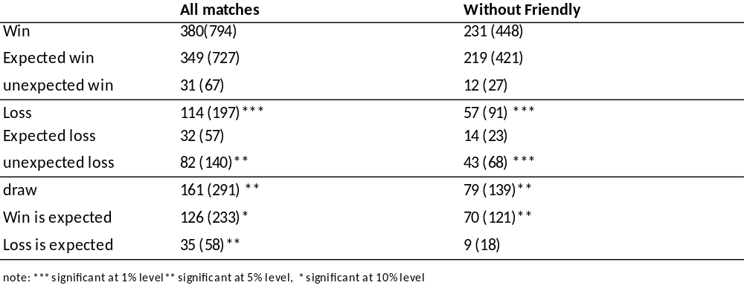

Table 5. Average Abnormal Returns and expectations about a match
This table shows the average abnormal returns (AAR) in combination with the importance. The AAR has been calculated according to the following formula:
${AAR}_{i,t} =1/N\sum_{t-1}^{N}{{AR}_{i,t}}$
Where n is the number of observations and ${AR}_{i,t}$ is the abnormal return of index i. The ${AR}_{i,t}$ and T-statistic have been calculated according to formula 5 and 6 in chapter 5.3.4 and as mentioned in table 3.
There have been made a differentiation in the expectations of a match. The expectations are based on the FIFA World Ranking list, the country which possessed the highest position on the list at the beginning of the year the match was played was expected to win. The statistics for all wins, losses and draws have been mentioned on top of each table, with the expected and unexpected results below. The total number of observations differs from the total number of observations in table 2, since the FIFA World Ranking list was founded in 1993. There have been made a differentiation between all matches and all matches without friendly matches.
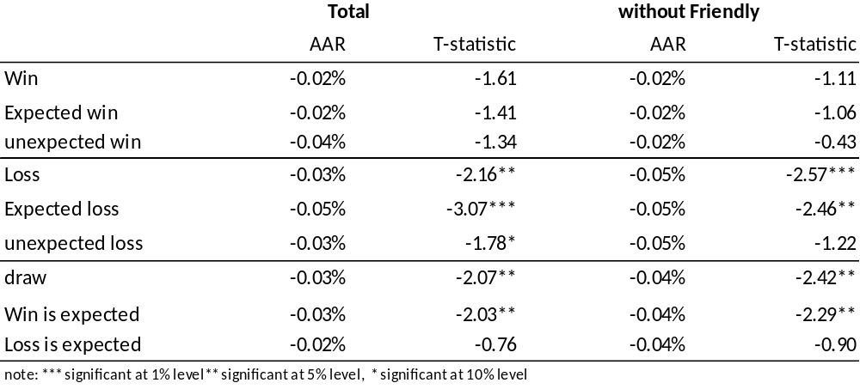

5.4 Asymmetric results
Table 2, 3, 4 and 5 in the appendix show information which is useful in order to answer the following hypothesis about asymmetric results:
$H_{0 }$: A loss, draw and win do lead to the same market reaction.
$H_{a }$: A loss does lead to a stronger market reaction compared to a win
All tables mentioned above report insignificant results after a win and a significant reaction after a loss. Table 2, 4 and 5 in the appendix show a negative market reaction at a 1% significance level. Table 3 shows a negative market reaction at a 10% significance level for all matches and at 5% level without friendly matches. Based on these results, one can reject $H_{0 }$ and therefore assume that the results are asymmetric. The degree of asymmetry depends on both expectations and importance of a match. Expected losses seem to have a stronger AAR reaction. The importance of match does play a role, only during a World Championship tournament one could expect a significant negative AAR and is the rate of negative outperformances significant. Excluding friendly matches does increase the level of significance and the size of the market reaction as reported in table 3 and 5.
A stronger reaction after a loss compared to the reaction after a win is in contrast with the findings of Boido and Fasano (2007) but line with the Asthon et al. (2003), Baker and Wagler (2007), Bernile and Lyandress (2011), Brown and Hartzell (2009), Edmans et al. (2007), Palamino et al. (2009), Renneboog and Vanbrabant (2000) and Scholtens and Peenstra (2010).

5.5 The draw effect
As mentioned in chapter 2.7 there is no clear expectation about the stock market reaction after a draw. Therefore the following hypothesis has been prepared:
$H_{0 }$: A draw will be followed by no stock market movement.
$H_{a }$: A draw will be followed by a negative stock market return.
In order to check this hypothesis table 2, 3, 4 and 5 should be observed. Table 2 shows a negative association between a draw and an outperformance at a 1% significance level, whereas the other tables show the same pattern at a 5% significance level. Therefore, one can reject $H_{0 }$of no stock market reaction after a draw and assume that a draw will be followed by a negative AAR. This effect will be strengthened by increasing the importance of match; a World Cup or European Championship draw will be followed by a significant stronger market reaction compared to other matches. The expectations of a match do play a role, if a win was expected the market reaction after the draw will be stronger en more significant. After excluding friendly matches the market reaction became stronger and more significant.

5.6 Robustness test
In order to determine the robustness of this investigation a robustness test has been. In line with Edmans et al. (2003) and Viera(2012) the GARCH (1.1) has been used in order to eliminate the problem of heteroscedasticity.

5.6.1 The AAR and the importance of a match
Table 6 shows the AAR by using the GARCH (1.1) model. Still a win does lead to an insignificant negative AAR. In contrast to previous findings, a draw and loss with all matches included does not lead to a significant result. However, after excluding friendly matches a draw and a loss turned out to be significant at a 5% level with an AAR of -0.03% and -0.02%. For this reason it can be assumed that the findings without friendly matches are robust to heteroscedasticity. However, the findings which include friendly matches are not robust against it.
A draw or loss during a World Championship does lead to a negative AAR of -0.06% at a 5% significance level, which is in line with the findings in table 3. Therefore, one can conclude that the findings as mentioned in chapter 5.2 and Table 3 are robust to heteroscedasticity.

Table 6. Robustness check: Average Abnormal Returns and importance of a match
This table shows the robustness check for the average abnormal returns (AAR) in combination with the importance of a match.
${AAR}_{i,t} =1/N\sum_{t-1}^{N}{{AR}_{i,t}}$
Where n the number of observations is and ${AR}_{i,t}$ is the abnormal return of index j. ${AR}_{i,t}$ has been defined as follows:
${AR}_{i,t}=R_{i,t}^{0}-(α_{i}+β_{i}R_{msci,t}$)
Where $α_{i}$ is the intercept, $β_{i}$ is the risk of a share, $R_{msci,t}$ is the return of the MSCI World Index and $R_{i,t}^{0}$ determined according to the GARCH (1.1) model in order to model the volatility. This has been done according to the following formula:
$σ_{t}^{2}= ω+ αR_{t-1}^{2}+ βσ_{t-1}^{2}$ with $α+β<1$
Where $σ_{t}^{2}$ is todays variance, $ω$ is the constant parameter, $R_{t-1}^{2}$ is the squared stock market return at t-1,$α and β$ are the variable parameter and $σ_{t-1}^{2}$ is the squared variance at t-1. The normal returns have been calculated according to the following formula:
$$R_{it}^{0}= α+ β\frac{1}{σ_{t}}R_{it}$$
Where $R_{it}^{0}$ is the new normalized stock index returns of index I, $α$ is the constant parameter, $β$ is the variable parameter, $σ_{t}$ is the time varying volatility calculated by the GARCH model, $R_{it}$ is the stock market return of index i according to formula 2. Finally the T statistic has been determined according to the following formula:
$T statistic=\frac{{AAR}_{t}}{Ŝ(AAR)}$
Where the AAR has been divided by Ŝ(AAR), which is the standard deviation of the AAR during the estimation period. There have been made a differentiation between the importance of matches. There are: World Cup matches, World Qualification matches, European Championship matches, European Championship Qualification matches and Friendly matches. Also there has been made a differentiation between all matches and all matches without friendly matches.
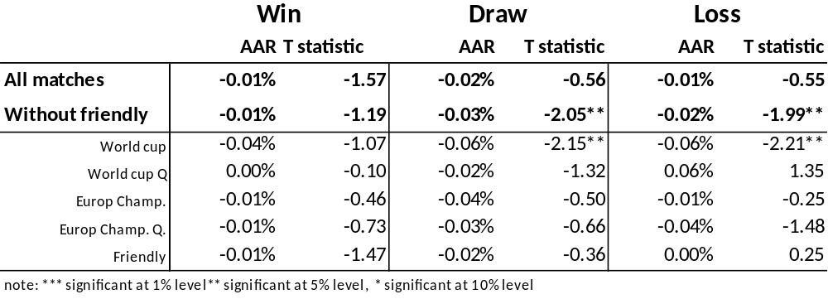

5.6.2 The AAR and expectations of a match
Table 7 shows the results of the AAR and expectations by using the GARCH (1.1) model. In line with previous findings a win does not lead to a significant AAR under no circumstance. A loss does not lead to a significant AAR anymore if every match is included. After excluding friendly matches a loss leads to a negative AAR of -0.02% at a 5% significance level, driven by an expected loss. A draw still leads to a significant negative AAR of -0.02% at a 5% level, due to a significant AAR of -0.03% after a draw when a win was expected. Excluding friendly matches does not change this pattern; a negative AAR of -0.04% at a significance level of 5% for both a draw in total as for a draw when a win was expected. A draw whether a loss was expected does not lead to any significant market reaction.
Since the results of the database without friendly matches show the same findings as the results in table 5 and chapter 5.3, these are robust against the problem of heteroscedasticity. However, this is not the case for all matches and therefore friendly matches are not robust for heteroscedasticity.
Table 7. Robustness Check: Average Abnormal Returns and expectations about a match
This table shows the robustness test for the average abnormal returns (AAR) results of the event study and expectations of a match:
${AAR}_{i,t} =1/N\sum_{t-1}^{N}{{AR}_{i,t}}$
Where n the number of observations is and ${AR}_{i,t}$ is the abnormal return of index j. The same methodology has been used as in chapter 5.3 and 5.4 and as mentioned in the description of table 6.
There have been made a differentiation in the expectations of a match. The expectations are based on the FIFA World Ranking list, the country which possessed the highest position on the list at the beginning of the year the match was played was expected to win. The statistics over all wins, losses and draws have been mentioned on top of each table, with the expected and unexpected results below. The total number of observations differs from the total number of observations in table 2, since the FIFA World Ranking list was founded in 1993. There have been made a differentiation between all matches and all matches without friendly matches.
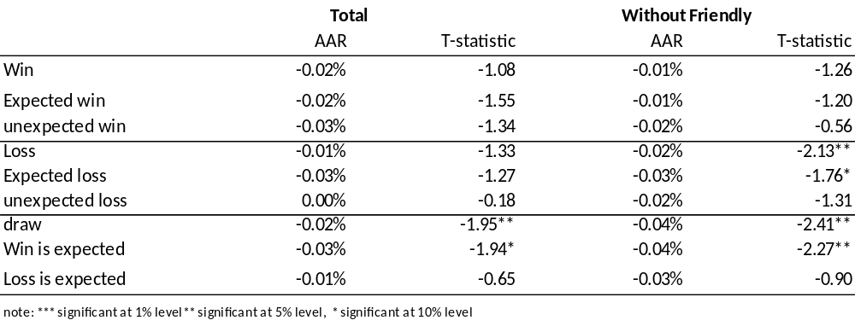
In this Chapter the results have been discussed and the hypotheses have been tested. The next Chapter contains the main conclusion and contains an answer on the research question and the propositions.

7 Conclusion
This chapter contains a short summary of the findings in this thesis. Secondly, the research question will be answered and at last the relevance of this thesis will be discussed.
This thesis is focused on the stock market’s reaction after an international football match. This has been done by analyzing the results on the stock market of England, France, Germany, The Netherlands and Spain from 9/7/1987 until 18/3/2014 the trading day after a match. There has been made a differentiation between the importance and expectations about matches.
By using a binomial test there has been tested if the amount of deviations after a match is significantly higher (lower) after a win (loss, draw). This thesis provides significant evidence that the trading day after a loss or draw of the national football team the stock market negatively outperforms the market. However, there is no significant evidence that a win does lead to a positive outperformance.
Due to an event study the influence of importance and expectations about matches have been tested. The importance of a match does not play a significant role for wins. However, a draw or loss during the World Cup Tournament does lead to a significant negative AAR, which is robust against heteroscedasticity. On the first sight, the expectations of matches do provide the same pattern as the importance of a match. A win does not lead to a significant AAR and a draw and loss generate a significant negative AAR. However, in contrast with the efficient market hypothesis, an expected loss does generate a significant higher AAR compared to an unexpected loss.
All findings provide asymmetric results; a draw and loss have a significant bigger influence on the stock market compared to a win. Never has led a win to a significant positive AAR according to table 2, 3, 4, 5, 6 and 7.
This thesis provides significant evidence that a draw will be followed by a negative outperformance and negative AAR the trading day after an international football match. Expectations and importance of a match do have influence on the stock market’s reaction after a draw; a world cup draw or a draw whether a win was expected has the biggest influence.

These conclusions for all matches are summarized in the following table:
 | Significant positive abnormal return after a win | Significant negative abnormal return after a draw | Significant negative abnormal return after a loss | Asymmetric results
Outperformance |  | x | x | x
Importance of a match |  | x | x | x
Expectations of a match |  | x | x* | x
* In contrast with the Efficient Market hypothesis, an expected loss does generate a higher and significant AAR.
The robustness test strengthened the conclusions about the importance of a match. Even after using the GARCH(1.1) model in order to correct for heteroscedasticity a World Cup draw and loss does lead to a negative significant AAR at a 5% level. Moreover, all matches do not provide a significant negative AAR anymore after a draw or loss. After excluding friendly matches, which are the least important, all matches turned out to be significant at a 5% level.
The robustness test weakened the conclusions about the correlation between expectations of a match and the stock market. By using the robustness test neither expected nor unexpected losses provide a significant AAR for all matches. After excluding the friendly matches, expected losses do lead to a significant negative AAR. This implies that the importance of a match, in the form of friendly matches, also plays a role. However, the robustness test strengthens the conclusions about the market’s reaction after a win or draw.
As to the research question: ‘Does the performance of the national football team have significant influence on the stock market return?’ one can conclude that a draw and loss have a significant negative influence on the stock market return. A win neither does lead to a significant outperformance nor AAR. The height of the negative reaction does depend on the importance of a match and the expectations about the match. A World Cup draw or loss does lead to a significant stronger stock market reaction compared to other matches.
In terms of outperformance an unexpected loss or a draw whether a win was expected does lead to a significant negative outperformance. However, in terms of AAR, an expected loss and a draw whether a win was expected do lead to a significant negative AAR.
Therefore, there is enough evidence to conclude that investors behave irrational as a result of international football losses or draws. Traders’ sentiment gets even more affected after a World Championship draw or loss. An expected loss or a draw whether a win was expected also has significant influence on investors’ behavior.
This thesis provides a unique investigation since it combines several theories and investigations from different authors. There complete new dataset was created, which contains the football performances of the best 5 European football countries combined with their stock market returns, abnormal returns, expectations about the matches, the importance of matches, outperformances of the market. Moreover, never have been done one investigation to the influence of international football matches and the stock market by using both a binominal test to outperformances and an event study to AARs.
The main practical implication of this thesis is the evidence of consistently irrational behavior of traders the trading day after a draw or loss of the national football team. If a trader anticipates on this behavior by going short in the index of the losing country the trading day after the match he could create abnormal returns.
This chapter provides the conclusion of this thesis. The next chapter will present the recommendations for future research.

8 Recommendations and further research
In this chapter the recommendations and advice for future research will be provided. First, there will be explained how to increase the statistical power of the tests. At second, a possible solution of how to reduce the problem of seasonality has been mentioned and at last a limitation in creating the expectations of a match has been mentioned.
This thesis contains historical international football results of 5 countries, England, Germany, France, The Netherlands and Spain from 9/7/1987 until 18/3/2014. In order to increase the statistical power of the results the number of observations could be increased by adding more countries to the database. It is also possible to add results from before 1987 in order to increase the amount of data.
In order to normalize the returns it is possible to add a dummy variable to formula 2 in chapter 4.2 which indicates 1 for which the previous 1 through 5 days are non-weekend holidays (Edmans et al. 2007, Viera 2012). By using this method the seasonality in the data will be reduced.
A crucial limitation in the determination of the expectations of a match is that the home/away advantage has been omitted. Bernille and Lyandress (2011) did find significant different stock market returns between home and away performances.
This chapter provides the recommendations and future research. The next chapter contains the list with relevant literature which has been referred to.

9. Literature

9.1 Articles
Alan, A., A.C. Gerrard, A. Coull, 1998, Approciamte is better than ‘exact’ for interval estimation of Binomial Proportions, The American Statistician, 52, 119-126.
Ashton, J.K., B. Gerrard, R. Hudson, 2010, Economic impact of national sporting success: evidence from the London stock exchange, Journal of applied economics, 10, 783 – 785.
Baker, M., J. Wurgler ,2007, Investor sentiment in the stock market, Journal of Economic Perspectives, 21, 129-151.
Bernile, G., E. Lyandres, 2011, Understanding investor sentiment: the case of soccer, Financial management, 357 – 380.
Boido, B., A. Fasano, 2009, Alternative Assets: A Comparison Between Commodities and Traditional Asset Classes, ICFAI Journal of Derivatives Markets, 6 , 74-105.
Bollerslev, T., 1986, Generalized autoregressive conditional heteroscedasticity, Journal of Econometrics, 31, 307-327.
Boyle, G., B. Walter, 2003, Reflected glory and failure: international sporting success on the stock market, Applied financial economics, 13, 225-235.
Brief, A.P., H.M. Weiss, 2002, Organizational behavioral: affect in the workplace, annual review of psychology, 53, 279-307.
Brown, S., J. Warner, 1985, Using daily stock returns: the case of event studies, journal of financial economics, 14, 3-31.
Brown. G.W., J.C. Hartzell, 2001, Market reaction to public information: The atypical case of the Boston Celtics, journal of Financial economics, 60, 333-370.
Cao, M., J. Wei, 2005, Stock market returns: a note on temperature anomaly, journal of banking and Finance, 29, 1559 – 1573.
Dubois, M., P. Louvret, 1995, The day-of-the-week effect; the international evidence, journal of banking and finance, 20, 1463 – 1483.
Engle, R.F., 1982, Autoregressive conditional heteroskedasticity with estimates of the variance of UK inflation, Econometrica, 50, 987–1008.
Ernst & Young, 2014, Sustainable Brazil, social and economic impact s of the 2014 World Cup, EY working paper
Forgas, J.P., 1995, Mood and judgment: The affect infusion model (AIM), Psychological Bulletin, 117, 39-66.
Forrest, D., J.A. Goddard, R. Simmons, 2005, Odd-setters as forecasters, the case of English football, international journal of forecasting, 21, 551-641.
Forrest, D., R. Simmons, 2000, Forecasting sports: the behavioral and performance of football tipsters, International Journal of Forecasting, 16, 317-331.
French, K.R., G.S. Williams, R.F. Stambaugh, 1987, Expected stock returns and volatility, Journal of Financial Economics, 19, 3-29.
Goodstein, R.C., C.T. Allen, D.R. John, 1994, Mood Effects in Consumer Behavior: a Unifying Theme, Advances in Consumer Research , 21, 526-529.
Hirshleifer, D., T. Shumway, 2003, Good day sunshine: Stock returns and the weather, Journal of Finance, 58, 1009–1032.
Junge, A., J. Dvorak, T. Graf-Baumann, 2004, Football injuries during the World Cup 2002, American Orthopaedic Society for Sports Medicine, 32, 23-28.
Kamstra, M.J., L.A. Kramer, M.D. Levi, 2000, Losing sleep at the market: The daylight-savings anomaly, American Economic Review, 90, 1005–1011.
Lakosishok, J., A.C. Shapiro, 1984, Stock Returns, Beta, Variance and Size: An Empirical Analysis, Financial Analysts Journal, 40, 36-41.
Leeuwen, R., C. Kalshoven, 2006, Soccernomics 2006, Working paper, ABN AMRO Working Paper.
Loewenstein, G.F., U.W. Elke, K.H. Christopher, N. Welch, 2001, Risk as feelings, Psychological bulletin, 127, 267-286.
Luce, M.F., J.W. Payne, J.R. Bettman, 1999, Emotional trade-off difficulty and choice,,Journal of Marketing Research, 36, 143–159.
MacKinlay, A.C.,1997, Event Studies in Economics and Finance, Journal of Economic Literature, 35, 13-39.
Mackinley, C., 1997, Event studies in economics and finance, journal of economic literature, 35, 13-39.
Malkiel. G.G.,2003, The Efficient market hypothesis and his critics, journal of economic perspectives, 17, 59 – 82.
Palomino, F., L. Renneboog, C. Zhang, 2009, Information salience, investor sentiment, and stock returns: the case of British soccer betting, Journal of Corporate Finance, 15, 368–387.
Renneboog, L., P. Vanbrabant, 2000, Share price reactions to sporty performence of soccer clubs listed on the London Stock Exchange and the AIM, Center for Economic Research, 1-28.
Saunders, A.M., 1993, Stockprices and the Wall Street Weather, The American Economic Review, 83, 1337-1345.
Scholtens, B., W. Peenstra, 2009, Scoring on the stock exchange? The effect of Football matches on stock market returns: an event study, Journal of Applied economics, 41, 3231-3237.
Trovato, F., 1998, The Stanley Cup of Hockey and Suicide in Quebec, Social Forces, 77, 105–127.
Vieira, E.F.S., 2012, Investor sentiment and market reaction: evidence on 2010 FIFA World Cup, International Journal of Economics and Accounting, 3, 51–76.
Vlastakis, N., G. Dotsis, R. Markellos, 2008, How efficient is the European Football Betting Market? Evidence from Arbitrage and Trading Strategies, International Journal of Forecasting, 44, 426-444.

9.2 Books
Brooks, C., 2008, Introductory economics for finance, Cambridge University Press., Second edition.
Christoffersen, P.F., 2003, Elements of Financial Risk Management. Amsterdam: Academic Press

9.3 Internet sites:
http://www.rsssf.com
http://www.fifa.com/worldranking/rankingtable/

9.4 Newspaper articles
Beeten, M., 17-4-2014, Ster reclame WK: 6666 euro per seconde, Algemeen Dagblad.

Appendix A

This table shows the regression coefficients and T value of the regression: $$R_{i,t}^{0}=α+ β_{1}R_{it-1}+ β_{2}R_{msci-1}+β_{3}R_{msci}+β_{4}R_{msci+1}+β_{5}D_{t}+ ε_{it}$$
Where $α$ is the constant parameter, $β$ is the slope, $R_{it-1}$ is the index return at t=-1, $R_{msci-1}$is the return of the MSCI World index at t=-1, $R_{msci}$is the return of the MSCI World index at t=0, $R_{msci+1}$is the return of the MSCI World index at t=+1, $D_{t}$is the dummy variable which contains 1 for Monday until Tuesday and $ε_{it}$is the error term.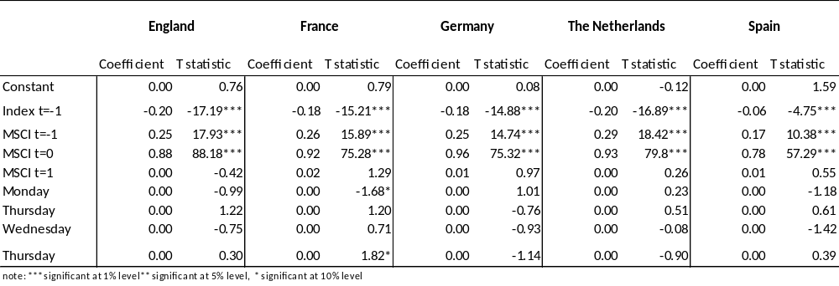

With football is meant the game with 2 teams of 11 players. The team which has scored the most goals by foot in the goal of the opponent after 90 minutes wins. This game is called ‘soccer’ in the USA(Scholtens and Peenstra, 2009).
Edmans et al., 2007, p. 1969
Cao and Wei (2005) did an investigation in order to determine if the weather temperature has significant influence on the stock market exchange. Therefore, only their methodology has been mentioned.
The GARCH model is an extension to the ARCH model created by Engle (1982)

