Collusion in Spatial Competition Markets
An analysis on the likelihood of collusion in markets with differentiated goods

ERASMUS UNIVERSITY ROTTERDAM
Erasmus School of Economics
Department of Economics

Supervisor: Dr. Dana Sisak

Name: Banu Atav
Exam number: 355108
E-mail address: 355108ba@student.eur.nl
August, 2014

Abstract
In this paper a Hotelling model with quadratic costs, as modeled by Chang (1991), is altered for different assumptions in order to determine to consequences for the stability of collusion. In particular, the model is altered by introducing endogenous locations and a capacity constraint. For each modification, the new outcome is computed. A critical discount factor for each of the models is determined by computing the profit. In the composed models the outcome is analyzed for two different assumptions of the reactiveness of the rival firm to deviation. The results show that collusion is less stable, for markets where the reactiveness to deviation of the rival firm is low, when locations are endogenous to the model. Furthermore, it is shown that a capacity constraint only diminishes the deviation profit. This implies that cooperative practices are more likely to be found in spatial competition markets where firms are constrained by their capacity. In markets with endogenous capacity choice, the location bundle $(1/4, 3/4)$ signals collusion. As the outcome is not robust to changes in assumptions, a case-by-case analysis is suggested.

I. INTRODUCTION
Even though the highest possible market power and high allocative inefficiency are often associated with single dominant firms, antitrust authorities are concerned with two ways in which market power, which threatens competition, can arise in oligopolistic markets (Ivaldi, Jullien, Rey, Seabright, & Tirole, 2003). The first is when market concentration is high, yet not at the level of a monopoly, while firms are behaving competitively and are only concerned with maximizing their own profits. This situation arises when firms exert high market power due to the characteristics of the market where one of the most evident occurrences is a market with differentiated goods. The second is when firms coordinate their behavior with rivals in order to achieve higher profits; also known as tacit collusion in economic literature. Albeit the consequence of both cases is similar, the essential distinction, as implied, is that in the first case firms take the behavior of their rivals as given (thus behave competitively), whereas in the second case firms jointly act to maximize profits (thus behave non-competitively). Even though a high market power resulting from competitive behavior in an oligopolistic market may be just and, when everything is considered, efficient compared to any alternative, high market power resulting from tacit collusion is typically welfare reducing.
On top of that, antitrust authorities find it very hard to detect collusion, since it is far from being clear what to consider as a sign. Generally, the first possibility for an indicator of collusion that comes to mind is the profit margin of the firms in a certain market. The problem with this is that high profit margins need not be a sign, since these can simply indicate high market power (Belleflamme & Peitz, 2010). In particular, this holds in markets with differentiated goods as in these markets demand is less reactive to price changes (which gives the firms market power). Furthermore, it is hard to determine for which values the margin should be considered high. In practice it is not easy to determine the exact structure of the market and the outcome in a competitive setting, which theoretically would serve as a benchmark to the collusive situation (Motta, 2004).
Since there is an overload of cases to look at, it is unfeasible to investigate each case. Hence, antitrust authorities are in need of proper indicators of collusion that assist in deciding which cases to look into. Consequently, these circumstances amplify the necessity for profound insight in collusion (and its indicators). In economics, often, this insight comes from modeling these game-theoretic situations. Although these models are not perfect, since the assumptions differ from reality, they show to be useful in predicting or explaining general tendencies. Nevertheless, since game-theoretic models are not robust, meaning that the outcome changes when the assumptions are changed, a case-by-case approach is suggested (Jacquemin & Slade, 1989).
The preceding points that are raised shape the fundamentals of this research. Both concerns of antitrust authorities in oligopolistic markets, market power (that results from product differentiation) and the stability of collusion, will be combined and analyzed. Based on a spatial competition model (which represents a market with differentiated goods), first modeled by Hotelling in 1929, the stability of collusion in these markets will be studied. Starting off with a general spatial competition model, certain assumptions are altered one by one. The effects of these changes on the outcome of each model and on the likelihood of collusion are determined. Here the likelihood of collusion is measured with a critical discount rate that is required for collusion to occur in a certain market. By evaluating the consequences of the changes in the assumptions on the outcome and interpreting the critical discount rate both in absolute sense and relative to the other models, this paper aims to gain more understanding of the likelihood of collusion in different markets. In particular, the assumptions are based on the model composed by Chang (1991). Altogether, these assumptions represent the first model, which assumes an exogenous location choice. Relaxing the exogeneity of the locations and introducing an exogenous capacity constraint form the second and third models. Additionally, the effect of the reactiveness to deviation of the rival firm is considered.
The results show that, under the assumption that the reactiveness to deviation of the rival firm is low, collusion is less stable in markets in which firms relocate at the beginning of each period compared to markets in which relocating is impossible. Furthermore, the introduction of a capacity constraint has a stabilizing effect on collusion. Lastly, whenever relocation is possible, the firms locate at $(1/4, 3/4)$ during collusion. These conclusions can serve as yet another guideline for the indicators of collusion and assist antitrust authorities in their case-by-case analysis. Each model serves as a close representation of a different market.
The subsequent sections (sections 2 and 3) proceed in presenting an overview of the existing literature on spatial competition and collusion models. Section 4 gives insight into the three models that are used and is aimed at giving a slightly more detailed explanation on the methodology. In section 5 all the fundamental assumptions of a basic Hotelling model (with quadratic transportation costs) are depicted and the outcome (of a one-shot game) is determined. Sections 6, 7 and 8 examine the Hotelling model in a supergame setting for each of the three models. Lastly, in section 9 the results are interpreted and in section 10 the conclusions are provided.

II. Literature review on spatial competition models
Since Hotelling’s “Stability in Competition”, spatial competition models have been ubiquitous in the Industrial Organization literature. In his paper, Hotelling argues that these models are necessary, since basic Cournot and Bertrand models are too general and therefore do not capture the full reality. The paper explains that the existence of small differences in price between certain products will not necessarily imply that the firm with the lowest price gets all the demand (Hotelling, 1929). The purchasing decision depends on many factors and in “Stability in Competition” Hotelling accounts for one of these factors by introducing differences in purchasing locations. The location differences can be more generally interpreted as a measure of differentiation between the goods in the market.
Next to the need to adjust the basic oligopoly models in order to make them more representative of reality, there is a discussion within these adjusted models as well. The Hotelling model is criticized for assuming linear transportation costs, which results in the two firms locating at the same location exactly in the middle of a linear city, indicating minimum differentiation. Even though this seems to be empirically justified, since firms that sell similar products often locate very close to each other (Anderson & Neven, 1991), Aspremont et al. show that Hotelling’s Minimum Differentiation principle is invalid. The paper shows that there is no equilibrium price solution when both firms are located too close to each other. Instead, they propose the transportation costs to be quadratic (in this case equilibrium prices do exist for each possible location). In the model with quadratic transportation costs the equilibrium outcome is entirely the opposite: the two firms locate at the ends of the linear spectrum, resulting in maximum differentiation (D'Aspremont, Gabszewitcz, & Thisse, 1979). The intuition behind the maximum differentiation is that when goods are more differentiated the price competition in the second period is relaxed, which is beneficial to both firms (Neven, 1985).
Most of the previous literature on this topic assumes price competition (Pal, 1998). The general model that is analyzed is a game where two firms first choose locations and then compete in prices on a linear city. Modifications can be made to this model by altering the assumptions on the distribution of the consumers on this linear city. Most models assume a uniform distribution. Furthermore, examining a city of a different shape, for example a city with a circular shape (Salop’s model), can serve as an alternative to the model. Even though the choice of strategic variable determines the outcome of an oligopolistic market, very little attention is paid to models with quantity competition. The strategic variable has an influence on the residual demand a firm faces given the action of the competitor. Quantity competition is less elastic than price competition, since undercutting the competitor’s price while having limited capacity, will not generate as much return as in price competition (which, as will be argued in section 3, also has consequence for collusion). The strategic variable that is suitable in each situation depends, therefore on the existence of capacity constraints (Belleflamme & Peitz, 2010).
Spatial competition models exist in two variants that differ in the assumption on the transportation costs. Mill pricing models assume that the consumers bear the transportation costs, similar to the Hotelling model, while spatial price discrimination models assume that the transportation cost is borne by the firms (Hobbs, 1986). Most models that analyze a Cournot setting in spatial competition are models of spatial price discrimination; for example as modeled by Anderson and Neven (1991) and Hamilton et al. (1989). Although there is little discussion on the outcome of the models with Cournot and spatial price discrimination in linear cities (Anderson & Neven, 1991) and despite the fact that generalization to multiple firms is relatively easy (which makes the model more realistic and useful), this model is not applicable to situations where consumers bear the transportation costs.
Both kinds of models, Hotelling model with price discrimination and spatial competition models, do not give proper analyses of markets with mill pricing, where firms have a capacity constraint, since most of the existing Cournot models do not capture the transportation costs being borne by consumers and the models on price competition assume no capacity constraints. In this paper the fundamentals of these models are taken for a more specific analyses on spatial competition markets with mill pricing with different assumptions (one of which is constrained by previously chosen capacities) as explained in section 4.

III. Literature review on collusion
The interest in collusion is rooted in the interest of efficiency and welfare in a certain market. When colluding, the main objective is to maximize joint profits, which aligns the interest of the firms in the cartel. When a larger sum of profits is attained, these profits can be Pareto optimally distributed amongst the players. Obviously, this makes collusion desirable for all firms in the cartel. While maximizing joint profits, the cartel acts like a monopolist by eliminating the competition between the players. In its most severe form all firms charge the monopoly price in the cooperative phase. In effect, this leads to an increase in prices and decrease in output compared to the oligopolistic (noncooperative) outcome (Belleflamme & Peitz, 2010). The competitive outcome of the industry is pushed towards the monopoly outcome, where the magnitude of this deviation from the competitive outcome depends on the choice of collusive strategy. In other words, the collusive agreement grants the firms in the cartel with market power they would not have had in the competitive setting (Motta, 2004). This implies that in the cooperation phase the collusive price can range from the Nash equilibrium price to the monopoly price. All in all, collusion is typically welfare reducing.
On a brighter note, collusion is highly unstable due to several reasons. First of all, even though some cartels are explicit, firms find it very difficult to communicate. It goes without saying that cartelization is prohibited. Therefore firms have limited options for communication, since every attempt of communication must be done in a clandestine fashion. Any record of communication that shows indication of cartelization can be used against the firms to either detect or to prove the existence of the cartel, either of which is unwanted. Secondly, emerging to an arrangement is troublesome. Theoretical models often assume high symmetry in the market, which ascertains that the interests (in collusive arrangement) of the firms are similar. In practice, this is often not the case. There are large differences between the products of different firms and the way these firms operate (e.g. differences in the production, cost efficiency etc.). When products are heterogeneous, firms will want to charge different prices, opt for different measurement units, etc., which complicates reaching an agreement. When the marginal costs of each firm is different, firms will have to produce different outputs in order to maximize joint profits, where the relatively efficient firms produce more. Therefore, heterogeneous cost efficiency in the industry complicates the agreement on how to divide the maximized joint profits (Jacquemin & Slade, 1989). All these differences make it challenging to determine the optimal strategy for collusion.
Next to explicit collusion, tacit collusion is a widely discussed topic in the Industrial Organization literature. This type of collusion is even harder to sustain, since firms collude without communication. The main issue in this type of collusion is deciding on the collusive strategy. While in explicit cartels this is a matter of discussing to arrive to an agreement and bargaining power, in tacit collusion the collusive strategy is based on the information of the players in the market have access to. Depending on how much knowledge these firms have (complete, imperfect or incomplete information), the firms determine the collusive strategy based on the expectations of what the other firms think the collusive strategy should be. There is a large variety of models that account for these differences in available knowledge ranging from the basic complete information models to models with uncertainty about demand as modeled by Rotemberg and Saloner (1986) and Green an Porter (1984).
Tacit collusion can emerge when firms compete in an infinite time horizon. This inference is based on the grim trigger strategy where firms choose the joint profit maximizing (collusive) strategy in each period as long as all other players do so. If one of the players deviates from this equilibrium, then the punishment phase starts. From this point on the firms return to the Nash equilibrium of the one-shot static game, previously denoted as the noncooperative competitive outcome. Assuming the other firms make use of the grim trigger strategy, each firm decides what the best strategy is. If the firm chooses to cooperate its profits will be its share of the joint profits $π^{C}$ forever. If it chooses to deviate the profits will be $π^{D}$in the current period. In this case the punishment phase starts and the firm earns $π^{N}$ starting from the following period ($π^{D} > π^{C} > π^{N}$) (Belleflamme & Peitz, 2010). If a firm assumes that its action to deviate will not be imitated by the other firms, there is a great incentive to increase its own output beyond the joint profits maximizing level (Donsimoni, Economides, & Polemarchakis, 1986). Since in a collusive setting price is above the noncooperative level, in this point (given the other firms follow the collusive price) the marginal revenue of reducing the price and increasing the output for an individual firm is higher than the marginal cost (Jacquemin & Slade, 1989). This creates incentives for cheating. On this account, the firm imposes a negative externality on the other firms, which reduces the profits of the other firms and joint profits.
The decision about a firm’s strategy boils down to a tradeoff between immediate gains in profits and future losses. In effect, firms compare the present discounted value of the profits of each scenario. This implies that this decision depends on the magnitude of the profits of each action and the magnitude of the importance of future profits relative to current profits, denoted by the discount rate $δ$. Knowing the profits for each of the three situations, the discount rate that makes the firm indifferent between deviating and colluding can be determined, which is the critical discount rate ($δ^{*}$). The likelihood of collusion is typically measured with the minimum discount rate that is needed to make collusion in a certain market stable (Bruttel, 2009). A high discount rate indicates high valuation of future income, which makes collusion more likely. A high critical discount rate indicates that for collusion in this market to be stable, the firms will have to value future profits relatively highly, meaning that stable collusion is less likely to occur.
The critical discount rate can be derived by determining the profits in the three possible phases (cooperation, deviation and punishment phase). Firms decide upon their strategy by maximizing the present value of profits. Therefore in order for the collusive strategy to be the strategy in the subgame perfect equilibrium, the present value of colluding should be higher than the present value of the deviation strategy. This tradeoff for firm $i$, also known as the incentive constraint, can be described as follows:

$$\frac{{π_{i}}^{C}}{1-δ}≥{π_{i}}^{D}+\frac{δ}{1-δ}{π_{i}}^{N}$$

By rearranging this equation the critical discount rate (on which point a firm is indifferent between the two strategies) can be expressed as a function of the three profits:

$$δ^{*}\left(π^{C}, π^{D},π^{N}\right)=\frac{π^{D}-π^{C}}{π^{D}-π^{N}}$$

Whenever a firm’s discount rate is higher than this threshold, it will find it most profitable to engage in collusion (given the discount rate of all other firms is higher than this threshold as well).
Collusion in Bertrand and Cournot models are widely used and can be extended in a variety of different ways. The market outcome and therefore the likelihood of collusion depend on the characteristics of the market. For instance, the number of firms in the market affects the stability of cartels negatively (Motta, 2004). The more firms operate in the market, the larger the gains from deviation (since while colluding the profits are shared with a lot of firms and when deviating a firm can capture the whole market). Determining the impact on the profit of each outcome and evaluating how the incentive constraint is altered due to the changes in the profit, can determine the consequence of the change for each factor for the stability of collusion.
As argued in the previous section, the outcome to the model, ceteris paribus, can differ with different strategic variables, indicating that the profits in each model can differ. For example, in a basic Bertrand model the economic profits are determined to be zero, while in a Cournot model (which can be interpreted as a two stage model where firms commit to a capacity first) the profits depend on the number of firms in the market, yet are not zero. Since the critical discount rate is determined with the profits of each outcome, this rate and therefore the likelihood of stable cartelization is different in each model. Likewise, the differences in outcome of the Bertrand model and Cournot model are reflected in the computed critical discount rate, where $δ^{* Bertrand}=1/2$ and $δ^{* Cournot}=\frac{{(n+1)}^{2}}{n^{2}+6n+1}$. Assessing the likelihood of collusion for each kind of market can therefore help gain understanding of collusion in different markets and can serve as yet another indicator; especially when the critical discount rates are considered in comparison to each other.
For this reason it is vital to consider collusion in different models that depict different markets in reality. The general collusion models that are based on price or quantity competition are not always the correct fit for reality, which has been argued in the previous section. Building on this argument and the arguments presented in this section, it is therefore important to analyze the stability of collusion in markets where price differences may exist due to differentiation in products, in this paper represented by spatial competition models. Since these models are obviously different from the general, widely used collusion models, the outcome and therefore the stability of collusion in these models, is likely to be different as well. A quick analysis of how spatial competition affects the profit in each situation does not give a sufficient answer. When goods are more differentiated the demand is less reactive to price changes. The consumers have a certain preference (bliss point) and a small difference in price with other goods can be acceptable to still buy the expensive variant, if the consumer values this variant more. This has two consequences. Firstly, it means that compared to, for example, price competition, gains from deviation are less. With differentiated products a greater price reduction is necessary to capture the whole market compared to, for example, price competition. This enhances the stability of collusion. (The optimal price might not the be the price that captures the whole market, however this means that with the same collusive price as in price competition the firm captures less demand. Either way of reasoning, the profits in the deviation phase will be less compared to price competition.) The second effect is that the punishment will be less severe, which diminishes the likelihood of collusion. The same argument holds for this effect, since the firms in a market with differentiated goods have more market power, price reduction has a less severe impact on demand. All in all, the net effect of introducing differentiated goods cannot be determined in such a way and further analysis is needed to be able to conclude which effect dominates the other.
One of the most notable papers on cartel stability in spatial competition markets is “The effect of product differentation on collusive pricing” by Chang (1990). In this paper collusion is introduced in a Hotelling model with quadratic costs. The locations of the firms are assumed to be exogenous to the model and from this point of view the likelihood (critical discount rate) of collusion is determined. The results show that collusive outcome is less likely when products are less differentiated (more substitutable). This result is different then the findings of Deneckere, where the conclusion is that cartelization is more likely when goods are strong or weak substitutes relative to moderate substitutes (Deneckere, 1983). The difference of the outcome of these papers can be explained by the differences between the models (Chang, 1991). While Chang analyzes a mill pricing model where firms compete in prices, Deneckere uses a Cournot and Bertrand model with a demand function that accounts differentiated goods by using a parameter that measures the substitutability of the products. The conclusion in Deneckere’s paper can be attributed to the fact that the collusive payoff is strictly declining in product substitutability, since consumer demand declines as products become more substitutable when consumers have homogenous tastes.
Although the outcome is in line with Chang (1991), Ross (1992) analyzes collusion in two other models of differentiation. Here a quadratic utility model and a spatial model, where the transportation costs are linear, the linear city is of infinite length and no assumption is made on the amount of firms located on the spectrum (firms are assumed to locate at equal distance), are analyzed. The findings show again that more differentiation could enhance cartel stability (Ross, 1992). Both Ross and Chang assume exogenous locations.
Similar to spatial competition models, collusion in spatial competition models with price competition is very well represented in the literature. The introduction of a quantity constraint, however, can affect the stability of collusion. The effect on the stability of collusion results from limited output in the deviation and punishment phase. Since the effects on both punishment (which is less severe when the quantity constraint is binding) and deviation (which is less profitable when the quantity constraint is binding) can work in the opposite direction, the net effect of a capacity constraint on the likelihood collusion is ambiguous. The existing models that assume a Cournot setting or a quantity constraint are spatial price discrimination models. The most recent and noteworthy paper on collusion in spatial discrimination markets is the analysis done by Gupta and Venkatu (2002). The results of the model show that when firms are located closer to each other, collusion is more likely (Gupta & Venkatu, 2002). Notably, this model has contradictory conclusions to the findings of the mill pricing model presented by Chang as well.
The ambiguity of conclusions, which change with the assumptions of the model, the lack of literature on collusion with endogenous locations, the lack of literature on collusion in mill pricing models that account for capacity constraints and the opportunity to use different models as an assessment of different realities raises the need for an extension to the existing literature, which will be addressed in this paper.

IV. THE MODELS
The previous sections have provided the reasons behind this research. This section aims to elucidate the three variants of the original Hotelling model that are chosen to be studied. In the next sections the outcome of these models will be further analyzed and the impact of the models on collusion will be determined.
The first model of importance is a Hotelling model with quadratic costs. In this model two firms that are located on a linear spectrum compete in prices. The locations of the firms are fixed and exogenous to the model. These fixed locations are assumed to be symmetric. Before the game starts all players are informed about each other’s characteristics (all information is known to each player). After this the firms play a one-staged supergame where price competition is infinitely repeated. This model represents a market where the location of a store (or the location of the product in a product space) is fixed, cannot be altered (or the costs to altering the location are sufficiently high, making alteration undesirable) and firms compete in prices.
The second and third models are based on the first model. In the second model the assumption of exogenous, fixed locations is relaxed by assuming that firms are obliged to choose location at the beginning of each new period. Each period is now a two-staged game where the first stage represents the choice of location and the second stage represents the choice of price. Relaxing the assumption on fixed locations grants the firms with more freedom to maximize profits. In essence the outcome of this model is a subset of the possible outcomes of the first model where both location and price are optimally chosen in each scenario. The second model represents a case where altering the location (on physical or product space) is repeated by each firm at the beginning of each period after which price competition takes place.
The last model introduces a capacity constraint $q$, which is exogenous to the model. This adds up to the information that is made public about the firms before the game starts. Each period of the game has again two stages, where firms first choose a location and then compete in prices. The firms cannot, by any means, alter their capacity. The third model is composed by including an exogenous capacity constraint in the second model, which takes account for the fact that the firm’s actions can be constrained by its capacity. The second and third model are assessed for two different assumptions on the reactiveness to deviation of the rival firm.
As hitherto explained, these models are composed by changing one aspect or assumption at a time. The rationale behind this choice is to be able to compare the outcomes of each model and evaluate the consequences of change to the stability of collusion. This raises the opportunity to conclude on the likelihood of collusion relative to each kind of market. Section 5 will first examine the detailed assumptions and outcome of a one-shot Hotelling model after which the subsequent sections will consider the three models as formerly defined and their collusive outcomes.

V. HOTELLING MODEL WITH QUADRATIC COSTS
The basic assumptions of the models used in this paper are based on the Hotelling model as corrected for by D’Aspremont et al. (1979). The model describes a duopoly, where two players, firm $1$ and firm $2$, each sell a product. For simplicity it is assumed that the constant marginal costs are zero. In the first stage the firms choose a location on a linear spectrum that ranges from $[0, 1]$. This location choice can be denoted by $x_{i}∈[0, 1]$ where $i∈\{1, 2\}$. In the second stage of the model firms choose prices denoted by $p_{i}$. The products produced by the two different firms may only differ in (product or firm) location and price. All other characteristics are perfectly substitutable.
Consumers are uniformly distributed on the market and either buy $0$ or $1$ unit of the good. Since the transportation costs are borne by the consumers, the consumer(s) located on address $x^{*}$ incur(s) two costs by purchasing a good: the price of the good purchased at firm $i$ ($p_{i}$) and the costs of traveling to firm $i$ on address $x_{i}$ of the linear spectrum ($t {(x_{i}-x^{*})}^{2}$). In a model where the location of a firm is interpreted as the location of the product in a product space, the transportation cost can be interpreted as the utility cost a consumer incurs for buying a good that is located at a distance from its bliss point $x^{*}$. In other words, the total cost of buying a good is represented by the sum of the price of the purchased item and the utility cost incurred in traveling to the location of the firm; these transportation costs are assumed to be quadratic. Hence, the total cost of the purchase to the consumer located on $x^{*}$ can be denoted by $p_{i}+t {(x_{i}-x^{*})}^{2}$where $t$ is a constant that represents the magnitude of the incurred utility (or transportations) costs.
The consumer takes the total costs into account while making the purchasing decision. This decision has two important aspects. Firstly, the consumer compares the total costs for each firm and evidently purchases at the firm that minimizes these costs. Secondly, the consumer has a reservation price $k$, which implies that consumers only purchase when $p_{i}+t {(x_{i}-x^{*})}^{2}$ is smaller than or equal to $k$. This reservation price is assumed to be sufficiently large to serve the market in its entirety in the competitive Nash equilibrium, but also to be finite.
The demand for the product of each firm (or given the uniform distribution the market share of each firm), which includes the division of the market amongst the firms, is calculated by finding the marginal consumer: the consumer $z(p_{1},p_{2})$ that is indifferent between purchasing at either one of the firms. In other words, the total cost of purchasing at firm $1$ is equal to the total cost of purchasing at firm $2$. Solving for this equality, determines the marginal consumer.

(1) $z(p_{1},p_{2}) =\frac{\frac{p_{1}-p_{2}}{t} – ({x_{2}}^{2}– {x_{1}}^{2})}{2(x_{1}-x_{2})}$

Without loss of generality it is assumed that $x_{1} ≤ x_{2}$, so that, for prices $p_{1}$ and $p_{2}$ that are close enough, the consumers to left of $x_{1}$buy at firm $1$ and the consumers to right of $x_{2}$ buy at firm $2$. In this case the consumers to left of the marginal consumer purchase at firm 1 and the consumers to right of the marginal consumer purchase at firm$2$.

The profit functions of the firms then become:

(2) ${ π}_{1}(p_{1},p_{2};x_{1},x_{2})= p_{1}z= p_{1}\frac{\frac{p_{1}-p_{2}}{t} – ({x_{2}}^{2}– {x_{1}}^{2})}{2(x_{1}-x_{2})}$
(3) $π_{2}(p_{1},p_{2};x_{1},x_{2})= p_{2}(1-z)= p_{2}\frac{ 2\left(x_{1}-x_{2}\right) – \frac{p_{1}-p_{2}}{t} + ({x_{2}}^{2}– {x_{1}}^{2})}{2(x_{1}-x_{2})}$

Maximizing the profit function of firm $i$ with respect to $p_{i}$ gives the best response functions of each of these firms given all price strategies of its opponent. In equilibrium, firms maximize their profit given their conjecture about the rival’s strategy and these conjectures about each other’s strategy are in accordance with each other. Therefore, solving these functions simultaneously results in the Nash equilibrium solution. The firms choose the following equilibrium price strategies (Neven, 1985):

(4) ${p_{1}}^{*}\left(x_{1},x_{2}\right)=\frac{2t}{3}\left(x_{2}-x_{1}\right)+\frac{t}{3}\left({x_{2}}^{2}-{x_{1}}^{2}\right)$
(5) ${p_{2}}^{*}\left(x_{1},x_{2}\right)=\frac{4t}{3}\left(x_{2}-x_{1}\right)-\frac{t}{3}\left({x_{2}}^{2}-{x_{1}}^{2}\right)$

In the first stage firms maximize their profit with respect to their location given these price strategies, which is known as the notion subgame perfect equilibrium. The first order derivatives of the profit functions given Nash equilibrium prices are:

$$∂π_{1}/∂x_{1}= -(1/18) t (2 + 3 x_{1} - x_{2}) (2 + x_{1} + x_{2})$$
$$∂π_{2}/∂x_{2}= -(1/18) t (4 + x_{1} - 3 x_{2}) (-4 + x_{1} + x_{2})$$

Since $x_{1}≤x_{2}$ the profit of firm $1$ is strictly declining and the profit for firm $2$ is strictly increasing in their location on the interval. Therefore firm one will locate as much left as possible and firm two will locate as much right as possible. This results in the firms choosing the locations ${(x_{1}}^{*},{x_{2}}^{*})=(0, 1)$and prices (${p_{1}}^{*},{p_{2}}^{*})=(t, t)$. This is in accordance with the findings of Neven (1985).

VI. COLLUSION IN PRICE COMPETITION WITH EXOGENOUS LOCATIONS
In the previous section a Hotelling model with quadratic costs has been presented. The one-shot equilibrium of the two-staged game is determined as done by Damien Neven (1985). In this section an infinite time horizon is introduced. As explained in section 3, by following a grim trigger strategy firms can collude in a tacit fashion. The likelihood of firms adopting a grim trigger strategy, and therefore the likelihood of collusion, can be measured with a critical discount rate. In order to determine the discount rate that makes a cartel stable, the profits in the three possible outcomes: cooperation phase, punishment phase and deviation period have to be calculated. The critical discount rate is based on the assumption that firms take the joint profit-maximizing price as the collusive price. By determining the profits in each of these phases, this section aims to find the critical discount rate of the first model, which assumes firms to compete in prices, and location to be exogenous and fixed.
Since this paper focuses on the effects of collusive behavior in differentiated products, it is assumed that $x_{i}∈\{[0, 1/2)∪(1/2, 1]\}$. In other words, the situation when firms locate on the same spot in the middle is excluded from the analysis. Furthermore, to simplify the analysis only symmetric locations will be analyzed as modeled by Chang (1990). The set of all possible pairs of location can be denoted with $X=\{\left(x_{1},x_{2}\right)|x_{1}∈ \left[0,1\right],{ x}_{2}∈ \left[0,1\right],{ x}_{1}≤x_{2}\}$. The set of all symmetric locations, which are assumed to be all possible locations in this model, can be denoted with $C=\left\{\left(x, 1-x\right)\right| x∈[0, 1/2)\}$, where $C⊂X$.
This means that the best response price, which has been determined in the previous section, becomes:

(6) ${p_{1}}^{*}\left(x,1-x\right)=t\left(1-2x\right)={p_{2}}^{*}\left(x,1-x\right)=p^{*}(x)$

Equation (6) shows that on symmetric locations the firms have equal prices. Therefore, in the noncooperative equilibrium, the marginal consumer is $1/2.$ The profits in this equilibrium for each firm are ${π_{i}}^{N}= t\left(1-2x\right)/2$. In order to find the critical discount rate, the collusive profits and deviation profits have to be calculated in each model.
First the collusive profits are determined. Assuming that the whole market is served when the firms adopt the joint profit-maximizing strategy, which will be proven to be the case later on, the firms will charge the highest possible price given the reservation price of the consumers. The joint profits are denoted by

(7) $π^{J}\left(p_{1},p_{2}\right)=π_{1}\left(p_{1}\right)+π_{2}\left(p_{1}\right)$

Naturally, the firms will charge the highest possible price. For an arbitrary consumer, this price is the price that equates the total cost of the consumer (which consists of the utility cost of traveling to the firm and the price) to its reservation price $k$.

(8) $k=p_{1}+t{(x_{1}-x)}^{2}$ and $k=p_{2}+t{(x_{2}-x)}^{2}$

In order to make sure that the whole market is served, proposition (8) should hold for the consumer that is situated on the location that is the farthest away from the firms. The distance for this consumer is minimized when the firms locate such that $x=1/4$. On the interval $[0, 1/4)$ the consumer that is farthest away is the consumer in the exact middle. While on the interval $[1/4, 1/2)$ it is the consumer on each endpoint of the spectrum. Therefore, as done by Chang (1990), it is easiest to compute the joint profit-maximizing price when considering these two intervals separately.
First the interval $[0, 1/4)$is considered. In this situation the firms are located in such a way that the products are considered to be relatively differentiated; both firms are local monopolists. To decide on the joint maximizing price the optimal marginal consumer $z^{*}$ is computed by maximizing the joint profits with respect to $z$. The joint profits as a function of the marginal consumer can be found by solving (8) for prices, where $x$ is the address of the marginal consumer $z$, and combining these prices with (2), (3) and (7). Maximization of the joint profits with respect to $z$, gives an optimal marginal consumer to $z^{*}$ of $1/2$. In the interval $[0, 1/4)$ the consumer with address $1/2$ is the consumer with the largest distance to either of the firms. Taking into account the symmetric locations this means that the joint profit maximizing price on this interval is $p^{J*}=k-t{(1/2-x)}^{2}$. To prove that at this price there is no incentive to increase the price, which ascertains that the whole market is served, $p^{J*}$ is used to solve for the demand of each firm to determine the joint profits: $π^{J}=p_{1}\left(x+\sqrt{\frac{k-p_{1}}{t}}\right)+p_{2}\left(x+\sqrt{\frac{k-p_{2}}{t}}\right)$. Taking the derivative with respect to $p_{i}$ shows that this derivative is negative. All in all, there is no incentive to increase the price beyond $p^{J*}$, since its effect will decrease the joint profits. This means that the conjecture on the whole market being served in equilibrium is proved to be true.
When firms are located in the interval $[1/4, 1/2)$ the products are considered to be relatively substitutable. Now the consumer that is located at the largest distance to each firm is situated at both ends of the spectrum. Therefore, with the same reasoning as previously described the price should be such that the total cost of purchase for the consumer on the endpoints $(0,1)$ is equal to the reservation price$k$. This gives the joint profit maximizing price $p^{J*}=k-tx^{2}$. Again the derivative of the joint profits with respect to $p_{i}$ is negative, which proves that there is no reason to deviate from the highest price at which the whole market is served. In conclusion the prices that maximize the joint profit of the two firms can be described by the following piecewise function:

(9) $p^{J*}\left(x\right)=\left\{\begin{aligned} k-t{(1/2-x)}^{2} &x∈[0, 1/4) \\ k-tx^{2} &x∈[1/4, 1/2)\end{aligned}\right.$

Now the joint profit-maximizing price is established, the existence of a cooperative equilibrium must be shown: there must be a discount rate $δ<1$ such that the present value of the collusive profits of a firm is higher than the present value of cheating and being punished after. The trade-off between colluding and deviating ca be described in the following way:

$$\frac{δ}{1-δ}\left({π_{i}}^{C}(p^{J*},p^{J*})-{π_{i}}^{N}(p^{*},p^{*})\right)≥{π_{i}}^{D}({p^{D*}(p}^{J*}),p^{J*})-{π_{i}}^{C}(p^{J*},p^{J*})$$

Chang (1990) shows this equilibrium by arguing that the left hand side ($LHS(δ)$) of this equation is strictly increasing in $δ$, while the right hand side ($RHS$) is independent of $δ$. When $δ$ is zero the $LHS(0) = 0$ and when $δ$ approaches one $\lim_{δ→1}{LHS(δ)}=∞$. This shows that $LHS(0)$<$RHS$<$\lim_{δ→1}{LHS(δ)}$. Hence, there must be a discount value such that the incentive constraint presented above holds. The discount rate that makes a firm indifferent between colluding or deviating at $p^{J*}\left(x\right)$ is the critical discount rate denoted with $δ^{*}(x)$. In his paper, Chang continues this analysis by calculating for which discount rates $p^{J*}\left(x\right)$ should be adopted as the collusive price and for which discount rates a different collusive price $p^{C*}(δ,x)∈[p^{*}\left(x\right), p^{J*}\left(x\right))$ should be adopted in order to make collusion stable for these (lower) discount rates. In more technical terms, $p^{C*}(δ,x)$ is the price that maximizes the joint profits subject to the stable collusion incentive constraint.

In this case the optimal collusive prices are:

$$p^{C*}(δ,x)=\left\{\begin{aligned} p^{J*}\left(x\right) &∀δ<δ^{*}(x) \\ \frac{t\left(1-2x\right)\left(1+3δ\right)}{1-δ} &∀δ≥δ^{*}\left(x\right), δ∈[0, 1/3] \\ \frac{t\left(1-2x\right)\left(2-3δ\right)}{1-2δ} &∀δ≥δ^{*}\left(x\right), δ∈[1/3, 1/2) \end{aligned}\right.$$

In order to determine the critical discount rate the collusive profits and the deviation profits need to be calculated. The collusive profits can be computed with (9) where market is shared equally by both firms. The per period profit for each firm during the cooperation phase then becomes:

(10) $π^{C}\left(x\right)=\left\{\begin{aligned}\frac{1}{2}k-\frac{1}{2}t{(1/2-x)}^{2} &x∈[0, 1/4) \\ \frac{1}{2}k-\frac{1}{2}tx^{2} &x∈[1/4, 1/2)\end{aligned}\right.$

In the deviation phase the deviating firm takes the collusive price given as the price of the competitor. Based on this price it charges a price that maximizes its own profits. Here there are two possibilities. Depending on the exact values of the parameters of the game, it might be profitable to undercut the competitor’s price so much that it becomes a monopolist or it might be profitable to charge a relatively high price and coexist with the other firm as a duopoly. The parameters of the game determine in which situation a firm is. The constraint, which summarizes this situation, can be determined with the marginal consumer. Given the location and the prices of the game, if the marginal consumer is larger than one, firm 1 will serve the whole market. Rearranging (1) with the use of this described inequality, it is found that firm 1 monopolizes the market when $p_{1}≥t\left({x_{1}}^{2}-{x_{2}}^{2}\right)+4t(x_{2}-x_{1})$. With the same reasoning this conditional constraint can be calculated for firm 2. By applying the assumption of symmetry the general constraint that holds for both firms can be determined. In a collusive setting the best response functions where $i≠j$ then can be denoted with:

(11) ${p_{i}}^{D*}\left(p_{j}\right)=\left\{\begin{aligned} \frac{1}{2}p_{j}+t\left(1-2x\right) { p}_{j}<3t(1-2x) \\ p_{j}-t\left(1-2x\right) p_{j}≥3t(1-2x)\end{aligned}\right.$

Equations (9) and (11) show that there are four scenarios. Firstly, the firms can be either situated in the interval $[0, 1/4)$ or $[1/4, 1/2)$. Secondly, depending on the price of the competitor in comparison to $3t\left(1-2x\right)$, the firm might find it attractive to become either a monopolist in this phase or choose to coexist and charge a relatively high price. Even though the Nash profits of the one shot equilibrium are the same in each situation, the cooperation profits depend on the location of the firms. This implies that there are four possibilities; the deviation profits depend on the location of the two firms and whether a firm would choose to monopolize the other in the deviation stage or not.
Firstly, the case where $p_{j}≥3t(1-2x)$ is considered. Here the collusive price is relatively high and the deviating firm can benefit from this by undercutting the (collusive) price of the rival just enough, so that it sets the marginal consumer on 1. The deviation price is determined with the second part of (11). Taking the corresponding collusive prices for the intervals $x∈[0, 1/4)$ and $x∈[1/4, 1/2)$ from (9) combined with the best response function in (11) the deviation prices (profits) are determined.

(12) ${p^{D}=π}^{D}=\left\{\begin{aligned}k-t{(1/2-x)}^{2}-t(1-2x) x∈[0, 1/4) \\ k-tx^{2}-t(1-2x) x∈[1/4, 1/2)\end{aligned}\right.$

Altogether with the profits that have been previously calculated, the following critical discount rates for $p^{J*}≥3t(1-2x)$ are determined.

(13) ${δ^{*}}_{Mon}\left(x\right)=\left\{\begin{aligned}\frac{k-t{\left(1/2-x\right)}^{2}-2t(1-2x)}{2k-2t{\left(1/2-x\right)}^{2}-3t(1-2x)}, x∈[0, 1/4) \\ \frac{k-tx^{2}-2t(1-2x)}{2k-2tx^{2}-3t(1-2x)}, x∈[1/4, 1/2) \end{aligned}\right.$

Secondly, the case where $p_{j}<3t(1-2x)$ is considered. The same steps for both intervals are repeated, this time with the second part of the best response function depicted in (11) combined with the right collusive prices in (9). Multiplying the best response function and $z\left(p^{D}(p^{C}), p^{C}\right)$ gives the deviation profits when it is profitable to retain the duopoly:

(14) $π^{D}=\left\{ \begin{aligned}\frac{{(4k+t(-4x^{2}-4x+3))}^{2}}{128t(1-2x)}, ∀x∈[0 , 1/4) \\ \frac{{(k-t\left(x^{2}+2x-1\right))}^{2}}{8t\left(1-2x\right)}, & ∀x∈[1/4, 1/2)\end{aligned}\right.$

(15) ${δ^{*}}_{Duo}\left(x\right)=\left\{ \begin{aligned}\frac{k-t{\left(\frac{1}{2}-x\right)}^{2}-t\left(1-2x\right)}{k-t{\left(\frac{1}{2}-x\right)}^{2}+3t\left(1-2x\right)}, & ∀x∈[0 , 1/4) \\ \frac{k-tx^{2}-t(1-2x)}{k-tx^{2}+3t(1-2x)}, ∀x∈[1/4, 1/2)\end{aligned}\right.$

A summary of all prices and profits can be found in the appendix (Section A, Tables 1.1 and 1.2).

VII. COLLUSION WITH FLEXIBLE LOCATIONS
As described in the fourth section, the second model endogenizes the locations of the firms. The firms choose a (new) location at the beginning of each period. As relocation is required in each period, the costs of relocating can be assumed to be zero without loss of generality. Again the profits in the one-shot Nash equilibrium, the cooperation profits and the deviation profits for this model need to be calculated in order to determine the critical discount rate.
In the one-shot Nash equilibrium in a game where the two firms can freely choose their location, as described section 3, the firms locate such that there is maximum differentiation. The firms will locate on the endpoints of the linear spectrum. The price that is charged then becomes ${p_{1}}^{*}\left(0, 1\right)={p_{2}}^{*}\left(0, 1\right)=$ t. The marginal consumer is located at $z(t, t;0, 1) =1/2$ and the market is shared equally. The noncooperative profits (Nash) for each firm are therefore ${π_{i}}^{N}=t/2$.
The cooperative profits are in this case determined by maximizing the joint profits as described by equation (7) with respect to prices and location. The previous section has already determined the joint profit-maximizing prices $p^{J*}\left(x\right)$ of the price competition stage.

(16) $p^{J*}\left(x\right)=\left\{\begin{aligned} k-t{(1/2-x)}^{2} &x∈[0, 1/4) \\ k-tx^{2} &x∈[1/4, 1/2)\end{aligned}\right.$

Proposition 1
The joint profit maximizing price is $p^{J*}\left(1/4\right)$=$k-(1/16)t$ and therefore the collusive profits are $π^{C}=1/2(k-t{(1/4)}^{2} )$.

Now for the first stage the joint profit maximizing locations should be determined while taking into account $p^{J*}\left(x\right)$. In the previous section it is reasoned that firms have no incentive to increase prices any further than $p^{J*}\left(x\right)$ and that when these prices are adopted, the whole market is served. Given that the total demand is fixed to be one, finding the location that maximizes price is sufficient. Calculating the derivative of the first part of this piecewise price function gives $∂{p^{J*}}_{p_{x∈[0,1/4)}}(x)/∂x=t(1-2x)$ which is larger than zero on its interval. The same can be checked for the second part of the function, $∂{p^{J*}}_{p_{x∈[1/4,1/2)}}(x)/∂x=-2tx$, which is strictly decreasing. Checking the right endpoint of the first function and the left endpoint of the second function gives: $\lim_{x^{-}→1/4}{k-t{\left(1/2-x\right)}^{2}=k-(1/16)t}$ which is equal to $p^{J*}\left(1/4\right)$=$k-(1/16)t$, indicating that the maximum price is attained at location 1/4. Therefore the joint profit maximizing strategy for the two firms is to locate at (1/4, 3/4). This outcome can be reasoned in a more intuitive way as well. The price that can be asked for the goods depends on the reservation price of the consumers and the utility cost of the consumer at the largest distance to the firms. This price should be the difference between the reservation price and the utility costs this consumer has in order to maximize profit. Therefore the maximum price is the price that minimizes the distance of the consumers with the largest distance. Since there are two firms, this happens when the firms are situated on (1/4, 3/4). In conclusion, the collusive profits are $π^{C}=1/2(k-t{(1/4)}^{2})$.
Depending on the assumptions on whether the rival firm can start punishing during each stage of the deviation period, two cases arise. Here the first assumption, where the punishment period can only start with each new period, is aimed at examining a situation where starting the punishment period is relatively hard and the deviating firm would have maximum freedom to maximize its profits. Whereas the second assumption, where the punishment period can start in each stage, depicts a situation where starting a punishment period is relatively easy (the rival is relatively reactive).

Assumption 1: Punishment phase starts at the beginning of a period
Proposition 2
The deviating firm always becomes a monopolist in the deviation phase. The prices and therefore profits in this stage approach $k-t/4$ and the deviating firm locates on $x_{D}=\frac{1}{2}$.

Since it is determined that the collusive price is $k-t{(1/4)}^{2}$, the deviating firm assumes that its rival adapts this price. From the best response functions it can therefore be deduced (without loss of generality, assuming the deviating firm is firm 1) that it will charge price:

(17) $p^{D}(k-\frac{t}{16}, \frac{3}{4})=\left\{\begin{aligned}k/2+t(\frac{1}{2}-{x_{D}}^{2})/2 k<t({x_{D}}^{2}-4x_{D}+\frac{5}{2}) \\ p^{M} & k≥t({x_{D}}^{2}-4x_{D}+\frac{5}{2})\end{aligned}\right.$

As the collusive price is not variable, since $k$ and $t$ are constants when the game starts, the constraint that determines whether the deviating firm monopolizes the market can be further analyzed. In order for the firms to coexist in the deviation phase the two constraints concerning the reservation price have to be met. The reservation price must be such that $k≥(5/4)t$ by assumption and $k<t({x_{D}}^{2}-4x_{D}+5/2 )=tf(x_{D})$ to be a duopoly. It can be easily checked that the function ${f(x}_{D})$ is a strictly declining convex function for $x_{D}∈[0,1]$ meaning that the function attains its maximum value on this interval on $0$ and its minimum value on $1$, respectively $5/2$ and $-1/2$. Clearly, somewhere on the interval $[0,1]$ the first constraint is violated if the second constraint is forced to hold. By finding for which $x$ the equation ${x_{1}}^{2}-4x_{1}+5/2=5/4$ holds, the range of $x$ for which the assumptions are violated can be found. Simple algebra gives that ${x_{1}}^{2}-4x_{1}+5/4=0$ holds when $x_{1}=2±(1/2)\sqrt{11}$, so on the interval $[0, 1]$ the solution is $x_{1}=2-(1/2)\sqrt{11}$. The result of this analysis is that, given the assumptions about the reservation price, the deviating firm will monopolize the other firm when it locates on [$2-(1/2)\sqrt{11}, 1]$ while on the interval $[0, 2-(1/2)\sqrt{11})$ it may either monopolize or coexist as a duopoly depending on what maximizes its profits.
In order to calculate deviation profits, both situations are considered. As proven in the previous section, the deviating firm will never increase its prices past the collusive level. Therefore in equilibrium, the deviating firm will either undercut or charge a price equal to the rival firm. When the deviating firm monopolizes the market, the demand for its product is one, thus the maximum price corresponds to maximum profits. This is true for prices $p^{M}$. The deviating price cannot be simply taken from the best response function of the previous model, since it does not account for the assumption on the reservation price, which can be violated for certain locations. Whenever the constraint for monopolizing the market is met, $p^{M}$ is equal to the best response monopoly price in the previous mode whenever the deviating firm is located at $[0, 1/2]$. Past this region, the monopoly price is equal to the price that equates the total cost of purchase of the consumer located on the left endpoint to the reservation price.

Summarized: $p^{M}=\left\{\begin{aligned}k + t (-x_{1}^{2}+2 x_{1}-1), &x_{1}≤\frac{1}{2} \\ k-t{x_{1}}^{2}, &x_{1}>\frac{1}{2}\end{aligned}\right.$

When firm 1 locates on this interval it is the leftmost firm. The price is as depicted in the second part of the best response price function. For $x_{1}≤\frac{1}{2}$, optimizing the price with respect to location gives $∂p^{M}/∂x_{1}=t(-2x_{1}+2)≥=0$, while the second derivative is always negative. This implies that the function is increasing and concave on this interval. Therefore there is an incentive to move as much to the right as possible. For $x_{1}>\frac{1}{2}$, optimization gives $\frac{∂p^{M}}{∂x_{1}}=-2{tx}_{1}<0$, meaning that there is no incentive to move to the right. The profit maximizing location on this interval is therefore $1/2$. Hence, the profit in the monopoly deviation phase will be $π^{mon}=k –\frac{1}{4}t$.
When the firms coexist, profits are the product of the marginal consumer and the price. Both demand and price are a function of location. The price function, as depicted in the first part of the best response function, is strictly declining in $x_{1}$on the interval. The price maximizing location is, therefore $x_{1}=0$. As a consequence, there is an incentive to move in the left direction of the price spectrum in order to increase price (profits). The marginal consumer can be derived by taking $p_{1}=\frac{1}{2}k+\frac{1}{2}t(1/2-{x_{1}}^{2})$ and $p_{2}=k-(1/16)t$:

(20) $z^{D}= \frac{-k/t+{x_{1}}^{2}-3/2}{4x_{1}-3}$

The first order derivative with respect to location can be written as $∂z^{D}/∂x_{1}=\frac{{(4x_{1}-3)}^{2}+16k/t-15}{4{(4x_{1}-3)}^{2}}$. Since the denominator is always positive, the sign of this function depends only on the numerator (where a positive numerator yields an increasing function and a negative numerator yields a decreasing function). By assumption the ratio $k/t$ is always equal to or larger than $5/4$, meaning that the numerator is always positive too.
Accordingly, the marginal consumer is increasing in $x_{1}$ and there is an incentive to move to the right in order to increase the demand (profits).
The effects of relocating on price and demand are not in the same direction. Hence, the net effect is not obvious. Finding the derivative of the profit function with respect to the location of firm 1, which measures the total effect of location changes on profit, makes this ambiguity disappear. The analysis of the derivative can be found in the appendix, Section B. The result of this analysis shows that the profit is strictly increasing for $x_{D}$. Therefore the profit maximizing location is always to locate at the right border of the interval. As the analysis of the constraint showed that the deviating firms cannot coexist as duopolists on $x_{D}>2-\sqrt{k/t+3/2}$, in the duopoly case the deviating firm locates such that $x_{D}→2-\sqrt{k/t+3/2}$. The profit in this case is $π^{duo}=t\sqrt{6 + 4 k/t }-5 t/2$.
Since the deviating firm has the possibility to freely locate itself and since the monopoly case or the duopoly case now is dependent of the location, the firm essentially makes a choice between these two outcomes. By checking for which values of $k$ and $t$ becoming a monopolist is more profitable, the best response of the deviating firm in model 2 can be determined. Checking for $π^{mon}>π^{duo}$, gives that in order for the inequality to hold ${(k/t+7/16)}^{2}>1$, must be true. Since the ratio $k/t$ is by assumption higher than $5/4$, this is satisfied for all possible $k$ and $t$. All in all, the deviating firm will always choose to be a monopolist, thus locates at $1/2$ and undercuts its rival in order to capture the full market. The critical discount rate for model 2 is therefore:

(18) $δ^{*}\left(k, t\right)=\frac{7}{24}+\frac{5 k}{24 k - 18 t}$

Assumption 2: Punishment phase starts at the beginning of a stage
Proposition 3
The deviating firm will never deviate in location in order to postpone the punishment period. In the price competition stage, the deviating firm undercuts the rival such that the prices are $(1/2)(k-1/16)+t/4$ for the duopoly case and $k-9t/16$for the monopoly case.

If the rival firm can start punishing the deviating firm right after finding out it deviates in the location phase, the deviating firm has two possible strategies. Firstly, it can deviate in the location phase, so that the punishment starts in the price competition phase. Secondly, it can choose to not deviate in the location phase, to appear as if it is colluding, and only deviate in the price competition phase.
In case the firm deviates in the location phase, the deviation profits can be found by using the best response price functions for both firms in order to capture the fact that the rival firm can punish the deviating firm in this stage. These functions can be plugged into the profit function (2). By taking the derivative with respect to the location of firm 1 the optimal location can be determined. The result is the following:

$$∂π_{1}/∂x_{1}=-(1/288)t(11+4x_{1})(5+12x_{1})$$

As $x_{1}∈[0, 1]$, this derivative is always negative on this interval. This means that there is always an incentive to locate more to the left, since this will increase the profits. In conclusion, the deviating firm will locate at $x_{1}=0$. The profits in this phase will be:

(19) $π^{D}=π_{1}\left(x_{1}=0\right)=\frac{363t}{1152}$

When the deviating firm chooses not to deviate from the collusive location in order to appear as if it is colluding, it can earn higher profits by deviating from the collusive price strategy. In this case the locations will be $x_{1}=1/4$ and $x_{2}=3/4$ in the first stage, while the rival firm will stick to the collusive price such that $p_{2}=k-t/16$. The deviating firm in this case maximizes profits with respect to price, which is equivalent to plugging the relevant variables as previously described in the best response function for both the duopoly and the monopoly case. In this case the prices and profits are:

(20) $p^{D}=\left\{\begin{aligned}(1/2)(k-1/16)+t/4, & k<(25/16)t \\ k - (9 t)/16, &k≥(25/16)t\end{aligned}\right.$

(21) $π^{D}=\left\{\begin{aligned}\frac{{(16k+7t)}^{2}}{1024t}, &k<(25/16)t \\ k - (9 t)/16, &k≥(25/16)t\end{aligned}\right.$

Now the profits for each of the strategies are determined. By comparing these profits, the strategy that a deviating firm will adopt can be determined. The inequality $\frac{363t}{1152}>\frac{{(16k+7t)}^{2}}{1024t}$, which computes for which values of $t$ and $k$ the duopoly profits without location deviation are lower than the profits with location deviation, holds when $k∈( \frac{\left(-\sqrt{968/3}-7\right)t}{16}, \frac{\left(\sqrt{968/3}-7\right)t}{16} )$. As by assumption $k≥(5/4)t$, the reservation price will never be in this range for the inequality to hold. Given the assumptions of the game, the duopoly profits are always higher. Similarly, the deviation monopoly profits are lower than the deviation profits when the firm relocates when $\frac{363t}{1152}>k - (9 t)/16$. Rearranging gives $k<\frac{1011t}{1152}$, since this cannot hold by assumption, the monopoly profits are always higher. Consequently, when the rival firm can start the punishment phase in each stage of the game, deviation in location will never be a best response strategy. In all cases, the deviating firm will pretend to be colluding in the first stage and undercut the rival firm in the second stage in order to capture a larger part of the market. Depending on the values of $k$ and $t$ the deviating firm can either become a monopolist or coexist with the rival firm. The critical discount rate in this case is:
(22) $δ^{*}=\left\{\begin{aligned}\frac{32 (-16 k + t) + t {\left(16 k + 7 t\right)}^{2}}{t (-512 + {\left(16 k + 7 t\right)}^{2})}, &k<\left(25/16\right)t \\ 1/2, &k≥\left(25/16\right)t\end{aligned}\right.$

A summary of all prices and profits can be found in the appendix, Section A (table 2.1 and 2.2).

VIII. COLLUSION WITH ENDOGENOUS LOCATIONS AND FIXED CAPACITY CONSTRAINTS
The third variant of the model introduces a quantity constraint. Here it is assumed that the capacity constraint is fixed and exogenous to the model. Additionally, it is assumed that the capacity is symmetric (all firms have the same capacity) and that the capacity is smaller than one (a capacity equal to one, gives the same results as the previous model). The game starts with the first stage where the firms choose a location for themselves. In the second stage the prices are determined. As the capacity can be binding, demand/profit function is piecewise:

$$d_{1}\left(x_{1}\right)\left\{\begin{aligned}0 z<0 \\ z 0≤z≤ \\ q z>q\end{aligned}\right.q$$

Case capacity is lower than $1/2$
In this case the outcomes in all phases are influenced. One important remark is that since both capacities are lower than ½, the whole market cannot be served. Therefore both firms become local monopolists. Starting to reason from the Nash equilibrium of the previous game, the new equilibrium can be determined. In equilibrium, the firms locate on the endpoints of each spectrum and charge price $t$. However, since the market is now separated where only the consumers located on $[0, q]$ and $[1-q, 1]$ are served, there is an incentive to deviate from this strategy. On this location, a firm can raise its price without losing market share, which means that this point is not an equilibrium solution in this game.

Proposition 4
The profits in Nash equilibrium and cooperative stage are both $(k-(1/4)tq^{2})q$.

First it is assumed that firm 2 takes the pervious Nash location and price strategy as given. Reasoned from this point of view and only considering the price stage, firm 1 has an incentive to increase price until the point where the marginal consumer is located on a distance equal to the capacity of the firm without losing market share, since it was not serving the consumers on $(q, 1/2]$. So far this deviation from the original strategy has no consequences for the rival. Since the game is symmetric, firm 2 would obviously do the same. By the same reasoning the firms will keep increasing their prices up to the point where they both charge prices such that the consumer located on the largest distance from each firm, which is still within the capacity range of the firms, is served (taking into account traveling costs and reservation price). A purchasing consumer that is located at the largest distance has a reservation price equal to the total cost of purchase. Solving for its location gives: $x^{*}= \sqrt{\frac{k-p_{1}}{t}}$. Therefore the profit for firm 1 can be expressed as $p_{1}x^{*}=p_{1}\sqrt{\frac{k-p_{1}}{t}}$. The derivative with respect to price is $\frac{2k-3p}{2t\sqrt{\frac{k-p}{t}}}$. For any transaction to be possible, $k$ must be higher than p; and taking this into account and the fact that t is a positive number, the denominator is a positive real number. For the whole derivative to be negative $k<3p/2$ must hold. At this point $p=k-tq^{2 }$, which means $k/t>3q^{2}$. Since by assumption $k/t≥5/4$ and $3q^{2}< 3/4$, this always holds. This means that increasing the price at this point results in lower profits.
All in all, there is no incentive to increase the price at this point. Let P denote the maximum price that a firm can ask at this location that would still serve its whole capacity. The firms can, however, still relocate. In the first model, it is shown that whenever the firms jointly act as a monopolist (price setter), it is most profitable to locate in such a way that the distance of the consumer located the farthest from the firm is minimized. Here, since the market is separated, each of the firms is a monopolist. Thus a firm can increase its profits by relocating, such that the distance to the consumer on each endpoint of its market is minimized. This holds when the firm locates at $q/2$ distance from where it was located originally. This action does not affect market share, it only gives the possibility to raise prices even further, since the total cost of purchasing to the consumer on the endpoint is lower. Now the output of the firm is still $q$, however the price is the maximum price it can charge such that the total cost of the consumer on the endpoints is equal to $k$, denoted by $P^{'}$, where $P^{'}>P$. In other words, the profits increase as a result of the price increase, while demand remains unaltered. At this point there is no incentive to move or increase price, which makes this point an equilibrium outcome to the game. Moving results only in serving different consumer at the same profits. At this point the price is $P^{'}=k-t{(1/4-q)}^{2}$ and since this is higher than $P$, $k<3p/2$ still holds, thus raising prices is not profitable. Moving does not result in extra market share or the possibility to raise prices. Moving towards the initial point results in a loss relative to this state and moving towards the middle results in the same payoff. Therefore there is no incentive to move towards the initial point. Even though there is no incentive to move to the right, making this point a Nash equilibrium solution, the firm is indifferent between locating here or slightly to the right. In fact all locations such that the two separated markets do not touch each other result in the same profit and are therefore equilibria as well. Regardless of the exact location they locate, where the two firms are at least of $q/2$ distance from each other, the profits always equal $(k-t{\left(1/4-q\right)}^{2})q$ in Nash equilibrium.
When colluding the firms jointly maximize profits. Now ${π^{J}=π}^{1}+π^{2}$ is maximized by choosing the optimal price and location. The optimal location is found by minimizing the distance to the consumer located at the largest distance, which is already the case in the Nash equilibrium. Given this location, the local monopolists already charge the highest profit-maximizing price. Therefore the profit-maximizing strategy in the cooperation phase is exactly equal to the Nash equilibrium (punishment phase). The firms have no reason to collude, since the profit-maximizing outcome is already achieved in the competitive equilibrium.

Case capacity is larger than $1/2$
In this case the capacity constraint is not binding. In section 6 it is shown that the Nash equilibrium without capacity constraints is to locate at 0 and 1 with price $t$. The introduction of an exogenously determined capacity constraint that is not binding has no further influence on the profit-maximizing location and price given the strategy of the competitor. Therefore the Nash equilibrium will be exactly the same as in the previous game.
The same argument holds for the collusive equilibrium. Section 4 has shown that the joint profit maximizing strategy is to charge a price of $k-t/16$ while locating on$1/4$ and $3/4$ of the interval. At this point there is no incentive to increase price, since it is not profitable, as the firms would be losing market share. However there is no incentive to jointly decrease the price at this point either, since the whole market is already served and thus a price cut does not result in more demand. The introduction of the capacity constraint has no effect.
The capacity constraint could influence the profits in the deviation phase if the capacity is lower then the output in this phase. Again this is examined for two different assumptions regarding the punishment phase.

Assumption 1: Punishment phase starts at the beginning of a period
Proposition 5
When the deviating firm locates on $x=0$ the deviation profits are $\frac{{(2 k + t)}^{2}}{24t}$, while for any other location the deviation profits are
${(q}^{2}/2) (3t - 8 qt + 2\sqrt{2t} \sqrt{2 k + t – 6 q t + 8 q^{2}t})$.

In the previous section it is shown that without capacity constraints the optimal strategy for the deviating firm in markets where punishment can only start with each new period is to become a monopolist. In this model however, undercutting the rival such that the deviating firm becomes a monopolist is not a possibility, since it assumed that the capacity is smaller than one. The best response price function for the duopoly case is given in (17). For the best response price, the deviating firm will want to sell as much as the quantity constraint allows it to sell. Therefore, it will want to locate at a location that will make its market share, the marginal consumer, equal to its capacity. The previous section has shown that the price is strictly decreasing in the location of firm 1, the closer to $x=0$ the firm locates, the higher the price that it can charge. The marginal consumer (or demand for firm 1) is shown to be increasing in the location of firm one, which creates an incentive to move closer to the rival in order to capture more of the market. The profit maximizing location cannot be deduced from this analysis, as the effects work in the opposite direction. Therefore the location choice is dependent of the dominating effect. By taking the derivative it is shown that, given the assumptions, profits are strictly increasing in location. Therefore the firm will locate on a location such that the marginal consumer is equal to its capacity. Up until that point there is an incentive to relocate more to the right (as the effect of the increasing demand dominates the loss due to the decrease of price), while on this point relocating more to the left does not increase output anymore as the capacity constraint is binding.
The marginal consumer is equal to the capacity constraint when $\frac{\frac{-(1/2)k+(1/2)t(5/8-{x_{D}}^{2})}{t} – (9/16– {x_{1}}^{2})}{2(x_{1}-3/4)}=q$ holds and rearranging gives:

(23) $x_{D}=\left\{\begin{aligned}0 x_{1}<0 \\ 2q-\sqrt{\frac{k}{t}+q\left(4q-3\right)+\frac{1}{2}} 0≤&x_{1}≤3/4\end{aligned}\right.$

Using (23) the deviation profits and critical discount rate can be calculated.
(24) $π^{D}=\left\{\begin{aligned}\frac{{(2 k + t)}^{2}}{24t} &{ x}_{D}=0 \\ {(q}^{2}/2) (3t - 8 qt + 2\sqrt{2t} \sqrt{2 k + t – 6 q t + 8 q^{2}t}) & 0≤x_{D}≤3/4\end{aligned}\right.$

The critical discount factor is:

(25) $δ^{*}=\left\{\begin{aligned}\frac{3 \left(-16 k + t\right)+ 4 t {\left(2 k + t\right)}^{2}}{(4 t (-12 + {\left(2 k + t\right)}^{2})) } &{ x}_{D}=0 \\ \frac{16 k + \left(-1 + 16 q^{2}\left(-3 + 8 q\right)\right)t- 32\sqrt{2}{ q}^{2} \sqrt{t} \sqrt{ 2k + t - 6 q t + 8 q^{2}t}}{(16 ((1 + q^{2}(-3 + 8 q)) t -2 \sqrt{2}{ q}^{2}\sqrt{t}\sqrt{2 k+ t - 6 q t + 8 q^{2}t})) } &0≤x_{D}≤3/4\end{aligned}\right.$

Assumption 2: Punishment phase starts at the beginning of a stage
Proposition 6
In equilibrium the deviating firm does not deviate in location. When $k/t>2q-7/16$, the capacity constraint is binding and deviating firm earns $k q + 1/16 (7 - 16 q) q t$. Otherwise the deviating firm earns $\frac{{(16k+7t)}^{2}}{1024t}$.
In the model without capacity constraints depending on the parameters $k$ and $t$ the deviating firm could be a monopolist or coexist with the rival firm. It has been concluded that deviating in location, compared to these two possibilities, is never profitable. In this model it has to be determined whether this still holds when capacity constraints are introduced by calculating the profits in each case.
In the previous section it is shown that when the firm decides to deviate in location, the profits are strictly decreasing in $x_{1}$. This implies that there is a strong incentive to locate as much to the left as possible. However, in this model, the firm is not limited by any capacity constraint. This means that the found equilibrium price and location might not be an equilibrium solution in this model. If the demand for the good of firm $1$ exceeds the capacity constraint in the previous equilibrium point, there is an incentive to increase the price (since the marginal benefit of increasing price is the increment in price times the output, while the marginal costs of increasing the price are zero, as the demand that is lost could not have been served due to the capacity constraint). Therefore the demand for the deviating firm in the previous equilibrium must be checked. In this equilibrium, the deviating firm located at $x_{1}=0$ and assuming collusion the rival firm locates at $x_{2}=3/4$. Since the rival firm notices the deviation from the collusive equilibrium the punishment period starts in the next stage where both of the firms play their strategy according the previously calculated best response functions (4) and (5). Solving these functions simultaneously and incorporating the chosen locations gives that the marginal consumer is $11/24$. As $11/24<1/2<q$, the capacity constraint will never impose a restriction on output when adopting the optimal location and price strategy. Therefore the equilibrium of the previous model applies.
Similarly the case where the deviating firm decides to keep to the collusive location strategy in order to pretend to be colluding has to be considered. Here the locations of the firms are $x_{1}= 1/4$ and $x_{2}=3/4$. Assuming the other firm is colluding the rival firm charges price $k-t/16$, therefore the deviating firm charges the price that is the best response. The deviating firm, however, cannot become a monopolist in this case, as the capacity constraint does not allow it. Depending on the capacity constraint, the duopoly best response price function as described in (17) might give the wrong results. This function takes into account the effects of a price increase via both the direct influence of price changes and the indirect influence of demand changes on the profit. The described relation between profit and price is the net effect of price on the profit. However, due to the maximum capacity the effect of price changes on demand is overestimated for this case. Therefore whenever the best response price gives a demand larger than the capacity constraint, the deviating firm should charge the price that equates the marginal consumer with its capacity. By plugging in the locations and collusive price as $p_{2}$ the best response price of the deviating firm is found to be $p_{1}=p^{D}=k/2 + 7 t/32$. Using this price and (1) the marginal consumer is determined to be $z=\frac{7}{32}+\frac{k}{2 t}$, which should be smaller than or equal to $q$. Rearranging gives $k/t≤2q-7/16$. Whenever this condition does not hold, the deviating firm charges the price that equates the marginal consumer with the capacity constraint. The deviation price and profits can be summarized as:

(26) $p^{D}=\left\{\begin{aligned}k/2 + 7 t/32, &k/t≤2q-7/16 \\ k +(7 /16)t - q t, &k/t>2q-7/16\end{aligned}\right.$

(27) $π^{D}=\left\{\begin{aligned}\frac{{(16k+7t)}^{2}}{1024t}, &k/t≤2q-7/16 \\ k q + 1/16 (7 - 16 q) q t, &k/t>2q-7/16\end{aligned}\right.$

Using the Nash and collusive profits the critical discount rates are determined to be:

(28) $δ^{*}=\left\{\begin{aligned}\frac{-512 k + 32 t + t {\left(16 k + 7 t\right)}^{2}}{t (-512 + {\left(16 k + 7 t\right)}^{2})}, &k/t≤2q-7/16 \\ \frac{(-1 + 2 q) (-16 k + t + 16 q t)}{32 k q - 2 (8 + q (-7 + 16 q)) t}, &k/t>2q-7/16\end{aligned}\right.$

A summary of the prices and profits can be found in the appendix (Section A, Tables 3.1 - 3.3).

IX. RESULTS AND COMPARATIVE STATISTICS
Model 1: Price competition with fixed locations
The first model analyzes collusion in a setting where symmetrically located (differentiated) firms compete in price, where the locations cannot be changed. This model aims at representing a situation where firms cannot relocate or where relocation is never profitable due to high relocation costs. The focus of the model is on variable $x$, which denotes the location of the leftmost firm. Due to the symmetry assumption the variable $x$ can be more generally interpreted as a measure of differentiation. The higher $x$ is, the smaller the distance $(1-2x)$ between the firms and therefore the less differentiated the firms will be.
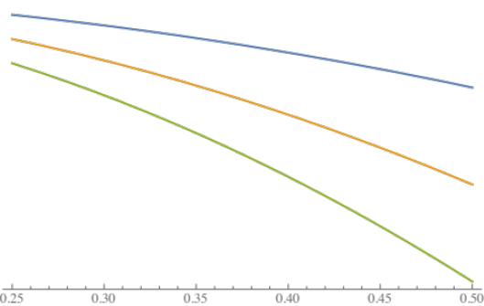
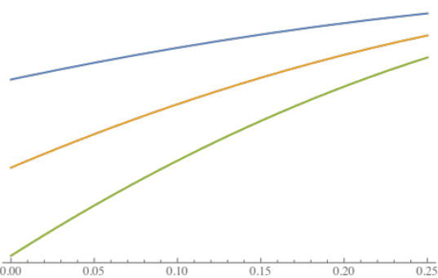
In the noncooperative equilibrium, the first model has shown that when symmetric locations are assumed, the price of the two firms is equal. In this case the market will always be shared equally between the firms. Furthermore, the prices in Nash equilibrium $t(1-2x)$ increase linearly in the distance between the firms. In other words, when the goods are more differentiated price competition is relaxed and the profits in the market are higher. This is due to the fact that when goods are more differentiated, firms have more market power (demand is less reactive to price changes) as explained in the introduction. The higher the transportation costs $t$, the lower the reactiveness of demand to price changes, giving the firms even more market power to charge higher prices. Depending on where the firms are located, the prices and therefore the profits in the collusive stage differ. The price charged in this stage depends on the consumer located on the largest distance to the firm. The farther away this consumer (consumer’s bliss point) is located from a firm (product), the larger is the utility cost of traveling to the firm or buying a good different from its bliss point. Taking into consideration the reservation price, the larger the distance, the lower is the maximum price it is willing to pay for the good is. In section 6 it is shown that there is no incentive to increase price beyond the level where the whole market is served. At this point the marginal benefit of increasing the price is less than the marginal cost that arises due to the loss of consumers. Therefore, the price is set such that the consumer on the largest distance is just willing to purchase the product (as this means that all other consumers are willing to purchase as well). The consumer on the largest distance can be either located on the left or right side of the market a firm is serving. For this reason the price function is piecewise.
Graph 2: Collusive price/profit on $x∈[1/4, 1/2)$
Graph 1: Collusive price/profit on $x∈[0, 1/4)$
The graphs above depict the collusive price for a fixed reservation price and different values of $t$. Here, higher values of $t$ correspond to steeper functions (identical coloured functions have identical values for the parameters $k$ and $t$). Around $x=1/4$, the impact of this variable on the price is relatively low for moderately differentiated goods. However, for highly substitutable products or highly differentiated products, the impact is relatively large where a high $t$implies a low price. The shape of the collusive price function can be explained by the transportation (utility) costs. As the utility cost function is quadratic, the utility costs are increasing in the distance at an increasing rate. Locating in the middle minimizes these utility costs and enables the firm to charge a relatively high price. Therefore high values of $t$ especially influence the likelihood of collusion negatively when goods are highly substitutable or highly differentiated. The reservation price is a constant in the price function and a change in this variable would result in an upward or downward shift of the function, an increase in the reservation price represents an increase in the price of the same magnitude. A higher reservation price makes the collusive profits therefore higher, contributing to the stability of collusion. On $x∈[0, 1/4)$ the price/profit is increasing in $x$ (the less differentiated the goods, the higher the joint profits maximizing price) and on $x∈[1/4, 1/2)$ the price/profit is decreasing in $x$. At $x=1/4$ it reaches its maximum. Even though the location $x=1/4$ is desired in the noncooperative equilibrium from a utility cost minimizing and therefore welfare enhancing point of view, it is undesired for when considering collusion, since it increases the prices and the collusive profits. Thus the closer the firms are located to the welfare optimizing location (desired in Nash equilibrium), the higher the prices will be (undesired to minimize profits in collusion to make collusion less attractive).

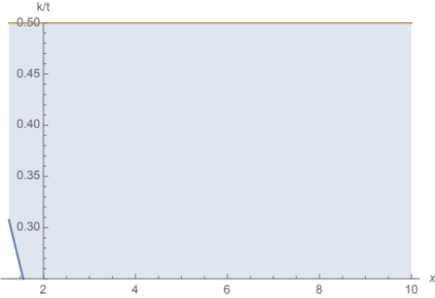
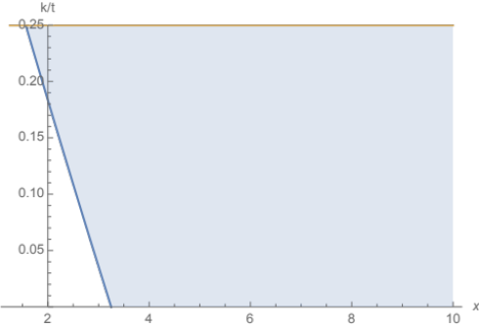
Graph 3: Constraint on $x∈[0, 1/4)$
Graph 4: Constraint on $x∈[1/4, 1/2)$

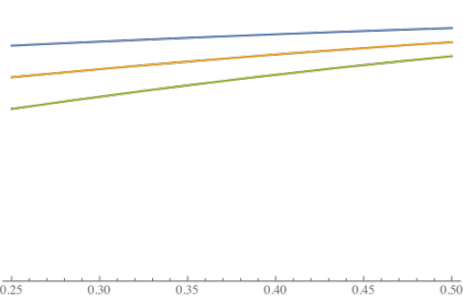
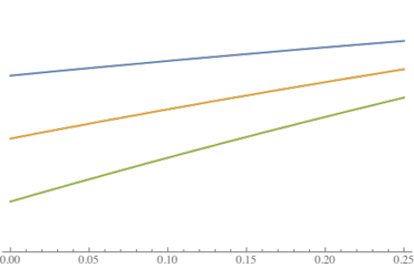
Graph 3 and 4 depict an analysis of the constraint, which determines whether in the deviation phase the deviating firm becomes a monopolist. On each relevant interval the constraint is shown in blue where the horizontal axis measures the ratio $k/t$ and the vertical axis gives the corresponding value of differentiation $x$. The orange line indicates the upper border of the interval. Given the values of the parameters $k$ and $t$ the firm becomes a monopolist whenever it is located in the shaded area in-between the blue and orange line. On the interval $x∈[0, 1/4)$ both becoming a monopolist and coexisting as a duopoly is possible for each location. From graph 3 it can be concluded that the scenario where the deviating firm becomes a monopolist is less likely to happen when the goods are very differentiated; especially when the ratio $k/t$ is low. Graph 4 shows that the firms will not coexist as duopolists on $x∈[1/4, 1/2)$ for each level of differentiation. Here too, the deviating firm is less likely to become a monopolist for low values of $k/t$ and in markets with moderately differentiated goods. The intuitive reason is that becoming a monopolist is relatively easy when goods are substitutable, since a small price cut will generate a large increase in demand. In markets where the level of differentiation is beyond $x≈0.31$, indicating that the goods are moderately to highly substitutable, the deviating firm always becomes a monopolist.
Graph 5: Monopoly Deviation price/profit on $x∈[0, 1/4)$
Graph 6: Monopoly Deviation price/profit on $x∈[1/4, 1/2)$
The deviation monopoly profits (prices) for a certain reservation price are depicted in graphs 5 and 6, where again identical coloured functions correspond to identical values of $t$. Here too, the reservation prices are just a constant where a higher $k$ shifts the function upwards. Higher levels of correspond to steeper $t$ (indicated with arrows), but lower prices/profits. Furthermore, the less differentiated the goods are, the higher are the deviation profits (which is in line with the previously made prediction). In a market with highly differentiated goods, changes in the parameter $t$ result in relatively large changes in price. A high $t$ means that consumers are less willing to switch to the other firm compared to low values of $t$ (for same changes in price). When moving away from the bliss point or location is relatively costly (especially since distance is a fast increasing function in this model), the consumers would rather purchase at the closest firm and pay a higher price than travel a lot to the deviating firm, which undercuts the rival, for a lower price.
The deviation duopoly profits are depicted in graph 7. For the same reservation value, the profit is plotted for different values of $t$ where a higher $t$ corresponds to lower positioned functions. In this graph the fact that the deviating firm will not stay a duopoly for each location is depicted. Especially for high values of $k/t$ this only happens when the goods are relatively differentiated. The effect of the reservation price on the deviation duopoly profits can be easily seen from the profit function: a higher reservation price implies a higher profit. This is true until the point where the reservation price is so high that the deviating firm becomes a monopolist.
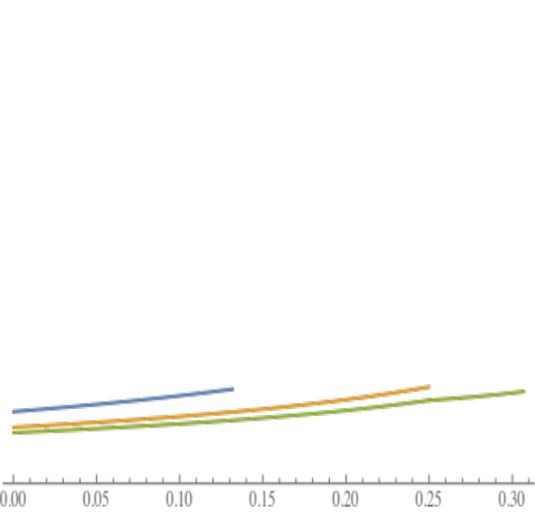
By taking the derivative of the critical discount rate with respect to $t$, $k$ and $x$ the influence of these parameters on the stability of collusion can be determined. Both $∂δ/∂t$ and$∂δ/∂k$ are strictly negative for all $x∈[0, 1/2)$. The partial effect of each parameter on the different profits is determined in the proceeding paragraphs. The net effect of these parameters is such that for higher values of $t$ and $k$, the critical discount rate is lower, indicating that collusion is more likely to occur. The intuition behind this is the following. When the transportation costs are higher, the demand is less reactive to price changes, which gives the firms market power. In other words, the profits in the punishment phase will be higher relatively for higher values of $t$. This effect is large enough to overpower the effect of high transportation costs on the deviation and collusive profits.
Graph 7: Duopoly Deviation profit on $x∈[0, 0.31)$
The derivatives of the discount factors with respect to $x$ ($∂δ/∂x$) are all strictly positive. This means that collusion is less likely the more substitutable the goods are. The effect of $x$ on the Nash profit is always negative, since firms have less market power when the goods are more substitutable. The effect on the deviation profits, on the other hand, is positive as demand becomes more reactive to price changes. The first effect makes collusion more stable, while the second effect makes collusion less stable. The effect of $x$ on collusion differs with the interval of differentiation. When goods are highly differentiated, an increase in substitutability has is positive effect on the profit (collusion becomes more stable), while at a certain point this effect becomes negative (collusion becomes less stable). However the effect of $x$ on the critical discount rate on the entire interval is positive. This indicates that when goods are highly differentiated, the effect of more substitutability on the deviation profits overpowers the effect on the collusive and Nash profits.

A summary of the effects of the variables on the different profits is given in the appendix (Section C, table 1).

Model 2: Price competition with flexible locations
In the second model the assumption of fixed locations is relaxed. In this model at the beginning of each period both firms are obliged to choose a location on the linear spectrum. This gives both firms the ability to further optimize their strategy regarding location and price. The consequence for the Nash equilibrium is that the profits of both firms are strictly increasing in the distance between the firms, implying that in a noncooperative equilibrium the firms will locate at each end of the spectrum. This allows them to exert the high market power and charge a high price $p_{1}=p_{2}=t$, which is obviously increasing in $t$. Due to their choice of symmetric locations and equal prices, the market is equally shared between the two firms. Compared to the previous model for equal values of $t$ and $k$, this means that the noncooperative equilibrium profit is the highest possible profit that could have been attained in model 1. This means that the effect of the Nash outcome on the stability of collusion, where higher punishment profits make collusion less stable, is at its maximum.
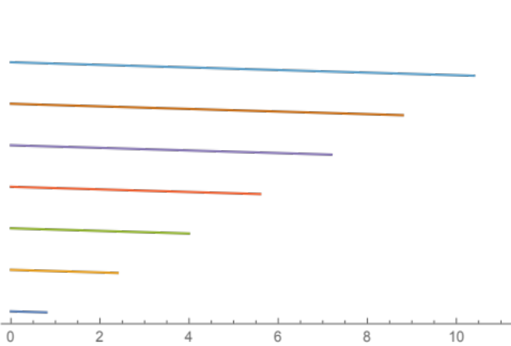
The collusive profits are optimized for location as well. To be able to charge the highest price at which the whole market is still served the firms locate at the location that minimizes the distance the consumers have to travel. This means that the collusive outcome in the first stage is welfare improving, while in the second stage welfare reducing due to the high prices. Graph 8 depicts the collusive profits, where the horizontal axis measures $t$ and the vertical axis measures the profit. Higher located functions correspond to higher values of $k$. This means that the profits increase in the reservation price (indicated by the arrow). The graph shows that the profit decreases linearly in $t$ and that the functions do not have a value for certain intervals of $t$. The latter is due to the assumption on the ratio $k/t$, which must be higher than $5/4$ to serve the entire market in the noncooperative equilibrium.

Graph 8: Collusive profits as a function of t (for different values of k)
The deviation outcome is analyzed for two assumptions, which differ in the reactiveness of the rival to the deviation.

Assumption 1: Punishment phase starts at the beginning of a period
The shape of deviation profit in this model is similar to the collusive profits as shown in graph 8. In fact, the interpretation of the relationship between the profit and the variables $t$ and $k$ is identical to the collusive profits. The difference is that the deviation profits decrease faster in $t$ and are therefore steeper. Since the punishment period can only start at the beginning of each period, the deviating firm has more freedom to maximize profits.
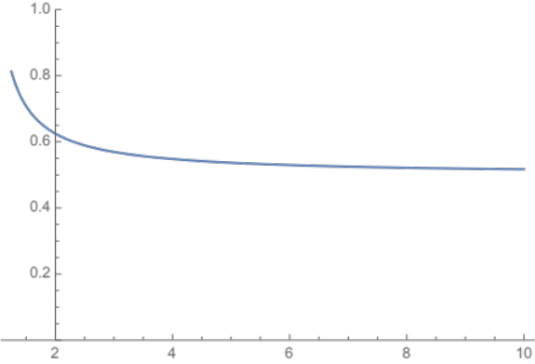
Graph 9 depicts the critical discount rate (vertical axis) for different values of the ratio $k/t$ (horizontal axis). For the lowest possible value of this ratio the critical discount rate is $13/16$, which is relatively close to one. The ratio $k/t$ measures the reservation price relative to the magnitude of the utility cost incurred from purchasing a good that is positioned at a distance from the consumers’ bliss point. The critical discount rate decreases in $k/t$. The ratio is large for small values of $t$ and large values of $k$. So given any$k$, a lower $t$ will make the ratio high and therefore the critical discount factor low. For any $t$, a higher $k$ will make the ratio high and therefore the critical discount factor low. Both effects, ceteris paribus a lower $t$ or a higher $k$, make collusion more likely. Vice versa for relatively small $k$ or relatively large $t$ collusion is less likely.
Graph 9: Critical discount rate as a function of the ratio $k/t$

Assumption 2: Punishment phase starts at the beginning of a stage
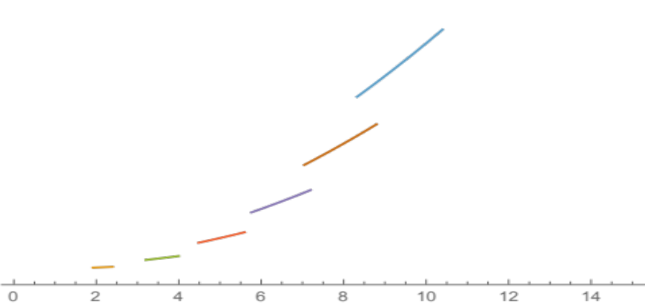
When the punishment phase can start in any stage, the rival firm can start punishing right after the stage where the first signs of deviation are perceived. Therefore the deviating firm has two options: firstly it can deviate in the location stage or it can pretend to collude in the location stage and choose to deviate in the price stage. In section 7 both cases have been examined and it is shown that the deviating firm will always choose for the latter. Therefore, the deviating firm is obliged to locate at the cooperative locations. Given this location it can maximize its profit in the second stage by cheating on the collusive price strategy. Since it does not have the freedom to choose a location, the deviating firm can either be a monopolist or a duopolist, depending on the values of $k$ and $t$. When $k<\left(25/16\right)t$, in other words for a relatively low reservation price or high $t$, the deviating firm chooses to coexist as a duopolist. In this case, severe undercutting in order to become a monopolist is not profitable compared to undercutting slightly in order to gain more demand.
Graph 10: Assumption 2: Deviation profit for duopoly as a function of t (for different values of k)
The profit for the duopoly case is depicted in graph 10. For different values of $k$, the profit is plotted as a function of $t$. Since the reservation price and the deviation profits are positively related, a higher reservation price corresponds to a higher profit curve. Remarkable is however that, as opposing to the other cases, the profit is now increasing in $t$. Even though a higher $t$ results in a less reactive residual demand curve, since the collusive price is decreasing in $t$, the best response price for the rival firm is increasing in $t$. The increasing effect the variable $t$ has on the price of the deviating firm is larger than the decreasing effect it has on the demand.
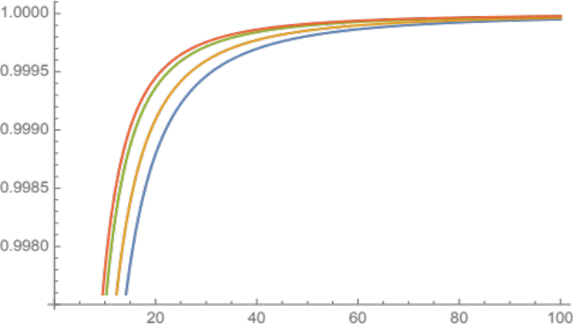
As it is not possible to simplify the critical discount rate to a function of the ratio $k/t$, it is plotted by first expressing $k$ as a function of $t$. In this case the critical discount rate increases for the variable $t$. For each value of $t$, a higher reservation price means a higher critical discount rate (function). In conclusion, higher values of both $k$ and $t$ make collusion less likely to occur.
Graph 11: Assumption 2: Critical discount rate for duopoly as a function of t (for different values of k expressed in t)
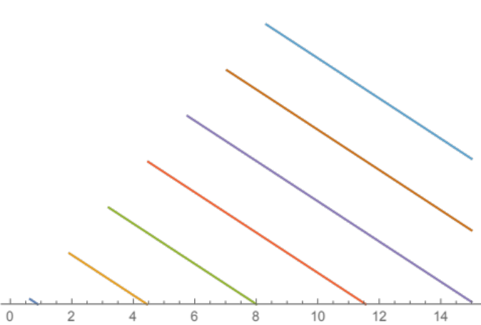
When the deviating firm becomes a monopolist, the profit maximizing price/profit is $k - (9 t)/16$. This function is shown for different values of $k$ as a function of $t$ in graph 12. As can be concluded from both the graph and the algebraic function, this function linearly decreases in the $t$ and increases in $k$. Given the location of the two firms $k - (9 t)/16$ is the highest price the deviating firm can adopt in order to reach the consumer located at the very end of the spectrum on the rival’s side. The critical discount rate is in this case always constant and equal to a half.
Graph 12: Assumption 2: Deviation profit for monopoly as a function of t (for different values of k)

The effects of the variables on the different profits are summarized in the appendix (Section C, table 2).
Model 3: Price competition with quantity constraints
In the third model an exogenous capacity constraint is introduced. The outcome is determined by dividing the game into two cases. In the first case it is assumed that the capacity constraint is smaller than $1/2$. Due to this assumption in the Nash equilibrium there is no incentive to move too far towards the firm, since that means that the markets will not be separated anymore. Taking a position such that both markets are separated is beneficial to both firms, since the rivalry to cover more market space disappears (there is enough demand for both firms) and locating such that the markets are separated ensures that there is no rivalry for consumers. However the one-shot Hotelling equilibrium or, in other words, maximum differentiation is certainly not the equilibrium outcome. Regardless of where the firm exactly locates, it will always want to locate such that it serves $q/2$ on one side and the remaining $q/2$ on the other side, meaning that no firm would want to locate at the end of the spectrum. Due to the separated markets, both firms become local monopolists and charge a price such that the consumer on the farthest distance is served. As the actions chosen by one firm do not impose any externality on the other, by maximizing individual profits the joint profits are maximized as well. In conclusion, the collusive profit is equal to the Nash profit making collusion unnecessary. Even though it is assumed that the capacity is symmetric, relaxing this assumption in a market where the firms cannot serve the entire market should not change the outcome. As long as the whole market cannot be served, the best response will be to locate such that the markets are separated.
When the capacity constraint is larger than a half, the markets of the firms are not separated anymore. Therefore depending on the assumption regarding the punishment period, two different games have been analyzed.

Assumption 1: Punishment phase starts at the beginning of a period
When the punishment period can only start at the beginning of a period, the punishment period is delayed. The deviating firm takes advantage of this situation and deviates in both location and price. Compared to the model without capacity constraints, the incentive to move towards the rival firm is less. As in this model the gain from moving towards the rival is limited by the capacity, the deviating firm will only move towards the rival as much as is needed to cover the capacity. Moving more towards the rival does not result in extra gain in demand, while it has a negative effect on the price. Once the location is chosen, the rival firm will choose the best response price for its location. As for very small capacities it might be such that the deviating firm would want to move at a larger distance than $3/4$, which is of course not possible as the spectrum is limited to be of length one, the profit function is divided into two pieces. The piecewise function covers the case where the deviating would want to position itself outside the spectrum and a case where the deviating firm would want to position itself inside the spectrum. The shape of the curves for the first case is similar to the duopoly case in the previous model under assumption 2. Therefore, relation between $k$ and $t$ is exactly the same. The profits are increasing in both $k$ and $t$.
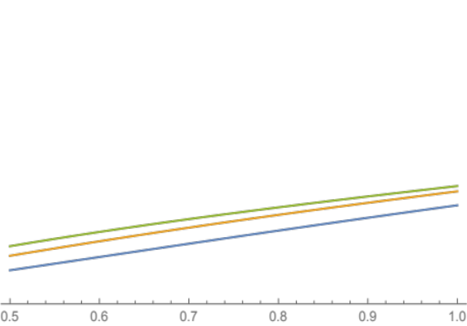
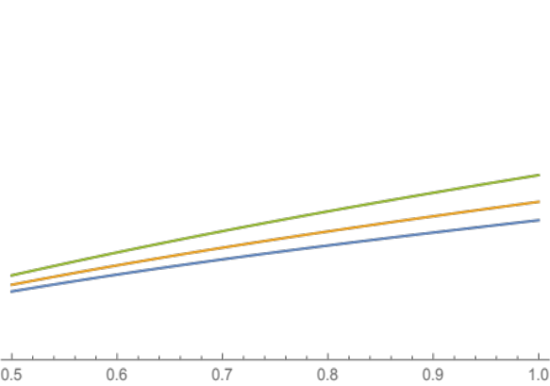
Graphs 13 and 14 show the deviation profit for the case where the firm wants to locate inside the spectrum. In the left graph the deviation profits (vertical axis) are plotted as a function of the capacity constraint for different values of $t$ holding the reservation price constant. The same function is plotted in the right graph similarly, this time holding $t$ fixed and varying the reservation price. In both cases, a higher $k$ or $t$, shifts the profit function up, which contributes to the instability of collusion.
Graph 13: Assumption 1: Deviation profit when the firm locates inside the spectrum for a fixed k and different values of t.
Graph 14: Assumption 1: Deviation profit when the firm locates inside the spectrum for for a fixed t and different values of k.
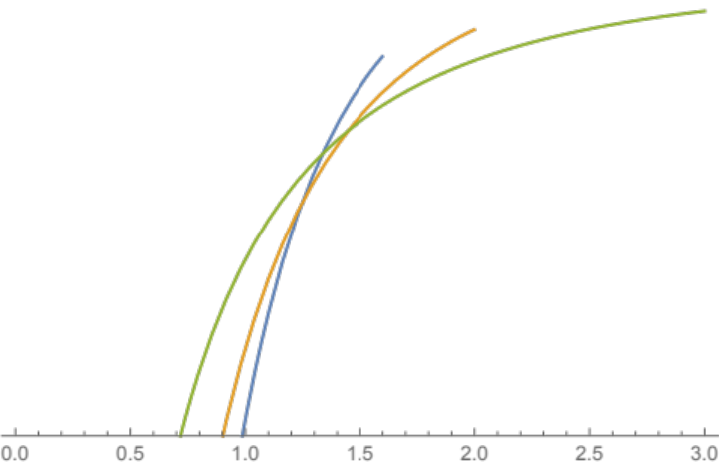
Graph 15 depicts the critical discount rate as a function of $t$ for different values of $k$. The horizontal axis measures $t$ and in the vertical direction the value of the critical discount rate is measured, where the graph shows the entire possible range $[0, 1]$. The first observation that stands out is that the critical discount rate is always increasing in $t$. For higher reservation prices the function moves outwards (${k_{green}>k_{yellow}>k}_{blue}$) and becomes less steep. In other words, higher reservation prices make the likelihood of collusion less reactive to changes in $t$. Because both the slope and the position of the functions change when the reservation price changes, a change in $k$ can make collusion more or less stable, depending on the value of $t$. For low values of $t$ a higher reservation price is likely to increase the critical discount rate, while for high values of $t$ a higher reservation price is more likely to enhance the stability of collusion.
Graph 15: Assumption 1: Critical discount rate when the deviating firm wants to locate outside the spectrum.
Graphs 16 and 17 depict the critical discount rate when the deviating firm locates inside the spectrum. In graph 16 the reservation price is held constant, for different values of $t$ the critical discount rate (vertical axis) is plotted as a function of $q$ (horizontal axis). For higher values of $t$ the function moves outwards (${t_{green}>t_{yellow}>t}_{blue}$), meaning that a higher $t$ corresponds to a higher discount factor.
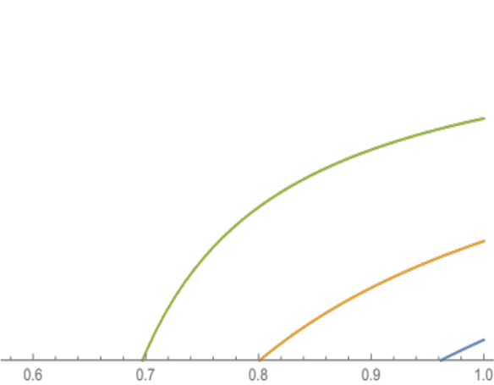
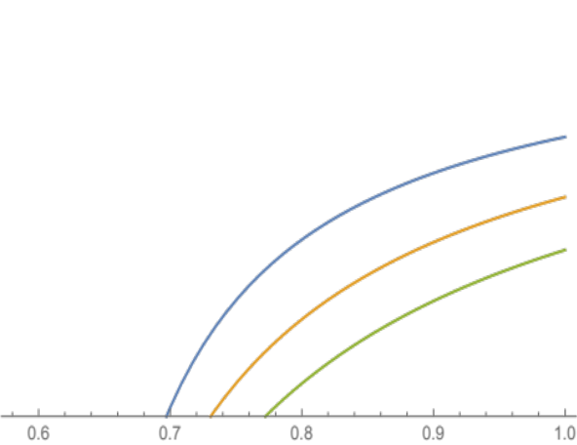
Graph 17 shows a similar plot where the only difference is that $t$ is fixed and the discount rate is plotted for different reservation prices. A higher reservation price corresponds to an inward shift of the function, meaning that the discount factor decreases in the critical discount rate. In both cases the critical discount rate increases in the capacity constraint. This is of course logical. For higher values of $q$, the deviation profits are higher and therefore collusion is less stable.
Graph 16: Assumption 1: Critical discount rate when the deviating firm wants to locate inside the spectrum for a fixed k and different values of t.
Graph 17: Assumption 1: Critical discount rate when the deviating firm wants to locate inside the spectrum for a fixed t and different values of k.

Assumption 2: Punishment phase starts at the beginning of a stage
As the punishment period can now start in each stage, the deviating firm is more restricted in its deviation. In the previous section it is shown that, when a deviating firm faces a reactive competitor, the deviating firm will always adopt the collusive location strategy, since relocating when the rival firm can punish in the price competition period is simply not profitable. Depending on the capacity constraint, the deviating firm can be limited in serving its demand or not. For $k/t≤2q-7/16$, it is never limited. This condition is more likely to be true for relatively low values of $k/t$ and for high values of $q$. While the latter observation is very obvious, the first is very logical too. When transportation costs are relatively high, a consumer is more reluctant to move to another firm after a price cut. Therefore, it might not be profitable to severely undercut the rival firm, as the price cut will not result in high demand. In other words, the demand for the firm will not be very high. When the deviating firm is not limited by its capacity constraint the profit is exactly the same as in model 2 under assumption 2.
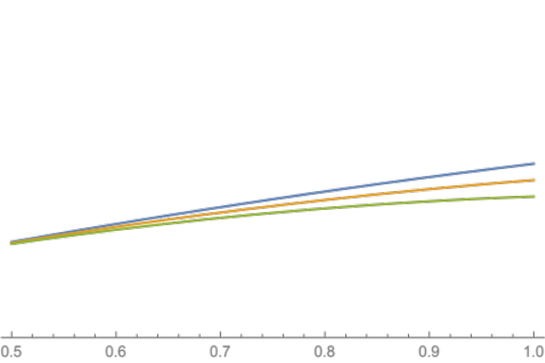
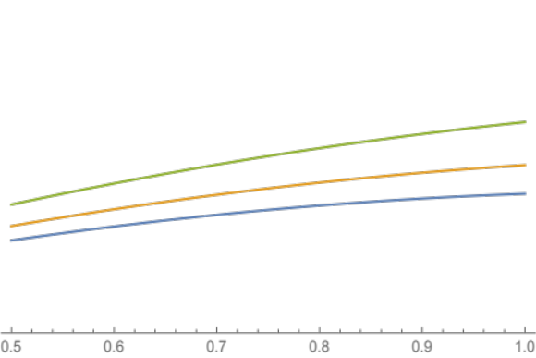
When the capacity constraint is binding the firm charges the price $k +(7/16) t – qt$. This price is decreasing in $q$, which is logical. The more market share the deviating firm wants to capture, the larger the difference between the prices of the firms must be in order to convince the consumers that live very close to rival to purchase from the deviating firm. The profit of the deviating firm when capacity is binding is depicted in the graphs 18 and 19. Graph 18 shows the profit for different values of $t$ and a fixed $k$, while graph 19 depicts the profit for different reservation prices and a fixed $t$. For higher values of $t$, the function becomes less steep. For the reservation price the effect is the opposite. A higher reservation price makes the production function steeper and shifts the profit function upwards. In both cases the profit increases in the capacity constraint.
Graph 18: Assumption 2: Deviation profit when capacity is binding for a fixed k and different values of t.
Graph 19: Assumption 2: Deviation profit when capacity is binding for a fixed t and different values of k.
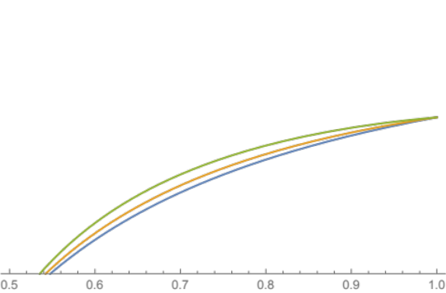
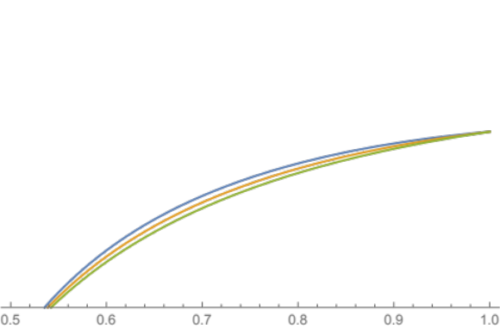
Graph 20 and 21 illustrate the critical discount rate when the deviating firm is limited by its capacity. In the graphs the critical discount rate is plotted against the capacity limit. In the plot on the left the reservation price is kept at a fixed amount while varying $t$, whereas in the plot on the right the reservation price is varied and the value of $t$ is kept fixed. In both cases the critical discount factor is increasing in $q$. The reason is identical to the reason given with assumption 1. When the capacity constraint is higher, the deviation profits are higher and deviating is more appealing. The value of $t$ has a negative effect on the critical discount rate, while the reservation price is positively related to the critical discount rate. Both have the largest impact when capacity is low or moderate ($q≈0.7$) and converge to the same critical discount rate for $q=1$.
Graph 20: Assumption 2: Critical discount factor when capacity is not binding for a fixed k and different values of t.
Graph 21: Assumption 2: Critical discount factor when capacity is not binding for a fixed t and different values of k.

The effects of $k$ and $t$ on the profits and critical discount rate are shown in the appendix (Section C, table 3).

X. CONCLUSION
In the preceding sections, the stability of collusion in different markets is examined. By determining the Nash, collusion and deviation profits, the likelihood of collusion is measured with a critical discount rate. Three models, where each subsequent model differs from the previous model in one assumption, have been examined. The assumptions of the first model are based on the game as modeled by Chang (1991). In order to create the second model, Chang’s model is modified by endogenizing the location of the firms. The game is transformed into a two-stage game, which allows firm to repetitively choose a location at the beginning of the period. Introducing an exogenous capacity constraint to the second model generates the third model. Both the second and third models are assessed for two different assumptions on the reactiveness of the rival to deviation. Under the first assumption the rival is not able to start the punishment phase in each stage and is obliged to wait until the start of a new period. This permits the deviating firm to maximize deviation period for both location and price without taking into account the burden a punishment period imposes on the profit in that period. The second assumption on the other hand, is intended to examine the effects of a reactive rival that starts the punishment phase in the subsequent stage.
The key assumption of the first model is the exogeneity of the locations $(x, 1-x)$ of the firms, which are presumed to be symmetric. Due to the symmetry assumption the location ($x$) of the leftmost firm can be interpreted as a measure of substitutability of the products of the firms, where when $x$ approaches $1/2$ the products become more and more substitutable. An increase in substitutability has an increasing effect on the deviation profit and a decreasing effect on the Nash equilibrium profit. The first effect decreases the stability of collusion, while the latter increases the stability. The effect of an increase in substitutability on the collusive profit is omnidirectional. Nevertheless, regardless of the effect on the collusive profit, the critical discount rate is monotonically increasing in substitutability. These findings show that collusion is more likely in markets where goods are very differentiated. The critical discount rate is, however, negatively related to the reservation price and the variable $t$.
The assumption on the exogeneity of the location limits the applicability of the model, since it only accounts for situations where it is impossible to relocate or where relocation costs are exceptionally high. In numerous markets this assumption is not met. For this reason the assumption on exogenous locations is discarded in the second model. The outcome of this model is, therefore a strict subset of the possible outcomes of the previous model. The consequence of modifying this assumption is that in each phase the firms can optimize the outcome of the previous model for location. In the Nash equilibrium firms locate on the endpoints of the linear city. The rationale behind this outcome is that when firms locate on a larger distance from each other the price competition decreases in severity. The Nash equilibrium of the second model is equivalent to the highest attainable profit of all possible outcomes of the first model, as the Nash equilibrium profit in the previous model is established to be decreasing in $x$. The solitary effect of the Nash equilibrium on the likelihood of collusion caused by relaxing the exogeneity assumption is negative. In line with this reasoning, the collusive and deviation profits are optimized for location. In the collusive equilibrium the location choice bundle $(1/4, 3/4)$ minimizes the utility cost the consumers incur. This effect allows the firms to charge maximum prices and earn maximum profit, contributing to the stability of collusion. Remarkably, the effect of the location stage during collusion is welfare enhancing. This positive effect on the allocative efficiency, however, is nullified by the increase in price.
The outcome of the deviation phase is determined for two different assumptions on the promptness of the start of a punishment phase. In a game where the rival firm can only start the punishment period at the beginning of each period, the deviating firm can maximize its deviation profits with respect to location and price. By undercutting the rival sufficiently the deviating firm always becomes a monopolist and locates on the middle of the linear spectrum. As the deviation profit in the first model strictly increases in $x:x∈[0, 1/2)$, the deviation profit in the second model under assumption two is the highest attainable deviation profit in the first model. Even though compared to model 1 all three profits are affected, the critical discount rate for model 2 under assumption 1 is always higher. This implies that the gain in deviation and Nash profits is sufficiently high to overpower the effect on the collusive profits. The effect of the reservation price on the critical discount rate is negative, while the effect of $t$ is positive.
When the rival firm is able respond to the deviation in each stage, the deviating firm can either choose to deviate in location or to deviate in price depending on the severity of the effect of the subsequent punishment period on the deviation profits. It is shown that deviation in location is never profitable, since the punishment period in the price stage decreases the deviation profit significantly. As a result both firms adopt the collusive location and locate on $(1/4, 3/4)$. The exact market structure in this phase depends on the values of the parameters $k$ and $t$. Since monopoly profits are always higher than duopoly profits and since both profits increase in location on $[0, 1/2)$ the deviation profit under assumption 1 is always higher. The difference in deviation profits is the only variance in the outcome between the models subject to the two different assumptions. Consequently, collusion is more likely when the punishment can be commenced rapidly. Under second assumption the deviation profit compared to the first model may either be higher or lower. In markets where the products are relatively substitutable the deviation profit in the first model will be higher and affect the probability of collusion negatively (relative to a comparable market with flexible locations). The effect of both the reservation price and $t$ on the duopoly critical discount rate is positive. The critical discount rate of the monopoly case is always $1/2.$ In summary, as the only difference between the two assumptions in the second model is the effect on the deviation profits, the effect on the critical discount rate is unilateral: a market which allows firms return to the Nash equilibrium directly after deviation is more prone to collusion. As opposed to the second model under assumption 1, the effect of removal of the exogeneity of locations under assumption 2 shows to be ambiguous.
The third model is composed by introducing an exogenous capacity constraint to the second model. The outcome of the model is described in two cases. In the first case the capacity constraint is assumed to be smaller than $1/2$. Due to this assumption the firms cannot serve the entire market for any price/location strategy. Therefore the Nash equilibrium strategy is to locate such that the markets of the firms are separated and to charge the highest possible price that depletes the selling capacity of each firm. As the strategy in the collusive phase does not differ from the strategy in the competitive phase, collusion is unnecessary in this market. High market power is exerted without colluding.
On the other hand, collusion is profitable when the capacity constraint is higher than $1/2$. Since the capacity constraint is not binding for both the Nash and collusive equilibrium, only the deviation profits are affected. Under assumption 1 the firm locates as much towards the endpoint of the linear city as it can. For this reason, the deviation profits are piecewise. For some values of the capacity constraint the incentive to increase the distance between the deviating and the rival firm is too large for the spectrum. In this case the deviating firm locates on the endpoint. Under assumption 2 it is never profitable to deviate in location, since the rival firm starts the punishment phase right after the deviation. Therefore, the firms always adopt the collusive location strategy. The firms choose a price strategy depending on the capacity constraint. When the constraint is binding the firm charges the price that equates the firm’s demand with its capacity. Under both assumptions the difference with the corresponding second model is only in deviation profits. In the second model the deviating firm always becomes a monopolist under the first assumption. Therefore, the deviation profits will be lower in third model under the corresponding assumption. The deviation profits under the second assumption are lower in the third model compared to the second model whenever the capacity is binding. For relatively high values of $k/t$ and for low values of $q$, the capacity is binding. Hence, collusion is relatively more stable in spatial competition markets with a binding capacity constraint
The variation in outcomes of the different models stipulates that the results are sensitive to changes in the assumptions. This finding suggests that any extension to the model can provide useful insight in the stability of collusion. The assumptions that limit the application of a Hotelling model the most, i.e. the most unrealistic assumptions, are the assumptions on the distribution of the consumers, the shape of the city and the number of operating firms. Whereas in the models used in this paper the marginal consumer represents the market share of one of the firms, this is not true for linear cities with a different distribution, cities with a different shape or in market with more than two firms. For instance, a distribution that assigns more weight to the middle of the linear spectrum will increase the marginal benefit of locating towards the middle compared to the current model. This change is likely to have consequences for the Nash equilibrium of the Hotelling model with quadratic costs. The location choice of the firms (and the price strategy) will differ from the current equilibrium if the increase in the marginal benefit of locating towards the middle is sufficiently high. Each of these extensions represents a different market. Therefore, analyzing their effect on current models improves the application of the suggested case-by-case analysis.

XI. APPENDICES

Section A: Summary of results
IV.A Model 1
Table 1.1 Prices in model 1
 | $$p_{j}≥3t(1-2x)$$ |  | $$p_{j}<3t(1-2x)$$
Interval | $$[0, 1/4)$$ | $$[1/4, 1/2)$$ | $$[0, 1/4)$$ | $$[1/4, 1/2)$$
Nash | $$t\left(1-2x\right)$$ | $$t\left(1-2x\right)$$ | $$t\left(1-2x\right)$$ | $$t\left(1-2x\right)$$
Collusion | $$k-t{(1/2-x)}^{2}$$ | $$k-tx^{2}$$ | $$k-t{(1/2-x)}^{2}$$ | $$k-tx^{2}$$
Deviation | $$k-t{(1/2-x)}^{2}-t(1-2x)$$ | $$k-t{(1-x)}^{2}$$ | $$1/8 (4 k + t (3 - 4 x (1 + x)))$$ | $$1/2 (k + t - tx^{2} - 2 t x)$$

Table 1.2 Profits in model 1
 | $$p_{j}≥3t(1-2x)$$ |  | $$p_{j}<3t(1-2x)$$
Interval | $$[0, 1/4)$$ | $$[1/4, 1/2)$$ | $$[0, 1/4)$$ | $$[1/4, 1/2)$$
Nash | $$t\left(1-2x\right)/2$$ | $$t\left(1-2x\right)/2$$ | $$t\left(1-2x\right)/2$$ | $$t\left(1-2x\right)/2$$
Collusion | $$(1/2)(k-t{(1/2-x)}^{2})$$ | $$(1/2)(k-tx^{2})$$ | $$(1/2)(k-t{(1/2-x)}^{2})$$ | $$(1/2)(k-tx^{2})$$
Deviation | $$k-t{(1/2-x)}^{2}-t(1-2x)$$ | $$k-tx^{2}-t(1-2x)$$ | $$-{\frac{(4 k + t (3 - 4 x (1 + x)))}{128 t (-1 + 2 x)}}^{2}$$ | $$-{\frac{(k + t - tx^{2} - 2 t x)}{8 t (-1 + 2 x)}}^{2}$$

IV.A Model 2
Table 2.1 Prices in model 2
 | Price | Location
Nash | $$t$$ | $$x=0$$
Collusion | $$k-t/16$$ | $$x=1/4$$
Deviation assumption 1 | $$k-t/4$$ | $$x=1/2$$
Deviation assumption 2: Duopoly | $$(1/2)(k-t/16)+t/4$$ | $$x=1/4$$
Deviation assumption 2: Monopoly | $$k - (9 t)/16$$ | $$x=1/4$$

Table 2.2 Profits in model 2
 | Profit | Location
Nash | $$(1/2)t$$ | $$x=0$$
Collusion | $$k/2-t/32$$ | $$x=1/4$$
Deviation assumption 1 | $$k-t/4$$ | $$x=1/2$$
Deviation assumption 2: Duopoly | $$\frac{{(16k+7t)}^{2}}{1024t}$$ | $$x=1/4$$
Deviation assumption 2: Monopoly | $$k - (9 t)/16$$ | $$x=1/4$$

IV.A Model 3
Table 3.1 Case capacity is smaller than 1/2
 | Location | Price | Profits
Nash | $$θ+q/2$$ | $$k-(1/4)tq^{2}$$ | $$(k-(1/4){tq}^{2})q$$
Collusion | $$θ+q/2$$ | $$k-(1/4)tq^{2}$$ | $$(k-(1/4){tq}^{2})q$$

Table 3.2 Assumption 1: Case capacity is larger than ½
Firms wants to locate | $${ x}_{D}$$ | Profits
Outside the spectrum | $$0$$ | $$\frac{{(2 k + t)}^{2}}{24t}$$
Inside the spectrum | $$2q-\sqrt{\frac{k}{t}+q\left(4q-3\right)+\frac{1}{2}}$$ | $${(q}^{2}/2) (3t - 8 qt + 2\sqrt{2t} \sqrt{2 k + t – 6 q t + 8 q^{2}t})$$

Table 3.3 Assumption 2: Case capacity is larger than ½
 | Price | Profits
Capacity Not Binding | $$k/2 + 7 t/32$$ | $$\frac{{(16k+7t)}^{2}}{1024t}$$
Capacity Binding | $$k +(7 /16)t - q t$$ | $$k q + 1/16 (7 - 16 q) q t$$

Section B: Analysis of derivative
Derivative deviation profits w.r.t. $x_{1}$ duopoly:

$$∂π^{d}/∂x_{1}=\frac{(2k+t-2t{x_{1}}^{2})(2k+t\left(1+6x_{1}\left(x_{1}-1\right)\right))}{2t{(3-4x_{1})}^{2}}$$

This function consists of three parts: two terms multiplied in the nominator and the denominator. The denominator is always positive, since $t$ is always positive. For each term the interval on which it is positive or negative has to be determined in order to determine the sign of the full derivative.

$$2k+t-2t{x_{1}}^{2}$$
Rearranging gives that this term is negative when $x_{1}>\sqrt{1/2+k/t}$. By the assumption $k/t≥5/$4 this is only true for minimally $x_{1}>\sqrt{7/4}$, which is already outside the range of the linear spectrum. In conclusion, this term is always positive in this model.

$$2k+t\left(1+6x_{1}\left(x_{1}-1\right)\right)$$
Rearranging gives that this term is negative when ${(x_{1}-1/2)}^{2}<1/12-(1/3)k/t$. Again since $k/t≥5/$4, this can never hold. Therefore the second term is also always positive in this model.

Since all terms are positive, the derivative is strictly positive in the interval. Hence, the deviation profits strictly increase when the deviating firm (firm 1) moves left given $x_{1}<x_{2}$.
Section C: Summary of the effects of the parameters
 | $$k$$ | $$t$$ | $$x$$
Nash | n/a | + | -
Collusion | + | - | +/-
Deviation monopoly | + | - | +
Deviation duopoly | + | - | +
Net effect on critical discount rate | - | - | +

Table 1: Model 1 - Summary of the effects of the parameters

 | $$k$$ | $$t$$
Nash | n/a | +
Collusion | + | -
Deviation Assumption 1 | + | -
Deviation Assumption 2: Duopoly | + | +
Deviation Assumption 2: Monopoly | + | -
Net effect on critical discount rate Assumption 1 | - | +
Net effect on critical discount rate Assumption 2: Duopoly | + | +
Net effect on critical discount rate Assumption 2: Monopoly | n/a | n/a
Table 2: Model 2 - Summary of the effects of the parameters

 | $$k$$ | $$t$$
Nash | n/a | +
Collusion | + | -
Deviation Assumption 1: Outside Spectrum | + | +
Deviation Assumption 1: Inside spectrum | + | +
Deviation Assumption 2: Capacity Not Binding | + | +
Deviation Assumption 2: Capacity Binding | + | -
Net effect on critical discount rate Assumption 1: Outside spectrum | - | +
Net effect on critical discount rate Assumption 1: Inside spectrum | +/- | +
Net effect on critical discount rate Assumption 2: Capacity Not Binding | + | +
Net effect on critical discount rate Assumption 2: Capacity Binding | - | +
Table 3: Model 3 - Summary of the effects of the parameters

XII. BIBLIOGRAPHY

Anderson, S. P., & Neven, D. J. (1991). Cournot Competition Yields Spatial

Agglomeration. International Economics Review , 32, 793-808.

Belleflamme, P., & Peitz, M. (2010). Industrial Organization: Markets and
Strategies. New York: Cambridge University Press.

Bruttel, L. V. (2009). The critical discount factor as a measure for cartel stability? Journal of Economics , 2, 113-136.

Chang, M.-H. (1991). The effect of product differentation on collusive pricing. International Journal of Industrial Organization , 9, 453-469.

D'Aspremont, C., Gabszewitcz, J. J., & Thisse, J. F. (1979). On Hotelling's "Stability in Competition". Econometrica , 1145-1150.

Deneckere, R. (1983). Duopoly Supergames With Product Differentiation. Economic Letters , 37-42.

Donsimoni, M.-P., Economides, N. S., & Polemarchakis, H. M. (1986). Stable
Cartels. International Economic Review , 27, 317-327.

Green, E. J., & Porter, R. H. (1984). Noncooperative collusion under imperfect price information. Econometrica , 87-100.

Gupta, B., & Venkatu, G. (2002). Tacit Collusion in a Spatial Model with Delivered Pricing. Journal of Economics , 49-64.

Hamilton, J. H., Thisse, J.-F., & Weskamp, A. (1989). Spatial Discrimination: Bertrand vs. Cournot in a Model of Location Choice. Regional Science and Urban Economics , 19, 87-102.

Hobbs, B. F. (1986). Mill Pricing Versus Spatial Price Discrimination Under Bertrand and Cournot Spatial Competition. The Journal of Industrial Economics , 35, 173-191.

Hotelling, H. (1929, March). Stability in Competition. The Economic Journal , 41-57.

Ivaldi, M., Jullien, B., Rey, P., Seabright, P., & Tirole, J. (2003). The Economics of Unilateral Effects. European Commission. Toulouse: Industrial Economics Institute.

Jacquemin, A., & Slade, M. E. (1989). Handbook of Industrial Organization (Vol. 1). (R. Willig, & R. Schmalensee, Eds.) Amsterdam: Elsevier.

Matsumura, T., & Shimizu, D. (2004). Spatial Cournot competition and economic welfare: a note. Regional Science and Urban Economics , 658-670.

Motta, M. (2004). Competition Policy: Theory and Practice. New York: Cambridge University Press.

Neven, D. (1985). Two Stage (Perfect) Equilibrium in Hotelling's Model. The Journal of Industrial Economics , 317-325.

Pal, D. (1998). Does Cournot competition yield spatial agglomeration? . Economics Letters , 60, 49-53.

Ross, T. W. (1992). Cartel stability and product differentiation. International Journal of Industrial Organization , 10, 1-13.

Rotemberg, J., & Saloner, G. (1986). Supergame-theoretic of price wars during booms. American Economic Review , 390-407.

In some cases this might be proven not to be true, for example when collusion redistributes production amongst firms in a market where firms are asymmetric in efficiency. If in the collusive outcome the efficient firms produce more than the inefficient ones, a welfare improvement can result from collusion. However, in most cases collusion will show to be welfare reducing.
The outcome in these models is that both firms locate in the middle with minimum differentiation.
The product space represents all possibilities of products that differ in one aspect.
At $k≥(5/4)t$ this condition is met (Chang, 1991).
The term $2 + 3 x_{1} - x_{2}>0$ even for the lowest possible value of $x_{1}$ and the highest possible value of $x_{2}$, while the term $2 + x_{1} + x_{2}$ is always positive since the location must be positive.
The term $4 + x_{1} - 3 x_{2}>0 even for the lowest possible value of x_{1} and the highest possible value of x_{2}$, while the term $-4 + x_{1} + x_{2}<0$ for the highest possible values for both locations.
The first part of the piecewise price function (where both firms coexist) is the best response price as derived in (4). The second part is the price that, given the rival’s price, equates the marginal consumer with 1 (this is from firm 1’s perspective).
The highest possible price at which the consumer still purchases the good.
Since the joint profits are a sum of the profits:$π^{J}=p_{1}\left(x+\sqrt{\frac{k-p_{1}}{t}}\right)+p_{2}\left(x+\sqrt{\frac{k-p_{2}}{t}}\right)$ and the profit of the rival is not a function of the price of the deviating firm $∂π^{J}/∂p_{1}=∂π_{1}/∂p_{1}$.
Due to the assumption $q<1/2$.
For increments that are sufficiently small.
For example for a best response price that gives a demand d>q, there is an incentive to deviate from this equilibrium price. The marginal benefit of increasing the price at this point is the price times d, while the marginal cost is zero as, due to the capacity constraint, the firm could not serve the lost consumers in the alternative case either.
To be precise there are two parts to the constraint that have to be met simultaneously in order for the deviating firm to become a monopolist. These are $x≤7/2+\sqrt{\frac{k}{t}+9}$ and $x≥7/2-\sqrt{\frac{k}{t}+9}$ on $x∈[0, 1/4)$ and $x≤3+\sqrt{\frac{k}{t}+6}$ and $x≥3-\sqrt{\frac{k}{t}+6}$ on $x∈[1/4, 1/2)$ . Since by assumption $x∈[0, 1/2)$ the conditions $x≤7/2+\sqrt{\frac{k}{t}+9}$ and $x≥3-\sqrt{\frac{k}{t}+6}$ are always met. In fact, the value of these functions is so high that it is not shown in graphs 3 and 4.

