Master Thesis
The Relationship between Attitudinal Measures and Firm Value
An international perspective



ERASMUS UNIVERSITY ROTTERDAM
School of Economics

Thesis supervisor Dr. Hariharan V.G.
Name Vincent Sean Schallenberg
Student number 329770
Email vince.schallenberg@hotmail.com
Study Economics and Business (Marketing)
Thesis Master

1. Abstract
The paper examines the relationship between attitudinal measures and firm value. Evaluations on attitudinal measures is done in 16 countries and a total of 270 observations has been made in Europe and the United States of America. By using a linear regression model the relationship between the attitudinal measures and firm value for international brands is examined. Company measures are used as control variables.
A highly significant positive relationship is found for the number of employees for international brands to firm value. Brand equity can be seen as a umbrella construct for all attitudinal measures including purchase intention. These attitudinal measures show a highly significant relationship on firm value.
In addition a comparison between the non-durable and –durable goods industry is made. For the durable goods industry research and development expenses are added as variable. Highly significant evidence is found for research and development expenditures in explaining firm value. For the non-durable goods analysis and the durable goods analysis highly significant relationships are found for the number of employees and attitudinal measures (brand equity and purchase intention) on firm value.
To conclude: The attitudinal measures have a positive relationship to firm value.
Keywords: attitudinal measures, firm value, brand equity, international, multiple industries.

2. Preface
The subject for this thesis is chosen based on the interest in the field of brand management. My preference in this subject has been grown since I started with the master Economics and Business Economics on the Erasmus University Rotterdam. I am glad to conclude my academic career with this paper. Most of all because it is something I stand for.
First of all I like to thank my thesis supervisor, dr. V.G. Hariharan. He was always there if I had troubles. With his guidance and help the thesis writing became a lot easier. The recommendations of dr. V.G. Hariharan has led to a more valuable research.
I also want to thank my father for the support and feedback throughout the process and the rest of my family and friends. In total evaluations have been gathered in 16 countries over the world. Especially here my family and friends were a great help in spreading the survey through Europe and the United States of America. This resulted in an in-depth view of attitudinal measures of international brands in relationship to firm value.

Table of contents
1. Abstract 1
2. Preface 2
3. Introduction 5
3.1 Problem indication 5
3.2 Problem Statement 6
3.2.1 Contribution in short 7
3.3 Thesis Outline 7
3.4 Research questions and design 8
3.4.1 Desk research questions 8
3.4.2 Field research questions 8
3.5 Scope of the paper 9
4. Theoretical Framework 10
4.1 Brand valuation 10
4.1.1 Financial based valuation 10
4.1.2 Attitudinal based valuation 11
4.2 Company variables 17
4.3 Conceptual framework - hypotheses summarized 18
5. Research Method 19
5.1 Company and industry selection 19
5.2 Data collection and data extraction 20
5.3 The questionnaire 21
5.4 Data preparation – Attitudinal measures versus company variables 22
5.5 Empirical Design 23
5.5.1 Preliminary formula all brands 23
5.5.2 Preliminary formula non-durable goods 23
5.5.3 Preliminary formula durable goods 23
6. Results 24
6.1 Pre analysis 24
6.1.1 Definite formulas 25
6.2 Regression analysis: the main model 25
6.2.1 Correlation matrices 25
6.2.2 Analysis on all brands 26
6.3 Non-durable sector versus durable-sector 29
6.3 Post hoc results 32
6.3.1 Purchase intention levels 32
6.3.2 Estimated models using the average 33
7. Limitations and suggestions for future research 33
8. Conclusion and managerial implications 35
9. References 37
10. Appendix 41
10.1 Survey Questions 41
10.2 Normality analysis 42

3. Introduction

3.1 Problem indication
‘A product is something made in a factory; a brand is something that is bought by a customer. A product can be copied by a competitor; a brand is unique. A product can be quickly outdated; a brand is timeless’. (Stephen King WPP Group London).
Most metrics-based quantitative research has focused on linking marketing actions directly to the company’s top line, bottom line, and stock market performance (Lehmann, 2004) (Pauwels, 2004) (Srinivasan & Hanssens, 2009). ‘Companies that make steady gains in mind and heart will inevitably make gains in market share and profitability’ (Kotler 2003, pp. 38–39). Lehman’s paper (2004) states that if marketing wants to play an important role in business decision making, you have to make the connection to financial performance. Instead of talking about abstract things you can link attitudinal measures (e.g. brand equity is a part of these attitudinal measures) to something what is most important for companies: firm value and thus performance.

Managerial implications
For managers this paper will contribute to the understanding of the connection between attitudinal measures and its relationship with firm value. Brands are worth billions and billions of dollars. For example Apple, is worth approximately 100 billion dollars according to the brand valuation website ‘branddirectory’. You can imagine that a small change in brand equity can lead to changes of millions of dollars for international brands. In a recent article of Tirunillai & Tellis (2012) for example they found that an increase of negative word of mouth (via blogs) leads to smaller trading volumes and negative stock performance. Luo (2009) even suggests that underperformance in stocks in the past creates a vicious circle of more negative word of mouth, which leads to bad performance and so on. Furthermore in the article of Baldrauf, Kravens and Binder (2003) they found results indicating strong support for measures of perceived quality, brand loyalty, and brand awareness in relationship to a firms’ performance, customer value and willingness to buy.
It is therefore essential to get deeper understanding in the relationship between attitudinal measures and firm value for good management of the brand’s performance. These days a lot of information is freely available, but there exists a gap between this free information and the information companies can use for their benefit. Nowadays connections to the other side of the world are made in less than a second. Sure, managers of international companies understand the importance of being a well-known brand. But is this enough? What is the relationship between brand equity and actual firm performance?
This paper will provide additional support in explaining the relationship between attitudinal measures and firm value.

3.2 Problem Statement
Anderson Fornell and Mazvancheryl (1994) link customer satisfaction to stock performance and find a clear positive relationship. This relationship is also confirmed by other research and show a positive correlation between brand equity and a firm’s performance as well (Hong-Bumm, Woo Gon, & Jeong, 2003). Smith and Wright (2004) found that measures of customer loyalty explain levels of relative revenue growth and profitability. Also earlier research ((Anderson Fornell and Mazvancheryl (1994), Hong-Bumm, Woo Gon, & Jeong (2003), Pauwels (2004), Srinivan et all. (2009)) link brand equity to a firms’ performance.
One article in particular from Srinivasan et all. (2009) uses information on brands on a national level (France) and use three factors for measuring brand equity: advertising awareness, brand consideration and brand liking. They find a significant relationship between these three factors and sales. They urge that quantitative modelers open the black box of customer mind-set metrics and branding experts consider competition (competitive brands in one category) more explicitly. They suggest further research is necessary to establish empirical generalizations by examining other mind-set metrics, regions, and product categories.
The focus of the current literature has been on single country brands and primarily based on a single industry category. In addition to the current literature this paper will examine brand equity, in depth, on an international level in relationship to firm value controlled for company variables. Additionally different industries are studied.
The main question to answer is the following: What is the relationship between attitudinal measures and firm value for international brands?

3.2.1 Contribution in short
Authors | Subject | Geographical level | Multiple industries?
Anderson Fornell and Mazvancheryl (1994) | Customer satisfaction to stock performance. | National (Sweden) | No
Hong-Bumm, Woo Gon, & Jeong (2003) | Consumer based brand equity on firms’ performance. | National (South Korea) | No
Rust, Lemon & Zeithaml, (2004) | Customer Equity and market valuation | National (United States) | Yes
Pauwels (2004) | Long term marketing effectiveness on firms’ performance | National (United States) | No
Srinivan et all. (2009) | Marketing actions, brand equity (3 factors), to a firms’ performance. | National (France) | No
This study (2014) | Attitudinal measures on firm value. | International (Europe and United States of America) | Yes

3.3 Thesis Outline
In the first section (‘3.2 Problem Statement’) the problem statement is described leading to the main question: ‘What is the relationship between attitudinal measures and firm value for international brands? To answer the main question, multiple underlying research questions will be discussed in ‘3.4 Research questions and design’. The research consists of two parts.
The first part, the desk research, contains the theoretical framework of the paper described in the next chapter ’4. Theoretical Framework’. Two approaches for linking valuation of customers to a firm’s performance are defined. Additionally the concept of intention to behavior and its role is briefly explained. Based on the theoretical framework, hypotheses are constructed.
The second part, namely the field research, will test these hypotheses in the context of attitudinal measures for international brands and its relationship with firm value. This relationship will be examined using a linear regression model. The model will be described in the section following the hypothesis section ‘5. Research Method’. After describing the research method (including the model’s formula) the results of the analysis will be discussed ‘6. Results’.
After the presentation of the result, the limitations of the paper and suggestions for further research are given ‘7. Limitations and suggestions for further research’ before going into the conclusion. Combining the desk and –field research will lead to an answer on the main question described in ‘8. Conclusion and managerial implications’

3.4 Research questions and design
Main Question: What is the relationship between attitudinal measures and firm value for international brands?
In order to answer the main question, the following underlying questions need to be answered. This is done by using the current literature and the information gathered using questionnaires linked to company measures from the Orbis database. So the research consists out of two parts. The first part is the desk research which gives an answer to research questions 1 to 4. Research questions 5 to 7 examines if the relationships found in the literature also apply to the context of international attitudinal measurements across countries in Europe and the United States of America. Combining the desk and field –research will result to an answer to the main question:

3.4.1 Desk research questions
- What attitudinal measures can be used according to the literature?
- According to the literature: Which approaches for brand valuation can be used?
- Could purchase intention play a role in the link between brand equity and the firm value of a company according to the theory?
- How are the company variables involved in the relationship between the attitudinal measures and firm value according to the literature?

3.4.2 Field research questions
- How can attitudinal value for international brands be measured across multiple countries?
- How does purchase intention play a role between international brand equity and firm value?
- Are there other variables involved in explaining the relationship between attitudinal measures and firm value for international brands?

3.5 Scope of the paper
This research will examine an in depth view on attitudinal measures in their relationship with firm value controlling for company variables (e.g. age, r&d, number of employees). Including a more detailed set of mind metrics (e.g. dimensions) on attitudinal measures (e.g. brand equity and purchase intention) will give more insight in the variables’ relationship with firm value. In contrast to most of the papers which examine brands on a national level ((Anderson Fornell and Mazvancheryl (1994), Hong-Bumm, Woo Gon, & Jeong (2003), Pauwels (2004), Srinivan (2009)), this paper will examine brand equity from an international perspective. This perspective is found in measuring attitudinal value, which is surveyed in 16 countries in the world. 48 leading international companies from 4 different industries are explored. To deal with outliers in operational revenue and company variable deviations information on five years of data is gathered. Data on company variables are collected using the Orbis database. The brand equity dimensions are measured as cross sectional variable and are regressed using a linear regression model with the company variables as control factors. The evaluations on brands are collected using a survey, which is distributed in 16 countries in Europe and the United States of America.
Using 48 leading international brands from different industries and multiple products allows to examine attitudinal measures with a model that could also be used in other contexts as well. The paper intents to give managers of international firms a deeper understanding of the relationship between attitudinal measures and firm value. Firm value is measured based on operating revenue over five years of data.
The next section will start with the review of the literature: the theoretical framework. The theoretical framework provides the foundation for the formed hypotheses. The section describes different measurement approaches of attitudinal valuation and defines the concepts used in the paper. Furthermore it will state the formed hypotheses to be tested empirically.

4. Theoretical Framework

4.1 Brand valuation
The literature does provide a good understanding in brand equity and its dimensions. An understanding of where the equities of the firm's and competitors' brands come from is essential for a brand manager to enhance the brand's equity. To measure a brand’s value for the market multiple approaches are used. Fairly a distinction is made between two approaches: financial-based valuation and attitudinal-based valuation. The first approach uses a financial based estimation of the value of a customer (e.g. Rust, Lemon & Zeithaml, (2004); Bolton, Lemon & Verhoef, (2004); Reinartz & Kumar, (2000)). The second approach is using a attitudinal based approach measuring brand equity (e.g. Kotler, 1993; Anderson Fornell and Mazvancheryl (1994); Hong-Bumm, Woo Gon, & Jeong (2003); Pauwels (2004); Srinivan (2009)). These two approaches are briefly described below.

4.1.1 Financial based valuation
In the article of Simon and Sullivan (1993) they use a financial based brand valuation method where brand equity is defined as the incremental cash flows which accrue to branded products over unbranded products. The estimation technique extracts the value of brand equity from the value of the firm's other assets. The market value of the firm have to be estimated. This estimate is based on the future cash flows of the brand. Although this approach is a forward looking estimation method, it is measured at firm-level and do not take into account individual customers.
A method that is often used in financial based valuation is customer equity (e.g. Rust, Lemon & Zeithaml, (2004); Bolton, Lemon & Verhoef, (2004); Reinartz & Kumar, (2000)). This concept is intrinsically related to market valuation or firm value but takes the individual customers as subject. Rust, Lemon & Zeithaml. (2004) define customer equity as ‘the total of the discounted lifetime values summed over all of the firm’s current and potential customers’. This is because it uses (most of the time) customer lifetime value to connect to market valuation of a company (Gupta, 2004). You calculate a company’s customer equity by taking the cost to acquire, retention costs and the profits per customer. Gupta, Lehmann and Stuart (2004) demonstrate that calculated with customer lifetime value the market valuation of a company comes close to its market value on the financial market. They have found evidence for three out of five companies and think that the remaining two companies are potentially mispriced/overpriced. However there are some limitations in using the customer equity approach in case off estimating many brands. First, this information is not easy to obtain from companies and second this specific information is not always available. Furthermore for different industries, different retention rates and acquisition costs are accounted to a customer: this makes it very difficult for generalization over greater numbers of companies in relationship to firm value. Although it is a good way of calculating a customer’s value for the company, it is not in line with the purpose of this paper and the concept is not a practical one to use.
Another method for financial based valuation uses the price premium as indicator for brand equity. A price premium is a proxy of the elasticity of demand. The disadvantage from this approach is that it only captures one dimension. A less price elastic demand implies more loyalty towards the brand. Because it only captures the brand loyalty dimension it could be biased using it to measure brand equity (Simon and Sullivan, 1993). Higher priced products are often caused by high quality products. Brand equity measured by this method could therefore be overestimated. Furthermore in respect to this paper which uses multiple product categories: multiple categories implies multiple prices and difficulties using this method.
The second approach is an attitudinal one, which will be used in this paper. This method measures attitudinal measures and links it to the performance of international brands. For this paper this implies a detailed and in-depth view on the attitudinal valuation of an international brand across different countries and product categories. An explanation of the brand equity construct follows in the next section.

4.1.2 Attitudinal based valuation
Attitudinal measures for this paper are divided in two parts namely brand equity and purchase intention. Firstly brand equity will be defined and secondly the role of purchase intention is explained in its relationship to firm value.

Defining brand equity
Firstly brand equity has to be defined. Multiple definitions are given in the literature. These definitions will be briefly described with the aim to formulate a definition of brand equity for this paper. Farquhar (1989): ‘A brand involves aspects that the consumer feels beyond its tangible features’. These aspects may include attitudes towards the company that produces the product or toward the brand itself, but also the relationship between the brand and others. Aaker (1991) defines it like this: “Brand equity is a set of assets and liabilities linked to a brand, its name and symbol that add to or subtract from the value provided by a product or service to a firm and/or that firm’s customers.”
Keller (1993) describes it like this: ‘Brand equity should be thought of as a multidimensional concept that depends on knowledge structures which are present in the minds of a consumer and what actions a firm can take to capitalize on the potential offered by these knowledge structures’. Firms can influence these brand awareness and brand image in different way using the marketing mix. A definition of Preston (1996): ‘A brand is a name that refers to the product of a particular product category. A brand includes tangible or intrinsic qualities’. Vázquez et al. (2002) defines it as “the overall utility that the consumer associates to the use and consumption of the brand; including associations expressing both functional and symbolic utilities.”
More recently according to the view from the article of Lehman (2004) it is all about ‘thoughts, feelings, perceptions and experiences linked to the brands in the minds’ of actual or potential customers’. This can be seen as associations towards a brand. Strong and favorable brand associations will lead to more loyalty towards the brand, less elastic demand and more increased intentions of buying behavior.
Taking the described definitions into consideration the chosen definition for this paper is based on the belief that companies can influence brand equity perceived by its consumer and the thought of brand equity as a concept divided in multiple dimensions. Therefore this paper will use primarily a combination of the research from Keller (1993) and Lehman (2004):
The definition of brand equity used in this paper: The multidimensional concept of the thoughts, feelings, perceptions and experiences linked to the brand in the mind of the actual of potential customer and the relationship to the brand and what actions a firm can take to capitalize on the potential offered by these formed structures.

Dimensions of Brand Equity
Based on this definition brand equity itself has been divided in the literature by different dimensions. Keller (1993) describes four dimensions namely: brand awareness, perceived brand quality, brand image and brand trust. Strength of the brand’s favorable associations and the dimension perceived brand quality is used in multiple studies as dimension for brand equity (Aaker, 1996; Brady et al. 2008; Sloot, Verhoef and Franses, 2005; Rust, Lemon, & Zeithaml, 2004).
Another article of Aaker found that brand attitude is an important factor in high technology markets (Aaker, 2001). The connection between brand attitude and brand equity is also found in the article of Yoo, B & Donthu (2001). Furthermore in the same year Faircloth and Arlodt (2001) underline that influencing the individual attitude construct has its impact as brand equity dimension. The paper of Delgado-Ballester & Munuera-Alemán (2005) finds that brand trust is rooted in the result of past experience with the brand, and it is also positively associated with brand loyalty, which in turn maintains a positive relationship with brand equity. Chaudhuri and Holbrook (2001) link the concept brand trust to a brands’ performance. More specific the authors linked it to market share of the brand. They found a positive relationship with purchase loyalty (a correlation of 0.46) and to market share (a correlation of 0.15). Although this last relation was not found significant, the authors claim that it would be significant with a larger sample. Inman and Zeelenberg (2002) has denoted a different dimension underlying the brand equity concept namely Brand Justifiability. Also in earlier research of Livesey & Lennon (1978) the importance of a brand decision is different for each product.
Based on these earlier findings this paper will use the following variables as dimensions for brand equity:
- Brand differentiation
- Strength of favorable associations
- Perceived brand quality
- Brand trust
- Brand attitude
- Brand justifiability
A short explanation of the variables used, follows.
Brand differentiation. Brand differentiation stands for the ability to set the brand apart from other brands. The marketing literature takes a motivational perspective: ‘a meaningful perceived difference that provides buyers with their reason to purchase and be loyal to the brand’ (Aaker, 2001; Kotler, 1994). Strength of the favorable associations refers to the connections made to the brand that will lead to more loyalty , less elastic demand and more increased intentions of buying behavior (Lehman, 2004). As said before the paper of Delgado-Ballester & Munuera-Alemán (2005) finds that brand trust is rooted in the result of past experience with the brand, and it is also positively associated with brand loyalty, which in turn maintains a positive relationship with brand equity. Brand justifiability refers to the easiness of motivating a decision. How easier it is to defend your brand choice, the more brand equity the firm gets. (Inman and Zeelenberg, 2002). Brand attitude stands for the reflection or the evaluation of the brand in the consumers mind. Perceived brand quality is defined as the quality (potential) consumers connect to the tangible or intangible assets from a brand (Keller, 2003).
You could imagine that if someone likes a brand very much, all ratings are high. In other words that all variable scores (brand differentiation, strength of brands’ favorable associations, brand trust, perceived brand quality, brand attitude and brand justifiability) of brand equity get high ratings. This would imply that the correlation between those variables (e.g. the relationship between) lies close to 1, so that these dimensions can be seen as one single construct namely Brand Equity. Therefore the following hypothesis is formulated.
H1: Brand Equity can be seen as umbrella-construct for the dimensions: brand differentiation, strength of a brand’s favorable association, perceived brand quality, brand attitude, brand trust and brand justifiability.
As said in earlier research (previous section) a significant relationship between brand equity has been found with various measures of a firms’ performance. But how is this relationship in an international context including multiple industries? More precise: how is the relationship between international brand equity and firm value?
H2: International brand equity has a positive relationship with firm value.
Earlier, brand equity for this paper is defined as: ‘The thoughts, feelings, perceptions and experiences linked to the brand in the mind of the actual of potential customer and the relationship to the brand and what actions a firm can take to capitalize on the potential offered by these formed structures’. But who says these positive mind-sets actually lead to better performance (e.g. profits, operational revenue etc.) for the brands in favor? The following section provides insight in this matter.

Purchase Intention
The article from Copp (1995) demonstrated the preference of a consumer and thereby the intentions to buy a brand. The study found a significant relationship with the consumers’ preferences and purchase intention for national brands. First the concept is briefly explained below. According to Ajzen (1991): ‘As in the original theory of reasoned action, a central factor in the theory of planned behavior is the individual’s intention to perform a given behavior. Intentions are assumed to capture the motivational factors that influence a behavior; they are indications of how hard people are willing to try, of how much of an effort they are planning to exert, in order to perform the behavior’.
‘As a general rule, the stronger the intention to engage in a behavior, the more likely should be its performance’ (Ajzen, 1991) It should be clear, however, that a behavioral intention can find expression in behavior only if the behavior in question is under volitional control’, i.e. if someone has the control to actually perform the behavior (time, money, opportunity). As been said Copp et all. (1995) found significant evidence for the positive relationship between a consumers preference and purchase intention. Research from Yoo and Danthu (1997) also finds significant evidence for this connection along with other dimensions specifically for brand equity. Also the paper of Washburn & Plank (2002) finds a positive relationship between brand equity and purchase intention.
To explain this more explicit: you can have very high brand equity for the brands Apple, Sony and Samsung, but you only want to buy an Apple for a specific reason (perhaps all your friends have an Apple product). This means that however you have high brand equity for all three brands (e.g. you score high on every dimension). If you go to the store and buy an Apple you will only have an effect to the firm value of one: Apple! So despite of the fact of having three high equity brands it only affects the performance of one. The role of purchase intention can manifest in different ways.
A first relation could be found through budget constraints, because a low income level could limit the choice for branded higher priced products. The results from the study of these product categories indicate that a household's price sensitivity is inversely related to its income level (Kalyanam & Putler, 1997). Furthermore their estimations conclude that lower income levels will lead to a higher chance of buying from private labels and generic brands, as compared to higher income levels. This implies that the chance of buying a brand is assumed to be higher for higher income levels. This seems logical: if you have the money to buy all the products you want (for example a car) with no budget constraint, you buy the brand which you value most. In other words: you will buy the brand with the highest perceived brand equity.
Bird and Ehrenberg (1966), covering more than 100 brands in 20 product categories, conclude that high purchase intentions could be reflected by the moment of the last buy (recency indication). In other words the moment of the last use highly correlates with the purchase intentions for a specific brand. High purchase intentions are more likely to be given with recent customers. The probability of buying a brand’s products, since the last buy, decreases over time. High purchase intentions will therefore reflect the relationship between brand equity and firm value best and this relationship from brand equity to firm value could be different for levels of purchase intention.
H3: Purchase intention levels influence the nature of the relationship between brand equity and firm value.
Next to consumer based variables, company variables have been included as control variables explaining the variance of firm value. These variables are explained below.

4.2 Company variables
Brand Equity is build up in years and years of advertising and investing in the brands’ image for the (potential) customers. Different studies link age of a company to its performance. A study written by Majumdar (1997) links a firms’ age to its productivity and profitability. Where profitability had a negative correlation to age (due to industry legalizations in India), productivity had a significant positive relationship with age. Also Simon and Sullivan (1993) find that age of the brand has its contribution to brand equity. Age could play a role as a factor and will be used as predictor.
In addition to age, research and development expenses are used as control variable for the durable goods industry. Research and development (R&D) expenditures for the brand could play a significant part in explaining operational revenue. Doukas and Switzer (1992) conclude that R&D expenditures are associated with firm value, but only applicable if companies have such a department. ‘R&D spending is positively related to financial performance at the firm/business level’ (Capon & Harley & Foenig, 1990). Most of the times this is for more technical industries (the car industry or electronics).
A research from Yang & Huang (2005) conducted in the electronic industry of Taiwan shows that R&D growth is linked to firm growth. Especially for small firms this was the case, what could be due to their potential in the market. A recent study of Deschryvere (2014) found that the positive association between R&D growth and subsequent sales growth is driven by high tech firms. This research also concludes that firms have to be a continuous innovator to have the biggest correlation (significant) with its sales. Large firms that are continuous innovators have significant positive two-way associations between R&D growth and sales growth.
The last variable included in the analysis is number of employees, which serves as control variable for firm size and the nature of the company in explaining operational revenue.
H4: Age (a), Research and Development (b) and Number of Employees (c) are significant predictors of firm value.

4.3 Conceptual framework - hypotheses summarized
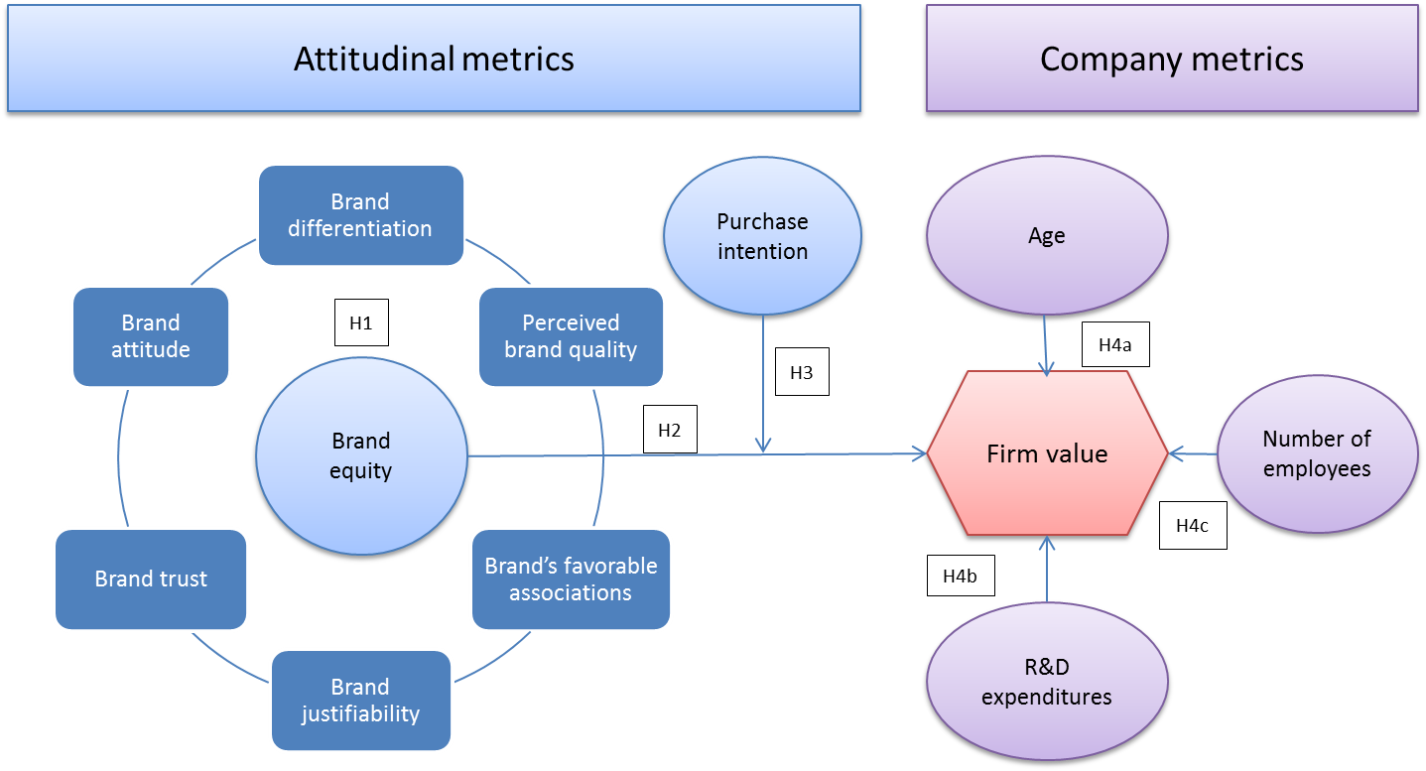

5. Research Method

5.1 Company and industry selection

The Companies (48 brands)
In total 48 international companies are examined and 270 respondents gave their vision on 4 brands each which led to 1080 independent observations in total. The data on the company variables for the brands are derived from the Orbis database. The Orbis Database is provided by Bureau van Dijk and contains annual report data from the last 10 years of 79 million public and private companies worldwide. Bureau van Dijk collects this data from local sources, for example: data of Dutch companies are taken from the Chamber of Commerce. This annual report data is processed by Bureau van Dijk, so that companies of different countries can be compared (this is called the Global Format)’ (Website Erasmus University Rotterdam, 2014). The selection of companies that have been used for analysis for this research is mainly chosen based on the firm’s international character and availability of data. After selection of companies, each company had to be searched in the database and copied in excel. Furthermore the variables have to be included as well. Furthermore for the results to be generalizable for other industries, not chosen in this research, companies are selected based on different life cycles of their products. Hereby a difference is made from durable products such as the car industry (for example Audi, Renault) to fast moving consumer goods from brands like Pepsi and Mars.

The industries
According to Foxall, Oliveira-Castro & Schrezenmaier (2004), within marketing science, the analysis of brand choices for fast-moving consumer goods, based on aggregate data, shows that most individuals tend to purchase a variety of brands within a product category on a daily basis. For more expensive and more durable products such as cars, there’s less risk involved in having multiple cars, and so owning multiple brands. Replacement of an average motorized vehicle lies between 3 and 6 years (Smith, 1974). This gives an average of 4.5 years.
For the electronic industry the mobile phones have a replacement cycle less than 1.5 years (Franke, Basdere, Ciupek & Selige 2006). On a recent research a lifespan of 2.9 years for a dell laptop has been used for analysis (Babbitt, Kahhat Williams & Babbitt., 2009). In the Sports wear industry it is also more common to own multiple brands, although 100% loyal consumers exist if the brand can ‘deliver it all’. The brands and industries can be seen on the next page.
Fast Consumer Goods | Sports wear
NESTLE | NIKE
PEPSICO | ADIDAS
L'OREAL | PUMA
HEINEKEN | ASICS
MARS | MIZUNO
KONINKLIJKE FRIESLANDCAMPINA | REEBOK
H. J. HEINZ COMPANY | NEW BALANCE ATHLETIC SHOE
BACARDI-MARTINI | BILLABONG
ORANGINA SCHWEPPES. | QUICKSILVER
NUTRICIA | O'NEILL
INNOCENT | ESPRIT
DANONE | SPEEDO
Electronics | Motorized Vehicles
SAMSUNG ELECTRONICS | TOYOTA
APPLE | HONDA
PANASONIC | PEUGEOT
SONY | AUDI
TOSHIBA | RENAULT
LG ELECTRONICS | AB VOLVO
NOKIA | MAZDA
HUAWEI | VOLKSWAGEN
DELL, INC. | SAAB
HP | YAMAHA MOTOR
NIKON | SUZUKI MOTOR
NINTENDO | NISSAN

5.2 Data collection and data extraction
The data collection has been done using the information available on the Orbis database. After selecting the companies each company had to be looked up for information on the various variables. Furthermore not all information was available for some companies and are replaced for likewise brands which had the information on the company metrics. First the information is summarized by implementing all information into an excel file. After summarizing the financials for 5 years of data in excel a file, evaluations on international attitudinal measures are collected by spreading a survey across multiple countries. To combine the attitudinal measures with the company financials implemented in excel, first the attitudinal measures had to be adjusted from a customer-level (questionnaire answers) to brand-level variables. This has been done by using the average and standard deviation of all customer evaluations. The final step was to implement the data of the attitudinal measures into the file of the financial information on the brands. This resulted in a final data file with information on 48 international brand including the average ratings on the questions of the survey and the financial data. Before the section of analysis starts, some background information follows on the questionnaire and the respondents’ description.

5.3 The questionnaire
This survey is spread using e-mail, social media and hard copy to collect all evaluations. To collect information from multiple countries over the world, family and friends were of great help. In total twelve surveys have been created and for each survey four brands are included. This means three surveys per industry. The surveys which are spread by link in email and social media are randomly given one out of twelve. The survey consists of sixty-three questions having fifteen to thirty-one evaluations for each brand. Fifteen questions per brand and three general questions asking for their age, income level and nationality. The questions included in the survey can be found in the appendix ‘10.1 Survey Questions’. As can be seen the questions are based on earlier literature on brand equity dimensions. In general questions as for a rating from 1-7 except the demographics. Answer possibilities go from completely disagree to completely agree. Based on the values given on the different questions each respondent gives a rating for the dimensions of brand equity. In the table below, the description of the respondents is given and their nationalities can be found on the next page.
Respondents’ description
* calculation based on the €/$ exchange. Average1€=$1.36295) over the period from the start of the survey until the last response (22nd of may 2014 – 17th of June 2014).

 | Mean and standard deviation
Age | 36.42 years (12.35)
Net income level (monthly) | $2516.81 ($1152.96)
 | Observations (N)
Nationalities | 16
Nationalities (16) |  | Observations (N)
Azerbaijan |  | 1
Belgium |  | 9
Estonia |  | 2
France |  | 11
Germany |  | 31
Great Britain |  | 2
Greece |  | 3
Italy |  | 1
Lithuania |  | 1
Netherlands |  | 178
Nigeria |  | 1
Poland |  | 1
Romania |  | 1
Russia |  | 1
Spain |  | 1
United States of America |  | 10
‘missing’ |  | 16
Total |  | 270

In total 270 respondents have given their opinion on four brands each, resulting in 1080 independent observations on the subject-level.

5.4 Data preparation – Attitudinal measures versus company variables
To combine the attitudinal measures with the company variables, the 1080 independent observations had to be averaged. Secondly these averages are copied for each year for every brand in Excel. This leads to an Excel file with 48 companies with new numbers for the company measures for each year. After all work was done in Excel. It is copied in SPSS and the final data was ready for the analysis on the brand – year level. Therefore an analysis using a linear regression model is done. This will be further discussed in the next section.
The company variables are measured at a five year base. Brand equity is the valued the same for each brand per year. Yearly dummies are created which represents the differences between years. First a factor analysis is performed to check if the preliminary formula’s presented are the ones to use for the regression analysis.

5.5 Empirical Design
Dependent variable: Firm value. For the analysis operating revenue specifically is used for firm value.
Independent Survey based variables: brand differentiation, brand trust, strength of the brand’s favorable associations, perceived brand quality, brand attitude, brand justifiability (survey), purchase intention.
Independent company variables: number of employees, research and development expenditures, age of company. Note: R&D is only available for electronics and motorized vehicles.

5.5.1 Preliminary formula all brands
${Firm value}_{it}= B_{0}+γ_{1}{Employees}_{i t}+{γ_{2}Age}_{i t}+γ_{3}{BE}_{i }+γ_{4}Y2012+γ_{5}Y2011+γ_{6}Y2010+γ_{7}Y2009+γ_{8}Y2008+ε$
$$BE= γ_{3}{Diff}_{i}+γ_{4}{Trust}_{i }+γ_{5}{Fav}_{i}+ γ_{6}{Qual}_{i}+ {γ_{7}Just}_{i}+{γ_{8}Att}_{i}+{γ_{9}Purchint}_{i}$$

5.5.2 Preliminary formula non-durable goods
${Firm value}_{it}= B_{0}+γ_{1}{Employees}_{i t}+{γ_{2}Age}_{i t}+γ_{3}{BE}_{i }+γ_{4}Y2012+γ_{5}Y2011+γ_{6}Y2010+γ_{7}Y2009+γ_{8}Y2008+ε$
$$BE= γ_{3}{Diff}_{i}+γ_{4}{Trust}_{i }+γ_{5}{Fav}_{i}+ γ_{6}{Qual}_{i}+ {γ_{7}Just}_{i}+{γ_{8}Att}_{i}+{γ_{9}Purchint}_{i}$$

5.5.3 Preliminary formula durable goods
${Firm value}_{it}= B_{0}+γ_{1}{Employees}_{i t}+{γ_{2}Age}_{i t}+γ_{3}{R\&D}_{i t}+γ_{3}{BE}_{i }+γ_{4}Y2012+γ_{5}Y2011+γ_{6}Y2010+γ_{7}Y2009+γ_{8}Y2008+ε$
$$BE= ω_{1}{Diff}_{i}+ω_{2}{Trust}_{i }+ω_{3}{Fav}_{i}+ ω_{4}{Qual}_{i}+ {ω_{5}Just}_{i}+{ω_{6}Att}_{i}+{ω_{7}Purchint}_{i}$$

The variables underlying brand equity are measured as cross section variables. These variables have its own weight denoted by $γ_{1}$ : Brand differentiation ($γ_{3}{Diff}_{i}$) Brand trust ($γ_{4}{Trust}_{i }$) Brands’ favorable associations ($γ_{5}{Fav}_{i}$), Perceived brand quality ($γ_{6}{Qual}_{i}$), brand justifiability (${γ_{7}Just}_{i}$), Attitude (${γ_{8}Att}_{i}$) Purchase Intention (${γ_{9}Purchint}_{i}$). Thereby is $B_{0}$ the intercept and is $ε$the error term. Y2012 etc. are dummy variables. The beta’s are estimated which denotes the differences over the years over all brands. For durable goods the following formula is used with an additional variable, namely R&D.

6. Results

6.1 Pre analysis
To identify the variables to conclude in the final model factor analysis has been done. It assumes a latent variable underlying the independent attitudinal variables. It tries to maximize the biggest portion of shared variance creating latent variables or factors. The table is given below.
Dimension | Factor loading
Brand differentiation | 0,738
Strength of brands’ favorable associations | 0,873
Perceived brand quality | 0,920
Brand attitude | 0,916
Brand trust | 0,860
Brand justifiability | 0,934
Purchase intention | 0,844
Total variance explained | 75,936%
Based on principal components extraction method. All dimensions load into one factor. Selected on eigenvalue greater than one.
A one factor solution is given. The variance explained by the common factor of the independent variables is more than 70% for all variables. In other words there is less than 30% explained by the individual variables.
In total more than 75% of the variance is explained by this factor. Hypothesis 1 is thereby accepted: Brand Equity can be seen as umbrella-construct for the dimensions: brand differentiation, strength of a brand’s favorable association, perceived brand quality, brand attitude, brand trust and brand justifiability.
To start with, the dependent variable is checked for normality. Firm value has a upward skewed distribution as can be seen in the appendix in section 11.2. Therefore a logarithmic function is used to meet the assumption of a normal distribution. As can be seen in the appendix the outliers are dealt with using a logarithmic transformation for all variables. This makes the distribution shift to the right. With the transformation the very strong positive skew is solved. The histogram, QQ plot and boxplot can be found in the appendix.
The following formulas are used for the analysis after transformation. For interpretation: a 1% increase in one of the independent variables results in a B times % increase in the dependent variable. The formula’s differ per analysis because the addition of the variable R&D. Not all brands included R&D: only the durable goods sector does.

6.1.1 Definite formulas

The formula used representing the all brands analysis
$$\left(ln\right){Firm value}_{it}= B_{0}+γ_{1}\left(ln\right){Employees}_{i t}+{γ_{2 }\left(ln\right)Age}_{i t}+γ_{3} {\left(ln\right)BE}_{i }+γ_{4}Y2012+γ_{5}Y2011+γ_{6}Y2010+γ_{7}Y2009+γ_{8}Y2008+ε$$

The formula used representing the non-durable goods analysis
$$\left(ln\right){Firm value}_{it}= B_{0}+γ_{1}\left(ln\right){Employees}_{i t}+{γ_{2 }\left(ln\right)Age}_{i t}+γ_{3} {\left(ln\right)BE}_{i }+γ_{4}Y2012+γ_{5}Y2011+γ_{6}Y2010+γ_{7}Y2009+γ_{8}Y2008+ε$$

The formula used representing the durable goods analysis
$$\left(ln\right){Firm value}_{it}= B_{0}+γ_{1}{\left(ln\right)Employees}_{i t}+{γ_{2}\left(ln\right)Age}_{i t}+γ_{3}{\left(ln\right)BE}_{i }+γ_{4}\left(ln\right)R\&D+γ_{4}Y2012+γ_{5}Y2011+γ_{6}Y2010+γ_{7}Y2009+γ_{8}Y2008+ε$$

6.2 Regression analysis: the main model

6.2.1 Correlation matrices
First the main model on including the main variables is tested. Additionally another analysis is done dividing brand equity into two constructs. This will be explained in the following sections. Below the correlation matrix for the all brands analysis is given. On the left the correlations are given for the main model. The blue marked (on the right) are representing the variables used for the interaction analysis.
Main variables |  |  |  |  | Variables for interaction
Variables | Firm value | Number of employees | Age | Brand equity | Brand equity excluding Purchase intention | Purchase intention
Firm value | 1 | 0.951* | 0.303** | 0.095 | 0.243 | -0.116
Number of employees |  | 1 | 0.355** | 0.038 | 0.167 | -0.156
Age |  |  | 1 | 0.079 | -0.005 | -0.234
Brand equity |  |  |  | 1
Brand equity excluding purchase intention |  |  |  |  | 1 | 0.308**
Purchase intention |  |  |  |  |  | 1
* significant at the 1% level
** significant at the 5% level

The main model
The variable ‘number of employees’ has a very high significant relationship to firm value of 0.951. Furthermore age has a significant relation with firm value. Brand equity has a 0.095 positive correlation to firm value but is not significant. All correlations are positive which means that a higher value for one variable also implies a higher value for the other variable ceteris paribus.

Moderator analysis
Brand equity without purchase intention has a bigger correlation to firm value. Purchase intention and brand equity are significantly correlated (5% level) which seems logical because the factor analysis already concluded a one factor solution. The results were insignificant when adding the interaction effect. The adjusted R² did not change significantly and remained 0.905 compared to the model without the interaction effect. Therefore H3: Purchase intention influences the nature of the relationship between brand equity and firm value is rejected. Additional analysis follows in the post hoc analysis at the end of the result section.

6.2.2 Analysis on all brands
The variables to put into the model for interpretation are based on adjusted R². The adjusted R² denotes the amount of variance explained by the variables in the model, but does not increase automatically by putting in more variables. In other words: The adjusted R-squared increases only if the new term improves the model more than would be expected by chance. It decreases when a predictor improves the model by less than expected by chance. The results of the estimated models are given on the next page. After the presentation of results the interpretation will follow. For the model 240 observations are analyzed. A different approach of estimating, by taking the average of five years is given in the post hoc analysis.

Regression models for the all-brands-analysis

All brands | Model 1 |  | Model 2 |  | Model 3 |  | Model 4
Variables | Parameter estimate | Significance | Parameter estimate | Significance | Parameter estimate | Significance | Parameter estimate | Significance
Number of employees | 0.921 (0.021) | 0.000* | 0.942 (0.022) | 0.000* |  |  | 0.927 (0.020) | 0.000*
Age | -0.114 (0.058) | 0.052 | -0.102 (0.059) | 0.088 | 0.801 (0.168) | 0.000*
Brand Equity | 1.000 (0.333) | 0.003* |  |  | 1.146 (1.026) | 0.265 | 0.954 (0.334) | 0.005*
Year 2011 | 0.003 (0.127) | 0.982 | 0.003 (0.129) | 0.980 | 0.012 (0.392) | 0.976 | 0.005 (0.128) | 0.966
Year 2010 | 0.006 (0.127) | 0.961 | 0.007 (0.129) | 0.958 | -0.014 (0.392) | 0.971 | 0.011(0.128) | 0.933
Year 2009 | -0.048 (0.127) | 0.706 | -0.047 (0.129) | 0.717 | -0.084 (0.392) | 0.830 | -0.041 (0.128) | 0.750
Year 2008 | -0.023 (0.127) | 0.855 | -0.022 (0.130) | 0.866 | -0.059 (0.392) | 0.880 | -0.014 (0.128) | 0.916
R² | 0.902 | 0.000* | 0.899 | 0.000* | 0.074 | 0.000* | 0.901 | 0.000*
* significant at the 1% level

Interpretation for the all brands analysis
The outcomes of the regression models show high consistency among the models. The number of employees is highly significant in all models. Brand equity is highly significant in model 1 and 4. Age is not significant in those models and is only significant in the model with only age and brand equity having the lowest adjusted R².
Because of the highest adjusted R squared model 4 is used for interpretation. In addition with age, the variance explained by the model does not change significantly in adjusted R squared (p=0.052) and even shows a negative relationship. This indicates that, ceteris paribus, a higher age of the company lead to smaller firm value. Therefore, H4a: ‘age has a positive relationship to firm value’ is rejected.
Both indicate a highly significant positive relationship to firm value. A 1% increase in the number of employees explains a 0.927% increase in firm value. An increase in brand equity of 1% explains a 0.954% increase in firm value. Hereby is H2: ‘International brand equity has a positive relationship with firm value’ accepted. H4c: ‘number of employees has a positive relationship to firm value’ is accepted.

6.3 Non-durable sector versus durable-sector
For this analysis the main model will be used based on the one factor solution from the factor analysis. The attitudinal measures are covered in one construct called brand equity. The durable sector includes the variable ‘research and development expenditures’. To compare the two sectors a two-part analysis has been done starting with the non-durable industries. For the analysis on both sectors two times 120 observations are examined. Below the correlation matrices are given indicating the relationship from the variables. The number of employees brand equity are still (compared to the full model on all brands) a significant predictor of firm value. Also age indicates a significant relationship to firm value.
* significant at the 1% level  ** Significant at the 5% level
  Non- Durable goods
  Variables | Firm value | Number of employees | Age | Brand equity
  Firm value | 1 | 0.947* | 0.355** | 0.267
  Number of employees |  | 1 | 0.445** | 0.207
  Age |  |  | 1 | 0.285
  Brand equity |  |  |  | 1
  Durable goods
  Variables | Firm value | Number of employees | Age | Brand equity | R&D
  Firm value | 1 | 0.858* | -0.121 | 0.248 | 0.810*
  Number of employees |  | 1 | 0.445* | 0.046 | 0.769*
  Age |  |  | 1 | -0.144 | 0.141
  Brand equity |  |  |  | 1 | 0.081
  R&D |  |  |  |  | 1

Interpretation
The correlations for both sectors show a significant (1% level) relationship for number of employees. Based on this correlations the durable goods sector analysis shows a significant relationship from research and development expenses (at the 1% level) to firm value. On the next page the results of all models are given. Again the best fitted model based on the R² is used for the conclusions. The models and are described on the next page. After giving the results of the estimated models for the non-durable and durable sector the interpretation of the regression analysis follows.

Regression models for the non-durable goods sector
Non-durable | Model 1 |  | Model 2 |  | Model 3 |  | Model 4
Variables | Parameter estimate | Significance | Parameter estimate | Significance | Parameter estimate | Significance | Parameter estimate | Significance
Number of employees | 0.883 (0.029) | 0.000* | 0.892 (0.030) | 0.000* |  |  | 0.844 (0.028) | 0.000*
Age | -0.235 (0.073) | 0.002* | -0.183 (0.074) | 0.015** | 0.669 (0.200) | 0.001*
Brand Equity | 1.530 (0.480) | 0.002* |  |  | 2.878 (1.430) | 0.046* | 1.193 (0.487) | 0.016**
Year 2011 | 0.098 (0.173) | 0.570 | 0.092 (0.180) | 0.608 | 0.109 (0.517) | 0.834 | 0.080 (0.179) | 0.657
Year 2010 | 0.077 (0.173) | 0.654 | 0.073 (0.179) | 0.684 | 0.105 (0.517) | 0.839 | 0.066 (0.179) | 0.715
Year 2009 | 0.037 (0.173) | 0.830 | 0.035 (0.179) | 0.846 | 0.044 (0.517) | 0.932 | 0.031 (0.179) | 0.865
Year 2008 | -0.023 (0.173) | 0.892 | -0.022 (0.179) | 0.903 | 0.006 (0.517) | 0.991 | -0.016 (0.179) | 0.927
R² | 0.901 | 0.000* | 0.893 | 0.000* | 0.112 | 0.003* | 0.893 | 0.000*

Regression models for the durable goods sector
Durable | Model 1 |  | Model 2 |  | Model 3 |  | Model 4 |  | Model 5
Variables | Parameter estimate | Significance | Parameter estimate | Significance | Parameter estimate | Significance | Parameter estimate | Significance | Parameter estimate | Significance
Number of employees | 0.478 (0.060) | 0.000* |  |  | 0.459 | 0.000* | 0.762 (0.042) | 0.000* | 0.521  (0.057) | 0.000*
Age | -0.150 (0.076) | 0.051 | -0.3670 (0.088) | 0.000* | -0.204 | 0.012** | 0.020  (0.080) | 0.801
Brand Equity | 1.372 (0.331) | 0.000* | 1.170  (0.412) | 0.005* |  |  | 1.604  (0.376) | 0.000* | 1.485 (0.330) | 0.000*
Research and development | 0.376 (0.063) | 0.000* | 0.773  (0.048) | 0.000* | 0.407 (0.133) | 0.000* |  |  | 0.330  (0.059) | 0.000*
Year 2011 | -0.009 (0.125) | 0.942 | -0.026  (0.156) | 0.867 | -0.010  (0.133) | 0.939 | 0.029  (0.143) | 0.838 | -0.013  (0.126) | 0.918
Year 2010 | 0.016 (0.125) | 0.897 | -0.001  (0.156) | 0.995 | 0.015  (0.133) | 0.913 | 0.051  (0.142) | 0.721 | 0.015  (0.126) | 0.909
Year 2009 | 0.062 (0.124) | 0.621 | 0.048  (0.156) | 0.760 | 0.061  (0.133) | 0.649 | 0.083  (0.142) | 0.560 | 0.061  (0.126) | 0.627
Year 2008 | 0.041 (0.124) | 0.740 | 0.008  (0.156) | 0.958 | 0.039  (0.133) | 0.770 | 0.063  (0.142) | 0.659 | 0.047  (0.126) | 0.708
R² | 0.808 | 0.000* | 0.700 | 0.000* | 0.780 | 0.000* | 0.748 | 0.000* | 0.803 | 0.000*
* significant at the 1% level ** significant at the 5% level

Interpretation non-durable goods sector
Brand equity, Age and the number of employees are in all models significant. Model 1 is chosen for interpretation because of the best fit according to the adjusted R squared. Adding age to model 4 (model 1) is a significant contribution (p=0.002*). The full model is significant and explains 90,1% of the variance in firm value. Furthermore the results show high consistency among the models.
The conclusions drawn from the regression are the same for the durable goods sector. Number of employees proves to be a significant explanatory variable for firm value. An 1% increase in the number of employees explains a 0,843% increase in firm value, ceteris paribus. An increase of 1% in the attitudinal measures explains an increase of 1.53% in firm value. Again age seems to have a negative relationship to firm value.

Interpretation for the durable goods sector
The model with the best fit based on the R² is chosen for interpretation. Again the models among show high consistency in outcomes. The outcomes of the models while dropping and adding variables is quite consistent. For interpretation the best fitted model is used based on the R². Therefore Model 5 is chosen. The full model is significant and explains 80.8% of the variance in firm value. Number of employees and brand equity still explain firm value very well and are highly significant. An increase of 1% in the number of employees explains a 0.521% increase in firm value. Age is not a significant predictor (p=0.051) for the durable goods sector, although again showing a negative relationship.
The addition of Research and development expenses prove to be significant. In the analysis on durable goods An increase of 1% in R&D explains an increase in firm values of approximately 0.324%, ceteris paribus. H4b is accepted: ‘Research and development expenses have a positive relationship with firm value’.
To conclude the analysis: The attitudinal measures do significantly predict firm value in all analysis. For the durable goods sector: an overall increase of the international brand equity of 1% stands for an increase in firm value of nearly 1.5%.

6.3 Post hoc results

6.3.1 Purchase intention levels
At first sight only number of employees does significantly explains the differences in operating revenue using the one factor solution generated. In contrast to the factor analysis solution an additional calculation is done using purchase intention used as grouping variable to explain the relationship between brand equity and operating revenue.
This has been done by calculating the average for brand equity using the ratings on the questions for six dimensions and purchase intention have been calculated using the two remaining question ratings. For this analysis purchase intention have been ranked by the numbers one, two and three. One stands for low purchase intention, two stands for medium purchase intention and the value three stands for high purchase intention. In the following graph the correlation lines are drawn with brand equity on the X-as and Operating revenue on the Y-as regressed for low, medium and high purchase intention.
** significicant at the 1% level
R²: 0.505
Correlation: 0.711**
R²: 0.006
Correlation: 0.077
R²: 0.1
Correlation: 0.320

As can be derived from the figure, no significant correlations can be found for low and medium purchase intention, although positive. For high purchase intention however, brand equity is a significant explanatory variable of operating revenue. In other words: if the average consumer has a ‘real’ intention to buy a particular brand (e.g. high ratings on purchase intention), the differences in attitudinal measures for brand equity are a good predicter for the differences in operating revenue.
In the next section the limitations and suggestions for further research are discussed. After this section an answer is given to the main question in the conclusion.

6.3.2 Estimated models using the average
In addition to the analysis performed before, an additional analysis has been done using the averages of the company variables and dependent variable. This method reduced the amount of independent observations at the subject level to 48. In comparing the non-durable goods sector with the durable goods sector only 24 observations are left. This makes it very hard to get significant results.
Although having low number of observations, the all brands analysis on 48 international brands have still led to a significant relationship for the number of employees on firm value (p=0.000*). For the durable goods industry research and development expenses (p=0.027**) are a significant predictor and also the attitudinal measures on brand equity (p=0.05**) significantly predict firm value. (* significant at the 1% level, ** significant at the 5% level)

7. Limitations and suggestions for future research
The aim of this paper is to provide, in addition to the literature, in depth understanding of the attitudinal measures and its relationship with firm values in an international context. This paper proves that for international brands, brand equity can be seen as one construct and it would be most appropriate to treat it as such. Influencing brand equity could impact a brands’ firm value significantly. Research and development expenditures and number of employees are also good indicators for a brands’ firm value but are not reflecting a causal direction. In other words, the direction of influence is not clear.

Causality
To examine this causality and its influence brand equity need to be measured multiple times, preferably each year. Combined with the yearly data on company variables such as research and development expenses and number of employees would be an extension that could be of benefit for managers from international brands. The changes international brand managers implemented in the years examined could then ultimately be seen in terms of a causal connection from brand equity to firm values or the other way around. In addition it could be there are some autoregressive effects. A big growth in firm value could have an effect of budgets spend next year for hiring the number of employees, R&D expenditures or the budget to influence brand equity (marketing mix).

Country and industry differences
This paper includes international companies and it would be interesting if the relationship between brand equity and firm value could be further examined between cultures. Company managers can get additional insight in dealing with different cultures for implementing marketing strategy.

Representativeness
A limitation is that the 16 nationalities that are included are not representative for the inhabitants and influence per country on brand equity. Because no differences between countries are examined this is not a major limitation.

Last note
A minor limitation was that the respondent panel was not representative for the population. Although chosen for an in-depth view on attitudinal measures for this paper, future research extensions could implement more product categories and more international brands to examine. They could elaborate on differences between industries to examine the relationship of brand equity with firm values for international brands.

8. Conclusion and managerial implications
The main question of the paper: ‘What is the relationship between attitudinal measures and firm value for international brands?

Definition brand equity
Different definitions are given for brand equity in the literature. Using these descriptions this paper defines brand equity as: ‘The multidimensional concept of the thoughts, feelings, perceptions and experiences linked to the brand in the mind of the actual of potential customer and the relationship to the brand and what actions a firm can take to capitalize on the potential offered by these structures formed’. Brand equity consists according to the literature out of multiple dimensions which could be seen as independent dimensions underlying the brand equity construct. Field research of this paper shows that a one-dimensional concept for brand equity is more appropriate in an international brand context.

Attitudinal measures and firm value
Brand equity does prove to have a positive relationship with firm value for the all brands analysis. Furthermore the positive relationship does exist for the non-durable and the durable goods industry. Attitudinal measures thus reflects the consumers’ behavior in buying these brands and therefore its relationship to firm value
The positive relationship assumed in the literature between brand equity and purchase intention also exist in the relationship for international brands according to the correlation matrix (correlation: 0.308) and factor analysis. The relationship from purchase intention can manifest in different ways. The first one is through budget constraints and a second relationship is seen through recency. Indeed an post hoc analysis on different purchase intention levels (low, medium and high) results in a positive relationship from brand equity to firm value for high purchase intentions. Recent customers of a brand have the highest probability of buying again, and therefore have the highest purchase intentions. This indicates that the most recent customers best reflect the relationship from brand equity to firm value.

Managerial implications on attitudinal measures versus firm value
For managers the one construct concept of brand equity is easier to interpret in its relationship with firm value, as opposed to the use of different dimensions. It is essential to understand this concept of linking attitude to behavior to revenues. Millions on advertising and other marketing expenses flow, but is this money well spend? This link is often missing and is of great importance in creating or maintaining firm value for international brands.

Company variables on firm value
An indicator for such value could be the number of employees. The number of employees showed a highly significant positive relationship to firm value in the all brands and the non-durable versus durable goods analysis. Age was a significant predictor and showed a negative correlation.

Comparison non-durable goods versus durable goods
In addition in comparing the non-durable goods (fast consuming goods and sports-wear) industry versus the durable goods industries (electronics and motorized vehicles) significant evidence is found for research and development expenses as predictor for firm values. To conclude this analysis: a significant relationship has been found for international brand equity and its relationship to firm value for durable goods.

Managerial implication
Especially in the durable goods industries, where a more difficult choice process is involved, managers could rely on the relationship from brand equity measures in relationship to financial measures. Small changes in brand equity can explain big differences in millions of dollars in firm value for international brands. The company measures including number of employees and the research and development expenses, could be used as good indicators of a firms’ performance in firm value.
For managers of international brands this paper provides support for the relation between attitudinal measures and firm value. It underlines that brand equity management is essential in maintaining or creating firm value for international brands.

Concluding answer
To conclude with an answer to the main question: The attitudinal measures have a positive relationship to firm value for international brands.

9. References

Aaker, D.A. (1991) Managing Brand Equity: Capitalizing on the Value of a Brand Name, New York, The Free Press.
Aaker, D. A. (1996). Measuring brand equity across products and markets. California management review, 38(3).
Aaker, D. A., & Jacobson, R. (2001). The value relevance of brand attitude in high-technology markets. Journal of marketing research, 38(4), 485-493.
Aaker, D. A. (2008). Strategic market management. 6th edition, John Wiley & Sons,.
Ajzen (1991), The Theory of Planned Behavior, Organizational Behavior and Human Decision Processes, 50, 179-211
American Marketing Association (2007) ‘Dictionary of Marketing Terms’ URL:http://www.marketingpower.com/mg-dictionary-view329.php
Anderson, E. W., Fornell, C., & Lehmann, D. R. (1994). Customer satisfaction, market share, and profitability: findings from Sweden. The Journal of Marketing, 53-66.
Baldauf, A., Cravens, K. S., & Binder, G. (2003). Performance consequences of brand equity management: evidence from organizations in the value chain.Journal of product & brand management, 12(4), 220-236.
Bird, M. and A. S. C. Ehrenberg (1966), "Intentions-to-Buy and Claimed Brand Usage," Operational Research Quarterly, 17 (March), 27-46.
Bolton, R. N., Lemon, K. N., & Verhoef, P. C. (2004). The theoretical underpinnings of customer asset management: a framework and propositions for future research. Journal of the Academy of Marketing Science, 32(3), 271-292.
Brady, Michael K., J. Joseph Cronin Jr., Gavin L. Fox and Michelle L. Roehm (2008),“Strategies to offset performance failures: The role of brand equity,” Journal of Retailing, 84(2), 151-164.
Capon, N., Farley, J. U., & Hoenig, S. (1990). Determinants of financial performance: a meta-analysis. Management Science, 36(10), 1143-1159.
Chaudhuri, Arjun and Morris B. Holbrook (2001), “The Chain of Effects from Brand Trust andBrand Affect to Brand Performance: The Role of Brand Loyalty,” Journal of Marketing, 65 (2), 81-93.
Cobb-Walgren, C. J., Ruble, C. A., & Donthu, N. (1995). Brand equity, brand preference, and purchase intent. Journal of advertising, 24(3), 25-40.
Deschryvere, M. (2014). R&D, firm growth and the role of innovation persistence: an analysis of Dinnish SMEs and large firms. Small Business Economics, 1-19.
Hong-Bumm, K., Woo Gon, K., & Jeong, A. A. (2003). The effect of consumer-based brand equity on firms’ financial performance. Journal of consumer marketing.
Farquhar, P. H. (1989). Managing brand equity. Marketing research, 1(3).
Faircloth, J. B., Capella, L. M., & Alford, B. L. (2001). The effect of brand attitude and brand image on brand equity. Journal of Marketing Theory and Practice, 61-75.
Foxall, G. R., Oliveira-Castro, J. M., & Schrezenmaier, T. C. (2004). The behavioral economics of consumer brand choice: Patterns of reinforcement and utility maximization. Behavioural Processes, 66(3), 235-260.
Gaillard, E., Romaniuk, J., & Sharp, A. (2005). Exploring Consumer Perceptions of Visual Distinctiveness (Doctoral dissertation, ANZMAC, The University of Western Australia).
Inman, J. Jeffrey and Marcel Zeelenberg (2002), “Regret in Repeat Purchase versus Switching Decisions: The Attenuating Role of Decision Justifiability,” Journal of Consumer Research, 29 (1), 116-128.
Kalyanam, K., & Putler, D. S. (1997). Incorporating demographic variables in brand choice models: An indivisible alternatives framework. Marketing Science,16(2), 166-181.
Keller, K. L. (1993, January). Conceptualizing, measuring, and managing customer-based brand equity.
Keller, K. L., & Lehmann, D. R. (2006). Brands and branding: Research findings and future priorities. Marketing Science, 25(6), 740-759.
Kotler, P., (1994) Marketing Management: Analysis, Planning, Implementation, and Control (Eighth ed.). Prentice-Hall Inc., Englewood Cliffs, New Jersey
Lehmann, D. R. (2004). Metrics for Making Marketing Mix Matter. Journal of Marketing.
Lev, B. (2004). Sharpening the Intangibles Edge. Harvard Business Review, 82 (6) 108-116.
Luo, X. (2009). Quantifying the long-term impact of negative word of mouth on cash flows and stock prices. Marketing Science, 28(1), 148-165.
F. Livesey, P. Lennon, (1978) "Factors Affecting Consumers' Choice between Manufacturer Brands and Retailer Own Labels", European Journal of Marketing, Vol. 12 Iss: 2, pp.158 - 170
Majumdar, S. K. (1997). The impact of size and age on firm-level performance: some evidence from India. Review of industrial organization, 12(2), 231-241.
Pauwels, H. K. (2004). How Dynamic Consumer Response, Competitor Response, Company Support and Company Inertia Shape Long-Term Marketing Effectiveness. Marketing Science.
Preston, I. L. (1996). The great American blow-up: Puffery in advertising and selling. Univ of Wisconsin Press.
Reinartz, W. J., & Kumar, V. (2000). On the profitability of long-life customers in a noncontractual setting: An empirical investigation and implications for marketing. Journal of marketing, 64(4), 17-35.
Riezebos, R. (1996) Merkenmanagement, Groningen, Wolters-Noordhoff.
Robert P. Leone, Vithala R. Rao, Kevin Lane Keller, Anita Man Luo, Leigh McAlister and Rajendra Srivastava. (2006). Linking Brand Equity to Customer Equity. Journal of Service Research 9: 125
Rodney E. Smith and William F. Wright (2004) Determinants of Customer Loyalty and Financial Performance. Journal of Management Accounting Research: December 2004, Vol. 16, No. 1, pp. 183-205.
Romaniuk, J., Sharp, B., & Ehrenberg, A. (2007). Evidence concerning the importance of perceived brand differentiation. Australasian Marketing Journal (AMJ), 15(2), 42-54.
Rust, R. T., Lemon, K. N., & Zeithaml, V. A. (2004). Return on marketing: using customer equity to focus marketing strategy. Journal of marketing, 68(1), 109-127.
Simon, C. J., & Sullivan, M. W. (1993). The measurement and determinants of brand equity: a financial approach. Marketing science, 12(1), 28-52.
Sloot, Laurens M., Peter C. Verhoef and Philip Hans Franses (2005), “The impact of brand equity and the hedonic level of products on consumer stock-out reactions,” Journal of Retailing, 81(1), 15-34.
Smith, R. P. (1974). A note on car replacement. The Review of Economic Studies, 567-570.
Srinivasan, & Hanssens, D. M. (2009). Marketing and Firm Value: Metrics, Methods, Findings, and Future Directions. Journal of Marketing Research.
Srinivasan, S., Vanhuele , M., & Pauwels, K. (2010). Mind-set Metrics in Market Response Models.
Tirunillai, S., & Tellis, G. J. (2012). Does chatter really matter? Dynamics of user-generated content and stock performance. Marketing Science, 31(2), 198-215.
Vázquez, R., del Río, B.A. en Iglesias, V. (2002) ‘Consumer-based Brand Equity: Development and Validation of a Measurement Instrument’, Journal of Marketing Management, 18: 1/2, 27-48
Washburn, J. H., & Plank, R. E. (2002). Measuring brand equity: an evaluation of a consumer-based brand equity scale. Journal of Marketing Theory and Practice, 10(1).
Yang, C. H., & Huang, C. H. (2005). R&D, size and firm growth in Taiwan‘s electronics industry. Small Business Economics, 25(5), 477-487
Yang, L., Cutright, M. K., Chartrand, T., & Fitzsimons, G. (2013). Distinctively Different: Exposure to Multiple Brands in Low Elaboration Settings. Journal of Consumer Research.
Yoo, B., & Donthu, N. (2001). Developing and validating a multidimensional consumer-based brand equity scale. Journal of business research, 52(1), 1-14.

10. Appendix

10.1 Survey Questions
Brand differentiation (Keller 1993)
Q1: Compared to other brands, this brand is (1 = “very similar”, and 7 = “very unique”)
Brand trust (Chaudhuri and Holbrook 2001)
Q2: I trust this brand (1 = “disagree”, and 7 = “agree”)
Q3: This brand can be counted on (1 = “disagree”, and 7 = “agree”)
Strength of brand’s favorable associations (Aaker 1996; Keller 2003; Yoo and Donthu 2001)
Please check the box if that brand tends to come to mind when you think about the particular attribute.
Q4: Choice Width (1=”Disagree”, and 7 = “Agree”)
Q5: Affordability perception (1=”Disagree”, and 7 = “Agree”)
Q6: Innovativeness (1=”Disagree”, and 7 = “Agree”)
Perceived Brand quality (Aaker 1996)
Q7: This is a high quality brand (1 = “disagree”, and 7 = “agree”)
Q8: When you take everything into account, how do you feel about each brand? (1 = “awful”, and 10 = “outstanding”)
Brand justifiability (Inman and Zeelenberg 2002)
Q9: How likely are you to recommend the brand to a friend/collegue
Q10: How easy it is to justify purchasing the brand. (1 = “hard to defend”, and 7 = “easy to defend”)
Attitude towards brand (Yoo, B., & Donthu, N. (2001))
Examine this statements.
Q11: Very unattractive, 2, 3, 4, 5, 6, very attractive
Q12: Very unlikable, 2, 3, 4, 5, 6, very likable
Purchase intention (Spears, N., & Singh, S. N. (2004))
Q13: I would like to buy this brand.
Totally disagree, 2, 3, 4, 5, 6, Totally agree
Q14: I intend to purchase this brand.
Very unlikely, 2, 3, 4, 5, 6, Very likely
Description of respondent
Characteristics Respondents
Age …
Net Income level / 0,1000 - 1000,2000 - 2000,3000 - 3000 and more
Nationality … Correlation matrix variables used for all brands (and non-durable goods)

10.2 Normality analysis
Original dependent variable: firm value:
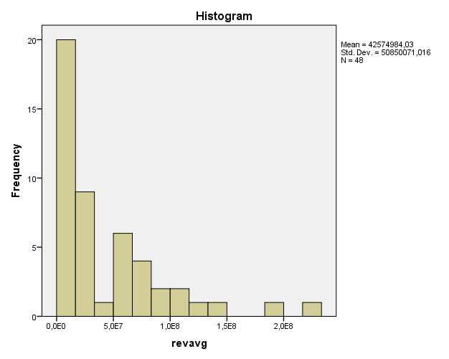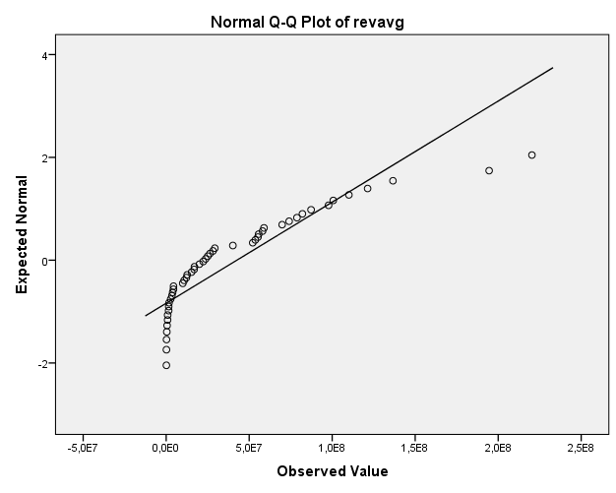

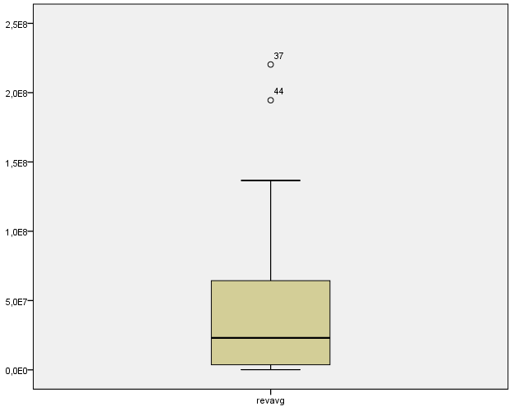

After log transformation:
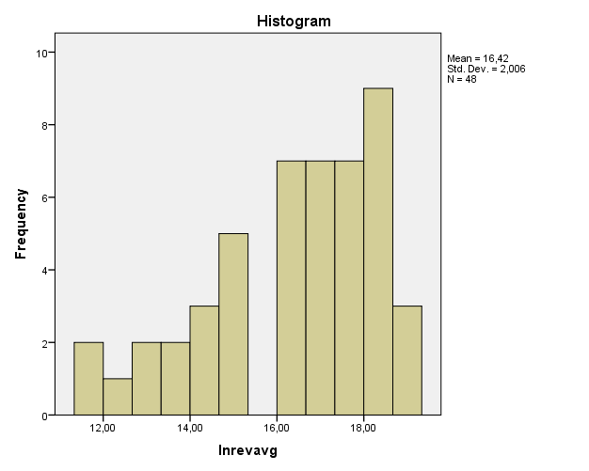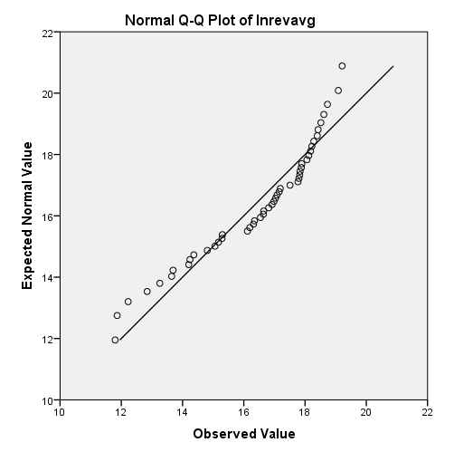

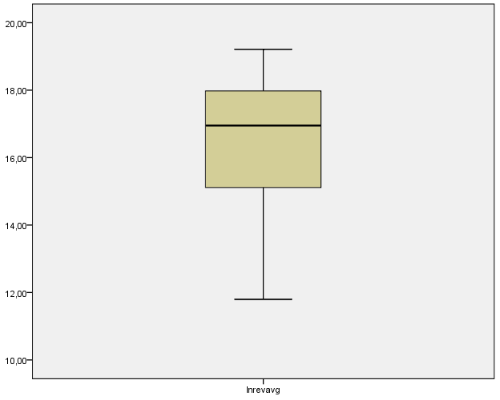

‘The Orbis Database is provided by Bureau van Dijk and contains annual report data from the last 10 years of 79 million public and private companies worldwide. Bureau van Dijk collects this data from local sources, for example: data of dutch companies is taken from the Chamber of Commerce. This annual report data is processed by Bureau van Dijk, so that companies of different countries can be compared (this is called the Global Format)’ (Website Erasmus University Rotterdam, 2014)).

