Erasmus University Rotterdam
Erasmus School of Economics
Section Accounting, Auditing & Control
Mandatory Audit Firm Rotation and Audit Fees Empirical Evidence from Italy
Abstract
To restore investors’ confidence in the audit profession mandatory audit firm rotation is required by the law from 2016 in the Netherlands. Results of prior scientific research on the effects of mandatory audit firm rotation are mixed. By considering the effects of the mandatory audit firm rotation on the audit fees, the research in this thesis performed adds to prior research by examining in which way the costs of the mandatory audit firm rotation in reality are reflected. This thesis provides an answer to the research question: ‘Does mandatory audit firm rotation affect the audit fees?’ In Italy audit firm rotation is mandated from 1974 and consequently provides valid results on the mandatory audit firm rotation, the sample consists of the 38 largest Italian public listed entities. The first two hypotheses suggest that low balling exists and the third hypothesis suggests that the financial crisis positively affects the audit fees. Results of the regression analysis support the first two hypotheses; audit fees are significant lower after a rotation and are significant higher in the second and in the third auditor tenure periods. No evidence is found to support hypothesis 3 which indicates that the financial crisis does not significantly affect the audit fees. Because the results suggest that the audit firms do have pricing strategies, these results have implications for the audit firms and for the audit clients. In addition the results have implications for the standard setters, because the auditor may meet more pressure to perform the audits within a limited time to reduce the audit costs. This could decrease the audit quality.
Date: 23-07-2014
Author: Daniël Tameeris
Student number: 327974
Supervisor: E. A. de Knecht, RA
Co-reader: drs. R. van der Wal, RA

Table of Contents
1. Introduction 4
1.1 Introduction 4
1.2 Background 4
1.3 Stakeholders’ perceptions on the costs and benefits of the audit firm rotation 6
1.4 Relevance 8
1.5 Research question and sub-questions 9
1.6 Methodology 10
1.7 Limitations 10
1.8 Structure 11
2. Theoretical Background 12
2.1 Introduction 12
2.2 Positive Accounting Theory 12
2.3 Agency Theory 14
2.4 Stakeholder Theory 15
2.5 Summary 16
3. Prior Research 18
3.1 Introduction 18
3.2 Auditor tenure and auditor independence 19
3.3 Auditor tenure and audit quality 22
3.4 Costs of audit firm rotation 25
3.5 Audit firm rotation and audit market concentration 26
3.6 Critical review prior research 27
3.7 Summary 28
4. Hypotheses Development 30
4.1 Introduction 30
4.2 Hypothesis 1 30
4.3 Hypothesis 2 31
4.4 Hypothesis 3 31
4.5 Summary 32
5. Research design 33
5.1 Introduction 33
5.2 Research approach 33
5.3 Regression model 34
5.4 Validity framework 37
5.5 Data collection 38
5.6 Summary 39
6. Results 41
6.1 Introduction 41
6.2 Normality check dependent variable 41
6.3 Check for multicollinearity 42
6.4 Adjusted regression model 43
6.5 Additional checks 43
6.6 Regression results 44
6.7 Discussion of the results 45
6.8 Summary 47
7. Conclusion 49
7.1 Introduction 49
7.2 Conclusion 49
7.3 Limitations 50
7.4 Further research 52
Bibliography 53
Appendices 56
Appendix 1 Summary prior research 56
Appendix 2 Normal distribution LnFEE 59
Appendix 3 Multicollinearity 66
Appendix 4 Normal distribution residual and homoscedasticity 67
Appendix 5 Regression results 70

Introduction

Introduction
This chapter provides an overview of the thesis. First, paragraph 1.2 provides the background information on the topic of the mandatory audit firm rotation. A historical overview is provided about mandatory the audit firm rotation. In paragraph 1.3, according to the different stakeholders, the potential benefits and costs of the mandatory audit firm rotation are examined. The relevance and the objectives of this thesis are provided in paragraph 1.4. To help to achieve the objectives as signaled in paragraph 1.4, in paragraph 1.5 the research question and the sub-questions are developed. Paragraph 1.6 continues with the methodology and in paragraph 1.7 the limitations of this thesis are provided. Finally, in paragraph 1.8 the structure of this thesis is provided.

Background
An auditor should be a competent and independent person who is responsible for gathering, evaluating and reporting evidence whether information, as provided by the audit client, is in conformity with the established accounting standards (Arens, Elder, & Beasley, 2013).
Concerning stock exchange listed companies auditors are hired by audit committees. An agency problem arises when the auditor and the management have different goals they want to achieve. Managers are responsible to produce the annual financial statements. Since bad performance reduces their bonuses management tries to avoid publishing bad performance. This could create the situation that stakeholders, who rely on these annual financial statements, are bad informed. Auditors provide assurance by communicating their opinion about whether the information disclosed in these annual financial statements truthfully and fairly represent a company’s performance (Francis & Schipper, 1999).
To add credibility, auditors have to be independent. Because an independent auditor is free from bias, the risk that the financial statements are material misstated is lower when an auditor is independent. Because the audit opinion is objective, an auditor who is free from bias adds value to the financial statements, (McGrath, Siegel, Dunfee, Glazer, & Jaenicke, 2001). An independent auditor is more objective and no incentive exists to act not objective. To add credibility to the published financial statements, objectivity is an essential feature.
During many years the benefits and the costs of the mandatory audit firm rotation have been debated. After the big fraud cases of Enron and WorldCom the debate of the mandatory audit firm rotation in addition involved the National Governments and Institutions, including in the European Union Commission, in the American Institute of Certified Public Accountant (AICPA) and in the US Securities and Exchange Commission (SEC) as well (Cameran, Di Vincenzo, & Merlotti, 2005).
Auditors were involved in these fraud cases. According to the United States General Accounting Office (GAO) auditors became too familiar with their clients and consequently were not objective anymore (United States General Accounting Office (GAO), 2003). After the collapse of Enron, investors’ confidence was harmed. To restore the investors’ and the other stakeholders’ confidence, mandatory audit firm rotation should increase the independence of the public auditor and the increased independence should results in a higher audit quality (Commission on Public Trust and Private Enterprise, 2003).
To restore the investors’ confidence in 2002 in the United States the Sarbanes-Oxley Act (SOX) was introduced. Although mandatory audit firm rotation is not required, audit partner rotation is. Because a lack of evidence exists that the benefits exceed the costs of the mandatory audit firm rotation, audit firm rotation was not required (United States General Accounting Office (GAO), 2003).
In addition, after the financial bank crisis investors lost their confidence in the audit profession. Investors questioned whether the public auditors should have expected the crisis coming. As a response to the financial crisis, to enhance the auditor independence and to create a less concentrated audit market, the European Commission proposed the mandatory audit firm rotation (European Commission, 2011). This resulted in a Green paper in 2010. After this Green paper the final proposal was published in 2011. It requires public interest entities to rotate the audit firm every 6 to 9 years (European Commission, 2011).
But research of the potential benefits is not able to link the increased auditor independence to an increase in the audit quality. There even might be an inverse relationship between the mandatory audit firm rotation and the audit quality (Cameran, Di Vincenzo, & Merlotti, 2005).
Despite the contradicting results of prior scientific research about the consequences of mandatory audit firm rotation in the Netherlands on 12 September 2012 a political debate has been performed about the costs and the benefits of the mandatory audit firm rotation. This debate was based on the proposal of the European Commission (2011). Based on the results of this debate was decided that the audit firm rotation in the Netherlands becomes mandatory from 1 January 2016. The rotation period is each 10 years (and partner rotation each 5 years) and is applicable for public interest entities. In this debate was concluded that the main benefit is the increased auditor independence, but it was questioned whether this benefit would exceed the costs (Eerste Kamer, 2012-2013). Research performed by VNO/NCW (2012) found that after rotating the audit firm each 8 years an increase in the potential costs of € 55 million for companies and € 80 million for audit firms is expected (VNO-NCW, 2012).
In addition questions were raised when deciding to implement the mandatory audit firm rotation in the Netherlands whether the past experiences in Spain were taken into consideration. Research performed in Spain provides evidence that the audit quality did not improve after the introducing of the mandatory audit firm rotation. Because a lack of improvement in audit quality exists, audit firm rotation became voluntary again (Ruiz-Barbadillo & Gòmez-Aguilar, 2002). Another question was raised about an alternative for firm rotation, partner rotation within the same audit firm. But since the consequences of the partner rotation are unknown, it is not possible to answer this question (Eerste Kamer, 2012-2013).

Stakeholders’ perceptions on the costs and benefits of the audit firm rotation
Mandatory audit firm rotation has an impact on different parties. The different views of regulators, audit firms, audit clients and shareholders are presented in this paragraph. These different parties have different views on the benefits of the mandatory audit firm rotation.
Regulators are proponents of the mandatory audit firm rotation. They expect with long auditor tenure, the auditor becomes too familiar with their client and auditors have incentives to please the client. These effects reduce the independence and the professional skepticism of the auditor. Regulators expect that with the mandatory audit firm rotation the auditors’ independence will increase (European Commission, 2011).
Regulators in addition claim that the public auditors with a long auditor-client relationship rely too easily on their prior years’ work. This in addition reduces the professional skepticism of the auditor and consequently the audit quality. With the mandatory audit firm rotation the new audit firm every few years has a fresh look and this according to the regulators will increase the audit quality (European Commission, 2011).
Third, regulators in addition argue that with the mandatory audit firm rotation the audit quality increases (European Commission, 2011). As a response to gain a new client the mandatory audit firm rotation increases the competition of the quality services. Clients want engagement with, in their opinion, the best capable audit firm. Because audit firms try to catch up to the demand of providing the quality services this effect in the audit market increases the potential capable audit firms (European Commission, 2011). With more competition in the audit market, a potential effect could be that lower initial audit fees will be asked and higher audit fees in subsequent years. This is qualified as low balling (DeAngelo, 1981).
Audit firms and audit clients have different perspectives of the benefits and the costs of the mandatory audit firm rotation. On the one hand they believe with long tenure, auditors are less skeptical and consequently the mandatory audit firm rotation would be beneficial. On the other hand, audit clients’ perspective is that audit firms need specific knowledge and with restricted tenure, audit firms are less willing to invest in this knowledge (Cameran, Di Vincenzo, & Merlotti, 2005); (EY, 2014).
In addition EY and audit clients expect that because the audit firm lacks client specific knowledge the risk of audit failures in the first years of an engagement is higher. It takes some years to gather this client specific knowledge. Since it is unclear whether this investment pays off, EY and audit clients in addition expect that it becomes less attractive to invest in specific industry knowledge. This forces companies to select a new audit firm with less industry specific experience (Cameran, Di Vincenzo, & Merlotti, 2005); (EY, 2014). Finally, EY and audit clients in addition argue that factors exist that maintain the auditor independence, like reputation and the revenue. Because a lack of independence will create punishment by the market, market forces are safeguards to be independent (Cameran, Di Vincenzo, & Merlotti, 2005); (EY, 2014)
Finally, shareholders and investors are unable to differ between a voluntary and a mandatory rotation. Because the audit firm will please the management of the firm and issue a favorable opinion, companies may choose an audit firm whose auditors issue the most favorable opinion. This is qualified as opinion shopping. Because the shareholders have to analyze why the company replaced its audit firm, the cost of information will increase (Cameran, Di Vincenzo, & Merlotti, 2005).

Relevance
Considering the potential benefits and costs, arguments exist for higher audit fees, and arguments exist for lower audit fees. Due to the increased competition audit fees could be lower. Alternatively, because of higher costs the audit fees could increase. Since no clear answer exists on the actual effect of the mandatory audit firm rotation and the audit fees, this thesis adds to prior research by focusing on the consequence of the mandatory audit firm rotation on the audit fees. In addition, this thesis creates a better understanding of the costs of the mandatory audit firm rotation.
Prior research mainly focused on the voluntary audit firm rotation. This research adds to prior research by considering audit fee changes in a mandated setting. In Italy audit firm rotation is mandated since 1974. Because good reasons could exist for voluntary changing audit firm, like opinion shopping, this setting adds value. Opinion shopping is attracting the audit firm who does issue the most favorable audit opinion (Ruiz-Barbadillo & Gòmez-Aguilar, 2002). Taking the Italian audit market into consideration, prior research found that in most cases no rotations is performed before the required rotation period is over (Cameran, Di Vincenzo, & Merlotti, 2005). This indicates that little voluntary rotations exist. Since companies have to rotate the audit firm every few years, this excludes onetime rotations. Since the voluntary rotations are excluded this in addition adds value to this thesis.
The results have implications for the regulators and for the standard setters. Since the higher costs are beard by consumers, the costs associated with the mandatory audit firm rotation are considered and this has implications for the economy as a whole. Because from 2016 in the Netherlands audit firm rotation will be mandated this is relevant. Consequently this thesis provides evidence of the potential consequences of audit fees in the Netherlands and creates a better understanding of the costs associated with the mandatory audit firm rotation.

Research question and sub-questions
To examine the effect of the mandatory audit firm rotation on the audit fees the next research question is developed:
“Does mandatory audit firm rotation affect the audit fees?”
To provide an answer to this research question several sub-question are developed. These sub-questions help to understand the concept of the mandatory audit firm rotation and the potential benefits and costs. The next sub-questions are developed:
1 Which theories help to explain the concept of the mandatory audit firm rotation?
First it is essential to understand the underlying theories which can help to explain and to predict the concept of the mandatory audit firm rotation. This helps to understand the perspectives of the stakeholders who are affected by the mandatory audit firm rotation rule.
2 What are the results of prior research on the mandatory audit firm rotation?
Because many contradictions are found, the answer on this question adds value to the arguments signaled in the discussion whether or not to implement the rotation rule, it is useful to explain the benefits and the costs found by prior research.
3 What hypotheses can explain the research?
Based on prior scientific research, to test the effect of the mandatory audit firm rotation on the audit fees hypotheses can be developed. The hypotheses are helpful to answer the research question.
4 In which way is this research performed?
To provide in which way the empirical part of this master thesis is performed, the sample and the research method are presented. Each methodology has its strengths and limitations. To interpret the results in the best way, it is helpful to understand in which way the research is performed.
5 In which way does mandatory audit firm rotation affect the audit fees in Italy?
The results of the research performed accept or reject the hypotheses and help to provide a structured answer on the research question.

Methodology
The methodology used in this thesis is a regression analysis of Italian public listed companies. A regression model is useful to predict an outcome, the dependent variable, from one or several independent variables. In this thesis a multiple regression is used, because the dependent variable is predicted from several independent variables (Field, 2009).
Because the information about audit fees and about the audit firms needs to be hand collected only the 38 largest companies are selected. The size is measured by total assets in 2013. Italy is chosen because since 1974 audit firm rotation in Italy is mandatory. Since 2007 it is required by the law, Article 149-duodecies to report the total audit fees paid to the audit firm and in addition the total fees paid to the audit firm. Consequently, the data availability the period 2007 up to and included 2012 will be chosen, 6 years, including the financial banking crisis. The initial sample consequently consists of 6*38 = 228 firm year observations.

Limitations
This study has several limitations. First, Italy is a different country than the Netherlands. Consequently it could be hard to generalize the results. On the other hand, both are European countries which apply the same rules and regulations within the European Union. This harmonization creates that the results are better comparable. In addition in Italy the mandatory audit firm rotation rule applies since 1974. This research only focuses on the last 10 years, because of data availability. In Italy the audit clients already have rotated audit firms a few times and consequently may face less cost with an audit firm rotation. Audit firms and audit clients could learn from prior rotations and consequently face less start-up costs than audit firms and audit clients in the Netherlands who never changed audit firm.
In addition, due to data availability, this thesis focuses only on the 38 largest Italian public listed companies. Data about fees and audit firm is not available in databases at the Erasmus University; consequently the data needs to be hand collected by reviewing the annual reports. This is a limitation because it is hard to generalize the results to the whole population.
Because the study conducted only involves the 38 largest Italian listed companies, although it is one of the potential benefits of the mandatory audit firm rotation, reduced audit market concentration is out of scope in this thesis. Findings cannot be generalized, because most large listed companies are audited by a Big4 firm.

Structure
This thesis is structured as follows. The next chapters provide an answer to each of the sub-questions. In chapter 2 the theoretical background is provided. This helps to understand the underlying concepts and theories used in this study. In this chapter the first sub-question about the underlying theories used in this study is answered.
In chapter 3 an overview of prior research is provided. In this chapter the second sub-question is answered by examining prior scientific research concerning the mandatory audit firm rotation. This is the more theoretical part of this thesis which helps to understand the concept of the mandatory audit firm rotation.
In the fourth chapter according to the prior research provided in chapter 3 the hypotheses are developed. An answer on sub-question 3 is provided.
In the chapter 5 the sample and the research method used are explained and the answer on sub-question 4 is provided.
In the chapter 6 the results are provided which will accept or reject the hypotheses. In addition in this chapter the fifth sub-question is answered.
In the last chapter the conclusion of this thesis is provided by answering the research question and indicating implications for the Netherlands. In addition the limitations of this study are examined and suggestions for future research are provided.

Theoretical Background

Introduction
In this chapter the theoretical background is provided. This helps to understand the underlying theories used in this thesis. In this chapter the first sub-question is answered:
Which theories help to explain the concept of the mandatory audit firm rotation?
In the second paragraph the Positive Accounting Theory is explained. This theory helps to understand in which way managers act in certain circumstances. In paragraph 2.3 the agency theory is explained. The agency theory helps to understand in which way principals can direct the agents’ actions, knowing that the agents act in self-interest. The third and last theory is the stakeholder theory. This theory helps to understand in which way companies balance the different objectives of their different stakeholders. This theory is provided in paragraph 2.4.

Positive Accounting Theory
Positive theories try to explain and to predict outcomes based on certain circumstances (Deegan & Unerman, 2011). Positive theories differ from normative theories. Normative theories try to explain what is socially preferred, based on norms and on values, what should be. Normative theories are prescriptive. Positive theories try to explain and to predict real behavior, which is predictive (Deegan & Unerman, 2011).
In the accounting fields, the most common used positive theory is the Positive Accounting Theory developed by Watts and Zimmerman (Deegan & Unerman, 2011). According to Watts and Zimmerman:
‘Positive Accounting Theory is concerned with explaining accounting practice. It is designed to explain and predict which firms will and which firms will not use a particular method. But it says nothing as to which method a firm should use’ (Watts & Zimmerman, 1986, p. 7).
In their article ‘Positive Accounting Theory: A Ten Year Perspective’ (1990) Watts and Zimmerman developed three hypotheses of the Positive Accounting Theory. These hypotheses are important elements in the Positive Accounting Theory. In addition, the three hypotheses could be empirically tested. The three hypotheses are:

1 Bonus plan hypothesis
The first hypothesis is about managerial behavior. Managers use accounting policies to increase the net income in the current period to meet targets on which their bonuses are based on (Watts & Zimmerman, 1990). In addition, because they will try to avoid volatile income risk-averse managers try to smooth the published net income. Because they are more certain than volatile incomes, smooth incomes have a higher utility. Risk-averse managers want more certainty about their own income. Consequently they try to smooth the published income of their company (Scott, 2014).
2 Debt covenant hypothesis
Debt contract are often based on the debt to equity ratios. When the possibility that a firm violates the ratio increases, managers are more likely to use an accounting policy to increase the published earnings in the current period (Watts & Zimmerman, 1990). Violation of the ratio could create penalties. By using accounting policies that increase the current published earnings, it seems that the company has no problems paying its debts. But increasing the current published earnings will create lower published earnings in the future. Consequently such income increasing or decreasing accounting policies results in more volatile published earnings (Scott, 2014).
3 Political cost hypothesis
Political costs arise when a company has, for example extreme high published earnings. These high published earnings could attract more media attention and consequently the government could raise taxes to pay back the high profits. This happened with the oil companies in the United States. As a response to the higher taxation, oil companies switched to the Last In First Out (LIFO) accounting method, which reduced the published net earnings. LIFO costs are usually higher than the First In First Out (FIFO) costs (Scott, 2014). In addition the high published earnings could result in other regulations. Another example of political costs is the import protection. This protects companies from foreign competition. To show that foreign competition harms their company, companies could use income decreasing accounting policies. With lower published incomes, foreign competition appears to have a high impact on the country’s companies and this result in more import restrictions (Scott, 2014).
Positive Accounting Theory can help to explain and to predict managers’ actions in certain circumstances. Because managers have incentives to act in their own interest at the cost of the company in this research this is relevant. Because they can anticipate on this behavior, knowing in which way managers will act is beneficial to the auditors and to the stakeholders. This is explained by the agency theory, which is provided in the next paragraph.

Agency Theory
To explain and to predict the decisions managers perform according to the accounting policies they use, in addition the agency theory helps to predict the managers’ actions. The agency theory helps to explain the different interests between the managers and the other stakeholders of a company. In addition the agency theory helps to understand the managerial behavior and consequently it could be used to direct managerial behavior. Knowing in which way managers will behave, principals are able to direct the objectives of the managers in accordance with the company’s objectives. In addition, investors can perform adjustments to their valuations of a certain company (Deegan & Unerman, 2011).
According to Eisenhardt (1989) managers (agents) have different interests than the other stakeholders (principals) of a company. This conflict of interest is qualified as the agency problem (Eisenhardt, 1989). Managers act in self-interest and want the highest wealth for themselves. Other stakeholders want the best performance of the company. Knowing in which way agents will act, principals can direct those actions according to the goals the company tries to achieve. Agency problems could be divided into two different subjects, information asymmetry and moral hazard.
Because managers want high wealth, like bonuses, they have incentives to not disclose all the information they have about a company’s performance. Releasing this information would reduce their benefits. Managers usually have more information about the company than the other stakeholders have. Because managers are better informed than the other stakeholders, this is qualified as the information asymmetry. To reduce this information asymmetry, financial statements are provided. Because managers have more information about the company in addition information asymmetry exists between a manager and an auditor. This could reduce the audit quality (Francis & Schipper, 1999).
Moral hazard is concerned with the actual actions of agents when a conflict of interest exists between a principal and an agent (Eisenhardt, 1989). An agent has the ability to act in such a way that is beneficial for the agent at the cost of the principal. Realizing that the agent acts in its own interest, the compensation needs to be based on the published results by the company. When the compensation is based on these results, the agent will act in a way to achieve these results (Eisenhardt, 1989). In addition when it is possible to monitor the agent, the agent will act in conformity with the principal’s interests (Eisenhardt, 1989).
Because managers who do not act according to the rules will be punished, the agency theory helps to understand in which way the regulations can help to increase the audit quality. In addition if they fail to provide a reasonable audit according to the standards, auditors will be punished

Stakeholder Theory
Mandatory audit firm rotation does not only have consequences for the shareholders and a company. It affects several other stakeholders, like auditors and regulators. Those different parties have different perceptions of the benefits and of the costs of mandatory audit firm rotation and whether or not the benefits exceed the costs. This is based on the idea that a company not only has responsibilities to its shareholders, but to other stakeholders as well. Consequently the stakeholder theory can help to identify the different stakeholders and their power to affect a company’s performance.
Friedman (1970) argues that the only responsibility a company has is to create profits for its shareholders. This implies that the company only takes the objectives of its shareholders into consideration. It does not take any other stakeholders’ objectives into consideration, like regulators, suppliers, consumers, society (Friedman, 1970).
But in the mid 1970’s it was argued that the objectives of other stakeholders in addition should be taken into consideration. If their objectives are not considered, the company is not possible to survive (Freeman, 1984). The stakeholder theory argues that different stakeholders’ objectives could be contradicting and a company should balance these different objectives to survive (Freeman, 1984).
To balance the different objectives of the different stakeholders, a company first needs to identify its stakeholders. Stakeholders are the ones who affect, or who are affected by the company’s actions (Freeman, 1984). The second step is to evaluate the power of each stakeholder. This helps to rank the objectives of the different stakeholders according to the importance to the company. When the power of the stakeholders is evaluated it is possible to manage the actions in the most favorable way (Freeman, 1984).
With mandatory audit firm rotation, regulators affect the performance of companies and audit firms directly. Companies have to search for new auditors. Audit firms need to learn the new clients. This increases the workload. Other stakeholders who rely on the annual financial statements are indirectly affected. Audit quality can be affected and consequently the accuracy of the auditor’s opinion. Since several stakeholders are affected by the rotation rule, the stakeholder theory in this thesis is relevant.

Summary
In this chapter the answer is provided to the first the sub-question: ‘Which theories help to explain the concept of the mandatory audit firm rotation?’ The three underlying theories used in this thesis are the positive accounting theory, the agency theory and the stakeholder theory.
The positive accounting theory helps to explain and to predict accounting practices used in given circumstances without suggesting which accounting practice should be used. Within the positive accounting theory three hypotheses exist. The first hypothesis is the bonus plan hypothesis. This hypothesis predicts that the chosen accounting practices maximize the rewards of them who choose the accounting practice.
The second hypothesis is the debt covenant hypothesis which suggests that managers choose an accounting practice to satisfy the creditors of a company. In this way the company is able to lend money at a favorable interest rate.
The last hypothesis is the political cost hypothesis which suggests that managers choose an accounting practice to minimize the political attention. Greater attention by the media or by government can create increased costs or litigation.
The second theory explained is the agency theory. Managers have different interest than the owners of a company. Mangers prefer high rewards, even if it is costly for a company. Owners want the best performance of the company. Because managers have more knowledge of the performance of a company than the owners have information asymmetry exists. Managers are involved in the daily operations and consequently know the true performance of the company. They can decide to publish only information if it increases their own rewards. Because they are involved with the daily operations, in addition managers can act in such a way that is harmful to the company. This is qualified as moral hazard.
The third theory explained is the stakeholder theory. This theory suggests that not only the owners are essential for a company to survive. In addition other stakeholders have power. Examples of the other stakeholders are governments, creditors, suppliers, and the society as a whole. Without knowing and considering the perspectives of these stakeholders the company is not able to survive.
The next chapter provides the results of prior scientific research on the mandatory audit firm rotation. This research is helpful to develop the hypotheses in chapter 4 and help to develop a regression model in chapter 5.

Prior Research

Introduction
This chapter provides an overview of prior scientific research concerning the mandatory audit firm rotation. An ongoing debate exists about the benefits and the costs of the mandatory audit firm rotation and whether this should be implemented or not. Potential benefits are the increased auditor independence and the increased audit quality. Since auditors need to know their client and its business on the other hand, the opponents claim a decrease in the audit quality. Gathering this knowledge takes some time. Consequently in the beginning years of an engagement about the client and its business a lack of knowledge exists. The auditor tenure is the length of an auditor-client relationship in years. This chapter provides an answer to the second sub-question:
What are the results of prior research on the mandatory audit firm rotation?
Auditor independence increases with mandatory audit firm rotation. But it is not clear whether the benefits of increased auditor independence do outweigh the costs (Hussey & Lan, 2001); (Gates, Lowe, & Reckers, 2007). Different findings of the effect of mandatory audit firm rotation on the audit quality exist because no clear definition exists of the term audit quality. Different researchers use different proxies to measure the audit quality. Audit quality is a complex concept that includes many indicators. Although some negative associations exist between the longer auditor tenure and the audit quality (Knapp, 1991); (Vanstraelen, 2000); (Carey & Simnett, 2006) most research found a positive association (Geiger & Raghunandan, 2002); (Myers, Myers, & Omar, 2003); (Gosh & Moon, 2005); (Jackson, Moldrich, & Roebuck, 2008); (Chen, Lin, & Lin, 2008). Indicating that most research performed provide evidence that the audit quality improves with longer auditor tenure. This evidence is contrary with the mandatory audit firm rotation rule.
Roos (2004) prefers internal rotation over external rotation. Internal rotation implies rotation of the audit partner within the same audit firm. External rotation implies rotation of the audit firm. This thesis focuses on the external rotation. According to Roos (2004) internal rotation is more cost efficient. Because the knowledge of the client is still within the audit firm, less start-up costs exist (Roos, 2004).
Research on the relation between the auditor tenure and the auditor independence is presented in paragraph 3.2. It is claimed that an increase in the auditor independence results in a greater audit quality. Research on the relation between the auditor tenure and the audit quality is presented in paragraph 3.3. Audit firm rotation is costly for the client and for the audit firm as well. Research on the costs of the audit firm rotation is presented in paragraph 3.4. Paragraph 3.5 provides research on the auditor tenure and concerning the audit market competition. Paragraph 3.6 provides a critical review of the prior research. This chapter ends in paragraph 3.7 with the summary of the main findings from prior research.

Auditor tenure and auditor independence
Because the public depends on the audit opinion, the auditor independence is often qualified as the cornerstone of the audit profession. Consequently the public needs confidence that an auditor is an independent person with no incentive to act not objective (Lindberg & Beck, 2004). A difference exists in the auditor’s independence ‘in fact’ and the auditor’s independence ‘in appearance’ (Lindberg & Beck, 2004). Independence in fact is the real state of mind of an auditor. This is how independent an auditor actually is. According to Lindberg & Beck (2004) this is hard, even impossible, to measure. Consequently researchers focus on the independence in appearance. This is the perceived view of others about how independent an auditor is. Consequently this paragraph focuses on research performed on the association between auditor tenure and auditor independence in appearance. Research on the relation between the auditor tenure and the auditor independence is relevant because it provides evidence for the effect of mandatory audit firm rotation on the auditor independence. An increase of the auditor independence is a potential benefit of the mandatory audit firm rotation.

DeAngelo (1981)
Auditors receive audit fees from their clients. With no mandatory audit firm rotation, an audit firm has the opportunity to get a premium on the audit fee in a subsequent tenure period. This is qualified as low balling (DeAngelo, 1981). Audit firms can set an audit fee which is lower than the audit costs in order to gain the audit client. Because start-up costs and switching costs exist, audit costs are higher in the first years of an engagement. Once these initial costs are made, these costs are qualified as sunk costs. If the initial audit fee is lower than these costs, audit clients face a discount. But audit firms know that the client also faces start-up and switching costs with a new audit firm. To compensate the loss of the initial audit fees, audit firms set audit fees in subsequent periods above the audit costs. These profits are qualified as quasi-rents. To lengthen the auditor tenure audit firms choose to set quasi-rents below the costs which audit clients face when they engage a new audit firm. In this way it is more costly for a client to change audit firm compared to lengthen the relationship with its current audit firm (DeAngelo, 1981).
The research performed by DeAngelo (1981) is relevant for the research performed in this thesis, because both researches concerned about low balling. The research of DeAngelo (1981) was the first research concerned with low balling audit fees as a response to increased market competition. The research performed in this thesis adds empirical evidence whether the logic model as developed by DeAngelo (1981) holds in practice.
Gietzmann & Sen (2002)
Revenues of audit firms are based on the audit fees; consequently the auditor has incentives to be independent. With long tenure the auditor can realize more importance to the economic benefits, at the cost of the independence. To test this association Gietzmann & Sen (2002) conducted two games and tried to logically predict the outcomes.
The first game had only one period which implicated that the auditor tenure was restricted by the law. This was considered as a mandatory rotation setting. There are two types of auditors, type M auditors who do invest in client specific investment in detection technology, and type N auditors who are not able to invest in client specific detection technology. In the first game there are two equilibria. The first equilibrium is the partial compliance equilibrium. In this setting type M auditors do not collude, but type N auditors do collude. In addition, a full compliance equilibrium exists when both types of auditors, type M auditors and type N auditors, do not collude (Gietzmann & Sen, 2002).
Gietzmann & Sen (2002) conclude that in the audit market with few large audit clients the chance that auditors collude with the management is high. In this market mandatory audit firm rotation could be beneficial. But when many large audit clients on the audit market exist, the mandatory audit firm rotation is too costly. With many large audit clients to the audit firms’ reputation loss could be harmful. This indicates that the market factors are sufficient safeguards in audit markets with many large audit clients (Gietzmann & Sen, 2002).
The research performed by Gietzmann & Sen (2002) is relevant for the research performed in this thesis, because the results suggest that mandatory audit firm rotation is costly and the audit market should be analyzed before implementing the mandatory audit firm rotation rule. The research performed by Gietzmann & Sen (2002) takes the audit fees into consideration.
Lindberg & Beck (2004)
Lindberg & Beck (2004) conducted a survey involving 379 Certified Public Accountants (CPA’s). To detect which factors influence the auditor independence in appearance the survey questions were based on open-ended interviews and focus groups with CPA’s and financial statement users. The results support the hypotheses that CPA’s do perceive non-audit services more negatively affect the auditor independence after the collapse of Enron and are more conservative to issues which could harm the auditor independence. The results in addition reject the hypothesis that CPA’s perceive no differences in independence in fact and the independence in appearance. After the collapse of Enron CPA’s are more concerned with the independence in appearance (Lindberg & Beck, 2004).
The research performed by Lindberg & Beck (2004) is relevant for the research performed in this thesis because it indicates that awareness of auditor independence in appearance is greater after the collapse of Enron. The collapse of Enron resulted in the introduction of SOX. In addition mandatory audit firm rotation was considered, but research suggests that the benefits of mandatory audit firm rotation do not outweigh the costs (United States General Accounting Office (GAO), 2003). In addition mandatory audit firm rotation is considered by the European Commission as a response to restore investors’ trust in the audit profession after the financial banking crisis (European Commission, 2011).
Daniels & Booker (2011)
Daniels & Booker (2011) studied the perceptions of 212 bank loan officers about the effects of the auditor tenure on the auditor independence and on the audit quality. They first questioned if the audit firm rotation affects the auditor independence and the audit quality. In addition they questioned if the length of the tenure influences the perceptions of the auditor independence and the audit quality.
An ANOVA analysis was conducted using a Scheffe Tests of Multiple Comparisons to compare the means of the three groups. These groups were the independent variables in the research. The first group was without mandatory audit firm rotation. The second group was audit firm rotation with auditor tenure of 1 year. The third group was audit firm rotation with auditor tenure of 6 years (Daniels & Booker, 2011).
Daniels & Booker (2011) found that bank loan officers perceive an increase in the auditor independence after rotating the audit firm. But the length of the auditor tenure did not influence the perceptions about the auditor independence. In addition, neither rotation, nor the length of the auditor tenure influences the perceptions of bank loan officers on the audit quality (Daniels & Booker, 2011).
The research performed by Daniels & Booker (2011) is relevant for the research performed in this thesis because it indicates that increased auditor independence in appearance does not inherently results in an increased audit quality. This suggests that other factors affect audit quality in addition to auditor independence. Further research is needed to investigate the benefits and costs of the mandatory audit firm rotation. In the next paragraph more research on the relationship between the auditor tenure and the audit quality is presented.

Auditor tenure and audit quality
Auditor tenure does not only affect the auditor independence, it in addition affects the audit quality. Proponents of the mandatory audit firm rotation argue that due to the increased auditor independence shorter auditor tenure results in an increased audit quality. On the other hand, opponents of the mandatory audit firm rotation argue that since the auditor after a rotation lacks client specific knowledge the audit quality decreases (Cameran, Di Vincenzo, & Merlotti, 2005). This paragraph presents research on the association between the auditor tenure and the audit quality. When the auditor tenure is shorter most studies found evidence of a decrease in the audit quality. Research on the relation between the auditor tenure and the audit quality is relevant to provide evidence for the effect of mandatory audit firm rotation on the audit quality. A potential benefit of mandatory audit firm rotation is an increased audit quality.

Copley & Douchet (1993)
Using a regression model Copley & Douchet (1993) analyzed 136 audits of federal financial assistance programs in 1985. This study examines the auditor’s incentive to provide a quality service. Two hypotheses are developed. The first hypothesis suggests that incumbent auditors reduce the audit quality. The second hypothesis suggests that fixed fee contracts reduce the audit quality.
According to their results because of fee dependence with longer audit tenure a higher risk exists of auditors decreasing the audit quality. But when companies are required to switch audit firms after a fixed amount of years, mandatory audit firm rotation reduces the fee dependence (Copley & Douchet, 1993).
The research performed by Copley & Douchet (1993) is relevant for the research performed in this thesis, because it considers the effects of the auditor tenure on the audit quality while controlling for fixed audit fee contracts and the size of a company. An increased audit quality is a potential benefit of the mandatory audit firm rotation.
Johnson et al. (2002)
According to the findings of Knapp (1991), Johnson et al. (2002) found evidence that the audit quality in the first years of the engagement is lower. Johnson et al. (2002) divided the audit tenure into three groups, short (2-4 years), medium (4-8 years) and long term relationships (>9 years). Using data of 2,463 US firm-years from 1986 to 1995 they tested if the quality of the financial reports is lower in the short term than in the medium term, and second if the quality of the financial reports is lower in the long term than in the medium term. The quality of the financial reports is measured by the level of the unexpected accruals and the persistence of the accruals of the earnings.
According to their results, compared to a shorter relationship the audit quality was significant higher in the medium period. But they did not find a significant difference between the medium term and the long term (Johnson, Khurana, & Reynolds, 2002).
The research performed by Johnson et al. (2002) is relevant for the research performed in this thesis, because it considers the effects of the auditor tenure as divided in groups on the audit quality while controlling for the size of a company and the financial risk of a company.
Gul et al. (2009)
Two studies examine moderating effects on the association between the auditor tenure and the audit quality (Gul, Fung, & Jaggi, 2009) (Lim & Tan, 2010). To test the effects of the auditor industry specialization and the use of low balling on the association between the auditor tenure and the audit quality Gul et al. (2009) used a regression model.
The sample consists of 32,777 firm-years of companies audited by a Big6/5/4 during the period 2000 to 2005. The results suggest that the association between shorter auditor tenure and a lower audit quality is lower when a company is audit by an audit firm industry specialist. They found no evidence for the effect of low balling (Gul, Fung, & Jaggi, 2009).
The research performed by Gul et al. (2009) is relevant for the research performed in this thesis, because it considers the effects of the auditor tenure on the audit quality while controlling for the size of a company, the industry specific effects and year specific effects.
Lim & Tan (2010)
Lim & Tan (2010) tested the effects of the auditor industry specialization and the fee dependence on the association between the auditor tenure and the audit quality. Using a regression model including 12,783 firm-years from 2000 to 2005 two alternative hypotheses have been tested. The first hypothesis suggests that when the auditor tenure increases, the audit quality increases more when the auditor is an industry specialist and is more likely when the fee dependence is low. The second hypothesis suggests that the joint effect of the auditor tenure and the fee dependence is moderated by the auditor industry specialization.
The results suggest that companies audited by an industry audit firm specialist have higher audit quality with longer auditor tenure. This increase in the audit quality is even higher when audit firms are fewer fees dependent on their clients (Lim & Tan, 2010).
The research performed by Lim & Tan (2010) is relevant for the research performed in this thesis, because it considers the effects of the auditor tenure on the audit quality while controlling for audit fee dependence, the size of a company and year specific effects.

Costs of audit firm rotation
The provide evidence whether the potential benefits do outweigh the potential costs this paragraph provides prior scientific research on the costs involved with the mandatory audit firm rotation. Because there is only few research on the costs of mandatory audit firm rotation it is relevant to examine the relationship between the mandatory audit firm rotation and the audit costs.
When a company rotates the audit firm, both the audit firm and the company face switching costs (Arruñada & Paz-Ares, 1997); (Blouin, Grein, & Rountree, 2005). The audit firm faces costs due to a lack of knowledge about its new client. This lack of knowledge creates an increased risk of mistakes in the audit engagement. Consequently audit firms need to spend time to understand the underlying accounting mechanisms used by the client. These costs are qualified as start-up costs (Arruñada & Paz-Ares, 1997); (Blouin, Grein, & Rountree, 2005). Because they have to spend time on finding a new audit firm clients in addition have higher costs. In addition clients have to spend more time on assisting the new auditor (Arruñada & Paz-Ares, 1997); (Blouin, Grein, & Rountree, 2005).
Arruñada & Paz-Ares (1997)
Arruñada & Paz-Ares (1997) estimate an increase in the total audit costs. Arruñada & Paz-Ares (1997) argue that the total audit costs in a mandatory rotation setting are higher than total costs in a voluntary rotation setting. Total audit costs increase between 2,5% and 50% depending on the length of the auditor tenure. When a company has to change the audit firm every 9 years, total audit costs will be 2,5% to 20% higher and if a company has to change the audit firm every 3 years, the total audit costs will be 12% to 50% higher (Arruñada & Paz-Ares, 1997). The results suggest that shorter tenure results in higher total audit costs. With mandatory audit firm rotation specific assets will be destroyed. Auditors’ client-specific knowledge will not be used anymore.
The research performed by Arruñada & Paz-Ares (1997) is relevant for the research performed in this thesis, because it suggests that the mandatory audit firm rotation results in an increase in the audit costs. Increased audit costs probably results in higher audit fees. Because there is only few research on the costs of mandatory audit firm rotation the research performed by Arruñada & Paz-Ares (1997) is a good starting point to examine the potential costs of the mandatory audit firm rotation.
Blouin et al. (2005)
Blouin et al. (2005) examined factors involved with audit firm rotation. Using a regression model they tested three hypotheses for 407 former Arthur Anderson clients. Because Arthur Anderson collapsed due to their involvement in the Enron scandal this setting provides some kind of mandatory rotation. Their clients had to find a new audit firm. The first hypothesis suggests that higher switching costs increases the likelihood that former Arthur Anderson clients follow their former Arthur Anderson audit team. The second hypothesis suggests that more agency conflicts increases the likelihood that former Arthur Anderson clients do not follow their former Arthur Anderson audit team. The third hypothesis suggests that firms that do not follow their former Arthur Anderson audit team, have less discretionary accruals after the rotation.
Results do support all the three hypotheses indicating that switching costs and agency benefits exist. In addition former Arthur Anderson clients that do not follow their former Arthur Anderson audit team after the rotation report less discretionary accruals. Former Arthur Anderson clients who did follow their former Arthur Anderson audit team still report high levels of discretionary accruals (Blouin, Grein, & Rountree, 2005).
The research performed by Blouin et al. (2005) is relevant for the research performed in this thesis, because it considers a mandatory rotation setting since Arthur Anderson audit clients had to find a new audit firm. The results suggest that switching costs and agency benefits do exist.

Audit firm rotation and audit market concentration
Beattie et al. (2003)
Beattie et al. (2003) conducted a time series analysis of the market shares of the Big4 audit firms measured by the number of audits performed and the audit fees. After the collapse of Arthur Anderson in 2002 the Big4 firms (Deloitte, EY, KPMG and PwC) held 96% of the total audit market concerning 2,180 listed companies in the UK. Before the collapse of Arthur Anderson the Big4 firms held 90% of the total audit market (Beattie, Goodacre, & Fearnley, 2003). The Big4 firms performed not only almost all the audits for the listed companies in the UK, but in addition elsewhere in Europe and in the US (Beattie, Goodacre, & Fearnley, 2003).
High market concentration is problematic for the reason that companies have less audit firms to choose from. Since some companies do not want the same audit firm as their competitors or an audit firm that performs non-audit services to the company’s competitors. With only four audit firms which almost audit all the listed companies, agency problems arise (Beattie, Goodacre, & Fearnley, 2003). Mandatory audit firm rotation in addition is an attempt by the European Commission to create a less concentrated audit market (European Commission, 2011).
The research performed by Beattie et al. (2003) is relevant for the research performed in this thesis, because it considers the effect of the mandatory audit firm rotation on the audit market concentration. This indicates that the mandatory audit firm rotation affects not only the auditor independence, the audit quality and the audit costs.

Critical review prior research
Appendix 1 provides a summary of the prior research described in this thesis. The prior research can be divided in four subjects. First, there are studies on the relationship between the auditor tenure and the auditor independence. Increased auditor independence is one of the potential benefits of the mandatory audit firm rotation. DeAngelo (1981) argued that low balling is a response to competition and it does not affect the auditor independence.
Gietzman & Sen (2002) found that the benefits of mandatory audit firm rotation depend on the audit market. Lindberg & Beck (2004) found that after the collapse of Enron CPA’s are more aware of the auditor independence. The last research is performed by Daniels & Booker (2011) which examined the relationship between the auditor independence in appearance and the perceived audit quality. All three studies found an increase in the auditor independence when the auditor tenure is shorter.
The second subject is the relationship between the auditor tenure and the audit quality. In addition to an increased auditor independence, an increased audit quality is another potential benefit of the mandatory audit firm rotation. Copley & Douchet (1993) measures the audit quality as a dichotomous variable which equals 1 of the Office of Regional Inspector General determined that the audit quality is sufficient and 0 otherwise. Johnson et al. (2002), Gul et al. (2009) and Lim & Tan (2010) all used accruals as a measure of audit quality. Johnson et al. (2002) divided the auditor tenure in three different groups; Gul et al. (2009) used 5 different groups for the auditor tenure. All studies described in this thesis provide evidence for a decrease in the audit quality with a shorter auditor tenure. These findings are inconsistent with the potential benefit that the audit quality increases with a shorter auditor tenure. There are studies which do provide evidence of an increase in the audit quality with a shorter auditor tenure, but these studies are not described in this thesis because they lack variables which are included in the regression model as developed in chapter 5.
The third subject of research on the effects of the mandatory audit firm rotation is research on the effects of the mandatory audit firm rotation on the audit costs. Arruñada & Paz-Ares (1997) found that the audit costs increase with the mandatory audit firm rotation. Blouin et al. (2005) found that when a company switches the audit firm, switching costs and agency benefits exist.
The last subject of research on the effects of the mandatory audit firm rotation is research on the effects of the mandatory audit firm rotation on the audit market concentration. Blouin et al. (2005) provides evidence that the audit market becomes more concentrated.
Researches on the benefits of the mandatory audit firm rotation are mixed. The auditor independence seems to increase, but the effects of the mandatory audit firm rotation on the audit quality are more mixed. Most studies provide evidence that the audit quality seems to decrease. Different findings in the research of the effects on the mandatory audit firm rotation on the audit quality exist because the different proxies used to measure the audit quality. In addition with a shorter audit tenure there are higher audit costs for both, the audit firm and the audit client. An increase in the audit costs could result in a lower audit quality, because auditors have to perform the audits within limited time to reduce the audit costs.
Consequently it can be argued whether the mandatory audit firm rotation is a solution. The research performed in this thesis tests whether low balling exists in a mandatory audit firm rotation environment. Consequently it adds evidence to the research on the costs of the mandatory audit firm rotation.

Summary
In this chapter the answer is provided to the second sub-question: ‘What are the results of prior research on the mandatory audit firm rotation?’ The results of prior scientific research on the effects of mandatory audit firm rotation are mixed. Most studies found evidence that with a shorter auditor tenure the auditor independence in appearance increases. Auditor independence in appearance is the perceptions of others of the independence of an auditor. Auditor independence in fact implies the real independence of an auditor. Because auditor independence in fact cannot be observed, in research auditor independence in appearance is used.
Increased auditor independence does not result in increased audit quality. Results of research on the association between the auditor tenure and the audit quality are more mixed than the results of research on the association between the auditor tenure and the auditor independence. Studies exist that provide evidence of an increase in the audit quality with a shorter auditor tenure. Consequently these studies support the mandatory audit firm rotation. But most research performed found evidence of a decrease in the audit quality with a shorter auditor tenure. This suggests that the results of most prior research provide evidence against the mandatory audit firm rotation.
Research of the mandatory audit firm rotation provides evidence that the auditor first lacks client specific knowledge. Consequently this lack of knowledge results in a lower audit quality. After a few years the auditor becomes familiar with the client and the audit quality increases. But because the auditor becomes too familiar with the client in addition the auditor independence decreases. This is qualified as the learning curve.
To gain client specific knowledge both, the audit firm and the audit client face increased costs. The auditor has to gain the client specific knowledge, consequently an auditor has to put more effort to gather this knowledge. This takes time, and consequently increases the audit costs. Audit clients on the other hand need to assist the new auditor which takes time and effort. In addition they have to put time and effort in finding a new audit firm. Both consequences increase costs.
Increased audit costs can put pressure to perform the audits within limited time to reduce the audit costs. Consequently it can be questioned whether the mandatory audit firm rotation should be implemented or not. This thesis adds to prior research on the costs of the mandatory audit firm rotation by testing whether low balling exists in a mandated environment.
The next chapter provides the hypotheses which help to answer the research question. The hypotheses are based on the prior research provided in this chapter.

Hypotheses Development

Introduction
In this chapter an answer is provided to the third sub-question: ‘What hypotheses can explain the research?’ These hypotheses are developed to answer the research question. The hypotheses are based on the prior literature as provided in the previous chapters. In the second paragraph the first hypothesis is developed. The first hypothesis examines whether the audit fee in the year after the audit firm rotation is significantly different from the audit fee in the year prior to the rotation. The second hypothesis is developed in paragraph 4.3. This hypothesis examines whether audit fees in subsequent years are significantly different from the audit fee in the first year. In paragraph 4.4 the third hypothesis is developed. This hypothesis takes the financial banking crisis into consideration. Paragraph 4.5 provides the summary of this chapter.

Hypothesis 1
The first two hypotheses are concerned with the total audit fees. Taking the relationship between the audit firm rotation and the audit fees into consideration, arguments exist that after the audit firm rotation the audit fees are higher. On the other hand, in addition arguments exist that after the firm rotation the audit fees are lower.
After the audit firm rotation, the audit fees increase. Both, the audit firms and the audit clients face increased costs (Cameran, Di Vincenzo, & Merlotti, 2005). Because it is not likely that audit firms could bear all the costs involved increased costs for the audit firms can be expected to result in higher audit fees. Audit firms consequently need to compensate the increased audit costs by asking higher audit fees. With higher audit fees, total audit costs for the audit clients will even increase more.
On the other hand the European Commission strives to a less concentrated audit market. With mandatory audit firm rotation the companies have to change the audit firms every few years. This results in a competition to gain new clients who can replace the clients who have to leave (European Commission, 2011). With more competition on the audit market to stay competitive it is likely that audit firm will charge lower audit fees.
Although competition increases on the audit market, research shows evidence that after the rotation the audit market is not less concentrated. Research provides evidence that large companies prefer a Big4 audit firm over a non-Big4 audit firm (Beattie, Goodacre, & Fearnley, 2003). Consequently competition between Big4 audit firms seems to increase, but non-Big4 cannot catch up. Taking this effect into consideration, Big4 firms do not lower the audit fees that much, only a bit to gain the client. This creates the next hypothesis:
H1
In the first year after an audit firm rotation the audit fees are lower

Hypothesis 2
Lower initial audit fees can be compensated by charging higher audit fees in the subsequent years of the engagement. To low the initial audit fees to attract new audit clients at a cost of negative earnings. When the audit firms charge higher audit fees, and provide non-audit services to its clients in the subsequent years the earnings become positive. This is qualified as low balling (DeAngelo, 1981).
Consequently, to gain the client, compared to last year’s audit fee in the first year after an audit firm rotation the audit firms will charge lower audit fees. These initial fees could even be lower than the costs. But to compensate for the increased audit costs, in the subsequent years of the engagement the audit fees will be higher with a premium. This effect creates the next hypotheses:
H2
Audit fees increase in the subsequent years

Hypothesis 3
The financial bank crisis from 2008 up to and included 2012 in addition could have an effect on the audit fees. Investors lost their confidence in the audit profession, consequently audit firms and regulators needed to restore this confidence (European Commission, 2011). This could create a higher workload. With more work, costs increase as well. Costs are reflected in the audit fees; consequently the audit fees during the crisis could be higher than before the crisis. This creates the next hypothesis:
H3
During the financial crisis audit fees are higher than before the financial crisis

Summary
In this chapter an answer is provided to the third sub-question: ‘What hypotheses can explain the research?’ The first two hypotheses are concerned with low balling. DeAngelo (1981) argues that low balling is a response to the increased competition. To gain the client, the audit fees are expected to be lower than the audit costs. This indicates a loss for the audit firms in the first period after a rotation. This argument results in the first hypothesis: In the first year after an audit firm rotation the audit fees are lower.
The audit firms charge higher audit fees in the subsequent auditor tenure periods. These higher audit fees are lower than the start-up and switching costs which would exist if a company decides to switch the audit firm. Consequently these higher audit fees compensate the initial losses but the costs to the audit client are lower than switching its audit firm. This results in the second hypothesis: Audit fees increase in the subsequent years.
The third hypothesis tests whether the financial banking crisis affects the audit fees. Because a higher workload is created to restore the investors’ confidence it is expected that during the financial crisis the audit fees increased. This expectation results in the third hypothesis: During the financial crisis audit fees are higher than before the financial crisis.
In the next chapter the research design of the research performed in this thesis is provided. The regression model is developed which is helpful to test the hypotheses.

Research design

Introduction
In this chapter the research method used in this thesis is described and provides an answer to the fourth sub-question: In which way is this research performed? To test the hypotheses a regression model will be used. First in paragraph 5.2 the research approach is provided. In paragraph 5.3 the research design is provided. The regression model and variables used are explained. The data used and data collection in provided in paragraph 5.4. Finally, paragraph 5.5 provides the summary of this chapter.

Research approach
Empirical research is based on observations of the reality. The two general accepted research approaches are quantitative research and qualitative research.
Quantitative research is deductive; it tends to move from the general to the specific. It is concerned about numbers which help to statistically test the developed hypotheses. Hypotheses are developed from a general theory and tested for a specific relationship between the variables of interest. There should be controlled for external factors which influence the results.
Qualitative research is inductive; it tends to move from specific results into a theory. Qualitative research is based on observations and/or interactions by the researcher. Because it is concerned to detect the underlying reasoning no hypotheses are developed. Observations, in-depth interviews and focus groups are the most common used forms of qualitative research. Because the researcher is able to direct the subjects into a specific way qualitative research is more flexible than quantitative research.
Two different types of quantitative research exist: surveys and experiments. Surveys are questionnaires or interviews with subjects. The outcomes of the sample of these surveys can be generalized to the population.
Experiments are used to determine cause and effect and subjects are random assigned and can be divided into laboratory experiments, quasi-experiments, simulation and desk research. Experiments are helpful to examine relationships between cause and effect.
Desk research is concerned with gathering and analyzing of existing data, with no interference by the researcher, to provide an answer to a problem. Secondary data is used because the data is available in databases. In addition desk research examines the association between variables and not the cause-effect relationship. Desk research is helpful to detect patterns in the market. Since secondary data is available and analyzed to examine the association between mandatory audit firm rotation and audit fees the research performed in this thesis can be considered as a desk research.

Regression model
To test the hypotheses a regression model will be used. Since no research is performed on the effect of mandatory audit firm rotation and on the audit fees, the regression model used is according to the research performed on factors that influence the audit fees (Cameran, 2005). Concerning companies that switched from audit firms an independent variable is added This results in the next logistic regression model:
$$LnFEE= β_{0}+β_{1}ROTATE+β_{2}TENURE1+β_{3}TENURE2+β_{4}TENURE3+β_{5}LnTENURE+{β_{6}CRISIS+β}_{7}LnASSETS+β_{8}Ln\#SEGMENTS+β_{9}LEVERAGE+β_{10-17}INDUSTRY+ε$$
Dependent variable
LnFEE is the audit fee paid to the audit firm. The natural logistic is taken like in prior research, because to perform a regression model the relationship between the dependent and independent variables should be linear (Cameran, 2005). Linearity is the first condition to perform a regression analysis. The regression analysis assumes a linear relationship. If the relationship between the dependent variable and independent variables is skewed, results from a regression model are not valid. The other three conditions to perform a regression analysis are no multicollinearity, normally distributed residuals, and homoscedasticity. The results of the second, third and fourth conditions are provided in chapter 6.
Independent variables
The ROTATE variable captures the effect of a rotation of the audit firm on the audit fees. According to hypothesis 1 the audit fees are expected to decrease after a rotation of audit firm (DeAngelo, 1981).
The three TENURE variables capture the effect of the auditor tenure on the audit fees (Cameran, 2005). Like Copley & Douchet (1993) and Johnson et al. (2002) the auditor tenure is divided into groups. Like Johnson et al. (2002) three the auditor tenure is divided into three groups. In Italy audit clients have to switch the audit firm every 9 years. An audit firm is assigned for 3 years and consequently the relationship can be extended 2 more times. TENURE1 is the variable indicating the first tenure period, consequently the first 3 years of the auditor tenure. TENURE2 indicates the auditor tenure for the years 4 to 6 and TENURE3 is an indicator for the last 3 years of the auditor tenure. Because TENURE is a dummy variable, TENURE3 is excluded from the model. This allows comparing the difference in the audit fees between TENURE3 and TENURE1. In addition it compares the difference between the audit fee in TENURE3 and TENURE2. The rationale behind this is that the regression model suggests that the auditor tenure is in the third period, because it is a logistic regression. Consequently according to hypotheses 2 a negative sign is expected for TENURE1, because the audit fees are expected in decrease in the first period. In addition, the sign for TENURE2 is not known, since TENURE 2 and 3 can be the same, both higher than TENURE1. Dividing the auditor tenure into 3 groups makes it possible to test the second hypothesis which provides evidence whether audit firms low ball audit fees according to DeAngelo (1981), although Gul et al. (2009) found no evidence for low balling. To test for year specific auditor tenure effects, the natural logarithm is taken of the auditor tenure (LnTENURE) as measured in years (Gul, Fung, & Jaggi, 2009); (Lim & Tan, 2010).
The CRISIS variable is a dichotomous variable which equals 1 if in period 2008-2012 and 0 if in 2007. According to hypothesis 3 a positive sign is expected, because it is expected that auditor have to perform more audit work. Consequently higher audit fees are expected.
Control variables
Audit fees are expected to increase with the audit clients’ size. Because more work has to be performed the larger a client the more time an auditor has to spend on this client. To control for audit client’s size the variable LnASSETS is added to the regression model (Johnson, Khurana, & Reynolds, 2002); (Blouin, Grein, & Rountree, 2005); (Cameran, 2005). The natural logarithm indicates that a probability of economies of scale exists that arise due to the client’s size. In addition, the assumption is that larger clients do have more sophisticated internal controls on which the auditor can rely (Copley & Douchet, 1993); (Johnson, Khurana, & Reynolds, 2002); (Blouin, Grein, & Rountree, 2005); (Cameran, 2005); (Gul, Fung, & Jaggi, 2009); (Lim & Tan, 2010).
When the audit client’s business is more complex audit fees are expected to increase. Although Cameran (2005) used inventories to total assets and receivables to total assets as proxies for audit client’s complexity she in addition argued that the natural logarithm of the number of segments is also a common used proxy for audit client’s complexity. Because banks do not have inventories or receivables, the natural logarithm of the number of segments is used in the research performed in this thesis (Ln#SEGMENTS). Because more work has to be performed the more complex a client is the more time an auditor has to spend on this client. In addition, when an audit client operates in more industries, auditors are required to have knowledge of the different industries. Gathering this knowledge takes time and effort (Blouin, Grein, & Rountree, 2005); (Cameran, 2005).
Audit fees are expected to increase when a higher financial risk for the audit client exists. Debt ratios indicate the ability to pay the short term debts. When a company cannot pay its debts it goes bankrupt. Clients’ that are bankrupt more often sue the audit firm. To reduce the risk of the potential legislation audit firms will charge higher audit fees to clients with a greater financial distress. To control for audit client’s financial risk the variable LEVERAGE is added to the regression model (Johnson, Khurana, & Reynolds, 2002); (Blouin, Grein, & Rountree, 2005). To calculate the leverage of a company, the total liabilities of year t are divided by the total assets of year t of a company. Consequently a negative sign is expected, because an increase in liabilities to assets indicates a higher financial risk (Johnson, Khurana, & Reynolds, 2002); (Blouin, Grein, & Rountree, 2005); (Cameran, 2005); (Gul, Fung, & Jaggi, 2009); (Lim & Tan, 2010).
The companies used in this study operate in different industries. Industries are different and consequently different industries can have different impacts on audit fees. It is expected that more sophisticated industries have higher audit fees, since auditors have to spend more time in gathering knowledge of the specific industries (Gul, Fung, & Jaggi, 2009). To control for industry specific differences the dichotomous dummy variables REFINERY, MANUFACTORING, COMMUNICATION, ELECTRICS, RETAIL, BANKS, LIFE_INSUREANCE, and OTHER are added to the regression model. All of these variables equal 1 if a company’s primary business operations are in the specific industry group and 0 otherwise. The industry groups are determined by the Standard Industrial Classification (SIC) codes of the primary industry. Each variable should consist of at least 10 to 15 observations. Because there are too less observations to add every SIC code separately in the regression these SIC codes are analyzed, and the most accurate industry group is determined. The OTHER industry variable includes firms which cannot be added in the other groups, but have too little observations to add them separately in the regression model, consequently no predictions of the effect of this group are made. INDUSTRY is a dummy variable, as are the TENURE variables. BANKS will be excluded from the regression model, indicating that for example a positive sign for a refinery company the audit fee will be higher than the audit fee would have been when the company was a banking firm. And a negative sign indicates that the audit fee will be lower compared to the audit fee of a banking company.
Because TENURE and INDUSTRY are dummy variables, consequently the regression model should be adjusted. Compared to a bank in the third auditor tenure period the next regression model holds:
$$LnFEE= β_{0}+β_{1}ROTATE+β_{2}TENURE1+β_{3}TENURE2+β_{4}LnTENURE+{β_{5}CRISIS+β}_{6}LnASSETS+β_{7}Ln\#SEGMENTS+β_{8}LEVERAGE+β_{9-15}INDUSTRY+ε$$

Validity framework
Conceptual variables cannot be observed directly. To test the relationships between independent variables and dependent variables the conceptual variables need to be operationalized. Concepts are too broad to test directly. Operationalized variables are specific definitions of the concepts. Libby (1981) developed a framework which is helpful to operationalize the conceptual variables. This framework is qualified as the predictive validity framework (Libby, 1981). The next predictive validity framework is developed to test the hypotheses in this thesis:
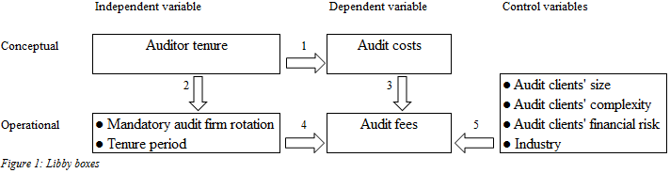
Link 1 in figure 1 is the relationship between the conceptual variables. This link captures the theory. In this thesis the relationship between auditor tenure and audit costs is examined. Link 2 and link 3 are the operationalization of the concepts. In this thesis the independent variables are mandatory audit firm rotation and the auditor tenure period. Mandatory audit firm rotation restricts the auditor tenure period and in the Italian audit market is the auditor tenure period three years, which can be lengthened two more times. Because audit fees are the revenues of audit firms the dependent variable is audit fees. Link 4 represents the relationships between the operational variables. These relationships are statically examined. Because discounts are given to gain the client and in the subsequent years the audit fees are thought to be higher to compensate the initial losses, mandatory audit firm rotation is likely to lower the audit fees. Link 5 represents the control variables which affect the dependent variable and consequently these control variables could significantly affect the results of the research.
The validity of the test is determined by the validity of each link (Libby, 1981). Internal validity is the degree of which the dependent variables are explained by the independent variables (link 4 in figure 1). Because other factors could explain the dependent variable as well, since this thesis focuses on the association between the audit firm rotation and the audit fees the internal validity is low. To increase the internal validity control variables are included in the model.
External validity is the degree to which findings can be generalized, to what degree link 4 captures link 1 in figure 1. The sample consists of 38 Italian public interest entities within a 6 year period. Consequently this study consists of 228 firm year observations. This sample is a good representation of the largest companies. The sample used is large because according to Field (2009) a sample with more than 200 observations can be considered large (Field, 2009). This increases the external validity in this thesis.
Construct validity is the degree to which the operationalized variables capture the conceptual variables (link 2 and 3 in figure 1). Because the operationalized variables are directly observable and do capture the concepts, the construct validity in this thesis is high.

Data collection
Because this data is not available in the databases of the Erasmus University, the data about the audit fees and about the audit firms are hand collected by searching for this information in the annual reports of the selected companies. Thomson WorldScope database only provides information of the total fees paid, not the audit fee. In addition, the audit firms are not provided at all in the Thomson WorldScope database. It is only from 2007 required for Italian companies (and other companies, reporting according to IFRS) to report the audit fees, and the fees paid for non-audit services. For Italian companies reporting the information about the audit fees paid is required by the law by Article 149-duodecies. Consequently the sample period is restricted from 2007 to 2012. All other data used in this study is retrieved from the Thomson WorldScope database. The initial sample consists of the 38 largest Italian public listed entities for 6 years which equals 228 firm year observations. Data of 18 firm years were not available. Consequently, these firm years were deleted from the initial sample resulting in a total sample of 210 firm year observations.

Summary
In this chapter the fourth sub-question is answered: ‘In which way is this research performed?’ Because secondary data is used in this research, this research can be qualified as a desk research. Desk research is a quantitative research approach. Quantitative research is concerned about numbers to statistically test the developed hypotheses.
The next regression model is developed which helps to accept or reject the hypotheses which are developed in chapter 4:
$$LnFEE= β_{0}+β_{1}ROTATE+β_{2}TENURE1+β_{3}TENURE2+β_{4}LnTENURE+{β_{5}CRISIS+β}_{6}LnASSETS+β_{7}Ln\#SEGMENTS+β_{8}LEVERAGE+β_{9-15}INDUSTRY+ε$$
Because conceptual variables cannot be observed variables should be operationalized. Internal validity is the degree to which the dependent variable is explained by the independent variables. Because other factors that are not included in the regression model could affect the audit fees the internal validity in this thesis is low. The external validity is the degree to which the findings of the study can be generalized. Because the sample in this thesis is large (>200) the external validity is high. Construct validity is the degree to which the operationalized variables do capture the concepts. Because the operationalized variables do capture the concepts, the construct validity in this research is high.
This study focuses on the 38 largest Italian public listed entities concerning the period 2007 up to and included 2012. The audit fees and the audit firms are hand collected. The other data used in this thesis is retrieved from the Thomson WorldScope database. The initial sample consists of 228 firm year observation. After deleting the missing data the sample consist of 210 firm year observations.
In the next chapter the results of the regression model are provided. The results accept or reject the hypotheses and are useful to answer the research question.

Results

Introduction
This chapter provides the results of the study performed in this thesis. The answer is provided to the fifth sub-question: In which way does mandatory audit firm rotation affect the audit fees in Italy? In the second paragraph the dependent variable is tested for normally and outliers are removed. In paragraph 6.3 a check for multicollinearity is performed. No multicollinearity is the second condition to perform a regression analysis. Multicollinearity indicates which independent variables explain the same dependent variable. Because in the initial regression model multicollinearity between the variables exists, in paragraph 6.4 an adjusted regression model is presented. This model has no multicollinearity. To be sure that the third and the fourth conditions are met to perform the regression analysis, in paragraph 6.5 additional checks for normality of the residuals and homoscedasticity are provided. In paragraph 6.6 the results of the adjusted regression model are presented which help to accept or reject the hypotheses. In paragraph 6.7 the results are discussed. Finally, in paragraph 6.8 the summary is provided.

Normality check dependent variable
Before performing the regression analyses the dependent variable LnFEE was tested for a normal distribution in SPSS. As shown in figure 1 in Appendix 2 the sample including 210 firm year observations was not normal distributed. A boxplot helps to detect outliers. Because they can affect the results outliers could be problematic. If outliers are not deleted, results are probably not valid (Field, 2009). In figure 2 of Appendix 2 it is visible that LnFEE does not have any outliers. But further analysis shows that when adding the independent variables some outliers in the LnFEE exist. Consequently these observations are deleted from the sample, then analyzing the new boxplot and delete new outliers. This is shown in figures 3 to 16 in Appendix 2. Deleting the outliers resulted in a final sample of 172 observations. With these 172 observations LnFEE is normal distributed (Kolmogorov-Smirnov P-value = 0,200, and Shapiro-Wilk P-value = 0,072) as presented by figure 17 in Appendix 2.

Check for multicollinearity
The second condition to perform a regression analysis is no multicollinearity. Multicollinearity is problematic for the reason that different variables explain the same outcome. In SPSS multicollinearity is measured by the VIF-score. A VIF-score above 10 indicates problematic multicollinearity and that variables should be eliminated (Field, 2009). The results of the multicollinearity test are presented in the next table:
Coefficientsª
Model |  | Unstandardized Coefficients |  | Standardized Coefficients | t | Sig. | Collinearity Statistics
 |  | B | Std. Error | Beta | t | Sig. | Tolerance | VIF
1 | (Constant) | 15,298 | ,770 |  | 19,855 | ,000
1 | ROTATION | -,730 | ,304 | -,276 | -2,397 | ,018 | ,228 | 4,380
1 | TENURE1 | -,861 | ,371 | -,469 | -2,322 | ,022 | ,074 | 13,460
1 | TENURE2 | -,306 | ,181 | -,173 | -1,696 | ,092 | ,290 | 3,444
1 | LnTENURE | -,597 | ,290 | -,492 | -2,061 | ,041 | ,053 | 18,853
1 | CRISIS | ,157 | ,139 | ,064 | 1,130 | ,260 | ,935 | 1,069
1 | LnASSETS | ,134 | ,047 | ,216 | 2,870 | ,005 | ,536 | 1,867
1 | Ln#SEGMENTS | ,435 | ,147 | ,215 | 2,966 | ,003 | ,576 | 1,736
1 | LEVERAGE | -2,404 | ,477 | -,375 | -5,039 | ,000 | ,546 | 1,832
1 | REFINERY | 1,951 | ,251 | ,465 | 7,761 | ,000 | ,842 | 1,187
1 | MANUFACTORING | ,690 | ,163 | ,288 | 4,231 | ,000 | ,651 | 1,535
1 | COMMUNICATION | ,760 | ,228 | ,234 | 3,336 | ,001 | ,618 | 1,619
1 | ELECTRICS | ,591 | ,152 | ,278 | 3,900 | ,000 | ,598 | 1,673
1 | RETAIL | ,470 | ,205 | ,139 | 2,296 | ,023 | ,829 | 1,207
1 | LIFE_INSURANCE | -,236 | ,157 | -,103 | -1,502 | ,135 | ,638 | 1,567
1 | OTHER | ,227 | ,224 | ,070 | 1,012 | ,313 | ,639 | 1,565
a. Dependent Variable: LnFEE
Table 1 Multicollinearity test
Based on the table above, the TENURE1 and LnTENURE variables have VIF-scores that are greater than 10. In addition ROTATION and TENURE2 have higher VIF-scores than the other variables in the model. An additional analysis indicates that the rotation and the tenure variables do have multicollinearity. The results of this analysis are shown in Appendix 3. To determine which variables have multicollinearity, the lowest eigenvalues should be considered. Based on the table in Appendix 3 it is visible that for eigenvalue ,002 ROTATION, TENURE1, TENURE2, and LnTENURE have collinearity values of 0,49, 0,73, 0,60, and 0,79 respectively. This indicates multicollinearity and one or more variables should be removed (Field, 2009).

Adjusted regression model
To eliminate the multicollinearity, variables need to be removed from the model. It is decided to delete ROTATION and LnTENURE. Because a company which rotates the audit firm will always end up in the TENURE1 group, ROTATION is deleted. Because the TENURE variables in addition indicate period specific differences LnTENURE is removed. Audit firms in Italy are assigned for 3 years, with the ability to lengthen this two more times. The assumption in this thesis is that because the auditor is assigned for 3 years and it is assumed that the audit fees for all the three years by an audit client are taken into consideration to assign an audit firm that the audit fees do not fluctuate much within a period.
Tenure is a dummy variable, because a company can be only in one auditor tenure group. Because tenure is a dummy variable, TENURE3 is excluded from the model. Auditor tenure period 3 is the control group. Any significant findings for TENURE1 and TENURE2 indicate differences in the audit fees in the first or the second auditor tenure period compared to the audit fees in the third auditor tenure period.
In addition, because industry is a dummy variable one industry group has to be removed to compare the audit fee of an industry group to the audit fee of the excluded industry group. The industry group BANK is excluded from the model by SPSS. Compared to a bank in the third auditor tenure period, the next regression model is developed:
$$LnFEE= β_{0}+β_{1}TENURE1+β_{2}TENURE2+β_{3}CRISIS+β_{4}LnASSETS+β_{5}Ln\#SEGMENTS+β_{6}LEVERAGE+β_{7-13}INDUSTRY+ε$$
All the variables have the same descriptions and predicted signs as provided in chapter 5. This model does not have multicollinearity. Detailed information of the results of the regression including the multicollinearity test is provided in Appendix 4.

Additional checks
The last checks performed before starting the regression analysis are to check whether the third and the fourth conditions are met to generalize the results. The third condition is that the residuals are normally distributed. Normal distributed residuals indicate that the error term of the regression is zero (Field, 2009). The standardized residuals were saved when running the regression in SPSS. The saved standardized residuals were tested for normality (Field, 2009). Results show that the standardized residuals are normally distributed, with a P-value of Kolmogorov-Smirnov 0,200, and a P-value of Shapiro-Wilk 0,129. Finally, the fourth condition was checked. To test the homoscedasticity the standardized residuals as observed and predicted are plotted so it is able to check if no pattern is observed. Homoscedasticity indicates that the variance of the dependent variable is the same (Field, 2009). It can be concluded that the homoscedasticity condition is met. Appendix 4 provides the results of both checks.

Regression results
As presented in Appendix 5 the model summary provides a R² of 0,510, indicating that the variables in the model explain the dependent variable for 51%. In addition the F-statistic of the ANOVA is 12,665, which is significant (0,000<0,05). In addition the results of main interest are provided and interpret in this paragraph. These results are provided in the next table:
Coefficientsª
Model |  | Unstandardized Coefficients |  | Standardized Coefficients | t | Sig.
 |  | B | Std. Error | Beta | t | Sig.
1 | (Constant) | 14,009 | ,426 |  | 32,914 | ,000
1 | TENURE1 | -,236 | ,115 | -,128 | -2,044 | ,043
1 | TENURE2 | -,021 | ,114 | -,012 | -,183 | ,855
1 | CRISIS | ,164 | ,139 | ,068 | 1,183 | ,238
1 | LnASSETS | ,150 | ,046 | ,241 | 3,239 | ,001
1 | Ln#SEGMENTS | ,422 | ,148 | ,209 | 2,855 | ,005
1 | LEVERAGE | -2,521 | ,480 | -,394 | -5,254 | ,000
1 | REFINERY | 1,939 | ,254 | ,462 | 7,626 | ,000
1 | MANUFACTORING | ,697 | ,165 | ,291 | 4,225 | ,000
1 | COMMUNICATION | ,770 | ,230 | ,237 | 3,344 | ,001
1 | ELECTRICS | ,574 | ,153 | ,269 | 3,745 | ,000
1 | RETAIL | ,457 | ,207 | ,135 | 2,208 | ,029
1 | LIFE_INSURANCE | -,215 | ,159 | -,095 | -1,359 | ,176
1 | OTHER | ,368 | ,212 | ,113 | 1,734 | ,085
a. Dependent Variable: LnFEE
Table 2 Regression results
The results in table 2 show that TENURE2, CRISIS, LIFE_INSURANCE and OTHER are not significant (α<0,05). This indicates that the audit fee in the second auditor tenure period does not significantly differ from the audit fee in the third auditor tenure period. In addition the audit fee paid by a life insurance company (and other group company) is not significantly different from the audit fees that banks have to pay. Finally, the crisis did not have a significant impact on the audit fees. Consequently hypothesis 3 is rejected.
The results suggest that if a company is in the first auditor tenure period, compared to the auditor tenure period 3 the audit fee is 23,6% lower in the auditor tenure period 1. This evidence supports the first hypothesis that after a rotation the audit fee is lower. Alternatively interpret does this implies that compared to the first auditor tenure period the audit fee in the auditor tenure period 3 is significant higher. No significant difference in audit fee exists between the second and the third auditor tenure period. Consequently in both auditor tenure periods the audit fees are expected to be higher than in the first auditor tenure period. This evidence supports the second hypothesis. The evidence in addition supports the logic model developed by DeAngelo (1981) which suggest that low balling exist.
Concerning a company within the refinery group, which in addition is in the third auditor tenure period, the sign of REFINERY is + 1,931. This indicates that the audit fee for a company in the refinery group is 193,1% higher than the audit fee for a banking company.
The other control variables should be interpreted as follows. A 1% increase in total assets is associated with a 0,150% increase in the audit fee, and a 1% decrease in the total assets is associated with a 0,150% decrease in the audit fee. In addition a 1% increase in the number of segments is associated with a 0,422% increase in the audit fee. A 1% decrease in the number of segments is associated with a 0,422% decrease in the audit fee. Finally, an increase of 1% in the leverage of a company is associated with a 2,521% decrease in the audit fee.

Discussion of the results
The findings of the effects of the independent variables on the audit fees are consistent with the findings in prior research. The results of Copley & Douchet (1993) and Johnson et al. (2002) provide evidence that the length of the auditor tenure significantly affects the audit quality. The findings in this thesis add to those researches that the auditor tenure in addition affects the audit costs.
The findings of the effects of the control variables are consistent with the results of prior research, except the finding of the effect of the financial risk of the audit client on the audit fees. The finding that the audit fee differs between different industry groups is consistent to the results of Gul et al. (2009). Like the results of Gul et al. (2009) significant results for different industries are found in this thesis.
The finding that the audit fee increases with an increase in the client’s size is consistent with the findings of evidence found by prior research. Johnson et al. (2002), Blouin et al. (2005), Gul et al. (2009) and Lim & Tan (2010) found a significant effect of audit client’s size on the audit quality. In addition Cameran (2005) found evidence that a 1% increase in assets results in a 0.00350 increase in the audit fee. This evidence is consistent with the expectations that larger audit clients have to pay higher audit fees.
The finding that the audit fee increases with an increase in the client’s complexity is consistent with the results found by Blouin et al. (2005) that the audit client’s complexity significantly affects the audit quality. In addition Cameran (2005) found that an increase in the audit client’s complexity results in an increase in the audit fee. This is consistent with the expectations that more complex audit clients pay higher audit fees.
The finding that the audit fee increases with an increase in the client’s financial risk is against the expectation that financial distressed companies are a greater risk for the audit firm. It is argued that audit firms to avoid litigation have to perform more audit work. Consequently it is expected that the audit fee increases if the leverage increases, because the leverage increases due to increased total liabilities or decreased total assets. Although the leverage is significant in this thesis, the sign is negative. Consequently the finding is inconsistent with the results of Cameran (2005). Cameran (2005) found evidence that an increase in the financial risk results in a higher audit fee.
The findings support hypotheses 1 of lower initial audit fees after a rotation and hypothesis 2 of an increase in the audit fees in subsequent years. This means that low balling exists in a mandatory audit firm rotation environment. In addition hypothesis 3 is rejected which indicates that the financial banking crisis does not affect the audit fees. It could be explained by considering the Italian audit market. Auditors are assigned for 3 years. Consequently the effects of crisis may not immediately affect the audit fees because fee contracts exist. Consequently the answer to the research question is that in a mandatory audit firm rotation environment low balling exist and that the financial banking crisis does not immediately affect the audit fees.
This adds to prior research by considering the audit fees as costs and tests the effect of the mandatory audit firm rotation on the audit fees. Prior research mostly focused on voluntary rotations and on the potential benefits of the mandatory audit firm rotation.

Summary
In this chapter the last sub-question is answered: In which way does mandatory audit firm rotation affect the audit fees in Italy? Before analyzing the regression results it was checked if the dependent variable was normal distributed and had no outliers. The dependent variable with 210 firm year observations was not normal distributed and had some outliers. After deleting these outliers the final sample consists of 172 firm year observations.
The second condition to perform a regression analysis is no multicollinearity. The variables of initial regression model have VIF values greater than 10. This indicates multicollinearity. To resolve this problem ROTATION and LnTENURE are deleted from the regression model. Consequently the next regression model is developed:
$$LnFEE= β_{0}+β_{1}TENURE1+β_{2}TENURE2+β_{3}CRISIS+β_{4}LnASSETS+β_{5}Ln\#SEGMENTS+β_{6}LEVERAGE+β_{7-13}INDUSTRY+ε$$
This regression model in addition was tested for multicollinearity. The results of this test indicate no multicollinearity in the new regression model.
The next checks are concerned with the third and fourth conditions to perform a regression analysis. The third condition is that the residuals should be normally distributed. Analysis of the residuals suggests that the standardized residuals are normally distributed. In addition analysis of the fourth condition suggests homoscedasticity.
The results of the regression analysis indicate that the audit fee in auditor tenure period 1 is significantly lower than in auditor tenure period 3. Consequently the first hypothesis is accepted. No significant difference exists in the audit fee in the auditor tenure period 2 and the auditor tenure period 3. The audit fee in the third auditor tenure period is significant higher than in the first tenure period. Consequently results suggest significant higher audit fees in subsequent periods. Based on these findings hypothesis 2 is accepted. Finally, the results indicate that the audit fees are not significantly higher during the financial banking crisis compared to the audit fees before the financial banking crisis. Consequently hypothesis 3 is rejected.
The results of the control variables LnASSETS and Ln#SEGMENTS are according to the expectations. These results indicate that the audit fees increase when an audit client is larger and more complex. The results for LEVERAGE are not according to the expectations. Leverage indicates the financial risk and with greater risk higher audit fees are expected. Results however suggest that an increase in the leverage results in a lower audit fee.
The next chapter provides the conclusion of the research performed in this thesis. The answer to the research question is provided. In addition the limitations of the research are provided. Finally some suggestions for further research are presented.

Conclusion

Introduction
This chapter provides the conclusion of the research performed in this thesis. In the next paragraph the conclusion of the research is provided. Limitations exist concerning the research performed these are provided in paragraph 7.3. Finally, paragraph 7.4 provides suggestions for further research.

Conclusion
To restore the investors’ confidence in the audit profession the European Commission accepted the motion to introduce the mandatory audit firm rotation. The potential benefits of the mandatory audit firm rotation are an increase in the auditor independence and an increase in the audit quality. Consequently the audit costs increase. Results of prior scientific research on the mandatory audit firm rotation are mixed. The research performed in this thesis adds to prior research by examining in which way the costs of the mandatory audit firm rotation are reflected in reality by considering the effects of the mandatory audit firm rotation on the audit fees. This thesis provides an answer to the research question: ‘Does mandatory audit firm rotation affect the audit fees?’
Because the audit firms want to gain the audit client, the mandatory audit firm rotation increases the competition in the audit market. To gain the audit client in the initial year after a rotation to the audit client received discounts. To compensate the initial losses by the audit firms in the subsequent periods quasi rents are expected to earn. These quasi rents are set above the costs, but are lower than the switching costs. This is qualified by DeAngelo (1981) as low balling. To test for low balling the next hypotheses are developed:
H1
In the first year after an audit firm rotation the audit fees are lower
H2
Audit fees increase in the subsequent years
To restore the investors’ confidence after the financial banking crisis more audit work has to be performed. Consequently the audit fees are expected to increase. To test the effect of the financial banking crisis on the audit fees the next hypothesis is developed:
H3
During the financial crisis audit fees are higher than before the financial crisis
The results indicate that low balling exists. The audit fees in the first auditor tenure period are significantly lower than the audit fees in the third auditor tenure period. This finding supports hypothesis 1. Findings in addition imply that there is no significant difference in the audit fees in auditor tenure period 2 compared to the audit fees in auditor tenure period 3. But in both auditor tenure periods the audit fees are significantly higher compared to the audit fees in auditor tenure period 1. This finding supports hypothesis 2. Finally, hypothesis 3 is rejected. The results suggest that the audit fees are not significantly higher during the financial banking crisis compared to the audit fees before the financial banking crisis.
In addition the audit fees are higher for larger audit clients and for more complex audit clients. It was expected that an increase in the leverage would result in a higher audit fee, but results show that the audit fees are lower when the leverage increases.
The results of the research performed in this thesis have implications for the standard setters, the audit firms and the audit clients. The results reflect the pricing strategy of the audit firms in a mandatory audit firm rotation setting. Auditors can feel pressure to work within limited time to reduce the audit costs. This could reduce the audit quality. In addition audit clients can take into consideration that the audit fees in subsequent periods probably are higher. This knowledge may be helpful in negotiating with an audit firm. Finally, standard setters should consider the consequences of mandatory audit firm rotation, especially if the mandatory audit firm rotation does reduce the audit quality.

Limitations
The research performed in this thesis has several limitations. First limitations exist concerning the sample. Because the sample contains non-randomly assigned data, it is hard to generalize the results of this research. The largest Italian public entities are included and consequently the sample is not a randomly assigned.
In addition the sample consists of 172 observations. A large sample consists of at least 200 observations which increase the external validity. Because of low external validity it is hard to generalize the results. Each variable should exist of at least 10 observations. The lowest numbers of observations are 12 observations within the industry groups. This implies that the sample size is sufficient.
Second, limitations exist concerning the data used. The industry groups are a limitation. Because each variable should exist of at least 10 observations companies are divided in industry groups. Because SIC codes are more specified and reflects a specific industry it is better to divide companies by their SIC code.
Another limitation with the data is the crisis variable. In this thesis is assumed that the industry groups face the consequences of the financial banking crisis in the period 2008 up to and included 2012. But the financial banking crisis could hit different industry groups at a different time. For example the life insurance industry group faces the consequences of the financial banking crisis in 2008 and another industry group faces the consequences of the financial banking crisis in 2009. In addition the consequences of the financial banking crisis may differ in different industry groups. For example the life insurance industry group may face greater consequences of the financial banking crisis compared to the communication industry group.
Third, limitations exist concerning the regression analysis. The results of a regression model are only an estimation of the dependent variable. Always some error exists. Another limitation concerning the regression analysis is that predictions cannot be made for values without the sample. To reduce these limitations concerning the regression analysis the four conditions to perform a regression analysis are considered in the research performed in this thesis.
A fourth limitation is that results in Italy are hard to generalize to the Netherlands. In Italy the mandatory rotation rule is introduced in 1974. Consequently the audit firms and the audit clients may face lower start-up costs and switching costs, because they are familiar with audit firm rotations. In addition no research is performed on the current pricing strategy in the Netherlands. Low balling could exist is the Netherlands before introducing the mandatory audit firm rotation rule.

Further research
Further research could examine more companies in the sample. In the research performed in this thesis only the 38 largest Italian public listed entities are considered. It is useful to consider more companies to increase the external validity and examine the effect of the mandatory audit firm rotation on the audit fees for smaller companies.
In addition further research is needed to examine the effects of the mandatory audit firm rotation on pressure that the auditors may feel to work within limited time to reduce the audit costs and whether this reduces the audit quality. This is beneficial because the European Commission tries to restore the investors’ confidence in the audit profession with the introduction of the mandatory audit firm rotation. But a decrease in the audit quality could be harmful to investors’ confidence.
Third, research may focus on the current pricing strategies in the Netherlands. When low balling exists it could be examined whether the mandatory audit firm rotation rule does affect the current pricing strategies.
Finally, further research may focus on the effect of the mandatory audit firm rotation on the audit fees in the Netherlands and compare the results with other countries which have to introduce mandatory audit firm rotation. This research cannot be performed in the coming years, because audit firm rotation is mandated from 2016.

Bibliography
Arens, A. A., Elder, R. J., & Beasley, M. S. (2013). Auditing and Assurance Services. An Integrated Approach (15 ed.). New Jersey: Pearson Prentice Hall.
Arruñada, B., & Paz-Ares, C. (1997). Mandatory Rotation of Company Auditors: A Critical Examination. International Review of Law and Ecnonomics, 17, pp. 31-61.
Beattie, V., Goodacre, A., & Fearnley, S. (2003). And Then There Were Four: A Study of UK Audit Market Concentration - Causes, Consequences and the Scope for Market Adjustment. Journal of Financial Regulation and Compliance, 11 (3), pp. 250-265.
Blouin, J., Grein, B., & Rountree, B. (2005). An Analysis of Forced Auditor Rotation: The Case of Former Arthur Anderson Clients. Working Paper, University of Pensylvania, United States.
Cameran, M. (2005). Audit Fees and the Large Auditor Premium in the Italian Market. International Journal of Accounting, 9, pp. 129-146.
Cameran, M., Di Vincenzo, D., & Merlotti, E. (2005). The Audit Firm Rotation Rule: A Review of the Literature. Working Paper, Bocconi University, Milan, Italy.
Carey, P., & Simnett, R. (2006). Audit Partner Tenure and Audit Quality. The Accounting Review, 81, pp. 653-676.
Chen, C. Y., Lin, C. J., & Lin, Y. C. (2008). Audit Partner Tenure, Audit Firm Tenure, and Discretionary Accruals: Does Long Auditor Tenure Impair Earnings Quality? Contemporary Accounting Research, 25, pp. 415-445.
Commission on Public Trust and Private Enterprise. (2003). Executive Summary. Findings and Recommendations. New York.
Copley, P., & Douchet, M. (1993). Auditor Tenure, Fixed Fee Contracts, and the Supply of Substandard Single Audits. Public Budgeting & Finance, 13 (3), pp. 23-36.
Daniels, B. W., & Booker, Q. (2011). The Effects of Auditor Firm Rotation on Perceived Auditor Independence and Audit Quality. Research in Accounting Regulation, 23, pp. 78-82.
DeAngelo, L. E. (1981). Auditor Independence, "Low-balling" and Disclosure Regulation. Journal of Accounting and Economic, 3, pp. 113-127.
Deegan, C., & Unerman, J. (2011). Financial Accounting Theory (Second European ed.). Maidenhead, Berkshire: McGrath-Hill Education.
Eerste Kamer. (2012-2013). 33 025.
Eisenhardt, K. M. (1989). Agency Theory: An Assessment and Review. Academy of Management Review, 14 (1), pp. 57-74.
European Commission. (2011). Proposal for a Regulation of the European Parliament and of the Council on Specific Requirements Regarding Statutory Audit of Public-interest Entities. Proposal, Brussels.
EY. (2014). Point of View. Our Perspective on Issues of Concern: European Union Audit Legislation. Retrieved April 30, 2014, from http://sg200.ey.net/GLOBAL/CKR/PPLCYCKR.NSF/646309c4a5106dcc8525710800779429/2c0dc4c45efb225448257cbc0067f95f/$FILE/EU%20Audit%20legislation%20POV_April2014.pdf
Field, A. (2009). Discovering Statistics Using SPSS (3th ed.). London: Sage.
Francis, J., & Schipper, K. (1999). Have Financial Statements Lost Their Relevance? Journal of Accounting Research, 37 (2), pp. 319-352.
Freeman, R. E. (1984). Strategic Management: A Stakeholder Approach. Boston: Pitman.
Friedman, M. (1970). The social responsibility of business is to increase its profits. New York Times Magazine, pp. 122-126.
Gates, S. K., Lowe, D. J., & Reckers, P. M. (2007). Restoring Public Confidence in Capital Markets Through Auditor Rotation. Managerial Auditing Journal, 22 (1), pp. 5-17.
Geiger , M. A., & Raghunandan, K. (2002). Auditor Tenure and Audit Reporting Failure. Auditing: A Journal of Practice and Theory, 21, pp. 67-78.
Gietzmann, M. B., & Sen, P. K. (2002). Improving Auditor Independence Through Selective Mandatory Rotation. International Journal of Auditing, 6, pp. 183-210.
Gosh, A., & Moon, D. (2005). Auditor Tenure and Perceptions of Audit Quality. The Accounting Review, 80 (2), pp. 585-612.
Gul, F. A., Fung, S. Y., & Jaggi, B. (2009). Earnings Quality: Some Evidence on the Role of Auditor Tenure and Auditors' Industry Expertise. Journal of Accounting and Economics, 47, pp. 265-287.
Hussey, R., & Lan, G. (2001). An Examination of Auditor Independence Issues from the Perspectives of U.K. Finance Directors. Journal of Business Ethics, 32 (2), pp. 169-178.
Jackson, A., Moldrich, M., & Roebuck, P. (2008). Mandatory Audit Firm Rotation and Audit Quality. Managerial Auditing Journal, 23 (5), pp. 420-437.
Johnson, V., Khurana, I., & Reynolds, J. (2002). Audit-Firm Tenure and the Quality of Financial Reports. Contemporary Accounting Research, 19 (4), pp. 638-660.
Knapp, M. (1991). Factors That Audit Committees Use as Surrogates for Audit Quality. Auditing: A Journal of Practice and Theory, 10 (1), pp. 35-52.
Libby, R. (1981). Accounting and Human Information Processing: Theory and Applications. Englewood Cliffs: Prentice-Hall.
Lim, C. Y., & Tan, H. T. (2010). Does Auditor Tenure Improve Audit Quality. Moderating Effects of Industry Specialization and Fee Dependence. Contemporary Accounting Research, 27 (3), pp. 923-957.
Lindberg, D. L., & Beck, F. D. (2004). Before and After Enron: CPAs' Views on Auditor Independence. The CPA Journal, 74 (11), pp. 36.
McGrath, S., Siegel, A., Dunfee, T. W., Glazer, A. S., & Jaenicke, H. R. (2001). A Framework for Auditor Independence. Journal of Accountancy, 191 (1), pp. 39-42.
Myers, N., Myers, A., & Omar, C. (2003). Exploring the Term of the Auditor-Client Relationship and the Quality of Earnings: A Case for Mandatory Auditor Rotation? The Accounting Review, 78 (3), pp. 779-799.
Roos, R. (2004, November). Roulatie van Accountantskantoor of Interne Roulatie? Maandblad voor Accountancy en Bedrijfseconomie, pp. 472-478.
Ruiz-Barbadillo, E., & Gòmez-Aguilar, N. (2002). Does Auditor Tenure Improve Audit Quality? Mandatory Auditor Rotation Versus Long Term Auditing. An Empirical Analysis. Working Paper, University of Cadiz, Spain.
Scott, W. R. (2014). Financial Accounting Theory (6 ed.). Harlow, Essex: Pearson.
United States General Accounting Office (GAO). (2003). Required Study on the Potential Effects of Mandatory Audit Firm Rotation. Washington D.C.
Vanstraelen, A. (2000). Impact of Renewable Long-term Audit Mandates on Audit Quality. The European Accounting Review, 9 (3), pp. 419-443.
VNO-NCW. (2012). Wetsvoorstel 33025 (Wet op het Accountantsberoep), brief aan de VC voor Financiën uit de Eerste Kamer. Retrieved May 23, 2014, from http://www.vno-ncw.nl/Publicaties/Brieven_en_commentaren/Pages/Wetsvoorstel_33025_Wet_op_het_Accountantsberoep_brief_aan_de_VC_voor_Financin_uit_de_Eerste_Kamer_1054.aspx?source=%2fPages%2fZoek.aspx%3fk%3dkantoor%2broulatie
Watts, R. L., & Zimmerman, J. L. (1986). Positive Accounting Theory. Englewood Cliffs, New Jersey: Prentice-Hall.
Watts, R. L., & Zimmerman, J. L. (1990). Positive Accounting Theory: A Ten Year Perspective. The Accounting Review, 65 (1), pp. 131-156.

Appendices

Appendix 1 Summary prior research
Auditor Independence
Author(s) | Year | Object of study | Sample | Methodology | Outcome
DeAngelo | 1981 | impact of low balling on the auditor independence |  | logical multi period model | Low-balling is a response to competition, it does not affect auditor the independence
Gietzmann & Sen | 2002 | Effects of mandatory audit firm rotation on the auditor independence |  | First game: 1 period with tenure period restricted by law. Second game: 2 periods with no mandatory rotation | In audit markets with few large clients, mandatory audit firm rotation is beneficial. In audit markets with much large clients, mandatory audit firm rotation is too costly
Lindberg & Beck | 2004 | CPA's perceptions on the auditor independence before and after the collapse of Enron | 379 US CPA's (2001) | Open ended interviews, focus groups and a survey. ANOVA | After the collapse of Enron the CPA's perception of the non-audit services more negatively affects the auditor independence. After the collapse of Enron CPA's are more concerned about issues which could harm the auditor independence in appearance. After the collapse of Enron CPA’s are more conservative about issues which affect the auditor independence.
Daniels & Booker | 2011 | Loan officers perceptions on the auditor independence and audit quality | 212 loan officers | between-subjects experimental design | Perceived auditor independence increases in a rotation setting. Tenure does not increase the auditor independence. Perceived audit quality does not increase.
Audit Quality
Author(s) | Year | Object of study | Sample | Methodology | Outcome
Copley & Douchet | 1993 | Effect of auditor tenure and audit quality and audit quality and fixed fee contracts | 136 audits of federal financial assistance programs in 1985 | Regression model | With fixed fee contracts significant more violations of professional standards exist and this effect is lower when provisions exist
Johnson et al. | 2002 | Association between the auditor tenure and the financial reporting quality | Big-6 clients, all data available, no modified opinions, resulting in 2,463 US firm-years from 1986 to 1995 from Compustat | Comparing 3 groups: short, medium and long term. 2 proxies for earnings quality. Unexpected accruals and persistence of accruals | Compared to the medium term in the short term the audit quality is significantly lower. No significant differences exist between the medium and the long term
Gul et al. | 2009 | Effects of specialization and low balling on the association between the auditor tenure and the audit quality | 32,777 firm-years audited by Big6/5/4 from 1993 to 2004 from Compustat | Multivariate logistic regression | The association between shorter auditor tenure and a lower audit quality is lower when a company is audited by an industry specialist auditor. No evidence is found for low balling.
Lim & Tan | 2010 | Effects of auditor specialization and fee dependence on the association between the auditor tenure and the audit quality | 12,783 firm-years from 2000 to 2005 from Audit Analytics and Compustat | Multivariate logistic regression | The audit quality is affected by specialization and is fee dependent
Audit Costs
Author(s) | Year | Object of study | Sample | Methodology | Outcome
Arruñada & Paz-Ares | 1997 | Effect of mandatory audit firm rotation on the audit costs and the audit quality |  | Estimation of costs by using models from prior researchers | Mandatory audit firm rotation results in higher audit costs and a lower audit quality
Blouin et al. | 2005 | Examine factors involved with audit firm rotation | 407 former Arthur Anderson clients in the US from Compustat | Regression model | Switching costs and agency benefits exist. Clients who did not follow their former AA audit teams have less discretionary accruals after the rotation. Clients, who did follow their former AA audit team, still had high levels of discretionary accruals.
Audit Market Concentration
Author(s) | Year | Object of study | Sample | Methodology | Outcome
Beattie et al. | 2003 | Examine the audit market concentration | 2,180 Firms listed on the London stock exchange from April 2002 | Time series of market share measured by number of audits and audit fees | After the collapse of Arthur Anderson Big4 firms held 96% of the audit market. With AA this was 90%

Appendix 2 Normal distribution LnFEE
Test for normality LnFEE
Case Processing Summary
 | Cases
 | Valid |  | Missing |  | Total
 | N | Percent | N | Percent | N | Percent
LnFEE | 210 | 92.1% | 18 | 7.9% | 228 | 100.0%
Descriptive
 |  |  | Statistic | Std. Error
LnFEE | Mean |  | 14.935 | .0806
LnFEE | 95% Confidence Interval for Mean | Lower Bound | 14.776
LnFEE | 95% Confidence Interval for Mean | Upper Bound | 15.094
LnFEE | 5% Trimmed Mean |  | 14.913
LnFEE | Median |  | 14.800
LnFEE | Variance |  | 1.364
LnFEE | Std. Deviation |  | 1.1677
LnFEE | Minimum |  | 12.9
LnFEE | Maximum |  | 17.3
LnFEE | Range |  | 4.4
LnFEE | Interquartile Range |  | 1.6
LnFEE | Skewness |  | .432 | .168
LnFEE | Kurtosis |  | -.777 | .334
Tests of Normality
 | Kolmogorov-Smirnovª |  |  | Shapiro-Wilk
 | Statistic | df | Sig. | Statistic | df | Sig.
LnFEE | .086 | 210 | .001 | .949 | 210 | .000
a. Lilliefors Significance Correction

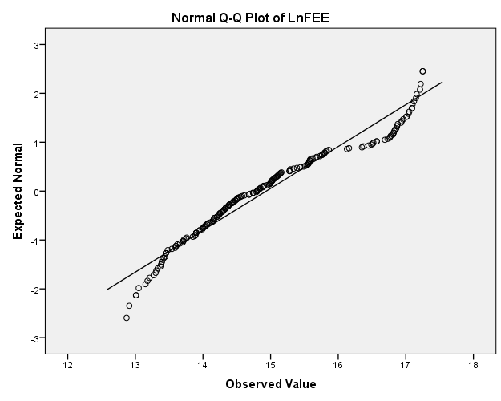
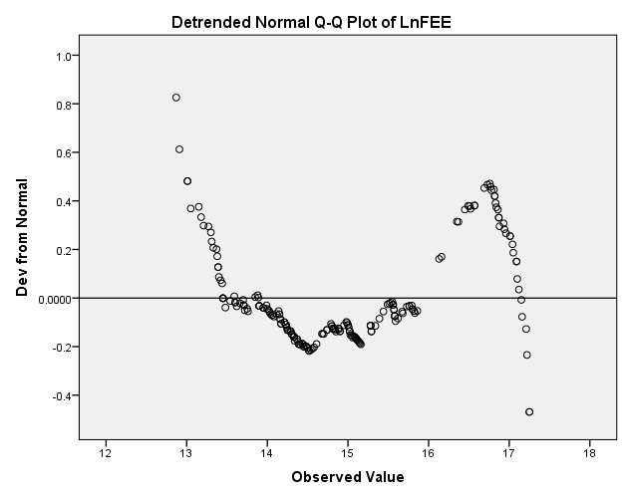

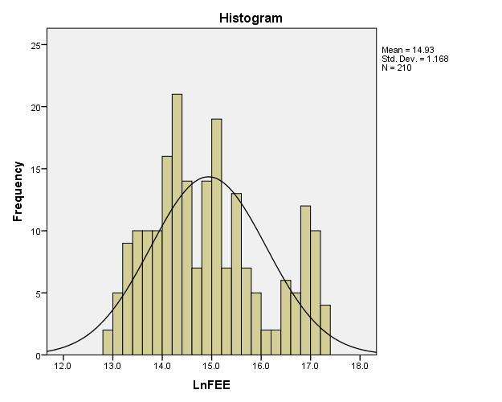

Figure 1 Normal distribution LnFEE

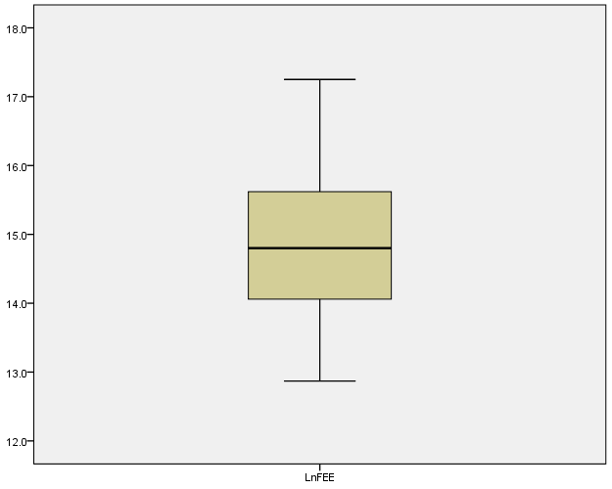
Boxplots LnFEE
LnFEE
Figure 2 Boxplot LnFEE (n=210)

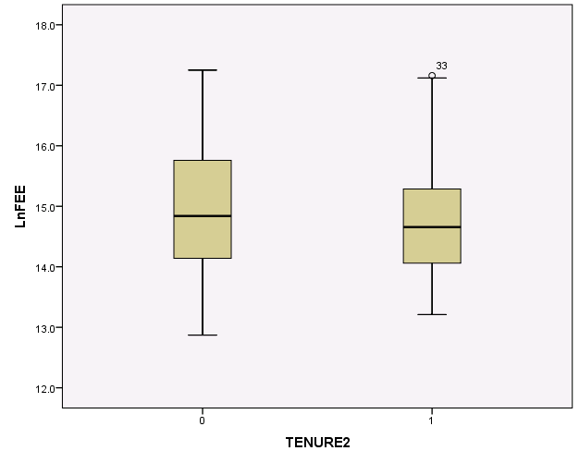 |  |  |  |  | 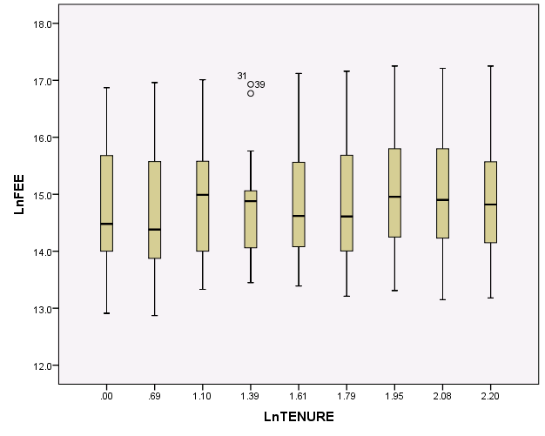
Figure 3 Boxplot LnFEE (n=210) |  |  |  |  | Figure 4 Boxplot LnFEE (n=210)
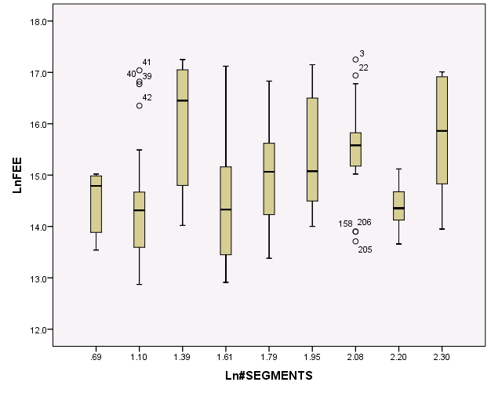 |  |  |  |  | 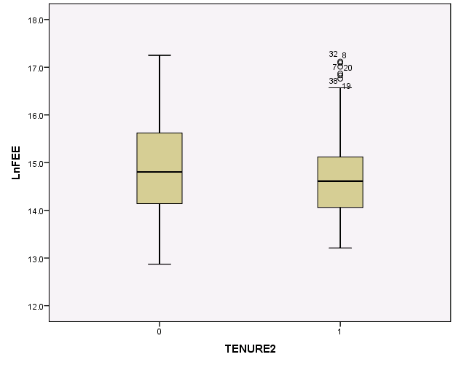
Figure 5 Boxplot LnFEE (n=210) |  |  |  |  | Figure 6 Boxplot LnFEE (n=199)
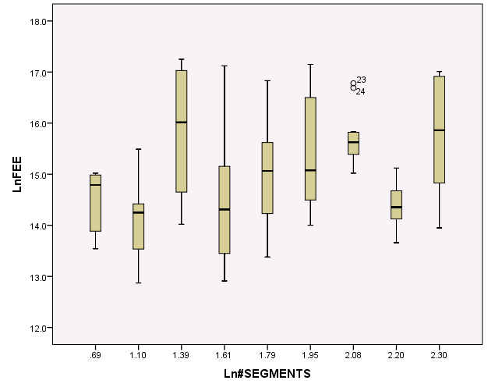 |  |  |  |  | 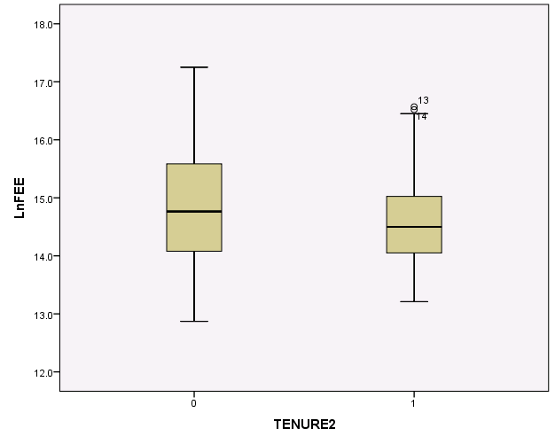
Figure 7 Boxplot LnFEE (n=199) |  |  |  |  | Figure 8 Boxplot LnFEE (n=191)
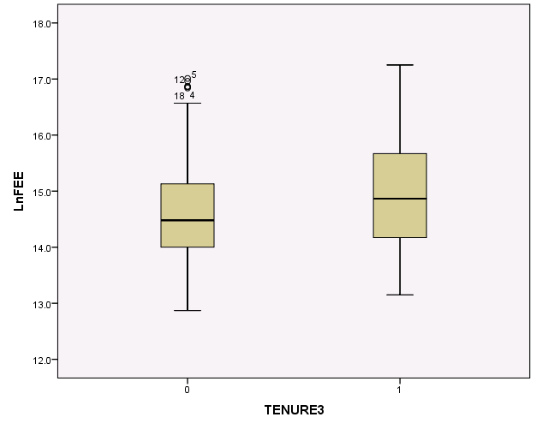 |  |  |  |  | 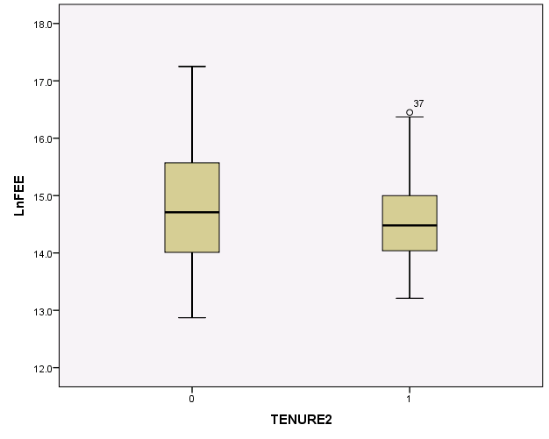
Figure 9 Boxplot LnFEE (n=191) |  |  |  |  | Figure 10 Boxplot LnFEE (n=185)
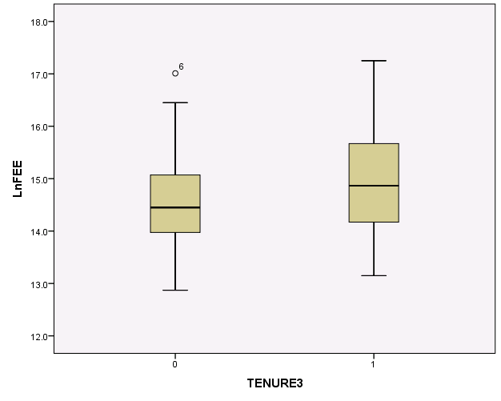 |  |  |  |  | 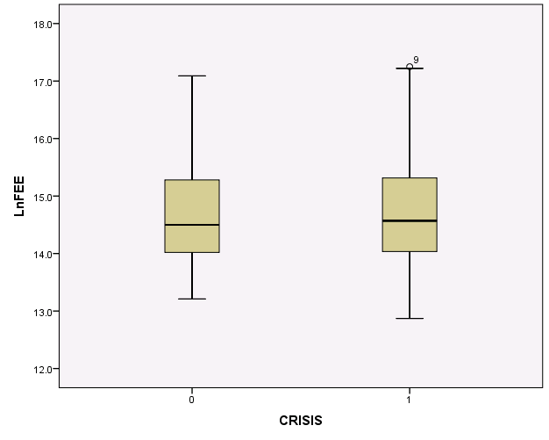
Figure 11 Boxplot LnFEE (n=185) |  |  |  |  | Figure 12 Boxplot LnFEE (n=185)
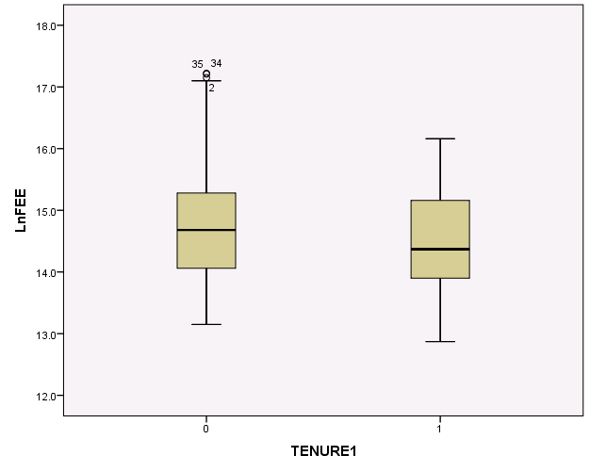 |  |  |  |  | 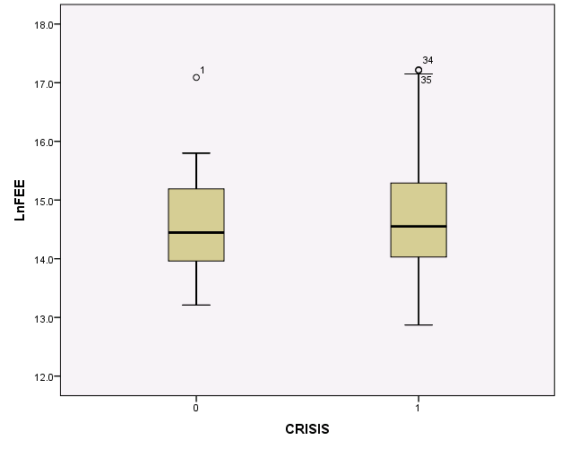
Figure 13 Boxplot LnFEE (n=182) |  |  |  |  | Figure 14 Boxplot LnFEE (n=182)
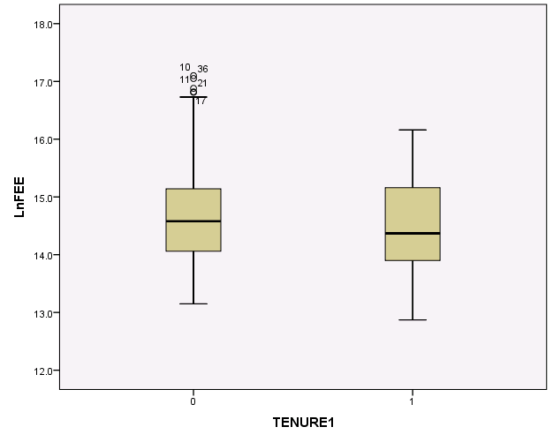 |  |  |  |  | 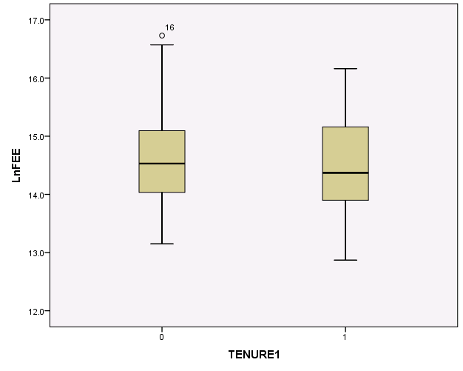
Figure 15 Boxplot LnFEE (n=178) |  |  |  |  | Figure 16 Boxplot LnFEE (n=173)

Normal distribution LnFEE (n=172)
Case Processing Summary
 | Cases
 | Valid |  | Missing |  | Total
 | N | Percent | N | Percent | N | Percent
LnFEE | 172 | 75.4% | 56 | 24.6% | 228 | 100.0%
Descriptive
 |  |  | Statistic | Std. Error
LnFEE | Mean |  | 14.553 | .0634
LnFEE | 95% Confidence Interval for Mean | Lower Bound | 14.427
LnFEE | 95% Confidence Interval for Mean | Upper Bound | 14.678
LnFEE | 5% Trimmed Mean |  | 14.543
LnFEE | Median |  | 14.480
LnFEE | Variance |  | .691
LnFEE | Std. Deviation |  | .8311
LnFEE | Minimum |  | 12.9
LnFEE | Maximum |  | 16.6
LnFEE | Range |  | 3.7
LnFEE | Interquartile Range |  | 1.1
LnFEE | Skewness |  | .129 | .185
LnFEE | Kurtosis |  | -.600 | .368
Tests of Normality
 | Kolmogorov-Smirnovª |  |  | Shapiro-Wilk
 | Statistic | df | Sig. | Statistic | df | Sig.
LnFEE | .045 | 172 | .200* | .986 | 172 | .072
*. This is a lower bound of the true significance.
a. Lilliefors Significance Correction

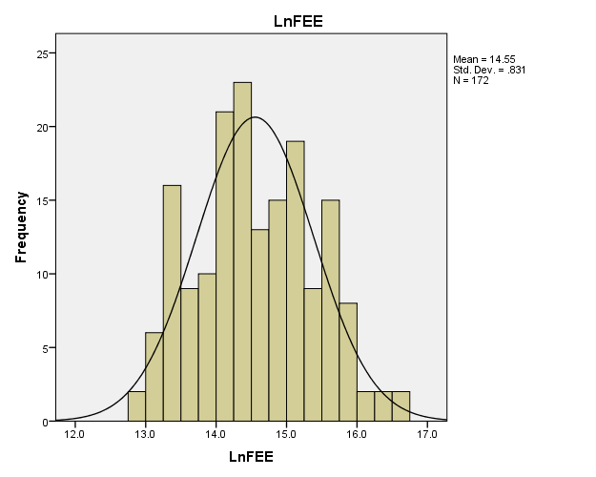

Figure 17 Normal distribution LnFEE
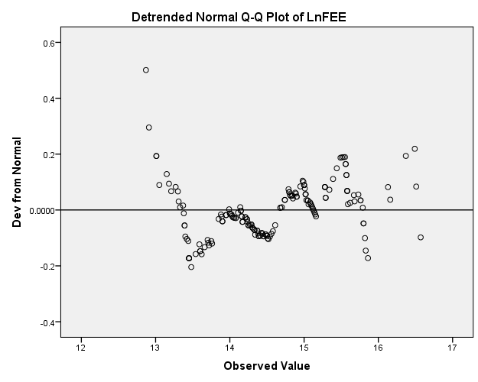
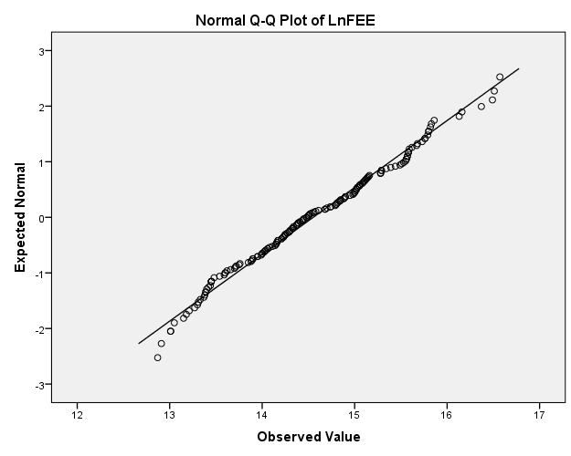
LnFEE
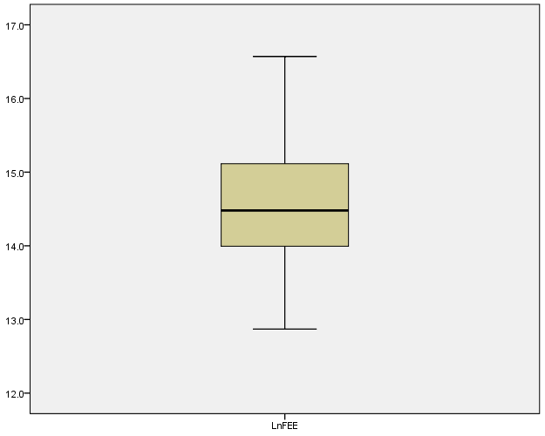

Appendix 3 Multicollinearity
Collinearity Diagnostics Dependent Variable: LnFEE
Model |  | Eigenvalue | Condition Index | Variance Proportions
 |  | Eigenvalue | Condition Index | (Constant) | ROTATION | TENURE1 | TENURE2 | LnTENURE | CRISIS | LnASSETS | Ln#SEGMENTS | LEVERAGE | REFINERY | MANUFACTORING | COMMUNICATION | ELECTRICS | RETAIL | LIFE_INSURANCE | OTHER
 | 1 | 7.132 | 1.000 | .00 | .00 | .00 | .00 | .00 | .00 | .00 | .00 | .00 | .00 | .00 | .00 | .00 | .00 | .00 | .00
 | 2 | 1.596 | 2.114 | .00 | .05 | .01 | .02 | .00 | .00 | .00 | .00 | .00 | .00 | .01 | .00 | .00 | .01 | .02 | .00
 | 3 | 1.016 | 2.649 | .00 | .00 | .00 | .00 | .00 | .00 | .00 | .00 | .00 | .02 | .04 | .14 | .05 | .17 | .11 | .07
 | 4 | 1.014 | 2.652 | .00 | .00 | .00 | .00 | .00 | .00 | .00 | .00 | .00 | .01 | .32 | .03 | .02 | .14 | .01 | .05
 | 5 | 1.003 | 2.667 | .00 | .00 | .00 | .00 | .00 | .00 | .00 | .00 | .00 | .00 | .00 | .05 | .25 | .00 | .02 | .22
 | 6 | 1.001 | 2.670 | .00 | .00 | .00 | .00 | .00 | .00 | .00 | .00 | .00 | .07 | .02 | .22 | .02 | .13 | .01 | .16
 | 7 | 1.000 | 2.671 | .00 | .00 | .00 | .00 | .00 | .00 | .00 | .00 | .00 | .65 | .00 | .05 | .02 | .04 | .00 | .00
 | 8 | .964 | 2.720 | .00 | .01 | .00 | .00 | .00 | .00 | .00 | .00 | .00 | .01 | .05 | .02 | .00 | .21 | .24 | .04
 | 9 | .562 | 3.563 | .00 | .07 | .00 | .23 | .00 | .00 | .00 | .00 | .00 | .00 | .01 | .00 | .00 | .01 | .04 | .00
 | 10 | .315 | 4.756 | .00 | .20 | .08 | .06 | .00 | .00 | .00 | .00 | .00 | .00 | .02 | .01 | .00 | .01 | .05 | .00
 | 11 | .232 | 5.550 | .00 | .01 | .00 | .01 | .00 | .05 | .00 | .00 | .00 | .16 | .38 | .19 | .45 | .24 | .36 | .19
 | 12 | .105 | 8.224 | .00 | .02 | .00 | .00 | .01 | .91 | .00 | .01 | .00 | .02 | .04 | .04 | .03 | .00 | .01 | .02
 | 13 | .031 | 15.210 | .00 | .00 | .02 | .01 | .01 | .00 | .01 | .97 | .03 | .03 | .03 | .17 | .13 | .03 | .07 | .04
 | 14 | .019 | 19.308 | .01 | .13 | .12 | .07 | .16 | .00 | .09 | .00 | .27 | .02 | .05 | .05 | .01 | .00 | .00 | .10
 | 15 | .008 | 29.109 | .01 | .02 | .03 | .00 | .03 | .00 | .64 | .02 | .69 | .00 | .04 | .03 | .00 | .01 | .06 | .02
 | 16 | .002 | 53.890 | .97 | .49 | .73 | .60 | .79 | .03 | .25 | .00 | .01 | .00 | .00 | .00 | .01 | .00 | .01 | .08

Appendix 4 Normal distribution residual and homoscedasticity
Residuals Statisticsª
 |  | Minimum |  | Maximum |  | Mean |  | Std. Deviation |  | N
Predicted Value |  | 13.563 |  | 16.550 |  | 14.553 |  | .5937 |  | 172
Residual |  | -1.5382 |  | 1.1129 |  | .0000 |  | .5816 |  | 172
Std. Predicted Value |  | -1.666 |  | 3.364 |  | .000 |  | 1.000 |  | 172
Std. Residual |  | -2.542 |  | 1.839 |  | .000 |  | .961 |  | 172
a. Dependent Variable: LnFEE
Normal distribution standardized residuals statistical check
Case Processing Summary
 | Cases
 | Valid |  |  |  | Missing |  |  |  | Total
 | N |  | Percent |  | N |  | Percent |  | N |  | Percent
Standardized Residual | 172 |  | 75.4% |  | 56 |  | 24.6% |  | 228 |  | 100.0%
Descriptive
 |  |  |  |  | Statistic |  | Std. Error
Standardized Residual | Mean |  |  |  | .0000000 |  | .07329364
Standardized Residual | 95% Confidence Interval for Mean |  | Lower Bound |  | -.1446768
Standardized Residual |  |  | Upper Bound |  | .1446768
Standardized Residual | 5% Trimmed Mean |  |  |  | .0176564
Standardized Residual | Median |  |  |  | .0217045
Standardized Residual | Variance |  |  |  | .924
Standardized Residual | Std. Deviation |  |  |  | .96123702
Standardized Residual | Minimum |  |  |  | -2.54216
Standardized Residual | Maximum |  |  |  | 1.83928
Standardized Residual | Range |  |  |  | 4.38144
Standardized Residual | Interquartile Range |  |  |  | 1.45483
Standardized Residual | Skewness |  |  |  | -.177 |  | .185
Standardized Residual | Kurtosis |  |  |  | -.495 |  | .368
Tests of Normality
 | Kolmogorov-Smirnovª |  |  |  |  |  | Shapiro-Wilk
 | Statistic |  | df |  | Sig. |  | Statistic |  | df |  | Sig.
Standardized Residual | .047 |  | 172 |  | .200* |  | .987 |  | 172 |  | .129
*. This is a lower bound of the true significance.
a. Lilliefors Significance Correction

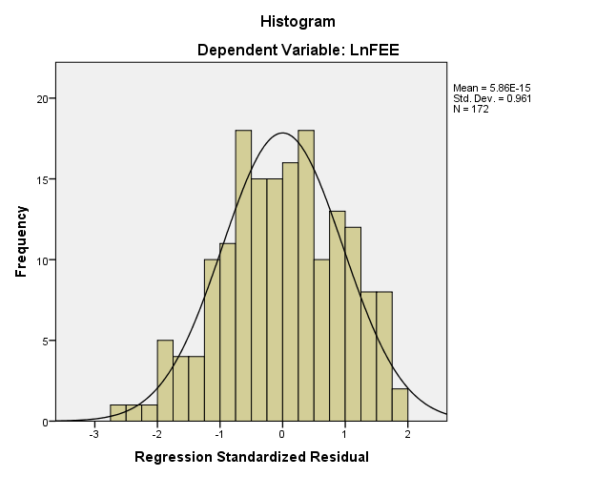
Plots standardized residuals
 |  |  |  | 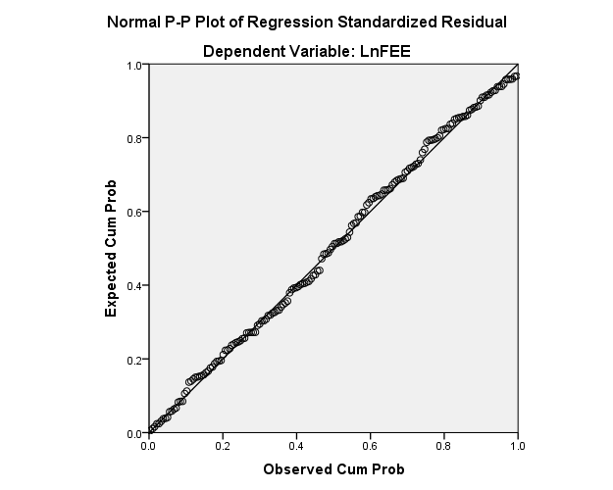
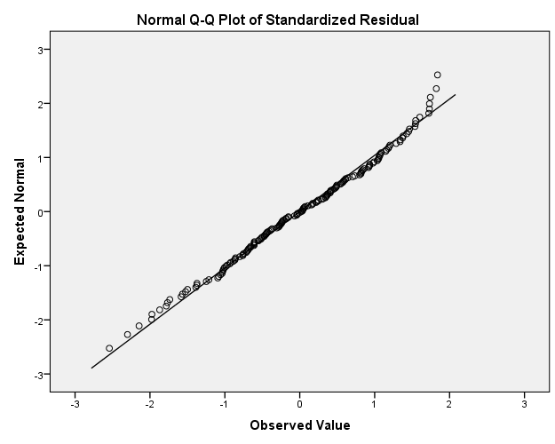 |  |  | 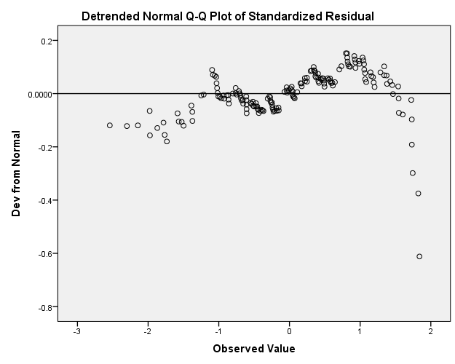
 |  | 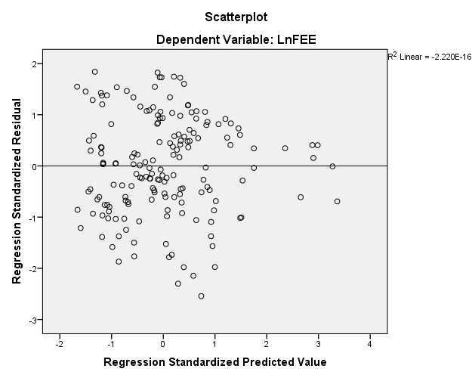
  Scatterplot to test homoscedasticity, the straight line indicates homoscedasticity
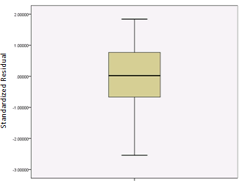

Standardized Residual
Boxplot Residual

Appendix 5 Regression results
Model Summary^{b}
Model |  | R |  |  |  | R Square |  |  |  | Adjusted R Square |  |  |  | Std. Error of the Estimate |  |  |  | Durbin-Watson
1 |  | .714ª |  |  |  | .510 |  |  |  | .470 |  |  |  | .6051 |  |  |  | .589
a. Predictors: (Constant), OTHER, TENURE1, REFINERY, COMMUNICATION, CRISIS, RETAIL, LnASSETS, MANUFACTORING, LIFE_INSURANCE, TENURE2, ELECTRICS, Ln#SEGMENTS, LEVERAGE
b. Dependent Variable: LnFEE
ANOVAª
Model |  |  |  |  |  | Sum of Squares |  |  |  | df |  |  |  | Mean Square |  |  |  | F |  |  |  | Sig.
1 |  | Regression |  |  |  | 60.280 |  |  |  | 13 |  |  |  | 4.637 |  |  |  | 12.665 |  |  |  | .000^{b}
 |  | Residual |  |  |  | 57.848 |  |  |  | 158 |  |  |  | .366
 |  | Total |  |  |  | 118.128 |  |  |  | 171
a. Dependent Variable: LnFEE
b. Predictors: (Constant), OTHER, TENURE1, REFINERY, COMMUNICATION, CRISIS, RETAIL, LnASSETS, MANUFACTORING, LIFE_INSURANCE, TENURE2, ELECTRICS, Ln#SEGMENTS, LEVERAGE
Coefficientsª
Model |  |  | Unstandardized Coefficients |  |  |  | Standardized Coefficients | t |  |  | Sig. |  | Correlations |  |  |  |  |  |  | Collinearity Statistics
 |  |  | B |  | Std. Error |  | Beta |  |  |  |  |  | Zero-order |  | Partial |  | Part |  |  | Tolerance |  |  | VIF
1 | (Constant) |  | 14.009 |  | .426 |  |  | 32.914 |  |  | .000
1 | TENURE1 |  | -.236 |  | .115 |  | -.128 | -2.044 |  |  | .043 |  | -.064 |  | -.160 |  | -.114 |  |  | .786 |  |  | 1.272
1 | TENURE2 |  | -.021 |  | .114 |  | -.012 | -.183 |  |  | .855 |  | -.071 |  | -.015 |  | -.010 |  |  | .741 |  |  | 1.349
1 | CRISIS |  | .164 |  | .139 |  | .068 | 1.183 |  |  | .238 |  | .039 |  | .094 |  | .066 |  |  | .952 |  |  | 1.051
1 | LnASSETS |  | .150 |  | .046 |  | .241 | 3.239 |  |  | .001 |  | .292 |  | .250 |  | .180 |  |  | .558 |  |  | 1.792
1 | Ln#SEGMENTS |  | .422 |  | .148 |  | .209 | 2.855 |  |  | .005 |  | .301 |  | .222 |  | .159 |  |  | .581 |  |  | 1.722
1 | LEVERAGE |  | -2.521 |  | .480 |  | -.394 | -5.254 |  |  | .000 |  | -.067 |  | -.386 |  | -.293 |  |  | .553 |  |  | 1.810
1 | REFINERY |  | 1.939 |  | .254 |  | .462 | 7.626 |  |  | .000 |  | .430 |  | .519 |  | .425 |  |  | .843 |  |  | 1.186
1 | MANUFACTORING |  | .697 |  | .165 |  | .291 | 4.225 |  |  | .000 |  | .029 |  | .319 |  | .235 |  |  | .652 |  |  | 1.534
1 | COMMUNICATION |  | .770 |  | .230 |  | .237 | 3.344 |  |  | .001 |  | .172 |  | .257 |  | .186 |  |  | .618 |  |  | 1.617
1 | ELECTRICS |  | .574 |  | .153 |  | .269 | 3.745 |  |  | .000 |  | .264 |  | .286 |  | .209 |  |  | .599 |  |  | 1.668
1 | RETAIL |  | .457 |  | .207 |  | .135 | 2.208 |  |  | .029 |  | -.033 |  | .173 |  | .123 |  |  | .830 |  |  | 1.205
1 | LIFE_INSURANCE |  | -.215 |  | .159 |  | -.095 | -1.359 |  |  | .176 |  | -.307 |  | -.107 |  | -.076 |  |  | .640 |  |  | 1.563
1 | OTHER |  | .368 |  | .212 |  | .113 | 1.734 |  |  | .085 |  | -.039 |  | .137 |  | .097 |  |  | .729 |  |  | 1.371
a. Dependent Variable: LnFEE

Excluded Variablesª
Model |  |  |  | Beta In |  |  | t |  | Sig. |  |  | Partial Correlation |  |  |  | Collinearity Statistics
 |  |  |  |  |  |  |  |  |  |  |  |  |  |  |  | Tolerance |  |  | VIF |  | Minimum Tolerance
1 | TENURE3 |  |  | .^{b} |  |  |  |  |  |  |  |  |  |  |  | 0.000 |  |  |  |  | 0.000
1 | BANKS |  |  | .^{b} |  |  |  |  |  |  |  |  |  |  |  | 0.000 |  |  |  |  | 0.000
a. Dependent Variable: LnFEE
b. Predictors in the Model: (Constant), OTHER, TENURE1, REFINERY, COMMUNICATION, CRISIS, RETAIL, LnASSETS, MANUFACTORING, LIFE_INSURANCE, TENURE2, ELECTRICS, Ln#SEGMENTS, LEVERAGE

