Erasmus University Rotterdam
Erasmus School of Economics
Bachelor Thesis
The Complex Link Between Gentrification and Displacement: a Case Study of New York City


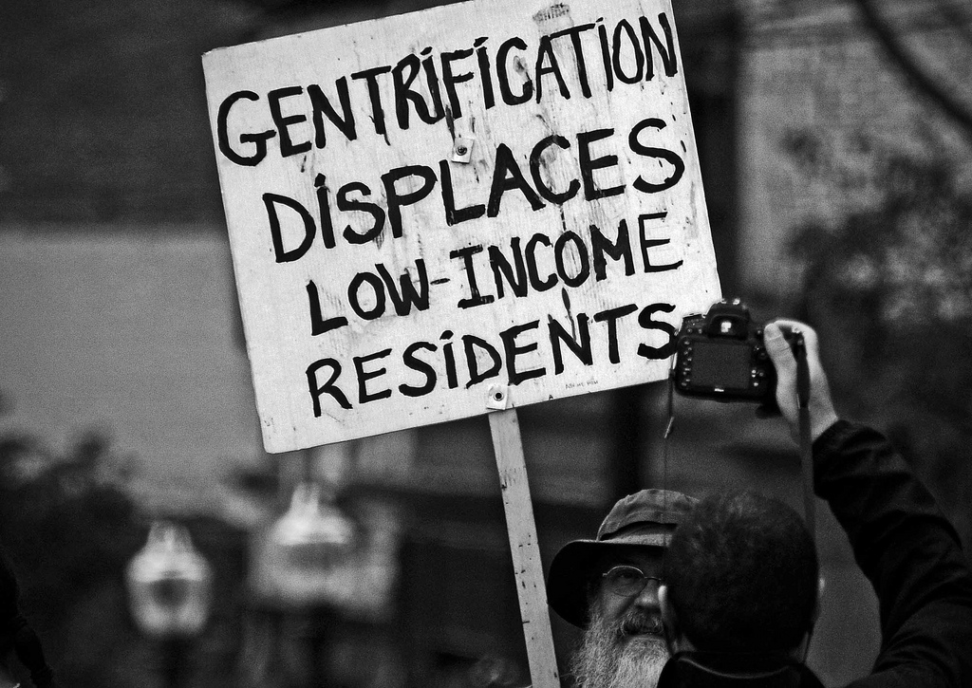
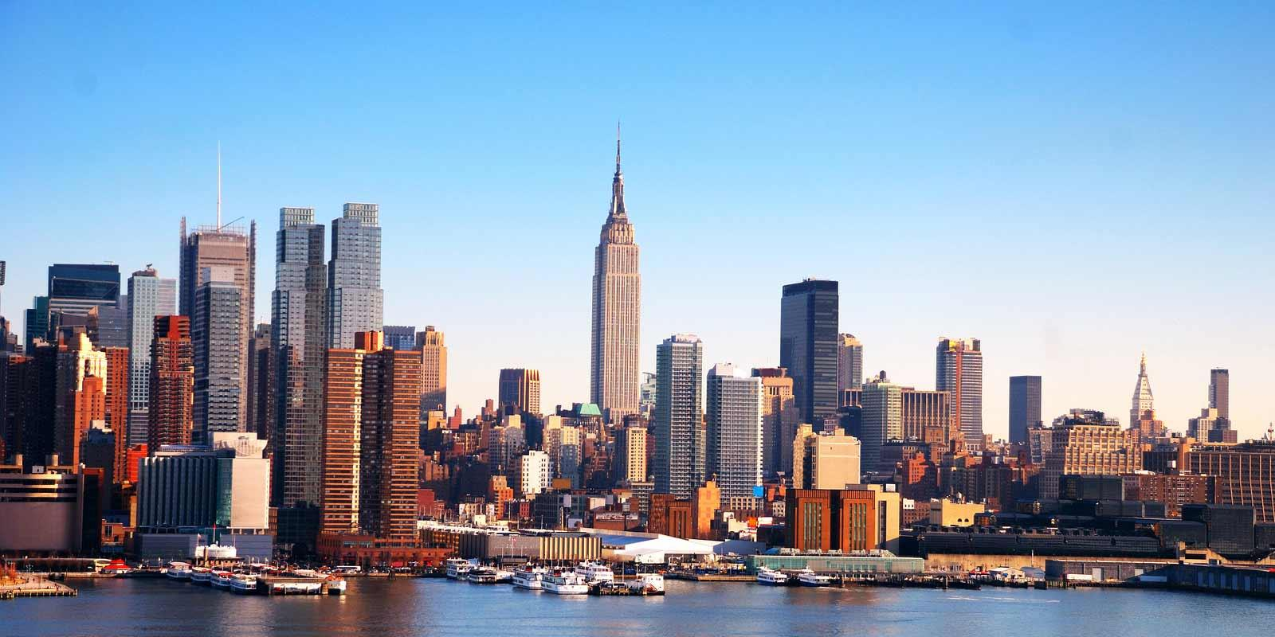
K. Frederiks
382988kf
Supervised by F. G. van Oort
June 27, 2016

Abstract
Gentrification has been viewed by some as a mean to revitalize devalued inner cities by the in-migration of more affluent households than currently occupies the area. However, others are wary of the potential for gentrification to displace poor residents. Research on this problem could guide policymakers. This thesis examines whether gentrification is correlated with displacement and whether this has led to a change in the proportion of poor households opposed to the proportion of more affluent households in New York City between 1998 and 2013. A quantitative analysis indicates that gentrification and displacement are correlated on city level, and that displacement may be used as an indicator of the intensifying class polarisation in New York City. This thesis concludes with a section on the implications of these findings for further research.

Keywords: Gentrification, Displacement, Class Polarisation and Quantitative Analysis

NON-PLAGIARISM STATEMENT
By submitting this thesis the author declares to have written this thesis completely by himself/herself, and not to have used sources or resources other than the ones mentioned. All sources used, quotes and citations that were literally taken from publications, or that were in close accordance with the meaning of those publications, are indicated as such.

COPYRIGHT STATEMENT
The author has copyright of this thesis, but also acknowledges the intellectual copyright of contributions made by the thesis supervisor, which may include important research ideas and data. Author and thesis supervisor will have made clear agreements about issues such as confidentiality.

Electronic versions of the thesis are in principle available for inclusion in any EUR thesis database and repository, such as the Master Thesis Repository of the Erasmus University Rotterdam.

Table of Contents
ABSTRACT 2
LIST OF FIGURES 4
LIST OF TABELS 4
INTRODUCTION 5
CHAPTER I: LITERATURE REVIEW ON GENTRIFICATION 8
1. 1 GENTRIFICATION HAS AFFECTED ESTABLISHED LOCATION PATTERNS 8
1. 2 THE THEORIES BEHIND GENTRIFICATION 9
1. 3 THE PROCESS AND EFFECTS OF GENTRIFICATION 12
1. 4 THE PROGRESSION AND SPREAD OF GENTRIFICATION IN NEW YORK CITY 16
1. 5 GENTRIFICATION-LED DISPLACEMENT IN NEW YORK CITY 18
1. 6 CONCEPTUAL FRAMEWORK 21

CHAPTER II: EMPIRICAL ANALYSIS 24
2. 1 METHODOLOGY 24
2. 2 GROSS RENTS 25
2. 3 SOCIO-ECONOMIC CHARACTERISTICS OF HOUSEHOLDS. 26
2. 4 DISADVANTAGED HOUSEHOLDS 28
2. 5 RESULTS 29
DIsCUSSION 30
CONCLUSION 31
REFERENCES 33

List of Figures
FIGURE 1 A MODEL CREATED BY BRUECKNER AND ROSENTHAL (2009) 14
FIGURE 2: CONCEPTUAL FRAMEWORK 22
FIGURE 3: MONTHLY GROSS RENT OF ALL RENTER OCCUPIED UNITS 25
FIGURE 4: MEAN INCOME OF RENTER HOUSEHOLDS 26
FIGURE 5: THE PROPORTION OF PEOPLE WITH A COLLEGE DEGREE 27
FIGURE 6: THE PROPORTION OF DISADVANTAGED HOUSEHOLDS 28

List of Tables

Table 1: The absolute change in the number of disadvantaged households 28

Introduction
‘’ I saw my neighbourhood change before my eyes, as zoning laws were changed and developers who owned tenements and row houses were given tax breaks to tear them down and build high rise condominiums in their place. The city mandated that within these new high rise 5% of apartments be reserved for low to mid-income families. This change in housing regulations and zoning laws guaranteed that the children of parents who lived in the Upper West Side, like me, would no longer be able to afford the new fees and rents in the neighbourhood they grew up in, forcing large generations and groups of low to middle income people to move to other, less desirable neighbourhoods and boroughs. The island of Manhattan turned into a big mall of consumption and wealth that erased racial, ethnic, and class diversity. Most of my friends moved away, while young professionals – ‘yuppies’ – moved in. Prices for goods and services escalated rapidly, gradually making Manhattan into an enclave for the wealthy. Artists, writers and actors had to find other places to live.’’ - (Lees, Slater, & Wyly, 2010, p. 21)

The previous citation by a New York artist clearly illustrates the image that accompanies gentrification. Gentrification is without a doubt one of the most important topics studied by urban scientists. Gentrification has attracted widespread attention after its birth in London, England, and in a number of east coast U.S. cities in the 1950s and 1960s (Lees, Slater, & Wyly, 2010). Gentrification can be defined as the revitalization of previously devalued and poor central city neighbourhoods by the in-migration of more affluent households (Van Weesep & Van Kempen, 1994). In both the United States and in Britain, post-war urban regeneration meant the bulldozing of old neighbourhoods to be replaced by modern housing. In New York City this was called ‘’brownstoning’’. As the destruction continued, so did the rebellion against it. At first the protesters were primarily architects and historians, but slowly young working class families joined them (Lees, Slater, & Wyly, 2010).

During the past several decades numerous central city neighbourhoods have experienced gentrification. Before the introduction of gentrification many cities faced fiscal problems due to the fact that higher income households increasingly tended to migrate to the suburbs, while more disadvantaged households concentrated themselves in the urban core (Boston & Ross 1997). The return of more affluent households is often associated with increasing housing prices and an increase in retail activity and the governments tax base. This larger tax base can be used to improve public services and the quality of the neighbourhood. Households with a low economic status therefore have to deal with increasing housing expenses while not being compensated in terms of for example an increasing income (Freeman & Braconi, 2004). As a consequence, many urban scientists introduce an additional condition to describe gentrification. This description contains the condition that current low-income households that have resided in the neighbourhood are displaced during the process of gentrification (Vigdor, Douglas, & Rivlin, 2002).
While gentrification provokes many different evaluations, the process has generated the interest of media, urban planners, developers and political activists. Whether the negative associations that accompany gentrification just make good material for newspaper feature stories or whether they are actually well grounded will be explored in this thesis. To be specific, in this thesis I will focus on the process of gentrification and gentrification-led displacement in New York City.

New York City has been identified as a superstar city and is therefore a very interesting city to study with respect to gentrification and gentrification-led displacement. Superstar cities are cities that have experienced an extraordinary house price growth over the past decades. Gyourko, Mayer and Sinai (2006) argue that this price growth is not completely due to increasing productivity levels. They argue instead that these cities have high-value amenities. They state that rising inequality in the US has led the wealthiest Americans to be willing to pay more and more to live in high amenity places such as New York City. The highest willingness-to-pay households are those who share the same preferences. If such sorting occurs along income lines, rising housing prices can lead to high-income homogeneity. This dynamic implies that these areas will develop into luxury cities and grow increasingly unaffordable for low-income households (Gyourko, Mayer, & Sinai, 2006). It is necessary to examine whether this condition has led to an even deeper relationship between gentrification and displacement in New York City.

The City of New York is celebrated for its wealth of nationalities and ethnicities. People from all over the world either study or work in New York City. However, the melting pot image of the City of New York contradicts the reality that much of the city remains divided along ethnic lines. The redevelopments that have occurred in New York City have increased diversity by bringing in higher-income residents in poorer neighbourhoods but at the same time left less rental units at an affordable rate (Freeman & Braconi, 2004). The link between gentrification and displacement is a crucial topic to examine since the degree to which the government of New York City should encourage gentrification depends on it (Freeman & Braconi, 2004).

The link between gentrification and displacement in New York City will be analysed by using both a literary review and by a generic empirical analysis of data available at city level. Throughout this thesis four sub-questions are central so that a conclusion can be drawn with regard to the following question:’’ is gentrification correlated with displacement and has it therefore affected the proportion poor households opposed to the proportion of more affluent households in New York City between 1998 and 2013?’’

These questions are as follows:
1. What is known about gentrification, displacement and income-related local economic development in the literature?
2. What are trends in poor and affluent household locational behaviour in New York City Neighbourhoods?
3. Can gentrification and displacement be associated with these trends? And do visible patterns exist that are in line with trends and theory?
4. What is needed for a full testing of causality?

The first two sub-questions will be answered throughout the literature review. This chapter starts off with a description of the term gentrification. Secondly, the forces behind gentrification will be explained in more detail by examining previous research on this topic. The process of gentrification and the way it has progressed in New York City will also be addressed. Those who are involved in the process of gentrification will then be mentioned in these sections. To answer sub-question 2, previous research on the relationship between gentrification and displacement in New York City will be examined. Question 3 will be answered using quantitative data provided by the New York City Housing and Vacancy Survey (NYCHVS) will be used to examine patterns with regard to crucial socio-economic characteristics and gross rent in New York City between 1998 and 2013. These factors will be studied since an increasing trend in these characteristics would be consistent with the process of gentrification (Redfern, 2003). Since the NYCHVS does not provide data on those moving out, it cannot directly be observed if those moving out have actually been displaced. Therefore, I will examine the net loss in the number poor households between 1998 and 2013. A net loss may suggest that poor households have become less able to remain in New York City and this suggests that disadvantaged households may have been displaced during 1998 and 2013. In addition, a short discussion will be presented in which question 4 will be answered on what is needed for a more accurate testing of displacement and segregation. Finally, a short overview of the most important results of this research will be elaborated on.

Chapter I: Literature Review on gentrification

The existing social and geographical literature defines gentrification as the reinvestment of capital at the urban centre, which is designed to produce for a more affluent class of people than currently occupies the space. Therefore, many hold the view that gentrification can be viewed as an urban renewal strategy. The term gentrification, first coined by Ruth Glass in 1964, is quite a controversial term since many researchers have studied it with their own opinions.

The literature reviewed in this section will provide the reader with more knowledge on what is known about gentrification, displacement and income-related local economic development in the literature. Furthermore, the reader will gain more insights into the locational behaviour patterns of poor and more affluent households in New York City.
Firstly, the term gentrification will be studied more thoroughly by looking at the affect it has had on established location patterns. In the 1970s and early 1980s many authors have attempted to theorize the term gentrification. In this chapter an overview will be provided of the most important theories behind gentrification. Later on, the process and effects of gentrification will be described. Those who are affected by gentrification, the so-called ‘’gentrifiers’’ and ‘’displaced’’, will then be considered. In addition, the different phases gentrification in New York City has gone through will be studied in chronological order. The last section of this chapter examines the relationship between gentrification and gentrification-led displacement in New York City.
1. 1 Gentrification has affected established location patterns
Cities in the United States lost population due to suburbanization since the 1960s. Cities became concentrations of low-income households. This process was strengthened by the continuing emphasis on the provision of social rental housing in the cities to fulfil the urgent needs of the local population (Vigdor, Douglas, & Rivlin, 2002). The model developed by Alonso, Mills and Muth (1969) has been effective in explaining these spatial patterns of land use and real estate prices in cities in the United States (Wheaton, 1977). This model states that the location of more affluent households reflects the tension by two opposing forces. First, the demand for housing can be satisfied in the suburbs at a low price per square meter, which creates a housing based pull towards the suburbs. Secondly, a time-based pool towards the city centre exists, since short commutes allow high income-households to save time (Brueckner & Rosenthal, 2009).
Gleaser et al (2008) argue that the time-based force is currently stronger than the housing-based force. This would imply a more central location for high-income households (Glaeser, Kahn, & Rappaport, 2008). Therefore, a possible explanation for the spatial patterns seen in the United States must be sought from outside this basic urban model.
Gleaser et al (2008) propose the following explanation: attractive amenities such as waterfronts and parks attract the rich and these can be found in the suburbs (Glaeser, Kahn, & Rappaport, 2008). On the contrary, Alonso, Mills and Muth (1969) found that high-income households prefer living in areas at the edge of the city because of the fact that in these areas the housing stock is relatively young (Brueckner & Rosenthal, 2009). Others say that fiscal amenities are more importation in the location decision. They argue that suburban communities allow more affluent households to escape redistributive central city taxation while still improving the quality of public goods (Vigdor, Douglas, & Rivlin, 2002). The poor households rely too much on public transport modes that is why they can be found in more densely populated areas. When regeneration brings new dwelling and desired amenities to central-city neighbourhoods, the forces earlier discussed will work in tandem, pulling high-income households toward the city centre (Glaeser, Kahn, & Rappaport, 2008). This is in line with what Glaeser et al. (2001) stated in their article ‘’consumer city’’. They found that high amenity cities have grown faster than low amenity cities, which suggests that demand for living in cities has risen for reasons beyond rising wages (Glaeser, Kolko, & Saiz, Consumer City, 2001). Due to the increasing demand for living in cities, many hold the view that gentrification can be described as ‘’back to the city’’ movement (Vigdor, Douglas, & Rivlin, 2002).

1. 2 The theories behind gentrification
Over the past decades many researchers have studied this so-called ‘’back to the city’’ movement or simply put gentrification. Many tried to answer the question; ‘’why does gentrification occur?’’ Neil Smith (1979) and David Ley (1987) were the first two researchers to attempt to theorize the concept of gentrification. Their approaches vary significantly from each other.

Smith (1979) primarily focuses on the economic forces, whereas Ley (1987) focuses additionally on the cultural aspects of the process (Goworowaska, 2008). Smith (1979) tries to explain the term by studying the ‘’supply side’’ equation of the gentrification process by using rent gap theory. The rent gap theory refers to the difference between actual and potential land values. If this gap is found significantly large, the property of entire neighbourhoods is ripe for gentrification. According to Smith, disinvestment is needed to secure redevelopment. Disinvestment occurs, either through neglected maintenance of the property or through ‘’natural’’ processes. Smith argues that both state-led initiatives and collective action undertaken by developers and communities can play a role in the process of regenerating the abandoned neighbourhood (Smith, 1979).

According to Smith (1979) capital flows where the rate of return is highest so the movement of capital to the suburbs led to the creation of the rent gap. However, if a neighbourhood is perceived to be unsafe and ridden by crime, it will not gentrify no matter how large the rent gap. Usually working class neighbourhoods with a significant rent gap, but acceptable safety conditions, will be the first to gentrify, especially when amenities such as waterfronts and monuments are present (Lees, Slater, & Wyly, 2010).
Over the past years, some researchers have criticized the rent gap theory by arguing that this theory is only based on rational individual behaviour. Smith (1992) tried to justify his theory by stating that ‘’economics strongly affect a person’s ability to exercise preferences’’ (Goworowaska, 2008, p. 31). Although Smith’s theory has received some criticism over the years, it is still continuously being used.

On the other hand, Ley (1987) explains the process of gentrification by focusing on the ‘’demand’’ side of the gentrification equation. He pays more emphasis on cultural factors (Ley, 1987). Ley (1987) divides the forces shaping gentrification into four different categories: housing market dynamics, urban amenity values, the economic base and demographic change. Ley (1987) presents two concepts with regard to the housing market forces. A supply oriented concept and a more demand-oriented concept (Lees, Slater, & Wyly, 2010). The supply oriented concept refers to the rent gap theory, as described in the previous paragraphs. The demand oriented concept pays attention to the rising prices of suburban homes and high mortgage rates in the 1970s. These two conditions made many households consider housing options outside the suburban areas. Their second choices included primarily apartments and modernized row houses in the city centre (Ley, 1987). The second category Ley (1987) discusses includes the urban amenities. He addresses that aesthetically pleasing areas, such as historic districts are the first to gentrify. Access to different cultural events, a great job market and high wages bring people who seek status to the city centre. Therefore, consumption by the more affluent households started to shape reinvestment in the city centre in the 1970s (Lees, Slater, & Wyly, 2010). As a third category Ley (1987), includes the so-called economic forces behind gentrification. This category includes the shift in metropolitan areas occupied by secondary sector businesses to metropolitan areas occupied by tertiary and even quaternary sector businesses. This shift caused the overflow of high-income household, who became the gentry that redeveloped the inner-city neighbourhoods. At last, Ley (1987) points out that demographic changes have been of huge importance with regard to reshaping the urban core. With these demographic changes he refers to the changes in household size. In the 1970s and 1980s two-wage earner households with no children became very common. Which led to different preferences with respect to the housing market (Ley, 1987).

Chris Hamnet (1994) takes a consumption-based approach as well (Goworowaska, 2008). He associates gentrification with the professionalization of the population. With the professionalization of the population Hamnet (1994) refers to the rise in the proportion of people employed in managerial/professional sectors of the economy, as opposed to all other sectors. He explains that this expanding middle-class puts pressure on the housing market. He assumes that the working class population currently resided in the inner city will be replaced rather than being displaced by the new middle-class. So he denies the concept of gentrification-led displacement (Hamnett, 1994).
However, none of the consumption oriented approaches focuses on those assumingly being displaced due to gentrification, as these are difficult to track down. These kinds of approaches focus more on the gentrifier, the person who benefits the most (Lees, Slater, & Wyly, 2010).

Next to researchers who tried to understand the forces behind gentrification there are also researchers who tried to investigate how to effectively revitalize the inner city. Micheal Porter (1995) is one of those researchers. He has advanced an interesting strategy for revitalizing the American inner-city. He concludes that the social problems of the inner city such as – drug abuse, crime and other associated problems- may be the most pressing issues facing America. Therefore, he studied past efforts to revitalize the inner cities. He found that past efforts to revitalize the inner cities have failed. Porter (1995) states that this is due to the fact that a government-facilitated social service model has guided these efforts. He argues that this will serve to undermine economic development and will even worsen social problems. So increasing social investments and hoping for economic activity to follow will not cure the problems the inner cities are facing. According to Porter (1995), private initiatives and investment based on self-interest is needed to create a sustainable economic base in the inner cities of America (Porter, 1995). Johnson, Farrell and Henderson (1996) have published an article in ‘’The Review of Black Political Economy’’ in which they criticize Porter’s strategy. They argue that evidence indicates that, while generating profits for the owner, these private companies did little to improve the quality of life of inner city residents. Moreover, they state that no single entity should be allowed to guide the process of revitalisation of the inner city. The government, philanthropic organizations and the private sector must all work together to direct their resources to economically viable projects. Next to these institutions, community based organizations and universities must also be engaged in designing and implementing these projects. These institutions must work collaboratively to gain the support of inner city residents. Furthermore, strategies must be developed to reverse economic decay in inner cities. Johnson, Farrell and Henderson (1996) state that employment must be fostered from within the community. Encouraging and assisting entrepreneurs in the development of businesses that employ a large number of inner city workers can accomplish this. This is in contrast to Porter’s model, which argued that companies from outside the inner city had to be attracted. Secondly, Johnson, Farrell and Henderson (1996) emphasize the importance of connecting training programs to specific job opportunities. Finally, Johnson, Farrell and Henderson (1996) claim that a new generation of social resource programs must be designed in order to reverse the trend of increasing anti-social behaviour among inner city youth (Johnson , Farrell, & Henderson, 1996).

This short summary of the most important trends in gentrification theory has provided an overview of the main causes of the gentrification process. Both Smith (1979) and Ley (1987) stress the importance of high-value amenities when trying to attract high-income households. It can be said that, both production and consumption-oriented theories contributed to gentrification studies. Later on, we will see that both the production and the consumption-orientated approach can be used to explain gentrification in New York City. Furthermore, this paragraph has provided an overview of the most important views with regard to how to revitalize the inner city. Porter (1995) states that efforts to revitalize the inner city must be guided by private investments while other researchers suggest that all institutions active within the community must guide these efforts. Later on, the process of gentrification as it has occurred in New York will be discussed. In this paragraph the reader will notice that both the government as the private sector have played a role in the process of gentrification in New York City.
1. 3 The process and effects of gentrification

In 1996 Neil Smith (1996) referred to gentrification as being a ‘’dirty word’’ (Smith, The New Urban Frontier: Gentrification and the revanchist city, 1996). While population movement is a quite common feature of cities, many researchers specifically associate gentrification with the replacement of a less affluent group by a wealthier group of households. This definition of gentrification relates gentrification to class (Atkinson, 2004). According to Berg et al (2008), gentrification has become a means of solving social malaise. While not by providing solutions to poverty, unemployment or broken homes, but by just referring the problem elsewhere. Consequently, geographically downgrading the poor (Berg, Kaminer , Schoonderbeek, & Zonneveld, 2008).

The literature reviewed in this section will be used to understand and test in a rough way whether or not gentrification-led displacement occurs. The actual process of gentrification is assumed to take place in many different forms. A commonly accepted form is the one explained by Phillip Clay. In his book ‘’The Mature Revitalized Neighbourhood: Emerging Issues in Gentrification’’ Clay (1979) differentiates four different stages to explain the process and the effects of gentrification (Lees, Slater, & Wyly, 2010). His four-stage model can be used to identify the moment at which gentrification-led displacement occurs. In the following paragraphs the model created by Clay (1979) will be discussed.

In stage one of his four-stage model a small group of risk-seeking and status-seeking people move into a neighbourhood and renovate specific properties for their own use. These neighbourhoods are often characterized by architecturally interesting housing and a unique spatial amenity such as a hilltop location. These sites are often at close proximity to the central business district. This pioneer group usually contains a high number of design professionals or artists who have the ability to undertake this kind of rehabilitation (Lees, Slater, & Wyly, 2010). According to Beauregard (1986), this is due to the fact that artist are able to provide the necessary cultural capital to pave the way for middle-class commercial consumption (Beauregard, 1986). Mortgage funds are hardly used, as they are unavailable at this stage of the process. At this stage little displacement occurs since many newcomers take housing that is vacant or part of the common market turnover (Lees, Slater, & Wyly, 2010).

In stage two more of the same type op people move in and renovate houses for their own use. In this stage more public attention is given to the revitalization of the neighbourhood. Property in this stage is still inexpensive according to Clay (1979), therefore renovation can easily spread to nearby blocks. Some small-scale speculators might renovate a few properties in visible locations for rental or resale. No large-scale speculators will come into play in this stage since capital, for investors and residents, is still relatively scarce. Displacement occurs more frequently in this stage because vacant housing becomes scarce (Lees, Slater, & Wyly, 2010).

Stage three is being identified by Clay (1979) as one of the more crucial stages in the gentrification process. This is due to the fact that at this stage official interest is directed towards the neighbourhood. More developers and even large-scale developers may move in. The arrivals in this third stage also include people who view the property as an investment in addition to being a place to live. Physical improvements become more visible due to their volume and the general improvement of the neighbourhood. As a consequence, prices begin to escalate quickly (Lees, Slater, & Wyly, 2010). This price increase is a result of speculation and a high level of optimism with regard to the future of the area. Many of the renovated properties become part of the middle-class housing market, often even with minimal improvement as landlords take advantage of the neighbourhood’s new reputation (Goworowaska, 2008). The organized community starts making demands for public resources. Resources are being used to take actions against crime. At this stage the neighbourhood is being viewed as safe for young professionals. Due to the increasing prices displacement continues. Even tensions arise between the gentry and the old residents. Social service institutions and subsidized housing are being resisted by the newly resided middle class-households (Lees, Slater, & Wyly, 2010).

In the last stage described by Clay (1979), stage four, a large volume of properties are already gentrified. Re-zoning occurs through which non-residential buildings are being converted into rental condominium units to provide additional housing. Retail and professionalized services begin to emerge. At this stage not only rental prices are being affected by gentrification so are the consumption prices. As a result, not only renters but also even homeowners are being affected by gentrification-led displacement (Lees, Slater, & Wyly, 2010).

The model created by Clay (1979) assumes that gentrification-led displacement occurs at every stage of the process. Not every researcher agrees with Clays (1979) four-stage model. These researchers hold the view that displacement does not have to occur when gentrification is present. They rather look at gentrification as a healthy economic present and future for cities across the globe (Goworowaska, 2008).
Researchers like Jan Brueckner and Stuart Rosenthal (2009) try to defend the latter statement by using a model which is primarily focused on the cost of moving (Brueckner & Rosenthal, 2009).
Brueckner and Rosenthal (2009) state that gentrification does not always have to be associated with displacement. They argue that, whether displacement occurs depends on the cost associated with moving. Figure 1 illustrates their point of view (Brueckner & Rosenthal, 2009).

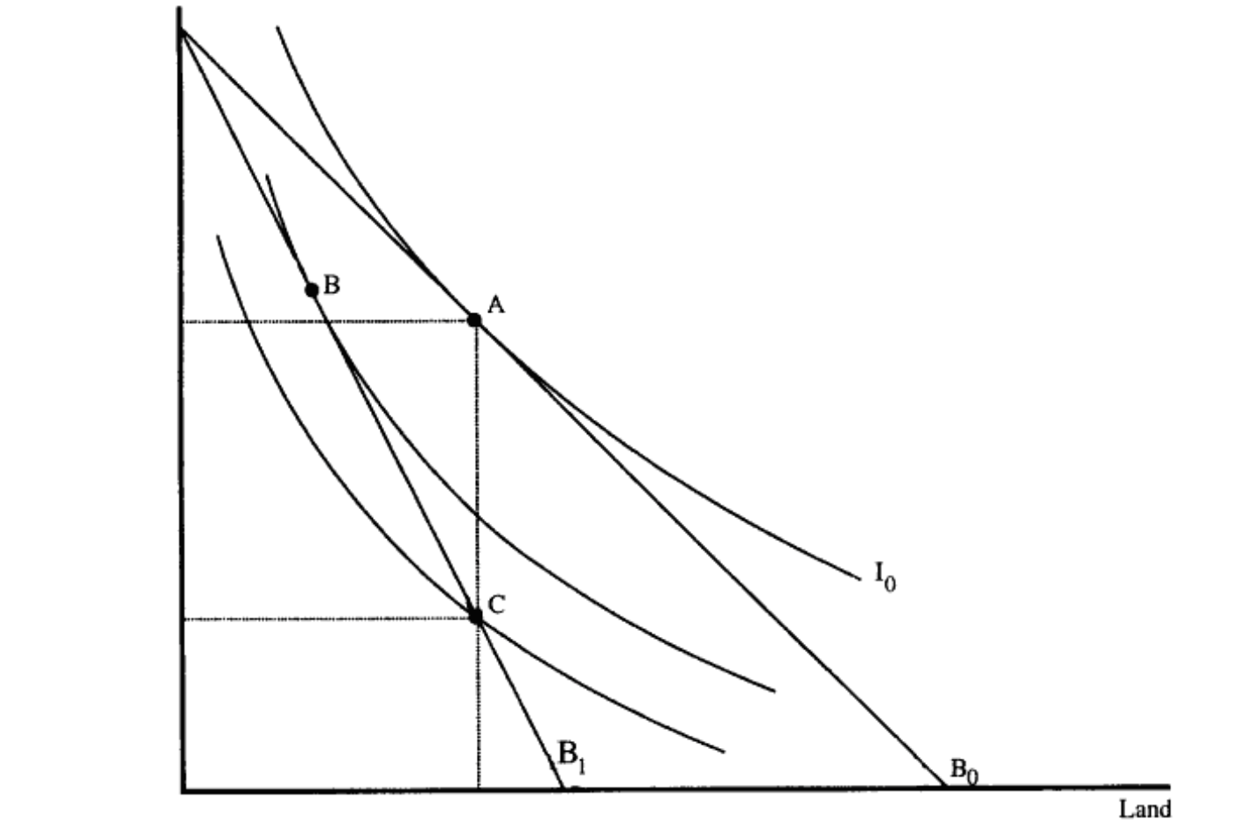
Figure 1 - (Brueckner & Rosenthal, 2009)

Figure 1 illustrates the consumption decision of poor renter households in the wake of gentrification. The x-axis represents the amount of land consumed by poor households and the y-axis represents the amount of other goods consumed by poor households. The initial bundle of land and goods consumed by poor households is determined by the point of tangency of the budget constraint B0 and the indifference curve I0, therefore this point can be found at point A. I0 represents the utility initially available outside the urban area. An increase in the price of land would shift the budget constraint to B1, and this would make I0 unattainable. If the current poor households can move at zero cost they will leave the neighbourhood and obtain utility outside the urban area. When moving outside the neighbourhood is sufficiently costly, but if the costs of moving within the neighbourhood are negligible, poor renter households will remain in this neighbourhood. In this situation they will re-optimize their land consumption and end up at point B. It is important to mention that this point reflects an obvious decrease in the utility of poor households with respect to point A. Finally, it could also occur that both moving costs between urban areas and within urban areas are sufficiently large.
In this case poor renter households will continue to consume their initial amount of land. However, their consumption for other goods must decline in order to compensate for the higher cost of land. This last option is marked as point C in figure 1. Once again, a clear utility loss for poor renter households can be observed (Brueckner & Rosenthal, 2009). From this model developed by Brueckner and Rosenthal (2009) it can be concluded that the demographic transitions associated with gentrification do not have to occur. However, they do emphasize that in both cases where moving is significantly costly poor renter households will encounter a decrease in their utility.

Newman and Wyly (2006) also study poor renter households who do not get displaced but seek strategies to stay put in the gentrifying neighbourhood. Through interviews they were able to conclude that many immigrants, elderly and other low-income residents move in with family or even enter the city shelter system in order to be able to cope with the increasing rents (Newman & Wyly, 2006).

Another researcher active in the field of gentrification and gentrification-led displacement is Rowland Atkinson (2004). He brings up the issue of the invisibility of those who have been displaced. He states that one can never be sure whether displacement has occurred because of gentrification. This is due to the fact that those who have been displaced are no longer there to be counted or questioned about their motives to move (Atkinson, 2004). Frank Braconi and Lance Freeman (2007) did try to illustrate the relationship between gentrification and gentrification-led displacement. They found that one could rather speak of exclusionary displacement. Exclusionary displacement describes a situation in which people are incapable to move into a housing unit, because it has gentrified and its price has become too excessive (Freeman & Braconi, 2004).

To be able to answer the question: ‘’is gentrification correlated with displacement and has it therefore affected the proportion poor households opposed to the proportion of more affluent households in New York City between 1998 and 2013?’’ it is important to understand the general relationship between gentrification and displacement. The previous section has provided a short overview of the many different views with respect to this relationship. It can be concluded that not every researcher agrees with Clay’s four-stage model in which he states that displacement occurs at every stage of the process. The following sections will be dedicated to the process gentrification as it has evolved in New York City. Next to this, previous research with respect to the influence of gentrification on the ratio poor more affluent households in New York City, will be studied.

1. 4 The progression and spread of gentrification in New York City
In this section, attention will be directed towards the progression and spread of gentrification in New York City. The different ‘’waves’’ gentrification in New York City has encountered, first distinguished by Hackworth and Smith (2001), will be addressed in chronological order. Afterwards, some new trends with regard to gentrification in the City of New York will be discussed.

Hackworth and Smith’s (2001) assessment of the progression of gentrification in New York City provides an analysis on the stepwise development of this process. They divide the progression of gentrification in New York City in three distinct waves. They argue that each wave is caused by a major recession (Doucet, 2014).

Prior to the economic recession that settled through the global economy in late 1973 gentrification was quite sporadic if widespread. In New York City, disinvested houses located in the city centre became a target for gentrification, which is in line with the rent gap theory first coined by Smith (1979). In classic first wave neighbourhoods, like SoHo, the state (mostly at city and federal level) played a very big role in organising and stimulating gentrification (Hackworth & Smith, 2001). The government justified their actions by stating that they wanted to counteract the private-market economic decline of central city neighbourhoods (Doucet, 2014). Inner-city revitalisation was still quite risky therefore the government orchestrated tax incentives, land assembly, incentives for banks and property condemnation. The government also used more informal attempts, such as marketing, to convince lenders and more affluent households to move into such neighbourhoods (Hackworth, Postrecession gentrification in New York City, 2002).

The second wave of gentrification began, when depressed markets began to recover in the late 1970s. After initial footholds in neighbourhoods such as SoHo, gentrification spread outwards without a direct need for state involvement. Most local state efforts focused on stimulating the private market to be more involved in the process of gentrification. Federal programmes such as block grants and enterprise zones represented this relatively laissez-faire role (Hackworth & Smith, The changing state of gentrification, 2001). In addition, the second wave was characterised by the integration of gentrification into a wider range of economic and cultural processes. This happened at a global and national scale, however nowhere was this more present than in New York City (Hackworth, Postrecession gentrification in New York City, 2002). Gentrification in New York City went hand-in-hand with the city’s emergence as a world city, the price increase in the real estate market and the increasing international popularity of the art scene in SoHo and the Lower East Side. During this second wave gentrification was celebrated as well as despised. Homelessness, eviction and the increasing vulnerability of poor residents around New York’s Tompkins Square Park was directly associated with gentrification by activists. Resistance also occurred in Clinton and in the Lower East Side (Hackworth & Smith, The changing state of gentrification, 2001).

The third wave occurred at the end of the 1980s, so after the recession. Social programs such as social mixing drove this third wave. Social mixing implies the actions taken by the local government to stimulate middle class residents to move into working class neighbourhoods. This strategy is undertaken to balance out decaying neighbourhoods and to encourage home-ownership (Lees, Slater, & Wyly, The Gentrification Reader, 2010). This third wave is distinct from earlier waves of gentrification in at least four different ways. First of all, after two decades of gentrification most of the easily gentrified neighbourhoods had been gentrified. By necessity, outside investors and gentrifiers started to invest in financially risky neighbourhoods (e.g. remote locations and protected parcels like public housing). So gentrification started to affect neighbourhoods beyond the immediate urban core (Doucet, 2014). Secondly, Hackworth and Smith (2001) point out that due to this development state assistance became more common relative to the second wave. This is because of the fact that properties located at a greater distance from the city centre are more difficult for individual gentrifiers to make profitable without state assistance (Hackworth & Smith, The changing state of gentrification, 2001). Due to the lack of federal redistribution policies, New York City was forced to attract investment with strategies that go beyond land-use control. Therefore, New York City started to provide corporate capital, low interest rates and loan guarantees at an increasing rate (Goworowaska, 2008). Thirdly, globalisation served as a stepping-stone for larger developers to become involved in gentrifying neighbourhoods in New York City. Such developers used to come into play after the neighbourhood had been ‘’tamed’’. In the third wave these developers increasingly started to orchestrate gentrification themselves (Hackworth, Postrecession gentrification in New York City, 2002). Lastly, resistance to gentrification started to decline as anti-gentrification groups of the 1980s transformed into housing service providers (Hackworth & Smith, The changing state of gentrification, 2001).

Lees et al. (2008) argue that even a fourth wave of gentrification can be distinguished. They state that this fourth wave has been observed in a few select cities like London and New York City (Lees, Slater, & Wyly, 2010). The term ‘’super-gentrification’’ was first coined by Lees (2003) to describe this fourth wave. In this wave previously gentrified neighbourhoods encounter a further upward class transformation by a new group of super wealthy professionals. In this case an even richer class of gentry displace and outbid the already wealthy residents (Lees, Super-gentrification: The case of Brooklyn heights, New York City, 2003). When Lees et al. (2008) published their work the world was on the edge of an economic crisis, which has slowed or even stopped gentrification in many cities. Therefore, super-gentrification has not yet occurred in al western cities. Third wave gentrification is therefore still the most common form of gentrification currently observed in most cities (Goworowaska, 2008).
Some geographers do not acknowledge the existence of a fourth wave. They believe that it is just a modification on existing policies (Goworowaska, 2008). Redfern (2003) is one of those researchers. According to Redfern (2003), the term gentrification can only be used when two specific conditions are met. First of all, improvable housing has to be available. Secondly, everyone involved in the demand side of gentrification must belong to the same economic class and therefore possess the same set of motivations. This set of motivations often includes status (Redfern, 2003). Redfern (2003) expresses status purely in economic terms. Therefore, in the case of super-gentrification, the only difference between the gentrifiers and those supposedly displaced is their access to means. Their motivations and desires are equal to each other. Redfern (2003) states that in the process of gentrification only one group can be identified as a group of status-seeking people (Goworowaska, 2008).

From this section, it can be concluded that the government played a large and decisive role in the progression and spread of gentrification in New York City. However, some differences between the three waves with regard to the extent of the government influence in this process can be observed. It is clear that the government was more engaged in the process of gentrification during the first and third wave than during the second wave. During the first wave the government primarily guided the revitalisation of the inner city on its own, whereas during the third wave both the government and the other institutions/organizations active within the city contributed to the process of gentrification in New York City. This section also shows that gentrification in New York City has spread considerable since the late 1960s. At the beginning only easily gentrified neighbourhoods close to the Central Business District formed a target for gentrification. These neighbourhoods contained various amenities sought by the first pioneers. Later on, even neighbourhoods located at a greater distance from the city centre became targets for gentrification. It can therefore be concluded, that gentrification in New York City has become a strategy for urban growth.

1. 5 Gentrification-led displacement in New York City

If gentrification can be associated with displacement, one could argue that gentrification influences the proportion poor households relative to the proportion more affluent households. Therefore, it is important to study the link between gentrification and displacement. Given the fears of displacement that have long been associated with gentrification it is not surprising that many academics have already attempted to measure this relationship. It is also a crucial topic to consider since the degree to which government policies should encourage gentrification in order to achieve societal and fiscal goals depends on the extent of this relationship (Freeman & Braconi, 2004).
The literature reviewed in this section will be used to examine gentrification-led displacement in New York City. In their article ‘’Gentrification and Displacement: New York City in the 1990’s’’ Freeman and Braconi (2004) argue that poor households are able to benefit from the revitalization of their neighbourhood as well (Doucet, 2014). They state that if gentrification proceeds without widespread displacement, it will be able to offer the opportunity to increase racial, social economic and ethnic integration. They state that an increasing wealthier class in city-centre neighbourhoods, to the degree that it includes white households, could help desegregate urban areas and even their school districts (Freeman & Braconi, 2004). In addition, current residents could benefit directly from gentrification if gentrification stimulates additional retail and cultural services. This could alter the employment prospects of low-income residents in a positive way. Gentrification is not only able to contribute to local job creation, it is also able to enrich the informal job information networks if the influx of working residents significantly increases (Lees, Slater, & Wyly, The Gentrification Reader, 2010).

Freeman and Braconi (2004) studied whether gentrification proceeded in New York City without widespread displacement between 1991 and 1999. They examined the relationship between residence in a gentrifying neighbourhood and residential mobility among disadvantaged households. They argue that if gentrification increases displacement, all other things being equal, higher mobility rates among disadvantaged households residing in gentrifying neighbourhoods than among those residing in other areas of the city should be observable (Freeman & Braconi, 2004).

Freeman and Braconi (2004) classified the sub-boroughs of Chelsea, Harlem, The Lower East Side, Morningside Heights in Manhattan and Fort Green Park and Williamsburg in Brooklyn as gentrifying neighbourhoods. They found that average monthly rent, mean income and educational attainment were rising relatively fast in these neighbourhoods compared to those not being gentrified (Freeman & Braconi, 2004). Relative increases in socioeconomic status are consistent with what would be expected from a gentrifying neighbourhood (Redfern, 2003). To determine if a disadvantaged household in New York City subsequently moved, Freeman and Braconi (2004) studied the residential mobility between 1991 and 1999. In their research they controlled for life-cycle characteristics that are likely to be associated with moving. They found that, in the case of the seven gentrifying neighbourhoods, increases in rent were associated with a lower probability of moving rather than a higher one. Several explanations can be thought of to explain this phenomenon. Firstly, it is possible that the lower rates of residential mobility among poor and less-educated households are due to a lower rate of moves within the neighbourhood. A lack of affordable housing alternatives in the neighbourhood can be the cause of the lower rate of moves observed in the neighbourhood (Freeman & Braconi, 2004).

Secondly, the households’ decision to move might also be affected by the rent regulation status of the dwelling. New York City has had some form of rent regulation in place since 1943. During the past decades New York City transitioned from a rigid form of regulation known as rent control to a more flexible form know as rent stabilization. Both forms of rent regulation are implemented to keep rent affordable (Goworowaska, 2008). Rent control sets a limit on the price a landlord can charge a tenant for rent whereas rent stabilization sets a limit on the rate at which rent is allowed to increase annually. Both regulation forms entitle the tenant to receive specific services from their landlord. Under rent stabilization, allowable rent increases for occupied dwellings generally correspond to the rate of inflation in operating costs. These forms of rent regulation do not apply to all housing units in New York City; many other units are regulated through federal and state housing assistance programs. Furthermore, a great share of the housing stock does not benefit from any form of rent regulation (Brueckner & Rosenthal, 2009). Freeman and Braconi (2004) found that households, which are resided in regulated or subsidized units, are less likely to move than those in unregulated dwellings. This is due to the fact that households resided in rent-regulated units are aware of the scarcity of available rent regulated units. Next to this, housing in the unregulated private sector is more costly and therefore not a good alternative for them (Freeman & Braconi, 2004).
A third alternative interpretation for disadvantaged households to stay in these gentrifying neighbourhoods exists as well. As neighbourhoods are being regenerated they also improve in ways that may be appreciated as much by the disadvantaged as by the more affluent households. As was already briefly mentioned in the introduction of this section, Freeman and Braconi (2004) found that mobility of disadvantaged households tends to decrease as the quality of the neighbourhood increases (Freeman & Braconi, 2004).

Although the results of this research imply that the volume of displacement occurring in gentrifying neighbourhoods is no worse than in other neighbourhoods, this does not mean that no-one is being displaced (Freeman & Braconi, 2004). Newman and Wyly (2006) carried out a similar investigation with regard to gentrification-led displacement in New York City. Their research relates to the period 1991 and 2003. They found that the rate of displacement of all moves among renter households in New York City fluctuated between 6.2% and 9.9%. By carrying out a survey Newman and Wyly (2006) found that the vast majority of these households were forced to move due to cost considerations. Landlord harassment, which occurs when the landlord wants to take advantage of rising rents, and displacement by private action were rarely mentioned as reasons for moving (Newman & Wyly, 2006).

It is important to note that those poor households that stay put in gentrifying neighbourhoods have to devote a substantial portion of their income for improved neighbourhood conditions (Berg, Kaminer , Schoonderbeek, & Zonneveld, 2008).
Data provided by the NHCHVS shows that the average rent burden for poor households living in gentrifying neighbourhoods was 61% during the period studied opposed to 52% for disadvantaged households living outside of gentrifying neighbourhoods (Freeman & Braconi, 2004).
Although the results presented by Freeman and Braconi (2004) refer to the 1990’s, their findings are still relevant. Their results still match the results of a research on gentrification in New York City carried out by NYU’s Furman Center in 2015. The NYU’s Furman Center also suggests that the impact of gentrification occurs more through increased rent burdens than through direct displacement (Austensen , Ellen, Herrine, Karfunkel, Jush, & Yager, 2015)

From the results of this research carried out by Freeman and Braconi (2004) it can be concluded that current poor residents of gentrifying neighbourhoods in New York City are not more likely to move than those living in non-gentrifying neighbourhoods. However poor households are also less likely to move into a gentrifying neighbourhood if they do not already live there. This is what Freeman and Braconi (2004) call exclusionary displacement. Under these circumstances, gentrifying neighbourhoods can still undergo demographic transformations if the households moving into vacated units have a higher income and a higher level of educational attainment than those currently resided in the neighbourhood (Freeman & Braconi, 2004). This is what has been observed in gentrifying neighbourhoods in New York City during the period 1991 and 1999. This implies that gentrification has influenced the proportion poor households with respect to the proportion more affluent households in New York City between 1991 and 1999. However it can be said that this change did not specifically occur as a result of displacement. This is in contrast with the previously described third-wave model composed by Hackworth and Smith (2001).

1. 6 Conceptual framework

Thus far, this thesis has provided the reader with evidence that there are a variety of elements and trends that should be taken into consideration upon the development of a conceptual framework that illustrates the link between gentrification and displacement. This section will pay attention to a variety of indicators that should be tracked to identify whether gentrification and displacement are occurring simultaneously. In the following chapter it will be tested whether visible patterns match with trends in these indicators.

In the previous sections gentrification has been defined as a process of neighbourhood change involving the migration of affluent households into poorer and devalued neighbourhoods. Numerous urban scientists argue that as new, more affluent households enter the neighbourhood lower-income residents get displaced involuntary. As we have seen in the literature review, contemporary studies identify several trends that could be utilized to reveal the existence of gentrification-related displacement. These studies identify changes in monthly rent as the most prominent condition indicating that a correlation exists between gentrification and displacement. This feature is a concrete metric for measuring area changes and is accompanied by changes in rent burden and the stock of affordable housing. Changes in mean income and changes in the volume of college-educated residents are also noteworthy indicators that gentrification and displacement are correlated. These demographic change indicators capture both the in-migration of better-educated, more affluent residents and the out-migration of current disadvantaged households. Finally, the proportion of disadvantaged households is also indicative of displacement in gentrifying areas. Studies have shown that the percentage of impoverished residents in an area alters following gentrification. Figure 2 schematically illustrates the linkages between gentrification and displacement.

Figure 2: Conceptual Framework

To be able to answer the research question: ‘’ is gentrification correlated with displacement and has it therefore altered the proportion poor households opposed to the proportion affluent households in New York City between 1998 and 2013?’’ the previously mentioned indicators have to be studied. To test whether visible patterns match with the trends that should be observed if gentrification and displacement were correlated, I formulated three hypotheses.

- First I will examine the trend in gross rent during 1998 and 2013. I hypothesize that the graph will show an increase during the period 1998 and 2013, corrected for other influences like structural economic, demographic and business-cycle change, as a result of gentrification.
- Assuming that rising rents induce displacement, I expect a positive relationship between rent inflation and the number of moves of disadvantaged households. To investigate the socioeconomic status of those moving in and those moving out I will take a closer look at the change in mean income and the change in the proportion of people with a college degree. I hypothesize that an increase will show for both measures as a result of – inter alia - gentrification and displacement.
- Furthermore, I will measure the change in the proportion of households living below the poverty line. I will examine the absolute change in the number of disadvantaged households located in New York City between 1998 and 2013. I hypothesize that a decrease in the number of poor households will show as a result of displacement (again controlled for other factors).
Following the results of this empirical analysis it can be suggested whether or not gentrification can be associated with displacement in New York City between 1998 and 2013.

Chapter II: Empirical Analysis
2. 1 Methodology
To determine whether gentrification may be associated with displacement in New York City between 1998 and 2013 an empirical analysis has been carried out. This empirical analysis is based on quantitative data provided by the New York City Housing Vacancy Survey. This survey is conducted every 3 years. The sample consists of approximately 19.000 housing units of which 70% are rental units. The same panel of dwelling units is generally visited for each survey. The main purpose of this survey is to collect data regarding New York City’s vacancy rate. However, the NYCHVS also collects a variety of other housing, demographic and socioeconomic data that are useful for studying gentrification and displacement.

First of all, I will examine the trend in gross rent during 1998 and 2013. Furthermore, socioeconomic data provided by the NYCHVS will be used to examine whether individuals moving into New York City are of a higher socioeconomic status than those moving out, as would be expected if gentrification were occurring. One cannot directly observe if disadvantaged residents are moving out of New York City, since the NYCHVS does not provide data on those moving out. Therefore, I will examine the net loss in the number disadvantaged households between 1998 and 2013. A net loss may suggest that disadvantaged households have become less able to remain in New York City. A net loss can therefore suggest that gentrification may be correlated with displacement. It is important to note that in this empirical analysis changes in rent and changes in the volume of disadvantaged people have not been controlled for changes in demographics, institutions or in the supply of amenities.
In this empirical analysis I identified disadvantaged households as those households living below the federal poverty line. A net loss in the number of disadvantaged households could therefore also suggest that poor residents have been able to lift themselves out of poverty during the studied period. For the sake of simplicity I will therefore assume that the position of all households with respect to the federal poverty line has not changed between 1998 and 2013.

2. 2 Gross rent
Fluctuations in gross rent will be studied in this paragraph in order to conclude whether hypothesis 1 should be accepted or whether it has to be rejected. Gross rent represents the monthly housing cost to a tenant. It equals the rent as it is stated in the contract plus the estimated cost of all tenant paid utilities. For this empirical analysis the change in gross rent between 1998 and 2013 has been studied. It is obvious from figure 2 that gross rent has increased during 1998 and 2013. To be specific, gross rent increased by 98,98%, which means that gross rent has almost doubled during this period. This 98,98% is not yet controlled for inflation. Data provided by the United States Bureau of Labor Statistics can be used to calculate the inflation that has occurred during 1998 and 2013. To calculate the inflation the changes in prices of all goods and services purchased for consumption have to be studied. Inflation between 1998 and 2013 occurs to be approximately 43%. This implies that rent, controlled for inflation, increased by 39,15%.

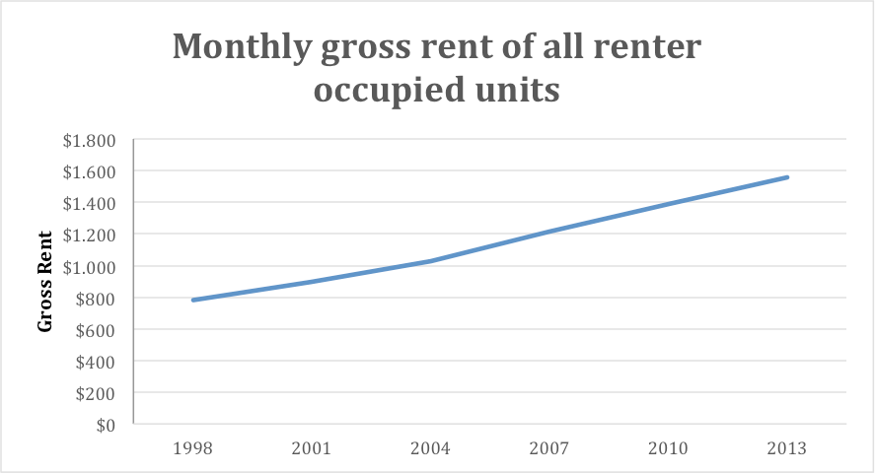
Figure 3
The increase in gross rent observed in New York City between 1998 and 2013 is in line with what was hypothesized in hypothesis 1. In the upcoming sections I will investigate whether this increase led to an increasing number of disadvantaged households leaving New York City during 1998 and 2013.

2. 3 Socio-economic characteristics of households
To investigate whether the households moving in in New York City were of a higher socioeconomic status than those moving out I examined two socioeconomic indicators. First of all I examined the change in the mean income in New York City between 1998 and 2013. Secondly, I studied the change in the proportion of people with a college degree living in New York City between 1998 and 2013. The results of this section will be used to conclude whether hypothesis 2 has to be accepted or whether it has to be rejected.
So firstly, I studied the change in mean income between 1998 and 2013. This change is illustrated in figure 3. From the graph it can be concluded that mean income increased in New York City between 1998 and 2013. Namely, mean income increased from $36.789 in 1998 to $66.758 in 2013. Which represents an 80,49% increase between 1998 and 2013. When this increase is controlled for inflation mean income shows a percentage change of 26,3%. Mean income especially grew between the years 2010 and 2013. Between these years mean income increased by 12,96%. Between 2010 and 2013 inflation is calculated at 7%, which implies that mean income, controlled for inflation, increased by 5,57% between 2010 and 2013.
This increase in mean income implies that those moving in between 1998 and 2013 received on average a higher mean income than those moving out. Even though income increased by 26,3% gross rent increased even more. This implies that the average rent burden has increased during this period. This is confirmed by data provided by the NYCHVS. The average rent burden has increased from 39,9% in 1998 to 44,7% in 2013.
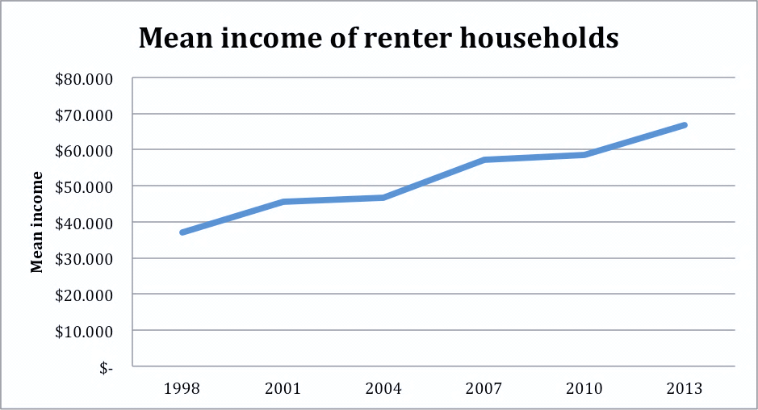
Figure 4

Secondly, I studied the change in the proportion of people with a college degree. While mean income is directly related to rent-paying ability, educational attainment is not as subject to fluctuation and is thus therefore an even more stable indicator of socioeconomic status. Consequently, if the socioeconomic status of in movers was indeed higher than that of out movers we should observe a rise in the proportion of people with a college degree in New York City between 1998 and 2013. The change in the proportion of people with a college degree is illustrated in figure 4.
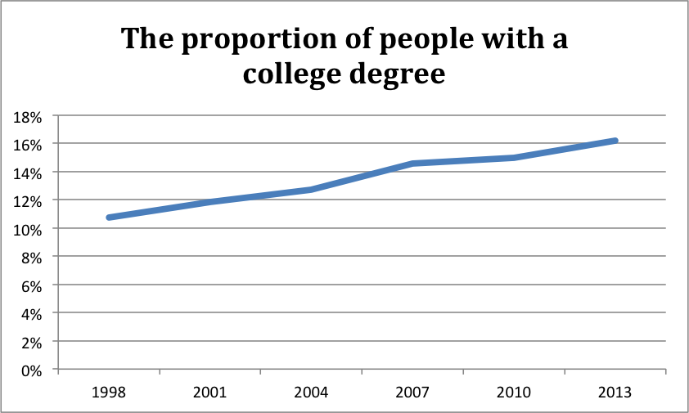
Figure 5
Figure 4 shows an increase in the proportion of people with a college degree living in renter units. From the graph we can read that the proportion of people with a college degree increased from 10,74% to 16,23%. So between 1998 and 2013 the proportion of people with a college degree increased with 5,48%. This result implies that the people moving in in New York between 1998 and 2013 had gained on average a higher educational level than those moving out.
From the results presented in this section it can be concluded that those moving in are on average of a higher socioeconomic status than those moving out. The observed increase in socioeconomic status is consistent with the process of gentrification. However, further investigation is needed to conclude whether those moving out include a great portion of people that have been displaced during the process of gentrification. Hence, the following section will measure the net loss of disadvantaged people and the change in the proportion of disadvantaged households.
2. 4 Disadvantaged households
In this section I will study fluctuations in the relative and absolute numbers of disadvantaged households. The results of this section will be used to draw a conclusion with regard to whether hypothesis 3 should be accepted or whether it should be rejected. I used one indicator of disadvantage: the household’s income level. I identified disadvantage households as those households with an income below the federal poverty threshold. The United States Census Bureau estimated the poverty threshold to be at $15142 in 2013, $14216 in 2010, $13540 in 2004, $12334 in 2001 and $10634 in 1998 (U.S. Census Bureau, 2014).
The trend in the proportion of disadvantaged households living in renter units is illustrated in figure 5.
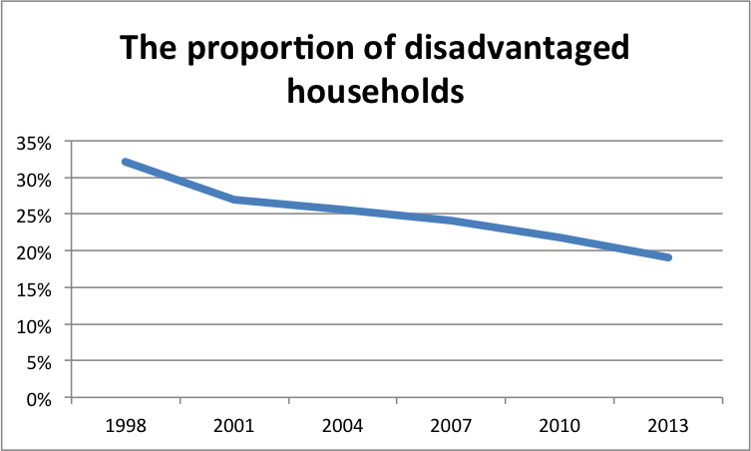
Figure 6
From the graph we can observe a decline in the proportion of disadvantaged households in New York City between 1998 and 2013. The graph shows a decline of 13,05%. This implies that the share of disadvantaged households was larger for those moving out than for those moving in. This is consistent with the process of gentrification.
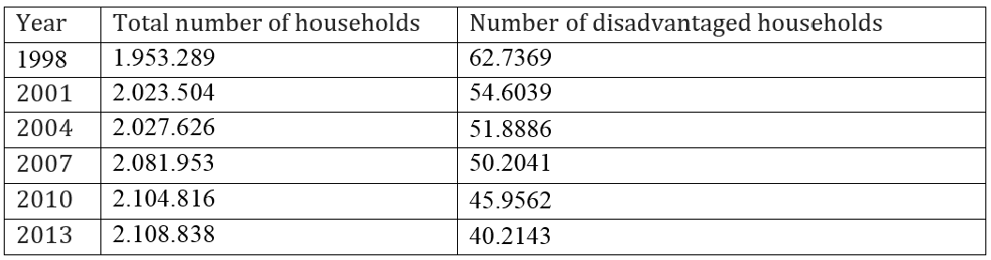
Table 1 – The absolute change in the number of disadvantaged households
Displacement has occurred if this decrease shows as a result of a net loss in disadvantaged households. Therefore, the absolute changes have to be studied. These absolute numbers are presented in table 1. Table 1 shows a net loss in the number of disadvantaged households. The number of disadvantaged households decreased from 62.7369 in 1998 to 40.2143 in 2013. This is a decrease of 35,9%. Assuming that the position of all resided households with respect to the federal poverty line has not changed between 1998 and 2013 it can be concluded that displacement has occurred during 1998 and 2013.
2. 5 Results
This empirical analysis has tested whether visible patterns in specific indicators match with trends that should be observed if gentrification was present and could be associated with displacement. In this section I will summarize the main findings of this analysis and I will conclude whether the three hypothesizes I posed in the previous chapter can be accepted or whether they have to be rejected.
I found that gross rent, mean income and the proportion of residents with a college degree have increased in New York City between 1998 and 2013. From these results it can be concluded that those moving in were of a higher socioeconomic status than those moving out. These changes are therefore consistent with what would be expected for gentrifying cities. These results imply that hypothesis 1 and 2 cannot be rejected.

Earlier I argued that rent inflation may be correlated with an increase in the number of disadvantaged households moving out. Therefore, I investigated the change in the proportion of disadvantaged households and the change in the absolute volume of disadvantaged households. Moreover, I hypothesized that a decrease in the number of disadvantaged households would show as a result of displacement. Figure 6 and table 1 show that both the proportion of disadvantaged households and the absolute volume of disadvantaged households have decreased in New York City between 1998 and 2013. These results imply that hypothesis 3 cannot be rejected either.
In conclusion, it can be said that visible patterns match with trends that should be observed if gentrification and displacement were correlated. The results of this empirical analysis therefore suggest that gentrification could be associated with displacement in New York City between 1998 and 2013 when this co-evolution of matched patterns hold once controlling for sorting effects, endogeneity and causality, and other factors effecting rents, demand and supply of types of housing.

Discussion
This thesis presents evidence suggesting that gentrification was an active process in New York City between 1998 and 2013 and that it can be associated with losses of groups who have been associated with displacement in previous studies. In this thesis I used a methodology that examined how the socioeconomic status of those moving in differed from those of moving out. The methodology used in this thesis can only help to define the upper bound of displacement. It cannot be used to determine whether neighbourhood changes occurred through displacement or through normal housing succession, because this methodology does not consider other reasons why households might move besides displacement. This methodology can therefore only verify that gentrification is present but without additional information, cannot demonstrate its impact on displacement. In this chapter I will explain the limitations of this study in more detail and I will provide some suggestions to solve these issues. Furthermore, I will address an additional measurement that has to be studied in order for one to conclude whether a causal relation exists between gentrification and displacement.
To measure the number of moves of disadvantaged household, I calculated the absolute change in the number of disadvantaged households. This methodology may have over-estimated displacement by including households who have voluntarily moved, but it may have under-estimated the problem by ignoring those who fall into homelessness or double up with relatives or friends. To solve this problem a life cycle model of housing consumption could be used. This model controls for life cycle events that typically trigger a relocation of a household. This framework controls for, for example age, marital stage and the presence of children. Furthermore, the empirical evidence presented in this thesis only measured last-resident displacement. Although longitudinal data was used, data provided by the NYCHVS only provides snapshots of location at three-year intervals. This implies that intervening moves have not been studied. To overcome this problem consecutive years have to be studied so that intervening moves can be studied as well. Another limitation of this research has to do with the geographical scope of this study. I did not stratify my analysis at a finer geographic scope than city level. It is therefore impossible to know if low-income to high-income successions were only concentrated in gentrifying neighbourhoods. New York City consists of 55-subboroughs and it cannot be concluded on the basis of city level data that in each individual sub-boroughs gentrification is present.

To determine whether gentrification causes an increased number of disadvantaged households to be displaced one has to compare a gentrifying area to another area in which gentrification is not occurring. This has however not been done for the purpose of this thesis. By comparing these areas one could conclude whether disadvantaged households living in gentrifying areas are significantly more likely to move out than those living in non-gentrifying areas. Nonetheless, it is questionable that all other areas are suitable to function as a control group. More appropriate would be an area that is similar to the gentrifying area except for undergoing gentrification.
Conclusion

I believe that the findings of this research have implications for how we understand the process of gentrification, what gentrification may mean to disadvantaged households and how policies should be constructed to address concerns about gentrification. This chapter summarizes the results of my research and provides an answer to the research question posed in the introduction. It also ties the story of gentrification in New York City together with the theories and models presented in the literature review.

From the model presented by Hackworth and Smith (2001) it is clear that both the production- and consumption-oriented approaches can be used to explain the occurrence of gentrification in New York City. At first, gentrification primarily occurred because of the existence of a gap between actual and potential land values. However, during the second wave, gentrification became more and more integrated in cultural processes. Before the introduction of gentrification many cities faced fiscal problems due to the fact that higher income households increasingly tended to migrate to the suburbs, while more disadvantaged households concentrated themselves in the urban core. It is therefore no surprise that the government played a huge role in the progression and spread of gentrification in New York City. During the first wave the government primarily guided the revitalisation of the inner city on its own, whereas during the third wave both the government and the corporate institutions contributed to the process of gentrification in New York City.

Gentrification has typically been defined as the revitalization of previously devalued and poor central city neighbourhoods by the in-migration of more affluent households. While population movement is a quite common feature of cities, many researchers specifically associate gentrification with the replacement of a less affluent group by a wealthier group of households. These researchers assume that displacement is the principal mechanism through which gentrification changes the socioeconomic character of the neighbourhood. Philip Clay (1979) is one of those researchers. In his four-stage model displacement occurs at every stage of the process.
On the other hand, Freeman and Braconi (2004) argue that a neighbourhood can gentrify without direct displacement as long as in-movers are of a higher socioeconomic status than those moving out. According to their beliefs a neighbourhood could go from a high proportion of poor households to a low proportion of poor households without any displacement whatsoever, providing that all vacated units are rented by non-poor households.

The results of a research carried out by Freeman and Braconi (2004) indicate that neighbourhood gentrification in New York City is associated with a lower tendency of poor households to move. This finding suggests that normal housing succession is the main reason why changes in neighbourhood demographics occur. A valid explanation for this finding is that gentrification brings along neighbourhood improvements that are valued by poor households. It is therefore quite likely that disadvantaged households try to make a greater effort to remain in their current neighbourhood. It is important to notice that the only way for these residents to stay put in a gentrifying neighbourhood is for them to devote a greater proportion of their income to rent.

The findings of Freeman and Braconi (2004) imply that the amount of displacement occurring in gentrifying areas is no worse than in non-gentrifying areas. This however does not mean that no one is being displaced. I carried out an empirical analysis to determine whether gentrification could be associated with displacement in New York City between 1998 and 2013. I found that visible patterns in New York City are in line with trends that should be observed if gentrification were correlated with displacement. Therefore, the results of my research suggest that gentrification may be correlated with displacement in New York City between 1998 and 2013. However, from the results of my empirical analysis it cannot be concluded that the change in the proportion of disadvantaged households was solely caused by gentrification-related displacement. As Atkinson (2004) already brought up, one can never be sure whether displacement has occurred because of gentrification. This is due to the fact that those who have been displaced are no longer there to be counted or questioned about their motives to move. Therefore, I suggest that more research should be carried out to determine whether city level changes occurred through displacement or through normal housing succession. Nonetheless, the results of this research do indicate that even though gentrification may provide benefits to disadvantaged households, it may also create adverse effects that public policies should take into consideration. Therefore, I also suggest that more research should be carried out to evaluate the usefulness of rent regulation and other means in keeping displacement at bay and moderating rent burdens for disadvantaged households.

REFERENCES
Atkinson, R. (2004, April). The Evidence on the Impact of Gentrification: New Lessons for the Urban Renaissance. European Journal of Housing Policy , 107-131.
Austensen , M., Ellen, I., Herrine, L., Karfunkel, B., Jush, G., & Yager, J. (2015). State of New York City's Housing and Neighbourhoods in 2015. NYU Furman Center. New York City: NYU Furman Center.
Beauregard, R. A. (1986). The chaos and complexity of gentrification. Gentrification of the City , 35-55.
Berg, J. J., Kaminer , T., Schoonderbeek, M., & Zonneveld, J. (2008). Houses in Transformation: Interventions in European Gentrification. Rotterdam: Nai Publishers.

Boston, T.D. & C.L. Ross (1997), The inner city. Urban poverty and economic development in the next century. London: Transaction Publishers.
Brueckner, J. K., & Rosenthal, S. S. (2009). Gentrification and Neighbourhood housing Cycle: Will America's Future Downtowns be Rich? The Review of Economics and Statistics , 725-743.
Doucet, B. (2014). A process of change and a chaning process: introduction to the special issue on contemporary gentrification. Tijdschrift voor Economische en Sociale Geografie , 105 (2), 125-139.
Freeman, L., & Braconi, F. (2004). Gentrification and Displacement New York City in the 1990s. Journal of American Planning Association , 39-52.
Glaeser, E. L., Kahn, M. E., & Rappaport, J. (2008). Why do the poor live in cities? The role of public transportation. Journal of Urban Economics , 63, 1-24.
Glaeser, E. L., Kolko, J., & Saiz, A. (2001). Consumer City. Journal of Economic Geography , 27-50.
Goworowaska, J. (2008). Gentrification, Displacement and the Ethnic neighbourhood of Greentpoint, Brooklyn. The University of Oregon, Department of Geography. Oregon: The University of Oregon.
Gyourko, Mayer, & Sinai. (2006). Superstar Cities. NBER Working Paper Series. National Bureau of Economic Research.
Hackworth, J. (2002). Postrecession gentrification in New York City. Urban Affairs Review , 200-234.
Hackworth, J., & Smith, N. (2001). The changing state of gentrification. Tijdschrift voor economische en sociale geografie , 464-477.

Hamnett, C. (1994). Social polarisation in global cities: theory and evidence. Urban Studies , 303-3013.
Johnson , J., Farrell, W., & Henderson, G. (1996). Mr. Porter's ''Competitive Advantage'' for inner city revitalization: exploitation or empowerment? The Review of Black Political Economy , 259-289.
Lees, L. (2003, November). Super-gentrification: The case of Brooklyn heights, New York City. Urban Studies , 2487-2509.
Lees, L., Slater, T., & Wyly, E. K. (2010). The Gentrification Reader. London: Routledge.
Ley, D. (1987). Reply: The Rent Gap Revisited. Annals of the Association of American Geographers , 465-468.
Marcuse, P. (1986). Abandonment, Gentrification, and Displacement: The Linkages in New York City. In N. Smith, & P. Williams, Gentrification of the City (pp. 153-177). Boston: Allen and Unwin.
Newman, K., & Wyly, E. K. (2006). The Right to Stay Put, Revisited: Gentrification and Resistance to Displacement in New York City. Urban Studies , 23-57.
Porter, M. (1995, May). The Competitive Advantage of the Inner City. The Harvard Business Review , unknown.
Redfern, P. (2003). What makes gentrification 'gentrification'? Urban Studies , 2351-2366.
Smith, N. (1996). The New Urban Frontier: Gentrification and the revanchist city. London and New York: Routledge.
Smith, N. (1979). Toward a Theory of Gentrification: A Back to the City Movement by Capital, not People. Journal of the American Planning Association , 45, 538-548.
U.S. Census Bureau. (2014, September 16). Poverty Threshold. Opgeroepen op May 27, 2016, van www.census.gov.com: www.census.gov/hhes/www/poverty.data/threshld
Van Weesep, J., & Van Kempen, R. (1994). Gentrification and the Urban Poor: Urban Restructuring and Housing Policy in Utrecht. Urban Studies , 31, 1043-1056.
Vigdor, J. L., Douglas, M. S., & Rivlin, A. M. (2002). Does Gentrification harm the Poor? Papers on Urban Affairs , 133-182.
Wheaton, W. C. (1977). Income and Urban Residence: An Analysis of Consumer Demand for Location. The American Economic Review , 67, 620-631.

A block grant is large volume of money granted by the national government to a regional government. The regional government can spend this money more freely than when it would have received a categorical grant.

