

How founders’ education affects the amount of early-stage capital raised for their technology startup.

Kasparas Aleknavicius
384533

Abstract:

Using data about 76 technology startups that have raised early stage investment capital in the Netherlands the years 2013-2015, I study the effects of type and level of education held by the founders on their ability to raise more capital. From the relevant literature I develop hypotheses related to managerial and technical education type, as well as education level in general. Results follow past findings and suggest, that there is no significant influence from neither type nor level of education on early stage investment capital amounts.

Erasmus University Rotterdam
International Bachelor of Economics and Business Economics
Bachelor’s Thesis
15-08-2016

Supervised by Thomas Peeters
Table of Contents
1. Introduction 4
2. Literature review 7
3. Theoretical framework 9
3.1. Theoretical considerations 9
3.2. Type of education 9
3.3. Level of education 10
4. Methodology 11
4.1 Data sources 11
4.2 Pilot study 11
4.3 Sample 11
4.3.1 Population 11
4.3.3. Early stage capital 12
4.4. Crunchbase 12
4.4.1 Timeframe 12
4.4.2. Crunchbase data collection 12
4.4.3 Startups in the sample 13
4.5. LinkedIn 13
4.5.1. LinkedIn data collection 14
4.6. Dependent variable 14
4.6. Independent variables 16
4.6.1. Type of education 16
4.6.2. Level of education 17
4.7. Control variables 18
4.8. Econometric regression model 18
4.8.1. Type of education 18
4.8.2. Level of education: 19
4.9. Potential bias 19
5. Results 20
5.1. Hypothesis 1 20
5.2. Hypothesis 2 22
5.3. Hypothesis 3 24
5.4. Hypothesis 4 24
5.5. Additional linear analysis 25
6. Summary of Findings 26
6.1. Overview 26
6.2. Data collection 26
6.3. Investment ranges 26
6.4. Rejection of hypotheses 27
6.5. Research Limitations 27
6.6. Future Research Suggestions 28
7. Conclusion 28
Bibliography 30
Appendix 32

1. Introduction

In 1993 world wide web became mainstream enough to spark a new generation. Internet generation (MOSAIC™, 1993). New technology opened up ways to reach millions of people very easily. Tech companies reached sky high valuations at tremendous speeds. For example it took Nike 24 years to reach $1 billion valuation, while Yahoo just needed three (Montini, 2014). This trend of decreasing time span to such valuation is still visible with the fastest company to reach $1 billion being Jet.com. It took them only 4 months (Tunguz, 2014; Unknown, 2016). These companies require trucks full of cash to support their swift growth, and at that stage, their best bet is to talk to angel investors and venture capitalists.

The initial heat wave started in the end of the previous century, with companies like Yahoo, Google and PayPal drawing a purple picture about startups. This hype lured more and more capital into the industry which was followed by unreasoned investments. Not too long after, the dream of earning big bucks easily from extreme growth and a succeeding IPO was squashed by the dot.com bubble (Cassidy, 2002). When investors poured money into startups with no business model, or overly optimistic expectations of future revenues behind it. The biggest, most infamous failures were Pets.com, Webvan.com and Kozmo.com which lost hundreds of millions of dollars of investment capital with a blink of an eye when their stocks became worthless (Goldman, 2010).

This devastating event taught investors how risky this industry is. Investors learned it the hard way, that there has to be a substance behind the startup, otherwise it has high chances of flopping, even with tremendous amount of funding in its bank. A widely popular saying that 9/10 of tech startups fail was born and so investors became more careful with their cash (Patel, 2015). They started looking more closely at what is behind the purple curtain. How good is the founding team, how well do they know the market, is the market ready for such innovation etc.

Nevertheless, number of tech startups kept on booming (Tracker, 2016). Fresh university grads or even dropouts wanted to change the world with their website or app. Events like mobile becoming a platform for apps and web product development becoming increasingly easy, costs for an internet company presumable dropped by ten times (Janz, 2011; Tenner, 2011). All in all, entrepreneurs would still need to attract more capital for growth. These entrepreneurs would need to turn to equity investors be it angel investors or venture capitalists for capital that would allow them to take their idea or prototype and turn it into a working product. Venture capitalists are professional investors who typically work in a team and manage large investment funds that seek high returns on risky investments, while angel investors are wealthy individuals who seek to invest their own money in high growth potential startups (Horowitz, 2010). With all this in mind, this easy start of a company created a lot of noise in the investment world because VC’s and angels had difficulties finding and selecting promising startups to invest into.

As mentioned previously, picking the right companies to invest into is very hard to put it mildly. There are many different aspects on why something might go wrong that will eventually push the company into bankruptcy. Bill Gross has determined 5 key determinants of a startup success (or failure for that matter): idea, funding, business model, team and time (Gross, 2015). It turns out that startups which got the timing right were the most successful. However, getting the time right is tricky. Investors therefore have to always be on their edge when looking for the next big thing. Which is challenging when there are so many startups and so many other investors. It becomes like gambling, unless investors set lots of investment criteria.

Investors’ decision making on whether to invest or not puts a lot of emphasis on criteria such as potential market size, future financial projections, business model, scalability, marketing and user acquisition plan and many more, but the priority is always given to the founding team. Which was also found to be the second most important determinant of success by the same study done by Bill Gross.

The importance of having a strong founding team if one wants to raise capital can be emphasized with a fact that the investment environment is slowly changing to the negative side (Primack, 2015; Chapman, 2016). Investors’ were relatively positive about the future projections up until recently, however we are already able to see some evidence with decreased venture capital activity. Interestingly, total amount of capital coming from business angels is still increasing but the number of investments into startups is decreasing (EBAN, 2014; EBAN, 2016). Meaning that early stage capital is accessible easier than later stage but angel investors rely on their exits and so they have to weigh possible exit opportunities which are heavily affected by venture capital participation. That is why investors not only think more before they invest but they also select less startups to invest into when comparing the years of 2014 and 2015.

Investors care about the background of the founders, how well do they understand the market, whether they have connections, whether management team is qualified, how motivated and enthusiastic they are. Investors look for things such as ability to guide the company with a strong vision, reliable communication flow within the team and many other aspects. Some of these are hard to identify via observation, hence, angels and VC’s have to come up with ways to spot these positive attributes. One option is education. Investors are able to use education as a signal to determine personal attributes of the individuals who are in the founding team (Hsu, 2007). Or are they not?

It appears that this part of investment criteria has not been studied enough. Thus I believe that it is of great interest to check whether education can indeed have a positive effect on investors’ expectations. In other words, the purpose of the research is to check whether education of the founders can help to convince early stage investors to put in more seed capital. The size of the investment round can be interpreted in way that a larger round means higher predicted revenues in the future. Hence, specific education might signal strong capabilities by the founders to achieve success with their startup. To elaborate, I will look into two main areas: type (managerial or technical) and level of education (college or university). On top of that, having a technical founder and a business founder is regarded as the best combination (Colombo & Grilli, 2005), therefore I will check if specific education combinations are able to predict a startup success in raising a larger seed round of funding in the Netherlands between years of 2013 and 2015.

Paper will try to answer a research question: How founders’ education affects the amount of early-stage capital raised for their technology startup.

Exploratory type of survey research will be undertaken as it takes place early stage into a development of a phenomenon of interest. The paper follows survey research design requirements proposed by Cipriano Forza (Forza, 2002). The main objective of the study is to gain preliminary insight on the topic that provides the basis for more in-depth research in the future. It will help with building up the concepts to be measured in association to the phenomenon of interest. Additionally, as researchers increasingly face more biases and issues with response rate using traditional survey data collection methods, a new method will be proposed. More and more companies are being asked to fill in various surveys which trumps the response rates significantly (Forza, 2002). Therefore, a novel approach will be incorporated which uses LinkedIn, a professional social network, for survey data collection. It has its own trade-offs between generally available data and the easiness of retrieving it which will be discussed in detail.

The structure of the exploratory research is as follows, literature review will be presented which summarizes and analyses previous scientific papers on the investment criteria, team education and the ability to raise early stage capital. After which theoretical framework will be explained in more detail. In this section hypotheses will be constructed and described. Next part will lay out methodology and the measures that were included in order to be able to retrieve valid data about early stage capital investments in the Netherlands and valid observations about founding team members’ education. Afterwards the results will follow and the paper will be closed with a discussion of the results and a conclusion.

2. Literature review

There is a solid amount of research carried out in the field of angel and venture capital investment decision making criteria. Research topics vary from market and product focused to financial and investor-entrepreneur fit (Bachher & Guild, 1996; Mason & Harrison, 1996). Majority of the studies have mostly looked at entrepreneur’s expertise in the industry, startup’s growth potential and ROI or exit opportunities. Size of investment, team dynamics and characteristics, or more specifically, educational background were researched to the lesser extent, which are the main focus areas of my analysis.

One particular study of interest is covered by (Feeney et al., 1999). Researchers wanted to pinpoint how business owner’s personal attributes are ranked by investors when the size of investment changes. They find that once the considered investment size is less than $50.000, investors put less emphasis on the skills of the founder. Interestingly, once investors start considering higher investment amounts, $100.000 or $500.000 their focus shifts towards the person who is running it and his skills. Nevertheless, Sudek (2006) suggests that the final decision on whether to invest or not in a startup does not really depend on the amount of investment that is being requested (Sudek, 2006). In his study investment size as an investment decision criterion was on the lower end of the rank. It is found that central identified reasons which can discourage an investment are especially the shortcomings of the entrepreneur, more precisely: lack of management knowledge, lack of realistic expectations, lack of integrity, lack of vision, lack of commitment and the need for control (Feeney et al., 1999).

Unexpectedly, out of 14 studies carried out specifically about investment decision making, none of the researchers discuss nor investors disclose education as a discrete decision making criteria. Nevertheless, human capital and personality characteristics are regarded as one of the initial decision makers (Feeney et al., 1999; Haines et al., 2003; Mason and Stark, 2004). Therefore, results can be interpreted in a way that diploma from a university or other institution does not affect investors decision significantly because any type of person with desired human capital could come from any kind of educational institution and thus it is unreasonable to favor someone with a specific educational background. More broadly, findings from studies (Paul et al., 2007; Feeney et al., 1999; Haines et al., 2003; Mason and Stark, 2004) confirm that confidence in the entrepreneur behind the project is critical, on top of that, Feeney et al. (1999) names entrepreneur and management team as the most common deal rejection factors. Therefore, one could argue that sole education does not impact investors decisions significantly, they need to know more about the founders’ traits. This argument can be scientifically reasoned, as Kang et al. (2006) finds that demographics (education, age, gender, tenure) of a founding team explain their effectiveness to a lesser extent if compared to team’s cognitive similarities like attitudes, values and beliefs, eagerness to learn, knowledge, skills, experiences and personality (Kang et al., 2006). Meaning that investors should indeed get to know the entrepreneur and the management team better before making a decision.

Nevertheless, there is some, but limited amount of research suggesting that education might, in fact, influence investors’ decision making. For example, Parker and van Praag (2006) indicated that level of educational background is associated with direct impact to firms’ growth as well as increased rate of return (Parker & Praag, 2006). Bates (1990) proposes that more capital should be given to highly educated founders, which would mean that some individuals should be getting higher valuations which in turn would give them higher investment size (Bates, 1990). Education as a strong signal also plays its role. If someone from a founding team has a doctoral degree, they are said to be more likely to receive higher valuations and investment from VC’s. This could indeed be the cause of a signaling effect (Hsu, 2007). Similarly, founders with higher educational background, prior innovation output and academic affiliation have a tendency to raise more funds for R&D (Honjo et al., 2010). Next to previous statements, formal education seems to be involved in improvement of a person's ability to search and process large amounts of information leading to a greater ability to identify potential business opportunities (Parker & Praag, 2006). This is of great importance when discussing technology industry, because business opportunities are not always visible. First there is just a problem that needs to be solved and then the entrepreneur has to come up with a business model behind it.
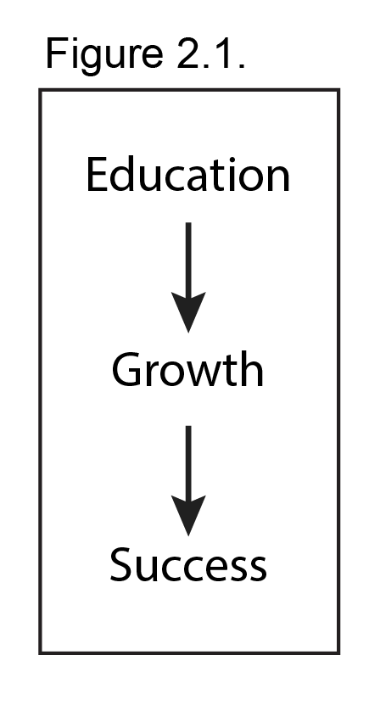
Different types of education seem to also affect the startup growth rates differently. Massimo G. Colombo finds that founders’ university education in managerial fields positively affects company’s growth. Likewise, engineering and technical education also influences growth, but only to a lesser extent. Education in other fields, however, seem to not contribute at all. Colombo also suggests that business administration studies help with making your venture more successful (Colombo & Grilli, 2005). To better understand the relationships discussed, see Figure 2.1.

To sum up, some researchers find that education does have significant influence on venture’s success rate or growth rate, but surprisingly it is also found that investors do not look at education explicitly when making investment decision. To analyze and verify this, hypotheses will be constructed in the following section.

3. Theoretical framework

3.1. Theoretical considerations
Past research finds relationship between education, growth and success. It also depicts what investors care about the most in the end of the day, which is growth and success, see Figure 1. I argue that education influences investment size which is a representation of investors’ perceived growth opportunities (Figure 2).

3.1. Figure 3.2. Figure
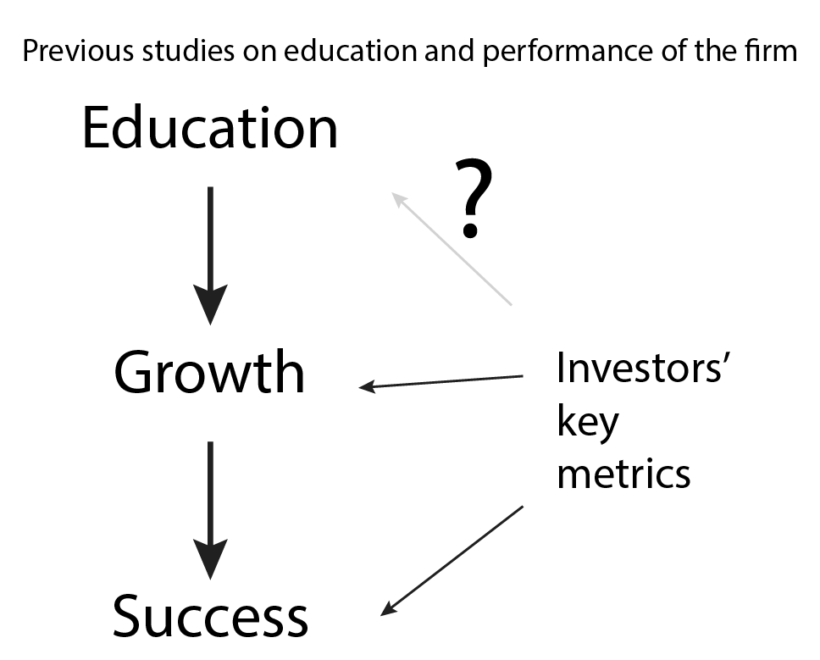
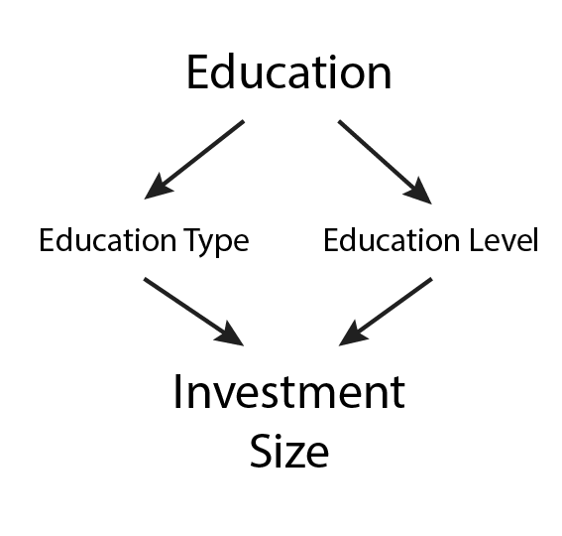

It is quite common that in operational management studies there is no properly defined theoretical model and formal theory is underdeveloped (Forza, 2002). Thus concepts of interest need to be better understood and weighted. Most of the past research on the topics related to this research were using survey data and information about the decisions when investors invest and when not. My research purely focuses on the startups that did get the funding. I also look at the past research about startup success and check whether previous results could also help us to better understand the amounts that are being raised by the startups.

3.2. Type of education
First three hypotheses relate to the type of founders’ education. In literal terms, in early stage environment, technology startups need tech founders to develop a technology and a management team to build a business model behind the technology. Unsurprisingly, majority of previous research finds that lack of skilled management team is the main cause of rejection when raising capital (e.g. Feeney et al., 1999). It is found that managerial education helps to achieve success which can also be used to convince the investors about founders’ managerial skills (Colombo & Grilli, 2005). Reason behind this, is if founders studied management - they should be able to manage better and so the management team grows stronger which prevents the startup from failing. Therefore, the first hypothesis is a directional one, which aims to find out whether managerial education affects investment size positively.
Hypothesis 1: More managerial educational background helps to raise more early stage capital.

When discussing purely technology based startups it is also important to emphasize the crucial role of technology, that is being built by the startup, in the valuation of company’s resources, as technology startups usually do not have any other valuable assets. On top of that, technology as means to beating competition to success. That is why investors rank technology high up among their investment criteria (Bachher & Guild, 1996). Therefore, founders’ technical education and other closely related subjects like computer science should convince the investors of their abilities to build a successful technology company. Which means that their valuation might increase with technical background.
Hypothesis 2: More technical educational background helps to raise more early stage capital.

As mentioned, startups need both technical and managerial-minded founders. It is hard to succeed without each other, as these are complementary educational backgrounds of founders which eventually help lead the venture to success (Colombo & Grilli, 2005). Nevertheless, it is of great interest to assess the synergistic gains, from the combination of complementary capabilities, in convincing an investor to invest a larger amount of early stage capital.
Hypothesis 3: Having both technical and business administration educational backgrounds helps to raise more early stage capital.

3.3. Level of education
Not only type but also level of education can play a significant role in previously developed skills by the founders, which can possibly influence investors’ confidence in the entrepreneurs and the venture behind them. As past research suggests, more capital should be given to more educated individuals, hence differences between capital investments in startups with founders that have earned university bachelor and master degrees or college bachelor and master degrees, should be assessed (Bates, 1990).
Hypothesis 4: Having higher educated founders helps with raising more early stage capital.

4. Methodology

Survey project is constrained by time and general resources; hence a unique method will be used. For finding out if type and level of education among the founders allow a startup to raise more early stage capital an exploratory survey research will be undertaken together with a novel approach to survey data collection. The paper follows operations management research design requirements proposed by Cipriano Forza, 2002.

4.1 Data sources

Data is collected from two sources. Crunchbase is used for early stage capital amount which is a dependent variable in the statistical model. The database is also used for finding out the names and contact information of the founders. LinkedIn profile information is used to determine the type and level of educational background of the founders, which are explanatory variables of this paper.

4.2 Pilot study

Before a full survey design was built, a pilot test with 10 startups was initiated to assess whether data collection measures and constraints do not prevent from answering hypotheses that were laid out earlier. This helped with obtaining information to better define the sample and to minimize issues related to sampling error. This is essential, as underdeveloped sample design can constrain the utilization of more appropriate statistical techniques and generalizability of the results (Forza, 2002). Few valuable observations were made, for example, that startups report multiple seed rounds which is not fully correct in terms of analysis, and so measures on how to assess these data points were created. These are explained in more detail in section 4.4.2 and 4.6.1. Likewise, initial statistical analysis was performed where most of the variables were found insignificant or the model fit was poor. To fix for possible biases additional control variables were included as well as multiple statistical methods were considered to make sure that the results are valid.

4.3 Sample

4.3.1 Population

A sample of technology startups based in the Netherlands was chosen. Technology startup is a wide term which is used to represent a young and small company that operates in sectors like financial technology, healthcare, e-commerce, internet-of-things, media and advertising, gaming, entertainment and many more. In wider terms, Paul Graham defines a tech startup as “a small company that takes on a hard technical problem” (Graham, 2004). Specifically, the Netherlands is chosen as tech startup population. Netherlands has been regarded as a country for entrepreneurs from all around the globe and they prove that by introducing Startup Visa and other flexible rules for foreign entrepreneurs to move to the Netherlands to pursue their dreams (IAmsterdam, 2015). Non-probabilistic sampling approach within the Netherlands is undertaken due to limited resources and time. Database with early stage capital data is used for the first part of the data collection and sample definition. Filters “seed” and “angel” are used together with years 2013-2015 and country Netherlands.

4.3.3. Early stage capital

Focus of the research is about early stage capital or also referred to as seed capital. Seed capital round is defined as a pre-revenue financial injection which is used for research and development, and to cover initial startup operating expenses. Here an educated guess is made that seed capital is better at determining the link between education and ability to raise capital, because at the early stage, startups are lacking valid business metrics, therefore investors have to rely on some other criteria. While at the later stages, series A or series B the metrics become the focus of the investment discussion.

4.4. Crunchbase

Crunchbase is a leading platform to discover innovative companies and the people behind them. It was founded in 2007 by Mike Arrington and it began as a simple crowd sourced database to track startups covered on TechCrunch, which is a technology news website. Crunchbase provides data on the size of investment, names of investors who participated in the round, names of the founders, startup’s online presence, startup’s headquarters and more.

4.4.1 Timeframe

A three-year timeframe is used, year of 2013, 2014 and 2015. These particular years are chosen for three main reasons. Firstly, past research associated to education and investment size were carried out about ten years ago, before the creation of new sectors like internet-of-things. Secondly, in recent years names of investment rounds have changed because of evolvement of the amounts that are being invested (Calacanis, 2015). Therefore, it is useful to use newer data. Lastly, data from the latest years are more readily available in the database which will help with robustness of the analysis later on by minimizing under or overestimation of the total seed amounts raised, because source of the data became more popular only in the recent years, meaning that more investment rounds are disclosed publicly.

4.4.2. Crunchbase data collection

Being the most versatile platform about startup investment information and much more, also has its downsides. There are more than a few aspects that need to be taken into consideration in order to keep the sample unbiased and research results reliable and valid.

- Most importantly, some startups disclose multiple investment rounds as seed rounds even though they are as much as two years apart. This does not represent better abilities to raise capital, because it could have been that the company was unable to release a product to the market for such a long period of time even with all that money, and so any investments recorded as seed but were received more than half a year after the first seed investment will be ignored and regarded as future rounds aimed for growth.
- Investments made by startup accelerators, like Startupbootcamp and Rockstart in the case of the Netherlands, will also be ignored, because that money is not representative. It is only meant for startups to cover their costs while they are in an accelerator which is typically three months and not for a longer period of time.
- Being a self reporting platform, Crunchbase sometimes lacks some data points, this is accounted for, as explained earlier, by picking recent years when the database became more popular and so more startups disclose more data. However, if a startup is found to have no information about the size of the seed round, or the names of the founders are missing, the observation will be excluded from the study. This is believed to be due to random factors and so the estimates resulting from deletion strategy are generally unbiased but less efficient than when no data is missing.
- Only startups that raised first seed round(s) in years 2013-2014-2015 are included. Exclude startups that raised a new seed round in the time span 2013-2015 if they have raised seed already before this timeframe.

4.4.3 Startups in the sample

After first part of data collection is done, 76 startups were identified as suitable for further analysis with a mean investment amount being around $550.000. This represents all startups that have raised early stage capital in a three-year time span and shared that information on Crunchbase database. Further comments about the distribution of the dependent variable are laid out in section 4.6.1., as well as a table with descriptive statistics of investment amounts (Table 4.1.).

4.5. LinkedIn

Past research used three most favorite types of data recordings: personal interviews, phone calls, mailed questionnaires (Miller & Salkind, 2002). I will be employing a novel approach. This part of survey data collection is carried out using a professional social network. LinkedIn is world’s largest professional network with more than 433 million members in 200 countries and territories around the globe. For entrepreneurs, LinkedIn is a useful tool to connect with other industry leaders, investors and possible employees. Professionals fill in their profiles with information such as current and past employers, years of experience, skills they have, languages they speak, causes they care about, organizations they belong to, and next to many more, their education. Its impact and importance to the professional world can be emphasized by its recent purchase by Microsoft Corporation for $26.2 billion (Greene, 2016).

Important to point out, however, that data collection from LinkedIn has a crucial trade-off. On the one hand, it can reduce the costs and other resources such as time needed to retrieve data which is used to test a phenomenon of interest in operations management studies, and not fully generalizable data points on the other. The latter means that data is sometimes not readily available if a person is from a Gen X (born in around 1960) or older. Similarly, other data is not complete sometimes as well: year of studies is missing, early work experience is not shared and sometimes information is incorrectly recorded. For instance, some founders choose to report 5 year studies saying they have received master degrees, which technically requires that the person first gets a bachelor. Therefore, some educated judgment is needed in order to split them up into two points. Nevertheless, these results should not be biased, as it is believed to be random.

Conveniently, LinkedIn is suitable for solving an issue which is visible in most survey researches. Increasingly, companies and respondents are being asked to complete more and more questionnaires, and thus are becoming more reluctant to collaborate (Forza, 2002). Here is where LinkedIn can add value, where data collection is non-intrusive. There is a need of more data points that are available on LinkedIn, though, but in the future researchers might be able to use it for fully generalizable results with easily accessible large samples of professionals. The platform also helps with minimizing non-response bias. Using regular methods specific group respondents can sometimes ignore researcher, likewise, a group of respondents might want to stay anonymous and so decline the offer to fill in the survey which eventually makes the sample biased. These types of problems should not arise when using LinkedIn.

4.5.1. LinkedIn data collection

The dataset with two main categories for independent variables will be collected. Type of education and level of education of all the startup founders. Next to that, control variables such as work experience will be added to the study.

4.6. Dependent variable

Table 4.1. Statistical analysis about the effect of education on the ability to raise early stage capital will be carried out using regression analysis. In order to test the hypotheses, dependent variable will be amount of early stage capital raised by a startup which is recorded as an absolute value. Descriptive statistics show, that mean investment size was around $505000, with the smallest amount being $35000 and the biggest reaching more than $4mln (Table 4.1.).

Histogram was created to check for distribution and possible skewness of the data. One particular observation with $4.090.000 was a strong outlier in this dataset.
Graph 4.2.
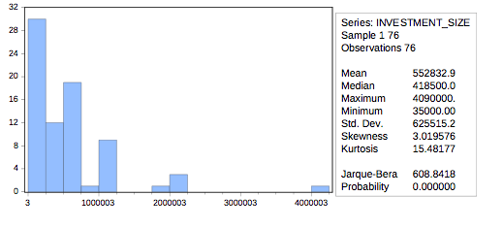

Graph 4.3.
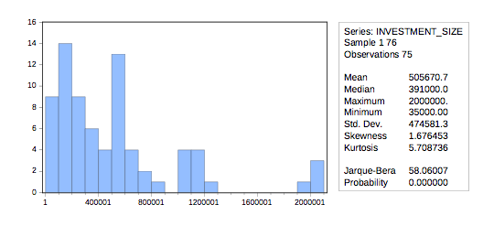
Once the outlier is deleted, new histogram provides better insights about the distribution of the results (Graph 4.3.). It is detected that the dependent variable does not follow a normal distribution and the data is still highly positively skewed (1.68). Partial explanation of it is the size of the sample, which is relatively small and the dependent variable being monetary amounts that tend to group around particular sums. One of potential further solutions to assess this skewed non-parametric data would be to group observations based on the size of the investment because there seem to be visible peaks followed by clear valleys at specific ranges of investment. This observation seems to be worth of further investigation. Therefore 4 groups of investment ranges were defined, and the deleted outlier was returned back to the analysis (Table 4.2.). Before any further analysis, four major assumptions of ordinal regression need to be addressed.
- The dependent variable should be measured at the ordinal level; hence this assumption is met as described above.
- One or more independent variables needs to be continuous, ordinal or categorical (including dichotomous variables). This is also accounted for by choosing a dummy variable.
- There is no multicollinearity, which refers to independent variables being correlated to each other. This assumption is also met; results can be seen in a correlation table which is included in the Appendix A.
- There are proportional odds. This is accounted for using test for Proportional Lines, which is included in the model summary table under “Null Hypothesis General”. It is interpreted in that if the outcome is not significant, there are proportional odds.

Table 4.2.
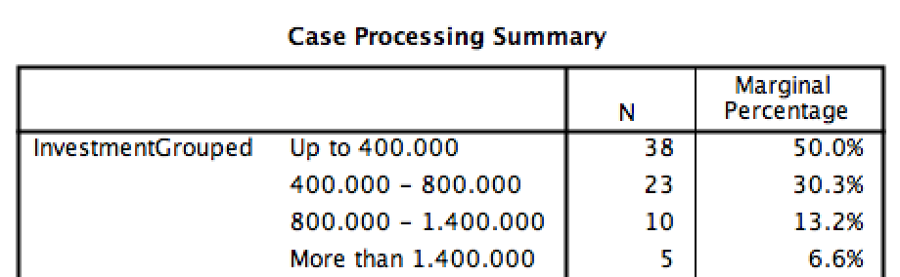

4.6. Independent variables

4.6.1. Type of education

Firstly, type of education will be collected. Here an educated judgment will be used to group some study programs that are rare but signal some strong similarities and characteristics. For example, if an individual has educational background in real estate management it will be grouped under variable “business administration”. Further detailed groups can be seen in Table 4.2. Data was firstly recorded as categorical variables, but in order to be able to assess whether founders are a good management team, or a technically competent team, variable coding methods from (Åstebro & Bernhardt, 2003) were borrowed. Here, proportions of education type between the founders were calculated which will enable us to interpret the data easier later on (Table 4.3.).
Based on the hypotheses, the focus variables are management and tech education, hence, proportions needed to be recoded into dummy variables for H1, H2 and H3 which would allow us to make a distinction between managerially educated founders or not for the first hypothesis. Likewise, to figure out whether a startup is technologically competent, a dummy variable for hypothesis 2 is needed. Mgmt is coded as (1) if more than half of the founders have managerial education background and otherwise (0). Tech is coded as (1) if at least a third of founders have technical education background and otherwise (0).

Table 4.3.
Study Type | Description
Mgmt_prop | Proportion of education that has business, administration, management, entrepreneurship or other closely related words in the official study programme name.
Econ_prop | Proportion of education that has economics, finance or other closely related words in the official study programme name.
Tech_prop | Proportion of education that has engineering, computer, system or other closely related words in the official study programme name.
Design_prop | Proportion of education that has graphic design, user experience, visual design, user interface, interaction design or other closely related words in the official study programme name.
Other_prop | Proportion of education that has have other miscellaneous words in the official study programme name.

Table 4.4.
Level Of Education | Description
ColBsc_prop | Proportion of founders with a degree after completing college bachelor’s, also called HBO or Hogeschool in the Netherlands
ColMsc_prop | Proportion of founders with a degree after completing college bachelor’s and master’s, also called HBO or Hogeschool in the Netherlands
UniBsc_prop | Proportion of founders with a degree after completing university bachelor’s
UniMsc_prop | Proportion of founders with a degree after completing university bachelor’s and master’s
Phd_prop | Proportion of founders with a degree after completing PhD.

4.6.2. Level of education

For the second part of analysis, level of education is collected. Here the main distinctions are between education from college, university bachelor, university master and university PhD degrees. Same as with type of education, these are collected as categorical variables and then transformed into proportions using methods from (Åstebro & Bernhardt, 2003). Table 4.4. explains in more detail. Hypothesis 4 aims to check for differences in the levels of education between startup founders, hence a dummy variable (EducLevel) is created which returns (0) if more than half of the founders have university Bachelor, Master or Phd studies, interpreted as higher education and (1) otherwise, which is interpreted as lower education.

4.7. Control variables

In order to improve the reliability of the research four control variables will be used (Table 4.5.). These will be added to regression analysis in hierarchical order, which is based on personal judgment. Firstly, average work experience of the founders will be used to expand the models. Rough estimation for work experience was used: year of investment minus year of graduation from a bachelor in college or university gives years of experience. If year of graduation is not provided, the year of the first job experience is counted as the start of the experience. This approach could be interpreted as reliable because the person chose not to share his past experiences which he might consider not important to his professional development. Secondly, a dummy variable for being a startup accelerator alumni or not will be added to the control variables, as startup accelerators’ one of the main purposes is to be a bridge between early stage capital investors and startups. Thus it might impact the results in a way that accelerator alumni receive more capital on average. Thirdly, year in which the investment was received. Early stage capital environment might have changed significantly to affect the mounts that are raised. Lastly, number of founders in the company, which is already partially accounted for by using proportions instead of absolute numbers.

Table 4.5.
Variable | Description
AvgExp | Average years of work experience per startup.
Accelerator | Dummy variable for participating in startup accelerator (1) and not participating (0).
InvYear | Year when the early stage investment was received.
NFounders | Number of founders in a startup.

4.8. Econometric regression model

4.8.1. Type of education

There is a prediction that education might have different effects when raising different amounts, and as a result of grouping investment amounts, ordinal regression model with management type of education as a dummy variable is used. Making it easy to distinguish between possible effects of more management education and less management education on the ranges of amounts of early stage capital investment. In order to find the best fitting model, hierarchical ordinal regression will be used to generate models together with a Model Fitting information and Pseudo R-square test to check for the best fit. In addition, Parameter Estimates will be assessed to find out significant variables in the models. One more tweak to the data was necessary, with which dummy variables Mgmt and Tech were recoded to (Mgmt2 and Tech2) be inverse. (0) for management studies above average number within the team, and (1) for under average. This is needed in order to interpret the results easier having (1) as a reference group, due to SPSS software output configurations.

Baseline model for H1: InvestmentGrouped = β0 + β1 * Mgmt2
H0: More managerial educational background does not help to raise more early stage capital.
Ha: More managerial educational background does help to raise more early stage capital.

Identical approach is taken to determine whether technical education has a positive effect on ability to raise early stage capital.
Baseline model for H2: InvestmentGrouped = β0 + β1 * Tech2

Third hypothesis aims to explain a possible interaction effect between the two types of education discussed above.

Baseline model for H3: InvestmentGrouped = β0 + β1 * Mgmt2 + β2 * Tech2 + β3 * (Mgmt2 * Tech2)

4.8.2. Level of education:

Last hypothesis refers to the level of education by the founders. Hypothesis aims to show that higher educated founders are able to raise more early stage capital. Ordinal hierarchical regression is used to determine best fitting model for finding out whether early stage capital investment ranges predict different levels of education. Same as before dummy variable Tech was recoded to be inverse.

Baseline model for H4: InvestmentGrouped = β0 + β1 * EducLevel
H0: More technical educational background does not help to raise more early stage capital.
Ha: More technical educational background does help to raise more early stage capital.

4.9. Potential bias

Due to the data collection approach, a number of potential biases might arise when statistical methods are employed to find out whether hypotheses can be supported. Anticipated issues:
- No observations of startups that were unable to raise capital that can be found on Crunchbase.
- Only more sophisticated startups record their investment rounds in the database which might have a positive bias towards the ability to raise more money.
- Startups from specific sectors might, on average, raise more due to the underlying operational costs, one example would be fintech (financial technology) startups might raise more capital for transactions to make the company operational rather than for covering expenses of the company, similar line of reasoning can be used for comparing hardware and software startups.
- Incomplete and scattered information about founder’s age and experience on LinkedIn platform makes it complicated to control for years of experience within the industry or any other prior entrepreneurial experience before getting the investment.

5. Results

5.1. Hypothesis 1

Firstly, cross tabulation table is built to check for visible relationships between more managerially educated founders and their ability to raise money in the higher ranges of investment (Table 5.1.). Results, unfortunately, do not give us any visible clues on possible links between dependent and explanatory variables, hence further analysis is needed to fully understand the outcome.

Table 5.1.
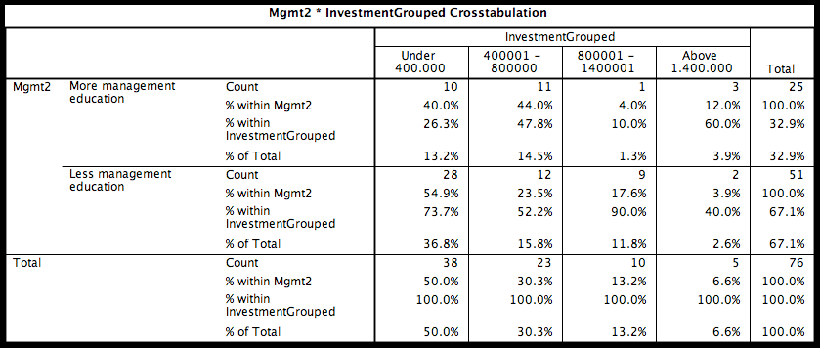

After running an ordinal regression analysis with a baseline model to check for possible effect of managerial education background of the founders on the different ranges of investment criteria, baseline model is assessed using Chi-Square and its significance in Model Fitting Information table. It is found, that the significance level is above 0.05 p-value. That indicates a very poor fit of the model which means that the model does not help to predict the change in dependent variable. Nagelkerke Pseudo R-square supports these findings, as the current model only explains around 1% of the variance in the differences of investment ranges. Such low R-Squared indicates that a model containing only managerial background is likely to be a poor predictor of the outcome for any particular investment. On top of all, looking at the parameter estimates, management education does not seem to affect the odds of getting an investment in particular ranges of investments, as it is found to be highly insignificant (0.402). Hence, to help improve the model, four categorical values are added, allowing us to generate 4 additional models. These are summarized in Table 5.2.

Table 5.2.
 | Parameter Estimates | Model 1 | Model 2 | Model 3 | Model 4 | Model 5
Threshold | InvestmentGrouped=1 | 0.134  (0.276) | 0.406  (0.475) | 0.631  (0.377) | -0.218  (0.497) | 15.761***  (1.410)
Threshold | InvestmentGrouped=2 | 1.541***  (0.335) | 1.813***  (0.522) | 2.492***  (0.520) | 1.923***  (0.590) | 18.005***  (1.495)
Threshold | InvestmentGrouped=3 | 2.788***  (0.457) | 3.066***  (0.639) | 3.573***  (0.705) | 3.043***  (0.760) | 19.146***  (1.582)
Location | Mgmt2=0 | 0.383  (0.457) | 0.416  (0.458) | 0.673  (0.561) | 0.609  (0.610) | 0.718  (0.623)
Location | Mgmt2=1 | 0 a | 0 a | 0 a | 0 a | 0 a
Location | AvgExp |  | 0.024  (0.034) |  | v
Location | Accelerator2=0 |  |  | 1.008*  (0.563) | 0.885  (0.608) | 1.062  (0.653)
Location | Accelerator2=1 |  |  | 0 a | 0 a | 0 a
Location | InvYear=1 |  |  |  | -0.789  (0.612) | -0.800  (0.628)
Location | InvYear=2 |  |  |  | -3.104***  (1.129) | -3.293***  (1.152)
Location | InvYear=3 |  |  |  | 0 a | 0 a
Location | NFounders=1 |  |  |  |  | 15.908***  (1.439)
Location | Nfounders=2 |  |  |  |  | 16.273***  (1.410)
Location | Nfounders=3 |  |  |  |  | 15.527***  (1.581)
Location | Nfounders=4 |  |  |  |  | 14.173  (0.000)
Location | Nfounders=6 |  |  |  |  | 0 a
Summary statistics | Model Fitting:  Chi-Square | 0.717 | 1.162 | 4.870* | 17.457*** | 20.870***
Summary statistics | Goodness-of-Fit: Pearson Chi-Square | 6.038** | 135.791 | 9.271 | 32.756 | 107.376***
Summary statistics | Pseudo R-Square | 0.010 | 0.17 | 0.094 | 0.303 | 0.352
Summary statistics | Parallel Lines: Chi-Square | 6.690** | 9.317* | 9.852** | .b | 11.940
Summary statistics | The values reported in the parentheses are the standard errors of the estimates.  A: this parameter is set to zero because it is redundant  *, **, and *** indicate a significance at the 10%, 5%, and 1% level respectively  b: The log-likelihood value of the general model is smaller than that of the null model. This is because convergence cannot be attained or ascertained in estimating the general model. Therefore, the test of parallel lines cannot be performed.

In Model 2 average work experience per startup is added, which seems to be insignificant in its ability to explain the changes in the dependent variable. Meaning that by adding average work experience to the model it does not help to explain the variances of the dependent variable. Worth to point out, that Nagelkerke Pseudo R-Square did increase after adding experience as a control variable, however, it might be because R-Square increases each time we generate a new model with more variables. This does not fully represent the fact that more variance in the dependent variable is being explained and thus should be interpreted with caution. Model 3 excludes average work experience, but adds a variable which includes information whether a startup has gone through a startup accelerator. It helps to improve the fit of the model relatively well (p-value 0.088). In addition, p-value for management variable also decreases almost by half, however it is still insignificant, whereas being an accelerator alumnus is slightly significant.

Model 4 includes one more control variable which is the year of investment. This improves the model fit even more. The statistically significant chi-square statistic at 0.05 level indicates that Model 4 gives a significant improvement over the baseline intercept-only model. Which is interpreted in that the model gives better predictions than if it was just guessed based on the marginal probabilities for the outcome categories. Unfortunately, management seems to still be insignificant. Last control variable is added to generate Model 5, which once more seems to improve the results slightly. Fit of the model is still highly significant, together with decreased most of the other coefficient p-values, and a higher Pseudo R-Square which explains roughly 33% of the variation between investment ranges. Nonetheless, the observed difference between majority and minority managerially educated founders per startup on investment ranges was not found to be statistically significant at the 0.05 level when controlling for average experience, going through a startup accelerator, year of investment and number of founders, which prevents us from drawing any conclusions about the possible effects on dependent variable. Therefore, I fail to reject the null hypothesis, which states that more managerial educational background does not help to raise more early stage capital.

5.2. Hypothesis 2
Equivalent to the first approach, testing the second hypothesis requires ordinal regression with a baseline model being Model 1, which incorporates one independent variable of interest, technical education of the founders (Table 5.3.). Same as with the first hypothesis, education variable is found to be insignificant in the first model. After following the same procedure as in the section 5.1., control variables were added one by one in the same hierarchical order. This proves the results to be very similar to the first hypothesis, where management education was still found to be insignificant even after control variables were added. The best fitting model is Model 5, with significant model fitting Chi-Square of 20.691 and with Pseudo R-Square of 0.349.
The hypothesis has to be dismissed as the observed difference between highly technically educated and less technically educated founders on investment ranges was not found to be statistically significant at the 0.05 level when controlling for number of factors, which prevents us from drawing any conclusions about the possible effects on dependent variable. Therefore, I once again fail to reject the null hypothesis, which states that more technical educational background does not help to raise more early stage capital.

Table 5.3.
 | Parameter Estimates | Model 1 | Model 2 | Model 3 | Model 4 | Model 5
Threshold | InvestmentGrouped=1 | 0.162  (0.303) | 0.458  (0.502) | 0.535  (0.389) | -0.242  (0.490) | 16.311***  (1.389)
Threshold | InvestmentGrouped=2 | 1.572***  (0.359) | 1.868***  (0.548) | 2.368***  (0.518) | 1.900***  (0.582) | 18.550***  (1.472)
Threshold | InvestmentGrouped=3 | 2.824***  (0.512) | 3.127***  (0.662) | 3.449***  (0.702) | 3.018***  (0.753) | 19.689***  (1.559)
Location | Tech2=0 | 0.355  (0.435) | 0.400  (0.438) | 0.328  (0.535) | 0.587  (0.597) | 0.644  (0.287)
Location | Tech2=1 | 0 a | 0 a | 0 a | 0 a | 0 a
Location | AvgExp |  | 0.025  (0.034)
Location | Accelerator2=0 |  |  | 0.997*  (0.561) | 0.849 | 1.006  (0.627)
Location | Accelerator2=1 |  |  | 0 a | 0 a | 0 a
Location | InvYear=1 |  |  |  |  | -0.875  (0.627)
Location | InvYear=2 |  |  |  |  | -3.387***  (1.158)
Location | InvYear=3 |  |  |  | 0 a | 0 a
Location | NFounders=1 |  |  |  |  | 16.550***  (1.430)
Location | NFounders=2 |  |  |  |  | 16.840***  (1.395)
Location | NFounders=3 |  |  |  |  | 16.169***  (1.574)
Location | NFounders=4 |  |  |  |  | 14.810  (0.000)
Location | NFounders=6 |  |  |  |  | 0 a
Summary statistics | Model Fitting: Chi-Square | 0.667 | 1.156 | 3.732 | 17.436*** | 20.691***
Summary statistics | Goodness-of-Fit: Pearson Chi-Square | 0.832 | 130.821 | 10.563 | 40.897** | 109.520***
Summary statistics | Pseudo R-Square | 0.010 | 0.017 | 0.073 | 0.302 | .349
Summary statistics | Parallel Lines: Chi-Square | 6.690** | 9.317* | 9.852** | .b | 11.940
Summary statistics | The values reported in the parentheses are the standard errors of the estimates.  a: this parameter is set to zero because it is redundant  *, **, and *** indicate a significance at the 10%, 5%, and 1% level respectively

5.3. Hypothesis 3

Model 5 with the same control variables seemed to be the most explanatory for both section 5.1 and 5.2. Therefore, in order to assess interaction effects, the same model is used together with both Mgmt2 and Tech2 variables and a new interaction term Mgmt2 * Tech2. Once the model was ran through SPSS, it did not return any values for the interaction term, because of an error “this parameter is set to zero because it is redundant”. One of the possible explanations of the error is multicollinearity between the independent terms, which prevents the software to write out the possible parameter values. To find out if that is the case, correlation between Mgmt2 and Tech2 is assessed (Table 5.4.).

Table 4.
It is found that managerial education and technical education are highly correlated with Pearson correlation coefficient as high as 0.778. As it is not possible to use current model for analysis and previously it was found, that neither managerial nor technological education have significant effects on the odds of reaching higher ranges of investment, this section is concluded with similar note as the last two. Third hypothesis is renounced, as there is not enough evidence to reject the null, which states that there are no interaction effects between management and technical education on the ranges of early stage investment.

5.4. Hypothesis 4

Last hypothesis aims to explain the effect of the differences in level of education on the odds of reaching higher investment ranges. The analysis follows the same structure as before (Table 5.5.). After determining that base model (Model 1) once more does not explain the majority of the variance in dependent variable, supplementary variables are added to form four more models. Unfortunately, the variable of interest stays insignificant even after controlling for multiple factors. The hypothesis has to be dismissed as the observed difference between highly technically educated and less technically educated founders on investment ranges was not found to be statistically significant at the 0.05 level when controlling for number of factors, which prevents us from drawing any conclusions about the possible effects on the dependent variable. Therefore, I am unable to reject the last null hypothesis, which states that more technical educational background does not help to raise more early stage capital.

Table 5.5.
 | Parameter Estimates | Model 1 | Model 2 | Model 3 | Model 4 | Model 5
Threshold | InvestmentGrouped=1 | 0.667  (0.504) | 0.976  (0.670) | 1.247*  (0.681) | 0.500  (0.817) | 16.805***  (1.353)
Threshold | InvestmentGrouped=2 | 2.109***  (0.554) | 2.422***  (0.717) | 3.125***  (0.790) | 2.690***  (0.910) | 19.075***  (1.451)
Threshold | InvestmentGrouped=3 | 3.377***  (0.863) | 3.697***  (0.812) | 4.231***  (0.926) | 3.851***  (1.039) | 20.243***  (1.540)
Location | EducLevel=0 | 0.863  (0.560) | 0.902  (0.565) | 1.053  (0.706) | 1.149  (0.796) | 1.018  (0.799)
Location | EducLevel=1 | 0 a | 0 a | 0 a | 0 a | 0 a
Location | AvgExp |  | 0.025  (0.34)
Location | Accelerator2=0 |  |  | 1.076*  (0.569) | 1.046*  (0.621) | 1.075*  (0.651)
Location | Accelerator2=1 |  |  | 0 a | 0 a | 0 a
Location | InvYear=1 |  |  |  | -0.930  (0.616) | -0.894  (0.626)
Location | InvYear=2 |  |  |  | -3.214***  (1.158) | -3.266***  (1.173)
Location | InvYear=3 |  |  |  | 0 a | 0 a
Location | NFounders=1 |  |  |  |  | 16.371***  (1.316)
Location | NFounders=2 |  |  |  |  | 16.693***  (1.269)
Location | NFounders=3 |  |  |  |  | 16.320***  (1.483)
Location | NFounders=4 |  |  |  |  | 15.001  (0.000)
Location | NFounders=6 |  |  |  |  | 0 a
Summary statistics | Model Fitting: Chi-Square | 2.576 | 3.085 | 5.954* | 18.860*** | 21.235***
Summary statistics | Goodness-of-Fit: Pearson Chi-Square | 2.215 | 145.723 | 8.173 | 23.142 | 76.710
Summary statistics | Pseudo R-Square | 0.037 | 0.044 | 0.114 | 0.323 | 0.357
Summary statistics | Parallel Lines: Chi-Square | 3.400 | 5.142 | 7.736 | .b | .b
Summary statistics | The values reported in the parentheses are the standard errors of the estimates.  a: this parameter is set to zero because it is redundant  *, **, and *** indicate a significance at the 10%, 5%, and 1% level respectively  b: The log-likelihood value of the general model is smaller than that of the null model. This is because convergence cannot be attained or ascertained in estimating the general model. Therefore, the test of parallel lines cannot be performed.

5.5. Additional linear analysis

After failing to reject all four hypotheses, one more method was carried out to measure the results. This time dependent variable was normalized using logarithmic transformation in SPSS (Graph 5.1), which allows us to use linear regression model in analyzing supposedly nonexistent differences between education type and level on early stage capital. To keep it short, variables from Model 5 in the previous analysis was used (Table 5.6.). The results represent the previous findings, which suggests that neither education type nor level has any significant influence on the amount of early stage capital received by the startup.

Graph 5.1.

Table 5.6.
 | Management Model | Technology Model | Education level Model
Constant | 5.195***  (0.217) | 5.172***  (0.222) | 5.244***  (0.208)
Mgmt | 0.068  (0.111)
Tech |  | 0.081  (0.105)
EducLevel |  |  | -0.119  (0.124)
AvgExp | 0.006  (0.090) | 0.006  (0.008) | 0.007  (0.009)
Accelerator | 0.008  (0.125) | 0.003  (0.124) | -0.013  (0.124)
InvYear | 0.104  (0.062) | 0.111*  (0.062) | 0.103*  (0.061)
NFounders | 0.015  (0.056) | 0.013  (0.056) | 0.016  (0.056)
*, **, and *** indicate a significance at the 10%, 5%, and 1% level respectively.

6. Summary of Findings

6.1. Overview

The purpose of the research was to find out whether founders’ educational attainment can positively influence the amount of early stage capital that the founders are able to raise for their technology startup. Previous literature showed some evidence that specific type and level of education helped founders to make their startup both grow faster and be more successful in the long run (Colombo & Grilli, 2005; Parker & Praag, 2006; Bates, 1990). In contrast, it was found that investors do not look at education explicitly, or at least do not disclose publicly, when deciding whether to invest and how much to invest. Their decision making is based more on the actual skills, values and attitude of the founder, together with other company related criteria such as growth and exit opportunities (Paul et al., 2007; Feeney et al., 1999; Haines et al., 2003; Mason and Stark, 2004). Nevertheless, if education can support founders in their company journey, this theoretically should be visible in their ability to convince investors, in that they are capable of building the startup and making it successful. Whether that is the case, four hypotheses were constructed and data for testing was collected.

6.2. Data collection

Here, an unconventional and novel way of gathering survey information was employed. Crunchbase investment database was used to collect investment information, while professional social network LinkedIn was used to find out about founders’ education type and level. The latter pool of information was proposed as a new way of gathering many data points for operational research, because costs of acquiring one observation are close to zero. After starting the procedure, it soon became apparent that the collection of the data is not as straightforward as expected. Multiple additional measures had to be taken in order to gather generalizable data points. Some data was not available, or recorded badly, which had to be fixed. This slowed down the research process. The conclusion of using LinkedIn as novel survey data collection method is somewhat negative, but there is hope, especially in the future. As the network is being used by more and more professionals, data will become even more readily available. This will certainly simplify generalization of various data points due to large sample sizes which can be attained much faster than using traditional collection methods.

6.3. Investment ranges

Once data was collected, basic tests were performed to learn more about the dependent variable, the amounts of early stage capital raised by startups in the Netherlands between 2013 and 2015. One particular finding became visible after excluding one strong outlier. The histogram of investment amounts resembled groups of investments at different amounts. There were noticeable peaks followed by valleys at amounts around $200.000 and $600.000. Similarly, peaks were also visible at $1.200.000, and $2.000.000, but these were not as evident because of lack of observations. Possible interpretation is that it is quite difficult for investors to decide what amount to invest at such an early stage, thus investors tend to have average amounts they invest over multiple companies in order to keep their portfolios balanced. In addition, for instance, if a startup is only building software products that do not require substantial capital in early stage, then the amounts that are raised are just enough to sustain the company for a year or so, meaning that only basic costs will be incurred such as office space and salaries, which adds up roughly the same for many early companies with just a few employees and that is why amounts between startups are similar. This can be regarded as the main and also surprising finding of this research, however it should be assessed more thoroughly in the future (section 7.3).

6.4. Rejection of hypotheses

Four hypotheses based on past literature were proposed for analyzing effects of founders’ type and level of education on their ability to raise more early stage capital. Founders that are better managerially and technically educated as well as higher educated in general were expected to raise more. However, there was not enough evidence to conclude in such manner after controlling for possible effects of having more founders on the team, more work experience, year of investment or taking part in a startup accelerator. Results of all four hypotheses gave an indication which is in line with investment decision criteria analyzed in previous research (Haines et al., 2003; Mason and Stark, 2004). With that, research question can also be answered. Investors do not invest larger amounts based on founders’ education. There is no credible evidence that education can influence the size of early stage capital injection, but there is not enough proof to say that this in fact is always true. The effect might be there but it is tiny. There seem to be other factors and criteria that determine the strength of investment decision making. Founders’ competency is important for the investors, but that, supposedly, does not incorporate neither type nor level of education. Which is interesting, as other past research also finds that education does, in fact, help with startup’s growth potential, and growth is one of the most important criteria of investment for early stage investors (Parker & Praag, 2006; Colombo & Grilli, 2005). One might think, that investors could benefit more by basing their decisions more on education of the founders.

6.5. Research Limitations

One of the limitations of this research was the constitution of the sample. Startups were not randomly selected from a larger population. Only startups that self reported their investment amount in the database were included in the study, which might signal positive bias, as smaller amounts of early stage capital raised by possibly less educated founders were not recorded in the sample. The size of the sample is an additional limitation. Only 76 observations were included, which prevents us from drawing more generalizable conclusions. Moreover, after testing out data collection using LinkedIn, it was apparent that gathered results needed more than a few measurement rules and educated guesses to be made in order to code data for easy analysis later on. This can be solved by using more traditional methods of data collection, which will be discussed in the next section. One more limitation was about founders’ experience information collection. In general, experience should contain a lot of explanatory power about founders’ human capital and such which is important for investment decision making, however, it did not seem to have any effect in this research and that can be due to the fact that experience was recorded on a general level and not as experience in particular industry where the startup is operating in. Last major limitation was an underrepresentation of investment amounts above $1.000.000 which made it difficult to generalize results about investment size ranges, which is unsurprising, as the sample size was relatively small.

6.6. Future Research Suggestions

This research was constrained by a small sample size, thus immediate suggestion would be to expand the sample to more appropriate levels. Larger sample will allow the researcher to draw more generalizable findings as well as implications. Likewise, as previously mentioned, more information about the experience of the founders as well as other control variables relating to their skills should be included. To facilitate the control for industry effects, information about specific technology sectors can also be incorporated. All in all, it would be valuable to analyze the reliability of the conclusions of this study. More quantitative data should be collected in order to be able to conclude that there is no effect of education on ability to raise early stage capital. This includes data on founders’ attributes, characteristics, categorical properties. On top of that, the use of more traditional data gathering methods such as questionnaires or interviews will enable the researcher to design the survey as well as the sample selection more precisely.

7. Conclusion

Raising early stage capital is hard. Finding appropriate startups to invest into is also difficult. Technology startup founders have to be able to convince the investors that their startup has potential to scale quickly as well as show their personal capabilities of realizing that growth. To prevent the mismatch, investors have an investment criteria framework which enables them to better weigh their investment decisions and screen potential prospects. These criteria rely heavily on the skills, values and attitudes held by the founders together with possible growth and exit scenarios. Previously it has been found that education improves the chances of startup’s growth and success rates. This paper aimed to answer a question whether founders’ education affects the amount of early-stage capital raised for their technology startup. This line of reasoning comes from a fact that larger investment rounds demonstrate increased future startup’s performance expectations by the investors. Meaning that investors are willing to put in more capital if they believe in the company and its future. Hence, finding out whether specific education can help to reassure investors about the potential of the company was of interest. However, I find that education does not seem to play a significant role in decision making when selecting what amount to invest. This is partially contradicting to the past research which finds that better educated as well as more managerially and technically educated founders succeed more, on average, which is the most important metric for investors. This suggests that investors should look more at education before investing, but it does follow another line of reasoning from contrasting literature which does not put education as an important investment decision criterion. Maybe education does signal better skills and values by the founders, but that is not enough to convince the investors to invest more. However, future research should be carried out to be able to conclude on this topic fully.

Bibliography
Åstebro, T., & Bernhardt, I. (2003). Start-up financing, owner characteristics, and survival. Journal of Economics and Business , 55, 303-319.
Anonymous. (2016, May 20). The speed of a unicorn. Retrieved July 16, 2016, from Fleximize: https://fleximize.com/unicorns/
Bachher, J. S., & Guild, P. D. (1996, January 1). Financing early stage technology based companies: investment criteria used by investors. Waterloo, Canada, Canada.
Bates, T. (1990). Entrepreneur Human Capital Inputs and Small Business Longevity. The Review of Economics and Statistics , 72, 551-559.
Calacanis, J. (2015, January 18). The Official Definitions of Seed, Series A, and Series B Rounds. Retrieved July 18, 2016, from Calacanis: http://calacanis.com/2015/01/18/the-official-definitions-of-seed-series-a-and-series-b-rounds/
Cassidy, J. (2002). Dot.con: How America Lost Its Mind and Money in the Internet Era: The Greatest Story Ever Sold. New York: Harper Collins, Inc.
Chapman, L. (2016, January 12). Tech Funding Slowdown Hits Venture Capital Firms. Retrieved July 18, 2016, from Bloomberg: http://www.bloomberg.com/news/articles/2016-01-12/tech-funding-slowdown-hits-venture-capital-firms
Colombo, M. G., & Grilli, L. (2005). Founders’ human capital and the growth of new technology-based firms: A competence-based view. Research Policy , 34, 795-816.
EBAN. (2016). European Early Stage Market Statistics 2015. Brussels: The Statistics Compendium.
EBAN. (2014). Statistics Compedium EBAN 2014. Brussels: The Statistics Compendium.
Feeney, L., Haines JR., G. H., & Riding, A. L. (1999). Private investors' investment criteria: Insights from qualitative data. Venture Capital , 121-145.
Forza, C. (2002). Survey research in operations managements: a process-based perspective. International Journal of Operations & Production Management , 22, 152-194.
Goldman, D. (2010, March 10). 10 big dot.com flops. Retrieved July 17, 2016, from CNN: http://money.cnn.com/galleries/2010/technology/1003/gallery.dot_com_busts/
Graham, P. (2004, May 15). Want to start a startup? Retrieved June 18, 2016, from Paul Graham: http://www.paulgraham.com/wealth.html
Greene, J. (2016, June 14). Microsoft to Acquire LinkedIn for $26.2 Billion. Retrieved July 18, 2016, from Wallstreet Journal: http://www.wsj.com/articles/microsoft-to-acquire-linkedin-in-deal-valued-at-26-2-billion-1465821523
Gross, B. (2015, March 15). The single biggest reason why startups succeed. Retrieved June 18, 2016, from TED: https://www.ted.com/talks/bill_gross_the_single_biggest_reason_why_startups_succeed?language=en
Haines Jr., G. H., Madill, J. J., & Riding, A. L. (2003). Informal Investment in Canada: Financing Small Business Growth. Journal of Small Business & Entrepreneurship , 16, 227-248.
Honjo, Y., Kato, M., & Okamuro, H. (2010, March 01). R&D financing of start-up firms: How much does founders’ human capital matter? Hitotsubashi, Hitotsubashi, Japan.
Horowitz, B. (2010, March 02). Angels vs. Venture Capitalists. Retrieved July 17, 2016, from Pmarca: http://blog.pmarca.com/2010/03/02/angels-vs-venture-capitalists-1/
Hsu, D. H. (2007). Experienced entrepreneurial founders, organizational capital, and venture capital funding. Research Policy , 36, 722-741.
IAmsterdam. (2015, January 06). New ‘start-up visa’ has come into effect. Retrieved July 18, 2016, from Iamsterdam: http://www.iamsterdam.com/en/expatcenter/latest-news/new-start-up-visa
Janz, C. (2011, February 25). Launching a web startup became 10x cheaper. Retrieved July 17, 2016, from Christophjanz: http://christophjanz.blogspot.com/2011/02/launching-web-startup-became-10x.html
Kang, H.-R., Yang, H.-D., & Rowley, C. (2006). Factors in team effectiveness: Cognitive and demographic similarities of software development team members. Human RElations , 59, 1681-1710.
Mason, C., & Harrison, R. (1996). Why business angels say no: a case study of opportunities rejected by informal investor syndicate. International Small Business Journal , 14, 35-51.
Mason, C., & Stark, M. (2004). What do Investors Look for in a Business Plan? International Small Business Journal , 22, 227-248.
Miller, D. C., & Salkind, N. J. (2002). Handbook of Research Design and Social Measurement. (6, Ed.) Thousand Oaks: SAGE Publications.
Montini, L. (2014, October 8). Then and Now: How Long It Takes to Get to a $1 Billion Valuation (Infographic). Retrieved July 15, 2016, from Inc.: http://www.inc.com/laura-montini/infographic/how-long-it-takes-to-get-to-a-1-billion-valuation.html
MOSAIC™, N. (1993, November 1). Mosaic Web Browser. Retrieved July 15, 2016, from National Center for Supercomputing Applications: http://www.ncsa.illinois.edu/enabling/mosaic
Parker, S. C., & Praag, M. v. (2006). Schooling, Capital Constraints, and Entrepreneurial Performance. Journal of Business & Economic Statistics , 24, 416-431.
Patel, N. (2015, January 16). 90% Of Startups Fail: Here's What You Need To Know About The 10%. Retrieved July 17, 2016, from Forbes: http://www.forbes.com/sites/neilpatel/2015/01/16/90-of-startups-will-fail-heres-what-you-need-to-know-about-the-10/#3e7ee02155e1
Paul, S., Whittam, G., & Wyper, J. (2007). Towards a model of business angel investment process. Venture Capital , 9, 107-125.
Primack, D. (2015, June 15). Andreessen Horowitz: Why we're not in the next tech bubble. Retrieved July 18, 2016, from Fortune: http://fortune.com/2015/06/15/andreessen-horowitz-why-were-not-in-the-next-tech-bubble/
Sudek, R. (2006). Angel investment criteria. Journal of Small Business Strategy , 17, 89-103.
Tenner, D. (2011, March 01). Are startups 10x cheaper than ten years ago? Retrieved July 16, 2016, from Swombot: http://swombat.com/2011/3/1/are-startups-10x-cheaper-than-ten-years-ago
Tracker, S. (2016, January 01). Startup Tracker. Retrieved July 17, 2016, from StartupBritain: http://startupbritain.org/startup-tracker/
Tunguz, T. (2014, December 16). Why The Time To $1B In Valuation For Startups Is Decreasing. Retrieved July 15, 2016, from Tomtunguz: http://tomtunguz.com/years-to-a-billion/

Appendix

Appendix A.
