ERASMUS UNIVERSITY ROTTERDAM Erasmus School of Economics
Bachelor Thesis Economics and Business Economics

Homeownership subsidies and the housing market: the effects of a policy reform in the Netherlands
Abstract
In 2017, the Dutch government started to reduce the maximum deductible amount of home mortgage interest from taxable income. The effects of this policy reform on the average housing prices and the homeownership rate are still uncertain. Based on the effects of a similar policy reform in Denmark, a prediction for the Dutch housing market is made. Data on the housing prices in the Netherlands and Denmark in the period 1980-2018 and data on the Dutch homeownership rate are used to come to a prediction. This prediction consists of two main components. Firstly, it is likely that the policy reform will decrease the average housing prices. Furthermore, it is likely that the homeownership rate will remain unaffected.

Bachelor Thesis Policy Economics
Name student: Kim Meeuwissen
Student ID number: 457218

Supervisor: D.S. Schindler
Second assessor: A.A.F. Gerritsen
Number of words: 11989
Date final version: 14/07/2019

The views stated in this thesis are those of the author and not necessarily those of Erasmus School of Economics or Erasmus University Rotterdam.

Table of contents

1 Introduction 3
2 Housing Market Theory 5
3 Literature Review and Hypothesis Development 9
4 Methodology 14
5 Data 16
6 Descriptive Statistics and a comparison of the Netherlands and Denmark 18
6.1 Housing prices development Netherlands 18
6.2 Nominal house price index comparison between the Netherlands and Denmark 19
6.3 Income taxation and policy reform in the Netherlands and Denmark 21
6.4 Economic circumstances and demography in the Netherlands and Denmark 21
6.5 Current housing market circumstances in the Netherlands 23
7 Predictions and Discussion 24
7.1 The effect on homeownership 24
7.2 The effect on housing prices 26
7.3 Discussion 27
8 Conclusion 29
Bibliography 31
Appendix A 33
Appendix B 35
Appendix C 42

1 Introduction

Government support for homeownership is an important policy instrument in many countries. Homeownership is encouraged through a mortgage interest payment deduction on income taxes, also known as housing subsidies. These subsidies create a situation where buying a house becomes more attractive than renting and they increase the affordability of homeownership for lower-income households. However, there is a lot of debate going on among politicians and economists about the precise effects of mortgage interest payment deductions. It enables people to borrow more money and buy homes that they actually cannot afford, which could result in an increase in the overall housing prices. Furthermore, these subsidies mainly benefit the higher-income groups because of the progressiveness of income taxation, creating more income inequality (Archarya, Richardson, Van Nieuwerburgh & White, 2011). This raises the question whether or not subsidising homeowners is still a desired policy and what would happen if the government decided to abolish or reduce this subsidy.

In 1893, the home mortgage interest deduction was implemented in the Netherlands. Homeowners were taxed on the value of their house, which was based on the rental value. However, they were able to deduct the costs of owning a home from the tax base, including mortgage interest costs. At the time, policymakers concluded that this tax deduction increases homeownership, which in turn creates more responsibility in maintaining property. Additionally, homeownership increases savings for future periods and it supports family stability. However, politicians started to doubt these positive effects later on. The tax deduction reduces the potential tax revenues for the government and it is not certain that it stimulates homeownership, since it increases demand and thus it could increase the housing prices (Kromhout & Oving, 2008).

As a consequence, in 2017 the Dutch government decided to reduce the maximum amount of home mortgage interest deduction for homeowners in the highest income bracket. The mortgage deduction will be reduced over the years until the target rate of 37.05 percent is reached in 2023 (Rijksoverheid, 2018). It is uncertain what the consequences of this new policy will be for the housing market and more specifically what the effects will be for the housing prices of current homeowners. Furthermore, the policy reform could affect the housing demand and thus the homeownership rate. This leads to the main question for this thesis: ‘what is the effect of the decrease in home mortgage interest deduction on the average housing prices and homeownership in the Netherlands?’

It is important for society to know what the consequences of a reduction in mortgage interest deduction will be, since many individuals consider their house as their main source of investment. Also, it is interesting for individuals just entering the housing market to know what effect the policy reform will have on the housing prices. In addition, the housing market is interdependent with many other markets such as the construction market, the market for consumptive goods and financial markets. Developments in the housing market might have spill-over effects on these related markets and thus affect the entire economy.

The effect of the reduction in home mortgage deduction in the Netherlands is not researched yet, considering the policy reform is not completely implemented. The effect of the policy reform on housing prices and the homeownership rate can only be estimated a couple of years after the full implementation. It takes time for markets to adjust and reach a new equilibrium and the necessary data has to be collected after the changes have realized. However, it is possible to predict the effects that the policy reform will have in the future based on the effects of similar policy reforms in other countries. When estimating the effect of the policy reform, the methodology that would ideally have been used if the data were available will be discussed followed by a prediction of the effect.

The Danish government implemented a policy reform similar to the Dutch reform in 1987. The policy change introduced a substantial reduction of mortgage deductibles for the higher and middle income groups. Gruber, Jensen & Kleven (2018) research the effect of this reform on the average housing prices and housing demand. The results show no effect on the homeownership rate for the affected income groups. Furthermore, they found some evidence that the reduction in housing subsidy was capitalized into house prices. These findings in combination with data on the current situation on the Dutch housing market will form the basis of the prediction. The Dutch housing price development up until the full implementation of the policy reform in 2023 will be estimated using a linear trend prediction based on the housing prices in the period 2013-2018. Then the effect of the policy reform found in Denmark is used to predict the effect on the housing prices for the Netherlands. Similarly, Dutch descriptive statistics on homeownership in combination with the findings for Denmark will be used to predict the effect of the policy reform on the homeownership rate in the Netherlands. Based on this analysis, it is likely that the homeownership rate will remain constant while the average housing prices will decrease.

The remainder of this paper is structured as follows. In section 2, general housing market theory will be discussed. Section 3 will provide the relevant findings from the existing literature on housing subsidy. Section 4 will provide the methodology used to answer the research question, followed by the data in section 5. In section 6, the descriptive statistics will be discussed and section 7 will provide the predictions and discussion. Finally, in section 8 the conclusion will be provided.

2 Housing Market Theory

In this section, economic theory on the demand and supply side of the housing market and home mortgage interest deduction will be discussed using some equations and a graph. There is still some debate going on among economists on the true effect of this deduction. The different visions will be mentioned and explained. It is important to have some theoretical understanding of the housing market in order to be able to predict the potential effects that a reduction in mortgage interest deduction might have on housing prices and demand.

In a tax system that grants home mortgage interest deduction, homeowners can deduct their mortgage interest costs from their tax base. This makes that the cost of homeownership are reduced. This effect of lowering cost increases with the nominal interest rate and the household’s marginal tax rate. Most countries employ a progressive tax system, where the marginal tax rate increases with income. In such tax systems, these deductions mainly benefit high-income households. Additionally, these user cost disparities distort consumer behaviour and create an increase in housing demand, which in turn could increase the housing prices (Poterba, 1992, pp. 1-4).

Economic theory states that the person who receives a subsidy is not necessarily the person who benefits from it, because subsidies can cause changes in economic behaviour, which in turn can affect market prices. This is known as tax shifting. The extent to which tax shifting is possible, depends on the relative elasticities of demand and supply. The lower the relative elasticity, the higher the tax incidence for that side of the market (Jacobs, 2011, pp. 9-10). The reason is that the relative inelastic side of the market does not have a strong response to price changes. This makes it easier to shift the tax to this side of the market without changing the quantity traded on the market too much.

Based on this economic theory, there are two main perceptions on the housing subsidy that homeowners receive. On the one hand, there are economists who argue that both demand and supply on the housing market are elastic. The demand side benefits from the subsidy because it reduces the costs of housing investment. Their reasoning is that a decrease in mortgage interest deduction will increase the cost of housing, which in turn negatively affects the economic preference for investment in housing relative to other forms of investment (Mann, 2000, pp. 1387-1388). Hence, the demand for owner-occupied housing will decrease and this will decrease the prices of these houses. However, the supply of housing is flexible and thus the change in prices would only be short-term. In the long run, the supply of housing will adjust and the effect on producer prices will be minimal. As a consequence, it will be more expensive for individuals to buy a house, because they no longer receive the subsidy and the consumer price increases.

Other economists argue that the supply side of the housing market is inelastic, because of the inelasticity of the supply of land. At the same time, the demand side is elastic and thus sensitive to changes in prices. Hence, only the supply side of the housing market benefits from these homeowner subsidies. A repeal of home mortgage interest deduction and property tax deduction will make investment in owner-occupied housing more expensive, which will lead to a decrease in housing demand. But supply cannot adjust and as a result, the prices will decrease in the long run (Mann, 2000, pp. 1388-1390).

The view that the supply side of the housing market is more or less inelastic is agreed upon by most economists (Mann, 2000, pp. 1384-1386). Hence, this economic perception will be used when determining the effect of home mortgage interest deduction on the housing market. By adopting the general market modelling in Jacobs (2011), a model of demand and supply of the housing market can be developed that allows for explaining the effect that the subsidy has on the housing market in theory.

Basic economic theory states that equilibrium prices and quantities in a market are determined by demand and supply. This will also be the starting point for the housing market model. Demand and supply are functions of the housing prices, where the housing subsidy that is given to homeowners needs to be taken into account. The demand side of the market receives a subsidy in the form of mortgage interest deduction. These housing subsidies create a wedge between the housing price received by the supply side of the market and the actual financing cost of housing paid by the demand side.

Housing supply $H^{s}$ is a function of the producer price of housing $ρ$ of the following form:

$H^{s}≡ H^{s}\left(ρ\right)={\overline{H}}^{s}$ (1)

The price $ρ$ is the price that the seller of the house receives on the market. As mentioned previously, the supply of houses is fixed because the amount of land available for housing is constant. This means that supply ${\overline{H}}^{s}$is perfectly inelastic; hence, the supply curve is vertical and insensitive to price changes.

Housing demand $H^{d}$is a function of the consumer price of housing $p$ of the following form:

$H^{d}≡ H^{d }(p)$ (2)

Demand decreases when prices increase, hence the demand curve is downward sloping. Households will substitute homeownership for rental housing if the housing prices get too high.
The quantity demanded depends on the consumer prices for housing, which means that the subsidy that homeowners receive is accounted for. Hence, the consumer housing prices are a function of the producer prices for housing $ρ$ minus the tax benefit $s$ of the following form:

$p=\left(1-s\right)* ρ$ (3)

The subsidy lowers the real financing cost of housing and thus affects the quantity of houses demanded. The size of this tax benefit determines the difference between the price that the supply side receives and the real price the demand side pays after they receive the subsidy.

In order for the housing market to be in equilibrium, demand should equal supply:

$H= H^{s }\left(ρ\right)={\overline{H}}^{s}= H^{d}(p)$ (4)

Here, $H$ equals the total amount of housing available, which is determined by the supply side of the economy. The equilibrium price is only determined by the demand side, because supply is constant while demand decreases with the consumer price. The subsidy determines the prices that homeowners effectively pay.

The housing subsidy affects the equilibrium that emerges on the housing market. Since the housing quantity is fixed, the subsidy only affects the equilibrium price. The extent to which demand and supply benefit from a subsidy depends on their relative elasticities, where the least elastic side of the market receives most of the benefits in the form of the subsidy (Jacobs, 2011, pp. 4-5). The price elasticities of supply and demand, respectively, are specified as follows, where $∂$ depicts a change:
$ε^{s}≡ \frac{∂H^{s}}{∂ρ} * \frac{ρ}{H^{s}}$ (5)

$ε^{d}≡ -\frac{∂H^{d}}{∂p} * \frac{p}{H^{d}}$ (6)
The elasticities show the percentage change of the quantities supplied and demanded when the housing prices go up by one percent. The supply of housing is perfectly inelastic, which means that the price elasticity of supply is equal zero ($ε^{s}=0)$. The quantity demanded responds to a change in housing prices, which means that demand has a positive elasticity ($ε^{d}>0)$.
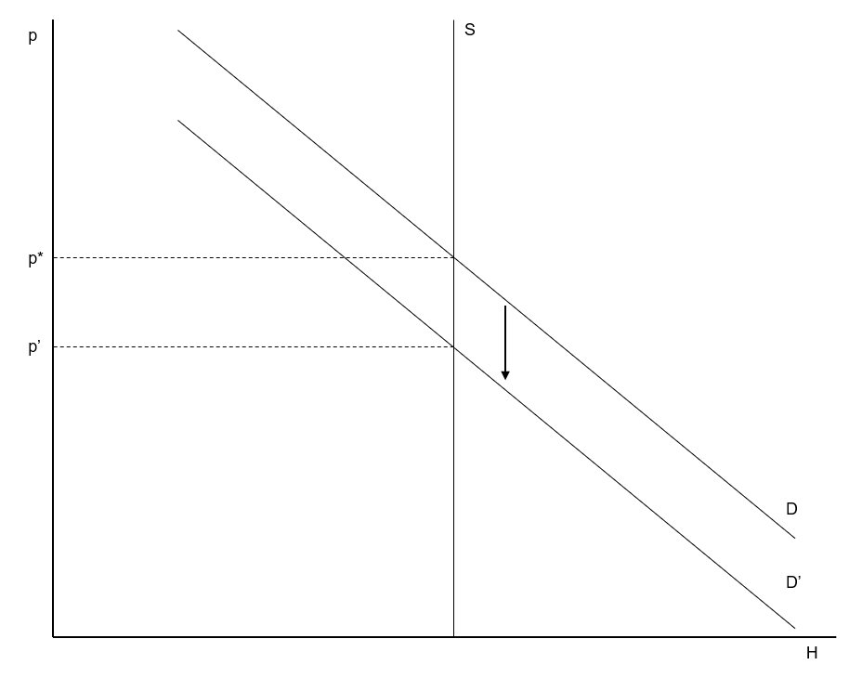
The model of the housing market is now used in order to determine what happens to the housing market when the home mortgage interest deduction decreases or is completely abolished. First of all, it follows from Equation (3) that a decrease in subsidy will increase the consumer housing prices. As a consequence, the demand for houses decreases, which leads to a downward shift of the demand curve from D to D’ as shown in Figure 1. The housing supply is inelastic, hence the quantity supplied does not change. This means that the equilibrium price has to adjust in order to clear the market. Producer housing prices will move from the old equilibrium (p*) to the new equilibrium price (p’). Producer housing prices will decrease and the quantity will remain the same, which means that the same number of houses will be sold, but for a lower producer price. Furthermore, the consumer housing price remains constant and unchanged in equilibrium. The inelasticity of supply and the positive elasticity of demand indicate that the supply side of the market receives all the benefits from the housing subsidy.This leads to the conclusion that in theory, the abolishment of home mortgage interest deduction will only decrease the producer prices for houses. At the same time, it will not affect homeownership, since it does not change the quantity of houses sold.

Source: Own illustration based on Jacobs, 2011, p. 8.
Figure 1 Housing market equilibrium before and after abolishment subsidy

3 Literature Review and Hypothesis Development

In the Netherlands, homeowners used to be able to deduct all their interest on home mortgage from their income. From 2017 onwards, the government decided to gradually reduce the mortgage interest deduction on income for individuals in the highest income bracket. Hence, only the high-income homeowners will be affected by this policy change. The initial policy was to reduce the deduction with 0.5 percent points per year. However, the government changed this policy in the meantime. From 2019 onwards, the government will accelerate the reduction of the mortgage interest deduction with three percent points per year until the target rate of 37.05 percent is reached in 2023 (Rijksoverheid, 2018).

The CPB report on the economic-political consequences of home mortgage interest deduction states that the Dutch housing market does not function well (Lejour, 2016, p. 14). The deduction has driven up the housing prices substantially, which made it difficult for young individuals just entering the housing market to find a house they could afford. The main goal of the policy reform is to create a housing market that is more stable and provides more opportunities for these people. In addition, the deduction of mortgage interest from taxable income decreases the potential tax revenue for the government. Hence, another argument in favour of the policy reform is to generate additional tax revenue. Finally, the report shows that the Dutch private debts are among the highest of all European countries (Lejour, 2016, p. 8). The explanations are the home mortgage interest deduction in combination with interest-only mortgages, where individuals only have to pay the monthly interest rate without paying off part of the debt (Lejour, 2016, p. 14). This results in substantial indebtedness of households, because the mortgage interest deduction generates tax benefit and households are not obligated to pay off their debt over a certain period of time. The policy reform increases the cost of borrowing money, which could result in households taking smaller mortgages. Hence, the reduction in home mortgage deduction can decrease this substantial indebtedness of households (Lejour, 2016, p. 17).

Furthermore, the Netherlands employs a progressive tax system, such that prior to the policy reform, the higher income groups benefited most from the home mortgage interest deduction. The reduction of the deductible amount for the higher income groups could bring disposable incomes closer together and thus reduce income inequality. Even though this is not the main goal of this policy reform, it could be a desired additional consequence.

The effect that the reduction in home mortgage interest deduction might have on the Dutch housing market consists of two components. It could affect the overall housing prices and it could affect the number of houses sold, hence, the homeownership rate. The effect in the Netherlands can be predicted by looking at the effect that similar policy reforms had in other European countries. Some countries like Germany and the United Kingdom completely abolished the home mortgage deduction, while other countries like Denmark only reduced it for some income groups without completely abolishing it. The Dutch reform is similar to the Danish one, since the deductible amount decreases for the highest income group only.

In some countries that completely abolished mortgage interest deduction, there is no clear effect of revisions in tax legislation on housing prices when comparing before and after the revision. In France, the tax deduction for mortgage interest payment was repealed in 1998, which increased the tax bill for many individuals. However, this increase in taxes did not affect the housing prices negatively. In fact, the housing prices increased in the four years following the tax deduction abolishment. The government of the United Kingdom decided to phase out mortgage tax relief gradually and completely abolish it in 1991. Again, there is no observable effect of the abolition on the housing prices (Boelhouwer, Haffner, Neuteboom & De Vries, 2004, pp. 422-424). However, the researchers acknowledge that a before-and-after comparison is only a partial analysis of the housing market. Since other factors affecting housing prices like household income might have changed over time, changes in tax deductibility can still have an effect on housing prices.

Voigtländer (2009) tries to explain the relatively low homeownership rate in Germany when compared to other European countries. It turns out that four factors are of substantial importance. First of all, Germany has an extensive social housing sector which takes up a large share of the total housing market. Secondly, in Germany there is less strict regulation of the rental housing market when compared to other countries. As a result, many households prefer renting a house over buying one. Furthermore, German housing prices are relatively low and stable, which makes housing investment not very profitable. Finally, the most relevant factor here is the tax treatment of homeownership. In the research, a comparison of the tax wedge for homeowners and the homeownership rate between Germany and the Netherlands is provided. In order to determine the tax wedge, the mortgage rate is compared to the effective after-tax interest rate. The results show how Dutch homeowners benefit more strongly from the tax regulation than German homeowners, where the tax wedge is very small. On top of that, the tax wedge in Germany is declining even further since the allowances were cut in 2004 and completely terminated in 2006. Since homeownership is lower in Germany than in the Netherlands, the relatively small tax benefit for homeowners could provide an explanation for this (Voigtländer, 2009, pp. 360-370).

The Dutch policy reform will decline the tax wedge between the mortgage rate and the real effective mortgage rate for the higher income brackets. This may result in a lower homeownership rate, because these income groups would not benefit as much from homeownership as before. However, it is important to keep in mind that the Dutch and German housing markets have different characteristics. Furthermore, it is a combination of factors that explains the relative low homeownership rate in Germany. Hence, the reduction of the mortgage interest deduction in the Netherlands does not necessarily have to lead to a lower homeownership rate.

As mentioned before, a policy reform similar to the Dutch one was implemented in 1987 in Denmark (Gruber, Jensen & Kleven, 2018). Denmark has three income brackets. The Danish tax reform substantially reduced the subsidies for home mortgage interest for the top bracket, while only partially reducing it for the middle bracket and even raising it for the individuals in the bottom bracket. This created the basis for quasi-experimental variation. The demand effect and house price effects of the mortgage interest deduction were estimated.

Gruber et al. (2018) analysed the effect of this tax reform on housing demand and housing prices using this quasi-experimental variation and a difference-in-differences estimation. They estimated the effect on the general equilibrium house price by comparing the development of housing prices in Denmark with a synthetic control group. The researchers distinguish between the intensive margin and the extensive margin of housing demand. The extensive margin is the trade-off between renting and buying a house and is measured by the homeownership rate, whereas the intensive margin focusses on home size and home value.

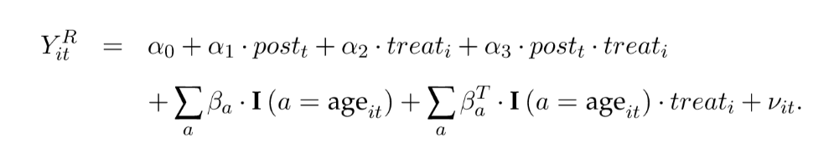
First, the extensive margin of housing demand is researched. The effect of the deduction in tax subsidy on the homeownership rate for the top bracket is estimated using the below-top and bottom brackets as control groups. The following regression equation is used:
((7)
The outcome variable Y_{it}^{R} is the homeownership rate for group i at time t. The interaction term of number of years after treatment with treatment is the main variable of interest. Age dummies are included as control variables. The effect is estimated for the period 1980-1996, where the main interest is the average 10-year effect of the reform in the years following the implementation, hence the period 1987-1996. The effect of the reform on homeownership is averaged over this 10-year period and presented in Table 1 of Appendix A, labelled ‘effect of reform’. The price elasticity of housing demand is calculated and also presented in this table. Columns (1)-(3) present different specifications of the age fixed effects and column (3) shows the specification that follows from Equation (7). Panel A shows the results with the below-top bracket as control group and Panel B with the bottom group as control group. The coefficients presented in column (3) are computed using the preferred specification that includes control variables for age fixed effects. Using the below-top bracket as control group, the coefficient has a value of 0.006 percentage points with a standard deviation of 0.001. This implies that the reduction in home mortgage deduction for the highest income group increases their homeownership rate with 0.006 percentage points. If the bottom bracket is used as a control group, then the effect is -0.002 percentage points with a standard deviation of 0.001. The standard deviations for these coefficients are small because of the large sample size that is used (Gruber et al., 2018, pp. 14-16).

For both control groups, the results only show a very small effect of the substantial reduction of the mortgage interest deduction on the average homeownership rate. The trends in housing demand for all income groups stay parallel before and after the implementation of the reform. The tax variation caused by the policy reform is substantial while the effects on homeownership rate are small, which translates into low elasticities. These results lead to the conclusion that the reduction of mortgage interest deduction did not have an economically relevant impact on homeownership. Hence, higher income groups do not make homeownership decisions based on housing subsidy (Gruber et al., 2018, p. 16).

This leads to Hypothesis 1: The reduction in home mortgage interest deduction will not affect the homeownership rate in the Netherlands.

Second, the researchers evaluate whether or not the policy reform affected the intensive margin of housing demand, where home size is the main determinant. Again, the difference-in-differences method is used with the highest income bracket as treatment group and the below-top and lowest income brackets as control groups. The specification of Equation (7) is used to estimate the effect of the policy reform on home size and home value, where home size is in logs. The effects are estimated using a sample of movers and the average effects are calculated over the 10 post-reform years.

Table 2 in Appendix A shows the effect of the policy reform on home size among movers and Table 3 in Appendix A shows the effect on home value. Similar to Table 1, different specifications of the regression equation are used in columns (1)-(3) and the estimates for both control groups are presented. Table 2 shows the estimates with the below-top bracket as control group in Panel A and the bottom-bracket as control group in Panel B. When comparing with the below-top bracket, the coefficient has a value of -0.063 log points with a standard deviation of 0.003 and when comparing with the bottom bracket, the coefficient has a value of -0.105 log points with a standard deviation of 0.003. The elasticity of home size has a value between 0.09 and 0.12 in absolute values, depending on the control groups. This means that the reduction in home mortgage deduction has a negative impact on the home size of households in the top bracket. This effect is visible right after the implementation of the policy reform and persists over time.

Table 3 shows the effect of the reduction in home mortgage deduction on home value. Panel A shows a coefficient of -0.119 with a standard deviation of 0.008 when the bottom-top bracket is used as control group. Panel B shows the estimates when the bottom bracket is used as control group, where the coefficient has a value of -0.215 with a significance level of 0.009. Hence, the home values of the higher income groups decrease after the policy implementation. The elasticities for both the coefficient specifications are moderate with a value between 0.18 and 0.25 because the tax variation created by the reform is large. The findings suggest that housing subsidies have an impact on real housing demand. Furthermore, the researchers show that the main mechanism by which households reduce home size and home value is by reducing their borrowing and thus the interest expenses (Gruber et al., 2018, pp. 17-21).

Additionally, the house price effects of the mortgage interest deduction are estimated using a synthetic control group. In order to construct this control group, the evolution of housing prices in Denmark and 16 other developed countries comparable to Denmark are compared in the period around the policy reform. Weights are constructed by matching price levels in each quarter prior to the reform, where the researchers focus on a narrow time window. The results show that the Danish house prices dropped by approximately 10 percent shortly after the implementation of the policy reform, which can be explained mostly by the intensive margin of housing demand. These findings suggest that the reduction in home mortgage interest deduction will not affect homeownership, but that it might lead to smaller houses and lower mortgage loans (Gruber et al., 2018, pp. 22-23).

These results lead to Hypothesis 2: The reduction in mortgage interest deduction will decrease the housing prices in the Netherlands.

4 Methodology

In order to estimate the effect that the Dutch policy reform has on the housing market, the effect on the housing prices and the effect on the homeownership rate have to be estimated. The effect on the housing prices can be estimated by using the difference-in-differences (DiD) design, where a country with similar economic characteristics and housing market circumstances is used as the counterfactual. Treatment is the implementation of the deduction in mortgage interest deduction. The treatment effect can be determined by taking the difference in housing prices before and after the treatment. First, the difference within each country is taken and then the difference in differences between these countries is taken. This will give the effect of the reduction in home mortgage interest deduction on the housing prices in the Netherlands.

The policy reform will only affect the highest income bracket. The Netherlands has four income brackets, which means that the three income brackets below the highest income bracket are untreated. These groups can be used as the counterfactual. Again, the effect on the homeownership rate can be estimated with the difference-in-differences design. The difference in homeownership rate before and after the implementation of the policy reform is taken within the treatment and control group. The difference in differences between the groups is the estimation of the treatment effect.

Since the Dutch government just started to implement the policy reform in 2017 and the new policy will only be fully implemented in 2023, it is not possible to empirically estimate the effects on housing prices and homeownership rate yet. The data on the housing prices, changes in deductible amounts for households and the homeownership rate that are needed, will only be available in a couple of years. Only then the effect of the policy change can be estimated using the methods described above.

Instead, the effects that the policy change will have in the Netherlands can be predicted by looking into the effects that a similar policy reform had in another country with comparable economic characteristics and housing market conditions. The effects that the Danish policy reform had on the housing market could be an accurate prediction for the future effects of the Dutch reform. Gruber et al. (2018) analyse the effects of the Danish policy reform on housing prices and housing demand, as described in Section 3.

However, it is important to keep in mind that there is a difference in the policy reform between the countries. In the Netherlands, the lower and middle income classes are not affected by the policy reform. In contrast, these groups were affected by the policy reform in Denmark to some extent. This means that the Netherlands has an even cleaner control group when estimating the true effects of the policy reform. At the same time, the Danish policy reform mainly affected the higher income group and only had a small effect on the other income groups, which means that it is likely that the effects of the policy reform are more or less the same for both countries. Hence, the results for Denmark can be used to make a prediction for the Netherlands, given that the countries have similar housing market characteristics. The economic characteristics and housing market situations in the Netherlands and Denmark will be described and compared in Section 6.

The effect of the policy reform on the homeownership rate in the Netherlands will be predicted based on three different sources. First of all, general housing market theory as described in Section 2 will form the basis of the prediction. Secondly, the current Dutch housing market situation will be analysed using descriptive statistics based on the DNB Household Survey. Finally, the effect that the Danish policy reform had on the homeownership rate as found in Gruber et al. (2018) will be used for the prediction.

The prediction of the effect of the policy reform on housing prices will be based on the results found for Denmark by Gruber et al. (2018). In combination with data on Dutch nominal residential property prices, their findings can be used to make a prediction of the Dutch housing prices after the policy reform. First, the housing price index for the fourth quarter of 2018 until the last quarter of 2022 has to be estimated, which is the period prior to the complete implementation of the policy change for which actual data is not yet available. This estimation will be done using a linear trend prediction based on the housing price index from the first quarter of 2013 until the third quarter of 2018, which is the most recent data available after the economy recovered from the financial crisis. In order to estimate the linear trend, the method of ordinary least squares will be used. The linear trend prediction is of the following form:

$y=ax+b$ (7)

Then, the estimated coefficient of the change in housing prices found in Denmark after the policy reform will be used to calculate the predicted nominal residential property prices after the reform in the Netherlands. This coefficient will be multiplied by the predicted housing price index for the fourth quarter 2022 to get the prediction the housing prices in the first quarter of 2023. The descriptive statistics on the Dutch and Danish housing prices that are necessary to make this prediction will be presented in Section 6.

5 Data

The data that are needed to statistically estimate the effect of the policy reform are not available yet, because the reform will only be fully implemented in 2023. Therefore, the effect that the policy reform will have on the housing market cannot be estimated. However, it is possible to provide some descriptive statistics in order to evaluate the current housing market situation in the Netherlands. This will be compared to the housing market in Denmark. Furthermore, the Netherlands and Denmark will be compared in terms of economic circumstances, population and housing market policy. If it turns out that these countries are similar in many aspects, a prediction of the effect of the Dutch policy reform can be done based on the effect that a similar policy reform had in Denmark. Data from six different data sources will be used for this research, which will be discussed next.

Data on the average housing prices in the Netherlands can be retrieved from Statistics Netherlands. This database provides data on the average sales prices of owner-occupied dwellings per year for all provinces and for the Netherlands as a whole for the period 1995-2018. Statistics Netherlands uses different sources in order to collect their data, including information from the tax authority, personal interviews, surveys and phone interviews. Data is collected at the household level and then the average sales prices are calculated per province per year. The average prices are calculated by dividing the sum of transaction prices by the number of housing transactions for the same period. The information available on housing transactions and housing prices for all provinces are used in order to calculate this, which makes it likely that this data is representative for the entire Dutch housing market.

Furthermore, data on the population number for the Netherlands in the period 2013-2018 is retrieved from Statistics Netherlands. The population number only consist of individuals that are included in the civil register of a Dutch municipality. Individuals that live in the Netherlands indefinitely are included in this register.

In order to compare the populations of the Netherlands and Denmark, data on the Danish population is retrieved from the United Nations World Population Prospects 2017. The Population Division of the United Nations focusses on population and development and they provide demographic estimates and projections for all countries. For this research, data on the Danish population is retrieved for the period 1982-1990, where population is defined as the number of individuals of both sexes in the country as of 1 July of the year indicated. The numbers are estimated to be consistent with official population estimates.

Additionally, data from the Bank for International Settlements (BIS) Statistics is used in this research. This database provides information on quarterly nominal residential property prices for different countries, including the Netherlands and Denmark. Data is available from the second quarter of 1970 until the third quarter of 2018. These time series data have been constructed using data provided by different sources like central banks and national statistical offices. Statistics Netherlands and Nederlandse Vereniging van Makelaars are the sources used to determine the nominal house price index for the Netherlands. For Denmark, Statistics Denmark is used. Trends in the nominal residential property price index for both countries are needed in order to determine whether or not it is likely that the reduction in mortgage interest deduction will have a similar effect in the Netherlands as it had in Denmark. If the trends in housing prices prior to the policy reform are comparable, it is likely that the policy reform will affect the Dutch housing market similarly.

For a comparison of economic circumstances between the Netherlands and Denmark, data on gross domestic product (GDP) is retrieved from Organisation for Economic Co-operation and Development (OECD) Statistics. This database includes data for OECD countries and other selected non-member countries and collects data using different sources, depending on the country and the subject. GDP is measured as annual growth rates in percentages relative to the previous year. For Denmark, data are selected for the period 1982-1990 where the data are compiled by Statistics Denmark. Data on GDP for the period 2013-2018 is selected for the Netherlands and these data are compiled by Statistics Netherlands.

Additionally, data on GDP per capita is retrieved from the World Inequality Database (WID). This data source collects information on wealth and income for several countries over a long period of time in order to gain insight in the historical evolution of wealth inequality, both within countries and between countries. Data is collected using national accounts, survey data, fiscal data and wealth rankings. GDP per capita is measured in terms of US dollars where there is controlled for purchasing power parity and the entire population is used to compute per capita. For the Netherlands, data on GDP per capita is selected for the period 2013-2017, because data for 2018 is not available yet. Between 2013 and 2015, WID compiled the data using the United Nations System of National Accounts (UN SNA) main tables. In the years 2016 and 2017, the GDP growth rates from the International Monetary Fund (IMF) World Economic Outlook are used to compile the data. GDP per capita in the period 1982-1990 is selected for Denmark. These data are based on the GDP growth rates from the UN SNA main tables.

Finally, the DNB Household Survey (DHS) from CentERdata is used in order to obtain data at the individual level for the Netherlands. This panel study collects data among 2000 households and has panel data available for the period 1993-2018. Data is collected using CentERpanel, which is the internet panel of CentERdata. Households are selected to complete the survey by randomly drawing addresses from a pool of national postal addresses. The composition of the panel is controlled for in terms of characteristics in order to make sure that the sample is an accurate reflection of the Dutch population. This method is used in order to avoid self-selection into filling out the survey and to form a representative cross-section of the population. Hence, it is likely that de data retrieved from this survey is representative for the Netherlands. There are different subjects covered in the questionnaire and panel data is available at the individual and at the household level. Household data on income, possession, debts and mortgages and individual data on living conditions and mortgages will be used in this research. Observations are dropped from the data set if respondents answered that they did not know if they had a mortgage or if they did not know their mortgage interest rate. They are dropped because these are the variables of interest and these observations could create bias in the calculations that follow.

6 Descriptive Statistics and a comparison of the Netherlands and Denmark

6.1 Housing prices development Netherlands
Figure 1 in Appendix B shows the average housing sales prices per province and for the Netherlands as a whole for the period 2007 until 2018 using data from Statistics Netherlands. It is useful to describe the housing prices development per region, because it is possible that the policy reform affects the housing prices differently per region, if substantial deviations in housing prices per province are observed. Utrecht and Noord-Holland are the provinces with the highest housing prices throughout this period, whereas Groningen and Friesland have the lowest housing prices. The provinces show a similar trend in housing prices over time. What stands out from this figure is that the housing prices drop between 2008 and 2009, which can be explained by the substantial effect that the financial crisis had on the Dutch housing market. After the decrease in housing prices in 2009, the prices remain considerable stable until 2013. From 2013 onwards, housing prices increase and grow steadily in all provinces with the fastest growth in Noord-Holland. All provinces reach average housing prices equal to or even higher than the prices of 2007 between 2015 and 2017, depending on the province. By 2018, the housing prices are higher than the housing prices of 2007, which is prior to the financial crisis. Hence, the housing market seems to be recovered from the financial crisis.

It follows from Figure 1 in Appendix B that the financial crisis had disrupting effects on the housing prices. For the purposes of this research, it is important to determine the market situation prior to the implementation of the policy reform without any other time-varying factors affecting the housing market, because these factors could result in biased predictions of the effect of the policy reform. Ideally, the trends in housing prices prior to 2018 would be examined for a period as long as possible. However, it is important to keep in mind that the financial crisis had a substantial impact on the Dutch housing market, since the house prices of existing dwellings dropped with -7.1 percent between 2008 and mid-2009 (van der Heijden, Dol, & Oxley, 2011).Therefore, when determining the overall housing market situation prior to the policy reform, the main focus will be on the market situation after 2013. Figure 2 in Appendix B shows the average housing prices per province and the Netherlands as a whole from 2013 until 2018. This figure shows a more stable housing market situation, where prices are increasing steadily for all provinces. The housing prices show the same trend over time for all provinces, which implies that the same market mechanisms affecting the housing prices are present throughout the country.

6.2 Nominal house price index comparison between the Netherlands and Denmark
Furthermore, a comparison of the overall housing prices development between the Netherlands and Denmark needs to be made in order to determine whether or not it is likely that the policy reform will affect the Dutch housing market in a similar way as it did in Denmark. Figures 3, 4 and 5 of Appendix B show the nominal house price index for the Netherlands and Denmark with 1995 as the base year, using data from BIS Statistics. It is important to keep in mind that prices are index numbers, which means that the countries can only be compared in terms of overall price development over time and not in absolute terms. First, a broad time spectrum from 1980 until 2018 is chosen to evaluate the overall housing price development generally. Then, a smaller time period is described in order to evaluate the effect of the policy reform in Denmark. Finally, the housing price development in the Netherlands and Denmark prior to the policy reform is described.

Figure 3 of Appendix B shows the nominal house price index for the Netherlands and Denmark from the first quarter of 1980 until the final quarter of 2018. In the Netherlands, the housing prices decreased between 1980-1986 and then increased slightly between 1986-1991. In 1991, the prices reached the same level again as they had in 1980 and from 1991 onwards the prices increase substantially until 2008, which is the peak period. Between 2008 and 2013 a sharp drop in housing prices is visible, which is the period in which the financial crisis hit the housing market in the Netherlands. From 2013 onwards, the housing prices start to increase again and by 2018 the prices are higher than they were in the peak period of 2008, before the financial crisis hit. Hence, these patterns in housing prices are similar to the ones observed in Figures 1 and 2 of Appendix B. In Denmark, housing prices increase between 1982-1986 in contrast to the decreasing housing prices in the Netherlands in this period. In 1987 the policy reform was implemented in Denmark, which lead to a decrease in housing prices between 1987-1992, whereas the housing prices in the Netherlands increased in these years. From 1992-1998 the prices in Denmark and the Netherlands increased with more or less the same trend, when from 1998 onwards the prices start to increase faster in the Netherlands, creating a growth gap. A substantial growth in housing prices is visible between 2003 and 2007 in Denmark, until the financial crisis hits the Danish housing market at the same time as the Dutch housing market in 2008 and prices start to drop substantially. In Denmark, the prices fluctuate between 2009-2011 and from 2012 onwards the prices show an increasing trend. A difference between the Dutch and the Danish housing market is that the housing prices in Denmark seem a bit more volatile during the increase after the financial crisis than in the Netherlands.

In order to have a closer look at the effect of the 1987 policy reform in Denmark, Figure 4 of Appendix B shows the nominal house price index for the Netherlands and Denmark over the period 1980-1997. The Netherlands shows a more or less stable housing prices growth trend in this period, with some small fluctuations over time. In contrast, there is a sharp increase in housing prices in Denmark between 1983-1987 until the policy reform is implemented in 1987. After the implementation, the prices in Denmark show a downward trend with some small upward fluctuations over time. From 1993 onwards, the Danish housing prices show a positive trend and from 1994 onwards the Dutch and Danish housing prices follow the same growth path.

Figure 5 of Appendix B shows the nominal housing price index for the Netherlands in the period 2013-2018 and Denmark in the period 1982-1990. These time series are plotted against each other in order to make a comparison of the housing market situation between the countries prior to the policy reform. The upper part of the figure shows the housing price trend for the Netherlands, where the period 2013-2018 is the most recent data available prior to the policy reform and after the housing market recovered from the financial crisis. The figure shows an upward trend in the Dutch housing prices in this period. The prices are increasing with a relatively stable positive trend. The lower part of the figure shows the housing price trend for Denmark in the period 1982-1990, which is around the implementation of the policy reform. In the years 1982-1987, before the introduction of the policy reform, the housing prices are increasing. It shows a positive trend that is similar to the housing price development in the Netherlands. In 1987, the Danish housing prices drop at the same time the policy reform is implemented. After this decrease, the prices seem stable with a small downward trend around 1989. Based on this figure, it can be stated that the housing price development prior to the policy reform in the Netherlands is very similar to the situation in Denmark.

6.3 Income taxation and policy reform in the Netherlands and Denmark
Furthermore, it is important to have a closer look at income taxation and the policy reforms regarding mortgage interest deduction in both the Netherlands and Denmark. In the Netherlands, labour income is taxed progressively through four income brackets. The lowest income bracket has a marginal tax rate of 36.65 percent, the second and third income brackets have a marginal tax rate of 38.10 percent and the highest income bracket has a marginal tax rate of 51.75 percent. Prior to the policy reform, homeowners were able to deduct all their interest on home mortgage from their income, where taxable income is labour income minus deductibles (Rijksoverheid, 2019). The government decided to gradually reduce mortgage interest deduction for individuals in the highest income bracket from 2017 onwards. The deduction was reduced with 0.5 percentage points per year initially, but from 2019 onwards the reduction will be accelerated with three percentage points per year until the target rate of 37.05 percent is reached. Then, it is not possible anymore to deduct the total amount of home mortgage interest from the highest income bracket (Rijksoverheid, 2018). The housing subsidy decreases with 14.7 percentage points for individuals in the highest income bracket, whereas individuals in the lower three income brackets remain unaffected.

In Denmark, income taxation is subject to three income brackets with progressive tax percentages. Individuals in the top income bracket pay a marginal tax rate of 73 percent, individuals in the middle bracket pay 62 percent and individuals in the bottom bracket have a marginal tax rate of 48 percent (OECD, 2018). The policy reform of 1987 mainly affected the top income group, since it substantially reduced the subsidy on mortgages for the top group. The subsidies for the middle income bracket were also reduced, but by much less. The homeowners in the bottom bracket received slightly more subsidy on mortgages. Hence, both Denmark and the Netherlands employ a progressive tax system on labour income and decided to reduce the subsidy on homeownership for the highest income bracket (Gruber et al., 2018, p. 1). This means that both countries have similar taxation policies. However, it is important to keep in mind that the Danish policy reform also affects the middle and bottom income groups, whereas these groups remain unaffected in the Dutch case. Also, the overall tax rates are higher in Denmark than in the Netherlands.

6.4 Economic circumstances and demography in the Netherlands and Denmark
To evaluate whether the Netherlands and Denmark are similar in terms of overall economic circumstances, data on GDP growth per year are compared. Figure 6 in Appendix B shows the percentage growth of GDP for Denmark in the years 1982-1990. In this period, the GDP growth lies between -0.01% and 4.9% per year. In the years 1983-1986 this growth increases, hence in this period GDP grows more each year than it did in the previous year. In 1986, the year prior to the policy reform, GDP grows with 4.9%. When the policy reform is implemented in 1987, GDP grows only with 0.25%. There is a negative GDP growth of -0.01% in 1988 after the policy reform is implemented.

The Dutch GDP growth in percentages for the period 2013-2018 is presented in Figure 7 of Appendix B. Overall, the GDP growth lies between -0.1% and 2.9% per year. In the years 2013-2017 GDP grows increasingly, which means that the economy is expanding. In 2018 there is a small decrease in the percentage growth of GDP. The growth percentage is still positive, hence the economy is still growing. A similarity between Denmark and the Netherlands is that there is a decrease in GDP growth in the years around the implementation of the policy reform. Furthermore, both countries show mostly positive GDP growth around the same percentage range in the years prior to the policy reform.

Additionally, the Netherlands and Denmark can be compared in terms of GDP per capita per year. Figure 8 of Appendix B shows GDP per capita for Denmark in the period 1982-1990 where the minimum value is $28,824 in 1982 and the maximum value is $35,301 in 1990. Between 1982 and 1986, GDP per capita increases steadily every year. In the period 1986-1988, which are the years around the policy reform, GDP per capita decreases slightly and then increases again between 1988-1990.

Figure 9 of Appendix B shows GDP per capita for the Netherlands in the period 2013-2017. The minimum value of GDP per capita is $49,900 in 2013 and the maximum value is $53,576 in 2017. Overall, GDP per capita grows increasingly every year, which corresponds to the values for GDP growth in percentages as shown in Figure B-7. All in all, both countries show a relatively stable growth of GDP per capita.

In order to compare Denmark and the Netherlands with respect to demographic conditions, the population size in thousands for both countries are presented in Figures 10 and 11 of Appendix B, based on data from United Nations World Population Prospects 2017. Figure 10 shows that the population size in Denmark lies somewhere between 5,114,657 and 5,141,115 individuals. Denmark had a small decrease in population size between 1982-1986, but in the years 1986-1990 there is consistent population growth. Hence, there is stable population growth before and after the policy reform.

The population size in the Netherlands for the period 2013-2018 is presented in Figure 11 of Appendix B. There is a stable and consistent population growth during this period, with a minimum of 16,779,575 individuals in 2013 and a maximum of 17,181,084 individuals in 2018. Similar to Denmark, population size shows a stable increasing trend in the years around the implementation of the policy reform.

6.5 Current housing market circumstances in the Netherlands
Furthermore, data from the DNB household survey 2018 is used to describe the current situation on the housing market and to gain a better understanding of the importance of mortgages in the Netherlands. Table 1 in Appendix B shows the homeownership rate, the home value, the number of mortgages an individual has, total mortgage value and the annual interest on mortgage. Here, the mortgage value and the mortgage interest rate are aggregated over all mortgages per individual, where the individuals have a maximum amount of five mortgages. Overall, 66.2% of the respondents is homeowner with an average home value of €184,135. The average number of mortgages is 0.664, which means that most individuals have 1 mortgage loan on their house. Mortgage value has an average of €72,015.95 and a maximum value of €1,400,000 which means that this variable has a broad range of values. The average interest on mortgage per year is €1,564.66 with a standard deviation of €3,543.88, hence this variable can also take a broad range of values.

Gruber et al. (2018) provide descriptive statistics on the aggregate homeowner rate in Denmark between 1980-2011. Around 58% of the population is homeowner in the period just before the 1987 policy reform and this percentage remains remarkably constant over time (Gruber et al., 2018, p. 8). The Danish homeownership rate is relatively close to the Dutch homeownership rate of 66.2%.

Table 2 in Appendix B shows specific information on the housing situation and mortgages at the household level for 2018. The first row of the table presents information on whether or not households took a mortgage at the time they purchased their house. Respondents answered 1 if they took a mortgage and 2 otherwise. The mean is 1.088, which means that 8.8% of the respondents did not take a mortgage and 91.2% did take a mortgage at the time of purchase. Of the respondents that took a mortgage, the average mortgage loan amount is €236,910 and the maximum amount is €9,000,000, which means that mortgages are taken among a broad range. Here the number of observations is lower, because not all respondents have a mortgage loan. Mortgage on home currently presents the share of individuals that still has a mortgage on their homes, with individuals answering 1 if they still have mortgages and 2 otherwise. The mean is 1.266, which means that 26.6% of the respondents does not have a mortgage on their homes currently whereas 73.4% does. The fourth row of the table provides information on the share of households that would have bought a more expensive home if they could have gotten a higher mortgage. Respondents answered 1 if they preferred a more expensive home and 2 otherwise. Only 9.1% answered yes to this question. The final row shows the average home mortgage interest rate for the first mortgage that households took. Homeowners could take up to five mortgages, but the first mortgage is considered here because most households have one mortgage. The average mortgage interest rate is 3.4% with a maximum of 7.8%.

7 Predictions and Discussion

In this chapter, predictions for the situation on the Dutch housing market after the policy reform will be done followed by the discussion. The hypotheses formulated to answer the research question will be repeated shortly, followed by the prediction. Since the data needed to test the hypotheses are not available yet, it is only possible to make predictions and not to accept or reject hypotheses. The predictions are based on economic theory, the results found for Denmark by Gruber et al. (2018) and descriptive statistics for the Netherlands. Finally, the discussion provides a short overview and interpretation of the results, the contribution of this paper to the existing literature and limitations to this research.

7.1 The effect on homeownership
Firstly, a prediction is presented for Hypothesis 1, stating that the policy reform regarding mortgage interest deduction will not affect the homeownership rate in the Netherlands. It is only possible to make a prediction on the effect of the policy reform, because the data are not available yet. This prediction is based on housing market theory, information on the current housing market situation in the Netherlands and the results found for Denmark by Gruber et al. (2018).

As mentioned in Section 2, basic economic theory states that the demand for housing is downward sloping, while supply is fixed at the total amount of houses available. It is likely that the demand for housing will decrease after the housing subsidy is reduced, leading to a lower producer price on the housing market. At the same time, the policy reform will not affect the total quantity of housing sold since this is fixed in the long run.

If the data were available, this hypothesis could have been tested empirically. Ideally, the effect on the homeownership rate would be estimated using the difference-in-differences method with the highest income bracket as treatment group and the other three income brackets as control groups. Data on the homeownership rate for all four income brackets would be necessary for a sufficient number years prior to the policy reform and after the policy reform in order to make an accurate estimation. The policy reform is gradually implemented from 2017 until 2023, hence data from 2013-2028 would probably be sufficient to estimate the effect. The regression equation used by Gruber et al. (2018) to estimate the effect on homeownership in Denmark could be used to estimate the effect in the Netherlands. This is Equation (7) as presented in Section 3 and repeated here for convenience:

In this equation, coefficient α₃ estimates the treatment effect, hence the effect of the subsidy reduction on the homeownership rate. The results found for Denmark by Gruber et al. (2018) can be used to predict the effect for the Netherlands.

In Denmark, the effect on the homeownership rate lies between 0.006 percentage points and -0.002 percentage points, depending on which control group is used. Hence, these results are inconclusive because the policy reform could have a relatively small positive or negative effect on the housing demand of the highest income bracket. Furthermore, housing demand trends between the treatment and control group remain parallel before and after the policy change. Additionally, the price elasticity of housing demand is considerably low in Denmark. As a result, higher income groups did not change their homeownership decisions after the housing subsidy reform, such that the policy reform had no economically relevant impact on the homeownership rate in Denmark.

The results found for Denmark are inconclusive and economically irrelevant, since the housing subsidy was cut substantially while there was no real change in the homeownership rate. It is likely that the price elasticity of demand is low in the Netherlands as well, such that there will be no effect of the policy reform on the housing demand for the highest income bracket. Hence, it should not be expected that there is an effect of the policy reform on housing demand in the Netherlands.

Based on the Danish example, the prediction for the Netherlands is that the reduction in mortgage interest deduction will not have a statistically significant effect on the homeownership rate of households in the highest income bracket. As presented in Table 1 of Appendix B, the homeownership rate is 66.2 percent in 2018 and it can be expected that this rate will not be significantly affected by the policy reform.

7.2 The effect on housing prices
Hypothesis 2 states that the reduction in home mortgage deduction will decrease the housing prices in the Netherlands. Ideally, the effect of the policy reform on the housing price index would be estimated using the difference-in-differences method with the Netherlands as treatment group and a country with similar economic, demographic and housing market characteristics as control group, for example Belgium, Germany, the United Kingdom, Norway or the United States. Also, it could be possible to compile a synthetic control group using these countries. Times series data on the house price index for these countries would be needed for a sufficient period of time before and after the full implementation of the policy reform in the Netherlands in order to make an accurate estimation. The period 2013-2028 would probably suffice, where it is important to test for the parallel trends assumption between treatment and control group in the years prior to the policy reform. Then, the difference in price index before and after the implementation of the policy reform would need to be taken within and between the treatment and control group in order to estimate the effect of the reform on the housing prices and test the hypothesis.

However, the effect cannot be estimated using this method because the data on housing prices are not available yet. Therefore, a prediction is made based on descriptive statistics of the nominal housing price index for the Netherlands and the results found for Denmark by Gruber et al. (2018). Here it is assumed that the effect of the reform on the housing prices will take place by the time the policy reform is fully implemented in 2023. Therefore, the development of the housing price index for the period 2019-2022 is predicted using the linear trend prediction based on the nominal house price index for the period 2013-2018. Then the effect of the reduction in home mortgage interest deduction on the house price index is predicted using the results found for Denmark and the descriptive statistics for the Netherlands.

The predictions for this hypothesis are presented in Tables 1 and 2 and Figures 1 and 2 of Appendix C. Table 1 shows the predicted values of the housing price index for the first quarter of 2013 until the last quarter of 2022, based on the linear trend prediction. The coefficients of the linear trend function are presented in Table 2. The constant is 210.17 and the slope of the linear trend is 3.103. This means that each quarter, the predicted value of the house price index increases with 3.103 percentage points. The R² of the linear trend prediction is relatively high with a value of 0.891, which means that it is likely that the house price index will follow a linear trend over time. The actual housing price index for the period 2013-2018 and the linear trend prediction are presented in Figure 1.

Figure 2 shows the actual house price index for the period 2013-2018 and the predicted house price index from 2013 until the first quarter of 2023. Hence, this includes the prediction for the period after the implementation of the policy reform. This predicted index number is based on the 10 percent decrease in house price index as found by Gruber et al. (2018) and the predicted house price index for the final quarter of 2022, which is 334.292. This results in a house price index of 300.863 in the first quarter of 2023, as presented in Table 1.

The results found for Denmark by Gruber et al. (2018) show that the policy reform had a significant negative effect on the nominal house price index, which decreased with 10 percent. A significant effect in Denmark implies that it can be expected that a similar policy reform will also have a significant effect on the housing prices in the Netherlands. Hence, based on the results for Denmark, one should expect that the policy reform will result in a substantial decrease in the housing prices in the Netherlands.

7.3 Discussion
The results show that it is likely that the housing prices will decrease substantially, while the homeownership rate will remain constant after the policy reform in the Netherlands. Hence, the price the supply side of the market receives will decrease, while the quantity of houses sold will not change. This implies that the home interest mortgage deduction does not benefit the demand side of the market, because the housing subsidy leads to an increase in the housing prices such that the supply side of the market effectively receives this subsidy. Hence, from the point of view of policy makers it is better to abolish this subsidy because it does not meet the desired goal of making homeownership more affordable. At the same time, the decrease in overall house prices after the subsidy reduction could make it more accessible for individuals in the lower income bracket to buy a house, which could be considered as a positive effect.

The findings of this research contribute to the existing literature because generally, the effect of a policy change is researched only after it is fully implemented. This is done for many other countries where a similar policy reform in implemented, such as England, France and Denmark. However, it can be useful to predict what the potential effects might be for the different parties involved. The method used in this paper could be used to predict the potential effects of other policy reforms.

The findings for this paper are only justified in case the development of the house price index up until the complete implementation of the policy reform in 2023 follows approximately the same linear trend as in the years 2013-2018. However, it could be the case that shocks or unexpected developments occur in the housing market that affect the housing prices. Additionally, the policy reform is implemented gradually over the period 2017-2023. In this paper it is assumed that the reform only affects the housing prices in 2023. However, it could also be the case that the reform affects the housing prices gradually over the years 2017-2023.

Furthermore, this paper only takes on a partial analysis. This means that only the development within the housing market is considered, without looking into the development of other markets that might affect the housing market indirectly. For example, shocks in the construction or labour market could affect the housing prices substantially. It is hard to predict the developments of these interrelated markets and come to a general analysis of the economy, which is a limitation of this research.

Another possible limitation is the fact that Denmark is used as a precedent to come to a prediction. The comparison of Denmark and the Netherlands in terms of economic development, population and housing policy reform shows that these countries are similar in these respects. This makes it plausible that the effect of the policy reform will also be similar, but it is important to keep in mind that the countries can still differ in some respects. A possible difference between the countries might be consumer trust. Denmark reformed the policy regarding home mortgage deductibility in the late 1980s, which is still prior to the financial crisis, whereas the Netherlands is only reforming this policy from 2017 onwards. The financial crisis could have negatively affected people’s perceptions on the housing market, which could make that consumers respond differently to this reform. For example, people could decide to buy less housing as a consequence, which could result in a further decrease in housing prices.

Additionally, the policy reform in Denmark was implemented at once while in the Netherlands home mortgage interest deduction is reduced gradually over a number of years. Furthermore, the policy reform in Denmark had a certain effect on all income brackets whereas in the Netherlands only the highest income bracket is affected by the reform. As a consequence, there might be a difference in the effect of the reform between the countries.

Furthermore, as mentioned in Section 3, some economists still believe the supply side of the market is not fixed in the long run. If the supply side is responsive to a price change caused by a reduction in mortgage interest deduction, the total amount of housing sold would decrease and the effect on the equilibrium housing price would be minimal. If this is the case, then the homeownership rate would decrease and the house price index would remain stable, which makes the prediction inaccurate. However, the results found for Denmark by Gruber et al. (2018) speak against such a scenario, which makes that this concern is not of any great importance.

8 Conclusion

In this chapter, the main findings from this research are discussed and based on this, a conclusion can be drawn. In the conclusion, the main research question is answered and suggestions for future research are provided.

The main question to be answered in this paper is: ‘what is the effect of the decrease in home mortgage interest deduction on the average housing prices and homeownership in the Netherlands?’ This paper provides an answer to this research question by making a prediction of the situation on the housing market after the policy reform. This prediction is based on economic theory and the effects found for a similar policy reform in Denmark. It is likely that the number of houses sold will remain constant on average, since the housing supply is considered to be fixed. This means that the homeownership rate will not be affected by the policy reform. Furthermore, the prediction states that the average housing prices will decrease substantially with approximately 10 percent. In conclusion, the decrease in home mortgage interest deduction will probably not have an effect on homeownership, but it is likely that it will negatively affect the house price index.

Based on this paper, some suggestions for future research can be provided. First of all, after the policy reform is fully implemented in the Netherlands, the effect of the reform on housing prices and homeownership rate can be estimated. This can be done using the difference-in-differences method as described in the methodology section. This estimated effect can be used to determine whether or not the prediction in this paper is accurate.

Additionally, this paper only predicts the effect on the average housing prices, but it could be interesting to research the effect on the housing prices for different housing segments. Since the policy reform only affects the individuals in the top income bracket, it could be that demand for large and luxurious houses decreases because individuals substitute these types of houses for less expensive houses. This would result in lower prices for large houses, which causes the decrease in the average housing prices.

Furthermore, the tax incidence for different types of subsidies and taxes should be researched, because there are other cases where taxes and subsidies are shifted from one side of the market to the other without actually benefitting the intended parties. As a consequence, these types of government policy only distort the market without actually achieving their intended goal. For example, subsidies on solar panels could only increase the prices without actually incentivising the usage of these panels and helping the environment. These types of research on the evaluation of policies could make that politicians and other stakeholders change their opinions on government intervention and this could have some important policy implications.

Bibliography

Archarya, V., Richardson, M., Van Nieuwerburgh, S., & White, L. (2011, August 16). White Picket Fence? Not So Fast. The New York Times, p. 23.
Boelhouwer, P., Haffner, M., Neuteboom, P., & De Vries, P. (2004). House Prices and Income Tax in the Netherlands: An International Perspective. Housing Studies 19(3), 415-432.
Gruber, J., Jensen, A., & Kleven, H. (2018). Do People Respond to the Mortgage Interest Deduction? Quasi-Experimental Evidence from Denmark (NBER Working Paper No. 23600).
Jacobs, B. (2011, September 22). Reader Fiscale Economie Afwenteling en Dood Gewicht van Belastingen. Retrieved from https://personal.eur.nl/bjacobs/fiscale_economie_reader.pdf
Kromhout, B., & Oving, R. (2008, July). Geschiedenis van de hypotheekrenteaftrek . Historisch Nieuwsblad.
Lejour, A. (2016). CPB Achtergronddocument: Een politiek-economische analyse van de groei en beperking van de hypotheekrenteaftrek. Retrieved from https://www.cpb.nl/sites/default/files/omnidownload/CPB-Achtergronddocument- 30juni2016-Politiek-economische-analyse-van-groei-en-beperking- hypotheekrenteaftrek.pdf
Mann, R. (2000). The (Not So) Little House on the Prairie: The Hidden Costs of the Home Mortgage Interest Deduction. Arizona State Law Journal, 1347-1397.
OECD (2018). Tax Policy Reforms in Denmark. Retrieved from https://www.oecd.org/tax/tax-policy/37154664.pdf
Poterba, J. (1992). Taxation and housing: old questions, new answers. The American Economic Review 82(2), 237-242.
Rijksoverheid (2018, September 18). Belastingplan 2019. Retrieved from Verlaging tarief aftrekposten voor hogere inkomens: https://www.rijksoverheid.nl/onderwerpen/belastingplan/belastingwijzigingen-voor-ons-allemaal/verlaging-tarief-aftrekposten-hogere-inkomens
Rijksoverheid (2019). Soorten Inkomstenbelasting. Retrieved from https://www.rijksoverheid.nl/onderwerpen/inkomstenbelasting/soorten- inkomstenbelasting

van der Heijden, H., Dol, K., & Oxley, M. (2011). Western European housing systems and the impact of the international financial crisis. Journal of Housing and the Built Environment 26(3), 295-313.

Voigtländer, M. (2009). Why is the German Homeownership Rate so Low? Housing Studies 24(3), 355-372.

Appendix A
Source: Gruber, Jensen & Kleven, 2018.
Table A-1 Effect on Homeowner Rate

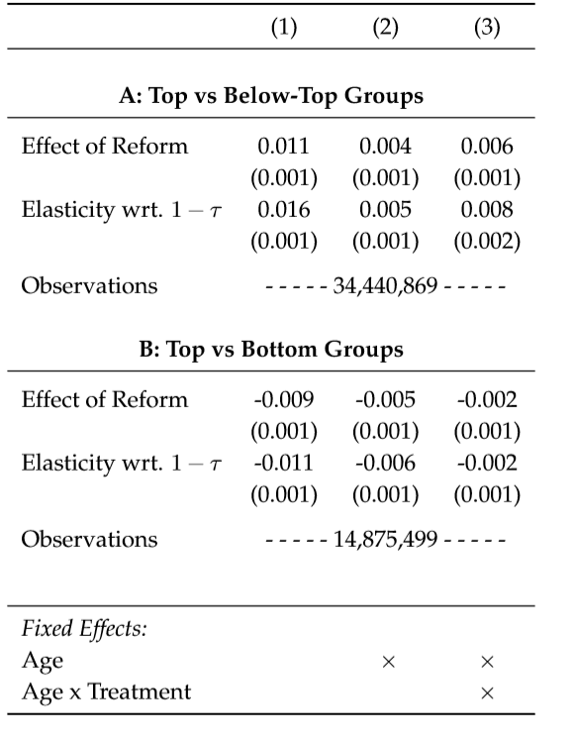
Source: Gruber, Jensen & Kleven, 2018.
Table A-2 Effect on Home Size among Movers
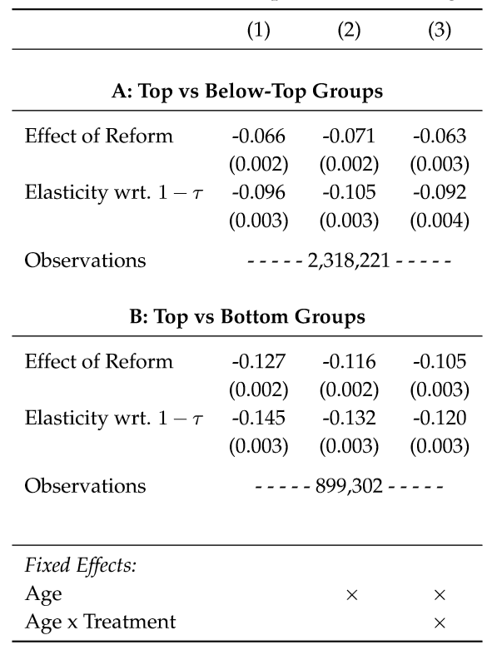
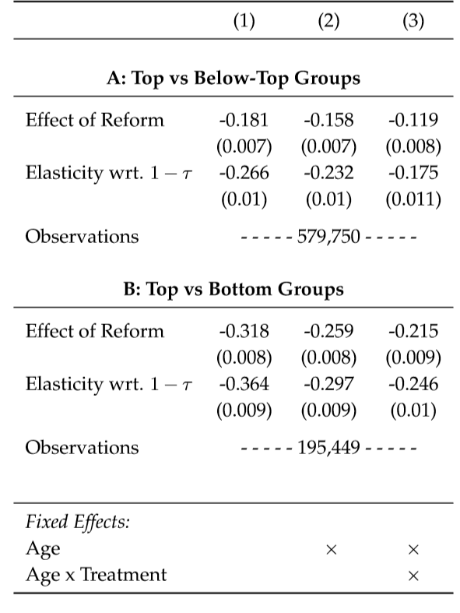
Table A-3 Effect on Home Value among Movers
Source: Gruber, Jensen & Kleven, 2018.

Appendix B
Figure B-2 Average housing prices in euros for the Netherlands and per province, 2013-2018
Source: Own illustration
Figure B-1 Average housing prices in euros for the Netherlands and per province, 2007-2018
Source: Own illustration
Figure B-3 House price index for the Netherlands and Denmark, 1980-2018
Source: Own illustration

Figure B-4 House price index for the Netherlands and Denmark, 1980-1997
Source: Own illustration

Nominal House Price Index (1995 = 100)
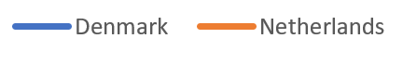
Figure B-5 House Price Index for Denmark 1982-1990 and the Netherlands 2013-2018
Source: Own illustration

Figure B-6 GDP growth in percentages for Denmark, 1982-1990
Source: Own illustration

Figure B-7 GDP growth in percentages for the Netherlands, 2013-2018
Source: Own illustration

Figure B-8 GDP per capita in Dollars for Denmark, 1982-1990
Source: Own illustration

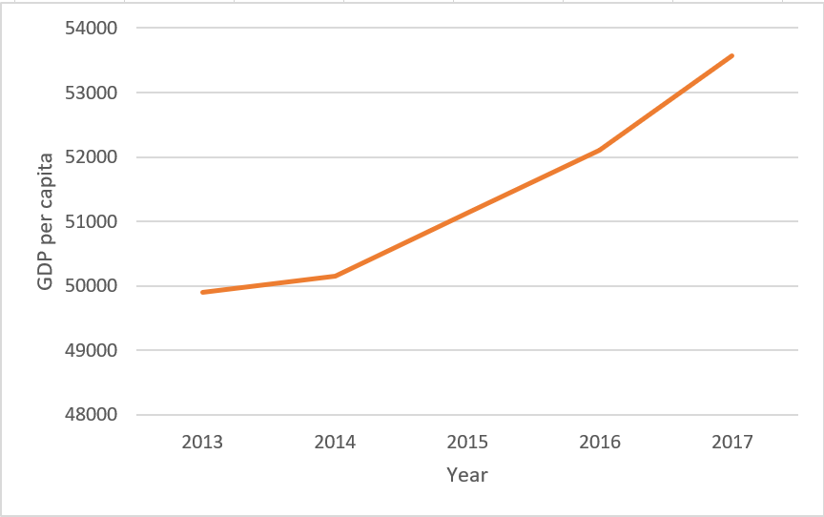
Figure B-9 GDP per capita in Dollars for the Netherlands, 2013-2018
Source: Own illustration

Figure B-10 Population given in thousands for Denmark, 1982-1990
Source: Own illustration

Figure B-11 Population given in thousands for the Netherlands, 2013-2018
Source: Own illustration

Table B-1 Aggregated home values and mortgages at the individual level in the Netherlands, 2018
Variable | Observations | Mean | Standard deviation | Min | Max
Homeownership | 1,766 | 0.662 | 0.473 | 0 | 1
Home value | 1,766 | 184,135 | 172,086.8 | 0 | 1,200,000
Number of mortgages | 1,766 | 0.664 | 0.852 | 0 | 5
Mortgage value | 1,766 | 72,015.95 | 11,198.6 | 0 | 1,400,000
Interest on mortgage | 2,083 | 1,564.659 | 3,543.878 | 0 | 52,896

Table B-2 Housing situation and mortgages at the household level, 2018
Variable | Observations | Mean | Standard deviation | Min | Max
Mortgage at time of purchase | 1,160 | 1.088 | 0.283 | 1 | 2
Mortgage loan amount (x1000) | 1,058 | 236.910 | 718.006 | 0 | 9,000
Mortgage on home currently | 1,160 | 1.266 | 0.442 | 1 | 2
Prefer more expensive house | 1,160 | 1.909 | 0.287 | 1 | 2
Mortgage interest rate | 716 | 3.353 | 1.319 | 0 | 7.8

Appendix C
Table C-1 House price index for the Netherlands based on linear trend prediction, 31.03.2013 –31.03.2023
Period | House Price Index
31.03.2013 | 229.244
30.06.2013 | 224.518
30.09.2013 | 225.959
31.12.2013 | 225.227
31.03.2014 | 226.361
30.06.2014 | 227.377
30.09.2014 | 228.842
31.12.2014 | 229.787
31.03.2015 | 232.197
30.06.2015 | 234.253
30.09.2015 | 238.979
31.12.2015 | 239.711
31.03.2016 | 242.925
30.06.2016 | 244.744
30.09.2016 | 250.840
31.12.2016 | 254.054
31.03.2017 | 259.133
30.06.2017 | 263.198
30.09.2017 | 269.412
31.12.2017 | 275.627
31.03.2018 | 283.212
30.06.2018 | 288.430
30.09.2018 | 296.257
31.12.2018 | 284.642
31.03.2019 | 287.745
30.06.2019 | 290.848
30.09.2019 | 293.951
31.12.2019 | 297.054
31.03.2020 | 300.158
30.06.2020 | 303.261
30.09.2020 | 306.364
31.12.2020 | 309.467
31.03.2021 | 312.570
30.06.2021 | 315.673
30.09.2021 | 318.777
31.12.2021 | 321.880
31.03.2022 | 324.983
30.06.2022 | 328.086
30.09.2022 | 331.189
31.12.2022 | 334.292
31.03.2023 | 300.863

Figure C-1 House price index for the Netherlands 2013-2022, actual and linear prediction
Source: Own illustration

Figure C-2 House price index for the Netherlands 2013-2023, actual and prediction
Source: Own illustration

Variable | Coefficient
Period | 3.103
Constant | 210.17
R² | 0.891
Table C-2 Linear trend prediction house price index for the Netherlands

