A Review on Transportation Demand Management
Transportation Demand Management Mechanisms to Improve Societal Welfare
Prabowoseto Sunaring Putro / 323764

Executive Summary
Transportation Demand Management (TDM) has become an important aspect in improving the societal welfare. It helps to improve the societal welfare by managing the use of transportation modes through the implementation of different measures. The implementation of these measures affects Marginal Social Cost (MSC), Marginal Private Cost (MPC), and Demand to improve societal welfare with different mechanisms.
There are three main mechanisms that can be identified: the mechanism of decreasing MSC, the mechanism of increasing MPC, and the mechanism of shifting demand. The first two mechanisms directly impact the overall societal welfare since the mechanisms directly affect the MSC and MPC, two aspects that directly impacts the overall societal welfare. The last mechanism, which is the mechanism of shifting demand, however, does not directly impact the overall societal welfare since it affects demand instead of MSC and MPC. Measures in this mechanism when implemented alone have questionable effect on the societal welfare.
Considering the TDM mechanisms, this paper suggests to focus on the implementation of measures that fall into the mechanism of decreasing MSC and the mechanism of increasing MSC. This paper also suggests combining the measures that fall into these mechanisms to get an optimum result. In order to better strengthen the implementation of the measures, this paper suggests the implementation of measures in the mechanism of shifting demand to support the measures in the other two mechanisms.

Table of Contents
I. Introduction 3
1.1 Transportation Demand Management Program 3
1.2 Research Problem Statement 3
1.3 Methodology 3
1.4 List of Chapters 3

II. MSC, MPC, and the Effect of TDM Implementation 3
2.1 Marginal Social Cost (MSC) and Marginal Private Cost (MPC) 3
2.2 The Effect of TDM Implementation on MSC and MPC 3

III. Classifications of TDM Measures and Strategies 3
3.1 TDM Measures and Strategies 3
Improved Transport Option 3
Incentives to Use Alternative Mode of Transport and Reduce Driving 3
Parking and Land Use Management 3
Policy and Institutional Reform 3
IV. Mechanisms and Classifications of TDM Measures 3
4.1 Mechanisms of TDM Measures 3
4.2 Classifications of TDM Measures Based on the Mechanisms 3
4.3 Suggestions 3

V. Conclusion 3

Appendix 3

Bibliography 3

I. Introduction
Transportation Demand Management (TDM) isa topic that has been discussed frequently recently.It is related with the growing trend of transportation mode use especially automobiles. TDM is especially important because it helps to manage the use of transportation modes. It is important because the use of transportation modes have resulted in problems for society such as congestion, accident, and pollution. All these problems result in costs for the society that further causes the decrease in overall societal welfare. TDM exists to help reduce the decrease in societal welfare caused by problems arising from transportation mode use.
In its implementation TDM varies in different cases. Either private firms or the government alone can implement TDM but both can implement it together as cooperation. Although private firms alone can do it, government intervention is still needed since private firms are reluctant in implementing efficient TDM programs (Enoch & Potter, 2003). The programs implemented vary depending on the needs and requirements in the society.All TDM programs implemented constitute TDM measures.
There is a wide range of different TDM measures implemented. The measures range from infrastructure improvements to the implementation of parking policies. All the measures established and implemented are aimed towards one goal, which is the increase of societal welfare (Meyer, 1999).

Transportation Demand Management Program

Transportation Demand Management is the arrangement of transportation in an efficient manner to alleviate the burden put on the society caused by problems arising from the use transportation modes. The burden put on the society is alleviated because there is no possible way to completely eliminate the negative effect of transportation on the society. Conceptually, according to LitmanTDM can be defined as (Litman, 2003):
Transportation Demand Management is a general term for strategies and programs to encourage more efficient use of transport resources (road and parking space, vehicle capacity, funding, energy, etc). TDM includes strategies that improves the transport options available to users, incentives that encourage traveler to use more efficient transport options, more accessible land use patterns, planning reforms and various support programs
According to the definitions above, TDM includes various strategies and programs that encourage the change of travel behavior. These strategies and programs are two separate aspects. The strategies implemented are embedded in theprograms as Victoria Transport Policy Institute defines (VTPI, 2009):
A TDM Program is an institutional framework for implementing a set of TDM strategies. Such a program has stated goals, objectives, a budget, staff, and a clear relationship with stakeholders. It may be a division within a transportation or transit agency, an independent government agency, or a public/private partnership.
As defined above, to implement a set of TDM strategies some programs are required. These programs have stated goals, objectives, budget, staff and clear relationship with stakeh(Garling, et al., 2002)olders. The programs are also done by both private firms and public sector. Based on the definition the programs are clear-cut and have no problems in their nature.
Although the definition is clear, little is known how the programs affect the societal welfare. There are two aspects that can increase societal welfare, which are Marginal Social Costs (MSC) and Marginal Private Costs (MPC)(Blauwens, De Baere, & Van de Voorde, 2007).TDM can increase the overall societal welfare by reducing MSC or increasing MPC.

1.2 Research Problem Statement

Based on the description in the previous section, one problem statement can be raised:
How do different TDM measures affect MSC and MPC and which combination constitutes the best policy?
To answer the main question the following sub-questions will be answered:
- What is the influence of TDM on societal welfare?
- What are the different TDM measures?
- What are the mechanisms? How could TDM measures improve societal welfare?
- How are the TDM measures classified into the mechanisms?
- What combination of the TDM measures constitutes ideal combination?
There are many different TDM measures. How do they influence societal welfare? What are the mechanisms to influence societal welfare? All these questions will determine how the measures affect MSC and MPC.

1.3 Methodology

This paper examines in detail how TDM programs implemented together by governments and private firms increase overall societal welfare. Firstly this paper will explain the concept of externalities and how TDM can internalize these externalities by increasing MPC or decreasing MSC. The paper will then go through the different kinds of measures that are available and classify all the measures according to how the measures influence MSC and MPC. Finally the paper will assess all the available measures and determines which combination of the measures will be most effective in increasing societal welfare.

1.4 List of Chapters

This paper will begin with a conceptual explanation about externalities, including the explanation of how TDM can internalize these externalities by affecting the two elements of externalities, which are MSC and MPC in chapter two. The third chapter will provide different kinds of TDM measures, how they are implemented and classify the measures according to how the measures affect MSC and MPC. This chapter will answer the sub-questions. Next, the fourth chapter will assess all the available measures and determines the most effective combination of the measures. The fifth and last chapter concludes all the previous chapters, explaining in brief how the TDM measures affect MSC and MPC and also the most effective combination of the measures.

II. MSC, MPC, and the Effect of TDM Implementation

2.1 Marginal Social Cost (MSC) and Marginal Private Cost (MPC)

In the previous chapter it has been mentioned that there are two aspects that can increase overall societal welfare in relation with TDM. Those aspects are Marginal Social Cost (MSC) and Marginal Private Cost (MPC). Theoretically, MPC represents the actions of all private entities in the market. The private entities include private firms, individuals, and all who consume goods and services. MSC, on the other hand, represents the interaction of these private entities in the market. Graphically it can be explained as follows:
Source: Transport Economics, (Blauwens, De Baere, & Van de Voorde, 2007).

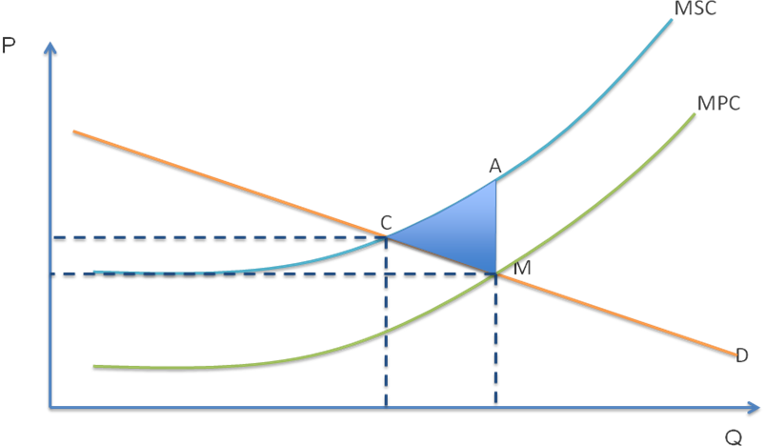
Graph 1.1, MSC and MPC in the market
The graph above depicts a situation where MSC, which is the cost burdened by the society, is higher than MPC, which is the cost that economic agents pay. From this graph it is noticeable that the cost that is burdened by the society is higher than the cost that the economic agents pay. The graph shows that there is a gap between MSC line and MPC line that represents the difference between the costs burdened by the society and the cost paid by private entities. This situation results in a societal welfare loss represented by the blue triangle that is formed by points C-M-A.

2.2 The Effect of TDM Implementation on MSC and MPC

Graph 1.1 has shown that the existence of gap between the MSC and MPC lines indicates a difference between the costs that is burdened by the society and the cost that is paid by private entities. In this case MSC is higher than MPC, which means that the costs burdened by the society is higher than the cost paid by private entities is. This difference creates a societal welfare loss represented by the blue triangle C-M-A.
In order to eliminate or at least minimize the welfare loss, there should be an increase in the societal welfare. The implementation of TDM can help to increase the societal welfare. As mentioned in earlier chapter, TDM increases societal welfare by decreasing MSC or increasing MPC to match MSC. Graphically it can be explained as follows:
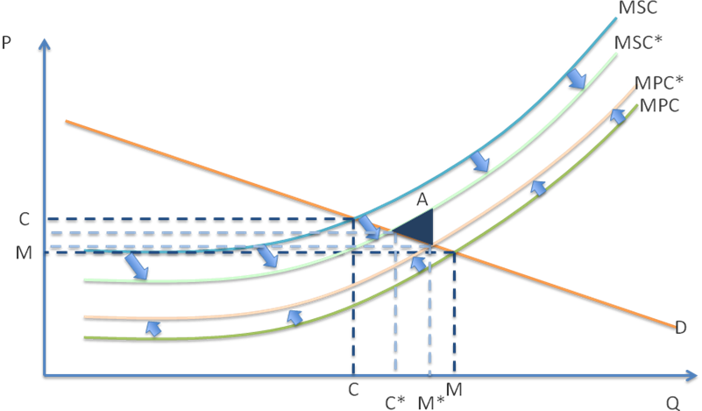Graph 1.2, TDM effect on MSC and MPC
The graph above shows how TDM increases welfare. It can increase societal welfare by decreasing MSC as shown in the graph that the MSC line moves downward to MSC*. TDM can also increase MPC to increase societal welfare as shown in the graph that the MPC line moves upward to MPC*. The end result of decreasing MSC or increasing MPC is the shrinking size of the triangle that represents societal welfare loss. When the triangle shrinks it means the welfare loss decreases, further means that there is an increase in the societal welfare.
In increasing MPC or decreasing MSC, TDM consists of different strategies such as Improving Transport Options, Creating Incentives to Use Alternative Mode of Transport, and Policy and Institutional Reform. All these strategies will have different effect on MSC and MPC. Since there are different effects with different strategies, carrying out TDM programs to increase societal welfare should be done in a correct manner(Weimer & Vining, 2004).

III. Classifications of TDM Measures and Strategies

3.1 TDM Measures and Strategies

In the previous chapter it has been mentioned that TDM measures consist of different strategies. These strategies affect MPC as well as MSC in different ways. Since the strategies affect MPC and MSC in different ways, they can be differentiated from one another. Essentially these strategies can be classified into four major categories:

Improved Transport Option

This strategy promotes the additional option of transport for commuters. According to VTPI there are four main impact points in this strategy (VTPI, 2009):
Infrastructure Improvements | Flexible Timing
• Cycling Improvements | • Alternative work schedules
• Pedestrian Improvements | • Telework
• Pedways | • Telework and different shifts
• Transit Station Improvements
• Transit Improvements
Transit and Shuttle Services | Alternative Modes of Travel
• Bus Rapid Transit | • Non Motorized Planning
• Light Rail Transit | • Non Motorized Facility Management
• Park and Ride | • Public Bike Systems
• Shuttle Services | • Small Wheeled Transport
• Transit Examples
• Ridesharing

In this strategy there are four main impact points as depicted in the table above. Within these impact points are the TDM measures in which the strategy is carried out. The main aim of this strategy is to give commuters improved options of transport, not only additional mode of transport, but as well as the way they can reduce the use of mode of transport especially automobiles.

Incentives to Use Alternative Mode of Transport and Reduce Driving

The strategy of Incentives to Use Alternative Mode of Transport and Reduce Driving emphasizes on offering incentives for commuters to change their travel behavior. This strategy can be broken down into two major incentives, the variable-based incentives and the fixed-based incentives. The grouping including the measures of both incentives are as follows:
Variable-based Incentives | Fixed-based Incentives
- Distance Based Pricing | - Carbon Taxes
- Parking Pricing | - Road Space Reallocation
- Road Pricing | - Speed Reductions
- Congestion Pricing | - Vehicle Use Restrictions
- Customer Bonuses | - Employee benefits
- Daily Travel Compensation | - High Occupancy Vehicle Priority

Variable incentives are incentives that are provided based on variables such as the distance travelled, frequency of parking, number of days coming to work using bicycle, etc. On the other hand, fixed-based incentives are provided to commuters regardless the variables that they have experienced. Both the variable-based incentives and the fixed-based incentives can stimulate commuters into using alternative modes of transport and discourage them from using private automobiles.

Parking and Land Use Management

This strategy, as the name expresses, focuses on managing the use of parking space as well as the use of land. Division of the strategy is shown in the table below:
Land Use Policies | Parking Policies
- Connectivity | - Parking Pricing
- Land Use Density and Clustering | - Parking Evaluation
- Location Efficient Development | - Shared Parking
- New Urbanism | - Parking Solutions
- Smart Growth | - Bicycle Parking
- Car Free planning

The management of parking spaces is much more emphasized on limiting the number of parking space available. It is because one of the most efficient ways to reduce the number of automobiles on the road is to limit parking (Petiot, 2004). At the same time land use management emphasizes more on increasing the accessibility to and from an area especially business and residential area.

Policy and Institutional Reform

This strategy targets the basic restructuring of transportation system to make it more efficient. The basic changes involve all aspects of the transportation system. The strategy has two major areas as its targets, which are Event and Location Awareness and Overall TDM Awareness. The targets are classified as in the table below according to VTPI (VTPI, 2009):
Event / Location Awareness | Overall TDM Awareness
- Aviation Transport Management | - Developing Country TDM
- School Transport Management | - TDM Marketing
- Event Transport Management | - TDM Programs
- Freight Transport Management | - TDM Associations
- Emergency Transport Management | - Access Management
 | - Intelligent Transportation

Event and Locations Awareness focuses on major locations and events within an area that attracts large traffic. It tries to solve transportation problems related with large events such as football matches, festivals, etc. The aim of this awareness is to create plans and programs to allow traffic to flow fluidly and reduce congestion. The Overall TDM Awareness is more focused on implementing an overall market reform. This reform includes setting pricing decisions for all modes of transport and establishing new institution to implement and supervise the reform.

IV. Mechanisms and Classifications of TDM Measures

4.1 Mechanisms of TDM Measures

As mentioned earlier, TDM measures are aimed towards one goal, which is to improve overall societal welfare. In order to achieve this aim, there are mechanisms that TDM measures go through. These mechanisms can be categorized into two mechanisms in general. The mechanisms are to decrease MSC and to increase MPC.
The first mechanism that TDM measures go through to improve welfare is to decrease the MSC. The objective of decreasing MSC is to reduce the cost that is burdened to the society. It has been explained earlier in graph 1.1 that the overall societal welfare loss is caused by the discrepancy between MSC and MPC and is depicted by the triangle. Thus the objective of decreasing MSC is to decrease this discrepancy that will further lead to an increase in the overall societal welfare. Graphically it can be explained as follows:
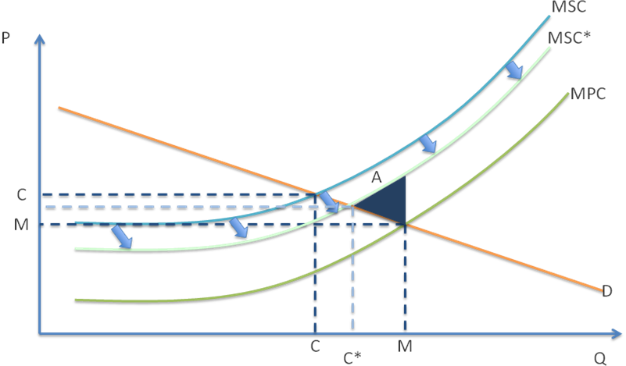Graph 1.3, TDM effect on MSC
The graph shows how TDM measures can impact MSC by decreasing it. TDM measures shift the MSC curve in the graph downward. This shift causes the triangle in graph 1.1 to shrink, reducing the overall societal welfare loss, which means improving the societal welfare.
This mechanism focuses on reducing the costs that is burdened by the society. In order to reduce the costs that are burdened by the society, this mechanism provides alternatives to methods that previously cost the society higher. These alternatives make available for economic agents in the market to reduce the impact of driving on the society(Garling, et al., 2002). There are several TDM measures that implement this mechanism. The measures include alternative work schedule, telework, and high occupancy vehicle priority.
Alternative work schedule is a form of flexible timing that gives the commuters an opportunity to come to work on different shifts. It enables commuters to choose the time to come to work to avoid rush hour. Providing commuters the ability to choose the time to depart to work will help them avoiding rush hour, which will further help to reduce overall congestion (Yen, 2000). In addition to alternative work schedule is telework. It works in a similar way with alternative work schedule. The main difference is that telework enables commuters to work from their homes. In this situation then commuters no longer need to travel to work since they can do their work at home. Telework then greatly helps reduce commuters’ needs to travel, which further helps to reduce congestion.
High Occupancy Vehicle (HOV) Priority is a measure in the form of priority given to vehicles with high occupancy. The priority given to HOV is in the form of HOV lane. This lane is dedicated for the use of HOV only. Since only HOV can use the HOV lane, then it will greatly reduce travel time for commuters who utilize HOV. HOV Priority also helps to reduce congestion since it attracts commuters to carpool. There are some ways for commuters to utilize this measure. The main way to do so is to rideshare with other commuters to the final destination. By ridesharing commuters can maximize the occupancy of their vehicles, thus enabling them to utilize the HOV Priority measure(Kitamura, Nakayama, & Yamamoto, 1999).
Another mechanism that TDM measures go through is to increase the MPC. The aim of increasing MPC is to increase the costs that economic agents pay so that it will match the costs that are burdened by the society. Increasing the costs that economic agents pay will decrease the overall societal welfare loss that has been depicted in graph 1.1. Graphically it can be explained as follows:
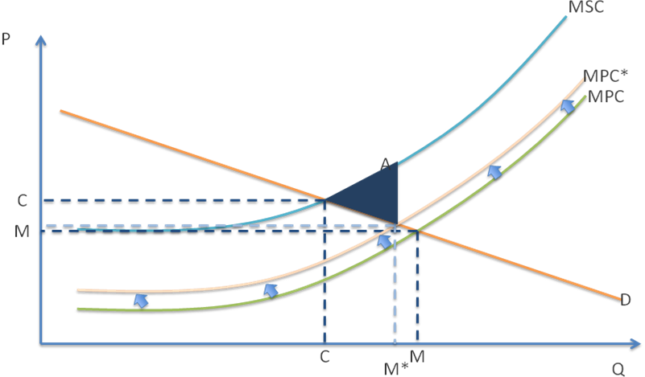Graph 1.4, TDM effect on MPC
The graph above shows how TDM increases MPC to improve overall societal welfare. The increase in MPC to MPC* decreases the discrepancy between MSC and MPC. This leads to the shrinking of the blue triangle that represents the overall societal welfare loss, further leading to the improvement of the societal welfare.
This mechanism focuses on adding more costs to economic agents in the market so that the costs the economic agents pay will match the costs that the society bears. The focus on adding more costs is implemented in different ways in this mechanism. The main point in this mechanism is to charge more costs to economics agents’ commute. The measures in this mechanism include distance based pricing, parking pricing, road pricing, congestion pricing, carbon taxes, and vehicle use restriction.
Distance based pricing is charging commuters a certain amount of money depending on the distance that the commuters go through with their vehicles. The more the distance the commuters go through the more they will have to pay. This measure certainly increases MPC since it charges commuters more costs. Another TDM measure similar to distance based pricing is parking pricing. As the name shows, parking pricing charges commuters who park their vehicles in parking facilities. Parking pricing varies in different parking facilities. Parking pricing can be fixed in some facilities but it can also be variable depending on the duration of the parking in other facilities. This method of pricing charges commuters more costs as continue parking their vehicles in their commute.
Road pricing charges commuters directly for the use of roads. The charges may take form in license fee, fuel taxes, or taxes against the commuters’ vehicle type. This type of pricing charges commuters directly. The more the commuters use the road, the higher the charge for them will be. In relation to road pricing is congestion pricing. Congestion pricing charges commuters for using the road during peak hours. The charges include higher peak charges for road pricing, public transport, etc. The aim of this pricing is to reduce traffic congestion without increasing supply by charging commuters higher peak charges during peak hours.
Carbon taxes are charged against commuters on the basis of carbon dioxide emission their vehicles produce. The more carbon dioxide produced means the more tax that the commuters have to pay. This taxing method increases MPC since it charges commuters more money accordingly with their vehicles’ carbon dioxide emission. Besides charging taxes, restriction is also applied. Vehicle use restriction restricts commuters in using their automobiles. Vehicle use restriction includes car-free zones, pedestrian oriented commercial area, etc. This restriction causes more cost to commuters because originally commuters can travel faster using their automobiles and with the restriction commuters can no longer use their automobiles.
Next to the previous two mechanisms is the mechanism to shift existing demand. The aim of this mechanism is the same with the previous two mechanisms, which is to reduce the costs burdened by the society. This mechanism reduces the costs by shiftingthe existing demand that burdens the society. The shifting of the existing demand will decrease the societal welfare loss that leads to the improvement on the overall societal welfare. Graphically it can be explained as follows:
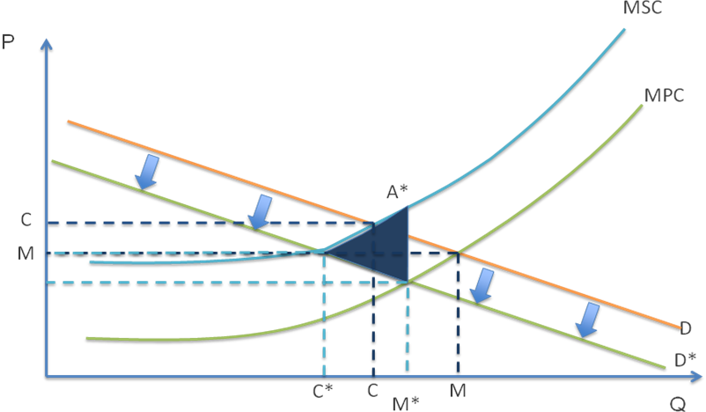Graph 1.5, TDM effect on Demand
The graph above shows how TDM measures can affect demand in their implementation. TDM measures in this case function to shift the existing demand that burdens the society. The previously existing demand, as depicted by triangle M-C-A in graph 1.1, burdens the society because it demonstrates an excessive consumption that causes more costs to the society. The optimum level of consumption in the existing demand triangle is depicted by C but the actual consumption is depicted by M. The gap between the two forms a triangle that previously has been mentioned depicting costs for the society that results in a societal welfare loss.
In this mechanism, TDM measures shift the existing demand that burdens the society to decrease the societal welfare loss that will improve the overall societal welfare. In the graph, it can be seen that the triangle that represents societal welfare loss shifts from M-C-A to M*-C*-A*. This shift lowers the excessive consumption by lowering the existing demand that burdens the society depicted by D that shifts to D*. The graph demonstrates the lowering existing demand that lowers excessive consumption and optimum consumption along the line.
As the graph demonstrates, the demand shifts downward as the result of TDM measures implementation. The existing demand in this case is the demand for automobile use. TDM measures shift the demand for automobile use downwards indicating reduced automobile use.Despite the lowering demand for automobile use that leads to decreasing automobile use, it remains questionable whether this mechanism actually improves the overall societal welfare.It is because as the demand shifts downward, the optimum consumption and actual consumption shift as well. As the graph demonstrates, initially with demand depicted by D, the optimum consumption and actual consumption are depicted by C and M, respectively. As measures in this mechanism work, the demand then shifts downward from D to D*. The downward shifting demand is then followed by C to C* and M to M*. With the optimum consumption and actual consumption following the demand to shift downward, the welfare loss will also follow this pattern.It is visible from the graph that the initially welfare loss depicted by M-C-A shifts downward to M*-C*-A and retains its size, further indicating that there is no decrease in the welfare loss. For this reason, it is questionable whether this mechanism directly impacts the overall societal welfare. Measures in this mechanism includes bus rapid transit, light rail transit, Park and Ride, and shuttle services.
The use of bus rapid transit reduces the needs of commuter to commute using their private automobiles. This is because bus rapid transit provides an alternative for commuters to commute using a mode of transport that is relatively less costly than using their private automobiles. Since it is relatively less costly, then it will attract commuters to use bus rapid transit, causing a shift in their demand for private automobile use. The shift in demand for automobile use, as explained earlier, leads to reduced number of automobiles on the road that further leads to less congestion and also less pollution. This method is also found in light rail transit as it works exactly the same. It helps commuters reducing their cost of commuting and it also detracts commuters from using their automobiles. The only difference is that light rail transit is used for greater distance compared to bus rapid transit.
Park and Ride also helps commuters to reduce the cost of their commuting. It lets commuters to drive their automobiles to the nearest transit and park their automobiles there to then transfer using public transit. Park and Ride reduces MSC by reducing the distance that commuters have to travel using their automobiles and let themselves continue their commuting using public transit. This helps commuters to reduce their travel distance by automobiles that will lead to less traffic congestion as well as pollution. The provision of shuttle service helps commuters to continue their commute to their final destination. Often after reaching certain public transit points, commuters have to continue to their final destinations with other mode of transport that contributes to congestion and pollution such as taxi. The provision of shuttle services will greatly reduce the need to usethis kind of mode of transport for the commuters to reach their final destination.
All the mechanisms previously mentioned are explained individually. Starting with the mechanism of decreasing MSC, increasing MPC, and lastly shifting the existing demand that burden the society. Although the explanations of the mechanisms are provided individually, the mechanisms above actually work together in their implementation rather than individually. The implementations of the mechanisms together are necessary since it will provide better improvement for the overall societal welfare. It can be explained graphically as follows:
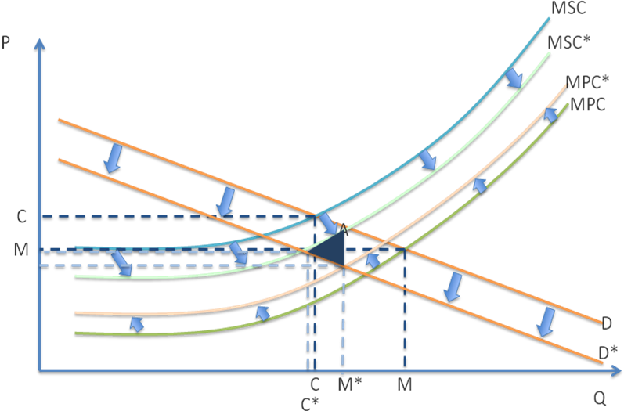Graph 1.6, Overall TDM Effect
The graph above depicts all the mechanisms when they are implemented together. As previously explained, the mechanisms that decrease MSC and increase MPC both have direct impact on overall societal welfare. Unlike these two mechanisms, the mechanism that focuses on shifting demand cannot directly impact the overall societal welfare. It is because the mechanism directly affects the demand rather than the MSC or MPC and thus it cannot directly impact the overall societal welfare. Since it cannot directly impact the overall societal welfare, it can only affect the overall societal welfare by shifting demand that burdens the society. This mechanism thus supports the other two mechanisms. For this reason, all the mechanisms above should be implemented together.
The three mechanisms above are generally known mechanisms that TDM measures go through to improve societal welfare. Both of the mechanisms decrease the overall societal welfare loss to improve the societal welfare. The mechanisms also include many different TDM measures to ensure the decreasing costs burdened by the society and increasing costs to the economic agents.
Despite the mechanisms described above, it is also necessary to notice different probabilities from the mechanisms that may arise as undesired side effects of the mechanisms. The undesired side effects may arise as the reactions of economic agents towards the TDM measures implemented. These undesired side effects may cause the TDM measures to be ineffective in their implementation.
One thing to notice is the increasing MSC along with the increase in MPC. This side effect may arise in the mechanism of increasing MPC to charge economic agents more costs to match the costs that is burdened by the society. This probability is especially true when the process of charging more costs to private entities in the market involves the society as a whole. Graphically, it can be explained as the following:
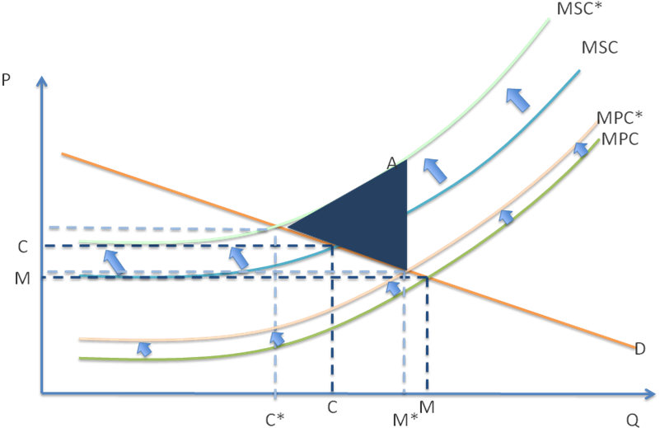Graph 1.7, Increasing MSC resulting from increasing MPC
The graph above shows how the increasing of MPC could potentially increase MSC as a result of economic agents’ reaction towards the increasing MPC. As mentioned earlier this situation is potential to occur when the process of increasing MPC involves the society as a whole. For example the TDM measure of road space reallocation. The aim of this measure is to reallocate the road space for other purposes so that the available road space will decrease, increasing the MPC. At first the idea might be feasible but there is a side effect to this mechanism. Since there is less road space available it means the traffic flow is compressed into the remaining available road space. This situation will certainly lead to congestion, which triggers the increase in MSC.
The situation above depicts the increase in MPC caused by the increase in MSC. The congestion resulting from the less road space available is a result of economics agents’ reaction towards the less road space available, which is to keep driving on the road space available. In this case, the economic agents are not discouraged by the less road space available and continue to utilize the remaining available road space, resulting in congestion that leads to higher MSC.
Another example of increasing MSC resulting from increasing MPC is parking pricing. Parking pricing is established to discourage economic agents to travel to their destinations using automobiles. The main aim is to reduce the number of automobiles on the road by increasing the costs parking, which increases MPC. The idea of parking pricing is feasible but there is also a potential side effect from this pricing.
Economic agents may react to this pricing by shifting their parking to the neighboring area where parking is cheaper or even free. The shifting parking space to the neighboring area, especially residential area will cause more noise as well as pollution. In addition, the shifting parking will also cause fewer parking spaces available for the residents in the area. This situation leads to the increase of MSC following the increase of MPC from the parking pricing.

4.2 Classifications of TDM Measures Based on the Mechanisms

In the previous section of this chapter, it has been discussed how the TDM measures affect the overall societal welfare through different mechanisms. These mechanisms, although different in their nature, work together as the TDM measures are implemented together to support each other. The TDM measures then can be classified into these different mechanisms based on how the measures are implemented.All the measures’ definition in the classifications below are provided in the appendix. Classification of the measures is as follows:

Decreasing MSC | Increasing MPC | Shifting Demand
- Alternative Work Schedule | - Distance Based Pricing | - Bus Rapid Transit
- Telework | - Parking Pricing | - Light Rail Transit
- HOV Priority | - Road Pricing | - Park and Ride
- Public Bike Systems | - Congestion Pricing | - Shuttle Services
- Non-Motorized Planning | - Carbon Taxes | - Customer Bonuses
- Non-Motorized Facility Management | - Vehicle Use Restriction | - Transit Improvements
 | - Car Free Planning | - Transit Station Improvements

In addition to the measures that can be directly classified into the three mechanisms above, there are some measures that cannot be classified into these mechanisms. The reason for this is because the measures are rather a combination of the mechanisms and thus, cannot be classified into individual mechanisms above. The measures are as follows:
Increasing MPC to Decrease MSC
- Speed Reductions
- Employee Benefits
- Daily Travel Compensation
- Shared Parking
- Road Space Reallocation

There are also some measures that cannot be classified into the classifications described above. The reason for this is because the measures focus more on raising TDM awareness and land use management. These measures are still unclear as to what extent they affect MSC, MPC, and demand. The measures are listed as the following:
Raising TDM Awareness | Land Use
- Aviation Transport Management | - Connectivity
- School Transport Management | - Land Use Density and Clustering
- Event Transport Management | - Location Efficient Development
- Freight Transport Management | - New Urbanism
- Emergency Transport Management | - Smart Growth
- Developing Country TDM
- TDM Marketing
- TDM Associations
- Access Management
- Intelligent Transportation

4.3 Suggestions

In the previous sections it has been discussed how TDM implementation affects MSC and MPC, the mechanisms of the TDM measures, and classifications of the measures. Taking all the discussions into account, it is now clear that of all the mechanisms of TDM measures above only two mechanisms can directly affect the overall societal welfare. The mechanisms are the mechanism of decreasing MSC and the mechanism of increasing MPC while the mechanism of shifting demand remains questionable in its effect on the overall societal welfare. As an addition, there is one mechanism that indirectly decreases MSC as a result of increasing MPC.
To obtain an optimum result out of the TDM measures, it is best to stay focused on implementing measures that directly affect the overall societal welfare. In this case, the measures that should be focused on are the ones classified into the mechanism of increasing MPC and the mechanism of decreasing MSC. Combining measures in the two mechanisms is also recommended. For example, while implementing distance based pricing to discourage the use of private automobile use, the implementation of public bike system to provide alternative mode of transport can be applied. By implementing the two mechanisms together, commuters are not only discouraged to utilize their private automobiles but at the same time given a solution to their private automobiles. The implementation of the two measures will also increase MPC and decrease MSC at the same time, leading to decreased welfare loss that further leads to improved overall societal welfare.
As an addition, although the mechanism of shifting demand cannot directly affect the overall societal welfare, it can be utilized to support the other two mechanisms. For example, in the previous example where distance based pricing is combined with public bike system, it can also be supported with the measure of light rail transit. The light rail transit here works as an alternative for commuters that travel longer distance to be able to travel without their private automobiles. The distance based pricing discouraged commuters to utilize their private automobiles while at the same time they are given the alternatives to travel longer distance using light rail transit and public bike system to reach shorter distance. The shifting demand measure then supports the other measures by lowering demand for private automobile use.

V. Conclusion

Transportation Demand Management is an important tool in improving the overall societal welfare. It works through different mechanisms that include wide range of measures that can be implemented. All the mechanisms are aimed towards reducing the welfare loss to improve the overall societal welfare.
The different mechanisms are categorized into three different mechanisms. The mechanisms are the mechanism to decrease MSC, the mechanism to increase MPC, and the mechanism to shift existing demand. All the mechanisms consist of different measures that when implemented will have certain impacts on the market. The impacts of the mechanisms include the decreased MSC, increased MPC, and shifted demand. All these mechanisms along with the impacts work together to improve the overall societal welfare.
Despite the well-aimed mechanisms towards the improvement of the overall societal welfare, there are only two mechanisms that can directly impact the societal welfare. The mechanisms are the mechanism to decrease MSC and the mechanism to increase MSC. As for the mechanism to shift demand, it is still unclear whether it is able to directly impact the overall societal welfare. Although its ability to impact overall societal welfare is still questionable, the mechanism can still function as a support for the other two mechanisms.
Taking all the discussions into account, it is then advisable to concentrate on implementing measures that fall into the two categories. It is because the measures will have direct impact on the overall societal welfare. It is also advisable to combine the two mechanisms together and with the mechanism to shift demand. The combination is advisable because the mechanism to shift demand will support the other two mechanisms in their implementation.

Appendix

Alternative Work Schedule: A measure that provides an alternative schedule for commuters to come to work. This measure enables commuters to choose the time to come to and leave from work and avoid rush hour. By enabling the commuters to avoid rush hour, this measure removes the need for commuters to utilize their automobiles, further reducing the cost that the society burdens from congestion and pollution.
Telework: A measure similar to the measure of alternative work schedule that enables commuters to work from their residences. Since the commuters no longer need to go to their workplace, this measure removes their needs to make use of their automobiles, further leading to less congestion and pollution that lessens the cost that the society burdens.
HOV Priority: A measure that prioritizes commuters that rideshare to use a special lane. This measure stimulates commuters to rideshare, reducing their needs to use automobiles individually.
Public Bike Systems: A measure that enables commuters to utilize public bicycles. This measure stimulates commuters to ride bicycles instead of their private automobiles, further leading to less automobile utilization that leads to less congestion and pollution.
Non-Motorized Planning and Facility Management: A measure that plans and improves non-motorized mode of travel such as bicycle lanes, sidewalks, and crosswalks. This measure improves the facility to stimulate commuters into using non-motorized mode of transports, leading to less private automobile utilization.
Distance Based Pricing: A measure that charges commuters costs based on the distance they travel. As commuters go through more distance, the more costs they will incur.
Parking pricing: A measure that charges commuters based on the use of parking facility for their automobiles. Imposition of the charges can be either on a fixed or variable basis. This measure will continue to charge commuters more costs as they continue to park their automobiles.
Road Pricing: A measure that charges commuters based on road usage. The charges include license fee, fuel taxes, or taxes against the commuters’ vehicle type. This measure charges more costs to commuters as they use the road more.
Congestion Pricing: A measure that charges commuters costs when they use the road during peak hours. This measure especially charges commuters more highly compared to other pricing measures. It is because during peak hours commuters impose more costs to the society and thus, should be charged higher to match the costs that the society burdens.
Carbon Taxes: A measure that charges costs to commuters based on the emission of carbon dioxide their automobiles produce. This measure takes into account the type of automobiles that the commuters use. The more carbon dioxide their automobiles produce, the more costs they will incur from the charges.
Vehicle Use Restriction: A measure that restricts commuters to use their automobiles. This measure increases the costs for commuters because they will have to reach their destinations slower compared to when they use their private automobiles.
Car Free Planning: A measure that sets certain areas to be free of automobiles. This measure imposes costs for commuters because they have to travel further through alternative route that allows automobiles to pass.
Bus Rapid Transit: A measure that shifts the demand for automobile use by offering commuters to utilize buses instead. This measure causes commuters to alter their use of private automobiles into buses, shifting the demand from private automobiles to buses.
Light Rail Transit: A measure that is similar to the measure of bus rapid transit except it focuses on commuters that need to go through further distances. This measure also alters commuters’ use of private automobiles to light rails.
Park and Ride: A measure that enables commuters to utilize their private automobiles through the least distance possible to the nearest public transit point. The commuters can then transfer from their private automobiles to public transits such as buses or light rails. This measure shifts demand for private automobile use although commuters still use their private automobiles to travel short distances from their residences to the nearest public transit point.
Shuttle Services: A measure that makes available for commuters a shuttle service that can transport them from public transit point to their final destinations, especially workplace. This measure shifts the demand for mode of transport that contributes to congestion and pollution such as taxi.
Customer Bonuses: A measure that provides customers that frequently utilize public transit incentives. The incentives are mostly given in the form of financial incentives.
Transit & Transit Station Improvements: A measure that focuses on improving public transit and its station. The measure is focused on improving both the transit and its station to attract commuters into using public transit.
Speed Reduction: A measure that imposes regulations to commuters to reduce the speed of their private automobiles.
Employee Benefits: A measure that provides employees of a company incentives to come to the workplace without their private automobiles. The incentives are given when the employees decide to rideshare, use public transit, or commit to utilize non-motorized vehicle to come to work.
Daily Travel Compensation: A measure that provides commuters that travel using public transit on daily basis compensation for the costs they incur.
Shared Parking: A measure that allocates parking space for multiple users. In most cases, one parking space in this measure is utilized by two different commuters with different time of utilization.
Road Space Reallocation:A measure that reallocates road space that originally serves automobiles for other purposes.

Bibliography
Blauwens, G., De Baere, P., & Van de Voorde, E. (2007). Transport Economics. Antwerpen: Uitgeverij De Boeck.

Enoch, M., & Potter, S. (2003). Encouraging the commercial sector to help employees to change travel behavior. Transport Policy , 51-58.

Garling, T., Eek, D., Loukopoulos, P., Fujii, S., Johansson-Stenman, O., Kitamura, R., et al. (2002). A Conceptual Analysis of the Impact of Travel Demand Management on Private Car Use. Transport Policy .

Kitamura, R., Nakayama, S., & Yamamoto, T. (1999). Self-reinforcing motorization: can travel demand management take us out of the social trap? Transport Policy .

Litman, T. (2003). The Online TDM Encyclopedia: mobility management information gateway. Transport Policy , 245-249.

Meyer, M. D. (1999). Demand management as an element of transportation policy using carrots and sticks to influence travel behavior. Transport Policy , 575-599.

Petiot, R. (2004). Parking enforcement and travel demand management . Transport Policy , 399-411.

VTPI, V. T. (2009, February). Victoria Transport Poilcy Institute. Retrieved May 07, 2009, from TDM Encyclopedia: http://www.vtpi.org/index.php

Weimer, & Vining. (2004). Policy Analysis and Concepts 4th edition. Upper Saddle River: Prentice Hall.

Yen, J. R. (2000). Intrepreting employee telecommuting adooption: An economics perspective. Transportation , 149-164.

