Marco Economic Contributions by International
New Ventures, a literature review
ERASMUS UNIVERSITY ROTTERDAM
Erasmus School of Economics
Department of Economics

Supervisor: Thurink, Roy
Second reader: Hessels, Jolanda

Name: Veldman, Ronald
Exam number: 303827
E-mail address: 303827rv@student.eur.nl

Table of contents

Page
Chapter one: introduction 4
Chapter two: definitions
2.1 Relevance 6
2.2 Defining entrepreneurship 6
2.3 Defining international new ventures 7

Chapter three: differences international vs. domestic new ventures
3.1 Relevance 8
3.2 Similarities 8
3.3 Management experience 9
3.4 Strategic differences 11
3.5 Empirical evidence 12

Chapter four: external business environment
4.1 Relevance 14
4.2 Trends in technology 14
4.3 Globalization of markets 15
4.4 Risk management 16

Page
Chapter five: Enhanced firm performance
5.1 Relevance 17
5.2 Firm Growth 17
5.3Learning 18
5.4 Empirical Evidence 19

Chapter six: Role of multinational firms
6.1 Relevance 21
6.2 Direct and indirect effects 21
6.3 Spillovers 22
6.4 Effects on new ventures 22
6.5 Empirical evidence 24

Chapter seven: Conclusion 25

Literature 26

Appendix 29

1: Introduction

Traditionally, multinational corporations are viewed as large established companies, mostly founded in the second half of the 19th century. These multinational enterprises have shaped the economy the last century, and globalized word markets. Their process of internationalization was considered to be a slow one, as successful penetration across borders should only be achievable after successful penetration of the domestic market (Johanson and Vahlne, 1977). The increased importance of new ventures in international business recent decades has seriously challenged this stage theory in international economics. In a pursuit to explain this development, especially researchers in entrepreneurship have recently published numerous papers and research on this topic. Additional research on INVs is needed to get a broader and deeper understanding of how INVs benefit the economy. For scientists it is important to investigate INVs in particular as it is a relatively new field of research, and current literature cannot fully explain its functioning. Furthermore, as INVs are assumed to stimulate economic growth by the generating spillovers, and increasing innovation in the economy. Therefore, a better understanding of INVs is useful for governments, so they can tailor their policies to stimulate new ventures’ international expansion.

In this thesis, a selection of these papers will be discussed with the purpose of explaining how some of these researchers came to conclude that international new ventures (INVs) contribute more to economic growth than domestic new ventures (DNVs) do. Furthermore, the thesis contains a review of already existing literature in this field, together with a review of some empirical studies conducted. Below, the research question together with 5 partial questions supporting the central research question are listed.

Why may international new ventures contribute more to GDP growth than domestic new ventures do?

1 How do we precisely define an international start-up and newly active firm?
2 What are the differences in characteristics of international- and domestic start-ups and their entrepreneurs?
3 What circumstances gave rise to the increased importance of international start-ups?
4 Does internationalization lead to better firm performance?
5 How do International firms affect the economy?
To start the research, the two main concepts; internationalization, and entrepreneurship are discussed in the second chapter. The purpose of this chapter is to stress the exact meaning of what is being researched in this paper in greater detail. Especially entrepreneurship is a topic that can be interpreted in numerous different ways, therefore it is important to stress the interpretation used in this research.
In the third chapter, the differences between international and domestic entrepreneurs themselves are examined and compared more closely to gain a better understanding of the different effects international and domestic start-ups have on the economy.
Chapter four examines changes in the international market space that have favored international start-ups. Based on these changes, their increased market share will be explained.
In chapter five, the effects of internationalization are analyzed at the micro level; does internationalization affect small ventures’ performance? These effects can help us understand why firms are internationalizing earlier in their life cycles.
To understand how international start-ups contribute more to national GDP growth the role they play in the economy will be displayed in the sixth chapter. Not only direct but also indirect contributions like motivation and enhanced learning will be discussed.

I have chosen this subject because of my personal interest in both entrepreneurship and international economics. Having studied international business and economics, I am familiar with many theories and models explaining and analyzing international trade. However, after completing my majors in entrepreneurship, I got familiar with the term international entrepreneurship. A topic including both subjects, but at the same time relatively new for me as international economics mainly dealt with large established firms and entrepreneurship with domestic firms.
With writing this thesis I aim to inform the readers about international entrepreneurship and its economic effects. Understanding the effects of international entrepreneurship is an important step in fully understanding companies’ foreign decisions, as new ventures are currently not included in most literature on international economics. Therefore I hope writing this thesis will stimulate further research in this field.

2: How do we precisely define an international start-up?

2.1 Relevance

When investigating the effect internationalization has on new ventures it is crucial to first clarify what exactly is being examined, therefore I will start this thesis by defining these terms. Only before defining these terms I will first describe the two dimensions this research primarily exists of; entrepreneurship, and international economics.

2.2 Defining entrepreneurship

Entrepreneurship has been subject of much economic research over the past decades. However, a universal definition of this subject is missing. The terms entrepreneurship or entrepreneur can be interpreted in various ways depending on the interest and background of the reader.

Historically entrepreneurship has been associated with innovation, market entrants, small businesses, flexibility and creativity. According to Schumpeter’s theories, entrepreneurial firms are responsible for changing the shape and scope of markets with the introduction of revolutionary new products. (Schumpeter, 1912) The neo-classical school stresses entrepreneurial firms’ capabilities to efficiently exploit market opportunities created by the changing of markets. Thus where Schumpeter explained the role of entrepreneurs as creators of change in markets, the neo-classical school emphasized the entrepreneur’s capabilities of recognizing and perceiving opportunities created by these changes in the market.

More recently, economists and other social-science academics have broadened the term entrepreneurship by including: ‘the process of creating or seizing an opportunity and pursuing it regardless of the recourses currently controlled’ (Timmons, 1994). From this broadened definition an increasing number of economic agents have started to refer themselves as entrepreneurs. Examples are terms such as the social- or corporate entrepreneur.

Thus entrepreneurship is regarded as innovative and creative behavior in general, instead of just in the creation of new businesses. International expansion of new ventures can also be seen as entrepreneurial behavior, since opportunities are being seized abroad, and internationalization at this stage of the business development was regarded as a rather a-typical growth strategy. Thus although this topic concerns new firms, it is merely the international expansion combined with the establishment of a new business that is entrepreneurial instead of the business creation itself.

The other component of international entrepreneurship; International economics, or internationalization is more easily defined. International economics naturally includes economic activities that cross national borders such as, imports, exports and foreign direct investment (FDI). Therefore activities with just the intend to span across national borders are not included.

2.3 Defining international new ventures

In short; international entrepreneurship deals with new, smaller firms which actively operate beyond national borders. In the leading paper; toward a theory of international new ventures, (Oviatt and McDougal, 1994), international new ventures are described as: “business organizations that from inception seek to derive significant competitive advantage from the use of resources and the sale of outputs in multiple countries” (p5). This definition is the most convenient in use as it the one of the most cited definitions used in the literature, and combines the most relevant aspects of internationalization; (substantial activity in multiple countries), and the focus on new and competitive businesses as in entrepreneurship. The simplicity of this definition is its strength as well as its shortcoming. Where it includes the most obvious aspects as mentioned above, it neglects important conducts of international operations such as indirect exporting, and other aspects of entrepreneurship like creativity and the innovative nature stressed by Schumpeter. Thus, while the definition used in this thesis is appropriate in this literature review, it may not be sufficient for research from other angles.

3: What are the differences in firm-characteristics of international- and domestic start-ups and their entrepreneurs?

3.1 Relevance

To completely understand why INVs may contribute more to innovation and growth than DNSs, it is essential to distinguish INVs’ from their domestically based counterparts, and closely examine the differences between the two. In this chapter I will describe the main characteristics of international and domestic new ventures, and highlight some interesting differences that can explain the importance of this particular topic.

3.2 Similarities

A key characteristic that both international as domestic new ventures possess is their small size. Firm growth is above many variables a function of age, and new ventures logically have not reached their maximal size yet. As a result, they face a disadvantage when considering scale economies, market knowledge, market power, and experience. Despite these disadvantages new ventures have found very successful ways to compete with established corporations. The success of small ventures is partially explained by their relative advantages over larger corporations. Large corporations have multiple layers of management to coordinate all actions taken by the business’ departments and subsidiaries in the most efficient way. As smaller firms normally have a more incomprehensive focus and have only one, or a few subsidiaries, they tend to employ only one layer of top-management being the entrepreneur or the entrepreneurial team. Although this simplicity in management structures of small firms may increases the risk of participating in unprofitable activities, the lower levels of bureaucracy also grant small firms with a shorter decision making progress. Therefore small firms need less time to actively react to changes and opportunities in the market. According to most recent entrepreneurship literature, established and entrepreneurial firms play complementary roles in the economy as a result of their different characteristics and strengths.

“Large firms have better resources to produce new basic innovations. Small firms have better behavioral qualities to translate technology-product-market combinations. As the temporary monopoly of the innovator wears off, and price competition increases, larger firms are at an advantage to exploit economies of scale in the pressure of costs. In residual niche markets small firms again have an opportunity” (Nooteboom, 1994, p18) .
Thus, new ventures are more active in highly differentiated niche markets since they possess the ability to translate customers’ needs into innovative differentiated products.

While small firms may have temporary monopolies in these niece markets, they face serious threats of larger firms when these commercialize the markets and outperform their rivals on costs. DNVs have to sustain their favorable position only against the active players in the domestic markets, while INVs face fierce competition from multiple angles. It is how INVs cope with this severe competition that sets them apart from domestically based businesses. In the remainder of chapter, these specific characteristics will be addressed, and empirical research is evaluated.

3.3 Management experience

According to (Mc Dougal et al. 2003), the entrepreneur or entrepreneurial team is of major importance in explaining the internationalization of new ventures. Internationalization brings numerous additional challenges along as each market entered is not entirely identical to the home market, and entering multiple markets means competing with a larger number of competitors. Where the complexity of starting up a business is combined with the challenges of internationalization, international business literature suggests that internationalization is often accompanied by a shift in emphasis from the role of a single decision maker to that of teams (Hedlund, 1986).

In their paper (McDougal et al. 2003), examine the differences between international and domestic new ventures in more detail. In this study, international and domestic new ventures are compared by 16 firm characteristics; (international experience, marketing experience, industry experience, technical experience, and start-up experience) concern the characteristics of the entrepreneurs. The three 8 strategic characteristics are: (Strategic aggressiveness, focus on low costs, focus on innovative differentiation, focus on quality, focus on service, marketing focus, number of distributions channels, focus strategies) finally the 3 variables that describe the different industry structures are: (global integration, technological change, competitive intensity).

Starting with the entrepreneurs’ characteristics, it is claimed that one would expect an INV to have a more internationally oriented management team than domestic new ventures do. First, international knowledge and experiences of management are crucial in the process of internationalization. An experienced management team is better equipped to recognize and respond to changes and growth opportunities in international markets more efficiently than managers which are only experienced in domestic markets. Therefore they will pursue opportunities beyond borders more often and more actively when they do, compared to managers without such extended international experiences.
Secondly, a firm with international ambitions is more likely to actively hire internationally experienced managers or entrepreneurs as they need the knowledge and experience such managers have gained in their careers. New ventures cannot have acquired international experience in their past operations since they have just started business. Therefore they need to rely on the international experience of their entrepreneurs or managers instead.

Just as with international experience, it is assumed that INVs also cope with the additional complexity of being an INV by relying on an entrepreneurial team that is more experienced in all facets of the business, such as marketing or industry experience. In case managers have previously been active in the industry, they do not need to familiarize as much with the products or services nor with the customers as inexperienced managers do. As a result, opportunities will be indentified more efficiently and more energy is available to focus on foreign market entry.

The case with marketing, technical and start-up experience is similar to the example of industry experience. Managers with experience in these fields are most likely to be among the better skilled, and therefore better capable of making positive in multiple countries. Moreover, starting a business for the first time is always harder than starting the next one.

3.4 Strategic differences

In addition to the composition of top management, INVs are hypothesized to differ in their strategic planning. First, it is assumed that INVs have more aggressive market objectives such as firm growth and the capture of market share. INVs need to grow quickly because of their innovative nature, R&D expenditures, and other fixed costs associated with international expansion need to be compensated for to keep the business profitable.
As mentioned earlier, INVs are mainly active in niche markets where they initially can rely on high margins before the larger corporations expand these markets and compete with the early movers on costs. Therefore it is hypothesized that INVs will rely less on low cost as a competitive strategy.
For INVs to successfully create a monopoly position from themselves they need to differentiate themselves from their competitors. By introducing unique and innovative products, INVs can avoid direct competition from other firms in the market, and gain an advantage over purely domestic firms. Moreover customer service is claimed to be crucial in small firms’ internationalization process (beamish et al., 1993). Providing superior customer service can help INVs build a loyal customer base as newcomers in the market. Another differentiation strategy INVs are believed to use is based on product quality. According to a (McKinsey and Company, 1993) report, product quality was the competitive edge small firms viewed as their most important unique asset. Therefore IVS are hypothesized to place more emphasis on innovative differentiation, quality, and service than do DNVs
Furthermore it is hypothesized that INVs will place more emphasis on marketing than DNVs, INVs will operate in a larger number of distribution channels than DNVs, and INVs will rely more on focus strategies that DNVs do.

3.5 Empirical evidence

To test these hypotheses, data is drawn from a sample that consists of all companies in the United States that originated from 1983 till 1988, and issued IPOs in less than 6 years from inception. The sample includes 214 new ventures, of which 127 DNVs, and 87 INVs.
To test the significant importance of the entrepreneurial characteristics, data about the years of experiences of the management teams’ members was collected from the firms’ annual statements. The different management teams counted 1 to 15 members with a mean of 5.7 members and a median of 5.

The results of the regression are both interesting and diverse. First, enough evidence seems to be found to support the main hypothesis that INVs differ significantly from DNVs. Nevertheless, the data did not find support for all hypotheses, and one showed even a negative relation where a positive link was forecasted.
As expected, international experience of the management team is significantly higher INVs either because of the firm’s intentions, or because of the orientation of the management team itself. Technical experience however was significantly higher in the firms only operating domestically. The researchers stress that this is possibly caused by a over-representation of pharmaceutical companies in the data set. Furthermore, a significant contribution of management nor start-up experience to the internationalization of new ventures was found. The strategic characteristics showed a more coherent set of outcomes, supporting all but one hypothesis.

In conclusion the survey showed remarkable results, and most importantly supported the main hypothesis that INVs differ significantly from DNVs. There are however a few remarks to be made. First of all, no proof was found for a majority of the management hypotheses, suggesting that either the hypotheses are not supported in real life, or that the analyses of the date could not successfully indentify the most important aspects of management experience.
Secondly it is rather unclear how the strategic variables were formed as no detailed information was enclosed in the paper. Furthermore, internationalization was measured only by international revenues, completely neglecting other ways in internationalization such as; foreign direct investments, international alliances, and foreign sourcing. Thus the paper shows interesting results, but more research in this field needs to be done to further validate the outcomes of this study.

Another paper that examines the differences between INVs and DNVs is; International versus Domestic Entrepreneurship: New Venture Strategic Behavior and Industry Structure (McDougel, 1989). Similar to the study mentioned above, this paper examines differences between international and domestic new ventures’ strategic and industry structures. Based on data from a sample of 188 new ventures in the computer and communication manufacturing industry, this study finds evidence to conclude that INVs differ significantly from DNVs. More specifically, the results supported the hypothesis that INVs have significantly different strategies and business structures than DNVs do. Although, the industry structure was forecasted to explain the largest share of this difference, it was the strategy contents of the businesses that explained the major part. So this study also finds strong statistic evidence to conclude that strategic planning and industry structures of international new ventures differ significantly from domestic ones. However the study fails to indentify how these differences can influence the performance of INVs.

4: What circumstances gave rise to the increased importance of INVs

4.1 Relevance

‘Early adoption of internationalization is driven by two key trends that have substantially reduced the transaction costs of foreign market expansion. The first is the globalization of markets, and the second is the trend in technological advances in information and communication technologies, production methods, transportation and international logistics.’ (Knight and Cavusgil, 2003, p2)
In this chapter I will elucidate how economic conditions have evolved in favor of international new ventures over the past decades to gain further insights in the functioning of INVs in the external business environment.

4.2 Trends in technology

The rapid development of telecommunication systems at the end of the last century has made a vast impact on the daily life in the western world. Inventions like the personal computer, the World Wide Web and the cellular phone have made it easier and especially cheaper to communicate and exchange information on a global base. The direct effects this so called internet revolution has had on the global market space are numerous. The costs of operating across borders have dropped significantly with the introduction of email, internet phone- services, and alike, making it affordable for the entrepreneur to create a multinational network around his business.

Just as networking costs, the price of market knowledge has dropped with similar rates. Basic demographic information as well as in-depth case studies and market analyses are available online against marginal prices. As a result, small firms have numerous sources of information at hand that were only affordable for well funded corporations before, granting them with better means to survive in the international market space.
However, the technological developments did not solely cut costs, but also improved the quality of communication- and virtually all information systems spectacularly. Where a mail by post took days to be delivered, an email takes just fractions of seconds. Applications such as video-conferencing and software for home-based working have helped businesses making more flexible use of their assets.

4.3 Globalization of markets

Simultaneously, countries have started opening up their borders at an increasing pace. National governments became more aware of the importance of global trade, therefore trade restrictions were abandoned and free-trade agreements were installed (Krugman et al., 1995).

As a result, trading beyond national borders became more attractive and trade volumes started to rise. At first sight, this seems a development strictly favoring well established firms, as they had the funds needed to successfully penetrate foreign markets. Although these corporations actually did profit from the relaxed border regimes, it were also the entrepreneurial firms that were benefitted by these policy changes. Small firms were compromised most by the restrictions in place. Small and medium-sized firms had difficulties in finding access to international markets since they lacked the resources and knowledge needed to cope with the bureaucracy and administrative expenses the trade restrictions brought along. These bureaucratic and administrative costs aligned with trade diminished, as a result of the reduced restrictions, making it feasible for a larger share of small and medium sized businesses to operate internationally.

Another result of both phenomena mentioned above is the globalization of markets, the formation of a global network of markets. As international enterprises captured a larger share of the markets, both the products offered as the costumers’ tastes have developed to be more homogenous. The increasing homogenization of many markets in distant countries has made the conduct of international business easier to understand for everyone. (Hedlund and Kverneland, 1985). Since the costs of communicating, gathering information, and doing business internationally have dropped, firms who were previously lacking resources now possibly have the assets for successful foreign market penetration. Thus firms may skip stages of international development that have been observed in the past, or internationalization may not occur in stages at all (McDougal and Oviatt, 1994).

4.4 Risk management

After having examined the supply and demand side, I will now take a closer look at the finance side of the organization. As mentioned above, markets have evolved to be more homogenous over time. Therefore, international operations are less risky as foreign markets are more alike to the markets at home. Risk management is of major importance in the process of financing projects and entire organizations. Both the launch of a new business and the entrance in foreign markets are projects which entail high levels of risks. (Miller, 1992) claims that 5 types of strategic actions that can be interpreted as actions to respond to international risks exist; imitation, avoidance, flexibility, cooperation and control. New ventures seem be better equipped than before to make use of these strategies as a result of the trends in technologies and the globalization of markets. To illustrate; the improved accessibility of market knowledge has made it easier for INVs to recognize and avoid markets with excessive levels of uncertainty. Moreover, advances in communication technologies give them better means to cooperate with overseas companies, and control foreign subsidiaries.

(Shrader et al., 2000) discuss the implementation of such strategies by international entrepreneurs in a paper published in the Academy of Management Journal in 2000. To successfully control risks, INVs need to rely on unconventional ways of international risk management since they lack the networks of foreign subsidiaries that established businesses use to diversify the risks of international operations. In the paper it is claimed that new ventures make several trade-offs to manage risks. They find proof for their theory that INVs manage risks by deliberately choosing between; commitment to the country entered, revenue exposure, and the riskiness of the host country when entering a new market. More specifically, it is stressed that international entrepreneurs will compensate a high involvement of risk in one of these factors by less commitment in the others. Thus entering a relatively risky country will be accompanied with an export-mode which involves little commitment and the exposure of a smaller share of revenues and vice versa.

5:Does internationalization lead to better firm performance?

5.1 Relevance

For internationalization of new ventures to happen there need to be substantial advantages for these firms in expanding beyond national borders in the first place. So logically one would expect that if new ventures are expanding internationally at increasing speed, these firms must expect better performance after geographical expansion. Unfortunately there have not been a lot of research done on the effect internationalization has on the performance of new ventures Most of the research on the impact internationalization has on firm performance is based on the established MNEs, so it remains unclear whether results of this research are also applicable for INVs. Although there have not been many empirical studies published that test the effects of internationalization on firm performance, there are numerous papers and theories available that try to reveal the performance of INVs. In this chapter a range of theories explaining international success for new ventures will be presented, as well as some of the empirics that are at hand.

5.2 Firm Growth

Geographic expansion is one of the most important paths for firm growth. It is a particularly growth strategy for SMEs whose business scope has been geographically confined (Barringer and Greening, 1998). After a geographic expansion, a firm enjoys a larger and broader customer base as they are active in a larger number and variety or markets. Not only the increased size, but also the variety of national markets opens opportunities as firms can profit from various market imperfections in the different markets. Furthermore firms have improved access to capital and resources to further stimulate their growth, therefore firms have better means to respond to the opportunities granted by these market imperfections.

5.3 Learning

As already mentioned in earlier chapters, international expansion doesn’t solely offer growth opportunities, it brings along numerous challenges as well. Particularly to newly active firms who do not have much experience embedded in their organizations yet. Firms need to acquire knowledge, gain experience, create a strong network, but most importantly they must persuade new potential customers in these foreign markets, which are often substantially different from the home market. These liabilities of foreignness, as defined by (Hymer, 1976), can be overcome by the offering a product superior to that of the competition. The emphasis of INVs on innovation, product quality, and service, as tested in the (McDougal and Oviatt, 2003) survey can be seen as indirect prove of INVs’ offering of technologically superior products.
However, even when having a technologically superior product, a new venture must learn other skills to position its product successfully on the market, and develop the competencies that are necessary for superior performance (McGrath et al., 1995).

Having an experienced management team, as suggested in chapter two, is one way firms can compensate for the lack of organizational experience. The problem with this reasoning is that the experience management poses a serious challenge on causational matters. Since new ventures are believed to have management teams with more years of relevant experience, it becomes questionable whether internationalization is a cause of superior new venture performance, or rather an effect of having a well trained and experienced management team. If international new ventures do have substantially more experienced management than domestic new ventures do, one would expect such ventures to perform better than their less-experiences counterparts regardless of the number of countries they are active in. Therefore it becomes doubtful whether internationalization leads to better firm performance, or if the management team explains both the international expansion as well as differences in firm performance. Unfortunately I could not find any study investigating this important causation issue.
A second way is to diversify the risks internationalization entails is to consciously choose the mode of entry and commitment to the entry mode chosen. (Mc Dougal et Al., 2000) ( Zahra et Al., 2000). As discussed in the 3rd chapter, these strategies of risk diversification further improve the INVs competitive capabilities as opportunity costs of doing business internationally decreases.
5.4 Empirical Evidence

In a follow-up study, based on a previous study which compared international and domestic ventures’ strategic and industrial aspects (McDougal 1987), the relationship between new ventures’ international sales and strategic change on the one hand, and firm performance on the other hand is investigated. The study studies whether international sales, or an increase in international sales, have a positive influence on firm performance. Furthermore strategic change is hypothesized to be beneficial for firm performance.
To study these statements, firms that were included in the first sample (McDougel 1987) were questioned again two years later. Of the 188 original firms, 62 were included in the second sample. The results of this longitudinal study show no significant relationship between international sales and firm performance. Furthermore, strategic change is only positively associated with firm performance if the firms increase their share of international sales over time.

In another study investigating the relationship between internationalization and firm performance (Zahra et al., 2000), statistical evidence is found for the existence of a relationship between internationalization of new ventures and their performance. In this study, internationalization, as measured by international diversity and entry-mode commitment, is assumed to have a positive effect on a firm’s depth, breadth, and speed of technological learning. The depth, breadth, and speed of technological learning themselves are again assumed to be beneficial for new ventures’ profitability and sales growth.
To test these hypotheses, data was drawn from a sample of 321 firms which are active in multiple high-technology industries. The firms had an average age of 3.4 years, and an average of almost 60 employees. The results of the study are based on questionnaires which were sent to the firms and archival data from various sources.

The outcomes of the study show a positive effect of most indicators of new ventures’ internationalization on the depth, breadth, and speed of technological learning. However, support for a relationship between international diversity and the speed of technological learning is mixed. Possibly because firms cannot focus their attention when active in a wide variance in markets. The same holds for the relationship between the interaction of international diversity and high control entry modes on the one hand, and the speed of technological learning on the other. Nevertheless, relatively strong evidence is found to suggest that a positive relationship exists between the internationalization of new ventures and their profitability and growth in sales through technological learning.

6: How do international firms affect the economy?

6.1 Relevance

After having discussed the effects of new venture internationalization on a micro level, this chapter describes the main mechanisms that explain the effect multinational firms have on the economy, specifically on the international behavior of firms. When understanding the effects international enterprises have on the economy, we can draw a link between multinational corporations in general and international new ventures in their influences on the economy.

6.2 Direct and indirect effects

As national growth and performance is the aggregate of the growth and performance of all the firms in the national economy, the economy is directly affected by the performance of international firms. In the literature it is assumed that international firms perform better than firms that only operate domestically, mainly through increased sales, improved innovative capacities, and the accumulation of knowledge. See chapter five for further motivation of this statement.
It has also been addressed in the literature that the internationalization of firms affects the national economy indirectly. For firms to survive in the international market space they need to possess unique resources or other sources of competitive advantage over their rivals since foreign markets require different products than the home market. This additional pressure on international firms makes them behave more competitively and to produce a wider range of products than domestic firms, which will increase competition in domestic markets as well. Finally and most importantly, the international activities of firms lead to knowledge spillovers. Spillovers occur where the experience and knowledge gained in the foreign markets spill over from the international firms to the firms in the domestic markets. ( Hessels and van Stel, 2008) The exact functioning of this mechanism will be discussed in the next paragraphs.

6.3 Spillovers

According to (Aitken et al., 1997), a firm’s export decisions are positively influenced by the concentration of internationally active firms in its proximity. In their paper it is argued that the presence of exporting firms increases the chance that other firms engage in exporting activities as well. The logic behind this reasoning lies in the effects of spillovers from the exporting companies to local firms. Spillovers are location specific externalities that allow firms to acquire knowledge from other economic players without having to pay for it in a formal market transaction (Acs et al., 1994). Thus in the presence of these multinational companies, local firms can learn about foreign markets, products, and networks either through direct or indirect channels. Therefore, the presence of exporters make it less costly for other firms to enter foreign market, as they can acquire some of the knowledge on exporting activities needed via spillovers from these exporters.
In their paper, it is hypothesized that the presence of exporting multinationals and exporters in general increases the probability that other start exporting as well. To test this theory, Mexican manufacturing plants were closely examined. Robust evidence was found only for the hypothesis that exporting multinationals reduce the cost of foreign market entry for other firms.

6.4 Effects on new ventures

A more recent paper by (de Clercq et al., 2008) examines the effect of international operations on a national scale. Building on the spillover theory formulated by (Aitken et al., 1997), they investigate whether a country’s level of FDI and international trade affect new ventures’ export orientations. This study is particularly important for this thesis as it studies both possible drivers of INV activity, and INV as driver of new business formations itself. This focus on new ventures is validated with the suggestion that export-spillovers have a stronger effect on new ventures which can rely less on internal spillovers. Secondly, costs associated with exporting activity are relatively higher for new ventures than for established firms, as suggested in previous chapters.

Spillovers from exporters influence INVs via a number of channels. Most directly firms learn about the products and customers of the exporting firm from direct business interactions. Thus when working for the MNE as suppliers or contractors, knowledge spills over from the MNE to the new venture. Moreover, when being surrounded by numerous exporting companies or MNEs, local firms might their copy their organizational behavior. This can happen either as a result of the creation of transport infrastructures, or because the internationally active firms are regarded as role-model companies. Third, the presence of MNEs increases the share of internationally experienced employees in the labor force. Therefore it is more likely new ventures internationalize successfully since international management experience positively influences new ventures’ export decisions as discussed in the third chapter. Finally, when entering a new market, MNEs intensify competition in the local market by introducing new products and technologies. As a result, local new ventures need to be more competitive and innovative, making it more likely they will expand their activities beyond national borders.

Based on these different channels through which international activity affects new ventures export orientates, three different sources that can generate export-spillovers are indentified. Outward FDI, inward FDI, and international trade, which is the sum of exports and imports. These three sources have a positive impact on the share of INVs as they reduce the transaction costs associated with international expansion. Export and import activity are examined simultaneously as they are highly correlated, and lead to similar effects.
Furthermore the role of INVs in new venture creation is examined. Just like MNEs might function as role model companies for local firms, INVs can function as role model specifically for other entrepreneurs. Individual economic actors may imitate the behavior or highly visible and successful peers, including export-oriented new ventures. (Powel and DiMaggio, 1991)
Finally a distinction is made between high and low income countries. Spillovers might have a stronger effect on developed economies because of their absorptive capacity, and developed economies have higher levels of human capital. Additionally, literature suggests that countries benefit most from spillovers when the differences in technological development in the investing, and host country are minimal. As developed countries are responsible for the largest share of international transactions, they should also favored by spillovers of international transactions.

6.5 Empirical evidence

The research is based on data from cross country regressions, including date from a set of 34 countries. As one of the first studies in international entrepreneurship to use data from a large number of countries simultaneously. Therefore the data is less likely to be biased by country specific factors like currency appreciation in the Lu and Beamish research.
However, spillovers result from close proximity to exporting firms (Aitken et al., 1997). Therefore national levels of FDI and trade may be helpful indicators of spillovers, but they are not accurate in predicting to what levels of spillovers new ventures are exposed.

The results show mixed support for the hypotheses. First it is found that inward FDI only has a significant and positive effect after distinguishing between high and low income countries. When examining them simultaneously the positive effects for higher income countries get ruled out by negative contributions on low income countries. Furthermore, prove is found in support of the positive effect of outward FDI and trade on new ventures’ internationalization in higher income countries. In lower income countries however no effect was found. Data on the effect of new ventures exporting activities on new venture creation shows rather ambiguous and just slightly significant result.

Therefore, the theories and the data are interesting, and show evident support of a relation between FDI and international trade on the one hand, and new ventures’ exporting activity on in high income countries on the other hand. But the lack of evidence for low income countries, and the weak results for spillovers from INVS seriously obstruct the power of these results. Furthermore causes the broad scope of the study, investigating national levels of international activity instead of local levels, the study to be rather inaccurate explaining spillovers. Spillovers result from close proximity to exporting firms (Aitken et al., 1997), therefore, national levels of FDI and trade may be helpful indicators of spillovers, they are not accurate in predicting to what levels of spillovers new ventures are exposed.

7: Conclusion

It is clear from previous research that new ventures are internationalizing at an increasing speed. There is also evidence to claim that a larger share of new ventures is exploring growth opportunities across national borders. Furthermore, an increasing number of papers have been published which try to explain the workings and relevance of these international new ventures.

In reaction to the research question, it can be concluded that INVs seem to contribute to economic growth for a wide variety of reasons. To start with, INVs can rely on a more experienced management team than do regular new ventures, and they also have a stronger focus on product differentiation and innovation than DNVs do. They can profit from a larger variety of markets and suppliers and have more sources to acquire important knowledge, either directly via business transactions, or indirectly as a result of knowledge spillovers. The combination of these factors should make INVs perform better in terms of firm growth and profitability. In the short run, improved firm performance is beneficial for the aggregate economy.

The innovative nature of INVs, in combination with the competitive markets they are active in make them more likely to engage in innovative business practices. Innovative products produced by these INVs also enter the domestic market, and therefore enhance competition and innovation in the domestic market as well. Another positive indirect effect of INVs innovative nature is the creation of knowledge spillovers, causing the knowledge gathered in the foreign markets to spill over from international new ventures to the domestic firms. This can happen directly, as a result of business interaction. But also indirectly through the labor market, or when successful international new ventures can take the role of example of role-model in the economy, stimulating aspiring entrepreneurs to launch their own business.

The only factor that is supported by strong empirical evidence is that INVs and DNVs differ substantially. Evidence for the other statements and assumptions is rather weak and divers. First of all, the empirical evidence on INV activity shows mixed results. Furthermore, the methods used to test the results of international entrepreneurship studies are often too limited to strongly rely on. Therefore extensive study on the effects and causes of international entrepreneurship is needed to be able to make stronger statements.

Literature

Acs, Z.J., Audretsch, D.B., & Feldman, M, 1994, R&D Spillovers and Recipient Firm Size, The Review of Economics and Statistics, Vol: 76, pp: 336–340.

Aitken, B., Hanson, G.H., Harrison, A.E., Spillovers, Foreign Investment, and Export Behaviour, Journal of International Economics, Vol: 43, pp: 103-132

Andersson, S., 2000, The Internationalization of the Firm from an Entrepreneurial Perspective, International Studies of Management and Organization, Vol: 30, pp: 63-92

Andersson, S., Wictor, I., 2003, Innovative Internationalization in New Firms: Born Globals -the Swedish Case, Journal of International Entrepreneurship, pp: 249-276

Barringer, B.R., Greening, D.W., 1998, Small Business Growth through Geographic Expansion: a comparative study case, Journal of business venturing. Vol: 13, pp: 467-492

Beamish, P.W., Craig, R.K., McLellan, K., 1993, the Performance Characteristics of Canadian versus UK exporters in Small and Medium Sized Firms, Management International Review, VOL: 33, pp: 121-137

Chell, E., 1985, The Entrepreneurial Personality: a Few Ghosts Laid to Rest?, International Small Business Journal, pp: 43 - 54.

De Clercq, D., Hessels J., van Stel, A., 2008, Knowlegde Spillovers and New Ventures’ Export Orientation, Small Business Economics, Vol: 31, pp: 283-303

Hedlund, G., 1986, The Hypermodern MNC a Heterarchy, Human Resource Management, Vol: 25, pp: 9 - 35

Hedlund, G., Kverneland, A., 1985, Are Strategies for Foreign Markets Changing? The case of Swedish Investment in Japan, International Studies of Management and Organization, Vol: 15, pp: 41-59

Hymer, S.H., 1976, A Study of Direct Foreign Investment, MIT press; Cambridge, MA

Johansson, J., Vahlne, J.E., 1977, The Internationalization of a Firm, a Model of Knowledge Development and Increasing Foreign Market Commitments, Journal of International Business Studies, Vol: 8, pp: 23,32

Knight, G.A., Cavusgil, S.T., 2004, Innovation, Organizational Capabilities and the Born-Global Firm, Firm, Journal of International Business Studies, Vol: 35, pp: 124-141

Krugman, P.T., Cooper, R.N., Srinivasan, T.N., 1995, Growing World Trade: Causes and Consequences, Brookings Papers on Economic Activity, Vol. 1995-1, pp. 327-377

Lu, J.W., Beamish, P.W., 2001, The Internationalization and Performance of SMEs, Strategic Management Journal, Vol: 22, pp: 565-586

McDougal, P.P., 1989, New Venture Strategic Behavior and Industry Structure, Journal of Business Venturing, Vol: 4, pp: 387-400

McDougal, P.P., Oviatt, B.M., 1996, New Venture Internationalization, Strategic Chance, and Performance: a Follow-up Study, Journal of Business Venturing, Vol: 11, pp: 23-40

McDougal, P.P., Oviatt, B.M., Shrader, R.C., 2003, A Comparison of International and Domestic New Ventures, Journal of International Entrepreneurship, pp: 59-82

McGrath, R.G., MacMillan, I.C., Venkataraman, S., 1995, Defining and Developing Competence: A Strategic Process Paradigm. Strategic Management Journal, Vol: 16: 251-275.

McKinsey and Company, 1993, Emerging Exporters: Australia’s high Value-added Manufacturing Exporters, Melbourne, Australian Manufacturing Council

Miller, K.D., 1992, A Framework for Integrated Risk Management in International Business, Journal of International Business Studies, Vol: 23, pp: 311-331.

Nooteboom, B., 1994, Innovation and Diffusion in Small Firms: Theory and Evidence, Small Business Economics, Vol: 6, pp: 327-347

Oviatt, B.M., McDougall, P.P., 1994, Toward a Theory of International New Ventures, Journal of International Business Studies, Vol: 25, pp: 45-64
Oviatt, B. M., McDougall, P.P., 2000, International Entrepreneurship: The Intersect of two Research Paths, Academy of Management Journal, Vol: 43.5, pp 902, 906
Shrader, R.C., Oviatt, B.M., McDougal, P.P., 2000, How New Ventures Exploit Trade-Offs among International Risk Factors: Lessons for the Accelerated Internationalization of the 21st Century, The Academy of Management Journal, Vol: 43, pp: 1227-1247

Schumpeter, J.A., 1912, Theorie der Wirtschaftlichen Entwicklung, 2d ed., München und Leipzig: Duncker & Humblot

Timmons, J.A., 1994, New Venture Creation, 4th edition, Irwin: Burr Ridge, Il

Wennekers, S., van Stel, A., Thurink, R., Reynolds, P., 2005, Nascent Entrepreneurship and the Level of Economic Development, Small Business Economics, Vol: 24.3, p: 293-309

Zahra, S.A., 2004, Theory of International New Ventures, Journal of International Business Studies, Vol: 36, pp: 20-28
Zahra, S.A., Ireland, R.D., Hitt, M.A., International Expansion by New Venture Firms: International Diversity, Mode of Market Entry, Technological Learning, and Performance,
The Academy of Management Journal, Vol: 43, pp: 925-950

Appendix one: Results of the study comparing INV and DNV characteristics.
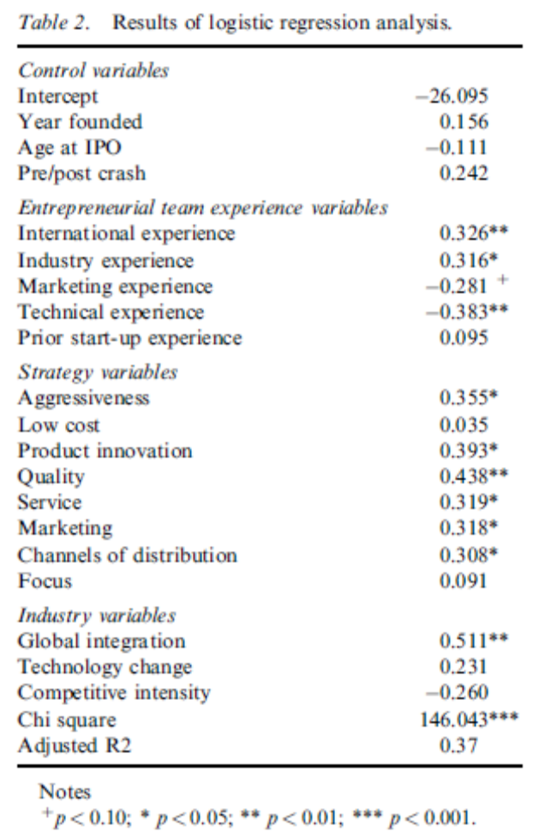

Appendix two: Correlation matrix ‘international spillovers’

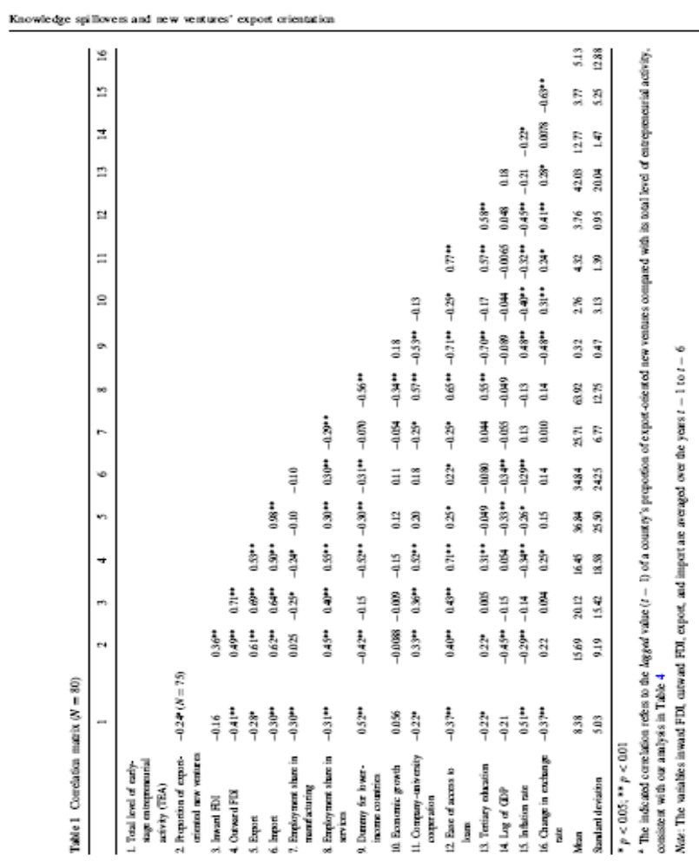

Appendix 3: Statistics ‘international spillovers’
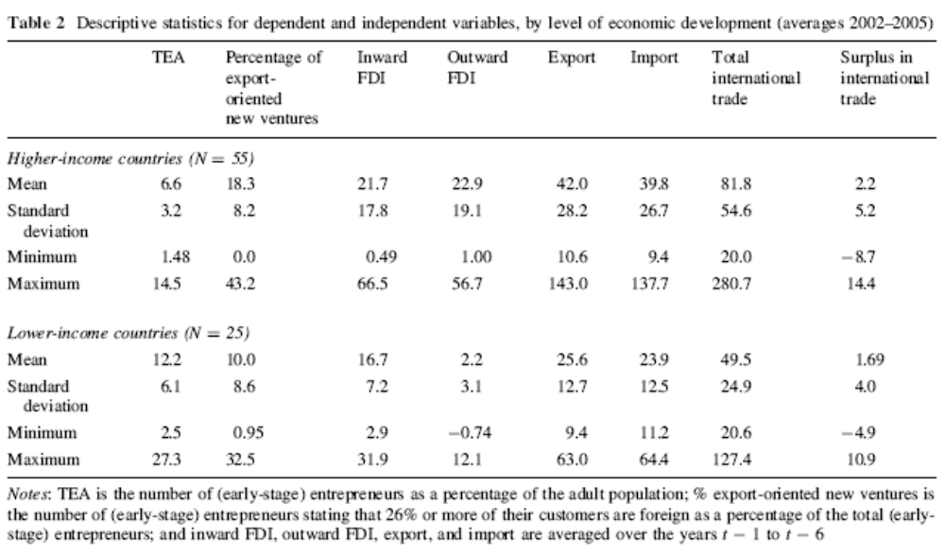

See appendix 4
See appendix 5

