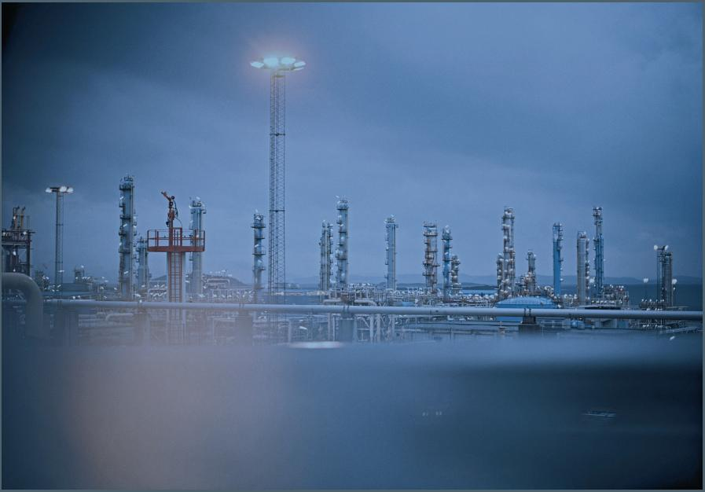
‘Three cases of cooperation between the Ministry of Economic Affairs and LNG related firms on the import of LNG’
Supervisor | | F.A.A. Boons
Second reader | | M.J.W. van Twist
Robert Zuurbier | | 280033
9/23/2010
 | 
IMPORT OF LNG: THE PUBLIC PRIVATE PROCESS OF COOPERATION AND MANAGEMENT OF EXPECTATIONS

Contents
Summary 6
Preface and acknowledgements 7
Chapter 1 Introduction 8
1.1 Research objective 8
1.2 Scope of the research 9
1.3 Scientific relevance 9
1.4 Practical relevance 9
1.5 Research questions 10
1.6 Structure of the thesis 10
Chapter 2 Theoretical framework 11
2.1 The basic idea: Easton’s system model 11
2.2 From Easton to Schulz 14
2.2.1 Inputs and the initiation context 15
2.2.2 Typology and role 15
2.2.3 Procedures 16
2.2.4 Effects: output, outcome and feedback 16
2.3 Schulz’s model adjusted: the conceptual framework 17
2.3.1 The initiation process: visions on cooperation 18
2.3.2 Typology: goals, actors and partners 22
2.3.3 Procedures 26
2.3.4 Effects 27
2.4 Management of expectations 28
Chapter 3 Research design and methodology 30
3.1 Design 30
3.1.1 Research strategy: case study 30
3.1.2 Unit of analysis and actors 30
3.2 Research method 31
3.3 Accuracy of measurements 31
3.3.1 Reliability 31
3.3.2 Validity 31
3.4 Methodology 32
3.4.1 Measuring initiation process 32
3.4.2 Measuring typology 33
3.4.3 Measuring procedures 33
3.4.4 Measuring effects 33
3.4.5 Measuring management of expectations 33
Chapter 4 Policy Context 34
4.1 Policy developments towards the gas hub 35
4.2 The gas hub as icon in Dutch energy policy 35
4.3 Energy related trade missions 37
Chapter 5 Three country units on the import of LNG 38
5.1 LNG, IOCs and NOCs 38
5.2 Cooperation as solution: Project Delta 40
5.3 Three cases: Algeria, Angola and Qatar 42
5.4 Algeria 43
5.5 Angola 46
5.6 Qatar 48
Chapter 6 Research findings 51
6.1 Initiation context 51
6.2 Typology 52
6.2.1 Orientation and role of the cooperation 52
6.2.2 Actors analysis 53
6.2.3 Partner selection 54
6.3 Procedures 56
6.3.1 Meetings 57
6.3.2 Activities: trade missions 58
6.4 Effects 62
6.4.1 Output 62
6.4.2 Outcomes and feedback 63
6.5 Management of expectations 63
6.5.1 Expectations in paradoxes 63
6.5.2 Case specific expectations 66
Chapter 7 Conclusions, discussion and recommendations 68
7.1 Discussion on findings 68
7.2 Conclusions 69
7.3 Recommendations 72
7.4 Notes for further research 73
Bibliography 74
ANNEX I Questionnaire 77
ANNEX II Interviews 80
ANNEX III Overview LNG related firms per country 100
ANNEX IV Organisational need for cooperation 101
ANNEX V Partner selection criteria LNG related firms 106

List of figures
Figure 1 Easton’s system model (Easton, 1965a) 12
Figure 2 Process of committees (Schulz, Van Twist and Geveke 2006, 23) 14
Figure 3 Conceptual framework of the process of cooperation 18
Figure 4 Input of conceptual framework 19
Figure 5 From consideration to ambition (Kaats, van Klaveren and Opheij 2006, 110) 21
Figure 6 Typology stage of conceptual framework 22
Figure 7 Triads of relationships (Stopford, Strange and Henley 1991, 22) 24
Figure 8 Procedures stage of conceptual framework 26
Figure 9 Output stage of conceptual framework 27
Figure 10Worldwide LNG Liquefaction and regasifacation capacity (National Energy Board Canada, 2009) 39
Figure 11 Proposed LNG consortia in the Netherlands (shareholders and capacity) 40
Figure 12 Combined results for the need for cooperation 52
Figure 13 Interrelations between actors, (based on Stopford, Strange and Henley 1991, 22) 54
Figure 14 Four types of energy trade missions (J. W. De Vries 2009) 59

List of tables
Table 1 Orientation of cooperation and characteristics (according to Schulz, van Twist and Geveke 2006) 23
Table 2 Paradoxes of expectations (Klijn and van Twist, 2007a). 28
Table 3 Partner selection, differences between public and private partners 55
Table 4 Two roles of the Ministry of Economic Affairs 56
Table 5 Operational variables procedures 60
Table 6 Characteristics of the trade missions (trade missions marked with an * included the Dutch Minister of Economic Affairs) 61
Table 7 Roles of public and private actors in the workgroups (based on Aamlid Syversen 2009) 65

List of Textboxes
Textbox 1 General premises of the System model (Easton, 1965a, 24-25) 13
Textbox 2 Porter’s and Fuller’s partner criteria (Child, Faulkner and Tallman 2005, 96-97) 25
Textbox 3 Gas Hub (Ministerie van Economische Zaken 2008A, 19) 36

List of Abbreviations
BCM Billion Cubic Meters
CSP Concentrated Solar Power, solar energy project
EVD Economische Voorlichtingsdienst, agency of the Ministry of Economic Affairs stimulating international entrepreneurship
IBO Investeeringsbeschermingsovereenkomst, Investment Guarantee Agreement
IEA International Energy Agency, international organisation acting as energy policy advisor
IOC International Oil Company, private multinational oil company
LNG Liquefied Natural Gas
LPG Liquefied Petroleum Gas
NOC National Oil Company, state owned oil company
MoU Memorandum of Understanding, bilateral agreement

Summary

This research scrutinises the public private cooperation between the Ministry of Economic Affairs and LNG related firms in three workgroups, targeting three LNG exporting countries (Algeria, Angola and Qatar). The research focuses on the process of cooperation and the management of expectation. The theoretical background used for analysing the three workgroups and provide a prescriptive conceptual framework are based on Easton’s system model (1965a) (1965b) and the model of Schulz, van Twist and Geveke (2006), who define four stages in the process of cooperation in the case of committees. The conceptual framework adjusts the existing literature in order to analyse and prescribe the process of cooperation in the case of the Ministry of Economic Affairs and LNG related firms. The management of expectations is integrated in this process of cooperation, based on the theory of Klijn and van Twist (2007b). The main research question relates the management of expectations to the process of cooperation in the three workgroups: ‘‘How can the Ministry of Economic Affairs manage expectations of cooperation when applying Schulz’ model to the case of the process of cooperation between the Ministry of Economic Affairs and LNG related firms in order to realise LNG import ambitions from Algeria, Angola and Qatar?’
The conceptual framework has provided the theoretical background to analyse and prescribe the process of cooperation between the Ministry of Economic Affairs and the LNG related firms. Schulz’s model has been revised in order to analyse the management of expectations during the process of cooperation. Here, the second stage of the conceptual framework, which involves the goal setting and partner selection, offers the opportunity for the Ministry of Economic Affairs to ‘think double’: the Ministry of Economic Affairs is able to play two roles in the three workgroups, as facilitator and as stakeholder. Now, the Ministry of Economic Affairs knows what the LNG related firms expect from the Ministry of Economic Affairs. Not only at the process level, which aims at the facilitating role of the Ministry of Economic Affairs and the process oriented role of the workgroups with a mediation and assisting goal, but also at the project level the Ministry of Economic Affairs should provide solutions for the LNG related firms to stimulate the LNG related firms.

Preface and acknowledgements

‘[...] To understand [energy] issues, we often need to resort to models. They provide a simplified version of the complex realities, yielding knowledge that can prove crucial in the long run. As a politician, I can put this knowledge to good use. But I have to apply it to practical policy issues in a complex world. A world where markets fail, where economic agents are not always rational, and where the international balance of power is shifting. Today I'd like to explore these themes and their significance in terms of the international energy market[...]’. This is how a speech started given by the Minister of Economic Affairs Van der Hoeven, at a conference of the European Association for Environmental and Resource Economics in 2009, (2009a).
This speech captures the essence of the thesis laying in front of you; the role of government in the dynamic energy market. My interest in the gas market was awakened at course at the TU Delft, ‘Electricity and Gas: Market Design and Policy Issues’, during which I’ve learned of the gas market and noticed a (European) policy gap on LNG. This brought me to the Ministry of Economic Affairs, where there was an opportunity to research the public private cooperation with LNG related firms.
The process of writing this thesis was very interesting as I’ve learned much during this period. Not only case specific information from the literature or during numerous meetings, lectures and conferences, but also being able to take on an internship at the Ministry of Economic Affairs gained me the opportunity to learn and provided me a new experience. Therefore I would like to thank Rodrigo Pinto Scholtbach, who took on the role of supervisor at the Ministry of Economic Affairs. His knowledge and visions on the gas market and his enthusiasm, emphasised by his dynamic character, helped me a lot during this internship. I would like to express my gratitude to Rodrigo for providing me the internship opportunity at the Ministry and his enthusiastic interest in my thesis project and his constructive advice throughout the process. Also, I would like to thank Bert Roukens for his support, and the help of the division Energy Market, providing me the opportunity to get in contact with the network. I would like to thank all the interviewees for their time and effort, including Martin Schulz for helping me out with the theoretical framework. Energyboy Jan Willem de Vries, thank you for your insights and the good times we had during our internship at the division Energy Market.
Moving on to the Erasmus University, I would like to thank Frank Boons, who joined me in this adventure. Although the writing process was not always easy, you’ve taught me some valuable lessons in life. Thank you for your advice and support during the process.
Then, there are my thanks to a lot of people on the background; I took some time and this thesis kept me from our conversations, visits or beers, so thank you JC Kroet, Château Niveau, study friends and rugby mates. Matthijs, your constructive support came at the right moment in time. Mom, dad, Paul and Sophie without your support I wouldn’t have graduated at all!

Robert Zuurbier - Rotterdam, August 2010

Introduction

The Dutch gas market has been characterised by public private cooperation from the moment the Groningen gas field has been discovered in Slochteren in 1959. Dutch government and private oil companies joined their efforts in the ‘Gasgebouw’ for exploiting, producing and distributing gas throughout the Netherlands and beyond its borders. The ‘Gasgebouw’ is the name of the complex set of policies, agreements and partnerships between the Dutch government and the private sector, controlling the ownership of the Dutch gas supplies (Köper 2009).
Now, five decades after the creation of the ‘Gasgebouw’ the outlook of the gas market has changed significantly due to changes in supply and demand and policy changes at both European and national level. However, public private cooperation in the Dutch gas market is still very relevant as public and private partners are both still very strong involved in the gas market in many roles.
From the moment the Slochteren field was discovered in 1959, the Netherlands became an important gas exporter for the European gas market. Now, fifty years later, the Ministry of Economic Affairs is seizing the future opportunities for the Dutch gas market. On the one hand, the future supply from the Dutch gas fields will decline and there are concerns surrounding the security of supply from foreign suppliers, on the other hand there has been installed a gas infrastructure throughout the Netherlands, the Dutch gas sector involves many industries and knowledge centres and the Dutch economy depends on the gas revenues. Therefore, the question is how to maintain the position as important supplier of the European gas market. In order to provide gas to Dutch and foreign (industrial) consumers, and extend the position as gas exporter, the Ministry of Economic Affairs proposed the idea of creating a Dutch gas hub (Ministerie van Economische Zaken 2008a). The gas hub would include the import and export of gas, adding (trade) services and strategically use the Dutch gas supplies and gas capturing, while connecting the gas streams of Northern Europe, Germany (with its Russian pipeline connection), the gas pipeline connection to southern Europe via Belgium to France and Italy and the interconnector to Great Britain, (Ministerie van Economische Zaken 2009b). However, as the national gas production will decline, the gas portfolio should be widened. Here, Liquefied Natural Gas (LNG) could be a solution, as this gas could be shipped in liquefied form to the Netherlands and then be regasified in order for it to flow through the Dutch gas hub for Northwest Europe.
The Ministry of Economic Affairs started to focus on the global LNG market, together with Dutch LNG related firms. It became apparent that these LNG related firms face difficulties when trying to contract LNG with LNG producing countries; the involvement of a government actor seems to be needed when contracting LNG. The Ministry of Economic Affairs realised it could play a role in the process of contracting and importing LNG; but how should this process of public private cooperation take place and what do the LNG related firms expect from the role of the Ministry of Economic Affairs?

Research objective
The objectives of this thesis are to explore and describe the cooperation between the Ministry of Economic Affairs and LNG related firms in order to contribute to improving the collaboration between those parties and with that, the overall process of importing LNG in the Netherlands. The process of cooperation between these public and private actors takes place in a certain way in order to combine interests and by doing so the cooperation targets specific countries by the combined efforts of the Ministry of Economic Affairs and the LNG related firms. The outcomes of the process of cooperation provide opportunities for the development of import of LNG, where both the roles of public and private actors play a role. These roles of the actors, the goals of the cooperation and the effects of the process of cooperation are the objects of this research. Within this cooperation context, this thesis provides an insight in the expectations of the LNG related firms regarding the cooperation and the role of the Ministry of Economic Affairs. The form of public private cooperation is at the core of this thesis and after analysing the process of cooperation and the management of expectations surrounding this process, recommendations will be made for the Ministry of Economic Affairs.
First, an exploratory research will to be done in order to understand the specific cooperation between the Ministry of Economic Affairs and the LNG related firms, as Robson puts it: ‘[...] To find out what is happening, particularly in little-understood situations[...] to seek new insights [...]’, (Robson 2002, 59). Then, a description has to be provided ‘[to] portray an accurate profile of persons, events or situations. [This] requires extensive previous knowledge of the situation etc. to be researched or described, so that you know appropriate aspects on which to gather information [...]’, (Robson 2002, 59). For both exploratory and descriptive research a flexible research design could be used, as will be provided in Chapter 3. Finally, recommendations for the Ministry of Economic Affairs will be included in this thesis about the process of cooperating with firms in the matter of LNG imports.

Scope of the research
This thesis will focus on the process of cooperation between public and private organisations. To be more specific, this thesis will scrutinize the cooperation between the division Energy Market of the Ministry of Economic Affairs and nine participating firms in order to generate the import of LNG from Algeria, Angola and Qatar. The process of cooperation in the three cases of Algeria, Angola and Qatar are the scope of this research, from the initiation of the cooperation, to the status of the situation when the interviews were conducted in May and June 2009.

Scientific relevance
The subject of cooperation between public and private actors has been described and tested in the scientific literature, from both the private and public perspective. However, the scientific relevance of this research lies in the fact that although strategic cooperation has been researched, the specific form of the process of cooperation like the one described in this research has not been described yet. The specific characteristics of the process of cooperation in the cooperation between the Ministry of Economic Affairs and the LNG related firms is unique in its sort; this form of cooperation has not been described or analysed in the existing literature. Therefore, this research will analyse the process of cooperation described in the cases by using concepts of Easton’s system model and a model from Schulz et al. (2006), and adding variables taken from existing literature, making measurement of strategic cooperation possible. In doing so, this thesis tries to relate theoretical concepts to a practical case study. The model of Schulz et al. has been created to analyse a different phenomenon (committees), which is described in Chapter 2, but is now used to analyse a strategic cooperation. This research aims to use Schulz’s model for another research object and in this way increase the usability of Schulz’s model. In addition, the management of expectations is linked to the adjusted model of Schulz et al. by adding theory of Klijn and van Twist, (2007a).

Practical relevance
The cooperation between the Ministry of Economic Affairs and the LNG related firms is regarded as the best possible opportunity for the LNG related firms to contract LNG from LNG exporting countries. However, so far no LNG contracts have been signed. Therefore, the Ministry of Economic Affairs is looking for instruments and mechanisms to enhance the process cooperation and effectiveness of the cooperation; the recommendations of this thesis are relevant for the existing form of cooperation and can be of use when deciding on starting a new cooperation. The conclusions and recommendations, which are part of this research, are intended to be of practical relevance to the Ministry of Economic Affairs and the LNG related firms participating in the cooperation.

Research questions
The topic of this research is process of cooperation and management of expectations throughout this process between the Ministry of Economic Affairs and LNG related firms. The research question is defined as:
How can expectations be managed when applying Schulz’s model on the process of public private cooperation between the Ministry of Economic Affairs and LNG related firms in the case of import of LNG from Algeria, Angola and Qatar?
In order to answer this research question, a number of sub questions are stated. By using theoretical concepts and making them measurable by adding variables in the conceptual framework, these sub questions can be answered:
- How could Schulz’s model be applied on the process of public private cooperation?

  - Why do partners regard cooperation as needed?
  - What are the characteristics of the cooperation?
  - What are the procedures involved in the cooperation?
  - What are the effects of the cooperation?

- How could expectations be managed in a public private cooperation?

Structure of the thesis
In the following chapter of the thesis, an overview will be provided of the theoretical framework. The theoretical concepts will be explained and a model will be given, which will be used to analyse the case. Variables will be added to this model, in order to answer the sub questions. In chapter 3, the research design will be provided and the reliability and validity of the research will be scrutinised. Chapter 4 provides the policy context of the three cases, which are described in chapter 5. Then, in chapter 6, the case will be analysed using the conceptual framework; the research findings are stated in this chapter. The final recommendations are to be found in chapter 7.

Theoretical framework

The process of cooperation between public and private actors has been the subject of scientific literature for many years, in different contexts and from public and private points of view. Public and business administration researchers have been interested in cooperation between the two sides of the civil society for decades. The cases of interest in this research are no exception to this, however, the specific characteristics makes the cases interesting. In order to analyse the cases, a range of theories will be used stemming from a variety of scientific schools and developed from both public and business administration. In this chapter, several theories will be combined in order to describe, analyse and prescribe the process of cooperation between public and private actors. A conceptual framework will be provided in order to analyse the cases. By using the conceptual framework a clear ‘roadmap’ for the process of cooperation and the management of expectations will be created, which will serve as the ‘theoretical lens’.
In order to provide a conceptual framework for cooperation, cooperation itself will has to be defined. Strategic cooperation between public and private actors comes in many ways and there are several typologies for cooperation between public and private actors, among alliances, networks, consortia or Public Private Partnerships. The definition used in this thesis is one formulated by Klijn et al., which stems from the Public Private Partnership theory. This theory describes the cooperation between public and private actors as the following: ‘A more or less sustainable cooperation between public and private actors in which collective products or services are being developed and in which risks, costs and returns are being shared among the partners’ (Klijn and Teisman 2000). Klijn and van Twist differ two sorts of PPP’s; one focusing on contracting, the other on partnerships. Because the cases do not consist of a contracting cooperation or a public tender for a specific service where private partners deliver public services or products, the second sort of PPP will be taken as the definition of cooperation: ‘In partnership-PPP’s separate and (parts of) projects are being integrated in order to create additional value. PPP’s are therefore organisational cooperation projects, integrating several projects. The additional value is created by synergy, by adding several projects together whereby interesting outcomes on content could be realised’, (Klijn and van Twist, 2007b, 159).
The characteristic of these partnership-PPPs is a joint decision-making structure, whereby public and private actors are involved in co decisive process of problem- and solution specification. Success factors to reach goals include the connection between ambitions and goals, clear rules on interaction and the creation of commitment and rewarding cooperation. The management style of this sort of PPP is focused on process management (goal attainment, allocation of actors and activities and the decision structure). Coproduction is aimed at the nature of ambitions and the linkage between the several ambitions, and along the cooperation on realising those ambitions, (Klijn and van Twist, 2007b, 159).

The basic idea: Easton’s system model
In order to explain the process of cooperation in this thesis, the process of converting inputs into outputs will be used; somehow the Ministry of Economic Affairs and LNG related firms have similar interests (inputs) and decide to work together (conversion) in order to source and import LNG (outcome). Easton’s system model serves as the basic theory in describing and explaining strategic cooperation. Easton’s theory emphasises the role and influence of the policy environment, which consists of the actors like policymakers, stakeholders and the civil society, on the policymaking process, which is his reaction to the Scientific Management movement. This scholar reasons from the technical procedures in a policy making process. ‘[..] There is no one-best way of organizing. The Scientific Management movement misjudges the specific demands which the environment asks, which is also ignored by the Science of Administration, the Human Relations movement and the revisionism [...]’, (Bovens, 't Hart and van Twist 2007, 244). ‘[...] In open systems, environment emerges as the crucial variable for organizational survival. To understand an organization, one must understand its environment. Managing an organization successfully requires constant monitoring of the environment and constant responsiveness to changes in that environment [...]’, (Heffron 1989, 9).
The system model has been applied in various political and sociological scientific researches, as the model is a general theory for identifying the interrelated influence of the environment on a political system. ‘[...] Easton’s system model could be applied to development of policy arenas on the long term. The model emphasises on the permanent, cyclical interaction between policymakers and their environment. It offers the opportunity to measure the influence of social-cultural changes on the policy process. However, Easton focuses on the political arena of the policymaking process [...]’, (Bovens, 't Hart and van Twist 2007, 148).
The relationship and interaction between the ‘system’ and the environment described as response is crucial to the model. As can be seen in Figure 1, the model works with a number of concepts. ‘[...] The system functions in a ceaseless process where inputs of the environment are being transferred by government (through the policy process) into outputs (policy decisions). The outputs aim to provoke changes in the environment. The results (outcomes) of the political efforts are considered in the environment and will lead to new inputs’ [...], (Bovens, 't Hart and van Twist 2007, 147). The model assumes a continuous process: ‘[...] A system is an ongoing process that transforms certain specified inputs into outputs; these in turn influence subsequent inputs into the system in a way that supports the continuing operation of the process [...]’, (Rainey 2003, 9).
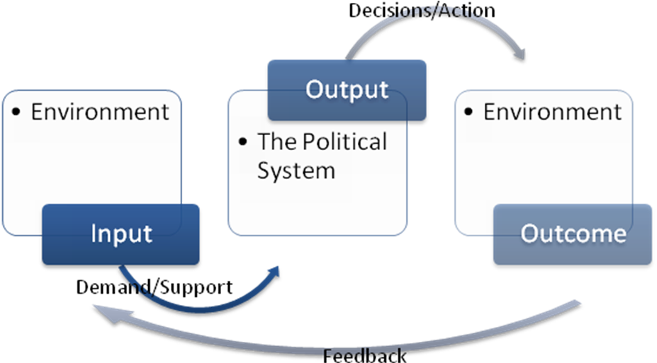
Figure 1 Easton’s system model (Easton, 1965a)
Easton conceives the political policy making process in a model consisting of several concepts, as could be seen in the model. These concepts represent parts of the ‘policy making reality’. Textbox 1 provides concepts of Easton’s model, explaining the interaction between the environment and the system.
‘[...] Systems analysis as conceived here will be built upon the following general premises. Only the first two of these need it share with other modes of analysis that revolve around the concept ‘system’ as a primary axis.
1 System. It is useful to view political life as a system of behaviour.
2 Environment. A system is distinguishable from the environment in which it exists and open to influences from it.
3 Response. Variations in the structures and processes within a system may usefully be interpreted as constructive or positive alternative efforts by members of a system to regulate or cope with stress flowing from environmental as well as internal sources.
4 Feedback. The capacity of a system to persist in the face of stress is a function of the presence and nature of the information and other influences that return to its actors and decision-makers [...]’

Textbox 1 General premises of the System model (Easton, 1965a, 24-25)
Policy making in the ‘political life’ might be at the core of Eaton’s system model, but what is of use to this research is the process of the system model. ‘[...] The usefulness of the system model depends on the degree of the availability of information of inputs, throughputs and other factors, and on degree of the congruence between the approach of issues and clear, well-defined and ‘hard’ cause-effect relationships. When information on parts of the system is available and when relationships between parts are clear and direct, the system could be optimised. When this is not the case, problems occur usually on the output or outcome side of the system model […]’, (Noordegraaf 2004, 152). The system model is not an operational tool; the concepts used by Easton are still vague and there is no clear idea of what this ‘system’ entails. Definitions of and measurement tools for the concepts are therefore much needed, but it is possible to use Easton’s model in order to conceptualise complex phenomena: ‘[...] In emphasising processes as opposed to institutions or structures, the approach is also useful in disaggregating the policy process into a number of different stages, each of which becomes amenable to more detailed analysis [...]’, (Hill 2005, 20).
The generic nature of Easton’s model will be of use for this thesis; however, specified and measurable variables will have to be added in order to indicate the inputs and outputs. In order to ‘differ stages’ in Easton’s system model to analyse strategic cooperation, an operational framework will be used. This framework is based on Easton’s system model and makes use of the input-conversion-output process and its concepts. However, the focus of the framework is not Easton’s ‘political system’, but it will be used to describe the process of cooperation between public and private actors. Therefore, a model is needed which is able to differentiate several stages in a process of cooperation. Schulz et al. (2006) have designed such a framework, which scrutinizes the phenomenon of ‘committees’ in several stages during its cooperation process. Although the phenomenon of committees is different from the research object of this thesis, being the process of cooperation between public and private actors, the model of Schulz is useful, as it is able to the several stages in a process. Their model has indicated four stages in the process of committees, which make operational measuring possible. In this way, the concepts of Easton are made measurable. The conceptual framework used in this thesis will be based on the model of Schulz et al. as it identifies several stages in the process of cooperation, while using the concepts of Easton. The choice for the use of the theory of Schulz is based on the different stages in the process of cooperation. There are similarities in the formation of committees and the process of cooperation between the Ministry of Economic Affairs and LNG related firms, which will be explained in the following paragraph.

From Easton to Schulz
In order to measure the concepts of Easton’s system model they will have to be integrated in Schulz’s model. First, the model designed by Schulz, van Twist and Geveke (2006) will be explained, which takes the basic idea of converting inputs into outputs in order to describe and identify the phenomenon ‘committees’ and its role in the contemporary system of governance and policymaking.
The analytical framework of Schulz et al. describes a process, explained by them as follows: ‘[...] Events in the environment of the committee and of the organisation of the initiator determine the context out of which the committee originates. Each committee has a specific compilation with specific relations between its members. These factors combined determine the terms of reference and procedures of accomplishing their tasks. Eventually, both the environment and the initiator encounter the consequence of the work done by the committee [...]’, (Schulz, van Twist and Geveke 2006, 23), (see Figure 2).

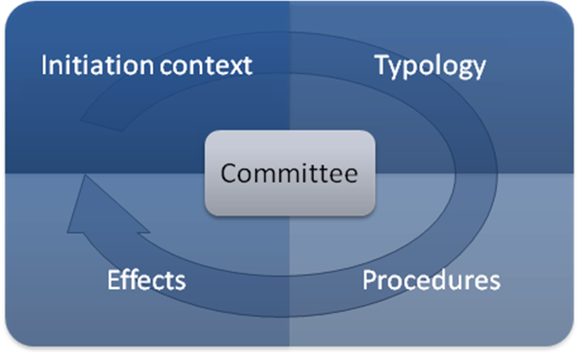
Figure 2 Process of committees (Schulz, Van Twist and Geveke 2006, 23)
The initiation of a committee originates in the societal context, which could be a new problem or a chronic issue, or emerging opportunities or threats. In other words: the societal context provides the ambitions and motives for the initiation of a committee, which affects the characteristics and compilation of the committee. Political sensitive subjects will demand a committee with a broad political scope, where other issues require certain expertise or administrative confidentiality. After the committee is composed, it will start its task. However, certain procedures will have to be taken into account. Procedures on openness of the committee for example open hearings versus closed meetings, or procedures on the final decisive making power. Eventually, the results will have to be presented and will the outcomes be put to practice.
They analyse ‘committees’ by taking several stages in the lifecycle of committees, but in doing so they follow Easton’s system model. Committees, as strategic cooperation and Easton’s political system, consist of inputs, outputs and outcomes. In a way, Schulz et al. adjust Easton’s model to explain a phenomenon by adding successive steps; they turn the model into a process. Different stages are assigned to the input-output process, in order to analyse the process of committees; Easton’s concepts are made measurable using case specific variables. In each stage of the model created by Schulz et al., the input-output process is differentiated and concepts defined in order to create a measurable toolkit. Inputs, outputs and the conversion process, which are vague in Easton’s model, are turned into defined variables by Schulz et al. to provide a tool to analyse the phenomenon of committees and capture its characteristics. Schulz’d model applies ariables to stages in Easton’s model, which makes it possible to accurately analyse the subject of their research. The reason why the research and model of Schulz et al. will be used is that it divides the process of cooperation (in their case cooperation in ‘committees’) in measurable parts, using specific variables in order to analyse its subject.
There is a clear linkage between the analytical model of Schulz et al. and Easton’s system model in the connection between the interrelated environment and the process at hand, which is in their research the committee. The initiation context of a committee could be taken as input, where the committee produces outputs in the form of reports or recommendations, which will have their effect in the policy environment. These overlapping concepts of both Easton and Schulz et al. will be combined per step in the analytical model of Schulz et al; Easton’s concepts have been used by Schulz et al., to which they added measurable variables.

Inputs and the initiation context
‘[...] The value of inputs as a concept is that through its use we shall find it possible to capture the effect of the enormous variety of events and conditions in the environment as they pertain to the persistence of the political system. Without the inputs it would be difficult to delineate in any precise operational way how behaviour in the various sectors of society affects what happens in the political sector [...]’, (Easton, 1965a, 112-113). Easton regards inputs as a concept to capture effects in the environment. Easton’s concept of ‘input’ is aimed at the ‘drivers’ of behaviour of actors, which shapes the process of policy making. The environment provides inputs in the form of demand or support, which Schulz et al. label the initiation context: ‘[...] Events in the environment of the committee and of the organisation of the initiator determine the context out of which the committee originates [...]’, (Schulz, van Twist and Geveke 2006, 23). Schulz et al. have used several variables to analyse the initiation context and identify the issue which should be the concern of the committee. First, they have defined four sorts of motives for the initiation of committees, which have their origin in the environment and are specific for the phenomenon of the committees. These motives are made tangible in order to provide the opportunity to measure the initiation context. The motives are to be found on two axes; a time axis (from short to long term) and one axis indicating the public attention of an issue. The timing of the initiation process and the political background of committee initiators are analysed. These inputs are formed around an issue in the environment and form the initiation context; an issue has been identified which is to be solved by the committee. In this way, Schulz et al. have created measurable variables indicating several characteristics of the initiation process of committees. All these variables stem from the environment, indicating demand or support for the initiation of committees; Schulz’s ‘events in the environment’ equals Easton’s ‘demands and support’, which allows committees to be composed.

Typology and role
After the initiation context is analysed and the need for a committee is acknowledged, the next step is to analyse the purpose of the committee, its goals and compilation of the committee itself. When demands or wants are known, these inputs will have to be voiced by ‘gatekeepers’ as Easton labels them: ‘It determines who converts want to demands and therefore their number and content’, (Easton, 1965b, 84). ‘Perhaps the most appropriate way to characterise these structural points in the system is to designate them as gateways regulating the flow along the demand channels’, (Easton, 1965b, 88), which in Schulz’s model can be seen as the committee itself, composed of several actors. Each member in a committee is such a ‘gatekeeper’, providing inputs and shaping the demands in the committee. Insight in these ‘channels of demands’ is therefore part of Schulz’s model, whereby characterization of the committee is of essence in the second part of the model.
Schulz et al. find that a committee could serve several goals, but setting the goal itself is very important for the process of the committee. Schulz et al. have found that committees might serve several goals in society and therefore they have identified several types of roles of committees, categorised in two sorts: goal-oriented committees and process-oriented committees, (Schulz, van Twist and Geveke 2006, 62). Goal-oriented committees could have a specific case which they research, advise upon, evaluate or stimulate. This sort of committees has a certain goal which it tries to obtain. Process-oriented committees focus not on the policy goal, but the policy process instead. Here, guiding or assisting a policy process is the focus of the committee, or mediation between actors. A process-oriented committee could propose an alternative or advocate certain policy. Again, the orientation of a committee determines the role a committee plays in the policy arena; is the role of the committee to put an issue on the public agenda or to evaluate a certain process? Timing in the policy process is therefore an important characteristic of committees, according to Schulz et al. (2006,69). Schulz et al. conclude that committees are most active in the agenda setting and preparation phase of the policy process and less in the evaluation phase. Besides, the committee is compiled of several members; each with specific characteristics like experience, professionalism, authority, political preference, style of age management and age. By taking all these characteristics, from the goals of the committee to the background of the individual committee members, Schulz et al. have created a tool to analyse the characteristics of the committee.

Procedures
The next step is to analyse the procedures in the committee. Easton’s model does not regard procedures as a measurable part in the political system and is therefore more concerned with the reduction of demands via channelling, while Schulz et al. take a more practical look at their subject. What are the actual activities conducted by the committee? With which tools do the committees aim to achieve their goals? First, Schulz et al. indicate several activities of committees, ranging from reading documents, to call meetings or convoke hearings. However, these activities differ per committee and to its related goals. Therefore, Schulz et al. note in their research a number of characteristics of procedures of committees; the degree of publicity (openness) of the work of a committee, the political influence (the degree of independency), the time scale of committees (from initiation to output in months) and the costs involved of a committee. These are tangible variables of the activities and characteristics of procedures of committees.

Effects: output, outcome and feedback
‘[...] Outputs [are] transactions moving from the [political] system itself to its environment. [...] It will be confined to those kinds of occurrences already described as authoritative allocations of values or binding decisions and the actions implementing and related to them[...]’, (Easton, 1965a, 126). In the variables used by Schulz et al. the direct output is the report written by the committee; the variable could even be numerically measured by the number of pages, (Schulz, van Twist and Geveke 2006, 112).
Schulz et al. measure the effect of a committee according to whether or not, and if so, in what way the cabinet responds to the final report. More important in this matter is the final outcome of the report, made measurable by Schulz et al. by indicating the follow up after the report of the committees has been published: the making of new policy, revising of policy, the initiation of new committee, internal action or passive attitude (non action). By indicating the follow up of a committee, its effect (outcome) can be measured. On its turn, the outcome serves as input for the next step in the process. As Easton puts it: ‘[...] In effect it conveys the idea that the political system looks like a vast and perpetual conversion process. It takes demands and support as they are shaped in the environment and produces something out of the called outputs. [...] We are alerted to the fact that the outputs influence the supportive sentiments that the members express toward the system and the kinds of demands they put in. In this way the outputs return to haunt the system, as it were [...]’, (Easton, 1965b, 29). The findings in the final report (output) might arouse questions in the cabinet (outcome), which could cause the initiation of a new committee (input).
The definition of feedback is the return of information to the authorities, providing decision-makers the ability to regulate or ‘correct’ their behaviour (Easton, 1965b, 366). Committees in Schulz’s model provide the decision-makers such feedback, as this is at the core of the initiation of committees.
Although the subject of their research is different from this thesis, committees versus public private cooperation, the initial stages of the process of cooperation in their research could be applied to this research, as a committee is a form of cooperation as well. The model is a helpful tool to analyse the case, however, it will has to be revised because the object it tries to analyse is different. Therefore, variables will have to be added to the model in order to analyse the phenomenon of public private cooperation; a new conceptual framework will be developed based on the model of Schulz et al., in order to analyse the phenomenon of public private between the Ministry of Economic Affairs and LNG related firms.

Schulz’s model adjusted: the conceptual framework
Schulz et al. have adjusted Easton’s concepts and have proven the usability of their analytical model by applying measurable variables in each stage of the committee process. As explained above, committees have their own specific characteristics, goals, procedures and effects. Therefore, the analytical framework used by Schulz et al. will has to be adapted to the research done for this thesis. The phenomenon of the cooperation between the actors in this research will use other variables of interest, depending on specific characteristics of the cooperation at hand. For example, the research of Schulz et al. does not include trade missions or specific issue driven ambitions of the LNG market. As the strategic cooperation between the Ministry of Economic Affairs and LNG related firms is a particular strategic cooperation, specific variables should be used for the analysis of the cooperation. However, the process and its sequential steps in the analytical descriptive model of Schulz et al. have proven their usefulness and specific variables for measuring strategic cooperation will be inserted in the model.
The concept of strategic cooperation could now be placed in the centre of Schulz’s analytical model and in this way a new theoretical model will be designed, shown in Figure 3, the conceptual framework. This framework consists of the stages of the Schulz’s analytical model however it makes use of other variables in order to capture the process of cooperation between public and private actors. This conceptual framework is a prescriptive model as it provides guidelines for the process of cooperation between public and private actors.
The conceptual framework consists of four stages, as could be seen in Figure 3. These four stage, or steps in the process of strategic cooperation, will be broken up in parts and will be scrutinised in this section, providing operational variables for the model. These variables used in this research are chosen specifically according to the object of the research. First, the range of ambitions and need for cooperation will be analysed. Then, the characteristics of the strategic cooperation are covered, followed by the internal procedures. Last, the variables indicating the effects and outcomes will be given. The model is a continuous process, which means that outputs created during the cooperation process serve as inputs for the further process of cooperation. Cooperation is therefore on ongoing process, which makes use of the achieved results or outputs.
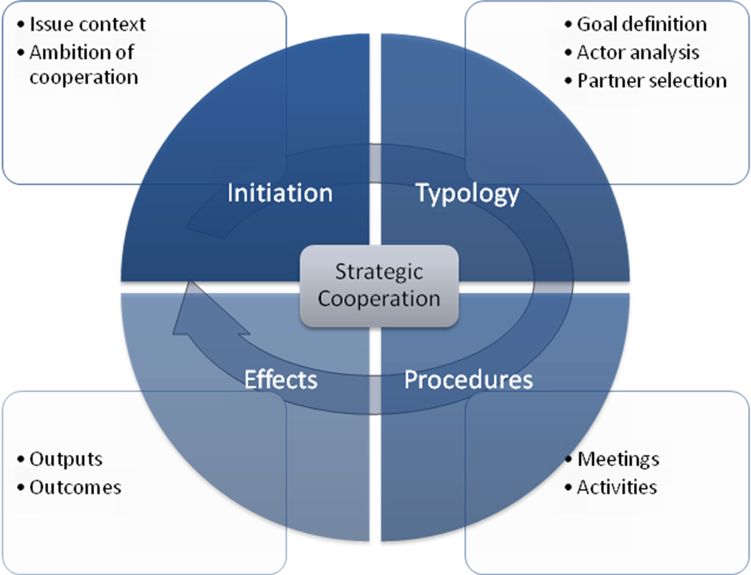
Figure 3 Conceptual framework of the process of cooperation

The initiation process: visions on cooperation
Like committees, each strategic public private cooperation has its own specific context; an urgent issue, a specific problem or a special need in order for organisations or institutions to work together. Schulz et al. measure the initiation of a committee using two axes, indicating time and public publicity in the environment. Measuring strategic cooperation will need more attention, as there is a wide range of dynamics involved in the case. Out of those dynamics in the environment the inputs for cooperation are shaped by organisations, which serve as starting point for cooperation. The first step is to make clear what this ‘common ground’ for cooperation is and if organisations have congruent ideas and ambitions to start cooperating with another, (Schulz, van Twist and Geveke 2006, 23). In order to ‘streamline’ those ambitions and create converging terms of reference in order to solve common problems or issues, the initial ideas of cooperation should meet; are organisations on the same level? The initiation process of a strategic cooperation consists of the context itself and the ambition of cooperation, see Figure 4.
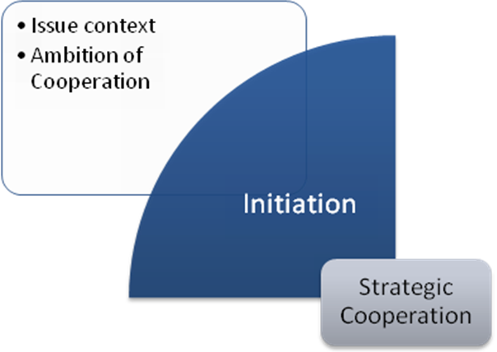
Figure 4 Input of conceptual framework
The context of an issue or problem is the reason for cooperation. The dynamics of the environment will have to be known in order to understand the inputs, which is this case are the dynamics of the Dutch gas market, specified on LNG. These facts in the environment create inputs of the cooperation. Out of the dynamics, organisations will have to identify their need for cooperation in order to solve the specific issue. Therefore, a model will be used to identify the ambitions or motives for cooperation. Kaats et al. (2006, 110) have identified ten generic axes with considerations for cooperation between organisations. The ten axes cover a wide range of issues of cooperation. The identification of the considerations for cooperation is necessary in the first part of the strategic cooperation process, because it provides the ‘common ground’ for cooperation. If organisations do not regard cooperation necessary for solving a problem, the whole purpose of cooperating is becoming irrelevant. Therefore, a measurable tool created by Kaats et al. will be used to identify the need for cooperation in a sector, by measuring considerations for the need for cooperation, out of which Kaats et al. identify three visions on cooperation. The ten axes which identify these ambitions are:
- The degree of dynamics in the environment in which the cooperation should be formed; from dynamic to stable.
- The degree of cooperation in the (sub-) sector; from much cooperation to limited.
- The degree of cooperation skills of competitors; from good to limited.
- The degree of willingness to cooperation; from much to limited.
- The role of an organisation; from a directors’ role to an executive role.
- The degree of capacity to realise goals alone; from much to limited.
- The degree necessity of providing an integrated product or service; from necessary to limited.
- The degree of necessity of cooperation; from strategic to operational.
- The degree of complexity of cooperation; from complex and multilateral to simple and bilateral.
- The degree of exploration of new products/markets; from exploration to exploitation.
As can be seen from the ten axes, the ambitions stem not only from the organisations itself, but from the environment an organisation operates in as well; again, the environment shapes the need for cooperation. ‘[...] Cooperation is not a goal in itself; it serves a goal. Therefore, cooperation is a tool. [...] Without ambition and goals it is hard to organise a sustainable cooperation [...]’ (Kaats, van Klaveren and Opheij 2006, 102). The identification of the need for cooperation is necessary; what is called ‘ambition’ by Kaats et al. ‘[...]We believe that at an increasing rate it is of importance for organisations to create a vision on cooperation and state goals for cooperation [...]’, (Kaats, van Klaveren and Opheij 2006, 102). The axes make it possible to measure the vision on cooperation by individual organisations: is cooperation needed according to the actors involved? Kaats et al. have distilled three visions on cooperation, which will be described shortly below. The three visions are three levels of increasing cooperation or can be seen as development phases in cooperation.

Cooperation as incidental solution
Cooperation is regarded as a given fact; there are several cooperative actions, without naming them a cooperation. ‘[...] Within these organisations cooperation is regarded as a tool which might come to use at a given point in time. These organisations reason from their own position and think of cooperation as opportunities or as a solution for a problem. They don’t see cooperation as strategic issue and therefore we call this ‘implicit cooperation’[...] (Kaats, van Klaveren and Opheij 2006, 103).

Cooperation as structural instrument
By cooperating between organisations, organisations learn about the process of cooperation. This is what Kaats et al. call the ‘first intervention’: ‘cooperation as object of learning’ (Kaats, van Klaveren and Opheij 2006, 104). Organisations are able to understand that their knowledge of cooperation and experience in cooperating can grow and the benefits of cooperation can increase. ‘[...] this will lead to increasing the quality of cooperation, regarding the effectiveness of cooperation [...]’ (Kaats, van Klaveren and Opheij 2006, 104).
The ‘second intervention’ is achieved by integrating cooperation into the management. ‘[...]This is done by stating explicit objectives and expressing expectations about the effectiveness of cooperation and the result of the cooperation relationship. Even by setting objectives organisations gain experiences and these experiences can be regarded as learning experiences in cooperation. In this stage, formalisation or standardisation of cooperation between organisations takes place [...]’, (Kaats, van Klaveren and Opheij 2006, 104). By acknowledging the importance of cooperation organisations embed cooperation in their objectives. Because cooperation will be part of daily operations, knowledge and experience has to be gained and responsibilities for cooperation are delegated within the organisation.

Cooperation as ‘way of life’
Cooperation is part of the identity of the organisation; cooperation is at the core of the vision and the mission of the organisation. ‘[...] The organisation makes cooperation a part of its identity, regards itself as a network-organisation and makes the learning process of cooperation core of business units [...] Modularisation plays an important role in the management and set-up of the organisation. This means that the business is divided in several modules, serving a particular part of its clients or producing a particular product. [...] When modules are not incorporated, they can be attracted from outside the organisation [...]’, (Kaats, van Klaveren and Opheij 2006, 105).
The axes as mentioned above measuring considerations for cooperation or ambitions and the visions on cooperation are placed in Figure 5.
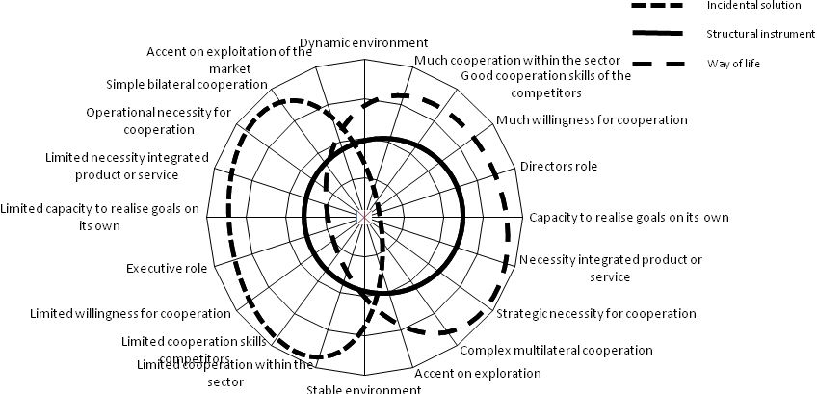
Figure 5 From consideration to ambition (Kaats, van Klaveren and Opheij 2006, 110)
The visions on cooperation of Kaats et al. will be used in the conceptual framework, as their tool makes the measurement of the need for cooperation possible. When the visions on cooperation match between organisations, the need for cooperation is acknowledged by organisations. This is the first step of forming a strategic cooperation: organisations affirm the fact that strategic cooperation is necessary in order to achieve its goals.
By measuring the considerations for cooperation stemming from the environment, the need for cooperation can be identified. When this need is identified, organisations can proceed to the next stage in the process of strategic cooperation: finding partners to cooperate with.

Typology: goals, actors and partners
The goal and compilation of a strategic cooperation are the characteristics which will be scrutinised in the second step in the process, providing more structure to the cooperation, see Figure 6. This stage of the conceptual framework provides an insight in the characteristics of the strategic cooperation: what are the goals of the cooperation and who are involved?
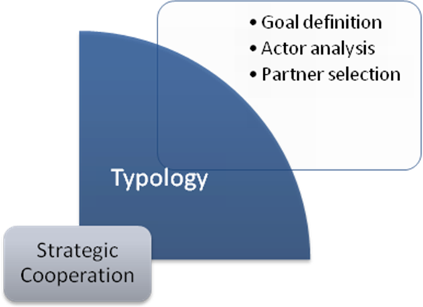
Figure 6 Typology stage of conceptual framework

Goal or process orientation
The goal identification of a cooperative relationship is essential for the following steps of the conceptual framework, as the goal defines the core of the cooperation. For the identification of the goals of cooperation, the goal and process orientation as described by Schulz et al. will be of use in this stage of the process, providing a measurable overview of the goals and roles of the cooperation. The orientation of the cooperation defines the role and the goals of the cooperation. Schulz et al. have identified eight roles for committees, which will be used in order to identify the role of the cooperation in the case as well. The orientations and their according roles of cooperation are listed in Table 1.

Orientation and role | Characteristics | Timing in policy process
Goal oriented cooperation
Researching | Recover facts or events, for informative purposes | After event, calamity or (media) attention
Advising | Research in order to judge or advise upon findings for policy advise | Policy preparation
Controlling | Evaluate content, quality or effectiveness of policy | Policy evaluation
Stimulating | Pro-active role to stimulate, achieve or implement change in policy | Policy implementation
Orientation and role | Characteristics | Timing in policy process
Process oriented cooperation
Assisting | Contribute to successful implementation in complex situations, based on experience | Continuous
Mediating | Mobilize support, find consensus among parties | Continuous
Reconsidering | Find alternative solutions for complex problems | Continuous
Advocating | Decisive role in political debate, steering role on velocity or content | Continuous
Table 1 Orientation of cooperation and characteristics (according to Schulz, van Twist and Geveke 2006)
The timing of goals during the policy cycle, goals are linked to their specific time scale as goals could evolve over time. Therefore, three time scales are identified which are also linked to the goals of the trade mission: short, mid and long term. These time scales will be elaborated on in the methodology of the research variables, in paragraph 3.4.3.

Actor analysis
This step clearly shows the difference in the roles and positions of the several actors within the cooperation; therefore, public and private actors will have to be identified and common interests will have to be defined in order to cooperate. This step will provide tools to do so on an actor bases. The compilation process of the conceptual model is divided in two parts; the identification of the relationships between the actors involved and identification of specific characteristics of the strategic partners, see Figure 6. Note that a differentiation is being made between actors and partners. Actors are the sectors involved, where partners are the actual organizations participating in the cooperation.
Where public and private organizations cooperate, borders of sectors are crossed and roles differ. However, from public parties to private actors; all parties depend on each other in the case, creating interrelated relationships. These relationships are shown in Figure 7, identified by Stopford et al.: ‘[The] players in the embassies and foreign ministries are still in business, but they have been joined by members of other government ministries and by the executives of firms, both local and multinational. All are involved in both bilateral and multilateral negotiation [...]’, (Stopford, Strange and Henley 1991, 21).
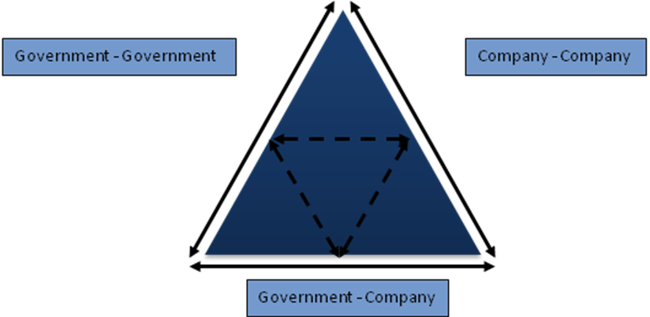
Figure 7 Triads of relationships (Stopford, Strange and Henley 1991, 22)
Before selecting the specific partners, this model analyses the relationships and the roles of the different actors. As government-to-government relations are different from government-to-company relations, the relationships will have to be identified, in order to know which actors are relevant in the case. These relationships are not to be taken light-heartedly: ‘[...] Frequently, as in inter-state diplomacy, elements of both conflict and cooperation exist simultaneously in the [...] process. The asymmetry of the process makes the choice of partner critical. For states, a sickly corporate partner may be just as damaging as an alliance with a weak or vacillating state. The other side of the coin is the firm’s choice of national site [...]’, (Stopford, Strange and Henley 1991, 22-23). As there are different relationships involving different actors, with different interests, an actor analysis can be made by identifying these relationships; how do the actors relate to each other?

Partner selection
When the relevant actors are known and their interrelationships are known, the next step is to define the strategic partners involved in the cooperation according to their role in these relationships; now, the partners could be ‘filled in’ according to their specific roles and interests.
In order to define the partners prescriptive criteria will be used, identified by Porter and Fuller (1986). Child et al. (2005) describe the process of selecting partners from a firm’s point of view. On finding the right partners for a strategic cooperation, Child et al. have written the following: ‘[...] Considerations of which partner and what form of cooperation appear to provide the best chance of success are the closing issues in the first phase of the alliance process. The decision having been made by (or forced on) the focal firm, the choice of contractual or equity alliance (and the details within each of these broad categories) and the choice of which of the prospective partners will be most compatible together move the process toward the critical transactional step of one-on-one negotiation. At this point, transaction-specific investments of time, money, and effort increase dramatically, as do the pressure to close a deal successfully, and the risks of a badly structured deal or poorly chosen partner climb. Bargaining and negotiations are critical to a strong alliance, and may result in changes to the initially preferred form, but choice of partner is difficult (and costly) to reconsider, plays a large part in the eventual success of the negotiation of the deal, and ultimately a poor selection cannot be corrected by the structure of the deal [...]’, (Child, Faulkner and Tallman 2005, 96-97). However, there are still certain characteristics which are to be found in a strategic partner. Porter and Fuller have identified six criteria which are essential when selecting a partner (see Textbox 2). Again, this is from a corporate point of view, but is an effective way for a public-private cooperation to select partners as well.
‘[...] Porter and Fuller (1986) identify six criteria by which they believe the appropriateness of an alliance partner may be judged:
1 Possession by the partner of the desired source of competitive advantage. By this Porter and Fuller mean that the partner should have the requisite scale, technology, market access or other contribution to give the coalition the competitive advantage that neither partner possesses alone.
2 The need for a complementary or balanced contribution from the partner. Porter and Fuller should perhaps have written ‘and’ not ‘or’ before ‘balanced’, since it is probably necessary that the partners are both complementary in their contributions, but also are roughly similar in size or strength so that the partnership is one of equals and not dominated by one or the other partner.
3 A compatible view of international strategy. If one partner is intent on concentrating in one trading area, this must be acceptable to the other. Their attitudes to the international coordination and configuration of their joint enterprise must also be congruent.
4 There must be a low risk of the partner becoming a competitor. This criterion is often ignored, however, as many alliances are set up between competitors. […] Clearly such potential future competiveness does not preclude the possibility of a successful alliance. It does, however, make the ever-present tension between the need to cooperate and the urge to defect and fight one’s erstwhile ally more of a problem to the establishment of trust and commitment than it would be in an alliance between partners cooperating at different point in the value chain. […] The dilemma of cooperation versus competition can be elucidated by the game theory.
5 The partner has pre-emptive value in relation to rivals. Setting up an alliance with the partner would thus undermine the range of apparent strategies of competitors.
6 The partners’ organizational compatibility is high. This criterion, in Porter’s and Fuller’s view, reduces the probability of future problems due to cultural conflict. [...]’
Textbox 2 Porter’s and Fuller’s partner criteria (Child, Faulkner and Tallman 2005, 96-97)
With these relations and criteria being analysed, an analysis of the actors can be made, which specifies on the characteristics of the partners. After the partner selection, the internal procedures and proceedings should be coordinated. The third consecutive stage in the conceptual framework covers this part.

Procedures
After the identification of the need for cooperation and the partners involved, the next step is to analyse the procedures within the cooperation, see Figure 8. When several organisations work together, especially when cooperation among competitors is concerned, procedures should be formulated to keep a strategic cooperation workable and effective. These procedures serve as converging processes in the strategic cooperation. The procedures of a public private cooperation will be broken up in two in this conceptual framework: meetings and activities.
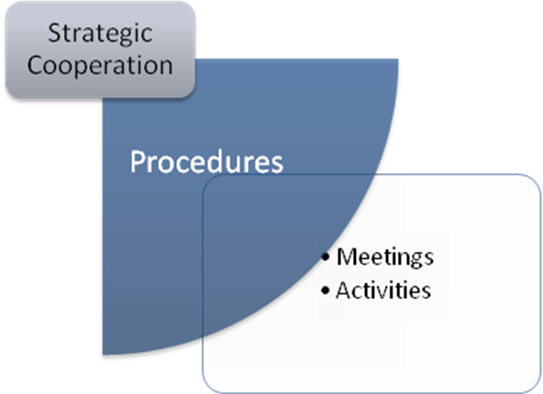
Figure 8 Procedures stage of conceptual framework
Sharing of knowledge between strategic partners is a discussed subject and this might even decide the eventual form of the strategic cooperation and participation in the collaboration. Note the way procedures are followed; formalisation and the structure of meetings have a significant impact on the structure and form of the cooperation. Therefore, partners should align their goals and roles in procedures in order to create an effective and efficient cooperation. Additionaly, time management is an important aspect of the cooperation: when should the organisations be meeting and on what time scale does the cooperation operate? And the costs of cooperation are an important aspect as well for all participating partners: what are the (shared) costs of cooperation? Is there an ‘entrance fee’ or an annual contribution system? In the conceptual framework, the procedures stage is subdivided into general meetings and its activities.

Meetings
Meetings are the essential for a strategic cooperation, as those are the moments where responsible managers of participating organisations actual get together. Meetings could be held with all the participating partners, a number of them or individual meetings could be arranged, depending on the goal of the meeting. Before a meeting the agenda is set, which is to be sent to the partners. Rules and roles during these meetings should be clear to all the participants, usually the role of an actor depends on the goal it tries to achieve (during a meeting). When direct competitors take part in a meeting where strategic corporate information is shared, rules on secrecy should be clear to all partners. Therefore, not all the information is shared between partners; some information will not be shared at all. It should be kept in mind that a certain level of trust is involved in cooperation. However, in order to achieve common goals, partners will have to overcome trust barriers in this process of information sharing; either way partners share their information with the whole group or only with specific actors. Eventually, decisions should be made on sending the minutes of a meeting to the partners. This decision depends on whether or not classified strategic information is to be shared or not.

Activities
The joined activities in the cooperation are bound to the nature and goals of the cooperative ambitions of the partners. According to the agenda and common goals of the cooperation, the activities take place. However, agreement on costs of joined activities and the duration of the activities should be reached among the participating partners, the terms of reference. In the case of the cooperation between the Ministry of Economic Affairs and LNG related firms the activities which are conducted are in the form of trade missions.
Eventually, when the strategic cooperation is compiled and the procedures are in place, the strategic cooperation should produce outputs. This final step is included in the conceptual framework as well.

Effects
The effects of the strategic cooperation could be measured as well, see Figure 9. Decisions taken by the participating organisations, both public and private are the direct outputs of the strategic cooperation. Results achieved by individual organisations are the final outcomes of the cooperation. Outputs will provide opportunities for actors in the strategic cooperation, as these will be taken as inputs for the future.
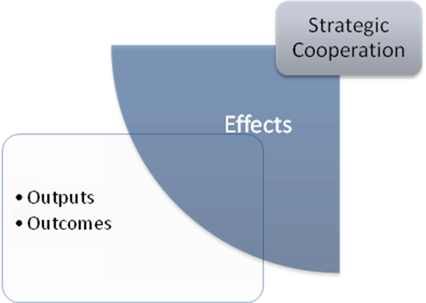
Figure 9 Output stage of conceptual framework

Outputs
The measurement of outputs in the last phase of the conceptual framework is of importance to notice the actual effects of the cooperation. Depending on the goals during the cooperation process and the procedures, outputs differ from simple agreements to cooperate in the beginning of the cooperation process, to evaluating certain steps in the cooperation process; the output of the cooperation process depends on the timing of the measurement of output. Outputs are created after each cycle in the cooperation process; however, each meeting, each trade mission and each evaluation provides output as well. The scale of outputs is therefore very wide but is of importance for each next step in the cooperation process, as it provides new input for the partners. Outputs will be measured depending on the goal set by the cooperating partners.

Outcomes
Outcomes are of the essence in the cooperation process, as these define whether or not the goals of cooperation are achieved or not. The issue with measuring the final outcome of the cooperation lies with the fact that outcomes are only achieved when the process of cooperation has passed the final phase. Therefore, this thesis will regard the final outcome to be contracting of LNG by (one of) the partners.

Management of expectations
Having created a tool for analysing the cooperation will not be enough to answer the research question. Therefore, the management of expectations is part of the theoretical framework as well. Expectations play an important role in the cooperation processes, as each actor has certain wishes and demands and expectations of the cooperation-partner.
These demands and expectations arise from the institutional backgrounds of the actors: they stem from core values and institutional rules of each actor, which are usually difficult to change and have long term value for the partner. Where public and private actors cooperate in a Public Private Partnership it could occur that these values or basics collide and this might create opposing strategy patterns, which could be harmful for the cooperation, (Klijn and van Twist, 2007a). In a PPP, private and public actors continuously cooperate in an arena where conflicting core values and interests shape the cooperation process; private actors are concerned with market shares, where public actors are concerned with the political programme. Private actors avoid political risks, as their participation in government projects are at stake and so is their profit. On the contrary, public actors could manage loss on investments in projects, but then it will need political support; when projects exceed their budgets, it will harm the political position of responsible decision makers. The core values and their depending strategies of the actors and the involved paradoxes in scheduled in Table 2. The expectation of cooperation between public and private actors in a PPP is the creation of added value, in any form or appearance. However, the successfulness of such a cooperation structure depends on the expectations of both involved actors.
 | Public actors | Private actors | Paradoxes
Core business | Goals: public goals  Continuity: political conditions | Goals: realising of profits  Continuity: financial conditions | Differing risk-perceptions: political risks in expectations versus market risks in annual profits
Values | Loyalty  Dedication to ‘public cause’  Controllability of process and approach  Emphasis on risks aversion and avoidance of expectations | Competitiveness  Dedication to consumer preferences  Controllability through shareholders  Emphasis on market opportunities and risks and innovations | Public actor hesitant in process versus private actor hesitant in knowledge sharing  Public actor hesitant in results versus private actor hesitant in participation
Strategies | Searching ways to guarantee influence on content (public primacy)  Minimising expectations and implementation risk in terms of costs | Searching security to provide service (contract)  Minimising political risks and organisational costs due to costly bureaucracy | Conflict leads to hard agreements and this devaluates cooperation to contractual agreements
Consequence for PPP | Emphasis on risks reduction and verification of decisions and procedures, which lead to governmental authority | Emphasis on guarantee of market share and revenue, which leads to a hesitant attitude and limited investment | Creation of added value through interaction between actors will not take place
Table 2 Paradoxes of expectations (Klijn and van Twist, 2007a).

Therefore, expectations of both actors should be managed, or at least should be coinciding. When cooperating partners have a mistaken belief or image of the partner, conflicting strategies will lead to failure in the cooperation. Examples on the public side of such misconceptions are that private actors are better at taking risks, more motivated to find innovative solutions than the public actor, and that their commitment will increase when cooperating in a PPP. Another important misbelief is that public spending will definitely decrease when involving private actors. Misconceptions on the private side are that public actors are a willing partner, while the public system could very well internally conflict (bureaucratically or on policy goals). Partners have expectations of each other, of each other’s role and behaviour. It is not necessarily about the expectations on cooperation, but on the expectations of the partner’s core values. When these expectations or believes are mistaken, they can produce conflicts in the cooperation, (Klijn and van Twist, 2007a, 38-39).
These expectations of behaviour and core values may lead to political-strategic behaviour; partners position themselves in the cooperation by emphasising certain expectations or contrary, decide to keep certain expectations hidden from their partners, which is highly opportunistic behaviour. In order to overcome this political-strategic behaviour, partners should share information, in order to have a successful cooperation. However, when sharing (strategic) information, the partner will lose its negotiation position. Information asymmetry is therefore a key problem in PPP’s.
A way of avoiding this information asymmetry and the withholding of expectations is to agree on provisions or ‘control mechanisms’ at forehand, so partners will have to comply with contracts and terms. This is very difficult however, and is a costly process. Therefore, cooperation should be based on trust; trust lowers the transaction costs, trust consolidates cooperation and trust enhances opportunities for innovation, (Klijn and van Twist, 2007a). Trust seems to be a key success factor for cooperation.
Klijn and van Twist argue that trust needs to be managed in order to manage expectations, when cooperating partners are working towards a successful cooperation or PPP. Partners estimate the behaviour of their cooperation partners in order to anticipate on their actions: ‘what would I do if I were my partner?’. Klijn and van Twist see this as an example of managing expectations, as expectation rise when cooperation is more successful. The continuous effort to reduce strain expectations by streamlining suspicions and desires could be interpreted as an important form of the management of expectations, (Klijn and van Twist, 2007a).
Each partner will try to manage expectations of the partner individually. The level of managing the individual expectations of the several partners is therefore the ‘playfield’ for managers to ‘think and act for two’, which becomes evident in two management styles: process and project management. In order to manage expectations, managers should use these two styles simultaneously. Process management focuses on the interaction between partners, while project management focuses on the content trough agreements and contracts. However, management of expectations will require both styles for effective and successful cooperation from both public and private actors. The management of expectation will be applied to each part of the conceptual framework, in order to capture the expectations of the involved partners of the cooperation.

Research design and methodology

The research for this thesis was done during an internship at the Ministry of Economic Affairs, division Energy Market, from April 2009 to July 2009.

Design
The research design of this research is aimed at qualitative research, which stems from the objective of the research objective: ‘[...] In other words, thought and attention will have to be given to the purpose(s) of your research; to theory; to the research questions to which you seek answers; to the methods of data collection; and to the sampling strategy which will be needed to get these answers [...]’, (Robson 2002, 164). The research design used for this research is the flexible design, which is a qualitative research design; data used in this research is non-numerical and therefore the design refers to a qualitative design. The research does not involve a sample or experimental strategy: there is no feature of actively introducing some form of change in the situation with a view to produce a resultant change in the behaviour, (Robson 2002, 88).

Research strategy: case study
‘The objective of a case study is to describe or explain the ‘natural’ relatedness between important factors of a certain phenomenon’, (Hutjes and Van Buuren 1992, 23). ‘[...] A case study is an empirical inquiry that investigates a contemporary phenomenon in depth and within its real-life context, especially when the boundaries between phenomenon and context are not clearly evident [...]’, (Yin 2009, 18). When there are only a small number of cases under investigation, we speak of a ‘small-N design’, (Johnson, Reynolds and Mycoff 2008, 148). This research conducts of a specific strategic cooperation between actors and therefore the object of the research are three unique ‘cases’; the cooperation aimed at three different countries, Algeria, Angola and Qatar.

Unit of analysis and actors
The research has three specific units of analysis: the three cooperation structures, concerning three countries, Algeria, Angola and Qatar. In these settings, the process of cooperation between the division Energy market of the Ministry of Economic Affairs and nine LNG related firms takes place. Annex III provides an overview of the participating firms in the three cases. Though there are more parties participating in the cooperation, these are not of interest to this research. The other parties concern research institutes, or agencies of the Ministry of Economic Affairs, such as the EVD (Economische Voorlichtingsdienst) or Senternovem. These specific executive and supporting agencies are left out in this research for the simple reason that they have a facilitating role in the cooperation and follow the Ministry of Economic Affairs. The do play an important role at the background, as these agencies posses specific information on the countries, but do not play a significant role in the immediate process of sourcing LNG. Therefore, these facilitating agencies are not part of this research. The relation between the Ministry of Economic Affairs and LNG related firms, or the public private cooperation, is at the core of this research. The LNG related firms are in the position to negotiate and contract LNG imports; only private firms are able to do so, however they need the support of government actors, as will be explained in chapter 5. The chosen LNG related firms are Dutch utility concerns, energy concerns and LNG infrastructure operators. The actors and partners are to be described and analysed in the research as well, see chapter 6.
The information has been collected via the persons responsible for the strategic cooperation at the time the research was conducted (April to July 2009). The contact persons of the LNG related firms possess key holding or strategic positions in the firms they represent. The representing civil servants of the Ministry of Economic Affairs each have their own portfolio concerning a specific region or country. As this research includes strategies of the several firms the names of actors (neither organisation nor person) won’t be revealed. Therefore, the actors will be referred to as ‘LNG related firms’, or ‘Firm X’.
The three cases of interest of this thesis all concern a specific LNG exporting country, namely Algeria, Angola and Qatar. These are not all energy priority countries, as will be explained in Chapter 4. However, the choice for these specific countries will be given here. Algeria is a priority country, listed by the Ministry of Economic Affairs as an important country to maintain strong bilateral relationships on energy issues; import of LNG is one of the criteria on which the country is selected as a priority country. Several trade mission activities have been organised regarding Algeria and the cooperation with the LNG related firms exists since 2006. This makes the Algeria case an interesting and developed case.
Angola is a relative newcomer to the energy agenda of the Ministry of Economic Affairs. Due to an invitation of the Angolan government a trade mission was organised in the beginning of 2009. By that time Angola had the responsibility of presidency of the OPEC, which made the mission even more interesting. This evolved into a new cooperation for the Ministry of Economic Affairs with LNG related firms, but LNG is not the direct focus of the group as other energy applications are relevant as well.
The third case of interest concerns Qatar. Qatar is not a priority country, but has been on the agenda of the Ministry of Economic Affairs since 2007. Qatar, compared to Algeria, has a more accessible economy, due to the fact that business-to-business relations do not need a strict government-to-government relation like in Algeria. Therefore, the role of the Ministry throughout the process is different from other cases, which makes it an interesting case for this research.

Research method
The research method used in this research is interviewing: ‘asking individuals a series of questions and recording their responses’ (Johnson, Reynolds and Mycoff 2008, 338). The interviews were conducted in a semi structured manor, which means that predetermined questions were asked, however the wording and order changed according to the appropriateness during the interview, (Robson 2002, 270). In total ten questions were formulated concerning several subjects in a semi-structured way during the interviews, see Annex I for the format used and Annex II for the extracts of the interviews. After the interview, the interviewees were asked to fill in a form, concerning the considerations and ambitions for cooperation, which will be used in the analysis in paragraph 6.1. By asking directly about situations concerning the strategic cooperation, the research questions could be answered more precisely. The personal narrative stories contributed to the research as personal experiences were shared. The results of the interviews were checked by the interviewees. Again, the interviewees are made anonymous, as strategic information and positions were shared in the interviews.

Accuracy of measurements

Reliability
‘[...] The reliability concerns the extent to which an experiment [...] yields the same results on repeated trials [...]’, (Johnson, Reynolds and Mycoff 2008, 94). The theory used in this research and the concepts and definitions thereof determine the process of the strategic cooperation. Therefore, the research does not only takes existing literature into consideration as stated chapter 2, but the conceptual framework tries to provide an accurate measurement tool for the variables indicating the specific strategic cooperation between the Ministry of Economic Affairs and LNG related firms. The used variables should provide measurable results, which should be accurate when trying to apply them again.

Validity
‘[...] Validity refers to the degree of correspondence between the measure and the concept it is sought to measure [...]’, (Johnson, Reynolds and Mycoff 2008, 97). The interviews were recorded after approval of the interviewee. Therefore, the respondent bias should be taken into account; the interviewees could have provided answers as they think the interviewer wants them to answer. On the other hand, the researcher bias might affect the answers of the interviewees, as specific questions are asked or other questions are left out, (Robson 2002, 172). Though the results were handled in discretion and anonymously, it is important to note that the research was conducted by an intern at the Ministry of Economic Affairs and therefore the interviewees might have felt obliged to cooperate. By having the interviewees checking the results of the interview, the results reflect the opinions and positions of the interviewees. As the research strategy is a case study, little could be said about the generalizability of the results; the outcomes are case specific.

Methodology
The conceptual framework provided in the previous chapter includes measurable variables for each step in the process of cooperation. The ways to measure and analyse the variables will be explained below, as some variables need further explanation.

Measuring initiation process
The variables indicating the ambition for cooperation of Kaats et al. (2006) are measured along ten generic axes with considerations for cooperation (Figure 5). The variables are measured by indicating the position of the firm or organisation on the ten different axes. The scales and variables of the axes were explained to interviewees, after which they indicated the variables on the figure, (see Annex I). The scale used resembles that of a Likert scale, a semantic differential: ‘a questionnaire format in which the respondent is asked to rate something in terms of two, opposite adjectives’, (Babbie, 2004, 170). By adding a score to the variables from (-4, -3, -2, -1, 0, 1, 2, 3, 4), the measured results from the questionnaire could be computed into Excel. The scores made it possible to convert the outcomes into a radar figure (spider chart). The individual outcomes are presented in Annex IV. The axes are described below.
Environment
Is there a dynamic environment, where standards should be set or does the organisation operate in a stable environment where positions are already taken?
Are there cooperation structures and constellations in the environment or do competitors and colleague organisation act as individuals? Are there purchase, production or distribution chains in the sector?
Cooperation skills
Which skills do other organisations in the sector have; what is the norm and are ‘best practises’ available?
Is it possible to agree on integral propositions on the cooperation between different parties? Are other organisations willing to cooperate with each other?
Position towards others
Does the organisation play the directors role in the strategic core, or is the organisation the executing party?
Is the organisation able to realise goals on its own, for example to realise the necessary or usual scale or to realise independently its products, (contracting) processes and/or marketing innovations?
Need and urgency
Do stakeholders ask for integrated products or services? Is the organisation able to exercise the possible requests and does it have the competencies to realise this on its own?
Is there a normal operational necessity possibly derived from (production) processes or urgent strategic necessity on the long term continuity for the need for cooperation?
Complexity of the cooperation
Does the organisation maintain flat, bilateral partnerships, or is it involved in complex, multilateral network interrelations?
Does the organisation focuses on the development of new products, services and markets or does it consolidates the current range of activities?

Measuring typology
The identification of the orientation of the process cooperation is measured by taking the two orientations towards cooperation, indicated by Schulz et al. (Table 1). The variables and the roles of cooperation are described in Table 1, which makes analysing the orientation in the three cases straight forward; picking the right role and orientation form the selected list provided in Table 1.
The actor analysis could be identified following Figure 7, identified by Stopford, Strange and Henley. The generic triad of relationships provides an overview of the relationships, which could be filled in when analysing the case. Then, the measurement of variables indicating the selection process of partners will be done in two steps. The measured variables indicated by Porter and Fuller in Textbox 2, will be presented in a table (Table 3), which provides the differences between the public and private partners. The criteria of Porter and Fuller are stated in questions, where for each actor the characteristics are provided by answering this question. The variables are elaborated on in Textbox 2. The second analysis of partner selection will be done at the individual level of the LNG related firms, which included in Annex V.

Measuring procedures
The measurement of variables indicating the procedures within the process of cooperation needs some attention. The variable ‘activities’ needs further specification in order to analyse and measure the three cases thoroughly. Therefore, the variable ‘activities’ will be operationalised as ‘trade missions’ as these are the activities of interest in this research. The meetings and trade missions will be analysed using several variables: the roles of the participants, the kind of professional relationship (informal or formal meetings), and the goals of the participants during the procedures, the time scale and the costs. The time scale used in the research are related to the development of the singing of LNG import contracts. With the short term the exploration phase is emphasised, indicating the partners’ preferences and positioning the Netherlands as a gas hub. The midterm indicates the process of diminishing trade barriers and emphasising the facilitation and infrastructural attractiveness of the Netherlands (and its LNG related firms) as trade partner, and investing in a strong bilateral relationship. The long term is aimed at the final contracting and import of LNG to the Dutch gas hub and maintenance of the government-to-government and business-to-business relations.

Measuring effects
The effects of the process of cooperation will be measured by the outputs generated throughout the process of cooperation. The effects will be provided in a narrative summation; describing the three cases individually and therewith provide the opportunity to note the differences between the three cases.

Measuring management of expectations
The management of expectations can be identified by taking the paradoxes indicated by Klijn and van Twist (Table 2) and describe the variables in the paradoxes in the three cases. Again, these will be a narrative analyses based on qualitative statements from the interviews (Annex II).

Policy Context

The Netherlands is known for it’s gas fields, gas policy and developed gas infrastructure. The position of the Netherlands as a gas exporter had generated significant revenues for the Dutch government and Dutch industries benefited from the well-developed gas infrastructure. However, the future brings challenges ahead as the predicted production from the Dutch gas fields will decline in the coming years (Ministerie van Economische Zaken 2009b). In its 2008 Energy report, the Ministry of Economic Affairs has announced a strategy in order to become the gas hub of Northwest Europe and LNG is mentioned as one of several opportunities in this gas strategy. The cooperation between the Ministry of Economic Affairs and the energy and gas sector in order to import LNG fits in this wider energy policy and is mentioned to be one of several instruments in order to create the gas hub.
This chapter provides the description of the policy context, which will be set in the wider scope of the developments in the gas market and the recent policy changes at both European and national level.
I The first important factor in the development of the Dutch gas policy and the cooperation in the gas sector are the developments in the gas market, being local and global.
The Dutch national gas production will decline, (Ministerie van Economische Zaken 2008a, 41). The yearly production of Dutch gas will decline from 77.8 BCM in 2007 (GasTerra B.V. 2007, 4) to a restricted production of 67 billion BCM a year in the period 2008-2012 according to the Small Field Policy in order to preserve the reserves of the Groningen field; the proven reserves may last for 20 years, but will be nearly exhausted by the year 2030 (Remme, Blesl and Fahl 2008, 1624, 1635). Taking into account the estimated demand of 54 BCM in 2030 the Netherlands will become a net-importer of gas, (Gasunie 2010, 21). The need for a stable security of supply of natural gas is therefore of utmost importance for the Dutch gas market. However, the Netherlands will have to compete in the global competition for the supply of gas, as many countries try to contract from the producing countries. The Russian-Ukrainian conflicts in 2006 and 2009, where Russia interrupted the gas supplies, are seen as a wakeup call for the European gas market in order to assure a stable delivery of gas.
II The second important factor is the European regulation towards a ‘common European gas market’.
European gas regulation has had a severe impact on gas related firms, the outlook of the gas market and the opportunities for consumers, and on the Dutch gas policy. By 1998, the European Commission stated the European gas directive, which aims for the creation of a common European gas market. The final goal of competition in the gas market is a fairer price for the consumer and a better service, (Algemene Energie Raad 2005, 74). In July 2004, the Dutch gas market liberalised, where after the market has been increasingly dominated by large international players, mostly by means of acquisitions of smaller Dutch utility companies (IEA 2009, 158). Energy consumers are now able to choose which energy company provides their electricity and gas. In 2007, the European Commission introduced the Third Package of Energy Regulation: a new set of rules and regulations, which aim is to create a single European energy market. It introduced unbundling of ownership and further liberalisation of the European energy market. Unbundling is the separation of supply and production activities by energy companies; some activities formerly conducted by energy companies are now in the hands of independent regulators (TUDelft 2008). This should create a transparent market, where national influence in the energy sector is to be minimised and monopoly is to be eradicated. This has had a significant impact on the outlook of the strategies of energy concerns; it became possible to expand activities over national borders.

Policy developments towards the gas hub
The strategy of the Ministry of Economic Affairs on the gas market, including the current reality and future opportunities and developments, is set out in the Gas hub Letter, which the Minister of Economic Affairs sent to the Parliament on October 23, 2009 (Ministerie van Economische Zaken 2009b). Three pillars are mentioned to be important for the future development for the role of the Netherlands as gas hub: in time availability of transport capacity, flexibility and diversification. This strategy is a broad strategy on the complete Dutch gas market, including investment strategies, gas production development, cooperation with the private sector, bilateral and multilateral gas diplomacy. The strategy of the Netherlands as a gas hub has developed over the last five years and fits in a wider development of both policy changes at European and national level and market changes.
By 2004, the ‘Gasgebouw’ got split up in two parts due to European competition regulation. The Dutch state would own the gas transport facilities (Gasunie GTS, Gas Transport Services), while the gas sale activities would be organised by private companies. In 2005, the Energy Council wrote an advisory report on the gas market policy for the Dutch government, ‘Gas for Tomorrow’ (Algemene Energie Raad 2005). This report, based on the two trends explained above, provided policy options for the Dutch government and the role for the Netherlands as energy or gas hub was first mentioned in this report. An analysis of supply and demand for the gas market is given in the report, combined with the urge for security of supply in the light of an even stronger liberalised European gas market. The Energy Council notes the strong strategic position of the Netherlands and its gas fields in the Northwest European gas market. The Energy Council state three elements of the role of the Netherlands in the gas sector: a) a strong position as buyer of gas on the world gas market and as contract partner in realising the transport infrastructure. The emphasis is to support private oil companies in contracting, b) strategic administrator of the Groningen gas field, c) act as trading, storage and transport ‘hub’ for the North European gas market. In this context, the Energy Council advises to invest in LNG facilities, as ‘this amplifies the import opportunities and with that the diversity of the gas supply and gas suppliers and gas trade possibilities’, (Algemene Energie Raad 2005, 103). However, the Ministry of Economic Affairs reacted in its Energy Report 2005 (Ministry of Economic Affairs 2005) that investments should be made by private parties. The report aims at sustainability and climate change, instead of the position of the Netherlands as gas hub. Later that year, the Energy Council report ‘Energetic foreign policy’ (Algemene Energie Raad & Adviesraad Internationale Vraagstukken 2005) introduces the term ‘energy diplomacy’. ‘The contracting of long term contracts with [gas] producing countries is more difficult in a liberal market [such as the Netherlands]’, and energy diplomacy will be needed to overcome problems in the security of supply. Energy diplomacy should be a matter of cooperation between the Ministries of Economic Affairs and Foreign Affairs, being both multilateral (European Union, IEA, OECD) and bilateral.
In 2006, the Minister of Economic Affairs provided the Parliament a letter stating his vision of the gas market, including diversification of supply after the Russian-Ukrainian gas conflict (Brinkhorst 2006). The vision consists of three crucial aspects: a) diversification of gas supply, b) free movement of gas in Europe, c) to extend the position of the Netherlands as gas hub. The link between the security of supply and foreign energy policy is made in this letter. Though, the role of the Netherlands is placed in the European context; for the import of gas European countries should bundle their efforts.

The gas hub as icon in Dutch energy policy
By 2008, the Ministry of Economic Affairs took the idea of the gas hub as one of the pillars of its Energy Report. The gas market provided opportunities to turn the gas market into a hub. Not only has the export of gas profited the Dutch yearly income, 1.8% of the Dutch GDP in 2008 (Ministerie van Economische Zaken 2008a, 35), the Netherlands has positioned itself as the gas supplier to the Northwest European market with an extensive gas infrastructure of over 12,000 km of high pressure pipelines with 17 feeding points from networks in neighbouring countries and a 12,3635 km distribution grid (Gas Transport Services 2008, 6) . According to the Ministry of Economic Affairs, the Netherlands has several strategic advantages; not only the several gas fields, but also its gas infrastructure, the intensive gas knowledge and experience and the geographical position of the network provide a strategic position in the Northwest European market. Gas networks from Norway, the UK, Germany and Russia will be linked by the Dutch gas hub, which will act as a distribution channel for the Northwest European market by a gas trade market. Empty gas fields can operate as buffers where gas can be stored, which will increase the flexibility of supply. Therefore, the Ministry has the ambition to be the ‘Gas hub’ of Northwest Europe, see Textbox 3.
‘[...] In the coming years, the government will devote additional attention to the future of our gas supply. On one hand, this is because our own gas reserves are shrinking and the Netherlands will become a net importer of gas starting in about 2025. On the other hand, because the Netherlands has the potential to develop into the gas hub of Northwest Europe.
The Netherlands can be the Northwest European centre of gas trade, knowledge and transport, storage and conversion. This will contribute to securing the gas supply and reinforce the country’s competitive position. ‘The Netherlands as a gas hub’ is therefore one of the three icons of the energy policy [...]’
Textbox 3 Gas Hub (Ministerie van Economische Zaken 2008A, 19)
The four Dutch gas policy goals are affordability (trough liberalization and regulation), reliability (security of supply, short-term reliability), and minimization of negative environmental effects and optimal utilization of Dutch natural gas supplies (De Vries, Correlje and Knops 2007, 82). In the future, affordability could conflict with the security of supply, as the import of gas will imply a rise in costs. At the same time, securing supply will get more attention as exploitation of the commodities are expected to peak in the coming decade on a global scale. The urge for energy security in energy trade policy was first acknowledged by the Energy Council in 2005 (Algemene Energie Raad & Adviesraad Internationale Vraagstukken 2005), which has lead to the appointment of ‘focus energy countries’ or priority countries by the Ministry of Economic Affairs in 2008, (Ministerie van Economische Zaken 2008a); Algeria, Kazakhstan, Russia and Saudi Arabia. Despite the fact that not all these countries are of importance to the gas portfolio, it was the start of the energy related trade missions. The report includes a policy agenda, in which a ‘consultation forum’ [literally; overleg platform, RZ] is suggested. This forum should develop the gas hub and should include private firms and the Ministry of Economic Affairs, (Ministerie van Economische Zaken 2008a, 53).
In October 2009, the Ministry of Economic Affairs provided the Parliament the latest developments of the Minister in the effort to create a gas hub for Northwest Europe. The ‘gas hub strategy’, as it is called in this letter to the parliament, fits in the proceedings of the Ministry to assure the security of supply of gas. Besides, it should generate innovation and trade activities, as well as export and trade knowledge and expertise in the gas sector, (Ministerie van Economische Zaken 2009b, 3). The gas hub strategy therefore integrates several goals, of which among others the European regulation, security of supply, further liberalisation of the gas market, the creation of a common gas trade market, investment in LNG terminals and storage facilities and thereby cooperation between public and private actors, and energy diplomacy and gas related trade missions to Algeria, Angola, Russia, Saudi Arabia, Qatar and Kazakhstan, (Ministerie van Economische Zaken 2009b, 6). The role of LNG terminals is a prominent feature of the gas hub strategy, as investment in gas infrastructure and these LNG terminals are of utmost importance for the future development of the gas hub. LNG will play an important role in the gas portfolio of the gas hub: ‘Given the importance of LNG, the Dutch government endeavours to facilitate and support initiatives for the realisation of LNG terminals’, (Ministerie van Economische Zaken 2009b, 13). Several LNG terminal projects have been proposed, of which one is already being built. ‘The international contracting policy of the energy companies at one of the LNG terminal projects focuses on countries like Russia, Algeria, Qatar and Angola’, (Ministerie van Economische Zaken 2009b, 13). The letter continues with the affirmation of the Minister of Economic Affairs to focus the international bilateral policy towards ‘gas diplomacy’ and diversification of gas suppliers. Again, Algeria, Angola and Qatar are mentioned in this context, as ‘[these] countries offer interesting opportunities for Dutch buyers of LNG’, (Ministerie van Economische Zaken 2009b, 15).
The letter mentions two important aspects for the cooperation with the private sector. The first, as mentioned in the Energy Report 2008, is the consultation forum (Overlegplatform Gasrotonde). The forum is not an official advisory organ, but rather an opportunity where innovation, initiatives and strategic issues could be discussed by private and public actors. ‘The aim of the forum (Overlegplatform Gasrotonde) is to connect activities of the public sector and initiatives from the private sector and thereby provide substance to the conduct of the gas hub. The government will consider the interests of the private sector in the policy making process and ventilate this in meetings with foreign governments’, (Ministerie van Economische Zaken 2009b, 14). The second aspect is related to the ‘gas diplomacy’ and the trade missions. ‘[Private firms] have to deal with foreign government who play important roles in the gas industry. Therefore, there is a close cooperation between the private and public sector on gas producing countries relevant for the Netherlands. With this policy, terms and conditions can be formulated by which private firms are able to utilise opportunities for gas contracting’, (Ministerie van Economische Zaken 2009b, 16). Here, the Ministry of Economic Affairs positions itself as facilitator. However, an important fact is that ‘economic relations with gas producing countries can only be sustainable when the economic priorities of those countries are integrated in the economic relations. Gas diplomacy can therefore aim at cooperation besides the energy sector, like agriculture or water’, (Ministerie van Economische Zaken 2009b, 16).

Energy related trade missions
By 2008, four energy priority countries including Algeria were selected in the Energy Report 2008, but another 28 countries were selected on the basis of importance for the security of supply of resources, (Ministerie van Economische Zaken 2008a, 51). Bilateral relations concerning energy related issues were continued or intensified with these countries, including Qatar and Angola. These countries were selected because of the specific interest in their gas production, explained in a letter by the Minister of Economic Affairs in 2009: ‘Currently, the interest of security of supply and the window of opportunity for Dutch businesses to get involved are increasing. Governments play a crucial role in the energy sector, especially in oil and gas producing countries. This means that contact between Minsters and governments are essential in the creation of opportunities for the Dutch private sector’, (Ministerie van Economische Zaken 2009c, 3). Gas diplomacy and diversification of suppliers are the drivers of the energy related trade missions, which stimulate the gas hub as a whole. Goals of energy related missions are to present the Netherlands as gas hub of Northwest Europe, explore opportunities for Dutch energy and gas related firms, and create opportunities for Dutch firms to contract gas, participate in LNG projects and stimulate foreign investment in energy infrastructure in the Netherlands. This letter mentions the broader interest during energy related trade missions, as other sector could be involved, like sustainability or efficiency.

Three country units on the import of LNG

LNG, IOCs and NOCs
More and more countries are participating in the market of LNG; the last decade has shown a rise in the number of liquefaction and regasification terminals and their capacity worldwide. The liquefaction process of LNG takes an extensive industry, which is very costly. But there is an even more important characteristic on the supply side of LNG reserves: producing companies are usually state-owned. Currently, around 85 percent of the total gas worldwide are state-owned, (TUDelft 2008). Approximately two-thirds of LNG imported into Europe in 2004 was supplied by Sonatrach in Algeria. However the situation is changing markedly with increased supplies coming on stream from Nigeria and Qatar and new countries such as Egypt, Libya and other countries in the Middle East, starting to supply LNG to Europe. State-owned oil and gas companies typically own between 25 and 70 per cent of these projects, compared with 100% in the case of Sonatrach leaving more room for involvement of international oil and gas companies, (TUDelft 2008, 32). ‘The National Oil Companies (NOCs) are owned by governments. Of some state-owned companies shares are traded on exchange markets like in the case of Gazprom, however legislation prohibits a takeover of the whole concern. At all times they remain under the supervision of the state’, (Op het Veld 2008, 62).
These NOCs have wider interests than International Oil Companies (IOC), which are usually interested in price and market shares. ‘Governments will use other considerations than private industry for the development of their resources. [...] Their agenda and drivers for new developments are dictated by many national (and international) political considerations and the objective to maximise the economic rent for their national resources’, (CIEP 2008, 29,36). State-involvement in NOCs leads to the demand of package-deals, which could include price, expertise, equity and development. Dealing with NOCs is therefore not only a company-to-company relationship, but involves government actors as well. The complex issue when dealing with NOCs or state-owned companies is the access to the company; ‘government-to-government relations have become important to facilitate the business-to-business’, (CIEP 2008, 13). Energy companies find it sometimes difficult to get access to these companies, when trying to arrange contract meetings. NOCs tend to prefer to include government actors when negotiating oil or gas deals, as private IOCs cannot deliver all the demands; expertise might be involved in a deal, but equity issues or developmental activities are usually not part of business deals done by IOCs. Besides, NOCs try to get involved in activities deployed in the importing country, in order to expand their influence in the gas market in the importing country. Here, NOCs negotiate shares in LNG terminal consortia. As mentioned above, the NOCs are in the position to decide what will happen on the LNG market, as the regasification capacity, which are the demanding parties, outnumber the supplying parties, see Figure 10. The ratio between the capacity of liquefaction and regasification terminals is currently 1.75 m³ regasification capacity per m³ liquefaction capacity. This ratio will rise to 1:3.22 in 2013. And because of the high investment costs in these terminal projects, there will be a strong competition on the LNG market, giving the producing countries a strong market position, (J. W. De Vries 2009).
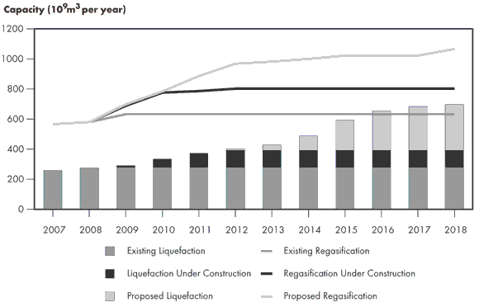
Figure 10Worldwide LNG Liquefaction and regasifacation capacity (National Energy Board Canada, 2009)
With the acknowledgement of the gas hub as icon in the Energy report in 2008, the Ministry of Economic Affairs highlights the importance of LNG in the gas portfolio, (Ministerie van Economische Zaken 2008a, 48). In order to be the gas hub of Northwest Europe and to secure future demand, gas imports will have to be secured, either by pipeline gas or by the import of LNG. Gas markets are bound to physical characteristics of gas and therefore regionalised; costs of transport and infrastructure limit the export possibilities of gas. Delivery of gas trough pipelines could be disrupted (Ukraine in January 2009), and huge pipeline projects to transport gas from the Caspian area (Nabucco pipeline) or Russia (Nord Stream pipeline) to Europe bring significant costs, financial risks and international (geo-) politics. LNG is a regular natural gas, however the gas is liquefied by cooling it to minus 160 degrees Celsius in the exporting country, shipped to the importing country and regasified again in an import terminal before it is injected into the gas network. This process makes long distance shipping possible and therefore diversifies the security of supply; markets out of the region could be targeted. ‘[...] The falling cost of LNG production, transport and handling and environmental considerations are changing traditional supply perspectives. By allowing gas to cross oceans and thus making it available in main consumer markets, geographical and economic patterns of gas supply are beginning to experience radical shifts [...]’, (TUDelft 2008, 26).
While the Netherlands is on its way to enter the LNG market, the global LNG market has been showing a steep rise in import terminals worldwide. The number of regasification terminals exceeds the gas producing capacity; gas importing countries and companies are competing on a global market. Recent technological developments in shale gas make it possible for the USA to act as a more independent player at the global market and in this way foresee in their own supply. Expanding producing capacity in the Middle East, Africa and the Asian regions are followed closely by market analysts all over the world. Even the contracting structure of gas is developing: instead of long-term contracts involving huge volumes, it becomes attractive for producing countries to contract short term spot-market deals, (CIEP 2008, 52). Uncertainty surrounds the LNG market, as technologies offer new opportunities, but the lack of a global gas price index like the oil-barrel price, still creates shifts in the market.
Currently, there is one LNG import terminal under construction in the Netherlands and there are several projects proposed. In the port area of Rotterdam, the first Dutch LNG terminal Gate BV should be operating by 2011. The project costs of LNG terminals are very high (around 800 million Euro per regasification terminal). The financial risks make it unattractive for companies to invest solely in such a project; risks are therefore covered by the creation of consortia. As LNG gas will mainly be used by energy companies to supply them gas for power generation, energy companies are included in consortia, as well as infrastructural companies and the gas network operator, see Figure 11.

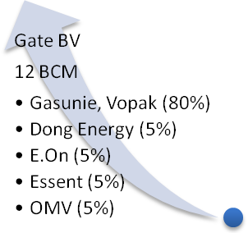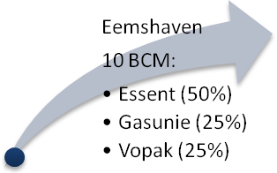

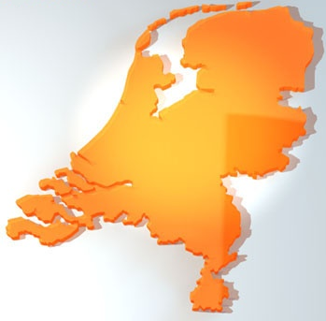

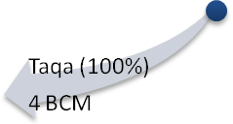

Figure 11 Proposed LNG consortia in the Netherlands (shareholders and capacity)
However, in order to operate the LNG terminals contracts will have to be agreed upon for the supply of LNG; the existence of a LNG terminal does not secure the delivery of LNG. Energy and international oil companies negotiate prices, volumes and terms of LNG delivery with the supplying countries.

Cooperation as solution: Project Delta
In order to realise the ambition of the Ministry of Economic Affairs to be the Gas Hub of Northwest Europe, import of LNG seems to play an important role. However, European and Dutch regulation of competition and liberalisation make it impossible for the Ministry to fulfil this ambition without the willingness of energy companies, which makes the Ministry of Economic Affairs dependent of these energy concerns, which on their turn face barriers of liberalisation and unbundling themselves. Even though, four LNG regasification terminal projects should meet this demand.
The firms concerned in these LNG consortia have tried to gain access to existing LNG producing companies themselves. The fact that a terminal is being built at this moment helps to overcome issues regarding the storage capacity: from 2011 a 12 BCM (billion cubic meters) regasification terminal will be operating in the port of Rotterdam. However, despite the fact that a site is being build, these consortia have not signed any LNG contracts yet, which raises the risks for these companies and can downturn the ambition of the Ministry of Economic Affairs.
The problem is that these consortia or individual companies have difficulties approaching the NOCs. Access to NOCs is difficult as these NOCs prefer to negotiate gas contracts with national governments instead of companies. Besides huge volumes and long term contracts, the NOCs are looking for package deals, including expertise and local development programmes, which energy companies find difficult to counter. Therefore, the Dutch LNG imports are still not realised. It becomes increasingly important to position the Netherlands as attractive country in the global gas and LNG market, where strong government ties are necessary to make import of LNG by companies possible in the future.
The Ministry of Economic Affairs might not be in the position to import LNG itself, but it has the authority to gain access to NOCs and LNG producing countries: LNG related firms in the Netherlands have therefore found a willing partner in the Ministry of Economic Affairs. Besides, the Minister of Economic Affairs has put energy and the security of supply high on the political agenda of her Ministry. By organising energy trade missions the Minister tries to position the Netherlands as the Gas Hub of Northwest Europe and in this way stimulates the energy sector to be involved in the activities of the Ministry abroad as well as within the Netherlands. The extensive travel agenda of the Minister now includes specific energy missions; visiting countries to promote the gas hub and stimulate the negotiating process of LNG contracts, sign MOUs (Memorandum of Understanding) and visiting mutual beneficial projects.
The cooperation between the Ministry of Economic Affairs, several firms, the Russian government and Russian gas related firms in Project Delta is the most developed collaboration, involving government-to-government relations as well as business-to-business relations in the energy sector. Project Delta is an extensive platform to streamline gas related activities by Dutch and Russian companies, guided by strong government relations between the two countries, as explained by one of the participants in the Project Delta Group (see Annex II, Interview J).
Russia has a long history of exploring and distributing gas and Gazprom is the largest gas producer of the world. However, due to new discovered exploration sites in more extreme conditions in the offshore parts of Russia (the Shtokman and Sakhalin field) Dutch expertise could provide solutions to the Russian gas industry. Complementary expertise and knowledge would help Russia to develop its gas production even further, by sharing knowledge in the maritime, on and offshore exploration and production, civil engineering, transport and harbour sectors.
In 2007, during the preparation of the energy related trade mission to Russia headed by Minister-President Balkenende, the cooperation concept of both government and business relations was proposed in order to stimulate the economic relationship between the two countries in the area of gas. Dutch business society related to gas and the Dutch Ministry of Foreign Affairs developed the concept. As the Russian Gazprom is state-owned, several layers of bureaucracy at both business and government level had to be crossed before the cooperation in Project Delta could be formed. The Russian state is the majority share holder, which means that the strategy of Gazprom is decided upon in the Kremlin. The implication of this top-down structure is that for cooperation relations have to be tightened at the government level in order to reach the business level.
Not only is there a strong connection between all sorts of sectors around the gas activities of the two countries, from the maritime sector to the gas drilling sector to the oil companies, but in Project Delta the structured meetings at government level are formalised as well. The cooperation takes place at ministerial level, but at other levels the cooperation is formalised as well; VNO-NCW and its Russian counter partner are involved in Project Delta, as well as the industry. Project Delta makes use of the institutionalised cooperation concepts: the bilateral economic cooperation between the Netherlands and Russia at government level, the Joint Economic Commission, and at business-to-business level the Joint Business Dialog. In both these bilateral economic relations, energy plays a significant role and Project Delta is the formal instrument for the cooperation at gas. Both the Russian government and market insist on this way of cooperation, as the formalisation of cooperation is on their initiative; Russia has similar projects with other countries. Project Delta provides Dutch firms and government an ‘access possibility’ to do business with Russian counter partners. Without Project Delta it would have been much harder for gas related firms to get access to the Russian market and to develop activities in Russia. Important to note is that Project Delta is not a consortium, but a facilitating instrument: individual businesses are offered the connections and benefits from the project, but act individually when it comes down to their strategic core business. The ‘sandwich’ of strong government and business relations, provide a long term cooperation structure. There is an essential difference in the role played by the Ministry of Economic Affairs in Project Delta and ‘ordinary’ trade missions. During trade missions a country is visited on a periodically by the Minister, joined by representatives of several industries. The trade missions are event-driven and after the trade mission it takes time before follow up is realised. Project Delta is a much more continuous process, with a high frequency of visits by the Ministry of Economic Affairs and a strong interrelation with the industry. A trade mission is a perfect instrument when the Ministry targets western oriented economies, where industries do not face difficulties when doing business, without the intervention of government actors. The continuous link in Project Delta between government-to-government and business-to-business is a fundamentally different model, which claims a continuous effort of the involved Ministries, (see Annex II, Interview J).
A cooperation structure like Project Delta is not possible in all countries. As the Russians prefer the setup of Project Delta, other countries have other preferences according to their market models and ways of doing business. As indicated above, several companies tried to gain access to NOCs in Algeria and Qatar. Here, no formal structures for cooperation are formed with the producing country as these countries do not prefer this setup of doing business.
In order to stimulate LNG imports, the Ministry of Economic Affairs has organised trade missions to Algeria, Qatar and other countries. During the planning process of these trade missions, the Ministry of Economic Affairs has invited LNG related firms operating in the consortia to provide input for organising this mission; shared interests were at the core of these meetings. These LNG related firms include energy concerns, infrastructural companies and knowledge institutes and government agencies concerning international business in the specific countries (like Senternovem and EVD). By organising these trade missions and facilitating meetings with the concerned partners, the Ministry of Economic Affairs aims to arrange contracts for LNG imports and therewith fulfil the ambition to be the Gas Hub for Northwest Europe.

Three cases: Algeria, Angola and Qatar
Before the three cases are given, they should be placed in the right context. When the research for this thesis was conducted, the letter to the parliament and it’s policy goals and programme for the development of the gas hub strategy were not made public yet. Therefore, the situation during the research was different; by February 2010 the Minister of Economic Affairs already opened the first meeting of the ‘consultation forum gas hub’ (overlegplatform Gasrotonde), (Ministerie van Economische Zaken 2010). As this thesis focuses on the process before the letter to the parliament concerning the gas hub strategy was made public, this consultation forum will not be part of the research. However, the Ministry of Economic Affairs was looking for ways to include private firms, government agencies like Senternovem, the Chambers of Commerce and research institutes like the NMi (Netherlands Meet Instituut). As the Ministry of Economic Affairs was organising energy related trade missions, participating private firms were interested in meeting the participating partners and influencing the agenda of the upcoming trade mission. Although there was no formal name for these meetings and participating members were not obliged to attend the meetings, it was a form of consultation for the trade missions.
The Ministry of Economic Affairs regarded these consultation meetings as modality; the Ministry of Economic Affairs was looking for options to include private firms and other organisations on LNG related issues of the specific countries of interest. The Ministry of Economic Affairs and private firms tried to find common ground to work from for the energy related trade missions and to organise the import of LNG.
There are three cases of interest in this research; these cases are three energy related trade missions, each aimed at one specific country of interest; Algeria, Angola and Qatar. In the preparation of the trade missions, the Ministry organised some meetings for the participating LNG related firms, in order to ‘streamline’ the interests. In a way, these ‘consultation forums’ are predecessor of the ‘consultation forum gas hub’, as the consultation forums served as meetings where participants could exchange ideas and discuss specific energy related topics of a specific country. Besides, the energy related trade missions were discussed in the consultation meetings, during which the participating private firms and organisations could express their interests in the trade mission. Previous experiences of activities conducted by the participating firms and organisations in the specific countries were shared in some extent, as well as the status updates on how the negotiation process on gas and LNG import developed.

Algeria
In January 2009, the Dutch Minister of Economic Affairs and the Algerian governmental partners (Minister of Energy, Minister of Trade and Investment and the Minister of Agriculture) have agreed upon Memorandum of Understandings (MoU) in the field of energy cooperation, where the Dutch LNG related firms play a significant role. The Ministers have discussed trade barriers and the position of the Netherlands as gas hub was promoted. Several CEO’s of LNG related firms attended the trade mission.
The ‘consultation forum’ on Algeria is one of the first organised setups where the Ministry of Economic Affairs and LNG related firms decided to act together, based on the energy related trade missions. However, the ‘forum’ of participating members was not a formal meeting. It was rather a meeting to share experiences and updates, presided by the Ministry of Economic Affairs.
Already in 2006 the first energy related trade mission was organised by Minister Brinkhorst aimed at Sonatrach, the Algerian NOC on gas. This was a fact finding mission, in order to explore the opportunities for Dutch energy and LNG related firms, including the LNG sector. One year later, in March 2007, the Ministry of Economic Affairs in person of Secretary of State Heemskerk signed an IBO (Investeringsbeschermingsovereenkomst, Investment Protection Agreement) with Algeria, concerning the protection of mutual investments specifically in the energy sector. This agreement increases the security of the investment risks.
However, in November 2007 the Algerian Minister of Energy Chakib Khelil announced that Algeria wouldn’t sign any more gas contracts for the period of five years. A 16BCM contract was signed between Italy and Algeria, leaving no more room for other supplies for the coming period, (Financieel Dagblad 2007). In the same month a business mission was organised headed by the director-general for Foreign Economic Relations of the Ministry of Economic Affairs Schreven to Algeria. Energy was one of the topics of the mission.
With a total gas reserve of 4300 BCM Algeria is an important pipeline gas supplier of the European market and a global player on the worldwide LNG market. Algeria exports LNG on a large scale to southern Europe and also France and the UK joined the list of LNG importing countries from Algeria, (CIEP 2008, 28,35). According to the interviewed business developers, Algeria is regarded as an important potential supplier of LNG for the Dutch gas hub. However, these individual LNG related firms faced problems overcoming barriers in openness, and contacting and contracting LNG from Sonatrach, (see Annex II, Interviews A.1, D.4, E.2, F.1 and I.1). Policy changes concerning the state involvement over 51 percent in oil projects with foreign investors since 2006 have created uncertainty, (Economische Voorlichtingsdienst 2008). ‘In the first few years of the new millennium, Algeria opened up the oil and gas industry for foreign investors and companies. But when the oil price started to peak in 2004, the Algerians realised they didn’t had to depend on western concerns. Therefore, in 2005 a law was introduced which stated that NOC Sonatrach would own at least 51 percent of new projects, and that profits would be ‘skimmed’ at a oil price of above 30 dollar. IOCs were left with no choice and the excitement about the opening of the Algerian oil and gas market was stemmed’, (Op het Veld 2008, 138). The trade barriers on investment in Algeria are noted by the IMF as well: ‘The new rules limiting stake holding and financing of foreign direct investment and the slow pace of regional and multilateral trade negotiations could hamper Algeria’s effort to ensure a sustainable export-oriented diversified growth’, (IMF 2010 , 3). Individual Dutch LNG related firms had built up relations with their Algerian counter partners, but were not able to follow up to direct contract negotiations. In order to overcome these trade barriers, several Dutch firms (‘BV Nederland’) notified the Ministry of Economic Affairs and asked to support the firms in order to gain access to the market. Algeria is a country where the government plays an important role in the national oil company and therefore the Dutch firms turned to the Ministry of Economic Affairs. The LNG related firms asked the Ministry to provide access to the Algerian market by creating a framework at government level between the Netherlands and Algeria. By doing so, it would create opportunities for the individual LNG related firms to gain access to the important (governmental) players in Algeria and therewith stimulate the process of contracting of LNG (see Annex II, Interviews A.1, B.1, C.3, D.4,5, and F.1,2).
An important fact is that before a common approach via the Ministry of Economic Affairs was being put forward, a number of (competing) Dutch firms tried to cooperate in order to gain access to the Algerian gas market. Several firms noticed that an individual approach was not working well, due to the relative small market size and purchasing power of the individual firms, (see Annex II, Interviews B.1, D.5 and F.2). Besides, these private firms had to compete with other global players in the gas market, which acted with government support, like Gaz de France and RWE. A ‘purchase combination’ or cooperation between LNG importing firms would combine the efforts of three individual firms and would create a stronger position in the negotiation process for LNG. During 2008, three Dutch firms looked at several options to create such a ‘buying power’ combination. Besides, in April 2008, the Sonatrach CEO Mohammed Meziane announced his interest in investing in a LNG terminal in the Netherlands and interest in cooperation with Dutch firms in a consortium, (Energie Raad 2008). An Algerian participation in the potential LNG facility in Rotterdam was regarded as a second important argument for the Algerian NOC to contract gas to the Netherlands. Algeria’s 100% state-controlled gas company announced that it was looking to secure its demand by acquiring downstream assets, a strategy of vertical integration, (CIEP 2008, 45). These options were suggested in cooperation with and researched by a consultancy firm, (Financieel Dagblad 2008). Despite these ideas and opportunities, the ‘purchase combination’ was cancelled, (see also Annex II, Interview F.2). One reason could be the fact that the ‘purchase combination’ would not pass European competition regulation. Another suggests that due to internal disagreement among the competing energy concerns the ‘purchase combination’ did suffer from lack of internal support. The failed take-over between two Dutch utility concerns could be at the core of this issue, (Köper 2009).
The energy related trade mission to Algeria took place in January 2009. The main goal of the Ministry during the trade mission was to intensify the economic relationship with the Algerian counter partners. The Minister of Economic Affairs lead the trade mission and met with several Algerian ministers; the Algerian Minister of Energy, Chakib Khelil, Minister Benaissa of Agriculture, and Minister of Water, Sellal. The Dutch Minister of Economic Affairs spoke at the Algerian entrepreneur organisation Forum des Chefs d’Enterprises, (Ministerie van Economische Zaken 2008b). Together with several CEO’s of Dutch energy and LNG related firms, she had a meeting with Sonatrach. Later, the LNG related firms had the opportunity to talk to Sonatrach on an individual basis.
The energy related trade mission did not only involve LNG matters, but included a broader energy agenda, indicated by the involvement of several other Algerian ministers. Besides LNG, another subject of meetings was the solar power opportunities in Algeria. Concentrating Solar Power (CSP) is a system to generate electricity from solar power and CSP is one of the sustainable policy priorities of Algeria. This was not only one of the topics discussed during the Ministerial meetings, but one of the energy concerns discussed opportunities for cooperation with Sonatrach on the development of a future project in this area, (Ministerie van Economische Zaken 2009f). This showed the broader interest in energy issues besides LNG during the energy related trade mission.
The energy related trade mission to Algeria was regarded as a successful mission by the Ministry of Economic Affairs: ‘This mission can be considered as an important step towards the intensification of the economic relations with Algeria [...] The joint effort of the Dutch government and private businesses has been a good formula to promote the Dutch gas hub and increase the opportunities to eventually import Algerian LNG and intensify the economic cooperation’, (Ministerie van Economische Zaken 2009c, 5).
During the preparation phase of the energy related trade missions to Algeria the Ministry of Economic Affairs hosted meetings with several energy concerns and other LNG related firms, together with governmental agencies like the EVD and Senternovem. The emphasis of the meetings was on the development of the LNG market in Algeria and the opportunities for the firms to get involved in the import of LNG from Algeria via the energy related trade missions. Business developers and others representatives from the LNG related firms attended the meetings where direct competitors shared their current status on the negation process and access to Algerian LNG to some extent. The difficulty of these meetings was to share strategic information with direct competitors. Although the emphasis was on LNG, some LNG related firms also have interests in other (more sustainable) energy sources besides LNG, like biomass and CSP, (see Annex II, Interviews E.8 and H.6). The involvement of firms with interests in several energy sources made it more complex to share relevant information between the involved LNG related firms, as not all firms had interest in issues not concerning LNG. The common divisor of the meetings was the interest in the creation of the Dutch gas hub and more specifically, the import of LNG. Even on the interest of the import of LNG there were several opinions, as several participating LNG related firms operate beyond the Dutch borders (see Annex II, Interview A.6 and B.2). This would mean that an LNG related firm could import LNG not only for the Dutch market, but for its operating area in Northwest Europe.
The participating LNG related firms acknowledged their peculiar positions; in order to gain access to the Algerian market they had to get involved in the meetings organised by the Ministry and participate in the trade mission. This would also mean that they had to share at least some information on their proceedings in their former attempts to negotiate LNG contracts. However, that seemed difficult for several firms (see Annex II, Interviews C.6, D.5, E.2, F.7, G.2, H.3,4 and I.7).
Under these circumstances the Minster of Economic Affairs went to Algeria in the beginning of 2009, joined by a number of CEO’s of LNG related firms. The interviewees regard the involvement of the Minister of Economic Affairs as a good development in the effort to promote the Dutch gas hub and therewith provided the opportunity to talk to Sonatrach. However, they also see the trade mission as a highly political trade mission, were business played a smaller, less significant role; from a governmental point of view the trade mission was a success, but not necessarily for the firms, as still no delivery contracts were signed.
In the case of Algeria, the meetings at the Ministry of Economic Affairs offered a ‘perfect opportunity for the participating LNG related firms to agree upon terms when approaching Algeria as ‘BV Nederland’ (the Dutch industry), (see Annex II, Interview D.5). However, this failed due to competition between participating LNG related firms’, according to one of the interviewees: ‘Although the Ministry of Economic Affairs offered the opportunity to set a proposition for the trade mission, it comes down to competing individual LNG related firms who have the opportunity to talk to the counter partner and negotiate their own interests’, (see Annex II, Interview D.5). Another interviewee expresses it as follows: ‘In the case of Algeria, the group tried to compose one proposition package on behalf of the ‘Dutch LNG sector’. We do not think this is feasible and won’t accomplish anything, as we learned from our previous experience, when a purchase combination failed’, (see Annex II, Interview F.2).
On the other hand, the interviewees made clear that the meetings and the focus of the energy related trade mission could be more focussed on LNG. Not only in the preparation phase for the trade mission at the Ministry of Economic the discussion started to diverge from LNG import towards broader energy issues, but during the visit as well. Sonatrach started to involve LPG (Liquefied Petroleum Gas) in the meetings with the Ministry and the LNG related firms during the trade mission. For some LNG related firms this is an opportunity besides their LNG interest, but for others like the utility concerns, this wasn’t of their interest. With an expanding discussion on energy issues instead of negotiating LNG contracts, some LNG related firms were disappointed in the effectiveness of the cooperation with the Ministry of Economic Affairs. Therefore, a stronger grip of the Ministry of Economic Affairs on the meetings and focus on LNG import negotiations is preferred by some LNG related firms, instead of inviting even more businesses in related energy sectors to the meetings and trade mission; not the grip on political relations, but focus on the core business. The effectiveness of the cooperation has its limits, if the focus shifts to broader energy interests. ‘The product LNG should be the focus of the cooperation, as LNG is the common interest of all the participants in the cooperation [literally; werkgroep, RZ]’, is a common reaction (see Annex II, Interview C). ‘The efficiency and effectiveness of the cooperation would benefit from a more resolute attitude of the Ministry’, (see Annex II, Interview E). So, the focus should remain on LNG, in order to organise a critical mass (see Annex II, Interviews B.7, C.5, D.4, E.8, and G.9).
However, due to the involvement of the Algerian government in the deal making of Sonatrach, an overlap between energy and development or agriculture could be suggested by the Algerian counter parties and are of relevance for the effectiveness of the cooperation between the LNG related firms and the Ministry of Economic Affairs. These cross sector demands (or cross binding/ countertrading) in the contracting of LNG make it very difficult for individual LNG related firms to be successful during the contract negotiations, as these individual LNG related firms are not able to meet those demands. Some LNG related firms might be interested in other energy sources like CSP, biomass or LPG, but others have nothing to do in their core business with these issues, like knowledge institutes on energy. In order to overcome these barriers, some interviewees suggest that the Ministry of Economic Affairs should take a stronger stand in the meetings with the firms: ‘We would like the Ministry to act stricter and focus on LNG in the cooperation [literally; werkgroep, RZ]. At some points in time, we would have wished the Ministry would have acted stricter in order to realise common goals’, (see Annex II, Interview D.5). The cooperation between the Ministry and the LNG related firms might be more effective when a core group of LNG related firms would chose for a strict focus on LNG and then negotiate with the Algerian partner. When cross sector or other demands are made, then the group as a whole should act and select other partners in order to achieve the common goals. This is a tough choice for the Ministry, as it should act harsher in the meetings and should keep involved LNG related firms more accountable in that case. By doing so, the Ministry of Economic Affairs would trigger the LNG related firms more to increase their involvement and more desirable outcomes could be achieved. However, some interviewees (B.5 and F.8) wouldn’t agree on this: ‘Overall, there is no need for a further development of the cooperation with the Ministry. A more strict approach of the Ministry during the meetings or in the cooperation [literally; werkgroep, RZ] would stimulate the cooperation neither’, (see Annex II, Interview F.8). When asked about consolidating the cooperation with the Ministry in a more formalised organisation structure, none of the interviewees would agree on this.
Two interviewees related the difficulties in the negotiating process with the Algerian counter partners to the lack of clarity from the Algerian side: ‘We have the feeling we do not know what the Algerian counter partners want: Sonatrach wants to sell LNG, but the Algerian government talks about sharing knowledge. The interaction between Sonatrach and the government makes it difficult for us to know their agenda. Only if you know your partner, you can make a business offer with specific products and services’, (see Annex II, Interview E.8). ‘We do not know exactly what the Algerians really want. This is an issue, which the cooperation via the Ministry did not solve’, (Annex II, Interview F.5).

Angola
Angola is a relative newcomer on the travel agenda of the Ministry of Economic Affairs regarding energy related trade missions. Angola was not marked as a priority country in the Energy Report 2008, but was mentioned in the report as one of 28 countries with which ‘bilateral relations will be continued and if necessary intensified’, (Ministerie van Economische Zaken 2008a). Therefore, the visit of the Minister and the trade mission came as a surprise and were ad-hoc of nature. During the Angolan presidency of the OPEC in 2009, the Angolan Minister of Economic Affairs invited the Dutch Minister of Economic Affairs for a visit in the beginning of 2009. In April, only a few months later, the energy related traded mission lead by the Minister of Economic Affairs took place in Angola.
Angola possesses a proven natural gas reserve of 300 BCM and is estimated to have an even bigger reserve. However, due to the violent history of the country the infrastructure of the country has been torn apart, but recently the economy is growing at a fast pace. The Angolan government is involved in the oil and gas sector through its NOC Sonangol. The final investment decision for the Angola LNG project was made in December 2007. Currently, the first LNG production site is under construction, which should provide 12 BCM a year from 2012. For the coming years, Sonangol is expected to invest 5 billion US dollar annually in the oil and gas sector, (Netherlands-African Business Council 2009). Therefore, Dutch firms regard the Angolan oil and gas sector as a perfect business opportunity.
There is a strong competition on the African market. Angolan LNG looks earmarked for delivery to the US market, but China seems to gain importance, (CIEP 2008, 50). Most of the West African countries export their oil and gas to America, but China seems to play the most important role in these countries. China competes with western IOC as China provides oil-backed loans for investment in local infrastructure and other development projects in Africa, (ASPO 2010). The difference between China and IOCs is that China ‘has a strict policy of non-interference in other nation’s affairs’, where IOCs like Shell do not invest in countries where the political situation is unstable like Sudan’, (BBC News 2006).
As nor the Angolan government neither Sonangol do have enough own resources in the form of knowledge and technology to fully develop its LNG market, the market is interesting for foreign investors. Besides LNG, Angola offers opportunities to expand activities to other available market segments, like port activities and infrastructural developments. Most of the partners who have joined the Algeria energy related trade missions since 2006, took part in the Angola trade mission, and therewith created an overlapping cooperation. In total, 36 businesses joined the trade mission to Angola, but not all were related to LNG activities. The visit of the Minister of Economic Affairs and the related trade mission were organised on an ad hoc basis, as the Angolan invitation for the Minister of Economic Affairs was spontaneous and ad hoc itself. This resulted in a wide scope of the trade mission, and not all participating LNG related firms were pleased with the ad hoc agenda of the trade mission. The goal of the mission was to intensify the cooperation in the areas of gas and oil, infrastructure, transport and port development. The Minister of Economic Affairs had meetings with the Angolan premier Kassoma, Minister of Economic Affairs Nunes Júnior, Minister of Transport da Silva Tomás, the Minister of Petroleum Botelho de Vasconcelos (then the President of OPEC), and three vice-ministers of Energy Borges, Education do Nascimento and Foreign Affairs Gambôa. The agenda included a business seminar with several CEO’s including the CEO of the Angolan NOC Sonangol/Sonangas. During the visit the Minister of Economic Affairs signed an IBO with the Angolan Minister of Economic Affairs, who invited his Dutch counter partner.
As the visit of the Minister of Economic Affairs was not originally planned in the travel agenda of the Minister, the visit and the trade mission were organised on an ad-hoc basis. The ad hoc characteristic resulted in a relative short preparation time, where several LNG related firms who participated in the Algeria energy related trade mission participated in the trade mission to Angola, as they took the opportunity to get involved in the Angolan LNG market via the contacts of the Minister of Economic Affairs. However, there has not been a ‘consultation forum’ on the trade mission to Angola: no meetings were held by the Ministry of Economic Affairs in the preparation phase of the mission. The Netherlands-African Business Council (NABC) participated in the mission and provided background information and facilitated business seminars on trade with Angola. The activities of the trade mission included several introduction seminars to Angola, matchmaking and networking events with businesses and Ministries, a World Bank briefing on Angola and several visits to oil and gas projects under construction, (Netherlands-African Business Council 2009). A visit to the Soyo LNG site was part of the programme, from which in the future Angolan LNG might be exported to the Netherlands.
The trade mission to Angola could be described as a first exploratory mission, a ‘fact finding’ mission: the first contacts were made and the market was explored. The follow up of the trade mission is up to the individual LNG related firms: ‘As we are in the first phase where connections are just made, we cannot foresee how the process will develop’, according to one of the interviewees, (see Annex II, Interview B.6). Some interviewees expected a firm evaluation of the trade mission, especially because this was a fact finding mission: ‘The Ministry should evaluate whether the right contacts were made after the mission. In this way, it guarantees continuity and content for the cooperation [literally; werkgroep, RZ]’, according to an interviewee (see Annex II, Interview H.4).
As with the Algeria trade mission, the participating firms in the trade mission to Angola have various interests partly due to the fact that this was a first, ‘fact finding’ mission. Again, besides LNG there were a number of sectors addressed during the trade mission. One of the interviews on this: ‘Countertrading [literally: ruilhandel, RZ] is an instrument which could be used to contract LNG. In the case of Angola solar projects could be part of a package deal to contract LNG. We as a utility concern are interested in such deals. Different parties from other sector could get involved in the contracting process as well. However, the cooperation [literally: werkgroep, RZ] should focus on contracting LNG! The target group remains the same (Sonangol), but they might have a wider value-proposition than exclusively contracting LNG. However, this should be agreed upon with the exporting country before the trade mission! Then LNG related firms know what to expect during the trade mission and can decide whether or not to participate in the cooperation [literally: werkgroep, RZ] as well’, (see Annex II, Interview H.6).
Although the history of the relation between the Netherlands and Algeria is far more extensive, the same remarks are heard in the case of the recently developed relation between the Netherlands and Angola on energy issues. As the energy related mission to Angola was organised on an ad hoc base the role of local knowledge played in important part as well: ‘During a trade mission, the management of the trade mission should be shared with local Dutch organisations (embassy, or Chambers of Commerce), as these parties have specific local knowledge’, (see Annex II, Interview H.7).

Qatar
The Middle East is essentially an LNG supply region. Qatar is the most prominent of all and has become the world’s number one LNG supplier, (CIEP 2008, 35). Qatar is therefore mentioned by the interviewees to be a very important exporting country for their LNG strategies: ‘Qatar is the main supplier of LNG worldwide and determines the market’, (see Annex II, Interview B.6). ‘We regard Qatar as the most important exporting country in the LNG sector, as the cooperation is the most developed with the Qatari’, (see Annex II, Interview D.3). Contrary to Algeria where strong government-to-government relations play an important part in the contracting and negotiation process with the NOC, Qatar is believed to behave in a more transparent western style of doing business by the interviewees, (see Annex II, Interviews A.3, B.6, D.2,3, F.3,5, H.9). Still, the Qatari government is the majority owner of the important LNG NOCs RasGas and QatarGas, but it leaves room for IOC to participate in local and global investment projects.
Early in the Middle East expansion in gas production, the Qatar government realised the potential of LNG and insisted on a majority share for their national company. In this way, they could manage both the resources and the money flows from these large projects in a manner that suited their national interests best. LNG projects in Qatar are now mostly developed in a 65-70% ownership role for Qatar Petroleum [NOC owning QatarGas, RZ], (CIEP 2008, 29).
Over the past few years it was expected that most of the additional RasGas and Qatargas LNG would go to US terminals, with some supply moving to Spain, Belgium (Zeebrugge terminal) and Taiwan. Producer strategies are, however, not cast in stone. Target destinations could still shift, with the large and growing Asia-Pacific customers an interesting alternative option for Middle East producers. The target LNG production level of Qatar currently stands at 100 BCM a year, (CIEP 2008, 51). ‘The current production of gas is sold to Asia, the USA and several European partners, but the increase of the production level would provide opportunities for the Dutch gas hub’, as the Minister said during her visit in 2008, (Ministerie van Economische Zaken 2008c).
The Minister of Economic Affairs recognised the importance of Qatar for its Gas hub strategy, and the Minister has visited Qatar in October 2008 during a trip to the Middle East. The Minister was invited by the vice premier and Minster of Energy and Industry Hamad al Attiyah. As with the other energy related visits of the Minster, the aim of the visit was to strengthen the economic and political ties with Qatar. The Minister of Economic Affairs promoted the Dutch vision on the gas market in Northwest Europe, while the participating LNG related firms had the opportunity to talk with the Qatari NOCs. Contrary to the Algerian NOC, the Qatari have a more western approach to doing business, which made it relatively easier for the participating LNG related firms to negotiate and get access to key persons during the energy related trade mission.
Unlike the situation in Algeria, LNG related firms have their own connections in Qatar. Most participating LNG related firms have been in contact with the NOCs in Qatar, where firms have had the opportunity to present their individual business proposals. Therefore, LNG related firms concluded that a strong government relation with Qatar is desirable, but for the purpose of getting access to the market not extremely necessary. ‘We are able to cooperate on a bilateral level with the counter partner in Qatar without the interference of the Ministry’, (see Annex II, Interview B.6). ‘In the case of Algeria, the cooperation between government and businesses of much more important than in the case of Qatar, where business is more accessible and government relations are already established. Here, the Ministry should let the individual LNG related firms mind their own contracting business, and not intervene with a cooperation structure [literally; werkgroep, RZ]’, (see Annex II, Interview D.4). ‘Due to the relative easier access to this [Qatar, RZ] market the cooperation with the Ministry on this country is less developed and not really necessary’, (see Annex II, Interview F.1). In the preparation phase for the trade mission to Qatar, the Ministry of Economic Affairs invited the LNG related firms, but as several firms already had their own contacts and strategies in Qatar, there was no need for a stronger support from the side of the government in order to get access to the Qatari market. Therefore, the LNG related firms did not meet up at the Ministry of Economic Affairs for the outgoing trade mission: ‘We don’t consider the Qatar group to be a structured cooperation: we’ve have had a meeting once, but that was to decide we wouldn’t get together in such a setting anymore’, (see Annex II, Interview E.1).
Important to note is the role of the Dutch ambassador in Qatar. In Qatar the involvement of the Dutch Ambassador has improved the relationship for all participating partners, as this local ‘lobby’ of the Dutch ambassador for the Dutch gas hub was ‘visible’ to the Qatari; not only during the trade missions, but a continuous presence has increased the relationship with Qatar in the case of LNG contracting. Several interviewees mentioned the facilitating role of the ambassador, as the ambassador had good connections in the oil and gas sector. ‘The specific involvement of and direct contact with the Dutch ambassador in Qatar is very helpful’, (see Annex II, Interview F.3). ‘Involvement of the Ministry of Foreign Affairs is crucial as well: the ambassadors play a key role in the process of getting access to foreign markets. An active Dutch embassy is crucial, as it can act as a local lobby for the Dutch industry’, (see Annex II, Interview B.4). During the trade mission the ambassador participated and interacted with the LNG related firms as well.
After the energy related trade mission in October 2008, the Qatari Minister of Energy Al Attiyah honoured the Netherlands with a return visit in June 2009. During this visit the Minister of Energy announced that Qatar is interested in supplying LNG to the Dutch market, but that importing LNG related firms should bundle their efforts, (Ministerie van Economische Zaken 2009d). Not all LNG related firms who participated in the trade mission to Qatar, where invited for the meeting at the Ministry during the return visit of the Qatari Minister. As the LNG related firms would not meet to discuss their efforts and progress like in the Algerian meetings, only some firms were involved in the meeting with the Qatari Minister, which did not please the other LNG related firms, (see Annex II, Interview C.5).
It can be concluded that the interviewed participating LNG related firms see a different role for the Ministry in the case of Qatar compared to the role of the Ministry in the Algerian case. In Qatar, the business-to-business contacts are far more established, diminishing a prominent role of the Ministry during the individual negotiation process between LNG related firms and the Qatari NOCs.

Research findings

The meetings organised by the Ministry of Economic Affairs each target a different LNG exporting country. The cases scrutinised are Algeria, Angola and Qatar; each with their own participating LNG related firms and country specific dynamics. The three settings will serve as three different cases of processes of cooperation between public and private actors; or more specific, between the Ministry of Economic Affairs and LNG related firms in order to stimulate the import of LNG. The three cases will be analysed using the conceptual framework, described in chapter 2. The processes of cooperation will be analysed by scrutinizing each part of the conceptual framework in order to keep the analysis structured and provide a chronological overview of the process of cooperation.

Initiation context
The context of the cooperation has been provided extensively in the previous chapter. The dynamics of the Dutch gas market, ranging from the shift from being an gas exporting country to a gas importing country, the European and Dutch energy and gas market regulation, the difficulties for energy concerns arranging contracts in LNG producing countries, the nature of NOCs and their government involvement, the position of LNG in the global gas market and the ambition of the Ministry of Economic Affairs to be the Gas Hub of Northwest Europe are conditions which together shape the context of the cooperation in the three cases. However, the three LNG exporting countries differ in their demands towards the LNG related importing firms and the Ministry of Economic Affairs. This will be explained later in this analysis. Therefore, the initial ambitions of the LNG related firms for cooperation with the Ministry of Economic Affairs are combined in this stage of the process; indicating that there are no significant differences between the three cases.
Both the Ministry of Economic Affairs and LNG related firms regard cooperation as a necessity in all three cases. The need for cooperation could be measured, using the indicators of Kaats et al. (2006). The ambitions are measured on an individual basis during the interviews, measuring the considerations for the need cooperation, (see Annex IV for the individual results). The outcomes of the individual results were combined in Figure 12, see the blue line. This figure shows how LNG related firms regard the environment and their ambition for cooperation within that environment. Clearly, the environment is dynamic, as indicated in the context (chapter 4 and 5). However, there is a difference between the willingness to cooperate within the sector and the strategic necessity to cooperate. This shows that competitors are willing to cooperate, but this willingness stems from a strategic consideration. However, partners might doubt the skills of competitors to cooperate. This may indicate that it is indeed difficult for companies to provide sufficient or adequate information in the cooperation. Though, each partner regards itself to have a director’s role above an executive role in the cooperation. This indicates that LNG related firms regard themselves to be in charge of what is going on in the market. This is partly true, as the companies are the actors in the Dutch LNG market who make the final deals and investments; the Ministry of Economic Affairs should play a facilitating role in the cooperation and is not in the position to (finance) import of LNG. The product delivered by the companies is actually indifferent. This stems from the fact that the partner firms do not deliver the same products; ranging from electricity to storage facilities. Therefore there is indifference in the final outlook of the product.

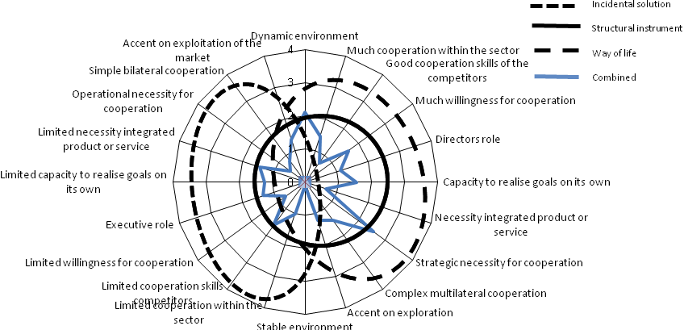
Figure 12 Combined results for the need for cooperation
When the outcome of the combined considerations for cooperation are compared with the theory of visions on cooperation of Kaats et al., it can be concluded that the LNG related firms in the case regard cooperation as a ‘structural instrument’. The blue line in the figure shows a significant match with this theoretical vision on cooperation. LNG related firms understand that cooperation is needed for achieving their goals and specific goals and objectives for cooperation will have to be set. Kaats et al. indicate that formalisation and standardisation of cooperation are part of this vision on cooperation; cooperation becomes part of the operation of LNG related firms in this matter. LNG related firms have the ambition to work together in order to realise their own goals. The Ministry of Economic Affairs provides a perfect tool for this, as the meetings for the trade missions are such forms of formalising the cooperation between the partners.
The coinciding vision of the LNG related firms provides opportunities for cooperation. However, the identification of the need for cooperation is just the first step in the process of cooperation.

Typology
The cooperation between the Ministry of Economic Affairs and LNG related firms in the three cases has specific characteristics, which will be provided in this paragraph. First, the goals will be defined, then the actors will be analysed and after which the partner selection will be scrutinised.

Orientation and role of the cooperation
First, the goals of the cooperation need to be specified, as these are the core of the cooperation. Not only should the need for cooperation be identified, but the purpose of the cooperation should be clear to all cooperation partners as well. When scrutinising the orientation of the cooperation as identified by Schulz et al. (Table 1), it becomes clear that the cooperation between the Ministry and firms is based on process oriented cooperation, instead of the goal oriented cooperation.
When taking the four roles of goal orientated roles of cooperation, at best the stimulating role of the cooperation could be applied to the cooperation at hand. As the Ministry and the sector pursue the contracting of LNG, they have formed workgroups to stimulate the process of contracting. By gathering the several interests in the three workgroups, the partners try to stimulate the process.
However, the role and orientation towards mediation, in order to mobilise support from several actors is a more evident goal of the cooperation. By finding consensus via the workgroup meetings and direct communication with the sector, the role of the cooperation is oriented towards the process of cooperation.
The assisting role of the cooperation could be of interest as well, as the cooperation in workgroups is aimed at the contracting of LNG; these groups aim to assist the process, by involving several actors. Therefore, the assisting role of the cooperation is relevant, besides the mediating role.
The main goal of the cooperation between the Ministry of Economic Affairs and LNG related firms is to contract LNG, which counts for the cooperation in all three cases. The goals of the three cases are therefore indifferent. Besides, the orientation of the cooperation is aimed at the process of this goal: by assisting and mediating between several actors the cooperation tries to achieve this main goal. Overall, the process orientation is more evident in the cooperation in all three cases. The orientation of the cooperation is therefore oriented towards the process, instead of achieving specific aims. The role of the cooperation is a continuous one, throughout the whole process of cooperation. Goals related to the cooperation are more specified at the process of cooperating, than on achieving specific goals.

Actors analysis
The following step in the process of cooperation is to identify the relationships in the cases and to select partners for the cooperation structures. First, the actors and the relationships among them will be identified using the overview of Stopford, Strange and Henley (1991).
The first actor involved is the Ministry of Economic Affairs (division Energy Market), which is the Dutch government actor. The private actors in the three cases are LNG related firms, which have interests in LNG activities in the Netherlands, of which several operate in consortia (see Figure 11). Although several (industrial) sectors are involved, namely the energy sector and the gas infrastructural sector, all private partners are engaged in LNG related entrepreneurial activities. However, not all the firms participating in the consortia participate in the workgroups and not even all participating LNG related firms participate in all three cases. Nine participating LNG related firms have been interviewed for this research, however not all the interviewed LNG related firms participate in all three workgroups (see Annex III). Because of strategic interests of the interviewed LNG related firms, their names will not be revealed. The third group of actors consists of the NOCs or LNG producing countries: for Algeria, the relevant NOC is Sonatrach, in the Angolan case this is Sonangol and in Qatar Rasgas and Qatargas. These NOCs are all majority state owned, but differ in their approach regarding the process of contracting; as described in chapter 5, the Qatari are relatively more approachable without government intervention, compared to Sonatrach.
Now, we can picture the relationships between those actors, see Figure 13. The Ministry of Economic Affairs has relations with both actors; access to NOCs on government level and stimulating the LNG related firms in order to fulfil its own Gas Hub ambition while stimulating the Dutch economy. The NOCs prefer to negotiate with governments, and therefore have a stronger connection with the Ministry of Economic Affairs than with the LNG related firms. On its turn, the LNG related firms would like to have a stronger relationship with the NOCs, but will have to cooperate with the Ministry of Economic Affairs to do so. It is rather difficult to specify the wishes and demands of the side of the NOCs, as indicated in chapter 4. However, it can be noted that there are significant differences in the approach towards the negotiation process between the several LNG producing countries. Algeria prefers a process where government is relatively strong involved, compared to Qatar where there is a more ‘western’ approach towards the negotiation process. The economy of Qatar is diversifying; creating synergy between oil and gas related activities and other industries and services, which provides opportunities for LNG related firms, but other sectors as well. Angola is an entirely new country of interest to the Ministry of Economic Affairs and has been recently added to the energy agenda. The first trade mission has provided new opportunities, not only in the field of LNG import; several other energy modes could play a significant role in the relationships with Angola. So, the role of the Ministry of Economic Affairs differs per country. However, this research takes this ‘supply side’ as given and focuses on solutions on the ‘demand side’, being the cooperation between the Ministry of Economic Affairs and LNG related firms. Therefore, the cooperation in the workgroups excludes the NOCs, as these do not formally take part in the cooperation process, but do form an important group of actors relevant for this research.
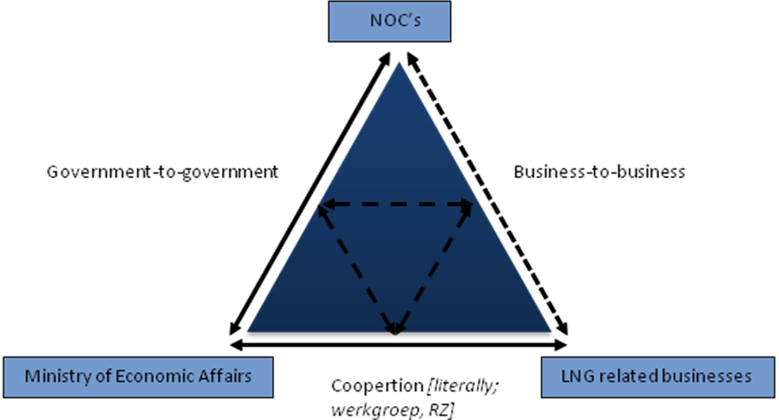
Figure 13 Interrelations between actors, (based on Stopford, Strange and Henley 1991, 22)
The interrelation between the several relations is noted in the figure as well. An example of this, are the MoU’s signed between the governments, which are directly related to the functioning of the relations at the business-to-business level. Otherwise, the cooperation between the Ministry of Economic Affairs and the LNG related firms, tries to stimulate the business-to-business relations between the NOCs and the LNG related firms.
Another group of actors which is of relevance for the process is the Dutch embassy. These do not actively take part in the cooperation process, but are relevant for the activities of the cooperation during trade missions. Embassies, represented by the Dutch ambassador or relevant civil servant, are engaged in trade missions and are mentioned to play a significant role for the cooperation. Depending on the interest and ambition of the embassy, the involvement of the embassy in LNG related negotiations and government or business related contacts in this field, could have a positive effect, as embassies could locally represent the Dutch interests of the cooperation between the Ministry of Economic Affairs and the LNG related firms. A good example of this is the (former) ambassador in Qatar, whom was very much involved in the negotiation process. However, like NOCs, the embassies are not formally part of the cooperation between the Ministry of Economic Affairs and LNG related firms. Therefore, we note the actor ‘embassies’, but regard them as part of the government-to-government relations in Figure 13.

Partner selection
Now the relationships between the actors are clear, the next step is to analyse the partner selection for the cooperation between the Ministry of Economic Affairs and LNG related firms in the workgroups. The ‘checklist’ with criteria of Porter and Fuller (stemming from Textbox 2) comes into play, see Table 3. In Annex V, an overview has been provided of the individual LNG related firms. As the cooperation involves both public and private organisations, two specific variables should be taken into account when these decide to cooperate: the competitive advantage for private organisations, and the equality principle guaranteed by the Ministry of Economic Affairs.
Criteria | Ministry of Economic Affairs | LNG related firms
Possession of desired resource of competitive advantage? | Yes, formal government relations, which provide access to the market for private partners | Yes, LNG specific knowledge, equipment, (human) capital
Need for a complementary or balanced contribution from the partner? | Yes, without the private sector the ambition of the Dutch gas hub cannot be realised (as the Ministry itself cannot import LNG) | Yes, in case of the Ministry, without government involvement contracting won’t be possible. In case of competitors: providing strategic information is difficult
Compatible view of international strategy? | Yes, ambition of gas hub is supported by private partners | Yes, all private partners pursue contracting of LNG for the Dutch market (although some have broader energy interests)
Low risk of the partner becoming a competitor? | Low, the Ministry cannot act as a private actor | High among private firms, as some participating partners are direct competitors
Partner has pre-emptive value in relation to rivals? | No, only indirect towards ‘competing’ countries in North West Europe | Yes, to keep track of competitors and equal the playing field
Partners’ organisational compatibility? | Low, governmental organisational design | High towards competitors, low towards the Ministry
Principle of equality? | Yes, core value of the Ministry | No, individual firms/consortia compete for LNG contracts
Table 3 Partner selection, differences between public and private partners
By having identified several characteristics of partners, the difference between the Ministry of Economic Affairs and private partners is evident. The Ministry of Economic Affairs represents the public sector, which forms the Dutch industry. Therefore, the Ministry of Economic Affairs is not in the position to exclude private organisations from the cooperation and all parties should get the same treatment. In selecting partners and during the cooperation process, the Ministry should safeguard the principle of equality; no preferred positions should be created. Meanwhile, LNG related firms cooperate in consortia, and therefore compete in these settings. These consortia or the individual firms are direct competitors, which have no preferred position according to the Ministry of Economic Affairs. Therefore, the Ministry of Economic Affairs is not in the position to exclude certain partners from the workgroups or trade missions.
The LNG related firms possess specific knowledge, expertise and/or capital, while they ‘depend’ on the Ministry of Economic Affairs for market access. Although this is a strong basis for cooperation, the cooperation includes direct competitors, which provokes uncertainty. From a strategic point of view, it is sometimes difficult for competing partners to share valuable or strategic information with competing partners. Eventually, the final contracting of LNG is not guaranteed and not all private partners are expected to benefit from the cooperation. Therefore, uncertainty surrounds the cooperation and private partners will behave on a calculated basis.
The Ministry of Economic Affairs plays two roles in the case, which are apparent at each stage of the cooperation process: the Ministry of Economic Affairs is a facilitator and a stakeholder in the Dutch gas hub, as Table 4 shows.
Role Ministry of Economic Affairs | Facilitator | Stakeholder in Gas Hub
Orientation | Executive | Legislative
Contracts | Not involved in negotiating | Manage ambitions
Trade mission | Host/facilitator/organiser | Advertiser, lobbyist
Equality | Provide equal opportunities for companies | Dutch economy
Administrative tool | Policy | Law
Style | Relatively informal in workgroups | Formal
Table 4 Two roles of the Ministry of Economic Affairs
The role of facilitator becomes eminent during the activities of the cooperation, while cooperating with the private partners. The role of stakeholder and ‘generator’ of the Dutch gas hub becomes clear when taking a look at the political side of the Ministry of Economic Affairs. As already mentioned in chapter 4, the Ministry of Economic Affairs has stated the ambition in its policy overviews (Energierapport 2008) and puts the gas hub on the international agenda. The orientation is aimed at an executive role when organising trade missions or meetings in the workgroups, while the political, legislative aspects are involved when the Ministry of Economic Affairs represents its position as the gas hub of Northwest Europe. The later role is more formal, where interaction with LNG related firms takes place in a more informal setting. The two roles of the Ministry become interrelated during an energy related trade mission, where the Minister of Economic Affairs promotes the gas hub as reliable market, and meanwhile facilitate meetings with the NOCs for the LNG related firms.
Important to note regarding the involvement of the LNG related firms is the position of foreign energy concerns: the current partners in the workgroups are Dutch energy concerns (whether on the brink of acquisition or European takeover or not). Therewith, it seems that the Ministry of Economic Affairs aims its activities towards Dutch LNG related firms.

Procedures
Now that the goals and partners are identified, the actual procedures and interaction processes between the Ministry of Economic Affairs and the LNG related firms can be scrutinised as these are the moments where the workgroups actually work together.
The main tool of the Ministry of Economic Affairs is the trade mission and around these trade missions the Ministry has formed workgroups with the LNG related firms, as described above. The organisation of the workgroups and trade missions is related to the target countries, indicated by the Ministry of Economic Affairs in the Energierapport (2008). However, the targeted countries for the workgroups in the case of LNG are Algeria, Angola and Qatar, as mentioned above.

Meetings
For the preparation of the trade missions and in order to set the goals of the mission and the workgroup itself, the Ministry of Economic Affairs organises meetings with the LNG related firms. The Ministry is therefore the host, agenda setter and organiser of those meetings, which provides opportunities for the competing firms to provide their opinion, ideas and strategies for the import of LNG for their business or consortium. The chair of a country specific meeting is the country-responsible civil servant of the Energy market division, who takes care of all energy related issues of the specific country in relation to the Ministry of Economic Affairs. Also the preparation and evaluation of the meetings is done by the Ministry of Economic Affairs. Private partners in the meetings are represented by their responsible employees, usually in the area of business development or public relations.
During the meetings, the sharing of information plays an important factor, as certain partners are not in the position to share valuable information with its direct competitors. This is a key issue for the Ministry of Economic Affairs in order to manage effective meetings; the sharing of valuable information is to be dealt with in agreement with all the partners. As the partners are all interested in the cooperation and the final contracting of LNG, partners will have several interests in the meetings. However, an important arguments of the LNG related firms for the involvement in the meetings is that participation has the advantage of keeping track of direct competitors and making sure no opportunities provided by the Ministry of Economic Affairs (like the trade missions) are missed. No formalisation takes place when LNG related firms participate in the meetings at the Ministry of Economic Affairs; no contracts are signed for cooperating in the workgroups. Therefore, the meetings and relationships in the workgroup are based on mutual trust, which is a fragile base to work on as partners could withdraw from the cooperation without consequences. However, as indicated by the interviewees, there is no need to consolidate the meetings in a more formalised way.
The meetings take place in the preparation phase for a trade mission, being incoming or outgoing, or in order to evaluate a trade mission, or to provide updates on the current evolvement of the individual contracting of the LNG related firms with the NOCs. However in the case of Qatar, the LNG related firms have decided not to get together in this setting until further notice, as they have their own individual contacts at the Qatari side and government involvement was not necessary at the moment of the interviews. In the case of Algeria, the Ministry tried to create one common document during a preparation meeting, in order to address the Algerian NOC with one voice. Due to the diverging individual interests this was difficult, as described in chapter 5. The ‘Algeria workgroup’ met several times during the last 3 years at the Ministry. The participants and contact persons of the LNG related firms change for time to time, (see Annex II, Interview F), and some non-LNG related firms and agencies joined the meetings. This did not always pleased the LNG related firms, as the focus would shift to other issues in Algeria, (see Annex II, Interview D). To some, as indicated in chapter 5, other energy sources or cross binding/selling involving knowledge or development, is of interest, to others this is not relevant. Most important is that all interviewees, even the LNG related firms with side interests, have indicated during the interviews that they would prefer the meetings to keep focused on the sourcing of LNG, as this is the common interest of all in the cooperation with the Ministry of Economic Affairs.
The interviews reveal that a good evaluation of the trade missions is a key task of the Ministry, which could be done during a meeting at the Ministry after an outgoing trade mission. The evaluation meeting is preferred to be held plenary. However, individual or consortia-based evaluation meetings should provide a more reliable or trustworthy setting, where LNG related firms are offered the opportunity to really provide insight in their strategic agenda. This could be very helpful for the individual participating LNG related firms, as specific requests could be negotiated during these individual meetings.
The meetings are thus useful for the LNG related firms, not only for business purposes, as indicated in chapter 5. LNG related firms regard the meetings a perfect opportunity to network, keep track of the market and competitors and to invest in the relationship with the Ministry of Economic Affairs. In this way, they try to influence both the market competitors and the Ministry of Economic Affairs and lobby for their cause. Some interviewees doubt the actual effectiveness of the meetings, but all interviewees appreciate the effort and the willingness of the Ministry organising the meetings and trying to facilitate opportunities for the LNG related firms.

Activities: trade missions
As energy trade missions are the core of the activities strategic cooperation described in this case, several types of trade missions will have to be distinguished. Energy trade missions are organised at several levels aimed at both public and private organisations, serving a wide range of goals and therefore each energy trade missions is different. The label ‘energy trade mission’ is used as these missions might conduct another approach than other trade missions, which is out of the scope of this research. However, it could be stated that energy missions have the ultimate goal of securing the export of energy commodities to the Netherlands. When organising a trade mission the goal of the trade mission has to coincide with the targeted visiting organisations and relations. Four types of energy trade missions are indicated, each with its own target and instruments (see Figure 14). This overview stems from research done by J.W. de Vries (2009). An exploratory mission is to introduce partners to parties in the host country; contacts are made and introductory meetings are held. The aim of the mission is to explore opportunities for further relations and negotiating future business opportunities, typically referred to as a ‘fact finding mission’. A resolving trade mission is a mission with a stricter agenda: a problem or trade issue is being discussed with the host country, at government or business level. The goal of the mission is to solve a certain problem and to generate future business deals. Consolidating missions are more formal missions, where contracts are finalised and declarations are signed. Agreements could be signed in the form of a Memorandum of Understanding (MoU) or an Investment Protection Agreement on foreign investment (Investeringsbeschermingovereenkomst, IBO). Maintaining trade missions are mission which are organised to develop an even stronger relationship; ‘extra’ attention to emphasise the current relationship. However, the types and targets could overlap during one mission; this classification could be used when planning an energy trade mission. The type of energy trade mission could be linked to the strategic time scale of the strategic cooperation, ranging from short, middle to long term.

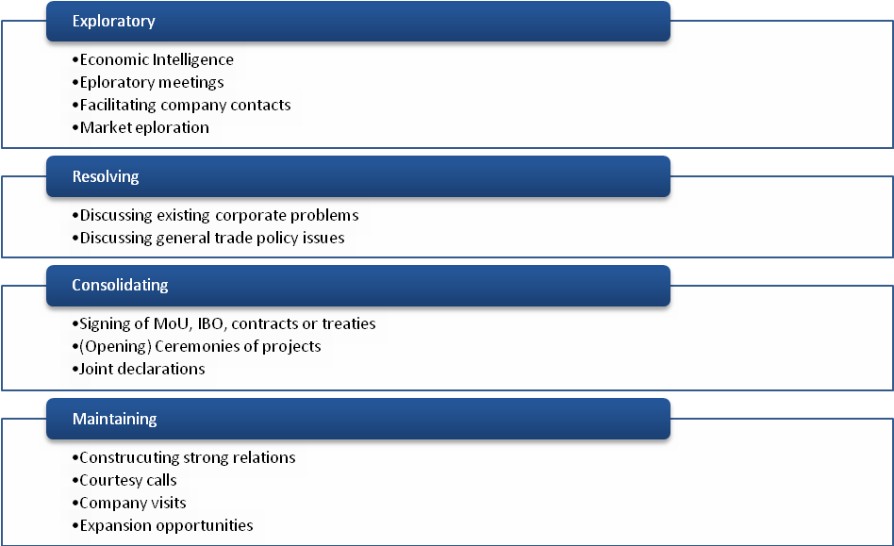
Figure 14 Four types of energy trade missions (J. W. De Vries 2009)
Trade missions are at the core of the procedures of the cooperation: the LNG related firms take the opportunity created by the Ministry of Economic Affairs to meet, negotiate, and do businesses with NOCs and in this way use the network opportunities of the Dutch government. The goals of the Ministry of Economic Affairs are stated as the presentation of the Netherlands as logistical and distribution centre of gas for Northwest Europe, the exploration of opportunities for Dutch energy related firms and the exploration of opportunities for the contracting of LNG, the participation in LNG projects, and the stimulation of investment in energy infrastructure in the Netherlands, (Ministerie van Economische Zaken 2009e).
During the trade missions an important factor is the involvement of certain key figures, which could have an impact on the trade mission. Therefore, when analysing the trade mission, the configuration of the trade mission should be included. Key elements are thus the participation of the Minister of Economic Affairs (or deputy Minister of State) or the involvement of CEO’s of the partners. These are included in the analysis as could be seen in Table 5, providing the operational variables for the procedures.

Criteria | Meetings |  | Trade Missions
 | Ministry of Economic Affairs | LNG related firms | Ministry of Economic Affairs | LNG related firms
Agenda setting done by |  | - |  | -
Role in meeting | Chair/ Mediator | Participant | Host/ Facilitator | Participant/ Negotiator
Persons involved | Country responsible civil servant | Business developer, PR manager | Country responsible civil servant and possibly (deputy) Minister | Business developer, and when necessary CEO
Relationship during procedure | Relatively informal | Relatively informal | Formal | Formal
Preference to share information | Group | Individual, with Ministry | Participants of trade mission | Individual, directly with NOC
Goal | Agenda setting, sharing of information/update, preparation trade mission or evaluation trade mission | Pursue or lobby for own interest in agenda setting, sharing of information/update, preparation trade mission, evaluation trade mission | Position the Netherlands as reliable gas hub, (re)establish (government) relations | Singing contracts with NOCs
Time scale | Short, mid and long term | Short, mid and long term | Short, mid and long term | Short, mid and long term
Costs | Organisational costs of a meeting | No participation or ‘entry’ costs | Organisational costs (accommodation, flight, travel expenses) | Participation costs (accommodation, flight and translation expenses)
Table 5 Operational variables procedures
Currently, for the three cases several incoming and outgoing energy trade missions have been organised, and more are planned. Table 6 provides an overview of the current status of the three cases and the characteristics of current trade mission. The type of trade mission depends on the goals defined by the workgroup: the first mission will be an exploratory mission, and depending on the negotiations between the individual LNG related business or consortia and the NOCs the goal of the mission will be oriented towards consolidating or maintaining. During these missions information from the local Chambers of Commerce and several agencies of the ministry of Economic Affairs (Senternovem and the EVD) is used by the cooperation partners. The goals of the trade mission will follow the goals of the cooperation, which depend on the time scale and development of the negotiation process of the contracting of LNG. Short terms goals are oriented towards the first meetings between the partners and the NOCs (exploratory missions) where the midterm goals concern content driven negotiations. Finally, the long term scale is coherent to the final goal of the cooperation which is the signing of contracts for the import of LNG. Therefore, trade missions and their goals are related to certain time scales alongside success of the cooperation.
Algeria
The trade mission in 2009 clearly shows the variety of goals the cooperation tries to achieve: from exploring contract opportunities to resolving trade issues and the consolidation and maintenance of the bilateral relationship between the two countries. As the bilateral contacts on energy issues have been established for a number of years now, the relationship has moved from the first initial steps of exploration to a more stable midterm relationship were investment in bilateral agreements are involved.
Angola
The goals attained during this mission included the exploration of opportunities and the signing of an IBO (consolidating). However, there only has been organised one energy related trade mission, so the relationship is in its first initial phase and the scale of the relationship is still underdeveloped (short term relationship); typically a first fact finding mission.
Qatar
The visit of the Qatari Minister of Energy Al Attiyah showed the developed relations between the two countries at government level and business level as well, as the visit was co-hosted by an energy concern. The cooperation between the two countries has developed to a mid to long term relation, where trade missions are aimed at consolidating and maintaining the ties.
Table 6 sums up the several workgroups and their characteristics. The phase at the time scale of this relationship can be identified as midterm; investments have intensified the bilateral relationship between the two countries at both government and business level.
 | Algeria | Angola | Qatar
Incoming trade mission | 2010* | - | 2009*
Outgoing trade mission | 2006*, 2007, 2009*, 2010 | 2008, 2009* | 2008*, 2010*
Type of mission | Exploratory, Resolving, Consolidating  Maintaining | Exploratory, Consolidating | Consolidating, Maintaining, Resolving, Exploratory
Agreement | IBO, MoU | IBO | MoU
Time scale | From short to mid term | Short term | From short to mid term
Table 6 Characteristics of the trade missions (trade missions marked with an * included the Dutch Minister of Economic Affairs)

Effects
The three cases show differences in the process of achieving their goals, which indicate that there are several differences in the three cases of cooperation between the LNG related firms and the Ministry of Economic Affairs.

Output
As can be seen from the last paragraph, the several cases are in different stages of the negotiating process connected to the several goals set by the workgroups, ranging from the first exploratory missions to the actual stage where participating LNG related firms in the process of negotiating contracts with NOCs.
However, to break it up; all the meetings of the groups and all trade missions create output in the cooperation process. The facilitating role of the Ministry of Economic Affairs includes the processing of the output created by the workgroup or individual partners; by identifying and noticing the several interests of the cooperation partners in the workgroup the Ministry of Economic Affairs is able to create the agenda for the trade mission. On the other hand, during the trade mission the negotiation meetings with the several NOCs produce output as well. Again, this could be on an individual level for the partners, or on the level of the group as a whole, where the Ministry represents the whole Dutch LNG industry and gas hub. An example of such an output is the demand of the Algerian government to include knowledge agreements in the contracting process and include local development asset clauses; this output was only provided after the first trade mission. These demands or barriers in the negotiation process are direct outputs of the work of the cooperation between the Ministry and the LNG related firms. Outputs are created throughout the cooperation process and shape the development and the successfulness of the cooperation. Evaluation during the cooperation is therefore needed as evaluation criteria serve as input for the next phase in the negotiation process. The role of the Ministry of Economic Affairs as facilitator in the three cases comes into play here. Evaluation is done during the meetings at the Ministry. However, some information is strictly confidential, as it is part of the individual corporate strategies. Therefore, the evaluation process of a trade mission could not always be in the interest of the whole workgroup. The Ministry of Economic Affairs should balance the evaluation process at the workgroup and individual level. The interviewees have indicated that the evaluation process could be improved by the Ministry. A more thorough evaluation of the Ministry would increase the effectiveness of the cooperation with the LNG related firms.
The outputs are valuable for the participating LNG related firms, as the (individual) negotiations proceedings depend on the follow-up of the outputs. A thorough evaluation in the separate meetings per country after each trade mission is therefore necessary in the cooperation process. The outputs combined can relate to a new insight for the next trade mission. A good example is the focus of LNG in the trade missions to Algeria; after the second energy related trade mission, the Algerian government showed specific interest to relate the LNG contracts to LPG (Liquefied Petroleum Gas) contracts. However, the core interest of the partners of the workgroup is LNG and some LNG related firms have no interest in LPG at all. This created a new outlook of the scope of the meetings: instead of focusing on one product/market, now for successful negotiating the involvement of LPG related firms became important. In order to include firms from other sectors in the meetings to achieve this cross binding/selling, a ‘critical mass’ should support this vision, otherwise the focus on LNG would disappear and therewith the initial common interest of the participating parties, (see Annex II, Interview G).
The Algerian example does not stand alone as negotiating LNG contracts involves more than the delivery of LNG, as shown in the case of Angola as well. These concepts will need the support of a lot more firms, NGO’s, research institutes and universities than the current number of participants in the meetings. Again, the shift from the focus on LNG contracting to a more intense cooperation on both the government and business levels between both countries is a shift towards a broader cooperation in the workgroup as well.
Here, Project Delta, where these ties between the government and business relations are very strong could function as an example as the cooperation in Project Delta on both levels has lead to a broad cooperation crossing the border of the energy sector. However, the relationship at government level with Algeria, Angola and Qatar all are very different from the relationship with the Russian government and firms. As the Russian government pushed towards such a broad cooperation Project Delta is a very successful formula in Russia; this type of cooperation is preferred by the Russian counter partners. The government of the three cases in this research do not push towards such a development of cooperation. MoU’s and IBO can solve trade barriers or stimulate cooperation, but this is still far from the well-organised formalised government and business relations in Project Delta.
These examples show the kind of outputs realised during the cooperation process. At forehand, neither the LNG related firms nor the Ministry of Economic Affairs did integrate these developments in their objectives or goals as the focus of the cooperation is the import of LNG. During the trade mission and the negotiation processes with the several NOCs these issues became known and point of internal discussion of cooperation between the Ministry and the LNG related firms.

Outcomes and feedback
The final outcome of the cooperation process between the Ministry and the LNG related firms in the three cases should be the realisation of LNG contracts with the NOCs. As is clear by now, so far no single partner or consortium has signed an import contract for LNG. However, the outputs gathered after trade missions and negotiation sessions have provided new input for further cooperation. The most striking one is that in the case of Qatar, where the participating LNG related firms agreed on not getting together in a group anymore at the Ministry.
Therefore, we can see that the outputs have functioned as feedback to the three cooperation settings; involvement of LPG and other energy sources in the Algerian and Angolan case are now part of the follow up procedures of the cooperation. The shift of focus from strict LNG negotiation towards broader energy related issues like local development programmes or even agricultural issues in these cases is a significant change in the goals of the cooperation and so far has not satisfied the demands of the LNG related firms.

Management of expectations
The management of expectations does play a significant role in the process of cooperation in the three cooperation cases between the Ministry of Economic Affairs and the LNG related firms; however, this process happens indirectly. The need for cooperation has been analysed and showed that cooperation is regarded as needed by the participating LNG related firms. However, all the partners in the meetings have certain expectations of the cooperation and its related goals and outcomes and each partner will try to influence the cooperation with the Ministry in order to achieve its own goals. Management of expectations is therefore especially relevant in the second step of the conceptual framework: the characteristics of the participating actors and specific partners are of influence on the management of expectations of the partners. This paragraph will describe the management of expectations in process and project management using the paradoxes identified by Klijn and van Twist and provide expectations of case specific issues.

Expectations in paradoxes
All the paradoxes provided in Table 2 are relevant real threats to the cooperation between the Ministry of Economic Affairs and the LNG related firms. The paradoxes arise because of the initial differences between public and private actors. Here, the analysis of paragraph 6.2 becomes of interest as core characteristics have been provided of the actors and the double role of the Ministry of Economic Affairs has been described. This paragraph will scrutinise the several paradoxes using the information of this analysis. The main question is how the partners regard each other and try to ‘double act’ in order to influence the cooperation partners, as described by Klijn and van Twist.
As stated in paragraph 2.4, the paradoxes stem from the misconceptions or mistaken beliefs of core values and strategies of the actors. The core business of the actors provide the characteristics of the first paradox: the political risks of the Ministry of Economic Affairs and the financial risks of the LNG related firms are at stake. However, as mentioned both agree that their individual goals (the creation of a Dutch gas hub and the contracting of LNG resp.) are only achieved via cooperation.
The second paradox is a more complex issue. The sharing of information is noted as a risk for the participation of LNG related companies, where the Ministry is more focused on creating equal opportunities for the participating countries (see Table 3). Hosting the process of cooperation as facilitator and the non-exclusive characteristic of the Ministry are of concern to the Ministry, while LNG related firms have to cope with direct competitors in the cooperation. Both the Ministry of Economic Affairs and the LNG related firms are aware of this paradox on their core values.
However, important to note is the difference in process and project management of expectations in the cooperation between the Ministry of Economic Affairs and LNG related firms. Expectations in process management concern the expectations regarding the direct cooperation between the actors in the three cases, where the expectations regarding project management regard the expectations in the actual contracting of LNG imports, the actual content. The LNG related firms are strongly in favour of the facilitating role of the Ministry of Economic Affairs; all interviewed LNG related firms agree on the role of the Ministry as a facilitator. They regard the Ministry as a crucial partner in the contracting of LNG imports, with the main asset that strong government relations are needed. Therefore, they also support the concept of the Dutch gas hub and appreciate a strong lobby of the Ministry of the Dutch gas hub towards LNG exporting countries. So, the facilitating role of the Ministry throughout the cooperation process (all four phases of the conceptual framework) is well supported by the LNG related firms. However, when it comes to the actual individual contractual negotiation process, which becomes relevant during the trade missions, LNG related firms expect a more passive role of the Ministry of Economic Affairs: this is the point where individual LNG related firms do not want the Ministry of Economic Affairs to intervene with their individual goal achievement. Involvement of the Ministry in this phase is only required in order to support the negotiation process in ways of diminishing trade barriers (procedural issues like authorization, permits or MoUs) in order to stimulate the contracting process of LNG. All interviewed LNG related firms expect the Ministry of Economic Affairs to provide the constraints regarding the cooperation, but do not want the Ministry of Economic Affairs to interfere with ‘their’ business.
The third paradox concerns the formal contractual side of the actual cooperation between the Ministry of Economic Affairs and the LNG related firms (which is different from the LNG contracting process between LNG related firms and the NOCs); this paradox is a more relative problem. As the cooperation between the LNG related firms and the Ministry of Economic Affairs is not officially limited in contracts or signed upon, the cooperation does not entail contractual agreements. It is up to the individual LNG related firms to take part in the meetings and their related trade missions. The Ministry of Economic Affairs offers them the opportunity to participate without further contractual consequences. Therefore, the LNG related firms are free to ‘breach’ the cooperation. This actually happened in the case of Algeria, where one of the LNG related firms decided to decrease its participation, (see Annex II, InterviewF). This was done as the results of the cooperation were not satisfying the firm. LNG related firms do think however such contractual agreements are not necessary and the cooperation with the Ministry will not have to be consolidated. A contractual agreement to participate in the workgroup would not increase the goal achievements of the workgroup or individual LNG related firms, according to all interviewed participants. Therefore, the third apparent paradox is not an issue in the cooperation between the Ministry of Economic Affairs and the LNG related firms. This paradox is strongly linked to the former paradox of information sharing. When the process of cooperation in the workgroups would be increased by signing a contractual agreement, LNG related firms fear that they will have to share in-depth strategic information during the meetings, which would mean that they could be forced to provide direct competitors strategic confidential information.
Including a contractual agreement for the cooperation between the Ministry of Economic Affairs and the LNG related firms is not regarded as more beneficial by the interviewed LNG related firms. The benefit for the LNG related firms of the cooperation with the Ministry of Economic Affairs is related to the ‘access’ the Ministry provides to NOCs or exporting countries, as NOCs prefer the involvement of governments in their oil and gas activities and contracts. Besides this, benefit of the direct cooperation with the Ministry in the workgroups lies in the fact that LNG related firms see the metings as a perfect opportunity to maintain, preserve and intensify relations with the Ministry of Economic Affairs and even with direct competitors and that the cooperation provides opportunities to inform and get informed on specific country issues. Therewith, besides the direct goals of contracting LNG via the cooperation with the Ministry of Economic Affairs, this is a completely new point of view to regard the cooperation. These indirect effects of cooperating in the workgroups are not measurable with the conceptual framework, but are definitely relevant for the behaviour throughout the process of cooperation.
The forth paradox is aimed at the consequences of the attitudes and behaviours of the public and private actors. The risk reduction and need for the verification of procedures within the cooperation by the Ministry of Economic Affairs is not emphasised upon in the meetings. Instead, the Ministry realises it plays a facilitating role for the LNG related firms. On the other hand, the LNG related firms do not have a hesitant attitude towards cooperating with the Ministry of Economic Affairs as they realise that they need the Ministry in order to gain contact with the NOCs. This ‘mutual understanding’ makes the cooperation in the three cases actually quite strong and creates a certain level of trust among the public and private actors. Therefore, cooperation creates added value for all the participating parties.
The four paradoxes identified by Klijn and van Twist are not all necessarily relevant in the cooperation in the three cases, however, by analysing the paradoxes the management of expectations in both process and project management the expectations of the roles of the Ministry of Economic Affairs and the LNG related firms can be summarized as shown in Table 7.
Klijn and van Twist regard trust as the main argument for the management of expectations. By taking the roles as described in Table 7 as the expected desired roles of the Ministry of Economic Affairs and the LNG related firms, the public and private actors now what is expected from them. With this, the partners in the workgroup can relate their activities to their expected role in the cooperation. When the partners keep in mind throughout the cooperation what is expected from them and their role, they could enhance the cooperation by ‘acting double' and this will enhance the trust between the partners in the workgroups in both the process management and the project management.
Expected role of | Conceptualization | Politicization | Commercialization | Construction
Ministry of Economic Affairs | Clear signals of political will | Trust enhancing measures based on credible discourse with view to shorten the phrase all together | Brokering of impasses only | Authorization Facilitation
LNG related firms | Solid and experienced project developer groups assembled | Provide information | Main responsibility of commercial parties | Execution
Table 7 Roles of public and private actors in the workgroups (based on Aamlid Syversen 2009)

Case specific expectations
Specific expectations of the LNG related firms of the cooperation in the workgroups are related to the outputs, which have been included in the analysis of this chapter. These expectations are related to the role of the Dutch embassy, the feedback on evaluation (output of the cooperation which turns into new demands) and cross binding/selling. The LNG related firms regard these three points as relevant outputs of the cooperation process so far, and raise certain expectations on these issues for the future cooperation in the workgroups.

The role of the embassy and external parties
The involvement of the Dutch embassy in Qatar had the advantage of a local representation of the Dutch industry, including the strong representation of the Dutch gas hub as attractive export opportunity. By having strong direct contact via the Dutch embassy in the exporting country, the embassy could function as a local ‘lobby’ for the participating LNG related firms, as has happened in Qatar. The LNG related firms in the cooperation were all very pleased by this positive and involved role of the Dutch embassy in Qatar, as the government-to-government relation were positively influenced by the involvement and this improved access to relevant NOCs. Although it is up to the individual agenda of the Dutch embassies to be involved in the process of LNG contracting or facilitation, the participating LNG related firms would appreciate this involvement of the embassies in other LNG exporting countries, based on the positive results in Qatar.
LNG related firms appreciate the involvement of local Chambers of Commerce, Business Councils or participating agencies of the Ministry of Economic Affairs, such as the EVD. The LNG related firms regard ‘local knowledge’ as crucial for further development of negotiating contracts. The emphasis is on cultural behaviour in business and local business strategy, as negotiation processes have proven to be different from the Dutch or European style. The local chapters of Ministerial agencies or Business Councils could provide specific knowledge which could be used during the negotiation process, as used in the case of Angola. Besides, this would increase the business-to-business relations between the LNG related firms and the NOCs as it could generate network and business opportunities, according to the expectation of LNG related firms. The LNG related firms expect the Ministry of Economic Affairs to facilitate these parties in the meetings or to have them involved in the trade mission as well. Again, like the Ministry of Economic Affairs, these parties should be involved in the process management of cooperation (the interaction process, aimed at the NOCs), not the project management (the involvement in the actual individual direct negotiation process between LNG related firms and NOCs). The expectation is that the involvement of parties possessing ‘local knowledge’ will improve the negotiation process and therewith the process of cooperation between the Ministry of Economic Affairs and the LNG related firms. Again, this is included in the expected role of the Ministry of Economic Affairs as facilitator.

Outputs and feedback
In the last phase of the cooperation process the outputs play an important role in the development of the cooperation as these provide new input for the future in the cooperation process. The LNG related firms consider the output of trade missions and the evaluation of the achievements of the LNG related firms as crucial for future cooperation process. The LNG related firms consider the outputs of the cooperation process as an essential factor in the cooperation and consider the Ministry to facilitate this in the cooperation process. The process management of the Ministry in the preparation and evaluation meetings is regarded as the most important role of the Ministry, as the LNG related firms measure the performance of the Ministry and therewith the benefit of taking part in the workgroups according to the use of the output generated in the (individual) meetings. Therefore, the LNG related firms expect the Ministry of Economic Affairs to facilitate the preparation and evaluation meetings and use this as input for the future.
Preparation meetings are considered by the LNG related firms as crucial, specifically the input provided by the partners. However, the LNG related firms do expect the Ministry of Economic Affairs to facilitate the preparation process with a relative strict agenda. The LNG related firms do appreciate the commonly shared characteristic of the agenda of the Angolan trade mission. However, the LNG related firms consider a strict agenda of trade missions to be more valuable. The ad hoc characteristic of the trade mission resulted in individual behaviour of participating partners (direct competitors). Therefore, LNG related firms prefer a strict common agenda, however equal opportunities when it comes to the process of contract negotiations. Agreement on the goals of the trade mission in advance and the procedures during the trade mission is therefore expected, which is the expected responsibility of the facilitating role of the Ministry of Economic Affairs. LNG related firms consider the preparation meetings as the main tasks of the Ministry, and the results of a trade mission are regarded to depend on the management of expectations in this phase of the cooperation.
The evaluation process is another task of the expected facilitating role of the Ministry, as the evaluation meetings provide the outputs of the procedures and trade missions of the cooperation. Therefore, the evaluation meetings are regarded as essential for the follow up of the cooperation. Information sharing is the trust barrier involved in this process, as outcomes of the trade missions provide strategic decisions at business level. Strict confidential information should be shared on a confidential individual session between the LNG related firm and the Ministry of Economic Affairs. However, the facilitating role of the Ministry is expected to provide relevant information when it comes to the evaluation of the trade mission and cooperation process itself. The outcomes of the evaluation meetings are regarded essential as it serves as new input for future participation in the cooperation and future goal setting process.

Cross binding/selling
The output of the cooperation in the case of Algeria and Angola included a development to include other (sub) sectors in the negotiation process, being in the energy sector like solar power or LPG, or being a cross sectoral cooperation to link LNG contracts to knowledge sharing, local development programmes or agricultural cooperation besides energy cooperation.
This development was initially not expected by the LNG related firms. For some, this is considered as a good development, as it provides even more business opportunities in areas where they are active in. For other LNG related firms this development is considered as a loss of focus on the core businesses and disturbs the reason for the cooperation process in the workgroups.
The implication of this development is a broader scope of the cooperation, as new partners from non-LNG related sectors are willing to participate in the meetings to benefit from this development. Instead of focusing on LNG contracting, the workgroup will set new goals in order to achieve its goals and these goals might be further than some participating LNG related firms expect. Therefore, the implication of a wider focus is not considered to be a good development by all LNG related firms. However, LNG related firms with a strong focus on solely contracting LNG do realise that such a wider cooperation might be necessary in order to achieve the individual goals. Still, the consequence might be that some LNG related firms might take a less active role in the workgroup and are less willing to share information in the workgroup in the future. Therefore, the interviewees have indicated that the focus of the cooperation should be the sourcing of LNG. The common interest is the sourcing of LNG; the ‘critical mass’ supports this vision.
The expected role of the Ministry of Economic Affairs is that the focus will be on LNG contracting, which could be achieved by investing in a stronger government-to-government relationship. MoU’s and the support of the government is essential, but the LNG related firms still expect a focus on LNG contracting, as this is the commonly shared characteristic of the cooperation. With such cross sectoral developments, participating LNG related firms expect the Ministry of Economic Affairs to be clear on the shift in goals, when necessary.

Conclusions, discussion and recommendations

Having analysed the process of cooperation and the management of expectations of the cooperation in the three cases by using the conceptual framework, conclusions can be drawn from the cases in this final chapter. First, a discussion will follow on these analyses, after which conclusions will be drawn in a structured way, by answering the sub questions and then formulate the answer for the research question. Then, this chapter will finish with recommendations for the Ministry of Economic Affairs. Finally, some notes for further research are made.

Discussion on findings
The previous chapter provided the analyses of the stages of the process of cooperation between the Ministry of Economic Affairs and the LNG related firms and the management of expectations in the three cases. A discussion will follow on the analyses of the cases, combining the analyses of the process of cooperation and the management of expectations.
The most striking differences between the three cases will not be found in the first stage of the process of cooperation, as the ambition for cooperation of the LNG related firms with the Ministry of Economic Affairs are the same in the three cases. Also, the initial goal of contracting LNG is the same in the three cases, though different LNG producing countries are targeted in the cooperation settings. Some differences occur in the participating LNG related firms, depending on the individual strategies of the LNG related firms. However, the important differences occur in the procedures stage and as a result the generated outputs of the three cooperations differ. The demands of the targeted LNG exporting countries are different, ranging from cross sectoral cooperation to local and regional development.
After a complete ‘cycle’ of the process of cooperation, the output serves as feedback and creates input for future cooperation. This cycle of the process of cooperation actually takes place in each of the three cases, as the final goal of the cooperation in the three has not yet been reached in any case; no LNG import contracts have been signed by any participating partner. Therefore, the cycle of the process of cooperation repeats itself, however, taking the output of the last ‘procedure’, the last trade mission and its outputs, as input for the next ‘cycle’ of the cooperation process. This provides the opportunity for the cooperation to expand its scope. In the case of Algeria, this meant that the focus of LNG widened to LPG and other sources of energy in the ‘new cycle’, as the new partners entered the meetings. For Angola, the same movement occurred: a wider scope moved the focus of LNG to a wider energy source discussion. The Qatar cooperation agreed on a ‘break’ of the cooperation, as individual LNG related firms prefer the Ministry not to get involved in their own contracting efforts.
So, after a cycle of the process of cooperation has been completed, the outputs serve via feedback as input for the cooperation. New partners could participate, current partners could decrease their involvement in the meetings and even the scope of the cooperation could shift from LNG to broader energy related issues, or even cross binding/selling. These shifts in the process of cooperation do influence the management of expectations of the involved partners, both public and private. A shift in the scope or goal of the cooperation does entail a shift in the expectations of the partners, not only about the achievement of the initial individual goals, but as well about the (expected) role of the partner. In order to manage the expectations, after a complete cycle of the process of cooperation, the cooperating partners should evaluate and discuss not only the output of the last trade mission, but should indicate the expectations of the role of the Ministry of Economic Affairs and the scope of the goals of the cooperation as well. In this way, the Ministry of Economic Affairs is able to streamline the expectations of the LNG related firms with the current reality. And in doing so, the Ministry of Economic Affairs is in the position to understand the expected role, as facilitator or stakeholder in the gas hub.
Overall, it can be noted that the conceptual model, where the basic concepts of Easton’s system model and Schulz’s model describing the process of cooperation in committees, is applicable in the three cases of public private cooperation between the Ministry of Economic Affairs and the LNG related firms in the process of contracting LNG.

Conclusions
This research has attempted to create a sound theoretical foundation for explaining the characteristics of the process of cooperation between the Ministry of Economic Affairs and LNG related firms and the management of expectations throughout this process.
The research question was stated as follows:
‘How can expectations be managed when applying Schulz’s model on the process of public private cooperation between the Ministry of Economic Affairs and LNG related firms in the case of import of LNG from Algeria, Angola and Qatar?’
In order to answer this research question, a number of sub questions were stated, which will be answered separately before answering the research question.
- How could Schulz’s model be applied on the process of public private cooperation?
To provide a theoretical basis for the research, first the process of cooperation between public and private actors was linked to Easton’s concepts of the system model (1965a) (1965b). The input-conversion-output style provided a guideline for the theoretical framework. These concepts were elaborated on by Schulz, van Twist and Geveke (2006), who scrutinised the process of cooperation in committees. By integrating the concepts of Easton’s model in the model designed by Schulz et al., a conceptual framework has been presented, which could describe and prescribe the process of cooperation between public and private partners, using various variables.
  - Why do partners regard cooperation as needed?
The first stage of the conceptual framework analysed the needs for cooperation, or the ‘ambition to cooperate’. This was done by analysing ten ambitions for cooperation, described by Kaats et al. (2006). The vision on cooperation which was evident after interviewing the participating LNG related firms was the vision of cooperation as a ‘structural instrument’. The dynamics in the environment and the strategic necessity for cooperation were regarded as important by the LNG related firms, where they all see the Ministry of Economic Affairs as a crucial actor in order to achieve individual results.
  - What are the characteristics of the cooperation?
The typology of the cooperation between the Ministry of Economic Affairs and the LNG related firms were based on three main characteristics, being the goals of the cooperation, the actors involved and the selection of partners. The main goals of the three workgroups were identified as the contracting of import of LNG. The difference in the three workgroups exists here in the different target countries of the workgroups; Algeria, Angola and Qatar. The orientation and role of the cooperation in the workgroup was identified as ‘process oriented’; the goal of the cooperation between the Ministry of Economic Affairs and the LNG related firms is to assist and mediate the process.
The actors involved in the three cases are the Ministry of Economic Affairs, the LNG related firms and the three LNG producing countries, or NOCs (Algeria, Angola and Qatar). These were identified by analysing the theory of Stopford et al. (1991).
However, the participating partners in the cases were nine interviewed LNG related firms and the Ministry of Economic Affairs (division Energy Market). Here, differences in characteristics were identified between the Ministry of Economic Affairs and the LNG related firms, by analysing theory of Porter and Fuller (1986). The Ministry regards the criteria of equal opportunities as important in the process of cooperation, while the LNG related firms regard the sharing of information and the cooperation with direct competitors as important aspects of the process of cooperation. Here, the double role of the Ministry of Economic as facilitator of the meetings and trade missions and as stakeholder in the Dutch gas hub became evident.
  - What are the procedures involved in the cooperation?
The procedures of the cooperation arise around the meetings and the activities; in the three cases, these activities were identified as the meetings and trade missions. The three cases involve different types of trade missions: the Algeria and Qatar workgroup trade mission are exploratory, resolving, consolidating and maintaining, where the Angola trade missions are only exploring and consolidating.
  - What are the effects of the cooperation?
The effects of the cooperation in the three cases are therefore different as well. The generated effects are measured by identifying the output of the cooperation and the outcome. The outcome should be the contracting of LNG, which so far was not successful. The differences in output between the cases are related to the differences of demands of the three targeted countries: the Algeria workgroup links the contracting of LNG to contracting of LPG and other energy sources, the Angolan cases does integrate other sectors (agricultural development) in the process and the cooperation on Qatar is expelled, as the LNG related firms consider the role of government not to be as important as in the other countries. The demands of the three LNG exporting countries cause differences in the outputs generated in the cooperation with the Ministry, which have effect on the future process of cooperation.

- How could expectations be managed in a public private cooperation?
The management of expectations in the process of cooperation has been described by Klijn and van Twist (2007a) and the three cases have been analyses by four paradoxes in the management of expectations. The management of expectations is done at two levels: the project and process level of the cooperation. The first paradox scrutinises the mistaken beliefs of core values and strategies, which are not relevant in the three cases, as the public and private partners do agree on common goals. The second paradox, focusing on the different roles of the public and private partners is more evident in the three cases, as the Ministry of Economic Affairs is expected to play a facilitating role throughout the process of cooperation and the negotiation processes. The expected facilitating role of the Ministry of Economic Affairs could collide with the role of the Ministry of Economic Affairs as stakeholder.
The third paradox on risk reduction by singing cooperation contracts is less relevant in the three cases, as the participating partners didn’t sign formal contracts for the participation in the cooperation. Besides, when analysing this paradox an indirect effect became apparent: the informal meetings provide opportunities for the LNG related firms to develop strong relations with the Ministry of Economic Affairs and the direct competitors.
Last, the fourth paradox of strategic behaviour is not evident in the three cases either, as there is a mutual understanding among the participating partners.
Considering the main findings it may be concluded that managing expectation in the three cases takes place throughout the four stages of the process of cooperation between the Ministry of Economic Affairs and the LNG related firms. The management of expectations takes place on the level of both process and project management; where the second stage of the process of cooperation (the partner selection) offers opportunity for the partners to influence the characteristics of the cooperation and try to influence expectations of the partners during the meetings and trade missions.
Having answered the sub questions the research question could be answered. The conceptual framework has provided the theoretical background to analyse and prescribe the process of cooperation between the Ministry of Economic Affairs and the LNG related firms. Schulz’s model has been revised in order to analyse the management of expectations during the process of cooperation. Here, the second stage of the conceptual framework offers the opportunity for the Ministry of Economic Affairs to ‘think double’: the Ministry of Economic Affairs is able to play two roles in the three workgroups, as facilitator and as stakeholder. Now, the Ministry of Economic Affairs knows what the LNG related firms expect from the Ministry of Economic Affairs. Not only at the process level, which aims at the facilitating role of the Ministry of Economic Affairs and the process oriented role of the workgroups with a mediation and assisting goal, but also at the project level the Ministry of Economic Affairs should provide solutions for the LNG related firms to stimulate the LNG related firms.
Below, conclusions are drawn from the analysis and the interviews. Some recommendations are drawn from the interviews and are therefore case specific.
- Public private cooperation in the three cases should be considered as highly complex and deserves strategic alignment between the participating partners in the three cases in terms of all stages of the process of cooperation.
- The second stage of the process of cooperation, where the goals of the cooperation and the choice of partners is done, provides opportunities for the Ministry of Economic Affairs to influence the expectations of the participating LNG related firms.
- The LNG related firms do see opportunities for the Ministry of Economic Affairs to move from a strict process orientation in the goal setting stage of the cooperation, to a goal orientation. The stimulating goal and role of the cooperation could provoke more in-depth interest during the trade mission towards the actual contracting of LNG.
- The Ministry of Economic Affairs should keep in mind that the LNG related firms do regard the Ministry of Economic Affairs to facilitate process of cooperation. The Ministry should provide solutions for the LNG related firms during the trade missions in the form of MOU’s and IBO’s to overcome trade barriers. The Ministry of Economic Affairs should not interfere during the individual negotiations with the NOCs.
- After the trade missions, the Ministry of Economic Affairs should take the lead in the cooperation for the evaluation meetings. The LNG related firms all agree that the evaluation after the trade mission has the advantage of keeping track of the negotiations developments of the competitors. However, not all LNG related firms agree to share all strategic information in a plenary meeting with the competitors. Therefore, the Ministry of Economic Affairs should provide individual LNG related firms the opportunity to share specific information during individual sessions. In this way, the facilitating role of the Ministry of Economic Affairs is still apparent, but provides the LNG related firms to fulfil their own individual goals as well. The evaluation is regarded to add value to the cooperation between the Ministry and LNG related firms.
- Besides the evaluation meetings, the LNG related firms would appreciate more output of the Ministry of Economic Affairs in the last stage of the process of cooperation; providing summaries, strategic evaluations of the trade missions, integrate feedback, regular updates of current LNG related events in the target countries. With these outputs, the Ministry of Economic Affairs could fulfil its facilitating role even better.
- The informal contact during the meetings serves as a ‘hidden’ feature of the cooperation. LNG related firms regard the meetings of the cooperation as a perfect opportunity to network with the competitors and keep track of the current developments in the LNG market. Besides, the meetings offer the LNG related firms opportunities to bond in an informal way with the Ministry of Economic Affairs.
- The cooperation between the Ministry of Economic Affairs and LNG related firm will not have to be consolidated, as contracts would decrease the participation of LNG related firms.
- The LNG related firms appreciate the interest of the Ministry of Economic Affairs in the LNG market and regard the effort and role of the Ministry of Economic Affairs to promote the Netherlands as gas hub for Northwest Europe. Therefore, the LNG related firms do applaud the attendance of the Minister of Economic Affairs at the trade missions, as the LNG exporting countries expect the government to be involved in the negotiation process as well.
- The involvement of the Dutch embassy has proven to be very helpful during the trade missions and negation processes in Qatar. Therefore, the LNG related firms would like to see more involvement of the Dutch embassies and other Dutch/local chambers of commerce. In this way, the LNG related firms are able to have a local ‘lobby’ for their cause, working in the targeted country with local knowledge. Therefore, the Ministry of Economic Affairs should cooperate closely with its ministerial agencies and the Ministry of Foreign Affairs (Dutch embassies).
- The ‘Russian model’ of Project Delta serves as a good example of public private cooperation, but LNG related firms do not see this happening in either of the cases at this moment. The LNG related firms do not foresee this demand from any of the targeted countries, to implement such a ‘heavy’ government-to-government and business-to-business relationship in a structured way as in Project Delta. Therefore, the LNG related countries do not advise the Ministry of Economic Affairs to steer the relationships with the targeted NOCs in such a way.
- The list of target countries selected by the Ministry of Economic Affairs, aside from the energy priority countries, for the LNG related trade mission, as believed by the LNG related firms to be well considered. However, they would like to be integrated in the selection process, as some countries might be of important future relevance for the LNG related firms, but not of the Ministry of Economic Affairs. Examples of countries mentioned by several LNG related firms are Equatorial Guinea, Australia, Nigeria and even Iraq and Iran.
- After the a ‘cycle’ of the process of cooperation, when reconsidering the focus of goals and partners of the cooperation in the second stage based on outputs gathered during the trade missions, the Ministry of Economic Affairs should involve the participating LNG related firms in the decision making meetings. The current participating LNG related firms should share their expectations on the future outlook of the cooperation and the role of the Ministry of Economic Affairs therein. By inviting the LNG related firms to share their thoughts and concerns the Ministry of Economic Affairs could manage the expectations of the partners and manage the workgroups towards a more effective cooperation.
- Overall, the LNG related firms are very positive towards the efforts of the Ministry of Economic Affairs to be involved in the process of contracting LNG. Therefore, the LNG related firms would like to keep the Ministry of Economic Affairs involved in the process of contracting LNG, via the cooperation settings.

Recommendations
However the current reality has shifted away from the cooperation between the Ministry and LNG related firms in the three cases to the ‘Overlegplatform Gasrotonde’, for the purpose of the thesis research some recommendation are made:
The process of cooperation with LNG related firms could be more effective. The Ministry of Economic Affairs should act stricter in the second phase of the cooperation process: the goal setting and partner selection process should be more aimed at the common goal of the cooperation, which is the sourcing and contracting of LNG. This common goal should prevail in each case. The critical mass of the participating LNG related firms should support this vision, as this is the reason why partners participate in the meetings. When cross sector/ cross binding propositions are of interest to the negotiating partner (NOC/government), this should be made clear to all participating partners, as not all partners have interests in such ‘package deals’. However, the Ministry should offer the participating LNG related firms the opportunity to make their wishes and positions clear when cross sector propositions are being discussed, in plenary sessions or individually. The focus should be on LNG, but when the negotiating NOC demands otherwise, the Ministry should communicate this clearly and set goals accordingly.
A strict agenda setting before and evaluation after the energy related trade mission is absolutely necessary for the role of the Ministry of Economic Affairs as facilitator. The Ministry should push the participating LNG related firms to provide information on their efforts and accomplishments in negotiating process, for the further process of cooperation. When participating LNG related firms decide not to provide information in a plenary session, the possibility should be provided to do this individually. In this way, the Ministry could help and support individual LNG related firms effectively in the process of negotiating and sourcing LNG. Where LGN related firms decide not to provide such an update, the Ministry is unable to provide the participating partners any added value to the cooperation. Providing output in the form of summaries, evaluation meetings and country specific LNG market updates are helpful ways to add value for the Ministry of Economic Affairs. Inclusion of local embassies and other agencies (EVD, local Chambers of Commerce) should be incorporated in the cooperation. These organisations and agencies have country or market specific information, which add value for the participating LNG related firms as well. The Ministry of Economic Affairs would again add value if these organisations are introduced and included at the right moment in time of the process of cooperation; that would be before the third stage, before the trade missions.

Notes for further research
When looking back on the process doing research for this thesis, several aspects should be kept in mind. The interviews were conducted during an internship at the Ministry of Economic Affairs. The provided information could be biased, as explained in chapter 3. Besides, the current reality changed significantly. The Ministry of Economic Affairs has organised a consultation forum on the gas hub, as stated in the Gas Hub Letter written by Rodrigo Pinto Scholtbach, (Ministerie van Economische Zaken 2009b). The interviews were conducted in May and Jun 2009, while the vision on the future of the gas hub was announced in October 2009, so at the time of the research this was not made public yet. Though, the results of the research and outcomes of the interviews are still very relevant, as the management of expectations will go on in this new form of cooperation, ‘Gasrotonede Overleg’, (Ministerie van Economische Zaken 2010).
However, more important is the procedure of writing this thesis. Due to the internship I’ve had a couple of months to gather information and conduct the interviews. Meanwhile, I’ve struggled combining two tasks: writing an academic thesis and doing practical research. Therefore, during the internship I’ve tried to work and research as practical as can be, while after the internship I focused on writing an academic paper. During the internship, I’ve gathered relevant information, but the academic base of the thesis, the theoretical framework, still lacked; the classical pitfall for a student when writing a thesis. This has had a significant influence on the proceedings writing this thesis. The outcome of this research is focused on three specific cases of cooperation between the Ministry and LNG related firms, analysed using a framework specified on these cases. Therefore, it can be suggested that the theoretical framework ‘leans’ towards the outcomes of the interviews, but in my opinion, this does not subverts the research. The current ‘Overlegplatform Gasrotonde’ has replaced the coopertation setting as described in this thesis, but the results of the analysis of the process of cooperation are still valuable for future cooperation forms between the Ministry of Economic Affairs and the (gas) industry.

Bibliography
Aamlid Syversen, O. “StatoilHydro, Shah Denoz and Natural Gas Supplies through the Southern Corridor.” Clingendael Institute, Caspian Region meeting. The Hague, the Netherlands: StatoilHydro, 2009. 33.
Algemene Energie Raad & Adviesraad Internationale Vraagstukken. Energiek Buitenlands Beleid. The Hague, the Netherlands: Van Deventer, 2005.
Algemene Energie Raad. Gas for Tomorrow. Advisory report for the Dutch government, The Hague, the Netherlands: Van Deventer, 2005.
ASPO. The OPEC Bulletin and focus on Angola. 31 January 2010. http://www.peakoil.net/headline-news/the-opec-bulletin-and-focus-on-angola (accessed June 4, 2010).
BBC News. Angola: China's African foothold. 20 June 2006. http://news.bbc.co.uk/2/hi/africa/5080626.stm (accessed June 4, 2010).
Babbie, E. The Practice of Social Research. Belmont, USA: Thomson Wadsworth, 2004.
Bovens, M.A.P., P. 't Hart, and M.J.W. van Twist. Openbaar Bestuur. Alphen aan den Rijn, the Netherlands: Kluwer, 2007.
Brinkhorst, Minister van Economische Zaken mr. L.J. “Visie op de gasmarkt.” Ministerie van Economische Zaken. 6 March 2006. http://www.ez.nl/Actueel/Kamerbrieven/Kamerbrieven_2006/Maart/Visie_op_de_gasmarkt (accessed February 21, 2010).
Child, J., D. Faulkner, and S. Tallman. Cooperative Strategy, Managing Alliances, Networks and Joint Ventures. New York, USA: Oxford University Press, 2005.
CIEP. The Gas Supply Outlook for Europe. The Hague, the Netherlands: Clingendael International Energy Programme, 2008.
De Vries, J. W. Rapportage Bilateraal Energiebeleid Nederland. Internal report, The Hague, the Netherlands: Ministry of Economic Affairs, 2009.
De Vries, L. J., A. F. Correlje, and H. P.A. Knops. Electricity and Gas, Market design and policy issues. Delft, the Netherlands: TUDelft, 2007.
Easton, D. A Framework for Political Analysis. Englewood Cliffs, USA: Prentice-Hall, 1965a.
Easton, D.. A System Analysis of Political Life. New York, USA: John Wiley & Sons, 1965b.
Economische Voorlichtingsdienst. Algeria. 26 November 2008. http://www.evd.nl/home/landen/landenpagina/land.asp?bstnum=115350&land=alg&location=/home/landen/landenpagina/land.asp?land=alg&highlight (accessed May 15, 2010).
Energie Raad. “Algerije wil investeren in Nederlandse LNG-terminal.” 24 April 2008. http://www.energieraad.nl/newsitem.asp?pageid=3239.
Financieel Dagblad. 15 11 2007.
Financieel Dagblad. “Plannen voor samen inkopen van gas.” 20 08 2008. http://www.fd.nl/artikel/9705422/plannen-samen-inkopen-gas.
Gas Transport Services. Transport Insight. Groningen, the Netherlands: Gas Transport Services, 2008.
GasTerra B.V. Maatschappelijk Jaarverslag. Groningen: GasTerra B.V., 2007.
Gasunie. Natural gas, part of an efficient sustainable energy future. Groningen, the Netherlands: N.V. Nederlandse Gasunie, 2010.
Heffron, F. Organization Theory and Public Organizations. Englewood Cliffs, USA: Prentice-Hall, 1989.
Hill, M. The Public Policy Process. Harlow, UK: Pearson Education Limited, 2005.
Hutjes, J. M., and J. A. Van Buuren. De gevalsstudie , Strategie van kwalitatief onderzoek. Meppel, The Netherlands: Boom, 1992.
IEA. Natural Gas Market Review 2009. Market Outlook, Paris, France: IEA, 2009.
IMF. IMF Country Report No. 10/57 (Algeria). Algeria: 2009 Article IV Consultation—Staff Report; and Public Information Notice, International Monetary Fund, 2010 .
Johnson, J. B., H. T. Reynolds, and J. D. Mycoff. Political Science Research Methods. Washington, USA: CQ Press, 2008.
Kaats, Edwin, Philip van Klaveren, and Wilfrid Opheij. Organiseren tussen organisaties; inrichting en besturing van samenwerkingsrelaties. Schiedam, the Netherlands: Scriptum, 2006.
Klijn, E. H., and G. R. Teisman. “Governing Public-Private Partnerships; analysing and managing the process and institutional characteristics of public-private partnerships.” In Public-Private Partnerships; theory and practise in international perspective, by S.P. Osborne. London, UK: Routledge, 2000.
Klijn, E. H., and M.J.W. van Twist. “Allientievorming en het management van verwachtingen.” Management en Organisatie, 2007a: 34-48.
Klijn, E. H., and M.J.W. van Twist. “Publiek-private samenwerking in Nederland.” Management en Organisatie, 2007b: 156-170.
Köper, N. Hoogspanning. Amsterdam, the Netherlands: Business Contact, 2009.
Ministerie van Economische Zaken. Nu voor later, Energierapport 2005. The Hague, the Netherlands: Ministry of Economic Affairs, 2005.
Ministerie van Economische Zaken. Energierapport 2008. The Hague, the Netherlands: Ministerie van Economische Zaken, 2008a.
Ministerie van Economische Zaken. “Minister Van der Hoeven naar Algerije.” December 31 2008b. http://www.rijksoverheid.nl/documenten-en-publicaties/persberichten/2008/12/31/minister-van-der-hoeven-naar-algerije.html.
Ministerie van Economische Zaken. “Video: Gas uit Qatar naar Nederland.” www.rijksoverheid.nl. 15 October 2008c. http://www.rijksoverheid.nl/nieuws/2008/10/15/video-gas-uit-qatar-naar-nederland.html (accessed June 18, 2010).
Ministerie van Economische Zaken. “Energy as a lever of power and shifting power balances.” Documenten en Publicaties, Toespraken. 25 June 2009a. http://www.rijksoverheid.nl/documenten-en-publicaties/toespraken/2009/06/25/energy-as-a-lever-of-power-and-shifting-power-balances.html (accessed July 7, 2010).
Ministerie van Economische Zaken. “Kamerbrief Gasrotonde.” ET/EM / 9182335. The Hague, the Netherlands, 23 October 2009b.
Ministerie van Economische Zaken. Overzicht reizen bewindspersonen Ministerie van Economische Zaken. BEB/IO / 9114784, Den Haag, the Netherlands: Ministerie van Economische Zaken, 2009c.
Ministerie van Economische Zaken. Van der Hoeven ontvangt energieminister van Qatar Al-Attiyah. 15 June 2009d. http://www.rijksoverheid.nl/nieuws/2009/06/15/van-der-hoeven-ontvangt-energieminister-van-qatar-al-attiyah%5B2%5D.html (accessed June 18, 2010).

Ministerie van Economische Zaken. “Vaststelling begroting Ministerie van Economische Zaken (XIII) voor het jaar 2009.” Rijksbegroting Ministerie van Financiën. 1 July 2009e. http://rijksbegroting.minfin.nl/2009/kamerstukken,2009/7/9/kst133017.html (accessed September 16, 2009).
Ministerie van Economische Zaken. Vragen van het lid Van der Ham (D66) over samenwerking met Algerije. ET/EM/9026168, Den Haag, the Netherlands: Ministerie van Economische Zaken, 2009f.
Ministerie van Economische Zaken. Overlegplatform Gasrotonde van start. 11 February 2010. http://www.ez.nl/Actueel/Pers_en_nieuwsberichten/Nieuwsberichten_2010/Februari_2010/Overlegplatform_Gasrotonde_van_start (accessed March 24, 2010).
National Energy Board Canada. Liquefied Natural Gas, A Canadian Perspective. Calgary, Canada: National Energy Board, 2009.
Netherlands-African Business Council. NABC.nl. 1 March 2009. http://www.nabc.nl/site/trademissions-past-show.php?id=12 (accessed May 14, 2010).
Noordegraaf, M. Management in het Publieke Domein. Bussum, the Netherlands: Coutinho, 2004.
Op het Veld, R. De strijd om energie. Amsterdam, the Netherlands: Business Contact, 2008.
Porter, M. E., and M. B. Fuller. “Coalitions and global strategy.” In Competition in global industries, by M. E. Porter, 315-344. Boston, USA: Harvard Business School Press, 1986.
Rainey, H.G. Understanding and Managing Public Organizations. San Fransisco, USA: Jossey-Bass, 2003.
Remme, U., M. Blesl, and U. Fahl. “Future European gas supply in the resource traingle of the Former Soviet Union, the Middle East and Northern Africa.” Energy Policy 36, 2008: 1622-1641.
Robson, C. Real world research. Oxford, UK: Blackwell Publishers, 2002.
Schulz, M., M. van Twist, and H. Geveke. Besturen in commissie. Den Haag, the Netherlands: SDU Uitgevers, 2006.
Stopford, John M., Susan Strange, and John S. Henley. Rival States, Rival Firms: competition for world market shares. Cambridge, UK: Cambridge University Press, 1991.
TUDelft. Natural Gas, Regulation of Energy Utilities. Delft, the Netherlands: TUDelft, 2008, 121.
Yin, R.K. Case Study Research. Thousand Oaks, USA: SAGE, 2009.

ANNEX I Questionnaire

Questionnaire LNG related firms
Name :………………………………………………………………………….
Firm :………………………………………………………………………….
Date :………………………………………………………………………….

- What are the reasons for your company to cooperate with the Ministry of Economic Affairs and other firms? On which terms, concerning the product, market (country) and access to information?

- How does your firm proceed in this cooperation? Are the relations (in-)formal?

- How do you perceive the current status the cooperation with the Ministry?

- What are the perceived differences in the motives and interests of the cooperating LNG related firms and the Ministry?

- Would the relationship and the cooperation change when interests would shift or change?

- Which criteria does your company use for the strategic positioning of your firm in foreign countries/contracting LNG? Are the focus countries in line with the vision of the Ministry?

- Which expectations do you have for the cooperation and the role different parties have (being the Ministry and competing firms)?

- Is there a strategic need for cooperation with the Ministry and is it necessary?

- What do you expect from the cooperation with the Ministry in the future?

- Which role should the Ministry play in the cooperation for it to be effective for you?

The position of your organisation in relation with the Ministry

Dynamic environment | . | . | . | . | . | . | . | . | Stable environment
Accent on exploitation of the market | . | . | . | . | . | . | . | . | Accent on exploration
Simple bilateral cooperation | . | . | . | . | . | . | . | . | Complex multilateral cooperation
Operational necessity for cooperation | . | . | . | . | . | . | . | . | Strategic necessity for cooperation
Limited necessity integrated product or service | . | . | . | . | . | . | . | . | Necessity integrated product or service
Limited capacity to realise goals on its own | . | . | . | . | . | . | . | . | Capacity o realise goals on its own
Executive role | . | . | . | . | . | . | . | . | Directors role
Limited willingness for cooperation | . | . | . | . | . | . | . | . | Much willingness for cooperation
Limited cooperation skills competitors | . | . | . | . | . | . | . | . | Good cooperation skills of the competitors
Less cooperation within the sector | . | . | . | . | . | . | . | . | Strong cooperation within the sector
Explanation:
Environment
- Is there a dynamic environment, where standards should be set or does the organisation operate in a stable environment where positions are already taken?
- Are there cooperation structures and constellations in the environment or do competitors and colleague organisation act as individuals? Are there purchase, production or distribution chains in the sector?

Cooperation skills
- Which skills do other organisations in the sector have; what is the norm and are ‘best practises’ available?
- Is it possible to agree on integral propositions on the cooperation between different parties? Are other organisations willing to cooperate with each other?

Position towards others
- Does the organisation plays the directors role in the strategic core, or is the organisation the executing party?
- Is the organisation able to realise goals on its own, for example to realise the necessary or usual scale or to realise independently its products, (contracting) processes and/or marketing innovations?

Need and urgency
- Do stakeholders ask for integrated products or services? Is the organisation able to exercise the possible requests and does it have the competencies to realise this on its own?
- Is there a normal operational necessity possibly derived from (production) processes or urgent strategic necessity on the long term continuity for the need for cooperation?

Complexity of the cooperation
- Does the organisation maintain flat, bilateral partnerships, or is it involved in complex, multilateral network interrelations?
- Does the organisation focuses on the development of new products, services and markets or does it consolidates the current range of activities?

ANNEX II Interviews

Interview A
INFRASTRUCTURAL OPERATOR: ALGERIA, ANGOLA, QATAR
Interview date: May 18, 2009
1 Cooperation and involvement with the Ministry:
‘BV the Netherlands’ expressed the desire for the import of LNG, via utility concerns and facilitating firms. In order to gain access to several non-western countries the involvement of the Ministry came into play. The Ministry got involved in the case of Algeria, as firms experienced several barriers during their individual attempts. The industry asked the Ministry of Economic Affairs to maintain government to government relations with the Algerian government and its NOC Sonatrach. By involving the Ministry, the chances and opportunities of the individual businesses to do business increased, as strong government relations are essential in this sector.
2 Role of the Ministry:
However, the fact that competing firms are all involved at the same level with the Ministry didn’t make it easier for the Ministry to operate. The government should create the framework at government level for the individual businesses to operate in. Therefore, the Ministry is a facilitator to support the firms in doing their own contracting with Algeria. The aim of the Ministry should be to facilitate the process of contracting LNG, and by doing so promote the Dutch market (gas hub). Due to the intertwining between the interests of the government and GasUnie, it might be difficult in some situations for the Ministry to speak with one voice.
3 Current status:
When analysing the current status, we should differentiate between the several countries. In the case of Algeria the Ministry is doing a good job to create opportunities for the businesses and gain access to the market. Getting access to the Qatari market is relatively easier, as the way of doing business is more western, with less trade barriers. We support the attempt of the Minister to promote the Netherlands as a reliable and worthy trade partner for LNG and emphasises on the Dutch knowledge of the gas market and infrastructure.
4 Choice of focus countries by the Ministry:
The current portfolio of the focus countries is sufficient, not illogical. The portfolio of focus countries is not irrational and backed up by the industry. However, choices should not be fixed and should be open for new input, like in the case of Angola. In that case, the Ministry has proven itself to be able to adapt easily between countries: there are plenty of opportunities and the Ministry is able to react to the market. Besides, the Ministry acts besides the priority countries and political and commercial business considerations are understandable (although there is plenty of gas, Iran is not an option).
5 Organisation as cooperation partner:
We are able to create our own opportunities in the market and have a wide network of contacts. However, our first attempts to facilitate the contracting of LNG were futile. It seemed crucial to secure the supply of LNG for the utility concerns. Parties would not prefer to be tied to capacity without a terminal and the facilities. However, it appeared to be different: even without supply the process could be started.
6 Differences of interest with the Ministry:
We have wider interests besides LNG, but on the issue of LNG we share the vision of the Ministry and the gas hub. However, when talking to negotiation partners, we have a broader, global horizon compared to the Dutch interest of the Ministry. Our organisation provides strategic global opportunities, but the core interest when cooperating with the Ministry is to contract LNG to the Dutch market.
7 Interests of the Ministry:
Government plays an important role on the Dutch gas market: excise duties are of great interest for the Dutch treasury. Private firms might have difficulties with this interest, as the Dutch government has interests in GasUnie/GasTerra. Private firms have to deal with this situation and take it in account when dealing with the government actor.
8 Cooperation with the Ministry:
The cooperation with the Ministry is satisfactory, however it differs per country. Intensifying the contact and consolidating the cooperation with the Ministry is not necessary. It is possible to gain access to the market in Qatar, where government involvement is needed in Algeria. It is essential for the trade partner to feel comfortable when doing business with Dutch firms and the Ministry should focus on the government relations. Now, this is going well. Involvement of the Ministry might not always be necessary, but it is still important for the individual private firms to have good relations at government level with trade partners.

Interview B
UTILITY CONCERN: ALGERIA, ANGOLA, QATAR
Interview date: May 20, 2009
1 Background relation with the Ministry:
The Energie Rapport 2005 paid attention to the intensifying of diplomatic channels to secure the supply and stimulate the import of LNG, done by Dutch private firms. Later on, the priority countries became important in the Energie Rapport 2008. Like the Ministry, we have our own bilateral business relations to develop our business, but we acknowledge the importance to do this in accordance with the Ministry in order to make use of their (political) opportunities. From 2007 on, we’ve been maintaining a relation with the Ministry through energy related trade missions.
2 Competing firms and interests:
We join the meetings [literally; werkgroep, RZ] at the Ministry with our direct competitors, but we don’t regard this as a reason not to do so. The question is where can we reach out to each other and all the participating parties regard the energy related trade missions as perfect business opportunities. Our interest is to contract gas to the Benelux. The immediate difference with the Ministry is that we operate beyond Dutch boarders. The question arises: what is the interest of the Ministry and what does the Dutch industry wants? There are the interests of individual Dutch firms on the one hand, and the common gas hub at the other.
3 Cooperation with the Ministry:
The participation in the trade mission can be labelled as ‘optional’, though we have common interests in the Dutch gas hub. The structure of the cooperation with the Ministry and the sector is based on this common goal, but the structure [literally; werkgroep, RZ] is not required to be consolidated. There is synergy in the cooperation [literally; werkgroep, RZ], so there is no need for a stronger grip of the Ministry.
4 Role of the Ministry:
The Ministry plays a facilitating role, as the Ministry itself cannot contract LNG, which is the role of the private firms. The stand and role of the Ministry should depend on the partnering country, like is the current case. The Ministry should position itself depending on the demand of the industry.
Involvement of the Ministry of Foreign Affairs is crucial as well: the ambassadors play a key role in the process of getting access to foreign markets. An active Dutch embassy is crucial, as it can act as a local lobby for the Dutch industry.
5 Vision on the Dutch gas hub:
We support the vision of the Ministry, but the gas hub is merely an infrastructural project; it is a market place where firms meet. The activities of the Ministry should be aimed at creating a stable market and pricing of LNG should be reliable. This should be at the core of the vision of the Ministry.
6 Selection of countries:
It is of importance to engage even more countries in the energy and LNG related portfolio of the Ministry. Countries like Nigeria, Australia, Equatorial Guinea, Egypt and even maybe Iran and Iraq on the long term. We would prefer a broader portfolio of countries, instead of deeper contacts: broader cooperation on a wide variety of countries instead of contracting a small number of countries.
Angola
Angola is a relatively new country in the selection of the Ministry and we have participated in the trade mission to explore opportunities for the contracting of LNG. As we are in the first phase where connections are just made, we cannot foresee how the process will develop. We will maintain our current position in the cooperation with the Ministry, but expect an active role of the Ministry in the case of Angola. The choice to visit Angola was not a rational choice though, but a choice based on coincidence. However, the Ministry proved that it is able to organise an ad hoc mission and took up the opportunity in cooperation with the industry.
Algeria
We have gained access to the Algerian partners and are in dialogue. The cooperation with the Ministry is a formula which could work.
Qatar
Qatar is the main supplier of LNG worldwide and determines the market. The Dutch state and we as a concern are only small players on the market, as we don’t have any market buying power. The cooperation depends on the role of the embassy in Qatar. The successfulness of the cooperation depends on the continuity and attention of the Ministry and the Dutch embassy. However, we are able to cooperate on a bilateral level with the counter partner in Qatar without the interference of the Ministry.
7 Benchmarking and other instruments for the Ministry:
The Dutch industry would benefit if the Ministry would benchmark with other Northwest governments, like Germany. By having an active lobby through trade missions Germany positions itself as a strong importing country. Benchmarking would be a good instrument for the Ministry when preparing the trade missions. The Ministry should involve (government) agencies like the EVD and Chambers of Commerce even more, with their specific knowledge of a sector or country. The following question should be asked in the Ministry: ‘Which ‘instrument’ could the Ministry use in which country in order to add value for the industry?’. This does not mean that the Ministry should let go of the focus on energy and LNG. Involvement of too many other sectors would shift the focus on energy issues, as key for the Ministry is to add value for the industry in order to import LNG.
8 EU:
The regulating role of the EU does not enhance the export at national level. The market is not yet liable, but amendable and to be influenced. There is not yet a common market level, like the National Balancing Point or the American Henry Hub. Creating a common Northwest European market should be a focus of the Ministry as well, by market integration. However, there is a lot of competition at this moment in the European market.
9 Project Delta, the Russian cooperation case:
The feasibility of Project Delta [intensive cooperation between the Netherlands and Russia at both government and business level, RZ] could be doubted, as there are huge political and business interests in Russia and this cooperation at two levels is very demanding and intensive. Precedence should be given to the business interests and B-to-B contacts.
10 Expectations of the Ministry:
We expect that the Ministry will provide continuity on the long term. We encourage the current way of cooperation in the country groups [literally; werkgroep, RZ]. The Ministry should keep track of the proceedings of the firms, but political changes shouldn’t provoke detriment for the cooperation. It would harm the position of the Dutch LNG industry in exporting countries if the ‘investment’ in the cooperation with the Ministry would be undone.

Interview C
INFRASTRUCTURAL OPERATOR: ALGERIA, QATAR
Interview date: May 27, 2009
1 Interest of the firm:
We do not contract LNG ourselves, but our client try to, which we support and facilitate. We are a service provider and offer infrastructural services to our clients; we act as an operator. Our consortium partners have their own (government) relations, which we make use of.
2 Vision of the Ministry:
We support the gas hub vision of the Ministry; the geographical location, infrastructure and the knowledge position and experience available in the Netherlands provide a perfect position to become the gas hub of Northwest Europe.
3 Cooperation with the Ministry:
The advantage of cooperating with the Ministry is that there are other connections at government level than at business-to-business level. By participating in the trade missions, we try to make use of the network of the Ministry and therewith create business opportunities. The position of the NOCs in the exporting countries make government involvement in this industry desirable.
The cooperation with the Ministry is based on personal relations with government officials of the Ministry and networks and is therefore not formally structured. There is no need for the cooperation to be consolidated by contracts. As we have our own networks and contacts, we do not totally depend on the network of the Ministry and these might even be more productive than the cooperation with the Ministry.
4 Selection of countries:
The Ministry should target regions: North Africa (from Algeria to Egypt), Western Africa (Nigeria). The current portfolio is a rational portfolio, as we have the notion that the Ministry involves the wishes from the industry.
Algeria and Qatar:
From 1997, we were active on the markets in Algeria and Qatar, so this we before the trade missions were organised by the Ministry. These countries are price-based: they supply wherever the price is best. These countries/NOCs prefer to contract their products to the end-user market, without interference of (price increasing utility) third parties. Besides, an LNG terminal increases opportunities to contract LNG, as there is a physical site for import.
Angola:
We do not regard Angola as a business opportunity, as the contracted gas flows to the USA and because of the distance to the European market. Besides, we do not have interests as an infrastructural operator in this country.
5 Role of the Ministry:
The Ministry should play a facilitating role, as it currently acts. The Ministry acts as ‘BV Nederland’, but compromises between commercial interests: how should the Ministry deal with competitors in the cooperation [literally; werkgroep, RZ]? The product LNG should be the focus of the cooperation, as LNG is the common interest of all the participants in the cooperation [literally; werkgroep, RZ]. The cooperation with the Ministry should be aimed at interaction: we, as LNG related firms provide (strategic) information, but we do not always get something in return. Sometimes there is an imbalance between input and output, due to the fact that direct competing firms are involved in the cooperation with the Ministry [literally; werkgroep, RZ]. An example of not getting something in return, is the visit of the Qatari Minister of Energy Al Attiyah in 2009 on invitation of an IOC and the Ministry. The other LNG related firms were not invited for this meeting, which was a disappointing move from the Ministry.
6 Interests and competitors:
As we participate in the cooperation [literally; werkgroep, RZ] with direct competitors, we sometimes face difficulties when asked for sharing strategic information, as for all participating firms. Commercial information and experiences are not easily shared and interests are sometimes very divers among the participants (some firms have interests in several energy sources). The cooperation [literally; werkgroep, RZ] tries speak with ‘one voice’ and have ‘a common interest’, but it is sometimes difficult for individual firms to operate in the meetings.
Besides, there are differences in the international experiences of the participating firms. We have a broad experience in the markets, even before the Ministry started to organise the trade missions. The meetings and cooperation should have an added value for it to be successful. We wonder sometimes if we get sufficient information in return. Feedback and evaluation meetings are essential in the cooperation, as well as effective follow-up after the trade mission. So, when the Ministry does not provide sufficient information after the mission, why would we provide more information? After the trade missions to Algeria and Qatar the Ministry provided a summary, but we would prefer more thorough output. The Ministry would add value if it could provide an insight in the interests of the exporting countries: ‘what could an institutionalised cooperation with the Netherlands at both government and business level mean for the trade relations with exporting countries?’
7 Usefulness of the cooperation:
The cooperation with the Ministry is useful: we gain experience in the exporting countries, expand our network, connect to key figures and gain business opportunities. As geo-politics plays a growing role in the energy sector and NOCs gain more and more market power in the end-user market, we are glad to have good contacts at government level.

Interview D
FACILITATOR: ALGERIA, QATAR
Interview date: May 28, 2009
1 (Government) Interests of the organisation:
We create the conditions for the development of the LNG infrastructure and consider LNG is one of the options in our ‘energy portfolio’. The choice for LNG is a strategic one, and the complementary vision of the Ministry to create a gas hub is very helpful. Even in 2004, our effort to involve LNG in the portfolio was discouraged, but due to uncertainty on the gas market, security of supply issues and a rising demand on the European market we started the LNG project, in which we play an executive role, in cooperation with other participants. There is mutual respect for the Ministry. We feel appreciated by the Ministry and have the feeling the Ministry listen to the industry. We possess a different position than private firms, due to our shared government interest. Besides, personal relations are of interest in the cooperation, as we feel welcomed by the Ministry.
2 Role of the Ministry:
The role of the Ministry should diversify per country. In Algeria it should play a stricter role in cooperation with the sector than in Qatar. The most important role of the Ministry should be to promote the Dutch market as a reliable market, willing to invest and with legislation creating opportunities for exporting countries. Exporting countries should feel welcome in the Netherlands. The Ministry should export this vision at government level, without interference in the business level. The government should facilitate legislation which does not handicap businesses, but support it where necessary like with MoUs.
3 Selection of countries:
We have good relations with exporting countries in a wide range of sectors. We regard Qatar as the most important exporting country in the LNG sector, as the cooperation is the most developed with the Qatari. And we see good market opportunities in Algeria as well. Angola is not on our list, as it is located far away and there are few infrastructural opportunities. However, upcoming markets should be involved; even maybe Australia on the long run. A yearly evaluation by the Ministry of the upcoming and downward markets would be good. In this way, Iran could be added to the agenda on the long run.
4 Interests and competitors:
All the participating LNG related firms in the cooperation with the Ministry [literally; werkgroep, RZ] have one common interest: to source LNG. Besides this interest, there are no shared interests, as there are competitors involved in the meetings. Therefore, the cooperation meetings [literally; werkgroep, RZ] are not very effective, but that differs per country. Some exporting countries demand thorough government attention, which leaves less room for the participating LNG related firms. In the case of Algeria, the cooperation between government and businesses of much more important than in the case of Qatar, where business is more accessible and government relations are already established. Here, the Ministry should let the individual LNG related firms mind their own contracting business, and not intervene with a cooperation structure [literally; werkgroep, RZ].
5 Suggestions for the Ministry:
A cooperation [literally; werkgroep, RZ] might not always be the best instrument. The Ministry should estimate where its involvement is needed; which is at government level where the Ministry should play a facilitating role and let the market do its work. The Ministry should determine its role per country, as all participating parties should determine its role in order for the cooperation [literally; werkgroep, RZ] to be effective. The tendency to create a cooperation [literally; werkgroep, RZ] for each trade mission is not effective. It might work for the Ministry, as a visit of the Minister could be considered successful after signing a MoU, but the industry might look at it otherwise. In Algeria government involvement was necessary, however the Ministry couldn’t manage to find agreement among the LNG related firms due to diverging interests. In a way, our interests were harmed by this as well, while we previously had established good relations in Algeria. We still have our own contacts and networks and do not necessarily need the Ministry to get access to markets. Due to the diverging interests of the Ministry itself, the focus blurs: political elements intervene with commercial interests. Now, non LNG related firms and organisations participate in the cooperation [literally; werkgroep, RZ]. These might be important for the relations in Algeria, but do have nothing to do with the focus of the cooperation: LNG. We would like the Ministry to act stricter and focus on LNG in the cooperation [literally; werkgroep, RZ]. At some points in time, we would have wished the Ministry would have acted stricter in order to realise common goals.
There was a perfect opportunity in the case of Algeria to agree as one group and act as one ‘BV Nederland’. But due to the competing interests of the individual LNG related firms, this did not work. Although the Ministry of Economic Affairs offered the opportunity to set a clear agenda for the trade mission, it comes down to competing individual LNG related firms who have the opportunity to talk to the counter partner and negotiate their own interests. The failure of the cooperation [literally; werkgroep, RZ], as instrument of the Ministry became apparent, as the group could not agree on terms. It became clear that the individual firms have their own (hidden) agendas, and that the need for a cooperation [literally; werkgroep, RZ] decreased. It wouldn’t be a good intension to participate in the cooperation for the wrong reasons: to be involved in the cooperation in order for the competing firm not to get a preferred position. Therefore, the common interest appeared to be: every individual LNG related firm would like to source its own LNG. However, the first mission to Algeria was very good, we as sector got good insight in the opportunities in the market and the Ministry facilitated and evaluated the mission well.
It would be more effective to have an open meeting three times a year. In this way, the Ministry could indentify needs of the LNG related firms and act accordingly. Forced cooperation on creating one document covering the common interests out of the diverging interests of the competitors does not satisfies any parties needs. The Ministry should evaluate in which countries the cooperation instrument [literally; werkgroep, RZ] proves effective; make it negotiable in the group. When individual interests of a firm compete with the success for the Dutch industry as a whole, the Minister should be in the position to talk to the CEO.
6 Project Delta, the Russian cooperation case:
There is no tension between government and business interests in this case. It could work in the case of Algeria, where strong government relations are necessary. The focus of LNG is difficult in Algeria, because of the broader energy interests of the Algerian partners. The Netherlands could offer education and knowledge to Algeria and include this in the government relations. The focus of LNG should be stimulated in the cooperation [literally; werkgroep, RZ], where other interests should be covered by a strong government relation, as these do not interfere with the contracting of LNG. In this way, the Ministry and other Dutch Ministries could create a commercial diplomacy, where LNG related firms could benefit from.
7 Expectations of the Ministry:
We expect from the Ministry to be well presented as a sector in exporting countries. There are differences between government officials: Secretary of State Heemskerk is focused on the industry, where the Minister of Economic Affairs Van der Hoeven emphasises the broader national interests. Her position is physically further away from the industry as well: we do not always benefit from her participation during a trade mission as less attention from the NOCs goes to the individual LNG related firms. It could even work contra-productive: we could not participate in meetings in Qatar when the Minister attended the meeting. This could harm our position, as we have our own government connections, from our role as facilitator.
8 Usefulness of the cooperation:
It is always useful to keep in touch with all parties involved in the business of LNG, both government and private actors. But we should not always keep holding on to the instrument [literally; werkgroep, RZ], as it does not always achieves the individual goals. However, we keep up to date and in touch by the cooperation meetings. We appreciate the effort of the Ministry.
The question could be raised: is the gas hub only available for Dutch firms, as utility concerns are taken over on a European scale? The next question is: could foreign countries join the gas hub strategy as well? So, what is the interest of the industry, ‘BV Nederland’? The Ministry should elaborate on these questions, as the gas hub cannot be seen apart from the European regulation. The implication of the gas hub is awareness of the position of the Ministry of Economic Affairs and its approach towards the industry.
Interview E
UTILITY CONCERN: ALGERIA, QATAR
Interview date: June 2, 2009
1 Background:
Only two years after the first start, we joined the cooperation with the Ministry in Algeria and Qatar. Therefore, we did not participate in the first traded missions to Algeria. We don’t consider the Qatar group to be a structured cooperation: we’ve have had a meeting once, but that was to decide we wouldn’t get together in such a setting anymore. The status of the Qatar cooperation is therefore not comparable to the status of the Algeria cooperation [literally; werkgroep, RZ]. We consider the two cooperation structures totally different. However, there is no reason to invest in a deeper or stronger consolidated cooperation level. Instead, making it stricter will make it less attractive for firms to participate.
2 The role of the Ministry and interests of competitors:
The role of the Ministry should be to promote the Netherlands as a reliable and interesting business partner for countries where government involvement in necessary. All the participating LNG related firms in the cooperation with the Ministry seek a platform; an introductory partner to gain access to the state owned concerns in LNG exporting countries. That is the role the Ministry should play, nothing more, nothing less, and all the participating parties know the role of the Ministry and the competitor positions in the cooperation. The individual interests can only commence after the contact with the potential negotiation partner in the exporting country. As long as there is no access to this partner, we all have the same interest: gaining access to the market. However, not many information is being shared in the cooperation [literally; werkgroep, RZ]; participating partners do share less information than we do, as we are a relative small partner and can learn more from them than vice versa and we have less experience. It was a strategic choice not to be involved from the start. It is obvious that information is not shared easily, but that is the consequence when cooperating in such a setting with competitors.
3 (In)formal relations:
In the energy sector, it is difficult to draw line between relations. There are few actors and we meet at different occasions, not only at the Ministry. The Ministry did not formally invite the LNG related firms to participate in the cooperation [literally; werkgroep, RZ], but it is a combination of informal networks and formal meetings at CEO level. De organisational and personal relations differ and converge.
4 Continuity:
Regarding the difficult character of the exporting countries (state owned concerns) and the long term of the LNG business, we expect a certain continuous effort from the Ministry. The interests of the government are parallel to those of the industry, as both the Ministry and the businesses try to achieve results. However, the process of the cooperation has a certain progress, according to the demand from the industry.
5 Project Delta, the Russian cooperation case:
It would not harm the relations with Algeria if there would be a more institutionalised relationship like in Russia, as part of the maturity of the relationship. However, the investments in Russia are tremendous, and cross several sectors. The commitment and continuity of Project Delta in Russia are therefore appropriate and desirable from the Russian side as well. This model works for complex relations, but is does not work when there is no need for it to be.
6 Cooperation with the Ministry:
The Ministry asks for the industry to provide substance to the cooperation, but we would rather see more content from the Ministry; a more resolute, decisive attitude from the Ministry. The Ministry should help the participating firms accountable for the commitment in the cooperation [literally; werkgroep, RZ]. In that way, the Ministry could act more determined during group discussions. And the Ministry should keep the focus on LNG issues when addressing the group and in talks during the trade missions with the exporting parties. The efficiency and effectiveness of the cooperation would benefit from a more resolute attitude of the Ministry.
7 Cooperation with the Ministry:
The effort you put in the cooperation determines the quality of the output you receive. Though other participating LNG related firms are more restricted in this, we gain from the cooperation as we can learn from them. But merely listening does not satisfy all the needs. The Ministry should try to provide more content and specific knowledge during the meetings; ask specific critical questions and provide feedback to the participating firms, work towards the deal making for the LNG related firms. Do not only act facilitating, but show a vision. The process is not the core of the cooperation, but the result should be at the core of the cooperation! Closing contracts is the goal for the industry, while a structured process is more important to the Ministry.
The industry acts opportune, while the role of the Ministry can too easily merely be labelled as facilitating: this does not create an effective cooperation! It might work to split the group up, in order to effectively share information with the Ministry and achieve results in that way. The Ministry could evaluate individually with the participating LNG related firms, in order to gain specific information, without the attendance of competitors.
8 Cross binding/selling
Cross binding or offering services from several sectors (education and energy) could work for the Ministry in their government relations, by providing a package deal (knowledge and trade). The question is: do we really listen to the Algerians? Maybe they want much more than only trading LNG? How about biomass, solar power projects? But some firms do not have interests in other energy related sources. Still, this could be the key for contracting LNG from Algeria. We have the feeling we do not know what the Algerian counter partners want: Sonatrach wants to sell LNG, but the Algerian government talks about sharing knowledge. The interaction between Sonatrach and the government makes it difficult for us to know their agenda. Only if you know your partner, you can make a business offer with specific products and services.
And only when the participating LNG related firms are really willing to cooperate in the group, we can achieve our goals. The Ministry could act more binding in this process and oblige parties to interact, in order to overcome issues of competition between participating firms. In this way, we might come to solutions crossing the LNG sector. The Ministry should evaluate this individually with the participating firms, as we think participating parties are obliged to the Ministry to provide their agenda. Currently, LNG related firms are not triggered: they play their own game in the cooperation, without achieving any goals.
9 Expectation:
We expect that the government will keep investing in the cooperation with the exporting countries at government level. This is the most important tasks of the Ministry: they can never put too much effort in trade relations!

Interview F
UTILITY CONCERN: ALGERIA, ANGOLA, QATAR
Interview date: June 3, 2009
1 Background:
We started our LNG activities three years ago, but without satisfactory results. Now, we are again building up our activities in the area of LNG in Algeria. We joined the trade mission to Algeria with Minister Brinkhorst and had follow up contact with Sonatrach. Two years ago, we visited the Algerian Minister Khelil with our president of the Board, which was followed by a return visit. We have presented many propositions, but there was no real discussion from the side of Sonatrach: to us it was unclear what their exact demands were and what they expected from us. After this, the relations ebbed. We still had relations with the Ministry and rejoined the cooperation [literally; werkgroep, RZ] last year. We are also active in Qatar, however due to the relative easier access to this market the cooperation with the Ministry on this country is less developed and not really necessary.
2 Common interests of the cooperation:
We regards gas hub as the most important interest of the Ministry and we do support this vision. Due to competition in the cooperation [literally; werkgroep, RZ] it is unclear what the common interest of the whole group is.
In the case of Algeria, the group tried to compose one proposition package on behalf of the ‘Dutch LNG sector’. We do not think this is feasible and won’t accomplish anything, as we learned from our previous experience, when a purchase combination failed. Therefore, we did not necessarily support the proceedings of the cooperation towards the Algerians.
3 The role of the Ministry:
The role of the Minister is to maintain of high-level relations with counterparts in Algeria and Qatar and process MoUs to manifest commitment and create a good trade environment for the private parties. In Algeria the task of the Ministry is to create comfort for all involved parties, both the Dutch participating LNG related firms, as well as the Algerian NOC. We have the feeling the Ministry had difficulties in positioning itself in that role. The Ministry has a less prominent role in Qatar, but at least the role of the Ministry is clear to all parties.
It is not a role of the Ministry to interfere with the content of the negotiation process. As there are several competitors with their own interests involved in the cooperation [literally; werkgroep, RZ], it is difficult for them to speak with one voice as ‘BV Nederland’ when they are in the process of negotiating their own business proposal.
We have presented several proposals to the Algerians, as other parties did as well without result. Therefore, we would like to see the Minister and the Ministry building relations, facilitate relations, inspire confidence at the government level and promote the Netherlands as a reliable and trustworthy market. This is what the Ministry does in Qatar as well, but there is more room for individual parties to do business due to the more western style of doing business in Qatar. Besides, the specific involvement of and direct contact with the Dutch ambassador in Qatar is very helpful. Though, we realise that each country is different and each case needs a balanced attention from both government and businesses. ‘Massaging’ contacts at government level is needed to get to signing MoUs, but it is also important to leave room for individual private firms to do business.
4 Project Delta, the Russian cooperation case:
It differs per country if such an institutionalised cooperation is needed and effective. At government level it is always good to maintain good relations, for all trading businesses in all sectors. At business level it might be difficult to coordinate commercial activities, because of the number of competitors.

5 Benefit of the cooperation:
It is difficult to determine the usefulness of the cooperation, as it is a long term process. Currently, we have not sourced any LNG; the final goal we haven’t achieved yet. Besides, we do not know exactly what the Algerians really want. This is an issue, which the cooperation via the Ministry did not solve. In the Qatari case it is clearer: we talk about gas contracts and business cooperation, sealed in a contract and supported by good government relations. Algeria is a more undefined case.
6 Selection of countries:
No doubt the countries are selected after a thorough analysis, but the industry was not asked for its opinion. In the future, the list could be checked with current and planned activities of participating parties in the cooperation [literally; werkgroep, RZ]. However, we see the usefulness of the priority and focus countries selected by the Ministry in the Energie Rapport.
7 Competitors in the cooperation:
Not much information is shared in the cooperation [literally; werkgroep, RZ]. We have relations with the Ministry and can approach them anytime. However, we will not participate in cooperation [literally; werkgroep, RZ] if there is no structural outcome.
8 Consolidating the cooperation:
This would depend on the country and the NOC. In Qatar, there is no involvement of the Ministry when we are dealing with a commercial partner. In Algeria or Angola this would be more desirable, as the government relations are more important. Overall, there is no need for a further development of the cooperation with the Ministry. A more strict approach of the Ministry during the meetings or in the cooperation [literally; werkgroep, RZ] would stimulate the cooperation neither.

Interview G
ENERGY CONCERN: ALGERIA
Interview date: June 3, 2009
1 Common interest in the cooperation:
We are involved in the cooperation with the Ministry in the case of Algeria. The interests of the participating parties in the cooperation [literally; werkgroep, RZ] are various. Direct competitors might have same interests, but there are several sectors involved in the LNG business, from infrastructure operators to utility concerns. This makes is difficult to define the common interest
2 Own interest and position in the cooperation:
Our interest is the access to upstream projects, a strategic decision. Besides, we have other interests in LNG, among trading. In the cooperation [literally; werkgroep, RZ] we do not have a direct competitor. However, we are still hesitant when sharing information, as it might ‘leave the room’. Our strong contacts at the Ministry are important to us, which we cherish.
3 The role of the Ministry:
The Ministry has a facilitating task, but should let the industry do the deal making. The Ministry should not decree the market, but should build trustworthy relations. In Algeria, a long term and reliable partnership is desired, with government intervention. However, it is up to the commercial parties to propose the business proposals.
It is unclear what the role of the government should be in the gas hub: is it merely a facilitating role, or even an infrastructural role? A role could be to emphasis on the interest of the energy infrastructure in the Netherlands and promote it abroad, in order to stimulate trade. The Ministry should have a broad perspective on the total energy supply in the interest of the Dutch economy and there should the focus of the Ministry be. Maintaining relations and securing infrastructure are the main roles of the Ministry.
From a realist point of view is the influence of the Ministry relatively limited. However, a clear vision from the government side does benefit the industry.
4 Cooperation:
The cooperation [literally; werkgroep, RZ] is a good instrument for both private and government parties. As the commercial parties have to close the deals with the NOCs, there is no use to sign complicated government agreements or work with too formal cooperation settings.
However, there could be natural decline in the progress of the cooperation. Currently, the Algerian market is developing, but it might be useful to evaluate the cooperation on the long run and make more room for the commercial parties. We see the added value and would prefer having looser cooperation settings in several countries, instead of having a strict and strong cooperation in only one or two countries.
5 Project Delta, the Russian cooperation case:
We are involved in Project Delta, which works perfectly in Russia. However, it differs per country if such a model would work. It might get important in a certain case to increase the relations at both government and business level, but that could be done ad hoc or on the long run. The role of the Ministry is crucial in that case, as the Ministry provides the ‘critical mass’ when dealing with an NOC. However, it is too early to do this in the case of Algeria.
6 Expectations of the cooperation:
As LNG is a new issue in the Dutch gas portfolio, we expect that the Ministry first listens to industry what is the expected role of the Ministry is and gain knowledge. Accordingly, the Ministry and the industry can complement each other; a ‘take-it-or-leave-it’ attitude would not be appropriate from both sides.
The cooperation [literally; werkgroep, RZ] is the perfect instrument to evaluate trade missions, in order to prevent a bilateral bias. The aim of the Ministry is to provide all participants a good business opportunity, so an open evaluation is preferred.
7 Use of the cooperation:
The cooperation [literally; werkgroep, RZ] is useful as it provide network opportunities and provides the needed support from the government. When there are negotiation possibilities with the NOC, the Ministry could assist outside the cooperation [literally; werkgroep, RZ]. The Ministry should indicate that individual projects stemming from the cooperation with the Ministry will be backed up by the Ministry, in order for the participating firms to feel supported.
8 (In)formal relations:
The LNG sector is relatively small, and the actors and their positions are known as there is a small group of specialists working on LNG import. That makes it relatively easy to connect to each other in the cooperation.
9 Cross binding/selling:
There can be cross binding in the case of LNG and involve more industries of sectors, without losing the focus on LNG. There is gas knowledge available in the Netherlands, which can be very valuable when contracting LNG. Technical knowledge on gas infrastructure could very well benefit the Algerians in the LNG sector, so this should not mean a loss of focus.
The role of the Ministry in the area of LNG is relative small. The Ministry should look for opportunities where it can add value for the exporting country, even while the discussion is not merely about LNG. However, the critical mass in the cooperation [literally; werkgroep, RZ] should support this vision and the right actors should be involved, with the final goal to source LNG. The process in the cooperation [literally; werkgroep, RZ] is based on ‘trial and error’. When all involved parties will leave room for development of the cooperation, continuity of the cooperation is guaranteed.

Interview H
UTILITY CONCERN: ALGERIA, ANGOLA, QATAR
Interview date: June 5, 2009
1 Background:
We are looking for opportunities to expand our gas portfolio, with long term contracts, including LNG. We only joined the cooperation on Algeria [literally; werkgroep, RZ] in a later stage, after the trade missions. We joined the group as we are relative new to the Algerian market and we are also interested in Qatar and Angola. In those countries it is more difficult to a) make new contacts, b) do business and trade because of the political implications. The Ministry plays a facilitating role in this.
2 Competitors and interests:
Although there are competitors, we have a common interest: to source gas and another benefit for us all is to present the Netherlands as an attractive gas importing country. The role of the Ministry is to merge those interests, in order for the sector to be well presented. Facilitating the trade missions in a proper way is therefore key and presenting the gas hub vision should be done by both the Ministry and the industry. Then, we as industry can negotiate bilateral or in groups with the exporting parties. In the case of Angola, the representation of the Dutch gas hub went well, with a prominent role for the Minister to promote the Netherlands as gas market.
3 Does the Ministry have the same interests as the industry?
Yes, but the preparation of the trade mission ails. We should agree on strict terms during the briefings in preparation of the trade mission: first, we should agree on the common interest of the Dutch gas hub, and only than there should be room for bilateral meetings for individual contracting. We expect in future trade meetings to emphasise on the common interest, before presenting individual business proposals. The Ministry should emphasise on this even more in the preparation phase! We had the idea during the Angola mission, this was ad hoc organised. In the preparation phase, we should all agree on a common approach, from which no party deviates during the trade mission. The host country will appreciate this common vision and understands there is room for individual meetings accordingly. So, the Ministry should take the time to plan and manage this process, in order for the hosting country to know what to expect: first a common vision on the gas hub, then individual business proposals. Similarly important is to state what the interests of the participating parties are: some firms act in consortia, others on their individual behalf. The Ministry does inquire about this, but should ventilate it to the hosting country as well! When doing so, the competitors do not have to share all their information to the whole group, but can clarify their interests and strategic agenda to the Ministry and therewith to the hosting country. Then, the Ministry can manage expectations of the participating LNG related firms and the hosting country at forehand.
4 The role of the Ministry:
The Ministry should merely play a facilitating role. However, in Angola there was one meeting with the NOC, Sonangol. The participating competing firms arranged among each other in which order they would have individual bilateral meetings with the NOC, without interference of the Ministry. The Ministry should have structured this at forehand, during the preparation. The Ministry has the skills and flexibility to arange meetings with qualified counter partners, but there is more to gain in the preparation phase of the trade mission! The ad hoc characteristic should make way for a structured trip. And after the trade mission, the outcome should be measured via evaluation meetings. This could be done plenary, as the Ministry then could get the overall picture of the total outcome of the trade mission. When participants do not want to share information, the Ministry should respect this and have individual voluntary meetings. But it has to try to have a plenary meeting at first. The emphasis of the trade mission was to connect to the right contact partners; matchmaking and introducing is the role of the Ministry. It is up to the individual businesses to follow up on this. Therefore, the Ministry should evaluate whether the right contacts were made after the mission. In this way, it guarantees continuity and content for the cooperation [literally; werkgroep, RZ]. The next step for the Ministry is to follow up a trade mission by inviting the host partners for a counter visit to the Netherlands, where participating firms should be able to present themselves again. Overall, it can be said that the strength of the mission is in the preparation!
5 Expectations:
We expect from the Ministry to guarantee continuity of the process and arrange a counter visit in which the participating firms are present as well. On the short term: the evaluation of the trade mission is equally important: what did we achieve, how will individual firms proceed on a bilateral basis? The Ministry should follow up on its facilitating role, and assist where necessary in a supporting role (setting preconditions for export licenses, investment guarantees). When firms are in the process of deal making, the Ministry should make it procedurally possible.
The facilitating role of the Ministry includes agenda setting, logistics and arranging meetings. It would be a good move if all participating LNG related firms would have a charter flight at the same time, which provides quality time among the participants.
6 Countertrading:
Countertrading [literally: ruilhandel, RZ] is an instrument which could be used to contract LNG; solar projects could be part of a package deal to contract LNG. We as a utility concern are interested in such deals. Different parties from other sector could get involved in the contracting process as well. However, the cooperation [literally: werkgroep, RZ] should focus on contracting LNG! The target group remains the same (Sonangol), but they might have a wider value-proposition than exclusively contracting LNG. However, this should be agreed upon with the exporting country before the trade mission! Then LNG related firms know what to expect during the trade mission and can decide whether or not to participate in the cooperation [literally: werkgroep, RZ] as well.
7 Cooperation:
The cooperation [literally: werkgroep, RZ] is really of importance during an outgoing and incoming trade mission. In between, the cooperation could be ‘stalled away’, until there is a motive to get together again. The cooperation should be seen as a long term relation, between the Ministry and the exporting country. The participating LNG related firms can diverge, as long as the Ministry maintains its relation with the exporting country in order to guarantee continuity. During a trade mission, the management of the trade mission should be shared with local Dutch organisations (embassy, or Chambers of Commerce), as these parties have specific local knowledge. This knowledge could be crucial in first meetings, in order to appear representative. When trading or negotiating, this might be crucial for the deal making. Therefore, embassies should get involved in the preparation phase as well.
8 Benefit of the cooperation:
The cooperation [literally: werkgroep, RZ] is beneficial for four reasons: a) we want to establish long term gas contracts, b) it is good to have quality time with colleagues in the sector: networking and creating business opportunities, c) same goes for the Ministry, and d) we gain knowledge about the counter partner/NOC, the local market developments and built our own local network. In a short time, we were able to gain experience and knowledge and speak with many people. The cooperation [literally: werkgroep, RZ] made this possible, and we wouldn’t have accomplished this ourselves.
9 Project Delta, the Russian cooperation case:
If a structured cooperation at both government and business level such in Russia could work in other countries, differs per country. The Ministry can’t apply the same business model in each country. The Qatari are used to business based on a more western market model. But the Algerian case shows a model where government is much more needed, as the Algerian NOC has a more arrogant approach towards businesses. The basic attitude differs per country, and there with the approach from the Ministry.
10 (In)formal relations:
We know the representatives in the cooperation [literally: werkgroep, RZ], as the group is relatively small and we meet often at several occasions. It is good to spend time together during a trade mission and secure relations. Same accounts for the trading partners in the hosting country. And with the Ministry it is easier to share information if there is a good relationship. The compilation of the group shouldn’t change, because of the personal relations and it would lose the added value of the group.
Interview I
INFRASTRUCTURAL OPERATOR: ALGERIA, QATAR
Interview date: June 11, 2009
1 Background:
As a gas infrastructure company we participate in a consortium. As we are not an end user of LNG, we support our partners in contracting LNG by providing access to our network and knowledge. We had our own contacts at the Algerian Sonatrach, trough which several intensive contacts commenced for the Dutch Ministry after Algeria was labelled a focus country in the Energy Report. We participated in the trade mission to Algeria in our role as operator of the gas hub and as partner of the consortium. So far, no LNG is contracted yet.
2 Interests in de cooperation:
Sometimes it is very difficult to define the common ground, the common interests. As partner of a consortium, we now have new interests. In the cooperation [literally: werkgroep, RZ], I represent our interest in the consortium. As a concern as a whole, we support the fact that gas will be imported in the gas hub and we share the vision on the gas hub with the Ministry.
3 The role of the Ministry:
The Ministry is ought to facilitate the cooperation unbiased, as there are competitors involved. The question is with this ‘open market’ tenet is however, whether results will be achieved as NOCs think in different structures. The competition on the Dutch energy market makes it difficult to represent the ‘BV Nederland’ and speak with one voice towards NOCs.
4 Selection of countries:
The Ministry decides on the focus countries, but to us it is unclear how this is done. We haven’t been asked for our insights or market foresights, while the market should provide these, as the firms do the trading of gas, not the Ministry. The cooperation [literally: werkgroep, RZ] could provide solutions to these issues; the Ministry could use the knowledge of the participating parties. We don’t think Qatar is really interested in the Dutch market, as there are Qatari LNG contracts in Zeebrugge and England. Angola is a long term project, but it a good cause to establish contacts. Algeria is focused on Southern Europe, through its pipelines.
5 Cross binding/selling:
Malaysia is a good example of cross binding. During a non-energy related trade mission in Malaysia, they contacted Petronas, where we already established good contacts. The Ministry should put more effort in its preparation, communication or procedures, as our contacts could have been far more beneficial for them. The Ministry and the cooperation [literally: werkgroep, RZ] should focus on contracting LNG; that is why firms participate. However, as firms with a broader energy portfolio are involved, we are able to provide a proposition based on broader energy sources and (gas) knowledge of institutes, as that is our competitive advantage.
6 Should the cooperation be more effective?
There is more to be gained from the cooperation, due to the fact of combined knowledge. Algeria is an example of a country where individual effort will result in nothing: the support of the Minister is crucial. The participation in the cooperation is necessary for the industry, to gain from the Ministerial contacts. Germany, for example, has a strong position through the finalising of many MoUs and the interference of Merkel. Other European countries are involved in their own gas contracting as well. But the European market is not one energy market, with many barriers, while Dutch companies are being taken over. So, who is BV Nederland nowadays and what is the interest of the Ministry on whose behalf?

7 Benefit of the cooperation:
Though, the cooperation [literally: werkgroep, RZ] is very useful and beneficial, as we want to know what happens in the market. However, it is difficult to share information with competitors: ‘it is difficult, but we manage’. We put time and effort in the cooperation and hope to see real results in the end. We’ve been active in Malaysia and Algeria for five years now, but haven’t signed a single contract. As we operate in the market, we are curious how competitors proceed and act. Therefore, the cooperation [literally: werkgroep, RZ] is a perfect platform to keep up to date. Still, we face difficulties sharing information and this makes it difficult to speak with one voice: individual parties have bilateral meetings with the NOCs, which fades the common interest. When firms are in the process of negotiating contracts, the Ministry should support only where needed (with trading procedures or investment guarantees). The Ministry should chose sides when LNG contracts are signed and LNG will be imported in the Netherlands; the facilitating goal of the Ministry is accomplished. The cooperation [literally: werkgroep, RZ] will then come to an end as well.
8 Project Delta, the Russian cooperation case:
The Dutch-Russian connection is very strong, but in this case the ‘BV Nederland’ could much better be promoted, as there were less direct competitors involved. This eased the process of negotiating, as interests corresponded. The setup could work in other countries as well, as with merely business-to-business contacts it is difficult to gain access to NOCs. The Ministry should intervene at the right moment, and the cooperation [literally: werkgroep, RZ] is a good tool to achieve this.
9 Cooperation with the Ministry:
The Ministry does match the demands of the market and uses the knowledge of the participating LNG related firms; however there is a discrepancy in the level of knowledge. Each party focuses on its own strengths and for the Ministry that is the government relations, which the industry does make use of. So, the Ministry and the participating firms do use each other’s strengths in the cooperation. It is a good interaction between the involved parties, which makes it useful for all.
10 Expectations of the Ministry:
We expect the Ministry to establish and maintain its contacts with exporting countries on the long run. The Ministry should keep on facilitating business opportunities for the industry.
11 Evaluation:
A thorough evaluation is a very important part of the cooperation, and preferably short after a trade mission. Not only should the results be evaluated, but also the logistical issues and the preparation of the mission. The evaluation should be done plenary, but otherwise during individual meetings.
12 (In)formal relations:
Personal relations are very important, as there are relatively few people in the business. The Ministry is very approachable for the industry, which creates a respectful business environment.
In short, the Ministry is doing a good job facilitating the sourcing of LNG, but the process seems to slow down through the difficulty of the negotiating process with the NOCs.
Interview J
ENERGY CONCERN; interview on PROJECT DELTA
Interview date: May 19, 2009
1 Project Delta Group (PDG):
PDG is a bilateral energy cooperation between the Netherlands and Russia, which is institutionalised at both governmental and business level and linked together in 2007. These talks between Putin and Balkenende were initiated at the Dutch Ministries of Foreign Affairs and Economic Affairs and the Russian Ministry of Energy, combined with a energy seminar consisting of business delegations from Gazprom, GasUnie, energy concerns, utility concerns, the maritime industry, the offshore industry and many other sectors.
From 2008, we’ve been actively trying to gain access at Gazprom, which is a majority state owned gas company. Therefore, it takes time and money to set up a bilateral cooperation, which involves many layers of bureaucracy.
2 Vision:
Russia is well-positioned in the gas sector, as it possesses state of the art technology, and has a striving development, production and marketing results. In the area of pipeline gas they have the best knowledge and expertise available. Due to declining production, the production areas shift to the northern part of Russia, where the environmental conditions are harsh. Therefore, complementary knowledge and production facilities are now imported from the Netherlands. Many sectors now share their knowledge with Russian counter partners,; from the on and offshore sectors, to civil engineering to the transport sector and the port industry.
Currently, seventeen Dutch firms/institutes are active in Project Delta, including midstream gas companies. This number is bound to grow, but now there is a ‘critical mass’. The top of Dutch industry is involved in the Project Delta Group: an open business-to-business collective, where expertise is shared from the Dutch and Russian delta’s.
3 Sandwich/formal institutionalising:
At two levels cooperation takes place; a constant interaction beween government-to-government and business-to-business, like a sandwich between government and business. The Ministry of Economic Affairs does officially not take part in the Project Delta Group, but is active in the management between the two levels. This coordination for the industry takes place in cooperation with Shell, GasTerra, the Ministry and VNO-NCW.
At government level there is a Joint Economic Commission: a bilateral economic cooperation between Russia and the Netherlands, which includes the energy sector. The presidents are Minister Van der Hoeven and First Deputy Prime Minister and chairman of Gazprom Zubkov.
At business level there is the Joint Business Dialogue, presided by the director of VNO-NCW and the director of the RSPP (Russian Union of Industrialists and Entrepreneurs). In the JBD, there is an energy group, chaired by the CEO of GasTerra and the CEO of CNK/BP (a Russian gas project, in cooperation with BP).
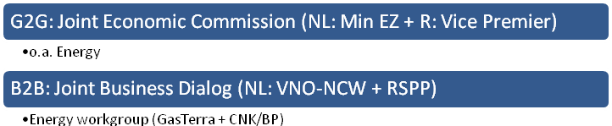
4 Top down Russian interest:
The energy sector in Russia is majority state owned, after a rush of privatisation after the collapse of the Russian Union. Legislation is adjusted for the state ownership of energy projects: strategic assets, single export legislation are examples of the influence on the energy sector. So, in Russia, the government decides on energy issues. Russian gas is per definition state owned by Gazprom, as it is the gas producer, 100% network operator and exporter. Globally, Gazprom is a huge player. Gazprom is majority owned by the Russian state, but there are private shareholders. The Kremlin and national interests therefore decides the strategic agenda of Gazprom. As a consequence, there is a top down decision making structure when cooperating with Gazprom: first, the government actors will have to be reached before business contact can be made. Government relations are essential for cooperation of the Project Delta Group in Russia.
This type of cooperation structure is distinctive for Russia, as Norway, Germany, Italy and France have similar bilateral cooperation structures with Russia. The Russian counter partners expect such an institutionalised bilateral cooperation pattern.
The model of Project Delta could be applied in several countries; there where government intervention is needed in order to support the business level, formal institutionalised channels could be established.
5 Vision Project Delta:
The cooperation between Russia and the Netherlands is based on sharing technology and expertise between businesses in both countries. Individual firms will be less successful when trying to gain access to the market themselves, as there will be a lack of accreditation from the Dutch side. Project Delta provides this accreditation and manifests expertise and the supportive governmental and business networks.
6 Cooperation within Project Delta Group:
There is a wide range of different firms active in Project Delta Group, each with its own interests in its own product or service segment; from joint ventures (Shell in Yamal), to contractors (Boskalis) and institutes (TUDelft), and competitors for tenders (Boskalis and Van Oord). However, all involved parties seek to gain access to the Russian market. PDG is not a company; it is not a consortium, but a facilitating group: firms do mind their own business! We always compare it with the Bolsjoi theatre: ‘ via PDG Dutch firms are allowed to sit on the front row, increasing the chances to take part in the orchestra. PDG is a stage, where contacts are made’.
Currently, the PDG is an occasionally collective, but in the future five firms are planning to form a foundation. The goal is to form an identity of a formal organisation. At the other hand, by formalising the cooperation we can organise co-sponsoring and have a budget for ‘ownership and participation’.
7 Comparison of the role of the Ministry in Project Delta and trade missions:
There is an essential difference in the role played by the Ministry of Economic Affairs in Project Delta and ‘ordinary’ trade missions. During trade missions a country is visited on a periodically by the Minister, joined by representatives of several industries. The trade missions are event-driven and after the trade mission it takes time before follow up is realised. Project Delta is a much more continuous process, with a high frequency of visits by the Ministry of Economic Affairs and a strong interrelation with the industry.
A trade mission is a perfect instrument when the Ministry targets western oriented economies, where industries do not face difficulties when doing business, without the intervention of government actors. The continuous link in Project Delta between government-to-government and business-to-business is a fundamentally different model, which claims a continuous effort of the involved Ministries.
8 Comparison between the expectations of the roles of the PDG and the Ministry in the cooperations [literally; werkgroepen, RZ]:
The expectations are intrinsically the same. When looking at the PDG from a ‘trade mission perspective’, we play a same role as the Ministry: the industry is being facilitated. The difference is that the PDG facilitates at one specific market; the Russian market. The Ministry plays a intensive and facilitating role during trade missions, and PDG plays the same role. Actually, the Project Delta is a continuous trade mission.

ANNEX III Overview LNG related firms per country

Firm | Description | Algeria | Angola | Qatar
A | Infrastructural operator
B | Utility concern
C | Infrastructural operator
D | Facilitator
E | Utility concern
F | Utility concern
G | Energy concern
H | Utility concern
I | Infrastructural operator

ANNEX IV Organisational need for cooperation

FIRM A
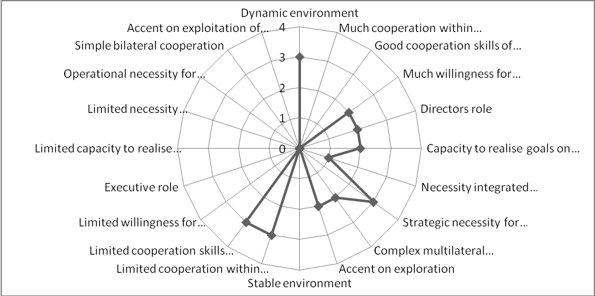

FIRM B

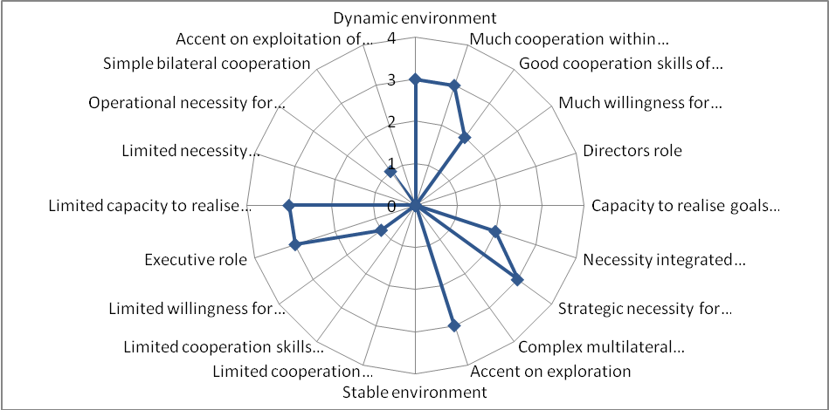

FIRM C
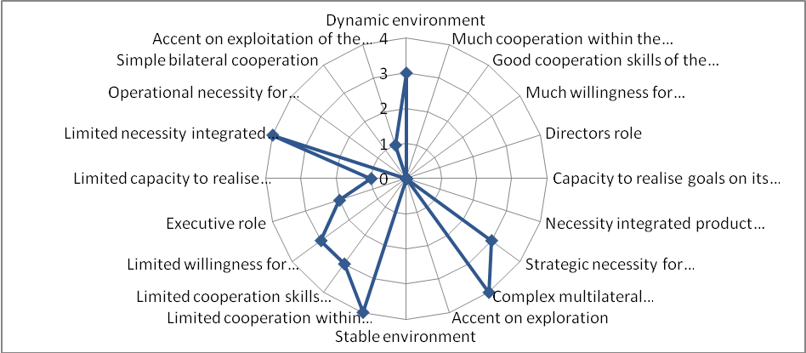
FIRM D
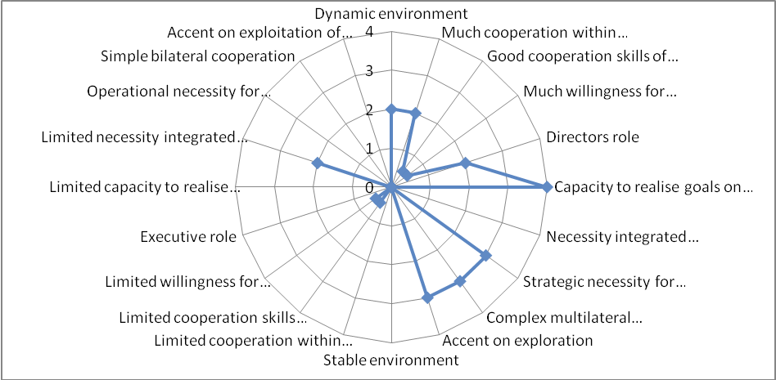

FIRM E
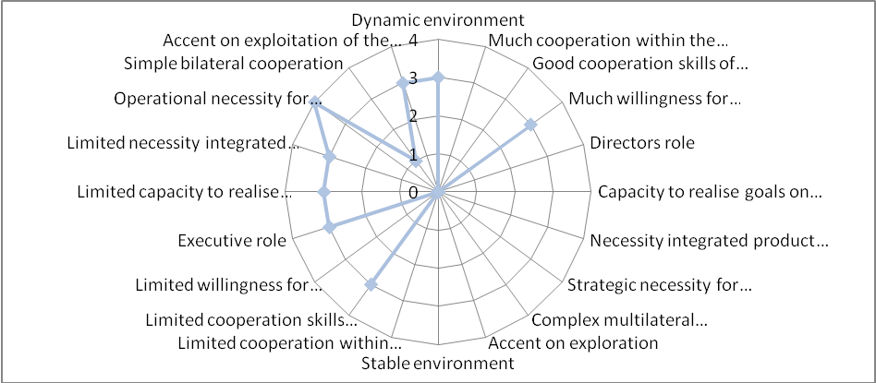
FIRM F
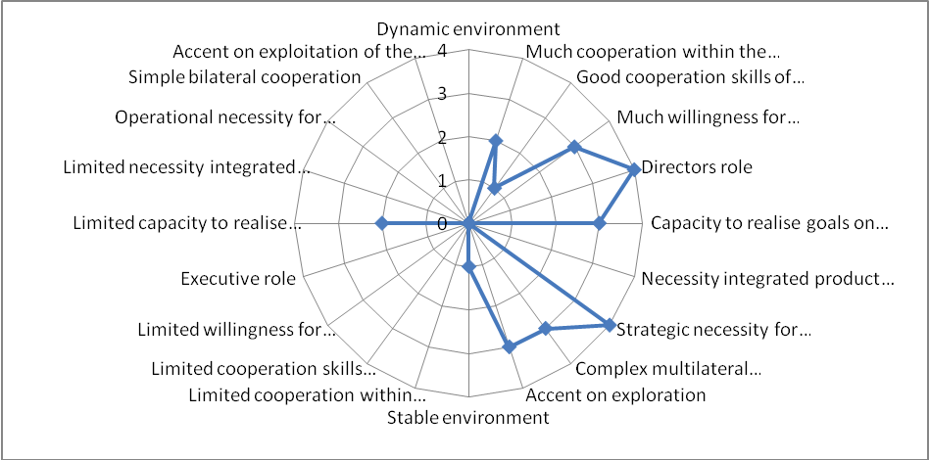

FIRM G
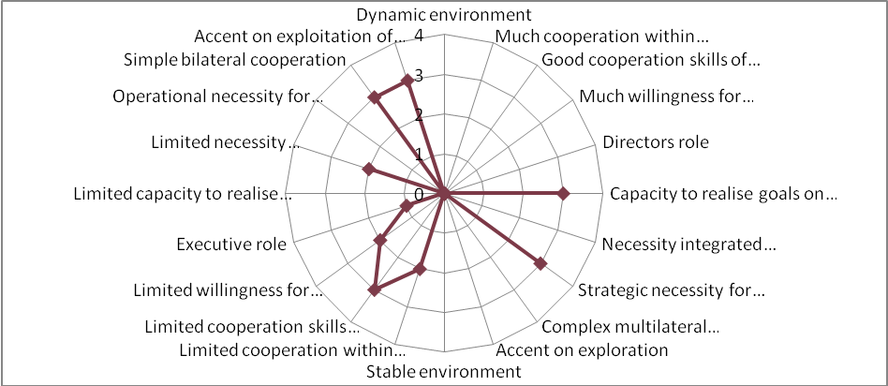
FIRM H
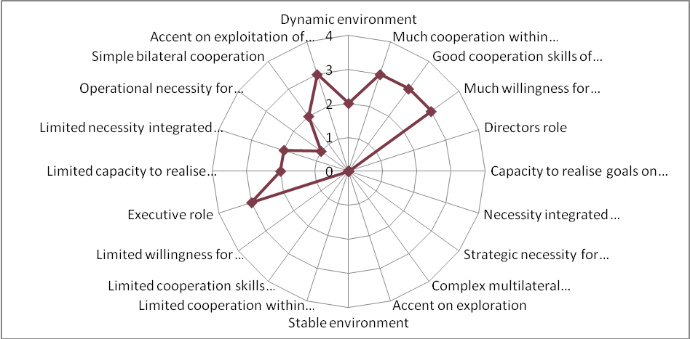

FIRM I
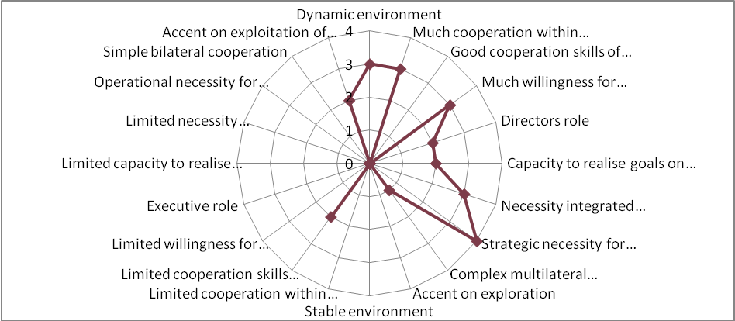

ANNEX V Partner selection criteria LNG related firms

Criteria | Firm A | Firm B | Firm C | Firm D | Firm E | Firm F | Firm G | Firm H | Firm I
Possession of desired resource of competitive advantage? | Infrastructure operator, storage capacity | Consortium partner, for producing electricity | Infrastructure, operator, storage capacity, consortium partner | Facilitator, consortium partner | LNG customer, for producing electricity | LNG customer, for producing electricity | Knowledge, resources, international network | LNG customer, for prod electricity | Knowledge, infrastructure and consortium partner
Need for a complementary or balanced contribution from the partner? | Yes | Yes, because of fair competition | Yes | Yes | Yes | Yes | Yes | Relatively new partner, willing to cooperate and provide info | Yes
Compatible view of international strategy? | Yes | Yes | Yes | Relative | Yes | Yes | Yes | Yes | Relative
Low risk of the partner becoming a competitor? | No | No | No | No | No | No | Yes | No, new partner, so high risk of becoming a competitor | Yes
Partner has pre-emptive value in relation to rivals? | Yes | Yes | Yes | Yes | Yes | Yes | Yes | Yes | Yes
Partners’ organisational compatibility? | High | High | High | High | High | High | High | High | Relative low

