ERASMUS UNIVERSITY ROTTERDAM Reprint Prohibited Erasmus School of Economics
Master Thesis

Do Local Environments Shape the Fortune of Firms, or do Local Firms Shape a Fortunate Environment?

An evolutionary study of the geographical concentration of the U.S. automotive industry around Detroit.

Rick de Bruin
334452
Supervisor: Martijn J. Burger
Rotterdam, 16-11-2010

Content

1. Introduction 5
2. History of the industry 9
2.1 The industrial climate of Detroit before 1890 9
2.2 Geographic pattern of the U.S. automobile industry 10
2.3 Market structure of the U.S. automobile industry 13
2.4 Technological progress and the influence big Three 15
3. Related Literature 19
3.1 Evolutionary economics 20
3.2 Spinoff dynamics and agglomeration economies 22
3.3 Windows of Locational Opportunity 26
3.4 Related Industries 30
3.5 The WLO concept and the U.S. automotive industry 31
3.6 Hypotheses 35
4. Study Design and Data Description 37
4.1 Data 38
4.1.1 Sources of Data 38
4.1.2 Checking Assumptions 39
4.2 Data Description 41
4.2.1 Automotive Industry Employment 41
4.2.2 Firms 43
4.2.3 Innovations 43
4.2.4 Relatedness 45
4.2.5 Control Variables 46
4.3 Methodology 46
5. Empirical Findings 48
6. Conclusions 57
7. Limitations and Directions for further research. 60
8. References 61
9. Appendices 64
9.1 Additional tables and figures. 64
9.2 Data Description 68
9.3 Checking Assumptions. 70

List of Tables

Table 1 Transmission type as a share of sales 17
Table 2 Theories of technological change 19
Table 3 Location Quotients for the North East and Mid West 42
Table 4 Automobile firms over states 43
Table 5 Number of Innovations over states 44
Table 6 Regression Results for analysis 1 48
Table 7 Regression Results for analysis 2, sensitivity analysis 50
Table 8 Regression Results for analysis 3, interaction effects 54

List of Figures

Figure 1 U.S. geographical distribution of automobile-assembly plants, 1900 12
Figure 2 U.S. geographical distribution of automobile-assembly plants, 1914 12
Figure 3 Number of entrants, exits and firms in the U.S. automobile industry 14
Figure 4 Annual sales of passenger cars 14
Figure 5 Percentage of firms located in Detroit 14
Figure 6 The window of locational opportunity concept 27

Introduction
Detroit is often used as a synonym for the American automotive industry and referred to as Motor City. In the period from 1900 through 1930 the city of Detroit experienced an exceptionally high physical growth for a large city and underwent an unprecedented pace of social and technological change. The flourishing of the Detroit area was mainly due to the large concentration of the automobile industry.
Initially the automobile industry was not confined to a single location, but rather was evolving in a number of widely scattered places, with the northeast as the centre of activity (Klepper, 2007). Most interestingly is the fact that in 1895, forty firms were producing motor vehicles for commercial purpose, however none of these firms was located in Detroit (Boas, 1961). The population of Detroit grew enormously, from 285,704 in 1900 to 1,568,662 in 1930. According to Klepper (2007) this unparalleled population growth of Detroit can be explained by the concentration of the automobile industry around Detroit which shifted from the Atlantic coastal region towards Detroit and Chicago supported by cities surrounding the Great Lakes such as Indianapolis, Cleveland and Milwaukee.
Rubenstein (2002) confirms this shift in automotive industrial activity when he found that best selling cars were made in southeastern Michigan. By 1914 a total of 50 assembly plants established Detroit as the capital of the automobile industry accounting for 80% of the total industry output with respect to leading makes and giving home to the three famous Detroit-based firms, General Motors, Ford and Chrysler also known as the big Three (Hurley, 1959). When the number of firms reached its top in 1909 at 274 firms entry stayed stable for a few years but started to decline in 1910 (Klepper and Simons, 1997, Klepper, 2007). The industry became more competitive as larger firms benefited from their economies of scale and mass production drove down the price of a motor vehicle (Klepper, 2007). Detroit consolidated its supreme position as a leader in the U.S. manufacturing car industry by absorbing many of the marginal producers inducing an industry shakeout which changed the market structure into a tight oligopoly dominated by the “Big Three”.
The geographical pattern which characterizes different industries gained particular interest of many schools in economics, geography, history and management (Boschma et al., 2002). Besides the automobile industry there are several industries, as the US tire industry around Akron, Ohio and the famous example of Silicon Valley which show similar patterns of concentration (Klepper, 1997). These agglomerations may provide insight in making a distinction between favourable location advantages and creative ability of firms in terms of generating and attracting their own favourable production environment. Getting insight in these forces could resolve a part of mystery in agglomeration economies and what should be the driving forces of endogenous growth and real business cycles (Ellison and Glaeser, 1999). According to geographic economics industries tend to concentrate and agglomerate in a region. However few other industries, then the U.S. automobile industry, are so closely identified with one single geographic location as in the case of Detroit. Many researchers have tried to identify the driving forces of the concentration and agglomeration of the U.S. automobile industry. Unfortunately, there is no consensus on why Detroit became the capital of the automobile industry. The current literature can roughly be divided in two bodies of research were one of them posits as central the importance of static location factors for the rise and agglomeration of new industries. Ellison and Glaeser (1999) found that industries’ locations are influenced by a wide range of natural advantages. In the case of the Detroit area researchers refer to Detroit’s low-cost access by water to raw materials. However Hurley (1959) argued that the automotive industry was dependent on any constant location specific factors such as land, climate or raw materials. Though he emphasized the importance of the flat land and the presence of the Great Lakes. According to Hurley these natural advantages resulted in a high concentration of vital industries which were extremely important in the early phase of the automotive industry. The indirect effects of natural advantages led to a large supply of basic suppliers and pools of semi-skilled and skilled workers.
Another explanation is given by Rae (1965), who attributes the supremacy of Detroit in the U.S. automobile industry to the fact that the city possessed “a unique group of individuals with both business and technical ability who became interested in the possibilities of the motor vehicle”. Rae (1965) referred to pioneers of the U.S. automobile industry such as Henry Ford, Ransom E. Olds, Elwood Haynes and Charles Duryea who lived in Michigan and by some extend became active in the region of Detroit.
Once these pioneers were located in the Detroit area it is plausible that agglomeration economies alone could have accounted for the subsequent growth of the industry in the Detroit Area. These agglomeration economies led to better infrastructure, the emergence of specialized suppliers, a large pool of semi-skilled and skilled workers and the establishment of supportive institutions (Boschma, 2007). However if these driving forces of agglomeration were significant, and these positive externalities were geographically bounded, firms of all types in Detroit should have benefitted from these supportive conditions and performed comparably with the automotive industry.
The driving forces behind the supremacy of Detroit as the capital of the U.S. automobile industry goes beyond the scope of static agglomeration economies. This means that the emergence of new industries is not a process in which rational economic actors choose their location based on the existing locational structure in order to minimize production costs. It would be misleading to interpret the spatial formation of a new industry based on how well the new requirements best correspond to specific locational factors. Therefore the main focus of this article will be on the second body of research which takes a critical stand towards the interpretation of spatial formation as an allocation process where the industry develops in places dependent on the existing local structures. It views the spatial formation of a new industry as a dynamic process of local development.
With this article I hope to provide new insights into the nature of geographic concentration of new industries. The main goal is to further enhance our understanding on whether new industries reflect continuous, evolutionary rather than discontinuous changes in spatial economies.
By extending the windows of locational opportunity concept by Boschma (Boschma, 1996) and the spinoff theory by Klepper (2007), this article provides new insights in to which extend the high concentration of the U.S. automobile industry in Detroit was due to the initial favorable local environment of Detroit or the ability of the emerging automotive industry to create its own supportive local environment. The theoretical concepts by Boschma (1996, 2002) and Klepper (2002a, 2007) regarding the varying ability of regions to grasp new technological opportunities with respect to technology and labor will be tested by, respectively hypotheses on the geographic distribution of innovations and professions in the automobile industry. The study tries to identify different stages of development of the U.S. automotive industry by making a distinction between the evolutionary concept of innovation and the discontinuous revolutionary concept of innovation. The evolutionary concept of innovation is composed by an accumulation of technological knowledge, skills and experience while the discontinuous revolutionary concept of innovation reflects a dramatic break with the past with regard to techno-industrial development process.
The structure of this article is as following; Section 2 will start with a historical overview of the U.S. automobile industry followed by section 3 which gives a theoretical framework with theories on dynamic and evolutionary economics with respect to industrial location. The focus will lie on the window of locational opportunity concept whereby the role of local labor markets and innovations is made explicit. Also limitations of these theories, the research question as well as the hypotheses will be presented. In section 4 the data, methodology, and the models which have been applied will be presented. Also a proper explanation of the used variables will be given. Section 5 presents some results of the analyses on the geographic distribution of innovative activity and the presence of related industry employment prior to the emergence of the automotive industry.. Section 6 will draw some conclusions and elaborates on the scientific and social relevance of the main findings. Section 7 will end with limitations and suggestions for further research.

History of the industry
According to Ellison and Glaeser (1997) industries are typically agglomerated geographically. However the exceptional high concentration of the automobile industry in Detroit, Michigan goes beyond the explanation of agglomeration economies. While the entire world considers Detroit as the capital of the U.S. automobile industry this was not necessarily the case throughout the history of the automotive industry. In this section we analyze the history and development of the U.S. automotive industry and its geographical concentration around Detroit. Subsection 2.1 gives an overview of the industry structure of Detroit before the start of the automobile industry. In subsection 2.2 the geographical pattern of the U.S. automobile industry, changing over time, is analyzed. 2.3 analyses the evolution of the market structure volume and size of producers. The largest breakthroughs in terms of product and process innovations that accelerated the car industry, as well as the influence of America’s biggest car manufacturers is handled in subsection 2.4. Subsection 2.5 will draw some conclusions.

The industrial climate of Detroit before 1890
When answering the question were and why new industries should emerge there is much debate about whether the spatial manifestation of innovations can be determined by specific circumstances or are the outcome of chance events (Boschma, 1996). This is because new techno-industrial knowledge can hardly draw on local conditions to support its economic exploitation as the new requirements of such a process are not given but come gradually into being as the development of the industry proceeds. With respect to the automotive industry in the United States, one might wonder if the extreme high concentration around Detroit can be explained by its former industrial structure. The following section describes the industrial climate of Detroit before the start of the automotive industry at the end of the 20th century. According to Denison (1956) the strength of the industry around Detroit finds its foundation in geology. The withdrawal of gigantic ice sheets thousands of years ago shaped a landscape providing favorable conditions. The presence of the Great Lakes, gave Detroit direct access to economic assets like iron, copper, salt and hardwood. Naturally, the abundance of these raw materials, combined with different skills resulted in a diversified industry structure producing a large scope of different goods. The Detroit area became famous for its steel railroad rails, wagons, carriages, all sorts of woodenwares but especially because of its stoves and small marine engines powered by illuminating gas and naphtha (Denison, 1956). Michigan became a leading center for the production of gasoline engines for agricultural and marine uses. Detroit’s shipyards were early converts to gasoline engines because of their dissatisfaction with the heating capacity of coal (Rubenstein, 2002). Denison (1956) also devotes the population of Detroit as a great asset in the development of the automotive industry. A mixed composition of people resulted in a diversified set of labor, skills and talent which made it possible to expand in different industries. As mentioned Detroit became a pioneer in making steel, railroad cars, industrial chemicals, carriages and marine engines. However, according to Denison (1956) and Hurley (1959), Detroit did not have a single dominating industry and instead of committing to a single resource the city created the perfect framework to grasp future opportunities. Denison (1956) and Hurley (1959) refer to fact that Detroit became the capital of the U.S. automobile industry with the highest concentration of producing activity. However this was the result of an evolutionary process rather than a single grasped opportunity. That is, the invention and economic exploitation of the automobile did not fall from the sky. Furthermore Detroit did not produce cars for commercial purpose for only 7 years after commercial production started in Connecticut and New York (Smith, 1968). The next section will provide an insight in this evolutionary process and provides an overview in the changes over time of the geographic pattern of the U.S. automobile industry.

Geographic pattern of the U.S. automobile industry
Based on studies of Boas (1961), Smith (1968) and Klepper (2007), the following section will give an overview of the geographic pattern of the U.S. automobile industry during the period 1895-1958. The first company that was organized to produce motor vehicles for commercial purpose was the Duryea Motor Wagon Company of Springfield, Massachusetts. After the leading start of Duryea in 1885, commercial production began and activity was scattered across the northeastern United States. Of the 40 plants operating in 1895 the only significant concentration was the grouping of 7 plants in the region around New York City. Interestingly enough there was no activity in the automobile industry in the city of Detroit. In the last five years of the 19th century the automobile industry grew rapidly and reached a total of 327 plants. By 1900 the number of plants in the Detroit area was negligible and the highest concentration, more than half of all automobile-assembly plants were located in the Atlantic coastal region as can be seen in figure (1). In 1905 a major shift in the locational pattern of the U.S. automobile industry started. Despite the fact that Boston, New York, northern New Jersey, Philadelphia and the upstate New York city’s continued to be the main centers of the industry, Chicago, Cleveland, Detroit, Milwaukee and St. Louis showed increasing automotive manufacturing activity. This trend towards the Midwest continued and between 1908 and 1911 there was a strong decline in assembly plants in the Atlantic Seaboard area and the concentration of assembly plants in San Francisco had disappeared. By 1914 the total number of car manufacturing firms reached its peak with 469 active assembly plants. More importantly Detroit became the Capital of the U.S. automobile industry, giving home to 50 assembly plants, making 1914 one of the most important years in the early phase of the automobile industry. The centre of the automobile industry was shifted from the Atlantic coastal region towards Detroit and Chicago supported by cities surrounding the Great Lakes like Indianapolis, Cleveland and Milwaukee as illustrated in figure 2. Despite the fact that the number of operating companies in 1919 was less than half of total assembly plants in 1914. After a small upturn in 1921 the industry started to decline and became more competitive. The larger firm started consolidating by absorbing many of the small manufacturers.
By 1926 the industry has been reduced to a total of 182 assembly plants the southern of Michigan had become the supreme center of the U.S. automobile industry. Although the economic crisis of the early 1930’s caused a large reduction in the total number of firms,the geographical distribution of automobile firms hardly changed. The main question that arises by looking at the development of the geographic distribution of U.S. automobile manufacturing plants is: Why did Detroit became the capital of the U.S. car industry? To illustrate the dynamic development the U.S. automobile industry underwent the following section will give a short overview of the changes in the automobile market structure during the period between 1895 and 1960.

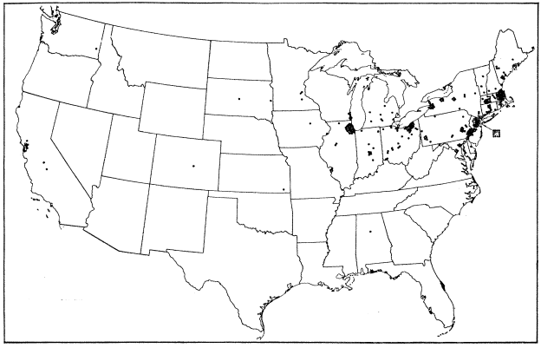
Figure 1 U.S. geographical distribution of automobile-assembly plants, 1900. (Boas, 1961)
(Each dot representing one operating plant)
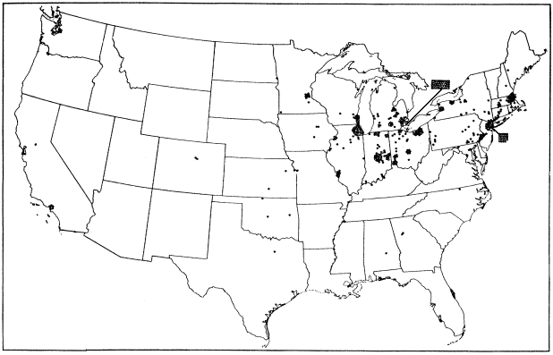
Figure 2 U.S. geographical distribution of automobile-assembly plants, 1914. (Boas, 1961)
(Each dot representing one operating plant)

Market structure of the U.S. automobile industry
Smith (1968) analyzed the history of the automobile industry and traced the design, financial and managerial trends which have shaped the course of the industry from the start in 1985 through 1966. He compiled a list that consisted all firms that manufactured motor vehicles for commercial purpose, their location, the year of each make and the reorganizations and ownership changes they underwent. Klepper (2007) used Smith’s list to derive the annual development of the market structure of the U.S. automobile industry as graphed in figure (3). According to Smith (1968), the number of entrants into the automobile industry grew steadily from 1895 to 1907, reaching its peak at 82 in 1907. The number of entrants remained high until a large dropdown in 1911 from were on entry became negligible. One explanation for this sharp dropdown was the fact that in 1914 the first practical moving assembly line was completed. Boas (1961) believed that economies of scale in the form of the moving assembly line in combination with the minimum basic loan the Ford Motor Company assured was the end of the large scale entry of small automobile manufacturers and started the industry shakeout.
The exit rate of the automobile industry was approximately 10% per year until 1910 were the number of exits overtook the number of entries and started the automobile industry shakeout. To evaluate the relative importance of the market structure and various locations of firms cited in the previous section the production and sales must be analyzed. The annual sales of passenger cars shows a sharp contrast compared to the number of entrants. Although there were more than 250 automobile manufacturers active around 1910, figure 4 (Klepper, 2007) shows that the total number of annual sales did not exceed 200,000 cars. Figure 4 shows a high increase in the total number of sales starting from 1914 while the total number of firms felt down. This contrary movement indicates that the industry shakeout was not caused by the demand side (Klepper, 2007). The importance of Detroit becomes clear in figure 5 (Klepper, 2007) where the percentage of firms that are located in Detroit are presented. According to Smith (1968) Detroit was producing 13 out of 15 makes in 1915 which indicates the relative importance of the city in the U.S. automobile industry.

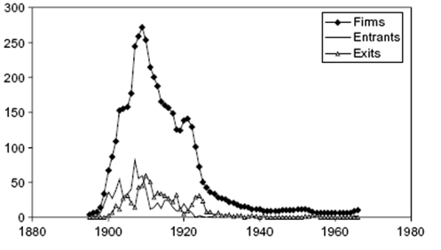
Figure 3 Number of entrants, exits and firms in the U.S. automobile industry (Klepper, 2002)

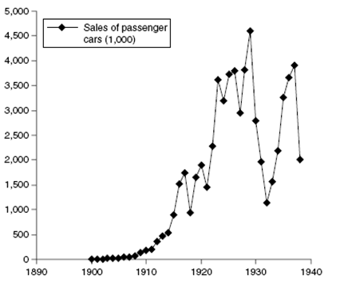
Figure 4 Annual sales of passenger cars (Klepper, 2002)

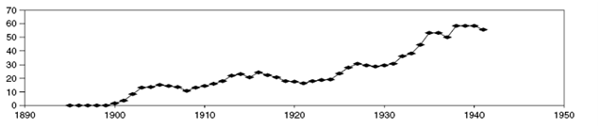
Figure 5 Percentage of firms located in Detroit (Klepper, 2002)

It is clear that there has been a major shift in the market structure of the U.S. automobile industry. The initial pattern of widely scattered small manufacturers, mostly concentrated in the west coast area, producing a relative small amount of passenger cars turned into a tight oligopoly highly concentrated in the region of Detroit selling millions of cars. The development and geographical pattern of the U.S. automobile industry can not been seen separate from the presence of the three largest firms and the technological progress the industry made.

Technological progress and the influence big Three
As discussed in the previous section the U.S. automobile industry evolved to be heavily concentrated around Detroit, Michigan. According to Rubenstein (2002) there are two important explanations for the high concentration of the automobile industry in the region of Detroit. .The first explanation regards technological progress. How did the horseless carriage evolved to be a streamlined, gasoline powered vehicle, with steering wheel, shaft-driven transmission, automatic starter windshield and four-wheel brakes? This was the outcome of technological progress that led to a successful design for the three fundamental components of the modern automobile vehicle. A practical combination of an engine to propel the vehicle, a drive train to convert engine power to motion and a strong platform or chassis to hold passengers and the power source meant the turnover from the experimental stage to the commercial production of automobiles. Still, the question remains why this evolution turned out to be most successful for southeastern Michigan. The second explanation and most popular theory among historians of automobile production is the ‘great person’ view that explains the spatial concentration of automotive production by the fact that the industry’s most successful pioneers either grew up in the area or migrated there. Technological progress (Nelson and Winter, 1978; Klepper and Simon, 1997) and the presence of a unique group of individuals with both business and technical ability (Rae, 1965) evolved the automotive industry to concentrate in southeastern Michigan. However, Rubenstein (2002) believes that founders of new businesses do not operate in isolation of the local industrial climate and build on their knowledge of a community’s experience in successfully manufacturing other products. The following section builds on the effect of technological progress in explaining dramatic shifts in market structure as well as the role the Big Three; General Motors, Ford and Chryslers played in this evolution. The presence of related industries form which automotive technology derived as well as their possible effect on the evolution of the industry will be discussed later. It is estimated that over 100,000 patents created the modern automobile, which indicates that the automobile as we know it, was not invented in a single day and cannot be assigned to a single inventor. This also accounts for, the transmission of a car. At the initial phase of the industry automobiles driven by gasoline-, steam- or electric engines were competing for the market. (Denison, 1956 and Rubenstein, 2002). At the turn of the century the steam engine was the dominating technology and according to Cowan and Hulten (1996) the gasoline engine was the least popular technology for transmission. As the development of the industry proceeds gasoline engines became more popular and as can be seen in table 1 by 1905 the gasoline engine was firmly entrenched as the dominant form of power.
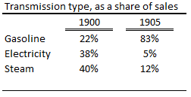
Table 1, Transmission type as a share of sales (Rubenstein, 2002)

Following Rubenstein (2002) the electric engines were especially popular in urban areas of the northeast because of they were easy to operate, clean and relatively quiet compared to gasoline and steam engines. However the lack of power, high costs and inconvenience of frequently recharging meant the turn side in popularity of electric engines. None of these shortcomings applied to the steam engine which was powerful and easy to produce. Rubenstein (2002) found that steam powered engines were particularly popular in New England. However, while the technological possibilities for the steam engine stopped at the turn of the century, the development of the gasoline engine proceeded and became the superior power source concerning horsepower, weight and costs to operate. Rubenstein (2002) mentions that Michigan was experienced in building gasoline engines for agricultural and marine uses and therefore gave Michigan automotive manufacturers a critical technological lead over competitors elsewhere in the country. However, as mentioned earlier the development of the automobile was not solely subject to the technology of the engine but evolved out of thousands of innovations. Furthermore, Klepper and Simon (1997) found that the highly concentrated market structure was not triggered by particular major technological innovations nor by dominant designs, but by what they call “an evolutionary process that contributes to a mounting dominance by some early-entering firms”. Elaborating on these three theories gives us the opportunity to enrich the findings of Klepper and Simon (1997) by incorporating notions of geography and the early presence of pioneers in the car manufacturing industry.
The key concepts of the three theories featuring technological change as the prime driver of industry shakeouts are summarized in table 2. Starting with the innovative gamble theory an industry is created by a basic invention and the shakeout is triggered later by a refinement invention. All the firms that are unable to develop the follow-on innovation to the major innovations will be forced out. A dominant design emerges after time and experimenting reveals the buyers preferences. After numerous of product innovations a dominant design emerges and those firms who are unable to adapt the dominant design as well as managing their production process will be forced out. The last theory leans on increasing returns form R&D. Large firms will experience higher returns from R&D, which renders entry unprofitable and forcing small firms to exit.
All theories give an explanation for the shakeout of the industry in terms of the low number of firms that remained active. However, are they also sufficient in explaining the geographical concentration of the automotive industry? Their predictions in the cause of the shakeout could be tested relative to geographical characteristics. Could it be that automotive industry was triggered to Detroit, because of a milestone innovation and the fact that the most successful follow-on innovators happen to live in or nearby Detroit? Was it a dominate design, for instance the gasoline engine, or the Model T by Ford that triggered the industry to concentrate in Detroit? Or did Detroit became the capital of automotive kingdom because it happened to possess the largest and most successful firms with respect to R&D?
Obviously GM, Ford and Chrysler were pioneers and revolutionary for the U.S. automobile industry, and in particular had their influence on technological progress. Nevertheless, all firms that were least able to adapt to the forces that triggered the shakeout exit and so the explanation of the rapid growth and dominance of Detroit in the automotive industry cannot be isolated from the local industrial environment (Rubenstein, 2002).

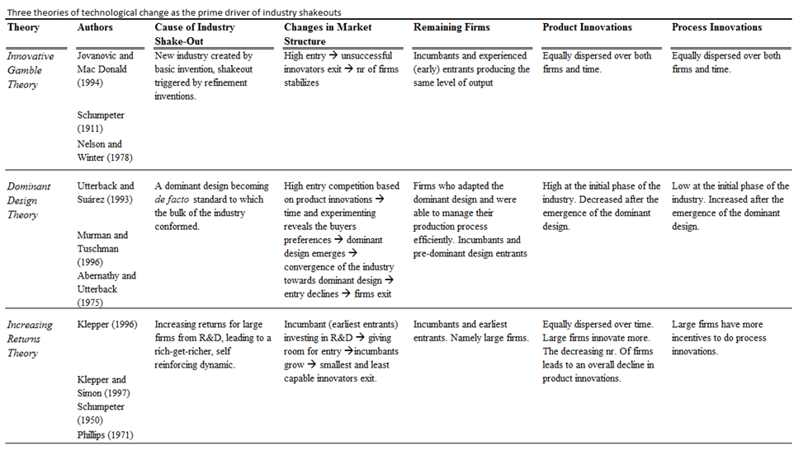
Table 2, Theories of technological change

Related Literature
When explaining the spatial emergence of a new industry most of the literature is based on fields of economic geography and takes the emergence of novelty as a starting point (Boschma and Lambooy, 1999). According to Scott (1988) researchers in the field of economic geography are interested in the spatial manifestation of economic activities across the world.. Most of the literature in economic geography teaches that the spatial pattern of economic activity is determined by specific locational factors (Boschma and Frenken, 2002). In this neoclassical view, firms are regarded as rational actors who choose their location based on locational costs minimizing characteristics. Arthur (1994) criticizes this one-sided view on economic geography and approaches the spatial pattern of a sector from an evolutionary perspective. The choice to locate depends on a combination of chance, determined by small historical events and necessity, defined by specific locational factors.
The main question economic geographers are facing is to which extent economic activity can be determined by specific circumstances or is the outcome of chance events (Feldman, 1994). This section will emphasize on this dichotomy between chance and necessity and attempt to explain the spatial formation of innovations and new industries by incorporating notions of evolutionary economies in to the field of economic geography. By combining economic geography and evolutionary economics we try to understand the behavior of firms in space guided by the innovative process (i.e., how major technological innovations influence the spatial pattern of their related industries).
This chapter is structured as follows; Section 3.1 will outline the main features of evolutionary economics guided by Nelson and Winter, Section 3.2 will elaborate on the theory of spinoff dynamics as proposed by Arthur and Klepper. Section 3.3 provides some critical notes on the spinoff theory and elaborates on the dichotomy of chance and necessity in explaining the spatial pattern of an emerging industry. The window of locational opportunity (WLO) concept, provided by Boschma (1996, 2007) is used as an analytical framework that accounts for chance and the influence of a generic favorable environment on the spatial evolution of an industry. Section 3.4 presents an ideal stage model of the WLO model applied on the spatial manifestation of the U.S. automotive industry. The hypotheses concerning the spatial agglomeration and concentration of the automobile industry in Detroit will be presented in section 3.5..

Evolutionary economics
When approaching economic geography from an evolutionary perspective the basic starting point is to understand firm behavior in space as being guided by routines. Evolutionary economists try to identify the driving forces behind the process of diffusion and spatial clustering of routines in emerging industries (Boschma and Wenting, 2007).
The theoretical and analytical framework that provides the basis for this research on the spatial formation of the U.S. automobile industry takes off on the ideas of Nelson and Winter (1982). Because of complex and dynamic environments firms do not possess perfect information on all possible options and therefore cannot predict future developments (Boschma and Lambooy, 1999). This uncertainty makes it impossible for firms to make optimal location choices based on rational decision making. According to Nelson and Winter (1982) the decision making process is guided by routines, were accumulated skills and experiences simplify the behavior of firms in to a risk averse predictable pattern. Nelson and Winter (1982) describe routines as skills which are determined by two elements. By repeating the same procedure an action becomes part of automatic behavior based on learning by doing. This automatic behavior is difficult to code and can be defined as tacit knowledge and is difficult to communicate or process in means of verbalizing or documenting. The complexity of the content makes it impossible to codify or transfer tacit knowledge through manuals or education and therefore can only be learned in a process were people interact and work together for a long time period (Foray and Lundvall, 1998).
According to Penrose (1959) firms are unique with respect to their routines even if they are competitors active in the same industry. Nelson en Winter (1982) illustrate this uniqueness by comparing routines as the DNA of an organization. Specific routines among firms will be reflected by specific competences, which will determine, for a large extent, the success of a company. These routines and competences are subject to competition. (Boschma and Frenken, 2003). In the evolutionary economic literature, the term selection environment is used to illustrate the forces that influence competition within an industry (Lambooy, 2002). The selection environment consists out of markets,institutions and the spatial environment which functions as a filter and results in asymmetrical profits between firms in an industry Consequently firms with fitter routines will survive and firms with lower fitness will disappear (Nelson and Winter, 1982).
To illustrate this process we can think of the changes in market structure the U.S. automobile industry underwent handled in section 2.3. By 1914 the large car manufacturing firms started to consolidate their position by absorbing the small manufacturers resulting in a decrease of the total number of firms. Accompanied with the introduction of the assembly line by Ford in 1914 the market structure changed into a tight oligopoly. This is a textbook example of how the selection environment with respect to changes in market structure works. Firms active in an oligopoly can raise high entry barriers, and produce more efficient through economies of scale which will result in increasing profits. Consequently firms with relatively high profits will tend to increase their market share at the expense of firms with relatively low profits. So if a firm cannot benefit from economies of scale it should diversify or find a way to produce against lower cost. The term ‘fitter routines’ refers to the ability of a firm to adjust to changes in the selection environment, and in this particular case to changes in the market structure.
If a firm faces declining profits because of a stagnating market, technological complications or a loose in market share it will search for innovation (Nelson and Winter, 1982). The existing routines become a threat when a firm cannot adjust to the new requirements of the changed market structure. So despite the fact that firms tend to employ conservative, risk-averse behavior to cope with uncertainty that does not imply that change does not occur (Boschma, 1996). To realize competitive advantages firms continuously attempt to improve their routines. This innovative behavior can be defined as routine-guided searches to explore possibilities of routine-changing innovations (Nelson and Winter, 1982). This search-behavior, guided by routines is strongly related to the evolutionary concept of path dependence which determines the behavior of a firm for a large extent by its specific history (Boschma et al. 2002). The theory of path dependence introduced by Nelson and Winter (1982) explains how a set of decisions a firm is facing for any given circumstance is limited by its historical accumulated experience and knowledge.
This path dependence of existing routines pushes firms to look in directions which are related to their past achievements (Boschma, 1996).
Much research have been conducted on the subject in the latter section which tries to explain the processes that make firms with fitter routines become more dominant in an industry. Concerning the research question it is of extreme relevance to understand the evolution of the market structure in terms of the mechanisms that led the U.S. car industry from a pattern of widely scattered small manufacturers into a tight oligopoly. But what about geography? Hence, a true evolutionary approach to the spatial evolution of an industry should focus on the spatial distribution of routines in a sector and its evolution over time.

Spinoff dynamics and agglomeration economies
According to Boschma and Wenting (2007) there is little understanding on how new routines emerge and diffuse spatially when a new sector develops and grows. This research takes particular interest in what role geographic proximity and locational factors play in the evolution of the locational pattern of the U.S. automobile industry.
Arthur (1994) explains the spatial emergence of new industries over time as a path-dependent process. Neo Classical theory explains the spatial pattern of a new industry as a consequence of specific locational factors like the low cost access to raw materials, the presence of skilled labor, stimulating government and regulations, good access to markets through a supportive infrastructure etcetera. Arthur (1994) describes the evolution of a locational pattern by a combination of historical events and the presence of specific locational factors. This approach gives space for the opportunity that the spatial pattern of an industry is not solely caused by rational decision making by firms but can also be the result of coincidence.
To illustrate this evolutionary approach the following section will elaborate on the spinoff model used by Arthur (1994) and Klepper (2002). The spinoff model explains the spatial distribution of firms as a path dependent process in which a new industry grows firm by firm through spinoff dynamics (Boschma, 2007). Spinoffs can be denoted as new firms founded by former employees of incumbent firms in the same industry (Klepper, 2002). Arthur’s spinoff model assumes that spinoffs locate in the same region as parent company. In the initial phase every region counts for the same amount of incumbent firms. If a region, by pure chance, generates many spinoffs, the probability that the same region will account for more spinoffs in the following phase rises (Boschma et al., 2002). The resulting spatial pattern is caused by pure chance and coincidence with respect to the spinoff rate in the in initial phase of an industry and therefore subject to multiple outcomes.
The models of Arthur are very appealing to analyze whether the spatial pattern of a new industry can be determined by specific locational factors or is the result of pure chance. However, the firm itself remains a black box and the model does not account for firm dynamics (e.g. all firms are considered equal: they do not grow, decline, exit or migrate). While Arthur ignored the effects of competition, market selection and changes in the market structure, Klepper (2002) constructed a spinoff model that explains the spatial pattern of a new industry by the diffusion of fitter routines from one firm to another. Klepper claims that the spinoff process is an effective mechanism of transferring tacit knowledge. To elaborate further, the founder of a spinoff company acquired his experience and knowledge as an employee of a succesfull parent organization that provides a superior learning environment.
Klepper (2007) assumes that technological changes induce increasing returns to scale and entrants are heterogeneous with respect to their technological capabilities. According to these conditions earlier entrants and firms with pre-entry experience are more likely to survive in an industry which is subject to technological change. Klepper (2007) found evidence for the tire, television and penicillin industry that earlier and pre-entry experienced firms survive longer and ultimately become dominate players within an industry.
The performance of new enterprises play a key role in a region’s vitality, however little is known about the origin of entrants. According to the spinoff theory by Klepper and Thomson (2006) one class of entrants in particular performs exceptionally well in some industries. This group consists out of firms that are founded by employees of incumbent firms in the same industry and are called spinoffs. Klepper (2007) denotes spinoffs as the phenomenon were employees of incumbent firms leave because of disagreements with management and start up their own firms. If information is transparent and all decisions makers act in the best interest of the firm by giving the same weight to the information, no disagreements will occur and the firm will sail its best course. However if information is biased and a decision maker has superior information based on his position in the firm, expertise or background, his strategic choices are not always regarded by the other decision makers to reflect the best interest of the firm. The disturbed balance in the distribution of information among the decision makers leads to strategic disagreements. When the disagreement outweighs the cost of starting a new firm, the decision maker with superior information whose best intensions are not recognized will leave to start its own firm (Klepper and Thompson, 2006).
Klepper and Thompson (2006) found a positive relationship between the performance of the parent firm and the number and performance of spinoff firms. This can be explained by the basic principle in Klepper’s model that spinoffs inherit the routines of parent firms. More interesting are the findings of Klepper and Thompson (2006) with respect to the locational pattern of spinoffs. According to Saxenian (1994) Sillicon Valley is the striking example of the importance of spinoffs in explaining the spatial concentrations of industries. Also for the U.S. automobile industrie (Klepper, 2002) and the wireless telecommunications (Dahl et al., 2003) evidence is found that spinoffs play a crucial role for the spatial evolution of industries.
Like normal firms, spinoffs tend to locate close to their geographical roots. Consequently, successful early entrants, generating a relative high rate of spinoffs, will create a region with superior firms because they have a superior learning environment. According to Klepper and Thompson (2006) spinoffs pursue novel ideas instead of leaning on their parental shoulders which expand the total output and contributes to an agglomeration of economic activity. This brings us to another mechanism, such as agglomeration economies that can explain the spatial emergence of a new industry.
Myrdal (1957) and Arthur (1994) made a dynamic approach towards agglomeration economies which Myrdal called the process of cumulative causation and can be seen as the geographical equivalent of increasing returns. Myrdal (1957) states that if more firms choose to locate in a specific region, new and better infrastructure comes available, specialized suppliers emerge, the local labor market becomes more diversified, supportive institutions are being established etc.. Consequently these positive externalities make the region more attractive for new entrants, leading to more local firms.
Arthur (1994) illustrates this process by simulating the emergence of a locational pattern of an industry based on agglomeration advantages. In the initial phase a population of firms enters the economy sequentially based on their preferences for a particular region (Boschma et al., 2002). Once a single region attracted a critical mass of firms increasing returns in terms of agglomeration economies will offset the natural preferences of a firm to locate in a particular region. Arthur uses a path dependent process where chance and necessity causes an industry to concentrate in one region. It is unpredictable which region will host many startups early on, but as a critical threshold is passed in a region, all other entrants, despite their natural preferences, will choose to locate in this region hoping to profit from the higher agglomeration economies (Arthur, 1994).
The spinoff approach by Arthur (1994) and Klepper (2002) and the theory of agglomeration economies are very appealing in analyzing the underlying forces which contribute to the spatial pattern of an industry. However, both models are criticized in a sense that they are in violation with the basic principles of evolutionary economics and therefore do not provide a true evolutionary approach to the spatial evolution of an industry based on the spatial distribution of routines in a sector and its evolution over time (Boschma, 1996, Boschma et al., 2002, Boschma and Wenting, 2007)

Windows of Locational Opportunity
Boschma and Wenting (2007) made an attempt to explain the spatial formation from an evolutionary perspective by using the window of locational opportunity (WLO) approach was introduced by the Californian School of Economic Geography (Scott and Storper, 1987). By combining economic geography and evolutionary economics they tried to understand the behavior of firms in space guided by the innovative process. The WLO-concept generally holds that new industries have the capability to generate or attract their own favorable conditions for their industry to grow. Emerging industries develop in space rather independently of established spatial structures and conditions. Instead of drawing back on early existing favorable institutional structures new industries provide new opportunities for every region because they represent a fundamental break with the past (Boschma, 2007).
By using the window of locational opportunity concept, Boschma (1996, 2007a and 2007b) focuses explicit attention to firm dynamics in terms of entry, exit and competition. The WLO-concept deals with the shortcomings of the models by Arthur (1994), and for some extend, Klepper (2002) while it allows for heterogeneous firms, competition and changes in market structure along the product life cycle. Boschma (1996) argues whether indeterminacy, human actions or accidental events, which are reflected by the existing spatial environment, influence or determine the spatial emergence of new industries. By doing so, Boschma tries to specify the extent to which chance and necessity are involved in the spatial manifestation of an industry. Unlike Klepper (2002) and Arthur (1994) who claimed that the spatial manifestation of an emerging industry is the outcome of pure chance events, Boschma discusses that the rise of a new industry is not an entirely accidental outcome. The WLO concept points out that it’s impossible to predict where a new industry will emerge, however the rise of new industries can be triggered by existing practices and structures that provide opportunities and challenges (Boschma, 1996). Furthermore, the selection environment cannot be treated as given while emerging industries interact with their production environment and firms might generate or attract their own favorable conditions in space. Combined with some appealing notions of spinoff dynamics and agglomeration economies mentioned in section 3.2, the WLO-concept provides the analytical framework for this research paper.
The WLO-concept states that the emergence of new industries in space is for a large extend unpredictable due to their discontinuity and creative ability however not entirely the result of pure chance events. The WLO concept rejects the view that technological change is exogenous to space, contrary states that it is interacting with its spatial context.
Boschma and van der Knaap (1997) constructed a figure (figure 6) which illustrates till what extend new industries emerge and prosper in space as a cause of chance or necessity. The figure distinguishes two filters referred to as triggers and selection environment.
The location of a new industry can be triggered by existing practices and structures which provide new opportunities or challenges. (Boschma, 1996). These signals from the environment can be denoted by the term ‘triggers’ which encourage economic actors to innovate (Boschma, 1996). One might think of the everlasting desire of humans for faster transportation, higher mobility and convenience.
Each surface in the figure is divided by ten different regions. The upper surface shows, per region, potential triggers in terms of existing spatial structures and practices that reveal specific problems or demands (Boschma et al. 2002). There is a fundamental uncertainty and unpredictability concerning which potential triggers will set in motion the spatial manifestation of an industry through a major innovation induced by local triggers. This uncertainty is due to the fact that major technological breakthroughs are the unpredicted and unexpected outcomes of searches (Nelson and Winter, 1982). Another explanation for this uncertainty is that the large extend of potential triggers are not locational specific but rather general and that there is an infinite number of location/specific triggers, that are present in every possible type of region.
The upper surface of the figure shows many location specific triggers in all of the ten regions but induce major innovations in only three of them. These innovations can be related to some specific locational triggers, however that does not imply a causal relation because we cannot explain why similar innovations did not occur in other regions (Boschma, 1996). The outcome depends on small arbitrary events, or even accidents, magnified by positive mechanisms like the creative ability of firms to shape their own favorable production environment (Boschma, 2007).

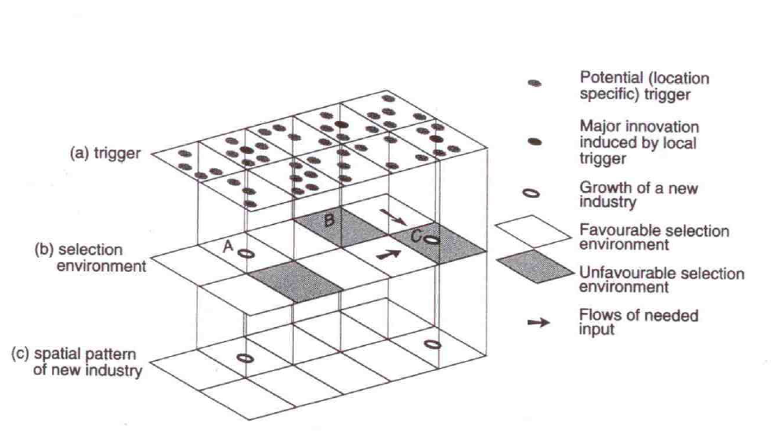
Figure 6 The window of locational opportunity concept (Boschma et al., 2002)

Moving down the figure brings us to the selection environment which Lambooy (2002) describes as the driving forces that influences competition within an industry. It is plausible to think that a region with a pre-established selection environment providing a specific set of constraints, advantages and capabilities might respond better to the development of a major innovation than others (Boschma, 1996). This is illustrated in figure X where the emergence of a new industry in region A can be explained by the potentially supportive selection environment. Boschma et al. (2002) temper the marginal impact of the local environment by stating that there is a mismatch with the new requirements of an emerging industry as they are not given but come into being as the development of the industry proceeds (Boschma, 2007). To understand how a potentially favorable environment influences the spatial emergence of a new industry a distinction must be made between generic and specific resources as well as the different stages of growth in a new industry. Specific spatial practices and conditions that have been accumulated in the past, will not provide any stimuli for the development of a new industries because of these specific requirements at their earliest stages of development are not pre-given but come gradually into being. Therefore at the initial stage of growth a new industry can only benefit from its selection environment if it provides favorable generic resources. It is plausible to think that the automobile industry built on generic favorable resources like skills and knowledge. This is especially the case if a new sector grows out of a related sector. Klepper and Simon (2000) found that the automobile industry emerged out of the cycle and coach making industry which provided knowledge and skills that were not yet specific to support the industry, but may have favored its development. As the development proceeds, local requirements for the emergence appeal and through the mechanism of creative ability the industry shapes and transforms his production space by turning favorable generic resources into custom specific resources like highly skilled labor and specialized knowledge (Boschma, 1996). By this means the WLO concept rejects the view that the emergence of an industry takes place regardless to their spatial environment. When situating new industries in their local context, as can be seen in figure X, it is plausible to think that regions endowed with particular generic resources may be more suited to adjust than others Boschma et al., 2002).
Again, the influence of potentially favorable generic resources on the spatial manifestation of an industry must be tempered because they are widely available in space and therefore far from sufficient to sustain the rise of new industries (Boschma, 1996). This is reflected in figure X were the rise of a new industry in region A might be explained by its potentially favorable environment. However it is uncertain and unpredictable in which region the presence of supportive generic resources, a favorable selection environment, will stimulate the development of a new industry. So, a favorable selection environment will only influence rather than determine the ability of regions to adjust as can be seen in the figure which shows six regions with similar beneficial conditions that did not succeed to develop the new industry. Furthermore, the figure also shows that the development of a new industry, though triggered by a major innovation in the case of region B, may fail because of a lack of basic requirements. Contrary, despite the lack of a supportive production environment a new industry emerges in region C. According to Boschma et al. (2002) this is only possible if a region draws required generic resources from surrounding regions with favorable environments, indicated by the arrows in figure X. This indicates that the spatial manifestation does not solely depend on chance events and selection. Hence, the spatial manifestation of new industries might also be influenced by the creative ability of firms as well as their strategic behavior to shape and transform their production space according to their needs as development proceeds (Boschma, 1996).

Related Industries
Although the WLO concept states that spatial practices and conditions that have been accumulated in the past cannot explain or predict the spatial emergence of a new industry it does not deny the importance of the techno-industrial background of a specific region. New industries do not start from scratch and this also accounts for the origin of the automobile industry. Many historians, behavioral and economic geographers argued that Southeastern Michigan attracted or retained the most successful motor vehicle producers, because industries from which automotive technology derived were already thriving in the region (Smith, 1968; Klepper and Simon, 2000; Denison, 1956; Abernathy, 1983; Rubenstein, 2002 and many others).
The importance of a community’s experience and expertise in successfully manufacturing other products is confirmed by Neffke (2009) who states that the creation of new knowledge often relies on the merger of preexisting knowledge. However, as argued in section 3.3 the emergence of a new industry reflects a fundamental break with the past whereas new requirements are not pre-given. Schumpeter (1935) explains this discontinuity of innovations as an historic and irreversible change in the way of doing things. Innovations are changes in the production function which cannot be decomposed into small steps. In the particular case of the invention of the automobile one might doubt the fact that the change in the production function was a discontinuous qualitative jump rather than a successful merger of existing technologies. Obviously the invention of the automobile was groundbreaking however it relied on the existing knowledge on how to produce an engine, drive train and platform.
Returning to the WLO concept the presence of related industries prior to the emergence of the automobile industries connects, in different stages of the industrial lifecycle, to both, the potential location specific triggers and a favorable selection environment. The innovation just prior to the emergence of a new industry can be triggered by location specific existing practices and structures that provide new opportunities or challenges. These signals from the environment can reveal in the desire for a new product or technology. Referring to section 2.4 the competition for the best performing power source was won by the gasoline engine. This was because it was more suitable for rough roads in rural areas and was therefore commonly installed in agricultural equipment. Prior to the emergence of the car industry the gasoline engine was also used for marine uses because they were dissatisfied with the heating capacity of locally mined coal. The anatomy of the predecessor of the automobile, the carriage, shows some interesting similarities with the fundamental components of the car. That is, components such as bodies, wheels, axles, springs etc. were also used in the production of a car. The production of carriages happened to cluster around extensive hardwood forests (Rubenstein, 2002).
Summing up these different examples of location specific triggers, and assuming that geographical proximity supports the spillover of technological knowledge (Audretch and Feldman, 1996; Jaffe, 1989) gives a proper explanation for the fact that mechanics and engineers skilled in other industries applied their expertise to experimenting with motor vehicles.
When analyzing the growth and maturity phase of the automotive industrial lifecycle the role of related industries with respect to a supportive selection environment becomes more explicit. As the development of the industry proceeds innovations become less radical and involve small changes on an existing design. Innovative activity is now regarded to improve the products functionality, performance and reliability. Contrasting with the spatial indeterminacy of major breakthroughs like the first invention of the car, incremental improvements builds on and reinforces applicability of existing forces. Neffke (2009) complements this contradiction by pointing out the importance of the availability of expert knowledge over a large variety of ideas. This professional expertise is more likely to be found in regions with a strong specialization in a specific industry and so when the automakers progressed from the experimental stage to commercial production they turned to the existing industries for skilled workers. In this case the presence of skilled workers from related industries contribute to a supportive selection environment which might respond better to the development of an industry than a region with endowed with less skilled workers.

The WLO concept and the U.S. automotive industry
The previous section provided a concept to analyze the extent to which chance and necessity are involved in the spatial emergence of new industries. Incorporating notions of spatial indeterminacy, creativity and randomness gives us the opportunity to apply the WLO concept to the central research question that reads: What are the forces that contributed to the agglomeration and concentration of the U.S. automobile industry in and around Detroit?
The WLO concept states that new industries provide new opportunities for each type of region. So, it basically says that new industries are likely to develop independently of established spatial structures and conditions (Boschma, 1996). The validation behind this assumption can be found in the discontinuity and randomness of major innovations, which represent a fundamental break with the past. It still remains uncertain where regional dynamics takes place because it is uncertain where new industries will emerge. Boschma (1996) provided a ideal stage model which shows how the windows of locational opportunity successfully opens and close over time and incorporates the uncertainty with respect to regional dynamics.
In the initial stage of growth, the industry may emerge spontaneously and, because of the discontinuity of major innovations, form a rather unpredictable spatial pattern independent of the techno-industrial legacy of the past. As illustrated in section 3.3 the new industry is extremely sensitive to a number of triggers that are highly available in space. Furthermore new industries build on generic resources, which can not be regarded as sufficient, but may support their growth and even act as necessary conditions. In this stage, the windows of locational opportunity are widely open.
The next stage Boschma (1996) describes as a cumulative self-reinforcing process that occurs in a few selected places. This snowball effect is achieved by the self-reinforcing feedback between successive rounds of innovative behavior and regional dynamics. Consequently these regions will experience strong local economic growth because of exclusive localization economies and the creation of specific knowledge resources which contributes to a socio-cultural climate of consensus and commitment to the new industry (Boschma, 1996). In other words, innovative behavior increases output. Regions, already endowed, or capable of drawing or attracting their own favorable generic resources will benefit from economies of scale, higher rates of specialization and more agglomeration advantages. Because of the self-reinforcing character of this process, leading regions will continue to stay ahead at the expense of lagging regions resulting in a disparity with respect to a more diversified experienced and skilled labor market, more specialized knowledge, better infrastructure, supportive government regulations, research facilities, a larger supply of capital etc.. At this latter stage the windows of locational opportunity have closed around the regions that turned out to be the most dynamic regions.
When projecting this ideal stage model to the development of the U.S. automotive industry there are some interesting similarities. As mentioned in section 2.2, in its initial growth phase the automobile industry was not confined to a single location, but rather was evolving in a number of widely scattered places. By 1905 a major shift in the locational pattern of the industry took place and Detroit started to play a significant role in the manufacturing of automobiles. Section 2.1 points out that Detroit did not have a single dominating industry however it did provide a favorable landscape and was well endowed with related industries such as the production of wagons, carriages, bicycles, marine engines, agricultural machinery and railroad and misctransportation equipment (Rubenstein, 2002).
As the development of the industry proceeds, the southern of Michigan became the supreme centre of the U.S. automobile industry. A similar, and complementing development was the change in market structure. The initial pattern of widely scattered small manufacturers, mostly concentrated in the west coast area, turned into an oligopoly concentrated in the region of Detroit producing millions of cars. The discussion remains if these developments were the result of accidental outcomes, or a combination of chance and the creative ability and strategic behavior of firms to transform and shape its production environment to the new requirements of the emerging automobile industry.
The WLO concept provides an analytical framework to estimate the importance of chance events in the spatial manifestation of the U.S. automotive industry. The question that remains to be answered focuses on the discrepancy between the new requirements of an new industry to develop( i.e. labor, capital and technological knowledge), and the local environment inherited from the past. As mentioned earlier, there are two possible outcomes of spatial change. Following Boschma (1996) the development of a new industry can be denoted as revolutionary if it cannot draw on local supportive conditions, as a stimuli for its development in space. Hence similar industries are dependent on their creative ability to attract their necessary resources themselves. Contrary, in the situation where an industry can rely on the local environment, in terms of favorable generic conditions, its spatial manifestation will be regarded as revolutionary.
Explaining the spatial agglomeration and concentration of the U.S. automobile industry in and around Detroit through the windows of locational opportunity concept and in particular how Detroit gained superior knowledge and skills in producing automobile has a number of testable implications. Can the supremacy of Detroit be explained by an evolutionary process, where chance influences the spatial manifestation but industries do not start from scratch but rather build on generic resources. Or is the high concentration of the U.S. automotive industry around Detroit simply the result of pure chance events?

Hypotheses
To test the WLO’s explantion for the geographic evolution of automotive industrial activity, a set of testable predictions concerning the location and diffusion of technological and organizational knowledge are formalized. These hypotheses are partly inspired by a table provided by Boschma (1996) which determines to what extent a new industry can build on its local environment when organizing its required inputs (i.e. labor, technological knowledge and other inputs) and the ability of an industry to draw its own favorable conditions to stimulate their development. Furthermore the influence of major product- and process innovations will be tested, as well as the role Ford, Chrysler and General Motors played in the evolution of the US automotive industry.
Consider first the effect of innovative activity and technological progress. The automobile was subject to numerous of innovations before it reached its modern design as we know it now. Referring to table 2 we are interested to the spatial pattern of automobile innovations. In this study product and process innovations can be distinguished, and the relative importance of an innovation can be estimated according to a 7 point transilience scale.
The WLO theory states that major innovations occur randomly and represent a fundamental break with the past. However, innovations do not necessarily occur abstract form space and it might be that they are triggered by specific locational factors as argued in section 2.4. We expect that innovations in the automotive industry at the initial stage of growth will occur rather independently from space, whereas in the second stage of this model successive rounds of innovations will induce regional dynamics resulting in a self-reinforcing process. Furthermore the number of product innovations is expected to be equally dispersed over time whereas the dispersion of process innovations is expected to grow as the development of the industry proceeds.
For the importance or quality of innovations it is expected that the geographical distribution of automotive manufacturing activity is expected to be positively related to both, high and low important innovations. However, innovations that involved incremental improvements of a car are strongly dependent on the ability to find expert knowledge whereas high important innovations, changing the fundamental structure of an automobile need access to a large variety of ideas. Therefore low important innovations are more likely to explain the geographical pattern of automobile activity since this type of technological development builds on a specialized environment. and that the leading automobile firms dominate innovative activity. To test whether these theoretical concepts hold the following hypotheses are formed H1-H4.
$H10:$ $The locational pattern of automobile manufacturing$activity is not
$$related to the locational pattern of automobile innovations.$$
$H1a:$ $The locational pattern of automobile manufacturing$activity is $related to the locational pattern of automobile innovations.$

$$H20:Process innovations do no account for more variability in the$$
$$geographicalpattern of the automotive industry than product product innovations.$$
$$H2a: Process innovations do account for more variability in the geographical$$
$$pattern of the automotive industry than product product innovations.$$

$$H30:High important innovations do not account for more variabillity in the$$
$$locational pattern of automotive industrial activity than low important$$
$$innovations do.$$
$$H3a:High important innovations do account for more variabillity in the locational$$
$$pattern of automotive industrial activity than low important innovations do.$$

$$H40: Leading automobile firms do not dominate innovative activity.$$
$$H4a: Leading automobile firms dominate innovative activity.$$

The model also has distinctive implications regarding the techno-industrial background of a region with respect to its automobile industry performance. It is tested whether car manufacturing firms perform better in regions that have inherited generic skills from its past industrial structure than regions with a lack of such experience. Furthermore we will test for the strength of this effect. If the techno-industrial background of a region accounts for any variability in the development of the U.S. automotive industry, was it stronger for Detroit than it was for other regions? Formalizing how certain patterns of related industries would be expected to influence the geographical evolution of the automotive industry are summarized as hypotheses H5 and H6.
$$H50:The geographical distribution of automotive industry employment is$$
$$not related to the precense of related industry employment prior to the$$
$$emergence of the automotive industry.$$
$$H5a:The geographical distribution of automotive industry employment is$$
$$related to the precense of related industry employment prior to the$$
$$emergence of the automotive industry.$$

$$H60: Automobile manufacturing activity was not higher in Detroit than it was for$$
$states with similar techno-industrial backgrounds.$
$$H6a: Automobile manufacturing activity was not higher in Detroit than it was for$$
$$states with similar techno-industrial backgrounds.$$

Study Design and Data Description
The goal of this section is threefold. One aim, handled in section 4.1, is to give an accurate and extensive description of the individual data. The data collection sources will be handled as well as its previous appearances in empirical research. Section 4.2 discusses patterns of regional specialization in the U.S. automotive industry over the course of time. The first steps towards our final regression- and relatedness model will be taken, explaining the spatial concentration of the U.S. auto manufacturing industry around Detroit. Common measures of specialization will be used to examine the dispersion of car manufacturing activity across the individual states of America. Referring to the theoretical concept, our leading variables of interest are employment, firms, innovativeness and related industries. Section 4.3 will give a clear description of the research methodologies that are applied.

Data

Sources of Data
The key source of information in this chapter is a U.S. industry level panel database for the period 1890-1940. Originally the dataset was constructed by Abernathy et al. (1983) and consists out of 631 commercial introductions or applications of an innovation in the U.S. automotive industry by year from 1893 till 1981. All innovations individually linked to their corresponding producers and categorized and weighted with respect to the subject of innovation and their relative impact on the production process of the car. In order to describe how the innovative pattern evaluates over time, with respect to geography the dataset is combined with an extensive list of automobile firms and their locations compiled by Smith (1968). Doing so, made it possible to determine where a company was located at the time of introducing or applying the innovation for the first time. Furthermore it enables us to determine whether the region of Detroit was introducing or applying a disproportional high number of innovations for commercial use compared to other regions.
The two different sources of data described above, were independently mentioned as sources of information for many studies regarding the industry structure of the U.S. automobile industry. So far, Klepper (2007) used the dataset created by Smith (1968) to support his theory in which disagreements lead employees of incumbent firms to found spinoffs in the same industry. The geographic concentration of the industry is attributed to four early successful entrants and the many successful spinoffs they spawned. Klepper (1997) also used the list of innovations to explain the changes in the automobile industry structure, which was extended by Rosegger and Baird (2003) who made an international comparison. The authors found that technological knowledge is an important force in shaping the long-term development of industries and markets.
However, what about the geographical diffusion of this new technological knowledge? One obvious explanation why innovative activity tends to cluster geographically is that the location of production is more concentrated spatially (Audretch and Feldman, 1996). So far, researchers did not study whether the high concentration of innovative activity in and around Detroit was the logic consequence of the fact that since 1914 Detroit has been home for a large portion of car manufacturing firms. For our first analysis this dataset allows us to investigate if it might be the case that Detroit showed a significant disproportional high level of innovations before the industry settled in Detroit, Michigan.
Extending the dataset with some auto-industry related variables, available for Census records from 1850 till 1940, makes it possible to analyze the effects of the techno-industrial background of Detroit, Michigan on its performance in the auto-industry. In this second part of the research we are interested in the different stages of the windows of locational opportunity concept as handled in section 3.5. Was the region of Detroit better endowed or more capable, relative to other regions, to organize its required inputs? In other words, is their statistical evidence to believe that there were potential triggers that attracted innovative activity to the region of Detroit And is their reason to believe that the selection environment favored the region of Detroit significantly more than others in developing the automotive industry?

Checking Assumptions
Before we can make reliable and valid statements about the hypotheses and later also about the research question we first need to guarantee that the datasets we are using are free of errors and misspecification. To test the hypotheses OLS or simple regression is used. The first assumption of an OLS regression is that the used model is linear in its parameters. To check this assumption the residuals were plotted and the scatter plot indicated that there is no reason to believe that there is a non-linear relationship between the outcome and the predictors. There seem to be no clustering of positive or negative residuals. Also partial scatter plots of the residuals of the outcome variable and each of the predictors, regressed separately, give no reasons to doubt the assumptions of linearity nor those of homoscedasticity.
Second, we need to check if the errors are normally distributed. This was also confirmed by the residual analysis.
As a third assumption, we have to test if the errors have a constant variance, or in other words if there is homoskedasticity in the data. The scatter plot shows a random array of dots which seems evenly dispersed around zero. There is no serious reason to doubt that the assumption of homoscedasticity is met within this model. The following assumption are to check whether there is auto or serial correlation in the model. There does not seem to be a cyclical pattern in the plotted residuals that provides a cause for concern about the autocorrelation of the residuals. In addition to the plot the Durbin-Watson statistic is used to detect autocorrelation. With a value of 2.397, which is reasonable the hypothesis that the regression results are not subject to autocorrelation can be accepted. The VIF values and their corresponding tolerance values do not violate the assumption of multicolinearity, they are both below their critical value of 5, and 0,20, respectively. Therefore the H0 hypothesis is accepted. So far none of the assumptions concerning the use of OLS for this dataset are violated. However, when checking the assumption for normality, the data appeared non-normal even after a log transformation. The violation of the normality assumption limits the research with respect to generalizations beyond the scope of this research. This implies that if the results of this research are significant, further insights on how the automotive industry became so concentrated around Detroit are obtained. However it would be misleading to project these outcomes on the overall topic of industrial agglomeration and therefore positive outcomes on this study can serve as new directions for further research concerning the spatial evolution of industries.

Data Description

Automotive Industry Employment
To analyze the geographical distribution of the U.S. automobile industry, as well as to evaluate its spatial evolution over time, we will start with the calculation of the location quotient. The location quotient, hereafter LQ, is probably the most widely used quantitative measure, along with a locational GINI coefficient, for assessing the geographical distribution of firms within one industry (Krugman, 1991). The LQ compares the local economy to a reference economy to identify the location of economic activity for highly aggregated geographic industries and regions. The LQ is comparable across industries and it controls for overall agglomeration. Our prime variable of interest used in this study are the number of employers active in the U.S. automotive industry. The equation for calculating the LQ can be written as:
$\left(1\right) LQ=\frac{e^{i}/e}{E_{i}/E}$,
where $e^{i}$ is the regional employment in industry $i$ divided by total regional employment e and $E_{i}$ is the reference economy employment in industry $i$ divided by total employment E.
The outcomes summarized in table 3 lends support to the view that a long term structural shift in automotive industrial leadership between regions have actually taken place in the U.S.. In this table the long term evolutions of regions is presented on the basis of their relative share in employment in (clusters of) automotive industries. A location quotient higher than one indicates that a region’s number of employment in the automotive industry exceeds the national average.

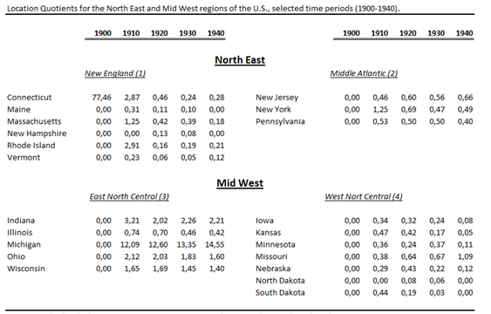
Table 3, Location Quotients for the North East and Mid West (based on author’s calculations)

The most striking pattern that numbers reveal is that the states of New England, in the North East of the U.S. were already losing their dominant position by 1910. At the same time,the East North Central States in the Midwest of the U.S. showed enormous activity in theautomotive industry with Michigan as its new undisputed leader. The degree of geographic concentration exhibited by the East North Central States is striking. The shares of employment in Indiana, Ohio, Wisconsin, and especially in Michigan are many times larger than in the nation as a whole. Also evident from the data is the decreasing localization level of the majority of states while those in Michigan remained stable and even grew.
While the number of employers gives a good impression of the size and the geographical pattern of automotive industrial activity it will be used as our dependent variable to study the possible effects of innovations and the presence of related industries on the geographical pattern of the U.S. automotive industry. As can be seen in figure 3 the automotive industry became stable through 1940 after which only a few firms were producing passenger automobiles. At that time Michigan employed 58 percent of all workers that were active in the automotive industry.

Firms
When analyzing the spatial pattern of car manufacturing firms in the period 1893 through 1940 as showed in table 4, the first thing that catches the eye is that in the first decade since the start of the industry there was not a single firm in Michigan, and therefore Detroit, that was producing passenger automobiles. As the development of the industry proceeds, Michigan becomes more prominent and by 1940, 62 percent of all car manufacturing firms in the U.S. were situated in Michigan. Additionally, the industry shakeout Klepper (1997) studied is clearly observable. The number of firms shows a large dropdown after reaching its peak in the mid 1910s. The comparison between the share of firms and the share of employment in Michigan show some interesting results. In 1910 and 1920 the share of employment is 35 and 46 percent, respectively. Surprisingly the share of firms located in Michigan is significant lower than the share of employers indicating that Michigan was the host of relatively large firms.

Innovations
Another key variable in describing the spatial concentration and the evolution of technological change of the U.S. automobile industry around Detroit is the number of innovations. Using data from the commercial inception of innovations allows us to identify whether a dominant design, a major product innovation or an evolutionary process might have caused the car manufacturing industry to cluster in the region of Detroit, Michigan. While focusing on both innovation and the diffusion of innovations across producers we will refer to the three theories concerning industry structure and technological change as discussed in section 2.4 as well as their possible connection towards the OWLO concept.

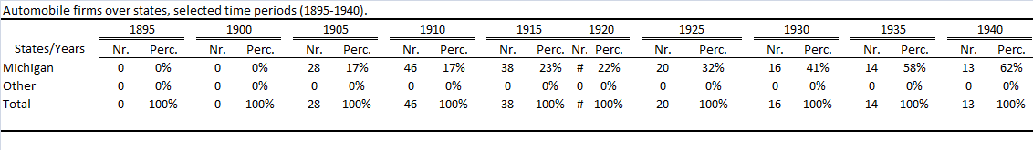
Table 4, Automobile firms over states (calculations based on Smith, 1968)

Table 5 shows the pattern of innovations over time. It becomes obvious that Michigan, at the initial phase of the automotive industry, did not play a significant role with respect to innovative activity. However, as the development of the industry proceeds, Michigan becomes more and more important concerning the number of innovations.
Furthermore, it seems to be that the share of process innovations grows over time and most remarkably Michigan accounts for nearly all commercial inceptions of process innovations.
Analyzing the relative importance of the product innovations over time shows that Michigan introduced a disproportional high number of high important innovations compared to the other states. Of course, as said earlier, innovative activity tends to cluster if production concentrates to a single location. Nevertheless, by 1910 Michigan employed 35% of all workers and 17% of all firms in the automobile industry. The total share of innovations show some comparisons with the number of firms and employers in Michigan. However Michigan accounted for 73% of the high important innovations and 90% of the process innovations which are disproportionally high relative to the share of the market.

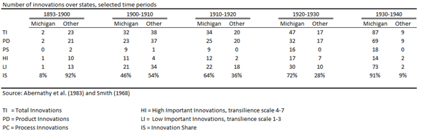
Table 5, Number of Innovations over states (Abernathy et al., 1983 and Smith, 1968)

Relatedness
As discussed earlier in section 2.4 and section 3.4 new industries do not start from scratch. They build on the knowledge and skills of a community’s experience in successfully manufacturing other products. According to Rubenstein (2002) the region of Detroit possessed the most successful car manufacturers because industries from which automotive technology derived were already thriving in the region. The related industries that were chosen were selected through previous citations by leading automotive historical articles and publications by economists. However not all related industries were available for American Census Data. The selected manufacturing industries were: Carriages and Wagons, Railroad and Misc Transportation equipment, Ship and Boat Building and Agricultural Machinery and Tractor building. These industries, or the skills expertise and knowledge of employers who were active in these industries are expected to be related to the competences and general knowledge that was required for the manufacturing of the automobile. For the related manufacturing industries Census Data for 1900 is used. Data from subsequent Censuses for these industries were influenced to a considerable degree by the presence of the automobile industry, which compromised the ability to test the influences of the related industries independent from the automobile industry.

Control Variables
Obviously automotive industrial employment is influenced by a large number of predictor variables. To prevent for overestimating the effects of innovative activity and the presence of related industrial employment a control variable is needed. It is plausible to think that the population of a certain state could explain a large amount of the variability in employment, of all sectors. Therefore to control for overestimation of the explanatory power of the independent variables in the regression model the population of the United States in 1920 is used.

Methodology
To explore the impact of technological progress on the growth of the automobile industry in the states, regression analysis will be used to estimate the effect of innovative activity on the growth of the automotive industry. The model also explores the impact of a region’s techno-industrial legacy on the growth of the automobile industry over states. Dependent and independent variables in the regression analysis are expressed as natural logarithms from their original value. Table (X) reports the means and standard deviations for the independent and dependent variables. The unit of analysis is the state ($i$), reflecting the availability of data at the state level from the American Census. Furthermore only the location of automotive industrial activity through 1920 is analyzed since it is doubtful that the evolution of the industry structure after 1920 was influenced by conditions that prevailed at the start of the industry, which is the focus of the analysis. The econometric model is specified as follows:
$$\left(2\right)LOG_{AIEi}=a+βLOG_{AIi}+ LOG_{RIEi}+ LOG_{PUS}+ ε$$
where $a$ is a constant term, β, χ and δ are the coefficients on independent variables and ε indicates the error term. The dependent variable is a measure for automotive industrial activity in 1920 for each state. This variable $LN(EMPLOYMENT_{AI})$ is calculated as the natural logarithm of automotive industrial employment for each state in 1920. To control for the size effects of the different states the natural logarithm for the population per state is used.
To analyze the effect of innovative activity on the spatial distribution of automotive industrial activity $LN(INNOVATIONS_{AI})$is defined as the natural logarithm of the total number of innovations, process and product, that were introduced in each state in the time period between 1893 and 1920. To increase the robustness of the model and to test different sources of variation in the input of the, model sensitivity analysis are used in model 2. The model distinguishes between the contend of innovations, the relative importance and tests the effect of different time periods. Sensitivity analysis: make a distinction between 1893-1910 and 1910-1920.
Four variables are introduced to capture the effect of a supportive techno-industrial background, regarding the presence of related industries prior to the emergence of the car manufacturing industry. The variable related industry employment ($LOG_{RIE })$collects the impact of employment in 1900 for the following industries; Carriage and Wagon, Railroad, Ship and Boat and Agricultural Machinery ($LOG_{CWBE}, LOG_{RMTBE}, LOG_{SBBE} and LOG_{AGMTBE,}$ respectively).

Empirical Findings
Formalizing the evolution of the automotive industry shows how certain patterns would be expected to hold if in fact notions of evolutionary economics like the WLO concept drove the agglomeration of the automotive industry around Detroit. The results for the OLS or simple regression of the first analysis are presented in table 6. For analytical clarity its chosen to mention both the direct effect of the independent variables on automotive industry employment, thus without the mentioned control variables, as well as the outcome of the full model as presented in equation 2 in the methodology section. The results should give new insights to interfere on the discussion concerning evolutionary notions like fitness and the potential impact of the selection environment in explaining the supremacy of Detroit. The focus is not on extreme outcomes of either determinism or complete indeterminism but on the reduction of the possible range of outcomes.
Table 6 provides the explanatory power of the model by presenting the variable’s corresponding values of R-squared, the regression coefficients (β) and the subsequent p-values. Table 6 shows the regression results for the sample of all 50 states and will be leading in analyzing the different models regarding their hypotheses. The main and final focus will be on the outcomes of the full model. In the full model the relationship between innovative activity and effect of techno-industrial knowledge and competences accumulated from the presence of related industries on the spatial manifestation of the automotive industry is given by the following equation:
$\left(3\right)LOG_{AIE}= -4.33+0.394LOG_{AI}+0.163LOG_{RMTEBE}+0.646LOG_PUS$

Innovative activity; In the theory and hypotheses sections the importance of innovative activity is frequently mentioned, stating that a large part of the spatial formation in automotive industrial activity could be captured by the effects of geographical spread in innovative activity. Regarding the implications of the WLO concept these effects might change over places, time and their relative importance, as will be discussed later.
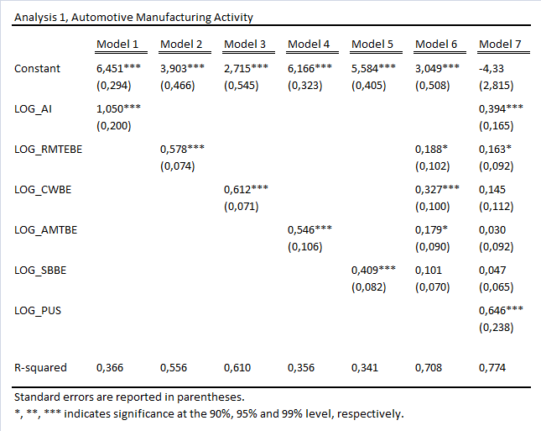
Table 6, Regression Results for analysis 1

The first specification includes one explanatory variable, the number of commercial inceptions of automotive innovations in a region between 1893 and 1920, denoted as $LOG_{AI}.$ The model predicts that the geographical spread of innovative activity should positively influence the spatial distribution of automotive manufacturing activity over the states. The direct effect of automotive innovations is both positive and significant at a 1% significance level. Looking at R-squared 36.6% in the geographical distribution of car manufacturing activity can be explained by the variation in innovativeness per region. In the full model the effect of innovative activity remains positive and significant at 1% level of alpha and however the coefficient estimate in the full model is smaller than its direct effect it is still gives enough evidence to reject H10. The coefficient of 0.394 in model 7 indicates that a 1% increase in automobile innovations in region $(i)$ results in a 0.394% increase in automotive industrial employment. In table 7 the results of the sensitivity analysis are presented which was applied to find different sources of variation in the input of the model. A distinction is made between the contend, importance and the time period in which the innovations were commercially incepted. All specifications are summarized in table 7.
Turning to the nature of innovations table (2) in section 4.2.3 shows that the number of product innovations is relative equally dispersed over both time and places. The relative share of product innovations seem to correspond with car manufacturing activity. Michigan accounted for 38.33% of all product innovations in 1910 while in this same year it possessed 17% of all automotive producing firms and 35% of the industries employment. For 1920 these numbers were 55.55% for the share of automobile’s and for firms and employment 22% and 46%, respectively. The share of product innovations did not deviate as the industry proceeds to concentrate around Detroit.
For the commercial inception of process innovations, the geographical distribution shows a large bias with the geographical distribution of automotive production. At the start of the industry in 1900 Michigan did not account for any of the process innovations. However in 1910 Michigan was responsible for 90% of all process innovations and in 1920, 1930 and 1940 Michigan accounted for all process innovations in the industry.
These results are partly confirmed by the results of the sensitivity analysis presented in table 7. Model 4 and 5 show the direct effects of respectively product and process innovations on the geographical pattern of automotive industrial activity. Notably the explainable power of product innovations (R-square = 0.396) is more than twice as high as the explainable power of process innovations (R-square = 0.173). However the direct coefficient of process innovations (β = 2.224) compared to the coefficient of product innovations (β = 1.466) indicates that an increase in process innovations has a larger effect on automotive industrial activity than an increase in product innovations. However, controlling for population only the effect of product innovations remains significant at a 1% level of alpha. So according to the sign of the effects of product innovations in model 6 of 0.656, which says that a 1 percent increase in the commercial inception of product innovations in state $\left(i\right)$leads to an increase of 0.656% in the total number of car manufacturing employment in state$\left(i\right)$. The insignificant coefficient of process innovations can be dedicated to the fact that Michigan accounted for a disproportionally large share (i.e. nearly all) of the process innovations.
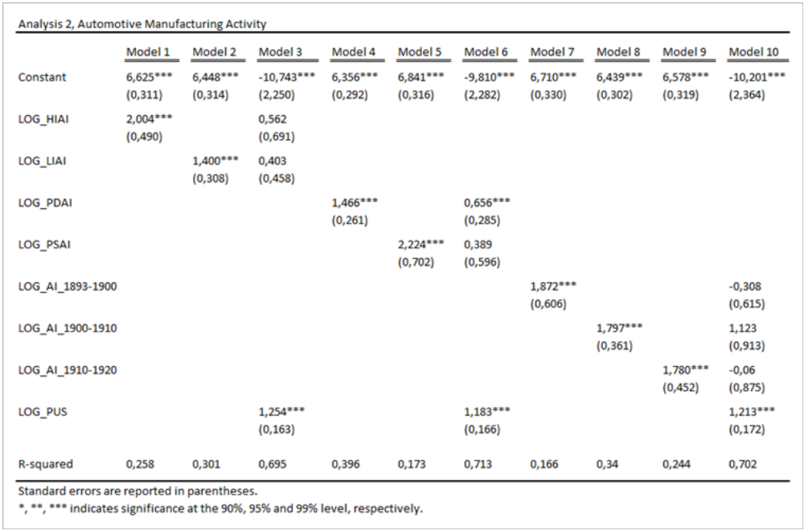
Table 7, Regression Results Analysis 2, sensitivity analysis

These results give little evidence to conclude that process innovations are more capable in explaining the geographical pattern of automotive industrial activity than product innovations. Therefore H20 is not rejected.
Considering the importance or quality of innovations the theory predicts that high important innovations occur with more locational freedom relative to low important innovations, and that low important innovations are more capable in explaining the locational pattern of automotive industrial activity than high important innovations.
Consistent with the theory the average transilience sore of innovations does not vary with significant amounts across regions. With an average transilience score of 3.78 the relative contribution of New York concerning the quality of innovations is higher than Michigan that denoted a transilience score of 2.6. This can be explained by the dominance of Michigan regarding both, high and low important innovations. Michigan did introduce a large number of high important innovations however these were associated with an even higher number of low important innovations resulting in a lower transilience score than New York.
Instead of the transilience score the share of high and low important innovations might give a better understanding of how the importance of innovations influences the spatial pattern of the automotive industry.
The relative importance of innovations is used as a predictor variable in the model to explain the variance in automotive industrial activity over space. The results are presented in table 7 in model 1, 2 and 3. Model 1 shows the direct effect of high important innovations and model 2 the effect of low important innovations on automotive industrial employment. Both direct effects are significant only the r-square of low important innovations explains 4.3% more of the model than high important innovations do. However the coefficient of high important innovations is higher, saying that an increase in high important innovations in a specific region has more impact on its industrial activity than for low important innovations. Putting both variables into one model and controlling for population the effects become insignificant and therefore gives no evidence to reject H30.
Worth mentioning are the possible effects of the different time periods in which the innovations were introduced. Model 7, 8 and 9 show the direct effects of automotive innovations on industrial activity for the periods 1893-1900, 1900-1910 and 1910-1920, respectively. Since the data analyses showed that the number of innovations became more and more concentrated towards the region of Detroit as the development of the industry proceeds this is expected to be reflected in the regression analysis. The direct coefficients of the distinctive time periods did not differ by trivial amounts, though it is obvious that the explainable power is highest for the time period 1900-1910. This is not surprising since this was the decade that Detroit became active in the automotive industry and the industry as a whole grew enormously regarding the number of firms.
Considering Ford, GM and Chrysler as the leaders of the automobile industry, it is expected that these three firms contributed a large share of automobile innovations. From the start of the industry through 1920 these firms accounted for only 25% of all innovations which was considerably less than their share of the market while GM and Ford accounted for 38% of total automobiles sold in 1911. In the period from 1920 through 1942 the three leading firms accounted for 66% of all innovations and had a combined share of the market which exceeded 60% by 1920 and 80% by 1930. Furthermore in the period before 1920 the top three firms accounted for only 9% of all process innovations while after 1920 through 1940 they contributed 97% of all process innovations. These results partly confirm the predictions made in hypothesis H4.
Related Industries; Turning back to table 6, the subsequent specifications of the model concern the impact of the presence of related industries on the spatial pattern automobile manufacturing activity. The model is used to test the effect of the carriage and wagon industry, ship- and boat building industry, railroad and misc transportation industry and the tractor building and agricultural machinery industry on the automotive industry. To isolate the effect of the presence of related industries a control variable in terms of population per state is introduced. Models 2, 3, 4 and 5 show the direct effect of the respectively $RMTEBE, CWBE, AMTBE and SBBE$. All four variables have a significant direct effect. However the effects of $RMTEBE and CWBE$ are considerably higher. The second column in table (X) shows the regression results for the direct effect of railroad and misc transportation building equipment LN(RMTEBE)$.$ The presence of skilled $RMTEBE$workers prior to the emergence of the automotive industry has a positive and significant direct effect on automotive industrial activity. This is highlighted by a R-squared of 0.578 and a coefficient of 0.556 indicating that a 1% increase in $RMTEBE$leads to a 0.556% in automotive manufacturing employment. The third model captures the effect of the presence of carriage and wagon employment prior to the emergence of the automotive industry. The regression results displayed in the third column of table 6 shows that the isolated effect of $CWBE$ is significant at the p < 0.01 level and yields a R-squared of 0.612. From the four industries $CWBE$ also has the highest coefficient, so when the carriage industry in certain region grows with 1%, the automotive industry in that same region grows with 0.612%.
Since no specific hypotheses concerning the population of a state are formalized only the full model effects the variable captures will be analyzed. Model 5 is the full model with all independent variables. This model offers stronger, multivariate test of the hypotheses and as showed before allows examination of how innovativeness and related industries effect the spatial distribution of automotive industrial activity. The full model explains 77 percent of the variance in automotive industry employment ( F = 37.795, p < 0.000). The coefficient of $RMTEBE$remains significant at a 10% level of alpha. Though its effect became less stronger it says that if $RMTEBE$increases with 1% automotive industrial activity increases with 0.163%. Interestingly, in the full model the coefficient of $CWBE, AMTBE and SBBE$ has switched from being significant at 10, 5 and 1 percent significance levels into an insignificant value. These results gives weak evidence for the positive relationship between the techno-industrial background of a region and it automotive industrial activity, and therefore is insufficient to reject H50.
Among the top eleven states Michigan was ranked 8th in terms of total manufacturing production volume, 5th in terms of the agricultural machinery industry employment, 7th for railroads and misc transportation, 11th for ship and boat building and 6th for carriage and wagon industry employment. Other states like New York, Illinois, Ohio and Pensylvania were far better endowed with related industries, and though they were also in the top ten of automotive manufacturing states, especially at the start of the industry, they cannot be compared with Michigan. Although no strong statistical evidence is found these findings support the prediction of hypotheses H6. This raises the question if it could be that the combined presence of the related industries together gives a better understanding on how technological relatedness influences the geographical pattern of the emerging automotive industry. To test this a new model is created which the results are presented in table 8.

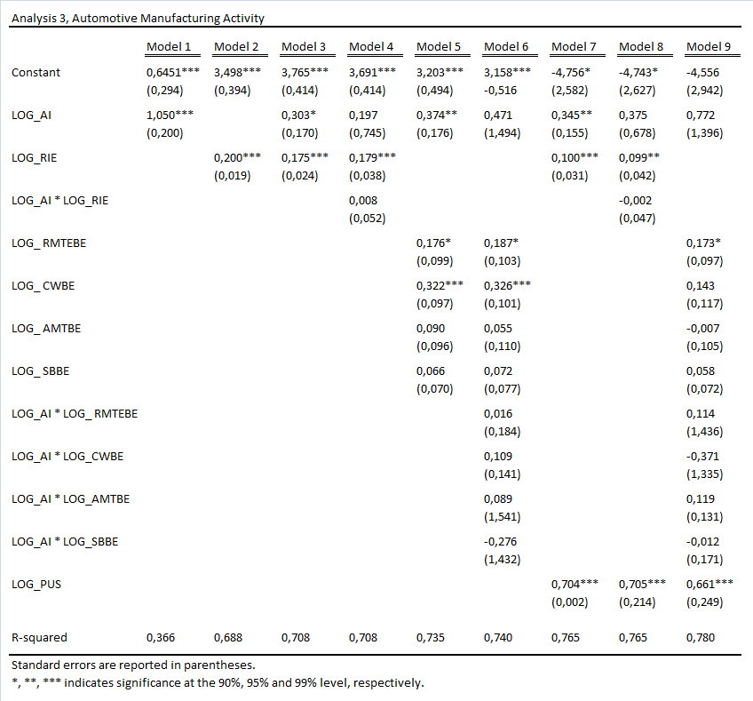
Table 8, Regression Results, Analysis 3, interaction effects

Starting with model 2 which shows the direct effect of related industry employment, which is measured as the accumulated employment in the four industries as mentioned above. At a 1% significance level $LN\left(RIE\right)$ explains 68,8 % of the variability in automotive industrial employment. Incorporating the effects of automotive innovations and controlling for the effect of population the effect of related industry employment remains significant for 1% level of alpha . Model 7 explains 76.5% of the variation in automotive employment, and can be formalized by the following equation:
$$\left(4\right)LOG_{AIE}= -4.756+0.345LOG_{AI}+0.100LOG_{RIE}+0.704LOG_PUS$$
The model says that a 1% increase in automotive innovations results in a 0.345% change in automotive industrial employment, Furthermore if employment in the related industries increases with 1% the automotive industrial employment will increase with 0.10%. This gives us satisfactory evidence to reject H50. Not surprisingly the effect of the population size has the largest effect on automotive activity saying that if the population increases with 1% the number of employees will increase with 0.7%.
To test whether the combination of innovative activity and the presence of related industry employment has a positive effect on automotive industrial employment interaction terms are introduced into the model. Both the combined related industry employment and the distinctive industries were multiplied with automotive innovations and showed that the effects on automotive industrial employment are not additive. The insignificant values in model 4, 5, 6, 8 and 9 indicate that the variable do not strengthen each other or interact in any other form.

Conclusions

This thesis examines the geographical evolution and resulting spatial concentration of the U.S. automotive industry during the period 1893-1940. The U.S. automotive industry was one of the most extreme examples of an agglomerated industry, yet the reasons for this extreme high concentration of industrial activity remains a puzzle.
A neoclassical economic explanation for industrial location choice learns that firms make rational decisions regarding the economic exploitation of inventions. They choose their location based on spatial cost minimizing characteristics that best correspond the new requirements which are needed for the development of the new industry. However such an explanation does not account for firm dynamics but more importantly it is impossible to choose a location based on a supportive economic structure as the specific needs of new industries at their earliest stages are not pre-given but come gradually into being.
To identify the driving forces behind the process of diffusion and spatial clustering of skills and knowledge in emerging industries, two theories of evolutionary economics are used. Starting with Klepper (2002) who constructed a spinoff model that explains the spatial pattern of a new industry by the diffusion of skills and knowledge from one firm to another. This effective mechanism of knowledge transfer between generations of firms results in a higher probability of survival due to the superior learning environment. Though the findings of Klepper are appealing in explaining the spatial manifestation of the automotive industry the spinoff model can be criticized in a sense that the emergence of a new industry occurs abstract from space as it is dependent on the accidental presence of some successful firms in the region that generate many successful spinoffs in the area.
The windows of locational opportunity (WLO) concept validates that the emergence of a new industry does not abstract from space. The WLO concept claims that the rise of new industries in space remains highly unpredictable. However it is not entirely the outcome of pure chance events since it is often triggered by existing practices and structures that provide challenges and opportunities. The WLO concept serves as an analytical framework to investigate how newly emerging industries shape and transform their production space according to their needs as the development of the industry proceeds. Evaluating the evolution of the automotive industry it seems plausible to think that Detroit may have positively reacted to path dependence processes: general resources like the presence of related industries and the learning processes regarding innovative behavior along trajectories may have favored the growth dynamics of the automotive industry.
Applying multiple linear regression to the available panel dataset evidence is found that the high spatial concentration of automotive industrial activity in Detroit cannot be isolated from the local industrial climate.
Starting with the effects of innovative activity. It is found that the geographical spread of innovative activity did explain a large part of the geographical pattern in car manufacturing activity. Also evidence is found for the fact that high important innovations occur with more spatial freedom than low important innovations. The results over time gives no evidence for the emergence of a major product innovation nor a dominant design that could have caused the industry to concentrate around Detroit. However the evolution of the quantity and quality of innovations is in line with the increasing returns theory, while later product innovations included incremental improvements rather than fundamental changes in the basic structure of the car and the number of innovations that were related to the production process increased.
Turning to the possible impact of the presence of related industries prior to the emergence of the automotive industry. It was expected that the presence of generic skills in the form of workers in related industries could explain the geographical evolution of car manufacturing activity. For workers in the railroad and misc transportation industry this was proved. However for the ship and boat building, agricultural machinery and the carriage and wagon industry no supporting evidence was found. However combining the presence of related industry employment by accumulating the total employees in the distinctive industries did prove to be beneficial for the development of the automotive industry.
These results are in line with the two types of spatial change that are distinguished in the WLO concept. At the start of the industry the windows of locational opportunity were likely to be widely open. As there was no consensus on buyer preferences for possible features of the car and technological means of satisfying this preferences were uncertain, the new industry could hardly draw on local conditions to support its growth which explains why the development of the automotive industry and technological development occurred rather abstract from space.
As the development of the industry proceeded it became clear that the gasoline engine was preferred above the steam and electric engine and the fundamental design of the automobile became clear. In the search for more powerful engines, better transmissions and more efficient technological means of manufacturing cars the ability to find expert knowledge became more important. In this case the creative ability of the new industry can build to some degree on generic resources like related industries.
It is not unlikely that the high concentration of automotive industrial activity around Detroit was influenced by its techno-industrial legacy of the past. Of course the fact that Detroit happened to possess a group of talented pioneers in the form of Ford, Buick, Olds and Dodge must not be ignored. However also founders of new businesses did not operate in a social and economic vacuum. The combination of timing, learning processes and the presence of generic skills and knowledge in the form of related industry employment could have provided the challenges and opportunities that triggered the rise of the automotive industry in Detroit. Together with the presence of pioneer like Ford, Chrysler and GM Detroit had the ability to create and/or attract the conditions needed to support their further development.

Limitations and Directions for further research.
Although an attempt is made to specify the relationship between the geographical concentration of automotive industrial activity and the geographical pattern of innovations the exact size of the effect of time and importance remains unclear. Further research should focus more on the relative importance of product and process innovations along the industrial life cycle. Furthermore this analysis investigates the impact of four industries while it is likely to think that the automotive industry was related to an extensive number of other industries.

References
Arthur, W. B.. 1994. Increasing Returns and Path Dependence in the Economy. Ann Arbor: The University of Michigan Press.
Boas, C. W.. 1961. “Locational Patterns of American Automobile Assembly Plants, 1895-1958.“ Economic Geography, 37(3):218-230
Boschma, R. A.. 1996. “The window of locational opportunity-concept” PhD Diss. University of Twente
Boschma, R. A., K. Frenken and J. G. Lambooy. 2002. Evolutionaire economie: Een inleiding. Bussum± Coutinho.
Boschma, R. A. and R. Wenting. 2007. “Spatial evolution of the British automobile industry: Does location matter?” Industrial and Corporate Change : 1-26
Boschma, R. A. and J. G. Lambooy. 1999. “Evolutionary economics and economic geography.” Evolutionary Economics, 9: 411-429
Boschma, R. A. and K. Frenken. 2003. “Evolutionary economics and industry location.” International Review for Regional Research. 23: 183-200
Cowan, R. and S. Hultén. 1996. “Escaping lock-in: The case of the electric vehicle.” Technological Forecasting and Social Change, 53(1): 61-79
Dahl, M. S., C. R. Horrobin. 1974. “Entry by Spinoff in a high-tech cluster.” DRUID Working Paper, 3-11
Denison, M.. 1956. The Power to Go; The Story of the Automotive Industry. New York: Doubleday & Company, Inc., Garden City
Ellison, G. and E. L. Glaeser. 1999. “The Geographic Concentration of Industry: Does Natural Advantage Explain Agglomeration. ”The American Economic Review, 89(2): 311-316
Feldman, M. P.. 1994. The geography of innovation. Boston: Kluwer Academic Publishers
Forray, D. and B. A. Lundvall. 1998. “The Knowledge-Based Economy: From the Economics of Knowledge to the Learning Economy.” The Economic Impact of Knowledge. 115-121
Hurley, N. P.. 1959. “The Automotive Industry: A Study in Industrial Location.” Land Economics, 35(1): 1-14
Jovanovic, B. and G. M. MacDonald. 1994. “The Life Cycle of a Competitive Industry” Journal of Political Economy, 102: 322-347
Klepper, S.. 2007. “Disagreements, Spinoffs, and the Evolution of Detroit as the Capital of the U.S. Automobile Industry.” Management Science, 53(4): 616-631
Klepper, S. and P. Thompson. 2006. “Spinoff Entry in High-tech Industries: Motives and Consequenses”
Klepper, S. and L. Simons. 1997. “Technological Extinctions of Industrial Firms: An Inquiry into their Nature and Causes.” Industrial and Corporate Change, 6(2): 379-445
Klepper, s.. 1996. “Entry, Exit, Growth, and Innovation over the Product Life Cycle.” American Economic Review, 86: 562-583
Klepper, S.. 2002a. “The Evolution of the U.S. automobile industry and Detroit as its capital.” Paper presented at 9th Congress of the international Joseph A. Schumpeter Society, Gainesville, Florida, March 2002.
Klepper, S.. 2002b. “The capabilities of new firms and the evolution of the U.S. automobile industry.” Industrial and Corporate Change. 11(4): 645-666
Myrdal, G.. 1957. Economic Theory and Underdeveloped Regions. London: Duckworth
Nelson, R. R. and S. G. Winter. 1982. An evolutionary theory of economic change. Cambridge: Cambridge University Press.
Penrose, E. T.. 1959. The Theory of the Growth of a Firm. Oxford: Basil Blackwell
Rubenstein, J.M.. 2002. “Automobile production concentrates in Michigan” In The Changing U.S. Auto Industry: A Geographic Analysis, 25-46. New York: Routledge.
Rae, J.B.. 1965. American Automobile Manufacturers: The First Forty Years. Philadelphia: Chilton
Sanxenian, A.. 1994. “ Silicon Valley’s New Immigrant High-Growth Entrepeneurs” Industrial and Corporate Change, 10(4): 893-920
Scott, A. J.. 1988. New Industrial Spaces: flexible production organization and regional development in North America and Western Europe. London: Pion.
Scott, A. J. and M. Storper. 1987. “High technology industry and regional development. A theoretical critique and reconstruction.” International Social Science Journal. 112: 215-232
Smith, P. H.. 1968. Wheels within Wheels. New York: Funk and Wagnalls.
Suárez, F. F. and J. M. Utterback. 1995. Dominant Design and the Survival of Firms.” Strategic Management Journal, 16:415-430

Appendices

Additional tables and figures.

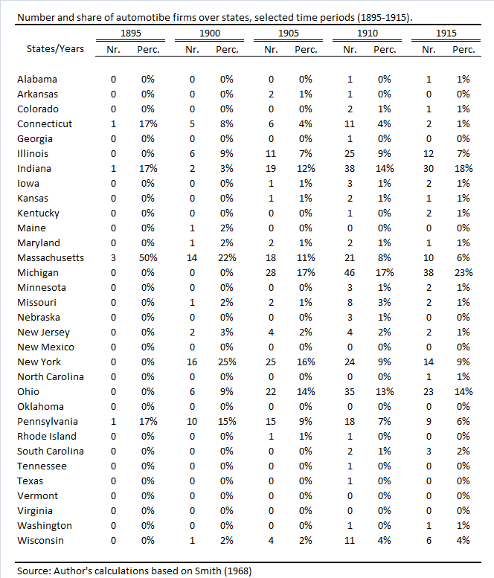

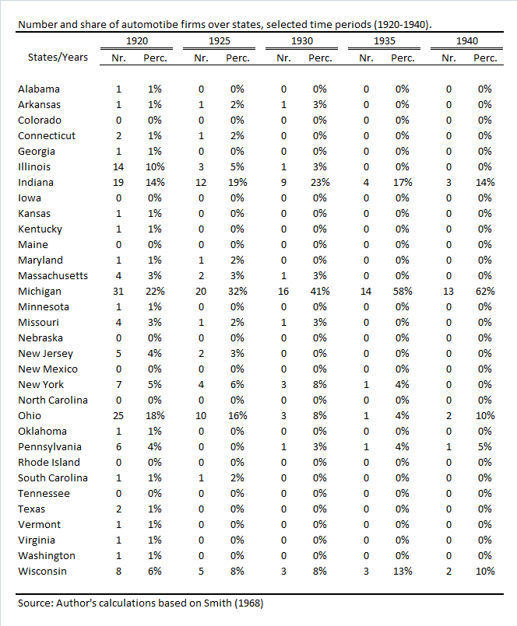

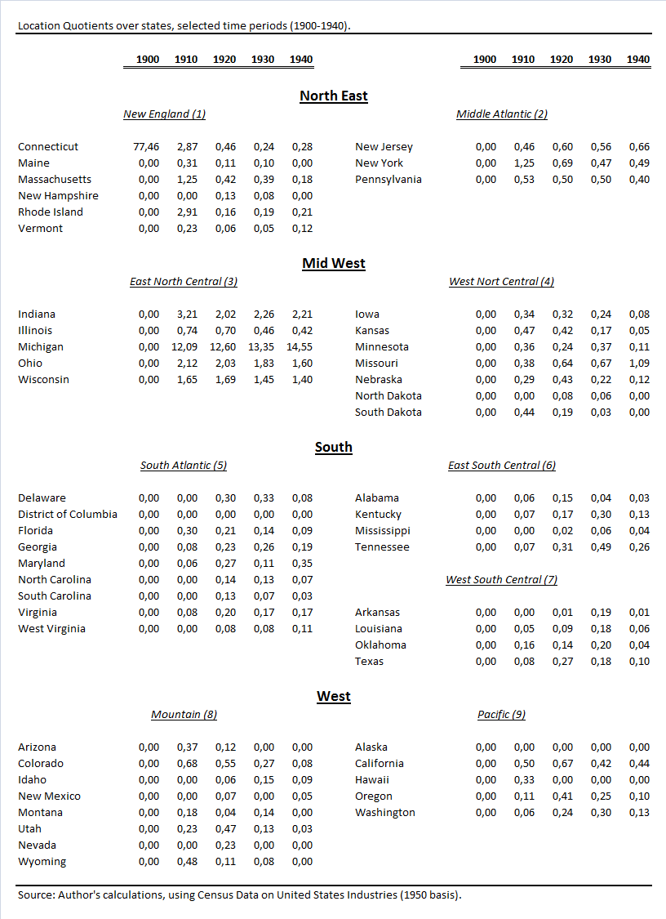

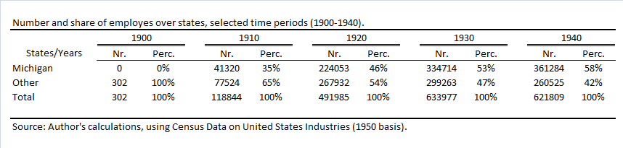

Data Description
Year
Product innovations were entered according to their model year introduction date. Hereby, model year and calendar year were treated both as equivalent. Innovations that were related to process and assembly were entered according to their calendar year date of introduction.
Manufacturer
The divisional name and/or the corporate name of the original equipment manufacturer is listed except for the following situations: The dataset excludes foreign makes and overseas production by American firms. Furthermore, if the introduction of an innovation relied on external suppliers, notably the production of tires and some all-steel bodies, the introduction of the innovation is excluded from the dataset. This is also the case for innovations that were applied for different purposes like racing vehicles or prototypes.
Innovation
The list contains the first significant commercial introduction or application of an innovation.
Years of activity
The total years of activity is listed according to the difference between the origin year and the year of termination following Smith (1968). At the time Smith (1968) published the table, several firms were still active, and so their termination date was set on 1966 which was the final year of Smith’s survey of the U.S. automotive industry.
City and State
The listing contains the city and state where the corporation was active at the time the innovation was introduced for the first time.
Ranking System
The chronological list of automobile innovations by firm is grouped into four categories: Drive Train: Includes engine, transmission, clutch, drive shaft, rear axle and related components. Process and Assembly: Contains all innovations directly related to the manufacturing process, including new machinery and equipment, new production techniques such as casting and other foundry methods, and new material uses. Body and Chassis: Includes frame, suspension, brakes, springs, steering, front end parts, chassis lubrication, wheels and tires, and body panels. Other: All miscellaneous items such as exterior trim parts, instrumentation, seats, and many safety related items like sidedoor impact protection and shoulder harnesses.
Weighting
Each innovation was weighted to analyze the overall impact on the production process. A seven-point transillience scale is used to give enough latitude to estimate whether an innovation had little or no impact on the production process, which are coded as 1’s, and those very disruptive for products and processes, coded as 7’s.

Checking Assumptions.
In this section the assumptions will be tested for the following model:
$\left(3\right)LOG_{AIE}= -4.33+0.394LOG_{AI}+0.163LOG_{RMTEBE}+0.646LOG_PUS$

Normality
$$H0:The residuals are normally distributed for each valu of the independent variables.$$
$$Ha:The residuals are not normally distributed.$$
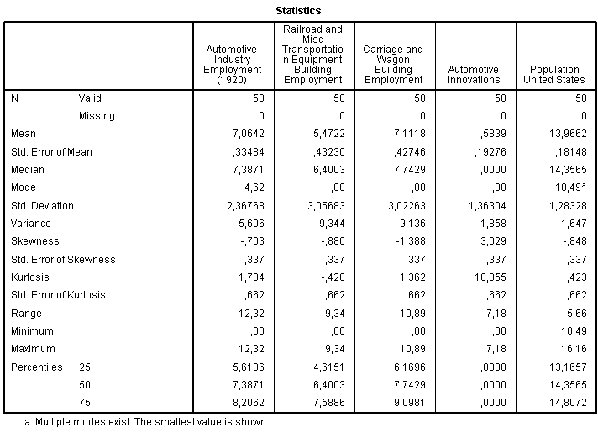
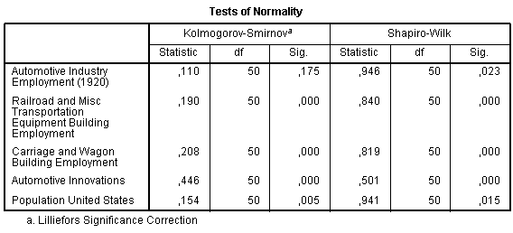
The automotive industry employment,$D\left(50\right)=0.11, p>0.05$ is significantly normally distributed.
The railroad and misc transportation equipment building employment, $D\left(50\right)=0.190, p<0.05,$the carriage and wagon building employment, $D\left(50\right)=0.208,p<0.05,$ automotive innovations, $D\left(50\right)=0.446,p<0.05$ and the population of the United States, $D\left(50\right)=0.154,p<0.05,$were all significantly not normal.
Also QQ plots indicated that the residuals were not normally distributed.
H0 can only be accepted for automotive industrial employment.

Homoscedasticity
$$H0:The variance of the residuals for every set of values for the independent variable is equal.$$
$$Ha:The variance of the residuals are not equal.$$
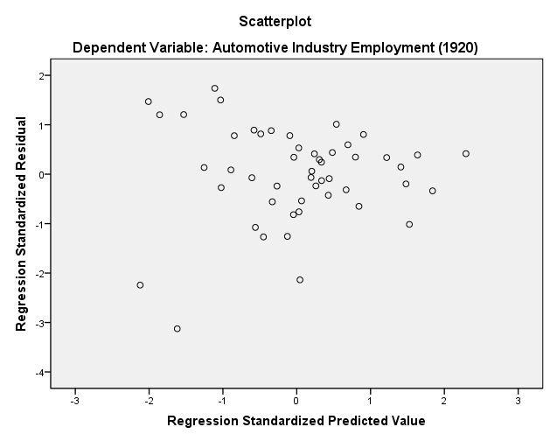
The scatter plot shows a random array of dots which seems evenly dispersed around zero, except for the two outliers in the left bottom corner. However both outliers do not exceed 3.5. There is no serious reason to doubt that the assumption of homoscedasticity is met within this model. Therefore Ho is accepted.

Linearity

$$H0:There is a linear relationship between the dependent variable and the explanatory$$
$$variables.$$
$$Ha:There is no linear relationship.$$
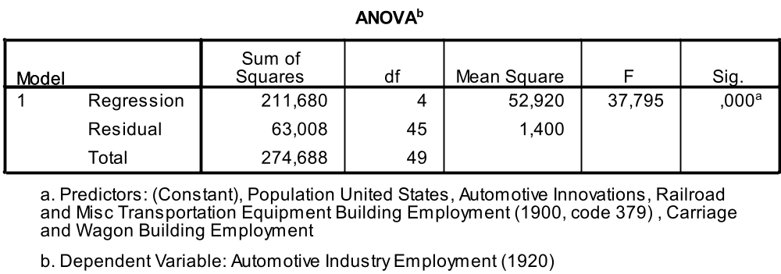
The residuals in the scatter plot of figure (X) indicate that there is no reason to believe that there is a non-linear relationship between the outcome and the predictors. There seem to be no clustering of positive or negative residuals. Also partial scatter plots of the residuals of the outcome variable and each of the predictors, regressed separately, give no reasons to doubt the assumptions of linearity nor those of homoscedasticity.
The ANOVA table shows a significant P value at the 99% confidence interval indicating that the independent variables reliable predict the dependent variable. A statistically significant proportion of the variability in automotive industrial employment over the different states can be explained by the regression model.
Therefore H0 is accepted, there is a linear relationship between the predictor variables and the outcome variable.

Autocorrelation

$$H0:There is no serial correlation between residuals for any two cases.$$
$$Ha:There is serial correlation.$$
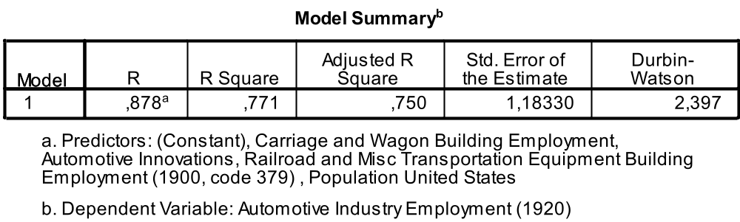
There does not seem to be a cyclical pattern in the plotted residuals that provides a cause for concern about the autocorrelation of the residuals. In addition to the plot the Durbin-Watson statistic is used to detect autocorrelation. With a value of 2.397, which is reasonable the hypothesis that the regression results are not subject to autocorrelation can be accepted.

Multicollinearity
$$H0:The independent variables in the regression model are not subject to multicolinearity.$$
$$Ha:There is multicolinearity between the independent variables.$$
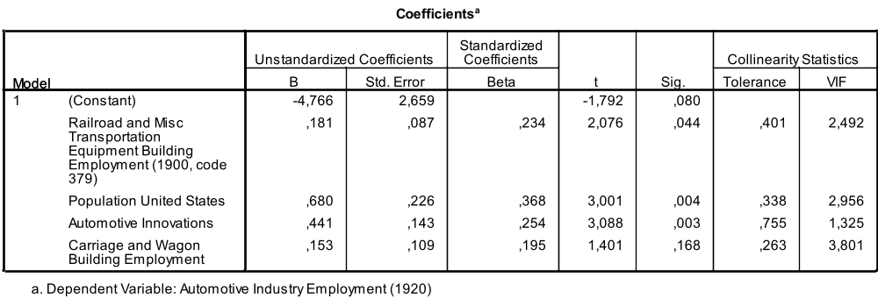
The VIF values and their corresponding tolerance values do not violate the assumption of multicolinearity, they are both below their critical value of 5, and 0,20, respectively. Therefore the H0 hypothesis is accepted.

β’s and R-Squared

As long as wages and prices are not bid up to the point where excess returns from locating in the region of Detroit are eliminated.
The data concerning the number and location of car manufacturing firms in the U.S. by Smith (1968) appears to be the most reliable of several available sources at including even very small producers while excluding firms that never reached commercial production.
A more precise description of all variables that were used to describe the evolution of technological progress can be found in the Appendix.
A more detailed and precise analyses of the assumptions for OLS can be found in the appendices, section 9.4.
Instead of employment several other parameters could be used, such as value added, the number of establishments or any other measure that is comparable across industries and regions.
A more extensive and detailed version of the table, with location quotients for all states, categorized in regions, over the period 1900 through 1940 can be found in the appendix.
Klepper (2010) found evidence that this 62 percent were even located in the region of Detroit instead of the entire state Michigan.
Table (x) in the Errata shows the share of employment in Michigan compared to the share of employment in the other states
Implications of these three theories are summarized in table 2
A more extensive and detailed version of the table can be found in the Appendix under table (x)
The bicycle industrie was considered to be related to the automotive industry as well, however data from the American Census was not available for occupations that were related to the bicycle industry.
Specific relationships regarding the production technologies of the selected related industries can be found in the appendix.
According to Klepper (2007) the automotive industry around Detroit flourished between 1900 and 1930. Entrants in the industry became negligible after 1922. After a peak of 272 firms in 1909 the total number of firms dropped down to reach a constant around 10 firms in 1930. The annual sales (indicating the size of the industry), Detroit leading makes and the percentage of Detroit firms, reached their peak around 1930 from which they grew steadily, remained constant or dropped slightly.
A more detailed version of this table can be found in the appendices.
High important innovations have transilience scores > 4
Taking into account all firms that were acquired by or merged with the leading company. Based on Smith (1968) page 280-283, who structured all genealogies into family trees for the most important companies.
With GM and Ford accounting for 23%.
A separate model was tested whether the effects of the related industries were stronger than a measure of total manufacturing activity. This to control for the effect that the presence of related industries served as a proxy for total manufacturing activity.

