The relationship between ownership structure and CSR disclosure in The Netherlands

U. R. Banwarie 280163

Table of contents
Chapter 1 Introduction 5
1.1 Introduction 5
1.1.1 Financial reporting 6
1.1.2 CSR reporting 7
1.2 Research question 8
1.3 Relevance 10
1.4 Structure of the paper 10
Chapter 2 Research Approach 11
2.1 Introduction 11
2.2 Research approach 11
2.3 Agency theory 13
2.4 Legitimacy theory 14
2.5 Theory based on research 15
Chapter 3 Incentives of managers to disclose information 16
3.1 Introduction 16
3.2 Incentives 16
3.3 Motives for sustainability reporting 19
Chapter 4 CSR disclosure measurement 20
4.1 Introduction 20
4.2 Subjective rating 20
4.2.1 Disclosure index studies 20
4.3 Model used for research 22
Chapter 5 Prior empirical research on the measurement of voluntary disclosure 23
5.1 Introduction 23
5.2 Study Boesso (2003) 23
5.3 Study Botosan (1997) 24
5.4 Study Rob, Single and Zarzeski (2001) 26
5.5 Dutch Transparency Benchmark 27
5.6 Discussion of outcomes 28
Chapter 6 Prior empirical research on the relation between ownership structure and voluntary disclosure 30
6.1 Introduction 30
6.2 Study Eng and Mak (2003) 30
6.3 Study Chau and Gray (2002) 33
6.4 Study Huafang and Jianguo (2007) 34
6.5 Discussion of outcomes 38
Chapter 7 Empirical research about the relation between ownership structure and CSR disclosure 39
7.1 Introduction 39
7.2 Study Ghazali (2007) 39
Chapter 8 Research design 41
8.1 Introduction 41
8.2 Hypotheses 41
8.3 Measurement of CSR disclosure 42
8.4 Model 47
8.5 Steps to conduct the research 48
8.6 Conclusion 49
Chapter 9 Empirical research 50
9.1 Introduction 50
9.2 Definition and measurement 51
9.3 Descriptive statistics 53
9.4 Linear multiple regression 53
9.5 Results 61
Chapter 10 Analyses 62
References 64
Appendix 1 Disclosure index Botosan 72
Appendix 2 Disclosure index Rob, Single and Zarzeski 73
Appendix 3 Disclosure model Dutch Transparency Benchmark 75
Appendix 4 Disclosure index Eng and Tao 81
Appendix 5 Disclosure index Chau and Gray 82
Appendix 6 Disclosure index Huafang and Jianguo 87
Appendix 7 Disclosure index Ghazali 88

Chapter 1 Introduction

1.1 Introduction
Nowadays, stakeholders such as shareholders, interest groups and government expect that companies are transparent about their performance on a societal level (Dutch Transparency Benchmark 2009). Because of the demand for more transparency companies give more disclosure of corporate social responsibility in their annual reports or sustainability reports than formerly. A sustainability report integrates the three dimensions of Corporate Social Responsibility: profit, planet and people or the Triple P ( Lamoen, 2001). These three principles also represent three types of reporting: social, environmental and financial reports.
From those three types of reporting financial reports distinguish themselves by the most strict rules and regulations. The International Financial Reporting and Standards (IFRS) of the International Accounting Standards Board are widely used international standards and are currently used in over 120 countries around the world, including the European union. In the United States the Financial Accounting Standards of the Financial Accounting Standards Board (U.S. GAAP) are currently used as reporting system. The main source of the U.S. GAAP is the Financial Accounting Standards Board (FASB). The IASB and the FASB strives for international convergence. The world is leaning towards for adopting IFRS as "the" international accounting standards. (www.iasb.org)
Corporate social responsibility implies openness on the ethical, social and environmental aspects of the business, products and services. Promoting such transparency is one of the pillars of the CSR policy. It is important to disclose non-financial information which is relevant and significant for the long term financial value of a company. In the Netherlands it is mandatory that companies under the Dutch Corporate Governance Code report on CSR. (officiële bekendmakingen, Kst-26485-86). The Code applies to all companies incorporated in the Netherlands whose shares or depositary shares are admitted to a stock, or more specifically to trading a regulated market or a comparable system and all major companies registered in the Netherlands (> € 500 million book value) whose shares or certificates admitted to trading on a multilateral trading facility or a comparable system (Punt 2 preambule Nederlandse Corporate Governance Code).

1.1.1 Financial reporting
Financial reporting and disclosure are potentially important means for management to
communicate firm performance and governance to outside investors (Healy and Palepu,
2001). Firms provide disclosure through regulated financial reports, including the financial
statements, footnotes, management discussion and analysis, and other regulatory filings.
Some firms engage in voluntary disclosure, such as management forecasts, analysts’
presentations and conference calls, press releases, internet sites, and other corporate reports.
There are also disclosures about firms by information intermediaries, such as financial analysts, industry experts, and the financial press. Moreover firms may furnish additional information by means of their websites.
The Financial Accounting Standard Board (FASB, 2000) describes “voluntary disclosures” as “information primarily outside of the financial statements that are not explicitly required by accounting rules or standards”. The International Accounting Standard Board (IASB) has a similar definition for voluntary disclosures as FASB. Voluntary disclosure regards information made public through the firm’s free choice.

Voluntary disclosure and its determinants have been identified as an important research area
in financial reporting since the 1970s. Previous studies on the determinants of voluntary
disclosure have been done mainly in the U.S. and other developed countries (e.g., Boesso and Kumar 2007; Linsley and Shrives 2006; Anilowski, Feng and Skinner 2007; Lang and Lundholm 1996).
Some studies have examined institutional mechanisms (i.e., corporate governance) that
may influence voluntary disclosure practice (e.g., Collet and Hrasky 2005). Corporate governance attributes examined in these studies include ownership structure (e.g., Hossain, Tan and Adams 1994; Raffournier 1995), the proportion or existence of independent directors (e.g., Forker, 1992; Malone, Fries and Jones 1993), the appointment of a nonexecutive director as chairman, (e.g., Forker 1992).

Voluntary disclosures are different per country, per sector and company size ( KPMG, 2008). The research of Eng and Mak (2003) approves that the structure of ownership is one of the reasons that determines the level of monitoring and thereby the level of voluntary disclosure.
There are different forms of ownership structure for example: managerial ownership, blockholder ownership, government ownership and family firm. Managerial ownership is the proportion of shares held by the CEO and executive directors (Eng and Mak, 2003).
Blockholder ownership is the proportion of ordinary shares held by substantial shareholders,
and is usually measured by shareholdings of 5% or more (Eng and Mak, 2003). In the Government-linked companies, the government has between 20% and 80% ownership (Eng and Mak, 2003). Family firms can be classified as firms that are managed or controlled by founding families (Ali et al, 2007).

1.1.2 CSR reporting
The World Business Council for Sustainable Development in its publication "Making Good Business Sense" by Lord Holme and Richard Watts, used the following definition for corporate social responsibility: “the continuing commitment by business to behave ethically and contribute to economic development while improving the quality of life of the workforce and their families as well as the local community and society at large”.

Research on factors influencing CSR disclosure has mainly focused on the significance of a number of corporate characteristics such as company size (e.g. Belkaoui and Karpik, 1989; Patten, 1991) and industry type (e.g. Roberts, 1992; Hackston and Milne, 1996; Adams et al., 1998). However, there is one research found about the association between ownership structure and CSR disclosure which is conducted in Malaysia (Ghazali, 2007). Ghazali examines two forms of ownership: director ownership and government ownership. According to Ghazali there is a relationship between ownership structure and CSR disclosure. Since the Malaysian business environment and corporate ownership differ from the Netherlands, it is interesting to do a similar research in the Netherlands. Also, in the Netherlands I expect a relationship between ownership structure and CSR disclosure. When blockholder ownership (shareholding of 5% or more) is high, there is may be less disclosure. This could be a reason of no public interest and thus lower pressure to make disclosures. And when the managers are the owners there is also less public interest and thus lower pressure to make disclosures.

1.2 Research question
In this study the influence of ownership structure on corporate social responsibility (CSR) disclosures will be examined. There will be only focused on two forms of ownership structure namely managerial ownership and blockholder ownership. Government ownership and family firms in the Netherlands are not chosen for the research of this thesis, because companies with government ownership and family firms publish less disclosures.
A number of studies have found a significant association between corporate voluntary disclosure (financial and non-financial information) and ownership structure (e.g. Hossain et al., 1994; Chau and Gray, 2002; Eng and Mak, 2003). Because CSR disclosure regards a large area of voluntary disclosure, the focus of this thesis will be on CSR disclosure. The examination of the possible influence of ownership structure on CSR disclosure will not only be insightful but may contribute towards assessing the relative importance of corporate ownership on CSR practices in the Netherlands. The following research question will be examined:

“What is the relationship between ownership structure and corporate social responsibility (CSR) disclosures in the annual reports of Dutch Stock Exchange listed companies?”.

To answer the research question, some additional sub questions have been formulated:

- Which theories are important for this research regarding ownership structure and voluntary disclosure/CSR disclosure?
- What are the incentives of managers to disclose information?
- Which methods can be used for the measurement of disclosure?
- Which empirical research has been done about the measurement of disclosure?
- Which empirical research has been done about the relation between ownership structure and voluntary disclosure?
- Which empirical research has been done about the relation between ownership structure and CSR disclosure?
- Which hypotheses can be formulated based on prior research?
- Which research design will be used to answer the research question?
- What are the results of this empirical research?
- What are the analyses and conclusion of this empirical research?
Ownership structure will be measured by managerial ownership and blockholder ownership.
Managerial ownership is measured by the proportion of ordinary shares held by the CEO and executive directors (Eng and Mak, 2003). Blockholder ownership is defined as the proportion of ordinary shares held by substantial shareholders, usually measured by shareholdings of 5% or more (Eng and Mak, 2003). CSR disclosure will be measured by disclosure on social and environmental aspects of business. Therefore, aspects of the measurement model of the Dutch transparency benchmark 2009 will be used ( PWC, 2009). After the measurement of CSR disclosure, a regression model will be used to measure the relationship between ownership structure and CSR disclosure.
The empirical research of this thesis is based on the Netherlands, there is no research (yet) done in the Netherlands regarding this subject. Companies listed at the Amsterdam Exchange Index (AEX) and the Amsterdam Midcap Index (AMX) in the year 2007 is the research sample. According to Botosan (2002) the research may be limited to one year because firms’ disclosure policies appear to remain relatively constant over time. Also in the researches of the Dutch Transparency Benchmark the scores of disclosures seems to be relatively constant over the years. The sample consists of 47 companies. The choice regarding the year is based on two aspects namely recent available annual reports and the crises. The annual reports of 2008 and 2009 are excluded, because these annual reports may contain the effect of the economic recession.

The information to measure ownership structure and CSR disclosure will be hand collected from the annual reports of the sample companies. Only reports (annual reports, social reports and environmental reports) available on the internet or company sites will be used for this research. Managerial ownership will be calculated as the number of shares held by managers in the percentage of total shares. Blockholder ownership will be calculated as the total percentage held by blockholders (≥ 5%). For measurement of environmental and social disclosure the model of the transparency benchmark 2009 will be used. The variables of this model are based on scores. To determine the extent of disclosures the scores of each company will be totalized.

1.3 Relevance
Research on the relation between ownership structure and disclosure was only done in Asian countries. In the Netherlands the corporate governance is different from Asian countries. For example in the Netherlands there are less family ownership and government ownership structures. Because there is a growing awareness by society of social responsibility as environmental and social consequences of actions, the results could be very interesting. Social responsibility disclosures in the annual report of firms can be used in a strategic manner to manage a firm relation with the community in which it operates and that would enhance their welfare. This research is important for investors and regulators. It is important for investors because in this way it will be clear if ownership structure effects CSR disclosure. For example if there are more blockholders in a company, the extent of disclosure will probably increase. So, the extent of disclosure can be helpful for investors to decide in which ownership structure they invest. It is also important for regulators because they can make changes in certain CSR disclosures to become mandatory. Hence, this research can influence the behavior of investors and regulators.

1.4 Structure of the paper
The remainder of this paper is organized as follows. Chapter 2 describes theorie that are important for this research regarding ownership structure and voluntary/CSR disclosure. Chapter 3 describes the incentives of managers to disclose information. Chapter 4 describes methods that can be used for the measurement of disclosure. In chapter 5 empirical research is described about the measurement of disclosure. In Chapter 6 the literature review is described about the relation between ownership structure and voluntary disclosure. Chapter 7 describes one empirical research about the relation between ownership structure and CSR disclosure. Chapter 8 outlines the hypothesis based on prior research and the research design. In chapter 9 the research will be conducted as described in chapter 8 and the results will be described. Finally, chapter 10 gives the analyses and conclusion of this empirical research.

Chapter 2 Research Approach

2.1 Introduction
In this chapter several research approaches will be described: the Capital Market approach, Behavioral approach, the Positive Accounting Theory approach. Further the agency theory and the Legitimacy theory will be described. After describing the approaches and theories, there will be determined which approaches and/ or theories are most related to this research.

2.2 Research approach
Different approaches are explained is this paragraph. There is a distinction between capital
market approach, behavioral accounting approach and the positive accounting approach.

1. From a capital market approach: this approach explores the role of accounting and
other financial information in equity markets. This type of research involves
examining statistical relations between financial information, and stock exchange
performance (Deegan and Unerman, 2005). In the research of this thesis, I will not explore statistical relations between financial information and stock performance. So the capital market approach is not suitable for the research of this thesis.
2. From a behavioral accounting approach: this approach considers how individuals
react or behave when they are provided with particular items of information. This kind
of research is often conducted in laboratory settings (Deegan and Unerman 2005, 2005). The focus of the research of this thesis is on information provided in annual reports and the behavioral approach is more based on the behavior of individuals. So, this approach is also not appropriate for the research of this thesis.
3. From a positive accounting approach: according to Watts and Zimmerman (1986) the
objective of positive accounting theory is to describe, explain and predict accounting
practice of managers. So it will be clear which firms publish certain information. The positive accounting approach says nothing about which method of reporting should be used. As a positive theory is based on empirical information and is not normative. Watts and Zimmerman (1978) assume that individuals act to maximize their own utility and consequently management lobbies on accounting standards based on its own self-interest. Self-interest is also a basic assumption of the agency theory.
Owners delegate to managers the leading function of the firm, due to this managers will have more information than owners which results in information asymmetry. Managers are better informed about the business than its owners and can use this information asymmetry to maximize their own utility. The positive accounting approach is related to this research because in firms where managers are not the owners, asymmetry of information and interests will exist.

Watts and Zimmerman (1986, 1990) highlight three key hypotheses. Those are:
(1) The bonus plan hypothesis:
If managers will be rewarded in terms of performance such as stock exchange rates and/or accounting profits, the manager will attempt to increase the stock exchange rates and/or accounting profits to maximize their own wealth (Deegan and Unerman, 2005). It is possible that more CSR disclosure leads to better firm performance. And as a result the managers will be more rewarded.
(2) The debt/equity hypothesis:
If a firm has entered into agreements with lenders, and these agreements involve accounting-based debt covenants then managers have an incentive to adopt accounting methods that relax the potential impact of the constraints (Deegan and Unerman, 2005). More CSR disclosure can lead to an increased possibility to have the debt/equity ratio increased. And as a result firms can borrow more capital with the same owners equity.
(3) The political cost hypothesis:
Underlying this hypothesis is the assumption that it is costly for individuals to become informed about whether accounting profits really represent monopoly profits and to ‘contract’ with others in the political process to enact laws and regulations (Watts and Zimmerman, 1990). If managers consider that they are under a deal of political scrutiny and public pressure, this could motivate them to disclose social reporting. Social disclosures in the annual report of firms can be used in a strategic manner to manage a firm relation with the community in which it operates and that would enhance their welfare.

Hence, all hypotheses mentioned above are important for this research. According to the bonus plan hypothesis more CSR disclosure could lead to a better firm performance. The debt/equity hypothesis is important because more CSR disclosure could lead to an increased debt/equity ratio. And as a result firms can borrow more capital. The political cost hypothesis is also important because this is an incentive to managers to disclose more social reporting.

2.3 Agency theory
Under agency theory, voluntary disclosures occur as a means for companies to minimize their agency costs. Jensen and Meckling (1976) define an agency relationship “as a contract under which one or more persons (the principal(s)) engage another person (the agent) to perform some service on their behalf which involves delegating some decision making authority to the agent”. The principles are the shareholders and the agents are de managers.
As a consequence, agency problem arises. The agency problem concerns a problem of asymmetric information between the agent and the principal. The agent has some information that the principal does not have. Because of the asymmetric information agents have the ability to operate in their own self- interest. The principle can establish appropriate incentives (rewards) for the agent(s). In this way the principle can limit divergences from his interest. Monitoring costs are also used by the principles to limit the aberrant activities of the agents.

Principles can also pay the agent to expand resources (bonding costs) so that the agent will not take actions which would harm the principle.
Jensen and Meckling (1976) define agency costs as the sum of:
• The monitoring expenditures by the principal;
• The bonding expenditures by the agent;
• The residual loss by the principal;
Also the principle and the agent have to incur costs of risks and rewards.

The level of monitoring and thereby the level of disclosure is determined by the structure of ownership (Eng and Mak, 2003). Managerial ownership and blockholder ownership are two major governance mechanisms that help control agency problems (Eng and Mak, 2003). The information asymmetry will decrease, as consequence of an increasing managerial ownership and blockholder ownership.
When managerial ownership is low, there is a greater agency problem. This arises from a high information asymmetry between the managers and the principal. Managers have greater incentives to maximize their own utility and thus more monitoring by the principle is needed in order to monitor the managers. By disclosing information voluntary, managers can reduce the monitoring and hereby the monitoring costs of the principle.
When the number of blockholders is high, share ownership is diffused and more monitoring is required.
By owning 5% or more shares of a company, you can be considered as a blockholder. When there is a large number of relatively “little” blockholders, share ownership is more diffused than when there is only one “big” blockholder. When managers start giving more voluntary disclosures, less monitoring is needed and so the agency problem will decrease. Voluntary disclosure occurs as a mean for companies to minimize their agency costs.

2.4 Legitimacy theory
“Legitimacy theory stresses the importance of societal acceptance in ensuring a company's survival. Underlying this theory is the belief that a company's actions can have an impact on the environment in which it operates. If a company's activities are seen or perceived to have detrimental effects on the community, the public may react by boycotting the company's product or pressuring for government intervention. CSR disclosure in this instance is provided to justify a company's continued existence” (Ghazali, 2007).

Deegan and Unerman (2005) define legitimacy theory as follows: ‟ Legitimacy theory asserts that organizations continually seek to ensure that they are perceived as operating within the bounds and norms of their respective societies, that is, they attempt to ensure that their activities are perceived by outside parties as being ‘legitimate”.
The legitimacy theory is related to this research because manager’s behavior can be influenced by the expectations of management for example what the society expects from managers. So, the behavior of managers to disclose information can change to get a better legitimacy in society. When managerial ownership and blockholder ownership in a company are high and there is less public interest, there may be less voluntary disclosures. But when managers are concerned about their legitimacy in society they may provide more voluntary disclosures.

2.5 Theory based on research
All the theories, except the capital market approach and the behavioral accounting approach, described are important for this research. The positive accounting theory is about the behavior of managers to disclose information. The agency problem that is part of the positive accounting theory concerns a problem of asymmetric information between the agent and principal. The bonus plan hypothesis, the debt/equity hypothesis and the political cost hypothesis are all important for CSR disclosure.
The legitimacy theory is also important because the behavior of managers can be influenced by the expectations of society. With this chapter research question one is answered.

Chapter 3 Incentives of managers to disclose information

3.1 Introduction
Managers have different reasons and incentives to disclose information. In this chapter, the incentives of managers to disclose information will be described.

3.2 Incentives
Healy and Palepu (2001) discuss six motives for voluntary disclosure from the perspective of
managers’ disclosure decisions. These motives are: capital market incentive, corporate control contests incentive, stock compensation incentive, litigation incentive, proprietary costs
incentive, and management talent signaling incentive. These incentives also apply for CSR disclosure, which are mainly voluntary.
- Capital market incentive: According to Healy and Palepu “managers who anticipate making capital market transactions have incentives to provide voluntary disclosure to reduce information asymmetry problem, thereby reducing the firm’s cost of external financing”. The capital market incentive consider that managers have superior information about the future prospect of the firm. When there is information asymmetry between managers and investors, investors will bear higher risks to reduce the information asymmetry. The capital market incentive is in relation with the debt/equity hypothesis. Because the debt/equity hypothesis also has influence on the capital market. When managerial ownership is low, this incentive can encourage managers to give more voluntary disclosure.

- Corporate control contest incentive: “The boards of directors and investors hold
managers accountable for current stock performance”. “Voluntary disclosure theory
hypothesizes that, given the risk of job loss accompanying poor stock and earnings
performance, managers use corporate disclosures to reduce the likelihood of
undervaluation and to explain away poor earnings performance” (Healy and Palepu, 2001). When managerial ownership is low, it is expected that because of the corporate control incentive managers will give more disclosures.

- Stock compensation incentive: According to Healy and Palepu “managers are rewarded using a variety of stocked-based compensation plan, such as stock option grants, and stock appreciation rights”. These compensation schemes are incentives for managers to engage in voluntary disclosure. The corporate control incentive is in relation with the bonus plan hypothesis. Because managers can also be rewarded on stock performance. The size of managerial ownership has no influence on the stock compensation incentive.

- Litigation cost incentive: Shareholder litigation effect managers disclosure decision in two ways. In the first place, there are legal actions against managers for inadequate or untimely disclosures. This legal actions can encourage firms to increase voluntary disclosure. In the second place, “litigation can potentially reduce managers’ incentives to provide disclosure, particularly of forward-looking information”. It doesn’t matter if managerial ownership is low or high, managers will take the litigation cost theory into account. Because this is about legal actions and counts for all managers.

- Proprietary cost incentive: “According to Healy and Palepu (2001) the proprietary cost incentive hypothesize that firms decisions to disclose information can damage their competitive position in product markets. The proprietary cost hypothesis assumes there are no conflicts of interest between managers and shareholders. This incentive is not applicable for this research, because as stated before there are conflicts between managers and shareholders (for example the agency problem, described in paragraph 2.2).

- Management talent signaling incentive: According to this incentive talented managers
have an incentive to make voluntary earnings forecasts to show their capabilities. This incentive is not applicable for this research, because in this research it is not about talented managers.

Another incentive to disclose information is the three P’s (planet, people, profit). The wish of information users is that companies try to keep a balance between the elements of the 3 P’s (people, planet, profit). If this combination is not harmonious, the other elements will suffer. This means that too much priority on profit, will affect people and the environment.
For example too much priority on profit, will affect people by poor working condition and the environment by destruction of nature. The three P's are used by many companies, such as oil –and energy companies, adopted as guidelines for corporate social responsibility. Examples of oil and energy companies uses the 3 P’s as CSR guidelines are respectively Shell and Nuon.

Based on the triple P there is a diversity of reports. In the figure below different reports are shown and how the reports overlap each other ( Lamoen and Tulder, 2001).
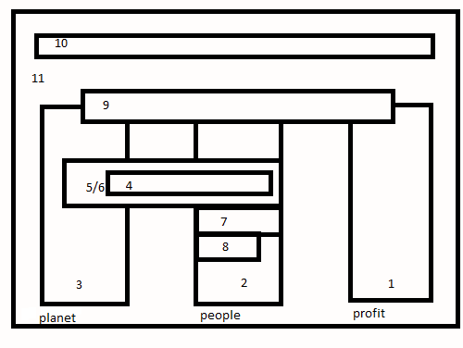
- Financial report
- Social report
- Environmental report
- Environmental and Social report
- Health, Safety and Environmental report
- Responsible Care report
- Welfare, Health, Safety and Environment report
- Social and Ethical report
- Corporate Social Responsibility report
- Vision on Sustainability
- Sustainability report
For the research of this thesis the Corporate Social Responsibility report is important. The Corporate Social Responsibility report is part of the financial, environmental and social report. In the financial report the information of managerial and blockholder ownership is described. In the social and environmental report the variables to score for CSR disclosure could be found.

3.3 Motives for sustainability reporting
The motives for the preparation of a sustainability report are very diverse, ranging from transparency and open to communication and pressure from financial institutions such as pension funds and institutional investors. Lamoen and Tulder (2001), did research about the motives of Dutch listed companies for the preparation of a sustainability report. The research sample consisted of 48 AEX and AMX companies. However, only 16 (33%) companies participated in their research. It seems that external pressures from shareholders and customers in the future will be the main reason for the preparation of a sustainability report. In addition it is expected that the desire for sustainable reporting from the Board of Directors will increase. Further is communication (public relations and reputation management) for all respondents a rapidly growing reason for sustainable reporting. A relatively small number of respondents are motivated by requirements on capital markets as a way to compete with direct competitors (Lamoen and Tulder).

Chapter 4 CSR disclosure measurement

4.1 Introduction
This chapter discusses several methods used to measure the quality of disclosure.
Afterwards a selection is made of a model which can be used for examining the research question.

4.2 Subjective rating
The analyst scores of disclosure quality provided by the Association of Investment
Management and Research (AIMR) (formerly the Financial Analysts Federation(FAF)), are used in many studies in the US. These analyst scores of disclosure quality provide an overall measure of corporate communications with investors. This information is obtained after the companies in each industry have been analyzed by analysts. “There are separate ratings for annual published information; quarterly and other published information; and investor relations” (Beattie, 2004). There are a couple of problems with the AIMR, one of them is that the last disclosure ranking goes back to 1997. And the other one is that in countries such as the UK and the Netherlands such subjective ranking are not available. There are some criticisms regarding this method for measuring quality. Healy and Palepu (2001) complain that there is a lack of clarity as to whether the analyst on the panels take the rating seriously, the basis is unclear on which firms are selected for inclusion, and the potential biases that analysts bring to the ratings.
Lang and Lundholm (1993) argue that a disadvantage of the Financial Analysts Federation
(FAF) data is “that they are based on analysts’ perceptions of disclosures rather than direct
measures of actual disclosures”. This method is not suitable for this research, because in the Netherlands there are no subjective ratings available.

4.2.1 Disclosure index studies
According to the study of Marston and Shrives (1991) “disclosure indices are extensive lists of selected items which may be disclosed in company reports. Calculating an index score for a particular company can give a measure of the extent of disclosure, but not necessarily the quality of disclosure.” Disclosure index studies presume that the amount of disclosure on specified topics is a substitute for the quality of disclosure, because it’s difficult to evaluate disclosure quality directly.
As a result, researchers tend to assume quantity and quality are positively related. Often a binary coding, this is a ordinal measure, scheme is used whereby the presence or absence of an item is recorded. Other coding schemes include other ordinal measures to allow for the quality of specific disclosure to be assessed (Botosan, 1997). Botosan created her own index to measure voluntary disclosure, the items included in
the index were guided by recommendation provided in the Jenkins report (AICPA, 1994), the
SRI International (1987) survey of investor information needs and the Canadian Institute of
Chartered Accountants (1991) study of the annual report. There were five categories of
information: background information; summary of historical results; key non-financial
statistics; projected information; and management discussion and analysis. The index
involved 35 major elements spread across these categories and additional point could be
earned for quantified information. In the literature review I will elaborate more on Botosan’s research.
Disclosure indexes are based on weighted or unweighted scores. Weightings are typically achieved by conducting attitude surveys among relevant users groups, asking about the importance of each item. It has been found that weighted and unweighted scores tend to give the same results where there are a large number of items (Beattie, 2004).

For the composition of disclosure index, content analysis is used. Content analysis involves classifying text units into categories. It is important that the classification procedure is reliable; by this is meant that every coder, use the same procedure to code the text in the same way. And it has to be also valid; by this is meant that the variable generated from the classification procedure represent what the researcher planned to represent (Weber, 1985).
Krippendorff (1980) indentifies three types of reliability, namely: stability, reproducibility
and accuracy. Stability is the extent to which the same coder is consistent over time when
coding the same content. Reproducibility is the extent to which different coders produce the
same results when coding the same content. Accuracy is the extent to which classification of
text corresponds to a standard or norm.

4.3 Model used for research
A disclosure index model will be used to measure the extent of CSR disclosure in this research. CSR disclosure will be measured by social and environmental aspects. Therefore, important variables of the measurement model of the Dutch transparency benchmark 2009 will be used. In order to determine the Disclosure Score (Dscore), it is necessary to go through the annual reports of the sample firms and seek for the variables. In the measurement model of the Dutch transparency benchmark the variables all get a score. In the research design there will be more elaborate on the CSR variables of the disclosure index model and how the relationship between ownership structure and CSR disclosure will be measured. With this chapter research question three is answered.

Chapter 5 Prior empirical research on the measurement of voluntary disclosure

5.1 Introduction
Voluntary and so CSR disclosure can be measured in several ways. In this chapter four empirical researches will be described about the measurement of voluntary disclosure. However, the measurement of disclosure in these researches is not related with the ownership structures of the sample firms. In this chapter the focus will be only on the manner how voluntary disclosure is measured in prior research.

5.2 Study Boesso (2003)
Boesso (2003) studied the non-mandatory information available on the web sites of 36 leading companies across Italy and U.S.. This sample include 18 Italian companies and 18 U.S. companies and were grouped into three macro-industries: Manufacturing, Banking & Finance and Public Utilities. The main objective of Boesso was to describe companies’ information patterns of firms from culturally different business environments in order to better understand voluntary disclosure choices. In particular, observed disclosures were presented through an original framework to combine strategic and stakeholder reporting. This framework is based on seven perspectives that highlight information addressed to key stakeholders categories and information concerning business effectiveness and efficiency. The seven perspectives were as follows: Investors, Employees, Customers, Suppliers, Social, Internal Processes and Innovation & Learning. For each perspective three qualitative levels of voluntary disclosure were defined:
1. Semi-mandatory and descriptive information;
2. Performance analyses;
3. Forward-looking and high-level operating data.
The first level includes the information required by the mandatory statements that companies highlight for a second time with particular graphic or contextual forms. This category also outlines basic non-mandatory operational information to describe the company, its businesses and other basic features of the seven perspectives. The second level consists of information which could represent an analysis of businesses performance in each specific perspective
object of external reporting.
It also includes the basic elaboration of financial and operational data commonly used by market and financial analysts (financial indices, ratios and margins, market share etc.). The third level represents the highest quality of voluntary disclosure. This level includes not only the forecast on future trends, but also the internal analysis. The internal analysis could help the annual report user to understand companies’ long term strategies for each perspective.
For each perspective, a list of voluntary disclosures was created by analyzing the 36 websites of the sample companies. Every time a company presented a new indicator/measure the list was updated. The research assumption was to assign a greater importance to the information of level three, medium importance to level two and low importance to level one. The final purpose was to discriminate between companies with the same number of positive observations but with a different distribution of observations among the three levels.
This index varies between a minimum of zero, if the company does not disclose any researched items, and a maximum of one, if the company discloses all the researched items.

The results of Boesso’s research shows that the percentage of observed items on the total number of researched items is very low. For the U.S there is a percentage of 24 and for Italy 21. In both countries managers seem to define disclosure policies which is quite different between companies. For example the U.S Public Utility industry disclosures focuses on long term strategies and future production capabilities. In this way managers give investors a clear message concerning the good potential of their large structural investments. The focus of Italian Banks is on employees and social perspectives. The reason for this focus is that these firms are strongly related to the local territory and a large descriptive communication of their social initiatives. Their employee relationships is probably valued as a potential competitive benefit.

5.3 Study Botosan (1997)
Botosan examines the association between voluntary disclosure level and the cost of equity capital. Because the association between voluntary disclosure level and the cost of equity capital “is a matter of considerable interest and importance to the financial reporting community” (Botosan, 1997).

To measure the amount of voluntary disclosure she used the 1990 annual reports of a sample of 122 manufacturing firms. Botosan created her own disclosure index to measure voluntary disclosure (which she refers to as DSCORE). The selection of the items included in the index were guided by recommendation provided in the Jenkins report (AICPA, 1994), the SRI International (1987) survey of investor information needs, and the Canadian Institute of Chartered Accountants (1991) study of the annual report.
“The items included in the DSCORE reflect five categories of voluntary information identified by investors and financial analysts as useful in investment decision making. These five categories are as follows: background information; summary of historical results; key non financial statistics; projected information; and management discussion and analysis” (Botosan, 1997). The index involved 35 major elements spread across these categories (See Appendix 1).
According to Botosan there is a major concern that large firms could achieve higher scores because they have more disclosure opportunities due to the complexity of their organizational structures. For example, if a company operates in several different industries, it may selectively disclose forecasts or other types of voluntary information for some industry segments while withholding this information for others. However, if a firm operates in only one industry segment, it does not have the same opportunity to strategically disclose or withhold forecast or other information for particular segments. Several steps were taken in the design of Botosan’s disclosure index and scoring procedures to circumvent this problem. Multi-segments firms earned all of the points allocated to projected information only if they provided a forecast for all segments or an overall forecast for the consolidated entity. Botosan limited the disclosure index to items that all sample firms could choose to disclose and she did not award multiple points for multiple references to the same disclosure item. The total points earned by a given firm was computed by the following formula:

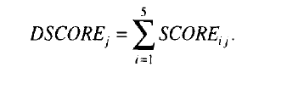
whereas:
j = firm
i = category 1 to 5
The total number of points awarded to firm j for category i is summarized to find a disclosure level (DSCORE) for each firm.
From Botosan’s research follows that for firms with relatively low analyst following, the evidence suggests that higher disclosure is associated with lower cost of equity capital. For firms with a high analyst following, there is no significant relation found between disclosure level and cost of equity capital. Botosan also provides some preliminary evidence on the types of disclosure in reducing cost of equity capital. Firms with low analyst following, disclosure of forecast information and key non-financial statistics is particularly important. For firms with a high analyst following disclosure of historical summary is important.

5.4 Study Rob, Single and Zarzeski (2001)
Rob, Single and Zarzeski (2001) examine the relationship between nonfinancial disclosure practices and firm characteristics. The firm characteristics include industry classification, country of domicile, geographic dispersion, cross-listings, and company size. The sample of this study is based on 53 Australian, 69 Canadian and 70 U.S. companies from the following industries: automobiles, chemicals, construction, electronic equipment, machinery and transportation equipment, and pharmaceuticals. These companies are culturally similar and are relatively high financial disclosure countries.
Rob, Single and Zarzeski employ the following model:

DISC = A+ B1 (#GEOSEG) + B2 (SIZE) + B3 (INDi) + B4 (COUNTRYi) + B5 (XLISTINGS) + e

Where:
DISC = Aggregate disclosure score by category
B1 till B5 = Coefficients
#GEOSEG = Number of geographic segments
SIZE = Natural log of total sales in U.S. dollars
IND = Industry classification; dummy variables
CTRY = Country of domicile of each firm; dummy variables
XLISTINGS = Dummy variable indicating whether a firm is listed on a foreign stock exchange

Rob et al. used annual reports of 1995 to obtain a disclosure score. To classify the information from each annual report, they prepared a detailed nonfinancial disclosure scoring system based specifically on the List of Nonfinancial Information desired by Users from AICPA Committee database. The detailed information items were then grouped into 6 categories: environment around the company; strategy and management; company trends; environment of the company; production; customers (See Appendix 2). Each category contains: (1) information that likely exists about every company and (2) information that financial analysts and investors have indicated as important for company valuation. Depending on degree of disclosure, a weighting of 1 (no disclosure), 2 (some disclosure), or 3 (extensive disclosure) was given to each disclosure item.

As a result Rob et al. find that more internationally oriented companies and/or more larger companies, tend to provide more nonfinancial disclosures. There were higher levels of strategic and management disclosures provided by companies in two industries (chemicals and construction), by companies with an international orientation and by large companies.

5.5 Dutch Transparency Benchmark
The Ministry of Economic Affairs, organizes since 2004 the Dutch Transparency Benchmark in order to allow comparison between companies on their CSR disclosures and see if forward progress was made. The purpose of the Dutch Transparency Benchmark is to provide transparency in reporting of the largest Dutch companies regarding CSR disclosure and is conducted by PricewaterhouseCoopers (PWC). The main themes to which CSR reporting is evaluated in the Dutch Transparency Benchmark are as follows: the economic aspects of the management, environmental aspects of operations, the social aspects of operations and supply chain responsibility. Other categories are profile, vision and strategy, corporate governance and management, stakeholders, verification and elaboration. Through a self created disclosure model, scores are assigned to the different aspects. Basis for the most recent scores are publicly available reports of 2009. The research is based on 84 listed companies, 85 non-listed companies and 14 universities. In appendix 3 there is more elaborated on the disclosure model. The results of the successive benchmarks show that there is an increasing disclosure of CSR reporting over the years especially for listed companies. The main reason that listed companies has higher disclosure scores over the years, is that listed companies are obliged to bring out a financial report because of national regulations.

5.6 Discussion of outcomes
In this chapter four empirical researches are described about the measurement of voluntary disclosure. In each research the measurement of disclosure is different.
Boesso based his framework on seven perspectives that highlight information addressed to key stakeholders categories and information concerning business effectiveness and efficiency. There were seven perspectives and for each perspective three qualitative levels of voluntary disclosure were defined:
1. Semi-mandatory and descriptive information;
2. Performance analyses;
3. Forward-looking and high-level operating data.
For each perspective, a list of voluntary disclosures were created by analyzing the mentioned information sources. Every time a company presented a new indicator/measure the list was updated. The research assumption was to assign a greater importance to the information of level three, medium importance to level two and low importance to level one.
Botosan created her own disclosure index to measure voluntary disclosure (which she refers to as DSCORE). The items included in the DSCORE reflect five categories of voluntary information identified by investors and financial analysts as useful in investment decision making. The total number of points awarded to firm j for category i was summarized to find a disclosure level (DSCORE) for each firm.
Rob et al. prepared a detailed nonfinancial disclosure scoring system based specifically on the List of Nonfinancial Information desired by Users from AICPA Committee database. The detailed information items were then grouped into 6 categories. Each category contains: (1) information that likely exists about every company and (2) informa2tion that financial analysts and investors have indicated as important for company valuation. Depending on degree of disclosure, a weighting of 1 (no disclosure), 2 (some disclosure), or 3 (extensive disclosure) was given to each disclosure item.
The research of the Dutch Transparency Benchmark conducted by PWC measure CSR disclosure by a self created disclosure model. The main themes to which CSR reporting is evaluated in the Dutch Transparency Benchmark are as follows: the economic aspects of the management, environmental aspects of operations, the social aspects of operations and supply chain responsibility.
Other categories are profile, vision and strategy, corporate governance and management, stakeholders, verification and elaboration. Through a self created disclosure model, scores are assigned to the different aspects.
As we can see in the above mentioned studies, disclosure measurement can be done in different ways. Because the disclosure model of the Dutch Transparency Benchmark is based on the Netherlands, this model will be used for research of this thesis. With this chapter research question four is answered.

Chapter 6 Prior empirical research on the relation between ownership structure and voluntary disclosure

6.1 Introduction
In this chapter an overview of empirical research about the relation between ownership structure and voluntary disclosure will be given. There are three researches described
conducted in Hong Kong, Singapore and Shanghai.

6.2 Study Eng and Mak (2003)
Eng and Mak (2003) investigate the association of ownership structure and board composition on voluntary disclosure based on a sample of 158 firms listed on the Stock Exchange of
Singapore. They measure ownership structure by:
(1) managerial ownership
(2) blockholder ownership
(3) government ownership
Eng and Mak define (1) managerial ownership as follows: “Managerial ownership is the
percentage of ordinary shares held by the CEO and executive directors”. They assume that when managerial ownership is lower, there is a greater agency problem. To reduce the agency problem, outside shareholders will increase monitoring of manager’s behavior. When managers voluntary disclose information it will be a substitution for monitoring costs. Thus they expected that voluntary disclosure increases with decreases in managerial ownership. Eng and Mak (2003) made the following hypothesis:
H1: there is a negative association of managerial ownership and the level of voluntary
disclosure.
Eng and Mak define (2) blockholder ownership as follows: “Blockholder ownership is the
percentage of ordinary shares held by substantial shareholders (that is, shareholdings of 5% or
more)”. They assume that when share ownership is diffused, more monitoring is required.
Eng and Mak made the following hypothesis:
H2: there is a negative association between blockholder ownership and the level of voluntary
disclosure.
There is a (3) government ownership when the government has vested ownership in
companies that are of strategic importance to the State (Eng and Mak, 2003).
Eng and Mak assume that when government vested interest in the Government linked companies (GLCs) and conflicting objectives were faced by these firms, there may be a greater need for communication with other shareholders of the firms. Eng and Mak made the following hypothesis :
H3: there is a positive association between government ownership and the level of voluntary
disclosure.
Eng and Mak also measure board composition on voluntary disclosure. They measure board
composition as the proportion of outside directors to the number of directors on the board.
They assume that outside directors who are less aligned to management may be more inclined
to encourage firms to disclose more information to outside investors. Eng and Mak made the
following hypothesis:
H4: there is a positive association between the proportion of outside directors and the level of
voluntary disclosure.

To measure disclosure, they used an aggregated disclosure score that measures voluntary disclosure of strategic, non-financial and financial information.
The disclosure index is based on the information Singapore firms provide in their annual reports to shareholders. The index they used is the same as in previous research of Eng and Tao (2000) (see Appendix 4). A score sheet was designed for scoring firms on the amount and the level of detail of disclosures. It’s not mentioned how they assign the score for disclosure, but a company can score a maximum of 84 points based on the listed items in the score sheet.
“The disclosure measure (DSCORE) produces a cross-sectional ranking of disclosure levels based on the amount of voluntary disclosure provided by firms in their annual reports” (Eng and Mak, 2003) . Eng and Mak employ an ordinary least squares (OLS) regression to examine the relationship between voluntary disclosure and the explanatory variables. “The corporate governance variables are managerial ownership (MOWN), blockholder ownership (BLOCK), government-linked companies (GLC) and percentage of outside directors on the board (OUTDIR)”( Eng and Mak, 2003). Eng and Mak also include control variables that have been found in prior research to be associated with disclosure. The control variables included are: growth opportunities, firm size, leverage, industry, reputation of auditor of the firm, number of analysts following the firm, stock price performance and profitability.

The following model is estimated to measure the DSCORE:
DSCORE=β0+β1MOWN+β2BLOCK+β3GLC+β4OUTDIR+β5GROWTH+β6FSIZE+β7DEBT+β8INDUSTRY+β9AUDITOR+β10ANALYST+β11STOCKRET+β12ROE

DSCORE = Disclosure score;
MOWN = Percentage of equity ownership by CEO and inside directors;
BLOCK = Percentage of equity ownership by substantial shareholders (with equity of 5% or more);
GLC = Dummy variable for government ownership, coded as 1 for GLCs and 0 otherwise;
OUTDIR = Percentage of outside directors on the board;
GROWTH = Factor score of growth opportunities;
FSIZE = Logarithm of market value of firm;
DEBT = Total liabilities divided by total assets;
INDUSTRY = Dummy variable for industry, coded as 1 for finance industry and 0 otherwise;
AUDITOR = Dummy variable for auditor reputation, coded as 1 for Big-Six firm and 0 otherwise;
ANALYST = Number of analysts following the firm;
STOCKRET = Stock return measured by change in stock price over the year;
ROE = Return on shareholders’ equity.

The result of this research is that lower managerial ownership and significant government ownership are associated with increased disclosure.
Eng and Mak find that blockholder ownership is not associated with disclosure. Further they find that an increase in outside directors reduces voluntary disclosure.

6.3 Study Chau and Gray (2002)
Chau and Gray investigate the association of ownership structure with voluntary disclosures of 60 Hong Kong and 62 Singapore listed companies. For their study they use the annual reports of 1997 of these companies. They assume that family-controlled firms have little motivation to disclose information. Because the demand for public disclosure is relatively weak in comparison with companies that have wider ownership. Chau and Gray made the following hypothesis:
H1: There is a positive association between wider ownership and the extent of voluntary
disclosure by Hong Kong and Singapore companies. This hypothesis is comparable with H2
of Eng and Mak 2003 because when ownership is diffused, more monitoring is required. And
there will be a greater demand for the extent of voluntary disclosures.
H2: There is a negative association between family ownership and the extent of disclosure by Hong Kong companies.

The disclosure index Chau and Gray used were based on a voluntary disclosure checklist (See Appendix 5) of a study by Meek et al. (1995). The major reason for adopting this checklist was that it was based on an analysis of international trends and observations of standard reporting practice. Chau and Gray categorized the items on the checklist into three information types: (A) Strategic information, (B) Nonfinancial information and (C) Financial information.
(A) Strategic information including: general corporate information, corporate strategy,
acquisitions and disposals, research and development and future prospects;
(B) Nonfinancial information including: information about directors, employee information,
social policy and value added information;
(C) Financial information including: segmental information, financial review, foreign
currency information, and stock price information.
The voluntary disclosure index for each company is being calculated by the number of total voluntary disclosures as a proportion of the maximum voluntary disclosure possible.
Chau and Gray used a linear multiple regression analysis to test the association between voluntary disclosure and ownership structure. In addition to the ownership structure, the following control variables were used: firm size, leverage, size of auditors, profitability and mutinationality.
These control variables have been frequently used in prior disclosure research studies. The analysis of voluntary disclosure was based on the following multiple regression model:
VOEXT= β0+β1SIZE+β2LEV+β3AUD+β4OOWN+β5PROF+β6MULT

VOEXT = Extent of voluntary disclosure scores;
β0 = Regression intercept;
SIZE = Firm size;
LEV = Leverage;
AUD = Size of auditors;
OOWN = Ownership structure;
PROF = Profitability;
MULT = Multinationality;
Βi = Parameters to be estimated; I = 1, …, 6.

Chau and Gray found that firm size and profitability are both significant control variables for voluntary disclosure at a significant level of 0.05. Larger firms and firms with higher profitability, disclose more information. The conclusion of this research is that there is a positive association between wider ownership and the extent of voluntary disclosure. Because of this positive association it is interesting to investigate if there is also an relation in The Netherlands. Chau and Gray find that family-controlled companies are likely to be negatively related with disclosure. As described earlier, I will not investigate family ownership in the Netherlands because the information is not always available.

6.4 Study Huafang and Jianguo (2007)
Huafang and Jianguo investigate the impact of ownership structure and board composition
on voluntary disclosures of listed companies in China. For their study they use a sample of
559 firms listed on Shanghai Stock exchange in 2002. Ownership structure is measured by:
blockholder ownership, managerial ownership, state ownership, legal-person ownership and
foreign listing/shares ownership. Board composition is measured by outside directors and
CEO duality. Blockholder ownership is the percentage of shares held by substantial
shareholders that is, shareholdings of 5 percent or more (Eng and Mak, 2003).

Managerial ownership is the proportion of ordinary shares held by senior managers, including
directors and supervisors (Eng and Mak, 2003). In the state ownership, the state-owned
shares are not publicly tradable and the state shareholders may focus on wealth
distribution and maintaining social order(Xu and Wang, 1999). The holders of legal-person
ownership shares have more resources and expertise to monitor listed firms than do individual
investors(Xiao et al. , 2004). CEO duality signals the absence of separation of decision
control and decision management (Fama and Jensen, 1983). Huafang and Jianguo made the
following hypothesis:
H1: there is a positive association between blockholder ownership and the extent of
voluntary disclosure.
According to Fama and Jensen (1983) diffusion in ownership causes conflicts between the principal and the agent. Agency problems exist because the managers have more information than the agents. Therefore, Huafang and Jianguo argue that managers are predicted to disclose more information in annual reports in order to reduce agency costs.

H2: there is a positive association between managerial ownership and the level of voluntary
disclosure.
According to Jensen and Meckling (1976) the extent of managers' shareholdings can reduce agency costs as it serves to align the interests of management with those of other shareholders. Huafang and Jianguo assume that managerial ownership is high. Therefore Huafang and Jianguo test above this hypothesis.

For the research of this thesis, it is assumed that when managerial ownership is low, there is a greater agency problem. Hence there is more information asymmetry and managers have a greater incentive to maximize their own interest. The shareholders will increase monitoring of managers behavior to reduce the agency problem. By disclosing more information, managers can avoid monitoring. So, for the research of this thesis it is expected that managerial ownership is negatively related to CSR disclosure.

H3: there is a negative association between state ownership and the level of voluntary
disclosure.
According to Tian (2001) the Chinese Government has approximately 30 percent direct or indirect voting rights in 35 percent of firms. The state-owned shares are not publicly tradable and the state shareholders may focus on wealth distribution and maintaining social order (Xu and Wang, 1999). Thus shareholder value may not be the primary objective of state ownership enterprises. According to Eng and Mak (2003) government would also be able to obtain information from other sources and be more likely to gain easier access to different channels of financing than non-state firms. These factors should weaken the pressures for voluntary disclosures directed at the public. Therefore, above hypothesis is tested because there may be less disclosure in corporations with a higher proportion of state-ownership corporation.

H4: there is a positive association between legal-person ownership and the level of voluntary
Disclosure.
According to (Xiao et al. , 2004) legal-person shareholders have great incentive to monitor firms because they are more concerned with profits than political and social goals. Therefore Huafang and Jianguo expect that the proportion of legal-person ownership increases voluntary disclosure.

H5: there is a positive association between foreign listing/share ownership and the level of
voluntary disclosure.
Firms with foreign listing/shares would voluntarily disclose more information to compete effectively in the capital market. According to Cooke (1998) firms with several stock exchanges make more information disclosure. Therefore Huafang and Jianguo made the above hypothesis.

H6: there is a positive association between the proportion of outside directors and the level of
voluntary disclosure.
According to Rosenstein and Wyatt (1990) independent directors are perceived as tools for monitoring management behavior. Independent directors are monitoring experts and have more incentives to increase disclosures (Fama and Jensen, 1983). Therefore, Huafang and Jianguo made the above hypothesis.

H7: there is a negative association between CEO duality and the level of voluntary
disclosure.
According to Gul and Leung (2004) CEO duality have more decision-making power. They have also the power to reduce disclosure levels, especially voluntary disclosures (Ho and Wong, 2001). Therefore Huanfang and Jianguo made the above hypothesis.
The level of voluntary disclosure is measured by the firms voluntary disclosure in annual reports. The items in the disclosure list are modified from Botosan (1997) to take into account the disclosure environment in China. The final-disclosure list containing 30 items, those were categorized in background information, business information, financial information and non-financial information. The background information includes corporate goals, strategy and competition. Business information includes items such as changes in sales, changes in costs of goods, and profit forecast. Financial information includes liquidity ratio, inventory turnover, and turnover of receivables. Non-financial information includes staff training, ISO issues, and corporate culture. For each item in the disclosure index, a company receives a score of "1" if it voluntarily discloses information on the item and a "0" otherwise. (See Appendix 6)
Huafang and Jianguo used an linear-multiple regression analysis to conduct their research.

The following model is estimated:
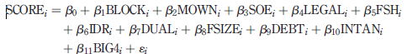

Where,
DSCORE = Voluntary disclosure score;
BLOCK = Proportion of equity ownership by substantial shareholders (with equity of 5 percent or more);
MOWN = Proportion of equity ownership by senior managers, including directors and supervisors;
SOE = Proportion of equity ownership by the state;
LEGAL = Proportion of equity ownership by legal person;
FSH = Dummy variable for foreign listing/shares ownership;
IDR = Proportion of IND on the board of directors;
DUAL = Dummy variable for CEO duality, 1 if the CEO is also chairman of the
board, 0 otherwise;
FSIZE = Logarithm of firm’s total assets at fiscal year end of 2002;
DEBT = Total liabilities divided by total assets;
INTAN = Total intangible assets divided by total assets;
BIG4 = Dummy variable for auditor reputation, 1 if the firm is audited by Big 4 auditor, 0 otherwise.
To test the main hypotheses, they selected several factors that had been identified by the extant literature as relevant to voluntary disclosure as control variables in multiple-regression models. The following control variables were used: firm-size, leverage, growth opportunities and auditor reputation. Huafang and Jianguo find the following results: higher blockholder
ownership and foreign listing/shares ownership is associated with increased disclosure.
Managerial ownership, state ownership, and legal-person ownership are not related to
disclosure. An increase in independent directors increases corporate disclosure and CEO
duality is associated with lower disclosure.

6.5 Discussion of outcomes
In this chapter three empirical researches about the relation between ownership structure and voluntary disclosure are described. Both Eng and Mak (2003) and Huafang and Jianguo (2007) test the association between managerial ownership and voluntary disclosure.
Eng and Mak find that lower managerial ownership is associated with increased disclosure. In contrast with Eng and Mak, Huafang and Jianguo find that managerial ownership is not related to disclosure.
Eng and Mak, and Huafang and Jianguo also test the association between blockholder ownership and voluntary disclosure. Eng and Mak find that blockholder ownership is not associated with disclosure, whereas Huafang and Jianguo find that higher blockholder
ownership is associated with increased disclosure. Because of the different results and cultural differences, it is interesting to look what the impact of ownership structure in the Netherlands is on disclosures.
With this chapter research question five is answered.

Chapter 7 Empirical research about the relation between ownership structure and CSR disclosure

7.1 Introduction
In this chapter one study about the relation between ownership structure and CSR disclosure will be described. Only one study is described because there are no more studies found about the relation between ownership structure and CSR disclosure.

7.2 Study Ghazali (2007)
Ghazali examines the influence of ownership structure on corporate social responsibility disclosure in 87 Malaysian company annual reports. The following three ownership structures were tested: ownership concentration, director ownership and government ownership. Ghazali measures ownership concentration as the proportion of shares held by the ten largest shareholders. Director ownership is measured by the proportion of shares held by executive and non-independent directors, consistent with Eng and Mak (2003). Government ownership is represented by an dummy variable, whether the government is a substantial shareholder in the company. The securities commission of Malaysia defines a substantial shareholder as a person having an interest in not less than 5 percent of the nominal amount of voting shares in a company.
To measure the extent of CSR disclosure Ghazali uses a CSR disclosure checklist. The checklist contains 22 items (See appendix 7). The checklist was made on bases of previous researches, particularly conducted in Malaysian companies. Also criteria developed by the Bursa Malaysia for the corporate awards and other recommended disclosure contained in the sample annual report prepared by the Malaysian Institute of Accountants and PriceWaterhouseCoopers in Malaysia. The scoring method of this research was based on the unweighted method. An disclosed item was awarded with a 1 and an undisclosed item with a 0.

To examine to association between ownership structure and CSR disclosure the following multiple regression analysis was used:
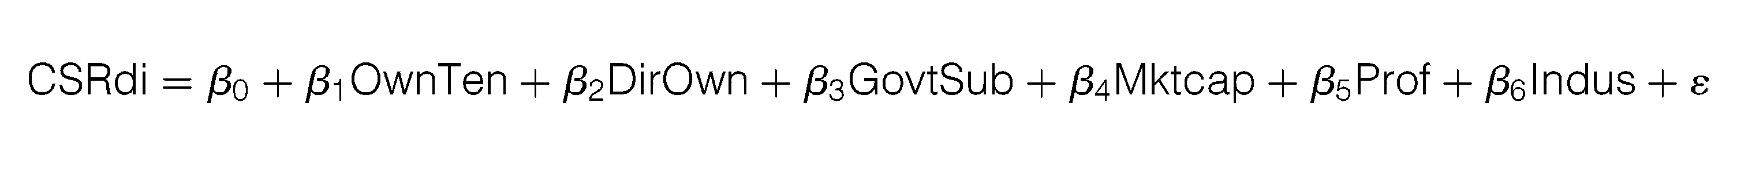
Where,
CSRdi = CSR disclosure index;
B_{o}…..B₆ = Regression coefficients;
OwnTen = Proportion of shares held by the ten largest shareholders;
DirOwn = Proportion of shares held by executive and non-independent directors;
GovtSub = 1 if the government is a substantial shareholder in the company; 0 otherwise;
MktCap = Market capitalization as at 31 December 2001;
Prof = Profitability measured by Profit before tax/Total assets;
Indus = Industry competitiveness measured by the ratio of the sample; company’s sales to the total sales of the companies in the same industry sector

The statistical results show that director ownership and the government as a substantial shareholder, significantly influence CSR disclosure in annual reports. Companies in which the directors hold a higher proportion of equity shares (owner-managed companies) disclosed significantly less CSR information, while companies in which the government is a substantial shareholder disclosed significantly more CSR information in their annual reports. Ownership concentration, is not statistically significant in explaining the level of CSR disclosure in annual reports. Ghazali found that CSR disclosures are closely related to public pleasure.

Chapter 8 Research design

8.1 Introduction
In this chapter the hypotheses based on prior research will be formulated. Subsequently the research design will be described. The variables used to measure CSR disclosure will be explained. Furthermore, there will be elaborated on the model used for conducting the relation between ownership structure and CSR disclosure

8.2 Hypotheses
As stated in the research question, the relationship between ownership structure and CSR disclosure will be examined. There are different forms of ownership structure for example: managerial ownership, blockholder ownership, government ownership, family firm. Managerial ownership is the proportion of ordinary shares held by the CEO and executive directors (Eng and Mak, 2003). Blockholder ownership is the proportion of ordinary shares held by substantial shareholders, and is usually measured by shareholdings of 5% or more (Eng and Mak, 2003). In the Government-linked companies, the government has between 20% and 80% ownership (Eng and Mak, 2003). Family firms can be classified as firms that are managed or controlled by founding families (Ali et al, 2007). The focus for the research in this thesis will be on two forms of ownership structure namely: managerial ownership and blockholder ownership. Firms with government ownership and family firms are not chosen for the research of this thesis. In the Netherlands there are less firms with government ownership and the information is not available. Also family controlled firms publishes less disclosures.

For the research of this thesis the definition of Eng and Mak ( 2003) will be used to measure managerial ownership and is as follows: managerial ownership is the proportion of ordinary shares held by the CEO and executive directors. When managerial ownership is low, there is a greater agency problem. Hence there is more information asymmetry and managers have a greater incentive to maximize their own interest. The shareholders will increase monitoring of managers behavior to reduce the agency problem. By disclosing more information, managers can avoid monitoring. So, it is expected that managerial ownership is negatively related to CSR disclosure.

H1: There is a negative association between managerial ownership and the level of CSR
disclosure.

To measure blockholder ownership the definition of Jensen and Meckling (1976) will be used and is as follows: blockholder ownership is defined as the proportion of ordinary shares held by substantial shareholders, measured by shareholdings of 5% or more.
When share ownership is diffused, more monitoring is required. Empirical evidence indicates
a negative relation between blockholder ownership and disclosure (Eng and Mak, 2003).
When managers start giving more CSR disclosures, less monitoring is needed and so the
agency problem will decrease. For this reason the second hypothesis is formulated:

H2: There is a negative association between blockholder ownership and the level of CSR
disclosure.

According to Ghazali shares in a widely held company are hold by a large number of small shareholders. “When a company is widely held the issue of public accountability may
become more important because there is a greater chance that these companies are being
held by the public at large” (Ghazali, 2007). Because of the public accountability of widely held companies there is more interest and demand for “involvement in social or community activities and hence disclosure of these activities” (Ghazali 2007). In contrast with a widely held company, “ownership concentration is negatively associated with the extent of social activities”. Ghazali defines ownership concentration as the proportion of shares held by the ten largest shareholders. If shares are in hands of a few large shareholders there is less public accountability and therefore it is expected that ownership concentration is negatively associated with CSR disclosure.
For the research of this thesis, both for blockholder ownership and ownership concentration will be determined whether there is a relation with CSR disclosure.

8.3 Measurement of CSR disclosure
A disclosure index model will be used to measure CSR disclosure. CSR disclosure will be measured by social and environmental aspects of business. Therefore, aspects of the measurement model of the Dutch transparency benchmark 2009 will be used.
Financial aspects of business are not included in the research of this thesis because there are a lot of researches done about financial aspects.
In order to determine the Disclosure Score (Dscore), it is necessary to go through the annual reports and/ or sustainability reports of the sample firms and seek for the variables. So content analysis will used to find the variables. The condition is that the reports can be downloaded from the internet. Annual reports of the Dutch listed companies are used from the following internet site: http://www.beursgorilla.nl/jaarverslagen.asp. In the measurement model of the Dutch transparency benchmark the variables all get a score. The same measurement method as the Dutch transparency benchmark will be used for the research of this thesis to measure the extent of CSR disclosure. Each environmental aspects and social aspects can achieve a maximum score of ten points.

The following variables will be used to measure the extent of social and environmental disclosure:

Environmental aspects of business (maximum score of 10 points)

- There is an explanation about companies environment
Protocol:
0 = no explanation
1 = the environmental policy is explained
A score of 1 is given for mentioning the environmental policy.
- Reporting provides insight into the performance of the company regarding the environmental aspects of the business. These themes include:
• the use of non-renewable resources (including energy)
• (re) use of materials and raw materials (including unsafe substances)
• impacts to air, water and soil (including greenhouse gas emissions)
• waste (including chemical waste)

Protocol
0 = no description
1 = The company provides quantitative information on at least two indicators relating to at least one of the above categories
2 = The company provides quantitative information on at least four indicators relating to at least two of the above categories
3 = The company provides quantitative information on at least six indicators for at least three of the above categories

- Reporting includes objectives concerning environmental aspects of operations.
Protocol
0 = no explicit mention of objectives
1 = general description of at least two goals
2 = specific description of at least two objectives, one objective, quantitative performance data and a specific timetable
- The report explicitly mention the improvements the company has made with regard to environmental policy.
Protocol
0 = no explanation
1 = there is an explanation of a specific claim relating to environmental
2 = there is an explanation of more than one specific claim relating to environmental
- The reports explicitly mention the improvement or deterioration in relation to the environment that the company has shown in the last reporting period.

Protocol
0 = no explanation
+ 1 in general terms there is an explanation of the improvement or deterioration in environmental performance compared to the previous period
+ 1 there is an explanation of the result improvement or deterioration, according to previously stated objectives at least two relevant areas

Social aspects of business (maximum score of 10 points)
- There is an explanation about companies social policy
Protocol
0 = no explanation
1 = the pursued social policy is explained
- Reporting provides insight into the performance of the company relating to the social aspects of business. These themes include:
• ethics and integrity
• employment (including staff turnover, education, training and career development)
• Safety and health (including illness and injuries)
• Diversity (including gender distribution, women in management positions, proportion of immigrant workers and percentage of employees with physical or mental disability)
• Product liability (including welfare, food safety and genetic modification)
• human rights (including discrimination, child labor, forced labor, freedom of association and collective bargaining, security, rights of indigenous
nations)
Protocol
0 = no description
1 = The company provides quantitative information on at least two indicators for at least two of the above categories
2 = The company provides quantitative information on at least four indicators relating to at least three of the above categories
3 = The company provides quantitative information on at least six indicators for at least four of the above categories
- Reporting includes objectives concerning the social aspects of business.
Protocol
0 = no explicit mention of objectives
1 = general description of at least two goals
2 = specific description of at least two objectives, one objective, quantitative performance data and a specific timetable
- The reports explicitly mention the improvements the company has made in relation to social policy.
Protocol
0 = no explanation
1 = there is an explanation of a specific claim relating to new or strengthened social policy
2 = there is an explanation of more than one specific claim relating to a new or strengthened social policies

- The reports explicitly mention the improved results or deterioration, in relation to social aspects, which the company showed in the last reporting period.
Protocol
0 = no explanation
+ 1 in general terms there is an explanation of the improvement or deterioration of social performance compared to the previous period
+ 1 there is an explanation of the result improvement or deterioration, according to previously stated objectives at least two relevant areas
The result of the assigned scores per company is called the DScore (disclosure score). For the environmental and social aspects the variables are reliable because of the scoring protocol for each variable.

8.4 Model
The linear multiple regression is used to examine the relationship between CSR disclosure and ownership structure. In addition to the ownership structure firm size and profitability are included in the linear multiple regression as control variables, because they are also relevant to disclosure information. Eng and Mak, and Chau and Gray found that larger firms and firms with higher profitability disclose more information.

The independent variables will be calculated as follows:
Managerial ownership = percentage of shares hold by managers/total shares.
Blockholder ownership = total percentage hold by blockholder (≥ 5%)
Ownership concentration = proportion of shares held by the ten largest shareholders.

The control variables will be calculated as follows:
Firm size = logarithm of firms total assets
Profitability = will be measured by ROA and ROE;
Profitability is measured in different ways in prior research. Profitability is measured as Return on shareholders’ equity (ROE) and return on assets (ROA). Return on shareholders’ equity measures a firm's efficiency at generating profits from every unit of shareholders' equity. Hence, return on equity shows how well a company uses investment funds to generate earnings growth. Therefore four regression analyses will be conducted to examine the relation between ownership structure en CSR disclosure.

The following regression models will be conducted:

- DSCORE = β0+β1MOWN+β2BLOCK+β3FSIZE+β4ROA+ε

- DSCORE = β0+β1MOWN+β2OWNTEN+β3FSIZE+β4ROA+ε

- DSCORE = β0+β1MOWN+β2BLOCK+β3FSIZE+β4ROE+ε

- DSCORE = β0+β1MOWN+β2OWNTEN+β3FSIZE+β4ROE+ε

Where:
DSCORE = disclosure score
β0 = regression intercept
β1 till β4 = the slope of the line of the variables Managerial Ownership, Blockholder ownership/ Ownership concentration, Firm size, Profitability
MOWN = Managerial ownership
BLOCK = Blockholder ownership
OWNTEN = Ownership concentration
FSIZE = Firm size
ROA = net income after tax/total assets
ROE = net income after tax/shareholders equity
ε = Error

8.5 Steps to conduct the research
In chapter 9, the research will be conducted. Table 1 contains the definition and measurement of all variables in the regression model. Table 2 contains descriptive statistics for the dependent and independent variables. Thereafter the linear multiple regression will be conducted for each of the four regression models. Presentation of the results of the linear multiple regression contains three steps. Firstly, the model summary table. In the model summary the R square indicates which percentage of disclosure score is explained by the independent variables. Secondly, the Anova table. The Anova table provides an analysis of variance. With the variance analysis, it can be tested whether the whole model is significant. Thirdly, the coefficients table. The coefficient table indicates the actual regression equation. With this table it can be concluded whether there is a positive or negative relation between ownership structure and CSR disclosure and whether this relation is significant or not.

8.6 Conclusion
To examine the research question: “What is the relationship between ownership structure and corporate social responsibility (CSR) disclosures in the annual reports of Dutch Stock Exchange listed companies?”, the following two hypotheses are formulated:
H1: There is a negative association between managerial ownership and the level of CSR
disclosure.
H2: There is a negative association between blockholder ownership and the level of CSR
disclosure.
In order to test those hypotheses the disclosure index model will be used to measure the extent of CSR disclosure. A linear multiple regression will be used to examine the relation between CSR disclosure and ownership structure.

Chapter 9 Empirical research

9.1 Introduction
In this chapter the research of this thesis will be conducted as described in chapter 8.5. Chapter 9.2 contains the definition and measurement of all variables in the regression model. Also total disclosure score (DScore) of each company will be summarized. In the Appendix there is more elaborated how the variables score per item. Chapter 9.3 contains descriptive statistics for the dependent and independent variables

In Chapter 9.4 the linear multiple regression will be conducted for each of the four regression models. The linear multiple regression contains three steps. Firstly, the model summary table. In the model summary the R square indicates which percentage of disclosure score is explained by the independent variables. Secondly, the Anova table. The Anova table provides an analysis of variance. With the variance analysis, it can be tested whether the whole model is significant. Thirdly, the coefficients table. The coefficient table indicates the actual regression equation. With this table it can be concluded whether there is a positive or negative relation between ownership structure and CSR disclosure and whether this relation is significant or not.

9.2 Definition and measurement
Table 1a
Definition and measurement of variables
Variable | Definition | Measurement
Dependent variable
DSCORE | Disclosure score | Total number of points awarded for CSR disclosure; environmental and social aspects
Independent variables
MOWN | Managerial ownership | The proportion of ordinary shares held by
 |  | the CEO and executive directors
BLOCK | Blockholder ownership | The proportion of ordinary shares held by substantial shareholders, measured by shareholdings of 5% or more
OWNTEN | Ownership concentration | Proportion of shares held by the ten largest shareholders
ROE | Profitability | Return on equity
ROA | Profitability | Return on assets
FSIZE | Firmsize | Logarithm of firms total assets

Table 1b
Total disclosure score per company

AEX | Dscore |  | AEX | Dscore
Ahold | 12 |  | Aalberts Industries | 4
Akzo Nobel | 18 |  | AMG | 5
Aegon | 12 |  | Arcadis | 9
ArcelorMittal | 6 |  | ASM International | 4
ASML Holding | 7 |  | BinckBank | 3
BAM Groep | 5 |  | Brunel International | 3
Boskalis | 5 |  | Crucell | 4
Corio | 4 |  | CSM | 8
DSM | 16 |  | Draka Holding | 7
Fugro | 4 |  | EUROCOMMERCIAL | 0
Heineken | 15 |  | Heijmans | 8
ING Groep | 20 |  | Imtech | 7
KPN | 11 |  | LOGICA | 6
Philips | 16 |  | Mediq | 8
Randstad | 6 |  | Nutreco | 16
Reed Elsevier | 17 |  | Ordina | 6
Royal Dutch Shell | 18 |  | SNS Reaal | 18
SBM Offshore | 8 |  | Ten Cate | 6
TNT | 17 |  | Unit 4 | 3
TomTom | 7 |  | USG People | 4
Unilever | 18 |  | VastNed Retail | 4
Wereldhave | 8 |  | Vopak | 9
Wolters Kluwer | 9 |  | Wavin | 7
 |  |  | Wessanen | 20

9.3 Descriptive statistics
Table 2
Descriptive Statistics
 | N | Minimum | Maximum | Mean | Std. Deviation
DSCORE | 47 | ,00 | 20,00 | 9,1064 | 5,47815
MOWN | 47 | ,00 | 50,90 | 2,8863 | 8,92577
NUMBLOCK | 47 | 0 | 5 | 1,49 | 1,317
BLOCK | 47 | 0 | 100 | 20,98 | 23,557
OWNTEN | 47 | 0 | 100 | 24,66 | 23,809
ROE | 47 | 0 | 1 | ,26 | ,183
ROA | 47 | 0 | 0 | ,09 | ,079
FSIZE | 47 | 12 | 22 | 16,50 | 2,832
Valid N (listwise) | 47

Table 2 shows descriptive statistics for all variables used for the research of this thesis. The disclosure score shows a wide range for the sample companies. The highest disclosure score is 20 and the lowest disclosure score is 0. The mean disclosure score is 9,1. The lowest managerial ownership is 0% and the highest is 50%. The mean managerial ownership is 2.88. The highest number of blockholders is 5 and the mean is 1.49. The highest blockholder ownership is 100 and the lowest is 0, while the mean blockholder ownership is 20.98.

9.4 Linear multiple regression
The linear multiple regression will be conducted for the following four regression models:

- DSCORE = β0+β1MOWN+β2BLOCK+β3FSIZE+β4ROA+ε

- DSCORE = β0+β1MOWN+β2OWNTEN+β3FSIZE+β4ROA+ε

- DSCORE = β0+β1MOWN+β2BLOCK+β3FSIZE+β4ROE+ε

- DSCORE = β0+β1MOWN+β2OWNTEN+β3FSIZE+β4ROE+ε
- DSCORE = β0+β1MOWN+β2BLOCK+β3FSIZE+β4ROA+ε

Model Summary
Model | R | R Square | Adjusted R Square | Std. Error of the Estimate
1 | ,621ª | ,386 | ,327 | 4,49266
a. Predictors: (Constant), ROA, MOWN, FSIZE, BLOCK
The model summary includes the multiple R or correlation coefficient of the whole model. The R square indicates that over 39% of the variance is explained by the disclosures of 4 independent variables: managerial ownership, blockholder ownership, Firmsize and ROA.

ANOVA^{b}
Model |  | Sum of Squares | df | Mean Square | F | Sig.
1 | Regression | 532,740 | 4 | 133,185 | 6,599 | ,000ª
1 | Residual | 847,728 | 42 | 20,184
1 | Total | 1380,468 | 46
a. Predictors: (Constant), ROA, MOWN, FSIZE, BLOCK
b. Dependent Variable: DSCORE

The Anova table provides an analysis of variance. With the variance analysis, it can be tested whether the whole model is significant. The degrees of freedom (df) of regression is equal to the number of independent variables, that is 4. The Residual degrees of freedom equals the number of cases minus the number of independent variables minus one (47- 4- 1= 42). The F-test shows that the model itself is significant (Sig. ≤ 0.05)

Coefficientsª
Model |  | Unstandardized Coefficients |  | Standardized Coefficients | t | Sig.
 |  | B | Std. Error | Beta | t | Sig.
1 | (Constant) | -6,618 | 4,046 |  | -1,636 | ,109
1 | MOWN | -,139 | ,076 | -,227 | -1,841 | ,073
1 | BLOCK | -,076 | ,029 | -,327 | -2,650 | ,011
1 | FSIZE | 1,022 | ,238 | ,529 | 4,304 | ,000
1 | ROA | 9,185 | 8,492 | ,132 | 1,082 | ,286
a. Dependent Variable: DSCORE
The coefficients table indicates the actual regression equation. The partial regression coefficients Bi are given in column B. They indicate the amount of change in Y, when the corresponding independent variable increases by one unit, while the influence of all other independent variables are constant. For two independent variables (managerial ownership and blockholder ownership) in this model a increase implies a decrease in the disclosure score.
The table shows that regression coefficients blockholder ownership and firmsize are significant (Sig. ≤ 0.05). The regression coefficients managerial ownership and ROA are not significant (Sig.> 0.05). However, managerial ownership is significant when Sig. ≤ 0.10
From the regression analysis it can be concluded that an increase in managerial ownership and an increase in blockholder ownership lead to an decrease of providing CSR disclosure. Furthermore, blockholder ownership is significant and managerial ownership is not significant.

- DSCORE = β0+β1MOWN+β2OWNTEN+β3FSIZE+β4ROA+ε

Model Summary
Model | R | R Square | Adjusted R Square | Std. Error of the Estimate
1 | ,617ª | ,380 | ,321 | 4,51299
a. Predictors: (Constant), ROA, MOWN, FSIZE, OWNTEN

The model summary includes the multiple R or correlation coefficient of the whole model. The R square indicates that over 38% of the variance is explained by the disclosures of 4 independent variables: managerial ownership, ownership concentration, firmsize and ROA.

ANOVA^{b}
Model |  | Sum of Squares | df | Mean Square | F | Sig.
1 | Regression | 525,050 | 4 | 131,262 | 6,445 | ,000ª
1 | Residual | 855,419 | 42 | 20,367
1 | Total | 1380,468 | 46
a. Predictors: (Constant), ROA, MOWN, FSIZE, OWNTEN
b. Dependent Variable: DSCORE

The Anova table provides an analysis of variance. With the variance analysis, it can be tested whether the whole model is significant. The degrees of freedom (df) of regression is equal to the number of independent variables, that is 4. The Residual degrees of freedom equals the number of cases minus the number of independent variables minus one (47- 4- 1= 42). The F-test shows that the model itself is significant (Sig. ≤ 0.05)

Coefficientsª
Model |  | Unstandardized Coefficients |  | Standardized Coefficients | t | Sig.
 |  | B | Std. Error | Beta | t | Sig.
1 | (Constant) | -6,774 | 4,059 |  | -1,669 | ,103
1 | MOWN | -,146 | ,076 | -,238 | -1,912 | ,063
1 | OWNTEN | -,073 | ,029 | -,319 | -2,566 | ,014
1 | FSIZE | 1,042 | ,239 | ,538 | 4,349 | ,000
1 | ROA | 10,000 | 8,498 | ,144 | 1,177 | ,246
a. Dependent Variable: DSCORE
The coefficients table indicates the actual regression equation. The partial regression coefficients Bi are given in column B. They indicate the amount of change in Y, when the corresponding independent variable increases by one unit, while the influence of all other independent variables are constant. For two independent variables (managerial ownership and ownership concentration) in this model implies an increase, an decrease in the disclosure score.
The table shows that regression coefficients ownership concentration and firmsize are significant (Sig. ≤ 0.05). The regression coefficients managerial ownership and ROA are not significant (Sig.> 0.05).
From the regression analysis it can be concluded that an increase in managerial ownership and an increase in ownership concentration lead to an decrease of providing CSR disclosure. Furthermore, ownership concentration is significant and managerial ownership is not significant.

- DSCORE = β0+β1MOWN+β2BLOCK+β3FSIZE+β4ROE+ε

Model Summary
Model | R | R Square | Adjusted R Square | Std. Error of the Estimate
1 | ,640ª | ,409 | ,353 | 4,40714
a. Predictors: (Constant), ROE, MOWN, FSIZE, BLOCK

The model summary includes the multiple R or correlation coefficient of the whole model. The R square indicates that over 41% of the variance is explained by the disclosures of 4 independent variables: managerial ownership, blockholder ownership, firmsize and ROE.

ANOVA^{b}
Model |  | Sum of Squares | df | Mean Square | F | Sig.
1 | Regression | 564,709 | 4 | 141,177 | 7,269 | ,000ª
1 | Residual | 815,759 | 42 | 19,423
1 | Total | 1380,468 | 46
a. Predictors: (Constant), ROE, MOWN, FSIZE, BLOCK
b. Dependent Variable: DSCORE

The Anova table provides an analysis of variance. With the variance analysis, it can be tested whether the whole model is significant. The degrees of freedom (df) of regression is equal to the number of independent variables, that is 4. The Residual degrees of freedom equals the number of cases minus the number of independent variables minus one (47- 4- 1= 42). The F-test shows that the model itself is significant (Sig. ≤ 0.05)

Coefficientsª
Model |  | Unstandardized Coefficients |  | Standardized Coefficients | t | Sig.
 |  | B | Std. Error | Beta | t | Sig.
1 | (Constant) | -7,194 | 3,976 |  | -1,809 | ,078
1 | MOWN | -,137 | ,074 | -,223 | -1,839 | ,073
1 | BLOCK | -,066 | ,029 | -,285 | -2,279 | ,028
1 | FSIZE | ,996 | ,233 | ,515 | 4,267 | ,000
1 | ROE | 6,247 | 3,693 | ,209 | 1,692 | ,098
a. Dependent Variable: DSCORE

The coefficients table indicates the actual regression equation. The partial regression coefficients Bi are given in column B. They indicate the amount of change in Y, when the corresponding independent variable increases by one unit, while the influence of all other independent variables are constant. For two independent variables (managerial ownership and blockholder ownership) in this model implies an increase, an decrease in the disclosure score.
The table shows that regression coefficients blockholder ownership and firmsize are significant (Sig. ≤ 0.05). The regression coefficients managerial ownership and ROE are not significant (Sig.> 0.05).
From the regression analysis it can be concluded that an increase in managerial ownership and an increase of blockholder ownership lead to an decrease of providing CSR disclosure. Furthermore, blockholder ownership is significant and managerial ownership is not significant.

- DSCORE = β0+β1MOWN+β2OWNTEN+β3FSIZE+β4ROE+ε

Model Summary
Model | R | R Square | Adjusted R Square | Std. Error of the Estimate
1 | ,638ª | ,408 | ,351 | 4,41243
a. Predictors: (Constant), ROE, MOWN, FSIZE, OWNTEN

The model summary includes the multiple R or correlation coefficient of the whole model. The R square indicates that over 41% of the variance is explained by the disclosures of 4 independent variables: managerial ownership, ownership concentration, firmsize and ROE.

ANOVA^{b}
Model |  | Sum of Squares | df | Mean Square | F | Sig.
1 | Regression | 562,747 | 4 | 140,687 | 7,226 | ,000ª
1 | Residual | 817,721 | 42 | 19,470
1 | Total | 1380,468 | 46
a. Predictors: (Constant), ROE, MOWN, FSIZE, OWNTEN
b. Dependent Variable: DSCORE

The Anova table provides an analysis of variance. With the variance analysis, it can be tested whether the whole model is significant. The degrees of freedom (df) of regression is equal to the number of independent variables, that is 4. The Residual degrees of freedom equals the number of cases minus the number of independent variables minus one (47- 4- 1= 42). The F-test shows that the model itself is significant (Sig. ≤ 0.05)

Coefficientsª
Model |  | Unstandardized Coefficients |  | Standardized Coefficients | t | Sig.
 |  | B | Std. Error | Beta | t | Sig.
1 | (Constant) | -7,357 | 3,972 |  | -1,852 | ,071
1 | MOWN | -,143 | ,075 | -,233 | -1,910 | ,063
1 | OWNTEN | -,064 | ,029 | -,280 | -2,254 | ,029
1 | FSIZE | 1,012 | ,235 | ,523 | 4,314 | ,000
1 | ROE | 6,710 | 3,647 | ,225 | 1,840 | ,073
a. Dependent Variable: DSCORE
The coefficients table indicates the actual regression equation. The partial regression coefficients Bi are given in column B. They indicate the amount of change in Y, when the corresponding independent variable increases by one unit, while the influence of all other independent variables are constant. For two independent variables (managerial ownership and ownership concentration) in this model implies an increase, an decrease in the disclosure score.
The table shows that the regression coefficient ownership concentration and firmsize are significant (Sig. ≤ 0.05). The regression coefficients managerial ownership and ROE are not significant (Sig.> 0.05).
From the regression analysis it can be concluded that an increase in managerial ownership and an increase of ownership concentration lead to an decrease of providing CSR disclosure. Furthermore, ownership concentration is significant and managerial ownership is not significant.

9.5 Results

After conducting the model summary for each of the four regression models it seems that regression model 3 and 4 score slightly higher than regression model 1 and 2. Regression model 3 and 4 have both a score of 41% and regression model 1 and 2 has respectively scored 39% and 38%. In the model summary the R square indicates the percentage of disclosure score explained by the independent variables. The higher score of regression model 3 and 4 may be a result of the ROE. Return on shareholders’ equity measures a firm's efficiency at generating profits from every unit of shareholders' equity. Hence, return on equity shows how well a company uses investment funds to generate earnings growth. Because the research of this thesis is about blockholder and managerial ownership and thus shareholders equity is measured, this could be the reason why regression models 3 and 4 have a higher R square than regression model 1 and 2. Further all four regression models are significant. This is tested in the Anova tables (Sig. ≤ 0.05). From the coefficients table of all four regression models it can be concluded that an increase in managerial ownership, blockholder ownership and ownership concentration leads to a decrease of providing CSR disclosure. Managerial ownership is not significant when Sig. ≤ 0.05. But managerial ownership is significant when Sig ≤ 0.10. So, Hypotheses 1 and 2 are supported. There is a negative association between managerial ownership and CSR disclosure. There is a negative association between blockholder ownership and CSR disclosure. And there is also a negative association between ownership concentration and CSR disclosure.

Chapter 10 Analyses

The research of this thesis
For the research of this thesis it was expected that when managerial ownership is low, there is a greater agency problem. There is more information asymmetry and managers have a greater incentive to maximize their own interest. Shareholders will increase monitoring of managers behavior to reduce the agency problem. By disclosing more information, managers can avoid monitoring. So, it was expected that managerial ownership is negatively related to CSR disclosure. This expectation is fulfilled, there is a negative association between managerial ownership and CSR disclosure found. But managerial ownership is not significant at a 5 % significance level and is significant at a 10% significance level. According the research results of managerial ownership of the AEX and AMX companies it can be concluded that managerial ownership is very low, often less than 2% of the shares. So it can be concluded that the relation between managerial ownership and CSR disclosure in Dutch listed companies is not significant. The result of the research of this thesis about managerial ownership is consistent with the findings of Eng and Mak. Eng and Mak find that lower managerial ownership is associated with increased disclosure. The research of Eng and Mak is done in Singapore. In Singapore there are more family-owned companies in the stock markets than western developed stock markets. This could be the reason why the relation between managerial ownership and CSR disclosure is significant for the research of Eng and Mak. Huafang and Jianguo find that managerial ownership is not related to disclosure. The reason that managerial ownership is not related to disclosure can be the sample firms of the research of Huafang and Jianguo. The sample firms of the research are the listed Chinese firms. Most listed Chinese firms originated as state-owned Enterprises. And thus there is no relation found between managerial ownership and CSR disclosure. The result of the research of this thesis about managerial ownership is also consistent with the findings of the research of Ghazali. Ghazali found that companies in which the directors hold a higher proportion of equity shares (owner-managed companies) disclosed significantly less CSR information. This could be the result of no public interest and thus there is no pressure for firms to disclose information. Malaysia have many family owned and government owned companies and in the Netherlands there are less family owned and government owned companies. And thus managerial ownership is more concentrated in Malaysia then in the Netherlands.

For the research of this thesis it was expected that there is a negative association between blockholder ownership and the level of CSR disclosure. This expectation is fulfilled, there is a negative association between blockholder ownership and CSR disclosure found. When blockholder ownership is high there is less disclosure. This could be a reason for no public interest and thus lower pressure to make disclosures. In contrast to the research of this thesis Eng and Mak found no association between blockholder ownership and CSR disclosure. When a company is owned by one or a few blockholders and the public at large has no investments in that company, there is no pressure for that company to disclose voluntary information. In Singapore there are more family-owned companies in the stock markets than western developed stock markets. If there is a company with blockholder(s) with only family the pressure from public is zero for disclosures. So this could be the reason why Eng and Mak found no association between blockholder ownership and CSR disclosure.
Huafang and Jianguo find that higher blockholder ownership is associated with increased disclosure. When blockholder ownership is higher, the pressure to disclose more voluntary information is also higher. Because when blockholder ownership is diffused there is more information asymmetry between managers and blockholders. And as a result there is more monitoring of the managers. This could be the reason why blockholder ownership is associated with increased disclosure.
For the research of this thesis it was expected that there is a negative association between ownership concentration and the level of CSR disclosure. This expectation is also fulfilled. If shares are in hands of a few large shareholders there is less public accountability and therefore it is expected that ownership concentration is negatively associated with CSR disclosure. Also Ghazali found a negative association between ownership concentration and CSR disclosure.

Limitations
- The sample companies of the research of this thesis also made CSR disclosures on their websites and magazines. For the research of this thesis CSR is only measured in annual reports and corporate social responsibility reports.
- For the research of this thesis content analyses is used. The disadvantage of content analyses is that there is only looked what there is reported in the reports and not what a company actually does or has done in terms of CSR.

References
- Adams, C.A., Hill, W., Roberts, C.B. (1998). Corporate social reporting practices in Western Europe: legitimating corporate behaviour?. British Accounting Review 30: 1-21.
- Ali, A ., T.Y Chen and S. Radhakrishnan. 2007. Corporate disclosures by family firms. Journal of Accounting and Economics44( 1-2) :238-286.
- Beattie V., W. McInnes, and S. Fearnley. 2004. A methodology for analyzing and evaluating narratives in annual reports: a comprehensive descriptive profile and metric for disclosure quality attributes. Accounting Forum 28 (3): 205-236.
- Belkaoui, A.R., Karpik, P.G. (1989). Determinants of the corporate decision to disclose social information. Journal of Accounting, Auditing & Accountability 2 (1): 36-51.
- Boesso, G. 2003. How to Assess the Quality of Voluntary Disclosures: An index to
measure stakeholder reporting and social accounting across Italy and U.S. Journal of
Accounting and Financial Research. n.33 December.
- Boesso, G. and Kumar, K. (2007). Drivers of corporate voluntary disclosure. Accounting, Auditing and Accountability Journal 20 (2): 269-296.
- Botosan, C.A. 1997. Disclosure level and the cost of equity capital. The Accounting Review 72 (3): 323–349.
- Chau, G.K., Gray, S.J. (2002). Ownership structure and corporate voluntary disclosure in Hong Kong and Singapore. The International Journal of Accounting 37: 247-265.
- Cooke, T.E. (1998). Regression analysis in accounting disclosure studies. Accounting & Business Research, Vol. 28 No. 3, pp. 209-24.
- Craswell, A., and S. Taylor . 1992. Discretionary disclosure of reserves by oil and gas companies: an economic analysis. Journal of Business Finance and Accounting 19: 295–308.
- De Vocht, A. (2009). Basishandboek SPSS 17. Tweede druk, Utrecht.
- Deegan, C., and Unerman, J., (2005), “Financial accounting theory”, European edition McGraw, Hill, London, UK
- Eng, L.L, and Y.T Mak. (2003). Corporate governance and voluntary disclosure. Journal of Accounting and Public Policy 22: 325–345.
- Fama, E., and Jensen, M.C. (1983), Separation of ownership and control, Journal of Economics and Law, Vol. 26, pp. 301-25.
- Ghazali, N. 2007. Ownership structure and corporate social responsibility disclosure: some Malaysian evidence. Journal corporate governance 7 (3): 251-266.
- Gray, R., Kouhy, R., Lavers, S. (1995). Corporate social and environmental reporting: a review of the literature and a longitudinal study of UK disclosure. Accounting Auditing & Accountability Journal 8 (2): 47-77.
- Gul, F.A. and Leung, S. (2004). Board leadership, outside directors expertise and voluntary corporate disclosures. Journal of Accounting & Public Policy, Vol. 23, pp. 351-79.
- Guthrie, J., Parker, L.D. (1989). Corporate social reporting: a rebuttal of legitimacy theory. Accounting and Business Research 19 (76): 434-52.
- Hackston, D., Milne, M.J. (1996). Some determinants of social and environmental disclosures in New Zealand companies. Journal of Accounting, Auditing & Accountability 9 (1): 77-108.
- Healy, P.M., and K. G. Palepu. 2001. Information asymmetry, corporate disclosure, and the capital markets: A review of the empirical disclosure literature. Journal of Accounting and Economics 31 (1-3): 405-440.
- Ho, S.S. and Wong, K.S. (200. A study of the relationship between corporate governance structures and the extent of voluntary disclosure. The Journal of International Accounting, Auditing and Taxation, Vol. 10, pp. 139-56.
- Hossain, M., Tan, L.M., Adams, M. (1994). Voluntary disclosure in an emerging capital market: Some empirical evidence from companies listed on the Kuala Lumpur Stock Exchange. The International Journal of Accounting 29: 334-51.
- Huafang X., Jianguo Y. 2007. Ownership structure, board composition and corporate voluntary disclosure; Evidence from listed companies in China. Managerial Auditing Journal. Bradford 22 (6): pg. 604.
- Kolk, A. 2003. Trends in sustainability reporting by the fortune global 250. Business Strategy and the Environment 12: 279-291.
- KPMG. 2008. KPMG International survey of Corporate Responsibility Reporting.
- Krippendorff, K. 1980. Content analysis: An introduction to its methodology, Sage Publications, Beverly Hills, CA.
- Lamoen, C en Tulder, R. 2001. Accepteren, aanmodderen of afwijzen. Economisch statistische berichten. 86e jaargang, nr. 4337, pagina 932-934. (datum)
- Lang, M.H., and R.J. Lundholm. 1996. Corporate disclosure policy and analyst behavior. The Accounting Review 71 (4): 467–492.
- Linsley, P, and Shrives, P. (2006). Risk reporting: A study of risk disclosures in the annual reports of UK companies. The British Accounting Review 38 (4): 387-404.
- Malone, D., Fries, C., & Jones, T. 1993. An empirical investigation of the extent of corporate financial disclosure in the oil and gas Industry. Journal of Accounting, Auditing and Finance, 249–273.
- Marston, C.L., and P.J. Shrives. 1991. The use of disclosure indices in accounting research: A review article. British Accounting Review 23 (3): 195–210.
- Mckinnon, J. L., & Dalimunthe, L. 1993. Voluntary disclosure of segment information by Australian diversified companies. Accounting and Finance, May, 33–50.
- Meek, G.K., Roberts, C.B. and Gray, S.J., 1995. Factors influencing voluntary annual report disclosures by US, UK and continental European multinational corporations. Journal of International Business Studies, pp. 555–572
- Myers, S. and Majluf, N., 1984. Corporate financing and investment decisions when firms have information that investors do not have. Journal of Financial Economics 13:187–222.
- Neu, D., Warsame, H., Pedwell, K. (1998). Managing public impressions: environmental disclosures in annual reports. Accounting, Organizations and Society 23 (3): 265-82.
- O'Dwyer, B. (2002). Managerial perceptions of corporate social disclosure: an Irish story. Accounting, Auditing & Accountability Journal 15 (3): 406-36.
- Patten, D.M. (1991). Exposure, legitimacy, and social disclosure. Journal of Accounting and Public Policy 10: 297-308.
- PWC. 2009. Transparantiebenchmark maatschappelijke verslaggeving. Een onderzoek in opdracht van het Ministerie van Economische Zaken naar de maatschappelijke verslaggeving van ondernemingen, uitgevoerd door PricewaterhouseCoopers.
- Raffournier.B .1995.The determinants of voluntary financial disclosure by Swiss listed companies. European Accounting Review 4 (2): 261–280.
- Robb, S.W.G., L.E. 2001. Single and M.T. Zarzeski, Nonfinancial disclosures across
Anglo-American countries, Journal of International Accounting 10 (1): 71–83.
- Roberts, R.W. (1992). Determinants of corporate social responsibility disclosure: an application of stakeholder theory. Accounting, Organizations and Society 17 (6): 595-612.
- Rosenstein, S. and Wyatt, J.G. (1990). Outside directors, board independence and shareholder wealth. Journal of Financial Economics, Vol. 26, pp. 175-92.
- Tian, G.L. (2001). Government shareholding and the value of China's modern firms. Working Paper, London Business School, London.
- Trueman, B., 1986. Why do managers voluntarily release earnings forecasts?. Journal of Accounting and Economics 8: 53–72.
- Tsang, E.W.K. (1998). A longitudinal study of corporate social reporting in Singapore: the case of the banking, food and beverages and hotel industries. Accounting, Auditing & Accountability Journal 11 (5): 624-35.
- Walden, W.D., Schwartz, B.N. (1997). Environmental disclosures and public policy pressure. Journal of Accounting and Public Policy 16: 125-54.
- Watts. R.L. & Zimmerman. J.L., (1978), “Towards a Positive Theory of the Determination of Accounting Standards”, The Accounting Review 53 (1): 112-134.
- Watts. R.L. & Zimmerman. J.L., (1986), Positive Accounting Theory, Prentice-Hall, London.
- Watts. R.L. & Zimmerman. J.L., (1990), “Positive Accounting Theory: A Ten Year Perspective”, The Accounting Review. 65 (1): 131-156.
- Weber, R.P. 1985. Basic content analysis, quantitative applications in the social sciences, Sage Publications, Beverly Hills, CA.
- Xiao, J. Z., Yang, H., and Chow, C. W. (2004). The determinants and characteristics of voluntary internet based disclosures by listed Chinese companies. Journal of Accounting & Public Policy, Vol.23, pp 191-225.
- Xu, X. and Wang, Y. (1999). Ownership structure and corporate performance in Chinese stock companies. Chinese Economic Review, Vol. 10, pp. 75-9.

Internet sites:
- http://www1.fee.uva.nl/pp/bin/137fulltext.pdf: betreft artikel van prof. Dr. Ans Kolk: Nieuwe ontwikkelingen in duurzaamheidsverslaglegging 2002. Geraadpleegd op 13 september 2010.
- http://www.gertjanschop.com/modellen/people_planet_profit.html: betreft ontstaan van people, planet,profit.
- http://en.wikipedia.org/wiki/Return_on_equity: betreft beschrijving van return on equity
- https://zoek.officielebekendmakingen.nl/kst-26485-86.html?zoekcriteria=%3fzkt%3dEenvoudig%26pst%3d%26vrt%3dkamerstuk%2b26485%2bnr%2b86%26zkd%3dInDeGeheleText%26dpr%3dAfgelopenDag%26sdt%3dDatumBrief%26ap%3d%26pnr%3d1%26rpp%3d10&resultIndex=5&sorttype=1&sortorder=4: betreft kst-26485-86 over mvo rapportage
- http://simplestudies.com/international-financial-reporting-standards.html: betreft IFRS
- http://www.mallenbaker.net/csr/definition.php (definition Corporate social responsibility)

Author | Title | Object of Study | Sample | Methodology | Outcome
Boesso (2003) | How to asses the quality of voluntary disclosures.  “An index to measure stakeholder reporting and social accounting across Italy and U.S” | The extent of non-mandatory information available on the web sites of leading companies across Italy and U.S. | This sample include 18 Italian companies and 18 U.S. companies | There were seven perspectives, for each perspective a list of voluntary disclosures  was created by analyzing the mentioned information  sources and updating the list every time a company presented a new measure | The results shows that the percentage of observed items on the total number of researched items is very low. Managers seems to define disclosure policies that is roughly different between companies
Botosan (1997) | Disclosure level and the cost of equity capital | The association between voluntary disclosure level and the cost of equity capital | This sample include 122 manufacturing firms and are based on their annual reports of 1990 | Botosan created her own disclosure index to measure voluntary disclosure. The items included in the DSCORE reflect five categories of voluntary information identified by investors and financial analysts as useful in investment decision making. | Firms with relatively low analyst following, suggests that greater disclosure is associated by lower cost of equity capital. Firms with a high analyst following, there is no significant relation found between disclosure level and cost of equity capital
Rob, Single and Zarzeski (2001) | Nonfinancial disclosures across Anglo-American countries | The relationship between nonfinancial disclosure practices and firm characteristics | The sample is based on 53 Australian, 69 Canadian and 70 U.S. companies | Descriptive statistics. Depending on degree of disclosure, a weighting of 1 (no disclosure), 2 (some disclosure or 3 (extensive disclosure) was given to each disclosure item | Higher levels of strategic and management disclosures were provided by companies in the chemical and construction industry, by companies with an international orientation and by large companies
Eng and Mak (2003) | Corporate governance and voluntary disclosure | This study investigates the impact of ownership structure and board composition on voluntary disclosure | The sample is based on 158 firms listed on the Stock Exchange of Singapore | They used a ordinary least squares (OLS) regression to measure the relationship between voluntary disclosure and the explanatory variables | Lower managerial Ownership and significant government ownership are associated with increased disclosure. An increase in outside directors reduces voluntary disclosures
Chau and Gray (2002) | Ownership structure and corporate voluntary disclosure in Hong Kong and Singapore | They investigate the association of ownership structure with voluntary disclosures | The sample is based on 60 Hong Kong and 62 Singapore listed companies | They used a disclosure index model and a multiple regression model to measure the relationship between ownership structure and voluntary disclosure | They find a positive association between wider ownership and the extent of voluntary disclosure. Family firms has a negative association with voluntary disclosure
Huafang and Jianguo (2007) | Ownership structure, board composition and corporate voluntary disclosure; Evidence from listed companies in China | This study investigates the impact of ownership structure and board composition on voluntary disclosures | The sample is based on 559 firms listed on Shanghai Stock exchange | They use an aggregated disclosure index model and an ordinary least squares (OLS) regression to measure the impact of ownership structure and board composition on voluntary disclosures. | Higher blockholder ownership and foreign listing ownership are associated with increased disclosure. Managerial, state and legal-person ownership are not related to disclosure An increase in independent directors increases corporate disclosure and CEO duality is associated with lower disclosure
Ghazali (2007) | Ownership structure and corporate social  responsibility disclosure: some Malaysian  evidence | Ghazali examines the influence of ownership structure on corporate  social responsibility (CSR) disclosure in Malaysian company annual reports (CARs) | The sample is based on 87 Malaysian company annual reports | A CSR disclosure checklist is used to measure CSR disclosure in annual reports and a multiple regression analysis is used to examine the association between  ownership structure and the extent of CSR disclosure | Companies in which directors hold a higher proportion of equity shares disclosed significantly less CSR information, while companies in which the government is a substantial shareholder disclosed significantly more CSR information in their annual reports

Appendix 1 Disclosure index Botosan
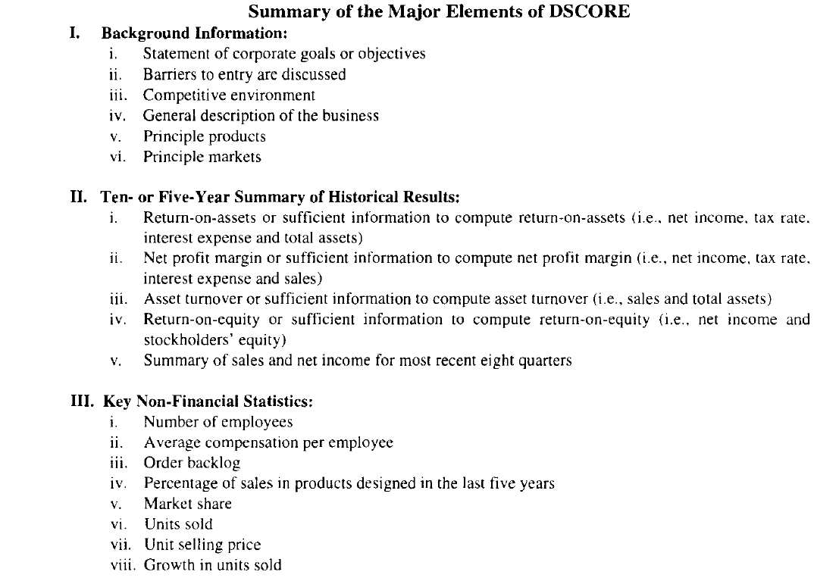
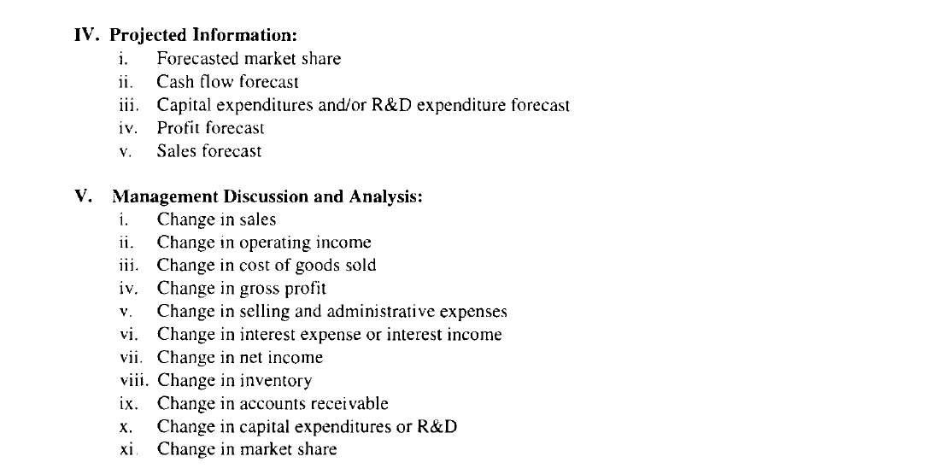

Appendix 2 Disclosure index Rob, Single and Zarzeski
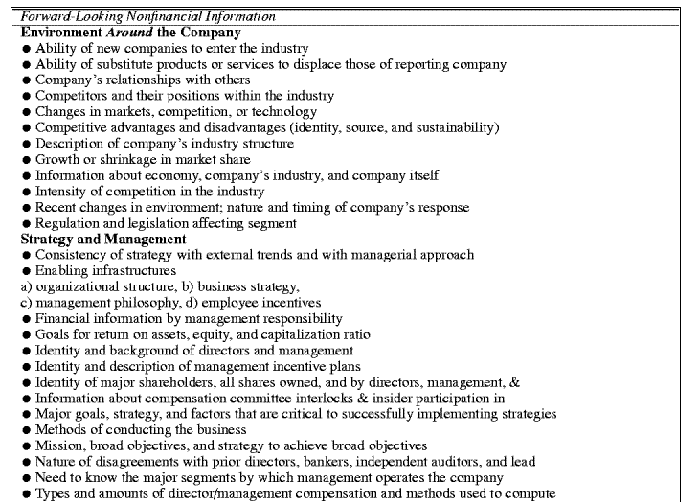

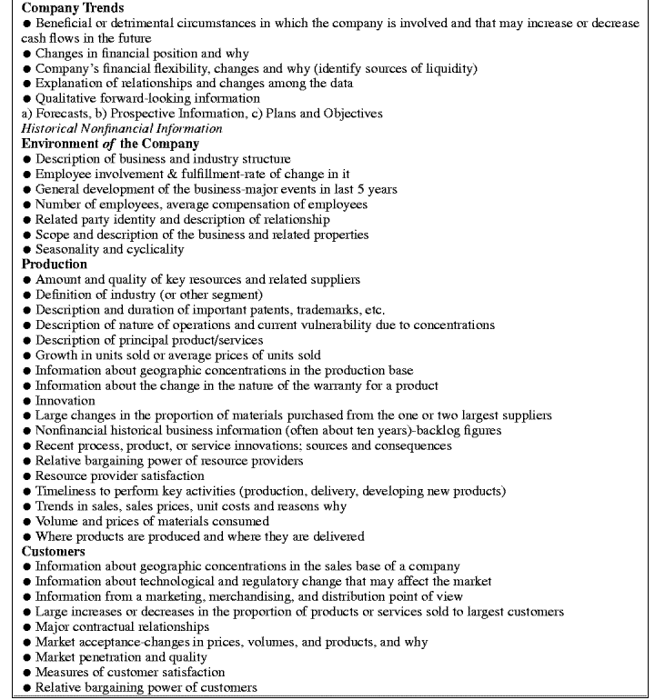

Appendix 3 Disclosure model Dutch Transparency Benchmark
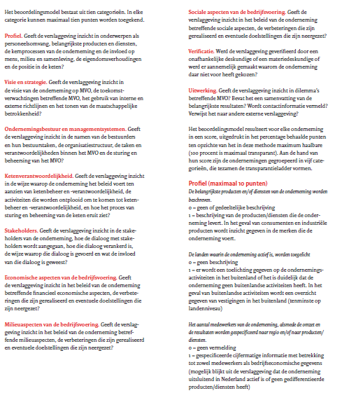
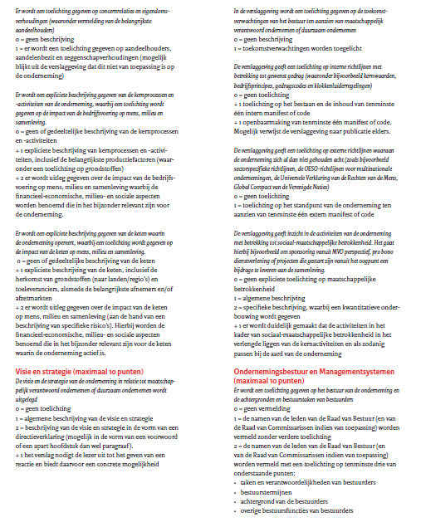
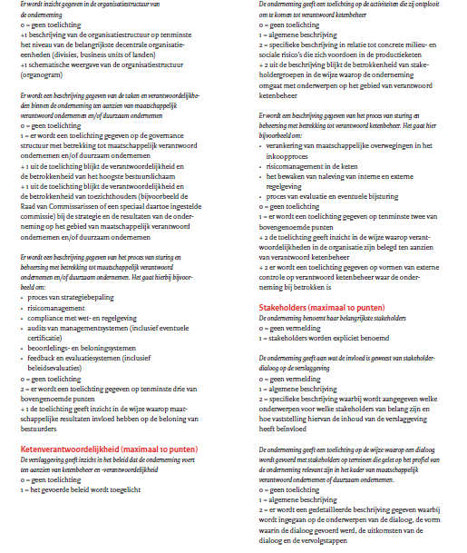
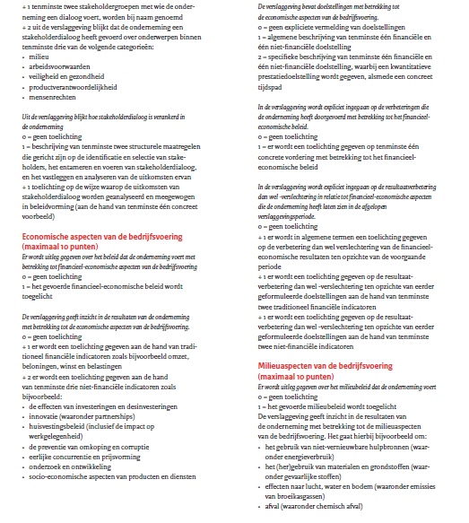

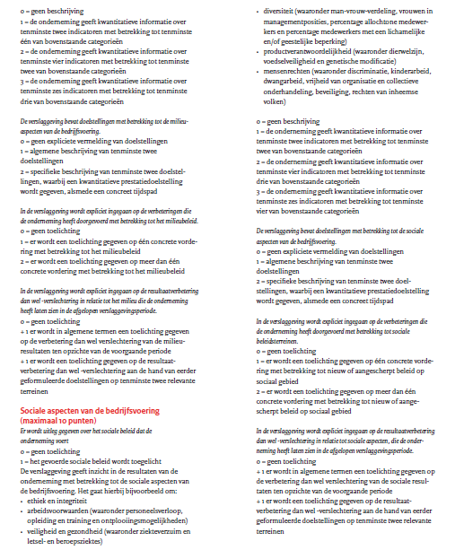

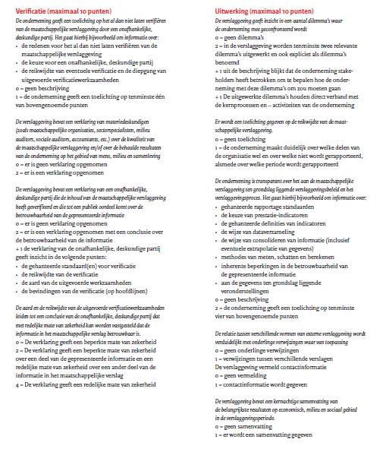

Appendix 4 Disclosure index Eng and Tao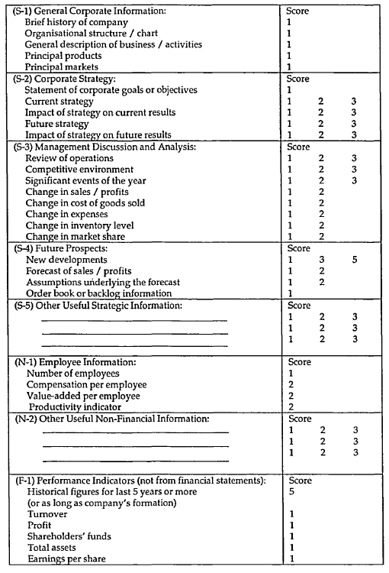

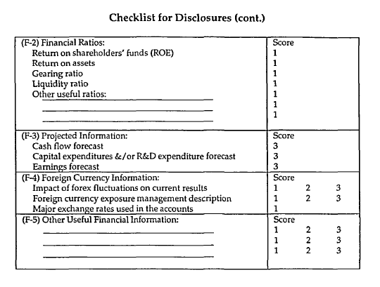

Appendix 5 Disclosure index Chau and Gray

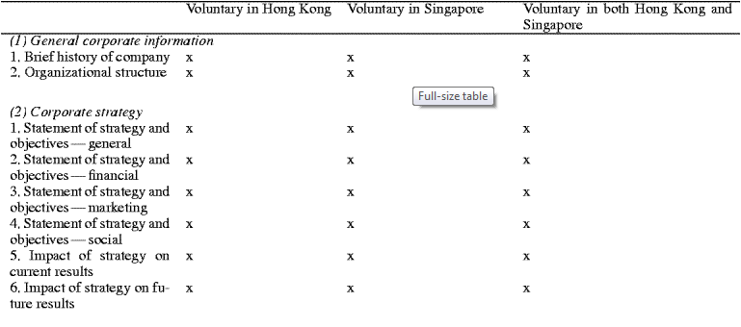

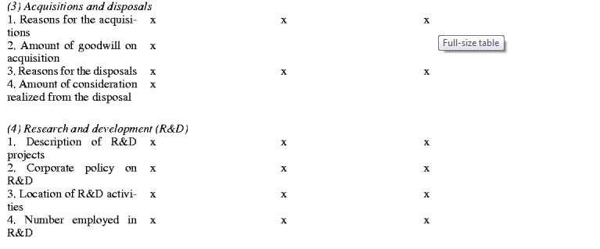

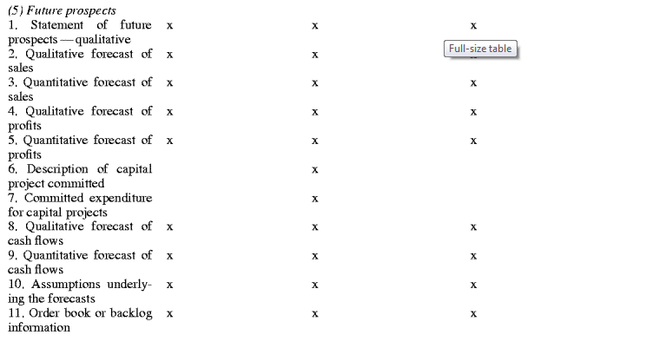

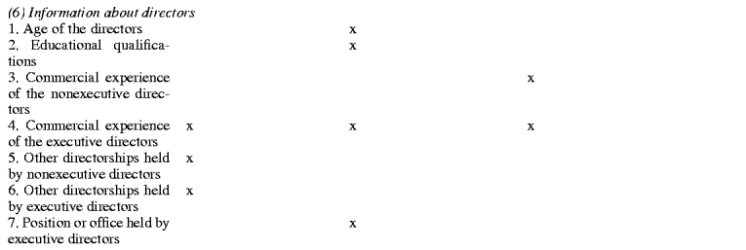

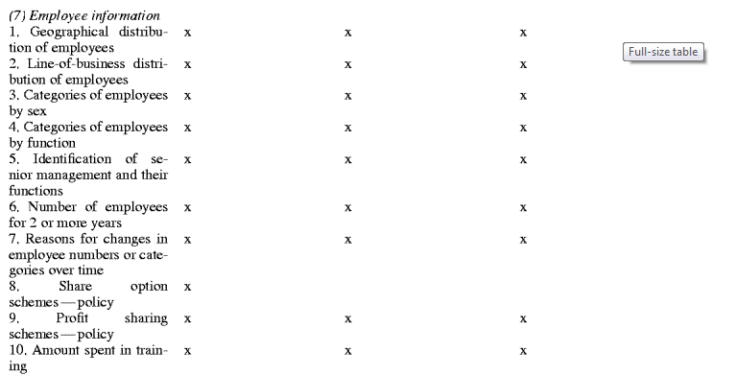

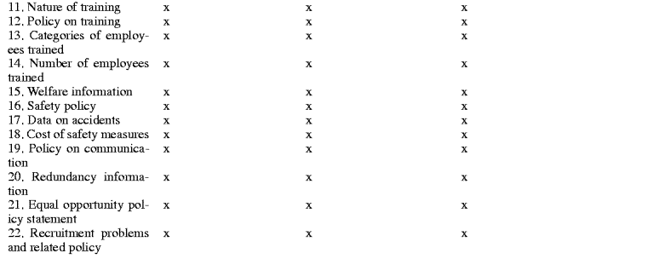

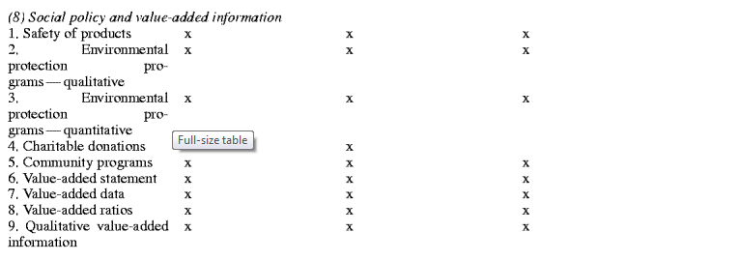

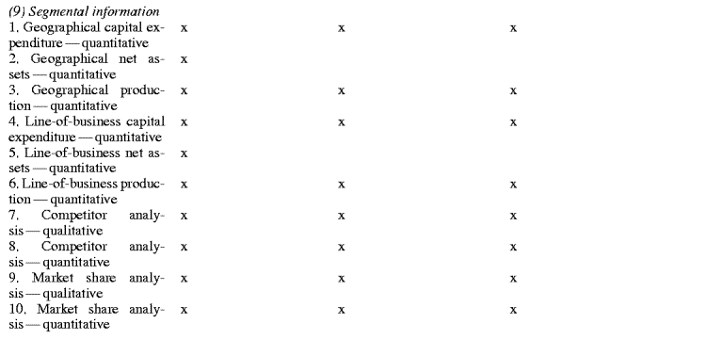

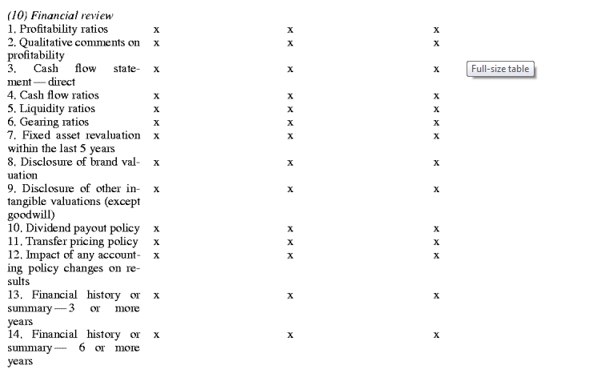

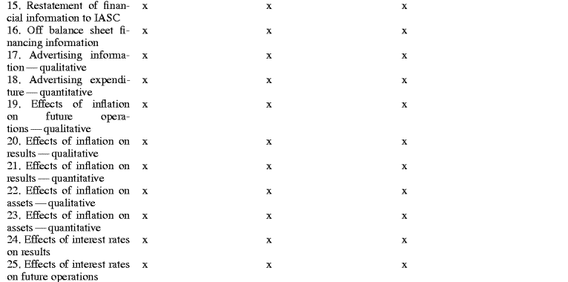

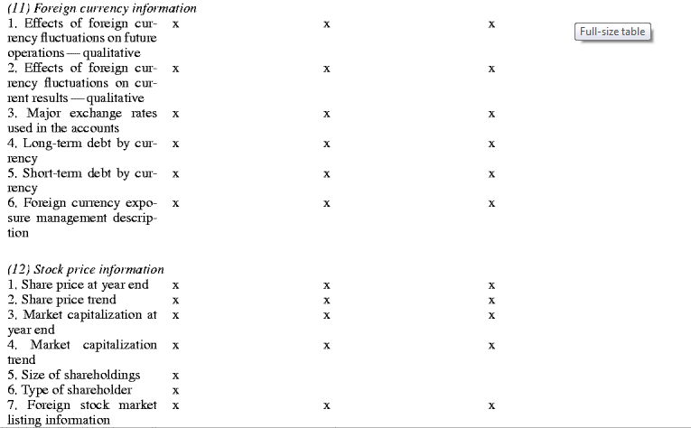

Appendix 6 Disclosure index Huafang and Jianguo
Items of voluntary disclosure index (DSCORE)
1. Background information
1.1 A statement of corporate goals is provided.
1.2 General statement of corporate strategy is provided.
1.3 Actions to be taken in future year discussed.
1.4 Competitive environment discussed.
1.5 Trade status discussed.
2. Business Information
2.1 Change in sales
2.2 Change in cost of goods sold
2.3 Change in gross profits
2.4 Change in administration expenses
2.5 Change in operating expenses
2.6 Change in financial expenses
2.7 Change in inventory
2.8 Change in accounts receivable
2.9 R&D expenditures
2.10 Comparison of previous plan to actual achievement
2.11 Operating plan next year
2.12 Future profits forecasted
2.13 Order backlog
3. Financial information
3.1 Liquidity ratio
3.2 Gearing ratio
3.3 Inventory turnover
3.4 Turnover of receivables
4. Non-financial information
4.1 Staff training
4.2 ISO or other quality awards
4.3 Other awards
4.4 Social commonweal
4.5 Brand
4.6 Names of the top five suppliers/customers
4.7 Enterprise culture
4.8 Environment protection

Appendix 7 Disclosure index Ghazali
