M A S T E R’S T H E S I S



International Trade and Economic Growth:Does is matter with whom you trade?

Name: Ruben Sicco Bakker
Address: Hoveniersstraat 74
3031 PE Rotterdam
The Netherlands
Student number: 303418
E-mail: ruben.s.bakker@gmail.com

Supervisor: Dr. J. Emami Namini
Academic year: 2010/2011
Hand-in-date: 09-06-2011
Master: International Economics and Business Studies
University: Erasmus University Rotterdam
Erasmus School of Economics

International Trade and Economic Growth:Does is matter with whom you trade?

By Ruben Bakker

Table of Contents

1. Introduction 2
2. Related literature 2
2.1 Foreign influence and welfare 2
2.2 Cross-border externalities and spillovers 2
2.3 Trade and growth 2
5. Data and methodology 2
5.1 Empirical approach 2
5.2 Empirical model 2
5.3 Independent variables: Structural Characteristics 2
5.4 Independent variables: Into The World 2
5.5 Interaction terms 2
5.6 Data 2
5.7 Descriptive statistics 2
6. Results 2
6.1 First evidence 2
6.2 Baseline regression and openness 2
6.3 Does is matter with whom you trade? 2
Conclusion 2
References 2
Appendix 2
List of Countries 2
Main trading partners: 2

1. Introduction

“No nation was ever ruined by trade” Benjamin Franklin

In an increasingly globalized world, economic developments in a country tend to be affected by economic developments in other countries. Economies become more integrated with each other and therefore also more dependent. Globalization can have different impacts on an economy depending on its size. The increasing dependency of economies on world markets can give larger economies more economic power than smaller economies. Larger economies can use the globalization process to increase their economic influence around the world. For example, China has invested more than 20 billion dollars in infrastructure developments in Africa in the last couple of years.
China’s influence in Ethiopia is overwhelming; its embassy is among the largest in the country. Chinese companies have become a dominant force; building power stations, mobile phone networks, schools and pharmaceutical plants (Leggett, 2005).

Figure 1 Trade between China and Africa
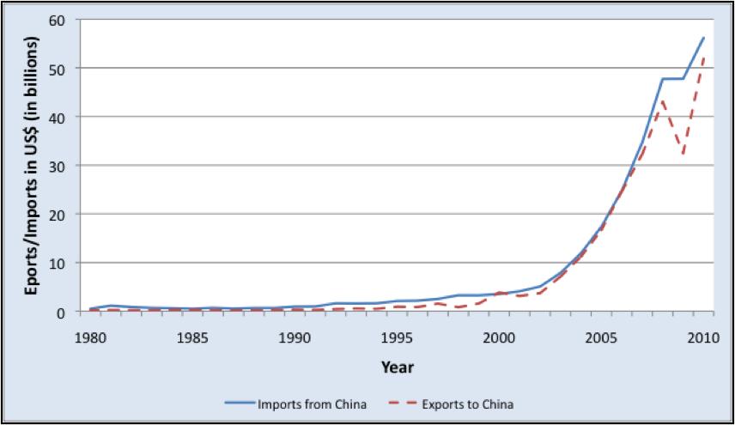

Course: IMF Direction of Trade Statistics

Figure 1 shows that the trade between China and Africa began to accelerate in about 2000. Between 2001 and 2006 Africa’s exports to China increased at an annual rate of over 40%. Also China’s direct investment in Africa increased significantly in these years, from around US$ 300 million in 2000 up to more that one US$ billion in 2005 (China’s National Bureau of Statistics).
China’s rising economic engagement is tied to conspicuously strategic goals, centered on access to energy and other scarce high-value commodities (Gill et al., 2007).
These developments raise the question whether trading with a larger economy influences the economic growth in the domestic country.

In October 2006 former prime minister of the Netherlands, Jan Peter Balkenende, used the term “VOC-mentality” as a reference to the Dutch entrepreneurial spirit. The VOC was the Dutch West Indian Company, and was known for its ruthless attitude towards its “trading partners” in the former colonial territories. For this reason, the public considered the quote of Balkenende to be very inappropriate. In their opinion trade should be ‘fair’ and the VOC-mentality should not be encouraged. Of course, Balkenende did not mean to make a reference to the unfair methods of the VOC, but just at the entrepreneurial spirit of exploring the world seas.
- Nowadays there are no colonies anymore, but this does not mean that one country cannot be influenced by another country. Therefore it is relevant to know whether it matters with whom you trade.

In this thesis I focus on the determinants of economic growth and look at how a country’s economic growth is influenced by other countries, especially by the main trading partners. I start with a baseline regression with only structural characteristics, like inflation rate, population growth and school enrollment, of the country itself. Then I add an openness term to look at the direct effect of a change in openness on the economic growth of a country. I also look at the long run effects by including one, two and three-year lags.
For the next step I determined the main trading partners with the use of the IMF Direction of Trade Statistics (DOTS). First, I determined the main trading partners for the years 1980 and 2000 based on exports and imports. Because I found very little variations in the most important trading partners between 1980 and 2000, I decided to use each country’s major trading partners in 2000 as an approximation for the same country’s major trading partners in each year of the time period 1970-2008. There was also very little variation between the main trading partners based on exports and the main trading partners based on imports. I decided to use the main trading partners based on exports because they proved to be a bit more stable over the years than the main trading partners based on imports.
For every country I calculated the difference in GDP with its main trading partner and added this variable into the regression equation together with an interaction term between the difference in GDP and the degree of openness. The interaction term proved to be positive, implying that for a given trade level, domestic economic growth becomes larger, the larger is the trading partner’s GDP.
I looked at some individual countries by calculating the elasticity of openness to domestic economic growth. For countries with a much smaller GDP level than its main trading partner I found lower elasticities than countries with very similar GDP levels than their main trading partners.
Put differently, this result implies that countries with lower GDP levels than their main trading partner benefit less from an increase in openness than countries with a very similar level of GDP. This is in line with the basis economic intuition that, like mentioned before, larger economies can profit more from an increase in openness than smaller economies because of their influence on world markets.
I also consider the difference in GDP per capita and an interaction term between the difference in GDP per capita and openness. Trading with a country that has a relatively high level of GDP per capita can have a positive or negative effect on domestic growth. In a Heckscher-Ohlin set-up, this country is relatively well endowed with capital relative to the domestic country, that is relatively well endowed with labor. In this case the domestic country specializes in labor-intensive activities and does not invest in human and physical capital, resulting in less economic growth than the foreign country.
The gains from trade, however, are expected to be large, since these two countries are very different; they specialize in different kind of goods. This can explain the negative coefficient for the difference in GDP per capita in the regressions, because this implies that the larger is the GDP per capita level of the main trading partner relative to the GDP per capita level of the domestic country, the higher is domestic growth. For the second interaction term I did not find a significant coefficient.

2. Related literature

2.1 Foreign influence and welfare

We speak of foreign influence when a foreign government or company actively influences decision makers in another country. This can be done in different matters. A powerful government can execute influence on another country by their allocation of foreign aid, by strategically giving contracts to foreign firms or by influencing the public opinion.
Antràs and Miquel (2008) focus on a specific kind of foreign influence: the strategic manipulation of election results. In a foreign country either the incumbent party or some opposition party, depending on their proposed policies, can be supported in their election campaign. Naturally, a foreign government will only take costly action to influence the electionresult in another country if they are not indifferent towards the outcome of the election. Therefore foreign meddling can only be rationalized when there are externalities on other countries.
Antràs and Miquel (2008) look closely at the welfare effects of foreign influence. For this they use a two-country version of a stylized probabilistic voting model of electoral competition based on that of Lindbeck and Weibull (1987). In this model there are two political parties in each country that announce some policy platform before the elections where after voters vote for whichever party offers them the highest (indirect) utility.
They conclude that the welfare effects of foreign trade depend strictly on the distribution of influence power. If one country has a significant larger influence power than the other country, its welfare level will increase at the expense of the other country. When the influence power is more evenly distributed, when both countries are influenced and influencing, foreign trade can increase world welfare.

Foreign influence can also be aimed at the political regime. Aidt and Facundo (2011) study a world in which FDI flows from a source country (the foreign country) to a destination country. The FDI is, together with domestic factors like land and labor, used for production. In most countries the land is owned by the local elite. The local government taxes the profit. In this case the policy preferences of the local elite and foreign investors coincide: they both want low taxes. As a consequence, foreign investors prefer a political regime where the local elite is in charge of the tax policy (autocracy) because this is likely to result in lower taxes than under democracy.
When we assume that the destination country is an autocracy with democratic tendencies, the foreign country can use three forms of intervention to represent their interests. First, foreign intervention can be aimed at consolidating the autocracy. This means supporting dictatorships, the United States did this in the Dominican Republic, Nicaragua and Cuba. The second form is overthrowing the newly established democracy when that occurs. And the third option is forcing a democratic government to offer tax concessions to foreign investors. Aidt and Facundo (2011) analyze which form is best in specific situations. For this they use a theoretical model based on that of Acemoglu and Robinson (2000).
They conclude that the pro-investor bias of the foreign government plays an important role in the decision. Furthermore, foreign coups tend to occur in relatively poor and unequal countries and require the cooperation of local elites. Also, foreign intervention aimed at consolidating an autocracy is the most likely strategy in situations where the local elite is weak.

2.2 Cross-border externalities and spillovers

Limão (2002) elaborates on whether linked agreements enforce more cooperative outcomes than non-linked agreements or that one goes at the expense of the other. Linkage means that trade agreements are made conditional on cooperation in non-trade issues (like environment standards). These non-trade issues may represent a cross-country externality that can be internalized through cooperation. Agreements must be self-enforcing since there is no supra-national authority to punish violators.
A model is used to answer the question whether linking trade policy to other cooperative agreements results in the creation of enforcement or just the reallocation of enforcement. This model consists of two symmetric countries with negative production externality with cross-border effects. Two enforcement regimes are compared with each other: linkage and no-linkage. The results show that when linked issues are independent and asymmetric, the reallocation of enforcement can be dominant. Linkage does create enforcement if the objective function is supermodular in linked policies. In other words: The trade related and non-trade related issues have to be strategic complements of each other for linkage to create enforcement. When this occurs, openness to trade can provide additional benefits because some externalities will be internalized and are therefore likely to become less harmful.

With the use of a dynamic trade game between North and South Alemdar and Özyildirim (1997) study the linkages between international trade, environmental degradation and growth. In this setup North is knowledge abundant and South has a comparative advantage in resource production. South starts with a low level of human capital and therefore specializes in low-skill/pollution-intensive goods. Authorities in the South are assumed to levy an export tax to internalize the local social cost of pollution.
They tend to capture the impact of the Northern growth on the quality of the Southern environment in the presence of tranboundary knowledge spillovers. Two different modes are considered, the noncooperative mode and the cooperative mode. In the noncooperative mode rival’s policies are taken as given and side effects are ignored. In the cooperative mode on the other hand all externalities are internalized. Agreements that are made between North and South may not always prove feasible because of the absence of an enforcement mechanism or high monitoring costs.
A genetic algorithm is used to solve open-loop differential games of infinite duration by which optimal policies are found. Their results show that North/South cooperation generates considerable welfare improvements for both countries. And even if they do not reach the first best solution, they may still achieve significant welfare improvements by increasing the knowledge flow from North to South.
Although this thesis does not focus on the influence of externalities and spillovers between countries directly, the difference in GDP per capita is considered to affect the GDP per capita growth of the domestic country.

2.3 Trade and growth

When we consider the relationship between trade and growth, trade can be divided into two parts: openness to trade and trade policy liberalization. Where openness to trade is measured by the ratio of trade to GDP and trade policy liberalization refers to how open a country is to trade with respect to its trade policy (Sachs and Warner, 1995). Winters (2004) reviews the literature on both aspects. The effect of trade policy liberalization on the income level can be either a growth effect or a level effect that implies only a boost in the income level but no increase in the growth rate of the income level. The US income level growth rate did not show anypermanent changes over the period 1880-1987, meaning that either the trade policy liberalization in that period had no effect on the income level growth rate, or that the effect was off-set by other developments.
Basic economic reasoning tells us that trade policy liberalization is likely to have a positive effect on an economy. Greater exposure to ideas and technologies increases the rate of technological progress, which is the main engine of economic growth. Furthermore, trade policy liberalization can provide significant efficiency gains in the allocation of the capital stock(Lopez, 2005).
Establishing an empirical link between trade policy liberalization and growth is faces with at least two difficulties. First, there is the definition of ‘openness’ since trade policy (import and export tariffs and taxes, quota’s etc) is hard to define in a number. Second, causation is extremely difficult to prove empirically. Even though lags can be used, it is still hard to isolate the effect of trade policy liberalization (Frankel and Romer, 1999). First looking at the relationship between trade policy liberalization and productivity can largely circumvent this difficulty because productivity is one of the main determinants of economic growth and countries can boost their productivity by trading with countries that have large ‘stocks of knowledge’ (Bayoumi et al., 1999).
Also other factors can play a role. Inflation is likely to be lower in open economies, since real depreciation is assumed to become more costly when a country becomes more open (Romer, 1993). Trade policy liberalization can increase investments, which in turn show a positive link with economic growth(Wacziarg and Welch, 2008).
Winters (2004)concludes that the empirical proof concerning the effect of trade policy liberalization remain uncertain, although the preponderance of evidence favors a positive effect on growth.

Lòpez (2005) investigates whether the theory about the relationship between openness to trade and economic growth is in line with the recent findings. Especially the finding that exporting firms where already more productive than non-exporting firms before they entered the export market (Melitz, 2003; Aw and Hwang, 1995). This raises the question whether exporting results in an increase in productivity or the other way around.
In the traditional models of international trade, openness to trade from an autarkic situation generates a static improvement in the allocative efficiency of the economy, but does not increase the economic growth. The marginal product of capital (MPK) is assumed to decline to zero as the capital-labor ratio increases indefinitely. Specific mechanisms to avoid the MPK from going to zero are used in endogenous growth models. In these models trade liberalization leads to level effects as well as growth effects.
Empirical cross-country analyses that havebeen done on the relationship between measures of openness and growth usually find a positive relationship.Edwards (1993), however, who reviewed the most important cross-country studies published until the early 1990s, concludes that most of these studies suffer serious problems. The theoretical foundations are very simplistic; they ignore important potential determinants of growth such as educational attainment, and they do not identify the exact mechanism by which trade affects growth.

Possible microeconomic explanations for the finding that exporting firms are more productive than non-exporting firms, are self-selection and learning-by-exporting. If productivity increases with exporting then this would support the learning-by-doing hypotheses and the idea that trade increases growth. It is also consistent with the existence of economies of scale (Lopez, 2005).
When firms decide to enter the export market in the near future (self-selection) they will invest in technology to increase the quality of the goods produced for export, and invest in R&D. Because of this their productivity increases even before they actually enters the export market.
Lòpez (2005) concludes that the causal link between trade and growth runs from the former to the latter. This link is not directly empirically tested in this thesis; however, we do test the relationship between GDP per capita growth and the degree of openness of the country.

Arora and Vamvakidis (2005) suspected that the economic growth of a country not only depends on its openness, but on the economic conditions among its trading partners as well. This is based on the commonly held view that with growing economic integration across countries, economic developments in a country are significantly influenced by developments abroad.
They have done some empirical research on this with the use of fixed-effects panel regressions. 101 industrial and developing countries where used for the period 1960-1999 and all the data where collected from the World Development Indicators (WDI). Their regressions show that the country’s growth is positively correlated with the economic growth of the main trading partner and with trade with relatively rich countries. They claim that the underlying reasons for this are demand effects and technological spillovers.
The country’s growth is also positively correlated with the growth in countries that are close to it. This may be because of regional trends as well as the fact that countries trade more with countries that are nearby. Arora and Vamvakidis (2005)do not focus on the impact of the relative size of the trading partner’s economy. The size of the trading partner’s economy can be considered to be an approximation for its market power. A big economy, like that of Japan, has a larger influence on international goods prices and can also use its economic power to influence trade policies in foreign countries (Antràs and Miquel, 2008; Aidt and Albornoz, 2011). Therefore it is interesting to look at the relationship between the growth of the domestic country and its economic size relative to that of its main trading partners.
In the empirical part of this thesis the model of Arora and Vamvakidis (2005) is extended with various additional variables, including the differences in total GDP and GDP per capita between the home country and its trading partner(s).

5. Data and methodology

5.1 Empirical approach

This chapter focuses on the empirical research I have done on the determinants of the economic growth of a country. The empirical approach is based on that of Arora and Vamvikidis (2005). I used the 50 most open economies for the empirical research. This way the research is kept manageable without affecting the relevant randomness of the selected countries. The countries include developed countries as well as developing countries. The dependent variable is supposed to reflect the economic growth in a country, for this the GDP per capita growth is used. The determinants of GDP per capita growth are estimated with a panel regression, which allows an analysis of a cross section of countries over time.

5.2 Empirical model

The empirical framework is a growth regression with the following specification:

(1)
where t stands for the year and i for the country. α is the matrix of constant terms, β is the matrix of parameters to be estimated and u is the error term. X consists of all the independent variables.

5.3 Independent variables: Structural Characteristics

The first five independent variables focus on some structural characteristics of the country itself. First the initial GDP per capita, with this we test the convergence property. This empirical hypothesis states that the lower the starting level of GDP per capita, the higher is the predicted growth rate. The convergence property derives in the neoclassical model from diminishing returns to capital (Barro, 1996). Thus,we assume initial GDP per capita to have a negativeimpact on GDP per capita growth.
- Furthermore, countries with high GDP per capita levels, like the United States and Japan, show low economic growth levels relative to countries with low GDP per capita levels but fast economic growth, like India and China. Initial GDP per capita is also considered to be a determinant of economic growth by other empirical researches (Barro, 1996;Arora and Vamvikidis, 2005).
The second independent variable is the population growth. This variable is also used in previous empirical studies on the determinants of economic growth (Barro, 1996, 1991;Arora and Vamvikidis, 2005; Brander and Dowrick, 1993). Although some population growth can be harmless or even stimulating for the economy, a large population growth is considered to be damaging for the economy when it is not combined with simultaneous investments in education (Barro, 1996). Lags are used because an increase in population growth is likely to have a different effect on economic growth after some years.
The third independent variable reflects the investment in physical capital as a percentage of GDP. Although common literature assumes a positive relationship between the accumulation of physical capital and GDP per capita growth, the direction of the relationship is ambiguous. Simple causality tests (Blomström et al., 1993) suggest that growth induces capital formation more than capital induces subsequent growth. We have to keep this in mind when interpreting the regression results.Investment in physical capital is also used as a determinant of economics growth in earlier empirical studies (Barro, 1996, 1991;Arora and Vamvikidis, 2005; Blomström et al., 1993).
Inflation is the fourth independent variable. Traditionally, inflation is considered to be harmful for the economy. Also with this characteristic the direction of the relationship is ambiguous. Barro (1995) found some evidence for causation from higher long-term inflation to reduced growth and investment. Clear evidence for the adverse effects of inflation on economic growth is only displayed in times of (very) high inflation. Because inflation can affect economic growth over a period of years, lags are used to better understand this relationship.
Unlike Arora and Vamvikidis (2005) I use primary instead of secondary school enrollment as the fifth independent variable. This type of human capital accumulation is assumed to have a significant, positive effect on economic growth (Barro and Lee, 1994). I used primary school enrollment instead of secondary school enrollment because not having a primary education can in some way tell you more about the level of human capital in a country then not having a secondary school enrollment.

5.4 Independent variables: Into The World

Trade plays an important role in the economic developments in a country. Therefore the degree of openness is likely to influence economic growth. A positive relationship between openness and economic growth is found in multiple empirical studies. Nevertheless, the question remains what the dynamics behind this relationship are. Does openness to trade by itself increase economic growth or does it affects the productivity and thereby the economic growth only indirectly? Or are open economies already more productive than closed economies? The answers to these questions remain indecisive in the literature (Lopez, 2005; Edwards, 1997).
Earlier the suggestion is mentioned that countries can influence other countries and that the welfare effects of this depend on the distribution of influence power. To test this hypothesis empirically I use GDP as an approximation for influence power and GDP per capita growth as an approximation for the welfare effects. Large economies are likely to have a bigger influence on world prices than smaller countries. Large economies also have the advantage that they have an important vote in international organizations like the United Nations, the World Trade Organization and the G20. Whether they use this influence power for their own interest and how they do this is hard to tell because it is hard to quantify. In this thesis the relative influence power of a country is quantified by the difference in total GDP with its main trading partner.
When determining the main trading partners, I first looked at both imports and exports of all the countries and arranged the trade flows from large to small. I calculated this with the use of the IMF Direction of Trade Statistics (DOTS). The top-5 trading partners where very similar for exports and imports. I decided to use exports to determine the main trading partnersbecause they proved to be a bit more stable over the years than the main trading partners based on imports. Thus, the main trading partner is the country to which a country exports the most products. These data are only available from 1980 on. Since for most countries the main trading partners stayed the same between 1980 and 2000, I decided to use the main trading partners in 2000 as an approximation for the main trading partners over the period 1980-2008.
It is also interesting to know whether it matters whether the main trading partners are wealthier then the domestic country or not. Having rich trading partners can have the benefit of knowledge and technology spillovers. The difference in wealth is quantified by the difference in GDP per capita between the domestic country and the average of its two most important trading partners. I calculated it this way, because the difference in GDP per capita between the two most important trading partners is relatively small and the difference in GDP per capita of the three most important trading partners significantly larger.

5.5 Interaction terms

In a world where countries hardly interact with each other, foreign influence is unlikely to have a significant impact on the distribution of welfare. This impact can be assumed to increase when a country becomes more open to foreign trade. More foreign trade is associated with more foreign interests and therefore a greater incentive to execute foreign influence. To test whether the effect of foreign influence increase as the degree of openness increases, interaction term 1 is used:

Interaction term 1: OPEN*∆GDP (2)

Table 1 gives some insight in the values of the differences in total GDP. Note that in this thesis differences are always calculated by subtracting the value of the foreign country from the value of the domestic country. The table shows that there is a large spread in the difference in total GDP. The difference in GDP is especially large for countries that trade intensively with the United States. The 10 countries with the largest difference in GDP all have the United States as its most important trading partner.

Table 1Very different/similar trading partners with respect to total GDP
Total GDP and GDP per capita differences
2000 | Very different trading partner w.r.t. total GDP
 | Maldives | Guyana
Most important trading partner (exports) | United States | United States
ΔGDP | -9.90E+12 | -9.90E+12
ΔGDPPC | -32787.46 | -34138.37
 | Very similar trading partner w.r.t. total GDP
 | Singapore | Macedonia
Most important trading partner (exports) | Malaysia | Serbia
ΔGDP | -1.07E+09 | -2.50E+09
ΔGDPPC | 18988.79 | 973.81

Earlier we assumed that trading with countries that have a higher GDP per capita level could have a positive effect on the domestic economic growth. To test whether this effect increases with openness, interaction term 2 is used:

Interaction term 2: OPEN*∆GDPPC (3)

Table 2 shows the minimum and maximum values for the difference in GDP per capita. Note that the difference in GDP per capita is, in general, smallwhen the main trading partner is a neighboring country.

Table 2Very different/similar trading partners with respect to GDP per capita
Total GDP and GDP per capita differences
2000 | Very different trading partner w.r.t. GDP per capita
 | Vietnam | Cambodia
Most important trading partner (exports) | Japan | United States
ΔGDP | -4.64E+12 | -9.90E+12
ΔGDPPC | -36387.7 | -34794.36
 | Very similar trading partner w.r.t. GDP per capita
 | Lithuania | Ireland
Most important trading partner (exports) | Latvia | United Kingdom
ΔGDP | 3.60E+09 | -1.38E+12
ΔGDPPC | -34.95 | 290.82

5.6 Data

All the quantitative data used come from the World Development Indicators (WDI). As mentioned before, the IMF Direction Of Trade Statistics database (DOTS) is used to determine the main trading partner(s).

Table 3Variables and descriptions
variable | abbreviation | definition | source
GDP per capita growth | GDPPCG | annual GDP per capita growth (constant 2000 US$) | WDI
GDP per capita | GDPPC | GDP per capita (constant 2000 US$) | WDI
LN(GDP per capita) | LNGDPPC | logarithm of GDP per capita (constant 2000 US$) | -
GDP | GDP | GDP (constant 2000 US$) | WDI
GDP difference | ΔGDP | country's GDP-GDP main trading partners | -
GDP per capita difference | ΔGDPPC | country's GDP per capita -average of the GDP per capita of the two most important trading partner | -
population growth | POP | annual population growth | WDI
investment/GDP | INV | gross capital formation (% of GDP) | WDI
inflation rate | INFL | annual inflation rate (GDP deflator) | WDI
primary school enrollment | EDU | gross primary school enrollment (in %) | WDI
openness | OPEN | (value of imports + value of exports)/GDP | WDI

When no source is mentioned for a variable, the variable is calculated with the use of other variables mentioned in the table.

5.7 Descriptive statistics

The following tables show the descriptive statistics of the data used. The averages are over all countries and years. The numbers of observations vary because of missing observations in the data. Note that the data for the (second) most important trading partner begins in 1980, while all the other data begin in 1970.

Table 4 GDP per capita growth, GDP per capita, population growth and investment
 | GDPPCG | GDPPC | POP | INV
Average | 2.66 | 5662.32 | 1.43 | 26.47
Median | 2.91 | 2113.42 | 1.35 | 24.76
Maximum | 90.14 | 56624.73 | 11.18 | 113.58
Minimum | -50.05 | 62.24 | -5.01 | -11.68
Number of observations | 1532 | 1520 | 1939 | 1463

Table 5 Inflation, primary school enrollment and openness
 | INF | EDU | OPEN
Average | 53.22 | 102.97 | 1.26
Median | 5.54 | 102.37 | 1.20
Maximum | 13611.63 | 232.84 | 4.38
Minimum | -29.17 | 13.55 | 0.14
Number of observations | 1528 | 1347 | 1481

Table 6 Total GDP
 | GDP 50 most open economies | GDP main trading partners
Average | 3.08E+10 | 2.72E+12
Median | 4.22E+09 | 1.28E+12
Maximum | 4.49E+11 | 1.17E+13
Minimum | 9.22E+07 | 4.96E+09
Number of observations | 1530 | 1662

Table 7 GDP per capita two most important trading partners
 | GDP per capita most important trading partners | GDP per capita second most important trading partner
Average | 18291.15 | 14993.26
Median | 19441.14 | 16249.61
Maximum | 40707.00 | 40707.00
Minimum | 122.29 | 122.29
Number of observations | 1622 | 1583

Table 8 Differences in total GDP and GDP per capita
 | ΔGDP | ΔGDPPC
Average | -2.84E+12 | -11282.73
Median | -1.30E+12 | -11664.32
Maximum | 9.54E+09 | 32176.31
Minimum | -1.167E+13 | -37111.59
Number of observations | 1388 | 1333

6. Results

6.1 First evidence

The relationship between openness and economic growth is not as straightforward as is may seem. As mentioned before, an increase in openness does not necessarily result in an increase in economic growth; it may also matter with whom you trade and what you trade. In this thesis we explicitly look at whether the main trading partner(s) matters for economic growth. Below are some figures that show the GDP per capita growth rate and the degree of openness for the year 2000. In figure 2 the GDP per capita growth and the degree of openness is displayed for the 10 countries with the most different trading partner with respect to total GDP. It shows that for these countries GDP per capita growth is negatively correlated with the degree of openness.

Figure 210 countries with most different trading partner with respect to total GDP in 2000
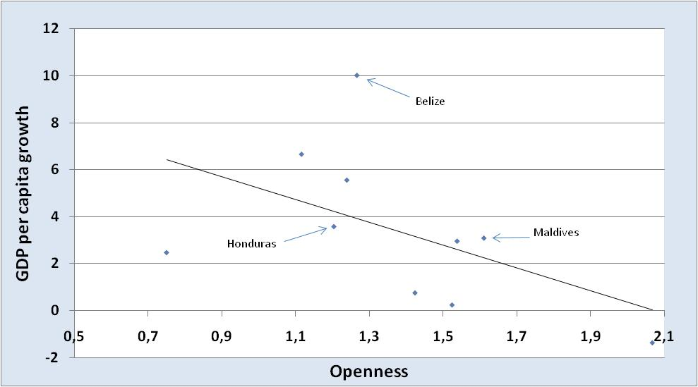

- 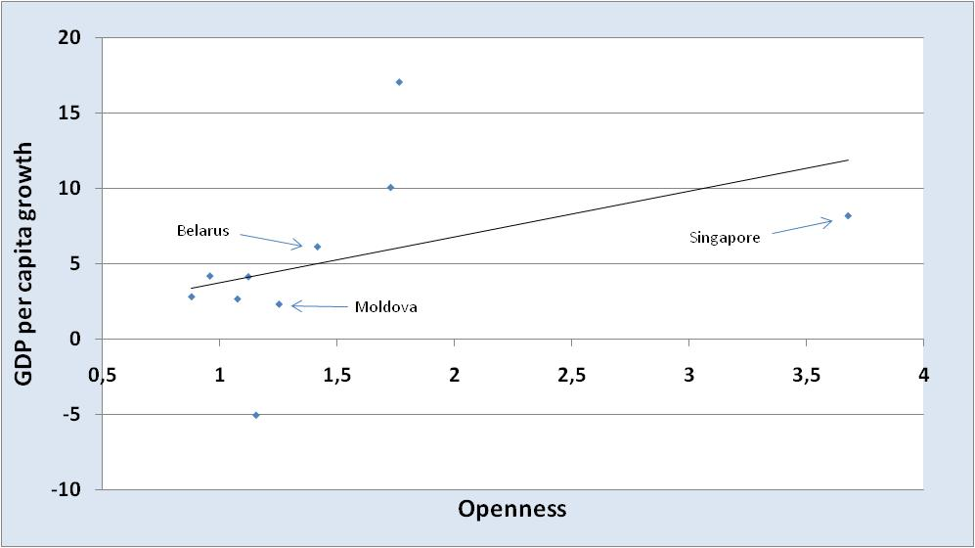Figure 310 countries with most identical trading partner with respect tototal GDP in 2000

Figure 3 shows that for countries with the most identical trading partner with respect to total GDP, GDP per capita growth is positively correlated with the degree of openness. These finding doesn’t necessarily imply that an increase in openness leads to an increase or decrease in GDP per capita growth, but it does tell us that the difference in GDP plays a role in this relationship.

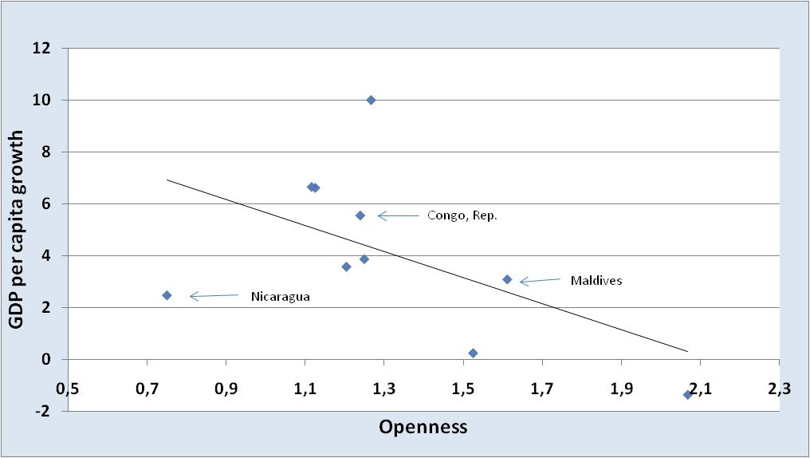Figure 410 countries with most different trading partner with respect toGDP per capita in 2000

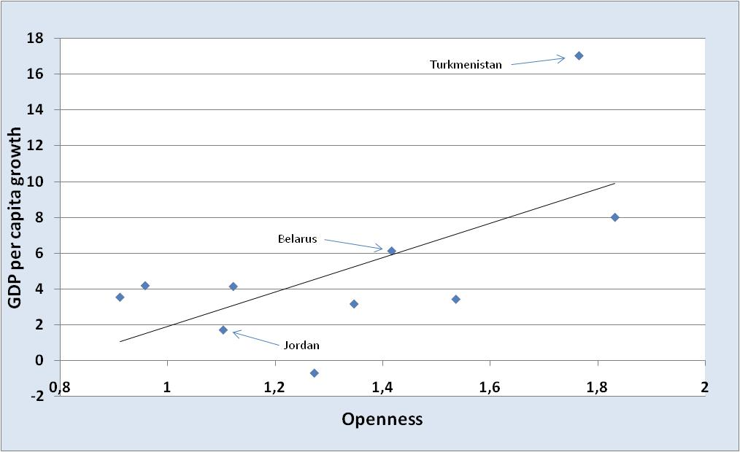Figure 510 countries with most identical trading partner with respect toGDP per capita in 2000

Also in figure 4 and 5 different countries are selected. Figure 4 displays the 10 countries with the most different trading partners with respect to GDP per capita. For these countries GDP per capita growth is negatively correlated with the degree of openness. Figure 5 shows apositive correlation for the 10 countries with the most identical trading partner with respect to GDP per capita.

6.2 Baseline regression and openness

In column (1) of table 9 the baseline regression is shown that uses the regression equation:

(4)

where t stands for the year and i for the country. LNGDPPC stands for the logarithm of GDP per capita; POP for population growth (in percentages); INV for gross domestic investment (percentage of total GDP); INFL for inflation (in percentages) and EDU stands for primary school enrollment (in percentages).Note that, in general, the number of observations can differ quite a lot; this is due to missing observations in the data.
Table 9 shows that only the impact of population growth is not significant. The coefficient for LNGDPPC is positive, and therefore not in line with the convergence hypothesis. This coefficient is negative in other empirical studies (Arora and Vamvikidis, 2005; Barro, 1996).
POP is not significant; this is in contrast with other empirical studies (Arora and Vamvikidis, 2005; Barro, 1996, 1991; Blomström et al., 1993). This can be due to the fact that they use more countries, for example Arora and Vamvikidis (2005) uses 101 countries against 50 in this regression.
An increase in investment as a percentage of GDP of 1 percent is correlated with an increase of 0.13 percent in domestic growth. This positive correlation is in line with empirical work by Barro (1996, 1991); Blomström et al. (1993) and Arora and Vamvikidis (2005). Note that in every regression table in this thesis the coefficient of ‘INV’ is positive and significant.
The impact of inflation on GDP per capita growth is small, but significant, like in other empirical studies (Arora and Vamvikidis, 2005; Barro, 1996). Inflation affects the degree of macroeconomic stability and can therefore be harmful for the economy. Nevertheless, it’s still hard to determine exactly what the direct effect of an increase in inflation is. Education is positively correlated with domestic growth. This positive correlation is also found in other empirical work (Arora and Vamvikidis, 2005; Barro and Lee, 1994) and makes sense because education increases the productivity of workers.

Dependent variable: GDP per capita growth
 | (1) | (2)
constant | -7.59*** | -8.45***
 | ( -4.81 ) | ( -4.7 )
LNGDPPC_{i,t} | 0.29** | 0.26 *
 | ( 2.33 ) | ( 1.86 )
POP_{i,t} | 0.06 | -0.04
 | ( 0.49 ) | ( -0.27 )
INV_{i,t} | 0.13 *** | 0.12***
 | ( 7.47 ) | ( 6.38 )
INFL_{i,t} | -1.67E-03 *** | -1.64E-03***
 | ( -5.28 ) | ( -5.23 )
EDU_{i,t} | 0.04 *** | 0.05***
 | ( 3.71 ) | ( 3.65 )
OPEN_{i,t} |  | 0.60
 |  | ( 1.59 )
adjusted R-square | 0.15 | 0.15
number of observations | 1131 | 960
time period  ***, **, * denote significance levels of respectively 99%, 95% and 90%. Time-fixed effects are included. | 1970-2008 | 1980-2008  ***, **, * denote significance levels of respectively 99%, 95% and 90%. Time-fixed effects are included.LNGDPPC_{i,5-year initial value} refers to the initial value of the 5-year period: the value of the first observation in the 5-year period.
Dependent variable: GDP per capita growth
 | (1) | (2)
constant | -8.24 *** | -9.39***
 | ( -3.02 ) | ( -2.80 )
LNGDPPC_{i,5-year initial value} | 0.24 | 0.24
 | ( 1.1 ) | ( 0.85 )
POP_{i,5-year average} | 0.30 | 0.22
 | ( 1.32 ) | ( 0.85 )
INV_{i,5-year average} | 0.20 *** | 0.19***
 | ( 6.57 ) | ( 5.57 )
INFL_{i,5-year average} | -2.22E-03*** | -2.08E-03***
 | ( -2.99 ) | ( -2.62 )
EDU_{i,5-year average} | 0.03 | 0.03
 | ( 1.44 ) | ( 1.26 )
OPEN_{i,5-year average} |  | 0.83
 |  | ( 1.04 )
adjusted R-square | 0.30 | 0.30
number of observations | 217 | 180
time period | 1974-2004 | 1984-2004
Table 9Baseline regression and opennessTable 10 Baseline regression with 5-year averages

In column (2) of table 9the openness variable is added to the regression equation:

(5)

where OPEN stands for openness. We see that the coefficient for openness is positive but insignificant; an increase in openness has no significant impact on the GDP per capita growth in that same year. Later we will see that this changes when we also consider the long run effects of an increase in openness.
To test the robustness of the regression, we take the 5-year averages and see whether the coefficients stay the same, in qualitative sense. Table 10 shows that for most of the variables this is indeed the case.

Some characteristics are likely to have a very different effect after some years. In table 11 we see that POP becomes significant after 3 years. This makes sense because an increase in the population growth will need some time to have an assignable impact on economic growth. Openness becomes significant after one year. Even after controlling for the other growth determinants, openness is positively correlated with GDP per capita growth. This is the same in the regression results of Arora and Vamvikidis (2005). A 1 percent increase in openness is correlated with as much as a 0.83 percentincrease in domestic growth after one year. This correlation stays stable in the next two years.
In the regressions with openness as well as in the regressions without openness, the impact of inflation in only significant after one year. An increase in inflation needs little time to affect the economy, because it is immediately reflected in price changes. Because inflation rates tend to fluctuate a lot, it is hard to find long-term effects of an increase in inflation. The coefficients for investment as well as education don’t change much over the years. Investments in (human and physical) capital seem to have a stable and long term effect on economic growth.

Table 11Baseline regression with openness and lags
Dependent variable: GDP per capita growth
 | (1) | (2) | (3) | (4) | (5) | (6)
constant | -8.23*** | -8.28*** | -7.75*** | -9.15*** | -7.87*** | -8.77***
 | ( -5.12 ) | ( -5.06 ) | ( -4.69 ) | ( -5.04 ) | ( -4.64 ) | ( -5.03 )
LNGDPPC_{i,t} | 0.35*** | 0.33*** | 0.31** | 0.30** | 0.20 | 0.24 *
 | ( 2.8 ) | ( 2.63 ) | ( 2.4 ) | ( 2.12 ) | ( 1.53 ) | ( 1.76 )
POP_{i,t-1} | 0.06 |  |  | -0.05
 | ( 0.5 ) |  |  | ( -0.39 )
POP_{i,t-2} |  | -0.13 |  |  | -0.35***
 |  | ( -1.04 ) |  |  | ( -2.84 )
POP_{i,t-3} |  |  | -0.40*** |  |  | -0.37***
 |  |  | ( -3.21 ) |  |  | ( -2.88 )
INV_{i,t} | 0.13*** | 0.13*** | 0.14*** | 0.12*** | 0.09*** | 0.13***
 | ( 7.28 ) | ( 7.32 ) | ( 7.56 ) | ( 6.32 ) | ( 4.94 ) | ( 7.4 )
INFL_{i,t-1} | -8.03E-04** |  |  | -7.82E-05**
 | ( -2.54 ) |  |  | ( -2.51 )
INFL_{i,t-2} |  | -3.76E-04 |  |  | -4.20E-04
 |  | ( -1.26 ) |  |  | ( -1.54 )
INFL_{i,t-3} |  |  | -2.55E-04 |  |  | -6.21E-05
 |  |  | ( -0.83 ) |  |  | ( -0.21 )
EDU_{i,t} | 0.05*** | 0.05*** | 0.05*** | 0.05*** | 0.06*** | 0.06***
 | ( 3.74 ) | ( 4.04 ) | ( 4.01 ) | ( 3.71 ) | ( 4.52 ) | ( 4.14 )
OPEN_{i,t-1} |  |  |  | 0.83**
 |  |  |  | ( 2.17 )
OPEN_{i,t-2} |  |  |  |  | 0.89**
 |  |  |  |  | ( 2.45 )
OPEN_{i,t-3} |  |  |  |  |  | 0.80**
 |  |  |  |  |  | ( 2.09 )
adjusted R-square | 0.13 | 0.12 | 0.08 | 0.13 | 0.13 | 0.14
number of observations | 1110 | 1077 | 1045 | 944 | 929 | 912
time period | 1971-2008 | 1972-2008 | 1973-2008 | 1980-2008 | 1980-2008 | 1980-2008
***, **, * denote significance levels of respectively 99%, 95% and 90%. Time-fixed effects areincluded.

6.3 Does is matter with whom you trade?

In this paragraph we look at whether the differences in total GDP and GDP per capita between the domestic country and its main trading partner(s) matter for the country’s economic growth. Note that the differences are calculated by subtracting the value of the foreign country from the value of the domestic country. So when, for example, the GDP difference is positive, this means that the domestic country’s GDP is larger than that of its main trading partner. In the descriptive statistics you can see that, in general, the trading partner’s total GDP and GDP per capita are larger than that of the domestic country. This makes sense because countries with high total GDP and GDP per capita levels, like the United States, Japan and Germany, are very common main trading partners.
Column (1) in table 7 first shows a regression where the GDP difference and interaction term 1 are included:

(6)

An increase in the difference in total GDP is correlated with a very small decrease in domestic growth. This implies that countries with lower GDP levels than its main trading partner exhibit higher domestic growth rate than countries with higher GDP levels than their main trading partner. Because a higher total GDP level can be associated with a larger influence on world markets, the difference in GDP level between two countries can also be reflected in a difference in prices. These differences in prices make it more attractive for both the small and the larger country to trade with each other, because the gains from trade can be expected to be higher. Therefore it is in line with basic economic reasoning that the coefficient for the difference in GDP is negative.
Interaction term 1 is positive, implying that the impact of the difference in GDP on domestic growth increases as openness increases.
Table 12 shows that the results for the GDP difference as well as for interaction term 1 are robust. And table 14 shows us that the coefficients remain stable also after some years. Because the coefficients are significant, it makes sense to calculate the elasticities. For Guyana, a country with a much smaller GDP level than its main trading partner, the United States, the elasticity is -0,27. This implies that an increase in openness of 1% leads to a decrease in domestic growth of 0,0027%. For Singapore, a country with a very similar level of GDP relative to its main trading partner, an increase in openness of 1% leads to a increase in domestic growth of 0,0069%. These elasticities are in line with what is found in the first evidence: countries with very different trading partners with respect to GDP show lower domestic growth rates when openness increases, while countries with very similar trading partners with respect to GDP show higher domestic growth rates when openness increases. Thus, the data support the view that it matters for economic growth with whom you trade.

In column (2) of table 12, the GDP per capita differences and interaction term 2 are used:

(7)

The difference in GDP per capita is not significant, implying that the difference in GDP per capita between the domestic country and its two most important trading partners does not matter for the domestic growth in that same year. However, as shown in table 15, this coefficient becomes significant after one year. The coefficient in negative, implying that trading with a country with a higher GDP per capita is correlated with a higher domestic growth level than trading with a country with a lower GDP per capita level. Apparently the benefits of trading with a relative wealthy country, possible demand effects and knowledge and technology spillovers, needs some time to influence the domestic economy. Arora and Vamvikidis (2005) find a similar relationship, only they used ratios of GDP per capita instead of differences.
The interaction term, however, stays insignificant, even after three years. This can be explained by the economic intuition that in this case it matters more what you trade that how much you trade. Trade in knowledge-intensive goods can have a larger impact on domestic growth than other goods.

Table 12Into the worldTable 13Into the world, 5-year averages
Dependent variable: GDP per capita growth
 | (1) | (2)
constant | -9.70*** | -12.18***
 | ( -5.22 ) | ( -5.48 )
LNGDPPC_{i,t} | 0.28** | 0.37***
 | ( 1.98 ) | ( 2.07 )
POP_{i,t} | -0.13 | -0.11
 | ( -0.92 ) | ( -0.79 )
INV_{i,t} | 0.12*** | 0.17***
 | ( 6.52 ) | ( 7.60 )
INFL_{i,t} | -1.71E-03*** | -1.61E-03
 | ( -5.47 ) | ( -5.05 )
EDU_{i,t} | 0.05*** | 0.06***
 | ( 3.46 ) | ( 4.15 )
OPEN_{i,t} | 1.45*** | 0.68**
 | ( 2.86 ) | ( 1.67 )
∆GDP_{i,t} | -4.36E-13***
 | ( -2.76 )
∆GDP_{i,t} * OPEN_{i,t} | 2.80E-13**
 | ( 2.54 )
∆GDPPC_{i,t} |  | -6.22E-05
 |  | ( -1.45 )
∆GDPPC_{i,t}*OPEN_{i,t} |  | 1.90E-05
 |  | ( 0.72 )
adjusted R-square | 0.16 | 0.18
number of observations | 960 | 875
time period  ***, **, * denote significance levels of respectively 99%, 95% and 90%. Time-fixed effects are included. | 1980-1008 | 1980-2008
Dependent variable: GDP per capita growth
 | (1) | (2)
constant | -11.40*** | -12.87***
 | ( -3.31 ) | ( -3.34 )
LNGDPPC_{i,5-year initial value} | 0.22 | 0.41
 | ( 0.8 ) | ( 1.37 )
POP_{i,5-year average} | 0.08 | 0.19
 | ( 0.3 ) | ( 0.73 )
INV_{i,5-year average} | 0.19*** | 0.21***
 | ( 5.52 ) | ( 5.82 )
INFL_{i,5-year average} | -2.35E-03*** | -1.99E-03**
 | ( -2.94 ) | ( -2.51 )
EDU_{i,5-year average} | 0.03 | 0.04
 | ( 1.32 ) | ( 1.44 )
OPEN_{i,5-year average} | 2.4** | 1.29
 | ( 2.23 ) | ( 1.51 )
∆GDP_{i,5-year average} | -6.84E-13**
 | ( -2.22 )
∆GDP_{i,5-y.a.} * OPEN_{i,5-y.a.} | 4.84E-13**
 | ( 2.20 )
∆GDPPC_{i,5-y.a.} |  | -1.23E-04
 |  | ( -1.49 )
∆GDPPC_{i,5-y.a.}*OPEN_{i,5-y.a.} |  | 4.96E-05
 |  | ( 0.95 )
adjusted R-square | 0.31 | 0.30
number of observations | 180 | 180
time period  ***, **, * denote significance levels of respectively 99%, 95% and 90%. Time-fixed effects are included.LNGDPPC_{i,5-year initial value} refers to the initial value of the 5-year period: the value of the first observation in the 5-year period. | 1984-2004 | 1984-2004

Table 14Difference in GDP and interaction term 1
Dependent variable: GDP per capita growth
 | (1) | (2) | (3)
constant | -10.40*** | -8.83*** | -9.80***
 | ( -5.56 ) | ( -5.09 ) | ( -5.50 )
LNGDPPC_{i,t} | 0.31** | 0.21 | 0.24*
 | ( 2.17 ) | ( 1.59 ) | ( 1.7 )
POP_{i,t-1} | -0.13
 | ( -0.93 )
POP_{i,t-2} |  | -0.44***
 |  | ( -3.4 )
POP_{i,t-3} |  |  | -0.46***
 |  |  | ( -3.36 )
INV_{i,t} | 0.12*** | 0.09*** | 0.13***
 | ( 6.4 ) | ( 4.99 ) | ( 7.16 )
INFL_{i,t-1} | -8.54E-04***
 | ( -2.74 )
INFL_{i,t-2} |  | -4.85E-04*
 |  | ( -1.78 )
INFL_{i,t-3} |  |  | -1.37E-04
 |  |  | ( -0.47 )
EDU_{i,t} | 0.05*** | 0.06*** | 0.05***
 | ( 3.59 ) | ( 4.28 ) | ( 4.03 )
OPEN_{i,t-1} | 1.72***
 | ( 3.35 )
OPEN_{i,t-2} |  | 1.65***
 |  | ( 3.39 )
OPEN_{i,t-3} |  |  | 1.73***
 |  |  | ( 3.33 )
∆GDP_{i,t-1} | -4.33E-13***
 | ( -2.75 )
∆GDP_{i,t-2} |  | -3.92E-13***
 |  | ( -2.67 )
∆GDP_{i,t-3} |  |  | -4.26E-13***
 |  |  | ( -2.78 )
∆GDP_{i,t-1} * OPEN_{i,t-1} | 2.90E-13***
 | ( 2.62 )
∆GDP_{i,t-2} * OPEN_{i,t-2} |  | 2.44E-13**
 |  | ( 2.35 )
∆GDP_{i,t-3} * OPEN_{i,t-3} |  |  | 2.89E-13***
 |  |  | ( 2.65 )
adjusted R-square | 0.14 | 0.13 | 0.15
number of observations | 944 | 929 | 912
time period  ***, **, * denote significance levels of respectively 99%, 95% and 90%. Time-fixed effects are included. | 1980-2008 | 1980-2008 | 1980-2008

Table 15Difference in GDP per capita and interaction term 2
Dependent variable: GDP per capita growth
 | (1) | (2) |  | (3)
constant | -13.67*** | -12.90*** |  | -13.74***
 | ( -6.09 ) | ( -6.17 ) |  | ( -6.43 )
LNGDPPC_{i,t} | 0.47*** | 0.41** |  | 0.34**
 | ( 2.58 ) | ( 2.41 ) |  | ( 2 )
POP_{i,t-1} | -0.15
 | ( -1.00 )
POP_{i,t-2} |  | -0.49***
 |  | ( -3.66 )
POP_{i,t-3} |  |  |  | -0.52***
 |  |  |  | ( -3.72 )
INV_{i,t} | 0.17*** | 0.13*** |  | 0.2***
 | ( 7.64 ) | ( 6.25 ) |  | ( 9.31 )
INFL_{i,t-1} | -6.98E-04**
 | ( -2.2 )
INFL_{i,t-2} |  | -3.21E-04
 |  | ( -1.16 )
INFL_{i,t-3} |  |  |  | -2.14E-05
 |  |  |  | ( 0.07 )
EDU_{i,t} | 0.06*** | 0.07*** |  | 0.07***
 | ( 4.18 ) | ( 5.13 ) |  | ( 4.88 )
OPEN_{i,t-1} | 1.01**
 | ( 2.39 )
OPEN_{i,t-2} |  | 1.18***
 |  | ( 2.93 )
OPEN_{i,t-3} |  |  |  | 1.21***
 |  |  |  | ( 2.82 )
∆GDPPC_{i,t-1} | -7.53E-05*
 | ( -1.71 )
∆GDPPC_{i,t-2} |  | -1.05E-04**
 |  | ( -2.50 )
∆GDPPC_{i,t-3} |  |  |  | -1.01E-04**
 |  |  |  | ( -2.28 )
∆GDPPC_{i,t-1}*OPEN_{i,t-1} | 1.81E-05
 | ( 0.75 )
∆GDPPC_{i,t-2}*OPEN_{i,t-2} |  | 3.29E-05
 |  | ( 1.39 )
∆GDPPC_{i,t-3}*OPEN_{i,t-3} |  |  |  | 4.02E-05
 |  |  |  | ( 1.57 )
adjusted R-square | 0.16 | 0.16 |  | 0.19
number of observations | 857 | 840 |  | 821
time period  ***, **, * denote significance levels of respectively 99%, 95%and 90%. Time-fixed  - effects are included. | 1980-2008 | 1980-2008 |  | 1980-2008

Conclusion

The economic growth of a country depends on many determinants; on structural characteristics like the inflation rate, the population growth and the investments in human and physical capital, but also on characteristics of the main trading partners. This thesis started with an overview of the literature on trade relationships and foreign influence. Larger economies have, in general, significantly more influence on world markets and international organizations than smaller economies. They can use this influence to manipulate decision makers in other countries. A combination of these factors can explain the regression result that for countries with lower GDP levels than their main trading partner the domestic growth decreases with openness.
When there is a difference in the GDP per capital levels between two trading partners, the country with the lowest GDP per capita level can possibly benefit from this through demand effects and technology and knowledge spillovers. This intuition is confirmed by the data: trading with relatively wealthy countries is correlated with higher domestic growth than trading with relatively poor countries.
So, when we consider the relative total GDP levels and GDP per capita levels of the trading partners, it does matter with whom you trade.

References

Acemoglu, D., Robinson, J.A., (2000) “Why did the west extend the franchise? Democracy, inequality, and growth in historical perspective” The Quarterly Journal of Economics

- Alden, C., (2005) “China in Africa” Survival 47:3, 147-164

Andràs, P., Padró i Miquel, G., (2008) “Foreign influence and welfare” Working Paper 14129, NBER Working Paper Series

Aidt, T.S., Albornoz, F., (2011) “Political regimes and foreign intervention” Journal of Development Economics 94 192-201

Alemdar, N.M., Özyildirim, S., (1998) “A genetic game of trade, growth and externalities” Journal of Economic Dynamics and Control 22 881 832

Arora, V., Vamvakidis, A., (2005) “How much do trading partners matter for economic growth?” IMF Staff Papers Vol. 52, No. 1

- Aw, B.-Y., Hwang, A.R. (1995) “Productivity and the export market: A firm-level analysis” Journal of Development Economics Vol. 47 313-332

- Barro, R.J., (1996) “Determinants of economic growth: A cross-country empirical study” NBER Working Paper 5698

Barro, R.J., (1995) “Inflation and economic growth” NBER Working Paper Series 5326

Barro, R.J., (1994) “Sources of economic growth” Public Policy 40 1-46

- Barro, R.J., (1991) “Growth in a cross section of countries” The Quarterly Journal of Economies, Vol. 106, No. 2 pp. 407-443

- Bayoumi, T., Coe, D.T., Helpman, E., (1999) “R&D spillovers and global growth” Journal of International Economics 47 399-428

Blomström, M., Lipsey, R.E., Zejan, M., (1993) “Is fixed investment the key to economic growth?” NBER Working Paper 4436

- Brander, J.A., Dowrick, S., (1993) “The Role of fertility and population in economic growth: Empirical results from aggregate cross-national data” Journal of Population Economics 7:1-25

Edwards, S., (1993) “Trade liberalization, and growth in developing countries” Journal of Economic Literature, Vol. 31, No. 3 pp. 1358-1393

Edwards, S., (1997) “Openness, productivity and growth: what do we really know?” NBER Working Papers 5978

Frankel, J.A., Romer, D., (1999) “Does Trade Cause Growth?” The American Economic Review Vol. 89 No. 3

Gill, B., Huang, C.-H., Morrison, J.S., (2007) “Assessing China’s Growing Influence in Africa” China Security, Vol. 3 No. 3 pp 3-21 World Secure Institute

Leggett, K., (2005) “China’s influence in Ethiopia” The Wall Street Journal Europe http://nazret.com/blog/index.php/2005/03/29/china_s_influence_in_ethiopia

Lindbeck, A., Weibull, J.W., (1987) “Balanced-budget redistribution as the outcome of political competition” Public Choice 52: 273-297

López, R.A., (2005) “Trade and growth: Reconciling the macroeconomic and microeconomic evidence” Journal of Economic Surveys Vol. 19, No. 4

- Melitz, M., (2003) “The impact of trade on intra-industry reallocations and aggregate industry productivity” Econometrica Vol. 71 No.6 1695-1725

- Romer, D., (1993) “Openness and inflation: theory and evidence” The Quarterly Journal of Economics 108 pp. 869-903

- Sachs, J.D., Warner, A., (1995) “Economic reform and the process of global intergration” Brookings Papers on Economic Activity Vol. 1995, No. 1, pp. 1-118

Siqueira, K., (2003) “International externalities, strategic interaction, and domestic politics” Journal of Environmental Economics and Management 45 674-691

Wacziarg, R., Welch, K.H., (2008) “Trade Liberalization and Growth: New Evidence” The World Bank Economic Review Vol. 22, No.2 pp. 187-231

- Wang, J.-Y., (2007) “What drives China’s growing role in Africa?” IMF Working Paper African Department

Winters, A., (2004) “Trade liberalization and economic performance: an overview” The Economic Journal 114, F4-F12

Yanikkaya, H., (2003) “Trade openness and economic growth: a cross-country empirical investigation” Journal of Development Economics 72 57-89

Zeng, D., Zhao, L., (2009) “Pollution havens and industrial agglomeration” Journal of Envirnomental Ecoomics and Management 58 141-153

Appendix

List of Countries

Table 16List of Countries
Countries:
Angola | Luxembourg
Antigua and Barbuda | Macedonia, FYR
Austria | Malaysia
Bahrain | Maldives
Barbados | Mauritius
Belarus | Moldova
Belgium | Mongolia
Belize | Montenegro
Bulgaria | Namibia
Cambodia | Netherlands
Congo, Rep. | Nicaragua
Czech Republic | Palau
Equatorial Guinea | Panama
Estonia | Papua New Guinea
Fiji | Seychelles
Guyana | Singapore
Honduras | Slovak Republic
Hong Kong SAR, China | Slovenia
Hungary | St. Lucia
Ireland | St. Vincent and the Grenadines
Jordan | Swaziland
Kyrgyz Republic | Thailand
Lesotho | Tunisia
Liberia | Turkmenistan
Lithuania | Vietnam

Main trading partners:

Table 17Main trading partners (export)
 | Most important trading partner | Second most important trading partner
Angola | United States | China
Austria | Germany | Italy
Bahrain | United States | India
Barbados | Uzbekistan | Ukraine
Belarus | Russian Federation | Ukraine
Belgium | France | Germany
Belize | United States | United Kingdom
Bulgaria | Italy | Turkey
Cambodia | United States | United Kingdom
Congo. Rep. | United States | Korea, Republic of
Czech Republic | Germany | Slovak Republic
Equatorial Guinea | Spain | China
Estonia | Finland | Sweden
Fiji | Australia | United States
Gyana | United States | Canada
Honduras | United States | El Salvador
Hong Hong | China | United States
Hungary | Germany | Austria
Ireland | United Kingdom | United States
Jordan | India | Iraq
Kyrgyz Republic | Germany | Uzbekistan
Liberia | Germany | Belgium
Lithuania | Latvia | Germany
Luxembourg | Germany | France
Macedonia | Serbia and Montenegro | Germany
Malaysia | United States | Singapore
Maldives | United States | Sri Lanka
Mauritius | United Kingdom | France
Moldova | Russian Federation | Romania
Mongolia | China | United States
Montenegro | Austria | Belgium
Netherlands | Germany | Belgium
Nicaragua | United States | El Salvador
Panama | United States | Sweden
Papua New Guinea | Australia | Japan
Seychelles | United Kingdom | France
Singapore | Malaysia | United States
Slovak Repuvlic | Germany | Czech Republic
Slovenia | Germany | Italy
St. Lucia | United Kingdom | United States
St. Vincent & Gren. | United Kingdom | Trinidad and Tobago
Thailand | United States | Japan
Tunesia | France | Italy
Turkmenistan | Russian Federation | Germany
Vietnam | Japan | China

I would like to thank my supervisor dr. J. Emami Namini for all his valuable comments and suggestions.
Data from other sources show significantly larger values.
Defined as GDP_{domestic} _{country} – GDP_{main trading partner}.
For externalities, think of trade policy, environmental policy, intellectual property rights, migration policies etc.
See Proposition 5 of Antràs and Miquel (2008) p. 23.
Frankel and Romer (1999) examine the component of trade that is due to geographic factors more closely.
I quantified openness for each country as (value of total imports+ value of total export)/GDP for the year 2008. See the appendix for a complete list of the 50 countries.
Because initial GDP per capita is included in the regression, only time fixed effects are used, not country fixed effects.
When yearly data are used, the initial GDP per capita is just the observation of that same year. When five-year averages are used, the observation of the beginning of the (five-year) period is used.
For ‘investment’ Arora and Vamvikidis (2005) use ‘gross domestic investment’, the closest approximation for this in the WDI database that I could find was ‘gross capital formation’.
In the research of Barro (1995) the impact of inflation is not very large; an increase in the average inflation rate by 10 percent points per year is estimated to lower the growth rate of real per capita GDP by 0.2-0.3 percent points per year.
Among others Yanikkaya (2002), Edwards (1997), Wacziarg and Welch (2000) and Frankel and Romer (1999).
See page 8.
Aidt and Albornoz (2011) did some extensive research on how the United States have used its influence power in the last couple of decades.
The following countries where not found in the IMF Direction of Trade Statistics (DOTS) database: Antiqua and Barbuda, Lesotho, Namibia, Palau and Swaziland.
See the appendix for a list of the two most important trading partners for each country.
See page 10
See the appendix for a complete list of the first and second most important trading partners of the selected countries.
Not 0,27 because openness is not quantified in percentages, but as a ratio.

